Osteogenic sarcoma of the vomer bone **: A rare case report and review of the**

**Literature**

**Abstract :**

Osteosarcoma is a rare tumor, originates from primitive bone-forming mesenchymal cells, represents the most common primary bone malignancy.

we present an exceptionally rare case of vomer osteosarcom, confirmed by histological analysis. Treatment primarily involved complete resection using oral and endoscopic nasal approach. This case prompts a review of the diagnosis, clinical characteristics, and treatment strategies for vomer osteosarcoma, drawing insights from existing literature.

Keywords: osteosarcoma, osteogenic, sarcoma, vomer bone, head and nec sinonasal.

**Introduction:**

Osteogenic sarcoma (OS) is an extremely aggressive and uncommon bone tumor, occurring at an approximate rate of 1 case per 100,000 individuals in the general population [1]. Osteosarcoma can develop in any bone, but it typically occurs near the metaphyseal growth plates of the long bones in the extremities . Roughly 7% of all osteogenic sarcomas occur in the head and neck region [2-6]. osteosarcoma originating from the vomer bone is exceptionally rare, with any cases reported in the English literature to date in our knowledge.

**Case report**:

A 70-year-old patient with no significant past medical history presented with progressive and persistent right nasal obstruction that had been evolving for months, associated with intermittent episodes of unilateral epistaxis, but without other rhinological signs such as rhinorrhea, anosmia, or additional symptoms. The condition was evolving in the context of overall good health.

Endoscopic examination revealed a bleeding, budding mass in the lower corridor of the right nasal cavity, obstructing the endoscope's passage. The left nasal cavity was unremarkable. Examination of the cervical lymph nodes showed no lymphadenopathy. The remainder of the ENT and general examinations were normal.

A facial CT scan (fig 1, 2) showed a tissue mass measuring 35 x 25 mm in the right nasal cavity, extending to the choanae, with the walls of the nasopharynx remaining clear. An endoscopic biopsy indicated an osteosarcoma of the vomer (fig 3). Additional imaging (cervico-thoracoabdomino-pelvic CT) to check for distant metastases showed no notable abnormalities.

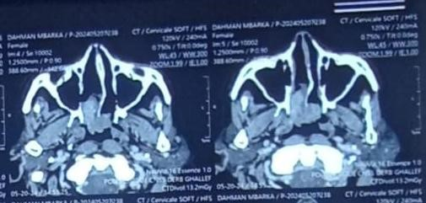

Figure1 : Axial CT scan of the face showing the tumor in the right nasal cavity extending to both choanae.

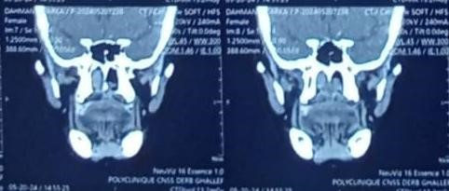

Figure 2 : Coronal section CT scan

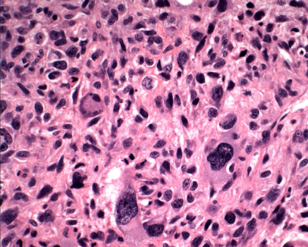

Figure 3: Histopathological results of the biopsy.

The therapeutic decision was surgical excision, performed endoscopically with the need for an additional endobuccal approach to completely remove the tumor and achieve negative margins (figures 4,5,6 and 7).

Postoperative recovery was straightforward, with no complications noted.

The patient was then presented at a multidisciplinary team meeting to discuss adjuvant radiation therapy.

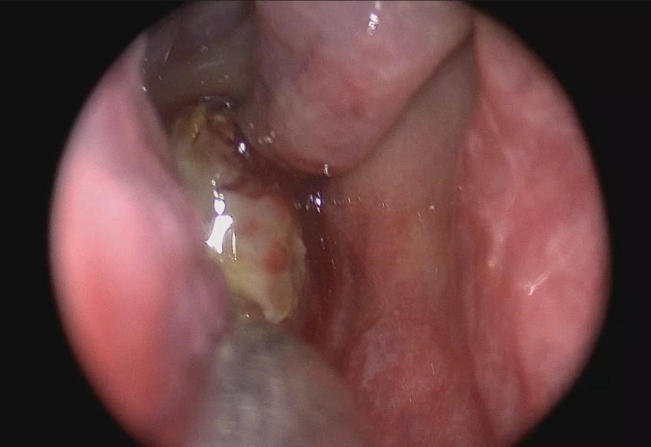

Figure 4 : endoscopic image showing the tumor preoperatively

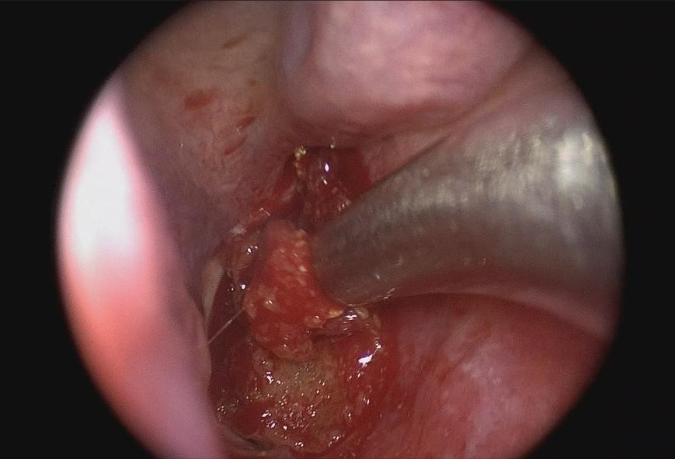

Figure 5 : endoscopic image during the early stages of surgical excision

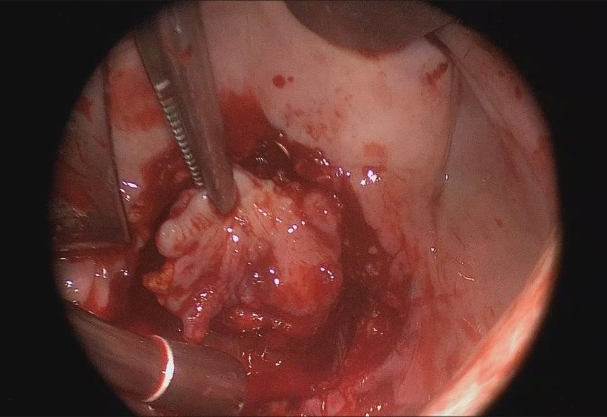

Figure 6 : image showing the surgical approach to the mass via the intraoral route

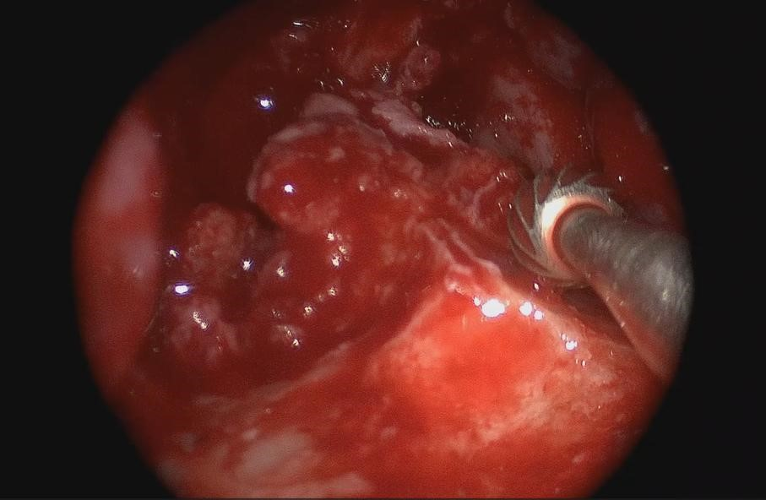

Figure 7 : completion of tumor excision and milling of the palatine bone

**Discussion:**

Sinonasal osteosarcoma is an exceptionally rare disease, Most head and neck lesions originate in the mandible, with the maxilla being less commonly affected [7]. So far, there has been no research into survival rates for this population or the factors that may impact them [8]. Several potential causes have been suggested, including prior radiation exposure, a history of retinoblastoma, Paget's disease of bone, fibrous dysplasia, and genetic predisposition. In one study, a history of radiotherapy was identified as the most significant risk factor [13].

The gender distribution is similar for both sexes, with a mean age in the 30s, following a bimodal age distribution pattern [9-11]. The most commonly observed symptom is a mass or swelling in the cheek or jaw and nasal obstruction . Pain is the initial symptom in about one-third of patients, while dental complaints are less common [12,14,15]. Endoscopic examinations of the nasal cavities are essential, as they can reveal any tumor-induced displacement of the lateral nasal wall. A CT scan is essential for diagnosing tumors in the sinonasal cavities because it helps assess the extent and local spread of the disease and can provide indications of the tumor type. Vascular and neurogenic tumors often exhibit contrast enhancement on CT scans. The scanner looks for specific indicators of an aggressive lesion, such as localized cortical destruction, characteristics of periosteal reaction, and improved visualization of the mineralized matrix. MRI is indicated as second intention in order to confirm or refute the existence of a lesion, and to specify the characteristic appearance of certain subtypes

Due to the limited number of sinonasal osteosarcoma cases, there is no consensus on the optimal treatment approach for this condition, while the primary treatment for head and neck osteosarcoma is thorough surgical resection with negative margins thus leading to a better prognosis. [10,16].

Local recurrence is the most frequent type of failure, occurring in 94% of patients. This finding is in line with previous research and indicates that achieving wide surgical margins is challenging

[17].

Regarding adjuvant treatments, radiation therapy appears to be ineffective for bone tumors and plays a very limited role in the treatment of bone cancers [18].

in literature, The effect of radiotherapy on patient survival was also not beneficial. Again, this may potentially be attributed to a selection bias, with a greater tendency to use adjuvant radiation therapy in patients with more advanced tumors and those with incomplete surgical resections.

The addition of adjuvant chemotherapy did not have a significant impact on the survival of patients .This is in contrast to osteosarcoma of the extremeties, which is may benefit more from the effects of chemotherapy, given to higher rate of distant metastases [19-21].

**Conclusion:**

Osteosarcoma of the vomer is a rare and highly malignant tumor that requires aggressive treatment, primarily through surgery with negative margins. The role of adjuvant radiochemotherapy is not well defined in the literature and is typically reserved for cases that are locally or distantly extensive.

Ethical Approval:

As per international standards or university standards written ethical approval has been collected and preserved by the author(s).

Consent

As per international standards or university standards, patient(s) written consent has been collected and preserved by the author(s).

Disclaimer (Artificial intelligence)

Option 1:

Author(s) hereby declare that NO generative AI technologies such as Large Language Models (ChatGPT, COPILOT, etc.) and text-to-image generators have been used during the writing or editing of this manuscript.

Option 2:

Author(s) hereby declare that generative AI technologies such as Large Language Models, etc. have been used during the writing or editing of manuscripts. This explanation will include the name, version, model, and source of the generative AI technology and as well as all input prompts provided to the generative AI technology

Details of the AI usage are given below:

1.

2.

3.

**References :**

1. Kassir RR, Rassekh CH, Kinsella JB, Segas J, Carrau RL, Hokanson JA.

Osteosarcoma of the head and neck: meta-analysis of nonrandomized studies. Laryngoscope 1997;107(01):56–61

1. Gurney JG, Swensen AR, Bulterys M. Malignant bone tumors. In: Ries LA, Smith MAS, Gurney JG, et al., ed. Cancer Incidence and Survival Among Children and Adolescents:

United States SEER Program 1975–1995. Bethesda, MD: National Cancer Institute; 1999.

Available at: http://seer.cancer.gov/publications/childhood/bone.pdf; Accessed August 2008.

1. Dahlin DC, Unni KK, eds. Bone Tumors: General Aspects and Data on 8,542 Cases. 4th ed.

Charles C. Thomas: Springfield, IL; 1986.

1. Marcove RC, Miké V, Hajeck JV, et al. Osteogenic sarcoma under the age of twenty one. A review of one hundred and forty-five operative cases. J Bone Joint Surg Am. 1970;52:411-423.
2. McKenna RJ, Schwinn CP, Soonh KY, et al. Sarcomata of osteogenic series (osteosarcoma, fibrosarcoma, chondrosarcoma, parosteal osteosarcoma, and sarcomata arising in abnormal bone): an analysis of 552 cases. J Bone Joint Surg Am. 1966;48-A:1-26.
3. Dahlin DC, Coventry MB. Osteogenic sarcoma. A study of six hundred cases. J Bone Joint

Surg Am. 1967;49:101-110.

1. Osteosarcorna of the Head and Neck: Meta-analysis of Nonrandomized Studies

Ramtin R. Kassir, MD; Christopher H. Rassekh, MD; John B. Kinsella, MD; John Segas, MD;

Ricardo L. Carrau, MD; James A. Hokanson, PhD

1. Sinonasal Osteosarcoma: Report of 14 New Cases and Systematic Review of the Literature

Christopher M. Low1 Nelson R. Gruszczynski2 Eric J. Moore1 Daniel L. Price1 Jeffrey R. Janus1 Jan L. Kasperbauer1 Kathryn M. Van Abel1 Janalee K. Stokken1 Jamie J. Van Gompel1,3 Michael J. Link1,3 Garret Choby1

9.Barosa J, Ribeiro J, Afonso L, Fernandes J, Monteiro E. Head and neck sarcoma: analysis of 29 cases. Eur Ann Otorhinolaryngol Head Neck Dis 2014;131(02):83–86

10.Gupta D, Vishwakarma SK. Osteogenic sarcoma of the frontal sinus. Ann Otol Rhinol Laryngol 1990;99(6, Pt 1):489–490

11.Yamaguchi S, NagasawaH, Suzuki T, et al. Sarcomas of the oral and maxillofacial region: a review of 32 cases in 25 years. Clin Oral Investig 2004;8(02):52–55

12 . Bennett JE, Tignor SP, Shafer WG, et al. Osteogenic sarcoma of the facial bones. Am J Surg 1968;116:538.

1. Geopfert H, Raymond AK, Spires JR, et al. Osteosarcoma of the head and neck. Cancer Bull 1990;42:347-54.
2. Erdur ZB, Gözen ED, Inan HC, et al. Osteosarcoma of the ethmoid sinus. J Craniofac Surg 2018;29(05):e487–e488
3. Cahan WG,Woodard HQ, Higinbotham NL, Stewart FW, Coley BL. Sarcoma arising in irradiated bone; report of 11 cases. Cancer 1948;1(01):3–29
4. Oda D, Bavisotto LM, Schmidt RA, et al. Head and neck osteosarcoma at the University of Washington. Head Neck 1997;19(06): 513–523
5. Mark RJ, Sercarz JA, Tran L, Dodd LG, Selch M, Calcaterra TC. Osteogenic sarcoma of the head and neck. The UCLA experience. Arch Otolaryngol Head Neck Surg 1991;117(07):761–76
6. Smith RB, Apostolakis LW, Karnell LH, et al. National cancer data base report on osteosarcoma of the head and neck. Cancer 2003; 98(08):1670–1680
7. Eilber FR, Giuliano JE, Eckhardt J, et al. Adjuvant chemotherapy for osteosarcoma: a randomized prospective trial. J Clin Oncol 1987;5:21-6.
8. Eilber FR, Morton DL, Eckhardt J, et al. Limb salvage for skeletal and soft tissue sarcomas:

multidisciplinary preoperative therapy. Cancer 1984;53:2579-84.

1. Eilber FR, Eckhardt J, Morton DL. Advances in the treatment of sarcomas of the extremity:

current status of limb salvage. Cancer 1984;54:2695-2701.