**Case report**

**A Seldom Encountered Intestinal Obstruction: Gallstone Ileus**

**Abstract**

Gallstone ileus refers to mechanical small bowel obstruction secondary to luminal occlusion by a gallstone, most frequently in the distal ileum or ileocecal junction. The gallstone enters the enteral lumen through a cholecystoenteric fistula and large enough to be impacted in the small bowel. Although rare, it is a significant cause of mechanical small bowel obstruction in older adults. Computed tomography is the diagnostic modality of choice, and demonstrating Rigler’s triad is diagnostic of gallstone ileus. We here report the case of an 83-year-old male with gallstone ileus, wherein the impacted stone spontaneously passed, relieving the obstruction; subsequently, laparoscopic subtotal cholecystectomy and duodenal fistula repair were performed successfully. Additionally, we highlight using indocyanine green fluorescence imaging to navigate the complexities of biliary surgery. This case underscores the challenges in diagnosing and managing gallstone ileus and emphasizes the role of minimally invasive surgical techniques in complex biliary diseases.

**Keywords**

Gallstone, Ileus, Intestinal obstruction, Rigler’s triad, Pneumobilia

**Introduction**

Gallstone ileus is an unusual cause of mechanical small bowel obstruction due to a lumen occluding gallstone. Even though cholecystolithiasis and related complications are frequent in clinical practice, gallstone ileus contributes only to 0.3-0.5% of patients with cholecystitis and less than 1% of cases of intestinal obstruction. (1) It is most frequently reported in elderly women, likely related to increased incidence of gall bladder (GB) calculus diseases amongst females. The Rigler’s triad on radiology, characterized by pneumobilia, intestinal obstruction, and an ectopic gallstone, is classical for gallstone ileus. (2) Surgery is the preferred line of management; however, the approach and procedure vary based on the patient's general condition and the surgeon's expertise. We here report the case of an elderly male presenting with intestinal obstruction, diagnosed as gallstone ileus, and managed laparoscopically.

**Case presentation**

An 83-year-old male presented with moderate to severe, diffuse, colicky abdominal pain of abrupt onset, worsening with oral intake. He had associated nausea and bilious, non-blood-tinged vomiting. He denies having any bowel movements over the past day, nor any overt bleeding manifestations or fever. He reported episodes of moderate to severe abdominal pain episodes in the past and was diagnosed with biliary calculus disease. He was recommended the surgery in the past, but he denied surgical interventions. He has a history of diabetes mellitus, hypertension, hyperlipidemia, and coronary artery diseases in the past. Upon arrival at the emergency, he was in severe pain, with evidence of dehydration, with a distended abdomen and hyperactive bowel sounds. A hemogram revealed leucocytosis and a hemoglobin of 14.3 g/dL. Biochemistry revealed a blood urea nitrogen of 61 mg/dL, creatinine 1.1 mg/dL, sodium 148 mEq/dL, potassium 3.2 mEq/L, and normal hepatic functions. He was initiated on intravenous fluids and symptomatic measures and taken up for an urgent computed tomography (CT) of the abdomen. Imaging revealed a distended stomach and jejunoileal loops, with a 2.7 x 2.4 cm hyperdense area, likely calculus, filling and occluding the lumen in the distal ileum. The GB was contracted with a luminal air pocket. The GB wall was thickened and appeared in continuity with the duodenal wall (Figure 1). The cystic duct could not be appreciated, while the rest of the liver, biliary tree, and pancreas were reported normal.

After initial management, the pain resolved in a couple of hours, as did the emesis, and he had two soft bowel movements over the first 24 hours. At 24 hours of admission, a repeat CT showed normal bowel loops and GB wall thickening with luminal air, while the ileal stone was not visualized (Figure 2). Laparoscopy revealed dense adhesion of the colon, omentum, and duodenum to a thickened, contracted GB. The Calots triangle was obliterated, with large fistulous communication between the GB and the duodenum. Adhesions were released, the duodenal fistula was dismantled, and the common bile duct was identified and safeguarded with indocyanine green dye injection (Figure 3). A subtotal cholecystectomy and omental plug patch repair were performed on the duodenal fistula opening. The patient had an uneventful periprocedural course, tolerated oral feeds and fluids, and was discharged on the third postoperative day.

**Discussion**

Gallstone ileus is an infrequent cause of small intestinal obstruction, most frequently reported among elderly females. The word ileus colloquially refers to non-mechanical or functional small bowel obstruction. However, gallstone ileus is a mechanical obstruction resulting from an impacted gallstone in the small intestine, making it a misnomer. It accounts for about 1% of cases of intestinal obstruction, and the rarity often makes the diagnosis and management challenging.

Gallstones typically form in the gall bladder and may remain there, cholecystolithiasis, or migrate down the cystic and common bile duct (CBD), choledocholithiasis. En route, they may get impacted, leading to cholecystitis, obstructive jaundice, or pancreatitis, or pass off uneventfully into the duodenum. The normal diameter of CBD is about 6mm, and it may be as high as 9mm in elderly people. (3) The diameter of the ampulla of Vater is approximately 6mm as well. (4) This implies that only small stones can pass spontaneously into the duodenum, insufficient to cause an intestinal obstruction with a normal luminal diameter of around 2.5 cm. (5) However, complicating chronic calculous cholecystitis, fistulization occurs typically between GB and duodenum, resulting in the migration of large gall stones into the lumen, which gets impacted downstream, typically in the ileum, causing mechanical obstruction: gallstone ileus. (6-8) Very rare cases of gall stones getting impacted in the duodenum with resultant gastric outlet obstruction have been reported in literature: Bouveret syndrome. (9)

The clinical presentation is similar to that of other causes of intestinal obstruction: abdominal pain, nausea, vomiting, and constipation. (7,8,10) Patients often have a history of biliary pain or complicated gallstone disease; infrequently, de novo gallstone ileus cases have been reported. The radiological triad of intestinal obstruction, pneumobilia, and an ectopic luminal gallstone, called the Rigler’s triad, is classical for gallstone ileus. (11) Conventional X-rays of the abdomen might reveal only evidence of obstruction, while CT more frequently reveals the radiological triad and confirms the diagnosis. Ultrasound of the abdomen reveals GB wall thickening and air in the GB; however, it can be challenging in the setting of intestinal obstruction.

Gallstone ileus, which is more frequent in the elderly who might have multiple concomitant comorbidities, is associated with higher morbidity and mortality compared to other complications of cholelithiasis. Initial management includes resuscitation with hydration and correction of electrolyte imbalances, in addition to symptomatic measures for pain and emesis. Surgery remains the most preferred line of definitive management. A laparotomy was the conventional choice, but off late, with improving technology and expertise, laparoscopic surgeries are more frequently utilized. However, the timing of surgery and the approach depends on the patient's clinical condition and the surgeon's expertise, and there are no guiding recommendations. In any patient with gallstone ileus, there are three simultaneous pathological processes: intestinal obstruction, complicated cholelithiasis, and cholecystoenteric fistula. Surgical removal of the stone, enterolithotomy, addresses the acute and life-threatening disease process and is the simplest standalone procedure of choice in frail patients. It may be combined with cholecystectomy and fistula repair in low-risk individuals as a single to two-stage procedure, depending on expertise. Emergent procedures, prolonged surgical time, and delayed diagnosis and management have been associated with worse outcomes. (12,13)

Our patient presented with classical clinical features of intestinal obstruction; imaging revealed Rigler’s triad, consistent with the diagnosis of gallstone ileus. He was managed with fluid and electrolyte resuscitation and symptomatic measures, including analgesics and antispasmodics. During this period, the impacted stone spontaneously dislodged, relieving the obstruction. The size of the calculus in our patient was 2.7 x 2.4 cm radiologically, which is roughly the expected minimum diameter of the small intestine. This borderline size of the stone might have allowed it to dislodge and traverse down the tract spontaneously. Subsequently, our dedicated and experienced gastrointestinal surgery team performed the reparative surgery laparoscopically without complications, leading to complete recovery. The surgical procedure was complex due to dense, localized adhesions and obliterated regional anatomy. Anticipating technical difficulties, indocyanine green (ICG) was administered preoperatively, allowing time for its biliary secretion, and the ICG mode of the Stryker® system was used for fluorescence imaging intraoperatively to delineate the fistula, allowing safe dissection, resection, and repair.

In conclusion,gallstone ileus, though rarely encountered in clinical practice should be on the list of differentials for mechanical intestinal obstruction, especially in the elderly. A CT scan of the abdomen is the diagnostic modality of choice and might reveal Rigler’s triad: intestinal obstruction, pneumobilia, and ectopic gallstone in the lumen. Management includes initial resuscitation followed by definitive surgical intervention, enterolithotomy with or without cholecystectomy, and repair of cholecystoenteric fistula as a single or dual staged, open or laparoscopic procedure, depending on expertise. ICG fluorescence technique may be utilized to navigate the technical challenges of complex biliary surgeries.

**Disclaimer (Artificial intelligence)**

Author(s) hereby declare that NO generative AI technologies such as Large Language Models (ChatGPT, COPILOT, etc.) and text-to-image generators have been used during the writing or editing of this manuscript.

**References**

1. Jacobucci RP, Lee E, Price D, Nguyen J, Marttos A Jr, Namias N. Gallstone Ileus. ACS Case Reviews in Surgery. 2022;3(8):33-37.
2. Roothans D, Anguille S. Rigler triad in gallstone ileus. CMAJ. 2013 Oct 1;185(14):E690. doi: 10.1503/cmaj.121432.
3. Piyawong W, Lekhavat V. Normal Measurement of Diameters of the Common Bile Ducts in Different Aged Groups. J Med Assoc Thai. 2016 Jul;99 Suppl 4:S153-8.
4. Lim JH. Papilla of Vater: normal sonographic appearance. J Ultrasound Med. 1996 Jan;15(1):33-5.
5. Cronin CG, Delappe E, Lohan DG, Roche C, Murphy JM. Normal small bowel wall characteristics on MR enterography. Eur J Radiol. 2010 Aug;75(2):207-11. doi: 10.1016/j.ejrad.2009.04.066.
6. Inukai K. Gallstone ileus: a review. BMJ Open Gastroenterol. 2019;6:e000344. doi:10.1136/bmjgast-2019-000344.
7. Nuño-Guzmán CM, Marín-Contreras ME, Figueroa-Sánchez M, Corona JL. Gallstone ileus, clinical presentation, diagnostic and treatment approach. World J Gastrointest Surg. 2016 Jan 27;8(1):65-76. doi: 10.4240/wjgs.v8.i1.65. PMID: 26843914; PMCID: PMC4724589.
8. Hussain J, Alrashed AM, Alkhadher T, Wood S, Behbehani AD, Termos S. Gallstone ileus: Unfamiliar cause of bowel obstruction. Case report and literature review. Int J Surg Case Rep. 2018;49:44-50. doi:10.1016/j.ijscr.2018.06.025.
9. Mavroeidis VK, Matthioudakis DI, Economou NK, Karanikas ID. Bouveret syndrome—The rarest variant of gallstone ileus: A case report and literature review. Case Rep Gastrointest Med. 2013;2013:839370. doi:10.1155/2013/839370.
10. Morosin T, De Robles MSB, Putnis S. Gallstone ileus: an unusual cause of intestinal obstruction. Cureus. 2020 Mar 15;12(3):e7284. doi: 10.7759/cureus.7284.
11. Zabeirou A, Saidou A, Younssa H, James Didier L, Younoussa M, Sani R. An authentic radiological triad of Rigler allowing the diagnosis of gallstone ileus: A case report. Radiol Case Rep. 2024 Jan 27;19(4):1565-1567. doi: 10.1016/j.radcr.2024.01.022.
12. Turner AR, Sharma B, Mukherjee S. Gallstone Ileus. (Updated 2022 Sep 19). In: StatPearls [Internet]. Treasure Island (FL): StatPearls Publishing; 2024 Jan-. Available from: <https://www.ncbi.nlm.nih.gov/books/NBK430834/>.
13. Kumar HR. Overview on gallstone ileus: an update on management. Asian J Med Health. 2024;22(12):224-31. doi:10.9734/ajmah/2024/v22i121152.

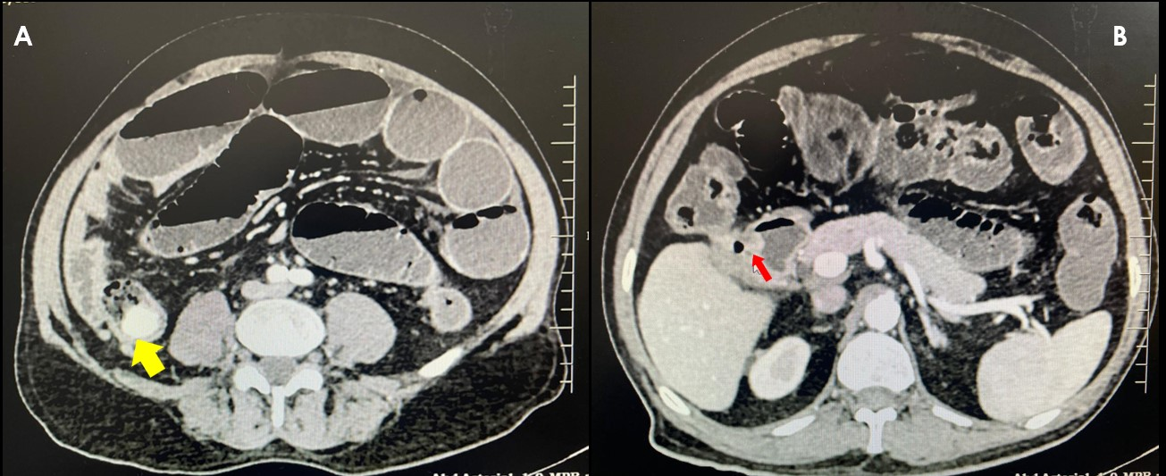

Figure 1: Panel A reveals CT abdomen with a stone impacted in the distal ileum (yellow arrow) with dilated upstream bowels and air-fluid levels. Panel B demonstrates a collapsed gall bladder with pneumobilia and cholecystoenteric fistula (red arrow)

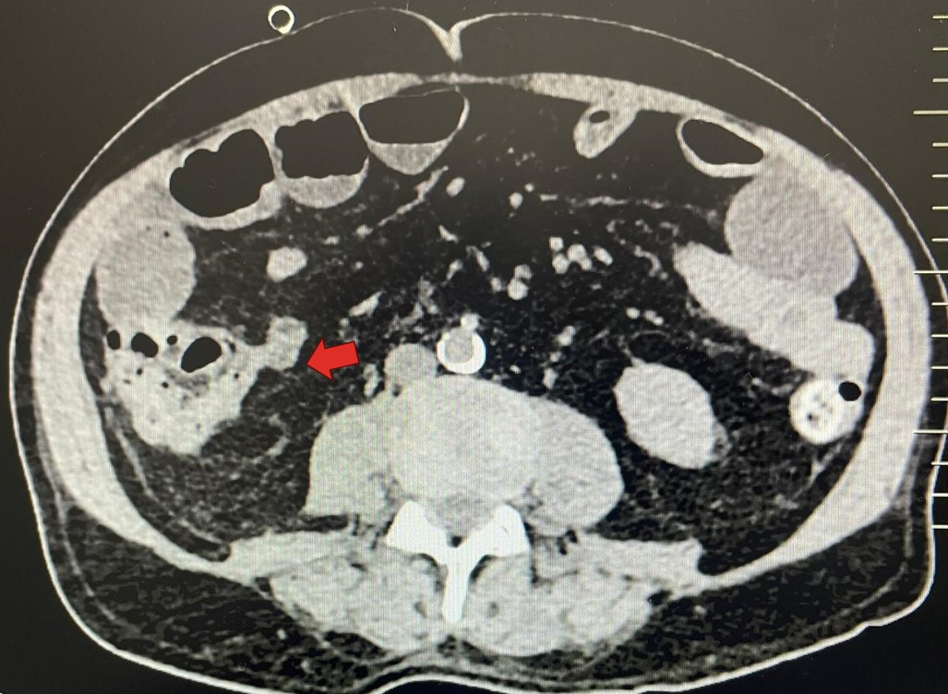

Figure 2: Repeat CT images showing relief of intestinal obstruction, with no stone at the distal ileum.

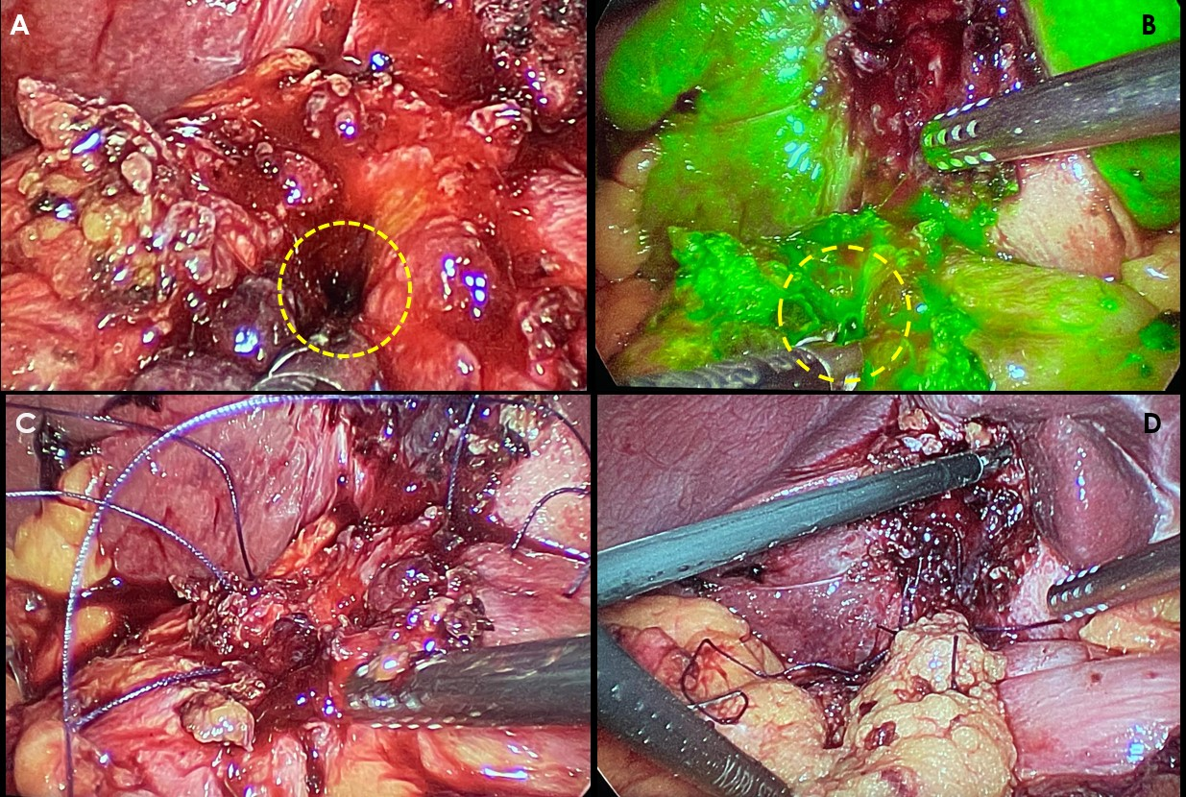

Figure 3: Panels A and B demonstrate the fistulous opening (broken yellow circles) after dismantling, normal, and ICG modes, respectively. Panels C and D images represent the reparative stages.