Histopathological Effects of Industrial Effluents on Lung Tissues of Wistar Rats

ABSTRACT
Background: Environmental pollution from industrial effluent discharge poses a significant health risk, particularly through inhalation and ingestion. This study aimed to evaluate the histological effects of treated and untreated effluents from selected chemical and petrochemical industry in Rivers State, Nigeria on the lung tissues of Wistar rats. Methods: A total of 40 adult male Wistar rats were randomly assigned into five groups (n=8 per group). Group 1 served as the control, while Groups 2–5 were administered 100% effluent samples (10 mL/kg body weight) of untreated refinery effluent, treated refinery effluent, treated Notore effluent, and untreated Notore effluent, respectively, via oral gavage for 28 days. Animals were sacrificed on days 3 and 28 to assess acute and chronic effects. Lung tissues were extracted, fixed in 10% buffered formal saline, and processed for histological examination using hematoxylin and eosin (H&E) staining. Results: Histological examination revealed significant inflammatory responses in treated groups. Day 3 samples showed inflammatory cell infiltration, alveolar congestion, and mild epithelial distortions. Day 28 samples demonstrated severe inflammatory cell infiltration, alveolar rupture, congestion, and bronchial epithelial distortion, with more pronounced effects in the untreated effluent groups. Conclusion: Findings indicate that exposure to industrial effluents, particularly untreated samples, induces severe lung tissue damage over time. This study underscores the health risks of industrial effluent pollution and the need for stringent effluent treatment and regulatory enforcement to mitigate environmental and public health hazards.
Keywords: Industrial effluents, Pulmonary histopathology, Toxicological assessment, Industrial Effluents, Chronic exposure, Lung tissue, Wistar rats

INTRODUCTION
Industrial effluents are liquid waste products generated from various industrial processes, often containing a complex mixture of organic and inorganic pollutants, heavy metals, and other hazardous substances (Ite et al., 2013). These effluents are a byproduct of industrialization, which has significantly increased over the past century. While industrialization has contributed to economic development, it has also led to severe environmental pollution due to the indiscriminate discharge of untreated or inadequately treated effluents into ecosystems. According to the World Health Organization (WHO), approximately 80% of wastewater globally is discharged untreated into the environment, contributing to water, soil, and air contamination and posing significant risks to both ecosystems and human health (Okafor et al., 2021; El-Shafey et al., 2024).
Exposure to toxic substances in industrial effluents has been linked to numerous health conditions. These pollutants can enter the human body through inhalation, ingestion, or dermal contact, leading to systemic toxicity. Studies have shown that exposure to pollutants such as heavy metals, hydrocarbons, and volatile organic compounds (VOCs) in effluents is associated with respiratory diseases, cardiovascular issues, and even cancer (Niamat et al., 2023; Ajibola et al., 2024). The lungs are particularly vulnerable as airborne pollutants can be inhaled directly. Chronic exposure to these toxins can result in oxidative stress, inflammation, and histopathological changes in lung tissues (Nissenbaum et al., 2023; Niamat et al., 2023).
The petroleum industry is one of the most significant contributors to industrial effluent generation. Petroleum refineries produce large volumes of wastewater containing hydrocarbons, heavy metals like lead and cadmium, and other hazardous chemicals. In Nigeria, particularly in Rivers State—a region heavily impacted by oil exploration activities—petroleum companies frequently discharge both treated and untreated effluents into the environment without adequate regulatory oversight. This practice exacerbates environmental degradation and poses severe risks to public health. Research indicates that communities in Rivers State experience high levels of air and water pollution due to these activities, with respiratory illnesses being among the most reported health issues (Abbas et al., 2023; Jung et al., 2024).
The impact of these effluents on human health is particularly concerning due to their potential to cause chronic respiratory conditions. Pollutants such as polycyclic aromatic hydrocarbons (PAHs) and VOCs present in petroleum effluents have been shown to impair lung function over time. Long-term exposure has been associated with chronic obstructive pulmonary disease (COPD), asthma, fibrosis, and even lung cancer (Rafiq et al., 2022; Faouzi et al., 2023). Despite these alarming trends, there is limited research exploring the direct histopathological effects of treated and untreated industrial effluents on lung tissues using animal models.
Animal models provide a controlled environment for studying the biological impact of toxic substances at cellular and tissue levels. However, there is a paucity of studies examining both short-term and long-term effects of industrial effluent exposure on lung tissues. This gap limits our understanding of how these pollutants contribute to respiratory diseases. This study aims to bridge this knowledge gap by investigating the histopathological effects of treated and untreated industrial effluents on lung tissues using Wistar rats as a model organism. By providing empirical evidence on the extent of lung damage caused by these pollutants, this research emphasizes the urgent need for stricter regulations on industrial waste management while contributing valuable insights into environmental toxicology.
MATERIALS AND METHODS
Sample sites
Notore Chemicals and Petrochemical Industry, formerly known as the National Fertilizer Company of Nigeria (NAFCON), is one of the largest nitrogenous fertilizer production facilities in Nigeria. Located at Onne, near Port Harcourt in Rivers State, the company plays a vital role in the agricultural sector by manufacturing fertilizers such as urea, ammonium nitrate, and other agrochemical products. Since its establishment in 1987, Notore has been instrumental in boosting agricultural productivity in Nigeria and across West Africa. However, Notore Chemicals’ proximity to the Okirika Creek raises significant environmental concerns. The plant discharges industrial effluents containing ammonia, urea, phosphate compounds, and other hazardous chemicals directly into the creek. Studies have shown that fertilizer plant effluents can contribute to water pollution, eutrophication, and toxicity to aquatic life due to high levels of nitrogen and phosphorus (Obire et al., 2008; Akinnawo, 2023). The presence of heavy metals, oil, and grease in these discharges further exacerbates ecological degradation. Given these environmental risks, it was necessary to collect effluent samples from Notore Chemicals for our study to evaluate the potential impact of these pollutants on surrounding water bodies and communities.
The Port Harcourt Refinery and Petrochemical Company Limited (PHRC) is a key player in Nigeria’s oil and gas sector. Established in 1962, the refinery is operated by the Nigerian National Petroleum Corporation (NNPC) and consists of two refining plants with a combined processing capacity of approximately 210,000 barrels per day. PHRC is responsible for refining crude oil into various petroleum products such as gasoline, diesel, kerosene, lubricants, and petrochemical feedstocks. The refinery is located in Alesa-Eleme, Rivers State, and has long been associated with environmental pollution due to the discharge of petroleum refinery effluents (PREs) into nearby water bodies, particularly the Okrika River system. These effluents contain hydrocarbons, heavy metals, phenols, sulfides, and polycyclic aromatic hydrocarbons (PAHs), all of which pose serious risks to aquatic ecosystems and human health. Continuous discharge of untreated or partially treated effluents can lead to the accumulation of toxic substances in water and sediment, affecting biodiversity and potentially contaminating drinking water sources for local communities. Effluents from PHRC were collected for our study to assess their health effect on the lungs, to provide evidence of the harm constituted by these effluents to humans.
Experimental Animals
Experimental animals used for this study were purchased and maintained at the Animal House of Biomedical Research Center of the University of Port Harcourt, Choba, Rivers State, Nigeria. A total of 40 male Wistar rats (Rattus norvegicus) were used. The age of animals were 4-6 months, and they weighed between 150 to 200 grams. 154 grams. Rats were kept for one week for acclimatization before being used in the experiments. They were divided into groups, and each group was housed in separate transparent plastic cages with stainless steel cover lids. The animals were maintained at a temperature of 20-25°C, and they had free excess to food (standard pellets by Eastern Premier Mills, Calabar) and water throughout the experimental work. Housing conditions were designed to meet species-specific needs, as outlined in the Guide for the Care and Use of Laboratory Animals (National Research Council, 2011).
Effluent Collection and Preservation
Treated and untreated effluent samples were collected from the discharge points of Notore Chemicals and Petrochemical Industry and Port Harcourt Refinery and Petrochemical Company Limited in Rivers State. The treated effluent from Notore Chemicals and Petrochemical Industry was obtained at its discharge point in Ipokiri Community, Okrika Local Government Area, where it flows into the Okoro River, while the untreated effluent was collected from the utility plant of the same facility in Onne, Eleme Local Government Area. Similarly, the treated effluent from Port Harcourt Refinery and Petrochemical Company Limited was collected at its discharge point in Ekerekana Community, Okrika, while the untreated effluent was obtained from its discharge point in Eleme. All effluent samples were collected in amber bottles and stored in a refrigerator for preservation before use.
Effluent Dosing
Experimental animals were administered 100% effluent samples, with each animal receiving 10 mL per kg of body weight (2 mL) of either treated or untreated effluent via oral gavage daily for the duration of the study. This dosage aligns with established guidelines for safe and effective oral administration in rodents. Specifically, the maximum recommended dosing volume for rats ranges from 10 to 20 mL/kg, with 10 mL/kg being a commonly utilized volume to ensure the well-being of the animals while delivering the intended experimental treatment (Institutional Animal Care and Use Committee, 2024). The dosing was adjusted based on individual body weight to ensure accuracy and ethical compliance. The effluents were administered orally via gavage for a duration of 28 days.
Experimental Design
The 40 adult male Wistar rats were randomly assigned into five groups, with eight animals per group. This sample size was determined to balance statistical robustness with ethical considerations. The experimental design is as shown in the table below;
Table 1. Experimental design
Group | Identification | Rats | Treatment/Exposure
Group 1 | Control | 8 | Fed with rat feed and water throughout the study period.
Group 2 | Untreated Refinery Effluent | 8 | Fed with untreated refinery effluent.
Group 3 | Treated Refinery Effluent | 8 | Fed with treated refinery effluent.
Group 4 | Treated Notore Effluent | 8 | Fed with treated Notore effluent.
Group 5 | Untreated Notore Effluent | 8 | Fed with untreated Notore effluent.

Sample Collection
Experimental animals were sacrificed on days 3 and 28 following effluent administration to assess both acute (short-term) and chronic (long-term) effects of the effluents. The rats were anesthetized using diethyl ether before sacrifice, and their lungs were carefully extracted. The lungs were then fixed in 10% buffered formal saline at room temperature for histological examination.

Histological examination
The lung tissues were trimmed to a thickness of 2–4 mm to facilitate optimal penetration of the fixative. Standard histological processing methods, as described by Baker (1945) and Isirima and Uahomo (2023), were employed, including fixation, dehydration, clearing, impregnation, embedding, sectioning, and staining with hematoxylin and eosin (H&E), followed by final mounting. Sections were observed under a digital brightfield microscope (OMAX 40x-200X 3MP Digital microscope USA) and photomicrographs were taken at 100X and 400X magnification.
Method of Data Analysis
Since no numerical data were generated in this study, the analysis was based on qualitative histological assessment. The histological slides were examined under a light microscope to evaluate tissue architecture, cellular integrity, and morphological changes in the lung samples. Observations were compared across experimental groups to identify structural alterations resulting from effluent exposure. Representative photomicrographs were captured for documentation and interpretation of findings.

RESULTS
Histopathological Findings of Lung Tissue
Histological analysis of lung tissues on day 3 revealed normal microstructure in the control group, while groups exposed to treated and untreated industrial effluents exhibited varying degrees of inflammatory cell infiltration, alveolar congestion, and epithelial distortion. The most severe distortions were observed in animals administered untreated refinery and Notore effluents, characterized by spreading inflammatory cells, alveolar sac distortion, and bronchial epithelial damage. By day 28, progressive deterioration was evident, with the untreated effluent groups displaying very severe inflammatory infiltration, coagulated/congested alveoli, and epithelial degeneration. The treated effluent groups also showed significant alveolar disruption and cellular degeneration, though less severe than their untreated counterparts. These findings indicate that both treated and untreated industrial effluents induce lung tissue damage, with untreated effluents causing more pronounced structural distortions over time.

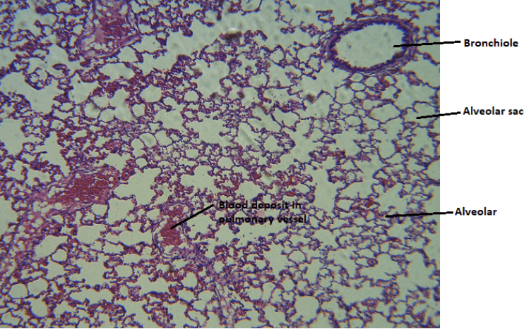 | 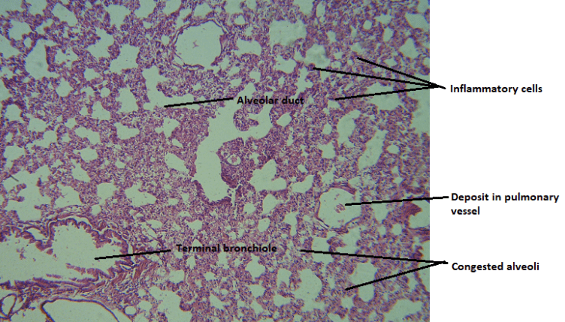
Group 1A | Group 2A (untreated refinery effluent)
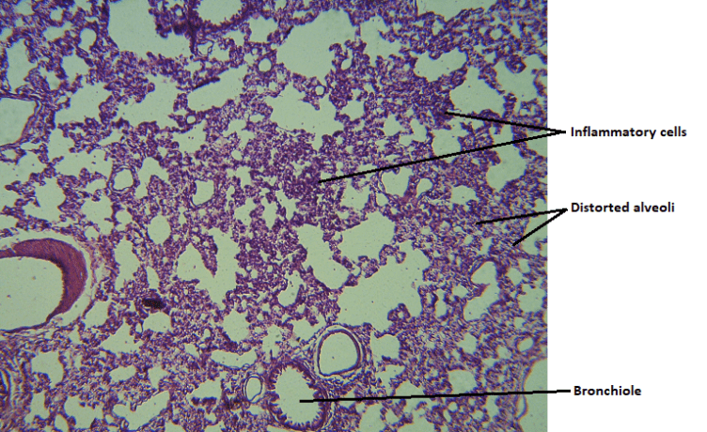 | 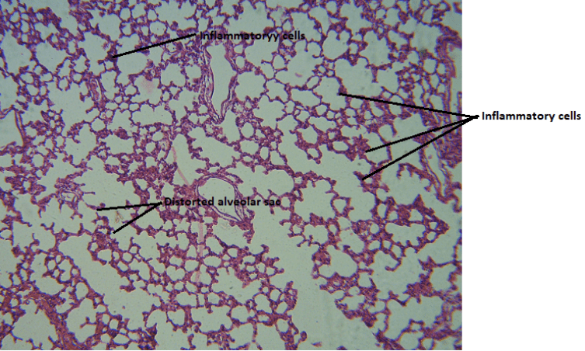
Group 3A (treated refinery effluent) | Group 4A (treated Notore effluent)
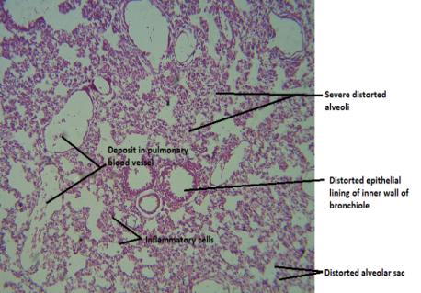
Group 5A (untreated Notore effluent)

Figure 1. Photomicrograph of Lung Tissue of experimental animals on day 3. Group 1A (control) showing alveolar sac, alveoli and pulmonary blood vessels. Tissue shows normal microstructure. Group 2A administered treated refinery effluent showing alveolar sac, inflammatory cells around congested alveoli and pulmonary blood vessels. The terminal alveoli show distorted inner epithelial lining. Distortion of tissue microstructure is indicated. Group 3A administered untreated refinery effluent showing spreading inflammatory cells around congested alveoli. Severe distortion of tissue microstructure is indicated. Group 4A administered treated Notore effluent showing spreading inflammatory cells and distorted alveolar sac. Distortion of tissue microstructure is indicated. Group 5A administered untreated Notore effluents showing spreading inflammatory cells and distorted alveolar sac and distorted bronchial wall epithelial lining. Distortion of tissue microstructure is indicated. Magnification: H & E, X100.

 | 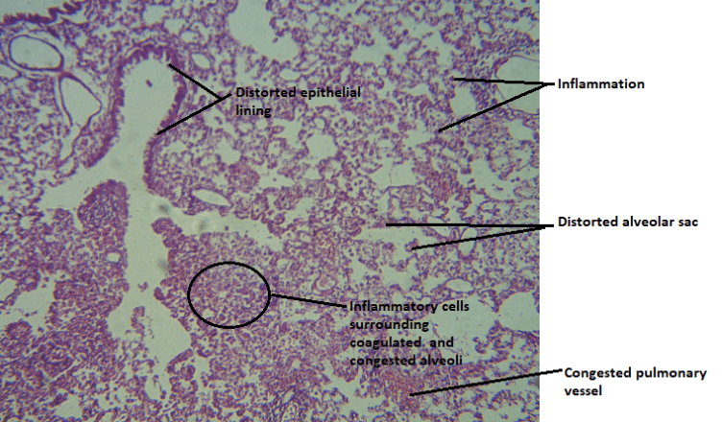
Group 1B (Control) | Group 2B (untreated refinery effluent)
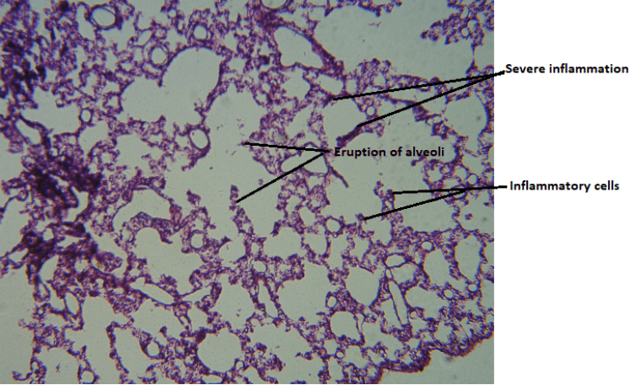 | 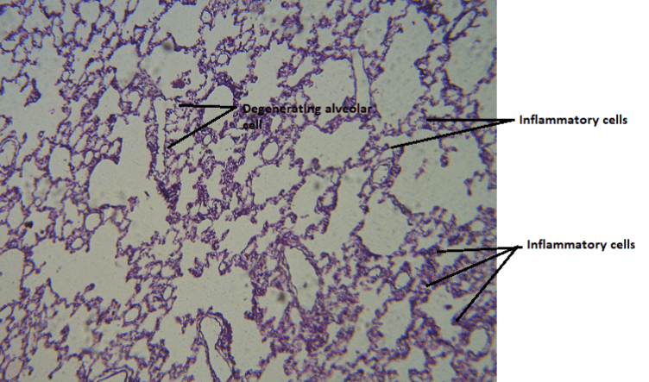
Group 3B (treated refinery effluent) | Group 4B (treated Notore effluent)
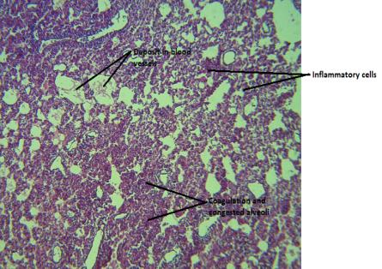
Group 5B (untreated Notore effluent)
Figure 2. Photomicrograph of Lung Tissue of experimental animals on day 28. Group 1B (control) showing alveolar sac, alveoli, and pulmonary blood vessels. Tissue exhibits normal microstructure. Group 2B administered untreated refinery effluent showing very severe inflammatory cells around coagulated/congested alveoli and a distorted alveolar sac. The epithelial lining around the terminal bronchioles also shows distortion. Distortion of tissue microstructure is indicated. Group 3B administered treated refinery effluent showing very severe inflammatory cells around the alveoli, with the eruption of alveoli in the alveolar sac. Distortion of tissue microstructure is indicated. Group 4B administered treated Notore effluent showing inflammatory cells and a distorted alveolar sac. Cellular degeneration around the alveolar sac is observed. Distortion of tissue microstructure is indicated. Group 5B administered untreated Notore effluent showing very severe inflammatory cells around coagulated/congested alveoli. Congested blood vessels are also observed. Severe distortion of tissue microstructure is indicated. Magnification: H & E, X100.

DISCUSSION
Industrial effluents, composed of heavy metals, volatile organic compounds, and persistent organic pollutants, pose a significant threat to public health and the environment. The release of untreated industrial waste into water bodies and air has been associated with numerous disease conditions, including respiratory disorders, cardiovascular complications, and carcinogenesis (Okereke et al., 2016; Landrigan et al., 2018; Schraufnagel et al., 2019). Studies have shown that chronic exposure to pollutants from petrochemical industries leads to increased incidence of chronic obstructive pulmonary disease, pulmonary fibrosis, and lung cancer due to prolonged oxidative stress and inflammatory responses (Schraufnagel et al., 2019; Yang et al., 2021; Raslan et al., 2023). Despite regulations aimed at minimizing industrial pollution, enforcement remains weak, particularly in developing regions such as Nigeria, where industrial hubs contribute significantly to environmental degradation.
This study examined the comparative histopathological effects of treated and untreated industrial effluents on lung tissues over short- and long-term exposure periods. Unlike previous research that primarily focused on general toxicological effects, this study uniquely investigates whether effluent treatment significantly mitigates lung tissue damage, providing critical insights into the effectiveness of treatment processes. The assessment of acute (3-day) and chronic (28-day) exposure allows for a deeper understanding of how industrial effluents progressively alter lung architecture.
The histological findings on day 3 revealed that control animals exhibited normal pulmonary architecture, while those exposed to both treated and untreated effluents showed inflammatory cell infiltration, alveolar congestion, and epithelial distortion. The severity of alterations varied, with untreated refinery and Notore effluents inducing pronounced inflammatory responses, alveolar sac distortion, and early-stage bronchial epithelial damage. This suggests that the high concentration of toxicants in untreated effluents induces oxidative stress and inflammatory signaling cascades, leading to early lung tissue degeneration (Adeboyejo et al., 2013). Treated effluents also triggered inflammatory responses, albeit with reduced epithelial and alveolar damage, indicating that effluent treatment reduces toxicity but does not entirely eliminate harmful effects. Previous studies have corroborated these findings, demonstrating that acute lung toxicity following industrial pollutant exposure is driven by oxidative stress and endothelial dysfunction, which accelerate cellular damage and immune activation (Alves et al., 2020; Bezerra et al., 2023; Sangkham et al., 2024).
By day 28, histological analyses showed severe pulmonary deterioration, particularly in animals exposed to untreated effluents. Pathological changes included extensive inflammatory infiltration, alveolar collapse, epithelial necrosis, and fibrosis-like lesions, suggesting a transition from acute inflammation to chronic degenerative lung disease. Untreated effluents led to increased pulmonary congestion, alveolar destruction, and fibrotic remodeling, reinforcing the hypothesis that continuous exposure exacerbates oxidative damage, impairs lung tissue regeneration, and promotes airway remodeling. The treated effluent groups, while still exhibiting significant alveolar disruption, demonstrated relatively preserved lung structures compared to their untreated counterparts. The milder impact observed in the treated effluent groups can be attributed to partial removal of toxicants during effluent treatment, which reduced but did not eliminate the harmful compounds responsible for oxidative damage and inflammatory responses (Cuerda-Correa et al., 2020; Jomova et al., 2023; Matesun et al., 2024). This suggests that while treatment processes may lessen toxicity, they remain inadequate in preventing long-term pulmonary harm.
The findings further highlight that untreated effluents contribute to more aggressive pathological changes, as they contain a higher load of unfiltered carcinogenic and inflammatory agents. Studies have shown that exposure to high levels of industrial pollutants, particularly in their untreated form, increases the risk of permanent pulmonary damage and heightened susceptibility to respiratory infections (Kurt et al., 2016; Monoson et al., 2023). The prolonged inflammatory responses observed in animals exposed to untreated effluents suggest that ongoing exposure could promote the development of chronic lung diseases, including fibrosis and emphysema. The failure to implement rigorous waste treatment processes could thus result in widespread respiratory complications among populations residing near industrial zones, further burdening healthcare systems and increasing morbidity rates.
The implications of these findings extend beyond individual health risks, highlighting the need for regulatory enforcement and public health interventions. Without stringent regulations, continuous exposure to industrial pollutants could escalate the burden of respiratory diseases, increase healthcare costs, and reduce life expectancy in affected populations. Given the widespread discharge of industrial effluents in many developing regions, environmental monitoring and stricter enforcement of wastewater treatment standards are imperative to mitigate these risks. Routine surveillance of industrial discharge zones should be conducted to track pollutant levels and assess their impact on public health. More stringent industrial wastewater treatment regulations must be implemented to ensure the complete removal of toxic contaminants before effluent discharge. The findings of this study also emphasize the necessity for longitudinal epidemiological research on human populations residing near industrial sites to assess long-term health impacts. Future research should focus on optimizing treatment technologies and evaluating alternative methods, such as bioremediation and nanotechnology-based filtration systems, to enhance effluent detoxification before environmental discharge.
While the study established the differential histopathological impacts of treated and untreated industrial effluents on lung tissues over varying exposure durations, it is important to acknowledge certain limitations. The exclusive reliance on histopathological analysis, though considered the gold standard for defining toxicological effects, is inherently invasive, time-consuming, and may not fully elucidate the underlying molecular mechanisms driving the observed tissue damage. Incorporating molecular assays to evaluate oxidative stress markers, inflammatory cytokine levels, and gene expression profiles would offer a more comprehensive understanding of the pathways involved in effluent-induced pulmonary toxicity. Additionally, the study's dependence on animal models presents challenges in directly extrapolating the findings to human populations. Animal studies often exhibit poor correlation to human toxicity and efficacy, leading to questions about their predictive value for human outcomes. Therefore, while the animal model provides valuable insights, caution must be exercised when applying these results to human health risk assessments.
CONCLUSION
This study demonstrated the significant histopathological impact of industrial effluent exposure on lung tissues, with untreated effluents causing more severe and progressive damage compared to treated effluents. The findings emphasize the critical need for stricter environmental regulations and improved wastewater treatment technologies to mitigate public health risks. Prolonged exposure to industrial pollutants may lead to chronic respiratory diseases, making immediate policy interventions essential. Strengthening industrial waste management, promoting sustainable treatment solutions, and conducting long-term epidemiological studies are crucial steps toward protecting both human health and the environment.

Ethics Approval
The study was carried out in adherence to ethical guidelines set by the National Institute of Health (NIH) for the ethical treatment of animals in research. The study was approved by the Research Ethics Committee of the University of Port Harcourt, Rivers State, Nigeria before commencement of the study.
Disclaimer (Artificial intelligence)
Option 1:
Author(s) hereby declare that NO generative AI technologies such as Large Language Models (ChatGPT, COPILOT, etc.) and text-to-image generators have been used during the writing or editing of this manuscript.
Option 2:
Author(s) hereby declare that generative AI technologies such as Large Language Models, etc. have been used during the writing or editing of manuscripts. This explanation will include the name, version, model, and source of the generative AI technology and as well as all input prompts provided to the generative AI technology
Details of the AI usage are given below:
1.
2.
3.

REFERENCES
Abbas, T., Ahmad, I., Khan, Z. I., & Ahmad, K. (2023). Micromorphological and anatomical responses of native dicots to industrial effluents released from a contaminated region of the Chenab River in Pakistan. SABRAO Journal of Breeding and Genetics, 55(4), 1222–1244. https://doi.org/10.54910/sabrao2023.55.4.17
Adeboyejo, O.A., Fagbenro, O.A., Adeparusi, E.O. and Clarke, E.O. (2013). Acute toxicity of industrial effluents from agbara environs of ologe lagoon on early life stages of African catfish Clarias gariepinus. American Journal of Research Communication, 1(3): 50-60
Ajibola, F. O., Onyeyili, I. N., Adabra, M. S., Obianyo, C. M., Ebubechukwu, D. J., Auwal, A. M., & Justina, E. C. (2024). Adverse health effects of heavy metal pollution in the Enugu area, Southeastern Nigeria. World Journal of Biology Pharmacy and Health Sciences, 20(3), 248–258. https://doi.org/10.30574/wjbphs.2024.20.3.0974
Akinnawo, S. O. (2023). Eutrophication: Causes, consequences, physical, chemical, and biological techniques for mitigation strategies. Environmental Challenges, 12, 100733. https://doi.org/10.1016/j.envc.2023.100733
Alves, N. de O., Pereira, G. M., Di Domenico, M., Costanzo, G., Benevenuto, S., de Oliveira Fonoff, A. M., de Souza Xavier Costa, N., Ribeiro Júnior, G., Kajitani, G. S., Moreno, N. C., Fotoran, W., Torres, J. I., de Andrade, J. B., Veras, M. M., Artaxo, P., Menck, C. F. M., Vasconcellos, P. de C., & Saldiva, P. (2020). Inflammation response, oxidative stress, and DNA damage caused by urban air pollution exposure increase in the lack of DNA repair XPC protein. Environment International, 145, 1–14. https://doi.org/10.1016/j.envint.2020.106150
Baker, J. R. (1945). Cytological technique (2nd ed.). Methuen.
Bezerra, F. S., Lanzetti, M., Nesi, R. T., Nagato, A. C., Silva, C. P. e., Kennedy-Feitosa, E., Melo, A. C., Cattani-Cavalieri, I., Porto, L. C., & Valenca, S. S. (2023). Oxidative Stress and Inflammation in Acute and Chronic Lung Injuries. Antioxidants, 12(3), 548. https://doi.org/10.3390/antiox12030548
Cuerda-Correa, E. M., Alexandre-Franco, M. F., & Fernández-González, C. (2020). Advanced Oxidation Processes for the Removal of Antibiotics from Water. An Overview. Water, 12(1), 102. https://doi.org/10.3390/w12010102
El-Shafey, S. E., Obada, M. K., El-Shamy, A. M., & Mohamed, W. S. (2024). Silica/klucel nanocomposite as promising durable adsorbent for lead removal from industrial effluents. Scientific reports, 14(1), 26095. https://doi.org/10.1038/s41598-024-74680-2
Faouzi, J., Rezouki, S., Bourhia, M., Moubchir, T., Abbou, M. B., Baammi, S., Khallouki, F., Aboul-Soud, M. A. M., Giesy, J. P., Benbacer, L., Eloutassi, N., & Lahkimi, A. (2023). Assessment of impacts of industrial effluents on physico-chemical and microbiological qualities of irrigation water of the Fez Rriver, Morocco. Environmental geochemistry and health, 45(6), 3933–3946. https://doi.org/10.1007/s10653-022-01449-9
Institutional Animal Care and Use Committee. (2024). Oral gavage in mice and rats: Standard operating procedure (Procedure #10). Washington State University. Retrieved from https://iacuc.wsu.edu/documents/2016/06/wsu_sop_10.pdf/
Isirima, J. C., & Uahomo, P. O. (2023). Acalypha wilkesiana exhibits antihyperglycemic potentials and ameliorates damages to pancreas and spleen of diabetic rat model. Saudi Journal of Biomedical Research, 8(7), 83–94.
Ite, A. E., Ibok, U. J., Ite, M. U., & Petters, S. W. (2013). Petroleum exploration and production: Past and present environmental issues in Nigeria’s Niger Delta. American Journal of Environmental Protection, 1(4), 78–90. https://doi.org/10.12691/env-1-4-2
Jomova, K., Raptova, R., Alomar, S. Y., Alwasel, S. H., Nepovimova, E., Kuca, K., & Valko, M. (2023). Reactive oxygen species, toxicity, oxidative stress, and antioxidants: Chronic diseases and aging. Archives of Toxicology, 97, 2499–2574. https://doi.org/10.1007/s00204-023-03562-9
Jung, S.-H., Choi, P.-K., Hwang, S.-M., Lee, J.-Y., Kwon, G.-R., Seo, S.-J., Park, S.-G., Go, S.-J., Kwak, M.-J., & Hwang, C.-W. (2024). The discharge characteristics of perfluoroalkyl substances from the effluents of the Sihwa National Industrial Complex into public waters. Journal of Environmental Analysis, Health and Toxicology, 27(4), 217–224. https://doi.org/10.36278/jeaht.27.4.217
Kurt, O. K., Zhang, J., & Pinkerton, K. E. (2016). Pulmonary health effects of air pollution. Current opinion in pulmonary medicine, 22(2), 138–143. https://doi.org/10.1097/MCP.0000000000000248
Landrigan, P. J., Fuller, R., Hu, H., Caravanos, J., Cropper, M. L., Hanrahan, D., Sandilya, K., Chiles, T. C., Kumar, P., & Suk, W. A. (2018). Pollution and Global Health – An Agenda for Prevention. Environmental health perspectives, 126(8), 084501. https://doi.org/10.1289/EHP3141
Matesun, J., Petrik, L., Musvoto, E., Ayinde, W., & Ikumi, D. (2024). Limitations of wastewater treatment plants in removing trace anthropogenic biomarkers and future directions: A review. Ecotoxicology and Environmental Safety, 281, 1–14. https://doi.org/10.1016/j.ecoenv.2024.116610
Monoson, A., Schott, E., Ard, K., Kilburg-Basnyat, B., Tighe, R. M., Pannu, S., & Gowdy, K. M. (2023). Air pollution and respiratory infections: the past, present, and future. Toxicological sciences : an official journal of the Society of Toxicology, 192(1), 3–14. https://doi.org/10.1093/toxsci/kfad003
National Research Council. (2011). Guide for the care and use of laboratory animals (8th ed.). National Academies Press. https://doi.org/10.17226/12910
Niamat, H., Yasmeen, R., Mustafa, M. D., Zahid, M. A., Noor, Z., & Abbas, J. (2023). Mitigating the harmful impacts of industrial effluents: The potential of biological treatment techniques. Markhor: The Journal of Zoology, 4(2), [Article type]. https://doi.org/10.54393/mjz.v4i02.77
Nissenbaum, M., Aramini, J., & Hanning, C. D. (2023). Adverse health effects of industrial wind turbines: A preliminary report. International Congress on Noise as a Public Health Problem (ICBEN) 2011, 650–655. Environmental Science. https://doi.org/10.25144/17000
Obire, O., Ogan, A., & Okigbo, R. N. (2008). Impact of fertilizer plant effluent on water quality. International Journal of Environmental Science and Technology, 5(1), 107–118.
Okafor, U. P., Obeta, M. C., Ayadiuno, R. U., Onyekwelu, A. C., Asuoha, G. C., Eze, E. J., Orji-Okafor, C. E., & Igboeli, E. E. (2021). Health implications of stream water contamination by industrial effluents in the Onitsha urban area of Southeastern Nigeria. Journal of Water and Land Development, 48(I–III), 105–114. https://doi.org/10.24425/jwld.2021.136153
Okereke, J. N., Ogidi, O. I., & Obasi, K. O. (2016). Environmental and health impact of industrial wastewater effluents in Nigeria: A review. International Journal of Advanced Research in Biological Sciences, 3(6), 55–67. http://s-o-i.org/1.15/ijarbs-2016-3-6-8
Rafiq, F., Techetach, M., Achtak, H., Boundir, Y., Kouali, H., Sisouane, M., Mandri, B., Cherifi, O., & Dahbi, A. (2022). First assessment of domestic and industrial effluents impact on the intertidal zone of the Safi coastline (west of Morocco): Physicochemical characteristics and metallic trace contamination. Desalination and Water Treatment, 245, 167–177. https://doi.org/10.5004/dwt.2022.27974
Raslan, A. S., Quint, J. K., & Cook, S. (2023). All-Cause, Cardiovascular and Respiratory Mortality in People with Type 2 Diabetes and Chronic Obstructive Pulmonary Disease (COPD) in England: A Cohort Study Using the Clinical Practice Research Datalink (CPRD). International journal of chronic obstructive pulmonary disease, 18, 1207–1218. https://doi.org/10.2147/COPD.S407085
Sangkham, S., Phairuang, W., Sherchan, S. P., Pansakun, N., Munkong, N., Sarndhong, K., Islam, M. A., & Sakunkoo, P. (2024). An update on adverse health effects from exposure to PM2.5. Environmental Advances, 18, 1–15. https://doi.org/10.1016/j.envadv.2024.100603
Schraufnagel, D. E., Balmes, J. R., Cowl, C. T., De Matteis, S., Jung, S. H., Mortimer, K., Perez-Padilla, R., Rice, M. B., Riojas-Rodriguez, H., Sood, A., Thurston, G. D., To, T., Vanker, A., & Wuebbles, D. J. (2019). Air Pollution and Noncommunicable Diseases: A Review by the Forum of International Respiratory Societies' Environmental Committee, Part 2: Air Pollution and Organ Systems. Chest, 155(2), 417–426. https://doi.org/10.1016/j.chest.2018.10.041
Yang, S., Kim, O. J., Shin, M., Kim, W. J., & Kim, S. Y. (2021). Association between long-term exposure to high levels of ambient air pollution and incidence of lung cancer in a population-based cohort. Environmental research, 198, 111214. https://doi.org/10.1016/j.envres.2021.111214

