Socioeconomic Profile of Learners in the Bangladesh Armed Forces: Insights from Open and Distance Learning

ABSTRACT
Bangladesh Open University (BOU) offers a specialized programme called HSC niche-1 that is intended for troops in the country's armed services. This programme has been operating successfully since 2014, and throughout the past years, a sizable number of students have graduated. These students are the Bangladesh Army, Navy, and Air Force's entry-level soldiers. This paper's primary goal is to ascertain the socioeconomic profile of the HSC niche-1 learner’s families. The author has attempted to investigate the learners’ socioeconomic situation by looking at their home location, income, occupation, and level of education. Both quantitative and qualitative data collection methods have been used in this study. Interviews were conducted with 225 learners who successfully completed the niche-1 programme utilizing a standardized questionnaire. Three focus group discussions (FGD) have been conducted to gather qualitative data. In total, 25 students took part in the FGD. According to the report, the majority of armed forces students came from moderately solvent households. The study found that a substantial portion of the students come from low-income backgrounds. The learner's families (parents) are not highly educated and not very wealthy. From a social standpoint, the majority of students come from middle-class and lower-middle-class backgrounds. Then, a sizable portion of the students were from households with poor socioeconomic status.
Key Word: HSC Niche-1 Programme, Armed Forces, Learners, Socioeconomic Profile, Family, Bangladesh Open University.

1. INTRODUCTION
The Higher Secondary Certificate (HSC) has been a crucial requirement for employment confirmation, promotions, and retirement benefits in the Bangladesh Army, Navy, and Air Force. It is also an essential qualification for selection in UN peacekeeping missions. Recognizing this need, the Bangladesh Army and Bangladesh Open University (BOU) signed a Memorandum of Understanding in 2014, launching the HSC Niche-1 programme. Over the past decade, a significant number of students have successfully graduated from this programme. The term "niche" originates from French and is commonly used in marketing, referring to a specialized market segment catering to specific consumer needs. While BOU already offered a standard HSC programme for general students, the Bangladesh Army requested a customized version at the same academic level but with tailored features. To enhance professional development, courses such as military studies, information and communication technology (ICT), and ocean geography were integrated into the curriculum. Additionally, the programme's operational procedures, including admission and examination schedules, differ from BOU’s traditional HSC programme. As a unique and specialized programme delivered through Open and Distance Learning (ODL), HSC Niche-1 serves a distinct educational purpose. Understanding the socioeconomic background of its participants could pave the way for expanding ODL opportunities in collaboration with other organizations in Bangladesh.
1.2 Overview of Literature: Various research studies have been conducted on the Open and Distance Learning (ODL) programmes in Bangladesh over time. Most of these studies have focused on aspects such as admission procedures, student supports and services, study materials, assessments, challenges, limitations, learner perspectives, and the integration of technology. Husain (2016) conducted a study specifically on the socioeconomic conditions of learners at Bangladesh Open University (BOU), aiming to outline the social and economic backgrounds of students across different BOU programmes.
Bordoloi (2018) explored the significance of higher education in India in the study Transforming and Empowering Higher Education through Open and Distance Learning in India. The research highlights the challenges and limitations of the higher education system and outlines strategies for transforming and strengthening higher education through the Open and Distance Learning (ODL) mode. Similarly, Ouma (2019) examined the perspectives of university staff and selected students on institutional challenges in managing and delivering learner support for in-service teachers engaged in distance education in Uganda. The study, titled Transforming University Learner Support in Open and Distance Education: Staff and Students’ Perceived Challenges and Prospects, identifies key difficulties faced by universities in providing effective learner support to these teachers.
Shrivastava (2014) conducted research on the professional preparation of teachers in the study Professionalizing Teachers through Distance Learning: A Case of D.El.Ed (ODL) Programme in Bihar (India). He emphasized that professional teacher training is a prerequisite for quality education. In modern education, teachers are expected to act as facilitators in students’ learning processes, making it essential for them to acquire the necessary skills and qualifications.
Akhter and Rahman (2022) investigated the evaluation process of the Niche-2 programme, which is designed for overseas learners of Bangladesh Open University (BOU). Launched in 2019, this programme specifically caters to Bangladesh’s remittance workers. In their study, Evaluating Offshore Open School Learners of Bangladesh Open University: Challenges and Problems, the researchers closely examined the programme’s evaluation process and assessed faculty attitudes toward online assessments for Non-Residential Bangladeshi (NRB) students. Similarly, Husain, Rahman, and Islam (2016) explored the challenges of BOU’s Secondary School Certificate (SSC) programme in their article, SSC Programme of Bangladesh Open University: Upcoming Challenges and Way Out of Remedies. Their research first analyzed BOU’s ongoing programmes in 2013 before identifying key challenges faced by the SSC programme within the Open and Distance Learning (ODL) system.
Islam and Numan (2011) examined the demographic profile of Bangladesh Open University (BOU) learners in their study, Comparative Study of Open School Learners and Their Demographic Profile: A Case of Bangladesh Open University. Focusing on students enrolled in the SSC and HSC programmes, they analyzed and presented their socio-economic and demographic characteristics. Husain (2014) investigated the admission process of the SSC programme in distance education in his study, Admission Process of SSC Programme in Distance Education in Bangladesh: An Analysis. He identified challenges and limitations within the existing admission system, critically reviewing its drawbacks and proposing recommendations to address these issues.
Most of the studies mentioned above have focused on specific aspects of individual ODL programmes. While some have explored the challenges of the admission process, others have examined professional development through ODL or analyzed the socio-economic and demographic backgrounds of learners. However, none of these studies directly relate to the present research. The HSC niche-1 programme has unique features, and this study aims to assess its impact and effectiveness.
1.3 Rationale of the Study: There is a common perception that most entry-level soldiers in the armed forces—including the Army (Sainik), Navy (Nabik), and Air Force (Biman Sena)—come from rural areas and belong to middle-class, lower-middle-class, or lower socioeconomic backgrounds. The modest financial conditions of these soldiers' families often create barriers to higher education, which in turn influences their decision to pursue careers in the military. This study aims to examine the actual socioeconomic backgrounds of Niche-1 learners within this demographic.
1.4 Objectives of the study: The broad objective of this study is to examine the socioeconomic profile of the armed forces learners of the HSC niche-1 programme of BOU. The specific objectives of the study are:
- to describe the demographic scenery of the niche-1 learners;
- to explore the family background of the mentioned learners; and
- to examine the educational and professional status of niche-1 learner’s families.
1.5 Research question
Question 1: Which socioeconomic background does the niche-1 learner’s families have?
Question 2: What level of education and profession does the family of the niche-1 learner have?
2. METHODS & TECHNIQUES
This research employed both quantitative and qualitative methods for data collection, ensuring a participatory approach with maximum researcher involvement. A total of 225 graduating learners (Sainik, Nabik, and Biman Sena) from the Niche-1 programme were interviewed using a structured questionnaire between January and September 2022. These learners were randomly selected at their respective Study Centers (SC) within relevant Cantonments/Ghatis, with the sincere support of SC coordinators and relevant officers.
Additionally, qualitative data was gathered through three Focus Group Discussions (FGDs), involving a total of 25 graduates. The first FGD, held in September 2022, included 10 learners from the Bangladesh Army at Station Central School (SCS), Savar Cantonment, Dhaka. The second FGD involved 8 learners from BNS Titumir, Khulna, while the final session was conducted with 7 learners from BAF Shaheen College, Chattogram, during the same month.

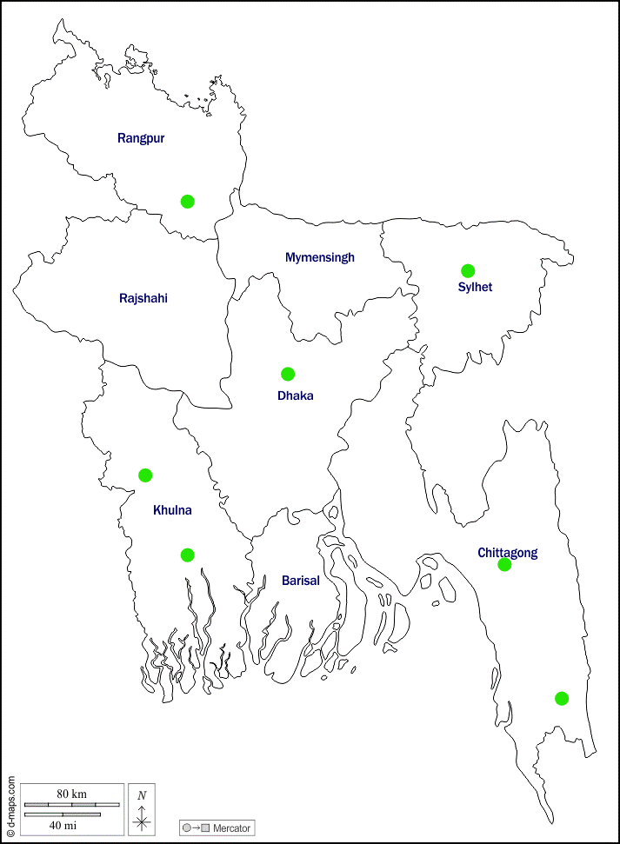
2.1 Study Area: Bangladesh Army (BA) is the major part of the HSC Niche-1 programme. 87% of the total learners enrolled in this programme belong to the Bangladesh Army. That is why the researcher selected maximum Study Centers (SCs) from BA. So most of the respondents belong BA. One SC selected from Bangladesh Navy (BN) and another one from Bangladesh Air Force (BAF). The researcher tried to cover the different regions of Bangladesh to ensure the reliability, accuracy and authenticity of the collected data. The selected SCs are as follows:
Bogura
Jashore
Khulna
Alikadom
Fig. 1: The Study Areas in the Map
Savar
- SCS Savar cantonment, Dhaka;
- SCS Majhira cantonment, Bogura;
- SCS Chattogram cantonment, Chattogram;
- SCS Sylhet cantonment, Sylhet;
- SCS Jashore cantonment, Jashore;
- SCS Alikadam cantonment, Bandorban;
- BNS Titumir, Khalishpur, Khulna; and
- BAF Shaheen College, Chattogram.

The selection of the aforementioned SCs was purposeful. Because a significant number of passing-out learners stayed at these SCs. Moreover, the relevant coordinators and officers were more supportive regarding data collection.
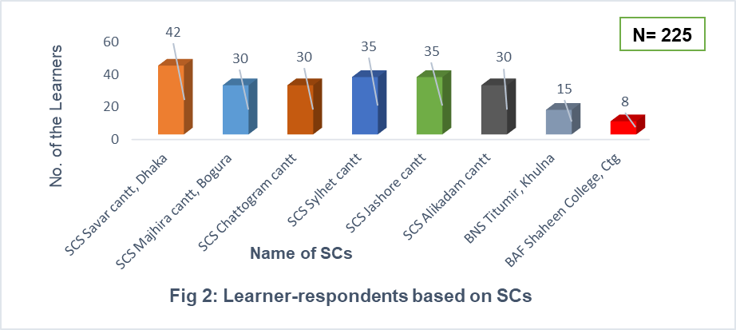

The top 42 (18.66%) responders (the learners of the HSC niche 1 programme) were selected from Station Central School (SCS) Savar, Dhaka Cantonment. Due to the availability of the learners, more respondents were selected from this study center. 35 (15.55%) respondents were chosen from each of the SCS Sylhet and Jashore. From the SCS Bogura, SCS Chattogram, and SCS Alikadam, Bandarban cantonments, 30 (13.33%) responders each were chosen. There were 15 (6.66%) participants from BNS Titumir, Khulna, and 08 (3.55%) from BAF Shaheen College, Chattogram study centers were selected. However, BNS Titumir is one of the bases of the Bangladesh Navy, and BAF Shaheen College is one of the SCs of the Bangladesh Air Force.
2.2 Data Analysis: The collected data was checked, sorted, and then analyzed using Excel sheets and the Statistical Package for the Social Sciences (SPSS) software. The sources of collected data are given below:
Table 1: Distribution of respondents based on the armed forces
Name of the Armed Forces | No. of the respondent | %
Bangladesh Army | 202 | 89.77
Bangladesh Navy | 15 | 6.67
Bangladesh Air Force (BAF) | 08 | 3.56
Total | 225 | 100
Source: Survey by the researcher of this paper in 2022

Out of 225 only 13 (5.78%) are female respondents. It is well known that very few female soldiers are enrolled in the armed forces. According to the programme software (ICT & E-learning Centre, BOU, July 2022), a total of 41,820 learners have been enrolled in the last 8 years. Only 728 (1.74%) are women among these learners. The highest 36,435 (87%) learners of the niche-1 programme came from the Bangladesh Army. Then the second highest number enrolled from the Bangladesh Navy. They have 4653 (11%) learners in niche- 1 programme. The BAF has 732 (2%) learners in the programme.

A total of 31,879 learners have passed out till 2022. Among the passing-out learners, 591 are female (1.85% of total passed-out learners). 98.78% of female learners who appeared in the examination passed successfully. A total of 6,156 passed-out learners belong to the science group (19.31% of total passed-out learners) and the passing rate in this group is 89.65%. The average passing-out rate is 91.19%. This rate is very close to the passing out rate of the conventional education board of Bangladesh. However, a total of 27,899 learners (91.70%) from the Bangladesh Army passed out during the mentioned time. The passed-out learners of the Bangladesh Navy are 3,364 (86.37%) and BAF is 616 (94.40%).
3. RESULT AND DISCUSSION
The prime objective of this study was to find out the socioeconomic profile of the HSC niche-1 learners of BOU. These learners are the soldiers of the armed forces of Bangladesh. To meet this objective, the researcher collected demographic data like the age of the learners, their family size and its structure, marital status; geographical location, education, occupation, income, social & economic status, etc. of the learner’s family. These factors may affect their attitude, personality, and learning capacity. The service in the armed forces is one of the major indicators of their socioeconomic condition. But here the author has explored the general socioeconomic background of the learners and their families.
Age of the HSC niche-1 learners: There is no age bar for the learners to get admission to BOU. But there is a restriction to being a recruit in the armed forces. So, a significant number of the learners are very close to their age. When learners of the HSC niche-1 programme have been recruited in the armed forces then they are 18 to 21 years old. They need a minimum of 2 years to achieve the certificate. So, a passing-out learner is at least 20 years old. The HSC niche-1 programme started in 2014. Table 2 shows the real picture of the learner’s age.

Table 2: Distribution of the respondents by their age
Age of the learners | No. of respondent | %
20 – 25 | 86 | 38
26 – 30 | 118 | 53
31 – 35 | 05 | 02
36 – 40 | 03 | 01
41-45 | 06 | 03
46 and above | 07 | 03
Total | 225 | 100
Arithmetic Mean (X̄) | 26.86 years
Source: Survey by the researcher of this paper in 2022

The average age of the respondents (learners of HSC niche 1) is 26.86 years, and 204 (91%) were under 30. According to Husain (2016), on average, BOU students are 27.53 years old. To perform better in their line of work, most people attempt to increase their eligibility and skill level early on. Students at BOU are also affected by this reality. A significant portion of students are under 30, even though they are primarily irregular, dropouts, and involved in various occupations. The Bangladesh Navy and BAF have some older students. Some of them are even on the verge of retiring! 13 learners (6%) are over 40 years old.
Family size & structure of niche-1 learners: According to BBS (2018), the average family size in Bangladesh is 4.2. The arithmetic mean (X̄) of the family size of this study is 4.67 (Table 3). The family size of the highest 123 (55%) respondents is 2 to 4 persons. The second highest number of 79 (35%) learners have 5 to 7 members in their family. So, in this study, 90% of the learner's family is not big. Only 10% (23) of learners have 8 or more family members. This information is very relevant to contemporary Bangladesh. As a result of public consciousness, large or joint families are reducing day by day, and small or nuclear families are growing up. WHO (2018) reported that in Bangladesh, 72.5% of couples use contraception, and 28.5% are not aware of family planning. The below table shows that 90% of learners' families are small in size. Because most of the learners came from the middle and lower middle class. They are more conscious than poor, illiterate, slum dwellers and other marginalized people.
Table 3: Distribution of learners/respondents based on their family size
Number of family members | No. of respondent | %
2 – 4 persons | 123 | 55
5 – 7 persons | 79 | 35
8 – 10 persons | 17 | 07
11 or above | 06 | 03
Total | 225 | 100
Arithmetic Mean (X̄) | 4.67
Source: Survey by the researcher of this paper in 2022
Based on size or structure, there are two types of families: a) the nuclear or single-unit family and b) the joint or undivided family (Rao, 2000). Because of urbanization, industrialization, and higher education, the flourishing of the service sector joint family is breaking gradually, and the nuclear family is formed (Rahman & Husain, 2014). Figure 1 shows that the maximum 198 (88%) respondents (HSC niche-1 learners) belong to single or nuclear families, and only 27 (12%) are joint families. Considering the family size and structure, it may be said that the learners and their families are comparatively advanced, modern, and progressive in their thoughts and attitudes.
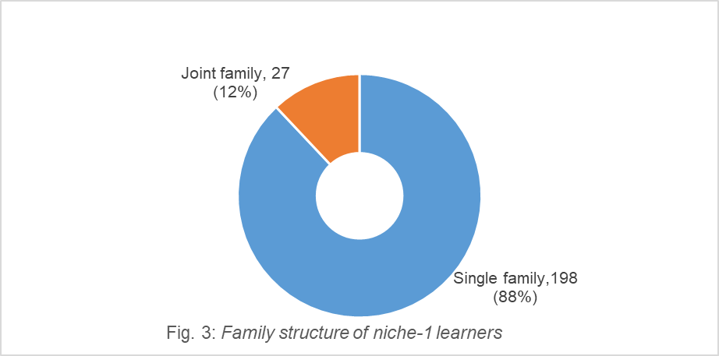
N= 225

Marital status of the learners: All learners of the niche-1 programme are service holders. However, many of them, especially in the Bangladesh army, are very young. 91% of learners are below 30 years old (Table 2). BBS (2018) reported that the average age of marriage in Bangladesh for males is 26.2 and for females is 18.8 years old. The Figure below shows the marital status of respondents.
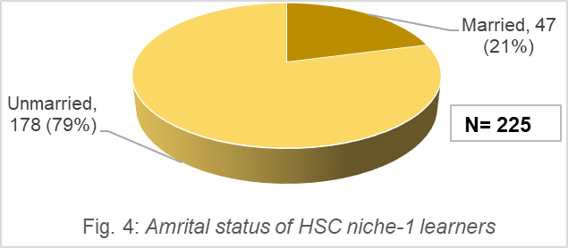

178 (79%) respondents who were actually members of the armed forces are unmarried (Figure 4). On the other hand, 47 (21%) respondents were married. Husain (2016) has shown that 57% of BOU learners are married. However, this study shows a different scenario. In the Bangladesh army, most of the learners are very young (see Table 2). There is an institutional restriction regarding marriage in the armed forces too. They have to complete the training period successfully and reach a certain level of age. Then they get permission for marriage from their authority. That is why a significant number of the learners of HSC niche-1 are unmarried.

Educational profile of the Niche 1 learners’ families: One of the most important socioeconomic markers of an individual is the family's educational background. Especially parent’s education is more important for the family and its all members. A parent's high level of education is a sign of their higher social standing. Conversely, a family is not as developed if one of the parents is illiterate or only minimally educated. To determine the respondents' socioeconomic standing, the mother's educational background is also more important.
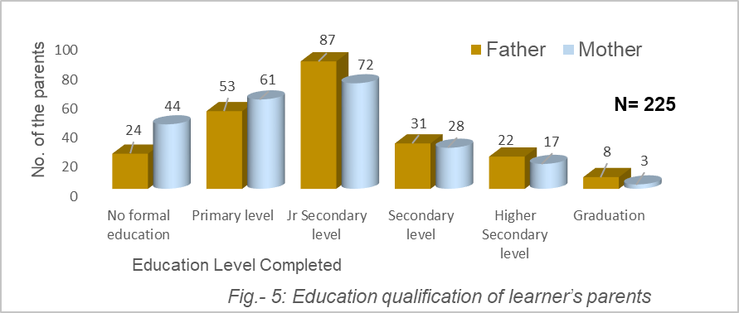

The educational qualification of the respondent’s father was more advanced than their mother’s (Figure 5). The highest 87 (39%) learners’ fathers completed junior secondary level of education, whereas 72 (32%) mothers completed the same educational level. 53 (23%) fathers completed primary education, and 24 (11%) had no formal education. However, mothers’ education at these two levels was 61 (27%) and 44 (19.55%). 31 (14%) learners’ fathers achieved SSC, and 22 (10%) achieved HSC. However, 28 (13%) mothers achieved SSC, and 17 (8%) achieved HSC. There are 8 (3%) graduate fathers; however, only 3 (1%) mothers are graduates.
The spouse’s educational qualification and occupation are very important indicators of social status for a person. Generally, it means a husband of a qualified wife is also qualified. So, if the wife is highly educated and has a better job, it's a matter of pride for her husband. Figure 4 shows that 47 (21%) learners of the niche-1 programme were married. The table below shows the educational qualification and occupational status of the learner’s wife.
Table 4: Distribution of respondents based on their wife’s education
Level of Education | No. of learners | %
Primary | 04 | 8.5
Junior Secondary | 05 | 10.5
Secondary | 13 | 28
Higher Secondary | 19 | 40
Graduation | 06 | 13
Total | 47 | 100
Source: Survey by the researcher of this paper in 2022

13 (28%) of the wives of niche-1 learners had completed secondary level, whereas the top 19 (40%) had completed higher secondary education. 09 (19%) of the learners' wives finished primary and junior secondary school, while 06 (13%) graduated. Women's empowerment has changed significantly when taking into account the statistics shown in Figures 5, and Table 4. Compared to the mothers of the respondents, the wives had higher levels of education. Figure 5 shows that 44 (19.55%) had no formal schooling. However, according to Table 4, there wasn't a wife in this educational status. 09 (19%) of the learner’s wives completed primary and junior secondary school, compared to 153 (68%) of the mothers. Therefore, a greater proportion of mothers are less educated than the wives of the respondents. Just 03 (1%) moms received graduation degrees, whereas 6 (13%) wives earned the same level of degrees. Therefore, the wives are more educated than moms.
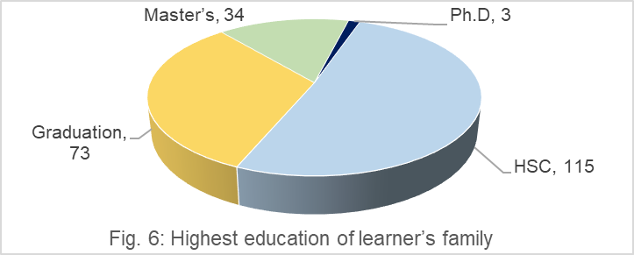
Family education is one of the key indicators of social standing. A family with a highly educated member or a professional in a prestigious position often gains respect and acceptance in society. Such families typically provide better opportunities for future generations, helping them progress. Conversely, families without highly educated or influential professionals may face various challenges and struggles.
N= 225

The highest 115 (51%) of the respondents said that the HSC was the greatest level of schooling in their family. For 73 (33%) of the learners' families, graduation was the highest degree. 34 students (15%) stated that at least one member of their family holds a master's degree, while 3 students (1%) had a PhD (Figure 7). Overall educational status of the learner’s family is shown the figure below.
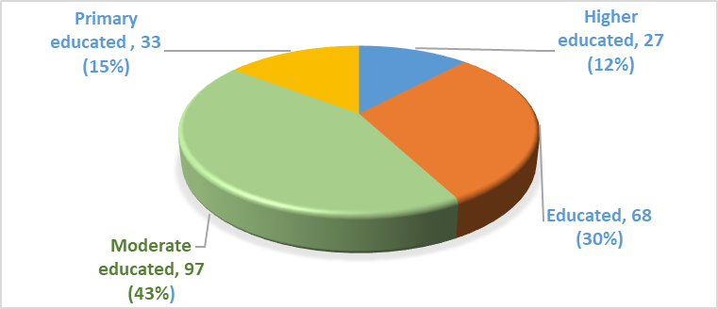
Fig. 7: Educational status of learner’s family
N= 225

In Bangladesh, 72.9% of people aged 15 and over are literate (MoF, 2019). However, no member of the armed forces of Bangladesh comes from an illiterate family (Figure 8). According to the largest percentage of respondents (97, or 43%), their family has a moderate level of education. Families of 68 (30%) of the respondents are educated. 27 (12%) respondents come from higher-educated families, while 33 (15%) of learners' families are primarily educated.
Occupation and Income: Occupation is one of the key indicators of social status. It is also closely relevant to education. Higher education is supportive of a sophisticated occupation. Figures 5, 6, and 7 illustrate the family’s educational picture. Here the occupations of the families are presented. There is an excellent synchronization between education and occupation of the HSC niche 1 learner’s family.
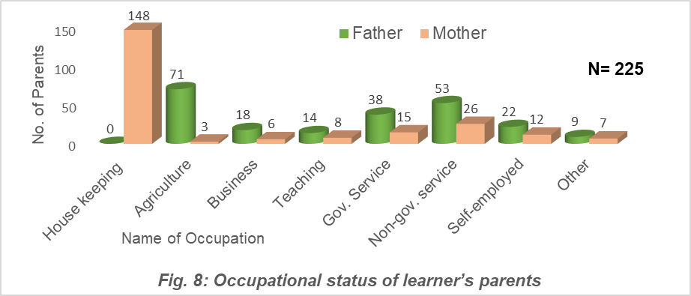

Mothers of the top 148 (66%) respondents were housewives (Figure 8). But there were no fathers doing housework. However, only 3 (1%) mothers worked in agriculture, compared to 71 (31%) fathers. In the context of Bangladesh, this is the social reality. Agriculture is not a career that women are interested in pursuing. However, a significant portion of the village's population is now abandoning agriculture as well. According to the Bangladesh Economic Review (MoF, 2022 & 2009), the largest percentage of workers (40.6%) in 2022 were employed in agriculture, up from 48.4% in 2009. Thus, the non-agricultural sector's workforce is steadily growing. 53 (24%) fathers and 26 (12%) mothers of HSC niche 1 learners work for non-government organizations. 38 (17%) fathers and 15 (7%) mothers work in the government sector. 22 (12%) learners’ fathers work as self-employed, and 18 (8%) work in the business sector. In contrast, this figure is 12 (5%) and 06 (2.66%), respectively, for mothers. Of the HSC niche-1 learners, 14 (6%) fathers and 8 (3%) mothers are teachers. However, 7 (3%) mothers and 9 (4%) fathers work in different occupations.

Women's occupation is an important measurement of a family’s status. In the context of Bangladesh, there are many families that do not permit their housewives to do any job due to religious fundamentalism or feudal mentality. On the other hand, due to a lack of educational qualifications or skills, many families didn’t get the opportunity to be appointed to service. So those families are advanced and progressive, whose female members are involved in income-generating occupations.
Table 5: Distribution of respondents based on their wife’s occupation
Occupation | No. of learners | %
Student/Housekeeping | 24 | 51
Business | 02 | 4
Government service | 10 | 21
Non-government service | 08 | 17
Self-employed | 03 | 7
Total | 47 | 100
Source: Survey by the researcher of this paper in 2022

24 (51%) of the learner’s wives worked as housekeepers or were students (Table 5). Then, 10 (21%) of the women were employed by the government, while 8 (17%) were employed by the non-government sector. 05 (11%) wives worked as self-employed or in the business sector. So, a total of 49% of learners’ wives were service holders or engaged in income-generating activities, whereas this number for mothers was 34%. So, there is one kind of social mobility between two generations within a family. This is also a symbol of women's advancement in Bangladesh in the last two decades.

Monthly income is one of the significant indicators to realize the socioeconomic condition of a family. Mostly, income or economic situation defines the ‘status’ or ‘class’ of a person and his family. The upper, middle, or lower class is ascertained by wealth and income.
Table 6: Distribution of respondents based on their monthly family income
Monthly family income | No. of respondent | %
11000 – 20,000 | 36 | 16
21,000 – 30,000 | 55 | 25
31,000 – 40,000 | 73 | 32
41,000 – 50,000 | 29 | 13
51,000 – 60,000 | 18 | 8
61,000 and above | 14 | 6
Total | 225 | 100
Arithmetic Mean (X̄) = BDT 34,611/-
Source: Survey by the researcher of this paper in 2022

Family income means all types of income by one or more members along with other sources like cropland, business, house rent, etc. The average (X̄) monthly family income of HSC niche-1 learners was BDT 34,611. According to the BBS report (2022, 2016, and 2010), the average monthly household income in Bangladesh was BDT 32,422, which was BDT 15,988 in December 2016 and Tk. 11,479 in December 2010. The highest 73 (32%) learners’ monthly family income was BDT 31–40 thousand. The second highest 55 (25%) learner’s family earned BDT 21–30 thousand per month. 29 (13%) learner’s families earned BDT 41–50 thousand, and 32 (14%) families earnd BDT 50 thousand or more in a month. 36 (16%) learners’ monthly family income was BDT 11–20 thousand. The last one was mostly the single-earner family, and they have no other source. These families are comparatively poor. MoF (2020) said that in Bangladesh, 10.5% of people are extremely poor and 20.5% are poor.
Husain (2019) has shown in his research that the average monthly income of a BOU learner’s family is Tk. 24,643. However, the average monthly income of HSC niche-1 learners is about 10 thousand more. This is the symbol of the economic growth of Bangladesh. On the other hand, these learners’ families are the comparatively advanced groups in society.
Table 7: Distribution of learners based on their family’s main source of income
Main source of family income | No. of Respondent | %
Agriculture | 54 | 24
Business | 16 | 7
Government service | 81 | 36
Non-government Service | 44 | 20
Self-employed | 18 | 8
Others | 12 | 5
Total | 225 | 100
Source: Survey by the researcher of this paper in 2022

The majority of HSC niche 1 learners (81, or 36%) said that the governmental job (grades 8–16) is the main source of income for their family (Table 7). In certain families, the learner was the family's main earner and the best service holder. The primary source of income was agriculture for the families of the second-highest 54 (24%) learners. As a government service holder, the learner supported his/her family. However, this was not the main income. 44 (20%) of the respondents stated that their family's best job is in the non-governmental sector. There was one or more earning members in the learner’s family, and they earned more than the learner. For 16 (7%) families, business was the primary source of income. 30 (13%) of the students said that the best job in their family is working self-employed or in another field.
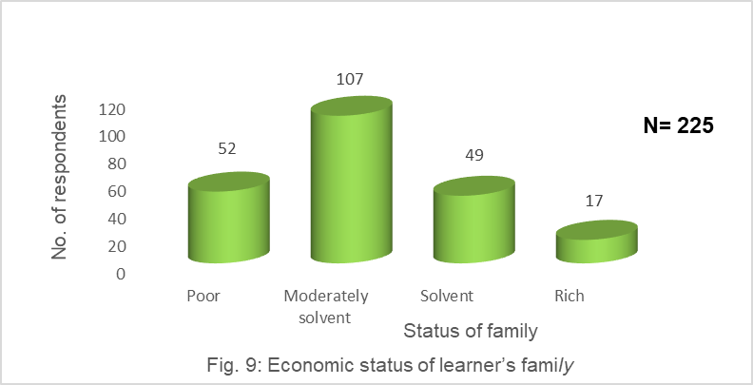
In recent years, Bangladesh has achieved momentous progress in economic development. Per capita income was 690 USD in 2009; however, it was 2,064 USD in 2020 (MoF, 2010 & 2019). The total size of the national budget was BDT 113,819 crore in 2009-10, whereas, in 2021-22, it was BDT 603,681 crore (MoF, 2009 & 202). There is a significant impact of the economic progress at the household level also.

The highest 107 (48%) HSC niche-1 learners came from moderately solvent families (Figure 9). That means 48% of learners’ families were neither poor nor solvent. They were self-sufficient based on their income. They were neither able to save money nor borrow frequently. The second highest 52 (23%) learners’ families were poor. These families couldn’t earn as per their basic needs. In most cases, these families were big (in terms of members) but depended on the single earner. Sometimes they have to borrow money from their relatives, neighbors, interest merchant moneylenders, NGOs, or banks. Bangladesh Economic Review (2022) shows that an average of 20.5% of people are poor. 24% of the BOU learners belong to poor families, and 12% are very poor (Husain, 2016).
However, 49 (22%) learners belong to the solvent family. The economic condition of these families is better than that of moderately solvent families. They earn more and save some money after maintaining their regular needs. 17 (7%) learners came from rich families. Besides the monthly income, they also have ample property. So, the overall economic condition of the niche-1 learner’s family is not so bad.
Social Class of the Niche-1 learner’s family: The middle class in Bangladesh is rising day by day. Almost 50% of people in Bangladesh belong to middle-class families. 10% is upper class, and 40% is lower class (Rahman & Husain, 2014).
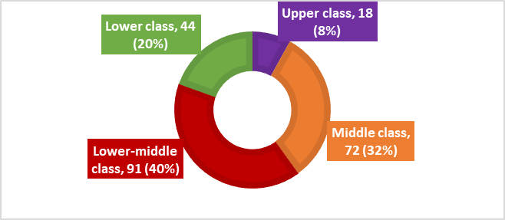
Fig. 10: Social class of learner’s family

N = 225

91 (40%) learners belong to lower-middle-class families (Figure 10). The second highest, 72 (32%) families of HSC niche-1 learners were the representatives of the middle class. 44 (20%) learners came from the lower class of society. Only 18 (8%) learners said their family belongs to the upper class in society. However, the lower class, lower-middle class, middle, and upper classes have been defined based on socioeconomic situation, educational level, social status, and power. Lower class means poor, minimum-educated families who have neither power nor status in society. The lower-middle class is more advanced than the lower class but more backward than the middle class. These families are moderately solvent, moderately educated, and have a little bit of power and honour in society. The middle class is a very common and popular portion of society. These people are educated or highly educated, solvent, and influential. Most middle-class people belong to white-collar or intellectual professions. Finally, upper-class people are the top-level people in society. They are rich, educated, powerful, and influential.

During data collection, many learners said that this programme upholds their social status. They are honored in their family, society, and offices for their education. They are treated as skilled, eligible, and knowledgeable human resources. Their job has been confirmed in the armed forces. The families of the learners are also moving forward in society. A poor family shifted into the moderately solvent category. Many learners’ families are treated now as lower-middle class instead of lower class. Some families in the rural areas have jumped from lower-middle class to middle class due to the service and education in the armed forces. Education is power; education is light! So, those who achieve education s/he is more powerful, enlightened, and resourceful. So, in light of education, poverty must be eliminated from society. That is why education in the armed forces not only benefits a person but also uplifts the institutions as well as the country.
Residential area of niche-1 learner’s family: People's socialization, psychology, attitudes, tastes, values, personality, etc., can be greatly influenced by their living spaces. People from rural and urban areas differ visually as well. Therefore, a person's living neighborhood is a crucial predictor of their socioeconomic profile.
Fig. 11: Living area of learner’s family
N= 225

Bangladesh is a village-driven country. Since the better flow of urbanization, still now more people of Bangladesh live in villages. The highest 157 (70%) of HSC niche-1 learners’ families live in rural areas (Figure 11). The remaining 68 (30%) learners' families live in urban and semi-urban areas. According to the World Bank’s report, 62 percent of people in Bangladesh live in rural areas (WB, 2021). Comparing this data, it may seem that rural youth are more eager to join the armed forces than urban youth. On the other hand, urban areas have more opportunities for higher education, entrepreneurship, civil services, business, etc., than rural areas. The rural youths have a limited scope of government service. So many of them have a dream to join the armed forces. Figure 12 illustrates this reality.
Everyone has a dream in life. Every young person sets goals for their career. In most cases, this goal is affected by the person’s socioeconomic condition. To achieve this goal, youngsters try to prepare themselves to do so as best they can. So, aim in life, preparation for a career, career plan, joining a job, etc. are closely connected to socioeconomic circumstances. However, many people can’t achieve their goals; they can’t make their dreams come true! On the other hand, some people can reach their goals and achieve their aim in life.

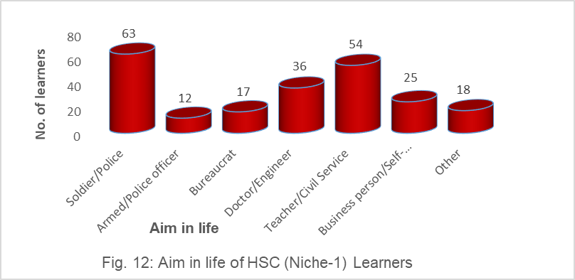
N= 225

The highest 63 (28%) learners had a dream to be a soldier (Soinik) or police. They have achieved their aim in life! The remaining 162 (72%) learners had different aims but couldn’t achieve their dream. 54 (24%) learners wanted to be teachers or civil service holders. 36 (16%) learners had an aim to be a doctor or an engineer. 25 (11%) learners had a dream to be a businessperson or self-employed (independent occupation). 17 (8%) learners had an aim to be a bureaucrat, and 12 (5%) learners wanted to be an officer of the armed forces or the police department. The remaining 18 (8%) learners had other dreams in their lives. Figure 7 represents the aim in life of the middle-class, lower-middle, and lower-class families of the society.
A maximum of 63 (28%) learners have an aim to be soldiers (Soinik) or police (Figure 12). The rest of the respondents have different dreams regarding their professional lives. All of the respondents have been questioned about why they chose the challenging occupation of the armed forces. What is the reason for joining as a soldier? Table 8 shows the answer to this question.
Table 8: Reason of choice for the challenging soldier life
Reason | No. of Respondent | %
Job and financial security | 81 | 36
Soldier by choice | 63 | 28
Poverty | 23 | 10.22
Family need | 41 | 18.22
Others | 17 | 7.56
Total | 225 | 100
Source: Survey by the researcher of this paper in 2022

The highest 81 (36%) students stated that they enlisted in the military in order to secure employment and financial stability. The second-highest percentage of students, 63 (28%), chosen to be soldiers on their own. They choose to be "soldiers." Then, 41 (18.22%) students stated that they had taken this employment in order to support their families. They have no other choice but to work here in order to provide for their own family. 23 (10.22%) students have chosen this line of work because they are poor. No other job was easy for them, and they couldn't manage their studies. Therefore, being a soldier is a huge accomplishment for them and their family. 17 students (8.56%) joined as soldiers or Soiniks for other reasons.
Currently, 23.4% of people lack literacy, while 10.5% of people live in extreme poverty (MoF, 2023). The lowest level of society is occupied by this group of people. However, the majority of HSC niche-1 students are middle- or lower-middle-class. Therefore, compared to the lowest-level families in society, these families are significantly superior.
Bangladesh Open University (BOU) is one of the mega universities in the world (Kamal & Sultana, 2011). Its main goal is to reach out to unreached people to enhance their skills and make them eligible for the job market. A total of 965,838 learners are studying here (BOU, 2022). According to the Student Support Services (SSS) division of BOU, 64 programmes are running in the country and abroad at present (June 2022). HSC niche 1 is one of the excellent academic programmes of BOU and the Bangladesh armed forces. The entry-level soldiers are glorifying their careers through this program. This study has illustrated the socioeconomic profile of the armed forces learners of BOU.
4. CONCLUSION
The motto of Open and Distance Learning (ODL) is delivering education to the doorstep of the people. The main theme of ODL is to reach out to the unreached. HSC niche-1 is a unique initiative of the ODL system that provides education for members of the armed forces who have achieved a Secondary School Certificate (SSC) before joining. There is an excellent homogeneity among the learners of the niche-1 programme. This homogeneity is not only in service but also in their socioeconomic background. The majority of the learners of the armed forces came from rural areas and belonged to middle- or lower-middle-class families. Very few learners’ families are extremely poor or rich. Most of the niche-1 learner families are moderately solvent, and they have a mid-level education. The education and occupation of the learner’s parent or wife are also relevant to their status. Even their dream or aim in life is very close to their socioeconomic circumstances. No doubt, the Bangladesh armed forces is a unique and specialized community in Bangladesh. There are so many issues related to its members except their socioeconomic background. Family life, lifestyle, challenges and opportunities of women soldiers, sender sensitivity, dreams about their offspring, personal skills, plans after retirement, etc. may be better research areas for the future.

Disclaimer (Artificial intelligence)
I, Iqbal Husain, the author of this paper, hereby declare that NO generative AI technologies, such as Large Language Models (ChatGPT, COPILOT, etc.) and text-to-image generators, have been used during the writing or editing of this manuscript. However, I have used only the QUILLBOT grammar checker and paraphraser to check grammatical errors. In some cases, I have paraphrased my own write-up using this software (free version).

REFERENCE
Akhter, S. H. & Rahman, M. M. (2022), Evaluating Offshore Open School Learners of Bangladesh Open University: Challenges and Problems, International Journal of Open Schooling, NIOS, India, Vol. 1, No.1, P. 79-88

BBS. (2016). Bangladesh Household Income and Expenditure Survey (HIES) 2016. Bangladesh Bureau of Statistics, GoB.
BBS. (2018). Demographic report of Bangladesh 2017. Bangladesh Bureau of Statistics, GoB.
BBS. (2022). Bangladesh Household Income and Expenditure Survey (HIES) 2022. Bangladesh Bureau of Statistics, GoB.
Bordoloi, R. (2018). Transforming and empowering higher education through Open and Distance Learning in India. Asian Association of Open Universities Journal, Vol. 13 No. 1, pp. 24-36. https://doi.org/10.1108/AAOUJ-11-2017-0037
BOU. (2022). Bangladesh Open University 2022. Retrieved from https://www.bou.ac.bd (30 June 2022)
BOU. (2023). Bangladesh Open University 2023. ICT & E-learning center.
Husain, I. (2014). Admission Process of SSC program in Distance Education in Bangladesh: An Analysis. COMOSA Journal of Open Schooling, Vol. 5, No. 2, 153-167.
Husain, I. (2016). Socio-economic condition of Bangladesh Open University’s learners: An Analysis. Bangladesh Open University Journal of Open School, Vol. 5, No. 1, 15-24
Husain, I. (2019). Use and Effectiveness of ICT in Quality Education in Bangladesh: Bangladesh Open University Perspective. Central Journal of Bangladesh Open University, Vol. V, No.1, 27-39
Husain, I. Rahman, M.S. & Islam, M.N. (2016). SSC Programme of Bangladesh Open University: Upcoming Challenges and Way out of Remedies. Bangladesh Open University Journal, Vol. 3, No. 1, 163-174
Islam, M.A. & Numan, S.M. (2011). Comparative Study of Open School Learners’ and their Demographic Profile: A Case of Bangladesh Open University. Journal of Open School (BOU), Vol. 4, (1 & 2), 11-20.
Kamal, M. A. & Sultana, S. A. (2011). Emergence of Mega University in a Developing country like Bangladesh: Opportunities and Challenges. Journal of Open School (BOU), Vol. 4, (1 & 2), 35-45.
MoF (2009). Bangladesh Economic Review 2009. Ministry of Finance, Government of Bangladesh.
MoF (2010). National budget of Bangladesh 2009-10 & 2018-19. Ministry of Finance, GoB.
MoF (2019). Bangladesh Economic Review 2019. Ministry of Finance, Government of Bangladesh.
MoF (2020). Bangladesh Economic Review 2020. Ministry of Finance. Government of Bangladesh.
MoF (2023). Bangladesh Economic Review 2023. Ministry of Finance. Government of Bangladesh.
MoF (2020). National budget of Bangladesh 2021-2022. Ministry of Finance, GoB.
Ouma, R. (2019). Transforming university learner support in open and distance education: Staff and students perceived challenges and prospects. Cogent Education, Vol. 6, Issue-1.
https://doi.org/10.1080/2331186X.2019.1658934
Rahman, AHM. M. & Husain, I. (2014, 2nd ed). Introducing Sociology. Lekhapora, Dhaka.
Rao, C. N. S. (2000). Sociology, New Delhi, S. Chand & Co. Ltd.
Shrivastava, C. (2014) Professionalizing Teachers through Distance Learning: A Case of D.EI.Ed (ODL) Programme in Bihar (India), COMOSA Journal of Open Schooling, Vol. 5, No. 2, July-December 2014, P-141-152
WB (2021). The World Bank 2021.
https://data.worldbank.org/indicator/SP.RUR.TOTL.ZS?locations=BD.
WHO (2018). ). World Health Organization 2018. World Health Statistics 2018,
Users/USER/Downloads/9789241565585-eng.pdf.

. Moderate educated family means maximum members of the family completed at least SSC.
. Educated family means maximum members of the family have graduation.
. Higher educated family means all are educated, some of them achieved Masters even PhD Degree.
. Primarily educated family means most of the members of the family are below SSC.

