**RESPONSE OF ROOTING HORMONE ON ROOTING AND MEDIA SHOOTING CAPACITY OF CHRYSANTHEMUM CUTTINGS AT TEHRATHUM, NEPAL**

**ABSTRACT**

Chrysanthemum is an herbaceous perennial flowering plant that belongs to the Asteraceae family, extensively grown all over the world. Hence, an experiment was carried out to assess the response of rooting hormone on the rooting and shooting capacity of chrysanthemum cuttings under different growing media at Tehrathum, Nepal during the year 2024. Further, the experiment was carried out in a Completely Randomized Design, with two factorial designs: rooting hormone and rooting media. As a consequence, a significance difference was observed in the rooting and shooting capacity of chrysanthemum cuttings in which rooting hormone, IBA with the concentration of 400ppm showed the best result, now that it was observed with the maximum number of roots in 29DAP (11.51), maximum length of roots (2.73cm) in 29DAP, higher leaf number (1.81) in 15 DAP, maximum leaf length (2.35cm) in 29 DAP. In like manner media composition of Soil, Sand, and Cocopeat in the ratio of 1:1:1 was observed with maximum root length (2.23cm) at 29DAP. Therefore, this study concludes that IBA as rooting hormone and the composition of Soil, Sand, and Cocopeat as media proved to be the best combination for the success of terminal Chrysanthemum cutting.

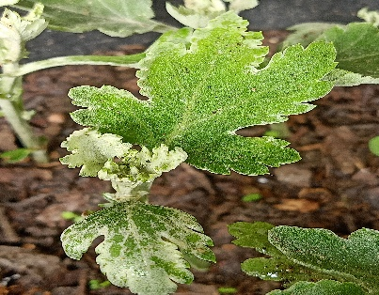**GRAPHICAL ABSTRACT**

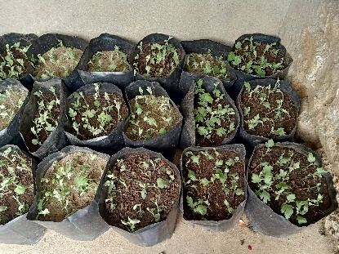 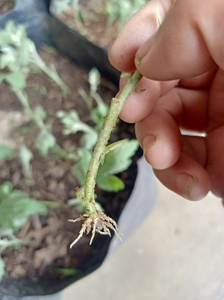

1st day of plantation Shoot initiation Root initiation

**Keywords:** *Chrysanthemum, Hormone, Media, Rooting, Shooting*

**1. INTRODUCTION**

## 1.1 Research background

Chrysanthemum (*Chrysanthemum morifolium*) is an herbaceous perennial flowering plant belonging to the Asteraceae family extensively grown all over the world for its beautiful, charming flowers with an excellent vase life. Chrysanthemum is derived from two Greek words chrysos-golden and anthemon-flower (Bhatt et al.,2017). It is also known as the divas or ‘queen’ of autumn gardens and is valued both as a landscape plant as well as a potted plant (El-Banna et al., 2023). It requires long days for vegetative growth and short days for flowering so it is a photosensitive crop (Kalyani & Prasad, 2022). In many countries, it is cultivated as a cut flower crop for commercial purposes (Haq et al., 2023). After rose and carnation, it is the third commercially important cut flower and the fifth as pot plant (Bhatt et al., 2017). It is a cosmopolitan flower with a wide range of types, sizes, and colors. Hazardous use of different chemical fertitlizers leads to loss of quality of plants and soil health (Gautam et al.,2025).

Plant propagation is a vital part in both the horticultural and agricultural industries. Even with the introduction of several propagation techniques (sexually and asexually), vegetative propagation by ‘cuttings’ is the majority preferred method for many plant species due to its luxuriant growth, accessibility, and inexpensive asexual techniques. It restores the quality of the mother plant leading to more uniform plants. For this reason, vegetative propagation is commonly used to produce the best and true to type plants in chrysanthemums (El-Banna et al., 2023).

An increase in the demand of ornamental flowers shows the need for a suitable growing medium to grow on to meet the desired quantity (Tanya & Grewal, 2019). Bhatt et al. (2017) stated that a best growing medium should have proper aeration, optimum water holding capacity and adequate amount of nutrition supply. Consequently, presence of sufficient nutrition, good water holding capacity and porosity a of media increases the root and shoot growth which ultimately, leads to good harvest increasing the yield of the crop. Nepal has huge gap between supply and demand of plant and its product (Shrestha et al., 2025).

Different rooting hormones are available naturally and artificially, among all the rooting hormones present auxins are commonly used for promoting rooting of the cuttings. The commonly used auxins are Indole Butyric Acid (IBA), Naphthalene Acetic Acid (NAA) and Indole Acetic Acid (IAA). The use of auxin aims to hasten root initiation, increase the rooting percentage, and increases in the formation of number of roots (Patil et al., 2022). IBA and NAA used to induce rooting that has been practiced since earlier time to ensure success of rooting in cutting and better establishment of plants (Kaushik et al., 2020).

**1.2 Research problem**

* Chrysanthemum propagated through root suckers produce tall plants making unsuitable for ornamental purpose.
* Terminal cuttings without the use of any root inducing hormone have low rate of propagation.
* Terminal cuttings do not propagate without a proper growing medium.

**1.3 Significance of research**

* This study helps in the assessment of the appropriate rooting hormone with concentration to avoid the failure of terminal cuttings propagation.
* This study helps in assessment of the appropriate rooting media to grow the terminal cuttings to enhance rooting and shooting percentage.

## 2. MATERIALS AND METHOD

### **2.1 Research Site**

The experiment was carried out in the Tehrathum district Myanglung-3 municipality in the whose administrative figure is shown in (figure1) eastern hills of Nepal year 2024. This place is with Sub-tropical climate where average temperature is 28 °C where annual rainfall in this area is reported as 250-300 cm. The location is at 27°7ˈ36ˈˈ N ,87°32ˈ12ˈˈ E with an elevation of 1843 meters above sea level.

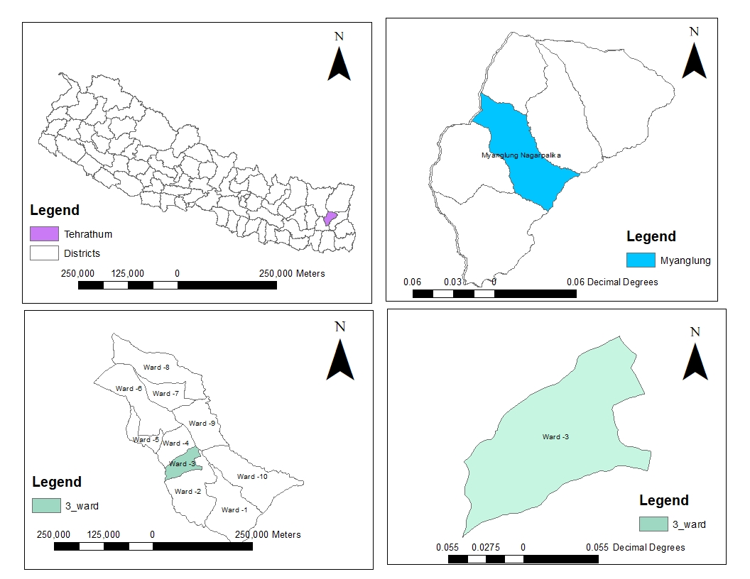 Figure 1: Administrative map of Tehrathum, Myanglung municipality*.*

### **2.2 Experimental details**

The experimental setup of this study was two factorial Completely Randomized Designs (CRD) with two factors i.e. rooting media (M) and rooting hormone (T) in which media and hormone interaction were carried out as shown in (Table 1) and the terminal cuttings of 8 cm were planted in a polybag with altogether 20 cuttings in a polybag and the arrangement of polybags was done as shown in (figure 2).

Treatment details

* M1: Soil
* M2: Sand
* M3: Soil+ Sand+ Cocopeat
* T1: IBA
* T2: NAA
* T3: Control

|  |  |  |  |  |  |  |  |  |
| --- | --- | --- | --- | --- | --- | --- | --- | --- |
| M2T1 | M3T1 | M2T3 | M3T2 | M2T1 | M2T2 | M1T3 | M2T3 | M1T2 |
| M3T1 | M3T3 | M1T2 | M2T2 | M3T2 | M1T1 | M2T3 | M3T2 | M1T3 |
| M2T1 | M1T1 | M3T1 | M3T3 | M1T2 | M2T2 | M1T3 | M3T3 | M1T1 |

Figure 2: Arrangement of polybags in CRD design.

Table 1 : experimental details

|  |  |  |  |
| --- | --- | --- | --- |
| Media/Hormone | IBA (T1) | NAA (T2) | Control(T3) |
| Soil (M1) | M1T1 | M1T2 | M1T3 |
| Sand (M2) | M2T1 | M2T2 | M2T3 |
| Sand+ Soil+ Cocopeat (M3) | M3T1 | M3T2 | M3T3 |

## 2.3 Observation variables

* **Number of roots:** Destructive sampling method was followed for counting the number of roots first after 15 days of plantation likewise second and third after seven days of first and second day of data collection, that is 22 and 29 days after plantation as stated by (Owusu& Kuavedzi, 2020). Lastly, the average of the three samples taken at once was calculated and recorded on Excel.
* **Root length:** Once the sample was selected it was uprooted and then root length was measured using a scale of 15cm first in the day 15 days after plantation (DAP), second and third at 7 days intervals of first and second data collection and average was calculated from 3 samples and recorded in excel.
* **Number of new leaves:** Newly formed leaves were identified coming from the tip part and recorded after 15,22,29 days after plantation and the average of the 3 sample was done and recorded in excel.
* **Leaf length:** Leaf length was also measured by using a scale of 15cm long and the average was calculated of the taken 3 samples after 15,22,29 days after plantation and recorded it in excel.
* **Hormonal preparation:** Indole butyric Acid of 400ppm and NAA of 200ppm was prepared by making the solution of IBA 40mg in 100ml distilled water and for 200ppm 20mg of NAA powder in 100ml distilled water.

**2.4 Data Analysis:**

All the Statistical data were analyzed by using Microsoft Excel and R-Stat (Version 4.4.1)

# 3. RESULT AND DISCUSSION

## 3.1 Number of roots:

The analysis of variance of data illustrated that there was no significant difference on number of roots on the media composition (Table 2). This result was supported by Albana et al. (2015) who stated that there was no significant difference on the media investigated on root numbers of *Bougainvillea spectabilis.*

The analysis of variance of data illustrated that there was significant difference on number of roots on the rooting hormone used (Table2). In the same way, after 29 DAP there was significant difference on the root number where IBA treated cuttings was observed with maximum number of roots as (11.51) and the lowest root number was found on control with the root number (5.74) on 29 DAP. Furthermore, the maximum number of roots per cutting under optimum concentration of IBA may lead to the increase in rate of respiration which accumulates higher level of amino acids at their bases in the auxin treated cuttings than untreated cuttings. Similarly, nitrogenous substances which are accumulated in the basal part of treated cuttings apparently are mobilized in the upper part and translocated as asparagine as reported by Bauri et al. (2017) which might be the cause of maximum number of roots under IBA treated cuttings. Similar result was observed by Kaur (2014) in rooting and growth performance of Peach, and stated that, IBA increases cell wall plasticity and cell division which stimulates callus development and root growth.

Table 2: Response of rooting media and hormone on number of roots.

|  |  |  |  |
| --- | --- | --- | --- |
| Media | Number of roots | | |
| **15DAP** | **22DAP** | **29DAP** |
| 1. Soil | 1.81±0.14 (5.66) | 9.11±0.12 | 9.62±2.30 |
| 2. Sand | 1.47±0.14 (3.59) | 7.55±0.25 | 9.52±1.35 |
| 3. Soil + Sand + Cocopeat | 1.83±0.18 (2.77) | 7.77±0.14 | 6.22±1.45 |
| LSD | 0.60 ns | 4.02 ns | 5.36 ns |
| Hormone |  |  |  |
| 1.IBA | 1.83±0.17 | 8.29±0.21 | 11.51±1.36a |
| 2.NAA | 1.59±0.17 | 8.00±0.19 | 08.11±1.69ab |
| 3.Control | 1.69±0.15 | 8.14±0.19 | 05.74±1.53b |
| LSD | 0.60 ns | 4.02 ns | 5.36 * |
| Mean | 1.70 | 8.14 | 8.45 |
| CV (%) | 27 | 18 | 58 |

*Statistically significant at p<0.05, CV: Coefficient of Variance, DAP: Days After Plantation, LSD: Least Significance Difference, ns: non-significant.

## 3.2 Length of roots:

The analysis of the variance of data illustrated that there was a significant difference in the length of roots on media composition (Table 3). The mixture of Soil + Sand + Cocopeat in the ratio of 1:1:1 was observed with the highest average length of roots (2.23cm) at 29DAP considering that the cocopeat and soil take the responsibility for the moisture availability and nutrition supply to the plant in other hand aeration provided by sand might have resulted in maximum plant spread (Bharati & Nair., 2015). Similarly, cocopeat can hold large quantities of water just like a sponge for this reason the moisture in smaller pores serves not only for metabolic activities but all also provides sufficient humidity to avoid excessive transpiration and destructive temperature fluctuation that may happen in the rhizosphere (Muraleedharan et al., 2020).

The analysis of variance of data illustrated that there was significant difference on length of roots on hormonal treatment in which IBA treated cutting was observed with maximum length of roots on 29DAP (2.73cm) (Table 3) which was supported by Kaur (2014) who observed on the rooting and growth performance of hardwood cuttings of Peach who stated that IBA promotes the cell elongation which helps in increase in root length ; because, certain level of endogenous auxin is already present in the cuttings, thus, treated cuttings with IBA could optimize the auxin level in the cutting and consequently improves the rooting percentage. In like manner Bauri et al. (2017) also supported this result, stated that the action of auxin activity which might cause hydrolysis and translocation of carbohydrates and nitrogenous substances in the cellular level at the base of cuttings which results in acceleration of cell elongation and division under favourable environmental condition.

Table 3: Response of rooting media and hormone on length of roots

|  |  |  |  |
| --- | --- | --- | --- |
| Media | Length of roots (Cm) | | |
| **15DAP** | **22DAP** | **29DAP** |
| 1.Soil | 0.61±0.04 | 1.32±0.15 | 2.05±0.54ab |
| 2.Sand | 0.51±0.04 | 0.97±0.11 | 1.13±0.30b |
| 3.Soil+ Sand + Cocopeat | 0.62±0.03 | 1.24±0.10 | 2.23±0.33a |
| LSD | 0.13 ns | 0.42 ns | 1.13 * |
| Hormone |  |  |  |
| 1.IBA | 0.66±0.03a | 1.39±0.16 | 2.73±0.38a |
| 2.NAA | 0.54±0.03ab | 1.05±0.10 | 1.53±0.33b |
| 3.Control | 0.53±0.04b | 1.81±0.09 | 1.26±0.37b |
| Mean | 0.57 | 1.17 | 1.84 |
| LSD | 0.13* | 0.42 ns | 1.13 ** |
| CV (%) | 20 | 28 | 31 |

**Statistically significant at p<0.01, *Statistically significant at p<0.05, CV: Coefficient of Variance, LSD: Least Significance Difference, ns: non-significant.

## 3.3Number of new leaves

The analysis of variance of data illustrated that there was no any significant difference on a number of new leaves on media composition (Table 4) which was supported by Albana et al. (2015) given that they stated that the number of branches and leaves per cutting did not differ significantly in all the media investigated. Moreover, Alikhani et al. (2011) also reported that there was no any significant difference of media on a number of leaves.

The analysis of variance of data illustrated that there was a significant difference on number of new leaves on the hormonal treatment (Table 4) in which the IBA-treated cutting was observed with a higher number of new leaves of (1.81) at 15 DAP; since this may be due to the fact that IBA produced healthy lengthy roots which helps in absorption of more nutrients and water contents that resulted in higher number of leaves produced by the plant. By the same token, these results are in conformity with the findings of (Kaur, 2014). On the other hand, NAA provided an inferior number of new leaves at 15 DAP which was supported by Abbas et al. (2013) who stated that maximum branches per plant were recorded in 400ppm NAA concentration followed by 300ppm while the minimum was observed at 200ppm. This concludes that increase in leaves per plant was observed with increase in NAA concentration.

Table 4: Response of rooting media and hormone on number of new leaves

|  |  |  |  |
| --- | --- | --- | --- |
| Media | New leaves | | |
| **15DAP** | **22DAP** | **29DAP** |
| 1.Soil | 1.22±0.38 | 1.25±0.12 | 1.48±0.81 |
| 2.Sand | 1.14±0.21 | 1.40±0.15 | 1.56±0.90 |
| 3.Soil +Sand + Cocopeat | 1.62±0.15 | 1.37±0.12 | 1.62±0.98 |
| LSD | 0.81 ns | 0.40 ns | 0.59 ns |
| Hormone |  |  |  |
| 1.IBA | 1.81±0.27a | 1.44±0.08 | 1.51±0.04 |
| 2.NAA | 1.00±0.15b | 1.37±0.15 | 1.55±0.12 |
| 3.Control | 1.18±0.24ab | 1.22±0.15 | 1.59±0.12 |
| LSD | 0.81* | 0.40 ns | 0.59 ns |
| Mean | 1.33 | 1.34 | 1.55 |
| CV (%) | 17 | 22 | 31 |

**\***Statistically significant at p<0.05, CV: Coefficient of Variance, DAP: Days After Plantation, LSD: Least Significance Difference, ns: non-significant.

## 3.4 New leaf length

## The analysis of variance of data illustrated that there was not any significant difference on new leaf length by the media composition (Table5).

The analysis of variance of data illustrated that there was significant difference on new leaf length on hormonal treatment (Table 5): IBA treated cutting was observed with maximum number of new leaf length with length of (2.35cm) at 29DAP. Besides this result was supported by Gama et al. (2019) where they stated that same concentration of IBA resulted maximum number of new leaves basically a greater number of new leaves means more surface area for photosynthesis leading to produce more assimilates which increases metabolic processes which is responsible for shoot proliferation.

Table 5: Response of rooting media and hormone on new leaf length

|  |  |  |  |
| --- | --- | --- | --- |
| Media | New leaf length (Cm) | | |
| **15DAP** | **22DAP** | **29DAP** |
| 1.Soil | 0.78±0.05 | 1.39±0.15 | 1.53±0.12 |
| 2.Sand | 0.94±0.09 | 1.59±0.09 | 1.56±0.26 |
| 3.Soil + Sand+ Cocopeat | 0.99±0.07 | 1.53±0.06 | 2.10±0.16 |
| LSD | 0.41ns | 0.76ns | 0.89ns |
| Hormone |  |  |  |
| 1.IBA | 0.99±0.10 | 1.52±0.09 | 2.35±0.28a |
| 2.NAA | 0.91±0.05 | 1.63±0.04 | 1.41±0.14b |
| 3.Control | 0.80±0.06 | 1.37±0.11 | 1.44±0.14b |
| LSD | 0.41 ns | 0.76 ns | 0.89* |
| Mean | 0.90 | 1.51 | 1.73 |
| CV (%) | 18 | 19 | 36 |

*Statistically significant at p<0.05, CV: Coefficient of Variance, DAP: Days After Plantation, LSD: Least Significance Difference, ns: non-significant.

# 4. CONCLUSION

In summary, cuttings treated with IBA with a concentration of 400 ppm produced a greater number of roots (11.51), root length (2.73cm), number of new leaves (1.81), and leaf length (2.35cm), and composition of soil+ sand + cocopeat was observed with the maximum number of length of roots (2.23cm). Therefore, it was concluded that cuttings treated with IBA with a concentration of 400 ppm produced a greater number of roots, root length, number of new leaves and leaf length, and composition of soil+ sand + cocopeat was observed with the maximum number of lengths of roots. As a result, terminal cuttings of Chrysanthemum cuttings should be treated with IBA with a concentration of 400ppm as well as planted in soil + sand cocopeat media for successful vegetative propagation as a result avoiding the chance of failure.

**5.DECLARATIONS**

**Data of availability:** The data that supports the findings of this study are available on request from the corresponding author.

Disclaimer(Artificial intelligence)

All authors, hereby declare No generative AI technologies such as Large Language Models (ChatGPT, COPILOT,etc) and text-to-Image generation have been used during the writing or editing of this manuscript.

**6. REFRENCES**

* 1. Abbas, J. S., Khan, I., Khan, U.A.M., Lutfullah, G., Malik, T., Naeem, N., & Ullah, Z. (2013). Effect of Indole-butyric acid (IBA) and Naphthaleneacetic acid (NAA) plant growth regulator on Marigold *(Tagetes erecta L.). African journal of Agricultural Research.* DOI: 10.5897/12.1721.
  2. Albana, B., Almaqtari, S., & Eed, M. A. (2015). The effect of growing media and stem cuttings type on rooting and growth of *Bougainvillea spectabilis* plants. DOI: <https://doi.org/10.47372/uajnas.2015.n1.a12>
  3. Alikhani, L., Ansari, K., Jamnezhad, M., & Tabatabaie, Z. (2011). The effect of different mediums and cuttings on growth and rooting of pomegranate cuttings. *Iranian Journal of Plant Physiology 1*(3), 199-203.
  4. Ara, A.K., Kabir, K., Raashid, T.M., Sadia, A.M., & Sharifuzzaman, M. (2022). Influence of foliar application of growth regulators on vegetative growth and flowering of chrysanthemum. *Bangladesh Journal,* *47*(1): 60-80.
  5. Bauri, K. F., Dey, K., Ghosh, A., Mani, A., & Mishra, K.D. (2017). Efficacy of different levels of IBA and NAA on rooting of Phalsa (*Grewia asiatica L.)* cuttings. *International Journal of Chemical studies, 5*(6): 567-571*.*
  6. Bhatt, S. D., Chavda, R.J., Desai, D.K., Padhiyar, M.B., & Patel, H.V. (2017). Influence of different potting media on growth and flowering of pot chrysanthemum var. ajina purple. *International Journal of Chemical Studies 2017; 5*(4): 1667-1669.
  7. Bharathi, U. T., & Nair, A. S. (2015). Influence of potting media on pot mum production*. The bioscan, 10*(1): 73-76, 2015*.*
  8. Cojocariu, A., & Tanase, C. (2019). Development and testing a new technology of Chrysanthemums planting material (*Chrysanthemum s.l.)*. *Journal of plant Development,* 26,93-107*.* https://doi.org/10.33628/jpd.2019.26.1.93
  9. Cojocariu., Chelariu, L.E., & Tanase, C. (2018). Adventitious roots development and root system architecture of Chrysanthemum cuttings. *Journal of plant development,* 25,91-98. doi: 10.33628/jpd.2018.25.1.91.
  10. Bauri, K. F., Dey, K., Ghosh, A., Mani, A., & Mishra, K.D. (2017). Efficacy of different levels of IBA and NAA on rooting of Phalsa (*Grewia asiatica L.)* cuttings. *International Journal of Chemical studies, 5*(6): 567-571.
  11. El-Banna, H., Haroun, S. A., Albishi, T. S., Rashed, A. A., Albadrani, M., Abdelaal, K., Alkhateeb, O. A., & Abdou, A. H. (2023). The Natural Alternatives: The Impact of Plant Extracts on Snowbush (*Breynia* *disticha Forst.)* Cuttings’ Morpho-Physiological and Biochemical Characteristics. *Horticulturae, 9*(10) <https://doi.org/10.3390/horticulturae9101122>.
  12. Gama, T., Mudyiwa, M. R., Musara, C., Takawira, M., & Shiri, M. (2019). Effects of rooting media and Indole-Butyric-Acid (IBA) concentration on rooting and shoot development of *Duranta erecta* tip cuttings. *African Journal of Plant Science*. *13*(10):279-285. DOI: 10.58971851.
  13. Gautam, S., Shrestha, K., Shrestha, S., & Shrestha, A. (2025). Determining the Effect of Different Organic Nutrient Sources on the Growth and Yield of Radish (Raphanus sativus L.). *Asian Journal of Research in Crop Science*, *10*(1), 44–50. https://doi.org/10.9734/ajrcs/2025/v10i1331.
  14. Grewal, S. H., & Thakur, T. (2019). Influence of potting media compositions on flower production of chrysanthemum (*Chrysanthemum morifolium Ramat)* cultivar kikiobiory. *Journal of plant Nutrition,* <https://doi.org/10.1080/01904167.2019.1648670>.
  15. Haq, U. A., Parveen, M., Saima, S., & Ahmad, K. M. (2023). Effect of NAA and IAA on the Rooting of Chrysanthemum morifolium Propagated by Tip Cuttings. *Sarhad Journal of Agriculture*, *39*(2), 346–350. https://doi.org/10.17582/39.2.346.350
  16. Hawzey, S.M.N., & Othman, D.N. (2022). Rooting of hardwood cuttings of Grape (*Vitis vinifera L.)* response to pre-treatments and rooting media.
  17. Kalyani, K., & Prasad, V. M. (2022). Studies on performance of Chrysanthemum (Dendranthema grandiflora T.) varieties under Prayagraj agro climatic conditions. *International Journal of Plant and Soil Science*.  <https://doi.org/10.9734/ijpss/2022/v34i2131340>
  18. Kaur, S. (2014). Effect of different treatments of Indole-3-butyric acid (IBA)on the rooting and growth performance of hardwood cuttings of peach (*Prunus persica* L. Batch).
  19. Kaushik, S., Krishi Vishwavidyalaya, G., Shukla, I. N., Corresponding, I., & Shukla, N. (2020). A review on effect of IBA and NAA and their combination on the rooting of stem cuttings of different ornamental crops. *Journal on pharmacognosy and phytochemistry, 9*(3), 1881-1885. www. Phytojournal.com.
  20. Kaushik, S., & Shukla, N. (2020). Effect of IBA and NAA and their combination on the rooting of stem cuttings of African marigold *(Tagetes* *erecta L.)* cv. Pusa Narangi Gainda. *Journal of Pharmacognosy and Phytochemistry*, *9*(30)1460-1461. <https://doi.org/10.22271/phyto.2020.v9.i3x.11517>
  21. Kuavedzi, N. R., & Owusu, E. S. (2020). Growth response of croton (Codiaeum variegatum pictum L.) to Aloe vera gel and Indole- Butyric-Acid in different propagation media. *Asian journal of Agricultural and Horticultural Research.*
  22. Muraleedharan, A., Sha, K., Kumar, S., Joshi, J. L., Praveen, C., & Kumar, S. (2020). Rooting Capacity of Chrysanthemum cuttings by using different types of growing media.
  23. Pahade, V. (2015). Effect of plant growth regulators on growth and flowering of chrysanthemum *(Dendranthema grandiflora Tzvelev).*
  24. Patil, B., Shiragur, M., & Kumar Nandimath, S. T. (2022). Effect of auxins on rooting of terminal cuttings of chrysanthemum (*Dendranthema grandiflora)* 1436 *The Pharma Innovation Journal*, *11*(3), 1436–1439. <http://www.thepharmajournal.com>.
  25. Shrestha, K., Gautam, S., Pandit, A., Shrestha, A., Shrestha, M., Poudel, G., & Ghimire, R. K. (2025). Comparing Effects of Legume Intercropping and Green Leaf Manuring on Performance of Maize and Residual Soil Properties. *Asian Journal of Research in Crop Science*, *10*(1), 18–27. https://doi.org/10.9734/ajrcs/2025/v10i1328.
  26. Uddin, A. F. M. J., Taufique, T., Ona, A. F., Shahrin, S., & Mehraj, H. (2015). Growth and flowering performance evaluation of thirty -two chrysanthemum cultivars. www.journalbinet.com/jbar-journal.html.