**Arthropod Diversity and Succession of Insect Pests In Black Gram Ecosystem**

**ABSTRACT**

A field experiment was conducted at agronomy farm, B. A. College of Agriculture, Anand Agricultural University, Anand during *Kharif*, 2019 and 2020 with an objective to study the diversity and pest succession based on crop growth stages in black gram. The results revealed that a total of eight insect pests and two natural enemies belonging to five orders and eight families were recorded in black gram. Besides, population of sucking pests *viz*., whitefly and jassid observed from seedling stage till maturity stage of the crop. While flower thrips were noticed from flower bud stage to pod formation stage. The population of green stink bug was observed from vegetative stage to pod formation stage. Among the lepidopteran pests, the incidence of semilooper was observed from vegetative stage to pod maturity stage. Bihar hairy caterpillar and leaf eating caterpillar were observed from seedling stage to pod maturity stage. Whereas, spotted pod borer population was observed with the initiation of flowering and remained till pod maturity stage of the crop. The natural enemies *viz.,* coccinellids and spiders were observed from vegetative stage to pod maturity of the crop. Moreover, correlation studies indicated that whitefly, jassids, flower thrips, green stink bug, semilooper, leaf eating caterpillar, Bihar hairy caterpillar and spotted pod borer were significant positively associated with each other. Besides, there was a significant positive companionship exhibited between natural enemies *viz*., coccinellids and spiders with insect pest population in black gram ecosystem.

***Key words:***  Bihar hairy caterpillar, Black gram**,** Coccinellids, Jassid, Succession, Whitefly

1. **INTRODUCTION**

Among a dozen of pulses growing in India, black gram (*Vigna mungo* L. Hepper.) is an important short duration pulse crop belonging to family: Leguminosae grown in many parts of the country. In India, black gram referred with different local and vernacular names *viz*., urad bean, udid, mash and black mapte *etc.* (Radhika and Reddy, 2018). With increase in irrigation potential, the area under black gram cultivation has registered an increasing trend in recent years. India is the largest producer as well as consumer of black gram followed by Myanmar and Pakistan caters for more than 70 per cent of the global production. The predominant black gram growing states in India are Madhya Pradesh, Uttar Pradesh, Maharashtra, Rajasthan, Karnataka, Telangana and Andhra Pradesh (Anonymous, 2020).

Despite higher production, black gram is a host for diverse array of arthropod pests such as whitefly, *Bemisia tabaci,* jassid, *Empoasca kerri* and green leaf hopper, *Nephotettix* spp*.* grasshopper, *Atractomorpha* spp*.* black aphid, *Aphis craccivora,* blister beetle, *Mylabris pustulata,* leaf webber, *Grapholita critica,* grey weevil, *Myllocerus* spp*.* leaf eating caterpillar, *Spodoptera litura,*  Bihar hairy caterpillar, *Spilosoma obliqua*, gram caterpillar, *Helicoverpa armigera*, semilooper, *Plusia orichalcea*  and green stink bug, *Nezara virudula*  appeared as foliage feeders (Yadav et al., 2020). Stem fly, *Ophiomyia phaseoli*, flower thrips, *Megalurothrips usitatus* and leaf miner, *Chromatomyia horticola* were classified as stem borer, pollen feeders and tissue borers. Spotted pod borer, *Maruca testulalis* and blue butterfly, *Lampides boeticus* are classified as pod borers (Kumar and Singh, 2016). The losses incurred due to defoliators, pod borers and sucking pests in black gram ranging from 27.7-67.8 per cent (Justin et al., 2015). Among the sucking pests whitefly, a potential vector of yellow mosaic virus (MYMV) haunts farmer fields and cause a substantial loss to a tune of 30-70 per cent (Duraimurugan and Tyagi, 2014).

In middle Gujarat conditions there is no research executed on diversity and succession of insect pests in black gram. To mitigate the damage caused by insect pets a study was undertaken to document the insect pests appeared during the crop period from sowing to harvesting at different crop development stages in order to determine their status of incidence *i.e*., whether the pest is major, minor, regular or sporadic. Therefore, it is imperative to study diversity and the succession of insect pests in order to formulate management tactics from the threat posed by insect pests in cultivation of black gram.

1. **Materials and Methods**

In order to study the diversity and pest succession as well as natural enemies in black gram, a field experiment was carried out on cultivar, T-9 during *Kharif*, 2019 and 2020 at Agronomy Farm, B.A. College of Agriculture, Anand Agricultural University, Anand. Sowing of the seeds was done by dibbling method on 17th July, 2019 and 19th July, 2020. The experimental plot covers an area of 20 × 10 m with a spacing of 45 cm row to row and 10 cm plant to plant. The plot was raised with complete agronomic practices except for insect pest management. The plot was divided in to six equal divisions and one division was considered as one repetition. Observations were recorded at weekly interval starting from one week after germination till the crop maturity. For sucking pests *viz*., whitefly and jassidobservationswere recorded from three leaves (upper, middle and lower) per plant from all 10 randomly selected plants in each division. Observations on number of green stink bugswere counted from the same selected plants in each division. Whereas, the population of flower thrips,was counted from 10 flowers from the same selected plants after attaining 50% flowering. For Lepidopteran pests *viz*., leaf eating caterpillar, Bihar hairy caterpillarand semilooper, number of larvae were recorded from 10 randomly selected plants in each division. In case of spotted pod borer number of larvae were recorded from the initiation of flowering till pod formation stage from the randomly selected 10 plants in each division. Similarly, the population of natural enemies *viz*., spiders and coccinellids (grub and adult) were recorded by counting from the randomly selected 10 plants from each division and mean population was calculated. Besides, correlation studies between the insect pests and natural enemies were also worked out.

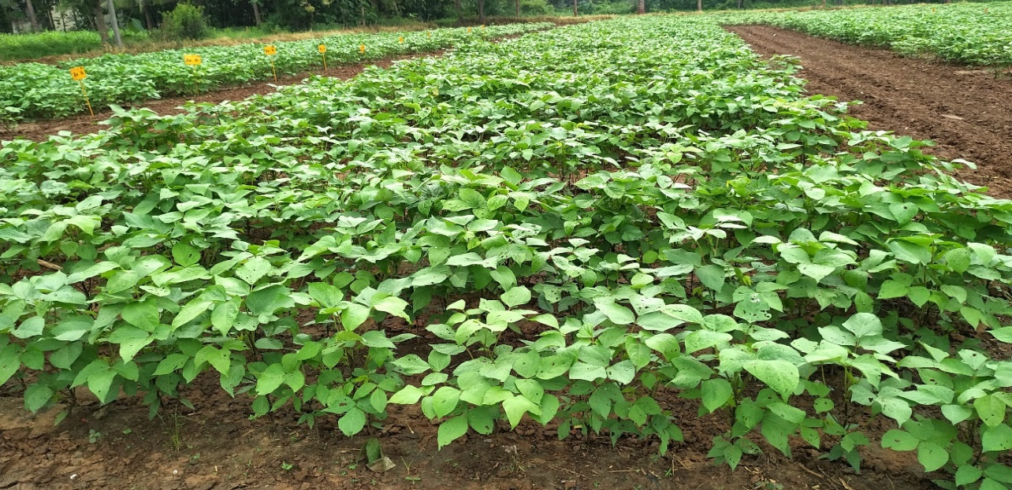

**Fig.1 Field View of Experimental Site, Diversity and Succession of Insect Pests in Black gram**

1. **Results and Discussion**

**3.1 Diversity of insect pests and natural enemies recorded in AAU campus, Anand**

Arthropod diversity study in AAU campus which is coming under middle Gujarat zone revealed that about eight insect pests and two natural enemies were recorded during various growth stages of the black gram. All the eight insect pests *Bemisia tabaci* (Gennadius), *Empoasca kerri* (Pruthi), *Megalurothrips usitatus* (Bagnall), *Nezara viridula* (Linnaeus), *Trichoplusia ni* (Fabricius), *Spodoptera litura* (Fabricius), *Spilosoma obliqua* (Walker) and *Maruca vitrata* (Geyer) belonging to three orders *viz*., Hemiptera, Thysonoptera, Lepidoptera followed by two natural enemies Coccinellids, *Coccinella transversalis* (Fabricius) and spider (Unidentified) belonging to two orders each *i.e*., Coleoptera and Acarina which are coming under eight families *i.e.,* Alyerodidae, Cicadellidae, Thripidae, Pentatomidae, Noctuidae, Erebidae, Crambidae and Coccinellidae. However, the family for spider was unidentified (Table 1 & Fig 2). Among the eight insect pests, seven were recorded as regular insect pests. Besides, two natural enemies also registered as regular in occurrence which appeared during *Kharif* 2019 & 2020. In contrast one insect pest *i.e*., semilooper recorded as occasional insect pest during the study period. Based on population density recorded during both the years, all the recorded insect pests are categorized as major except for semilooper and green stink bug which are categorized as minor insect pests. According to Chandra *et al*., (2010) and Kumar and Singh (2016) Dhuri and Singh, (1983) and Singh and Singh, (1977) black gram is infested by sap feeders *viz*., *Bemisia tabaci*, *Empoasca spp*. and *Nezara viridula* defoliators *viz*., *Spodoptera litura and* *Spilosoma obliqua* and pod borer, *Maruca vitrata* at different stages of crop period. Patidar (2015) reported that white fly and Bihar hairy caterpillar recorded in black gram. Berani et al., (2017) revealed that black gram is infested with lepidopteran pests *viz*., Bihar hairy caterpillar and Spotted pod borer. Jat and Lekha (2017) reported that incidence of whitefly, thrips and jassids were recorded in black gram. Mohapatra et al., (2018) registered whitefly, jassids, Bihar hairy caterpillar, Leaf eating caterpillar and Coccinellids in black gram. Kurly and Singh (2021) reported the incidence of semilooper and leaf eating caterpillar in black gram.

**3.2 Succession of insect pests and natural enemies in black gram based on crop growth stages**

Succession of insect pests as well as natural enemies based on different crop stages in black gram during *Kharif*, 2019 and 2020 are presented in (Table 2). In *Kharif*, 2019 black gram was first attacked by whitefly, *Bemesia tabaci* followed by jassid, *Empoasca kerri*, leaf eating caterpillar, *Spodoptera litura* and Bihar hairy caterpillar, *Spilosoma obliqua* at the seedling stage *i.e.,* at 15 DAS (Days After Sowing) and their infestation was continued up to pod maturity stage of the crop. Whereas 25 DAS *i.e*., at vegetative stage green stink bug, *Nezara viridula* population was observed and sustained up to pod formation stage. Flower thrips, *Megalurothrips usitatus* population was first observed during the flowering stage *i.e.,* 35 DAS and remained up to pod formation stage *i.e.,* 60 DAS. In case of spotted pod borer, *Maruca vitrata* initial population was observed during flowering stage and remained in the field up to pod maturity *i.e.,* up to 80 DAS. Moreover, natural enemies Coccinellids, *Coccinella transversalis* appeared at the vegetative stage *i.e*., 25 DAS and remained in the field till pod formation stage. However, spider population sustained up to pod maturity stage *i.e*., 80 DAS (Days After Sowing).

Similar trend of succession was recorded during *Kharif*, 2020 as observed in *Kharif*, 2019. However, semilooper, *Trichoplusia ni* which was appeared in only *Kharif*, 2020 remained in the field from vegetative stage *i.e.,* 25 DAS (Days After Sowing) to pod maturity stage of the crop *i.e*., 80 DAS (Days After Sowing).

**3.3 Correlation co-efficient (r) between the insect pests and natural enemies**

During *Kharif*, 2019 whitefly population showed highly significant positive correlation with jassid, flower thrips, green stink bug, leaf eating caterpillar, Bihar hairy caterpillar, spotted pod borer, coccinellids and spiders (r=0.94**, 0.87**, 0.77**, 0.96**, 0.96**, 0.90**, 0.92** and 0.95**, respectively) which indicated their simultaneous occurrence in the crop. (Table 3). Incidence of jassid showed highly positive companionship with flower thrips, green stink bug, leaf eating caterpillar, Bihar hairy caterpillar, spotted pod borer, coccinellids and spiders (r=0.90**, 0.79**, 0.97**, 0.95**, 0.92**, 0.95** and 0.94**, respectively). Flower thrips showed highly significant positive correlation with green stink bug, Bihar hairy caterpillar, spotted pod borer, coccinellids and spiders (r=0.77**, 0.90**, 0.95**, 0.92**, 0.94** and 0.94**, respectively). Green stink bug incidence showed highly significant positive companionship with Bihar hairy caterpillar, coccinellids and spiders (r= 0.84**, 0.81**, 0.81** and 0.72**, respectively). While green stink bug incidence showed significant positive companionship (r=0.64*) with spotted pod borer. However, leaf eating caterpillar, showed highly significant positive correlation with Bihar hairy caterpillar, spotted pod borer, coccinellids and spiders (r=0.96**, 0.91**, 0.94** and 0.94**, respectively). Bihar hairy caterpillar showed highly significant positive correlation with spotted pod borer, coccinellids and spiders (r=0.91**, 0.96** and 0.97**, respectively). Spotted pod borershowed highly significant positive companionship with coccinellids (grub and adult) and spiders (r=0.90** and 0.94**, respectively). Coccinellids (grub and adult) showed highly significant positive correlation with whitefly (r=0.92**), jassids (r=0.95**), flower thrips (r= 0.94**), green stink bug (r= 0.81**), leaf eating caterpillar (r= 0.94**), Bihar hairy caterpillar (r= 0.96**) and spotted pod borer (r= 0.90**). Besides, coccinellids exhibited highly significant positive correlation with spiders (r= 0.96**). Spider, a universal predator exhibited highly significant positive correlation with whitefly, jassid, flower thrips, green stink bug, leaf eating caterpillar, Bihar hairy caterpillar and spotted pod borer (r=0.95**,0.94**,0.94**,0.72**, 0.94**,0.97** and 0.94**, respectively) in black gram ecosystem.

In *Kharif*, 2020 population of whitefly was highly significant positively correlated with the population of jassid, flower thrips, green stink bug, leaf eating caterpillar, Bihar hairy caterpillar, coccinellids (grub and adult) and spiders with ‘r’ value 0.97**, 0.87**, 0.79**, 0.93**, 0.93**, 0.85** and 0.75**, respectively (Table 4). However, significant positive (r=0.59*) association was established with spotted pod borer population. A highly significant positive correlation was also noticed between jassid and flower thrips (r=0.90**), green stink bug (r=0.75**), Bihar hairy caterpillar (r=0.92**) and coccinellids (grub and adult) (r=0.76**). Whereas, with spotted pod borer and spiders, jassids showed significant (r= 0.61* and 0.65*) positive association. Besides, semilooper and leaf eating caterpillar established a non- significant positive association with jassid population. Flower thrips, population showed highly significant positive correlation with leaf eating caterpillar(r=0.72**), Bihar hairy caterpillar (r=0.90**) and spotted pod borer (r=0.80**). While with coccinellids (grub and adult), flower thrips showed significant (r=0.66*) positive correlation. Green stink bug showed highly significant positive correlation with semilooper, leaf eating caterpillar, Bihar hairy caterpillar, coccinellids (grub and adult) with ‘r’ value 0.77**, 0.89**, 0.78** and 0.86**, respectively. With spiders, green stink bug showed significant positive correlation (r=0.67*). Semilooper had established highly significant positive correlation with leaf eating caterpillar, coccinellids (grub and adult) and spiders (r=0.76**, 0.79** and 0.87**) and highly significant correlation with spiders (r= 0.71**). But, semilooper showed non-significant positive association with Bihar hairy

### Table 1. Diversity of insect-pests and natural enemies in black gram ecosystem (*Kharif*, 2019 and 2020)

|  |  |  |  |  |  |  |  |  |
| --- | --- | --- | --- | --- | --- | --- | --- | --- |
| **Sr. No.** | **Common name** | **Scientific name** | **Family** | **Order** | **Occurrence** | | **Economic status** | |
| **2019** | **2020** | **2019** | **2020** |
| 1 | Whitefly | *Bemisia tabaci* (Gennadius) | Alyerodidae | Hemiptera | Regular | | Major |  |
| 2 | Jassid | *Empoasca kerri* (Pruthi) | Cicadellidae | Hemiptera | Regular | | Major |  |
| 3 | Flower thrips | *Megalurothrips usitatus* (Bagnall) | Thripidae | Thysonoptera | Regular | | Major |  |
| 4 | Green stink bug | *Nezara viridula* (Linnaeus) | Pentatomidae | Hemiptera | Regular | | Minor |  |
| 5 | Semilooper | *Trichoplusia* ni (Fabricius) | Noctuidae | Lepidoptera | Occasional | | Minor |  |
| 6 | Leaf eating  caterpillar | *Spodoptera litura* (Fabricius) | Noctuidae | Lepidoptera | Regular | | Major |  |
| 7 | Bihar hairy  caterpillar | *Spilosoma obliqua* (Walker) | Erebidae | Lepidoptera | Regular | | Major |  |
| 8 | Spotted pod borer | *Maruca vitrata* (Geyer) | Crambidae | Lepidoptera | Regular | | Major |  |
| 9 | Coccinellids | *Coccinella transversalis* (Fabricius) | Coccinellidae | Coleoptera | Regular | | Major |  |
| 10 | Spider | Unidentified | Unidentified | Acarina | Regular | | Major |  |
|  |  |  |  |  |  | |  |  |

**Table 2. Succession of insect-pests and natural enemies based on crop growth stages in black gram (*Kharif*, 2019 and 2020)**

|  |  |  |  |  |  |
| --- | --- | --- | --- | --- | --- |
| **Duration/growth**  **stages**  **Insect pests & Natural**  **enemies** | **Days after sowing (DAS)** | | | | |
| **15** | **25** | **35** | **60** | **80** |
| **Crop Growth Stages (CGS)** | | | | |
| **Seedling** | **Vegetative** | **Flowering** | **Pod formation** | **Pod maturity** |
| Whitefly |  |  |  |  |  |
| Jassid |  |  |  |  |  |
| Flower thrips |  |  |  |  |  |
| Green stink bug |  |  |  |  |  |
| Semilooper |  |  |  |  |  |
| Leaf eating caterpillar |  |  |  |  |  |
| Bihar hairy caterpillar |  |  |  |  |  |
| Spotted pod borer |  |  |  |  |  |
| Coccinellids (grub & adult) |  |  |  |  |  |
| Spider |  |  |  |  |  |

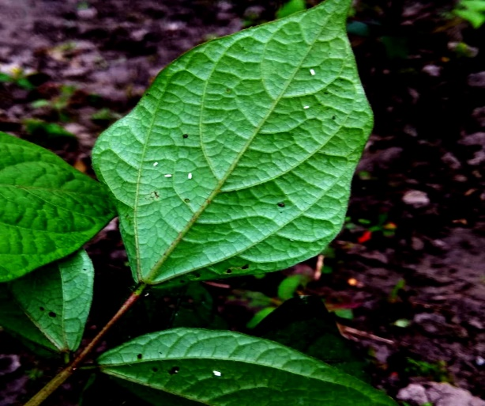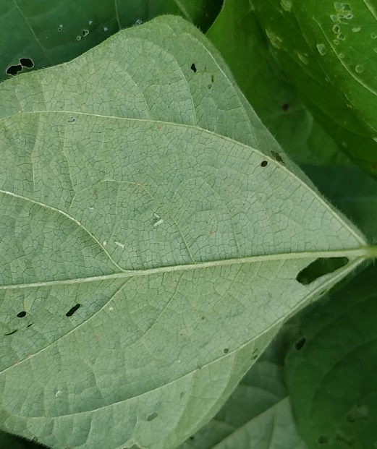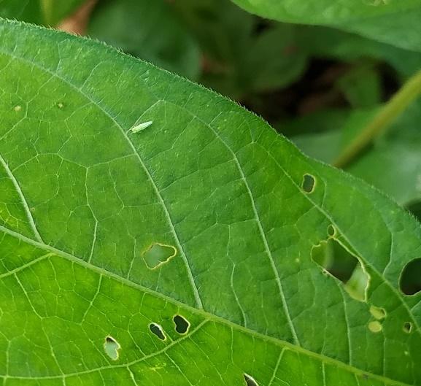

1. **Jassids, *Emposca kerri* (nymphs & adults)**
2. **Whitefly, *Bemesia tabaci* (nymphs & adults)**

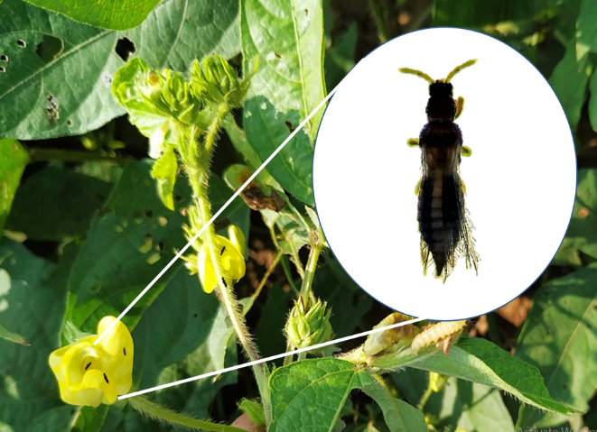 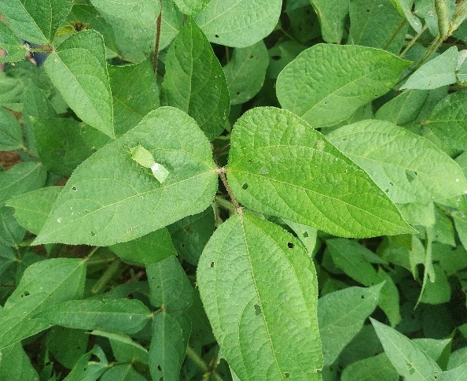 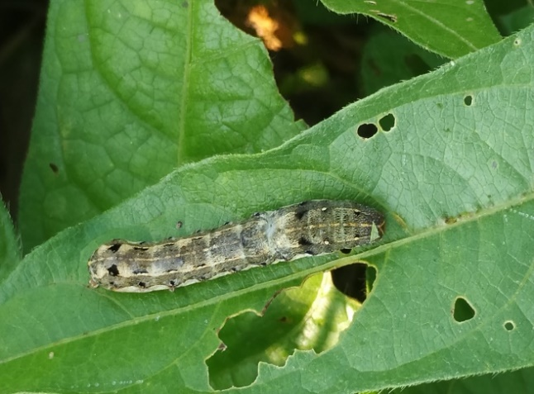

**E. Leaf eating caterpillar, *Spodoptera litura***

1. **Green stink bug, *Nezara viridula***
2. **Flower thrips, *Megalurothrips usitatus***

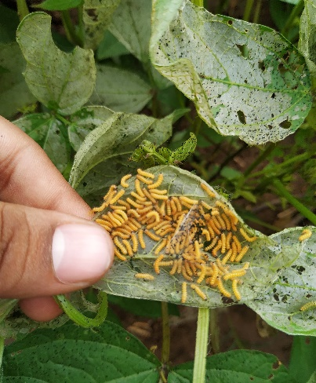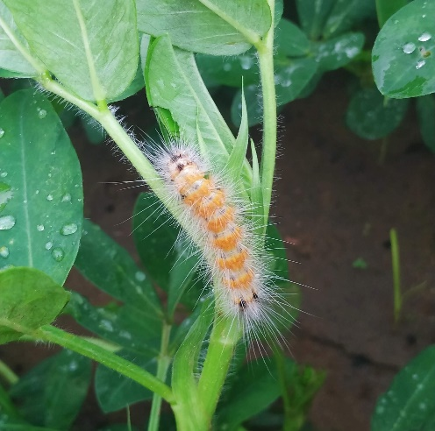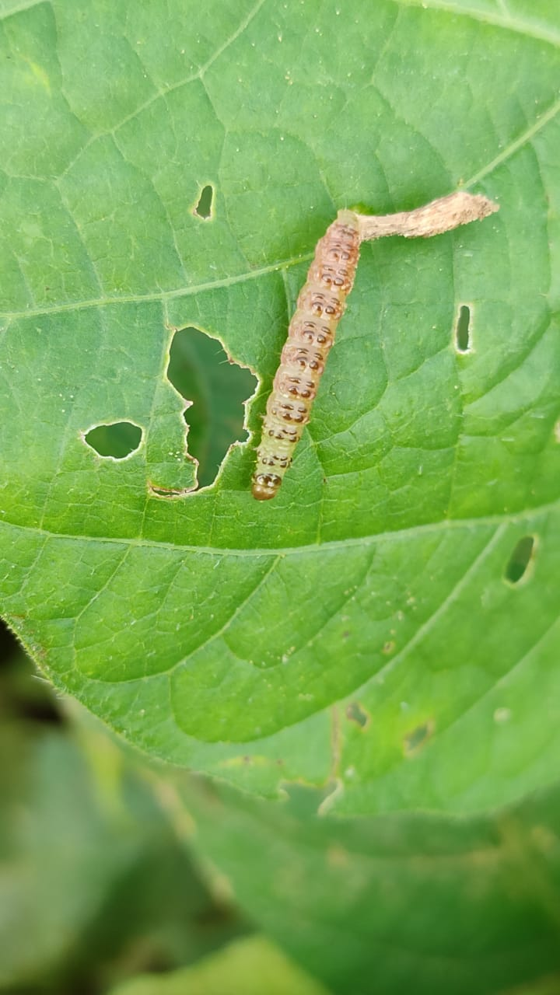 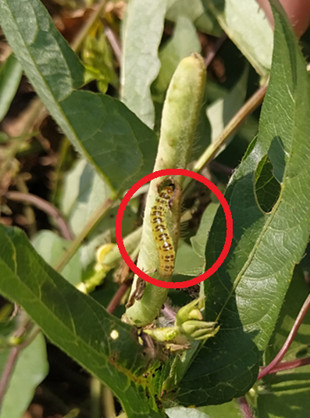

**G. Spotted pod borer caterpillar, *Maruca vitrata***

1. **Bihar hairy caterpillar, *Spilosoma obliqua***

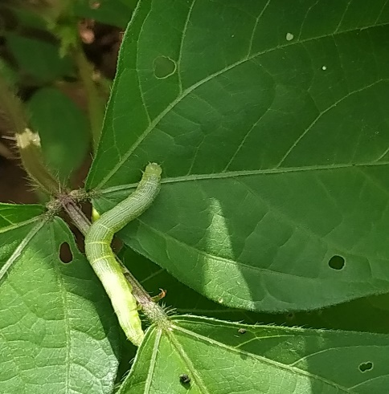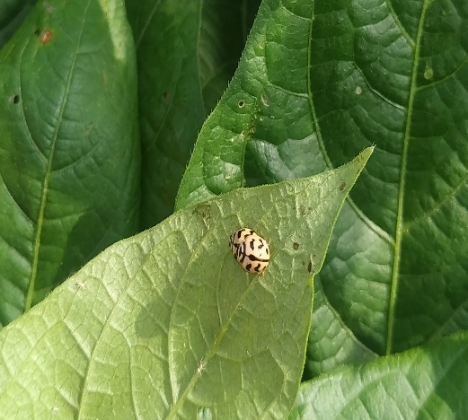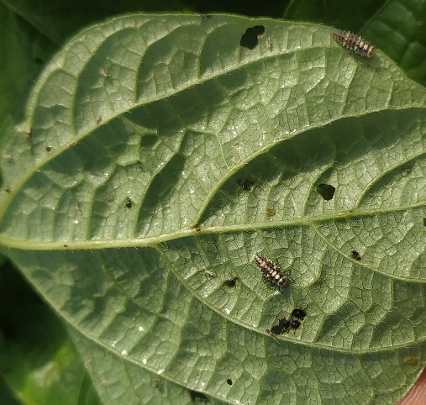 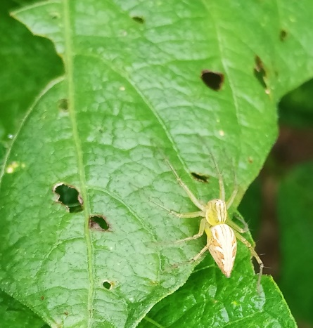

1. **Coccinellids, *Coccinella transversalis* (adult & grub)**
2. **Semilooper, *Trichoplusia, ni***
3. **Spider (adult)**

**Fig 2. Insect pests and natural enemies recorded in black gram ecosystem during *Kharif*, 2019 & 2020**

**Table 3. Correlation coefficient (r) between insect pests and natural enemies (*Kharif*, 2019)**

|  |  |  |  |  |  |  |  |  |  |
| --- | --- | --- | --- | --- | --- | --- | --- | --- | --- |
| **Insect-pests** | **Whitefly** | **Jassid** | **Flower thrips** | **Green stink**  **bug** | **Leaf eating**  **caterpillar** | **Bihar hairy**  **caterpillar** | **Spotted pod**  **borer** | **Coccinellids (grub &**  **adult)** | **Spider** |
| Whitefly | - | - | - | - | - | - | - | - | - |
| Jassid | 0.94** | - | - | - | - | - | - | - | - |
| Flower thrips | 0.87** | 0.90** | - | - | - | - | - | - | - |
| Green stink bug | 0.77** | 0.79** | 0.77** | - | - | - | - | - | - |
| Leaf eating caterpillar | 0.96** | 0.97** | 0.90** | 0.84** | - | - | - | - | - |
| Bihar hairy caterpillar | 0.96** | 0.95** | 0.95** | 0.81** | 0.96** | - | - | - | - |
| Spotted pod borer | 0.90** | 0.92** | 0.92** | 0.64* | 0.91** | 0.91** | - | - | - |
| Coccinellids (grub & adult) | 0.92** | 0.95** | 0.94** | 0.81** | 0.94** | 0.96** | 0.90** | - | - |
| Spider | 0.95** | 0.94** | 0.94** | 0.72** | 0.94** | 0.97** | 0.94** | 0.96** | - |

* Significant at 0.05 % level ** Significant at 0.01 % level

### Table 4. Correlation coefficient (r) between insect pests and natural enemies (*Kharif*, 2020)

|  |  |  |  |  |  |  |  |  |  |  |
| --- | --- | --- | --- | --- | --- | --- | --- | --- | --- | --- |
| **Insect-pests** | **Whitefly** | **Jassid** | **Flower thrips** | **Green stink bug** | **Semilooper** | **Leaf eating**  **caterpillar** | **Bihar hairy**  **caterpillar** | **Spotted pod**  **borer** | **Coccinellids (grub &**  **adult)** | **Spider** |
| Whitefly | - | - | - | - | - | - | - | - | - | - |
| Jassid | 0.97** | - | - | - | - | - | - | - | - | - |
| Flower thrips | 0.87** | 0.90** | - | - | - | - | - | - | - | - |
| Green stink bug | 0.79** | 0.75** | 0.57 | - | - | - | - | - | - | - |
| Semilooper | 0.57 | 0.44 | 0.18 | 0.77** | - | - | - | - | - | - |
| Leaf eating caterpillar | 0.93** | 0.58 | 0.72** | 0.89** | 0.76** | - | - | - | - | - |
| Bihar hairy caterpillar | 0.93** | 0.92** | 0.90** | 0.78** | 0.44 | 0.63* | - | - | - | - |
| Spotted pod borer | 0.59* | 0..61* | 0.80** | 0.26 | -0.06 | 0.44 | 0.59* | - | - | - |
| Coccinellids (grub & adult) | 0.85** | 0.76** | 0.66* | 0.86** | 0.79** | 0.91** | 0.83** | 0.37 | - | - |
| Spider | 0.75** | 0.65* | 0.39 | 0.67* | 0.87** | 0.82** | 0.82** | 0.09 | 0.77** | - |

* Significant at 0.05 % level ** Significant at 0.01 % level

caterpillar. In contrast, semilooper established a negative association with spotted pod borer population. Leaf eating caterpillarpopulation showed highly significant positive correlation with coccinellids (grub and adult) and spiders (r= 0.91** and 0.82**) While the pest showed significant positive correlation with Bihar hairy caterpillar (r = 0.63*). However, spotted pod borer showed non-significant positive association with leaf eating caterpillar. Bihar hairy caterpillarestablished highly significant positive correlation with coccinellids (grub and adult) and spiders (r= 0.83** and 0.82**) while the pest showed significant positive correlation (r= 0.59*) with spotted pod borer. In case of spotted pod borer, the pest showed non-significant positive association with coccinellids (grub and adult) and spiders. Coccinellids (grub and adult) exhibited highly significant positive correlation with whitefly, jassid, green stink bug, semilooper, leaf eating caterpillar and Bihar hairy caterpillar(r= 0.85**, 0.76**, 0.86**, 0.79**, 0.91** and 0.83**). With flower thrips, coccinellids (grub and adult) showed significant positive association (r=0.66*). Besides, coccinellids (grub and adult) showed highly significant positive correlation with spiders (r= 0.77**). Spiders showed highly significant positive correlation with whitefly, semilooper, leaf eating caterpillarand Bihar hairy caterpillar rwith ‘r’ value 0.75**, 0.87**, 0.82** and 0.82** whereas with jassid and green stink bug spider exhibited significant positive correlation (r= 0.65* and 0.67*). However, flower thrips and spotted pod borerestablished a non-significant impact on spider population. Overall, there was a significant positive association between the insect pests and two natural enemies *viz*., coccinellids (grub and adults) and spiders with their hosts in black gram ecosystem.

The present findings are in accordance with Prasad et al., (2005) where whitefly, *Bemesia tabaci* was observed during seedling stage followed by leaf eating caterpillar, *Spodoptera litura* and Bihar hairy caterpillar *Spilosoma obliqua* were noticed at vegetative stage and continued till the pod formation stage of the crop. Sravani et al., (2015) concluded that larval incidence of *Maruca vitrata* was observed from vegetative stage and continued till the end of crop maturity stage in green gram. Radhika et al., (2018) reported that population of whiteflies were started from 2nd week after sowing and sustained in the crop up to reproductive stage in black gram. The results are corroborated with Sain *et* al., (2020) where leafhopper, *Emposca kerri* and white fly, *Bemisia tabaci* marked their appearance from seedling to pod filling stage. Besides, defoliators *viz*., semilooper, *Trichoplusia ni*, tobacco caterpillar, *Spodoptera litura* and Bihar hairy caterpillar, *Spilosoma obliqua* appeared from vegetative to pod maturity stage. However, legume pod borer, *Maruca vitrata* appeared from flowering stage to pod maturity in black gram. Duraimurugan and Tyagi, (2014) stated that during seedling stage whitefly population was observed followed by flower thrips population observed during flower initiation stage whereas pod borers were recorded during pod formation stage in black gram. From the findings of Yadav et al., (2020) the population of whitefly, jassid, and semilooper appeared during vegetative stage. While tobacco caterpillar, Bihar hairy caterpillar and spotted pod borer appeared during vegetative and sustained up to pod formation stage in black gram. Dash et al., (2023) revealed that whitefly, leaf eating caterpillar and semiloopers appeared at the vegetative stage while thrips appeared during flowering stage followed by pod borers from flowering to crop maturity stage in black gram. Sujatha and Bharpoda (2017) and Swathi et al., (2019) and Singh et al., (2019) concluded that occurrence of coccinellids and spiders noticed from vegetative stage to pod maturity stage in green gram and black gram. Rajawat et al., (2021) reported that coccinellids and spiders were recorded from flowering to pod maturity stage in black gram. The present findings are more or less in line with the earlier researchers. However, there is a scanty literature is available on correlation studies between insect pests and natural enemies in black gram.

**CONCLUSION**

In culmination, from the findings it was revealed that black gram crop recorded eight insect pests and two natural enemies belonging to five orders with eight families, respectively. Besides, succession of insect pests based on crop growth stages revealed that the population of sucking pests *viz*., whitefly and jassids were observed from seedling stage to maturity stage and green stink bug population was observed from vegetative stage to pod formation stage. In case of flower thrips, population was observed from flower bud formation stage to pod formation stage Among the lepidopteran pests, Bihar hairy caterpillarand leaf eating caterpillar observed from seedling stage to pod maturity stage of the crop whereas, spotted pod borerwas observed with the initiation of flowering and continued till pod maturity. The natural enemies of the insect pests *viz.,* coccinellids and spiders were observed from vegetative stage to pod maturity. All the insect pests showed significant companionship with natural enemies. The information on simultaneous occurrence of the pest in black gram ecosystem will be very useful in formulating the management strategy.

**DISCLAIMER (ARTIFICIAL INTELLIGENCE)**

As the author(s), I hereby declare that no generative AI technologies, including Large Language Models (such as Chat GPT, COPILOT, etc.) or text-to-image generators, have been used in the writing or editing of this manuscript

**REFERENCES**

Anonymous, (2020). State/Season wise-Area, Production and Productivity of Urad in India. Retrieved from https://www.indiastatagri.com/table/agriculture/state- season-wise-area-production-productivity-ura/1409250/

Berani, N. K, Pathan, N. P., & Godhani, P. H. (2017). Population dynamics of lepidopteran insect pests of black gram, *Vigna mungo* (L.) Hepper, *Trends in Biosciences*, 10 (46), 9419-9422.

Chandra, U., Singh, K., Singh, H. M. & Kumar, R. (2010). Population dynamics of sap feeders in urd bean (*Vigna mungo* (L.) Hepper) and their correlation with abiotic factors. *International Journal of Plant Protection*, 3 (2), 274-276.

Dash, S. S., Nayak, S. K., & Dhal, A. (2023). Biodiversity and Succession of Insects of Black gram (*Vigna mungo* (L.) Hepper) During rabi in the Western Undulating Zone of Odisha. *Environment and Ecology*, 41(4), 3033-3042.

Dhuri, A. V., & Singh, K. M. (1983). Pest complex and succession of insect pests in black gram *Vigna mungo* (L.) Hepper. *Indian Journal of Entomology*, 45 (4), 396-401.

Duraimurugan, P., & Tyagi, K. (2014). Pest spectra, succession and its yield losses in mung bean and urd bean under changing climatic scenario. *Legume Research,* 37(2), 212-222.

Jat, S. K., & Lekha, B. R. (2017). Effect of abiotic factors on the incidence of major insect pests of black gram [(*Vigna mungo* L. Hepper)]. *International Journal of Agriculture Sciences*, 9 (17), 135-139.

Justin, C.G.L, Anandhi, P., & Jawahar, D. (2015). Management of major insect pests of black gram under dryland conditions. *Journal of Entomology and Zoology Studies,* 3(1), 115-121.

Kumar, M., & Singh, P. S. (2016). Population dynamics of major insect pest of black gram [*Vigna mungo* (L.) Hepper] in relation to weather parameters. *International Journal of Agriculture and Environment Biotechnology,* 9(4), 673-677.

Kurly, S., & Singh, P. K. (2021). Seasonal incidence of defoliators on black gram and its correlation with abiotic factors. *The Pharma Innovation Journal*, 10 (3), 175-178.

Mohapatra, M. M., Singh, D. C., Gupta, P. K., Chandra, U., Patro, B., & Mohapatra, S.D. (2018). Seasonal incidence of major insect pests on black gram, *Vigna mungo* (Linn.) and its correlation with weather parameters. *International Journal of Current Microbiology and Applied Science*, 7 (6), 3886-3890.

Patidar, G. (2015). Studies on population dynamics of insect pests of black gram, *Vigna mungo* (L.) Hepper and the management of some major pests. M.Sc. (Ag.) thesis submitted to JNKVV, Jabalpur, M. P.

Prasad, D., Kumar, D., Prasad, R., & Sahaya, S. (2005). Succession of insect pests associated with black gram. *Environment and Agriculture*, 9, 304-307.

Radhika, M., & Reddy, C.K. (2018) Estimation of avoidable yield loss due to sucking pest complex in black gram. *International Journal of Current Microbiology and Applied Science*,7 (5), 2403-2410.

Radhika, M., Reddy, C. N., Anitha, V., & Vidhyasagar, B. (2018). Seasonal incidence of sucking pest complex in black gram. *Journal of Entomology and Zoology Studies*, 6 (4), 901-903.

Rajawat, I. S., Kumar, A., Alam, M. A., Tiwari, R. K., & Pandey, A. K. (2019). Insect Pests of black gram (*Vigna mungo* L.) and their management in Vindhya region. *Legume Research*, 44 (2), 564-569.

Sain, Y., Singh, R., Singh, G., Singh, D. V., Khilari, K., Vivek, A. S., & Gautam, M. P. (2020). Seasonal profile of different insect-pests of black gram in the western region of Uttar Pradesh. *Journal of Entomology and Zoology Studies*, 8 (1), 771- 773.

Singh, K. M., & Singh, R. N. (1977). Succession of insect-pests in green gram and black gram under dryland conditions at Delhi. *Indian Journal of Entomology*, 39 (4), 365-370.

Singh, M., Bairwa, D. K., & Jat, B. L. (2019). Seasonal incidence of sucking insect pests of green gram. *Journal of Entomology and Zoology Studies*, 7 (2), 654-658.

Sravani, D., Mahalakshmi, M. S., Sandhyarani, C., & Kumari, V. P. (2015). Incidence of spotted pod borer, *Maruca vitrata* (Fabricius) (Crambidae: Lepidoptera) on green gram under unsprayed conditions. *International Journal of Pure and Applied Biosciences*, 3 (5), 152-158.

Sujatha, B., & Bharpoda, T. (2017). Succession of major insect pests and impact of abiotic factors in green gram. *Agriculture Update*, 12 (10), 2788-2794.

Swathi, K., Seetharamu, P., Dhurua, S., Suresh, M., & Govinda rao, S. (2019). Influence of weather parameters on the incidence of sucking pests of rice fallow black gram in north coastal Andhra Pradesh. *Indian Journal of Plant Protection*, 47 (4), 140 146.

Yadav, A., Singh, G., Singh, H., Singh, D.V., & Khilari, K. (2020). Succession of insect pests complex associated with black gram in western Uttar Pradesh. *Journal of Entomology and Zoology Studies,* 8(2), 213-218.