**Original Research Article**

**Formulation and Evaluation of Hydroethanolic and Chloroform Extracts** **of *Zanthoxyllum oxyphyllum* for Analgesic and Wound Healing Activities**

**Abstract**

*Zanthoxylum oxyphyllum* under the family Rutaceae, commonly known as Mezenga in Assam grow in tropical and temperate regions. Hydroethanolic and chloroform extractsof leaves of the plant were screened for analgesic activity and wound healing property by hot plate test and excision, incision wound model. The acute toxicity study revealed that both the plant extracts were non-toxic and safe for oral dosing. Both the extracts were non-sensitizing to rabbit skin and caused very little or no irritation in intact and damaged skin rabbits treated with single and multiple doses. Irritation scores did not differ significantly between the control and treatment groups, according to the acute dermal toxicity study. It was observed that the hydroethanolic extract of the selected plant possess significant analgesic effect against thermal stimuli and inhibits pain induced by chemically stimuli. It was also showed that hydroethanolic extract was found to be most activeand was responsible forthe significant and dose-dependent wound healing property comparablewith the standard extract.

**Keywords**

*Zanthoxylum oxyphyllum;* Hydroethanolic; Chloroform; Analgesic; Wound healing

**Introduction**

Since the beginning of time, herbal medicines have served as the cornerstone of healthcare worldwide. Today, they are widely used and contribute significantly to global trade, with billions of dollars being exchanged annually.Though to differing degrees worldwide, the therapeutic, pharmacological, and economic relevance is still acknowledged.In addition to serving as direct therapeutic agents, plant components are crucial for pharmacological research and drug development because they can be used as models for pharmacologically active compounds or as starting materials for drug production.The United Nations Convention on Biological Diversity states that access to and sharing of genetic resources and technologies are necessary for the conservation and sustainable use of biological diversity in order to meet the needs of the world's expanding population in terms of food, health, and other areas.The development of laws pertaining to medicinal plants has not followed a planned, controlled paradigm.Countries have adopted a variety of strategies for licensing, distributing, producing, and trading medical plants, herbs, and items derived from them in order to ensure their safety, efficacy, and quality.Only a small number of plant species have been studied for possible therapeutic use, despite the lengthy history of using herbal medicines.Traditional medical practices like Siddha, Ayurveda, and Unani, which use a variety of herbs to treat human ailments, originated in India. Approximately 65 percent of people worldwide still receive their primary medical treatment from traditional drugs. In recent years, there have been significant scientific advances involving chemical and pharmacological studies of medicinal plants, focusing on new compounds with therapeutic properties. “The demands for medicinal plants are increasing all over the world due to the growing recognition that the medicinal plants have fewer side effects and are lesser toxic as compare to synthetic medicines pharmacologically active, cost effective and easier to use for human diseases” (Kumari et al.,2022).Their medicinal, delicious, and fragrant qualities have obviously been valued for antiquity, but for a very long period, they were eclipsed by the manufactured goods of contemporary society. Folk medicine usually involves the use of natural, especially herbal, remedies and is defined as traditional medicine practiced by untrained healers or represented in local custom or knowledge. “Traditional medicine is defined by the World Health Organization (WHO) as “the health practices, approaches, knowledge and believes incorporating plant, animal and mineralbased medicines, spiritual therapies, manual techniques and exercise, applied singularly or in combination to treat, diagnose and prevent illness or maintain well- being.” Zanthoxylum oxyphyllum under the family Rutaceae, commonly known as Mezenga in Assam grow in tropical and temperate regions” (Pirani et al., 1993). “They are represented by thorny, dioecious shrubs or small trees with dense foliage and prickly trunk and leaves with a strong and pungent taste” (Chayee et al.,1996). The majority of *Zanthoxylum* fruits include seeds that are high in oil that contains a lot of alkaloids and unsaturated fatty acids with significant antioxidant properties. Fruits aid with digestion and are used as spices. The stem bark produced the indoquinazoline alkaloid, which is frequently used to treat leg pain, skin conditions, varicose veins, ulcers, and rheumatism. Additionally, it is used to treat fevers, hypotension, and inflammation. Human keratinocyte proliferation has been demonstrated to be inhibited by the antiproliferative properties of *Z. oxyphyllum's* bark and root extract. In addition to its stimulant, stringent, and digestive qualities, it is also used to treat diarrhea and dyspepsia. The current study was carried out to assess the analgesic and wound-healing properties of leaf extracts from *Zanthoxylum oxyphyllum* in mice and rats.

**Materials and Methods**

**Plant collection and processing**

The Indian Botanical Survey found and described the plant *Zanthoxylum oxyphyllum*. *Zanthoxylum oxyphyllum* leaves were gathered from the Goalpara area of Assam, which lies close to the Meghalaya border. To get rid of dirt, dust, and other debris, the gathered leaves were carefully cleaned with fresh water. After that, the leaves are left to dry in the shade for 15 to 20 days at room temperature. A Laboratory Willey Mill was used to grind the plant's shade-dried leaves into a fine powder. They were kept at 4˚C in airtight containers with appropriate labeling until the necessary extracts were ready for the experiments, and they were often turned on and off to avoid fermentation, rot, and other damage.

**Preparation of hydroethanolic and chloroform extracts**

Hundred (100) grams of powdered Z. oxyphyllum leaves were suspended in 1 litter of 1:1 ethanol and distilled water solution and 1 litter of chloroform solution and kept for 9 days with intermittent stirring every 8 hours. Finally, on the tenth day, the suspension was passed through muslin cloth to remove the coarse material, followed by Whatman filter paper 1. The solvents used for extraction of the bioactive compound were evaporated with the help of a rotary evaporator and the semi-solid residue from the rotary evaporator was subjected to further solidification by heating for 24 hours in a hot water bath at very low temperature. The remaining compound on the petri dish is the hydro ethanolic and chloroform extract.

**Experimental Animals**

Analgesic activity and wound healing property of Zanthoxylum oxyphyllum carried out in albino mice (25 grams body weight) and adult healthy Wister rats (50-200 grams body weight). The animals were kept in stainless steel cages at the animal house, at the Department of Veterinary Pharmacology and Toxicology, Khanapara, under ambient temperature, light and relative humidity. Food and water were provided ad libitum. Prior to the start of the test, the animals were acclimated to laboratory conditions for 7 days.

**Phytochemical analysis of extracts**

The hydroethanolic and chloroform extracts of *Zanthoxylum oxyphyllum* were phytochemically analysed for the presence of various active principles such as steroids, alkaloids, phenolic compounds, tannins, flavonoids, glycosides, triterpenes, and saponins.

**Acute oral toxicity study**

The study was conducted in compliance with the Organization for Economic Cooperation and Development's (OECD) 423 standards.For the acute toxicity investigation, female albino mice that were nulliparous and not pregnant and weighed between 30 and 40 g at 8 to 10 weeks of age were selected.To enable them to become acclimated to laboratory settings, the animals are marked for individual identification and housed in their cages for a minimum of five days before dosing.The animals were fasted (food but not drink) for three to four hours before the dose.*Zanthoxylum oxyphyllum* leaf extract (hydroethanolic, chloroform) was administered orally to the mice.Prior to the limit test, the animals were given unlimited water and starved for the whole night.Group I served as the vehicle control (20% Tween-80), while Group II-V received *Zanthoxylum oxyphyllum* leaf (hydroethanolic, chloroform) extract @ 2000 mg/kg orally as a single dose. The animals were closely monitored for behavioural changes, toxicity, and mortality for 72 hours, and then for 14 days to record any mortality. Based on acute toxicity studies, three doses were choosen to evaluate the plant extracts analgesic and wound healing properties.

**Evaluation of analgesic activity**

**Hot plate method**

Eddy and Leimbach's (1953) method was used to accomplish the Hot Plate method on either-sex mice. The reactions include paw licking, paw withdrawal, and jumping. Eight groups of mice, each consisting of six animals, were created. The second group was given the conventional medication Meloxicam (5 mg/kg, I/M), while the first group was used as a control and was given simply vehicle (10% Tween 80 in distilled water). Animals in groups three through five were given hydroethanolic extract of *Zanthoxylum oxyphyllum* leaves (10, 30, 100 mg/kg, orally), while animals in groups six through eight were given chloroform extract of the same leaves (10, 30, 100 mg/kg, orally).The commercially available hot plate is made up of an electrically heated surface. The mice were placed on the Hot Plate, which was kept at 55º C ±1ºC, and the time between placement on the hot plate and the occurrence of either licking of the paws, jumping off the plate or paw withdrawal was recorded as the reaction time (sec). Mice with reaction times of more than 10 seconds were excluded from the study, with a cut off time of 30 seconds, the reaction time of each mouse was recorded at 0, 15, 30, 45, 60, 90, 120, and 150 minutes after test compound and standard drug administration.

**Evaluation of wound healing properties**

Incisional and excisional animal models of wound healing were employed in this study. Male Albino Wister rats weighing 250–275 grams were employed in the research. The animal shelters were kept clean and in good condition. Rats were kept in 32 x 24 x 16 cm³ polypropylene cages, with nine or six animals per group. They were given unlimited access to tap water and commercial food pellets. On alternate days, sanitation and cleaning tasks were completed. The bedding was made of paddy husk, which was replaced daily. All studies were carried out between 10 a.m. and 6 p.m., and the cages were kept clean.

**Anaesthesia**

The anaesthesia was induced by intramuscular injection of xylazine at 5-12 mg/kg and ketamine at 40-75 mg/kg (Burke.,1999).

**Drug used**

5% Povidone Iodine Ointment (commercially available) was used for standard group of animal. The ointments were applied topically over the wound area.

**Preparation of ointments**

**TABLE 1. PREPARATION OF THE TEST OINTMENTS**

|  |  |  |
| --- | --- | --- |
| **Ointment** | **Extract (in gms)** | **Vaseline (in gms)** |
| Chloroform 1% | 0.5 | 49.50 |
| Chloroform 3% | 1.5 | 48.50 |
| Chloroform 10% | 5.0 | 45.00 |
| Hydro ethanol 1% | 0.5 | 49.50 |
| Hydro ethanol 3% | 1.5 | 48.50 |
| Hydro ethanol 10% | 5.0 | 45.00 |

**Incision wound model**

Wistar albino male rat weighing between 250-300 gm was divided into nine groups, each group consisting of 6 rats, and each animal was kept separately in polypropylene cages under laboratory conditions. Group I animals were kept as normal control. Group II animals were topically treated with vaseline as vehicle control. Group III animals are topically treated with the Povidone Iodine (5%) ointment as standard. IV, V and VI were treated with 1%, 3% and 10% w/w hydroethanolic extract ointments prepared from the plant *zanthoxylum oxyphylum.* The animals of Group, VII, VIII and Ⅸ were treated with 1%, 3% and 10% w/w chloroform extract ointments. Animals were anaesthetized with a combination of xylazine (@ dose rate of 13 mg/kg b.wt and ketamine (@ dose rate of 87 mg/kg b.wt by the intramuscular route (I/P) prior to the creation of the wounds. The animals were fasted overnight without taking out the water supplement. A longitudinal paravertebral incision, three centimetres in length, was made through the skin and cutaneous muscle on the back as described by Ehrlich and Hunt (1968). Full aseptic measures were not taken and no local or systemic antimicrobials were used throughout the experiment. After the incision, surgical sutures were applied to the parted skin at intervals of one centimetre using nylon surgical threads (No. 000) and a curved needle (No. 11). The wounds were left undressed to environment. The sutures were removed on the 10th post wound day and the treatment was continued till 12th day. Breaking strength was measured on the last day of the experiment that is on 12th day.

**Excision wound model**

On the day of inflicting the wound, the rats were anaesthetized prior to the creation of the wounds. The animals dorsal fur was shaved with a shaving razor, and the area of the wound to be created was outlined with methylene blue using a circular stainless steel stencil on the back of the animal. Using toothed forceps, a surgical blade, and pointed scissors, a 1cm2 excision wound was created along the markings. The wound was left completely open. All surgical interventions were performed in a sterile environment. After 24 hours, the ointments at different concentrations were gently applied to the wounded area once daily until complete healing. The wound area and contraction, as well as the epithelialization period, were all monitored.

**Measurement of wound contraction**

The wound area was calculated by tracing the wound on millimetre scale graph paper. For the final analysis of results, the percentage of wound healing of the original wound size (1 cm2) was calculated for each animal in the group and the mean of each group was calculated on predetermined days, i.e., 0, 3, 7, 14 and 21. The fall of the scar, leaving no raw wound behind, was taken as the end point of complete epithelization, and the days required for this were taken as the epithelization period (Cross *et*. *al*.,1995).

**Calculation**

$percent wound contraction =\frac{healed area}{total area } ×100$

**Stastical Analysis**

Results were expressed as Mean ± S.E. Statistical analysis was performed by MS-excel to calculate mean, standard error of mean (SEM), analysis of variance (ANOVA), and co-efficient of correlation (r) values. All statements of significance were based at least on 95% confidence limits (i.e. P<0.05).

**Result**

The dried and powdered leaves of *Zanthoxylum oxphyllum* were extracted using a standard technique. The hydro ethanolic extract yield was found to be 14% and that of chloroform extract yield was found to be 6 %.

**Phytochemical analysis*:*** The hydroethanolic and chloroform extracts of *Zanthoxylum oxphyllum* were qualitatively analyzed for the presence of different active phytoconstittuents. The extracts were found to be positive for alkaloids, steroids, flavonoids, phenols, carbohydrates, Diterpenes, Triterpenes.

**Acute oral toxicity study**

Hydroethanolic and chloroform extracts of *Zanthoxylum oxphyllum* leaves @ 2000 mg/kg body weight produced no mortality when administered orally mixed in the vehicle (20% tween 80 solution). Mortality is the main criterion in assessing the acute toxicity (LD50) of a drug. There was no mortality recorded even at the highest dose level i.e., 5000 mg/kg body weight of all the groups. Thus, the plant extract is considered safe for oral dosing.

**Eddy’s hot plate method**

In the eddy’s hot plate method, hydroethanolic extract (100 mg/kg, orally) showed significant increase in reaction time as compared to control and chloroform extract. Hydroethanolic extract (10,30 and 100 mg/kg) showed promising dose-dependent activity which is comparable to the standard drug Meloxicam. The hot plate test is the specific central antinociceptive test. Hydroethanolic extract showed significant result in this test, it may be due to presence of phenol and flavonoid compounds in the extract. The phenol and flavonoid compounds exert their analgesic action via blocking the opioid receptor. Results are shown on the Table no-2 and Fig no-1

**Table 2: ANALGESIC ACTIVIT *OF ZANTHOXYLUM OXYPHYLLUM* HYDROETHANOLIC LEAF EXTRACT BY EDDY’S HOT PLATE METHOD**

|  |  |  |  |  |  |
| --- | --- | --- | --- | --- | --- |
| **Time**  **(Min)** | **Group** | | | | |
| **Normal control** | **Standard control** | **Hydro-Ethanolic**  **(10 mg)** | **Hydro-Ethanolic**  **(30 mg)** | **Hydro-ethanolic**  **(100 mg)** |
| 0 | A11.833a ±0.759 | A13.333a ± 0.308 | A13.500a ± 0.428 | A15.333 a ±0.558 | A20.667a±1.282 |
| 15 | A9.167a ± 0.469 | B29.167b ± 0.867 | B29.000b±0.516 | B32.167 b ±0.703 | A35.167b±1.973 |
| 30 | A13.167a ± 0.990 | CD46.333b±0.149 | CD46.167b±2.088 | BC46.167 b ±1.014 | B50.500b±1.408 |
| 60 | A20.000a ± 0.286 | CD47.667b±0.256 | CD49.167b±1.088 | CD52.167 b ±1.740 | B55.667b±0.882 |
| 90 | A16.000a ± 0.066 | C44.167b ± 0.580 | C45.333b±0.667 | CD51.167 b ±1.078 | B53.333b±0.989 |
| 120 | A15.500a ± 0.861 | D59.167b ± 0.306 | D60.167b±0.850 | D61.500 b ±0.875 | B63.333b±0.882 |

*All values are Mean ± S.E. (n=6) **Means with different superscripts (small letters) within a column and different subscripts within rows (capital letters) differ significantly (P< 0.05)

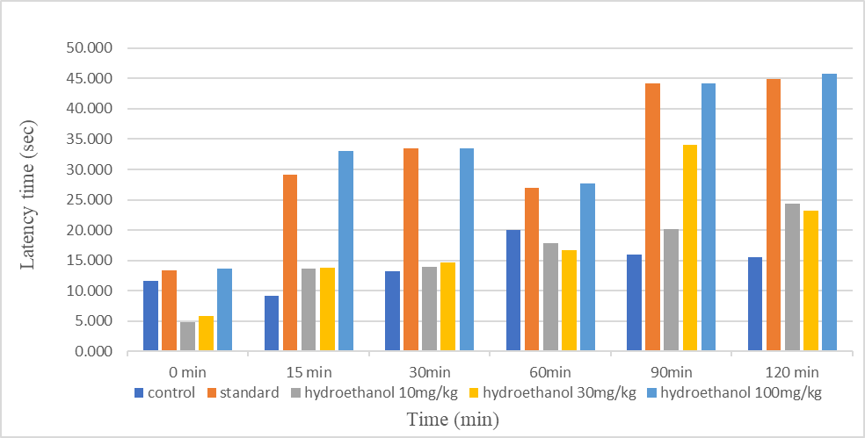

**Fig.1: EFFECT OF HYDROETHANOLIC EXTRACT OF Z. OXYPHYLLUM ON EDDY’S HOT PLATE METHOD**

**Incision wound model**

**Wound healing effect of the hydroethanolic extract**

On the 10th day of creation of the wound, the breaking strength (grams) of the incision wounds was measured using a tensiometer after removing the sutures. The mean SE values of breaking strength (grams) of the wounds in different experimental groups are depicted in table no. 3 after administration of the hydroethanolic extract of *Z. oxyphyllum*. The extract treated groups showed a significant increase in wound breaking strength as compared to the normal and vehicle control groups. The differences were not statistically significant in the standard control, 1%, 3%, and 10% extract groups of *Z. oxyphyllum*. The graphical representation in Fig.2 showed concentration dependent action in increasing the breaking strength in the extract treated groups. The mean ± SE values of breaking strength (grams) of low (1%), medium (3%), and high (10%) doses of *Z. oxyphyllum* were 428.667 ± 0.422, 436.167 ± 0.477, and 444.667 ± 0.615respectively. The values of normal control, vehicle control, and standard control were 363.833 ± 0.461, 380.333 ± 0.369 and 424.000 ± 0.957 respectively.

**Table 3 : BREAKING STRENGTH OF *ZANTHOXYLUM OXYPHYLLUM* HYDROETHANOLIC LEAF EXTRACT IN INCISION WOUND MODEL**

|  |  |
| --- | --- |
| **Group** | **Breaking Strength** |
| Normal Control | 363.833 ± 0.461a |
| Vehicle Control | 380.333 ± 0.369b |
| Standard Control | 424.000 ± 0.957b |
| Hydroethanol 1% | 428.667±0.422 b |
| Hydroethanol 3% | 436.167±0.477 b |
| Hydroethanol 10% | 444.667±0.615 b |

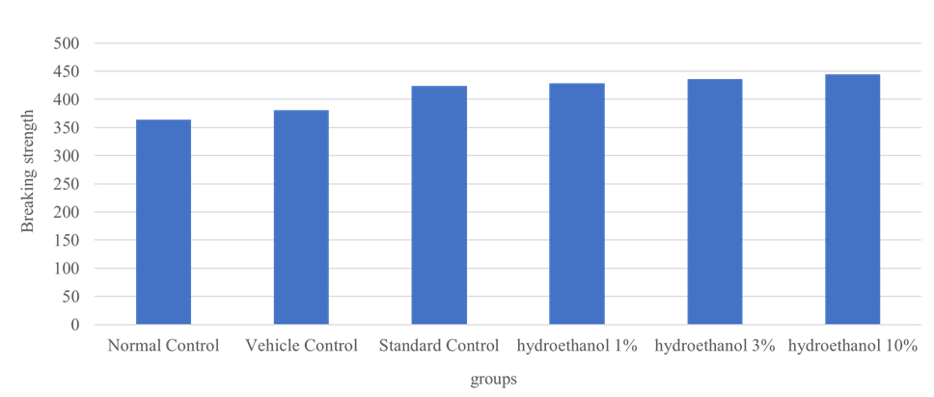

**Fig.2: BREAKING STRENGTH OF *ZANTHOXYLUM OXYPHYLLUM* HYDROETHANOLIC LEAF EXTRACT IN INCISION WOUND MODEL**

**Wound healing effect of the chloroform extract**

Chloroform extract of *Z. oxyphyllum* at concentrations of 1%, 3%, and 10% were applied topically over the incision wound in the experimental animals. The breaking strengths of the wounds were measured using a tensiometer on the 10th day. The mean SE values of breaking strength (grams) of the wounds in different experimental groups were depicted in table no. 4 and Fig. no. 3. There was a significant elevation in the breaking strengths (grams) of the wounds in the extract treated groups as compared to the normal and vehicle control groups. The standard control group showed slightly higher breaking strengths as compared to the 1% and 3% extract groups, which was statistically not significant. Maximum breaking strength was observed in higher concentrations, *i.e.*, 10% extract of *Z. oxyphyllum*. The mean SE values of breaking strength (grams) of low (1%), medium (3%), and high (10%) doses of *Z. oxyphyllum* were 420.500 ± 0.563, 422.667 ± 0.760, 436.500 ± 0.428 respectively. The values of normal control, vehicle control, and standard control were 363.833 ± 0.461, 380.333 ± 0.369 and 424.000 ± 0.957 respectively.

**Table 4 : BREAKING STRENGTH OF *ZANTHOXYLUM OXYPHYLLUM* CHLOROFORM LEAF EXTRACT IN INCISION WOUND MODEL**

|  |  |
| --- | --- |
| **Group** | **Breaking Strength** |
| Normal Control | 363.833 ± 0.461a |
| Vehicle Control | 380.333 ± 0.369b |
| Standard Control | 424.000 ± 0.957b |
| Chloroform 1% | 420.500 ± 0.563b |
| Chloroform 3% | 422.667 ± 0.760b |
| Chloroform 10% | 436.500 ± 0.428b |

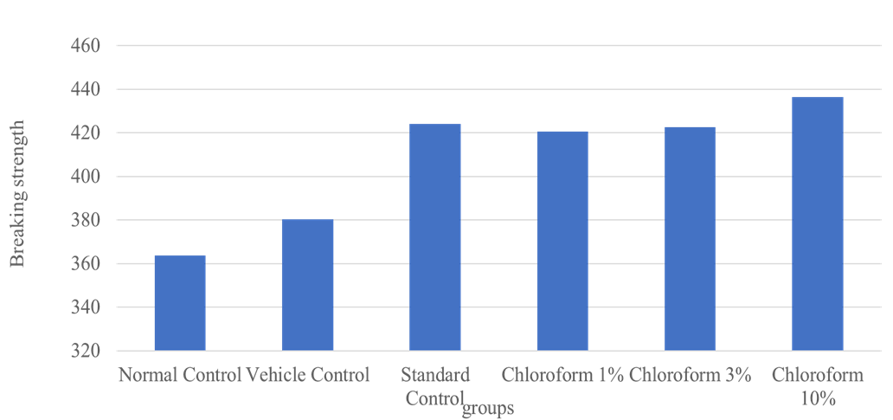

**Fig.3: BREAKING STRENGTH OF *ZANTHOXYLUM OXYPHYLLUM* CHLOROFORM LEAF EXTRACT IN INCISION WOUND MODEL**

**Excision wound model**

**Wound healing effect of the hydroethanolic and chloroform extracts**

Both the hydroethanolic and chloroform extracts of *Z. oxyphyllum* showed significant elevation of wound contraction on the 7th and 14th days observation which is comparable to standard group.

**Discussion**

Alkaloids, steroids, flavonoids, phenols, carbohydrates, diterpenes, and triterpenes were found in the hydroethanolic and chloroform extracts of *Zanthoxylum oxyphyllum*, according to the current phytochemical investigation. According to Ayangla et al. (2016), crude ethanolic extracts of ZAL, ZOL, ZOS, ZRL, and ZR included glycosides, coumarins, flavonoids, phenols, and tannins, all of which are consistent with the current study. Additionally, he stated that the leaves of *Zanthoxylum oxyphyllum* had the highest phenolic concentration. But according to Borah et al. (2012), the primary constituent of *Zanthoxylum oxyphyllum* leaves is methyl heptyl ketone.

**Acute oral toxicity study**

The acute toxicity test was done according to OECD-425 guidelines, which revealed 2000 mg/kg as the safe dose for further evaluation and dose regime. The hydroethanolic extract of the plant in the present investigation showed no mortality even at the highest dose level, i.e., 5000 mg/kg body weight in Mice of all the groups. Thus, the plant extract is considered safe for oral dosing in Mice. The chloroform extract of the plant in the present investigation also showed no mortality even at the highest dose level, i.e., 5000 mg/kg body weight of all the groups. Thus, the plant extract is considered safe for oral dosing. Accordingly, 10, 30, and 100 mg/kg were taken for further evaluation.For evaluation of wound healing properties, 1 %, 3 %, and 10 % doses of vehicle Vaseline are taken. In comparison with the present investigation, Ibrar and Mohammad(2011) carried out acute toxicity tests on the crude ethanolic extract of leaves and fruit of *Zanthoxylum armatum* and found no mortality. Verma *et* *al.* (2010) also performed an acute toxicity study using Wister albino rats for the extract of defatted ethanolic extract of *Zanthoxylum armatum* and reported the safe dose to be up to 2000 mg/kg. Similarly, Chaterjee *et* *al.* (2020) also reported a lower safe dose (2000 mg/kg) of ethanolic extract of leaves of *Zanthoxylum oxyphyllum*.

**Analgesic activity of *zanthoxylum oxphyllum***

In the present study, a hydroethanolic extract of leaves of Z. oxyphylum was evaluated for analgesic activity against thermal stimuli using Eddy’s hot plate method. The effects shown by the experiment were conclusive for analgesic activity as the mean paw withdrawal time of each group was significantly increased from the control in hydroethanolic extract and the results are shown by the graphs. The chloroform extract of leaves of *Z. oxyphyllum* was also evaluated for analgesic activity against thermal stimuli using Eddy’s hot plate method. However, the mean paw withdrawal value was slightly less than the dose observed with hydroethanolic extract. Since both the hydroethanolic and chloroform extracts of *Zanthoxylum oxyphyllum* protected thermally induced analgesia, so the probable mechanism may be mediated through opioid receptors. The plant is reported to have flavonoids and phenols, which have potent antioxidant properties. The analgesic activity may be due to the free radical scavenging activity of these antioxidants. Contrary to our present findings, Munda *et al.* (2018) reported that the ethanolic and methanolic extracts of the plant could not protect the animals from the thermally induced hyperalgesia.

**Wound healing**

 Wound healing processes consist of integrated cellular and biochemical cascades leading to re-establishment of structural and functional integrity of the damaged tissue (Boateng *et al.* 2008). “A repaired injured tissue occurs as a sequence of events, which includes inflammation, proliferation, and migration of different cell types” (Sidhu *et al.* 1999). “The inflammatory stage begins immediately after injury, first with vasoconstriction that favours homeostasis and releases of inflammatory mediators. The proliferative phase is characterized by granulation tissue proliferation formed mainly by fibroblast and the angiogenesis process. The remodeling stage is characterized by reformulations and improvement in the components of the collagen fibre that increases the tensile strength” (Varoglu *et al.* 2010). “Factors that contribute to causation and perpetuation of the chronicity of wounds include repeated trauma, poor perfusion or oxygenation, and excessive inflammation” (Harding *et al.* 2005). “Imbalance in free radical generations and antioxidants has been observed to induce oxidative stress and tissue damage that delays wound healing. Therefore, elimination of ROS could be an important strategy in healing chronic wounds” (Mikhal’chik *et al.* 2006).

“Fibroblasts regulate the synthesis of collagen and other proteins throughout the process of wound repairing. Numerous cytokines, such a transforming growth factor beta (TGFβ), platelet-derived growth factors (PDGF) and epidermal growth factor (EGF), are responsible for fibroblast stimulation for collagen synthesis. TGF-β1 plays an important role as an inflammatory mediator in the initiation of wound healing by activating and stimulating macrophages to secrete cytokines that further act as fibroblast growth factors (PDGF, TNF-α and inter leukin-1). In the proliferative phase, macrophages secrete TGF-β1, T lymphocytes, and platelets. TGF-β1 is considered to be a major control signal that regulates fibroblast functions” (Abood *et al.* 2015).

**Incision wound model**

The study was designed to investigate the influence of the hydroethanolic and chloroform extracts of Z*anthoxylum oxyphyllum* on the breaking strength, wound contraction, and epithelization. In the present study, the extract was applied topically to promote the breaking strength, wound contraction, and period of epithelization. It appears that both the hydroethanolic and chloroform extracts of *Zanthoxylum oxyphyllum* possess significant pro-healing activity by accelerating the healing process at various phases of tissue repair. The presence of biologically active ingredients such as flavonoids, phenolic acids, terpenes, benzoic acids, amino acids, vitamins etc. may be attributed towards the wound healing activity of leaves of *Zanthoxylum oxyphyllum*. Both the hydroethanolic and chloroform extracts showed a significant increase in breaking strength in incision wound models in rats. The increase in breaking strength of the incision wound may be due to increase synthesis of collagen and the free radical scavenger activity of the phytochemical constituent of the leave extracts. Both the extracts of the plant contain tannins which are used as an anti-inflammatory agent and used topically in burn injuries cited by Somayaii and Jacob (1995). Animals in the untreated group showed some degree of healing. As earlier suggested, healing in this untreated group may be due to self-immunity. It is important to note that throughout the period of wound treatment, the extracts did not cause irritation or pain to the animals, as the rats did not show any signs of restlessness nor scratching or biting at the wound site when the extracts were applied. The increased tensile strength in the plant extract treated healing tissues may be due to higher collagen density and fibre stabilization at the incision site. The present study is in close agreement with the findings of Baruah *et al*. (2009).

**Excision wound model**

Extract treated excision wounds showed an increased rate of wound contraction, leading to faster healing as confirmed by the increased healed area when compared to the control untreated group. The *Zanthoxylum oxyphyllum* showed similar effectiveness when compared to the group treated with a commercial brand of 5% povidone iodine ointment, and the magnitude is assumed to be higher than that of povidone iodine in the case of the hydro ethanolic extract. An increased wound contraction rate was also observed in the extract treated excision wounds when compared to control and standard povidone iodine. The rate of healing was observed to be slightly more than the standard in the case of hydroethanolic extract, and the chloroform extract also showed a similar effect as povidone iodine, but the magnitude is not much higher. The rapid healing process observed in both the hydroethanolic and chloroform extracts may be due to the presence of antioxidants in the extracts which acts as a free radical scavenger and inhibit the buildup of free radicals in the wounds which impedes wound healing. Due to the cleansing of free radicals from the wound, the tissue can regenerate at a faster rate. This may probably explain the wound healing property of *Zanthoxylum oxyphyllum*. Wound healing is always a complex extensively interacted process among various cells and its extra cellular matrix Baruah *et al.*(2009). In our study, the plant extract treated wounds were observed to cause contraction in a faster way than the standard. This may be due to increased proliferation of fibroblasts, transformation into myofibroblast cell, higher granulation and scar formation at the site of wound. The present study is in close agreements with the findings of Baruah *et al.* (2009). There had been no report on the wound healing properties of *Zanthoxylum oxyphyllum*. No review of literature had been found to do reassessment of wound healing property. Therefore, this work may be considered as novel and may be reported as first report on wound healing property of *Zanthoxylum oxyphyllum*.

**Conclusion**

*Zanthoxylum oxyphyllum* have been found to possess significant wound healing property in 10 % concentration doses in Rats and possess no skin irritation when applied topically on Rabbit.The acute oral toxicity of ethanolic and chloroform extract of leaf of *Zanthoxylum oxyphyllum* has been found to be safe. Leaf extracts also possess significant analgesic activity against thermal and chemical stimuli and possess potential antioxidant properties. Finally, it may be concluded that the plant, *Zanthoxylum oxyphyllum* has potential wound healing, analgesic property & further explorative study may be needed for its large scale medicinal use.

**Ethical Approval**

The animal experimentation was carried out according to the Committee for the Purpose of Control and Supervision of experimental animals (CPCSEA) guideline and Institutional Animal Ethical Committee with the ethical clearance number 770/GO/Re/S/03/CPCSEA/FVSc/AAU/IAEC/20-21/862 dated 31/07/2021 at the Department of Veterinary Pharmacology and Toxicology, College of Veterinary Science, Khanapara. Animals used in this study were not subjected to any unnecessary painful and terrifying situations.The animals were protected from pathogens and placed in appropriate environment. The numbers of animals were reduced to the minimum possible that allows investigators achieving the scientific objectives of the study

**Acknowledgement**

We are thankful to Dept of Pharmacology & Toxicology, College of Veterinary Science, Assam Agricultural University, Khanapara for providing lab facility for carrying out research work.

**Declaration**

As a corresponding author, I Sumitra Debnath certify that the entire article is an original creation and none of the material in the manuscript has been published previously, or has not been accepted or considered for publication elsewhere. I also certify that I have not assigned, licensed, or otherwise transferred any right or interest in the manuscript to anyone.

**Data Avilability**

Data will be available on request.

**Funding**

This work was funded by College of Veterinary Science, Assam Agricultural University, Khanapara.

**Author’s contributions**

All the authors read and approved the final manuscript.

**Conflict of Interest**

The author declared no conflict of interest.

**References**

Kumari, A., Kaur, H., Kumar, M., & Bala, R.(2022). Traditional Medicinal Values of *Rubus ellipticus* with Biological Activities Observed From its Crude Extract: A Review. *Ecology, Environment and Conservation***,** 28 (17) :226.

Abood, W. N., Al-Henhena, N. A., Abood, A. N., Al-Obaidi, M. M. J., Ismail, S., Abdulla, M. A., & Al Batran, R. (2015). Wound-healing potential of the fruit extract of Phaleria macrocarpa. *Bosnian journal of basic medical sciences*, **15**(2): 25.

Arun K.K.V, Paridhavi M (2012). An ethno botanical phytochemical and pharmacological utilization of widely distributed species Zanthoxylum: A comprehensive overview. International Journal of Pharmaceutical Innovation; 2(1).

Ayangla N.W, Neetu Singh, Ajay Kumar, (2016); Phytochemical analysis of plant species of genus Zanthoxylum*International Journal of Medicine and Pharmaceutical Science* **6** (1): 1-8

Barua, C. C., Talukdar, A., Begum, S. A., Sarma, D. K., Pathak, D. C., Barua, A. G. and Bora, R. S. (2009). Wound healing activity of methanolic extract of leaves of Alternanthera brasiliana Kuntz using in vivo and in vitro model.

Boateng, J. S., Matthews, K. H., Stevens, H. N., & Eccleston, G. M. (2008). Wound healing dressings and drug delivery systems: a review. *Journal of pharmaceutical sciences*, **97**(8): 2892-2923.

Borah, R., Saikia, K., Talukdar, A. K., &and Kalita, M. C. (2012). Chemical composition and biological activity of the leaf essential oil of Zanthoxylum oxyphyllum. *Planta Medica*, *78*(05): 100.

Buragohain, J., Konwar, B.K. and Bordoloi, M.J. (2011). Isolation of an antimicrobial compounds from the tender shoots of Zanthoxylum. Der Pharmacia Sinicia, 2(6): 149.

Burke, D., Magnuson, D. S., Trinder, T. C., Zhang, Y. P., Morassutti, D. J., and Shields, C. B. (1999). Comparing deficits following excitotoxic and contusion injuries in the thoracic and lumbar spinal cord of the adult rat. *Experimental neurology*, **156**(1): 191-204.

Chatterjee, J., Mohan, P., & Dutta, M. (2020). Pharmacological Evaluation of Xanthoxylum oxyphyllum Edgew Extract with Special Reference to Anti-inflammatory Activity. *Int. J. Curr. Microbiol. App. Sci*, *9*(8), 2330-2336.

Chayee, C.C.; Mau J.L.; Wu C.M.; (1996). Characteristics of the the steam distilled oil and carbondioxide extract of Zanthoxylum simulans fruits. Journal of Agriculture and Food Chemistry; **44**(1):1096-1099.

Cross, S. E., Naylor, L., Coleman, R. A., & Teo, T. C. (1995). An experimental model to investigate the dynamics of wound contraction. *British journal of plastic surgery*, **48**(4): 189-197.

Eddy, N. B., and Leimbach, D. (1953). Synthetic analgesics. II. Dithienylbutenyl-and dithienylbutylamines. *Journal of Pharmacology and Experimental Therapeutics*, **107**(3): 385-393.

Ehrlich, H. P., and Hunt, T. K. (1968). Effects of cortisone and vitamin A on wound healing. *Annals of surgery*, **167**(3): 324.

Harding, K. G.; Moore, K. and Phillips T. J. (2005). Wound chronicity and fibroblast senescence implications for treatment. Inter- national Wound Journal., 2(4): pp. 364368.

Ibrar, M., & Muhammad, N. (2011). Evaluation of Zanthoxylum armatum DC for in-vitro and in-vivo pharmacological screening. *African Journal of Pharmacy and Pharmacology*, **5**(14): 1718-1723.

Kumar S, Muller K (1999). Inhibition of keratinocyte growth by different Nepalese Zanthoxylum species. *Phytotherapy Research*, **13**: 214–217.

Medhi K, Purohit B.P, Gogoi A.J, Saikia S.P, Kanjilal P.B, Bhau B.S (2009). Molecular marker based genetic diversity analysis of two economically important plants (Zanthoxylum hamiltonianum and Nepenthes khasiana) of North-East India. Biodiversity in herbal medicine. IQAC Synod College and Akansha publishing house,New Delhi pages: 47-55.

Mikhal’chik, E. V., Anurov, M. V., Titkova, S. M., Miroshnikova, E. A., Lukasheva, E. V., Deeva, I. B., & Korkina, L. G. (2006). Activity of antioxidant enzymes in the skin during surgical wounds. *Bulletin of Experimental Biology and Medicine*, **142**(6), 667-669.

Munda, S., Dutta, S., Haldar, S., and Lal, M. (2018). Chemical analysis and therapeutic uses of ginger (Zingiber officinale Rosc.) essential oil: a review. *Journal of essential oil-bearing plants*, 21(4): 994-1002.

Pirani J.R (1993). A new species and a new combination in Zanthoxylum (Rutaceae) from Brazil. *Brittonia*; **45**(2):154-158.

Sidhu, G.S.; Mani, H.; Gaddipati, J. P.; Singh, A. K.; Seth, P.; Banaudha, K. K. and Maheshwari, R. K. (1999). Curcumin enhances wound healing in streptozotocin induced diabetic rats and genetically diabetic mice. *Wound Repair and Regeneration*, **7**(5): 362-374.

Somayaji SN, Jacob AP, Bairy KL. (1995). Effect of tolmetin and its copper complex on wound healing. *Indian J Exp Biol*, 33(3):201-204.

Varoglu, E., Seven, B., Gumustekin, K., Aktas, O., Sahin, A., and Dane, S. (2010). The effects of vitamin E and selenium on blood flow to experimental skin burns in rats using the 133Xe clearance technique. *Central European Journal of Medicine*, *5*(2), 219-223.

Verma, N. and Khosa, R. L. (2010). Hepatoprotective activity of leaves of Zanthoxylum armatum DC in CCl 4 induced hepatotoxicity in rats.

Xia L, You J, Li G, Sun Z, Suo Y. (2010). Compositional and antioxidant analysis of Zanthoxylum bungeanum seed oil obtained by supercritical CO2 fluid extraction. *J Am Oil Chem Soc*, 88(7):1029-1036.