**QUALITY EVALUATION OF COMPOSITE FLOUR AND BREAD MADE FROM WHEAT AND ORANGE-FLESHED SWEET POTATO SUPPLEMENTED WITH CRICKET POWDER**

**ABSTRACT**

**Aim:** This study evaluated the effect of orange-fleshed sweet potato (OFSP) flour and edible cricket powder on wheat-based bread's chemical, functional, physical, and sensory quality.

**Study design:** Three flour blends were formulated and denoted as Samples B to D. Sample A was the control with 100% wheat flour. At the same time, samples B to D had orange-fleshed sweet potato flour added in increasing order of 5 to 25 % and cricket powder at a constant level of 5 %.

**Place and Duration of Study:** Department of Chemistry, Center for Food Technology and Research, Benue State University, Makurdi, between July 2022 and October 2023.

**Methodology:** We made three blend formulations using different constituents of wheat flour, cricket powder, and orange-fleshed sweet potato flour. This was followed by an evaluation of the chemical, functional, physical, and sensory qualities of the blend formulations.

**Results:** The proximate composition of the flour blends and bread samples showed that crude protein, fat, crude fibre, and ash increased significantly (p≤0.05) with values from 8.13 % to 16.84, 2.56 to 3.77 %, 0.64–2.03 %, 4.47 to 6.40 % and 12.62–19.53 %; 6.02–8.62 %; 6.02–7.97%; 5.02–6.03 % respectively. While the moisture content of the flour blends and bread samples was not significantly (p≤0.05) different, the carbohydrate content decreased significantly (p<0.05) with values from 78.76 to 65.89 % and 51.72–64.40% respectively. Higher levels of amino acids were observed in the bread samples made from composite flours. Vitamin A, B6, and B12 values ranged from 0.01-0.05 mg/100 g, 0.16-0.48 mg/100g, and 0.25–0.76 mg/100 g respectively. The result showed a low level of anti-nutrients in the bread samples compared to the flour blends. Results of the sensory properties showed that the 100 % wheat bread recorded the highest scores in all the parameters.

**Conclusion:** The bread produced from composite flour had a favorable comparison with the control bread in terms of physical and sensory attributes.

**Keywords:** Bread, Orange-fleshed sweet potato, Cricket powder, Blend formulation, Proximate analysis

**1.** **INTRODUCTION**

Bread, a staple food, has a Compound Annual Growth Rate CAGR of 1.43% from 2019 to 2024 [1]. Made from wheat flour, water, yeast, and salt, bread provides essential nutrients like carbohydrates, protein, fibre, vitamins, and minerals [2]. In Nigeria, bread consumption is increasing due to convenience and cultural significance. Whole wheat bread contains 11.48% protein but may lack certain amino acids [1-3].

Insects are recognized as healthy food choices due to their nutritional benefits, environmental and economic advantages, and potential for sustainable protein production [4]. Insects are rich in essential amino acids, fatty acids, fibre, vitamin B12, and other nutrients [5]. The European Food Safety Authority (EFSA) has classified insects as novel foods under Regulation (EU) 2015/2283, and the Food Agriculture Organization (FAO) recommends incorporating them into Western diets [5-8]. Common edible cricket species include house crickets, field crickets, ground crickets, and tobacco crickets [9]. Sweet potatoes, part of the morning glory family, are a significant and underutilized crop. They are a popular Nigerian dish and are used in various dishes. The orange-fleshed sweet potato (OFSP) is a significant source of β-carotene, a precursor to vitamin A. Sweet potatoes are also high in calories, vitamin C, and minerals, making them suitable for both children and adults [10,11].

Nigeria ranks among the world’s biggest producers of cassava and sweet potatoes [12]. People often blend flour from these and other food crops with wheat flour to create composite flours [13]. There is a need, therefore, to engage in research that could promote the use of these locally available products as alternatives in the production of baked foods and so reduce wheat flour importation. From a perspective of nutritional demand, the contributions of insects are largely underrated, owing to the inadequacy of research that could provide valuable data on the type and amount of nutrients found in insects, which may promote their consumption. The lack of sufficient reports on the nutritional contributions of insects has not promoted their usage as food. The present research provides more information on the nutritional value of edible crickets and encourages the use of insects as food. This study explores an innovative approach to enhance the nutritional quality of wheat-based bread. By investigating the effect of orange-fleshed sweet potato and cricket powder supplementation, the research highlights the development of nutritionally enhanced food products and this could open new avenues in food science, particularly in improving the nutritional quality of bread through value addition with orange-fleshed sweet potato and cricket powder.

**2. MATERIALS AND METHODS**

**2.1 Source of Raw Materials, Production of OFSP flour and Cricket powder**

The dry and starchy, orange-fleshed cultivar of sweet potato (*Ipomea batatas*), fresh crickets (Brachytrupes membranaceus), and wheat flour were bought from a local market in Makurdi, Benue state, Nigeria, in polythene bags, and transported to the laboratory for processing. Production of OFSP flour was carried out using the method described by Ubbor et al. [14] with slight modifications. Washing of the orange-fleshed sweet potatoes was properly done under running tap water (to remove adhering soil particles). The sweet potatoes were then peeled and washed again. They were then sliced to about 1 to 2 mm thickness with the aid of a manual slicing instrument. At a temperature of 50 0C, the slices were oven-dried for 12 h. Milling of the dried slices into powder was carried out using a Panasonic blender and screened using a 0.5 mm sieve to produce the flour (Figure 1A). Kure et al.'s [15] approach was followed in the preparation of the cricket powder used in this study with slight modifications. The crickets were thoroughly washed under running water, and the wings were removed, after which the crickets were fried, and then oven-dried. The dried crickets were further milled into powder using a Panasonic blender (Figure 1B).

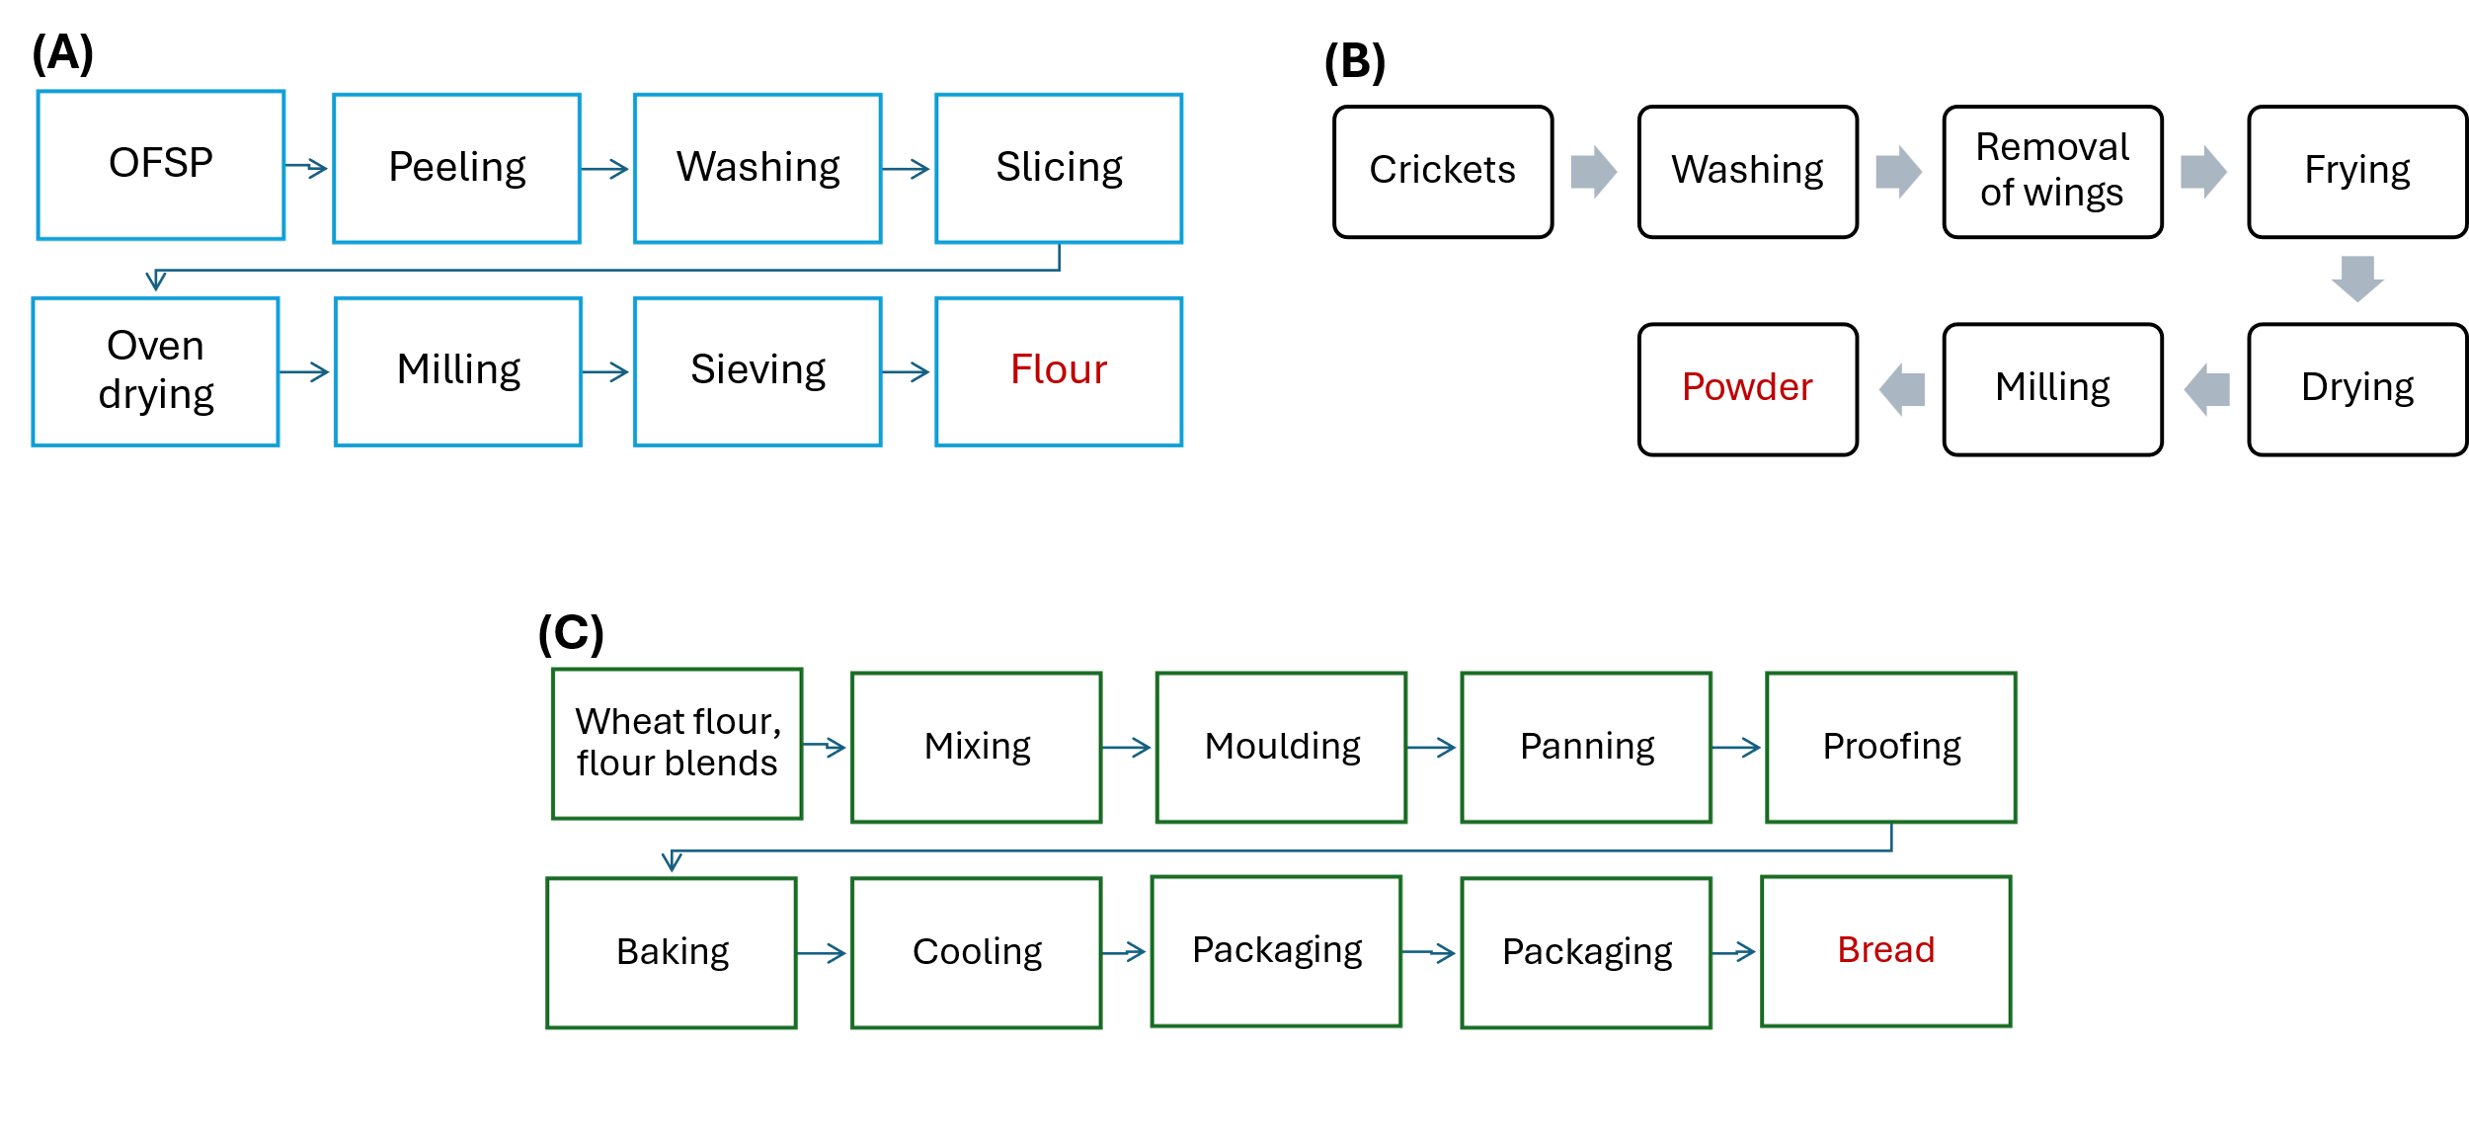

Figure 1. (A) Flow chart for the production of orange-fleshed sweet potato flour, (B) Flow chart for production of cricket powder, and (C) Flow chart for the production of bread (Ubbor et al., 2022; Kure et al., 2022; Igbabul et al., 2022)[14-16].

**2.2** **Production of Bread**

Three blends of wheat flour (WF), sweet potato flour (SP), and cricket powder (CP) were prepared by mixing the constituents in the proportions of 90:5:5, 80:15:5, and 70:25:5 respectively, with the ratio, 100:0:0 as control (Table1). The ingredients used for bread making in this work are presented in Table 1. They were purchased locally. The straight dough method described by Igbabul *et al.* [17] was employed with slight modifications in the production of bread and composite breads. Three (3) blend formulations (Table 2) including control (wheat flour 100 %) were properly mixed with the other baking ingredients in Table 1. After mixing, the dough was kneaded properly using a Kenwood mixer for 15 min. The resulting dough was moulded in uniform sizes and placed in labeled greased pans. These were further placed in a proofing cabinet and allowed to proof for 30 min at 50 0C. Baking was carried out in a pre-heated oven at a temperature of 250 0C for 30 min. Bread samples were removed from the pans, allowed to cool, packaged in polyethylene bags, and stored at ambient temperature till subsequent analyses (Figure 1C).

**Table 1:** Ingredients for Bread Making

|  |  |  |  |  |  |
| --- | --- | --- | --- | --- | --- |
| Samples | Sugar (g) | Margarine (g) | Yeast (g) | Salt (g) | Water (mL) |
|  |  |  |  |  |  |
| 100:0:0 | 80 | 40 | 10 | 5 | 270 |
| 90:5:5 | 80 | 40 | 10 | 5 | 270 |
| 80:15:5 | 80 | 40 | 10 | 5 | 270 |
| 70:25:5 | 80 | 40 | 10 | 5 | 270 |

Source Igbabul *et al.,* (2018) Slightly Modified

KEY: WTF = Wheat Flour, OFSPF = OFSPFlour, CP = Cricket Powder

**Table 2:** Blends formulation of the Composite Flour (%) for Bread Production

|  |  |  |  |
| --- | --- | --- | --- |
| Sample | WTF | OFSPF | CP |
| A | 100 | 00 | 00 |
| B | 90 | 05 | 05 |
| C | 80 | 15 | 05 |
| D | 70 | 25 | 05 |

**KEY: WTF = Wheat Flour, OFSPF = OFSPFlour, CP = Cricket Powder** A**=** 100 % Wheat Flour + 0 % OFSPFlour + 0 % Cricket Powder B= 90 % Wheat Flour + 5 % OFSPFlour + 5 % Cricket Powder C= 80 % Wheat Flour + 15 % OFSPFlour + 5 % Cricket Powder D= 70 % Wheat Flour + 25 % OFSPFlour + 5% Cricket Powder

**2.3 Determination of Properties of the Flour Blends and Bread Samples**

Standard methods were employed in determining the functional properties of the flour blends, oil absorption capacity, evaluation of swelling capacity [18], evaluation of bulk density, and determination of water absorption capacity and foaming capacity [19]. The evaluation of the proximate composition of the bread samples (crude protein, crude fats, crude fibre, ash content, moisture content, and carbohydrate content) was carried out according to the approach prescribed by AOAC [20]. The anti-nutrients examined in the bread samples were oxalates, tannins, phytates, and saponins. The technique outlined by Onwuka [21] was used for determining oxalates and phytates. For tannin content analysis, the Folin Denis Spectrophotometric method as described by Ohizua et al. [19] was used while saponin was determined according to the method of Ejikeme et al. [22]. The minerals Magnesium, Potassium and Sodium, Calcium, and Iron were determined according to the method reported by Kure *et al*., [15]. In addition, the amino acid profile was determined with Technicon Sequential Multi-Sample Amino Acid Analyzer using the method described by AOAC [20], and standard analytical procedures were employed to determine the vitamin A, B12, and B6 composition of the bread samples [20]. With slight modifications, the conventional procedures outlined by Ding et al. [23] were used to establish the physical features of the bread samples, including their weight, volume, and specific volume. Kure et al. [15] reported a method for determining the oven spring which was employed.A description of the organoleptic properties of the bread samples was done in agreement with the report of Ayensu et al. [24]. Specifically, the descriptive sensory analytical method was employed for the evaluation of organoleptic properties. A quantitative descriptive analysis (QDA) was carried out where a trained panel evaluated sensory attributes using standardized descriptors and intensity scales. Findings were reported as mean ± standard deviation for c values obtained in three replicates (n = 3). All data analyses were undertaken utilizing one-way ANOVA. To deal with the main factors of variation, the Least Significant Difference (LSD) was employed, and data was collected using a statistical analysis system (SAS) with statistically significant values stated as p < 0.05.

**3.0 RESULTS AND DISCUSSION**

**3.1 Functional properties of flour blends of wheat, OFSP, and cricket powder**

Table 3 outlines the flour blends' functional characteristics. The study reveals that the oil absorption capacity of flour blends increased significantly with the addition of sweet potato flour. The swelling and foaming capacities also increased with the addition of sweet potato flour and cricket powder. However, the water absorption capacity declined with the addition of OFSP flour. These functional characteristics are crucial for predicting the behavior of new proteins, fats, carbohydrates, and fibre in a food structure and determining the potential use of these substances in traditional food products [25,26].

**Table 3.** Analysis of functional features of Flour blends of Wheat, OFSP, and Cricket Powder

|  |  |  |  |  |  |
| --- | --- | --- | --- | --- | --- |
| Samples | Oil Absorp. Capacity % | Bulk density  g/m3 | Water Absorption Capacity % | Swelling capacity % | Foaming capacity % |
|  |  |  |  |  |  |
| 100:0:0 | 75.44a ± 0.01 | 0.65a ± 0.01 | 88.70d ± 0.02 | 16.33a ± 0.02 | 16.82a ± 0.02 |
| 90:5:5 | 78.22b ± 0.01 | 0.69a ± 0.01 | 84.74c ± 0.02 | 17.52b ± 0.07 | 18.43b ± 0.03 |
| 80:15:5 | 81.34c ± 0.01 | 0.67a ± 0.01 | 78.67b ± 0.02 | 18.74c ± 0.02 | 20.16c ± 0.02 |
| 70:25:5 | 87.94d ± 0.01 | 0.65a ± 0.01 | 73.48a ± 0.02 | 20.17d ± 0.02 | 22.78d ± 0.02 |
| LSD | 0.02 | 0.09 | 0.03 | 0.07 | 0.04 |

Results are displayed as the average of three (n=3) replicates ± Standard deviation. All displayed averages accompanied by superscripts that differ down the column vary substantially (p ≤ 0.05).

The functional analysis results reveal that flour blends with higher OFSP content and cricket powder increase oil absorption capacity. The sample with 70% wheat flour, 25% OFSP, and 5% cricket powder had the highest absorption capacity, while the control had the lowest. This suggests that high protein foods have better oil absorption capacity, which is crucial for enhancing mouthfeel, flavour retention, and improving the texture of baked goods. Bulk density data assesses flour weightiness, processing demands and packing materials for food. Blended flours showed no significant variation in bulk density compared to the control. Lower bulk density indicates more flour particles, resulting in greater packing benefits. This aligns with Asaam et al. [27] findings on lower bulk-density flours.

Interestingly, the study found that the water absorption efficiency of flour blends decreased with increased OFSP content and cricket powder incorporation. The control sample had a high-water absorption efficiency of 88.70%, possibly due to high carbohydrate concentration. However, all composite blends showed better absorption efficiency towards water molecules, making them useful for creating baked goods, soups, gravies, and ready-to-eat culinary products. Swelling capacity, a measure of starch hydration, indicates synergistic adhesive force within starch granules. It increases with the addition of OFSP flour, with the highest score in a 70:25:5 sample. This suggests that OFSP flour could be used in bakery products, as it indicates non-covalent bonding between starch molecules and α-amylose and amylopectin ratios [28]. It was further observed that protein is the primary factor for foaming, with higher foaming capacity in composite flours compared to the control sample. The bread sample with 30% wheat flour substitution had the highest foaming capacity, possibly due to the substantial protein content in cricket flour.

**3.2** **Proximate assessment of flour blends of wheat, OFSP, and cricket powder and their composite bread**

The result of the proximate assessment of flour blends of wheat, OFSP, and cricket is presented in Figure 2A. The study evaluated flour blends of wheat, OFSP, and cricket, revealing a significant increase in crude protein, fat, crude fibre, and ash in bread samples. Cricket powder added to flours increased crude protein, aligning with previous research showing a high protein score of 62.51% in cricket flour [29]. Edible crickets have high protein content, beneficial for overweight or diabetics [30]. The addition of cricket powder to wheat-sweet potato blend bread increased fat content, with the 70:25:5 ratio having the highest fat content. This could be due to the high-fat content of cricket powder, a functional fatty acid with health benefits [29,30]. Blended bread with more fat is expected to be more appealing and have a low level of rancidity, extending its shelf life. The highest level of crude fibre was recorded in the 70:25:5 flour blend ratio. The ash content in flour blends and bread improved with increased OFSP flour and cricket powder, indicating a higher mineral composition. This is due to the addition of cricket powder. Studies suggest that high ash content OFSP could help prevent undetected starvation, especially among young people, expecting mothers, and breastfeeding women, and enhance sweet potato supply and demand in Benin [31].

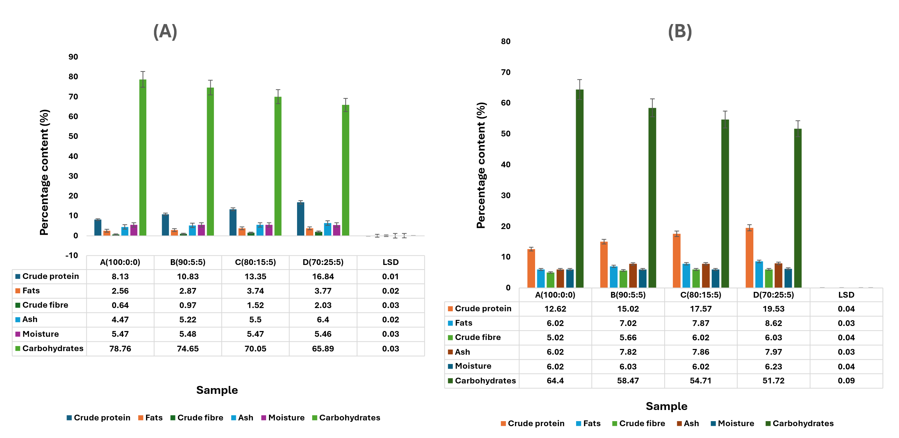

**Figure 2.** Proximate assessment of flour blends of wheat, OFSP, and cricket powder (A) Proximate composition of composite bread from flour blends of wheat, OFSP, and cricket powder (B)

The results of moisture composition of the flour samples found no significant variation in moisture composition between flour blends and control flour. However, the water absorption capacity decreased with increasing OFSP flour and cricket powder addition. The significant increase in moisture composition in sample 70:25:5 may be due to water added during baking. Low moisture content can delay chemical reactions and microbiological activity, extending food substance lifespan [32]. The carbohydrate composition of blend flours decreased compared to 100% wheat flour, with wheat flour being the major contributor. This decrease is consistent with previous studies [1, 33, 34]. Despite the decrease, carbohydrate values remained high due to the high carbohydrate content in wheat flour, suggesting that consuming bread made from these flours provides energy. Interestingly, variations in the composition of nutrients (Figure 2B) of 100% (wheat bread), the control, and bread produced using the composite flours were relevant (p≤0.05). Crude protein contents elevated substantially (p≤0.05) with values ranging from 12.62–19.53 %; fat, 6.02–8.62 %; ash, 5.02–6.03 %; fibre, 6.02–7.97 %; moisture, 6.02–6.23 %., while carbohydrate contents with values ranging from 51.72–64.40 % reduced substantially (p>0.05) with decreasing levels of wheat flour in the composite flours.

**3.3** **Anti-nutrient component analysis of flour blends of wheat, OFSP, and cricket powder and their composite bread**

The analysis found that the anti-nutrient content in bread increased with the incorporation of cricket powder, but fewer anti-nutrients were found in bread made from these flours (Table 4). This reduction may be due to baking processes. Anti-nutrients can be harmful when consumed in high amounts, so processing operations can reduce their presence [35]. Oxalates levels also increased with wheat flour composition, but the study found that the lethal level of oxalate in adults is less than 3-5 g, indicating no side effects [36,37]. The composition of tannins rises with the persistent rise in the amount of OFSP and the incorporation of cricket powder. Tannins, which have antinutritional properties, inhibit nutrient breakdown and lower the risk of heart attacks [38]. The level of phytates also increased, possibly due to the addition of cricket powder. Phytates can impact mineral bioavailability, solubility, and digestion by reducing the absorption of minerals and blocking digestive enzymes. The study suggests that the incorporation of cricket powder in flour blends could also contribute to the increase in phytate levels in the flour blends and bread [39].

**Table 4**. Anti-nutrient composition of Flour blends of Wheat, OFSP, and Cricket Powder (g/100g)

|  |  |  |  |  |
| --- | --- | --- | --- | --- |
| Sample | Oxalates | Tannins | Saponins | Phytates |
| 100:0:0 | 0.25a ± 0.02 | 0.53a ± 0.02 | 1.06a ± 0.02 | 0.68a ± 0.02 |
| 90:5:5 | 0.73b ± 0.02 | 0.86a ± 0.49 | 2.24b ± 0.02 | 1.22b ± 0.01 |
| 80:15:5 | 0.78c ± 0.02 | 0.93a ± 0.49 | 2.52c ± 0.02 | 1.89c ± 0.01 |
| 70:25:5 | 0.84d ± 0.01 | 1.06a ± 0.50 | 2.90d ± 0.02 | 2.12d ± 0.01 |
| LSD | 0.03 | 0.81 | 0.03 | 0.02 |

Results are displayed as average of three (n=3) replicates ± Standard deviation. All displayed averages that accompanied by superscripts that differs down the column varies substantially (p ≤ 0.05).

Granules and cereals are deficient in saponins, which may be due to increased levels of OFSP and cricket powder [40]. Saponins are not-volatile glycosidic chemicals found in most plants and have various biological properties, including antioxidant, anti-tumor, hypocholesterolemia, diabetic, and anti-inflammatory properties [41]. They are generally poisonous to cold-blooded species but have low oral hazard in mammals. Saponins react with various anti-nutrients, reducing their toxic effects. However, increased intake may decrease mineral availability [42,43]. The values presented in Figure 3 show the concentration of anti-nutrients in the bread samples. The values show a notable variation (p ≤ 0.05) among the anti-nutrient components of the bread samples Values for oxalates ranged from 0.14-0.50g/100g; tannins (0.22-0.71 g/100g), saponins (0.78-1.06 g/100g), and phytates (0.35-0.88 g/100g).

**Figure 3.** Anti-nutrient Composition of Bread baked using Flour blends of Wheat, OFSP, and Cricket Powder

**3.5 Mineral analysis of bread made using flour blends of wheat, OFSP, and cricket powder**

The analysis of the mineral component of the bread samples is reported in Table S1. It can be observed that bread made from composite flours had significantly higher levels of magnesium, potassium, calcium, sodium, and iron compared to those made from 100% wheat flour. This could be attributed to the increased percentage composition of OFSP flour and cricket powder, which are known for their high mineral content. The study also found that the bread samples baked with the blended flours had higher levels of calcium, which is essential for maintaining a normal heartbeat, blood coagulation, nerve impulse transmission, bone growth and strength, and muscular function. Consuming bread made from these flour blends alongside other calcium-rich foods could yield desirable results [44]. Furthermore, it was found that bread made from flour blends had higher sodium content than those made from a 100:0:0 flour mix. This increase could be attributed to the cricket powder in the blends. The addition of table salt for taste could also increase sodium content. The bread also had higher iron content, surpassing those reported by other research groups [45]. Iron aids in red blood cell formation and oxygen transport, making it suitable for low-salt diets. The results suggest that good mineral content bread can be baked with flour blends of wheat, OFSP, and cricket powder.

**3.6 Amino acids profile of bread baked with flour blends of wheat, OFSP, and cricket powder**

The results in this report show that the non-essential amino acid composition was correspondingly greater than the essential amino acids (Figure 4). Amino acids are crucial for assessing protein quality. The dosage of OFSP flour and cricket powder increased progressively with a corresponding rise in the amino acids profile, an indication that the bread's protein integrity is determined by its essential amino acids. The essential amino acids increased along the composite flours with leucine showing the greatest concentration (8.94 mg/100 g) and methionine having the lowest value (1.56 mg/100 g). Wheat flour comprises just 0.953 g of leucine per 100 g [46]. High levels of tryptophan, phenylalanine, and histidine in OFSP flour may promote fast development in children and teens. Adding OFSP flour to wheat flour in baking increased its lysine and threonine components (Mafu et al., 2022)[1].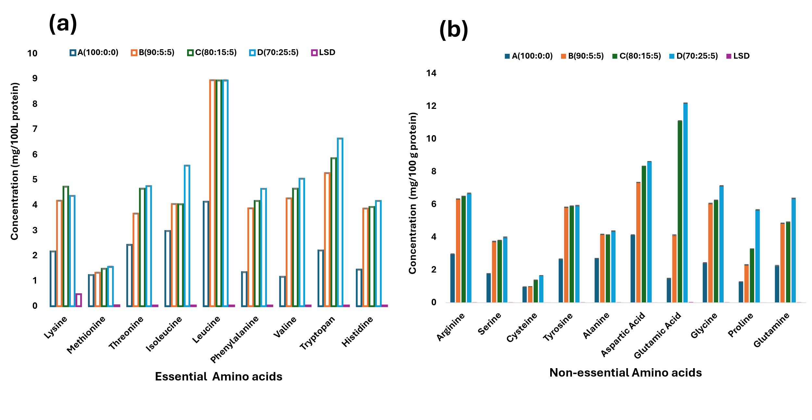

**Figure 4.** Essential amino acids composition of bread baked with flour blends of wheat, OFSP, and cricket powder (a) and non-essential amino acids composition of bread baked with flour blends of wheat, OFSP, and cricket powder (b).

It was observed that non-essential amino acids in flour blends increased gradually, with glutamic and aspartic acids having the highest levels. The high levels of non-essential acids in the flour blends, which were fortified with cricket powder, indicate high protein quality in the bread samples [1].

**3.7** **Vitamin composition of bread baked with flour blends of wheat, OFSP, and cricket powder**

Vitamin contents analysis showed an infinitesimal increase in the vitamin A composition of bread due to the inclusion of OFSP in composite flours (Figure 5). OFSP, a bio-fortified crop, has high beta carotene content, potentially preventing vitamin A deficit in susceptible populations. The bread also contains a substantial amount of pro-vitamin A, which is lacking in whole-wheat flours and breads. The vitamin B12 composition was greater in the composite bread, possibly due to the inclusion of cricket powder in the formulation. These findings align with previous research [15,47].

**Figure 5.** Vitamin composition of bread baked with flour blends of wheat, OFSP, and cricket powder

**3.9**: **Physical analysis of bread baked with flour blends of wheat, OFSP, and cricket powder**

Physical examination of the bread samples revealed that bread baked with flour blends had lower oven spring, loaf volume, and specific loaf volume compared to the control (Table 5). This reduction may be due to the diluting impact of wheat gluten and the dough's inability to swell during proofing. The lowest loaf volume and specific loaf volume were reported in sample 70:25:5, while specific loaf volume and loaf volume were higher in the control sample. The study also found that adding cricket powder to the bread mix reduced loaf volume and specific volume, and the total weight of the loaf decreased as the amount of wheat flour declined.

**Table 5.** Physical Properties of Bread baked using Flour blends of Wheat, OFSP, and Cricket Powder

|  |  |  |  |  |  |  |  |  |  |
| --- | --- | --- | --- | --- | --- | --- | --- | --- | --- |
| Sample | | Oven spring (cm) | | Loaf weight (g) | | Loaf volume | | Specific loaf volume | |
|  | |  | |  | | (cm3) | | (cm3/g) | |
| 100:0:0 | | 8.45d ± 0.05 | | 236.50d ± 0.50 | | 465.11d ± 0.01 | | 1.97d ± 0.01d | |
| 90:5:5 | | 8.25c ± 0.05 | | 231.50b ± 0.50 | | 442.24c ± 0.01 | | 1.91c ± 0.01c | |
| 80:15:5 | | 6.85a ± 0.05 | | 228.00a ± 0.00 | | 425.11b ± 0.01 | | 1.86b ± 0.01b | |
| 70:25:5 | | 7.15b ± 0.05 | | 234.50c ± 0.50 | | 420.44a ± 0.01 | | 1.79a ± 0.01a | |
| LSD | 0.09 | | 0.82 | | 0.02 | | 0.01 | |  | |

Results are displayed as average of three (n=3) replicates ± Standard deviation. All displayed averages that accompanied by superscripts that differs down the column varies substantially (p ≤ 0.05).

**3.10** **Sensory mean scores of bread baked with flour blends of wheat, OFSP, and cricket powder**

Sensory assessment is an essential factor for determining quality in the creation of new goods and satisfying consumer demands [48]. This study assessed bread sensory qualities, focusing on crust appearance, crumb texture, aroma, taste, and general satisfaction. Results showed that bread with 100% wheat flour had better qualities than blended flours. The crust color was altered due to the Maillard process, which creates fragrance and color compounds. The study found no significant variation in crust look or crumbs quality between control and 90:5:5 bread.

**Table 6.** Sensory properties of bread baked using flour blends of Wheat, OFSP, and Cricket Powder

|  |  |  |  |  |  |
| --- | --- | --- | --- | --- | --- |
| Sample | Sensory Attributes | | | | |
|  | Crust appearance | Crumb texture | Aroma | Taste | General acceptability |
|  |  |  |  |  |  |
| 100:0:0 | 8.36b ± 0.86 | 8.24b ± 1.17 | 8.20b ± 0.58 | 8.52b ± 0.83 | 8.52b ± 0.77 |
| 90:5:5 | 8.16b ± 0.80 | 7.92b ± 0.76 | 7.68ab± 1.11 | 8.08ab ± 1.41 | 8.08ab± 0.81 |
| 80:15:5 | 7.44a ± 0.92 | 7.80b ± 0.87 | 7.88ab ± 0.93 | 7.79ab ± 0.79 | 8.20b ± 0.82 |
| 70:25:5 | 7.32a ± 0.95 | 7.12a ± 1.24 | 7.44a ± 1.16 | 7.52a ± 1.19 | 7.64a  ± 1.19 |
| LSD | 0.54 | 0.58 | 0.50 | 0.51 | 0.61 |

Results are displayed as average of three (n=3) replicates ± Standard deviation. All displayed averages that accompanied by superscripts that differs down the column varies substantially (p ≤ 0.05).

Texture is the property of bread that may be determined by touch, such as whether it is rough or smooth, firm or soft (Burt et al., 2020)[29]. The addition of cricket powder has a high fat content (7.02-8.62%), leading in the crumble of enhanced bread. Furthermore, a high fat content might alter the framework and texture. The study explored the impact of adding cricket powder to bread, which has a high fat content. The results show that the crumb texture decreases with wheat flour reduction, but no panellists showed a total dislike for any flour blends. The taste preference was highest for a ratio of 90:5:5, possibly due to the presence of anti-nutrients and high fibre content. The universal credibility metric showed no negative impact on sensory qualities. The most preferred bread was made with 90% wheat flour, 5% OFSP flour, and 5% cricket powder.

**4. CONCLUSION**

The study found that adding cricket powder to wheat and orange fleshed sweet potatoes (OFSP) flour blends increased crude protein, ash content, and fat content, while decreasing carbohydrate and fibre composites. Additionally, the addition of cricket powder increased mineral, vitamins, and amino acid contents. The results suggest that good mineral content bread can be baked with these flour blends.

Disclaimer (Artificial intelligence)

Author(s) hereby declare that NO generative AI technologies such as Large Language Models (ChatGPT, COPILOT, etc.) and text-to-image generators have been used during the writing or editing of this manuscript.

**REFERENCES**

[1] Mafu, A., Ketnawa, S., Phongthai, S., Schönlechner, R., & Rawdkuen, S. (2022). Whole Wheat Bread Enriched with Cricket Powder as an Alternative Protein. *Foods*, *11*(14), 2142.

[2] Ibrahim, U. K., Salleh, R. M., & Maqsood-ul-Haque, S. N. S. (2015). Bread towards functional food: an overview. *International Journal of Food Engineering*, *1*(1), 39-43.

[3] Zhou, W., Therdthai, N., & Hui, Y. H. (2014). Introduction to baking and bakery products. *Bakery products science and technology*, 1-16.

[4] de Carvalho, N. M., Madureira, A. R., & Pintado, M. E. (2020). The potential of insects as food sources–a review. *Critical reviews in food science and nutrition*, *60*(21), 3642-3652.

[5] Ercolini, D., & Fogliano, V. (2018). Food design to feed the human gut microbiota. *Journal of agricultural and food chemistry*, *66*(15), 3754-3758.

[6] FAO. (2017). The Future of Food and Agriculture—Trends and Challenges. Rome, Italy.

[7] Cappelli, A., Oliva, N., Bonaccorsi, G., Lorini, C., & Cini, E. (2020). Assessment of the rheological properties and bread characteristics obtained by innovative protein sources (Cicer arietinum, Acheta domesticus, Tenebrio molitor): Novel food or potential improvers for wheat flour?. *Lwt*, *118*, 108867.

[8] Del Hierro, J. N., Gutiérrez-Docio, A., Otero, P., Reglero, G., & Martin, D. (2020). Characterization, antioxidant activity, and inhibitory effect on pancreatic lipase of extracts from the edible insects Acheta domesticus and Tenebrio molitor. *Food Chemistry*, *309*, 125742.

[9] Adeyeye, E. I., & Awokunmi, E. E. (2010). Chemical composition of female and male giant African crickets, *Brachytrypes membranaceus* L. *International journal Pharmaceutical and Bio-medical Sciences*, *1*(4), 125-136.

[10] Purcell, A. E., Walter, W. M., & Wilson, L. G. (2021). Sweet potatoes. In Quality and preservation of vegetables (pp. 285-304). CRC press.

[11] Van Jaarsveld, P. J., Marais, D. W., Harmse, E., Nestel, P., & Rodriguez-Amaya, D. B. (2006). Retention of β-carotene in boiled, mashed, orange-fleshed sweet potato. *Journal of Food Composition and Analysis*, *19*(4), 321-329.

[12] FAO (2006). A Cassava Industrial Revolution in Nigeria. FAO Corporate Document Repository. http://www.fao.orga// docrep/007/y5548e/y5 548e06htm. (Accessed 05/12/11).

[13] Noorfarahzilah, M., Lee, J. S., Sharifudin, M. S., Mohd Fadzelly, A. B., & Hasmadi, M. (2014). Applications of composite flour in development of food products. International Food Research Journal, 21(6).

[14] Ubbor, S. C., Arukwe, D. C., Ezeocha, V. C., Nwoso, O. N., Iguh, B. N., & Nwibo, O. G. (2022). Production and quality evaluation of ready to eat extruded snacks from flour blends of acha-cowpea and sweet potato starch. Fudma Journal of Sciences, 6(4), 245-153.

[15] Kure, O. A., Ibrahim, S., & Inikpi, I. Z. (2022). Quality Evalution of Nigeria Base-masa from Broken Rice Enriched with African Yam Bean and Cricket Flour Blends. *Current Journal of Applied Science and Technology*, *41*(5), 37-50.

[16] Igbabul, B., Ogunrinde, M. D., & Amove, J. (2018). Proximate, micronutrient composition, physical and sensory properties of cookies produced with wheat, sweet detar and moringa leaf flour blends. *Current Research in Nutrition and Food Science Journal*, *6*(3), 690-699.

[17] Igbabul, N. D. B., & Abu, F. S. B. I. J. (2016). Physicochemical, nutritional and sensory properties of bread from wheat, acha and mung bean composite flours. *Food Sci Qual Manag*, *56*, 21-4.

[18] Ihembe, W. (2023) Effects of Treatments on the Quality of Biscuits Produced from Flour Blends of Wheat and Bambara Nut.Unpolished master’s thesis, Department of Chemistry, Faculty of Science, Benue State University Makurdi.

[19] Ohizua, E. R., Adeola, A. A., Idowu, M. A., Sobukola, O. P., Afolabi, T. A., Ishola, R. O., ... & Falomo, A. (2017). Nutrient composition, functional, and pasting properties of unripe cooking banana, pigeon pea, and sweetpotato flour blends. *Food science & nutrition*, *5*(3), 750-762.

[20] Association of Analytical Communities. (2023). Official Method 922.06. Fat in flour: Acid hydrolysis method. Official methods of analysis of AOAC International.

[21] Onwuka, G. I. (2005). Food analysis and instrumentation theory and practice. Naphthali prints. *Lagos. Nigeria*, 64-76.

[22] Ejikeme, C., Ezeonu, C. S., & Eboatu, A. N. (2014). Determination of Physical and Phytochemical Constituents of some Tropical Timbers Indigenous to nigerdelta area of nigeria. *European Scientific Journal*, *10*(18), 247-270.

[23] Ding, S., Peng, B., Li, Y., & Yang, J. (2019). Evaluation of specific volume, texture, thermal features, water mobility, and inhibitory effect of staling in wheat bread affected by maltitol. Food chemistry, 283, 123-130.

[24] Ayensu, J., Lutterodt, H., Annan, R. A., Edusei, A., & Loh, S. P. (2019). Nutritional composition and acceptability of biscuits fortified with palm weevil larvae (Rhynchophorus phoenicis Fabricius) and orange‐fleshed sweet potato among pregnant women. Food Science & Nutrition, 7(5), 1807-1815.

[25] Galanakis, C. M. (2021). Functionality of food components and emerging technologies. Foods, 10(1), 128.

[26] Awuchi, C. G., Igwe, V. S., & Echeta, C. K. (2019). The functional properties of foods and flours. International Journal of Advanced Academic Research, 5(11), 139-160.

[27] Asaam, E. S., Adubofuor, J., Amoah, I., & Apeku, O. J. D. (2018). Functional and pasting properties of yellow maize–soya bean–pumpkin composite flours and acceptability study on their breakfast cereals. Cogent Food & Agriculture, 4(1), 1501932.

[28] Sere, A., Bougma, A., Bazié, B. S. R., Nikièma, P. A., Gnankiné, O., & Bassolé, I. H. N. (2022). Nutritional and Functional Properties of Defatted Flour, Protein Concentrates, and Isolates of Brachytrupes membranaceus (Orthoptera: Gryllidae) (Drury: 1773) and Macrotermes subhyalinus (Isoptera: Blattodea)(Rambur: 1842) from Burkina Faso. *Insects*, *13*(9), 764.

[29] Loypimai, P., Moontree, T., Pranil, T., & Moongngarm, A. (2024). A comparative study of nutritional components of Gryllus bimaculatus and Acheta domesticus cricket powder prepared using different drying methods. Journal of Food Measurement and Characterization, 18(5), 3974-3983.

[30] Magara, H. J., Niassy, S., Ayieko, M. A., Mukundamago, M., Egonyu, J. P., Tanga, C. M., ... & Ekesi, S. (2021). Edible crickets (Orthoptera) around the world: distribution, nutritional value, and other benefits—a review. Frontiers in nutrition, 7, 537915.

[31] Sanoussi, A. F., Adjatin, A., Dansi, A., Adebowale, A., Sanni, L. O., & Sanni, A. (2016). Mineral composition of ten elite sweet potato (*Ipomoea batatas* [L.] Lam.) Landraces of Benin. *International Journal of Current Microbiology and Applied Sciences*, *5*(1), 103–115.

[32] Amit, S. K., Uddin, M. M., Rahman, R., Islam, S. R., & Khan, M. S. (2017). A review on mechanisms and commercial aspects of food preservation and processing. Agriculture & Food Security, 6, 1-22.

[33] Kidane, G., Abegaz, K., Mulugeta, A., & Singh, P. (2013). Nutritional analysis of vitamin A enriched bread from orange flesh sweet potato and locally available wheat flours at Samre Woreda, Northern Ethiopia. Current Research in Nutrition and Food Science Journal, 1(1), 49-57.

[34] Godswill, A. C. (2019). Proximate composition and functional properties of different grain flour composites for industrial applications. International Journal of Food Sciences, 2(1), 43-64.

[35] Popova, A., & Mihaylova, D. (2019). Antinutrients in plant-based foods: A review. *The Open Biotechnology Journal*, *13*(1).

[36] Salgado, N., Silva, M. A., Figueira, M. E., Costa, H. S., & Albuquerque, T. G. (2023). Oxalate in foods: extraction conditions, analytical methods, occurrence, and health implications. Foods, 12(17), 3201.

[37] Chukwujekwu, O. J. (2024). Nutritional Composition and Antinutritional Factor Analysis of Kpokpogari and Starch: A Comparative Study Using Commercial Wheat. Archives of Advanced Engineering Science, 2(2), 114-121.

[38] Anbuselvi, S., & Muthumani, S. (2014). Phytochemical and antinutritional constituents of sweet potato. Journal Chemistry Pharmaceutical Research, 6, 380-383.

[39] Zhong, Z. Y., Lin, L. Z., Cui, P., Lü, Z. F., Pang, L. J., & Lu, G. Q. (2021). Effect of growth period on content (activity) of antinutritional factors in sweet potato tubers.

[40] Stull, V. J. (2021). Impacts of insect consumption on human health. Journal of Insects as Food and Feed, 7(5), 695-713.

[41] Sharma, K., Kaur, R., Kumar, S., Saini, R. K., Sharma, S., Pawde, S. V., & Kumar, V. (2023). Saponins: A concise review on food related aspects, applications and health implications. Food Chemistry Advances, 2, 100191.

[42] Samtiya, M., Aluko, R. E., & Dhewa, T. (2020). Plant food anti-nutritional factors and their reduction strategies: an overview. Food Production, Processing and Nutrition, 2, 1-14.

[43] Chukwuebuka, E., & Chinenye, I. J. (2015). Biological functions and anti-nutritional effects of phytochemicals in living system. J Pharm Biol Sci, 10(2), 10-19.

[44] Agrahar-Murugkar, D., & Dixit-Bajpai, P. (2020). Physicochemical, textural, color, nutritional, scanning electron microscopy and sensorial characterization of calcium-rich breads fortified with sesame, malted finger millet, cumin and moringa leaves. Nutrition & Food Science, 50(1), 47-60.

[45] Ranjbar, A., Heshmati, A., Momtaz, J. K., & Vahidinia, A. (2019). Effect of iron-enrichment on the antioxidant properties of wheat flour and bread. Journal of cereal science, 87, 98-102.

[46] Litwinek, D., Boreczek, J., Gambuś, H., Buksa, K., Berski, W., & Kowalczyk, M. (2022). Developing lactic acid bacteria starter cultures for wholemeal rye flour bread with improved functionality, nutritional value, taste, appearance and safety. PLoS One, 17(1), e0261677.

[47] Perez-Fajardo, M. A. (2020). Impact of cricket protein powder replacement on wheat protein composition, dough rheology and bread quality (Doctoral dissertation).

[48] Munoz, A. M. (Ed.). (2013). Sensory evaluation in quality control. Springer Science & Business Media.