COMPARATIVE EVALUATION OF C-ARM GUIDED AND OPEN INTRAMEDULLARY PIN FIXATION FOR LONG BONE FRACTURES IN DOGS

ABSTRACT
The present study was carried out on 12 clinical cases of dogs having long bone fractures. The dogs were randomly divided into two groups based on the methods used for fracture stabilization. The fractures were stabilized using intramedullary pinning either by the open reduction (group A, n=6) or the C-arm guided closed reduction method (group B, n=6). A higher incidence of fractures was observed in male dogs (66.67%) among which femur was most common (58.34 %) followed by tibia/fibula 25 %. The main causes of the fractures were automobile accidents (58.34%) followed by free falls from height (25%).Breed wise distribution found the highest incidence in non-descript dogs (50%) followed by German shepherds (25%). The dogs in the age group of 0-6 months were found most affected (41.67%), followed by the age group of 7-12 months (33.34%).The mean incision length and duration of surgery were shorter in group B as compared to group A. The mean radiographic healing score was higher in group-B than in group-A, although statistically non-significant. The lameness score decreased faster in group B compared to group A. C-arm guided intramedullary pinning is more suitable for transverse fracture as compared to oblique and comminuted fracture. The shorter incision lengths and operating times result in more rapid fracture healing and favour early ambulation with fewer post-operative complications.
Keywords: Dogs, long bone fracture, Retrograde pinning, Closed reduction, C-arm.

INTRODUCTION
With the evolution of society, the role of dogs has also evolved. Despite all the care taken by pet owner dogs are susceptible to various injuries mainly accidental injuries due to their surrounding environment (Balagopalan et al., 1995), accidental injury mainly disrupts bones and leads to fracture. The management of fracture mainly includes 4Rs i.e. recognition, reduction, retention and rehabilitation. The main objective of fracture fixation is to promote faster fracture healing and to restore normal function with early mobility (Aron et al., 1995; Taljanovic et al., 2003). Conventionally, fracture management in canines is done by using external co-optation techniques such as bandages, slings, Plaster of Paris and Thomas splints which yield acceptable results with some complications such as shortening, malformation, auto-mutilation, contraction of muscles, non-union, mal-union and delayed union (Denny, 1991). In long bone fracture management, reduction of bone is achieved by either open or closed methods. In open reduction, additional soft tissue trauma and disturbance to hematoma at the fracture site may delay the healing as it contains multilineage mesenchymal progenitor cells.
Biological osteosynthesis is a new concept which emphasises a less rigid fixation of fracture ends with minimal biological damage and without interfering physiological environment at the fracture site (Déjardin et al., 2020). The biological osteosynthesis can be achieved using c-arm guided closed intramedullary pinning which causes minimal surgical wound and early healing. The advancement of novel methodologies to augment the pace of fracture healing and reduce the complications encountered after surgery remains a topic of significant scholarly investigation in the field of veterinary practice.
It was hypothecated that c-arm guided closed intramedullary pinning may be superior to open intramedullary pin fixation in case of long bone fracture management in dogs.

MATERIALS AND METHODS
The present clinical study was carried out on 12 cases of dogs having long bone fractures, presented to the Veterinary Clinical Complex. On preoperative clinical assessment, history was collected; the clinical cases were subjected to radiological examination to ascertain the type of fracture and bone involved. Similarly, the incidence of fractures was analyzed concerning the breed, age, sex, etiology and the bone involved. The cases which were presented with open, oblique and comminuted fractures were selected for open reduction and assigned as group A. whereas, cases with simple, closed, and transverse fractures were selected for closed reduction using C-arm and assigned as group B.
Pre-operative preparation
After the presentation of the dogs, based on radiographic examination, the size of the intramedullary pin was decided in such a way that the pin occupies 60%-70% of the medullary cavity. The fracture site was stabilized temporarily using splints or Roberts-Jones bandages until the day of surgery. Food was withheld for 12 hours and water for 6 hours before surgery. For the surgical procedure dogs were premedicated with inj. Atropine Sulfate @ 0.04 mg/kg body weight subcutaneously and sedation was done using Xylazine at 1 mg/kg (Xylaxin®, Indian Immunological Limited, India). The induction of anaesthesia was done with inj. Ketamine (10 mg/kg body weight) and inj. Diazepam (0.5mg/kg body weight), maintenance of anaesthesia was done using inj. Ketamine and inj. Diazepam in a 1:1 combination.
Surgical Technique
In group A, retrograde pinning with open reduction was performed (Fig.1). The approach was decided according to fractured bone. An incision was made from the greater tubercle to the lateral epicondyle on the cranio-lateral aspect of the humerus, whereas a cranio-medial aspect incision was made for the tibia, In the femur fracture, the incision was made on the cranio-lateral border from the great trochanter to the lateral side of the patella. After the exposure of bone fragments, proximal and distal fragments were held in the bone holder and reduced anatomically (Fig. 2). Then Steinmann pin was inserted from the fracture site into the medullary cavity of the proximal fragment using Jacob’s chuck which came out from the proximal end of the fragment later the chuck disengaged and was applied to the protruding pin from the proximal end. Then withdraw the pin slowly till its end level with the distal end of the proximal segment, by simultaneous traction and manipulation fracture fragments were reduced and aligned. Then Chuck was advanced into the medullary cavity of the distal fragment. The depth of the pin was measured using another pin of the same length i.e., the reference pin. The cerclage wire was used wherever necessary and the remaining pin was cut using a pin cutter.

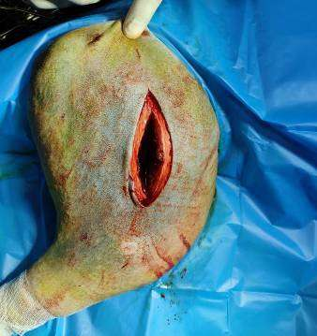

Fig. 1 Length of incision in group A

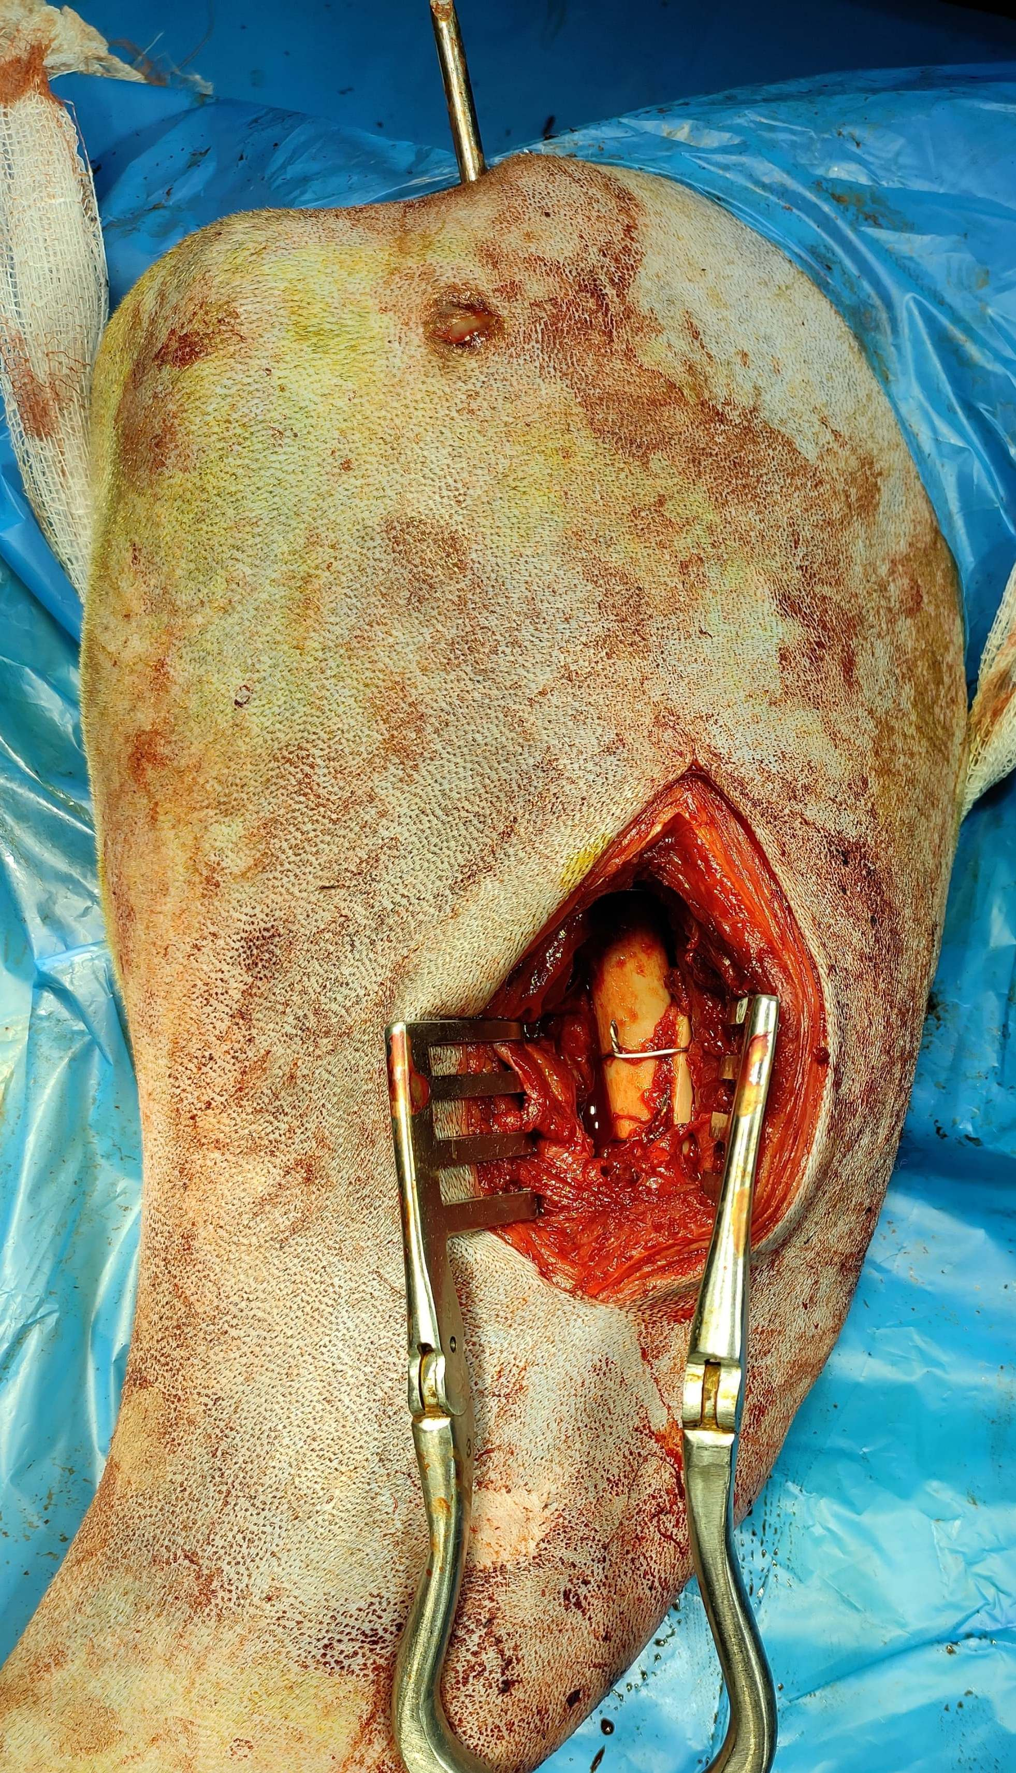
Fig.2 Anatomical reduction of fracture fragment in group A
In group B, after locating the insertion site, a small skin incision was made (Fig. 3). The subtrochanteric fossa was a site of interest for pin insertion in the femur, ending at the distal caudal condyle (Fig. 4A&B). Whereas in the humerus pin was inserted at the anterior crest of the greater tubercle, directed distally which was further rested on medial condyle. For the tibia pin was inserted through the medial border of the patellar ligament, entering the proximal end of the tibia about ¼ inches below the tibial tuberosity or between the medial tuberosity and the medial patellar ligament (Fig. 4 C&D). The intramedullary pin was inserted using Jacob’s chuck with closed reduction under fluoroscopy. Traction and manipulation aligned and reduced the fracture fragments, and the pin was secured and cut under fluoroscopic guidance.
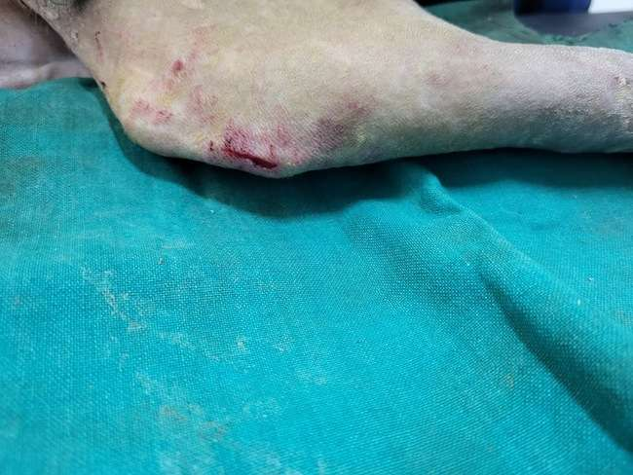

Fig. 3 Length of incision in group B

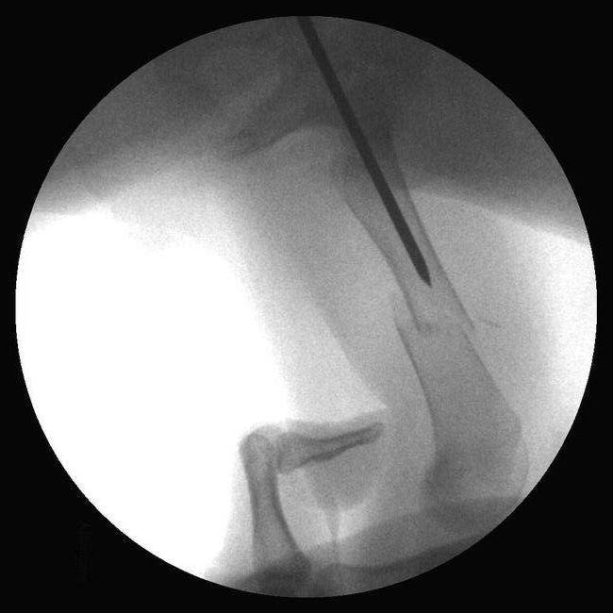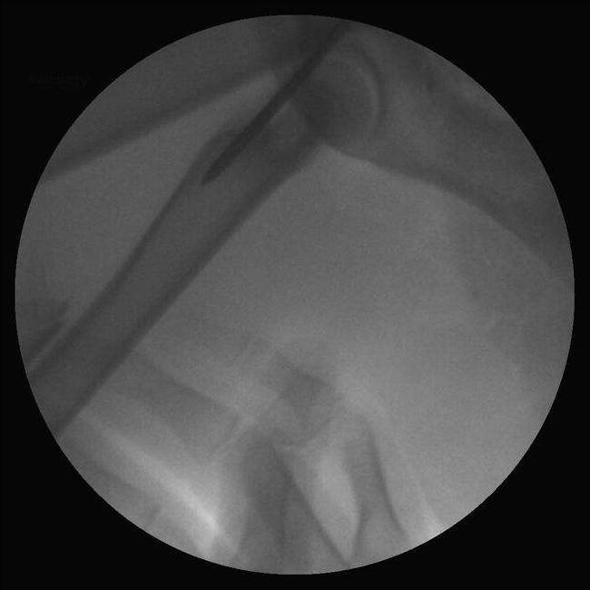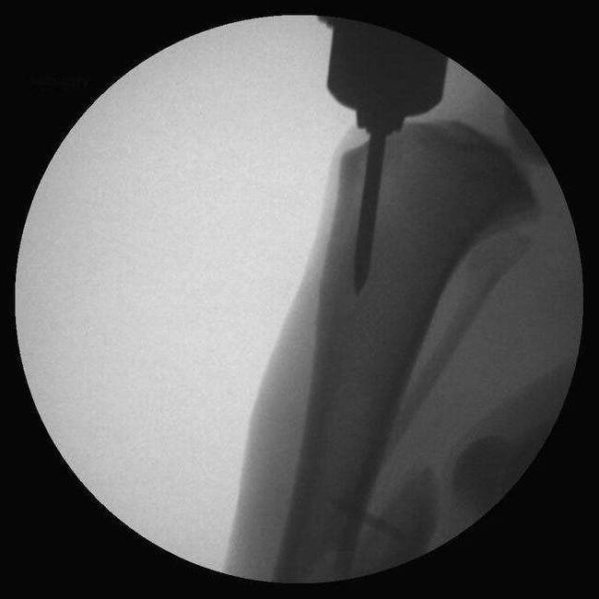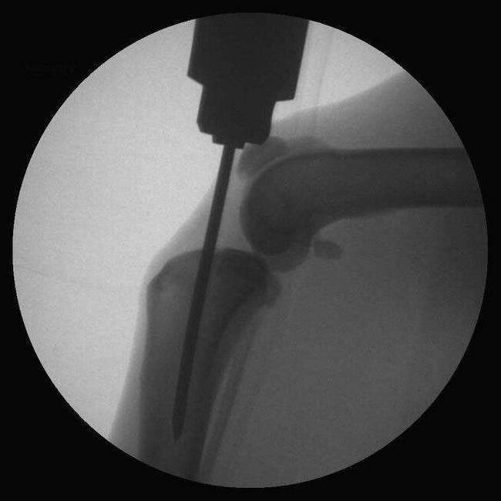
A B C D
Fig. 4 C- arm view of insertion site for Femur (A&B) and Tibia (C&D) for group B
Intra-operative and postoperative observations
Intraoperative observations such as length of incision and duration of surgery were recorded and compared between the groups. The surgical wound healing was evaluated based on the presence of inflammation, edematous swelling and exudation at the fractured site.
Postoperative evaluation of lameness and weight bearing was made on 0, 20th and 45th postoperative days, based on the scale (1-6) given by (Cook et al., 1999). 1: No observable lameness, 2: Intermittent, mild weight-bearing lameness with little if any change in gait, 3: Consistent, mild weight-bearing lameness with little change in gait, 4: Moderate weight-bearing lameness- obvious lameness with noticeable ‘head bob’ and change in gait, 5: Severe weight-bearing lameness- ‘toe-touching’ only, 6: Non-weight-bearing. The radiographic assessment of fracture healing was carried out (Hammer et al., 1985). They scored fracture healing on the scale of (1-5) based on callus formation and elimination of the fracture line or gap in the following manner (Table 1).
Table 1. Grading of radiographic healing
Grade/score | Callus formation | Fracture line
1 | Homogeneous bone structure | Obliterated
2 | Massive Callus, Bone trabeculae crossing fracture line | Barely discernible
3 | Apparent callus, Bridging of the fracture line | Discernible
4 | Trace callus. No bridging of the fracture line | Distinct
5 | No callus formation | Distinct

Statistical analysis was conducted using the Software Package for Social Science (SPSS). T-test and one-way analysis of variance were employed to compare the parameters between the group and within the group respectively.
RESULTS AND DISCUSSION
Incidences in Dog

Table 2. Study of incidences
Groups | Case  No. | Age  (M) | Sex  M/F | Weight  (Kg.) | Breed | Etiology | Bone Involved | Type of Fracture
1  OPEN | 1 | 10 | M | 23 | GS | Accidental | Femur | Transverse
1  OPEN | 2 | 25 | F | 21 | ND | Accidental | Femur | Oblique
1  OPEN | 3 | 6 | M | 23 | ND | Accidental | Femur | Oblique
1  OPEN | 4 | 6 | M | 22 | Cocker s | Accidental | Humerus | Transverse
1  OPEN | 5 | 7 | F | 20 | Labrador | Accidental | Tibia | Transverse
1  OPEN | 6 | 13 | M | 31 | GS | Accidental | Femur | Comminuted
2  CLOSED | 1 | 11 | M | 22 | ND | Accidental | Femur | Transverse
2  CLOSED | 2 | 5 | M | 17 | Pomeranian | Accidental | Tibia | Transverse
2  CLOSED | 3 | 6 | F | 15 | GS | Accidental | Femur | Transverse
2  CLOSED | 4 | 9 | F | 20 | ND | Accidental | Tibia | Oblique
2  CLOSED | 5 | 5 | M | 21 | ND | Accidental | Femur | Transverse
2  CLOSED | 6 | 21 | M | 38 | ND | Accidental | Humerus | Oblique
During the study period total 12 cases of long fractures were reported to the VCC, among theses 12 clinical cases (Table 2)studied, 8 were male (66.67 %) and 4 were females (33.34 %). Most of the fractures were caused due to the accidental injury (7), followed by fall from height (3) Similar findings have been observed previously (Keosengthong et al., 2019; Bidari et al., 2023). In breed wise distribution highest incidence was in non-descript dogs (50%, n=6), followed by German shepherd (25 % n=3), Cocker spaniel (8.34%, n=1) Labrador retriever (8.34 %, n=1) and Pomeranian (8.34 %, n=1). The femur was most frequently involved bone, accounting for 58.34 % of cases (n=7). The tibia/fibula had the second highest incidence of fractures at 25 % (n=3), followed by the humerus 16.67% (n=2), Similar findings have been observed previously (Kallianpur et al., 2018; Keosengthong et al., 2019; Bidari et al., 2023).
Assessment of techniques
Group A had a mean surgical incision length of 8.75 ± 0.85 cm, significantly longer than Group B, 2.67 ± 0.51 cm (Table 3). The shorter incision in Group B led to fewer postoperative complications and less pain due to minimal tissue damage during fracture stabilization.

Table 3. The length of incision and duration of surgery in both groups.
Case No. | Incision length |  | Duration of surgery
Case No. | Group A (cm) | Group B (cm) | Group A (minutes) | Group B (minutes)
1 | 11 | 1 | 92 | 35
2 | 9 | 2 | 85 | 48
3 | 8 | 3 | 70 | 60
4 | 5 | 4 | 108 | 55
5 | 9.5 | 5 | 89 | 50
6 | 10 | 3 | 95 | 45
Mean (cm) | 8.75 | 2.67 | 89.83 | 48.83
Mean ±SE (cm) | 8.75 ± 0.85 | 2.67 ± 0.51 | 89.83± 5.10 | 48.83±3.52
Range (cm) | 5-11 | 1.5-5 | 70-108 | 35-60

Group A had mean surgery duration of 89.83 ± 5.10 minutes, significantly (p≤0.01) longer than Group B's 48.83 ± 3.52 minutes (Table 3). This difference was statistically significant. The longer duration in Group A resulted in increased trauma, stress, blood loss, and infection risks compared to Group B. A 30 min increase in operative time, increases the risk of developing postoperative complications by 14 % (Cheng et al., 2018).
Surgical wound assessment
On postoperative follow-up, the surgical wound healed normally after the regular dressing with povidone-iodine. The skin suture was removed after a period of 10-15 days. A serosanguinous discharge from suture line was reported in two cases from group A. The observation during study noted that the opening of the fracture site poses a greater risk of infection compared to closed methods. Incision length acts as a significant risk factor for surgical site infection (Nagaria et al., 2017). Additionally, an increased length of incision disrupts vascular supply, consequently impeding the wound healing process (Waldorf and Fewkes, 1995).
Closed method (group B) had a shorter operative time compared to the open method (group A). The duration of surgery serves as a critical risk factor for predicting wound infections (Brown et al., 1997). In closed reduction, minimal disruption of soft tissues and blood supply occurred, decreased risk of surgical site infection and an earlier return to function, which enables faster recovery ( Cook et al., 1999).
Lameness grade and weight-bearing
The graded scores showed progressive improvement over the studied intervals in both groups (Table 4). Group B, using the closed method, exhibited earlier ambulation compared to group A using the open method, though this difference was not statistically significant. The higher lameness grade in Group A may be attributed to incisional trauma.

Table 4. Postoperative lameness score in both groups.
Days | Group A | Group B
0 | 5.83±0.17 | 5.50 ± 0.22
10 | 4.67 ± 0.21 | 4.17 ± 0.31
20 | 3.33 ± 0.21 | 2.50 ± 0.43
45 | 1.67 ± 0.21 | 1.50 ± 0.22

In group A, three cases showed partial weight bearing on 4th day after surgery, whereas in two cases there was a delay. In group B, initial partial weight bearing was observed on 3rd day whereas, one case delayed, this might be due to the open method of fracture fixation which causes more tissue trauma, leading to delayed weight bearing than the closed method and also due to less tissue damage early tissue vascularization seen in cases of group B as compared to group A ( Manjunatha et al., 2011).
Radiologic assessment
The radiographic healing improved progressively in both groups during the post-operative period. Comparing mean radiographic healing scores (Table 5) at each interval showed higher scores in group B than in group A, although the difference was not statistically significant. On the 15th day postoperatively, radiographic examination revealed a moderate periosteal callus with a feathery appearance, more prominently observed in group B compared to group A. On the 30th postoperative day, there was an extensive and diffuse periosteal reaction extending along the bony surface in both groups. The periosteal callus appeared irregular in nature. Importantly, the fracture line persisted, and a radio-opaque callus formed with lower clarity at the fracture site in group B compared to group A. On the 45th day, the periosteal callus along the bony surface appeared extensive with irregular borders, maintaining a feathery appearance around the fracture site in both groups(Fig. 5,6).
Table 5. Radiographic healing score in both groups.
Days | Group A | Group B
0 | 5 | 5
15 | 3.89 ±0.23 | 3.81±0.22
30 | 2.67 ± 0.21 | 2.50 ± 0.22
45 | 2.00 ±0.26 | 1.83 ± 0.31

Fig. 5 Radiographic views of periosteal callus formation of subsequent days in group A
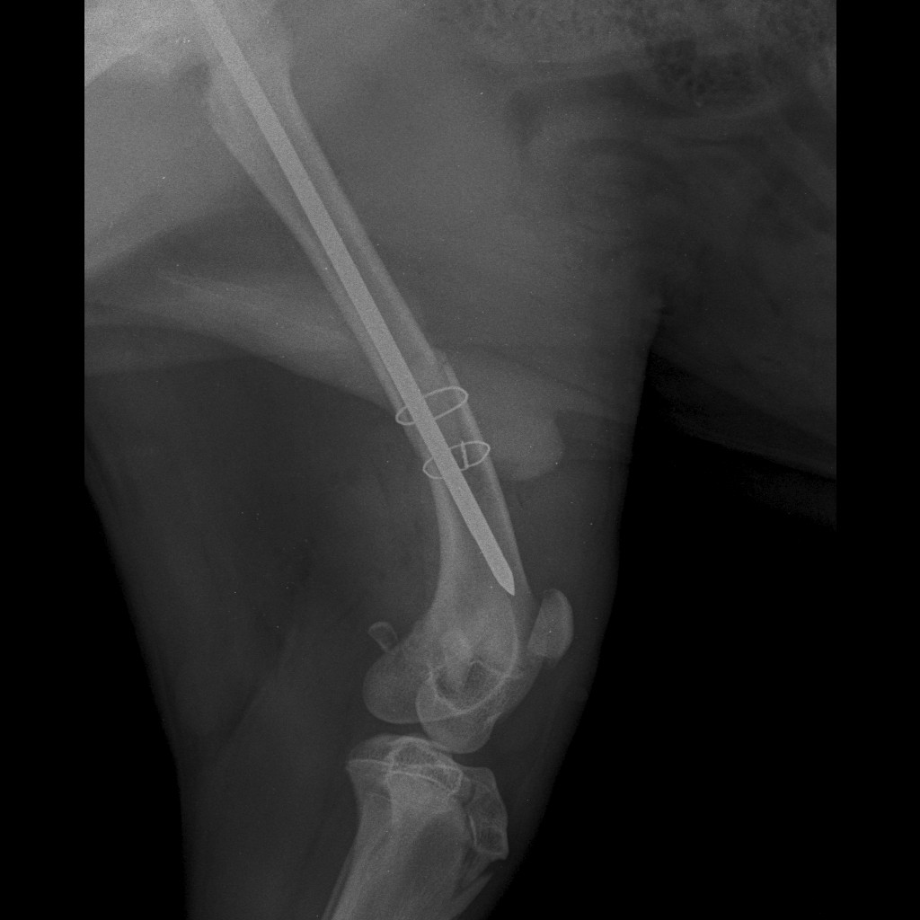 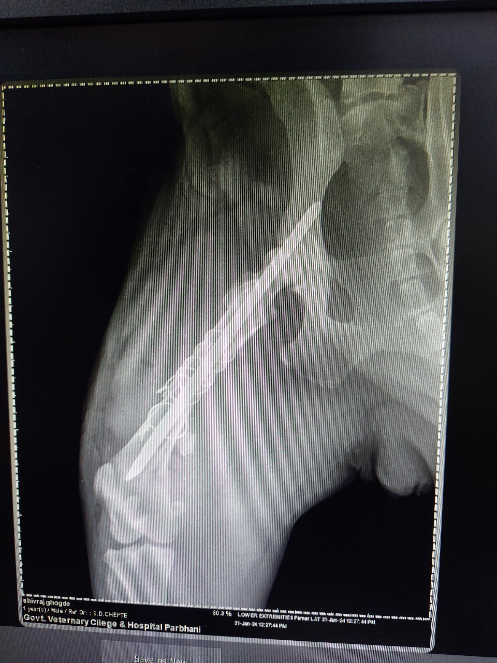 INCLUDEPICTURE "../../../../GANESH%20K/GANESH%20KARAD/THESIS/C-ARM%20in%20dog/writeup/photos/xray/work%20ganesh/PELVIS%20-Pubis-30-Oct-23-04_20_33%20PM-86.JPEG" \* MERGEFORMAT INCLUDEPICTURE "../../../../GANESH%20K/GANESH%20KARAD/THESIS/C-ARM%20in%20dog/writeup/photos/xray/work%20ganesh/PELVIS%20-Pubis-30-Oct-23-04_20_33%20PM-86.JPEG" \* MERGEFORMAT 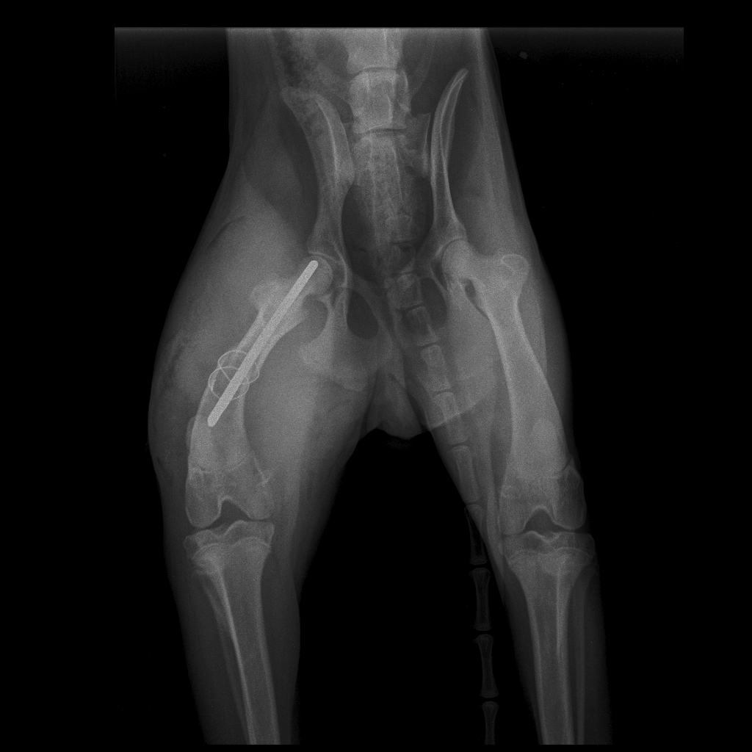 INCLUDEPICTURE "../../../../GANESH%20K/GANESH%20KARAD/THESIS/C-ARM%20in%20dog/writeup/photos/xray/work%20ganesh/PELVIS%20-Pubis-30-Oct-23-04_20_33%20PM-695.JPEG" \* MERGEFORMAT INCLUDEPICTURE "../../../../GANESH%20K/GANESH%20KARAD/THESIS/C-ARM%20in%20dog/writeup/photos/xray/work%20ganesh/PELVIS%20-Pubis-30-Oct-23-04_20_33%20PM-695.JPEG" \* MERGEFORMAT 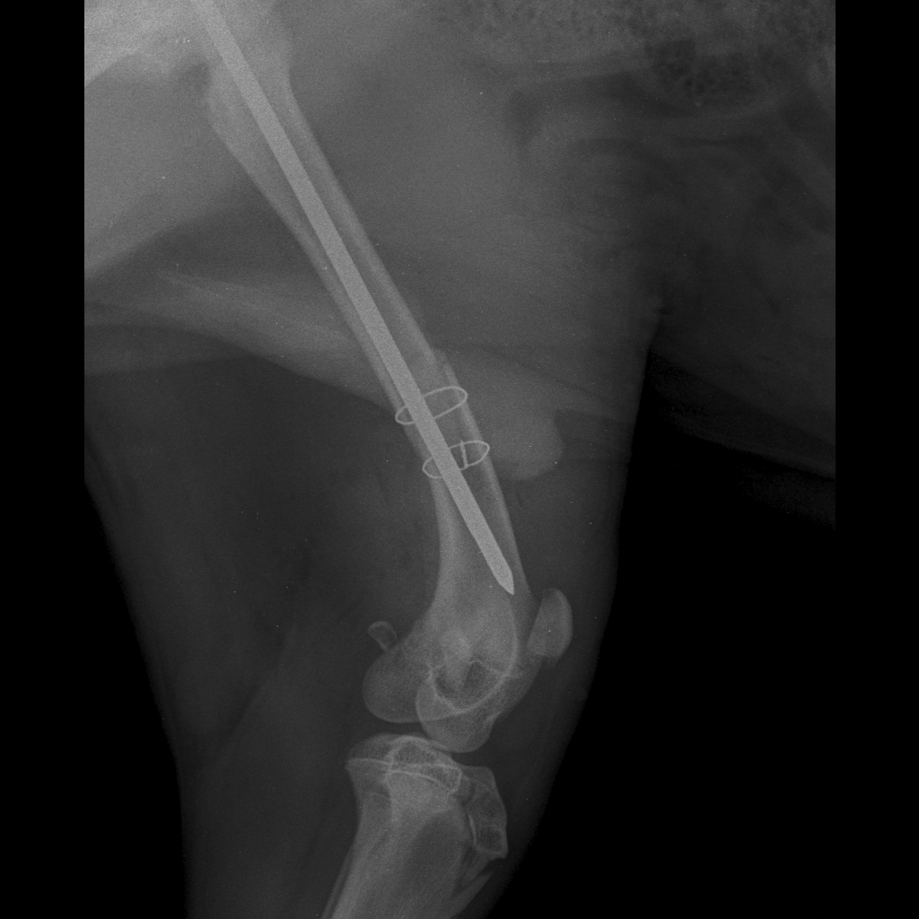 INCLUDEPICTURE "../../../../GANESH%20K/GANESH%20KARAD/THESIS/C-ARM%20in%20dog/writeup/photos/xray/work%20ganesh/LOWER%20EXTREMITIES-Femer%20LAT-27-Sep-23-05_23_04%20PM-805.JPEG" \* MERGEFORMAT INCLUDEPICTURE "../../../../GANESH%20K/GANESH%20KARAD/THESIS/C-ARM%20in%20dog/writeup/photos/xray/work%20ganesh/LOWER%20EXTREMITIES-Femer%20LAT-27-Sep-23-05_23_04%20PM-805.JPEG" \* MERGEFORMAT 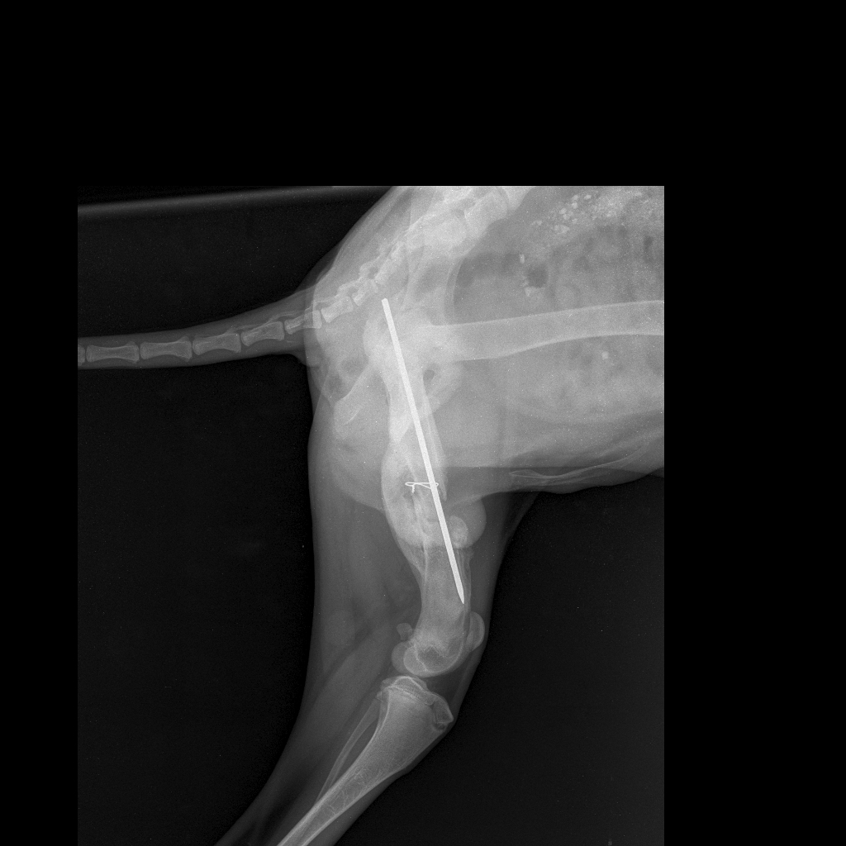 INCLUDEPICTURE "../../../../GANESH%20K/GANESH%20KARAD/THESIS/C-ARM%20in%20dog/writeup/photos/xray/work%20ganesh/PELVIS%20-Pubis-30-Oct-23-04_20_33%20PM-86.JPEG" \* MERGEFORMAT INCLUDEPICTURE "../../../../GANESH%20K/GANESH%20KARAD/THESIS/C-ARM%20in%20dog/writeup/photos/xray/work%20ganesh/PELVIS%20-Pubis-30-Oct-23-04_20_33%20PM-86.JPEG" \* MERGEFORMAT INCLUDEPICTURE "../../../../GANESH%20K/GANESH%20KARAD/THESIS/C-ARM%20in%20dog/writeup/photos/xray/work%20ganesh/LOWER%20EXTREMITIES-Femer%20LAT-13-Oct-23-01_08_08%20PM-211.JPEG" \* MERGEFORMAT INCLUDEPICTURE "../../../../GANESH%20K/GANESH%20KARAD/THESIS/C-ARM%20in%20dog/writeup/photos/xray/work%20ganesh/LOWER%20EXTREMITIES-Femer%20LAT-13-Oct-23-01_08_08%20PM-211.JPEG" \* MERGEFORMAT 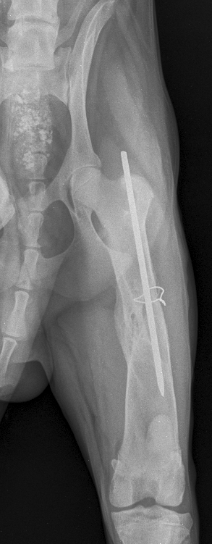 INCLUDEPICTURE "../../../../GANESH%20K/GANESH%20KARAD/THESIS/C-ARM%20in%20dog/writeup/photos/xray/work%20ganesh/PELVIS%20-Pubis-17-Nov-23-12_25_33%20PM-841.JPEG" \* MERGEFORMAT INCLUDEPICTURE "../../../../GANESH%20K/GANESH%20KARAD/THESIS/C-ARM%20in%20dog/writeup/photos/xray/work%20ganesh/PELVIS%20-Pubis-17-Nov-23-12_25_33%20PM-841.JPEG" \* MERGEFORMAT 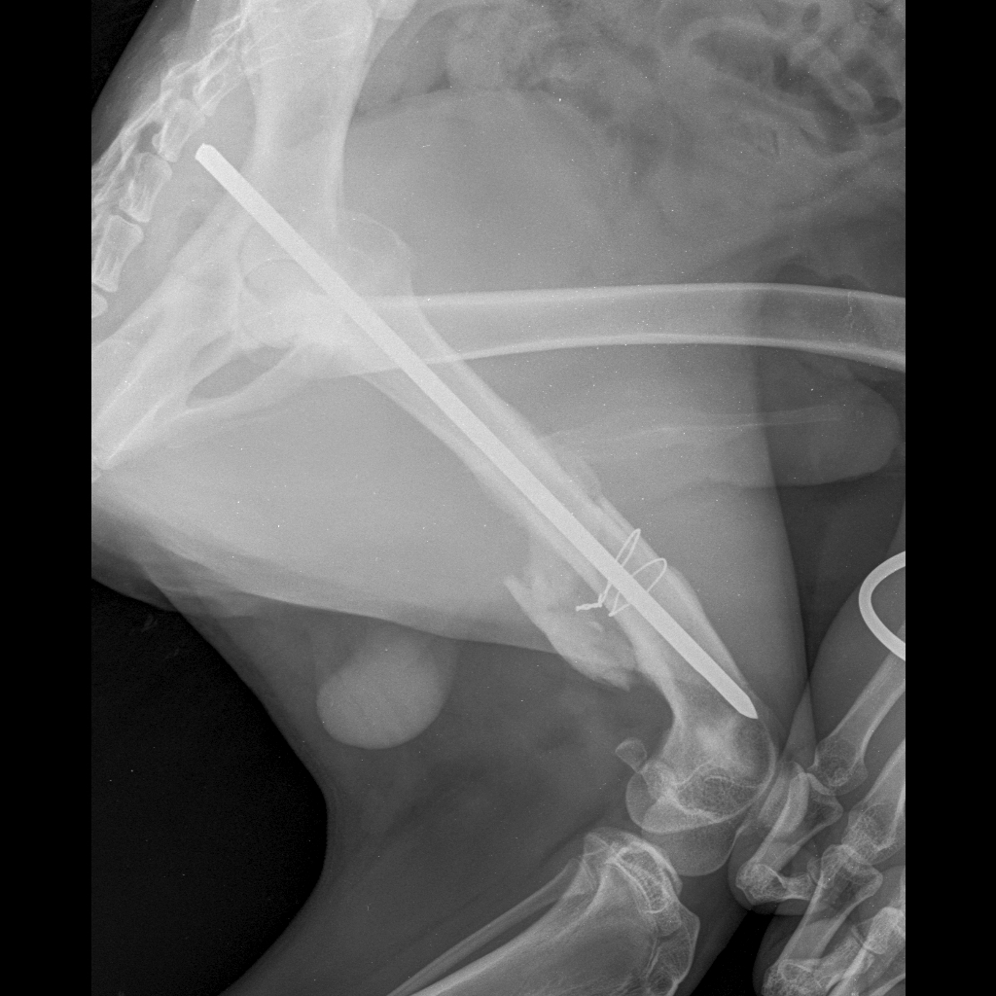
0th Day
15th Day
30th Day
45th Day

Fig.6 Radiographic views of periosteal callus formation of subsequent days in group B
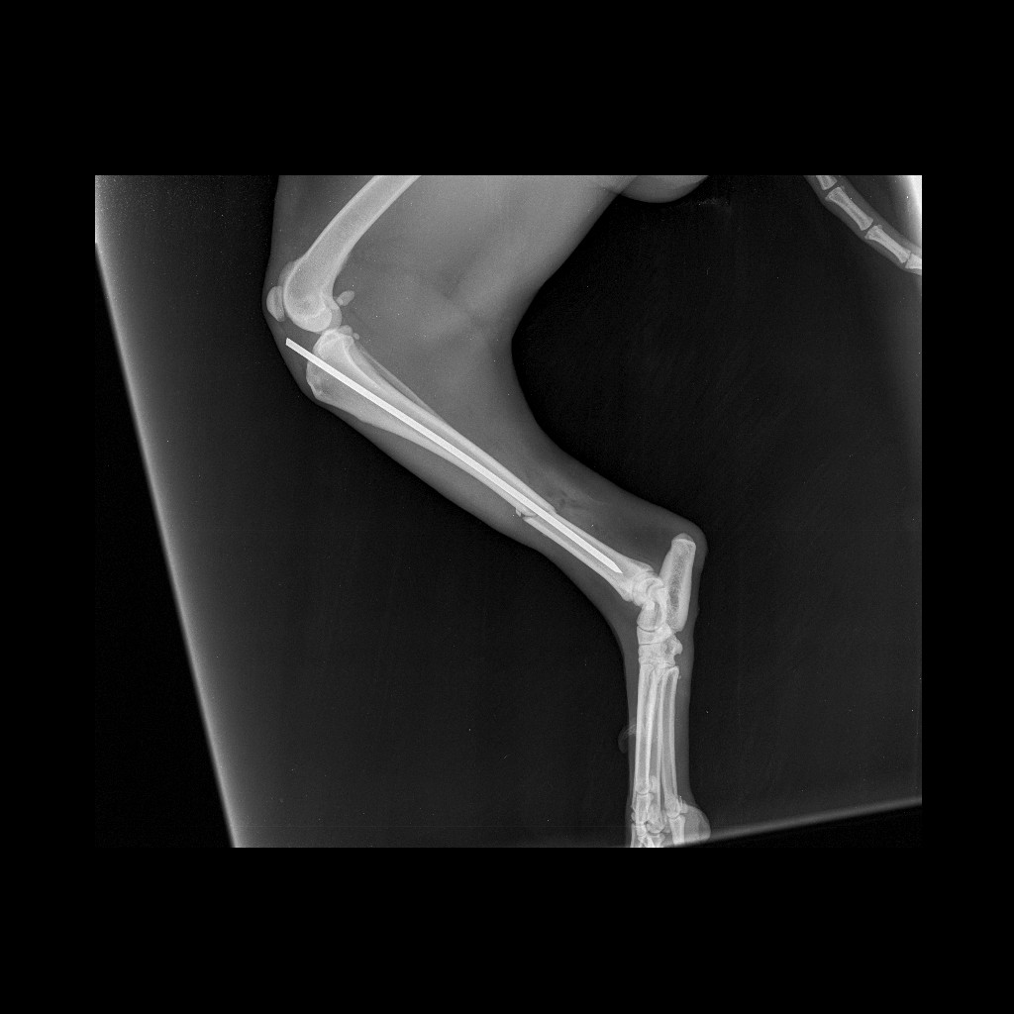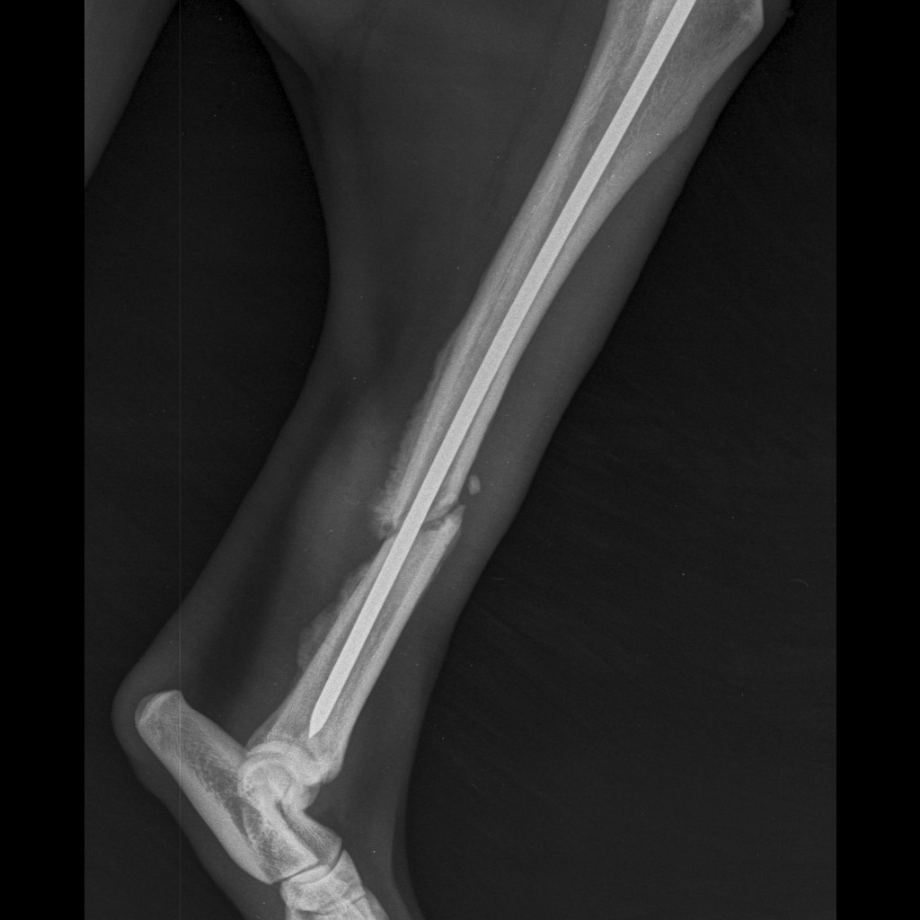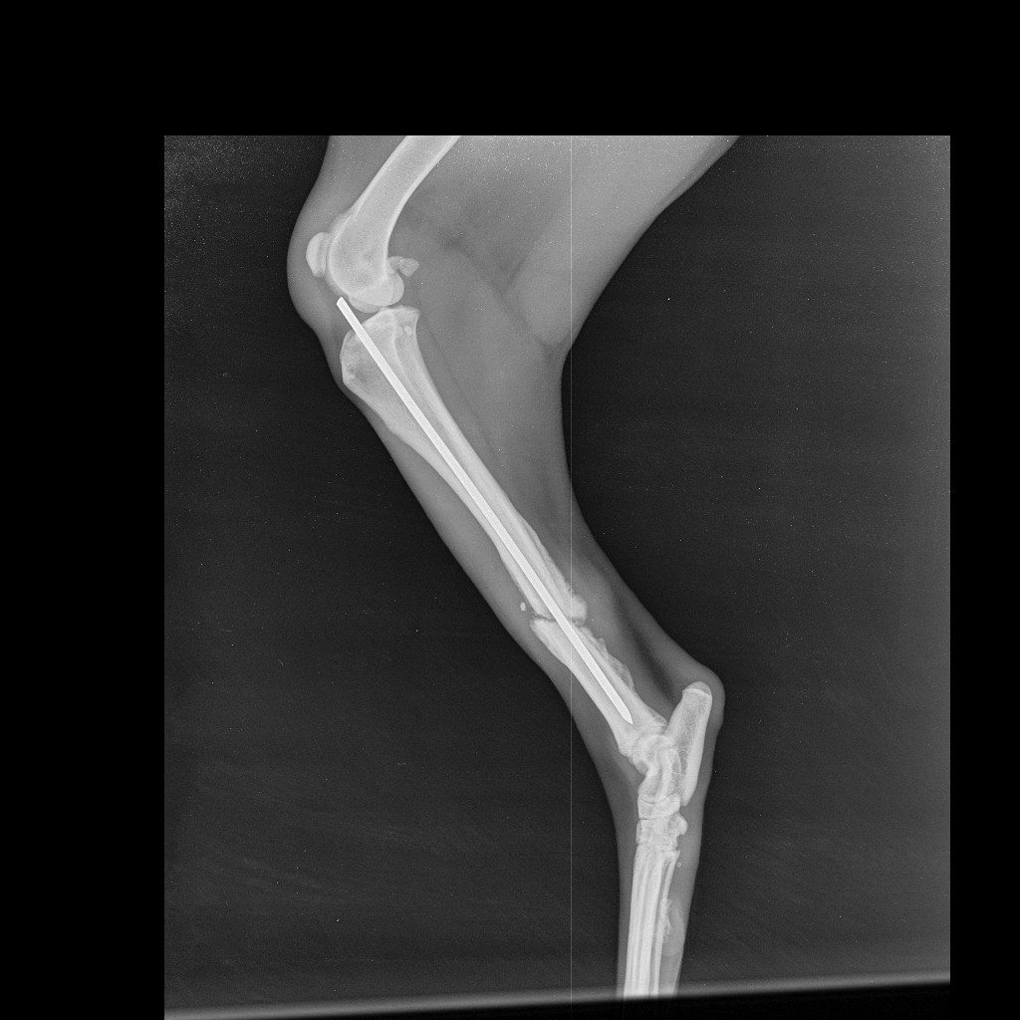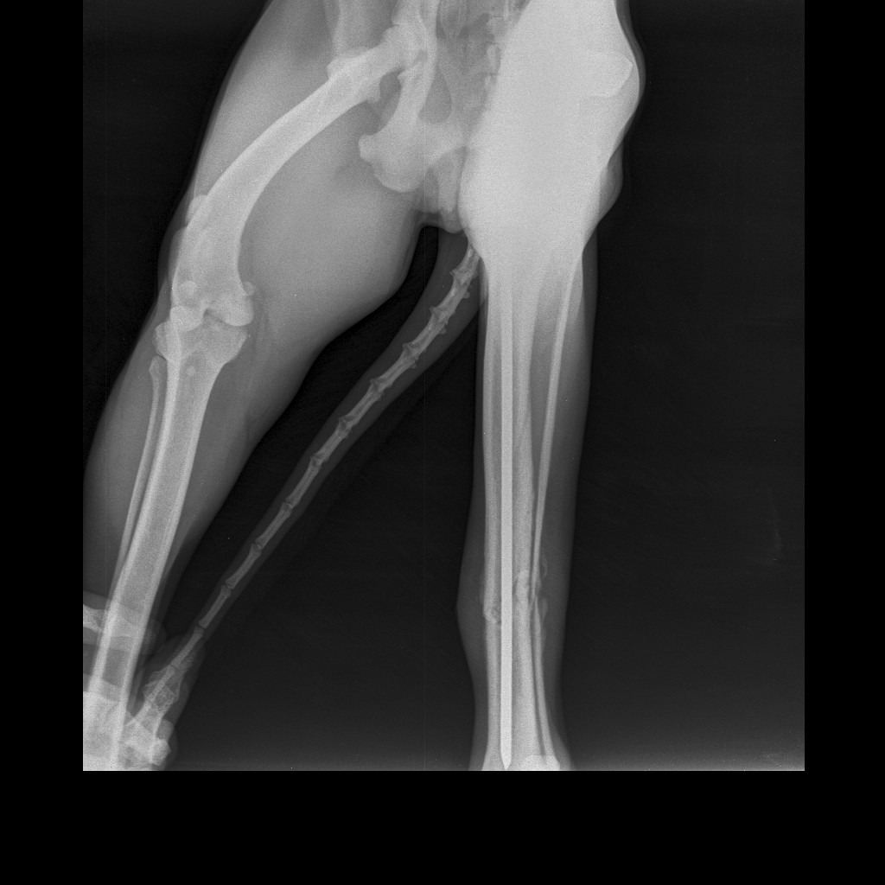
30th Day
45th Day
0th Day
15th Day

Conclusions
The Shorter incision lengths and reduced surgical time, hasten the fracture healing and favours early ambulation. However, C-arm guided intramedullary pinning is more suitable for transverse fracture. Similarly, C-arm guided intramedullary pinning in dogs results in fewer post-operative complications compared to open procedures.
Ethical Approval
Animal Ethic committee approval has been collected and preserved by the author(s)
Disclaimer (Artificial intelligence)
Option 1:
Author(s) hereby declare that NO generative AI technologies such as Large Language Models (ChatGPT, COPILOT, etc.) and text-to-image generators have been used during the writing or editing of this manuscript.
Option 2:
Author(s) hereby declare that generative AI technologies such as Large Language Models, etc. have been used during the writing or editing of manuscripts. This explanation will include the name, version, model, and source of the generative AI technology and as well as all input prompts provided to the generative AI technology
Details of the AI usage are given below:
1.
2.
3.

References
- Aron, D.M., A.L. Johnson, and R.H. Palmer (1995). Biologic strategies and a balanced concept for repair of highly comminuted long bone fractures. The Compendium on continuing education for the practicing veterinarian (USA). Vol.17 (1): 35-49.
- Balagopalan, T.P., C.B. Devanand, K. Rajankutty, T.S. Amma, S.R. Nayar, C.A. Varkey, and P.O. George (1995). Fracture in dogs: A review of 208 cases. Indian J. Vet. Surg. 16(1): 41-43.
- Bidari, K., D. Jahangirbasha, D. Dilipkumar, and B. Bhagavantappa (2023). Incidence of long bone fractures in dogs: A retrospective study (2016–2021). Pharma Innov. J. 12: 531-534.
- Brown, D.C., M.G. Conzemius, F. Shofer, and H. Swann (1997). Epidemiologic evaluation of postoperative wound infections in dogs and cats. J. Am. Vet. Med. Assoc. 210(9): 1302-1306.
- Cheng, H., J.W. Clymer, B.P.H. Chen, B. Sadeghirad, N.C. Ferko, C.G. Cameron, and P. Hinoul (2018). Prolonged operative duration is associated with complications: A systematic review and meta-analysis. J. Surg. Res. 229: 134-144.
- Cook, J.L., J.L. Tomlinson, and A.L. Reed (1999). Fluoroscopically guided closed reduction and internal fixation of fractures of the lateral portion of the humeral condyle: Prospective clinical study of the technique and results in ten dogs. Vet. Surg. 28(5): 315-321.
- Déjardin, L.M., K.L. Perry, D.J. von Pfeil, and L.P. Guiot (2020). Interlocking nails and minimally invasive osteosynthesis. Vet. Clin. Small Anim. Pract. 50(1): 67-100.
- Denny, H. (1991). Fracture fixation in small animal practice. In Practice. 13(4): 137-143.
- Hammer, R.R., S. Hammerby, and B. Lindholm (1985). Accuracy of radiologic assessment of tibial shaft fracture union in humans. Clin. Orthop. Relat. Res. 199: 233-238.
- Kallianpur, N., K. Singh, A. Gopinathan, S.B. Sarangom, C. John, C. Sowbharenya, and P. Sharma (2018). Investigation on relation between factors affecting occurrence and outcome of repair of long bone fractures in 216 dogs. Int. J. Livest. Res. 8(2): 225-234.
- Keosengthong, A., N. Kampa, S. Jitpean, S. Seesupa, P. Kunkitti, and S. Hoisang (2019). Incidence and classification of bone fractures in dogs and cats: A retrospective study at a veterinary teaching hospital, Khon Kaen University, Thailand (2013–2016).
- Manjunatha, D.R., B.N. Nagaraja, S. Rao, S. Yathiraj, and L. Ranganath (2011). Evaluation of closed and open interlocking nailing for femoral fracture repair in dogs. Indian J. Vet. Surg. 32(1): 65-66.
- Nagaria, T., A. Kujur, and N. Thakur (2017). Incision length, an emerging risk factor for surgical-site infection following cesarean section. Int. J. Reprod. Contracept. Obstet. Gynecol. 6(5): 1829-1833.
- Taljanovic, M.S., M.D. Jones, J.T. Ruth, J.B. Benjamin, J.E. Sheppard, and T.B. Hunter (2003). Fracture fixation. Radiographics. 23(6): 1569-1590.
- Waldorf, H., and J. Fewkes (1995). Wound healing. Adv. Dermatol. 10: 77-96.

