**Review Article**

**Transforming Global Food Systems: Pathways to Sustainability, Resilience and Equity**

**Abstract**

The global food system is at a crucial stage, facing unprecedented challenges threatening its ability to sustainably feed a growing population. This paper explores the multifaceted issues faced by current food systems, including environmental degradation, inequitable access, and inefficiencies that compromise both human and ecological health. We analyze the urgent need for a transformative approach that addresses these challenges and aligns with the Sustainable Development Goals (SDGs), particularly those focused on hunger, health, and sustainable production. The paper argues that a reimagined food system must be sustainable, resilient, and equitable to ensure long-term food security and social justice. By examining case studies of innovative practices and policies, we highlight pathways for systemic change that can foster environmental stewardship, economic viability, and social inclusion. This highlights the importance of integrating sustainability principles into food system transformation efforts to create a more robust framework for future food security.

**Key words** : Food system, Equitable , Resilient , and Sustainable food systems, SDG’S.

**Introduction**

Today's agriculture has multiple issues, such as feeding the world's enlarging population, reducing rural poverty worldwide, and managing ecosystem goods and services in the face of environmental change. To increase the effectiveness of a particular element or activity, studies have historically evaluated or examined components of current production and consumption systems with the hope that doing so will increase the efficiency of the entire system. But in the past few decades, it has become evident that these complicated problems require a more comprehensive framework (Ruben *et al*., 2021). As a result, to find intervention sites for improving food security, a food systems approach has been widely used to determine, examine, and assess the effects and feedback of the different actors, activities, and outputs of the systems.

**Food System**

Food systems is a complex term that includes everything from farm to table. Food systems encompass the entire range of actors and their interlinked activities involved in the production and consumption aspects in which they are embedded (Anonymous,2024; Caron *et al.*, 2018). This includes every process in the food production, starting from production till it reaches the end user and even after that, including waste recycling and recovery.

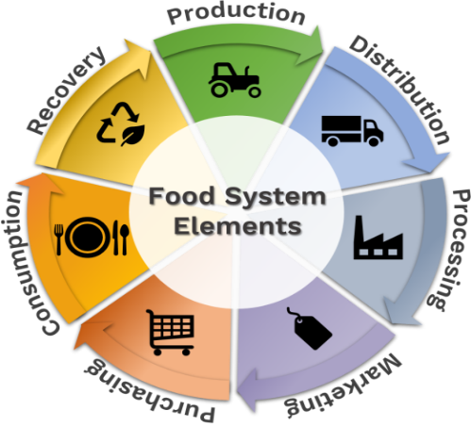

**Fig 1 : Elements of Food System**

**Fig 2-Components of Food Systems**

### Food Supply Chains

### Each of the processes required to produce and transport food from farm to table is included in the food supply chain. Every stage in the food supply chain is interconnected. A change in one stage can have an impact on subsequent steps in the chain as well as other elements of food systems. Depending on the food system, food supply chains function at varying levels and scales. The length and complexity of food supply networks can vary greatly in major urban settings and rural and geographically remote settlements (Fanzo *et al*., 2021).

### Food Environments

### People's interactions with the food system for the goal of obtaining and consuming food are known as the food environment. This covers the actual locations where people purchase food, like shops or marketplaces, as well as the food-related messaging that consumers encounter (Anderson *et al.,* 2019). Social, economic, and cultural aspects are also included. The choice architecture of the food environment includes food availability, cost, quality, safety, convenience, and advertising. These aspects of the food environment impact how people obtain foods, which in turn affects diets.

### Individual Factors

## Individual characteristics encompass a person's financial position, general circumstances, way of thinking, and actions. All of these elements have an impact on how people engage with their food environment and, eventually, the meals they purchase, cook, and consume. A person's understanding of nutrition or awareness of environmental effects, for instance, may influence what they buy and consume, and their money may decide what diet is affordable.

## Drivers of Food Systems

To have an idea about food system there is a need to understand the drivers of the food system. The drivers of the food system are as follows,

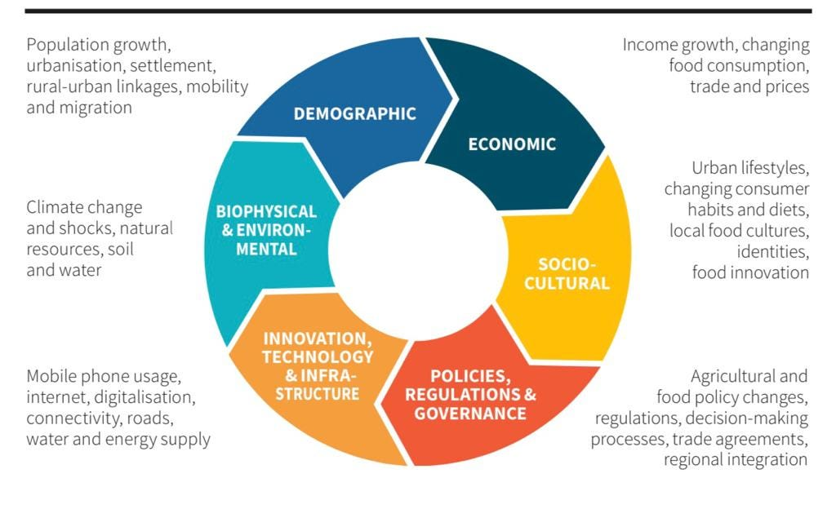**Fig 3-** **Drivers of Food Systems**

**FSD**

**Environment and Climate Change**

Increased food insecurity is already a result of unchecked climate change. Climate change may cause fish populations and crop yields to drop at the food system's production level. Staple crops cultivated in high carbon dioxide environments are likely to contain fewer nutrients (such as protein, iron, and zinc), which has an impact on the nutritional value of people's diets. Increased losses may also result from climate change-induced temperature increases during the food system's distribution and storage phases. Additionally, production, storage, and distribution losses are brought on by extreme weather occurrences. A decrease in crop yields and agricultural losses may lead to an increase in food costs.

**Globalization and Trade**

People and nations become more interdependent and connected as a result of globalisation. It influences local economies and has both beneficial and detrimental effects on human diet and health. Trade can lead to new job opportunities, but it can also make it more competitive for local producers, which could lower the cost of domestic goods and jeopardise smallholders' livelihoods. Foods that could be difficult to grow where they reside or that are scarcer during a given season can be obtained through trade. This makes seasonal foods more accessible all year round and diversifies the food supply. However, trade and globalisation can also negatively impact nutrition and diets. Due in part to trade regulations and extensive advertising, unhealthy foods are now more widely available and reasonably priced globally.

### Urbanization

### Global urbanisation is happening, with Africa and Asia experiencing the largest growth in urban populations. A nation's food system is shaped by urbanisation, which reduces dependency on agricultural areas and lengthens food supply chains. By dilating the number of supermarkets in a given area, urbanisation alters the food environment. More stores can make more healthy and nutritious items, especially more highly processed foods, accessible. The demand for convenient foods, eating out, and higher salaries are all associated with urbanisation. Access to fresh, healthful food is scarce in many places, but fast food and highly processed foods are regrettably common.

### Politics and Leadership

Food systems are influenced by a region's trade, nutrition, and agricultural policy. Economic policies about trade and agricultural subsidies may have an impact on the cost and accessibility of particular foods, which may then have an impact on dietary consumption. Governments can enact tax laws to deter people from consuming unhealthy foods like sugar-sweetened beverages and highly processed meals, or they can establish dietary standards to encourage people to eat healthily. To guarantee that there are enough resources to establish a sustainable food system, political determination and investment are required.

**Socio-Cultural Context**

Food preferences, meal preparation methods, and customs are all influenced by social and cultural traditions, which in turn affect diets. In some cultures, a person's food choices might reveal their social standing within the family or society. Foods linked to wealth status may be more appealing. Food has a major role in holidays and customs in the majority of nations. The transition to diets heavy in ultra-processed foods and reliance on fast food may be halted by strong cultural connections to traditional meals and meal customs.

**Challenges of the global food system**

Growing food demand and competition for resources like land, water, and energy that influence food availability are two problems facing global food systems. Resilience in global food systems is more important than ever in light of climate change and unanticipated shocks like a worldwide epidemic. Global food production and related trade have grown steadily since the 1950s, when food systems became more interconnected. This expansion has been fuelled by improvements in communications and transportation, as well as the removal of trade restrictions and agricultural tariffs. However, two major issues that embrace the global food system's efficacy are nutrition and waste (Agrawal,2021).

Food waste occurs at every level of the food chain. Harvesting, transportation, storage, and processing all play a part in the loss of around 13.8% of food in supply chains. However, it is difficult to assess how pricing strategy can minimise food waste due to a lack of scientific understanding and study on the price elasticity of food waste. The resources, land, and energy required to produce food are also wasted. From 2007 to 2016, forestry, agriculture, and other land uses accounted for over 23% of all human-induced greenhouse gas emissions. In addition to farming and raising cattle, agriculture also contributes to emissions by clearing land for farming. More than, two billion people are affected by starvation, wherein people lack key micronutrients. Apart from nutrient deficiency, approximately two billion people are obese and affected by chronic conditions such as type 2 diabetes, and cardiovascular diseases.

In digest, the world's food system is unable to meet the population's evolving and growing needs. Social-cultural interactions, shifting dietary patterns, rising wealth and the wealth gap, limited resources, the difficulties of unequal accessibility, and the demands of the underprivileged who spend the largest percentage of their income on food, are all factors that need to be taken into consideration when upgrading the system. Food demand and supply chains must be lined up across different geographies and at different scales of space and time to feed the world's population, which is expected to reach 10 billion by 2050. Developing sustainable, equitable, and healthful food systems that provide food and nourishment is closely related to the future of global food systems.

**Relation between the food system and SDG**

The foundation of many nations' economies is their food systems, but as nations get wealthier, their share of the GDP declines. There are several concerns about the ability of food systems in low- and middle-income nations to keep up with economic and demographic expansion. Given that problems and concerns also bring opportunities, food systems should be seen as potent levers for achieving Agenda 2030 for Sustainable Development and its 17 Sustainable Development Goals (FAO, 2020). An increasing number of publications and writers advocate for their transformation, which is viewed as a top priority to address sustainability issues and avoid significant disruptions. Prajal *et al*.,2021 in his study reported that the food system and sustainable development goals are interrelated. Any positive changes in the component of the food system will result in positive changes that help the achievement of SDG by 2030.

**Need for transformation**

One of the main risk factors for the worldwide burden of disease is poor nutrition quality. Current food systems have not only failed to end hunger, but they have also encouraged the rise of diseases linked to diet. As the supply has increased and food products have changed in nature, new nutrition issues have surfaced. In many nations, the proliferation of highly processed meals high in fat, sugar, and salt poses a threat to public health. These days, undernutrition, including stunting and wasting, micronutrient deficiencies, and overweight/obesity, affects every nation in the globe, with the majority suffering from several forms of malnutrition. At the international, national, local, and even family levels, the triple burden of malnutrition coexists. Dietary patterns and consumer tastes have changed as a result of several socioeconomic and environmental factors, including global trade, demographic and economic shifts, rapid urbanisation, and the growing availability and affordability of low-quality, ultra-processed food (FAO, 2017). The demand for ready-to-eat, quick, highly processed food—often of low quality—has increased as more women participate in the workforce.

Globally, poverty and inequality are the root causes of all types of malnutrition because they restrict vulnerable populations' admission to a multifariousness of high-quality foods due to their geographic location (remote places) or social standing (gender, ethnicity, and economic class). For the benefit of present and future generations, food systems must be transformed to ensure that everyone has access to enough wholesome food.Furthermore, the current food system's social and environmental problems are endangering the system's resilience and sustainability.

**Elements of Transformation**

As given by Herrero *et al.,*2020 the elements of transformation are as follows:

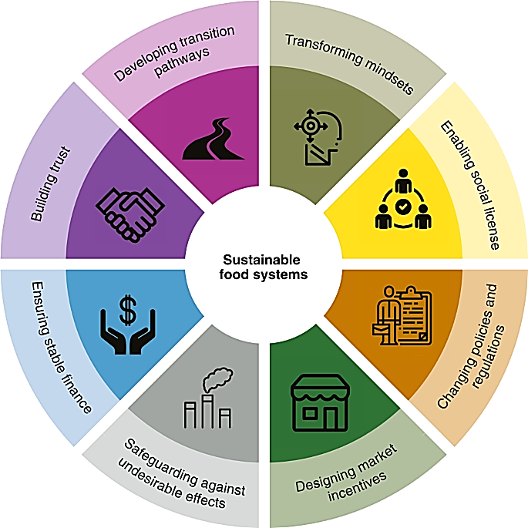

**Fig 4- Elements of transformation**

Focus on these elements when working together towards transformation in the current food system would support the achievement towards a food system that bolster up to meet future food insecurities that result in sustainable, resilient and equitable food systems.

**SUSTAINABLE FOOD SYSTEM**

A sustainable food system (SFS) is a food system that provides nutrition and food security to all and sundry while upholding the social, economic, and environmental underpinnings required to ensure that subsequent generations have equal opportunity for food and nutrition (FAO,2018). This indicates that: It should be constantly profitable (economic sustainability); It should be broadly benefitable to society (social sustainability); It should have a beneficial or indifferent impact on the environment (environmental sustainability).

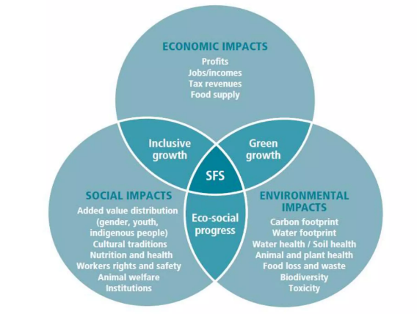

## ****Fig 5 : Interaction between components of SFS****

**RESILIENT FOOD SYSTEMS**

Food system resilience is defined as the “ability of a food system and its components at different levels over time to supply enough food that is suitable and available to everyone, even in the face of a variety of unanticipated disruptions”. (Chao and Kang,2024)

**Integration of food systems and resilience**

The necessity to comprehend what occurs to one or more components of a food system when subjected to one or more shocks, or a combination of shocks, is highlighted by the integration of resilience and food systems ideas. The degree to which the components of a particular food system, as well as the food system overall, can withstand a shock is indicated by the difference in the condition of the components at the periods before the shock (t1) and after the shock (t2). Resilient food systems take into account the nation's structural circumstances, laws, and tactics. (Helfgott,2018).

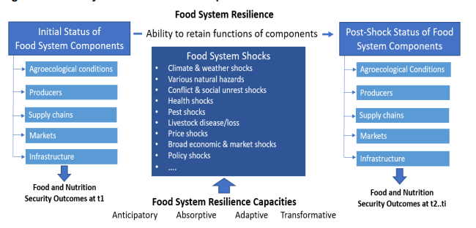

**Fig 6 : Food System Resilience**

**Food System Shocks, Stresses, And Risks**

Numerous interrelated shocks and pressures can affect food systems. Both can significantly impact key components of the food system, including livelihoods, environmental sustainability, and the provision of sufficient amounts of high-quality food at reasonable costs (Tendall *et al.,* 2015). Both have the potential to directly or indirectly influence change. Analysis of the global shock drivers for land- and marine-based food systems revealed that

extreme weather,

geopolitical events,

Financial market meltdowns,

the escalation of fertiliser and other input costs,

the spread of illness, and conflicts are examples of significant shocks that are frequently made worse by changes in policy and poor management. Here, we envisage food system proneness as linked to the risk of a system being exposed to adverse events and falling into vicious loops that challenge food security and other desirable food system outcomes (Caron *et al*., 2023).

**Resilience Concepts for Food Systems: The Three “Rs”**

Emphasising the responses to the four-pointer questions requires taking resilience-building strategies for food systems into account (Constas *et al.,* 2023).

* What is resilience?
* What does resilience mean?
* Whose perspective is resilience?
* How long does it take to develop resilience?

Enhancing the resilience of food system outcomes is emphasised in the majority of policy, practice, and social discussions, with a focus on either robustness or recovery (Zurek *et al.,* 2022).

The potentiality of the players in the food system to modify their actions to withhold disruptions to the intended results—that is, the preservation of the status quo—is the foundation of robustness. More heat-tolerant crops, on-farm water storage to prevent drought, altering land management to provide enough natural habitat for organisms and pollinators, diversifying supply chains, improving soil quality and nutrient reserves, and fortifying strategic food reserves are a few examples.

Recovery is based on the ability of food system actors to adapt their activities to return to desired expectations following disruption (i.e., bounce back to the status quo).

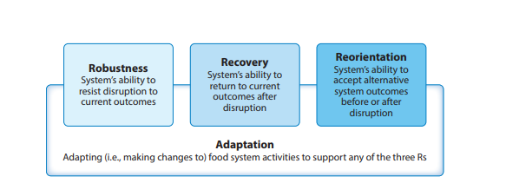

Fig 7 : 3R’s of Resilient Food System

There is, however, Reorientation as a third idea to improve the food system outcomes' resilience. This is based on the notion that by making the food system inherently less vulnerable to shocks and stresses, changing public expectations and demands of system outcomes may increase system resilience. It means accepting alternative food system results before or following a disruption. Compromises will be made, though.

**Equitable food systems**

An equitable food system ensures that all people have the ability and opportunity to access healthy, affordable, and culturally significant food. It also means that no one or community experiences a disproportionate burden of food production impacts. In an equitable food system, community members can cultivate, acquire, barter, exchange, sell, and discard food in a way that puts human health, ecological sustainability, fair and equitable prices and wages, cultural preservation, and equitable access to land first. (Policylink,2024).

**Strategies to create an equitable food system**

* Expand healthy food distribution options in underserved neighbourhoods
* Encourage community gardens and remote food production
* Utilise the purchasing power of big institutions to guarantee that everyone has access to healthy food and excellent jobs
* Support the survival and expansion of small farms and expand food businesses.
* Preserve and improve food aid programs
* Increase the pay and standard of food and farming jobs

**Conclusion**

In conclusion, numerous issues with the current food system make it difficult for it to feed the world's expanding population while maintaining environmental integrity and guaranteeing fair access. Because the systemic problems at hand cannot be resolved by little adjustments, there is an obvious and pressing need for change. The important connection between food systems and the Sustainable Development Goals (SDGs) has been emphasised in this study, along with the need to match food system changes with more general sustainability, health, and equity goals. A comprehensive strategy is needed to create a changed food system that is resilient, sustainable, and equitable. This includes adopting practices that enhance environmental sustainability, such as reducing waste and promoting regenerative agriculture, as well as ensuring that food distribution and access are fair and inclusive. Additionally, fostering resilience through diversified supply chains and supportive policies can mitigate the impacts of climate change and other disruptions.

The future ultimately depends on communities, corporations, and legislators working together to adopt and encourage creative solutions that tackle the underlying reasons for food system failures. We can create a food system that not only satisfies present demands but also ensures a healthy and just future for future generations by emphasising systemic transformation and adopting a vision of food security that incorporates sustainability and social justice.

Disclaimer (Artificial intelligence)

Option 1:

Author(s) hereby declare that NO generative AI technologies such as Large Language Models (ChatGPT, COPILOT, etc.) and text-to-image generators have been used during the writing or editing of this manuscript.

Option 2:

Author(s) hereby declare that generative AI technologies such as Large Language Models, etc. have been used during the writing or editing of manuscripts. This explanation will include the name, version, model, and source of the generative AI technology and as well as all input prompts provided to the generative AI technology

Details of the AI usage are given below:

1.

2.

3.

Disclaimer (Artificial intelligence)

I hereby declare that no generative AI technologies have been used in this manuscript.

**References**

1. [Anonymous]. 2024. *GAIN and The Columbia Climate School* [on line]. Food systems dashboard. Available: <https://www.foodsystemsdashboard.org/information/about-food-systems> [10 Aug.2024].
2. Agrawal, M. 2021. Future of food: Exploring challenges to global food systems [on line]. Available: https://news.climate.columbia.edu/2021/01/15/global-food-systems-challenges. [7 Aug.2024].
3. Arora, Y. 2020. The key to achieving sustainable food systems lies in going back to the basics: Understand the issue, assess implications of solutions and collaborate [on line]. Available: https://www.linkedin.com/pulse/key-achieving-sustainable-food-systems-lies-going-back-yoshita-arora. [14 Aug.2024].
4. Caron, P., Daguet, E., and Dury, S. 2023. *The global food system is not broken but its resilience is threatened*. In: Bene, C. and Devereux, S. (eds), *Resilience and Food Security in a Food Systems Context* [on line]. Available: <https://doi.org/10.1007/978-3-031-23535-1_3> [13 Aug.2024].
5. Chao, K. 2024. Family farming in climate change: Strategies for resilient and sustainable food systems. *Heliyon* 10(7): 12-13.
6. Constas, M. A., Errico,M., Hoddinott, J. F., and Pietrelli, R. 2021. Resilient food systems A proposed analytical strategy for empirical applications. In: *FAO Agricultural Development Economics working paper*, November 2021, Rome [on line]. Available: <https://openknowledge.fao.org/server/api/core/bitstreams/3a34460a-d46a-461e-ace5-c9c814b78b61/content> [13 Aug.2024].
7. FAO [Food and Agriculture Organisation]. 2013. Investing in smallholder agriculture for food security. In: *A report by the High Level Panel of Experts on Food Security and Nutrition of the Committee on World Food Security*, June, 2013, Rome [on line]. Available: <https://www.fao.org/4/i2953e/i2953e.pdf>. [20 Aug.2024].
8. FAO [Food and Agriculture Organisation]. 2017(b). Nutrition and food systems. In: *A report by the High Level Panel of Experts on Food Security and Nutrition of the Committee on World Food Security*, September, 2017, Rome [on line]. Available: https://openknowledge.fao.org/server/api/core/bitstreams/4ac1286e-eef3-4f1d-b5bd-d92f5d1ce738/content. [17 Aug.2024].
9. FAO [Food and Agriculture Organisation]. 2020. Food security and nutrition building a global narrative towards 2030. In: *A report by the High Level Panel of Experts on Food Security and Nutrition of the Committee on World Food Security*, 2020, Rome [on line]. Available: https://openknowledge.fao.org/server/api/core/bitstreams/8357b6eb-8010-4254-814a-1493faaf4a93/content. [17 Aug.2024].
10. FAO [Food and Agriculture Organization]. 2018. Sustainable food systems – Concepts and framework [on line]. Available: <https://openknowledge.fao.org/server/api/core/bitstreams/content>. [9 Aug.2024].
11. Helfgott, A. 2018. Operationalising systemic resilience*. Eur. J. Oper. Res.* 268(3): 852–864.
12. Herrero, M., Thornton, P.K., D'Croz, D.M., and Palmer, J. 2020. Innovation can accelerate the transition towards a sustainable food system. *Nat. Food* 1(5) : 266-272.
13. Policylink. 2014. An Equitable Food System: Good for Families, Communities, and the Economy [on line]. Available: <https://www.policylink.org/sites/default/files/Equitable-Food-Systems-FINAL-03-11-16.pdf>. [19 Aug.2024].
14. Prajal, P.,Tek,S., and Jurgen, K.2021. Why food systems transformation is crucial for achieving the SDGs. *Rural* 21 : 10-12.
15. Tendall, D.M., Joerin, J., Kopainsky, B., Edwards, P., Shreck, A., Le, Q.B., Krütli, P., Grant, M., and Six, J. 2015. Food system resilience: Defining the concept. Glob. Food Secur. 6: 17–23.
16. Zurek, M., Ingram, J., Bellamy, A, S., Goold, C., Lyon, C., Alexander, P., Barnes, A., Bebber, D.P., Breeze, T.D., Bruce, A., Collins, L.M., Davies, J., Doherty, B., Ensor, J., Franco, S.C., Gatto, A., Hess, T., Lamprinoupoulou, C., Liu, L., Merkle, M., Norton, L., Oliver, T., Ollerton, J., Potts, S., Reed, M.S., Sutcliffe, C., and Withers, P.J.A. 2022. Food system resilience: Concepts, issues, and challenges. *Annu. Rev. Environ. Resour.* 47: 511-534.
17. Ruben R, Cavatassi R, Lipper L, Smaling E, Winters P. Towards food systems transformation—five paradigm shifts for healthy, inclusive and sustainable food systems. Food Security. 2021 Dec;13:1423-30.
18. Caron P, Ferrero y de Loma-Osorio G, Nabarro D, Hainzelin E, Guillou M, Andersen I, Arnold T, Astralaga M, Beukeboom M, Bickersteth S, Bwalya M. Food systems for sustainable development: proposals for a profound four-part transformation. Agronomy for sustainable development. 2018 Aug;38:1-2.
19. Fanzo J, Haddad L, Schneider KR, Béné C, Covic NM, Guarin A, Herforth AW, Herrero M, Sumaila UR, Aburto NJ, Amuyunzu-Nyamongo M. Rigorous monitoring is necessary to guide food system transformation in the countdown to the 2030 global goals. Food Policy. 2021 Oct 1;104:102163.
20. Anderson CR, Bruil J, Chappell MJ, Kiss C, Pimbert MP. From transition to domains of transformation: Getting to sustainable and just food systems through agroecology. Sustainability. 2019 Sep 25;11(19):5272.