**Survey for natural incidence of diseases in *rabi* soybean in Telangana, India**

**ABSTRACT**

Soybean (*Glycine max* (L.) Merrill) also known as “Miracle Crop”, is a major oil seed crop grown worldwide. The present study was undertaken to assess the incidence of soybean diseases during *rabi* 2023-24. Roving surveys were conducted in Adilabad, Jagtial, Nizamabad, Kamareddy districts of Telangana state. The survey results revealed that, the highest incidence of Alternaria disease (40.30%) was recorded in Nizamabad, while the lowest (8.60%) in Adilabad. Yellow Mosaic Disease had the highest incidence (52.4%) in Jagtial and the lowest (11.2%) in Adilabad. Jagtial also recorded the highest incidence of both, dry root rot (42.9%) and anthracnose (16.8%), whereas Kamareddy reported no incidence (0%) of these diseases at the vegetative stage. Nizamabad had the highest incidence of both powdery mildew (12.4%) and sudden death syndrome (6.4%). These findings highlight the need for awareness and the implementation of effective management strategies to control soybean diseases in the affected districts.

**KEYWORDS:** Soybean, per cent disease incidence (DI), alternaria leaf spot, Yellow Mosaic Disease, dry root rot, anthracnose, powdery mildew, sudden death syndrome

**1.INTRODUCTION**

Soybean [*Glycine max* (L.)], known as the “Miracle Crop” or “Golden Bean” is the second largest oilseed crop in India after groundnut. It is a legume crop belonging to the family Leguminosae and sub-family Papilionaceae. This crop can be grown in tropical, sub-tropical as well as the temperate regions. It is renowned for its substantial oil (20%) and protein (40%) content. It is referred to as "poor man's meat" due to its high protein levels (Borah et al*,* 2019). It is used to make soybean milk, tempeh, tofu, soybean paste, as well as cosmetics and biofuel. Among the various soybean products in the market, soybean oil stands out as the most popular and widely consumed oil worldwide. Additionally, soymeal is a highly valuable feed for livestock and poultry, accounting for 60% of global oil production (Sharma, 2016). Soybean crop contribute significantly to soil fertility due to their symbiotic association with the nitrogen-fixing bacteria *Bradyrhizobium japonicum.* This association increases the availability of nitrogen and phosphorus in the soil, which promotes sustainable agriculture ( Olszak- Przybyś *et al*, 2021).

In India, soybean cultivation extended over 12.07 million hectares with a production of 13.98 million tons and productivity of 1158 kg per hectare (Soybean Statistics, ICAR-IISR, Indore, MP 2022-2023). The major soybean growing states include Madhya Pradesh, Maharashtra, Rajasthan, Karnataka, Gujarat and Telangana with around 80-85% of the acreage concentrated in Madhya Pradesh. India plays a significant role in exports, particularly **soybean defatted oil cake**, valued at **USD 82.1 million** (Amrate *et al,* 2023). Despite its production, the country relies on imports to meet **50% of its edible oil demand**.

In Telangana, the cultivation of soybean is increasing at faster rate and extensively grown in districts of Adilabad, Nirmal, Nizamabad, Komuram bheem Asifabad, Kamareddy, Karimnagar, Jagtial and Sangareddy with cultivable area of 0.16 million ha and 0.27 million tons production and 1716 Kg ha-1 productivity (https://agricoop.nic.in/en, 2021-22).

The average soybean yield per hectare in India has remained below the global average in recent years. Among the various contributing factors, weed infestation, crop diseases, and pest invasions are significant challenges that hinder production. The impact of abiotic and biotic stresses, weed infestation are the three primary constraints in soybean production (Gaikwad *et al*,2021). Among the biotic stresses, 29 are fungal, 6 bacterial, 18 viral, 6 nematodal and 3 mycoplasmal are the diseases reported in soybean. Amongst all fungal diseases, about 10 have a consistent presence in diverse parts of the world (Tripathi *et al*. 2022). The diseases like anthracnose, bacterial blight, bacterial pustule, brown spot, charcoal rot, leaf spots, *Fusarium* root rot, pod and stem blight, purple seed stain and *Cercospora* leaf blight, *Rhizoctonia* aerial blight, *Sclerotium* blight, rust, virus and seedling diseases have been reported in India (Fagodiya *et al*, 2022 ) In India, loss due to various diseases has been estimated to an extent of 12% of total production ( Borah *et al* , 2022).

In India, Alternaria leaf spot disease of soybean caused by *A. alternata* was reported by (Shrivastava and Gupta, 2001)*.* All the aerial parts of the soybean plant are susceptible to *Alternaria spp*. which reduces the quality and quantity of seed yield. On foliage, the disease symptoms develop as brown necrotic spots with concentric rings and yellow halo, large necrotic lesions that eventually coalesce and cover the entire leaf in advanced stages (Fagodiya *et al,* 2021). The Yellow mosaic disease (YMD) caused by begomovirus (*Geminiviridae*) is transmitted by whitefly *Bemisia tabaci* and also infect other legumes such as blackgram, greengram *etc*,. Economic loss caused by SMV typically ranges between 8%-35% and in severe case may reach up to 100% (Ahangaran *et al,* 2009).

The charcoal rot, which is used to be a minor disease of soybean until 2004 in India, became a serious disease due to altered weather conditions particularly on the account of longer drought spells during crop growth period (Gupta *et al,* 2012). It is caused by *Macrophomina phaseolina,* whichis a soil inhabiting pathogen capable of infecting soybean at any crop growth stage, but usually, it infects at post flowering stage. The charcoal rot at the seedling stage, roots turned brown and rotted. As the disease progressed, lesions spread and the plant turning brown as small black pycnidial structures appeared on the stem.

Soybean anthracnose is mainly associated with falcate conidiated *C. truncatum* (Schw.) Andrus and Moore (syn.*C. dematium* var. *truncata*; sexual stage *Glomerella truncate* affecting all stages of crop growth and potentially leading to yield losses ranging from 16% to 100%. The disease manifests on various plant parts, including leaves, fruits, pods, and stems. Symptoms include black sunken lesions or reddish-brown patches on the plant and blackening of the veins in lower leaves. Early-stage infections can prevent seed formation, and infected seedlings might experience pre- and post-emergence damping-off and seedling blight. (Akshaya and Shete ,1985)

Powdery mildew disease is caused by a fungus belonging to the genus *Erysiphe.* This disease reached epidemic levels in soybean crop, leading to a significant yield reduction of 35–40% (Le *et al,*2017)

Sudden death syndrome (SDS) is a novel disease of soybean (*Glycine max* (L.) Merr.) caused by blue-pigmented *Fusarium solani (Mart.) Sacc*. strains, recently identified as *F. solani f. sp. glycines.* Initial symptoms included chlorotic spots that progressed to chlorotic streaks, while the leaflet veins remained green (Nakajima *et al*, 1996)

Soybean is primarly a *kharif* crop. Though soybean has immense opportunity in global market, farmers face seed shortages due to its poor germination and seed viability.The Government of Telangana promotes *rabi* soybeancultivation for seed production. But there is no report about disease incidence of *rabi* soybean in the Telangana state. In view of the importance of the crop and impact of diseases on yield, the present work is planned to determine the natural incidence of diseases in soybean growing areas of Telangana.

**2. Materials and Methods**

Roving surveys were conducted in soybean growing districts *viz*., Adilabad, Nizamabad, Kamareddy, Jagtial districts (Northern Telangana Zone) of Telangana state to record the incidence of soybean diseases during *rabi*, 2023-24 under natural field conditions. A total of 25 fields were surveyed covering 10 mandals of 4 districts in Telangana during *rabi* 2023-2024. In each field, three (1m x 1m) quadrants were randomly selected based on (Ghosh *et al*. 2013) and diseased plants were identified based on characteristic symptoms. Besides this, the information on geographical location (latitude and longitude), variety/cultivar grown, area cultivated, previous crop, soil type were recorded. Based on number of plants infected and total number of plants, Percent Disease Incidence (DI) was calculated by following formula

$Per cent disease incidence(DI\%)=\frac{No of infected plants by particilar disease ×100}{Total number of plants observed}$

**3. Results and Discussion**

Roving surveys were conducted during *rabi* season 2023-24 in different soybean growing districts of Telangana state. A total of 25 fields in 10 mandals covering 4 districts were surveyed and information pertaining to soil type, cultivars grown, disease incidence and agronomic practices followed by the farmers were recorded (Table 1).

**3.1. Prevalence of Alternaria leaf spot disease**

The plants infected with alternaria leaf spot disease in the field exhibited symptoms on all aerial parts, including leaves, stems, and pods, regardless of the plant's age. On the foliage, small circular brown necrotic spots with concentric rings were observed. In advanced stage, the spot coalesced and formed large necrotic areas.

Survey conducted in different villages of Telangana during *rabi* 2023-24 revealed that alternaria leaf spot disease incidence ranged from 8.6% to 40.3%. Among the four districts surveyed, the highest disease incidence (40.30%) was recorded at the flowering stage in Kummanpally village, Bodhan mandal, Nizamabad district, while the lowest incidence (8.60%) was observed at the pod maturity stage in Waddadi village, Tamsi mandal, Adilabad district. The highest mean disease incidence was recorded in Jagtial (34.35%), whereas Adilabad had the lowest mean incidence (18.34%)(Table 1).

The results of the present study align closely with the findings of Zade *et al.* (2018), who reported a maximum incidence (41.66%) of *Alternaria alternata* in Amravati district, followed by Tiwsa (40.19%), while the minimum incidence was observed in Wardha (12.50%) and Washim (13.93%) respectively. Similarly, Fagodiya *et al*. (2021), reported a maximum percent disease index (22.02–29.08% and 37.52–42.35%) of alternaria leaf spot in the Udaipur region, whereas the minimum PDI (14.70–19.39% and 23.27–28.33%) was recorded in the Kota region at the flowering and pod formation stages of soybean respectively. They reported that the occurrence, development, and spread of the disease were favored by temperatures ranging from 21.8°C to 29.4°C and relative humidity levels between 73.3% and 92.4%. Balai *et al*. (2013) reported that disease intensity in pigeonpea caused by *A. tenuissima* ranging from 16.93% to 38.59% in 2010 and 15.12% to 38.86% in 2011. Favorable weather conditions, including heavy rainfall, high relative humidity, and moderate temperatures, likely contributed to the high disease pressure observed in Aurangabad and Sivan districts.

**3.2. Prevalence of Yellow mosaic disease**

The Yellow Mosaic Disease (YMD) is caused by a bipartite *Begomovirus* belonging to *Geminiviridae* familyand is transmitted by the whitefly species, *Bemisia tabaci*, (Gennadius). Symptoms are most obvious on young, rapidly growing leaves. During survey, it was observed that infected leaf blades were puckered along the veins and curled downward.

### Survey conducted in different villages of Telangana during *rabi* 2023-24 revealed that incidence of Yellow mosaic disease ranged from 11.2 percent to 54.4 per cent. It is evident from Table 1. that, the highest disease incidence (52.4%) was recorded in ARS, Polasa, Jagtial mandal & district during the pod formation stage. In contrast, the lowest incidence (11.2%) was observed in Waddadi village, Tamsi mandal, Adilabad district.The highest mean disease incidence was recorded in Jagtial (48.87%), while the lowest mean incidence was in Adilabad (23.5%) (Table.1). The observed variation in disease incidence across different surveyed areas could be attributed to weather conditions, alternate host, source of inoculum and vector population.

These results are agreement with the findings of (Gaikwad *et al*. 2021) who reported the highest mean incidence of soybean Yellow Mosaic Disease was in Sangli (27.87%), followed by Satara (27.66%) and Ahmednagar (25.66%), while the lowest incidence was recorded in Solapur (17.66%) in a survey across seven districts in Western Maharashtra. Similar results were reported by (Karchi *et al*. 2023), that Yellow Mosaic Disease incidence in Northern Karnataka during the summer 2021-22 was ranged from 16.30% to 50.45%, with an average incidence of 24.71%. (Panduranga *et al*. 2012) reported that Mungbean Yellow Mosaic Virus (MYMV) incidence in Warangal district, with 49.6% at the vegetative stage and 57.70% at the flowering stage, compared to Khammam district, which recorded 42.20% and 50.62% respectively.

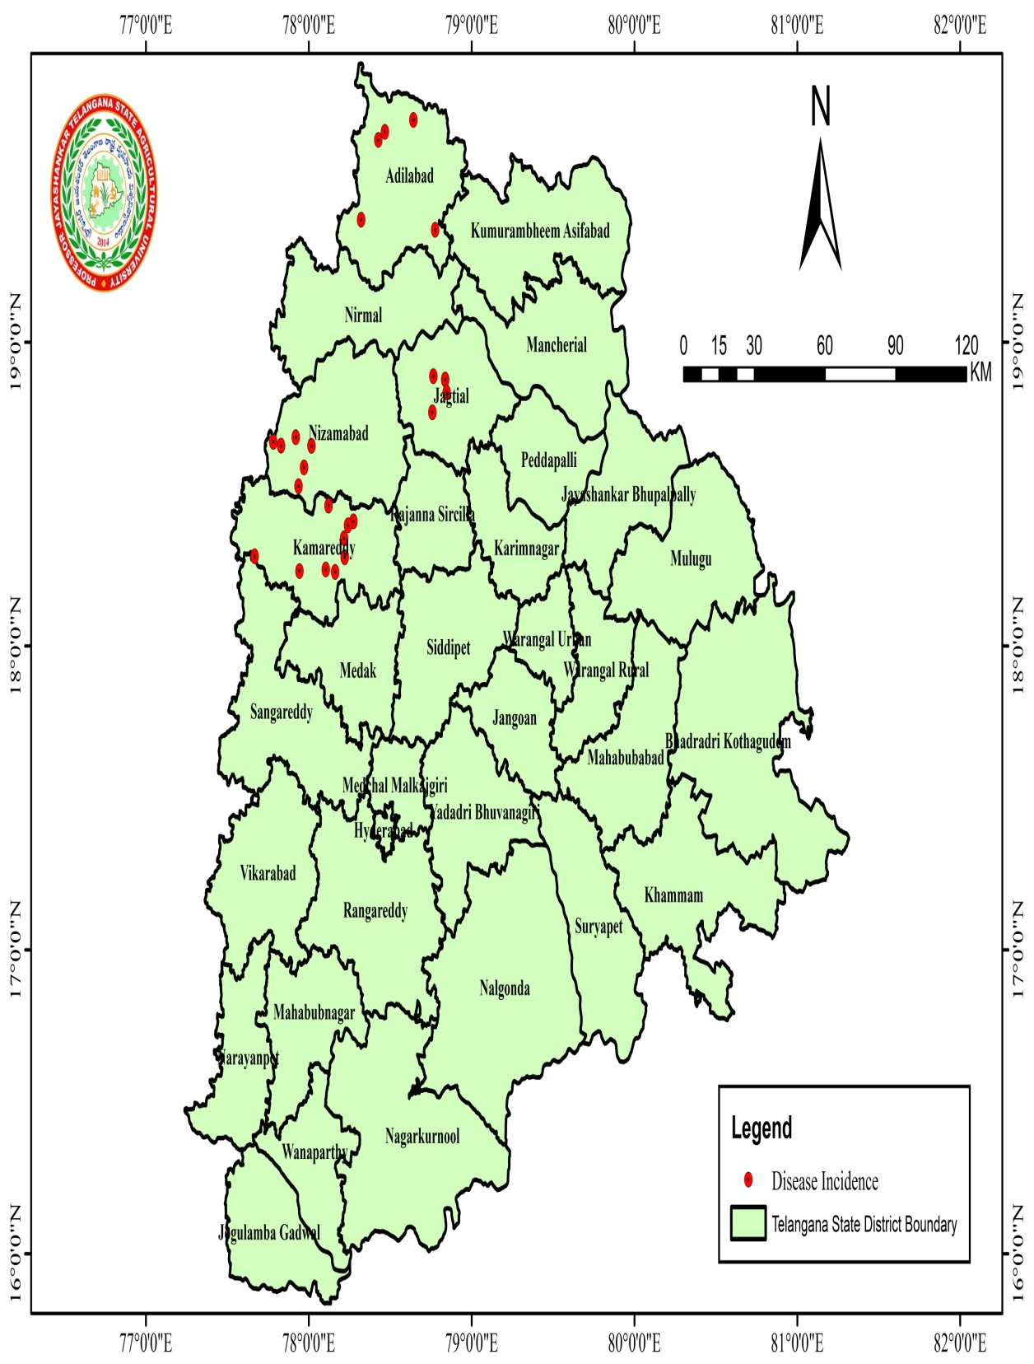

**Fig.1- Map showing surveyed locations for the incidence of soybean diseases in Telangana state during *rabi* 2023-2024.**

**3.3. Prevalence of Dry root rot disease**

In the field, the disease manifested as **yellowing and drooping** of young leaves. Dark brown **lesions appeared at base** of the **stem** accompanied by **bark shredding.** Affected plants were **easily uprooted**, leaving behind **dried, rotten root portions** in the soil. The **rotted stem and root tissues contained numerous black minute sclerotia**, which were characteristic symptoms of **dry root rot disease.** The survey results revealed that during *rabi* 2023-24, the incidence of dry root rot varied from 0 per cent to 38.4 per cent. Among the four districts surveyed, the maximum dry root rot disease incidence (42.9%) was recorded in Kalleda village Jagtial mandal & district at pod maturity stage. No disease incidence (0%) was recorded in Durgam and Ghandari villages of Kamareddy district during vegetative stage. The maximum mean disease incidence was recorded in Jagtial (24.27%) and minimum mean disease incidence was recorded in Kamareddy (7.65%)(Table 1).

The similar results were reported by (Kendre, 2018) while surveying for charcoal rot incidence in soybean across different tahsils of Jalna and Aurangabad districts, ranging from 13.61% to 31.51%, with the highest incidence in Badnapur tahsil, Jalna (31.51%). Local soybean varieties were found to be highly susceptible (33.47% incidence), whereas NRC-177 suffered the least (5.42%). Similar trend was reported by Avanija *et al.* (2023) in mungbean with the highest incidence in Ichoda village, Adilabad district (31.7%), and the lowest in Pallipadu village, Khammam district (5.3%). The maximum mean dry root rot incidence in mungbean was recorded in Mahabubabad district (18.9%), followed by Warangal district (18.1%). Karibasappa *et al.* (2018) observed dry root rot in sesame, with the highest incidence in Babapur village, Nirmal district (15.00%), and the lowest in Korutla village, Jagtial district (2.50%). From his findings, the disease was more prevalent in sandy loam soils, followed by clay loam, and was least severe in clay soils.

**3.4. Prevalence of Anthracnose/pod blight disease**

In the field, disease was characterized by black sunken irregular lesions or reddish-brown patches. The veins of lower leaves were turned black.

The survey revealed that anthracnose disease incidence ranged from 0.0% to 18.3%. Among the four districts surveyed, the highest disease incidence (16.8%) was recorded in Kalleda village, Jagitial mandal & district at the pod maturity stage. No disease incidence (0%) was observed in Kamareddy district, particularly at the vegetative stage. The highest mean disease incidence was recorded in Jagitial (8.16%), while the lowest mean incidence was observed in Kamareddy (2.57%) (Table .1). The results of present study are in agreement with Amrate *et al*. (2023) who reported aerial blight and anthracnose/pod blight affected soybean genotypes from the R1 to R7 stages and the V3 to R7 stages, with incidence rates ranging from 0.0% to 46.8% and 0.0% to 56.2%, respectively. Similarly, Bhatt *et al*. (2022) found that anthracnose/pod blight was present in all surveyed districts of Uttarakhand, except Haridwar district. The pooled mean disease incidence varied from 3.96% to 27.0%, with severity ranging from 2.04% to 15.69%. Akshaya *et al*. (2021) reported that in Tamil Nadu, the highest anthracnose/pod blight incidence was recorded in Yercaud (17.1%), while Ooty (4.8%) had the lowest incidence.

|  |  |  |  |  |  |  |  |  |  |  |  |  |  |  |  |  |  |  |  |
| --- | --- | --- | --- | --- | --- | --- | --- | --- | --- | --- | --- | --- | --- | --- | --- | --- | --- | --- | --- |
| S.No. | Name of the farmer | District | Mandal | Village | Field location | | Soil type | Previous  crop | Variety | DOS | DOV | Area  (acre) | Crop stage | Disease Incidence | | | | | |
| Latitude | Longitude | ALS | YMV | DRR | Anthracnose | PM | SDS |
| 1 | M.Ashok Reddy | Adilabad | Jainath | Jainath | 19.7313 | 78.6425 | Black soil | Maize | JS 335 | 14.11.2023 | 20.12.2023 | 3 | Vegetative stage | 38.2 | 45.2 | 3 | 1.6 | 1.2 | 2 |
| 2 | Venkat swamy | Adilabad | talamadugu | Umadam | 19.6657 | 78.4272 | Clay soil | Maize | Basara | 17.04.2024 | 06.04.2024 | 2.5 | Pod maturity stage | 12.4 | 13.7 | 15.6 | 9 | 0 | 0 |
| 3 | Burri Shiva | Adilabad | Tamsi | Waddadi | 19.692036 | 78.46751 | Sany loamy soils | Maize | Suraj gold | 07.01.2024 | 06.04.2024 | 3.5 | Pod maturity stage | 8.6 | 11.2 | 18.4 | 12.3 | 0 | 1 |
| 4 | D.Mahipal reddy | Adilabad | Jainath | Jamini | 19.403218 | 78.32154 | Black soil | Maize | JS 9305 | 08.11.2023 | 20.12.2023 | 4 | Vegetative stage | 14.2 | 11.4 | 2.5 | 1 | 0 | 1 |
| 5 | D.Surendhar | Adilabad | Jainath | Nirala | 19.403218 | 78.32154 | Black soil | Maize | JS 335 | 27.11.2023 | 20.12.2023 | 4 | Vegetative stage | 18.3 | 21.2 | 1 | 2.7 | 0 | 0.9 |
| 6 | M.Mallesh | Jagtial | Jagtial | Kalleda | 17.4322 | 79.4327 | Clay loam | Paddy | KDS 753 | 15.12.2023 | 10.02.2023 | 2 | Pod maturity stage | 22.6 | 47.1 | 42.9 | 16.8 | 2.6 | 0 |
| 7 | G.Upendhar Reddy | Jagtial | Metpally | Vellula | 18.4934 | 78.5545 | Sandy loam soil | Paddy | JS - 9305 | 23.12.2023 | 26.01.2024 | 1.5 | Pod Formation stage | 39.6 | 46.7 | 18.7 | 12 | 0 | 1 |
| 8 | RARS,,Jagtial | Jagtial | Jagtial | Polasa | 18.84083 | 78.950146 | Black soil | Cotton | MAUS612 | 15.11.2023 | 04.01.2024 | 1.5 | Pod Formation stage | 38.2 | 52.4 | 17 | 4 | 0 | 3.6 |
| 9 | B.Gangaram | Jagtial | Jagtial | Tippanapet | 18.83994 | 78.950574 | Black soil | Maize | JS 335 | 04.01.24 | 21.3.2024 | 2 | Pod Formation stage | 37 | 49.3 | 23 | 6 | 3.8 | 3.2 |
| 10 | B.Prasad Rao | Kamareddy | Ghandari | Durgam | 18.46212 | 78.12136 | Clay soil | Paddy | JS 335 | 22.12.2023 | 19.01.2024 | 1.5 | Vegetative stage | 14 | 28 | 0 | 0 | 0 | 0 |
| 11 | Ch. Narsiah | Kamareddy | Ghandari | Burugul | 18.41043 | 78.27432 | Clay soil | Maize | JS 335 | 12.12.2023 | 19.01.2024 | 3 | Flowering stage | 36.1 | 26.5 | 14.2 | 8 | 0 | 0.6 |
| 12 | Ch.Chandra Reddy | Kamareddy | Sadasivnagar | Sadasivnagar | 18.2437 | 78.162 | Clay soil | Paddy | JS 335 | 26.12.2024 | 24.01.2024 | 3 | Pod maturity stage | 13.7 | 19.3 | 22.3 | 10.7 | 0 | 0 |
| 13 | S.Venkateshwarlu | Kamareddy | Sadasivnagar | Utnoor | 19.369814 | 78.77623 | Clay soil | Maize | JS 335 | 21.12.2023 | 24.01.2024 | 6 | Vegetative stage | 18.2 | 34.3 | 2 | 0 | 0 | 0 |
| 14 | G. Yadi Reddy | Kamareddy | Ghandari | Ghandari | 18.2516736 | 78.1045992 | Clay soil | Maize | JS 335 | 28.12.2024 | 19.01.2024 | 5 | Vegetative stage | 18 | 36.7 | 3 | 0 | 3.7 | 0 |
| 15 | G.Sathyam | Kamareddy | Sadasivnagar | Dharmaraopet | 18.39734 | 78.24155 | Clay soil | Paddy | JS 335 | 06.01.2024 | 24.01.2024 | 1 | Vegetative stage | 11.4 | 21.7 | 0 | 0 | 0 | 0 |
| 16 | K.Rajeshwar Rao | Kamareddy | Sadasivnagar | Lingam palle | 18.2953 | 77.6679 | Clay soil | Paddy | JS 335 | 17.12.2023 | 24.01.2024 | 2 | Vegetative stage | 22.3 | 26.4 | 4 | 0 | 0 | 0 |
| 17 | K.Rajeshwar Rao | Kamareddy | Tadwai | Gunkul | 18.2467 | 77.9432 | Clay soil | Maize | JS 335 | 16.11.2023 | 19.01.2024 | 2 | Vegetative stage | 24 | 48 | 8 | 0 | 0 | 0.9 |
| 18 | M. Tirupathi Reddy | Kamareddy | Tadwai | Yerrapahad | 18.29233 | 78.2209 | Clay soil | Paddy | JS 335 | 10.11.2023 | 19.01.2024 | 6 | Pod formation stage | 36.2 | 22.4 | 17 | 7 | 0 | 2.4 |
| 19 | T.Nageshwar Rao | Kamareddy | Tadwai | Tadwai | 18.354444 | 78.216944 | Clay soil | Maize | JS 335 | 25.12.2023 | 19.01.2024 | 10 | Vegetative stage | 18 | 34.1 | 6 | 0 | 2.4 | 1.2 |
| 20 | Maruthi Rao | Nizamabad | Bodhan | Mandarna | 18.6718 | 77.7488 | Clay | Cotton | KDS 753 | 25.12.2023 | 04.02.2024 | 8 | Pod Formation stage | 33.4 | 42.3 | 24 | 5 | 9 | 2.3 |
| 21 | P.Chandra shekahar | Nizamabad | Bodhan | Saloora | 18.692 | 77.8239 | Black soil | Cotton | KDS 753 | 05.01.2024 | 04.02.2024 | 2 | Flowering stage | 17.8 | 42.3 | 34.3 | 3.6 | 11.2 | 6.4 |
| 22 | T.Jaipal Reddy | Nizamabad | Bodhan | Hunsa | 18.6717 | 77.7821 | Clay | Maize | KDS 753 | 01.12.2023 | 04.02.2024 | 5 | Pod maturity stage | 22.6 | 36.2 | 38.2 | 11 | 6.3 | 1.7 |
| 23 | RS&RRS,Rudrur | Nizamabad | Rudrur | Rudrur | 18.37 | 77.9 | Clay loam | Cotton | KDS 753 | 11.12.2023 | 04.02.2024 | 1.5 | Pod Formation stage | 38.2 | 49.2 | 26.7 | 7.2 | 12.4 | 3.2 |
| 24 | B.Lalaiah | Nizamabad | Bodhan | Kopparthy | 18.66767 | 77.84678 | Sandy loam | Paddy | KDS 753 | 08.01.2024 | 04.02.2024 | 3 | Pod maturity stage | 28.4 | 33.4 | 22.4 | 14.2 | 6 | 1 |
| 25 | V.Ravi | Nizamabad | Bodhan | Kumman pally | 18.6596 | 77.8303 | Sandy loam | Tumeric | Karishma | 16.01.2024 | 04.02.2024 | 12 | Flowering stage | 40.3 | 38.4 | 34.6 | 8 | 9 | 3 |

**Table 1. Natural incidence of diseases recorded in soybean during *rabi* 2023-24 in Telangana**

|  |  |
| --- | --- |
| **C:\Users\Bhanuprasad\AppData\Local\Packages\5319275A.WhatsAppDesktop_cv1g1gvanyjgm\TempState\E02A35B1563D0DB53486EC068EBAB80F\WhatsApp Image 2024-06-25 at 10.25.56_6519fee9.jpg**  **(A)** | **_DSC0340.JPG**  **(B)** |
| **C:\Users\Bhanuprasad\AppData\Local\Packages\5319275A.WhatsAppDesktop_cv1g1gvanyjgm\TempState\4A4526B1EC301744ABA9526D78FCB2A6\WhatsApp Image 2024-06-26 at 10.41.29_aa1868b5.jpg**  **(C)** | **C:\Users\Bhanuprasad\AppData\Local\Packages\5319275A.WhatsAppDesktop_cv1g1gvanyjgm\TempState\50D2D2262762648589B1943078712AA6\WhatsApp Image 2024-06-26 at 11.38.31_02233abe.jpg**  **(D)** |
| **C:\Users\Bhanuprasad\AppData\Local\Packages\5319275A.WhatsAppDesktop_cv1g1gvanyjgm\TempState\43975BC2DFC84641A2A8C4D3FE653176\WhatsApp Image 2024-06-26 at 10.37.33_023fcc58.jpg**  **(E)** | **C:\Users\Bhanuprasad\AppData\Local\Packages\5319275A.WhatsAppDesktop_cv1g1gvanyjgm\TempState\EF0EFF6088E2ED94F6CAF720239F40D5\WhatsApp Image 2024-06-25 at 14.23.20_946273fa.jpg**  **(F)** |

**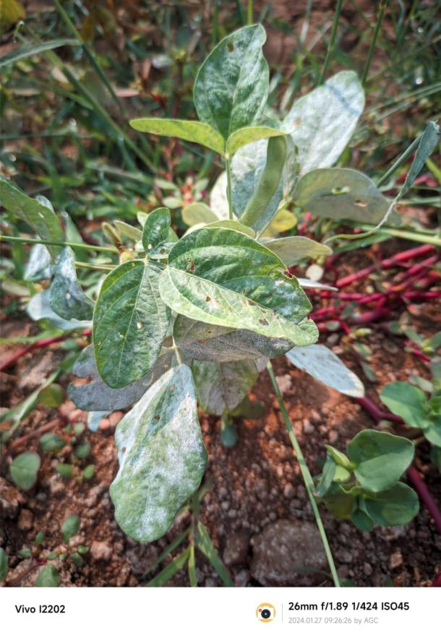 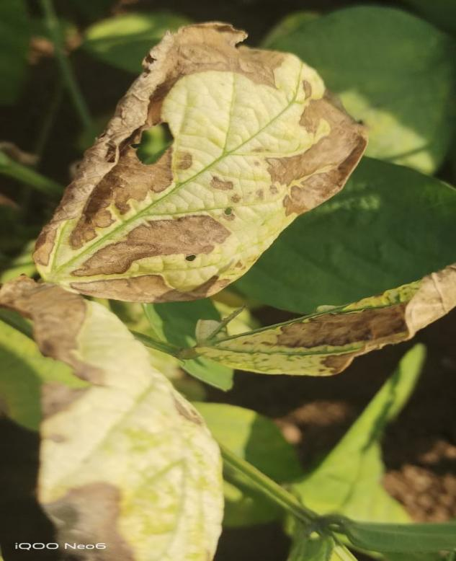**

**(G) (H)**

**Fig 2**. Diseases of *rabi* soybean in Telangana:- **A,B:** Alternaria leaf spot-dark brown to black necrotic spots appear on foliage **C,D**: Yellow Mosaic of soybean ; **E**:Dry root rot caused by *Macrophomina phaseolina* ; **F**: Symptom of Pod blight caused by *Colletotrichum spp;* **G**: Symptom of Powdery mildew on upper surface of leaves **F**: Sudden death syndrome (SDS).

**3.5**. **Prevalence of Powdery mildew disease**

In the field, small, circular areas of white or light grey mold appeared on upper surface of leaves. Later they enlarged and covered the whole leaf are the symptoms of powdery mildew observed during survey.

The survey was conducted in different villages of Telangana during *rabi* 2023-24 showed that anthracnose disease incidence was ranged from 0.00 to 12.4 per cent. Among the four districts surveyed, it was observed that maximum disease incidence (12.4) was recorded in RS& RRS **Rudrur, Nizamabad district** at the **pod formation stage**. The **highest mean disease incidence (7.91%)** was observed in **Nizamabad district**, whereas the **lowest mean incidence (0.24%)** was recorded in **Adilabad district ( Table 1)**.

**The results are similar with Savaliya *et al*. (2018)** who reported the prevalence of **mungbean powdery mildew disease** in all surveyed villages. Among the two districts studied, the **highest mean disease intensity** was recorded in **Navsari district (22.35%)**, followed closely by **Surat district (22.11%)** during *rabi* season.

**3.6. Prevalence of Sudden death syndrome disease**

The infected plant showed small, pale green to yellow circular spots on leaves. The interveinal areas were turned bright yellow to brown and the leaf veins remained green.

According to the findings from the (Table 1) it was observed that maximum sudden death syndrome disease incidence (6.4%) was recorded in Saloora village, Bodhan mandal, Nizamabad district. The maximum mean disease incidence was recorded in Nizamabad (2.93%) and minimum mean disease incidence was recorded in Kamareddy (0.79 %).

Similar studies were reported by (**Tande *et al*. 2014)** whoconducted a survey targeting **SDS-symptomatic soybean plants** in **20 counties of eastern South Dakota** between **July and August.** SDS symptoms were reported in **eight counties,** but with **very low incidence (<3%).**

**4. Conclusion**

The current study revealed that the incidence of Alternaria leaf spot, Yellow mosaic disease, Dry root rot, Anthracnose, Powdery mildew, and Sudden Death Syndrome in soybean varied across different surveyed districts. The survey results revealed that, the highest incidence of Alternaria disease (40.30%) was recorded in Nizamabad, while the lowest (8.60%) was observed in Adilabad. Yellow Mosaic Disease had the highest incidence (52.4%) in Jagtial and the lowest (11.2%) in Adilabad. Jagtial also recorded the highest incidence of both, dry root rot (42.9%) and anthracnose (16.8%), whereas Kamareddy reported no incidence (0%) of these diseases at the vegetative stage. Nizamabad had the highest incidence of both powdery mildew (12.4%) and sudden death syndrome (6.4%). The variation in percent disease incidence was influenced by multiple factors, including cropping patterns, agro-climatic conditions, varieties sown, soil type, time of sowing and crop growth stages. These findings emphasize the importance of roving surveys in plant pathology, which play a crucial role in monitoring plant health, tracking disease spread, and supporting effective disease management strategies. Regular surveys help in early detection, guiding the implementation of preventive and control measures to ensure sustainable soybean production.

Disclaimer (Artificial intelligence)

Option 1:

Author(s) hereby declare that NO generative AI technologies such as Large Language Models (ChatGPT, COPILOT, etc.) and text-to-image generators have been used during the writing or editing of this manuscript.

Option 2:

Author(s) hereby declare that generative AI technologies such as Large Language Models, etc. have been used during the writing or editing of manuscripts. This explanation will include the name, version, model, and source of the generative AI technology and as well as all input prompts provided to the generative AI technology

Details of the AI usage are given below:

1.

2.

3.

Option 1 I do, hereby declare that no generative AI technologies have been used during writing of this manuscript.

**References**

* **Anonymous.** 2022-2023.Soybean Statistics, ICAR-IISR, Indore, MP.
* Ahangaran A, Mohammadi M, Koohi H, Khezri S, Shahraeen N . 2009. Use of rapid serological and nucleic acid based methods for detecting the Soybean mosaic virus. *Agricultural Science and Technology* ,11: 91-97
* Akshaya, N.M. and Shete, P. 1985. Survey on anthracnose disease of soybean (*Colletotrichum truncatum*) in selected locations of Tamil Nadu. *Phytopathology*, *75*: 489-492
* Alka and Singh, S. P. 2004. Survival of *Alternaria tenuissima* causing leaf spot of pigeonpea in diseased plant debris. Ann. Pl. Prot. Sc. 12(1): 231-232.
* Amrate, P. K., Shrivastava, M. K., Bhale, M. S., Agrawal, N., Kumawat, G., Shivakumar, M and Nataraj, V. 2023. Identification and genetic diversity analysis of high-yielding charcoal rot resistant soybean genotypes. *Scientific Reports*. 13(1): 8905.
* Avanija, M., Padmaja, G., Vidyasagar, B., Hari, Y., Devi, G.U., Kumar, J.H. and Ramulu, C., 2023. Assessment of disease incidence of dry root rot of mungbean incited by *Macrophomina phaseolina (Tassi.) Goid,* in Telangana state. *Journal of Food Legumes*, *36*(1), pp.54-58.
* Balai, L.P., Singh, R.B. and Yadav, S.M., 2013. Survey for the disease status intensity of Alternaria blight of pigeonpea in eastern part of Uttar Pradesh and adjoining districts of western Bihar. *The Bioscan*, *8*(1): 63-66
* Borah, M and Saikia, H. 2019. Influence of Weather Parameters on the Development of Collar Rot of Soybean caused by *Sclerotium rolfsii*. *International Journal of Current Microbiology and Applied* *Sciences*. 8(10): 1667-1675.
* Borah, M. and Deb, B., 2022. Fungi causing leaf spot diseases of soyabean: Their epidemiology and integrated management strategies. *International Journal of Economic Plants*, *9*(1): 88-94.
* Fagodiya, R.K., Trivedi, A., Fagodia, B.L. and Ratnoo, R.S., 2021. Prevalence and distribution of Alternaria leaf spot in soybean growing areas of Rajasthan. *Indian Journal of Agricultural Sciences*, *91*(5): 699-702.
* Gaikwad, H. D., Deokar, C.D., Kolase, S.V., Deshmukh, M.P., Chimote, V.P., Narute, T.K. and Prabha, K. 2021. Survey for Natural Incidence of Soybean Yellow Mosaic Disease in Western Maharashtra. *International Journal of Current Microbiology and Applied Sciences*.*10*(03):800-809.
* Gupta, G.K., Sharma, S.K. and Ramteke, R., 2012. Biology, epidemiology and management of the pathogenic fungus *Macrophomina phaseolina (Tassi) Goid* with special reference to charcoal rot of soybean (Glycine max (L.) Merrill). *Journal of Phytopathology*, *160*(4): 167-180.
* Karchi, R.M., Balol, G.B., Lokesh, B.K. and Mogali, S., 2023. Prevalence of mungbean yellow mosaic virus on greengram in northern parts of Karnataka. *Journal of Farm Sciences*, *36*(1): 47-49
* Karibasappa, C.S., Bhat, B.N. and Rao, S.C., 2018. Survey for the disease incidence of root rot of sesame caused by *Macrophomina phaseolina (Tassi.) Goid,* in major sesame growing areas of Telangana. *Journal of Pharmacognosy and Phytochemistry*, *7*(6): 655-657.
* Kendre, A.H., 2018. *Studies on soybean charcoal rot caused by macrophomina phaseolina (tassi) goid* (Doctoral dissertation, Vasantrao Naik Marathwada Krishi Vidyapeeth, Parbhani).
* Le, T.T.T. and Sato, Y., 2017. Identification of the fungus Erysiphe diffusa causing powdery mildew disease on soybeans in Vinh Phuc, Vietnam. *Vietnam Journal of Science, Technology and Engineering*, *59*(2): 43-47.
* Mallaiah, B. and Rao, V.K., 2016. Survey and virulence studies on dry root rot of greengram [*Vigna radiate* (L.) Wilczek] incited by *Macrophomina phaseolina* (Tassi.) Goid.
* Nakajima, T., Mitsueda, T. and Charchar, M.J.D., 1996. First occurrence of sudden death syndrome of soybean in Brazil. *Japan Agricultural Research Quarterly*, *30:* .31-34.
* Olszak-Przybyś, H., Korbecka-Glinka, G., Czubacka, A. and Patkowska, E. 2021. Identification of fungi inhabiting underground plant parts of soybean [*Glycine max (L.) Merrill*] intwo developmental stages. *Acta Scientiarum Polonorum Hortorum Cultus*. 20(5): 139-149.
* Panduranga, G.S., Reddy, P.K. and Rajashekara, H., 2012. Survey for incidence of mungbean yellow mosaic virus (MYMV) in mungbean Vigna radiata (L.) Wilczek. *Environment and Ecology*, *30*(3), pp.1030-1033.
* Sharma, M., Ghosh, R., Mangla, N., Saxena, K. B. and Pande, S. 2012. Alternaria tenuissima causing alternaria blight on pigeonpea [Cajanus cajan (L.) Millsp.] in India. Pl. Disease. 96(6): 907-917.
* Sharma, P. 2016. Dynamics of growth of soybean in India: role of income and risk. *Agricultural Situation in India*. 73(6): 37-46.
* Sharma, S., Singh, R., Sharma, B.K. and Kumar . 2020 . Survey and surveillance on Alternaria Blight of Cluster bean of in Northern MP ,India *Plant Archives*. 20 (2) : 3609-3614.
* Silodia, K., Bhale, U. and Bhale, M.S., 2018. Status and evaluation of soybean varieties against Mungbean Yellow Mosaic (MYMV) disease under changing climatic conditions of Kaymore plateau zone, Madhya Pradesh, India. *Indian Journal of Agricultural Research*, *52*(6), pp.686-690.
* Tripathi, N., Tripathi, M.K., Tiwari, S. and Payasi, D.K., 2022. Molecular breeding to overcome biotic stresses in soybean: update. *Plants*, *11*(15), p.1967.
* Vengadeshkumar, L., Kalaiselvi, M., Sanjaygandhi, S. and Jaiganesh, V., 2019. Survey on the incidence of cowpea root rot disease and assessing the cultural characters and virulence of *Macrophomina phaseolina.*
* Zade, S.B., Ingle, Y.V., Mane, S.S. and Gathe, A.G., 2018. Survey of alternaria leaf spot of soybean in central vidarbha. *Journal of plant disease sciences*, *13*(2), pp.107-110.
* (https://agricoop.nic.in/en, 2021-22)