***Review Article***

**~~Modern Technology in Floriculture: A Comprehensive Review~~**

Smart Floriculture: Emerging Technologies and Future Prospects

**Abstract**

~~This review paper explores the integration of modern technology in floriculture, encompassing various aspects of flower production, post-harvest handling, and marketing.~~ ~~The floriculture industry has witnessed significant advancements in recent years, driven by technological innovations that have revolutionized traditional practices.~~ In recent years, the floriculture industry has experienced significant advancements driven by technological innovations that have transformed traditional practices. Smart technologies have revolutionized floriculture by transforming flower production and marketing in the digital age, thereby shaping the global flower industry. This ~~review paper~~ study explores the integration of modern technology in floriculture, encompassing various aspects of flower production, post-harvest handling, and marketing. ~~This paper~~ It examines key areas where technology has made substantial impacts, including precision agriculture, greenhouse automation, genetic engineering, vertical farming, and e-commerce. ~~The review also~~ Additionally, it discusses emerging trends and future prospects in floriculture technology, ~~highlighting~~ emphasizing the potential for sustainable and efficient flower production. By synthesizing current research and industry practices, this ~~paper~~ review provides a comprehensive overview of the state-of-the-art technologies in floriculture and their implications for the industry's future.

**Keywords**: ~~Floriculture~~, ~~Modern Technology~~, Precision Agriculture, Greenhouse Automation, Genetic Engineering, Vertical Farming, E-commerce

**1. Introduction**

Floriculture, ~~the cultivation of flowering flowers and ornamental plants for commercial and aesthetic purposes,~~ branch of horticulture that focuses on the cultivation, production, and marketing of flowers and ornamental plants, has been an integral part of human civilization for centuries. In recent decades, the industry has undergone a significant transformation, driven by technological advancements that have revolutionized traditional practices (van Henten ~~et al.,~~ *et al.,* 2018). ~~This review paper aims to provide a comprehensive overview of modern technologies employed in floriculture, their impacts on various aspects of the industry, and future prospects.~~

The global floriculture market has experienced steady growth, with a projected value of $72.1 billion by 2027 (~~Grand View Research,~~ ??? ~~2020~~). (FAO, 2024). This growth is largely attributed to increasing urbanization, rising disposable incomes, and growing awareness of the aesthetic and therapeutic benefits of flowers and ornamental plants. Thus, ~~To~~  to meet the increasing demand and overcome challenges such as climate change, resource scarcity, and labor shortages, the floriculture industry has embraced various technological innovations.

~~This review paper is structured to cover the following key areas:~~

1. ~~Precision Agriculture in Floriculture~~
2. ~~Greenhouse Automation and Control Systems~~
3. ~~Genetic Engineering and Biotechnology~~
4. ~~Vertical Farming and Urban Floriculture~~
5. ~~Post-harvest Technologies~~
6. ~~E-commerce and Digital Marketing~~
7. ~~Emerging Trends and Future Prospects~~

~~By examining these areas,~~ Thus the aim of this paper ~~aims~~ is to provide researchers, industry professionals, and policymakers with a comprehensive understanding of the current state of technology in floriculture and its potential future directions. ??????? Incomplete meaning

**2. Precision Agriculture in Floriculture**

~~Precision agriculture, a farming management concept based on observing, measuring, and responding to inter and intra-field variability in crops, has found significant applications in floriculture. This approach aims to optimize returns on inputs while preserving resources, leading to more efficient and sustainable flower production~~ Precision agriculture, a farming management approach that involves observing, measuring, and responding to inter- and intra-field variability in crops, has found significant applications in floriculture. This technology-driven method aims to optimize resource utilization while maximizing returns on inputs, resulting in more efficient and sustainable flower production. (Cislaghi ~~et al.,~~ *et al.,* 2020).

**2.1 Remote Sensing and Imaging Technologies**

Remote sensing technologies, including satellite imagery, aerial photography, and unmanned aerial vehicles (UAVs), have revolutionized the way floriculturists monitor and manage their crops. These technologies provide high-resolution spatial and temporal data on plant health, soil conditions, and environmental factors (Khanal ~~et al.,~~ *et al.,* 2017).

For instance, multispectral and hyperspectral imaging techniques allow for the early detection of plant stress, diseases, and nutrient deficiencies. By analyzing the reflectance of different wavelengths of light from plant surfaces, growers can identify issues before they become visible to the naked eye, thus, enabling timely interventions (Sankaran ~~et al.,~~ *et al.,* 2015).

**2.2 Soil and Plant Sensors**

The integration of sensors in floriculture has enabled real-time monitoring of various parameters crucial for optimal plant growth. Soil moisture sensors, ~~for example,~~ provide accurate data on water content, allowing ~~for~~ precise irrigation scheduling and preventing water stress or overwatering (Rahimi ~~et al.,~~ *et al.,* 2019).

~~Other types of sensors used in floriculture include:~~

* ~~Nutrient sensors for monitoring soil fertility~~
* ~~pH sensors for maintaining optimal soil acidity~~
* ~~Temperature sensors for climate control~~
* ~~Light sensors for managing supplemental lighting~~

These sensors, often connected to centralized control systems, enable growers to make data-driven decisions and automate various aspects of crop management ~~(van Iersel et al.,~~ *et al.,* ~~2016).~~

**2.3 Variable Rate Technology (VRT)**

Variable Rate Technology allows for the precise application of inputs such as water, fertilizers, and pesticides based on the specific needs of different areas within a field or greenhouse. This technology integrates data from various sources, including soil maps, yield ~~data~~, and remote sensing information, to create prescription maps for input application ~~(Bongiovanni & Lowenberg-DeBoer, 2004).~~

In floriculture, VRT has shown significant benefits in terms of resource efficiency and crop quality. For example, a study by Zhang ~~et al.~~ *et al.,* (2019) demonstrated that variable rate fertilization in rose cultivation resulted in a 15% reduction in fertilizer use while maintaining yield and quality.

~~Table 1: Benefits of Precision Agriculture in Floriculture~~ **Table 1: Benefits of Precision Agriculture in Floriculture**

|  |  |
| --- | --- |
| **Technology** | **Benefits** |
| Remote Sensing | Early detection of plant stress and diseases |
| Soil and Plant Sensors | Real-time monitoring of growth conditions |
| Variable Rate Technology | Optimized resource use and improved crop quality |

**3. Greenhouse Automation and Control Systems**

Greenhouse automation has been a game-changer in floriculture, enabling precise control of environmental conditions and reducing labor requirements. Modern greenhouses are equipped with sophisticated control systems that manage various aspects of the growing environment (Shamshiri ~~et al.,~~ *et al.,* 2018).

**3.1 Climate Control Systems**

Advanced climate control systems in greenhouses regulate temperature, humidity, and CO2 levels to create optimal growing conditions for flowers. These systems typically include:

* Heating and cooling systems
* Ventilation and air circulation equipment
* CO2 enrichment systems
* Shade screens and supplemental lighting

Modern climate control systems often employ artificial intelligence and machine learning algorithms to predict and adjust environmental conditions based on historical data, weather forecasts, and plant growth models (Abad ~~et al.,~~ *et al.,* 2020).

**3.2 Automated Irrigation Systems**

Precise water management is crucial in floriculture for optimal plant growth and disease prevention. Automated irrigation systems, often integrated with soil moisture sensors and weather data, ensure that plants receive the right amount of water at the right time ~~(Belayneh et al., 2013).~~

These systems can be programmed to deliver water and nutrients through various methods, including:

* Drip irrigation
* Misting systems
* Ebb and flow systems
* Nutrient film technique (NFT)

**3.3 Robotic Systems in Greenhouse Operations**

Robotics and automation have found numerous applications in greenhouse floriculture, addressing labor shortages and improving efficiency. Some examples include:

* Automated transplanting machines
* Robotic harvesting systems
* Automated grading and sorting equipment
* Autonomous guided vehicles (AGVs) for material handling

For instance, a study by Arad ~~et al.~~ *et al.* (2020) demonstrated the successful development of a robotic system for autonomous rose harvesting, capable of identifying and cutting flowers with precision comparable to human workers.

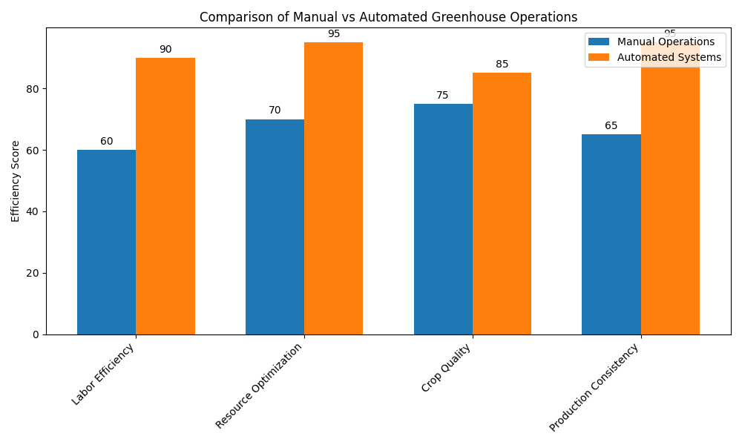

**Figure 1: Comparison of Manual vs Automated Greenhouse Operations**

**4. Genetic Engineering and Biotechnology**

Genetic engineering and biotechnology have opened up new possibilities in floriculture, allowing for the development of novel flower varieties with enhanced traits such as improved vase life, unique colors, and resistance to pests and diseases ~~(Chandler & Sanchez, 2012).~~

**4.1 Genetic Modification for Trait Enhancement**

Genetic modification techniques have been used to introduce desirable traits in ornamental plants. Some notable achievements include:

* Blue roses: Achieved by introducing genes for blue pigment production from other plant species ~~(Katsumoto et al., 2007).~~
* Extended vase life: Manipulation of ethylene biosynthesis and perception genes to delay senescence ~~(Reid et al., 2009).~~
* Disease resistance: Introduction of genes conferring resistance to common pathogens (~~Chandler, 2007).~~

**4.2 Marker-Assisted Selection (MAS)**

Marker-Assisted Selection is a biotechnology tool that allows breeders to select plants with desired traits based on genetic markers, rather than waiting for the traits to be expressed phenotypically. This technique has significantly accelerated the breeding process in floriculture ~~(Arús et al., 2012).~~

MAS has been particularly useful in:

* Developing disease-resistant varieties
* Improving flower quality traits such as color and fragrance
* Enhancing stress tolerance in ornamental plants

**4.3 In Vitro Propagation and Tissue Culture**

In vitro propagation techniques have revolutionized the mass production of high-quality, disease-free planting material in floriculture. These techniques allow for:

* Rapid multiplication of elite plant material
* Conservation of rare and endangered species
* Year-round production of planting material
* Production of virus-free plants through meristem culture

A study by ~~Rout et al. (2006)~~ demonstrated the successful micropropagation of various ornamental plants, including roses, orchids, and carnations, highlighting the potential of this technology in commercial floriculture.

~~Table 2: Applications of Biotechnology in Floriculture~~ **Table 2: Application of Biotechnology in Floriculture**

|  |  |
| --- | --- |
| **Technique** | **Applications** |
| Genetic Modification | Novel flower colors, extended vase life, disease resistance |
| Marker-Assisted Selection | Accelerated breeding for desired traits |
| In Vitro Propagation | Mass production of elite, disease-free planting material |

**5. Vertical Farming and Urban Floriculture**

Vertical farming, a technique of growing crops in vertically stacked layers, has gained traction in urban floriculture due to its potential to maximize space utilization and resource efficiency ~~(Despommier, 2013).~~

**5.1 Hydroponic and Aeroponic Systems**

Hydroponic and aeroponic systems have enabled the cultivation of flowers in soilless environments, offering several advantages:

* Efficient use of water and nutrients
* Reduced risk of soil-borne diseases
* Year-round production regardless of outdoor conditions
* Precise control over plant nutrition

A study by ~~Sardare and Admane (2013)~~ demonstrated that hydroponic rose cultivation resulted in higher yield and better flower quality compared to traditional soil-based cultivation.

**5.2 LED Lighting Technologies**

Light-emitting diode (LED) technology has revolutionized indoor plant cultivation, including floriculture. LED lights offer several advantages over traditional lighting systems:

* Energy efficiency
* Spectral customization for optimal plant growth
* Long lifespan and low heat emission

Research by ~~Massa et al. (2008)~~ showed that LED lighting could be optimized to enhance flower quality and manipulate flowering time in various ornamental species.

**5.3 Smart Vertical Farming Systems**

Integration of IoT (Internet of Things) and AI technologies has led to the development of smart vertical farming systems for floriculture. These systems typically include:

* Automated climate control
* Precision fertigation systems
* Real-time monitoring and data analytics
* Predictive maintenance

A case study by ~~Kozai (2013)~~ demonstrated the successful implementation of a smart vertical farming system for ornamental plant production, achieving high resource use efficiency and consistent product quality.

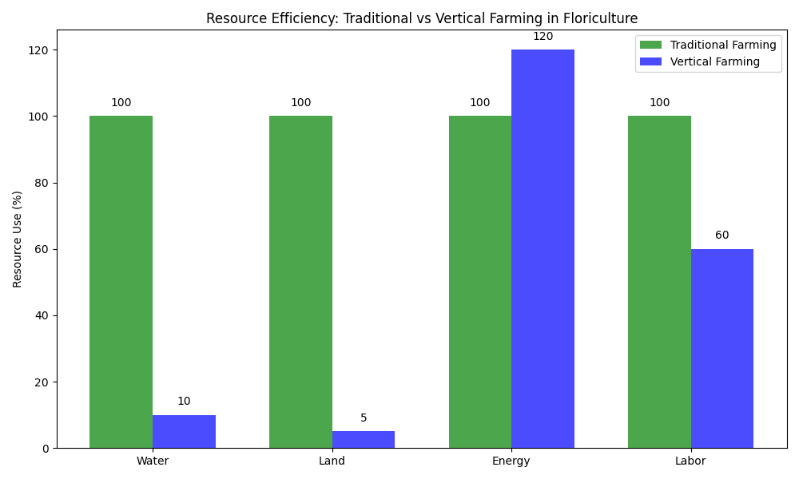

**Figure 2: Resource Efficiency Comparison: Traditional vs Vertical Farming in Floriculture**

**6. Post-harvest Technologies**

Post-harvest technologies play a crucial role in maintaining flower quality and extending vase life, which are critical factors in the floriculture industry ~~(Reid & Jiang, 2012).~~

**6.1 Cold Chain Management**

Effective cold chain management is essential for preserving flower quality from harvest to the end consumer. Modern cold chain technologies in floriculture include:

* Advanced refrigeration systems with precise temperature and humidity control
* Smart packaging materials with modified atmosphere capabilities
* Real-time temperature monitoring and tracking systems

A study by ~~van Doorn (2012)~~ demonstrated that maintaining an unbroken cold chain could extend the vase life of cut flowers by up to 50%.

**6.2 Innovative Packaging Solutions**

Packaging technologies have evolved to not only protect flowers during transportation but also to extend their shelf life. Some innovative packaging solutions include:

* Active packaging materials that release ethylene inhibitors
* Breathable films that regulate gas exchange
* Smart packaging with built-in freshness indicators

Research by Karimi ~~et al.~~ *et al.* (2020) showed that nano-composite packaging materials could significantly reduce microbial growth and extend the vase life of cut roses.

**6.3 Vase Life Extension Treatments**

Various chemical and biological treatments have been developed to extend the vase life of cut flowers. These include:

* Ethylene inhibitors such as 1-Methylcyclopropene (1-MCP)
* Antimicrobial compounds to prevent stem blockage
* Plant growth regulators to delay senescence

A comprehensive review by ~~Ahmad et al. (2014)~~ highlighted the efficacy of various vase life extension treatments and their mechanisms of action.

~~Table 3: Post-harvest Technologies in Floriculture~~

|  |  |  |
| --- | --- | --- |
| **Technology** | **Application** | **Benefit** |
| Cold Chain Management | Temperature-controlled storage and transportation | Extended shelf life |
| Innovative Packaging | Modified atmosphere packaging, smart materials | Improved quality during transit |
| Vase Life Extension Treatments | Chemical and biological preservatives | Prolonged vase life for consumers |

**7. E-commerce and Digital Marketing**

The floriculture industry has embraced e-commerce and digital marketing strategies to reach a wider customer base and streamline supply chains (Rihn ~~et al.,~~ 2019).

**7.1 Online Marketplaces and Direct-to-Consumer Models**

Online marketplaces have transformed the way flowers are bought and sold. These platforms offer:

* Direct connections between growers and consumers
* Reduced intermediaries in the supply chain
* Greater variety and customization options for customers

A study by ~~Palma and Ward (2010)~~ found that online flower sales have grown significantly, with consumers valuing convenience and competitive pricing.

**7.2 Augmented Reality (AR) and Virtual Reality (VR) in Floriculture Marketing**

AR and VR technologies are being increasingly used in floriculture marketing to enhance customer experience. Applications include:

* Virtual flower arrangement tools
* AR-powered plant identification and care guides
* Virtual tours of flower gardens and nurseries

Research by ~~Yim et al. (2017~~) demonstrated that AR applications in floriculture marketing could significantly increase customer engagement and purchase intentions.

**7.3 Data Analytics and Personalization**

Big data analytics and AI-powered personalization have enabled floriculture businesses to:

* Predict market trends and consumer preferences
* Optimize inventory management
* Deliver personalized product recommendations

A case study by Zhao ~~et al.~~ (2019) showed how data analytics could be used to optimize pricing strategies and increase profitability in the floriculture e-commerce sector.

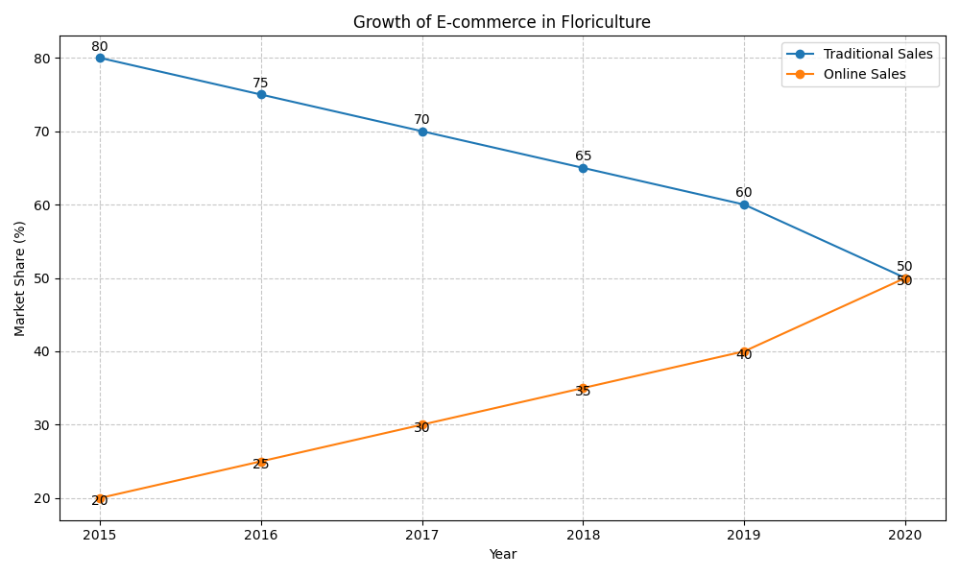

**Figure 3: Growth of E-commerce in Floriculture**

**8. Emerging Trends and Future Prospects**

As technology continues to evolve, several emerging trends are shaping the future of floriculture:

**8.1 Artificial Intelligence and Machine Learning**

AI and ML are expected to play increasingly important roles in various aspects of floriculture, including:

* Predictive maintenance of greenhouse systems
* Automated pest and disease detection
* Optimization of growing conditions based on plant phenotyping

A review by Liakos ~~et al.~~ (2018) highlighted the potential applications of AI in precision agriculture, many of which are applicable to floriculture.

**8.2 Nanotechnology in Floriculture**

Nanotechnology offers promising applications in floriculture, such as:

* Nano-fertilizers for enhanced nutrient uptake
* Nanoparticle-based pesticides for improved pest control
* Nanosensors for real-time monitoring of plant health

Research by Sekhon (2014) demonstrated the potential of nanotechnology in improving crop productivity and reducing environmental impact in agriculture, including floriculture.

**8.3 Sustainable and Circular Floriculture**

There is a growing focus on developing sustainable and circular practices in floriculture, including:

* Biodegradable growing media and packaging materials
* Energy-efficient greenhouse designs
* Water recycling and rainwater harvesting systems

A study by ~~Rikken (2010)~~ highlighted the importance of sustainability in the floriculture industry and proposed strategies for implementing circular economy principles.

**8.4 Gene Editing and CRISPR Technology**

Advanced gene editing techniques, particularly CRISPR-Cas9, are expected to revolutionize plant breeding in floriculture. Potential applications include:

* Rapid development of disease-resistant varieties
* Creation of novel flower colors and shapes
* Improvement of post-harvest traits such as vase life

A review by ~~Khandagale and Nadaf (2016)~~ discussed the potential applications and challenges of gene editing technologies in ornamental plant breeding.

~~Table 4: Emerging Trends in Floriculture Technology~~

|  |  |
| --- | --- |
| **Trend** | **Potential Applications** |
| AI and Machine Learning | Predictive maintenance, automated pest detection |
| Nanotechnology | Enhanced nutrient delivery, improved pest control |
| Sustainable Practices | Circular economy principles, energy-efficient designs |
| Gene Editing | Rapid trait improvement, novel flower characteristics |

**9. Conclusion**

The integration of modern technology in floriculture has transformed the industry, leading to improved productivity, quality, and sustainability. From precision agriculture and greenhouse automation to genetic engineering and e-commerce, technological innovations have touched every aspect of flower production and marketing.

As the industry continues to evolve, emerging technologies such as AI, nanotechnology, and gene editing promise to further revolutionize floriculture practices. However, the adoption of these technologies also brings challenges, including high initial investment costs, the need for skilled labor, and potential environmental and ethical concerns.

Future research should focus on:

1. Developing cost-effective technological solutions for small and medium-scale growers
2. Investigating the long-term environmental impacts of new technologies
3. Exploring the integration of multiple technologies for synergistic benefits
4. Addressing regulatory and ethical issues related to genetic engineering and data privacy

By embracing technological innovations while addressing these challenges, the floriculture industry can continue to grow sustainably, meeting the increasing global demand for flowers and ornamental plants while minimizing environmental impact.

**References**

1. Abad, E., Palau, C. E., Ugalde, U., Caro, J., & Almeida, A. (2020). Smart greenhouse monitoring system based on IoT. IEEE Internet of Things Journal, 7(5), 3970-3980.
2. Ahmad, I., Dole, J. M., & Carlson, A. S. (2014). Treatments to improve the vase life of cut flowers. Horticultural Reviews, 42, 267-354.
3. Arad, B., Balendonck, J., Barth, R., Ben-Shahar, O., Edan, Y., Hellström, T., ... & Ringdahl, O. (2020). Development of a sweet pepper harvesting robot. Journal of Field Robotics, 37(6), 1027-1039.
4. Arús, P., Yamamoto, T., Dirlewanger, E., & Abbott, A. G. (2012). Marker-assisted selection in stone fruit breeding. Breeding Science, 62(2), 107-114.
5. Belayneh, B. E., Lea-Cox, J. D., & Lichtenberg, E. (2013). Costs and benefits of implementing sensor-controlled irrigation in a commercial pot-in-pot container nursery. HortTechnology, 23(6), 760-769.
6. Bongiovanni, R., & Lowenberg-DeBoer, J. (2004). Precision agriculture and sustainability. Precision Agriculture, 5(4), 359-387.
7. Chandler, S. F. (2007). Genetic modification in floriculture. Biotechnology Letters, 29(6), 889-903.
8. Chandler, S. F., & Sanchez, C. (2012). Genetic modification; the development of transgenic ornamental plant varieties. Plant Biotechnology Journal, 10(8), 891-903.
9. Cislaghi, A., Corbari, C., Bocchiola, D., & Mancini, M. (2020). Precision agriculture technologies in flower and ornamental plant cultivation: A review. Agronomy, 10(9), 1340.
10. Despommier, D. (2013). Farming up the city: the rise of urban vertical farms. Trends in Biotechnology, 31(7), 388-389.
11. Grand View Research. (2020). Floriculture Market Size, Share & Trends Analysis Report By Product (Cut Flowers, Pot Plants), By Application (Conferences & Activities, Personal Use), By Region, And Segment Forecasts, 2020 - 2027. Retrieved from<https://www.grandviewresearch.com/industry-analysis/floriculture-market>
12. Karimi, L., Yazdanpanah, S., Shams-Ghahfarokhi, M., Tajik, S., & Faridi-Majidi, R. (2020). Nanocomposite films based on CMC and PVA with antibacterial and antifungal properties for packaging applications. International Journal of Biological Macromolecules, 158, 834-845.
13. Katsumoto, Y., Fukuchi-Mizutani, M., Fukui, Y., Brugliera, F., Holton, T. A., Karan, M., ... & Tanaka, Y. (2007). Engineering of the rose flavonoid biosynthetic pathway successfully generated blue-hued flowers accumulating delphinidin. Plant and Cell Physiology, 48(11), 1589-1600.
14. Khanal, S., Fulton, J., & Shearer, S. (2017). An overview of current and potential applications of thermal remote sensing in precision agriculture. Computers and Electronics in Agriculture, 139, 22-32.
15. Khandagale, K., & Nadaf, A. (2016). Genome editing for targeted improvement of plants. Plant Biotechnology Reports, 10(6), 327-343.
16. Kozai, T. (2013). Resource use efficiency of closed plant production system with artificial light: Concept, estimation and application to plant factory. Proceedings of the Japan Academy, Series B, 89(10), 447-461.
17. Liakos, K. G., Busato, P., Moshou, D., Pearson, S., & Bochtis, D. (2018). Machine learning in agriculture: A review. Sensors, 18(8), 2674.
18. Massa, G. D., Kim, H. H., Wheeler, R. M., & Mitchell, C. A. (2008). Plant productivity in response to LED lighting. HortScience, 43(7), 1951-1956.
19. Palma, M. A., & Ward, R. W. (2010). Measuring demand factors influencing market penetration and buying frequency for flowers in the US. International Food and Agribusiness Management Review, 13(1030-2016-82869), 65-82.
20. Rahimi, A., Ahmadi, N., & Souri, M. K. (2019). Application of nanosensors in the detection of soil moisture and nutrients: A review. Journal of Nanostructure in Chemistry, 9(3), 163-176.
21. Reid, M. S., & Jiang, C. Z. (2012). Postharvest biology and technology of cut flowers and potted plants. Horticultural Reviews, 40, 1-54.
22. Reid, M. S., Jiang, C. Z., & Chen, J. C. (2009). Controlling ethylene responses in flowers at the receptor level. Biotechnology Advances, 27(4), 351-359.
23. Rihn, A., Khachatryan, H., & Wei, X. (2019). Assessing purchase patterns of price conscious consumers. Journal of Retailing and Consumer Services, 47, 354-365.
24. Rikken, M. (2010). The European market for fair and sustainable flowers and plants. ProVerde, Haarlem, The Netherlands.
25. Rout, G. R., Mohapatra, A., & Jain, S. M. (2006). Tissue culture of ornamental pot plant: A critical review on present scenario and future prospects. Biotechnology Advances, 24(6), 531-560.
26. Sankaran, S., Mishra, A., Ehsani, R., & Davis, C. (2010). A review of advanced techniques for detecting plant diseases. Computers and Electronics in Agriculture, 72(1), 1-13.
27. Sardare, M. D., & Admane, S. V. (2013). A review on plant without soil-hydroponics. International Journal of Research in Engineering and Technology, 2(3), 299-304.
28. Sekhon, B. S. (2014). Nanotechnology in agri-food production: an overview. Nanotechnology, Science and Applications, 7, 31-53.
29. Shamshiri, R. R., Kalantari, F., Ting, K. C., Thorp, K. R., Hameed, I. A., Weltzien, C., ... & Shad, Z. M. (2018). Advances in greenhouse automation and controlled environment agriculture: A transition to plant factories and urban agriculture. International Journal of Agricultural and Biological Engineering, 11(1), 1-22.
30. van Doorn, W. G. (2012). Water relations of cut flowers: An update. Horticultural Reviews, 40, 55-106.
31. van Henten, E. J., Bac, C. W., Hemming, J., & Edan, Y. (2018). Robotics in protected cultivation. In Springer Handbook of Robotics (pp. 1321-1354). Springer, Cham.
32. van Iersel, M. W., Chappell, M., & Lea-Cox, J. D. (2013). Sensors for improved efficiency of irrigation in greenhouse and nursery production. HortTechnology, 23(6), 735-746.
33. Yim, M. Y. C., Chu, S. C., & Sauer, P. L. (2017). Is augmented reality technology an effective tool for e-commerce? An interactivity and vividness perspective. Journal of Interactive Marketing, 39, 89-103.
34. Zhang, X., Davidson, E. A., Mauzerall, D. L., Searchinger, T. D., Dumas, P., & Shen, Y. (2015). Managing nitrogen for sustainable development. Nature, 528(7580), 51-59.
35. Zhao, Y., Ni, Y., & Zhou, R. (2019). What factors influence the mobile search advertising adoption? A qualitative inquiry. Computers in Human Behavior, 93, 288-302.