Original Research Article

Effect of cell wall neutral sugars and uronic acid compounds on cassava (*Manihot esculenta* Crantz) retting ability

.

ABSTRACT

|  |
| --- |
| **Aims:** Evaluate the effect of cassava cell wall neutral sugars and uronic acids on the ability of cassava to be retted by a traditional starter (sta_96).  **Place and Duration of Study:** sample: collected from a farm in the Center region in Cameroon. All the analysis were performed at the Department of Microbiology of the University of Yaounde 1 in Cameroon, between June 2024 and December 2024.  **Methodology:** height (08) different local cassava varieties 12 months aged were submitted to fermentation with Sta_96 and their retting kinetic parameters (retting rate and retting times) were assessed by penetrometry. Furthermore, their parietal compounds (neutral sugars and uronic acids) and non-parietal compounds (reducing and total sugars) were analyzed by spectrophotometry and the data obtained were submitted to correlation analysis.  **Results:** It was observed that the roots of the VB 3, CB 1, CB 2, sweet, 6M, and CR varieties softened more easily, with retting speeds ranging from 1.04 ± 0.88 to 1.75 ± 0.23 cm/h and retting times ranging from 42.64 ± 7.07 to 50.64 ± 0.44 h. The roots of the VB 1 and VB 4 varieties softened with greater difficulty. Negative correlations (-0.79 and -0.881 respectively for neutral sugars and uronic acids) were observed between neutral sugars, uronic acids and softening rate, suggesting that these compounds increase cassava’s retting time by decreasing it retting speed. This study shows that the cassava’s softening ability is linked to the neutral sugars and uronic acids content in cassava root walls.  **Conclusion:** Taking into account the cell wall composition in the formulation of starters can lead to a standardization of the cassava roots retting time. |

*Keywords: Cassava cell wall; traditional starter star_96; neutral sugars; uronic acids; fermentation*

1. INTRODUCTION

Most cassava-derived products for human consumption are obtained by cassava root fermentation. This operation, which can be carried out in a solid or liquid medium (retting), is found in almost all processes for transforming cassava into most popular fermented products (stick, miondo, water fufu, chikwangue, or flour) (Ze et al., 2021). During this process, cassava roots are immersed in water and left to ferment for few days, resulting in the breakdown of parietal compounds such as polygalacturonans, galactans, and consequently the roots softening (Ngolong Ngea et al., 2016). At the same time, cyanogenic substances endogenous to cassava roots are brought into contact with enzymes catalyzing their breakdown, thus leading to their detoxification (Apeh et al., 2021; Njankouo Ndam et al., 2019). During this process, microbial activity contributes to the aromas, taste, texture, and characteristics of fermented cassava products, which are highly appreciated by consumers (Nkoudou et al., 2016). However, cassava retting is limited by its length, which ranges from 3 to 7 days depending on the cassava variety and the season. In order to reduce the duration of this one-off operation and ensure the quality of the products made available to consumers, the use of pure starters or traditional starters has been recommended by various authors (Darman et al., 2015; Nkoudou et al., 2016; Assamoi et al., 2022). Since the requirements of pure starters make them difficult to use in rural areas, the use of traditional starters, which are more flexible and better adapted to the rural environment, appears to be the best way of reducing retting time. This is the case with the sta_96 starter proposed by (Nkoudou et al., 2016). This starter, which is made of prefermented cassava chips, reduces retting time by 50%. However, its retting capacity differs from one cassava variety to another, which is why retting times vary when cassava roots are retted with this starter and why fermented cassava-based products are so rare, even though they are highly appreciated by consumers. In our knowledge, no study has demonstrated the impact of cell wall compounds in accelerated cassava retting process. The investigation of the reasons behind the differences in behavior of this starter with regard to various cassava varieties would provide important data in the development of starters for retting. The aim of this study was therefore to investigate the influence of the variability in the neutral sugar and uronic acid contents of cassava walls on the retting ability of cassava by Sta_96.

2. materialS and methods

**2.1. Sta_96 production**

The traditional starter (Sta_96) used in this work was produced according to the protocol described by (Ze et al., 2021). Harvested cassava roots were peeled, cut into cylinders, and washed. 1 kg of the pieces obtained was immersed in 1000 ml of tap water and incubated at room temperature for 96 h for fermentation. After this, the cassava roots were wrung out and sun-dried to a water content of less than 15%, then ground and stored in a dry place.

**2.2. Cassava varieties fermentation**

Roots from 08 local varieties (VB 1, VB 2, VB 3, VB 4, CB 1, CR, 6M, and Sweet,) 12-month aged were harvested and packed in polyethylene bags before being transported to the laboratory, where they were peeled, cut into cylinders, and washed. 1 kg of cylindrical cassava pieces of each variety obtained were immersed in 1000 ml of tap water, inoculated with 1% (w/w) of the starter previously produced, and left to ferment at room temperature (28±2°C).

**2.3. Assessment of the kinetic parameters of root fermentations**

The kinetic parameters of root fermentation were evaluated by penetrometry every 2 h of fermentation according to the method described by (Ze et al., 2016). For this purpose, roots randomly taken from the fermentation medium were subjected to pressure from the tip of a penetrometer (RPN10 Berlin), and the level of softening was estimated by the penetration distance of the tip into the cassava root. Four measurements were taken on each side, and the average of these measurements was taken as the penetration distance of the penetrometer needle, enabling the level of root softening to be assessed. The data obtained were adapted to the Baranyi & Roberts, 1994 model using DMFIT software in order to determine the rate and the retting time of the different cassava roots.

**2.4. Neutral sugars and uronic acids content analysis**

Neutral sugars and uronic acids of cassava walls were analyzed using the following methodology: preparation of the alcohol insoluble residue (AIR), extraction of parietal material (CWM), and quantification of cassava cell wall material neutral sugars and uronic acids.

**2.4.1. Preparation of the alcohol insoluble residue (AIR)**

The alcohol insoluble residue was prepared as described by (Ngolong Ngea et al., 2016). Fresh roots samples were immersed in 03 volumes of 96% ethanol and heated to 95°C for 10 min. The mixture obtained was cooled and then filtered using a No. 4 Wattman paper. After filtration, the AIR obtained was subjected to several successive washes with 70% ethanol until the carbohydrates were no longer detectable in the supernatant. The residue from the 70% ethanol wash was rinsed with 96% alcohol before being dried at 40°C for 12 hours.

**2.4.2. Extraction of cell wall material (CWM) by de-starching of AIR**

Deamidation of AIR was carried out as described by (McCleary et al., 1997). 0.5 g of AIR was suspended in 1 ml of MOPS (3-(N-morpholinopropanesulphonic acid)) buffer (50 mM; pH 7) and then heated to 100°C. 5 ml of thermostable alpha-amylase (60 U/ml) was added to the medium, and the mixture was incubated at 100°C for 20 min. The medium was cooled to 50°C, the pH adjusted to 4.5 with acetate buffer, and 5 ml of 40 U/ml amyloglucosidase was added to the mixture, which was once more incubated at 50°C for 1 hour. The whole mixture was cooled, and 4 volumes of 96% ethanol were added to the mixture, which was then filtered. The resulting pellet was successively washed with 80% and 96% ethanol and then dried for 12 hours at 40°C. The deamidated AIR obtained was considered as cell wall material (CWM) and used for further analysis.

**2.4.3. Quantification of CWM neutral sugars and uronic acids.**

Quantification of CWM neutral sugars and uronic acids was done after acid hydrolysis. The samples were pre-hydrolyzed with 72% (v/v; 26 M) sulphuric acid for 30 min at 25 °C and then hydrolyzed into monomers at 100 °C for 2 h in 1 M sulphuric acid. Uronic acid content and neutral sugars were determined in the acid hydrolysis supernatant as described by (Blumenkrantz and Asboe-hansen, 1972) and (Monsigny et al., 1988) respectively.

For Neutral sugars quantification, 200 µL of acid hydrolysis supernatant was mixed with 200 µL of resorcinol solution (6 mg/mL) and 1 mL of 80% H2SO4. The tubes were shaken and then kept in a water bath at 80°C for 3 min. After cooling to room temperature on a dark place, absorbance was measured at 450 nm. The concentration of neutral sugars was determined from a calibration line previously established between the optical density and known concentrations of glucose solutions (Monsigny et al., 1988).

uronic acids were determined by dissolving 4.58 g of sodium tetraborate (Na2B4O7,10H2O) were in 100 mL of 95% sulfuric acid in an ice bath. This solution was stored at 4°C away from light. 15 g of m-HDP (metahydroxydiphenyl) were dissolved in a 0.5% sodium hydroxide solution and diluted 100 times. To 200 µL of sample, 1.2 mL of a 0.125 M sodium tetraborate solution in concentrated sulfuric acid was added. The mixture was thoroughly homogenized by vortexing, and the tubes were placed in a boiling water bath for 5 minutes. Once cooled in an ice bath, 20 µL of m-HDP solution was added. The tubes were then shaken. A pink color develops for 15 min, and the optical densities were determined at 490 nm. The uronic acid concentrations were determined from the equation of a calibration line linking the optical density values to those of known concentrations solutions of galacturonic acid (Blumenkrantz and Asboe-hansen, 1972).

**2.5. Determination of reducing and total sugars contents**

**2.5.1. Total sugars**

Total sugars were determined as described by (Dubois et al., 1956). To this end, 0.5 ml of sample was taken and mixed with 0.5 mL of 5% phenol. The mixture was homogenized, and 2 ml of 75% sulfuric acid was added. The mixture was boiled for 15 min, after which the tubes were cooled in the dark place for 15 min and the optical densities determined at 492 nm.

**2.5.2. Reducing sugars**

The reducing sugar content was determined as described by (Miler, 1958). 0.1 ml of sample was taken and mixed with 0.4 ml of distilled water. The mixture was homogenized, and 1 ml of DNS solution was added and boiled for 10 min. After cooling, the optical densities were determined at 546 nm, and the concentrations of reducing sugars were determined using a calibration line based on various glucose solutions of known concentrations.

**2.6. Statistical analysis**

The data analysis of the softening profile according to time was performed by adapting them to the Baranyi and Robert model (1994) using DM-fit software. The data obtained were subjected to one way ANOVA in order to identify significant differences, and the Duncan test was used to classify varieties on homogenous group according to the neutral sugars and uronic acids content of the wall (P = 0.05). Data of neutral sugars and uronic acids; reducing sugars and total sugars; and retting kinetic parameters were subjected to principal component analysis in order to establish correlations and to group together cassava varieties analyzed on the basis of their characteristics.

3. results and discussion

**3.1. Retting times of cassava retted by Sta_96**

The retting of cassava roots is a process essentially driven by microorganisms. This process makes cassava roots to be soften throughout the microbial activity. During the retting process, the activity of these microorganisms can be influenced by various factors. The retting times of eight (08) cassava varieties subjected to retting by Sta_96, which are illustrated in Figure 1, shows that, cassava roots soften faster when they are subjected to retting by the Sta_96 starter compared with spontaneous retting. This is justified by the starter's richness in microorganisms, as indicated by (Ze et al., 2021; Nkoudou et al., 2016). However, retting speeds differ from one cassava variety to another (Table 1). The highest retting speeds were obtained with the VB3, CB1, and 6M varieties, with values ranging from 1.04 ± 0.88 to 1.75 ± 0.23 cm/h. On the other hand, the lowest retting rates were observed with the VB 1 and VB 4 varieties, with values of 0.12 ± 0.02 and 0.47 ± 0.09 cm/h, respectively. This shows statistical differences in the retting ability of cassava roots using sta_96 and explains the variability in retting times observed in rural areas when cassava roots are retted using Sta_96 starter.

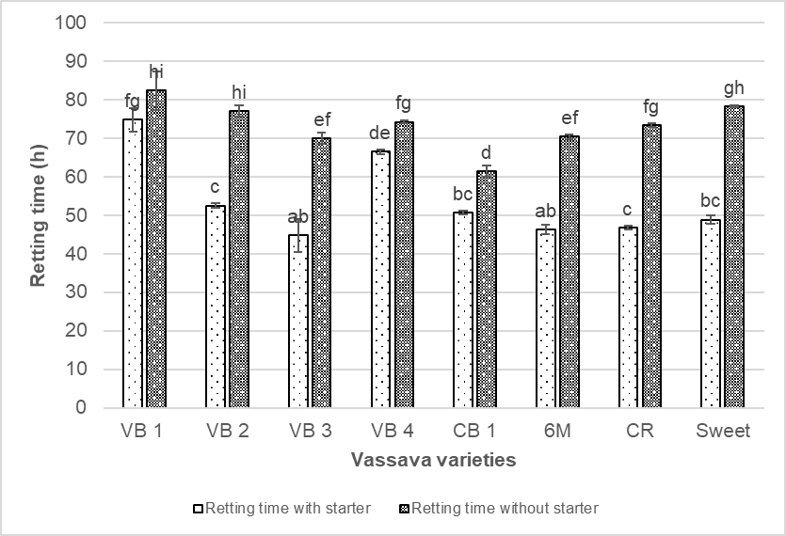

**Fig. 1. Distribution of retting times for cassava roots in the presence and absence of the sta_96 starter.** *For the same cassava variety, the means with different subscript letters are different (P<.05).*

**3.2. Influence of parietal and non-parietal compounds on the softening capacity of cassava roots by Sta_96**

To explain the difference in root retting ability, the cell walls of cassava were analyzed. To this end, parietal and non-parietal compounds were quantified.

**3.1.1 Neutral sugars and uronic acids content of cassava cell wall material**.

Spectrophotometric analyses of cassava cell wall compounds have shown that the neutral sugars and uronic acids content differs significantly from one variety of cassava to another. It is known that the plant wall is essentially composed of pectin, cellulose and hemi cellulose in varying percentages (Zhang et al., 2021). Hydrolysis of these macromolecules releases neutral and/or acidic sugars that are monomers (Ngolong Ngea et al., 2016 ; Staark et al., 2019). The quantitative differences observed in the neutral sugars and uronic acids content of the different varieties of cassava used in the present study confirm the heterogeneity observed in the composition of cassava cell walls of different varieties (Staark et al., 2019 ; Favaro et al., 2008). It was observed that the cells of VB 1 and VB 4 cassava roots, which do not soften easily, contain more neutral sugars (38.91 ± 0.24 and 37.29 ± 0.71 mg neutral sugars/g walls, respectively), which would explain why their retting times are longer, unlike the cells of VB 3 cassava roots (19.38 ± 0.28 mg neutral sugars/g walls). The cassava root cells of the VB 1 variety also contained the highest levels of uronic acids (868.84 ± 6.48 mg/g wall), in compare to the cassava root cells of the CB 1 variety (388.37 ± 0.00 mg/g wall) (table 1). Similar data have been reported in previous studies (Favaro et al., 2008). However, the differences observed with those presented by (Ngolong Ngea et al., 2016) can be explained by the genotypic aspects of each variety and the conditions of the growing environment of these cassava varieties (Simandjuntak et al., 1996). Heterogeneity in the composition of cassava walls would therefore explain the differences in the ability of cassava roots to soften during the accelerated retting process.

**3.1.2. Non-parietal components of cassava cell walls**

Out of all the cassava varieties whose non-parietal compounds were analyzed, only the reducing sugars content of cassava varied slightly from one variety to another. It is therefore not possible to distinguish between the cassava varieties analyzed on the basis of their reducing sugar content, as there is no significant association between reducing sugars and the cassava varieties analyzed. On the other hand, total sugar content differed significantly from one cassava variety to another. The highest total sugar content was observed in the sweet variety, which nevertheless had one of the shortest retting times. The VB3 variety, by contrast, has the lowest total sugar content, although its retting time is not significantly different from that of the sweet variety. These data therefore seem to indicate that there is no significant correlation between the non-parietal components of cassava and their behavior during the retting process.

**Table 1:** **Cell wall components, cell wall non components and retting kinetic parameters of cassava roots retted by Sta_96.***.*

|  |  |  |  |  |  |  |
| --- | --- | --- | --- | --- | --- | --- |
| **Cassava varieties** | **Non cell wall components** | | **Cell wall components** | | **Retting kinetic parameters** | |
| **Reducing sugars**  **(mg/g)** | **Total sugars**  **(mg/g)** | **Neutral sugars**  **(mg/g)** | **Uronic acids**  **( mg/g)** | **Retting times (h)** | **Rate (cm/h)** |
| **VB1** | 1.48 ± 0.74ab | 139.18 ± 13.45b | 38.91 ± 0.24g | 868.84 ± 6.48f | 74.76 ± 3.09fg | 0.12 ± 0.02a |
| **VB2** | 0.62 ± 0.24a | 181.37 ± 11.98c | 26.73 ± 0.18c | 688.82 ± 8.84de | 52.47 ± 0.54c | 0.93 ± 0.16c |
| **VB3** | 2.36 ± 0.52ab | 95.10 ± 0.00a | 19.38 ± 0.28a | 492.55 ± 4.71b | 44.70 ± 4.26ab | 1.60 ± 0.14c |
| **VB4** | 1.11 ± 0.22ab | 253.30 ± 1.22e | 37.29 ± 0.71f | 714.65 ± 11.19e | 66.42 ± 0.72de | 0.47 ± 0.10b |
| **CB 1** | 3.83 ± 0.98ab | 171.17 ± 0.00c | 27.23 ± 0.38c | 388.37 ± 0.00a | 50.64 ± 0.44bc | 1.75 ± 0.23c |
| **CR** | 7.28 ± 0.36b | 308.62 ± 1.22f | 30.16 ± 0.32d | 649.23 ± 0.00cd | 46.703 ± 0.499abc | 0.94 ± 0.23c |
| **6M** | 3.33 ± 0.71ab | 221.31 ± 7.34d | 24.35 ± 0.28b | 598.81 ± 65.41c | 46.18 ± 1.23ab | 1.04 ± 0.88c |
| **Sweet** | 5.31 ± 1.66ab | 709.75 ± 23.23g | 31.26 ± 0.46e | 647.56 ± 3.54cd | 48.813 ± 1.167bc | 0.23 ± 0.04ab |

*Data are presented Mean ± S.E.M = Mean values ± Standard error of means of three experiments the means with different subscript letters are different (P<.05)*

**3.3. modification of cell wall compounds during cassava retting**

Since the softening observed during retting is caused by the breakdown of parietal components and the hydrolysis of those compounds essentially releases neutral sugars, they were measured before and after retting the cassava roots. The data obtained, illustrated in Figure 2, shows a decrease in these compounds during retting. This reduction in the content of neutral sugars and uronic acids observed between the beginning and the end of retting is thought to be linked to the use of galactose, galacturonic acid, and arabinose resulting from the hydrolysis of galactans, pectin, and arabinans that make up the cassava walls (Ngolong Ngea et al., 2016). However, this reduction, which varies significantly from one cassava variety to another, is at least 50% of the initial content of neutral sugars, whatever the variety considered. It would therefore seem that the softening of cassava roots during retting is only observed when half of the parietal components (polygalacturonans, galactans, and arabinans) is hydrolyzed.

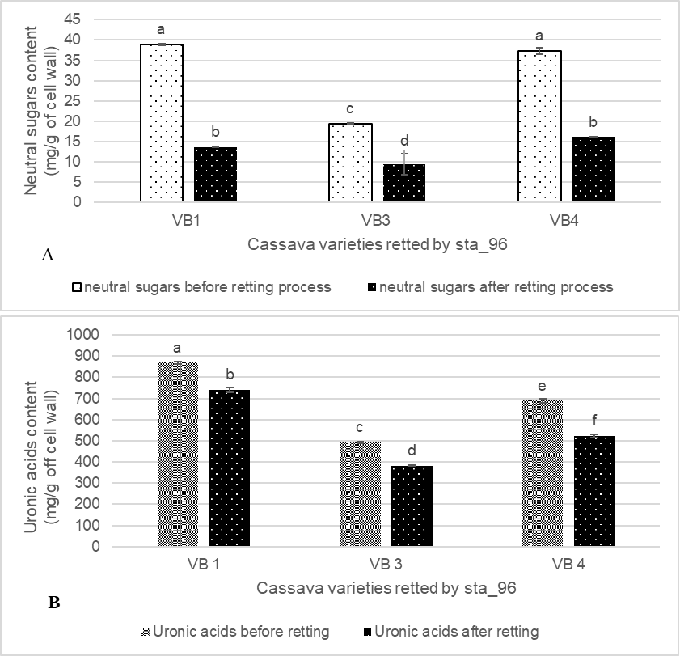

**Fig.2. Changes of neutral sugars (A) and uronic acids (B) contents in cassava varieties subjected to retting by sta_96 at the start and end of retting.** *For the same cassava variety, the means with different subscript letters are different (P<.05).*

**3.4. Principal component analysis (PCA) of the different characteristics of cassava varieties and their behavior during retting.**

A principal component analysis (PCA) was carried out to identify correlations between the kinetic parameters of cassava root retting and root characteristics. Table 2 shows the correlations between the various parietal compounds, the non-parietal compounds, and the kinetic parameters of the cassava roots. The table shows that neutral sugars and uronic acids are negatively correlated with retting speed and positively correlated with retting time. This shows that neutral sugars and uronic acids increase the retting time of cassava roots by reducing their softening speed. On the other hand, reducing sugars are negatively correlated with retting time and positively correlated with retting speed, whereas total sugars are negatively correlated with both retting time and retting speed. Reducing sugars would therefore be used during cassava root retting by microorganisms in the environment for the synthesis of enzymes involved in softening, which would result in an increase in softening speed and consequently a reduction in retting time. On the other hand, the presence of starch, which is a complex macromolecule, would justify the positive correlation observed between total sugars and the cassava retting speed, since hydrolysis of the starch would require energy from the oxidation of reducing sugars.

**Table 2: Pearson correlation coefficients between parietal compounds, non-parietal compounds and retting kinetic parameters.**

|  |  |  |  |  |  |
| --- | --- | --- | --- | --- | --- |
| **Kinetics**  **parameter** | | **Neutral sugars** | **Uronic acids** | **Reducing sugars** | **Total sugars** |
| Correlation coefficient | Retting rate | **-0,790** | **-0,881** | 0,063 | -0,499 |
| Retting Time | **0,860** | **0,697** | -0,535 | -0,206 |
| P-value | Retting rate | **0,01** | **0,002** | 0,441 | 0,104 |
| Retting time | **0,003** | **0,027** | 0,086 | 0,313 |

*Correlation coefficients in bold are statistically significant (P<.05).*

The distribution of cassava varieties on the F1 and F2 axis system according to their characteristics is shown in Figure 3. Analysis of this figure shows that the cassava roots from the varieties studied can be classified into four main groups. The first group is made up of cassava roots from varieties VB1 and VB4. Due to their high content of neutral sugars and uronic acids, these roots are characterized by their low retting speed and consequently long retting time. In contrast, cassava roots of varieties 6M, CB1, and VB3 make up the second group. These are characterized by their low content of neutral sugars and uronic acids. They have a high retting rate and therefore soften easily. The third group of roots is made up of roots from the CR and Sweet varieties, which contain high levels of reducing sugars and total sugars, while the fourth group is made up of roots from the VB2 variety. This group contains low levels of total and reducing sugars, unlike the roots in the previous group.

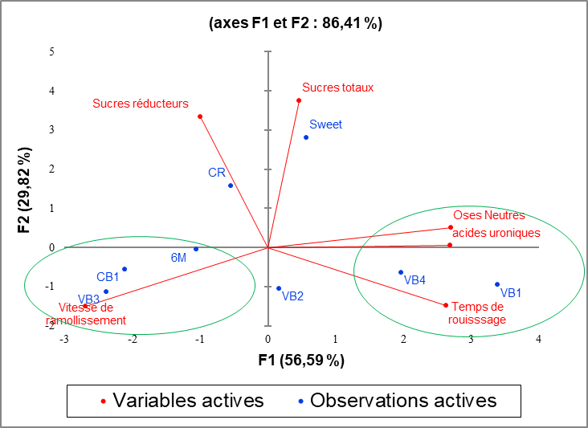

**Fig. 3. Fermented cassava varieties grouped according to their characteristic**

4. Conclusion

This study shows that the variability in retting times observed when cassava roots are retted using the traditional Sta_96 starter is due to differences in the composition of cassava root cell walls. The composition of the cassava cell wall has a significant influence on its ability to soften and therefore on the retting capacity of the traditional Sta_96 starter. As the softening observed during the retting of cassava roots is linked to a reduction in parietal compounds, it would be essential to take into account the cassava genotype in the formulation of starters for the cassava retting process.

References

**Assamoi A.A., Victoire, K.A.A., and Modeste, K.K. (2022).** Use of microbial starter culture for "Attoupkou" (a fermented cassava pancake) production", *J.Anim.Plant Sci.* 54 (1) 9821-9831 doi: 10.35759/JAnmPlSci.v54-1.3.

**Apeh, D. O., Mark, O., Onoja, V. O., Awotunde, M., Ojo, T., Christopher, P., & Makun, H. A. (2021).** Hydrogen cyanide and mycotoxins : Their incidence and dietary exposure from cassava products in Anyigba, Nigeria. *Food Control* *121*, 107663 doi.org/10.1016/j.foodcont.2020.107663

**Baranyi, J., & Roberts, T. A. (1994).** A dynamic approach to predicting bacterial growth in food. *Int. J.F. M*. *23* (3‑4), 277‑294 doi.org/10.1016/0168-1605(94)90157-0

**Blumenkrantz, N. and Asboe-Hansen, G. (1973).** New Method for Quantitative Determination of Uranic Acids. *Anal. Biochem.* 54, 484-489.

**Darman, R. D., Ngang, J. J. E., & Etoa, F.-X. (2015).** *Amelioration du rouissage du manioc par utilisation d’un starter microbien de trois souches* [Amelioration of cassava retting by a stater culture of three strains ]. Int.J.I.Sc.R. 14 (2) 268-277

**DuBois, M., Gilles, K. a., Hamilton, J. K., Rebers, P. a., & Smith, F. (1956).** Colorimetric method for determination of sugars and related substances. *Anal Chem* 28(3), 350–356. doi.org/10.1021/ac60111a017.

**Favaro, S.P., Beléia, A., Da Silva Fonseca Junior, N., and Waldron, K. W. (2008).** The roles of cell wall polymers and intracellular components in the thermal softening of cassava roots. *Food Chem* 108, (1) 220-227 doi: 10.1016/j.foodchem.2007.10.070.

**McCleary, B., Gibson, T., & Mugford, D. (1997).** Measurement of total starch in cereal products by amyloglucosidase-alpha-amylase method: Collaborative study. *J. Assoc. Off. Anal Chem* 80(3), 571–579.

**Miller, L.** (1959). Use of dinitrosalicylic acid reagent for determination of reducing sugar. *Anal chem* 31, 426-428.

**Monsigny, M. Claire P., Andannie-claude R.** (1988). Colorimetric Determination of Neutral Sugars by a Resorcinol Sulfuric Acid Micromethod. *Anal Biochem* 175, 525-530.

**Ngolong Ngea, G. L., Guillon, F., Essia Ngang, J. J., Bonnin, E., Bouchet, B., & Saulnier, L. (2016).** Modification of cell wall polysaccharides during retting of cassava roots. *Food Chem.* *213*, 402‑409 doi.org/10.1016/j.foodchem.2016.06.107

**Njankouo Ndam, Y., Mounjouenpou, P., Kansci, G., Kenfack, M. J., Fotso Meguia, M. P., Natacha Ngono Eyenga, N. S., Mikhaïl Akhobakoh, M., & Nyegue, A. (2019).** Influence of cultivars and processing methods on the cyanide contents of cassava (Manihot esculenta Crantz) and its traditional food products. *Sc Afr*, *5*, e00119 doi.org/10.1016/j.sciaf.2019.e00119

**Nkoudou Ze, N. Kamdem, S. Agnia, H. Mengo, F. and Ngang, J. (2016).** Assessment of Cassava (Manihot esculenta Crantz) Fermentation and Detoxification Using Previously Cassava- fermented Chips. *B.J.A.S.T.* 13(3) 1-10 doi: 10.9734/BJAST/2016/22262.

**Staack, L. Della Pia, E. A., Jørgensen, B., Pettersson, D., and Rangel Pedersen, N. (2019).** Cassava cell wall characterization and degradation by a multicomponent NSP-targeting enzyme (NSPase). *Sci Rep*. 9 (1), p.10150 doi: 10.1038/s41598-019- 46341-2.

**Ze, N. N., Engama, M.-J. M., & Ngang, J.J.E. (2021).** New retting method of cassava roots improve sensory attributes of Bobolo and Chikwangue in Central Africa: An approach through just about right (JAR) test. *E.J.F.Agri.* 33(6) 475-482 doi: 10.9755/ejfa.2021.v33.i6.2716

**Zhang, B., Gao, Y., Zhang, L., and Zhou, Y. (2021).** The plant cell wall: Biosynthesis, construction, and functions. *J.I.P.B.* 63 (1) 251-272 doi: 10.1111/jipb.13055.