**Original Research Article**

**Hepatoprotective Effects of Curcumin Against Dichlorvos-Induced Toxicity in Male Wistar Rats**

**ABSTRACT**

The liver, a vital organ responsible for metabolism, detoxification, and homeostasis, is highly susceptible to damage from prolonged exposure to toxins such as dichlorvos (DDVP). DDVP has been linked to oxidative stress, which compromises liver integrity and function. Conversely, curcumin, a bioactive compound with potent antioxidant and anti-inflammatory properties, may mitigate DDVP-induced hepatic damage. This study investigated the effects of curcumin on liver function, oxidative stress, inflammation, and apoptosis markers in male Wistar rats exposed to DDVP. Thirty-two male Wistar rats (180-200g) were divided into four groups (n=8): Group A (control) received 2 mL/kg of olive oil orally; Group B was exposed to 8 mg/kg of DDVP daily; Group C received both DDVP and curcumin (100 mg/kg orally); Group D received only curcumin (100 mg/kg orally). Treatments lasted six weeks, after which rats were euthanized using ketamine (40 mg/kg) route of drug administration and liver tissue was collected for biochemical assays (ALT, AST, ALP, MDA, GSH, SOD, CAT, TNF-α, IL-1β and CRP) and histological analysis (Hematoxylin and Eosin staining). DDVP exposure significantly elevated hepatic and inflammatory markers, while curcumin treatment reduced these levels, demonstrating its hepatoprotective effects. Histological findings revealed curcumin-mediated regeneration of DDVP-induced hepatic damage. In male Wistar rats,exposure to dichlorvos, curcumin showed notable hepatoprotective effects by reducing oxidative stress, inflammation, and apoptosis while promoting liver regeneration.

***Keywords*:***Dichlorvos, Curcumin, Oxidative stress, Inflammation and hepatotoxicity.*

**INTRODUCTION**

The liver is a large, vital organ with remarkable regenerative capacity, performing a broad range of biological functions essential for maintaining systemic homeostasis. These functions include energy balance, detoxification of xenobiotics and toxins, synthesis of blood proteins, metabolism of vitamins and minerals, and regulation of the immune system [1]. Anatomically, the liver is located beneath the diaphragm and is divided into four lobes, each containing thousands of small functional units known as hepatic lobules [2]. These lobules are connected to small ducts that converge to form the hepatic duct, which transports bile to the gallbladder [3]. Gallbladder are not present in rats, please verify it

Due to its central role in xenobiotic metabolism and its direct exposure to toxins ingested via the oral route, which enter the portal circulation, the liver is particularly susceptible to injury, leading to impaired function [4]. Indeed, drug-induced hepatotoxicity is a leading cause of the withdrawal of certain drugs from the market [5].

Dichlorvos (2,2-dichlorovinyl dimethyl phosphate; DDVP) is an organophosphate widely utilized as a pesticide for controlling household pests, public health pests, and stored product insects [6]. Its mechanism of action involves inhibiting acetylcholinesterase [7], an enzyme responsible for degrading acetylcholine in cholinergic synapses, thereby disrupting nerve function. This can lead to symptoms such as perspiration, nausea, lacrimation, vomiting, diarrhea, excessive bronchial secretion, and potentially fatal outcomes [8]. Human exposure to dichlorvos can occur via air, water, or food, as it is readily absorbed [9]. Dichlorvos exposure has been associated with significant adverse health effects, including hepatotoxicity[10].

The demand for effective treatments with minimal side effects has led to a renewed interest in traditional medicines. Curcumin, a secondary metabolite derived from the spice turmeric, has been used in Ayurvedic medicine for centuries to treat a variety of conditions, including inflammation, cancer, and infections [11].

The widespread use of dichlorvos, an organophosphate insecticide, in both domestic and agricultural contexts has raised concerns because it has been demonstrated to cause substantial hepatotoxicity [12]. Since the liver is the main organ in charge of detoxification, it is especially susceptible to harm from xenobiotics like dichlorvos, which could lead to long-term harm and poor function [13]. The possible hepatoprotective benefits of traditional medicine, especially the usage of chemicals derived from plants, have drawn interest due to their low side effects [14]. A promising option for reducing liver damage brought on by environmental pollutants like dichlorvos is curcumin, a bioactive molecule obtained from Curcuma longa that has anti-inflammatory, antioxidant, and hepatoprotective properties [15]. Its therapeutic ability to reverse dichlorvos-induced hepatotoxicity is still unknown.  
This study aim idto assess curcumin's hepatoprotective properties in reducing dichlorvos-induced toxicity in male Wistar rats. The study's specific objective is to evaluate curcumin's capacity to lower oxidative stress, histological alterations, liver enzyme indicators, and inflammatory reactions linked to dichlorvos exposure. Write the statement of novelty, as many other organophasphates are discussed in detail The results will provide light on curcumin's potential as a natural remedy to shield the liver from harm caused by pesticides.

**MATERIALS AND METHODS**

**Experimental Animal**

Thirty-two healthy male Wistar rats with weights ranging from 180-200g were bought from a private animal breeder around Taki in Ogbomoso North L.G.A, Oyo state. They were kept in well-ventilated plastic cages and housed in the animal house of the Department of Physiology, Faculty of Basic Medical Sciences, LAUTECH, Ogbomoso, Oyo State. The animals in the study had access to food and water and the methods followed the National Research Council's Guide for the Care and Use of Laboratory Animals.

**Chemical and Drugs**

**Curcumin** was procured from commercial source (AK Scientific, U.S.A)

**Dichlorvos:** The local pesticide used in this study is marketed under the trade name Sniper™. It contains 1000 g/L of 2,3-dichlorovinyl dimethyl phosphate (DDVP) as the active ingredient and was manufactured by Forward (Beinaj) Hepu Pesticide Co. Limited, China, for SaroAgrosciences Limited, Oyo State, Nigeria. The pesticide was purchased from the New Waso market in Ogbomoso, Oyo State.

**Preparation of Curcumin**

The imported curcumin powder was weighed and dissolved in a specified volume of olive oil. A dose of 100 mg/kg was prepared and administered via oral gavage, following the method described in previous studies [16,17].

**Ethical Approval**

Ethical approval for the protocol of this study was granted by the Ethical Research Committee of the Faculty of Basic Medical Sciences, Ladoke Akintola University of Technology, Nigeria (ERC Approval Number: ERCFBMSLAUTECH 064/09/2024).

**Experimental Design and Groupings**

Thirty-two healthy male Wistar rats, weighing between 180 - 200g, were used in this study. The animals were acclimatized for a period of two weeks and were randomly assigned using stratified randomization method) into four groups (n=8 each group);

**Group A Rats (Control):**This group consists of rats treated with vehicle, 1ml/kg olive-oil

orally

**Group B Rats (Dichlorvos-exposed rats):** This group consists of rats treated with 8 mg/kg of DDVP

**Group C Rats (Dichlorvos+Curcumin rats):** This group consists of rats treated with 8 mg/kgof DDVP

and 100mg/kg ofCurcumin orally simultaneously as previously reported [10].

**Group D Rats (Curcumin treated rats):** This group consists of rats treated with100mg/kg of Curcumin

orally [18].

Group B and C animals were exposed to DDVP via inhalation. The rat was placed inside the desiccator and allowed to inhale the dichlorvos (that was briefly soaked on a piece of cotton wool) for 15 minutes daily for 42 days to induce liver toxicity.

**Animal Sacrifice and Sample Collection**

Animals were weighed before, during and after the experimental period. After 42 days of exposure and treatment, the rats were fasted over-night [19,20] and culled under ketamine (40 mg/kg) anesthesia administered intraperitoneally [21]. Liver tissue was harvested, weighed, rinsed with normal saline, and preserved in formaldehyde solution for further analysis (biochemical and histological studies). Blood is not collected for biochemical analysis?

**Tissue Homogenization**

Liver tissue samples was homogenized in ice-cold of 0.1M phosphate buffer saline (pH 7.4) and 10% homogenate was prepared [22]. The homogenate was thereafter centrifuged for 15 minutes at 3000 rpm and the supernatant was used for the assay of liver function and inflammatory markers. Why not serum is used for ELISA?

**Biochemical Assay**

**Estimation of hepatic markers:** Alkaline phosphatase (A.L.P.), alanine aminotransferase (A.L.T.), aspartate aminotransferase (A.S.T.) were measured using standard laboratory kit according to manufacturer's guide. Kit makeup?

#### **Oxidative Stress Markers:** Oxidative stress markers were assayed as follows;

**Superoxide Dismutase (SOD)**:This was assayed using the pyrogallol auto-oxidation method [23].

**Catalase (CAT)**:Cat activity was assayed by measuring residual hydrogen peroxide following enzymatic reaction [24].

**Glutathione (GSH)**: This was determined spectrophotometrically according to the method described by Appala et al., [25].

**Malondialdehyde (MDA)**: This was measured by the thiobarbituric acid reactive substances (TBARS) method [26].

**Estimation of Inflammatory markers:**Tumor necrotic factor-alpha (TNF-α), interleukin 6 (IL-6) and CRP C-reactive protein markers of inflammation were assayed using respective rat ELISA kits (Elabscience Biotechnology Co, Ltd, U.S.A.) following the manufacturer protocols. At the same time, Myeloperoxidase (M.P.O.) was equally assayed.

**Histology of the liver:** Immediately after the rats were sacrificed, the hepatic tissues were fixed in 10% formalin, dehydrated in graded alcohol, cleared in xylene, and then embedded in paraffin wax. Afterwards, the tissues were cut into 2–3μm thick sections by a microtome, fixed on the slides, and then stained with haematoxylin-eosin (H and E). The slides were examined under a light microscope at x40 magnification and photomicrographs were taken.

**Statistical Analysis**

Data are expressed as means ± SEM. Statistical significances for measured variables were determined by one-way analysis of variance (ANOVA) for comparison of means across all groups, followed by Tukey’s *posthoc* test for pair-wise comparison. Values of *P<*.05 were considered statistically significant. Statistical analysis was performed with GraphPad Prism 5 software (GraphPad Software, La Jolla, California, USA).

**RESULTS**

**Effect of Curcumin on AlanineAminotransferase (ALT), AlkalinePhosphatase** (**ALP) andAspartate Aminotransferase(AST) in Dichlorvos-Exposed Male Wistar Rats.**

Male Wistar rats exposed to dichlorvos (DDVP) had significantly higher levels of alanine aminotransferase (ALT) (*P*<.05) than the control group, the DDVP+Curcumin-treated group, and the Curcumin-treated group. However, when compared to rats treated with DDVP alone, the co-administration of Curcumin and DDVP resulted in a significant (*P*<.05) decrease in ALT levels. Curcumin's hepatoprotective impact was further demonstrated by the comparable decrease in ALT levels seen in the group that received just Curcumin treatment. Figure 1 displays these findings.

Rats subjected to DDVP also showed significantly higher levels of alkaline phosphatase (ALP) (*P*<.05) than the control, DDVP+Curcumin-treated, and Curcumin-treated groups. However, compared to the DDVP-only group, the administration of Curcumin in addition to DDVP considerably (*P*<.05) decreased ALP levels. ALP levels were also lower in the group that took curcumin exclusively, indicating that it had a protective effect on liver function. Figure 2 illustrates these findings.

Likewise, rats exposed to DDVP had significantly higher levels of aspartate aminotransferase (AST) (*P*<.05) than the control, DDVP+Curcumin, and Curcumin-treated groups. In rats exposed to DDVP, co-treatment with curcumin considerably (*P*<.05) reduced AST levels, putting them closer to those seen in the control group. Reduced AST levels were also observed in the curcumin-only group, indicating that curcumin helps to mitigate the aberrations in liver enzymes brought on by DDVP. Figure 3 provides specifics on these findings.   
Improvements in important liver enzyme markers (ALT, ALP, and AST) demonstrate the preventive and restorative effects of curcumin in reducing DDVP-induced liver damage.

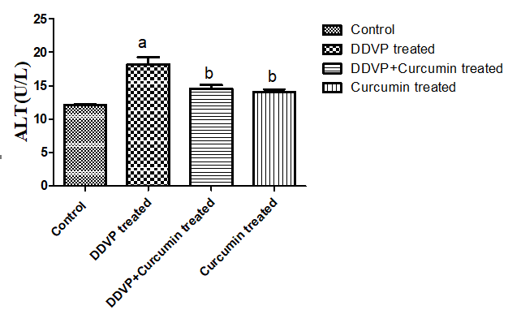

**Figure 1: Effect of Curcumin on AlanineAminotransferase (ALT) in Dichlorvos-Exposed Male Wistar Rats.**

Values are represented as the mean ± SEM.

a*P*<.05 vs Control

b*P*<.05 vs DDVP-treated

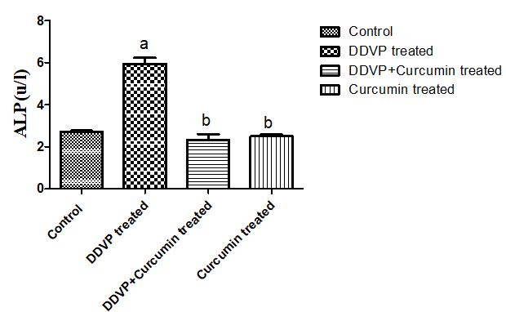

**Figure 2: Effect of Curcumin on AlkalinePhosphatase** (**ALP) in Dichlorvos-Exposed Male Wistar Rats.**

Values are represented as the mean ± SEM.

a*P*<.05 vs Control

b*P*<.05 vs DDVP-treated

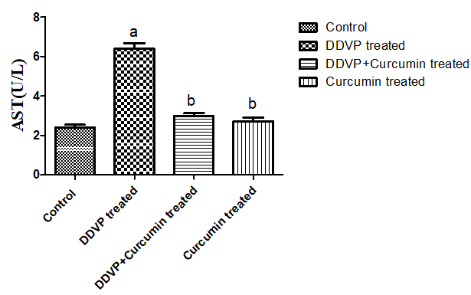

**Figure 3: Effect of Curcumin on Aspartate Aminotransferase(AST) in Dichlorvos-Exposed Male Wistar Rats.**

Values are represented as the mean ± SEM.

a*P*<.05 vs Control

b*P*<.05 vs DDVP-treated

**Effect of Curcumin on Hepatic Oxidative Stress Markers (Malondialdehyde (MDA),Superoxide Dismutase (SOD), Catalase (CAT) and Glutathione (GSH))in Dichlorvos-Exposed Male Wistar Rats.**

The hepatic malondialdehyde (MDA) levels were significantly elevated (*P*<.05) in DDVP-treated rats compared to the control and Curcumin-treated groups. However, Curcumin treatment in DDVP-exposed rats significantly reduced (*P*<.05) MDA levels. Additionally, DDVP-treated rats exhibited significantly lower levels of GSH, SOD, and CAT compared to the control and Curcumin-treated groups. Curcumin administration in DDVP-exposed rats, however, significantly increased the levels of GSH, SOD, and CAT, bringing them closer to those observed in the control and Curcumin-treated groups. These findings are depicted in Figures 4, 5, 6, and 7.

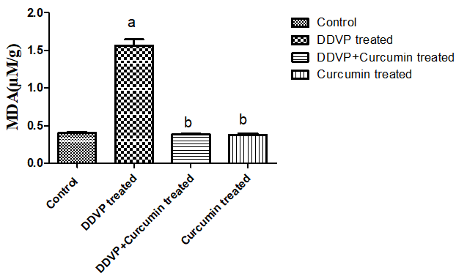

**Figure 4: Effect of Curcumin on Hepatic Malondialdehyde(MDA) in Dichlorvos-Exposed Male Wistar Rats.**

Values are represented as the mean ± SEM.

a*P*<.05 vs Control

b*P*<.05 vs DDVP-treated

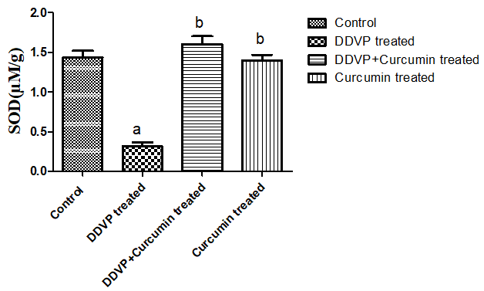

**Figure 5: Effect of Curcumin on Hepatic Superoxide Dismutase (SOD) in Dichlorvos-Exposed Male Wistar Rats.**

Values are represented as the mean ± SEM.

a*P*<.05 vs Control

b*P*<.05 vs DDVP-treated.

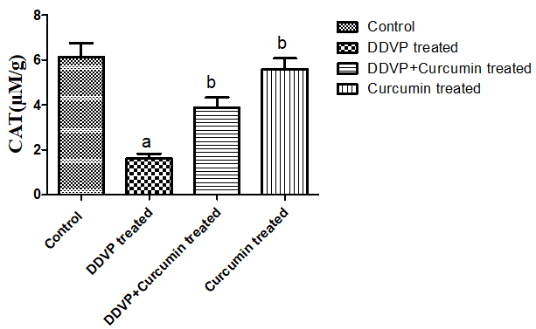

**Figure 6: Effect of Curcumin on Hepatic Catalase (CAT) in Dichlorvos-Exposed Male Wistar Rats.**

Values are represented as the mean ± SEM.

a*P*<.05 vs Control

b*P*<.05 vs DDVP-treated.

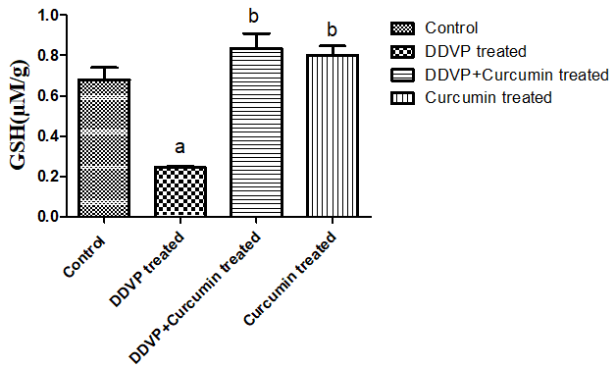

**Figure 7: Effect of Curcumin on Hepatic Glutathione (GSH) in Dichlorvos-Exposed Male Wistar Rats.**

Values are represented as the mean ± SEM.

a*P*<.05 vs Control

b *P*<.05 vs DDVP-treated.

**Effect of Curcumin on Hepatic Inflammatory Markers (**Tumour Necrosis Factor-Alpha (TNF-α), C-Reactive Protein (CRP) and interleukin-1 beta (IL-1β)) **in Dichlorvos-Exposed Male Wistar Rats.**

Male Wistar rats exposed to dichlorvos (DDVP) had significantly higher levels of Tumour Necrosis Factor-Alpha (TNF-α) and C-Reactive Protein (CRP) (*P*<.05) than both the untreated control group and the curcumin-treated group. The elevated levels of these important inflammatory biomarkers suggest that exposure to dichlorvos causes a noticeable inflammatory response. Further supporting curcumin's possible anti-inflammatory qualities and pointing to its protective effect against dichlorvos-induced systemic inflammation is the group that received curcumin, which showed a substantial decrease in TNF-α and CRP levels. This highlights the adverse effects of dichlorvos exposure and the therapeutic potential of curcumin in mitigating such inflammatory responses.

Interestingly, compared to rats treated with dichlorvos alone, there was a substantial decrease in interleukin-1 beta (IL-1β) levels when dichlorvos and curcumin were co-administered. According to this research, curcumin has a strong anti-inflammatory impact and successfully reduces the inflammatory cascade that dichlorvos exposure starts. Curcumin seems to disrupt the signaling pathways that cause systemic inflammation by reducing the rise of IL-1β, a crucial pro-inflammatory cytokine. These findings demonstrate curcumin's medicinal potential in controlling systemic inflammatory reactions brought on by harmful substances like dichlorvos. This also emphasizes curcumin's wider significance as a natural anti-inflammatory agent, which may be used to prevent inflammatory diseases brought on by chemicals.

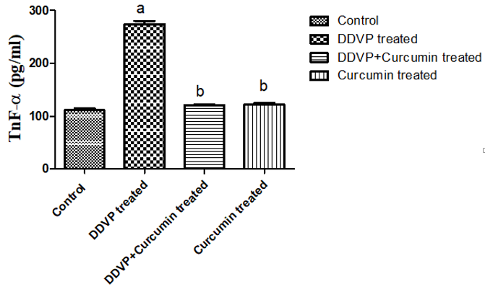

**Figure 8: Effect of Curcumin on Hepatic Tumor-α Necrosis Factor-(TNF-α) in Dichlorvos-Exposed Male Wistar Rats.**

Values are represented as the mean ± SEM.

a*P*<.05 vs Control

b*P*<.05 vs DDVP-treated.

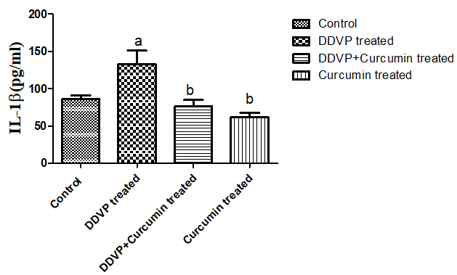

**Figure 9: Effect of Curcumin on Hepatic Interleukin-6(IL-6) in Dichlorvos-Exposed Male Wistar Rats.**

Values are represented as the mean ± SEM.

a*P*<.05 vs Control

b*P*<.05 vs DDVP-treated.

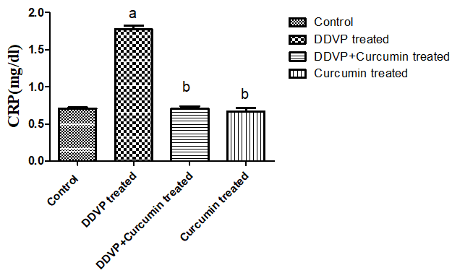

**Figure 10: Effect of Curcumin on Hepatic C-Reactive Protein (CRP)in Dichlorvos-Exposed Male Wistar Rats.**

Values are represented as the mean ± SEM.

a*P*<.05 vs Control

b*P*<.05 vs DDVP-treated.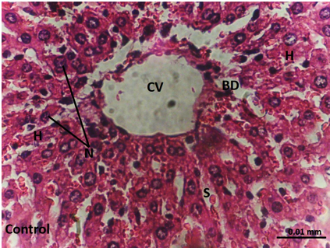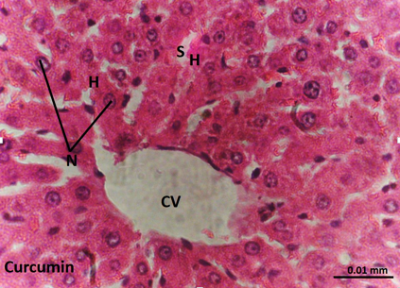

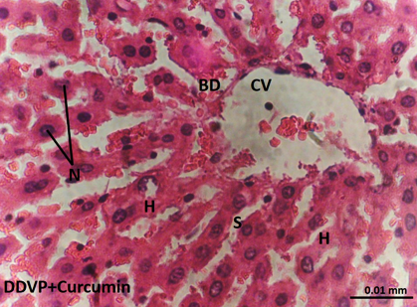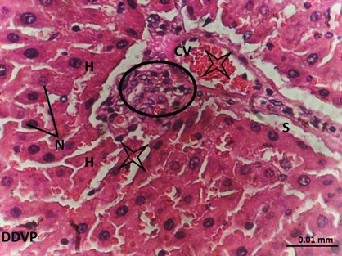

**Fig 11. Haematoxylin and Eosin (H&E)-stained liver tissue photomicrographed at x400 at 400X? magnification displays unique histological characteristics.**

The hepatocytes (H) exhibit their distinctive polygonal form, complete with vesicular nuclei (N) and clearly defined borders. The capillary gaps between hepatocyte plates, known as sinusoids (S), are easily discernible. Notably, localised inflammation inside the liver tissue is indicated by focal foci of inflammatory cell infiltration, which are denoted by a black circle. Furthermore, there is noticeable localised vascular congestion, shown by a star, which indicates reduced blood flow in particular areas. The complex vascular and biliary systems of the liver are reflected in the photomicrograph, which also shows the typical architecture of the bile duct (BD) and the central vein (CV). These findings offer important new information on the liver morphology and potential pathological alterations being studied. Stat is missing for histology

**DISCUSSION**

This study revealed a significant increase in hepatic injury marker enzymes, namely aspartate aminotransferase (AST), alanine aminotransferase (ALT), and alkaline phosphatase (ALP), following exposure to dichlorvos (DDVP). This elevation indicates acute liver damage, suggesting that the toxic effects of DDVP accumulation in hepatic tissue provoke cellular destruction and increase hepatocyte membrane permeability. These findings align with earlier reports by reference style [27], which attributed such enzymatic increases to the hepatotoxic activity of DDVP. Similarly, Saka et al. [10] demonstrated the hepatic injury potential of DDVP.

Conversely, in the DDVP group co-administered with curcumin, a marked reduction in AST, ALT, and ALP levels was observed. This suggests that curcumin exerts a hepatoprotective effect, likely through its anti-inflammatory properties that suppress the production of pro-inflammatory cytokines. This observation corroborates findings by [28], who reported the ability of curcumin to modulate liver enzyme levels and attenuate inflammatory responses. Furthermore, these results support the findings of refrence style [29], which highlighted curcumin's mechanism of action through scavenging reactive oxygen species (ROS), inhibiting their generation, and enhancing endogenous antioxidant defenses.

The study also provided evidence of oxidative damage resulting from dichlorvos exposure. This was reflected in elevated levels of malondialdehyde (MDA) and C-reactive protein (CRP), accompanied by a reduction in antioxidant enzyme activities, including superoxide dismutase (SOD) and catalase (CAT), as well as decreased glutathione (GSH) levels in hepatic tissue. These findings suggest that dichlorvos induces oxidative stress by increasing ROS, disrupting the balance between oxidative agents and the antioxidant defense system. Sule et al. [30] similarly demonstrated that DDVP exposure elevates oxidative stress markers, while [10] reported lipid peroxidation and hepatic oxidative injury induced by dichlorvos.

Co-administration of curcumin significantly mitigated these effects by suppressing lipid peroxidation and enhancing antioxidant defenses. Specifically, curcumin improved GSH, SOD, and CAT activities while reducing MDA and CRP levels, thus attenuating hepatic oxidative damage. The antioxidant activity of curcumin may be attributed to its ability to inhibit the peroxidation of polyunsaturated fatty acids such as linoleate, preventing the formation of fatty acid radicals, as described by Rahaman et al. [31].

Inflammatory processes were also closely linked to oxidative stress in this study, as evidenced by elevated levels of pro-inflammatory markers, including tumor necrosis factor-alpha (TNF-α) and interleukin-1 beta (IL-1β), following dichlorvos exposure. This supports the concept that ROS-induced oxidative damage contributes to inflammation through the activation of signaling pathways essential for inflammatory disorders, as outlined by Simpson et al. [32]. Dichlorvos-induced inflammation further promotes cytokine and chemokine release by immune cells, exacerbating oxidative stress and tissue damage through ROS generation, a mechanism highlighted by Camacho-Pérez [33]. Interestingly, curcumin co-administration attenuated the dichlorvos-induced elevation of pro-inflammatory markers, likely by reducing oxidative stress. This aligns with findings by Yang et al. [34], who demonstrated curcumin's ability to prevent diabetic retinopathy by reducing oxidative and inflammatory mediators.

Histopathological analysis of hepatic tissue corroborated these biochemical findings. Dichlorvos exposure caused significant degradation of hepatic histoarchitecture, including reduced lobular integrity and evidence of structural degeneration, consistent with earlier studies by Hannanet al. [35]. The observed histological alterations may be attributed to oxidative damage, resulting in hepatic tissue disruption. However, curcumin co-administration significantly preserved hepatic architecture, reducing the extent of tissue damage and improving lobular integrity. This protective effect is likely due to curcumin's antioxidant properties and its ability to scavenge free radicals, as reported by El‐Mekkawy et al. [36].

**CONCLUSION**

This study concludes by highlighting the negative effects of dichlorvos exposure on hepatocellular function and illustrating how it contributes to oxidative stress and inflammation mediated by IL-1β, both of which degrade hepatic function. Interestingly, curcumin was demonstrated to have strong hepatoprotective properties, reducing oxidative stress and inflammatory reactions to lessen dichlorvos-induced hepatotoxicity. These results highlight curcumin's potential as a treatment to prevent liver damage brought on by toxins. The exact processes behind curcumin's protective benefits and its wider uses in treating pesticide-induced organ damage require more investigation.

**REFERENCES**

1.Song, W., Wang, Y., Huang, T., Liu, Y., Chen, F., Chen, Y., Jiang, Y., Zhang, C. & Yang, X. T-2 toxin metabolism and its hepatotoxicity: New insights on the molecular mechanism and detoxification. *Environmental Pollution*, 2023; *330*, p.121784.

2. Ugo, L., Brocco, S., Merola, A., Mescoli, C. and Quaia, E. Liver Anatomy. *Imaging of the Liver and Intra-hepatic Biliary Tract: Volume 1: Imaging Techniques and Non-tumoral Pathologies*, 2021;pp.15-47.

3. Carotti, S., Morini, S., Carpino, G. &Gaudio, E.. Liver histology. *Liver Diseases: A Multidisciplinary Textbook*, 2020; pp.17-28.

4. Hirao, H., Nakamura, K. &Kupiec-Weglinski, J.W. Liver ischaemia–reperfusion injury: a new understanding of the role of innate immunity. *Nature reviews Gastroenterology & hepatology*, 2022;*19*(4), pp.239-256.

5. Babai, S., Auclert, L. and Le-Louët, H. Safety data and withdrawal of hepatotoxic drugs. *Therapies*, 2021; *76*(6), pp.715-723.

6. Mishra, A., Kumar, J., Melo, J. S., &Sandaka, B. P. Progressive development in biosensors for detection of dichlorvos pesticide: A review. *Journal of Environmental Chemical Engineering*, 2021; *9*(2), 105067.

7. Zhang, Y., Zhang, W., Li, J., Pang, S., Mishra, S., Bhatt, P., & Chen, S. Emerging technologies for degradation of dichlorvos: a review. *International journal of environmental research and public health*, 2021; *18*(11), 5789.

8. Kobylarz, D., Noga, M., Frydrych, A., Milan, J., Morawiec, A., Glaca, A., Kucab, E., Jastrzębska, J., Jabłońska, K., Łuc, K. &Zdeb, G. Antidotes in Clinical Toxicology—Critical Review. *Toxics*, 2023; *11*(9), p.723.

9. El-Nahhal, I., & El-Nahhal, Y. Pesticide residues in drinking water, their potential risk to human health and removal options. *Journal of Environmental Management*, 2021; *299*, 113611.

Elsevier. 14, 1-11.

Food Bioscience, 59 (91), 104070.<https://doi.org/10.1016/j.fbio.2024.104070>

10. Saka, W. A., Akhigbe, R. E., Abidoye, A. O., Dare, O. S., & Adekunle, A. O. Suppression of uric acid generation and blockade of glutathione dysregulation by L-arginine ameliorates dichlorvos-induced oxidative hepatorenal damage in rats. *Biomedicine & Pharmacotherapy*, 2021;*138*, 111443.

11. Fuloria, S., Mehta, J., Chandel, A., Sekar, M., Rani, N.N.I.M., Begum, M.Y., Subramaniyan, V., Chidambaram, K., Thangavelu, L., Nordin, R. & Wu, Y.S. A comprehensive review on the therapeutic potential of Curcuma longa Linn. in relation to its major active constituent curcumin. *Frontiers in Pharmacology*, 2022; *13*, p.820806.glucose homeostasis in high-fat fed Wistar rats supplemented with Cocoa flavonoid-rich aqueous.

12. Fu, H., Tan, P., Wang, R., Li, S., Liu, H., Yang, Y., & Wu, Z. Advances in organophosphorus pesticides pollution: Current status and challenges in ecotoxicological, sustainable agriculture, and degradation strategies. *Journal of Hazardous Materials*, 2022; *424*, 127494.

13. Badr, A. M. Organophosphate toxicity: Updates of malathion potential toxic effects in mammals and potential treatments. *Environmental science and pollution research*, 2020; *27*(21), 26036-26057.

14. Abd Rashid, N., Abd Halim, S. A. S., Teoh, S. L., Budin, S. B., Hussan, F., Ridzuan, N. R. A., & Jalil, N. A. A. The role of natural antioxidants in cisplatin-induced hepatotoxicity. *Biomedicine & Pharmacotherapy*, 2021;*144*, 112328.

15. Jafari-Nozad, A. M., Jafari, A., Aschner, M., Farkhondeh, T., &Samarghandian, S. Curcumin combats against organophosphate pesticides toxicity: A review of the current evidence and molecular pathways. *Current medicinal chemistry*, 2023; *30*(20), 2312-2339.

16. Chiagoziem, A.O., Sunny, O.A., Victoria, I.O., Azeezat, L.A. and Oluwafemi, E.K.. Protective effect of curcumin against the liver toxicity caused by propanil in rats Pbl. *Int Sch Res Notices*, *2014*, p.853697.

17 Hussein, R.M., Kandeil, M.A., Mohammed, N.A. and Khallaf, R.A. Evaluation of the hepatoprotective effect of curcumin-loaded solid lipid nanoparticles against paracetamol overdose toxicity: Role of inducible nitric oxide synthase. *Journal of Liposome Research*, 2022; *32*(4), pp.365-375.

18. Osman, E. M., Rateb, D. G., & Hussein, S. I. Effect of Curcumin Loaded Poly (lactic-co-glycolic acid) Nanoparticles Versus Native Curcumin on the Healing of the Tongue Ulcer in Albino Rats (Histological, histochemical and Immuno-histochemical Study). *Egyptian Journal of Histology*, 2022; *45*(2), 548-567.

19. Igbayilola Y.D, Morakinyo A.O &Iranloye B.O. Adverse effects of perinatal protein restriction on glucose homeostasis in offspring of Sprague-Dawley rats. Scientific African,

20. Igbayilola, Y.D. and Gujja, M.G. Alpha-amylase and alpha-glucosidase upregulated glucose homeostasis in high-fat fed wistar rats supplemented with cocoa flavonoid-rich aqueous. *Food Bioscience*, 2024; *59*, p.104070.

21. Akhigbe, R. E., Ajayi, L. O., & Ajayi, A. F. Codeine exerts cardiorenal injury via upregulation of adenine deaminase/xanthine oxidase and caspase 3 signaling. *Life Sciences*, 2021; *273*, 118717.

22. Igbayilola, Y., Grema, M. G., &Jibrin, S. Molecular docking assessment of cocoa bean flavonoid extract and its impact on lipase enzymes and blood markers in high-fat diet fed rats. Food and Humanity. <https://doi.org/10.1016/j.foohum.2024.100443>

23. Hamed, M., Soliman, H. A., Said, R. E., Martyniuk, C. J., Osman, A. G., & Sayed, A. E. D. H. Oxidative stress, antioxidant defense responses, and histopathology: Biomarkers for monitoring exposure to pyrogallol in Clariasgariepinus. *Journal of Environmental Management*, 2024;*351*, 119845.

24. Iwase, T., Tajima, A., Sugimoto, S., Okuda, K., Hironaka, I., Kamata, Y., Takada, K., &Mizunoe, Y. A simple assay for measuring catalase activity: a visual approach. Scientific reports, 2013;3, 3081. <https://doi.org/10.1038/srep03081>

25. Appala, R. N., Chigurupati, S., Appala, R. V., Krishnan Selvarajan, K., & Islam Mohammad, J. A Simple HPLC-UV Method for the Determination of Glutathione in PC-12 Cells. Scientifica, 2016, 6897890. https://doi.org/10.1155/2016/6897890 (Retraction published Scientifica (Cairo). 2022 Feb 24;2022:9781919. doi: 10.1155/2022/9781919)

26. Tsikas D. Assessment of lipid peroxidation by measuring malondialdehyde (MDA) and relatives in biological samples: Analytical and biological challenges. Analytical biochemistry, 2017; 524, 13–30. <https://doi.org/10.1016/j.ab.2016.10.021>

27. Hozayen, W. G., AbouSeif, H. S., & Amin, S. Protective effects of ruitn and/or hesperidin against doxorubicin-induced hepatotoxicity. *Int J Clin Nutr*, 2014; *2*(1), 11-7.

28. Meganathan, M., Gopal, K.M., Sasikala, P., Mohan, J., Gowdhaman, N., Balamurugan, K., Nirmala, P., Santhakumari, S. & Samuel, V. Evaluation of hepatoprotective effect of omega 3-fatty acid against paracetamol induced liver injury in albino rats. *Global J Pharmacol*, 2011; *5*(1), pp.50-3.

29. Liu, J., Han, X., Zhang, T., Tian, K., Li, Z., & Luo, F. Reactive oxygen species (ROS) scavenging biomaterials for anti-inflammatory diseases: From mechanism to therapy. *Journal of Hematology & Oncology*, 2023; *16*(1), 116.

30. Sule, R. O., Condon, L., & Gomes, A. V. A common feature of pesticides: oxidative stress—the role of oxidative stress in pesticide‐induced toxicity. *Oxidative medicine and cellular longevity*, *2022*(1), 5563759.

31. Rahaman, M.M., Hossain, R., Herrera‐Bravo, J., Islam, M.T., Atolani, O., Adeyemi, O.S., Owolodun, O.A., Kambizi, L., Daştan, S.D., Calina, D. & Sharifi‐Rad, J. Natural antioxidants from some fruits, seeds, foods, natural products, and associated health benefits: An update. *Food science & nutrition*, 2023; *11*(4), pp.1657-1670.

32. Simpson, D. S., & Oliver, P. L. ROS generation in microglia: understanding oxidative stress and inflammation in neurodegenerative disease. *Antioxidants*, 2020; *9*(8), 743.

33. Camacho-Pérez, M. R., Covantes-Rosales, C. E., Toledo-Ibarra, G. A., Mercado-Salgado, U., Ponce-Regalado, M. D., Díaz-Resendiz, K. J. G., &Girón-Pérez, M. I. Organophosphorus pesticides as modulating substances of inflammation through the cholinergic pathway. *International Journal of Molecular Sciences*, 2022; *23*(9), 4523.

34. Yang, J., Miao, X., Yang, F. J., Cao, J. F., Liu, X., Fu, J. L., &Su, G. F. Therapeutic potential of curcumin in diabetic retinopathy. *International journal of molecular medicine*, 2021; *47*(5), 1-12.

35. Hannan, M.A., Rahman, M.A., Sohag, A.A.M., Uddin, M.J., Dash, R., Sikder, M.H., Rahman, M.S., Timalsina, B., Munni, Y.A., Sarker, P.P. &Alam, M. Black cumin (Nigella sativa L.): A comprehensive review on phytochemistry, health benefits, molecular pharmacology, and safety. *Nutrients*, 2021; *13*(6), p.1784.

36. El‐Mekkawy, H. I., Al‐Kahtani, M. A., Shati, A. A., Alshehri, M. A., Al‐Doaiss, A. A., Elmansi, A. A., & Ahmed, A. E. Black tea and curcumin synergistically mitigate the hepatotoxicity and nephropathic changes induced by chronic exposure to aflatoxin‐B1 in Sprague–Dawley rats. *Journal of Food Biochemistry*, 2020; *44*(9), e13346.