Original Research Article
Morphological, Cultural and Physiological Studies on Stem rot of Brinjal caused by Sclerotinia sclerotiorum Lib de Bary

Abstract:
The morphological, cultural, and physiological aspects of Sclerotinia sclerotiorum were studied in solids and by isolating and pure culturing the pathogen in a PDA medium. The pathogen produced aerial mycelium, which was hyaline, branched, well-developed, and cottony, consisting of closely septate hyphae that were inter- and intracellular. The hyphae were 2.0 to 11.5 µm in width and contained dense granular protoplasm. The sclerotia were round to irregular in shape in culture and measured 1.5 to 7 mm in width and 2 to 15 mm in length. Under physiological studies, the result concluded that the temperature 20-25℃ and pH 4.5 to 5.5 were most suitable for the growth and sclerotial formation by the pathogen.
Keywords: Morphology, Culture, physiology, sclerotia, Sclerotinia sclerotiorum
Introduction:
Brinjal is a significant solanaceous vegetable crop cultivated in many countries owing to its delicious taste. The colour of fruit differs from various intensities of purple to white to even stripes of colour combinations (Hassan et al., 2015). It is of primary economic importance throughout the world. It is mainly grown in Asian subtropical regions (94% of world production), where its popularity has earned it the title of “the king of vegetables”. The immature fruits are an integral part of the Indian vegetarian diet. It is typically used as a vegetable but also in several cuisines. Apart from its use as a vegetable, it also possesses several healing properties. They comprise a host of vitamins and minerals, dietary fibre, proteins, antioxidants, and phytochemicals that have antioxidant activity (Whitaker and Stommel, 2003; Concellòn et al., 2004). Brinjal, without a doubt, is one of the most important vegetable crops of the Indian subcontinent, and several high-yielding and nutritionally rich cultivars are available to the farmers, along with modern cultivation technologies. However, in farmers' fields, crop growth and production are still challenged by several stresses led by both abiotic (chilling injuries, frost, drought, etc.) and biotic factors (fungi, bacteria, viruses, phytoplasmas, nematodes, and several insect pests).
Although the crop is vulnerable to many diseases, fortunately, only a few are regarded as economically significant. Sclerotinia rot caused by Sclerotinia sclerotiorum is considered to be the most devastating, omnivorous, and non-specific soil-borne plant pathogen that contributes severe yield losses to the crop not only in India but in all the brinjal growing countries of the world (Saharan and Mehta, 2008; Sharma, 2014). The disease is more frequent and severe in temperate and sub-tropical regions of cold and wet seasons, but it also occurs in some semi-arid areas where conditions seem unfavourable for disease development. The phytopathogen is necrotrophic and non-host specific, infecting the healthy plant tissues leading to necrosis. The pathogen can attack all the plant parts (viz., leaf, stem, root, and fruit) and growth stage (i.e., vegetative and reproductive). The symptoms vary from plant part to age of infection, as it may produce white rot or soft rot symptoms (Sharma et al., 2015). The fungal invasion in older seedlings is limited to the outer cortical tissues, which leads to the development of an elongated tan to a reddish-brown lesion on the stem. The infected plants may exhibit sudden drooping of leaves followed by drying, which is the characteristic feature of the disease. It can destroy brinjal under wet and moist conditions of massive plant growth and damp weather, especially in greenhouses (Barros et al., 2015).
Management of this devastating pathogen is challenging and wasteful due to the broad host range and long-term survival of the pathogen. Managing the disease in the farmer's field is still a great challenge against the growers and scientists (Garg et al., 2010). Traditionally, the farmer adopts cultural practices and chemical methods against this pathogen. However, none of these are sufficient in inoculum reduction or managing the disease, as the pathogen shares a broad host range and survives on wild relatives and weeds, simultaneously making crop rotation a total failure. The fungicidal application can be a promising practice, but the timing of application and the release of ascospores may not coincide (Bolton et al., 2006). The growing pesticide load in food and the environment and the development of pesticide resistance in the pathogen have pushed the scientific and farming community to go for alternative management strategies, which pose the least threat to the environment. Hence, applying biocontrol agents or adopting an integrated management approach would produce an excellent opportunity for sustainable disease management. Considering the significance of the crop and the disease, an attempt was made to study the morphology, culture, and physiology of Sclerotinia sclerotiorum to give more information for taxonomy and disease management strategy.
Materials and Methods:
Isolation and purification of the phytopathogen: Brinjal plants showing characteristic symptoms of white mycelia growth on stem, twigs, and leaves were collected from the agricultural field of Aligarh Muslim University. Diseased specimens were wrapped in clean polyethene bags and labelled correctly. The samples were stored in the refrigerator for further processing. The infected portions of the plant were cut into small bits of 2-3 mm dimension adjacent to the healthy portion. They were washed thoroughly in tap water, followed by surface sterilization with 1% hydrogen peroxide solution for one minute. Then, they were washed in three changes of sterilized distilled water to wash out all the traces of hydrogen peroxide. The surface-sterilized bits were transferred to plates containing PDA culture medium with the help of a sterilized inoculating needle and incubated in a BOD incubator at 25±1℃ for 7 to 9 days to obtain the growth of the fungus along with mature black hard sclerotia. The pure fungus culture was obtained by transferring a single sclerotium to another plate containing a PDA culture medium. The pure culture of Sclerotinia sclerotiorum was sealed with paraffin wax and stored in a refrigerator for further study.
Effect of temperature and pH on growth of the phytopathogen: The effect of temperature on mycelial growth and formation of sclerotia was studied by inoculating the pathogen in plates containing PDA culture medium and incubating them at different temperatures (10℃, 15℃, 20℃, 25℃, 30℃, and 35℃) for five days. For studying the effect of pH on the mycelial growth of the pathogen, 30 ml of potato dextrose broth (PDB) was pipetted in 100 ml flasks. Seven different pH levels, i.e. 4.5, 5.0, 5.5, 6.0, 6.5, 7.0, and 7.5, were adjusted with the help of a pH meter by using HCl or NaOH solutions and inoculated with the pathogen in three replications. Data on the dry weight of mycelium and sclerotia and the average number of sclerotia formed per flask were recorded.
Results and Discussion:
The pure culture of Sclerotinia sclerotiorum isolate is presented in Figure 1 from the infected brinjal plant. The myceliogenic characteristics of the fungus were recorded by examining a 7-day-old culture under the microscope. The pathogen produced aerial mycelium, which was hyaline, branched well developed, and appeared cottony, consisting of closely septate hyphae inter and intra-cellular. The hyphae were 2.0 to 11.5 µm in width and contained dense granular protoplasm. The sclerotia were round to irregular in shape in culture and measured 1.5 to 7 mm in width and 2-15 mm in length. Sclerotia formed on the host surface were usually loaf-shaped or globose, while those formed in the pith of the stem were elongated. Sclerotia produced in culture were similar to those made on the host in all morphological characters. In-vitro studies reveal its distribution at the edge of Petri plates on PDA. They were primarily globose, elongated, and irregularly shaped.
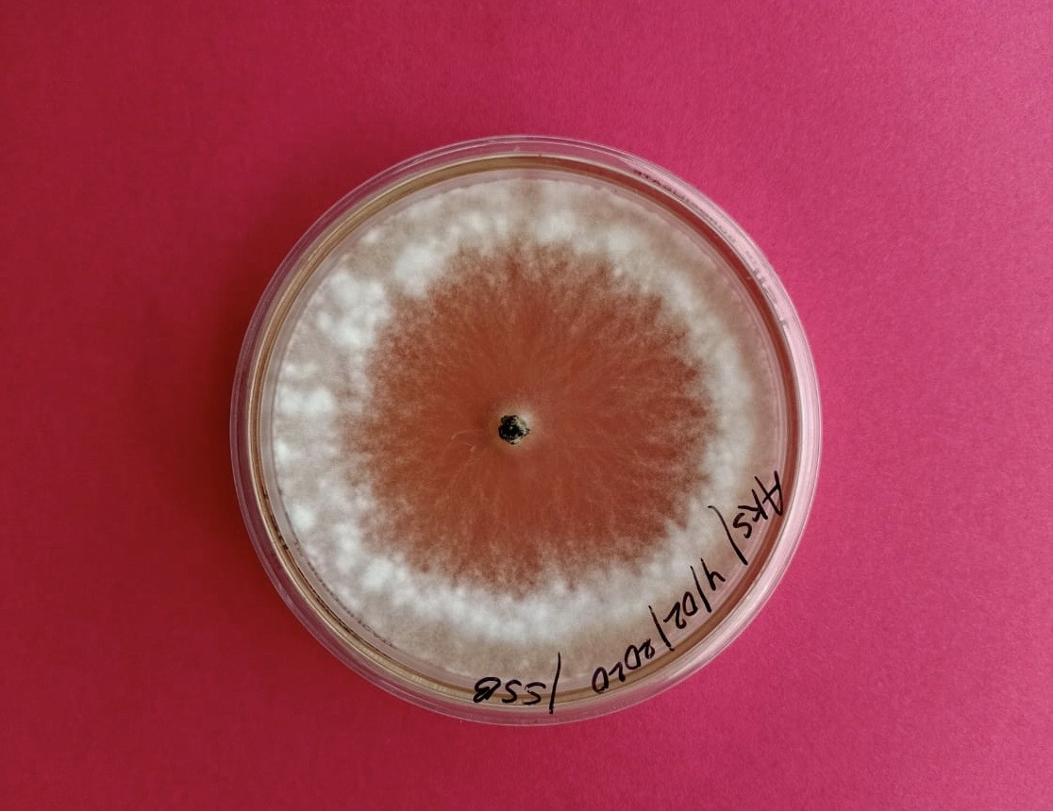
Figure 1: A pure culture of Sclerotinia sclerotiorum isolated1 from the infected brinjal plant.
The entire microorganisms grow under a specific range of temperatures within which a minimum, optimum, and maximum temperature could be located. The effect of temperature on the growth of Sclerotinia sclerotiorum was observed 3 days post inoculation (DPI) and 5DPI as provided in Table 1. Maximum mycelial growth was observed when the pathogen was incubated at 20°C, followed by a temperature of 15°C. Minimum mycelial growth was observed at a temperature of 35℃. Sclerotium production was also highest at 20°C and lowest at 15°C. The phytopathogen, however, didn’t produce any sclerotium at 10°C and beyond 30°C. Bedi (1962), Khan (1976), Panchal et al. (2012), and Husain and Choudhary (2018) also reported similar results. Abawi and Grogan (1979) reported that mycelial growth and sclerotial production were optimum at 20-25°C. Krishnamoorthy et al. (2017) found that temperature affected the size of sclerotia, with the most significant size occurring at 25°C. Kumar et al. (2004) observed 20°C as the optimum temperature for growth and 20°C to 25°C for sclerotia formation of Sclerotinia sclerotiorum, causing stem and root rot.
Table 1: Effect of different temperatures on growth of Sclerotinia sclerotiorum under in-vitro conditions on PDA medium.
Sl. No. | Temperature | Mycelial growth |  | Number of sclerotia produced per plate
 |  | 3DPI (mm) | 5DPI (mm)
1 | 10℃ | 4.26^{c} | 12.73^{c} | 0^{c}
2 | 15℃ | 33.51^{b} | 73.18^{b} | 7^{b}
3 | 20℃ | 61.26ª | 87.69ª | 16ª
4 | 25℃ | 30.01^{b} | 73.34^{b} | 8^{b}
5 | 30℃ | 4.76^{c} | 8.71^{d} | 0^{c}
6 | 35℃ | 1.13^{d} | 2.27^{d} | 0^{c}
DPI – Days post inoculation
The alphabet in superscript denotes the DNMRT value at 5%
In general, fungi can grow within a wide range of hydrogen ion concentrations in the medium, while most grow best in neutral or slightly acidic mediums. The pH preference of most pathogens ranges between 5.0 and 7.5, favouring the establishment of pathogens in their host. It is evident from the data presented in Table 2 that among all the pH levels, pH 5.0 was found to be ideal and produced the maximum dry mycelium weight, followed by pH 4.5 and 5.5. At pH above and below 5.0, the dry mycelium weight was found to be declined. The least dry mycelium weight was recorded at pH 7.5, which indicates that it is unsupportive for the growth of the pathogen. Significantly, a maximum number of sclerotia were formed at pH 5.5 after 14DPI at 25±1°C temperature. This was followed by pH 5.0 and 4.5. The least number of sclerotia were formed at pH 7.5. Sharma (1979) also found pH 5.0 suitable for vegetative growth of the fungus. However, Willetts and Wong (1980) reported that a pH below 5.0 was the optimum. Jani (1990), Kumar et al. (2004), Panchal et al. (2012), and Husain and Choudhary (2018) also found the same type of results obtained.

Table 2: Effect of different pH on growth of Sclerotinia sclerotiorum under in-vitro conditions on PDB medium.
Sl. No. | pH | Dry weight of mycelium (mg) at 14DPI | Number of sclerotia produced per flask
1 | 4.5 | 183.95^{b} | 22^{b}
2 | 5.0 | 194.32ª | 31ª
3 | 5.5 | 160.74^{c} | 34ª
4 | 6.0 | 129.21^{d} | 19^{b}
5 | 6.5 | 117.87^{d} | 12^{c}
6 | 7.0 | 78.43e | 6^{d}
7 | 7.5 | 37.57^{f} | 3^{d}
DPI – Days post inoculation
The alphabet in superscript denotes the DNMRT value at 5%
Conclusion:
It can be concluded that the pathogen was isolated on a PDA medium and identified as Sclerotinia sclerotiorum (Lib.) de Bary. The fungus produced aerial mycelium, which was hyaline, branched well developed and appeared cottony with closely septate hyphae. The hyphae were 2.0-11.5 µm in width and contained dense granular protoplasm. The sclerotia were round to irregular in shape in culture and measured 1.5-7 mm in width and 2-15 mm in length. Apothecia were brown and were round to globose type, measured 5-21 mm in length, 2-9 mm in diameter, and 0-7 numbers arose from a single sclerotium. The pathogenic behaviour of the fungus was also confirmed after the test. Temperature 20-25℃ and pH 4.5 to 5.5 are most suitable for the growth and sclerotial formation of Sclerotinia sclerotiorum.
References:
Abawi, G. S., & Grogan, R. G. (1979). Epidemiology of diseases caused by Sclerotinia species. Phytopathology, 69(8), 899-904.
Barros, D. C. M., Fonseca, I. C. D. B., Balbi-Peña, M. I., Pascholati, S. F., & Peitl, D. C. (2015). Biocontrol of Sclerotinia sclerotiorum and white mold of soybean using saprobic fungi from semi-arid areas of Northeastern Brazil. Summa Phytopathologica, 41(4), 251-255.
Bedi KS. 1962. Effect of temperature on the formation of Sclerotinia sclerotiorum(Lib.) de Bary. Indian Phytopathology.11(1) 55 60.
Bolton, M. D., Thomma, B. P., & Nelson, B. D. (2006). Sclerotinia sclerotiorum (Lib.) de Bary: biology and molecular traits of a cosmopolitan pathogen. Molecular plant pathology, 7(1), 1-16.
Concellón, A., Añón, M. C., & Chaves, A. R. (2005). Effect of chilling on ethylene production in eggplant fruit. Food chemistry, 92(1), 63-69.
Garg, H., Li, H., Sivasithamparam, K., Kuo, J., & Barbetti, M. J. (2010). The infection processes of Sclerotinia sclerotiorum in cotyledon tissue of a resistant and a susceptible genotype of Brassica napus. Annals of botany, 106(6), 897-908.
Hassan, I., Jatoi, S. A., Arif, M., & Siddiqui, S. U. (2015). Genetic variability in eggplant for agro-morphological traits. Science, Technology and Development.
Husain, M. A., & Choudhary, C. S. (2018). Morphological, cultural and physiological studies on Slerotinia sclerotiorum causing stem rot of oilseed brassica. International Journal of Current Microbiology and Applied Sciences, 7, 1044-1052.
Jani, S. M. (1990). Studies on stem blight of mustard [Brassica juncea (L.) Czern and Coss] caused by Sclerotinia sclerotiorum (Lib.) de Bary (Doctoral dissertation, Ph. D. Thesis (Unpublished), Submitted to Gujarat Agricultural University, Sardarkrushinagar, 1990, 78).
KHAN, M. A. (1977). Studies on stalk rot of cauliflower caused by Sclerotinia sclerotiorum (lib.) de Bary (Doctoral Dissertation, Solan, HPU, Agricultural Complex).
Krishnamoorthy, K. K., Sankaralingam, A., & Nakkeeran, S. (2017). Effect of temperature and salinity on the growth of Sclerotinia sclerotiorum causing head rot of cabbage. Int. J. Curr. Microbiol. Appl. Sci, 6, 950-954.
Kumar, B., Pandey, R., & Verma, A. K. (2004). Effect of temperature and pH on growth and sclerotial formation of Sclerotinia sclerotiorum causing stem and root rot of broccoli. Progressive Agriculture, 4(1), 89-90.
Panchal, J. A., Patel, K. D., Jaiman, R. K., & Patel, N. R. (2012). Physiological studies of Sclerotinia sclerotiorum causing stem rot of fennel (Foeniculum vulgare Mill.).
Saharan, G.S. and Mehta, N. (2008). Sclerotinia diseases of crop plants: Biology, ecology and disease management. Springer Science+Busines Media B.V. The Netherlands, pp. 485.
Sharma, P. (2014). Worldwide new host record of Sclerotinia sclerotiorum. Sarson News, 18(9).
Sharma, P., Meena, P. D., Kumar, A., Kumar, V., & Singh, D. (2015). Forewarning models for Sclerotinia rot (Sclerotinia sclerotiorum) in Indian mustard (Brassica juncea L.). Phytoparasitica, 43, 509-516.
SHARMA, R. C. (1979). Stalk rot of cauliflower caused by Sclerotinia sclerotiorum (Lib.) de Bary (Doctoral dissertation, COLLEGE OF AGRICULTURE, SOLAN).
Whitaker, B. D., & Stommel, J. R. (2003). Distribution of hydroxycinnamic acid conjugates in fruit of commercial eggplant (Solanum melongena L.) cultivars. Journal of Agricultural and Food Chemistry, 51(11), 3448-3454.
Willetts, H. J., & Wong, J. A. L. (1980). The biology of Sclerotinia sclerotiorum, S. trifoliorum, and S. minor with emphasis on specific nomenclature. The Botanical Review, 46, 101-165.

