**Incidence, intensity and symptomatology of mid whorl yellowing disease of coconut in southern Kerala**

.

ABSTRACT

|  |
| --- |
| Mid whorl yellowing disease (MWYD) of coconut, a disease of an unknown etiology, has caused severe damage to coconut cultivation in southern tracts of Kerala. A periodic and purposive roving survey was conducted from 2021 to 2024, over four southern districts of AEU 9 (South central laterites), to assess the incidence and intensity of MWYD on the natural incidence. The average disease incidence and intensity of MWYD in southern Kerala was 1.05 and 0.51 respectively. The disease incidence and intensity of MWY showed a decreasing trend moving northward, from Thiruvananthapuram (1.33 % and 0.79 %) to Kottayam (0.29 % and 0.13 %). The MWYD showed symptoms like abnormal nut fall, inflorescence necrosis, yellowing of leaves, especially the middle whorls, and finally death of the palm (telephone pole-like) symptoms. The present study is one of the first comprehensive efforts to detail the symptomatology and assess the incidence and intensity of MWYD of coconut in Kerala. |

*Keywords*: *Coconut; Phytoplasma; Mid Whorl Yellowing Disease; Incidence; Intensity; Kerala*

1. INTRODUCTION

Coconut (*Cocos nucifera* L.) is a major perennial plantation crop cultivated in Kerala, contributing significantly to the state's economy and livelihoods. The state is known as the "land of coconuts," and it accounts for a substantial share of India’s coconut production economy and provides livelihoods to lakhs of households [1]. However, the sector faces numerous constraints that threaten its sustainability and productivity. The incidence of pests and diseases has adversely affected the production and productivity of the state over the years [2]. Among the major diseases of coconuts, phytoplasma diseases have adversely affected the global production scenario [3]. Most phytoplasma diseases in coconut are lethal, like Yellowing-like Diseases (YLD). At the same time some are non-lethal and debilitating *viz*., Root-Wilt Disease (RWD) in Kerala, Tatipaka diseases in Andhra Pradesh and Weligama wilt disease in Sri Lanka [4,5]. The repercussions of such unruly phytoplasma diseases in coconuts can vanish the entire coconut plantations within a short period. YLD has been reported in Asian, American, and African continents with similar symptoms. However, these all are caused by different groups of phytoplasma viz., the 16SrIV group (*Candidatus* Phytoplasma palmae and Ca. P. pini), 16SrXXII-A (*Ca.* P. palmicola), 16SrXXXII-B (*Ca*. P. malaysianum), 16SrI (*Ca*. P. asteris), 16SrXI (*Ca*. P. oryzae), 16SrXIV (*Ca.* P. cynodontis) and *Ca.* P. noviguineense [6,7,8,9]. So far, three coconut phytoplasmas have been reported from India *ie*, Tatipaka disease in Andhra Pradesh [10], and Root-Wilt Disease (RWD) caused by *Ca*. P. oryzae [11,12] and the Lethal Wilt Disease (LWD) caused by *Ca*. P. asteris in Tamil Nadu [13]. Among these phytoplasma diseases, the LWD-affected palms die within 5 months of symptom development. The polyphagous herbivores act as the vectors of phytoplasma, which help these organisms infect a wide range of plant hosts, including woody plants and grasses [14]. Hence there is always a chance of emergence of a new group of phytoplasma or the widening of host range for an existing phytoplasma group in a particular region. This demands a consistent and vigilant assessment to identify the emergence of any such phytoplasma diseases in coconut plantations.

In recent years, the incidence of another disease called mid whorl yellowing disease (MWYD), characterised by rapid mid whorl yellowing, abnormal and near total shedding of nuts and flowers, drying of inflorescence and spadix, and intense leaf spots and blights were observed in major coconut growing tracts of Kerala, especially the southern district [15,16]. The affected palms often die within a short period. Deepa *et al.* (2011) [17] attempted to identify the etiology of the pathogen and found that the disease is different from root wilt phytoplasma. However, no elaborate studies have been taken to describe the symptomatology and the current status of MWYD in Kerala. Considering these, the current study was designed to elucidate the symptomatology of MWYD, disease progress pattern, and incidence status in Southern districts of Kerala.

2. material and methods

A periodic purposive field survey on the natural incidence of MWYD was conducted during 2021-2024 in 15 locations across Kerala's major coconut-cultivating locations in AEU 9. At least ten locations were selected, and 100 palms were observed. The extent or degree of damage incited by the disease on individual palms has been estimated as disease severity based on a score chart (Table 1), where each score corresponds to a specific range of symptoms. As the MWYD has drastically distinct symptoms compared to other coconut diseases, a new disease scoring scale has been developed by comparing the symptom progression pattern.

**2.1 Assessment of disease incidence and intensity**

$$Disease incidence=\frac{Number of palms infected}{The total number of palms observed} X 100$$

The disease intensity in the surveyed area is calculated as a combination of disease incidence and severity.

$$Disease intensity\left(DI\right)=\frac{\sum{\frac{\left(n_{i}Xs_{i}\right)}{N}}}{S_{max}}×100$$

*ni*​ - Number of palms at each severity level *i*

*s*i - Severity score for each severity level *i*

N -Total number of palms observed in the population

*Smax* - Maximum possible severity score on the scale

**2.2 Assessment of symptomatology of MWYD**

The diverse symptoms of mid whorl yellowing disease were recorded during the survey. The progression of symptoms was monitored regularly to study the variation in symptom expression.

**Table 1. Disease score and description on extend of Mid whorl yellowing disease in coconut**

|  |  |  |
| --- | --- | --- |
| Score | Description | |
|  |  | |
| 0 | | Healthy palms, all leaf fronds are green, produce healthy inflorescences and nuts. | |
| 1 | | Healthy palms produce green leaves and healthy inflorescences, a sudden increase in nut production, and shedding of mature and immature nuts in low to moderate form, more than 75 per cent of expected nuts, tender coconut, and button remain in the palm. | |
| 2 | | Inverted ‘V’ shaped yellowing with distinct margins develops in the tip leaflets of mid whorl fronds (1-2), inner and outer whorls remain green, sudden nut fall of tender coconut and buttons in moderate form, 50-75 per cent of nuts and tender coconut remains in the palm. | |
| 3 | | Progression of yellowing towards the basal leaflets, Asymmetric yellowing on either side of leaf lamina, mid whorl fronds show partial yellowing, heavy fall of tender coconut, nuts and buttons, 25-50 per cent buttons and tender coconut remains, blackening of rachillae from tip and shredding of male flowers of the newly opened spadix, if the unopened spathe is cut opened, discolouration of male flowers can be seen. | |
| 4 | | Tips of leaflets turn orange-yellow, sectored yellowing with orangish spots can be seen in the lower surface of mid-whorl fronds. In some cases, the leaflet tips turn greyish and dry, up to 5 middle whorl fronds show yellowing symptoms, 50 to 75 per cent nuts and buttons shed, newly opened and unopened spathe show blackening of male flowers and rachis. | |
| 5 | | Yellowing of entire middle whorl fronds, and progress towards the inner whorl or outer whorls, inner leaves of inner and outer whorls also start to exhibit the yellowing symptoms, and only a few nuts and buttons (less than 10) remain in the palm, the inflorescence corresponding to lower and middle whorls are blackened, initial browning or blackening of female flowers can be seen. | |
| 6 | | The entire middle whorl turns yellow, the leaflet margin turns orange to brown colour, yellowing inner leaves of inner and outer whorls, complete inflorescence necrosis and complete shedding of nuts, and blackened buttons remain attached to the inflorescence. Drooping of most of the mid-whorl fronds, nut production ceases and complete dropping of nuts leaving the crown without any mature and tender / immature nuts | |
| 7 | | Complete symmetric yellowing of the entire crown, inflorescence production ceases, outer and inner whorl yellowing is more common, drooping and shedding of most of the mid whorl and outer whorl fronds. | |
| 8 | | Yellowing of all the inner whorl fronds, drooping and shedding of most of the outer whorl and inner whorl fronds with barren crown | |
| 9 | | The entire crown falls and the stem will be telephone pole-like without a crown. | |

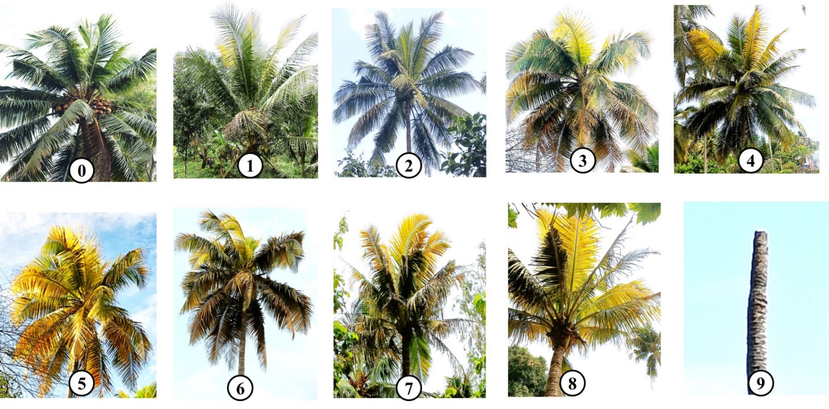

**Fig 1. Score chart for assessing the severity of Mid whorl yellowing disease of coconut**

3. results and discussion

**3.1 Disease incidence and intensity of MWYD in southern central laterites**

All the major coconut cultivating tracts in AEU 9 (Southern central laterites) showed the incidence of MWYD with varied disease intensity. The incidence of MWYD in the fields was assessed based on the number of plants infected and the total number of palms observed randomly in the field. Among the 1,047 palms surveyed, only 11 showed the characteristic symptoms of MWYD with an overall disease incidence of 1.05 per cent in southern parts of Kerala (Table 2). The district-wise disease incidence analysis showed that the Thiruvananthapuram district has the highest incidence (3.5 %) of MWYD, greater than the overall disease incidence in the state. The incidence of the disease showed a decreasing trend moving northward, with recorded rates of 2.5 % in Kollam, 0.91 % in Pathanamthitta and 0.29 % in Kottayam (Table 2 and 3).

The status of MWYD in the surveyed areas was assessed in terms of disease intensity. The district-wise disease intensity also showed the same trend as of disease incidence viz., Thiruvananthapuram (0.79%), Kollam (0.52%), Pathanamthitta (0.40%) and Kottayam (0.16%). The reduced levels of disease incidence and intensity towards the northern regions indicate that southern districts like Thiruvananthapuram and Kollam are playing as the hotspot of the MWYD and are gradually spreading towards the northward directions through insect vectors. The present study failed to isolate culturable microbes like bacteria and fungi from the diseased palms.

**Table 2. Mid whorl yellowing disease incidence and intensity in AEU 9**

|  |  |  |  |  |  |  |
| --- | --- | --- | --- | --- | --- | --- |
| Sl.no | Location | District | Number of palms observed | Number of palms infected | Disease  incidence | Disease intensity |
| 1 | Thiruvananthapuram | Aruvikkara | 100 | 3 | 3 | 1.33 |
| 2 | Thiruvananthapuram | Nedumangadu | 100 | 4 | 4 | 2.44 |
| 3 | Kollam | Kottarakkara | 50 | 2 | 0 | 0 |
| 4 | Kollam | Nilamel | 30 | 0 | 0.25 | 0.83 |
| 5 | Pathanamthitta | Adoor | 50 | 0 | 0 | 0 |
| 6 | Pathanamthitta | Kulanada | 40 | 1 | 4 | 1.11 |
| 7 | Pathanamthitta | Pandalam | 20 | 0 | 0 | 0 |
| 8 | Kottayam | Ettumanoor | 42 | 0 | 0 | 0 |
| 9 | Kottayam | Kuravilangadu | 100 | 0 | 0 | 0 |
| 10 | Kottayam | Pala | 100 | 0 | 0 | 0 |
| 11 | Kottayam | Uzhavoor | 100 | 0 | 0 | 0 |
| 12 | Kottayam | Monippally | 80 | 1 | 1.25 | 0.56 |
| 13 | Ernakulam | Vazhakulam | 35 | 0 | 0 | 0 |
| 14 | Ernakulam | Muvattupuzha | 100 | 0 | 0 | 0 |
| 15 | Ernakulam | Piravam | 100 | 0 | 0 | 0 |
| Total | | | 1047 | 11 | 1.05 | 0.56 |

**Table 3. Mid whorl yellowing disease incidence and intensity in southern districts of Kerala**

|  |  |  |  |  |  |
| --- | --- | --- | --- | --- | --- |
| Sl.no | District | The number of palms observed | Number of diseased palms | Disease incidence | Disease intensity |
| 1 | Ernakulam | 135 | 0 | 0 | 0 |
| 2 | Kottayam | 342 | 1 | 0.29 | 0.16 |
| 4 | Pathanamthitta | 110 | 1 | 0.91 | 0.40 |
| 5 | Kollam | 80 | 2 | 2.5 | 0.52 |
| 6 | Thiruvananthapuram | 200 | 7 | 3.5 | 0.79 |
|  | Total | 1,047 | 11 | 1.05 | 0.56 |

This study represents one of the first comprehensive efforts to examine the status and details of the symptomatology of mid-whorl yellowing disease in Kerala. Even though the incidence of the MWYD is very low as compared to the prevalent diseases like bud rot, leaf rot, Mahali, and root-wilt (RWD) of coconut, the lethal nature of the MWYD and its alarming rate of spread from southern districts towards the northern direction demands the immediate attention on the status of the disease as well as the spreading nature of the disease in the state.

The state's southern coastal plains (AEU 1) are characterised by a high-water table and sandy soil texture, which makes ideal edaphic conditions for coconut cultivation. Hence in this region, coconut is grown as the dominant crop along with the lowland rice [18]. Astonishingly the incidence and intensity of MWYD in southern central laterites (AEU 9) was higher compared to the southern coastal plains, where the coconut is being cultivated as an intercrop with other crops like banana, tapioca and vegetable crops. The plausible explanation for this increased MWYD incidence in AEU 9 might be, the intercropping of alternate hosts of phytoplasma including areca nut and oil palm may act as an inoculum source for phytoplasma compared to the southern coastal plains. Similarly, the LWD disease in Tamil Nadu was observed to be predominant in the south eastern coastal plains of Tamil Nadu [13]. Recently a novel group of phytoplasma, *Ca.* P. noviguineense added to the YLD phytoplasma group, can infect coconut, areca nut and banana plants, causing banana wilt disease and areca nut, causing Arecanut yellow leaf in Papua New Guinea. It is believed that this particular phytoplasma has a complex life cycle involving at least three different crops (coconut, banana and areca nut palm), rather than ecologically separate life cycles in each of these host plant species [19].

**3.2 Symptomatology of MWYD**

The MWYD symptoms were observed in palms of all ages, in the case of bearing palms the disease initially appeared as premature nut fall (Figure 1a). The succeeding inflorescence showed necrotic symptoms progressing from the tip of the rachilla towards the base (Figure 1 b). The newly emerging inflorescence with few or no female flowers showed necrosis of spikelets from the tip downwards either before or after opening (Figure 1 c). The foliar yellowing initially appears as a parallel yellow streak or yellow spotting on the middle whorl frond leaflets (Figure 1 d & e), which later on coalesces together and covers the entire leaf lets to produce the characteristic intense yellowing of middle whorl fronds which can be visible from a far distance (Figure 1 f & g). In severe cases, the entire crown turns yellow and finally, the death of the palm occurs (Figure 1 h). The MWYD-infected palms showed a significant reduction in the number of mature, tender, immature and buttons (more than 90 %). As the disease progresses the entire crown perishes and appears as a ‘telephone pole-like’.

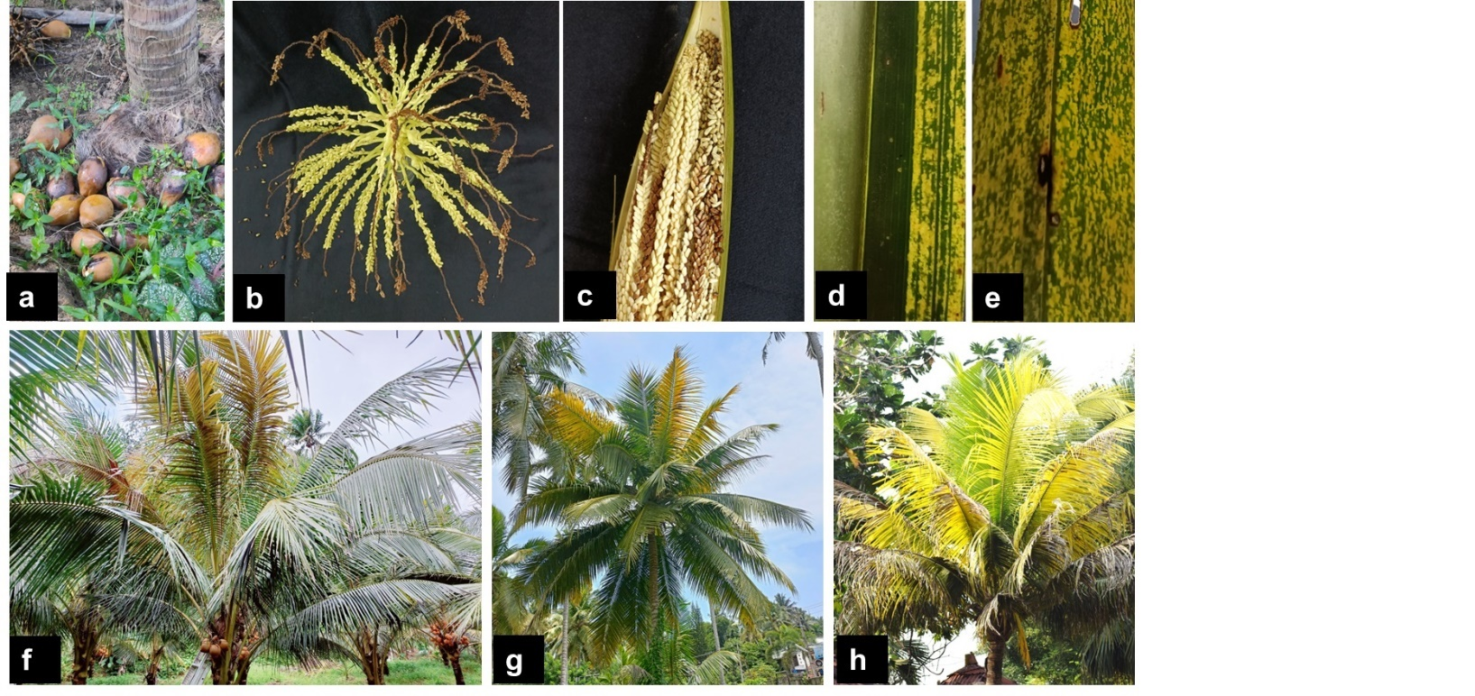

**Fig 2. Symptoms of MWYD (a) abnormal nut fall, (b & c) inflorescence necrosis, (d) parallel yellow streak on the leaflet, (e) yellow spotting on the leaflet, (f & g) yellowing of fronds in a middle whorl, (h) yellowing of crown.**

Similar symptoms like abnormal nut fall, inflorescence necrosis and yellowing of leaves are observed in Yellowing-Like Diseases (YLD) of coconut [20,21,22]. The inability to detect the presence of culturable bacteria and the similarity in symptom patterns and progression to Yellowing Like Disease (YLD), strongly suggests that the etiology of MWYD is linked to phytoplasma. Although MWYD shows symptoms similar to YLD, the disease has some peculiar symptoms that make it different from YLD. Like the yellowing of middle whorls either partially or completely, while the YLD causes complete yellowing and sometimes wilting of the leaves [23,24]. Both disease infections will eventually lead to the death of the palm but in YLD-infected palms death will occur within 5-8 months whereas in MWYD infection palm, death of the affected palms happens very slowly. Root necrosis and reduced root respiration rates are reported in the YLD infection [25,26], meanwhile, the root system of MWYD-infected palms didn’t show any sign of root necrosis.

Similarly, RWD is non-lethal and debilitating and is characterised by flaccidity, yellowing, and ribbing of leaves, marginal necrosis, and root necrosis, which drastically differ from MWYD symptoms [27]. Moreover, the RWD phytoplasma is taxonomically and symptomatically different from the other YLD phytoplasma groups [13]. The preliminary observations of the present study confirmed that the phytoplasma might be consistently associated with MWYD-affected palms. To our knowledge, this is the first detailed study of this deadly emerging coconut disease in Kerala.

The etiology of the disease should be scientifically proven rather than speculations. The slow rate of spread from the hotspots to nearby districts confirms the involvement of insect vectors associated with MWYD. In case, the etiology is confirmed as phytoplasma as the symptoms indicate, the chances of cross-transmission among the other plant hosts also have to be studied, because coconut is widely cultivated as a mixed crop in the state. In that case, the intercropped plant host may also act as host for the MWYD-associated pathogen. The rate of spread and susceptibility of all the cultivated varieties in the state have to be determined to develop strategies to prevent a sudden upsurge in disease incidence in the ensuing years. Uprooting the infected palms is the first step in a disease eradication strategy. Breeding tolerant coconut varieties is a viable option for pluralistic strategies and integrated farming systems to decrease the risk to farmers in the long run.

4. Conclusion

Mid-Whorl Yellowing Disease of coconut is an emerging coconut disease in southern Kerala regions. There are speculations about the etiology of the disease as phytoplasma, but these are not scientific evidence for the causal agents that have not yet been identified. This study would be an important initiative in developing a micro-level database on the symptomatology, incidence and intensity of Mid Whorl Yellowing Disease. The etiology must be elucidated and proper disease management practices should be adapted to eradicate the disease and its spread to other regions.

References

Jayasekhar, S. & Chandran, K.P., (2021). World economic importance. The Coconut Genome, pp.1-12.

Thamban, C., Jayasekhar, S., Chandran, K.P. & Jaganathan, D., (2016). Coconut production in Kerala. Indian Coconut Journal*.* 8, 10-15.

Brown, S.E., Been, B.O. & McLaughlin, W.A., (2007). The lethal yellowing (16SrIV) group of phytoplasmas. Pest Technology*,* 1(1), 61-69.

Wijesekara, H. T. R., Perera, L., Wickramananda, I. W., Herath, I., Meegahakumbura, M. K., Fernando, W. B. S., & De Silva, P. H. P. R. (2008). Preliminary investigation on Weligama coconut leaf Wilt disease: a new disease in Southern Sri Lanka. In: *Proceedings of the Second Symposium on Plantation Crop Research-Export competitiveness through quality improvements. Coconut Research Institute,* Lunuwila. Available:/https://core.ac.uk/download/pdf/52174498.pdf [03 Feb.2021].

Solomon, J.J., Hegde, V., Babu, M. & Geetha, L. (2018). Phytoplasmal diseases. *The Coconut Palm (Cocos nucifera L.)-Research and Development Perspectives*, pp.519-556.

Harrison, N. A., Myrie, W., Jones, P., Carpio, M. L., Castillo, M., Doyle, M. M. & Oropeza, C. (2002). 16S rRNA interoperation sequence heterogeneity distinguishes strain populations of palm-lethal yellowing phytoplasma in the Caribbean region. Annals of Applied Biology. 141(2), 183-193.

Nejat, N., Sijam, K., Abdullah, S. N. A., Vadamalai, G. & Dickinson, M. (2009). Phytoplasmas associated with disease of coconut in Malaysia: phylogenetic groups and host plant species. Plant Pathology*.* 58, 1152-1160.

Perera, L., Meegahakurnbura, M. K., Wijesekara, H. R. T., Fernando, W. B. S. & Dickinson, M. J. (2012). Phytoplasma is associated with the Weligama Coconut Leaf Disease in Sri Lanka. Journal of Plant Pathology. 94(1), 205-209.

Arocha-Rosete, Y., Konan, J. L., Diallo, A. H., Allou, K. & Scott, J. A. 2014. Identification and molecular characterization of the phytoplasma associated with a lethal yellowing-type disease of coconut in Côted’ Ivoire. Canadian Journal of Plant Pathology,36, 141-150.

Rao, A.P., 1966. Identification of Tatipaka disease of Coconut. Andhra Agricultural Journal, 13, 112-113.

Radha, K. & Lal, S.B., (1972). Diagnostic symptoms of root (wilt) disease of coconut. [Indian Journal of Agricultural Science*.*](https://www.cabidigitallibrary.org/action/doSearch?do=Indian+Journal+of+Agricultural+Sciences) 42(5), 410-413.

Manimekalai, R., Soumya, V.P., Sathish Kumar, R., Selvarajan, R., Reddy, K., Thomas, G.V., Sasikala, M., Rajeev, G. & Baranwal, V.K. (2010). Molecular detection of 16SrXI group phytoplasma associated with root (wilt) disease of coconut (Cocos nucifera) in India. Plant Disease, 94(5), 636-636.

Babu, M., Thangeswari, S., Josephrajkumar, A., Krishnakumar, V., Karthikeyan, A., Selvamani, V., Daliya, M., Hegde, V., Maheswarappa, H.P. & Karun, A. (2021). First report on the association of *Candidatus* Phytoplasma asteris with lethal wilt disease of coconut (*Cocos nucifera* L.) in India. Journal of General Plant Pathology*,* 87, 16-23.

Maejima, K., Oshima, K. & Namba, S., (2014). Exploring the phytoplasmas, plant pathogenic bacteria. Journal of General Plant Pathology*.* 80, 210-221.

Anju, C. (2011). Foliar fungal pathogens associated with yellowing disease of coconut. M. Sc. Thesis. Kerala Agricultural University, 210p.

Paul, A., Sinijadas, K. & Johnson, J. M. (2023). Mid whorl yellowing of coconut: a serious concern of coconut farmers. Indian Coconut Journal*.* (65), 20-21.

Deepa, S. (2011).  Physiological, anatomical and molecular analysis of coconut palms *(Cocos nucifera* L.*)* affected with yellowing*.* M.Sc. Thesis. Kerala Agricultural University, Thrissur. 95 p.

Kerala State Department of Agriculture. "Agroecological Zones of Kerala." *Kerala Soil Fertility.* Accessed January 10, 2025. <https://www.keralasoilfertility.net/en/agroecology.jsp>.

Miyazaki, A., Shigaki, T., Koinuma, H., Iwabuchi, N., Rauka, G. B., Kembu, A., Saul, J., Watanabe, K., Nijo, T., Maejima, K. & Yamaji, Y. (2018). *‘Candidatus* Phytoplasma noviguineense’, a novel taxon associated with Bogia coconut syndrome and banana wilt disease on the island of New Guinea. International Journal of Systematic Evolutionary Microbiology, 68(1), 170-175.

Dabek, A. J., (1974). Biochemistry of coconut palms affected with the lethal yellowing disease in Jamaica. Journal of Phytopathology*,* 81(4), 33-39.

McCoy, R. E., Howard, F. W., Tsai, J. H., Donselman, H. M., Thomas, D. L., Basham, H. G., Atilano, R. A., Eskafi, F. M., Britt, L. & Collins, M. E. (1983). Lethal yellowing of palms. Bulletin No. 834. University of Florida Agricultural Experiment Station Gainesville, USA, 7p.

Harrison, N.A., Helmick, E.E. & Elliott, M.L. (2008). Lethal yellowing‐type diseases of palms associated with phytoplasmas newly identified in Florida, USA. Annals of Applied Biology*,* 153(1), 85-94.

Cordova, I., Jones, P., Harrison, N.A. & Oropeza, C. (2003). In situ PCR detection of phytoplasma DNA in embryos from coconut palms with lethal yellowing disease. Molecular Plant Pathology, 4(2), 99-108.

Islas-Flores, I., Santamaria, J. M., Cordova, I. & Oropeza, C. (1999). Biochemical changes in roots of coconut palms (*Cocos nucifera* L.) affected by lethal yellowing. Journal of Plant Physiology, 155(1), 48-53.

Maust, B. E., Espadas, F., Talavera, C., Aguilar, M., Santamaría, J. M., & Oropeza, C. 2003. Changes in carbohydrate metabolism in coconut palms infected with the lethal yellowing phytoplasma. Phytopathology, 93(8), 976-981.

Solomon, J. J. & Geetha, L. (2004). Phytoplasma diseases of coconut in India-root (wilt) and tatipaka diseases. Coconut Research and Development 20(1), 34-34.