Original Research Article
Morphological Variability and Phytogeographic Structures of Chrysophyllum albidum G. Don (Sapotaceae) in Benin

ABSTRACT
Chrysophyllum albidum is an agroforestry tree that provides enormous and essential goods and services to local populations in West Africa. However, the unbridled exploitation of its various organs has led to its vulnerability, even its disappearance in certain regions, in Benin. The study aims to evaluate the morphological diversity of C. albidum population in Benin to differentiate and identify valuable morphotypes for conservation. Nine (9) variables were used to evaluation of the phenotypic diversity of sixty (60) fruiting trees of the specy, selected in four (04) phytodistricts of Benin. To determine the inter and intra-population variability of the specy, the descriptive statistic was carried out on the quantitative morphology variables of trees by population, and for all populations. Analysis components of the variance were carried out on all the morphological descriptors, in order to study the part of the overall variability due to individuals, soil types and climatic conditions of phytodistricts. An Ascending Hierarchical Classification was performed to identify the different morphotypes of the specy. The results obtained reveal significant variability in certain morphological descriptors used, depending on the phytodistricts and soil groups. The descriptors based on the fruits and the leaves of trees of the specy are more discriminants than those the trunk and crown. Three (03) morphotypes of C. albidum were obtained in Benin. Chrysophyllum albidum’s plants of the phytodistricts Coastal and Plateau belong to the same phenotypic class while the trees of the phytodistricts Pobè and Valley of Ouémé each have a morphotype of the specy. Consisting of relatively short trees bearing longer and wider leaves and fruits, the morphotype of C. albidum from the phytodistrict Valley of Ouémé is better indicated for future selections. These various data found must be further supplemented by the molecular genetics characterization, for the definition of integrated and effective strategies.

Keywords: Benin, Chrysophyllum albidum, Morphological variability, Phytodistrict, West Africa.

ABSTRACT
Chrysophyllum albidum is an agroforestry tree that provides essential goods and services to local populations in West Africa. However, the uncontrolled exploitation of its various organs has led to its vulnerability and, in some regions of Benin, its potential disappearance. This study aims to evaluate the morphological diversity of C. albidum populations in Benin to differentiate individuals and identify valuable morphotypes for conservation. Nine morphological variables were assessed to determine the phenotypic diversity of sixty (60) fruiting trees selected from four (4) phytodistricts in Benin. To analyze inter- and intra-population variability, descriptive statistics were applied to the quantitative morphological variables of trees within and across populations. Variance component analysis was conducted to assess the contribution of individual differences, soil types, and climatic conditions to overall variability. Additionally, hierarchical cluster analysis was performed to identify distinct morphotypes. The results revealed significant variability in certain morphological descriptors across phytodistricts and soil types. Fruit- and leaf-based descriptors exhibited greater discriminatory power compared to trunk and crown descriptors. Three distinct morphotypes of C. albidum were identified in Benin. Trees from the Coastal and Plateau phytodistricts belonged to the same phenotypic class, whereas those from the Pobè and Ouémé Valley phytodistricts each exhibited unique morphotypes. The C. albidum morphotype from the Ouémé Valley phytodistrict, characterized by relatively short trees with longer and broader leaves and fruits, is considered the most promising for future selection and conservation efforts. Further molecular genetic characterization is recommended to complement these findings and facilitate the development of integrated and effective conservation strategies.

Keywords: Benin, Chrysophyllum albidum, Morphological variability, Phytodistrict, West Africa.

- INTRODUCTION
Climate change has significantly reduced agricultural yields (Brou et al., 2005), prompting rural communities to increasingly rely on plant genetic resources, particularly fruit trees (Mbaye, 2011).
Food security remains a major global concern, particularly concerning climate change and a growing population (Kanazoe, 2017). Climate change has significantly reduced agricultural yields (Brou et al., 2005), prompting rural communities to increasingly rely on plant genetic resources, particularly fruit trees (Mbaye, 2011). These resources are critical in food security and sustainable economic development (FAO, 1996). Chrysophyllum albidum, a woody plant species with valuable genetic resources, is particularly significant in West Africa.
In Benin, nearly all parts of C. albidum are exploited by local populations.
In Benin, nearly all parts of C. albidum are exploited by local populations. Its wood is used for fuel and timber, its fruits are widely consumed, and its bark, roots, and leaves are utilized in traditional medicine (Houessou et al., 2012). However, factors such as aging tree populations, urbanization, and unsustainable harvesting methods have contributed to the species' decline (Alowanou-Kélé et al., 2023). Effective conservation strategies are therefore necessary to prevent its disappearance (Agbo et al., 2018).

Sustainable management and conservation of forest species require an analysis of morphological variability to differentiate individuals and identify elite morphotypes for propagation (Kouyaté & Van Damme, 2002; Houètchégnon, 2016). Several studies have explored the morphological variability of economically significant tree species, including Detarium microcarpum (Kouyaté, 2005; Agbo et al., 2018), Tamarindus indica (Fandohan et al., 2011), Jatropha curcas Linn (Gbèmavo et al., 2015), Pentadesma butyracea (Ewédjè et al., 2012), Celtis australis (Ammari et al., 2016), and Haematostaphis barteri (Sourou Kuiga, 2017). These studies have identified key morphological parameters that differentiate various morphotypes within species.

Previous research on the phenotypic diversity of C. albidum in Benin has demonstrated significant morphological variability across its organs (Dadégnon et al., 2014; Lougbégnon et al., 2016). However, these studies did not account for edaphic factors, despite the critical role of soil quality in agroforestry species conservation (Kouyaté, 2005). Fertile and suitable soils support plant growth, preventing desertification and land degradation (FAO, 2015). Identifying soil types favorable to multi-purpose species like C. albidum can enhance food security and sustain ecosystem functions.

The primary objective of this study is to assess the morphological diversity of C. albidum in Benin. Specifically, the study aims to: (i) describe the morphological variability of C. albidum, (ii) analyze the influence of phytodistricts and soil types on morphological variability, and (iii) characterize the species' morphotypes in Benin.

- MATERIAL AND METHODS
2.1. Study zone
This study was conducted in four (4) phytodistricts of Benin, each characterized by distinct biophysical and climatic conditions (Table 1). The selected phytodistricts—Coastal, Plateau, Pobè, and Ouémé Valley—are located within the Guineo-Congolese zone, where C. albidum populations are naturally present (Figure 1).

Table 1: Biophysical characteristics of the phytodistricts of the study area (Gbèmavo et al., 2015).
Phytodistricts  of the area  of study | Percentage cor-responding to each of phyto-districts in the surface company of Benin | Diet rain | Rainfall | Main types  of soil | Main training  vegetables
Coastal | 1% | Bimodal | 900 à 1300 | Sandy + Hy-dromorphic & Halomorphic | Coastal forest and Mangrove
Plateau | 7% | Bimodal | 900 à 1100 | ferralitic without concretions | Semi- deciduous forest
Pobè | 2% | Bimodal | 1200 à 1300 | ferralitic without concretions | Semi- deciduous forest
Valley of Ouémé | 2% | Bimodal | 1100 à 1300 | Soil hydromorphic | Swamp and Semi-deciduous Forest deciduous.

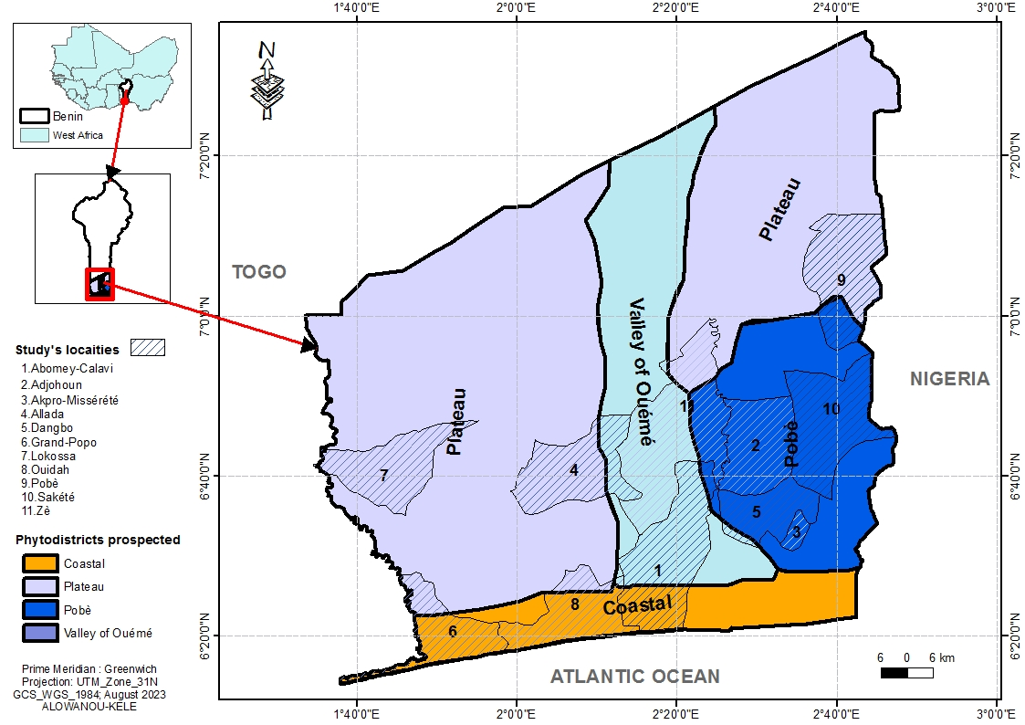

Figure 1: Map of prospected localities according to the phytodistricts of the study area (Alowanou-Kélé, 2023).
  - Collection of Data
Following a spacing of at least 50 meters, sixty (60) fruiting trees of Chrysophyllum albidum, at a rate of fifteen (15) plants per phytodistrict, were selected and geo-referenced using a GPS (Geographical Positioning System). All of the individuals sampled in a phytodistrict was considered as a population at the same as those found on the same type of soil.
The morphological variability of C. albidum was evaluated using nine (09) descriptors inspired by the research work of several authors (Ouédraogo, 1995; Zitan, 1995; Agbo et al., 2018). These descriptors were measured on the trunk and crown, leaves and fruits of the trees retained. Morphological descriptors collected at the trunk and crown level are the diameter of the trunk at the height of a man's breast-breast (Dbh) expressed in centimeters (cm), the height of the first basal branching relative to the ground (Hpr) and the height of the plant (Hpl) each expressed in meter (m). The diameter of the trunk at the height of a man’s breast has was measured using a tailor's meter, while the variables Hpr and Hpl were taken using a penta decameter. At the leaf level, the morphological descriptors identified are the leaf length (Lfe), leaflet length (Lfo) and width leaflets (lfo). The variables Lfe, Lfo and lfo expressed in centimeter (cm) were measured using a 90 cm graduated ruler. Morphological descriptors considered at the level of fruits are the mass of the fruits (mfr) expressed in grams (g) using a balance precision, the length of the fruits (Lfr) and the width of the fruits (lfr) expressed in centimeters (cm) using a graduated ruler. Furthermore, to measure morphological parameters relating to leaves and fruits, it was collected from each of the selected trees, five (5) perfectly developed and unparasitized fresh leaves, and five (5) unparasitized fresh fruits.

  - Data Analysis
The soil groups considered in this study (figure 2) were identified using the projection of the geographical coordinates of the plants of Chrysophyllum albidum on the base Harmonized World Soil Database (HWSD) version 1.21 (FAO/IIASA/ISRIC/ISS-CAS/JRC, 2012). Quantitative morphological data measured on the trunk and crown, leaves and fruits of the selected trees, were used to calculate the mean, standard error and coefficient of variation, in order to evaluate the inter- and intra-population variability of the specy. An analysis of the components of the variance was carried out on all the morphological descriptors considered in the four (4) populations of C. albidum, in order to study the part of the overall variability linked to individuals of the species, soil types and phytodistricts. From the coefficient of variation whose scale of interpretation was proposed by Ouédraogo (1995) and adopted by certain authors (Kouyaté et al., 2011; Sourou Kuiga, 2017; Agbo et al., 2018), the classification of variability was carried out the one hand, within and between the phytodistricts of origin of C. albidum, then on the other hand, within and between soil groups. According to this scale, the variation can be low (CV = 0 - 10%), medium (CV = 10 -15%), quite significant (CV = 15 - 44%) or even very important (CV > 44%). To test the variation of morphological descriptors within phytodistricts and across level of soil types, the recorded morphological variables were subjected to an Analysis of Variance (ANOVA). Likewise, all the morphological descriptors used were subjected to Ward's Ascending Hierarchical Classification (Euclidean distances on the averages of the characters studied), to identify the different morphotypes of the specy in Benin. All these analyzes were carried out with the statistical software R version 4.2.0 (R. Core Team, 2022).

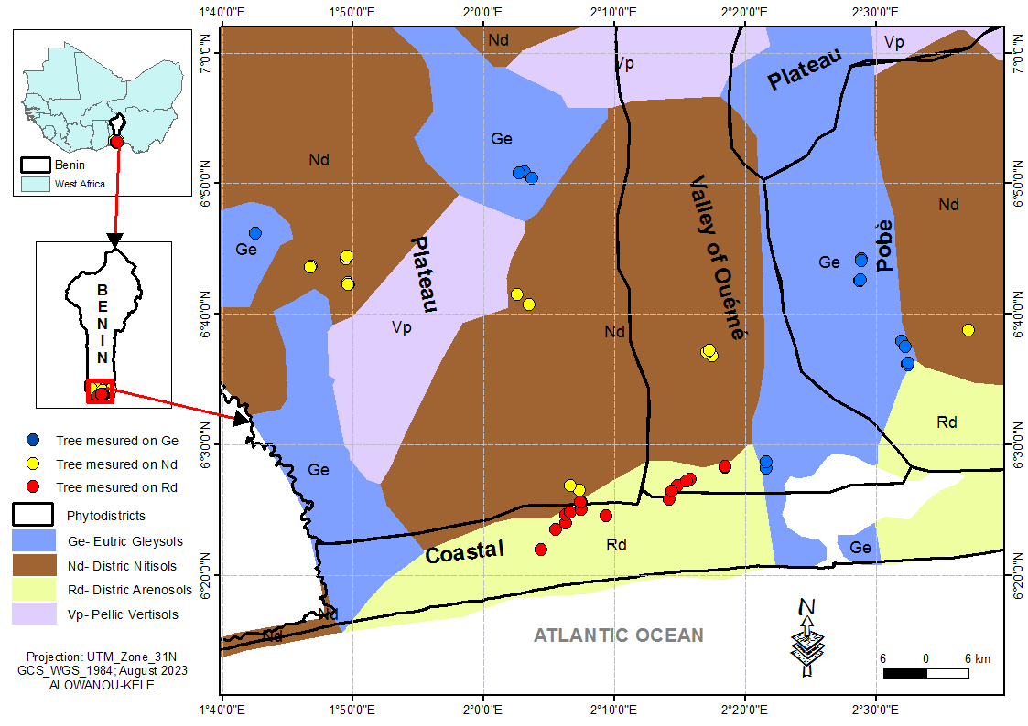
Figure 2: Identification map of the soil groups hosting the sampled Chrysophyllum albidum plants (Alowanou-Kélé, 2023).
- RESULTS

3.1. Variability of Morphological Descriptors of Chrysophyllum albidum

In Benin, the plants of C. albidum are found in the Guineo-Congolese, more precisely in the phytodistricts Coastal, Plateau, Pobè and Valley of Ouémé. Tables 2 and 3 presents respectively according to phytodistricts and soil types, variations of nine (9) descriptors quantitative morphological measured on the trunk and crown, leaves and fruits of C. albidum trees sampled.
    - Descriptors of the Trunk and Crown of C. albidum Trees
The height of the feet (Hpl) of C. albidum inventoried varied from 8 to 33 m with a average of 20.07 (± 6.62) m. The height of the first basal branching relative to the ground (Hpr) is between 1.4 and 15 m with an average of 3.56 (± 3.22) m. However, alone the average Hpr of the plants of the specy located in the phytodistrict Pobè is less than that given by all the individuals of C. albidum considered (figure 3). The diameter of the trunk at the height of a man' breast-breast (Dbh) varied from 20 to 136.5 cm with an average of 53.54 (± 26.84) cm, slightly exceeded by the average Dbh of the specy' feet found in the phytodistricts Plateau and Pobè (figure 4). Intra-phytodistrict variability of the height of C. albidum plants was quite significant (15% < CV < 44%) in all the four (04) phytodistricts. Intra-phytodistrict variability of the height of the first basal branching in relation to the ground of the feet of the specy is very important (CV ˃ 44%) in all the phtytogeographical districts covered. The intra-phytodistrict variability of the diameter of the trunk at the height of a man' breast-breast of the C. albidum plants, is quite important (15% < CV < 44%) in the Coastal district and very important in the others phytogeographic districts (CV ˃ 44%) of the study environment.
The intra-type of soil variability of C. albidum plant height is quite significant (15% < CV < 44%) regardless of the soil group where the plants are found the specy. The intra-type of soil variation in the height of the first basal branching relative to the ground of the specy is quite important (15% < CV < 44%) on the Gleysols soil group, and is very significant (CV ˃ 44%) on Nitisols and Arenosols. Intra-type of soil variability of diameter of the trunk at the height of a man' breast-breast of C. albidum plants, is quite significant (15% < CV < 44%) on the Arenosols type of soils, and very important (CV ˃ 44%) on the Gleysols and Nitisols.
    - Leafs Descriptors of C. albidum Plants
The specy C. albidum has leaves whose length (Lfe) is between 29 and 70 cm with an average of 44.68 (± 10.16) cm, relatively lower than the averages of Lfe of plants of the specy in the Pobè and Valley of Ouémé districts (figure 5). There leaflet length (Lfo) varied from 14.73 to 33.93 cm with a mean of 22.39 (± 3.47) cm. Leaflet width (lfo) is between 5 and 11.16 cm with an average of 8.03 (± 1.23) cm. There intra-phytodistrict variability in C. albidum leaf length was quite significant (15% < CV < 44%) in all phytodistricts in the study area. Variability within phytodistricts leaflet length was quite significant in the Plateau (15% < CV < 44%), and moderately low (10% < CV < 15%) in the phytodistricts Coastal, Pobè and Valley of Ouémé. Intra-phytodistrict variability in leaflet width is low in the Plateau (0% < CV < 10%), moderately low in the Valley of Ouémé (10% < CV < 15%), and quite significant in the others districts of the study environment (15% < CV < 44%).
The intra-soil type variability of leaflet length (Lfo) and width of leaflets (lfo) is average (10% < CV < 15%) in C. albidum plants whatever the type of soil that shelters them. On the other hand, with regard to the length of the leaves (Lfe), this variation is quite significant (15% < CV < 44%) on each of the soil types in presence.

    - Fruit Descriptors of C. albidum Plants
The fruits of C. albidum have a length (Lfr) between 3.3 cm and 5.5 cm with an average of 4.61 (± 0.63) cm, lower than those the Lfr of the plants of the specy in the phytodistricts Coastal and Valley of Ouémé. Its width (lfr) varied from 2.3 to 4.6 cm with an average of 3.65 (± 0.64) cm, higher than those the lfr of the plants of the specy C. albidum in the phytodistricts Coastal, Plateau and Pobè. The fruits mass (mfr) of C. albidum in the study environment is between 23 g and 54 g with an average of 47.72 (±7.22) g, lower than those of the mfr of the specy located in the phytodistricts Coastal and Ouémé Valley (figure 6). Intra-phytodistrict variability in C. albidum fruit length is moderately low (10% < CV < 15%) in the phytodistricts Coastal, Pobè and Valley of Ouémé. The variation in fruit width is moderately low (10% < CV < 15%) within the populations of C. albidum sheltering the phytodistricts Pobè and Valley of Ouémé, and quite significant (15% < CV < 44%) in the phytodistricts Coastal and Plateau. The intra-phytodistrict variability of C. albidum fruit mass is moderately low (10% < CV < 15%) in the phytodistricts Plateau, and quite significant (15% < CV < 44%) in the phytodistricts Coastal, Pobè and Valley of Ouémé.
The intra-type of soil variability of fruit length of C. albidum plants is medium (10% < CV < 15%) on Gleysols, Nitisols and Arenosols. Intra-type of soil variability of width fruit of plants of the species is average (10% < CV < 15%) on Gleysols, and quite significant (15% < CV < 44%) on Nitisols and Arenosols. Furthermore, the variation of the fruit mass of individuals of the species is low (0% < CV < 10%) on Nitisols, average (10% < CV < 15%) on Regosols, and quite significant (15% < CV < 44%) on Gleysols.
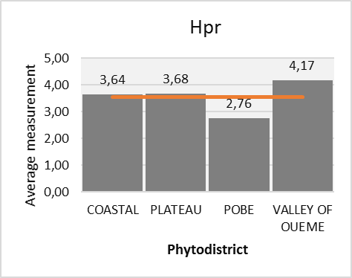
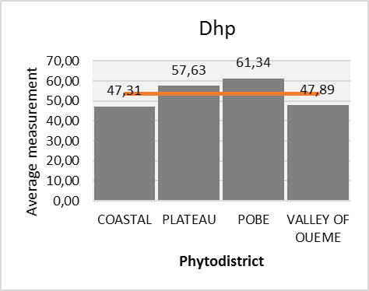
Figure 3 : Height of the first basal branching (Hpr) relative to the ground of C. albidum plants, depending on the phytodistricts.
Figure 4 : Trunk diameter at height man's chest (Dhp) of the feet of C. albidum, depending on the phytodistricts.

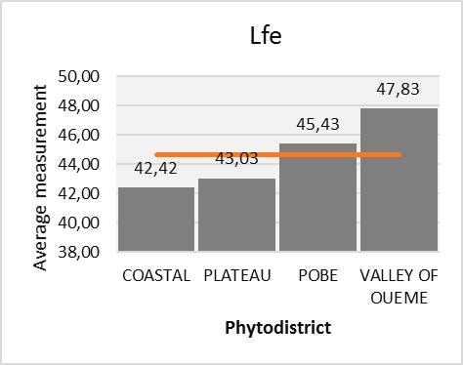
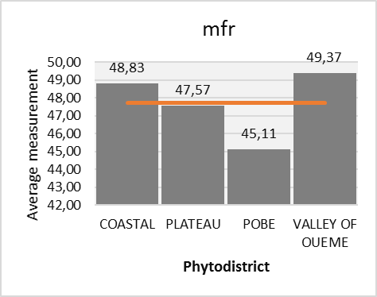
Figure 5 : Leaf length (Lfe) of feet of C. albidum, depending on the phytodistricts.

Figure 6 : Fruit mass (mfr) of trees of C. albidum, depending on the phytodistricts.

Table 2: Morphological description of quantitative variables of Chrysophyllum albidum, depending on the phytodistricts.
Phytodistricts | Parameter | Hpl (m) | Hpr (m) | Dhp (cm) | Lfo (cm) | lfo (cm) | Lfe (cm) | Lfr (cm) | lfr (cm) | mfr (g)
COASTAL | Average | 17.87 b | 3.64 a | 47.31 a | 21.36 bc | 7.83 b | 42.42 a | 4.64 ab | 3.61 ab | 48.83 a
COASTAL | SE | 5.97 | 3.89 | 17.42 | 3.08 | 1.19 | 6.92 | 0.59 | 0.65 | 8.05
COASTAL | CV (%) | 33.44 | 106.85 | 36.81 | 14.43 | 15.16 | 16.31 | 12.74 | 18.07 | 16.49
PLATEAU | Average | 20.4 ab | 3.68 a | 57.63 a | 23.47 ab | 7.96 ab | 43.03 a | 4.38 b | 3.53 ab | 47.57 a
PLATEAU | SE | 5.64 | 2.69 | 31.2 | 3.59 | 0.77 | 9.66 | 0.68 | 0.68 | 6.33
PLATEAU | CV (%) | 27.63 | 73.21 | 54.14 | 15.31 | 9.64 | 22.44 | 15.61 | 19.36 | 13.31
POBE | Average | 24.11 a | 2.76 a | 61.34 a | 20.26 c | 7.36 b | 45.43 a | 4.43 ab | 3.35 b | 45.11 a
POBE | SE | 6.77 | 2.32 | 28.59 | 2.92 | 1.21 | 13.59 | 0.53 | 0.42 | 6.77
POBE | CV (%) | 28.08 | 84.06 | 46.61 | 14.40 | 16.43 | 29.93 | 11.86 | 12.39 | 15.02
VALLEY OF OUEME | Average | 17.88 b | 4.17 a | 47.89 a | 24.49 a | 8.99 a | 47.83 a | 4.99 a | 4.09 a | 49.37 a
VALLEY OF OUEME | SE | 6.59 | 3.85 | 27.97 | 2.81 | 1.17 | 9.47 | 0.56 | 0.59 | 7.58
VALLEY OF OUEME | CV (%) | 36.83 | 92.36 | 58.42 | 11.49 | 12.99 | 19.80 | 11.29 | 14.53 | 15.35
Probability |  | 0.0259 * | 0.692ns | 0.386ns | 0.00168 ** | 0.00146 ** | 0.456ns | 0.0295 * | 0.00917 ** | 0.383ns
Minimum population |  | 8 | 1.4 | 20 | 14.73 | 5 | 29 | 3.3 | 2.3 | 23
Maximum population |  | 33 | 15 | 136.5 | 33.93 | 11.16 | 70 | 5.5 | 4.6 | 54
Average population |  | 20.07 | 3.56 | 53.54 | 22.39 | 8.03 | 44.68 | 4.61 | 3.65 | 47.72
SE population |  | 6.62 | 3.22 | 26.84 | 3.47 | 1.23 | 10.16 | 0.63 | 0.64 | 7.22
CV (%) |  | 32.99 | 90.42 | 50.13 | 15.50 | 15.27 | 22.75 | 13.59 | 17.62 | 15.14

CV: Coefficient of Variation; SE: Standard Error, *: Significant at the 5% threshold; **: Highly significant at the 1% level; ***: Very highly significant at the 0.1% level; ns: not significant.

Table 3: Morphological description of the quantitative variables of Chrysophyllum albidum, according to soil types.
Soil types | Parameter | Hpl (m) | Hpr (m) | Dhp (cm) | Lfo (cm) | lfo (cm) | Lfe (cm) | Lfr (cm) | lfr (cm) | mfr (g)
Ge - Gleysols | Average | 23.07 a | 2.24 b | 61.01 a | 20.24 b | 7.42 b | 42.62 a | 4.3 b | 3.3 b | 43.63 b
Ge - Gleysols | SE | 6.69 | 0.46 | 28,08 | 2.42 | 1.09 | 12.32 | 0.58 | 0.47 | 8.41
Ge - Gleysols | CV (%) | 29.01 | 20.41 | 46.02 | 11.94 | 14.68 | 28.91 | 13.58 | 14.15 | 19.28
Nd - Nitisols | Average | 19.24 ab | 5 a | 50.82 a | 24.5 a | 8.54 a | 45.74 a | 4.71 ab | 3.83 a | 49.76 a
Nd - Nitisols | SE | 7.24 | 3.95 | 33.04 | 3.28 | 1.16 | 8.24 | 0.6 | 0.62 | 3.65
Nd - Nitisols | CV (%) | 37.61 | 79.05 | 65.02 | 13.39 | 13.54 | 18.01 | 12.65 | 16.20 | 7.33
Rd - Arenosols | Average | 17.89 b | 3.45 ab | 48.8 a | 22.44 ab | 8.14 ab | 45.68 a | 4.83 a | 3.82 a | 49.77 a
Rd - Arenosols | SE | 4.87 | 3.52 | 16.32 | 3.36 | 1.21 | 9.71 | 0.6 | 0.7 | 7.18
Rd - Arenosols | CV (%) | 27.21 | 102.14 | 33.45 | 14.98 | 14.89 | 21.26 | 12.51 | 18.36 | 14.43
Probability |  | 0.0339 * | 0.0227 * | 0.309ns | 0.000231 *** | 0.0112 * | 0.548ns | 0.0184 * | 0.0104 * | 0.0063 *
Minimum population |  | 8 | 1.4 | 20 | 14.73 | 5 | 29 | 3.3 | 2.3 | 23
Maximum population |  | 33 | 15 | 136.5 | 33.93 | 11.16 | 70 | 5.5 | 4.6 | 54
Average population |  | 20.07 | 3.56 | 53.54 | 22.39 | 8.03 | 44.68 | 4.61 | 3.65 | 47.72
SE population |  | 6.62 | 3.22 | 26.84 | 3.47 | 1.23 | 10.16 | 0.63 | 0.64 | 7.22
CV (%) |  | 32.99 | 90.42 | 50.13 | 15.50 | 15.27 | 22.75 | 13.59 | 17.62 | 15.14

CV: Coefficient of Variation; SE: Standard Error; *: Significant at the 5% threshold; **: Highly significant at the 1% level; ***: Very highly significant at the 0.1% level; ns: not significant.

3.2. Impacts of Phytodistricts and Soil Types on Chrysophyllum albidum Variability
Leaflet length (Lfo), leaflet width (lfo) and fruit width (lfr) are the morphological descriptors of C. albidum that showed highly significant differences significant between phytogeographic districts (table 2) at the 1% threshold (P ˂ 0.01) according to the Student-Newman-Keuls test. Plant height of C. albidum (Hpl) and fruit length (Lfr) of trees of the species, showed inter-phytodistrict differences significant at the 5% level (P ˂ 0.05) according to the Student-Newman-Keuls test. In function phytogeographic districts, the morphological variables which best discriminate the populations of C. albidum, are leaflet length, leaflet width and width fruits. The leaf of C. albidum plants that was found in the phytodistrict Valley of Ouémé is on average longer and wider than those of the leaves of the feet which were found in the others phytodistricts (figure 7). The fruits of plants of C. albidum which were measured in the phytodistrict Valley of Ouémé are in average longer and wider than those of the feet sampled in the others phytodistricts (figure 7). Furthermore, the feet of the tree, found in the phytodistrict Pobè, are on average larger in size than those of others phytodistricts (figure 7).
Depending on the soil types, quantitative morphological variables such as the height of C. albidum plants (Hpl), the height of the first basal branching per relationship to the ground (Hpr), the width of the leaflets (lfo), the fruits length (Lfr) and the width of the fruits (lfr) showed significant inter-pedological differences (Table 3) at the threshold of 5% (P ˂ 0.05) according to the Student-Newman-Keuls test. On the other hand, the mass of the fruits of plants of the specy (mfr) showed highly significant inter-pedological differences at the threshold of 1% (P ˂ 0.01), and the length of the leaflets (Lfo) of the trees of the specy showed very highly significant differences between the soil types, at the threshold of 0.1% (P ˂ 0.001) according to the Student-Newman-Keuls test. Depending on the type pedological, the morphological variables which best discriminate the populations of C. albidum, are the length of the leaflets and the mass of the fruits of plants of the specy. The feet of the tree which were found on the Gleysols, are on average larger in size than those occupying the other soil groups (figure 8). The fruits of the plants of C. albidum which have been found on the Arenosols, are on average longer, and weigh more than those of the feet which were found on other soil types (figure 8). However, these fruits of plants of the species are wider on Nitisols than on Gleysols and Arenosols. Furthermore, the leaflets of the leaves of the plants of C. albidum which were measured on the Nitisols are on average longer than those of the leaves of the feet which were found on the others soil types (figure 8).
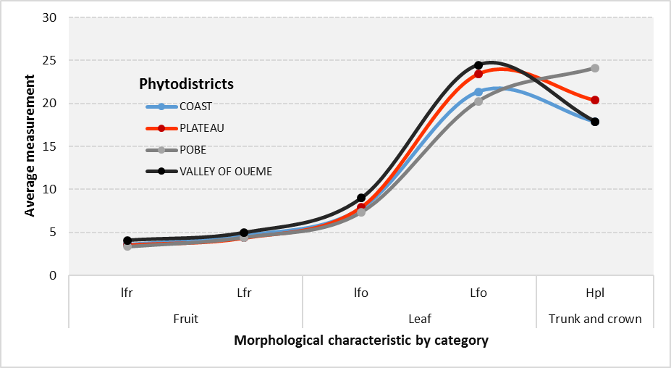
Figure 7 : Variation of the five (05) significant morphological descriptors (Hpl, Lfo, lfo, Lfr and lfr) of Chrysophyllum albidum, according to their averages and phytodistricts.

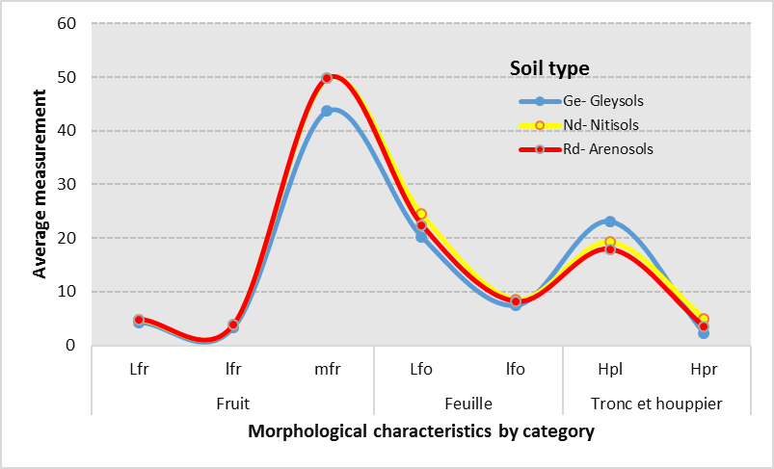
Figure 8 : Variation of the seven (07) significant morphological descriptors (Hpl, Hpr, Lfo, lfo, Lfr, lfr and mfr) of Chrysophyllum albidum, according to their averages and soil types.

  - Phytogeographic Structures of Chrysophyllum albidum
Using the morphological descriptors of C. albidum considered, the Ascending Hierarchical Classification was carried out, and made it possible to highlight three (03) morphotypes at the 20% similarity threshold (figure 9).

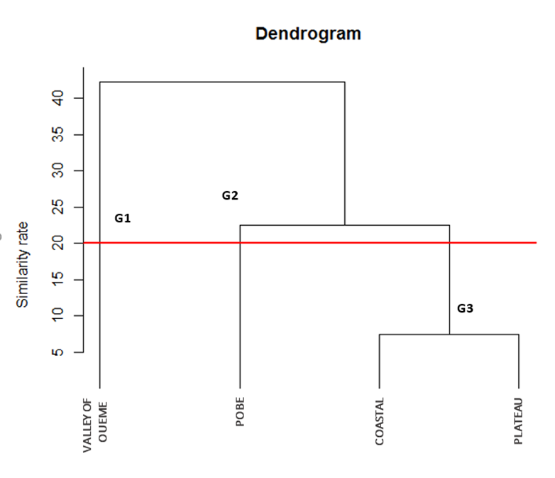

Figure 9 : Chrysophyllum albidum morphotypes from hierarchical classification ascending.

Group G1 consists of C. albidum plants from the phytodistrict Valley of Ouémé. This morphotype is characterized by short trees, bearing fruits longer, wider, heavier, and with longer and wider leaves. The group G2 is made up of C. albidum plants from the Pobè phytodistrict. This morphotype is characterized by larger trees, developing less long and wider leaves, and bearing lighter fruits of average length and width. The G3 group contains the C. albidum plants from the Coastal and Plateau phytodistricts. This class phenotypic is characterized by moderately tall individuals, presenting leaves moderately long and wide, bearing fruits of average mass, length and width.

- DISCUSSION
  - Morphological Variability of Chrysophyllum albidum

Chrysophyllum albidum is a multipurpose tree species that provides essential goods and services to local communities (Houessou et al., 2012; Lougbégnon et al., 2012). However, its high economic and ecological importance has made it increasingly vulnerable, with populations declining in several regions of Benin (Alowanou-Kélé et al., 2023). Similarly, Detarium microcarpum was classified as highly vulnerable in the Zou phytodistrict, with an index of 2.67 (Agbo et al., 2017). The morphological traits of C. albidum vary significantly across phytogeographic regions and soil types, highlighting the species’ adaptation to different environmental conditions.

The present study reveals that shorter C. albidum trees tend to produce longer and broader fruits and leaves, a finding consistent with the observations of Dadégnon et al. (2014). These shorter trees, primarily found in the Ouémé Valley phytodistrict, exhibit characteristics that make them promising candidates for breeding programs aimed at selecting elite morphotypes for improved fruit production.

Furthermore, significant morphological variation is observed among populations based on phytogeographic location. Leaf morphology is highly polymorphic at the 1% significance level, particularly in terms of leaflet length and width. Fruit characteristics, such as width and length, also exhibit high levels of polymorphism at 1% and 5% significance levels, respectively. In contrast, trunk and crown attributes, including total tree height, display polymorphism at the 5% significance level.

Soil type also influences morphological variability. The height of the first basal branching and trunk diameter at breast height show significant variation at the 5% level, while leaflet width and fruit mass are highly polymorphic at 0.1% and 1% significance levels, respectively. These variations can be attributed to a combination of climatic factors, soil characteristics, and the reproductive biology of the species (Agbo et al., 2018). Additionally, genotypic factors may contribute to this diversity (Sourou Kuiga, 2017).

A comparison with previous studies confirms that the fruit characteristics of C. albidum exhibit considerable variability. Similar patterns have been reported by Lougbégnon et al. (2016) for C. albidum, Fandohan et al. (2010) for Tamarindus indica, and Abasse et al. (2011) for Balanites aegyptiaca.

At the phytodistrict level, five key morphological descriptors were identified, compared to seven descriptors influenced by soil type, indicating that soil conditions exert a stronger influence on C. albidum variability. This finding aligns with Agbo et al. (2018), who reported that both phytodistricts and soil types play an equally significant role in shaping the morphological diversity of D. microcarpum. However, morphological variation in C. albidum appears more pronounced than in D. microcarpum, possibly due to the latter’s wider distribution across Benin, which exposes it to greater environmental variability.

Despite these variations, some morphological traits—such as the height of the first basal branching, trunk diameter at breast height, leaf length, and fruit mass—are relatively stable across different phytodistricts. Dadégnon et al. (2014) similarly reported a high degree of similarity in the total height of C. albidum trees across agroecological zones in Benin.

  - Influence of Environmental Factor on the Growth and Survival of Chrysophyllum albidum
Ward’s hierarchical clustering analysis identified three distinct morphotypes of C. albidum in Benin. The populations from the Coastal and Plateau phytodistricts belong to the same phenotypic class, whereas the trees from the Pobè and Ouémé Valley phytodistricts form two distinct morphotypes. Despite all four phytodistricts being located within the Guineo-Congolese biogeographic zone (6°25’N to 7°30’N), notable morphological differences exist among populations. This suggests that local environmental conditions play a critical role in shaping the species’ morphological diversity (Assogbadjo et al., 2008).

The larger trees found in the Pobè phytodistrict, which is predominantly characterized by ferralitic soils with minimal concretions (Gbèmavo et al., 2015), likely benefit from favorable growth conditions and ample space for development. Additionally, statistical analyses confirm significant intra- and inter-pedological variations in six morphological traits, as well as significant intra- and inter-phytodistrict differences in five traits. This underscores the importance of soil type in determining the morphological structure of C. albidum in Benin.

The Ouémé Valley, with its extensive wetlands (Gbèmavo et al., 2015), emerges as a key ecological zone for C. albidum conservation and selection programs. This region is particularly suitable for identifying elite morphotypes for sustainable genetic resource management.

However, the widespread utilization of C. albidum, coupled with rapid urbanization in many parts of Benin, poses a severe threat to the species. Habitat destruction and overexploitation have led to a decline in natural populations, particularly in phytodistricts where large trees are becoming increasingly rare. Anthropogenic activities thus have a profound impact on the species' distribution and long-term survival.

- CONCLUSION
This study highlights the significant morphological variability of C. albidum in Benin, influenced by phytogeographic and pedological factors. The findings indicate that leaf and fruit characteristics exhibit greater polymorphism than trunk and crown attributes. Three distinct morphotypes of C. albidum were identified, each associated with specific phytogeographic structures. The morphotype found in the Ouémé Valley, characterized by superior fruit quality, holds the greatest potential for future breeding and conservation initiatives.
Moving forward, further studies incorporating molecular genetics are needed to complement morphological analyses and develop integrated conservation strategies for C. albidum in Benin.

- REFERENCES
Abasse , T. , Weber C.J. , Katkore , B. , Boureima , M. , Larwanou , M. , Kalinganire , A. (2011). Morphological variation in Balanites aegyptiaca fruits and seeds within and among parkland agroforests in eastern Niger. Agroforest Syst 81 :57–66. DOI 10.1007/s10457-010-9323-x.
Goat, I.R., Missihoun, A.A., Vihotogbe, R., Assogbadjo, E.A., Ahanhanzo, C., Agbangla, C. (2017). Impacts of traditional uses on the vulnerability of Detarium microcarpum Guill. & Perr. (Caesalpiniaceae) in Zou phytogeographic district in Benin. International Journal of Biological and Chemical Sciences. 11(2): 730-743.
Goat, I.R., Missihoun, A.A., Great, R.A., Assogbadjo, E.A., Scent, C. (2018). Morphological variability of Detarium microcarpum Guill. & Perr. (Caesalpiniaceae) in Benin, West Africa. Asian Journal of Research in Agriculture and Forestry, 1(2): 1-12, 2018.
Alowanou-Kele, B., Missihoun, A.A., Agbo, R.I., Ewedje, E.-E.B.K., Yedomonhan, H. and Agbangla, C. (2023). Impacts of the Use of Chrysophyllum albidum G. Don on Its Vulnerability and Its Conservation in Benin. Annual Research & Review in Biology. 38, 11 (Dec. 2023), 1-1 DOI : https://doi.org/10.9734/arrb/2023/v38i1130613 .
Ammari , Y. , Zouaoui , R. , Abbasi , M. , Jebali , S. , Hamdi , S. (2016). Study of Dendrometric and Morphological Variability of Celtis Australis Located in Northern Tunisia. International Journal of Agricultural Innovations and Research, 5(3).
http://dx.doi.org/10.1037/0021-843X.112.2.202 Assogbadjo, A.E., Cocoa Glaze, R., Chadare, F.J., Thomson, L., Kyndt, T., Sinsin, B., Van Damme, P. (2008). Folk classification, perception and preferences of baobab products in West Africa : Consequences for species conservation and improvement. Econ. Bot. 62(1) (2008) 74–84.
Brou , Y.T. , Akindes , F. , Bigot , S. (2005). Climate variability in Côte d’Ivoire: between social perceptions and agricultural responses. Agricultural Notebooks, Vol.14(6):533-40.
Dadegnon , S. , Gbemavo , C , Ouinsavi , C , Sokpon , N. (2014). Morphological variation and ecological structure of Chrysophyllun albidum G. Don. International Journal of Plant & Soil Science. 5 : 25-3
Ewedje , E.B.K. , Parmentier , I. , Natta , A. , Ahanchéde , A. , Hardy , O.J. (2012), Morphological variability of the tallow tree, Pentadesma butyracea Sabine (Clusiaceae), in Benin. Gene Resour Crop Evol 59 : 625–633.
Fandohan , B. , Assogbadjo , A.E. , Cocoa Island , R. , Kyndt , T. , De Caluwe , E. , Codjia , J.T.C. , Sinsin , B. (2010). Women’s Traditional Knowledge, Use Value, and the Contribution of Tamarind (Tamarindus indica L.) to Rural Households’ Cash Income in Benin. Economic Botany, 64 : 248-259.

Fandohan , B. , Assogbadjo , E.A. , Kakaï , G.R. , Kyndt , T. , Sinsin , B. (2011). Quantitative morphological descriptors confirm traditionally classified morphotypes of Tamarindus indica L. fruits. Gene Resour Crop Evol, 58 : 299–309. DOI 10.1007/s10722-010-9575-3.
FAO (1996). Global Action Plan for the Conservation and Sustainable Use of Phytogenetic Resources for Food and Agriculture and the Leipzid Declaration. International Technical Conference on Phytogenetic Resources Leipzid, Germany 17-23 June 1997.
FAO, IIASA, ISRIC, ISSCAS, and JRC (2012). Harmonized World Soil Database (version 1.21), FAO and IIASA, Rome, Italy, and Laxenburg, Austria.
FAO (2015). Soils are fundamental to vegetation. 1st Conference on Afro-Mediterranean Soils: “Constraints and Potentials for Sustainable Management”, Marrakech 18 and 19 December 2015.
(2015). Morphological variability and conservation of morphotypes of Jatropha curcas Linn. (Euphoriaceae) in Benin. Journal of Agriculture and Environment for International Development , 109 ( 1 ): 55 – 69 .

Houessou , G. L. , Lougbegnon , O. T. , Gbesso , G. H. F. , Anagonou , S. E. L. , Sinsin , B. (2012). Ethnobotanical study of the African star apple (Chrysophyllum albidum G. Don). Journal of Ethnobiology and Ethnomedicine, 8:40.
Houetchegnon, O.T. (2016). Ethnobotanical, ecological and morphological studies of Prosopis africana (guill, perrott. and rich.) taubert in Benin and impacts of climatic changes on the species. Single Doctoral Thesis. Doctoral School of Agronomic and Water Sciences, University of Parakou, Benin. 159 p.
Kanazoe, A. (2017). The contribution of the rural center for incubation of agri-food technologies (CRITA) to the food security of Lebda households in Burkina Faso. Master's Memoir, Department of Philosophy and Psychology, University of Ouaga I Professor JOSEPH KI- ZERBO, Burkina Faso.
Kouyaté , A.M. , Van Damme , P. (2002). Morphological characters of Detarium microcarpum Guill. and Perr. in the south of Mali. Fruits, Vol. 57 : 231–238.
Kouyate, A.M. (2005). Ethnobotanical aspects and study of morphological, biochemical and phenological variability of Detarium microcarpum Guill. & Perr. In Mali. PhD thesis. Faculty of Bioscience Engineering, Ghent University, Belgium um. 190 p.
Kouyaté, A.M., Decalluwé, E., Guindo, F., Diawara, H., Diarra, I., N’diaye, I., Van Damme, P. (2011). Morphological variability of the baobab (Adansonia digitata L.) in Mali. Fruits, 66: 247-255.
Lougbégnon, O.T., Anagonou, L, Houessou, G.L., Gbesso, G.H.F., Sinsin, B. (2012). Socioeconomic importance of the organs (fruits, bark and roots) of the white star apple (Chrysophyllum albidum G. Don, 1831) on the Allada plateau. Ann. Univ. of Lomé, ser. Lett., Volume XXXI-1, 294: 157-165.

Lougbégnon, O.T., Houessou, L.G., Gbesso, G.H.F., Codjia, J.T.C. (2016). Eco-morphological variability of Chrysophyllum albidum G. Don fruits across phytogeographic districts of the Guinean zone in Benin. Bulletin of Agronomic Research of Benin (BRAB) - Special issue Agronomy, Society, Environment & Food Security - August 2016, 109-117. ISSN on paper (on hard copy): 1025-2355 and ISSN online (on line): 1840-7099.

Mbaye, A. (2011). Jatropha cultivation in Senegal: Between promoters' logic and farmers' skepticism. In: Collection of abstracts from the final workshop of the RIPIECSA program, Palais des congrès, Cotonou. Benin, 10p.

Ouédraogo, A.S. (1995). Parkia biglobosa (Fabaceae) in West Africa. Biosystematics and improvement. Thesis. Univ. Agron. Wagening. Inst. For. Nat. Res. IBN-DLO. Netherlands. 205 p.
Sourou Kuiga, N.B. (2017). Socio-economic importance and structural, morphological and genetic characterization of red plum (Haematostaphis barteri Hook F.) in Benin. Doctoral thesis in Agricultural Sciences from the University of Parakou, Benin. 143 p.
Zitan, L. (1995). Analysis of morphological characters for the evaluation of the genetic variability of cork oak (Quercus suber L.). 3rd cycle Agron mem. Inst. Agron. Vet. Hassan II. Morocco. 30-39.

