Original Research Article

Effects of Shade and Deficit Irrigation on Chinese Potato (Colocasia esculenta (L.) Schott) Growth and Development

.
ABSTRACT

Aims: This study aimed to evaluate the effects of shade levels and deficit irrigation on the growth and physiological responses of Chinese potato (Colocasia esculenta), providing insights into optimal agronomic practices for improving crop performance under abiotic stress.
Study design: A factorial experiment was conducted in a randomized complete block design with two factors: shade levels (35%, 65%, and 100% daylight) and irrigation regimes (100% and 50% of field capacity). Eight replicates were used for each treatment for a total of 48 plants.
Place and Duration of Study: The study was carried out at the Experimental Plot of the University of the Pacific, located in Buenaventura D.E., Valle del Cauca, Colombia, between July 2023 and September 2023.
Methodology: Morphological and physiological parameters, including plant height, leaf area (LA), specific leaf area (SLA), dry mass accumulation, and relative water content (RWC), were measured. Data were analyzed using ANOVA to assess the main and interaction effects of shade and irrigation.
Results: Plants grown under 35% daylight exhibited greater height, LA, and SLA compared to those under higher light intensities, reflecting adaptive responses to low-light conditions. Fully irrigated plants accumulated higher dry mass and LA than deficit-irrigated plants, highlighting the importance of water availability for maintaining productivity. However, no significant interaction effects were observed between shading and irrigation, suggesting that these factors independently influence growth.
Conclusion: These findings underscore the adaptability of Chinese potato to varying environmental conditions and provide insights for optimizing its cultivation under abiotic stress, particularly in resource-limited settings.

Keywords: Light intensity, soil moisture, tuber crop, plant growth, abiotic stress, physiological adaptation.

1. INTRODUCTION

The Chinese potato (Colocasia esculenta (L.) Schott) is a staple crop with significant cultural and nutritional importance in many tropical and subtropical regions, particularly in the Pacific region of Colombia where has been used as a primary source of carbohydrates (Ararat, 2014). Chinese potato contributes to the food security of rural communities in these areas, where its cultivation is deeply rooted in traditional agricultural practices (Lozada, 2005). Despite its importance, Chinese potato has received very limited research attention from agricultural, academic, and development institutions, as a consequence, farming in this region remains largely non-technical, relying on low-input, small-scale methods. As a result, yields are consistently below the global average, and production has fluctuated dramatically over the last two decades, posing challenges to both local food security and agricultural sustainability (Lasso-Rivas & Cundumí-Jori, 2016).
Chinese potato, like many other crops, is highly sensitive to environmental factors such as Shading and soil moisture, which play critical roles in determining its growth, yield, and overall physiological performance. Studies on the effects of these factors on C. esculenta have shown that the crop's growth is significantly influenced by its environmental conditions. Light intensity is a crucial factor influencing the growth and development of taro. Optimal light conditions enhance photosynthetic efficiency and overall plant health. However, excessive light can lead to photoinhibition, particularly under high-temperature conditions. Research has indicated that controlled light exposure can improve the growth rate and biomass accumulation in Chinese potato, for instance, (Sanou et al., 2012) found that Chinese potato plants grown under shade exhibited increased leaf area and dry matter accumulation, shade also enhance Chinese potato germination (Mabhaudhi, 2011). Similarly, soil humidity plays a vital role in growth and the physiological responses of taro to abiotic stresses. Adequate moisture levels are essential for maintaining turgor pressure and nutrient uptake. The results of different investigation shown that drought stress affect root development resulting in loss of total plant biomass and decreased yields (Lebot, 2009; Gouveia, 2020).
Despite these existing studies, there remains a significant gap in the understanding of how Chinese potato responds to the combined effects of light intensity and soil humidity. Most previous research has focused on the individual effects of these stressors, neglecting their potential interactions. Furthermore, there is little data on how Colombian Chinese potato landraces react to abiotic stressors, which emphasizes the need for research that is customized to the region's unique environmental circumstances and farming methods (Lasso & Cundumí, 2016). This study aims to investigate the interactive effects of shade and deficit irrigation on the growth, physiology, and yield of C. esculenta. Examining the combined effects of these stressors provides a more comprehensive understanding of the Chinese potato's tolerance and adaptability to environmental challenges. The findings of this study will help develop more effective agricultural practices and strategies to boost taro production in this region.

2. material and methods

A greenhouse study was carried out at the Experimental Plot of the University of the Pacific, located in Buenaventura D.E., Valle del Cauca, Colombia. Chinese potato plantlets, consisting of the top 1 cm of the corm along with 20 cm of the petiole, were planted in 10-liter pots filled with a soil and sand mixture at a 2:1 volume ratio. Plantlets were distributed equally among three spectrally neutral shading treatments: 35%, 65%, and 100% of full daylight. Three structures with their tops and sides partially covered by Polyethylene film were constructed. For the 35% (maximun photosybthetic photo flux density (PPFD) = 233 µmol m-2s-1) and 65% (maximun PPFD = 507 µmol m-2s-1) daylight treatments, the structures were covered with 65% and 35% black shade cloths respectively; for the 100% daylight treatment the structure was left uncovered (maximun PPFD = 907 µmol m-2s-1). In addition to altering light availability, the shading cloths used in this study have also been shown to affect microclimate: 3 ֠C and 5 ֠C cooler temperatures during the day. 7% higher relative air humidity were registered in 35% and 65% daylight treatments compared with 100% daylight.
Before planting, the field capacity of the pots was determined by saturating the soil with water. The pots were covered with plastic sheets and left to drain for 3 d. Pot weights were recorded after 3 d of drainage. The weight of soil moisture at field capacity was calculated as the difference between the soil weight after drainage and soil weight after oven drying for 105 °C for 24 h. Once planted, the plantlets were watered every two days and allowed to grow for 20 days. The plantlets were then separated into two groups: fully irrigated treatment (100% field capacity) and deficit irrigated treatment (50% field capacity) for six treatments, eight replicates were used for each treatment for a total of 48 plants.
Sixty days after the irrigation treatments started, plants were harvested. All leaf blades were digitalized using a table scanner, and the open-source ImageJ® program was used to calculate the leaf area. The harvested samples were washed in distilled water to remove soil remains from the surface tissues. Sampled plants were separated into leaves, petioles, roots, and corms, and oven-dried at 70 ˚C. Dried plant samples were weighed for the estimation of plant growth. plant height, leaf number, specific leaf area (SLA) were determined. Plant height was measured from the base of the plant up to the base of the 2nd youngest fully unfolded leaf. Leaf number was counted only for fully unfolded leaves with at least 50% green leaf area. The average chlorophyll content (SPAD reading) was measured on the adaxial surface of the second youngest fully formed, fully unfolded leaf using a SPAD 502 chlorophyll content meter (Minolta Camera Co., Osaka, Japan). The SPAD values were the average of the values at six points of measurement on each selected leaf. Fresh samples of leaves were used for the determination of relative water content (Turner, 1981). About 0.1 g leaf sample was cut into smaller pieces and weighed to determine fresh weight. The leaf sample was floated in freshly de-ionized water for 12 hours and weighted thereafter to determine fully turgid weight. The leaf sample was oven -dried at 80 C for 3 days and the dry weight was obtained. The relative water content (RWC) was determined using the formula: RWC = (fresh weight – dry weight)/ turgid weight -dry weight) x 100. Pots were arranged in completely randomized design. An analysis of variance (ANOVA) was performed followed by Tukey´s range test (p ˂ 0.05) using R 4.4.1 statistical software.

3. results and discussion

Although the results of the study demonstrated significant effects of both light intensity and soil moisture on the growth and physiological parameters of the Chinese potato plant, no significant interaction effects were observed between shade and irrigation on the evaluated variables (Table 1).

Table 1. Summary of the ANOVA results for morphological and physiological variables in Chines potato plants grown with three shading conditions (0, 35%, and 65%) and two irrigation levels (full and deficit) for 12 weeks.

Table footer: LA = leaf area, SLA = specific leaf area, RWC = relative water. Comparisons that are significantly different are indicated with an asterisk =.* P < 0.05; ** P < 0.01; ** P < 0.001.

Parameter | Shading treatment |  |  | Irrigation |  |  |  | Shading:Irrigation
 | Df | F | Pr(>F) |  | Df | F | Pr(>F) |  | Df | F | Pr(>F)
Number of leaves | 2 | 1.17 | 0.321 |  | 1 | 4.01 | 0.052 |  | 2 | 0.39 | 0.68
Height | 2 | 16.77 | 4,4e-06*** |  | 1 | 0.94 | 0.34 |  | 2 | 0.73 | 0.49
Leaf dry mass | 2 | 0.13 | 0.879 |  | 1 | 14.58 | 0.0004*** |  | 2 | 1.18 | 0.316
Shoot dry mass | 2 | 0.01 | 0.99 |  | 1 | 20.56 | 4.8e-05*** |  | 2 | 0.56 | 0.57
Root dry mass | 2 | 0.1 | 0.91 |  | 1 | 2.57 | 0.12 |  | 2 | 0.19 | 0.83
Total dry mass | 2 | 0.02 | 0.982 |  | 1 | 15.41 | 0.0003*** |  | 2 | 0.49 | 0.61872
Corm mass | 2 | 0.38 | 0.69 |  | 1 | 2.56 | 0.12 |  | 2 | 0.57 | 0.57
LA | 2 | 20.57 | 5.9e-07*** |  | 1 | 4.66 | 0.037* |  | 2 | 0.79 | 0.459
SLA | 2 | 10.98 | 0.0001*** |  | 1 | 2.71 | 0.107 |  | 2 | 0.01 | 0.98699
RWC | 2 | 8.60 | 0.0007*** |  | 1 | 4.27 | 0.045* |  | 2 | 0.09 | 0.91217
3.1 Effects of Light Intensity
Plants grown under 35% daylight exhibited significantly greater height, LA (Table 1; Fig. 1), and SLA (Table 1; Fig. 2) compared to those under 65% and 100% daylight. These results align with previous studies discussing the potential benefits from shade management in agroforestry systems for C. esculenta cropping (Rogers & Iosefa, 1993; Pant et al., 2010; Amin, et al., 2022). The phenomenon can be attributed to the plant's adaptive response to limited light availability, which often leads to increased stem elongation as a mechanism to reach more favorable light conditions (Semchenko et al., 2012), and major leaf area and thinner leaves in order to optimize light interception under suboptimal light conditions, enhancing photosynthetic efficiency (Feng & van Kleunen, 2014). Conversely, plants grown under full sunlight had the lowest SLA values, consistent with thicker leaves that are typical of plants exposed to high light intensities, where water loss and photoinhibition become primary concerns (Valladares & Niinemets, 2008). Interestingly, while higher shade levels correlated with increased leaf area, they did not affect dry mass accumulation (Table 1). This finding suggests that while plants may allocate resources towards leaf expansion under shaded conditions, this does not necessarily translate into increased biomass. Such a pattern has been documented in other species where shade-induced growth strategies prioritize leaf area over structural growth (Martinez‐Garcia & Rodriguez‐Concepcion, 2023). In this study the corm mass was not affected by shade (Fig. 1), but it is noteworthy, that yield response of Chinese potato to shade can vary with the type of cultivars, with some having increase, reduction or no effect (Rogers & Iosefa, 1993, Sanou et al., 2012).
3.2 Effects of Soil Moisture
Water availability is another key factor that influences plant growth and physiology, particularly in water-demanding crops like Chinese potato. In this study, soil moisture levels significantly affected dry mass accumulation, with fully irrigated plants showing higher total dry mass (12.5 g/plant) compared to plants subjected to water deficit (8.4 g/plant) (Fig. 2). The observed decrease in dry mass under deficit irrigation conditions aligns with findings from other studies that report reduced growth rates and physiological stress when Chinese potato plants experience water scarcity (Mabhaudh et al., 2011; Gouveia et al., 2020). Fully irrigated plants also had larger leaf areas and higher RWC compared to those under 50% soil moisture (Table 1; Fig. 2), further demonstrating the importance of water availability in maintaining plant growth. The reduction in leaf area under water deficit may represent a protective strategy to minimize water loss through transpiration, as smaller leaves have a lower surface area exposed to evaporative demand (Fang & Xiong, 2015). This adaptation is crucial for taro, as water stress can severely limit its productivity (Mabhaudh et al., 2011). The ability of Chinese potato to maintain relatively high RWC even under reduced irrigation suggests a degree of drought tolerance; however, it is evident that prolonged water deficit negatively impacts overall growth metrics.
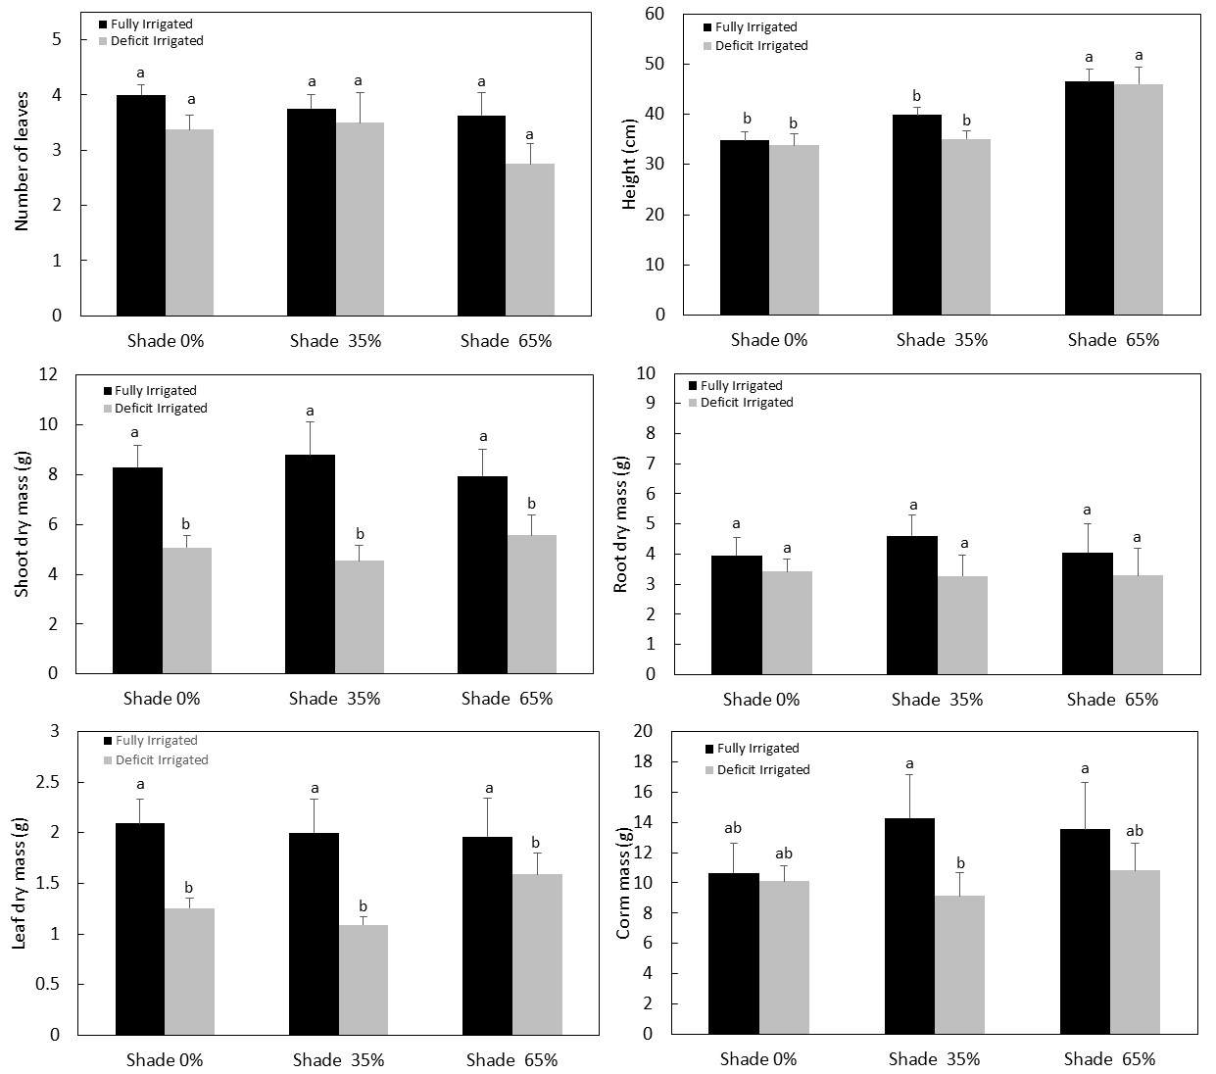
Fig. 1. Morphological and physiological variables in Chinese potato plants grown with three shading conditions (0, 35%, and 65%) and two irrigation levels (full and deficit). Different letters indicate significant difference at P < 0.05 as determined by the Tukey HSD test (n = 8). Vertical bars represent standard error of mean (SE).

3.3 Combined effects and interactions
The absence of significant interaction effects between light intensity and soil moisture is noteworthy. This suggests that while both factors independently influence growth parameters, their combined effects do not amplify or mitigate each other in a significant manner for Chinese potato. Such findings may indicate a level of resilience in C. esculenta to varying environmental conditions, allowing it to adapt effectively without exhibiting compounded stress responses. This observation contrasts with other studies where interactions between light and water availability have shown significant synergistic or antagonistic effects on plant growth (Madsen, 1994; Löf et al., 2005; Guidi et al., 2008; Silverio et al., 2024).
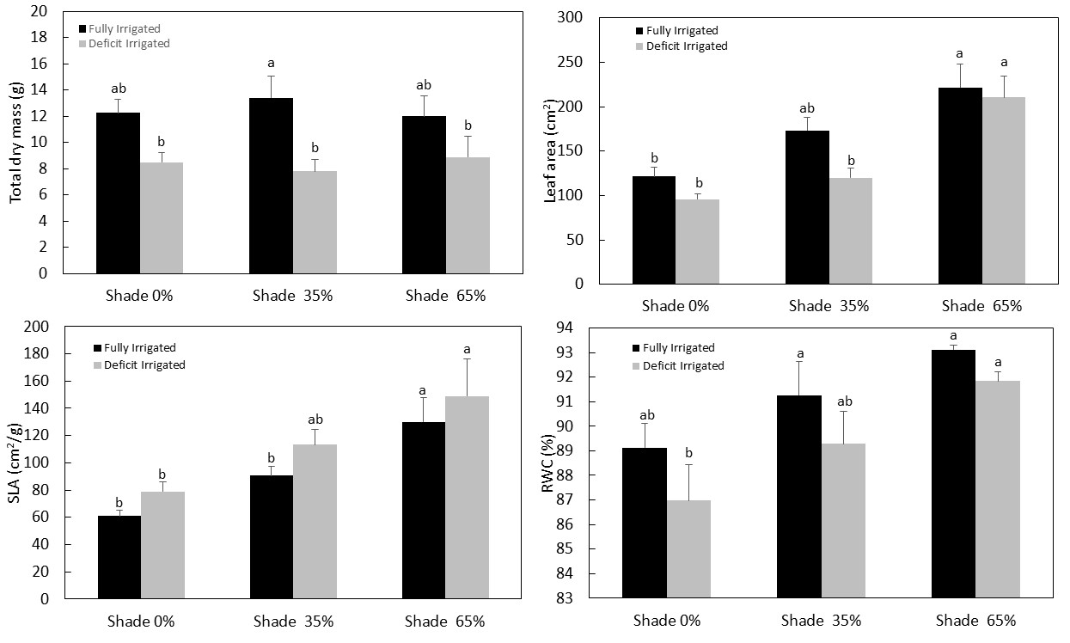
Fig. 2. Morphological and physiological variables in Chinese potato plants grown with three shading conditions (0, 35%, and 65%) and two irrigation levels (full and deficit). Different letters indicate significant difference at P < 0.05 as determined by the Tukey HSD test (n = 8). Vertical bars represent standard error of mean (SE).

3.4 Practical Implications
The findings of this study have important implications for the cultivation of Chinese potato under abiotic stress. The positive effects of shading on morphological traits suggest that moderate shade (e.g., 35% daylight) may be beneficial for optimizing plant height and leaf area. This has practical relevance for agroforestry systems where shade management can improve crop performance (Rogers & Iosefa, 1993). Conversely, irrigation remains critical for maximizing biomass production, highlighting the need for efficient water management practices in regions prone to drought. The absence of interaction effects suggests that shading and irrigation can be managed independently to address specific environmental challenges. For example, moderate shading can mitigate heat and light stress in high-temperature regions, while adequate irrigation ensures sustained growth during dry periods.

4. Conclusion

This study demonstrates that light intensity and soil moisture independently influence the growth and physiology of Chinese potato, with significant effects on traits such as plant height, leaf area, SLA, and dry mass. The absence of interaction effects underscores the resilience of this crop to individual stressors and provides flexibility in managing these factors. These findings inform sustainable cultivation practices for Chinese potato, particularly in regions facing abiotic stress, and highlight the need for further research on cultivar-specific adaptations and long-term stress responses.

References

Ararat, M. C. A., Garcés, C. L. S., & Rivera, C. H. (2014). Valoraciones agronómicas y de rendimiento en la cosecha de “papa china” (Colocasia esculenta L.) en el trópico húmedo colombiano. Revista de Investigación Agraria y Ambiental, 5(2), 169-180. https://doi.org/10.22490/21456453.1335

Lozada, A. (2005). Producción del cultivo de papa china (Colocasia esculenta) utilizando dos métodos de propagación asexual bajo cuatro niveles de fertilización orgánica. Quito: ESPE.

Lasso-Rivas N.L. & Cundumí- Jori I. (2016). Efecto de abono orgánico y densidad de siembra en crecimiento y producción de papa china (Colocasia esculenta L.) Revista de Investigación Agraria y Ambiental. 7 (1). 8. https://doi.org/10.22490/21456453.1535

Sanou, J., Bayala, J., Teklehaimanot, Z., & Bazié, P. (2012). Effect of shading by baobab (Adansonia digitata) and néré (Parkia biglobosa) on yields of millet (Pennisetum glaucum) and taro (Colocasia esculenta) in parkland systems in Burkina Faso, West Africa. Agroforestry Systems, 85, 431-441. https://doi.org/10.1007/s10457-011-9405-4

Mabhaudhi, T., Modi, A. T., & Beletse, Y. G. (2011, June). Growth response of selected taro [Colocasia esculenta (L.) schott] landraces to water stress. In II International Symposium on Underutilized Plant Species: Crops for the Future-Beyond Food Security 979 (pp. 327-334).

Lebot, V., 2009. Tropical root and tuber crops: cassava, sweet potato, yams and aroids. CABI, Reading, UK
Gouveia, C. S., Lebot, V., & Pinheiro de Carvalho, M. (2020). NIRS estimation of drought stress on chemical quality constituents of taro (Colocasia esculenta L.) and sweet potato (Ipomoea batatas L.) flours. Applied Sciences, 10(23), 8724. https://doi.org/10.3390/app10238724
Turner, N. C. (1981). Techniques and experimental approaches for the measurement of plant water status. Plant and soil, 58, 339-366.
Rogers, S., & Iosefa, T. (1993). Potentials for shade management in agroforestry systems for taro cropping.
Pant, K. S., Mishra, V. K., Sanwal, C. S., & Dinssa, K. U. (2010). Effect of nitrogen and poplar spacing on yield and nutrients content of Taro (Colocasia esculenta L.). Indian Journal of Agroforestry, 12(1).
Amin, M. H. A., Sumi, S., Jutidamrongphan, W., & Techato, K. A. (2022). Economic potentiality of Colocasia esculenta L. under multipurpose tree-based agroforestry systems. Asian J Agric & Biol. 3, 1-10. DOI: 10.35495/ajab.2021.01.059

Semchenko, M., Lepik, M., Götzenberger, L., & Zobel, K. (2012). Positive effect of shade on plant growth: amelioration of stress or active regulation of growth rate?. Journal of ecology, 100(2), 459-466. https://doi.org/10.1111/j.1365-2745.2011.01936.x

Feng Y, van Kleunen M. (2014). Responses to shading of naturalized and nonnaturalized exotic woody species. Annals of Botany 114: 981–989. https://doi.org/10.1093/aob/mcu163

Valladares F. & Niinemets U. (2008). Shade tolerance, a key plant feature of complex nature and consequences. Annual Review of Ecology, Evolution, and Systematics 39: 237–257. https://doi.org/10.1146/annurev.ecolsys.39.110707.173506

Martinez‐Garcia, J. F., & Rodriguez‐Concepcion, M. (2023). Molecular mechanisms of shade tolerance in plants. New Phytologist, 239(4), 1190-1202. https://doi.org/10.1111/nph.19047

Gouveia, C. S., Ganança, J. F., de Nóbrega, H. G., de Freitas, J. G., Lebot, V., & Pinheiro de Carvalho, M. A. (2020). Phenotypic flexibility and drought avoidance in taro (Colocasia esculenta (L.) Schott). Emirates Journal of Food and Agriculture. 32(2): 150-159. DOI:10.9755/ejfa.2020.v32.i2.2075

Fang, Y., & Xiong, L. (2015). General mechanisms of drought response and their application in drought resistance improvement in plants. Cellular and molecular life sciences, 72, 673-689. DOI: 10.1007/s00018-014-1767-0

Silverio, J. M., Scalon, S. D. P. Q., Santos, C. C., Linné, J. A., Dias, A. D. S., Bernardes, R. D. S., & Dantas, T. (2024). Water-Light Interaction and Its Effect on the Morphophysiology of Cedrela fissilis Vell. Seedlings. Plants, 13(18), 2654. https://doi.org/10.3390/plants13182654

Guidi, L., Degl'Innocenti, E., Remorini, D., Massai, R., & Tattini, M. (2008). Interactions of water stress and solar irradiance on the physiology and biochemistry of Ligustrum vulgare. Tree Physiology, 28(6), 873-883. DOI: 10.1093/treephys/28.6.873

Löf, M., Bolte, A., & Welander, N. T. (2005). Interacting effects of irradiance and water stress on dry weight and biomass partitioning in Fagus sylvatica seedlings. Scandinavian Journal of Forest Research, 20(4), 322-328. DOI:10.1080/02827580500201593

Madsen, P. (1994). Growth and survival of Fagus sylvatica seedlings in relation to light and soil water content. Scandinavian Journal of Forest Research, 9, 316/322. https://doi.org/10.1080/02827589409382846

