Seasonal Analysis of Land Surface Temperature and Urban Heat Island Dynamics: A Comparative Study of Kochi and Fairbanks

## Abstract

This study investigates the seasonal and decadal dynamics of Urban Heat Island (UHI) effects and Land Surface Temperature (LST) trends in two climatically distinct cities—Kochi, India, and Fairbanks, Alaska—from 2000 to 2023. Using MODIS and Landsat 8 datasets analyzed using Google Earth Engine, we examine variations in LST and UHI intensity during summer and winter. Kochi, a tropical city, exhibits a pronounced increase in LST, with a decadal warming trend of 0.07°C per year in summer and 0.08°C per year in winter. Conversely, Fairbanks, a subarctic city, shows a modest summer LST rise of 0.04°C per year and a slight winter cooling trend (-0.003°C per year), influenced by increased snowfall and albedo effects.

UHI intensity in Kochi reveals an amplified winter effect, with a spatial expansion of high-UHI zones from 2014 to 2023, reflecting urbanization and reduced vegetation cover. In contrast, Fairbanks demonstrates a slight summer UHI intensification but reduced winter UHI extent, aligning with its cooling trend. Comparative analysis highlights the contrasting impacts of urbanization and climatic conditions on UHI formation and evolution across the two cities. This study underscores the necessity for tailored mitigation strategies, emphasizing green infrastructure in tropical cities and adaptive urban planning in subarctic regions, to address region-specific thermal stress and enhance urban climate resilience.

## Introduction

The Urban Heat Island (UHI) phenomenon represents a significant and growing environmental challenge, characterized by elevated temperatures in urban areas compared to their rural surroundings. This issue has been on a steady upward trajectory for many years and is projected to intensify in the coming decades, driven by the continuous rise in land surface temperatures (Feng et al., 2018).

This phenomenon is primarily driven by rapid urbanization, changes in land use, and meteorological factors, which collectively amplify temperature differentials, with substantial impacts on local climates and ecosystems (Magee et al., 1999; Singh & Grover, 2015; Perera & Emmanuel, 2018; Zhao et al., 2020). As cities expand, the transformation of natural landscapes into built environments intensifies UHI effects, often exacerbating the impacts of global climate change and reducing the resilience of urban communities (Giridharan & Emmanuel, 2018).

Land Surface Temperature (LST), a key metric in understanding UHI dynamics, refers to the temperature of the Earth's surface and is influenced by factors such as land cover, vegetation, and atmospheric conditions. Remote sensing technologies like MODIS and Landsat have been instrumental in providing high-resolution spatial data on LST, enabling a deeper understanding of UHI patterns and trends (Li et al., 2013). However, the spatial variability of UHI effects across different climatic and geographic regions remains a complex issue that requires further exploration.

This study aims to conduct a comparative temporal analysis of LST and UHI dynamics between two climatically distinct cities—Kochi, India, and Fairbanks, Alaska—spanning the period from 2000 to 2023. By leveraging advanced remote sensing tools such as Google Earth Engine, we analyse the UHI effect during summer and winter seasons in both cities, focusing on decadal trends. The contrasting geographical contexts of Kochi, a tropical city, and Fairbanks, located in the subarctic region, offer a unique opportunity to explore how urbanization and climatic patterns influence UHI formation and intensity in two extreme climatic cities.

Tropical cities, which often experience high humidity, are significantly impacted by the urban heat island (UHI) effect, which exacerbates land surface temperature (LST) trends due to rapid urbanization and climate change. ​ These cities typically feature dense populations, extensive impervious surfaces, and limited green spaces, all of which contribute to elevated surface and air temperatures, further intensifying UHI effects (World Bank, 2023).

In contrast, subarctic cities like Fairbanks also experience significant UHI effects, where persistent temperature anomalies enhance climate warming, particularly in winter months. Research has shown that UHI effects in Arctic regions can lead to pronounced temperature disparities between urban and rural areas, with urban temperatures rising sharply due to surface inversions and other meteorological factors (Esau et al., 2021; Varentsov et al., 2018). By analysing these two cities, this study provides insights into how diverse climatic conditions and land surface temperature patterns since the early 2000s influence UHI dynamics and offers a comparative perspective on the challenges and **mitigation strategies** applicable to urban environments across different climate zones.

## Data & Methods

This study employs the MODIS MOD11A2.061 Terra Land Surface Temperature and Emissivity 8-Day Global 1km resolution dataset to calculate Land Surface Temperature (LST). The MOD11A2 Version 6.1 product provides average LST values over an 8-day period within a 1200 x 1200 kilometre grid. The dataset is derived by averaging the corresponding MOD11A1 LST pixels collected during the 8-day period (Wan et al., 2021).

Using Google Earth Engine (GEE), the monthly mean LST was calculated from the MODIS collection. For each study area, the median value of the total image was extracted, and this median was used to represent the monthly mean LST. The process involved taking the median value of each pixel within the study area, converting the result into a single data point. This data was subsequently used to generate time series plots of LST.

The monthly mean LST was calculated separately for summer and winter seasons. For Kochi, the summer months were defined as March and April, excluding May due to the early onset of pre-monsoon conditions, which contribute to cooling. The winter months in Kochi were identified as November and December. For Fairbanks, the summer months were June and July, while the winter months were November and December.

For the Urban Heat Island (UHI) analysis, the study employed the USGS Landsat 8 Level 2, Collection 2, Tier 1 dataset, which offers improved visualization of UHI patterns. Landsat 8 provides high-resolution imagery with a 30-meter spatial resolution, capturing detailed multispectral and thermal data of the Earth's surface approximately every two weeks. This dataset, available from April 2013 to the present, serves as a valuable resource for analysing long-term environmental changes.

Land Surface Temperature (LST) was derived from Band 10 of the Landsat 8 Operational Land Imager (OLI) and Thermal Infrared Sensor (TIRS) images using a single spectral band algorithm. Band 10 (10.6 - 11.19 µm) was selected over the split-window algorithm, which utilizes both Bands 10 and 11, to avoid the higher calibration uncertainty associated with Band 11 (Guha et al., 2018). The analysis was performed using Google Earth Engine (GEE), and cloud masking was applied to eliminate cloud cover, ensuring that only clear-sky observations were included (Mateo-García et al., 2018).

A normalized method is used here to generate UHI. This approach is represented by the following equation (Faisal et al., 2021):

UHI = Ts − Tm / Tstd

Where UH is the normalized UHI, Ts is the LST, Tm is the mean LST of the study area, and Tstd is the standard deviation LST of the study area.

The Urban Heat Island (UHI) intensity was quantified for both summer and winter seasons for the years 2014 and 2023. While Land Surface Temperature (LST) data was calculated for the period spanning 2000 to 2023, the UHI analysis specifically focused on 2014 and 2023 to ensure consistency in using a single data product. This was necessary because Landsat 8, which provides the required thermal measurements, has only been available since 2013.

To provide a more representative condition of the study areas during a season, the mean UHI of each image during the selected seasonal months was calculated (Kafy et al., 2021). The analysis was limited using shapefiles as boundaries for Kochi and Fairbanks, with the TIFF images generated via Google Earth Engine (GEE). The resulting images were then visualized in ArcGIS to illustrate variations in temperature and UHI intensity across different seasons and time periods.

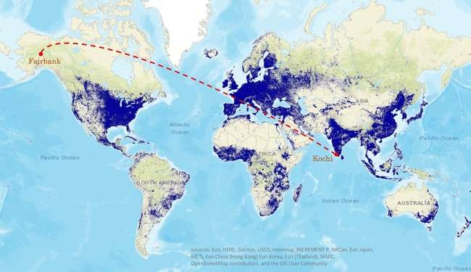

Fig 1: Global-scale map showing the locations of Fairbanks and Kochi, with a binary mask outlining the extent of human settlements worldwide. The settlement data is derived from 2014-2015 multitemporal Landsat-8 and Sentinel-1 imagery.

## Results & Discussions

Decadal Trends in LST

The analysis of Land Surface Temperature (LST) data from 2000 to 2023 highlights a steady upward trend in Kochi. The LST has increased at an average rate of approximately 0.07°C per year, leading to a total rise of 1.7°C during the peak summer month, March, over the study period. April, which is supposed to be a summer month, shows comparatively lower LST primarily due to the early onset of the pre-monsoon. These early pre-monsoon showers brought a cooling effect, mitigating the typical summer heat.

The winter trendline suggests a consistent rise in temperature, with a total increase of 1.9°C, reflecting an average annual increase of 0.08°C (see fig 2). Which shows the increasing trend more prominent during winter season, even though the temperatures are comparatively lower in winter months. This indicates a significant warming trend, with winters in Kochi becoming progressively warmer over the years. The year 2014 was particularly notable, as Kochi experienced unusually high temperatures during the summer month, with a peak of 35.23°C. This increase was attributed to the influence of a weak El Niño event.

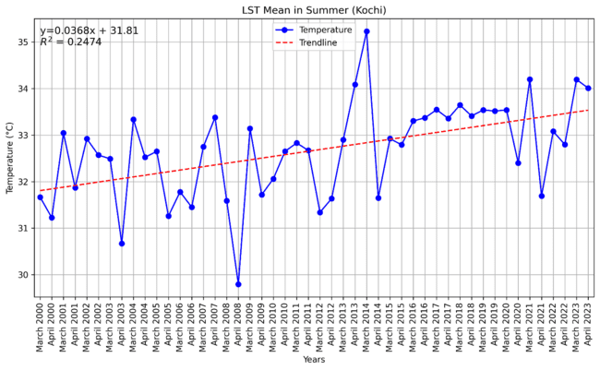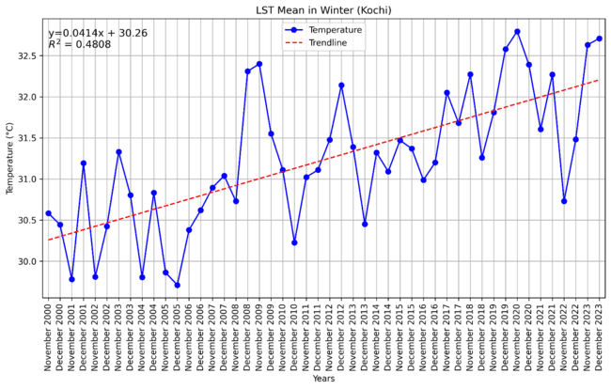

Fig 2. Land Surface Temperature (LST) Trends in Kochi Summer & winter (2000-2023).

The analysis of Land Surface Temperature (LST) trends in Fairbanks, Alaska, from 2000 to 2023 reveals a gradual but noticeable increase in LST during the summer season. Over the study period, the total rise in temperature is recorded as 1.04°C, with an average annual increase of 0.04°C. While the increase may appear modest, it is significant for a subarctic climate like Fairbanks, where even small changes in temperature can have pronounced ecological and environmental impacts. Notably, June 2013 experienced an extreme heatwave, with temperatures peaking at 29.46°C (see fig 3) between June 17-21, making it the hottest summer month on record for Fairbanks. This atmospheric event not only intensified local temperatures but also contributed to a broader warming trend in the region.

Despite the overall warming during the summer, the subarctic region is subject to highly variable weather patterns, which can cause short-term cooling in specific areas. These patterns, including shifts in atmospheric circulation such as changes in the polar vortex, occasionally bring colder air to certain regions. In line with this variability, the analysis shows a slight decrease in LST during the winter months, with a total reduction of 0.06°C and an average annual decrease of 0.003°C. Although the winter cooling trend is modest, it is noteworthy in the context of the overall Arctic warming. One key factor contributing to this cooling is increased snowfall, which enhances the surface albedo effect. The high reflectivity of snow increases the reflection of solar radiation, leading to cooler surface temperatures during the winter months.

Both Kochi and Fairbanks exhibit an increase in Land Surface Temperature (LST) during the summer, though the rise is more pronounced in Kochi. This suggests that tropical regions like Kochi may experience more intense warming than sub-Arctic regions such as Fairbanks, likely due to differences in regional climate dynamics and the influence of urbanization. Over the decade, Kochi shows a consistent warming trend in both summer and winter, while Fairbanks experiences warming in summer but slight cooling in winter. The more significant warming in Kochi, particularly during winter, may also exacerbate the urban heat island (UHI) effect. These contrasting trends underscore the complexity of weather pattern, which varies by region, season and local factors.

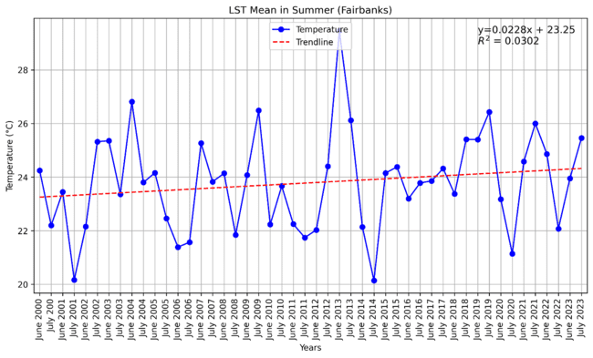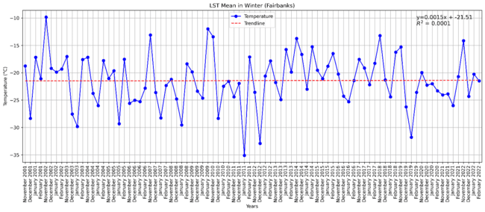

Fig 3. Land Surface Temperature (LST) Trends in Fairbank Summer & winter (2000-2023).

**Seasonal and decadal variation of Heat Island Intensity**

The summer of 2014 in Kochi was marked by a notably strong Urban Heat Island (UHI) effect, with a mean UHI of 1.7°C. This heightened UHI can be attributed to 2014 being one of the warmest years on record, with a weak El Niño effect. March 2014 recorded the highest monthly mean temperature of 35.2°C, further amplifying the UHI. But the summer of 2023 saw a comparatively reduced mean UHI of 0.9°C than 2014. But there are also pockets of UHI where the intensity is >2.5oC. This can be attributed to 2014 being the warmest summer of the study period. But the LST shows an increasing trend for Kochi throughout the years. This comparison, along with LST trends, demonstrates the significant role climatic conditions play in the formation of UHIs.

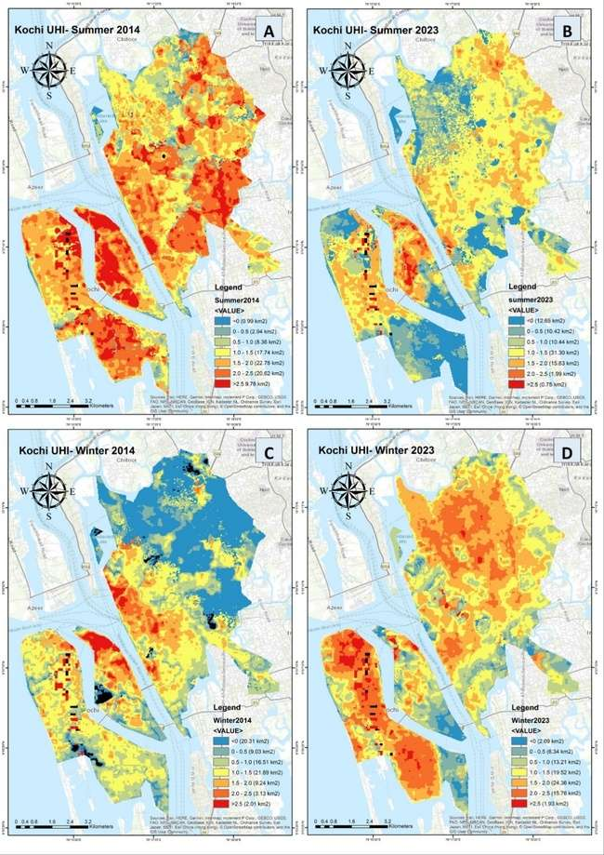

Fig 4: A) (UHI) Kochi- Summer Months Mean, 2014 B) UHI, Kochi- Summer Months Mean, 2023

C) UHI, Kochi- Winter Months Mean, 2014 D) UHI, Kochi- Winter Months Mean, 2023

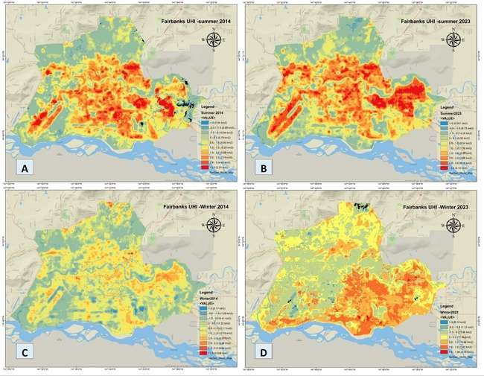During the winter of 2014, Kochi’s UHI effect resulted in a mean UHI increase of 0.6°C above rural surroundings. By 2023 winter, this effect had intensified, with the mean UHI rising to 1.4°C, suggesting more frequent and severe urban heating episodes. This increase reflects ongoing urbanization, reduced green spaces, and highlights a trend toward more extreme urban heat events during the winter months and underscores how UHI effects can exacerbate the extreme weather events in urban areas like Kochi.

Fig 5: A) Urban Heat Islands (UHI) Fairbanks - Summer Months Mean, 2014 B) UHI, Fairbanks - Summer Months Mean, 2023 C) UHI, Fairbanks - Winter Months Mean, 2014 D) UHI, Fairbanks - Winter Months Mean, 2023

Kochi exhibits a clear seasonal distinction in UHI patterns. In winter 2023, UHI intensity was significantly higher than in 2014, with elevated temperatures spreading beyond central urban areas. This shift is likely due to urban sprawl and reduced vegetation cover. In contrast, the summer of 2014 experienced a significant intensification of Urban Heat Island (UHI) effects compared to 2023, which can be potentially attributed to the El Niño phenomenon in 2014. This aligns with the Land Surface Temperature (LST) analysis, further supporting the correlation between the El Niño event and the heightened UHI intensity during that period. Nevertheless, the overall trend still indicates increasing heat stress across both seasons.

In the summer of 2014, Fairbanks experienced a mean Urban Heat Island (UHI) effect of 0.8°C, which increased to 1.0°C by the summer of 2023, signalling a gradual intensification of the UHI effect over time. The rise in mean UHI suggests a more prevalent urban heating pattern, likely driven by ongoing urbanization and land-use changes. This points to a stronger UHI effect during the summer months. But the winter in Fairbanks has become strong in 2023 compared to 2014 as the LST trend shows a decreasing trend. The mean UHI intensity reduced from 0.4°C in 2014 to 0.1°C in 2023. Which requires more heating requirements and more GHG emissions, which can lead to an increase of UHI in near future.

**Seasonal and decadal variation of spatial extend of Heat Island**

In Kochi, the UHI effect has expanded significantly between 2014 and 2023, as shown in Figures 5A and 5B for summer and Figures C and D for winter. In summer, the area having UHI >0oC have slightly reduced from ~82km2 in 2014 to ~71km2 in 2023. Whereas in winter, the area having UHI >0oC have increased significantly from ~62km2 in 2014 to ~81km2 in 2023. By the winter of 2023, compared to summer of 2023, a larger portion of the city experienced higher UHI intensities. This increase in spatial extent more prominent during the winter season, with high-heat zones expanding into areas that were previously comparatively cooler, reflecting both the loss of vegetation and increased energy use.

Fairbanks displayed similar UHI growth over the same period in summer, but with lighter intensity and lesser area extent, with 2023 showing greater heat accumulation in urban areas than in 2014 (Figures 5A and 5B for summer, Figures 5C and 5D for winter). The area having UHI >0oC have increased slightly from ~49km2 in 2014 to ~52km2 in 2023. In winter as per the LST trend also there is slight decrease in UHI intensity and area extent. The area having UHI >0oC have decreased significantly from ~47km2 in 2014 to ~24km2 in 2023. This affirms the fact that extreme climatic conditions are becoming stronger, with summers becoming warmer and winters becoming cooler.

A comparison of Kochi's Urban Heat Island (UHI) effect between 2014 and 2023 reveals significant changes in both summer and winter patterns. We assume areas with high UHI intensity to be >1.5°C and remaining areas to be mild or cooler. The 2023 data reveal a significantly broader pattern of heat retention in the central urban areas, in contrast to 2014, when such heat retention was minimal. This suggests an evolving UHI pattern, with the urban core retaining more heat over time, particularly during the winter.

In the summer of 2023, UHI intensity was notably lower, with cooler areas (<1.5°C) were more in 2023. Where as in 2014 areas with high intensity UHI (>1.5°C) is more, decreasing from ~52 km² in 2014 to ~ 17 km² in 2023. This uncommon shift suggests that more regions experienced milder heat island effects in 2023 compared to the El Niño-influenced summer of 2014, which saw warmer conditions. The data highlights the significant impact of El Niño on UHI intensity, particularly in tropical cities, where thermal comfort is likely to be more severely affected during such events. Significantly, Kochi exhibits an increase in areas experiencing higher UHI intensities, particularly between 0.5°C and 1.5°C, which expanded by over 23.12 km², despite the overall reduction in mean land surface temperature (LST) during the summer of 2023. Moderate UHI intensities (1.0-1.5°C) rose from 17.74 km² to 31.30 km², indicating a broader spread of UHI effects across the city, though the heat island intensification in these regions remained moderate rather than extreme.

The heat island effect pattern has intensified during the winter season from 2014 to 2023. The high intensity UHI areas has significantly increased from ~14km2 in 2014 to ~41km2 in 2013. There was also a severe reduction in cooler areas (<0°C), shrinking from 20.31 km² in 2014 to just 2.09 km² in 2023. This data highlights a dynamic shift in UHI patterns, reflecting a spatial redistribution of heat effects in winter alongside evolving climatic conditions over the decade.

Urban Heat Islands (UHIs) in Fairbanks display clear seasonal variability in both intensity and spatial distribution. In the summer, heat pockets show higher temperature intensities but remain spatially limited, while in the winter, elevated temperatures spread over larger areas, though with moderated intensity. If we take the same criteria for severe UHI to be >1.5°C, winter season shows lower temperature, with mean being around 1°C. And we can see cooler areas (<0.5°C) has expanded in 2023, from ~34Km2 in 2014 to ~58Km2 in 2023.

Fairbanks, located in a subarctic inland region, experiences more extreme winter, where the -3°C to -1.5°C temperature class covers approximately 22.18 km². This indicates a broader distribution of mild heat pockets, while higher intensities are absent due to the cold seasonal conditions.

During the summer, areas with UHI intensities below 0°C shrink, and zones with UHI >1.5°C experience slight expansion from ~20km2 in 2014 to ~25Km2 in 2023. Conversely, in winter, zones with UHI >1.5°C contract significantly, with no areas exhibiting temperatures over 1.5°C, reflecting a particularly cold winter. A consistent cooling effect is observed around the Chena River during winter, likely due to the thermal characteristics of the water. These patterns highlight the complex interaction of seasonal factors affecting UHI dynamics in subarctic regions like Fairbanks.

The UHI patterns in Fairbanks and Kochi differ considerably, reflecting the influence of geographic location and seasonal climate. While Kochi's UHI intensification is more pronounced in the winter, Fairbanks sees a more significant increase in summer UHI intensity, highlighting the distinct seasonal dynamics in each city. In Fairbanks, the summer UHI has intensified, particularly in more urbanized areas. However, the expansion of winter UHI in Kochi presents a more concerning trend.

## Conclusion

The UHI effect in both Kochi and Fairbanks has intensified from 2014 to 2023, albeit with distinct seasonal and geographical differences. Kochi, a coastal city in a tropical climate, experiences higher baseline temperatures throughout the year. The intensification of the UHI effect, particularly in winter, indicates that anthropogenic heat sources, urban expansion, and land-use changes are overwhelming natural cooling mechanisms, such as sea breezes. The combination of high humidity and increased UHI effects poses significant health risks and elevates energy demand, especially for cooling.

Fairbanks, an inland city in a subarctic climate, has historically experienced extreme cold winters, However, the 2023 summer data shows that UHI has become slightly pronounced, likely due to increasing infrastructure and warming trend. Fairbanks experiences more severe winter, which could lead to increased snow cover, increased freeze-thaw cycles, and greater energy demands for heating. This suggests that geographic and climatic differences play a major role in shaping the intensity and spatial distribution of UHI, with tropical cities like Kochi experiencing relatively more intense urban heat during winter, whereas subarctic cities like Fairbanks exhibit pronounced UHI effects during summer due to heat retention in built environments.

Kochi's intensification is more consistent across seasons, pointing to sustained heat stress, while Fairbanks sees a sharp winter-driven intensification. This redistribution underscores the importance of adaptive urban planning in both cities, though the climatic drivers behind these shifts differ, with Kochi's heat stress being driven primarily by anthropogenic factors and urbanization, while Fairbanks may be more influenced by climatic warming and infrastructural development.

These findings emphasize the growing influence of global and regional climatic changes on local environments. The observed warming trends in both Kochi and Fairbanks, alongside the intensifying UHI effects, underscore the need for adaptive strategies to mitigate the adverse effects of rising/cooling temperatures. The increasing severity of extreme climatic conditions reinforces the urgency of addressing climate change to minimize the risks associated with unpredictable and extreme weather patterns.

To conclude there is drastic difference in UHI effect between two geographically different extreme climatic regions. In the tropical region like Kochi the UHI effect is more prominent in winter months: both in intensity and spatial extent. Whereas in subarctic region like Fairbanks, the UHI effect is prominent in summer months both in intensity and spatial extent.

## Reference

Feng, Y., Li, H., Tong, X., Chen, L., & Liu, Y. (2018). Projection of land surface temperature considering the effects of future land change in the Taihu Lake Basin of China. In *Global and Planetary Change*. <https://doi.org/10.1016/j.gloplacha.2018.05.007>

Esau, I., Miles, V., Soromotin, A., Sizov, O., Varentsov, M., & Konstantinov, P. (2021). Urban heat islands in the Arctic cities: an updated compilation of in situ and remote-sensing estimations. *Advances in Science and Research*, *18*, 51-57.

Varentsov, M., Konstantinov, P., Baklanov, A., Esau, I., Miles, V., & Davy, R. (2018). Anthropogenic and natural drivers of a strong winter urban heat island in a typical Arctic city. In Atmospheric Chemistry and Physics. <https://doi.org/10.5194/acp-18-17573-2018>

World Bank Group. (2023). Unlivable: What the Urban Heat Island Effect Means for East Asia’s Cities. World Bank Group. <https://www.worldbank.org/en/region/eap/publication/unlivable-what-the-urban-heat-island-effect-means-for-east-asia-s-cities>

Wan, Z., Hook, S., Hulley, G. (2021). MODIS/Terra Land Surface Temperature/Emissivity 8-Day L3 Global 1km SIN Grid V061 [Data set]. NASA EOSDIS Land Processes Distributed Active Archive Center. Accessed 2024-09-05 from <https://doi.org/10.5067/MODIS/MOD11A2.061>

Kafy, A. A., Al Rakib, A., Akter, K. S., Jahir, D. M. A., Sikdar, M. S., Ashrafi, T. J., ... & Rahman, M. M. (2021). Assessing and predicting land use/land cover, land surface temperature and urban thermal field variance index using Landsat imagery for Dhaka Metropolitan area. Environmental Challenges, 4, 100192.

Guha, S., Govil, H., Dey, A., & Gill, N. (2018). Analytical study of land surface temperature with NDVI and NDBI using Landsat 8 OLI and TIRS data in Florence and Naples city, Italy. European Journal of Remote Sensing, 51(1), 667–678. <https://doi.org/10.1080/22797254.2018.1474494>

Mateo-García, G., Gómez-Chova, L., Amorós-López, J., Muñoz-Marí, J., & Camps-Valls, G. (2018). Multitemporal Cloud Masking in the Google Earth Engine. In Remote. Sens. <https://www.mdpi.com/2072-4292/10/7/1079/pdf?version=1531111736>

Faisal, A.-A.-, Kafy, A.-A., Al Rakib, A., Akter, K. S., Jahir, D. Md. A., Sikdar, Md. S., Ashrafi, T. J., Mallik, S., & Rahman, Md. M. (2021). Assessing and predicting land use/land cover, land surface temperature and urban thermal field variance index using Landsat imagery for Dhaka Metropolitan area. In Environmental Challenges. <https://doi.org/10.1016/j.envc.2021.100192>