**SENSORY EVALUATION AND HAEMATOPOIETIC POTENTIAL OF FERMENTED SORGHUM grain FORTIFIED WITH *Sorghum bicolor* LEAF IN 2,4-DINITROPHENYLHYDRAZINE –INDUCED ANAEMIA IN RATS**

**ABSTRACT**

Food fortification is a well-known technique used to address micronutrient deficiencies in susceptible populations. *S. bicolor* leaf (SBL) is usually employed as colouring additives in many food preparations but its haematopoietic potential has not been fully explored. This study therefore, investigated the acceptability of fortified S. bicolor formula and its haematopoietic potential in anaemic rats. SBL obtained from market was pulverized into powder, out of which 0.5 g and 0.75 g of pulverized SBL were supplemented into fermented sorghum and made into thick pap, respectively. Questionnaire was designed to access organoleptic acceptability of the pap. Anaemia was induced in rats using 2,4-diphenylhydrazine (40 mg / kg) for the first two days after which the rats were fed with different proportion of fortified S. bicolor formulas from day 3 to day 15. Haematological parameters of the fortified S. bicolor- treated rats were compared to the non-treated group, and the group treated with multivitamin (orheptal) as a standard drug. The organoleptic property of the fortified formula was rated 75% overall in terms of acceptability compared to 85% of the unfortified control sample. The PCV level increased significantly in the treated groups (40%) compared to the untreated group (33%), RBC of all the treated animal groups increased significantly (6%) and Hb (12%). *S. bicolor* leaf enriched-pap has haematopoietic capabilities and can be an affordable remedy for anaemia. Therefore, it is recommended as functional food for anaemic patient. Conducting clinical trials and production of appealing Sorghum-based food products is hereby suggested.

***Keywords***: Organoleptic property, Sorghum bicolor leaf, anaemia, haematopoietic, fortification.

**INTRODUCTION**

Food fortification is one of the techniques that can be used to intentionally improve the nutritive values of regularly consumed foods during preparation. It is a tried-and-true, and risk-free technique that is deemed as one of the most cost-effective developmental goals (Horton *et al.,* 20011; Hoddinot *et al.,* 2012). It is less common in low-medium income countries (LMICs), where food systems are not delivering nutritionally adequate diets. This is due to the production and consumption of a few major starchy food crops (maize, rice, and wheat) with low micronutrient contents and/or bioavailability (Wakeel *et al*., 2018). However, food fortification has been made mandatory in high-income countries (HICs) and being used as a strategy to prevent micronutrient deficiencies. This is due to the production and consumption of a few major starchy food crops (maize, rice, and wheat) with low micronutrient content and bioavailability (Wakeel *et al*., 2018).

Food fortification in HICs has been shown to be effective in addressing micronutrient deficiencies (Osendarp *et al*., 2018). The results of a recent meta-analysis and systematic review of extensive food fortification programmes e.g. large-scale food fortification (LSFF) revealed that fortification has a positive effect on nutritional outcomes, such as ameliorating vitamin A deficiencies, low iodine levels, anaemia associated with vitamin B9/B12 and iron deficiencies, and neural tube defects in both women and children. It has also been reported to improve serum folate levels in women of reproductive age (Keats *et al*., 2019). The most suitable and effective form of fortification for a particular country depends on a number of factors, such as the prevalence of certain deficiencies in micronutrients (e.g. vitamins, minerals, etc.); the population or groups of people most affected by the deficiency (e.g., children, adolescents, the elderly), dietary composition, infrastructure, such as processing and production facilities, capacity for food processing or production systems, national regulation, and governmental guidance (Osendarp *et al*., 2018; Olson *et al.,* 2021).

Micronutrient deficiencies, also known as hidden hunger, are a huge global health problem (Muthayya *et al*., 2013). Nutrient deficiency affects about 40% of the world's population, primarily women and children in developing nations particularly those with low incomes (Bathla and Arora, 2022). Point-of-use micronutrient fortification (home fortification) is the process of adding micronutrients to foods that have already been prepared for consumption. It is regarded as a major intervention for increasing micronutrient intakes (Zhang *et al*., 2016). Fortified meals will sustain nutritional storage in the body more efficiently and effectively than intermittent supplements if ingested on a regular and frequent basis. Additionally, fortified foods are more effective in reducing the danger of the many deficiencies that might arise from seasonal shortages in the food supply or a diet of poor nutritional value. By boosting the amount of vitamins in breast milk, fortification can help postpartum moms and new-borns avoid the need for supplements (UNICEF, 2020).

The most prevalent micronutrient deficiency in children is anaemia, particularly in sub-Saharan African nations (Lemoine *et al.,* 2020). Lack of one or more vital elements, particularly iron, which is necessary for the production of haemoglobin, can cause anaemia, a condition in which the blood's haemoglobin level is lower than normal. A condition known as anaemia is one in which the amount of haemoglobin in the body is inadequate, and it might differ from person to person and from gender to gender. When men have anaemia, their haemoglobin concentration is below 13 g/dl, and when young girls under the age of 15 have anaemia, it is below 12 g/dl (Contaldo *et al.,* 2019). A haemoglobin level of less than 11 g/dl is considered anaemic in children, according to the world health organization (WHO) (Patel, 2008). All age groups are affected by anaemia, although children under the age of two are the most at risk (Lozoff *et al.,* 2006; Joo *et al.,* 2016). There are different types of anaemia but the one of interest is called hemolytic anaemia.

Sorghum (*Sorghum bicolor*) belongs to the *Poaceae* family of plants and was originally found growing wild in Africa, Sudan, and central Asia. The common names are millet, sweet sorghum and guinea corn. It is known as "Oka baba" (Yoruba), "dawa" (Hausa), and "soro" (Igbo) in Nigerian languages. It is also referred to a number of different names including milo or milo-maize in the United States and kafir corn in South Africa (FAO, 1995). In Sub-Saharan Africa, it is cultivated as the second most common cereal after maize (Mabhaudhi *et al.,* 2016; Sobowale *et al.,* 2019; FAO, 2019). Millions of people rely on it as a main meal and a staple, making it one of the continent's most adaptable cereal crops (Adebo *et al.,* 2018; Sobowale *et al.,* 2019). It is a significant provenance of calories, a range of nutrients, and healthy food ingredients (Odunmbaku *et al.,* 2018). The objectives of this study are to fortify fermented sorghum grains (pap) with various concentrations of its leaf, determine its acceptability and to determine the haematological parameters in anaemic rats fed with the fortified pap.

**MATERIALS AND METHODS**

***Preparation of Plant Materials***

The dried leaf of *S. bicolor* and the sorghum grainswere purchased from Ibaka market, Akungba-Akoko, Ondo State, Nigeria. The samples were identified and authenticated at the Department of Plant Science and Biotechnology, Adekunle Ajasin University, Ondo State, Nigeria. The samples were air-dried at room temperatures (28oC) and protected from moisture in a drying cabinet. The dried samples were then crushed to powder using Atlas grinding machine and stored in suitable containers at room temperature.

***Preparation of Sorghum Grain and Fortificant***

The sorghum grains were sorted, washed, and soaked in a clean plastic filled with water for 2 days at ambient temperature. The water was then drained, the soaked grains were rinsed and milled using Atlas grinding machine (Atlas UK). The product was then mixed with water and sieved with a muslin cloth. The filtrate was allowed to settle for 24 hrs for colored starchy sediment. Every day, before preparation, the water was decanted; the portion needed was scooped out with a clean spoon before clean and fresh water was added.

The first portion was prepared in two different proportions by scooping 190 g of the fermented sorghum grain and fortified with 10 g of the dried blended sorghum leaf, mix together and then stirred in boiling water until homogeneous (5%). The second portion was prepared in same way by scooping 185 g of the fermented sorghum grain and fortified with 15g of the dried blended leaf (7.5%). Lastly, the third portion was also prepared same way but only 200 g of the fermented sorghum grain was scooped without fortification. The prepared samples were left for few minutes to cool and solidify before feeding.

***Sensory Evaluation of the Finished Products***

A sensory evaluation was conducted, to check for the taste, appearance, aroma, color, texture and moisture. These were done by the use of questionnaire given to ten respondents. The samples were coded (with letters and a number) and served at random to the panelists, to avoid bias. Panelists were then asked to rank the fortified and non-fortified samples based on their attributes. Overall acceptability of the samples was determined using six-point hedonic scale where the degree scores are rated as: 1-Excellent, 2-Very good, 3-Good, 4-Fair, 5-Poor and 6-Very poor.

***Experimental Animal***

Thirty male rats of Wistar strains with body weight between ninety and one hundred and twenty grams (90-120g) were purchased from the animal house of the Department of Animal and Environmental Biology, University of Ado-Ekiti, Ekiti State, Nigeria. The experimental animals were transported to the Animal House of Department of Biochemistry, Adekunle Ajasin University and kept in rat cages with free access to water and dry pellet feed for two weeks for acclimatization in a well-ventilated room. They were regularly cleaned to ensure optimal development and to prevent animal infection.

***Treatment of Experimental Animal***

The rats were grouped into six each containing five rats in a separate cage and feed twice daily with normal pap, fortified pap, normal pellet and water. Group 1(control) were fed with normal animal pellets but not induced. Group 3 (positive control) was not induced but were given only 5% sbl fortified pap. The rats of groups 2, 4, 5 and 6 were subjected to 2, 4-dinitrophenylhydrazine (2, 4-D) to induce anaemia in the rats. Anaemia was induced using 2, 4-D powder (KEM Light Laboratories PVT. Ltd.) which was dissolved in 10% dimethyl sulfoxide (DMSO) solution. This was administered to the rats intraperitoneally (IP) at a dose of 40 *mg/kg* of body weight per day for two days according to Naughton *et al.* (1995). The blood samples of the rats in each group were taken through tail vein puncture using capillary tubes and analyzed for red blood cell (RBC), white blood cell (WBC), pack cell volume (PCV) and haemoglobin (Hb) using auto-analyzer before inducement with 2, 4-D.

***Confirmation of Anaemia Induction***

Blood samples of the rats were taken after the inducement with 2, 4-D and analyzed for red blood cell (RBC), white blood cell (WBC), pack cell volume (PCV) and haemoglobin (Hb) using auto-analyzer to determine the effectiveness of the 2, 4-D applied. After the confirmation of anaemia inducement, animals were then treated. The animals in group 2 were not treated but were only fed with ordinary pap without fortificant, group 4 were treated with pap fortified with 5% sbl, group 5 were treated with pap fortified with 7.5% sbl and the group 6 were fed with normal animal pellets and treated with 1ml /kg /day of the referenced iron multivitamin (orheptal) by gavage using a gastric tube. All groups were treated for two weeks.

***Collection of Blood Samples***

After two weeks of treatment, animals were sacrificed after overnight fast and blood was rapidly collected by direct heart puncture after cervical dislocation. Blood samples was collected in ethylenediamine tetra-acetate (EDTA) bottles and analyzed for red blood cell (RBC), white blood cell (WBC), pack cell volume (PCV) and haemoglobin (Hb) using auto-analyzer to determine the effectiveness of the treatment applied.

***Statistical Analysis***

Statistical analysis was performed using the program R 3.4.0 (http://www.rproject.org/). Data for PCV, WBC, RBC and Hb was analysed independently using two-way ANOVA (Statistical Procedures for Agricultural Research package (AGRICOLAE) with treatments and sampling time (before inducement, after inducement and after treatment) as fixed factors. Tukey HSD multiple post-hoc tests were used to assess the significance of the differences among the means.

**RESULTS**

The physical characteristics of the fermented *S. bicolor* paps with different concentrations of SBL and the rats feed pellets showed that the prepared animal feeds are of good quality in terms of its appearance (Figure 1). About 50% of the population of people who tasted the fermented *S. bicolor* pap confirmed that the *S. bicolor* pap without fortification was excellent and 50% indicated that the *S. bicolor* pap without fortification was very good based on the appearance. While for the 5% fortified *S. bicolor* pap, 75% of the people indicated that it was very good and nobody indicated that 5% fortified *S. bicolor* pap was fair and poor. However, 25% of the population indicated that it was very good. Also, 50% of the population indicated that cooked 7.5% fortified fermented *S. bicolor* paste was very good while 12.50% of the population indicated that it was good but only 37.50% of the population indicated fair in their judgement based on the appearance of the cooked fermented fortified *S. bicolor* pasted (Figure 2). Moreover, for the colour 75% of the population indicated that the colour of the cooked fermented *S. bicolor* without fortification was excellent while 25% attested that the *S. bicolor* without fortification was very good. The 62.5% of the population indicated that colour of the cooked fermented *S. bicolor* fortified with 5% sbl was excellent, while 37.5% of the population indicated that it was good, but no one indicated that it was fair and poor. Moreover, 25% of the population indicated that the 7.5% sbl fortified cooked fermented *S. bicolor* paste was very good while 37.5% each indicated the colour was good and fair (Figure 2).

Additionally, 75% of the population indicated that the cooked fermented *S. bicolor* fortified with 5% sbl was excellent while only 25% indicated that it was very good. The 62.5% of the population indicated that the cooked fermented *S. bicolor* fortified with 7.5% sbl was excellent while 37.5 % of the population indicated that the aroma was very good (Figure 2). The 87.5% of the population of people who tasted the cooked fermented *S. bicolor* pap without fortification indicated that it was excellent while only 12.50% indicated that the *S. bicolor* without fortification tasted very good. For the 5% fortified cooked fermented *S. bicolor* pap, 50% of the population of people who tasted it indicated that it was excellent and the remaining 50% indicated that it tasted very good. However, for the 7.5% fortified cooked fermented *S. bicolor* pap, 37.50% of the population indicated that it tasted excellent while 62.5% indicated that it tasted very good (Figure 3). Moreover, for the texture, 100% of the population indicated that the texture of cooked fermented *S. bicolor* pap without fortification was excellent and 25% confirmed that the cooked fermented *S. bicolor* without fortification was very good. About 75% of the population indicated that the texture of the 5% fortified cooked fermented *S. bicolor* pap was excellent while 25% indicated that the texture was very good. Also, 62.5% of the population indicated that 7.5% fortified cooked fermented *S. bicolor* pap was excellent while the remaining 37.5% indicated that it was very good (Figure 3). The 87.5% of the population indicated that the moisture of cooked fermented *S. bicolor* without fortification was excellent while only 12.5% of the population indicated that the moisture content of the cooked fermented *S. bicolor* without fortification was very good. Moreover, 100% of the population indicated that 5% fortified cooked fermented *S. bicolor* was excellent while for the 7.5% fortified cooked fermented *S. bicolor*, 87.5% of the population indicated that it was excellent and only 12.5% indicated that its moisture content was good. Finally for the overall acceptability of the cooked fermented *S. bicolor* without fortification, 87.5% of the population indicated that was excellent while 12.5% indicated that it was very good. For the 5% and 7.5% fortified cooked fermented *S. bicolor* pap, 75% of the population indicated that they were both excellent while only 25% of the population indicated that each of them (5% and 7.5%) was very good in terms of the overall acceptability (Figure 3).

***Haematological Assessment***

The pack cell volume (PCV) of the experimental animals before induction of anaemia ranges between 36 and 37%. There were no significant differences (p<0.01) in the PCV of the experimental animals before induction. But after induction, the PCV of the induced groups (group 2, 4, 5 and 6) decreased significantly (p<0.01) compared to the non-induced groups (group 1 and 3). The group 3 had the highest PCV of 38.33% followed by the group 1 (general control) with 37%. The group 4 had a PCV of 32.66%, group 5 and group 6 had 32% each, while group 2 had 31% respectively. After treatment, group 6 (animals treated with the standard drug (orheptal) had the highest (42%) followed by group 3 (animals not induced but treated with 5% fortified cooked fermented *S. bicolor* pap) with PCV of 40.66%. The group 5 (animals induced and treated with 7.5% fortified cooked fermented *S. bicolor* pap) had 40.33%, while group 4 (induced and treated with 5% fortified cooked fermented *S. bicolor* pap) had 39%. However, group 1 (not induced but was given animal feed pellets) had PCV of 36% and group 2 (animals induced and treated with non-fortified cooked fermented *S. bicolor* pap) had the lowest value of 32.66%. There was a significant increase on the effect of the treatment on the PCV of the different group of the experimental animals (p < 0.01) (Figure 4). Finally, the PCV of the animal treated with both 5% and 7.5% fortified cooked fermented *S. bicolor* pap increased significantly after treatment compared to their initial PCV before treatments (p < 0.01) (they both had PCV of 32% before treatment compared to the PCV of 39% and 40%, respectively after final treatment). The red blood cell (RBC) of all the experimental animals before induction ranges between 5.53 x 1012 million/mm3 and 5.68 x 1012 million/mm3. There was no significant difference (p < 0.01) in the red blood cell count (RBC) of the experimental animals before induction. But after induction, the RBC of the induced groups (group 2, 4, 5 and 6) decreased significantly (p < 0.01) compared to the non-induced groups (group 1and 3). The group 1 had the highest RBC of 5.76 x 1012 million/mm3, followed by the group 3 with RBC of 5.65 x1012 million/mm3. The group 2 had RBC of 5.03 x 1012 million/mm3, while group 4 and group 5 had RBC of 5.02 x 1012 million/mm3 each; group 6 had RBC of 5.01 x1012 million/mm3. After treatment, group 6 (animals treated with the standard drug (orheptal)) had the highest RBC (6.36 x 1012 million/mm3) followed by group 1 (animals not induced but was given animal feed pellets) with RBC of (6.28 x 1012 million/mm3). The group 4 and group 5 (animals induced and treated with 7.5% fortified cooked fermented *S. bicolor* pap) had the RBC of (6.06 x 1012 million/mm3), while group 3 (induced and treated with 5% fortified cooked fermented *S. bicolor* pap) had RBC of (5.90 x1012 million/mm3). However, group 2 (animals induced and treated with non-fortified cooked fermented *S. bicolor* pap) had the lowest RBC of (5.26 x1012 million/mm3). There was a significant difference on the effect of the treatment on the different group of the experimental animals (p < 0.01) (Figure 5). Finally, the RBC of the animal treated with both 5% and 7.5% fortified cooked fermented *S. bicolor* pap increased significantly after treatment compared to their RBC before treatment (p < 0.01) (they both had initial RBC of 5.02 x1012 million/mm3 final treatment compared to the RBC of 6.06 x1012 million/mm3 after treatment).

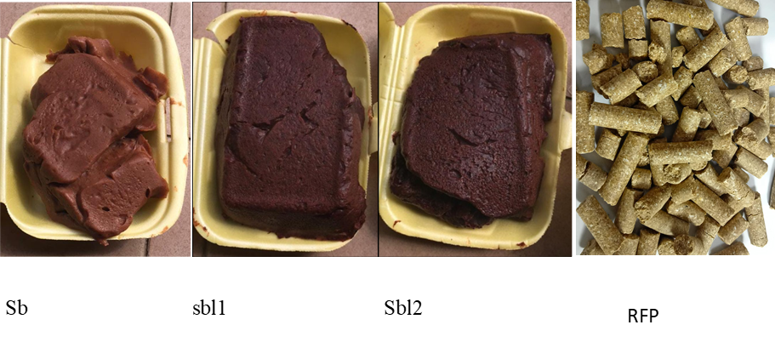

**Figure 1:** The physical characteristic of the fermented sorghum paps with three different concentrations of *S. bicolor* leaf and rat feed pellets

Legend: Sb = normal *S. bicolor* pap; Sbl1= fortified *S. bicolor* pap with 5% of Sbl, Sbl2= fortified *S. bicolor* pap with 7.5% of Sbl

**Sb 9.5 sb/0.5 g sbl 9.25 sb/0.75 g sbl**

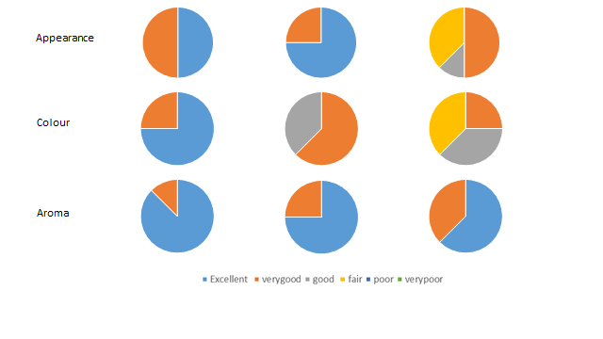

**Figure 2:** Assessment of appearance, colour and aroma of the fortified fermented *S. bicolor* pap

Sb = *S. bicolor*. Sbl = *S. bicolor* leaves, 0.5g sbl = 5% sbl fortified, 0.75g sbl = 7.5% sbl fortified.

**Sb 9.5 sb/0.5 g sbl 9.25 sb/0.75 g sbl**

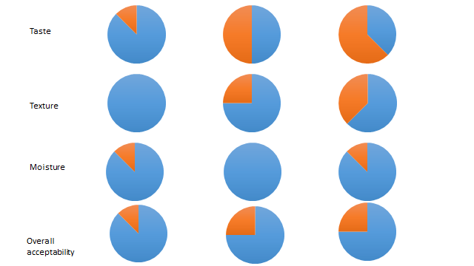

**Figure 3:** Assessment of taste, texture, moisture and overall acceptability of the fortified fermented *S. bicolor* pap

Sb = *S. bicolor*, Sbl = *S. bicolor* leaves, 0.5g Sbl = 5% Sbl fortified, 0.75g Sbl = 7.5% Sbl fortified. The haemoglobin (Hb) of all the experimental animals before induction ranges between 12.1gl-1 and 12.16 gl-1. There was no significant difference (p<0.01) in the Hb of the experimental animals before induction. However, after induction the Hb of the induced groups (group 2, 4, 5 and 6) decreased significantly (p<0.01) compared to the non-induced groups (group 1and 3). The group 3 had the highest Hb of 12.16 gl-1 followed by the group 1 with Hb of 12.2 gl-1. The group 4 had Hb of 10.75 gl-1, group 6 had Hb of 10.73 gl-1,while group 5 had Hb of 12.16 gl-1. However, group 2 had Hb of 10.8 gl-1. After treatment, group 6 (animals treated with the standard drug (orheptal)) had the highest Hb (12.67 gl-1) followed by group 3 (induced and treated with 5% fortified cooked fermented *S. bicolor* pap), (12.16 gl-1), group 1 (animals not induced but was given animal feed pellets) with Hb of (12.2 gl-1).While group 4 and 5 (animals induced and treated with 7.5% fortified cooked fermented *S. bicolor* pap) had the Hb of 12.1gl-1. However, group 2 (animals induced and treated with non-fortified cooked fermented *S. bicolor* pap) had the lowest Hb of (11.56 gl-1). There was a significant difference on the effect of the treatment on the different group of the experimental animals (p<0.01) (Figure 6). Moreso, the Hb of the animal treated with both 5% and 7.5% fortified cooked fermented *S. bicolor* pap increased significantly after treatment compared to their Hb before treatment (p < 0.01) (they had Hb of 10.75 gl-1 and 10.64gl-1, respectively before treatment compared to the Hb of 12.1 gl-1 for both group after treatment). The white blood cell (WBC) count of all the experimental animals before induction ranged between 12.53 x 103 mm3 and 12.73 x 103 mm3. There was no significant difference (p < 0.01) in the white blood cell volume (WBC) of the experimental animals before induction. But after induction, the WBC of the induced groups (group 2, 4, 5 and 6) decreased significantly (p<0.01) compared to the non-induced groups (group 1and 3). The group 3 had the highest WBC counts of 12.33 x 103 mm3 followed by the group 1 with WBC of 12.1 x 103 mm3. The group 6 had WBC of 11.53 x 1010 mm3, group 4 had WBC of 11.43 x 103 mm3, while group 2 and 5 had WBC of 11.23 x 103 mm3 each. After treatment, group 6 (animals treated with the standard drug (orheptal)) had the highest WBC counts (12.73 x 103 mm3) followed by group 3 (induced and treated with 5% fortified cooked fermented *S. bicolor* pap), (12.33 x 103 mm3), group 5 (animals induced and treated with 7.5% fortified cooked fermented *S. bicolor* pap) had WBC counts of 12.23 x 103 mm3, group 4 (induced and treated with 5% fortified cooked fermented *S. bicolor* pap) had WBC counts of 12.2 x 103 mm3. However, group 1 (animals not induced but was given animal feed pellets) had the WBC of 12.1 x 103 mm3 and group 2 (animals induced and treated with non-fortified cooked fermented *S. bicolor* pap) had the lowest WBC counts of 11.23 x 103 mm3. There was a significant difference between the treatment groups of the experimental animals (p < 0.01) (Figure 7). Finally, the WBC of the animal treated with both 5% and 7.5% fortified cooked fermented *S. bicolor* pap increased significantly after final treatment compared to their WBC before initial treatment (p < 0.01) (they had WBC of 11.43 x103 mm3 and 11.23 x103 mm3, respectively before treatment compared to the WBC of 12.2 x103 mm3 and 12.23 x103 mm3 respectively after treatment).

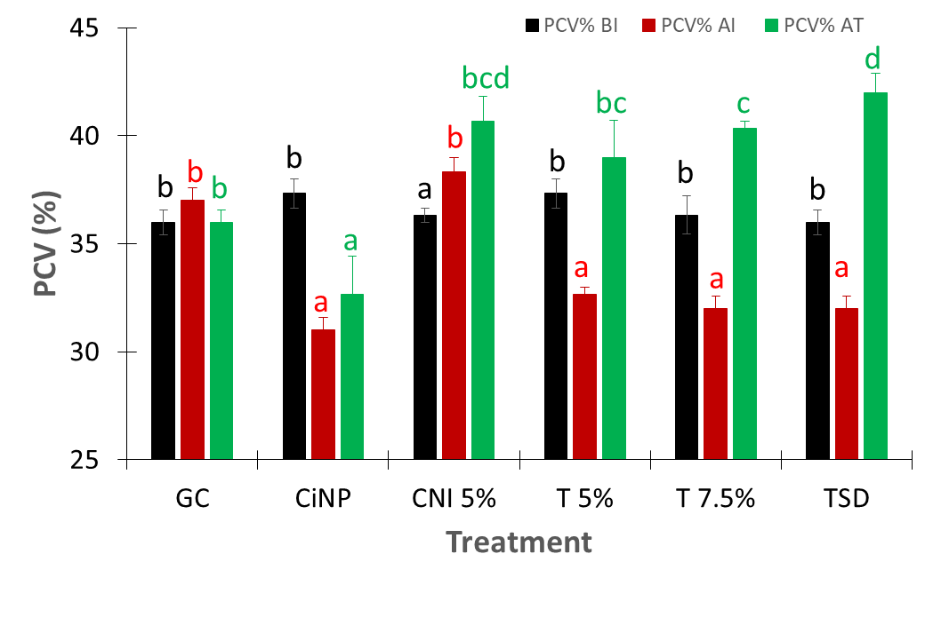

**Figure 4:** The pack cell volume (PCV) of the experimental animals

**Key:** PCV% BI (before inducement), PCV% AI (after inducement), PCV% AT (after treatment),GC-general control, CNIP-induced but not treated, CNI 5%-not induced but treated with 5% Sbl, T 5%-induced and treated with 5% Sbl, T 7.5%-induced and treated with 7.5% Sbl and TSD-induced but treated with standard drug.

*Values carrying different alphabets are significantly different from each other at *p<*0.01.

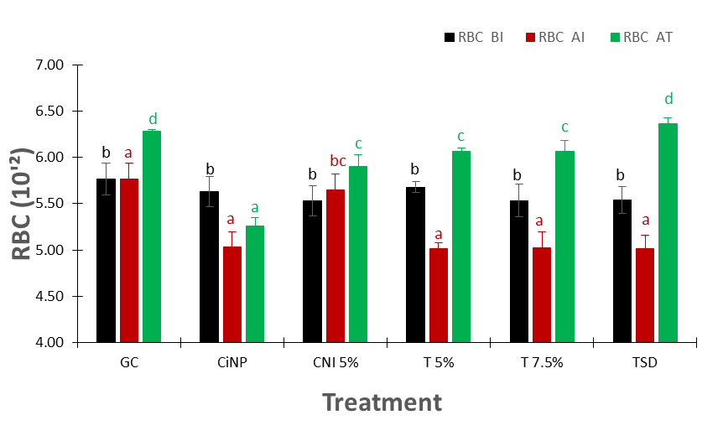

**Figure 5:** The red blood cell (RBC) of the experimental animals

**Key:** RBC BI (before inducement), RBC AI (after inducement), RBC AT (after treatment),GC-general control, CNIP-induced but not treated, CNI 0.5-not induced but treated with 5% Sbl, T 0.5-induced and treated with 5% Sbl, T 0.75-induced and treated with 7.5% Sbl and TSD-induced but treated with standard drug.

*Values carrying different alphabets are significantly different from each other at *p<*0.01.

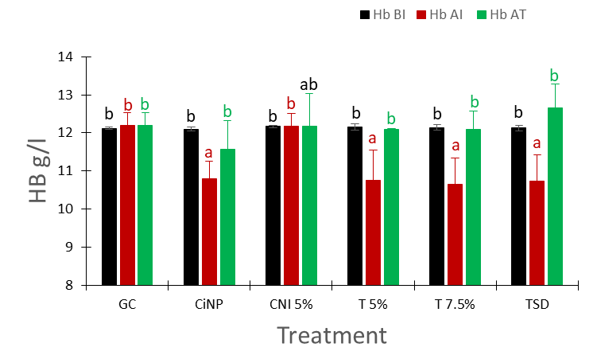

**Figure 6:** The haemoglobin of the experimental animals

**Key:** Hb BI (before inducement), Hb AI (after inducement), Hb AT (after treatment), GC-general control, CNIP-induced but not treated, CNI 0.5-not induced but treated with 5% Sbl, T 0.5-induced and treated with 5% Sbl, T 0.75-induced and treated with 7.5% Sbl and TSD-induced but treated with standard drug.

*Values carrying different alphabets are significantly different from each other at *p<*0.01.

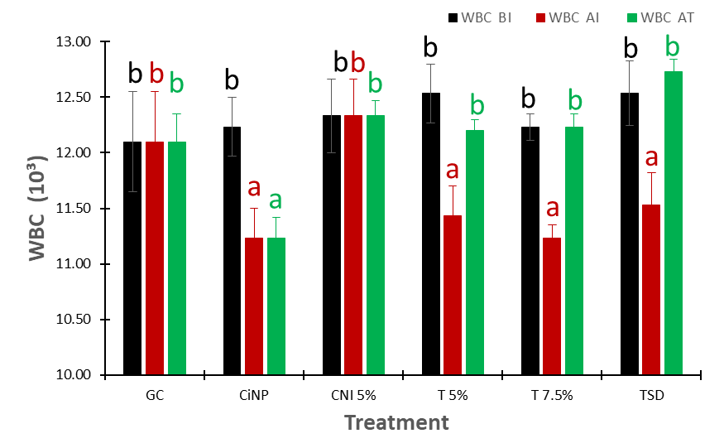

**Figure 7:** The white blood cell (WBC) of the experimental animals

**Key:** WBC BI (before inducement), WBC AI (after inducement), WBC AT (after treatment), GC-general control, CNIP-induced but not treated, CNI 0.5-not induced but treated with 5% Sbl, T 0.5-induced and treated with 5% Sbl, T 0.75-induced and treated with 7.5% Sbl and TSD-induced but treated with standard drug.

*Values carrying different alphabets are significantly different from each other at *p<*0.01.

**DISCUSSION**

The overall acceptability of *S. bicolor* is a holistic attribute that reflects the overall impression of the sample based on all the sensory attributes. Therefore, the overall acceptability of the fortified cooked fermented *S. bicolor* pap in the present study indicates that the fortified cooked fermented *S. bicolor* pap appearance (the pigment called anthocyanins gives it the red colour), taste, aroma, texture, moisture and colour were not negatively affected by the fortificant (*S. bicolor* leaf). Thus, the results suggest that fortification of cooked fermented *S. bicolor* pap with *S. bicolor* leaf did not have undesirable impact on the sensory characteristics of the fortified *S. bicolor* pap and did not affect its overall acceptability. The results obtained from the present study corroborates results from the previous studies by IFT (2007) and Kemp *et al*. (2009) who in their independent studies suggest that good food fortificants must not have adverse effect on the organoleptic properties of the food.

The decreased in the haematological parameters (pack cell volume (PCV), red blood cell (RBC), haemoglobin (Hb) and white blood cells (WBC)) of all the induced animal groups compared to the group that was not induced (controls) before treatment further confirmed that the toxicant (2, 4-dinitrophenylhydrazine) was able to cause a drastic reduction in the level of the haematological parameters of the animal. This is not unconnected to its mechanism of action such as the production of the reactive oxygen species (ROS) during the metabolism which causes oxidative damage to the blood cells (BCs), thus resulting in hemolysis and anaemia (Gnangoran *et al*., 2020). The main function of RBCs in the blood is the transport of respiratory gases (oxygen (O2) and carbon dioxide (CO2)) to and from tissues, by binding gases to haemoglobin (Hb) inside erythrocytes (Cotoraci *et al.,* 2021). The results obtained in the present study agrees with the previous study by Onyeabo *et al.* (2017) who showed that 2, 4-dinitrophenylhydrazine induce hemolysis in animals and human respectively.

However, the increased in the haematological parameters (Pack cell volume (PCV), red blood cell (RBC), haemoglobin (Hb) and white blood cells (WBC) of the experimental animals after treatment with 5% and 7.5% fortified cooked fermented *S. bicolor* pap for two weeks, respectively, compared to the controls (positive and negative control) indicates that the administration of the aqueous extracts of *S. bicolor* leaf stalkhas haematopoietic  
and antioxidant properties. The results of the present study corroborate the findings of Akande *et al*. (2010) who both obtained an increase in haematological parameters (pack cell volume (PCV), red blood cell (RBC), haemoglobin (Hb) and white blood cells (WBC) of Wister rats administered with extracts of *S. bicolor* leaf stalk. It is safe to deduce that fortified cooked fermented *S. bicolor* pap has no negative effect on the hematological parameters. The results also indicated that the fortified cooked fermented *S. bicolor* pap was able to restore the haematological parameters in the treated rats similar to the level recorded in the control group, thus confirming haematopoietic activity of the fortified cooked fermented *S. bicolor* pap.

The anti-anaemic potential of the *S. bicolor* leaf stalk reported in the present study also agrees with previous report by Okubena *et al*. (2018) involving rats and rabbits made anaemic by inoculation with *Trypanosoma brucei* in which the anaemic condition was reversed by the administration of *S. bicolor* leaf stalk extracts. Their results (Okubena *et al*.) in 2018 demonstrated significant increases in the red blood cell count, haemoglobin and packed cell volume within 5 weeks of administration of the *S. bicolor* leaf stalk. This further confirmed that *S. bicolor* leaf stalk extract has the ability to boost haemoglobin concentrations in anaemic conditions.

**CONCLUSION**

This research has successfully established that *S. bicolor* leaf (sbl) has no negative effect on the organoleptic properties of sorghum-based food. Also, this study has shown that fortified sorghum-based diets have a positive effect on the blood parameters (pack cell volume (PCV), red blood cell (RBC), haemoglobin (Hb) and white blood cells (WBC) of anaemic rats and could be useful in preventing anaemia in young children and adult. These results support the potential therapeutic effects of *sorghum* and its potential use as a functional food.

**REFERENCES**

Adebo, O. A., Njobeh, P. B., Mulaba-Bafubiandi, A. F., Adebiyi, J. A., Desobgo, S.C.Z and Kayitesi, E. (2018). Optimization of fermentation conditions for ting production using response surface methodology. *Journal of Food Processing and Preservation,* 42, e13381.

Akande, I. S., Oseni, A. A. and Biobaku, O. A. (2010). Effects of aqueous extract of *S. bicolor* on hepatic, histological and haematological indices in rats. *Journal of Cell Animal Biology,* 4: 137–142.

Contaldo, A., Losurdo, G., Albano, F., Iannone, A., Barone, M. and Ierardi, E. (2019). The spectrum of small intestinal lesions in patients with unexplained iron deficiency anaemia detected by video capsule endoscopy. *Medicina,* 55(3): 5 9.

Cotoraci, C., Ciceu , A., Sasu, A. and Hermenean, A. (2021). Natural antioxidants in anaemia treatment. *International Journal of Molecular Science,* 22 (1883): 1-35.

FAO (1995). Sorghum and millets in human nutrition. FAO (*Food and Nutrition* Series) 27.

FAO (2019). FAO Statistical Database (online). Food and Agricultural Organization of the United Nations. Rome.

Gnangoran, B.N., Coulibaly, Y. S., N’dia, K.F. and Yapo, A. P. (2020). Influence of an aqueous fruit extract of *Solanum Torvum* Swartz on phenylhydrazine induced hemolytic anaemia in *wistar* rats. *Pharmacology Online,* (1): 195-205.

Hoddinott, J., Rosegrant, M. and Torero, M. (2012). Investments to reduce hunger and under nutrition; Copenhagen Consensus Challeng Paper.

Horton, S., Wesley, A. and Mannar, M. V. (2011). Double-fortified salt reduces anemia, benefit: cost ratio is modestly favorable. *Food Policy,* 36(5): 581-587.

Institute of Food Technologists IFT. (2007). *Sensory Evaluation Methods*. The Society for the Food Technologists, Chicago, IL, 10: 362-386.

Joo, E. Y. (2016). Iron deficiency anaemia in infants and toddlers. *Blood Research,* 51(4): 268–73.

Keats, E. C., Neufeld, L. M., Garrett, G. S., Mbuya, M. N. and Bhutta, Z. A. (2019). Improved micronutrient status and health outcomes in low-and middle-income countries following large-scale fortification: evidence from a systematic review and meta-analysis. *The American Journal of Clinical Nutrition*, *109*(6), 1696-1708.

Kemp, S. E., Hollowood, T. and Hort, J. (2009). *Sensory evaluation a practical handbook.* John Wiley and Sons Ltd., Chichester, West Sussex, U.K.

Lemoine, A. and Tounian, P. (2020). Childhood anaemia and iron deficiency in sub- Saharan Africa–risk factors and prevention: A review. *Archive of Pediatr*ics, 27 (8): 490–496.

Lozoff, B., Kaciroti, N. and Walter, T. (2006). Iron deficiency in infancy: applying a physiologic framework for prediction. *American Journal of Clinical Nutrition,* 84(6): 1412–21.

Mabhaudhi, T., O’Reilly, P., Walker, S. and Mwale, S. (2016). Opportunities for underutilized crops in Southern Africa’s post-2015 development agenda. *Sustainability,* 8(4): 302.

Muthayya, S., Rah, J. H., Sugimoto, J. D., Roos, F. F. and Kraemer, K. (2013). The global hidden hunger indices and maps: an advocacy tool for action*. Public Library of Science*, *One* 8: 7860. Bathla, S., and Arora, S. (2022). Prevalence and approaches to manage iron deficiency anemia (IDA). *Critical Reviews in Food Science and Nutrition*, 62(32); 8815-8828.

Naughton, B. A., Moore, E., Bush, M. E., Lapin, D. M and Domfest BS. **(**1995). Hemostatic alterations associated with phenylhydrazine – induced haemolytic anaemia. *European Journal of Clinical Investigation,* 25:722-7.

Odunmbaku, L. A., Sobowale, S. S., Adenekan, M. K., Oloyede, T., Adebiyi, J. A. and Adebo, O. A. (2018). Influence of steeping duration, drying temperature, and duration on the chemical composition of sorghum starch. *Food Science and Nutrition,* 6(2): 348–355.

Okubena, O., Makanjuola, S., Ajonuma, L.C., Dosunmu, A., Umukoro, S. A. and Erah, P.O. (2018). The West African *S. bicolor* leaf sheath extract Jobelyn® and its diverse therapeutic potentials. *MOJ Drug Design Development and Terapy,* 2(1): 20-28.

Olson, R., Gavin-Smith, B., Ferraboschi, C and Kraemer, K. (2021). Food fortification: The advantages, disadvantages and lessons from sight and life programs. *Nutrients,* *13*(4):1118.

Osendarp, S. J. M., Martínez, H., Garrett, G. S., Neufeld, L., de Regil, L., Vossenaar, M. and Darnton-Hill, I. (2018). Large-scale food fortification and bio-fortification in low- and middle-income countries: A Review of Programs, trends, challenges, and evidence gaps. *Food Nutrition* *Bulletin,* 39(2): 315–331.

Onyeabo, C., Achi, N. K., Ekeleme-Egedigwe, C. A., Chidinma U. Ebere, C. U. and Okoro, C. K. (2017). Haematological and biochemical studies on *Justicia carnea* leaves extract in phenylhydrazine induced-anaemia in albino rats. *Acta Scientiarum Polonorum, Technologia Alimentaria, 16*(2): 217–230.

Sobowale, S. S., Adebo, O. A. and Mulaba-Bafubiandi, A. F. (2019). Production of extrudate pasta from optimal sorghum–peanut flour blend and influence of composite flours on some quality characteristics and sorption isotherms. *Transactions of the Royal Society of South Africa,* 74(3): 268-275.

United Nations International Children’s Emergency Fund. UNICEF (2020). *Multiple Micronutrient Powder Price Data*. New York. Research Hand Book*,* pp. 719-731.

Wakeel, A., Farooq, M., Bashir, K., and Ozturk, L. (2018). Micronutrient malnutrition and biofortification: recent advances and future perspectives. *Plant micronutrient use efficiency*, 225-243.

Zhang, Y., Wu, Q., Wang, W., van Velthoven, M. H., Chang, S., Han, H. and Scherpbier, R. W. (2016). Effectiveness of complementary food supplements and dietary counselling on anaemia and stunting in children aged 6–23 months in poor areas of Qinghai Province, China: a controlled interventional study. *British Medical Journal open*, 6(10): e011234.