Cotesia ruficrus (Hymenoptera: Braconidae) Parasitizing Beet Armyworm, Spodoptera exigua (Lepidoptera: Noctuidae) larvae in Clover Fields in Egypt

Abstract
Clover, Trifolium alexandrinum L. is the key fodder winter crop for feeding livestock in Egypt, particularly with a sharp decline in meat and dairy production. One of the important insect pests attacking clover is the beet armyworm, Spodoptera exigua Hübner (Lepidoptera: Noctuidae) which feeds upon clover stems and leaves, and in severe infestation, it can defoliate the plants resulting in considerable foliage reduction. The current investigation was conducted at clover fields in Rasheed district, Beheira Governorate, during the 2020/2021 and 2021/2022 seasons, to monitor the population fluctuations of S. exigua as well as the fluctuations of the larval endoparasitoid, Cotesia ruficrus (Haliday) (Hymenoptera: Braconidae) and its efficiency against S. exigua larvae. The first infestation by the beet armyworm was detected on November 1st with 28-30 larvae, and the highest pest densities were recorded in April and May. The parasitism of S. exigua larvae was recorded started from mid-March up to mid-May. The numbers of the parasitoid’s clusters were low during January, February and March, and were notably high during April and May. This study revealed that C. ruficrus attacked the larvae of S. exigua in clover fields, particularly during April and May, with overall parasitism percentage of 14.41-17.86%. Thus, the parasitoid, C. ruficrus could be considered as an efficient control element in the integrated pest management (IPM) of the beet armyworm, S. exigua.
Keywords: Cotesia ruficrus, Spdoptera exigua, Trifolium alexandrinum.

Introduction

Clover, Trifolium alexandrinum L., is the key fodder winter crop for feeding livestock in Egypt, particularly with a sharp decline in meat and dairy production. This crop is highly significant as a multi-cut crop and an excellent soil-reclaiming crop because of its ability to fix the atmospheric nitrogen in its roots (Malaviya et al., 2005; Zayed et al., 2011; Roy et al., 2015).
Clover cultivations is a host of a diverse fauna of insect pests and natural enemies as well. Since this crop is cut almost daily for animal feeding, pesticide applications are heavily restricted. Accordingly, the populations of diversified natural enemies have become very high, and these natural enemies migrate clover to the following or the successive summer crops (Hervet et al., 2018). However, one of the most important insect pests attacking T. alexandrinum plant is the beet armyworm, Spodoptera exigua Hübner (Lepidoptera: Noctuidae). This insect feeds upon clover stems and leaves, and in severe infestation, it can defoliate the plants resulting in considerable foliage reduction (Mardani et al., 2012, Hameed et al. 2016 and Cabello, 1989). The S. exigua pest poses a significant threat to early-sown clover (from late August to early September). During this period, the temperature is still relatively high in Egypt, which enhances the damage in clover plantations and may need chemical control, before offering the plants for livestock feeding.
Fortunately, the parasitoid, Cotesia ruficrus (Haliday) (Hymenoptera: Braconidae) has proven to parasitizes several economic insect pests including S. exigua (Patil et al. 2016 and Mansour and Abou-El Kassem 2022).
The following yellow part was repeated once more (blue part), please remove one of them (the blue one).

It is well known that the wide host range of any parasitoid is desirable, to ensure the establishment of many natural enemies in a wide range of zones (Hervet et al., 2022). Patil et al. (2016) recorded five insect pests as hosts for the larval gregarious endoparasitoid, C. ruficrus. These hosts were discerningly preferred as Helicoverpa armigera (Hubner), Mythimna separata Walker, Agrotis ipsilon Hüfnagel, Spodoptera litura Fab. and S. exigua Hübner. Gupta et al. (2019) surveyed C. ruficrus as one of the parasitoids of S. frugiperda in the maize fields. The larvae of the leaffolder, Cnaphalocrocis medinalis that parasitized by C. ruficrus suffered reductions in wet or dry weight, food consumption and fecal matter (Chen et al., 2016). Mansour and Abou-ELkassem (2022) detected 21.48-27.58% of S. exigua larvae was parasitized by C. ruficrus in sugar beet fields, depending on the date of sowing. The female of C. ruficrus attacked the larvae of S. frugiperda infesting maize fields in India (Gupta et al., 2019). The maximum number of the parasitoid’s cocoons of C. ruficrus (65.2 cocoons) was obtained when the parasitoid was reared on the 4th larval instar of the tea looper, Hyposidra talaca (Walker) (Lepidoptera: Geometridae), followed by 27.2 and 4.60 in the third and second larval instars, respectively (Sarkara et al. 2020 and 2021). S. exigua (Patil et al. 2016 and Mansour and Abou-El kassem 2022).
The wide host range of any parasitoid is desirable, to ensure the establishment of natural enemies in a wide range of zones (Hervet et al., 2022). Patil et al. (2016) recorded five insect pests as hosts of the larval gregarious endoparasitoid, C. ruficrus. These hosts were discerningly preferred as H. armigera, (Hubner), Mythimna separata Walker, A. ipsilon Hüfnagel, S. litura Fab. and S. exigua Hubner. Gupta et al. (2019) surveyed C. ruficrus as one of the parasitoids of S. frugiperda in maize fields. The larvae of the leaffolder, Cnaphalocrocis medinalis parasitized by C. ruficrus suffered reductions in wet or dry weight, food consumption and fecal matter (Chen et al., 2016). Mansour and Abou-ELkassem (2022) detected 21.48- 27.58 % S. exigua larval parasitism by C. ruficrus in sugar beet fields, depending on the date of sowing. C. ruficrus attacked the larvae of S. frugiperda infesting maize fields in India (Gupta et al., 2019). The maximum number of parasitoid cocoons of C. ruficrus was obtained when the parasitoid was reared on the 4th larval instar of the tea looper, Hyposidra talaca (Walker) ( Lepidoptera: Geometridae ) with 65.2 cocoons, followed by 27.2 and 4.60 in the third and second larval instars, respectively (Sarkara et al. 2020 and 2021).
The objectives of the current study were to monitor the population fluctuations of the beet armyworm, S. exigua larvae, in clover fields, as well as the fluctuations of the endoparasitoid larvae, C. ruficrus. In addition, the status of the parasitoid, and its capability of emergence from cocoons was discussed.

Materials and Methods

- Experimental Site

This study was conducted at clover fields at Rasheed district, Beheira Governorate. Rasheed lies at the western branch of River Nile Delta; about 50 Km far of Mediterranean Sea seashore, with a latitude of 31.40 N and longitude of 30.41 E. Soil at the experimental site is fertile with 7.1 pH and a good source of fresh irrigation water.

Cultural Practices

The experimental area was prepared following the recommendations of Egypt's Ministry of Agriculture. Throughout the experimental period, all-normal agricultural procedures were adopted, but without any pesticidal treatments. On September, 15,, clover, T. alexandrinum L (Leguminosae) seeds (Helaly cultivar) were sown, in the 2020/2021 and 2021/2022 seasons.
- Population Fluctuations of S. exigua

The population fluctuations of S. exigua were monitored throughout the experimental period from the beginning of November until the end of May in both seasons of study. Biweekly samples (4m² of cut clover plants each) were examined to count the number of S. exigua larvae present in the clover vegetation. The collected larvae were kept for further investigation.
- The author did not mention the experimental design of his work and how many replicates (plots) did the author used; in addition, is the area (4m² of cut clover) for each replicate (plots) or for the whole experimental area??

- Population Fluctuations of the Parasitoid, C. ruficrus (Haliday)

The biweekly collected larvae of S. exigua were examined and those with any disease symptoms were excluded. The larvae were individually kept in glass containers and provided with clover plant pieces for feeding until they completed their larval stage. By monitoring the enclosed larvae, the clusters of the parasitoid’s cocoons could be observed; otherwise, the S. exigua pupae are formed. By counting the cocoons attached to S. exigua larvae, the percentage of S. exigua parasitism was computed.

3. Parasitism Status of C. ruficrus

Formed clusters of the parasitoid were examined to record the number of pupae per cluster. In addition, the resulted clusters were kept individually in glass vials, and the emerging adult parasitoids were counted to calculate the percentage of C. ruficrus emergence throughout the period from early November up to late May.
- Why the author did not calculate the sex ratio of the resulted pupae in each cluster throughout the experimental period??

Results
- Population Fluctuations of S. exigua Larvae

1.1- Season 2020/2021
In the first sample (Table 1) examined on November 1st, 28.00 larvae of S. exigua were detected in 4 m² cut clover plants, which increased to 38.25 larvae/4 m² two weeks later. By the beginning of December up to the beginning of February, the beet armyworm larvae decreased progressively from 26.75 to 10.50 larvae/4 m² cut clover, respectively. However, the larval population steadily increased from 12.25 to 44.25 larvae/4 m² on March 15 and May 15, respectively.

1.2- Season 2021/2022
The population densities of S. exigua larvae (Table 1) ranged between

24.00 and 30.00/4m² cut clover through the period extending from November, 1st up to January, 1st. However, the highest densities were recorded in April and May, ranging between 26.00 and 43.25 larvae/4m² cut clover plants.
- Population Fluctuations of C. ruficrus
Data presented in Table (2) shows that the parasitoid C. ruficrus (Fig 1) was low active from the beginning of November up to late March, except for a few individuals in some examinations. In the 2020/2021 season, the parasitism of S. exigua larvae was notable from mid-March (22.22%) up to Mid-May (32.43%). In addition, the parasitism was higher during April and May, ranging from 24.24 to 28.57%.

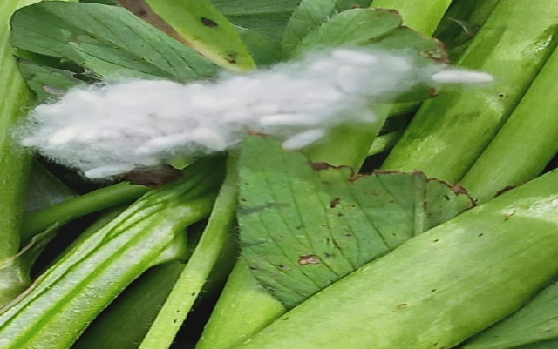

Fig (1): A cluster of Cotesia ruficrus parasitoid attached to clover stems.

Table (1): Population dynamics of Spodoptera exigua larvae in clover fields, at Rasheed District, Beheira Governorate

Date of Examination | No. larvae/4m²
Date of Examination | 2020/2021 | 2021/2022
Nov.1 | 28.00±SE | 30.00±SE
Nov. 15 | 38.25±SE | 28.75±SE
Dec. 1 | 26.75±SE | 28.50±SE
Dec. 15 | 16.50±SE | 16.00±SE
Jan. 1 | 14.00±SE | 24.50±SE
Jan. 15 | 12.75±SE | 10.00±SE
Feb.1 | 10.50±SE | 9.50±SE
Feb. 15 | 0.00±SE | 0±SE
Mar.1 | 0.00±SE | 0±SE
Mar. 15 | 12.25±SE | 0±SE
Apr.1 | 30.25±SE | 26.50±SE
Apr 15 | 34.00±SE | 38.75±SE
May. 1 | 42.50±SE | 32.00±SE
May. 15 | 44.25±SE | 43.25±SE

Parasitism Status
3.1- Season 2020/2021
Data presented in Table (3) show that the number of the parasitoid cluster was low during January, February and March (3-9 cluster/4m² cut clover plants). However, the number was notably higher during April and May with 17- 37 cluster/4m².
Fig. (2): A cluster of Cotesia ruficrus parasitoid showing gregarious pupae of the parasitoid emerging from one Spodoptera exigua larva.
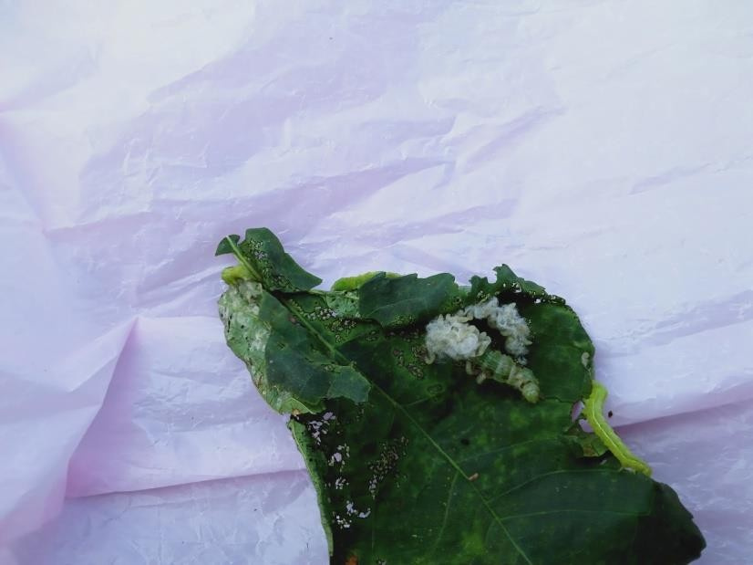

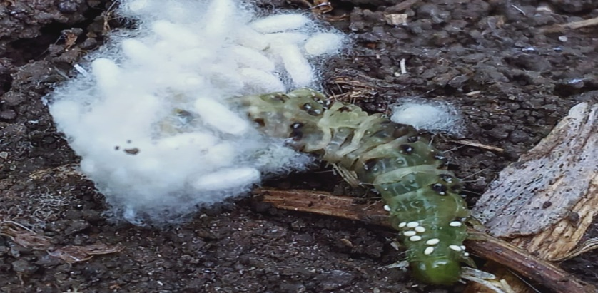

Table (2): Population dynamics of Spodoptera exigua parasitism by Cotesia ruficrus in clover fields, at Rasheed District, Beheira Governorate (sample size is 4m² cut clover).

Date of sampling | 2020/2021  Season |  |  | 2021/2022  Season
Date of sampling | No. incubated larvae | No. formed cluster | Parasitism  % | No. incubated larvae | No. formed cluster | Parasitism  %
Nov.1 | 25±SE | 0 | 0 | 20±SE | 0 | 0
Nov.15 | 30±SE | 0 | 0 | 25±SE | 0 | 0
Dec. 1 | 16±SE | 0 | 0 | 24±SE | 0 | 0
Dec. 15 | 16±SE | 0 | 0 | 14 | 0 | 0
Jan. 1 | 12±SE | 0 | 0 | 18 | 0 | 0
Jan. 15 | 10±SE | 3 | 30.00±SE | 4 | 0 | 0
Feb.1 | 10±SE | 2 | 20.00±SE | 2 | 1±SE | 50.00
Feb 15 | 0 | 0 | 0 | 0 | 0 | 0
Mar.1 | 0 | 0 | 0 | 0 | 0 | 0
Mar.15 | 9 | 2 | 22.22±SE | 0 | 0 | 0
Apr.1 | 21 | 6 | 28.57 | 26 | 7 | 26.92
Apr.15 | 26 | 8 | 30.77 | 35 | 9 | 25.71
May 1 | 40 | 12 | 30.77 | 28 | 8 | 28.57
May 15 | 37 | 12 | 32.43 | 33 | 8 | 24.24
Overall | 252 | 45 | 17.86 | 229 | 33 | 14.41

3.2- Season 2021/2022
Data for the second season (Table 4) is similar to those for the first one. Numbers of C. ruficrus clutches were low during January and February (2-9/4m² cut
clover plants), increased to 5-12 clutches in March. The activity of the parasitoid was higher in April and May with 12-20 clutches/m². The emergences of the parasitoid wasps were lower in the second season compared to those of the first one, with the lowest value in February (81.32%), and highest in April (90.73 %).
Table (3): Spodoptera exigua parasitism status, and activity of the parasitoid Cotesia ruficrus at clover fields, at Rasheed District, Beheira Governorate 2020/2021
Date of sampling |  |  | No. of collected cluster | No. of parasitoid pupa | No. emerging parasitoids | Parasitoids emerging %
Month | Week
January | 1st |  | 4±SE | 188±SE | 180±SE | 95.74
January | 2nd |  | 6±SE | 240±SE | 230±SE | 95.83
Average |  |  | 5.00±SE | 214.00±SE | 205.00±SE | 95.81
February | 1st |  | 5±SE | 175 | 155 | 88.57
February | 2nd |  | 7±SE | 231 | 210 | 90.91
February | 3rd |  | 9±SE | 198 | 180 | 90.91
February | 4th |  | 5±SE | 85 | 80 | 94.12
Average |  |  | 6.50±SE | 172.25 | 156.25 | 91.13
March | 1st |  | 3±SE | 120 | 114 | 95.00
March | 2nd |  | 4±SE | 112 | 104 | 92.86
March | 3rd |  | 7±SE | 259 | 245 | 94.59
March | 4th |  | 6±SE | 264 | 258 | 97.72
Average |  |  | 5.00±SE | 188.75 | 180.25 | 95.04
April | 1st |  | 20±SE | 560 | 540 | 96.43
April | 2nd |  | 17±SE | 527 | 510 | 96.77
April | 3rd |  | 22±SE | 550 | 528 | 96.00
 | 4th |  | 25±SE | 875 | 805 | 92.00
Average |  |  | 21.00±SE | 628.00 | 595.75 | 95.30
May |  | 1st | 27±SE | 1700 | 1470 | 86.47
 |  | 2nd | 30±SE | 810 | 750 | 92.59
 |  | 3rd | 37±SE | 911 | 812 | 89.13
Overall Average |  |  | 31.33±SE | 1140.33 | 1010.67 | 89.40

It was observed that the parasitoid emergence was almost the same within January, March and April (95.04-95.00).
Table (4): Spodoptera exigua parasitism status, and activity of the parasitoid Cotesia ruficrus at clover fields, at Rasheed District, Beheira Governorate 2021/2022

Date of sampling |  | No. of collected clusters | No. of parasitoid’s pupa | No. of emerged parasitoids | Parasitoids emergence %
Manth | Week
January | 1st | 6±SE | 240±SE | 190±SE | 79.17±SE
January | 2nd | 9±SE | 324±SE | 300±SE | 92.59±SE
Average |  | 7.50±SE | 282.00±SE | 245.00±SE | 85.88±SE
Febraury | 1st | 6±SE | 180 | 151 | 83.89
Febraury | 2nd | 4±SE | 120 | 100 | 83.33
Febraury | 3rd | 2±SE | 56 | 43 | 76.79
Febraury | 4th | 3±SE | 48 | 39 | 81.25
Average |  | 3.75±SE | 101.00 | 83.25 | 81.32
March | 1st | 5 | 175 | 160 | 91.43
March | 2nd | 7 | 210 | 181 | 86.19
March | 3rd | 9 | 270 | 215 | 79.63
March | 4th | 12 | 480 | 360 | 75.00
Average |  | 8.25 | 283.75 | 229.00 | 83.00
April | 1st | 15 | 420 | 405 | 96.43
April | 2nd | 13 | 377 | 311 | 82.49
April | 3rd | 16 | 320 | 291 | 90.94
 | 4th | 20 | 720 | 670 | 93.06
Average |  | 16.00 | 459.25 | 419.25 | 90.73
May | 1st | 17 | 425 | 399 | 93.88
May | 2nd | 12 | 360 | 307 | 85.28
May | 3rd | 20 | 400 | 336 | 84.00
Overall Average |  | 16.33 | 395.00 | 347.33 | 87.72

DISCUSSION
The Egyptian clover, T. alexandrinum L. (Leguminosae) is the most important forage crop in Egypt, it is rich in protein, and thus, is of high nutritional value for livestock. Furthermore, atmospheric nitrogen fixed by Azotobacter, enriches the soil, particularly in newly reclaimed lands. Clover sown by late August up to early September, it is highly infested by the beet armyworm, Spodoptera exigua, due to the relatively high temperature during this period. Since the insect pest has built up resistance to several insecticides, it has become important to enhance the activity of natural enemies. Among the parasitoids efficient against this insect pest, is the larval endoparasitoid, Cotesia ruficrus (Haliday) (Hymenoptera: Braconidae). In the current study, this parasitoid proved active against beet armyworm, S. exigua, fortunately, clover plantations are an ideal shelter for several natural enemies that move, by the end of clover season, to the neighbouring summer plantation fields. For the successful establishment of the parasitoids in new geographic zones, parasitoids need to find several suitable hosts that are of economic importance to cultivable plants (Hervet et al., 2018). Accordingly, Hearvet et al. (2023) considered Cotesia vanessae (Hymenoptera: Braconidae) a successful parasitoid in North America, as it was reared on several noctuid pest species. Patil et al (2016) indicated that the main noctuid insect pests attacked by C. ruficrus are H. armigera (Hubner), Mythimna separata Walker, A. ipsilon (Hufnagel), S. litura Fab. and S. exigua (Hubner).
In the current study, C. ruficrus attacked the larvae of S. exigua in clover fields, particularly during April and May, with overall parasitism percentage of 14.41-17.86%. In the study of Mansour and Abou-El-Kassem (2023), the parasitism of S. exigua in sugar beet fields by C. ruficrus ranged from 21.48 to 34.33%, with significant positive correlations between the population of the pest and parasitism level. In addition, Chen et al. (2016) indicated the efficient parasitism of C. ruficrus on leaf folder, Cnaphalocrocis medinalis, and the parasitism negatively affected all biological aspects of the host.

REFERENCES

Cabello, T. (1989). Natural enemies of noctuid pests in alfalfa, corn, cotton and soybean crops in southern Spain. J. Appl. Entomol, 108: 80-88.
Chen, YChen, Y.; X. G Liu, J. Wang; J. Zhao; Z. X. Lu and Y. H. Liu (2016). Cotesia ruficrus (Hymenoptera: Braconidae) parasitizing Cnaphalocrocis medinalis (Lepidoptera: Pyralidae): Developmental Interactions and Food Utilization Efficiency of Hosts. Journal of Economic Entomology,109 (2): 588–593.

Gupta, A.,S.; R. Babu, and M. S. Kumar (2019). Cotesia ruficrus (Haliday, 1834) ( Hymenoptera: Braconidae) emerging as a common natural parasitoid of S. frugiperida (J.E.Smith) ( Lepidoptera : Noctuidae) in Indian maize fields. Journal of Biological Control,33(3): 193-196.
Hameed, A.; H. Karar, N. Muhammad and R. A. Kainth (2016). Varietal response to population fluctuation of insect pests, predators and pollinator fauna associated with berseem (T. alexandrinum L) crop. Pakistan J. Zool., 48(3),729-734.
Hervet, Y. A. D.; R. A. Larid and K. D. Floate (2023). Potential host range of Cotesia vanessae (Hymenoptera: Braconidae), a parasitoid new to North America and a possible biological control agent of noctuid pest species. Bulletin of Entomological Research, 113 (2): 145-161.. doi: 10.1017/S0007485322000025
Hervet, Y. A. D.; R. A. Larid and K. D. Floate (2018). Siblicidal behavior by larvae of the gregarious parasitoid, Cotesia vanessae. Journal of Hymenoptera Research, 67: 55-62.
Mansour, M. R. K. and A. B. Abou-Elkassem (2022). Ecological studies on Spodoptera exigua (Hubner) and its biological control by the novel parasitoid, Cotesia ruficrus (Haliday) (Hymenoptera: Braconidae) on sugar beet. Middle East Journal of Agriculture Research, 11(4): 1193-1200.
Mardani, M.; T. G. Nouri; G. B. Naseri and M. Hassanpour (2012). Life history studies of the beet armyworm, Spodoptera exigua (Hübner) (Lepidoptera: Noctuidae) on 10 corn hybrids J. Entomol. Res. Soc., 14(3): 09-18.

Malaviya, D. R.; A. K Roy; P. Kaushal; B.Kumar and A. Tiwari (2005). Development and characterization of interspecific hybrids of Trifolium alexandrinum x T. apertum using embryo rescue. Plant Breed, 123: 536-542.
Patil, S. S.; C. Kamble and T. V. Sathe (2016). Biocontrol potential of Cotesia ruficrus Hal. (Hymenoptera : Braconidae) against different lepidopterous pests. Biolife Journal, 4(2): 343-346.
Roy, D. C.; M. Ray; N. K Tudu and C. K. Kundu (2012). Impact of phosphate solubilizing bacteria and phosphorus application on forage yield and quality of berseem in west Bengal. IJAEB, 8(2):315-321.
Sarkara, S. S.; A. Babua; K. Chakrabortyb; B. Dekaa and S. Royc (2021). Seasonal abundance of Cotesia ruficrus ( Hymenopera: Braconidae) and its host tea looper, Hyposidra talaca (Lepidoptera: Geometridae) in tea ecosystem. International Journal of Pest Management, 69 (4): 332-345.
Sarkar,S, A. Babu; K. Chakraborty and B. dcka (2020). Biology and life history of Cotesia ruficrus (Hymenoptera: Braconidae) a potential parasitoid of Hyposidra talaca (Lepidoptera: Geometridae) larvae, a major tea pest. J. Biopest, 13 (1): 79-84.
Zayed, E. M.; E. M. R. Metwali; A. F. Khafaga, and M. M. Azab (2011). Field performance of commercial Egyptian clover (Trifolium alexandrinum L.) cultivars under high temperature condition. Range Mgmt. and Agroforestry, 32 (2): 87-91

