**Review Article**

**Indoor Plants: A Review on Phytoremediation**

**ABSTRACT**

From ancient times plants are considered an auspicious symbol for many cultural and traditional purposes. Plants have also set their very significance in our lives, not only biologically but also culturally. Plants pose many beneficial activities like air purification, stress reduction, improvement in cognitive power, and many pharmacological activities. Besides this, plants also add colors to the bland place, which makes the place more attractive and approachable. Our sedentary lifestyle indoors has also put a great impact on our health. The closed and inadequately ventilated indoor spaces lead to Sick Building Syndrome (SBS), which is caused by particulate matter, volatile organic compounds, and inorganic compounds released by the appliances and furniture present indoors. In this review, several indoor plants are taken into consideration as a phytoremediation. This technique deals with cost-effective environmental restoration by using plants to clean air, soil and water.

*Keywords: Air purification, phytoremediation, house plants, stress reduction, indoor plants.*

**INTRODUCTION**

Throughout history, several decorative plants have been utilized as a means of expressing well-being and the beauty of the natural environment. This circumstance raises the appeal of ornamental plants, which are used in Asia, Africa, and Latin America as part of the custom of brightening rituals and national day celebrations (Meutia et al., 2020). Sunlight is an environmental factor that must be taken into account because it is crucial to metabolism, particularly to the ongoing production of energy in the form of ATP and plant nutrients through photosynthesis, which is always linked to the growth and development of the plant. Plants are classified as either sun plants or shade plants (sometimes known as semi-shade plants) based on their requirements for light intensity. A physical defense mechanism for plants against adverse weather conditions is achieved through the provision of shade. This shade plant includes a variety of beautiful plant species as one of its plant groups (Silalahi et al., 2023). Furniture and other equipment present indoors, releases particulate matter, volatile organic compounds such as benzene, toluene, ethylbenzene, xylene, formaldehyde and polyaromatic hydrocarbons, also inorganic pollutants like O3, NO2, SO2, etc and organic pollutants like CO2, CO, etc. Due to the sedentary lifestyle most of the people prefer to stay in indoor spaces in which there is no proper ventilation which ultimately leads to Sick Building Syndrome (SBS) a condition in which one suffers from respiratory dysfunction, allergies, fatigue, ocular & cutaneous irritations, etc. All these compounds present in the air cause many severe respiratory and cardiac disorders. Thus indoor plants are used as Phytoremediation for the purification of air (Reshma et al., 2017, Davamani et al., 2020, Seung et al., 2017, Nisitha et al., 2023). The allelochemicals like polyphenols and alkaloids released by the plants also pose antimicrobial activity, which interact with airborne microbes (Tanbouly et al., 2021).The presence of indoor plants can also improve cognitive power, physiological, health-related, and behavioral functions (Liu et al., 2022). In this, various indoor plants are taken into consideration due to their phytoremediating activities.

**1. SPIDER PLANT**

**Common names**: Spider ivy, Airplane plant, Ribbon plant, St. Bernard's lily.

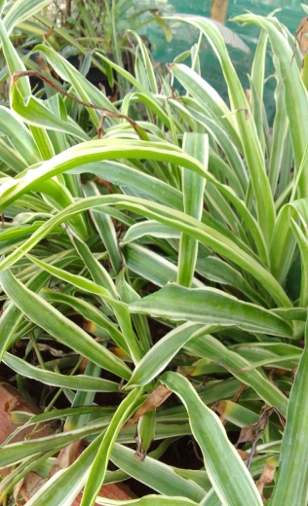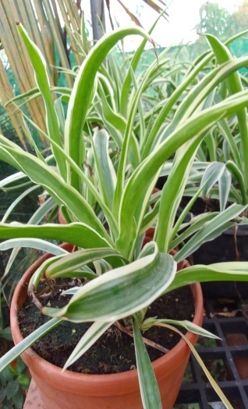

**Fig 1-** **Spider ivy, Airplane plant, Ribbon plant, St. Bernard's lily**

*Chlorophytum comosum* (Spider plant) is an evergreen horticultural plant, a member of the Asparagaceae family, native to southern Africa and naturalized in Australia and Bangladesh (Kavya et al., 2024). Due to indoor sources including wood items and furniture, formaldehyde concentrations are higher indoors than outdoors. Spider plants may promote formaldehyde biofiltration because their roots absorb formaldehyde and their root exudates accelerate microbial formaldehyde breakdown (Zhongjun et al., 2010). Spider plants have been shown to successfully lower indoor CO (Carbon monoxide) levels by 65% and can lower COHb (Carboxyhemaglobin) levels by 75%. Carbon monoxide when inhaled forms a carboxyhemaglobin complex which causes a headache, dizziness, weakness and nausea along with confusion, and shortness of breath (Wicaksono et al., 2022).

**2. PEACE LILY**

**Common names**: Madonna lily, White sails, Spathe flower, White Flag.

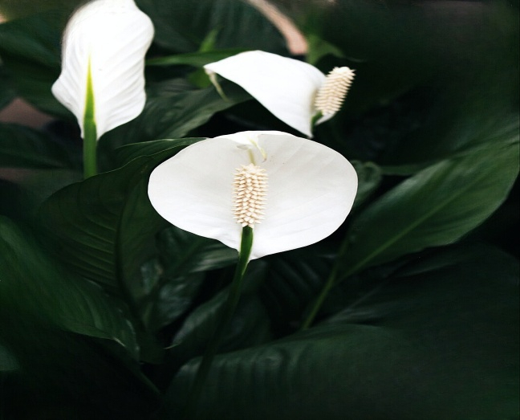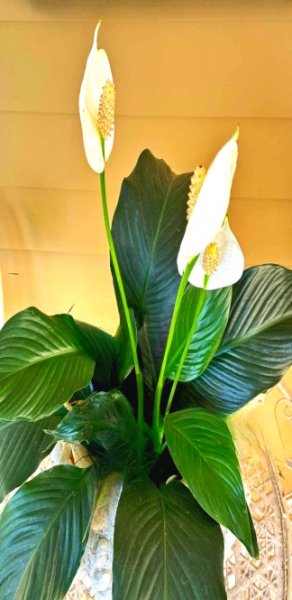

Fig 2- Madonna lily, White sails, Spathe flower, White Flag

The herbaceous, commercially significant decorative plant, the Peace lily (*Spathiphyllum wallisii*) is a member of the Araceae family. It is native to tropical regions of America and Southeast Asia. In temperatures lower than 55°F, it flourishes in the shade and eliminates toxic compounds like acetone, ammonia, benzene, ethyl acetate, formaldehyde, methyl alcohol, trichloroethylene, and xylene (Sailaja et al., 2024). As a result, it receives a high performance rating in NASA's clean air assessment (Katakam et al., 2017). In China, the peace lily is also referred to as the "successful wind" signifying that life would proceed without hiccups (Huiyi et al., 2022).

**3. AGLAONEMA**

**Common names**: Golden Evergreen, Poison Dart Plant, Philippine Evergreen.

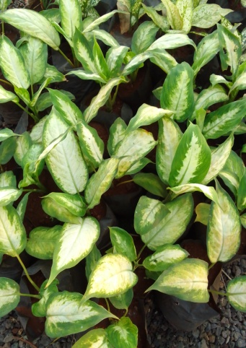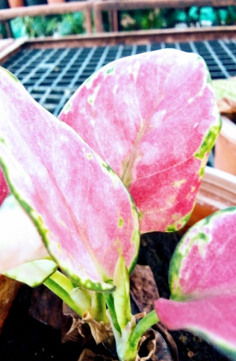

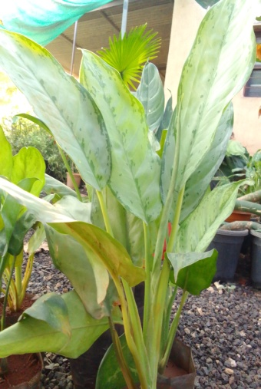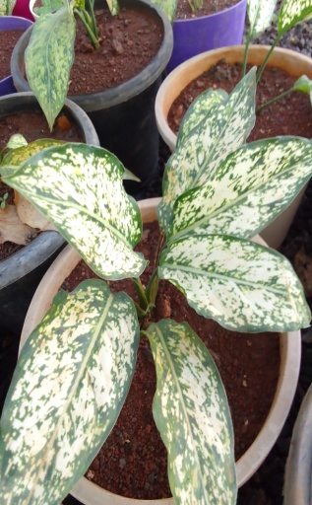

**Fig 3-** **Golden Evergreen, Poison Dart Plant, Philippine Evergreen**

Aglaonema belongs to the arum family, Araceae comprising over 21 species. It is native to tropical and subtropical regions of Asia and New Guinea (Saloni et al., 2023). Although Chinese evergreen has no direct medical application, it is well-known for its capacity to eliminate toxins like formaldehyde, benzene, and other dangerous substances from indoor air. Because of this, it lowers the risk of several respiratory disorders and other health problems (Seema, 2016). They can easily thrive in low-light conditions making them best for indoor plant (Chen et al., 2003).

**4. CALATHEA**

**Common names:** Zebra plant, Peacock plant, Cathedral plant, Rattlesnake plant, Prayer plant.

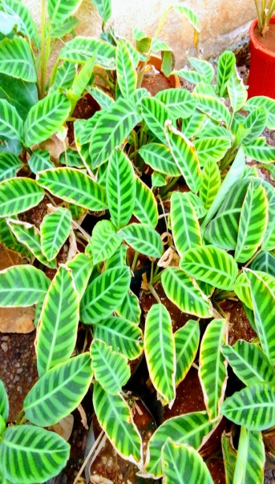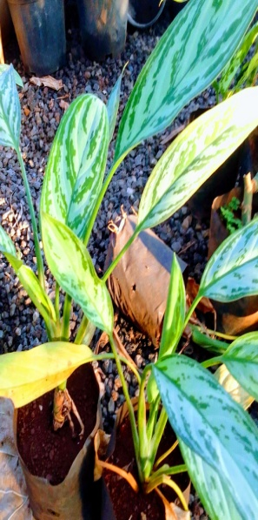

**Fig 4-** **Zebra plant, Peacock plant, Cathedral plant, Rattlesnake plant, Prayer plant**

Calatheas belong to the genus of flowering plants members of the Marantaceae family comprising over 285 known species. It is native to the tropical America. Calatheas are mostly grown as beautiful foliage plants variegated with bright colors such as pink, orange, red and white best suited for interior landscaping because of their capacity to withstand low light levels and their striking color patterns and variety of leaf textures. It can produce a very lovely inflorescence. The horticultural industry has also made extensive use of the other *Calathea sp.* because of its eye-catching variegation patterns and foliar hues (Chih et al., 2005, Borchsenius et al., 2012, Van et al., 2018, Jalinsky et al., 2014)**.** Calathea helps purify the air in our homes by absorbing pollutants such as formaldehyde and benzene, which are often released by household products (Donghe et al., 2024).

**5. KALANCHOE**

**Common names:** Mother of thousands, Miracle leaf, Life plant, Chandelier plant.

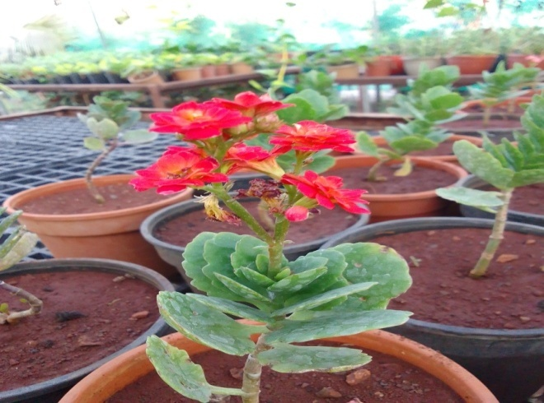

**Fig 5-** **Mother of thousands, Miracle leaf, Life plant, Chandelier plant.**

Kalanchoe is a genus belonging to the Crassulaceae family comprising over 125 species. It is native to Madagascar and tropical Africa (Donghe et al., 2024). They produce beautiful and long-lasting blooms in various colours like red, orange, yellow, pink, and white. Species like *Kalanchoe blossfeldiana* are considered the best indoor plants which absorb benzene and other inorganic compounds present in the air released by furniture and appliances present indoors which causes several health-related disorders (Milad et al., 2014).

**6. PILEA PEPEROMIOIDES**

**Common names:** Chinese money plant, Missionary plant, UFO plant, Pancake plant.

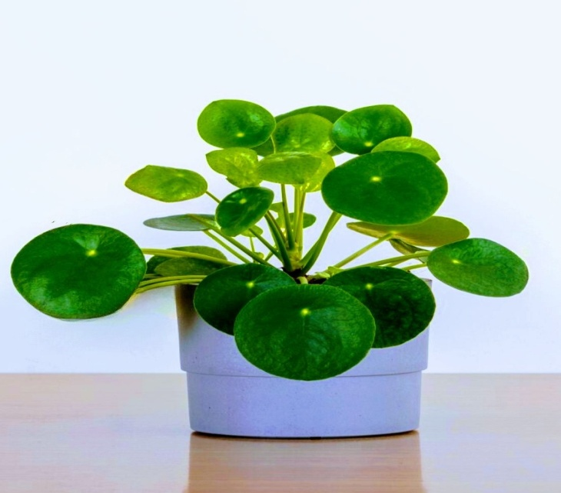

**Fig 6-** **Chinese money plant, Missionary plant, UFO plant, Pancake plant**

*Pilea peperomioides*, are perennial herbs belonging to the Urticaceae family. It is native to China, primarily found in tropical and subtropical locations, while certain species are also found in warm temperate climates (Jingling et al., 2021). It is considered the best indoor plant as it can survive frost and tolerate dry weather. They absorb significant amounts of formaldehyde and inorganic compounds present in the air (Katrine, 2018).

**7. MOTH ORCHID**

**Common names**: Moon orchid, Mariposa orchid.

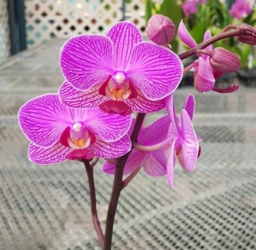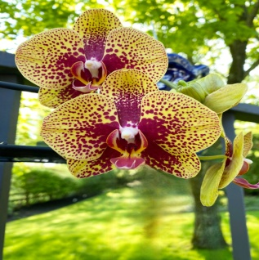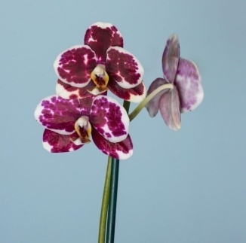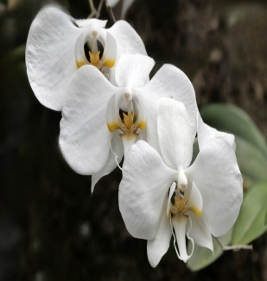

**Fig 7-** **Moon orchid, Mariposa orchid.**

Moth orchid also known as Phalaenopsis belongs to the Orchidaceae family. It is native to tropical and subtropical regions of Asia and the South Pacific Islands (Anzai et al., 2001). Worldwide, phalaenopsis orchid hybrids are highly valued as potted plants and cut blooms (Jiemin et al., 2024). The blooms can last for 60-90 days making it the best choice as flowering indoor plant which gives an attractive look to the indoor space. They are very effective at removing various pollutants such as carbon dioxide and xylene (Reshma et al., 2017).

**8. COLEUS**

**Common names:** Painted nettle, Spurflower, Flybush, Hedgehog plant.

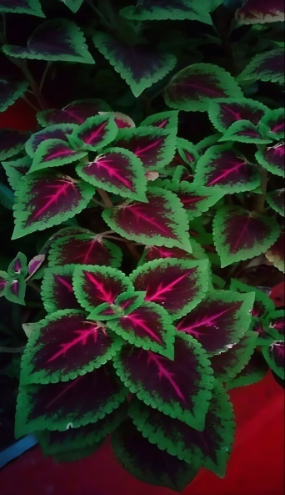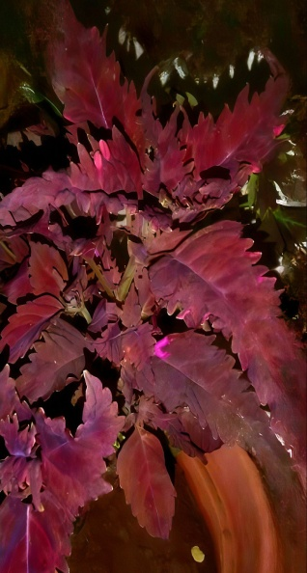

Fig 8- Painted nettle, Spurflower, Flybush, Hedgehog plant

Coleus plants belong to the Lamiaceae family, commonly found in tropical and warm regions of Africa, Asia, and Australia (Gamal et al., 2022). It is used as an indoor plant as it has the ability to detoxify and purify the air (Mohanto et al., 2024). It also repels pests like mosquitoes, snakes, flies, etc because of its fragrant nature having a lemony and camphor-like fragrance (Jaarsveld, 1997).

**9. DRACAENA FRAGRANS**

**Common names:** Corn plant, Dragon plant, Cornstalk plant, Fortune plant.

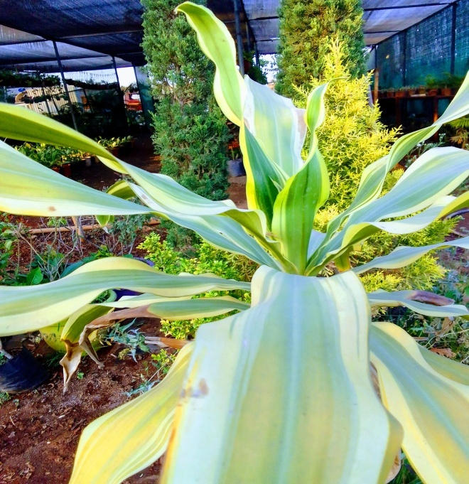

**Fig 9-** **Corn plant, Dragon plant, Cornstalk plant, Fortune plant**

*Dracaena fragrans* is a member of the Asparagaceae family. It is native to the African regions of Upper Guinea (Baby et al., 2021). The appellation ‘fragrans’ tells about its fragrant nature which produces fragrant flowers. According to NASA Clean Air Study indicated that the plant aided in the removal of indoor pollutants such as formaldehyde, xylene, and toluene (Wolverton, 1996, Hemant, 2024).

**CONCLUSION**

Nowadays, indoor plants have become an integral part of home decor. Plants help to boost happy and positive feelings. They imply an aesthetic look to the room. Besides this they also purify the air from the harmful and toxic compounds present in it. They also boost cognitive power and improve physiological and behavioral functions. Plants create an essential environment required for one’s healthy life.

**REFERENCE**

1. Meutia Zahara, Cho Cho Win. (2020). A Review: The Effect of Plant Growth Regulators on Micropropagation of Aglaonema sp. Journal of Tropical Horticulture, 3(2), 96-100.
2. Silalahi T. P., & Murni P. (2023). Effect of Light Intensity on Phenology and Morphological Characteristics of Aglaonema Bigroy (Aglaonema sp.) Leaves. Jurnal Penelitian Pendidikan IPA, 9(12), 10892–10901.[doi: 10.29303/jppipa.v9i12.5593](https://doi.org/10.29303/jppipa.v9i12.5593)
3. Reshma V.S., Prashant Kumar, Chaitra G.S. (2017). Significant role of ornamental plants as air purifiers. International Journal of Current Microbiology and Applied Sciences, 6(8), 2591-2606. doi: 10.20546/ijcmas.2017.608.308.
4. Davamani V., M. Deepsari, E. Parameswari, S. Arulmani, S. Paul Sebastian, T. Ikalia. (2020). Chemistry of indoor pollutants and their impacts on human health. International Research Journal of Pure and Applied Chemistry, 21(9), 40–61. doi: 10.9734/IRJPAC/2020/v21i930197.
5. Seung-Han Hong, Jiyeon Hong, Jihyeon Yu, Youngwook Lim. (2017). Study of removal difference in indoor particulate matter and volatile organic compounds through the application of plants. Environmental Health and Toxicology, 32, doi: 10.5620/eht.e2017006.
6. Nisitha S, Geetha Balasubramani, Paul Pradeep J. (2023). Systemic review on indoor plants as an alternative techniques for reducing indoor air pollutants. Journal of Xidian University, 17(11). doi: 10.37896/jxu17.11/092.
7. Tanbouly R., Hassan, Z., El-Messeiry, S. (2021). The Role of Indoor Plants in air Purification and Human Health in the Context of COVID-19 Pandemic: A Proposal for a Novel Line of Inquiry. Frontiers in molecular biosciences, 8.
8. Liu Fudan, Ya Lianyu, Meng Xi, Zhang Cen. (2022). A review on indoor green plants employed to improve indoor environment. Journal of Building Engineering. 53. doi: 10.1016/j.jobe.2022.104542.
9. Kavya P, Theijeswani R.C., Gayathri M. (2024). Phytochemical analysis, identification of bioactive compounds using GC-MS, in vitro and in silico hypoglycemic potential, and in silico ADME analysis of Chlorophytum comosum root and leaf. Sec. Medicinal and Pharmaceutical Chemistry, 12. doi: 10.3389/fchem.2024.1458505.
10. Zhongjun Xu, Na Qin, Jinggang Wang, Hua Tong. (2010). Formaldehyde biofiltration as affected by spider plant, Bioresource Technology, 101(18), Pages 6930-6934, ISSN 0960-8524. doi: 10.1016/j.biortech.2010.03.128.
11. Wicaksono Rizky, Sudikno Antariksa, Marjono Marjono, Sholichah Ummu, Putri Marsha. (2022). Investigation of indoor spider plant (Chlorophytum comosum) affecting the carbon monoxide and carboxyhemoglobin reduction. 28. S62-S67. doi: 10.53550/EEC.2022.v28i01s.008.
12. Sailaja B., Bhavani K., Hyma A., Sai Deepika L., Udaya J., Asif S.K., et al. (2024). A Review on Spathiphyllum: Pharmacognostic and Pharmacological Approach, 8, 211.
13. Katakam Mounika, Birendranath Panja, Jayanta Saha. (2017). Diseases of Peace lily [Spathiphyllum sp.] caused by fungi, bacteria and viruses: A review. Pharma Innovation, 6(9), 103-106.
14. Huiyi Tan, Keng Yinn Wong, Hong Yee Kek, Kee Quen Lee, Haslinda Mohamed Kamar, Wai Shin Ho, … Muhammad Akmal Hakim Hishammuddin. (2022). Small-scale botanical in enhancing indoor air quality: A bibliometric analysis (2011-2020) and short review. Progress in Energy and Environment, 19(1), 13–37. doi: 10.37934/progee.19.1.1337.
15. Saloni Utekar, Radhika Bhise, Prathmesh Ghorpade, Santhosh Sawardekar, Sandip Sherkar. (2023). In vitro propagation of valuable ornamental aglaonema species; a review. Bioscience Discovery, 14(3), 40-52.
16. Seema Ghate. (2016). Assesment of phytoremediating potential of aglaonema commutatum schott for indoor plants. International Journal of Plant and Environment, 2(1-2), 87-92.
17. Chen Jianjun, McConnell Dennis, Henny Richard, Everitt, Kelly. (2003). Cultural Guidelines for Commercial Production of Interiorscape Aglaonema. 10.32473/edis-ep160-2003.
18. Chih-Cheng T. Chao, Pachanoor S. Devanand, Jianjun Chen. (2005). AFLP analysis of genetic relationships among Calathea species and cultivars. Plant Science, 168(6), Pages 1459-1469, ISSN 0168-9452, doi: 10.1016/j.plantsci.2005.01.012.
19. Borchsenius Finn, Suarez Luz, MacKechnie Linda. (2012). Molecular Phylogeny and Redefined Generic Limits of Calathea (Marantaceae). Systematic Botany, 37, 620-635. doi: 10.2307/41515151.
20. Van Huylenbroeck Johan, Calsyn Evelien, Van den Broeck Andy, Denis Rene, Dhooghe Emmy. (2018). ["Calathea"](https://doi.org/10.1007/978-3-319-90698-0_13), Ornamental Crops, Handbook of Plant Breeding. Cham: Springer International Publishing, *301–*318.  [doi](https://en.wikipedia.org/wiki/Doi_(identifier)" \o "Doi (identifier)): [10.1007/978-3-319-90698-0_13](https://doi.org/10.1007%2F978-3-319-90698-0_13), [ISBN](https://en.wikipedia.org/wiki/ISBN_(identifier)) [978-3-319-90698-0](https://en.wikipedia.org/wiki/Special:BookSources/978-3-319-90698-0).
21. Jalinsky J., T.A. Radocy, R. Wertenberger, C.S. Chaboo. (2014). Insect diversity in phytotelmata habitats of two host plants, Heliconia stricta Huber (Heliconiaceae) and Calathea lutea Schult (Marantaceae) in the south-east Amazon of Peru. Journal of the Kansas Entomological Society, 87(3), 299–311.
22. Donghe Li, Wang H, Gao Q, Lu M. (2024). Study on the ability of indoor plants to absorb and purify benzene pollution. Sci Rep, 14(1), 13169. doi: 10.1038/s41598-024-63811-4. PMID: 38849491; PMCID: PMC11161576.
23. Milad, Rola, Sherweit El-Ahmady, Abdel Nasser Singab. (2013). “Genus Kalanchoe (Crassulaceae): A Review of Its Ethnomedicinal, Botanical, Chemical and Pharmacological Properties”. European Journal of Medicinal Plants, 4 (1), 86-104. [doi: 10.9734/EJMP/2014/5901](https://doi.org/10.9734/EJMP/2014/5901).
24. Jingling Li, Tang J., Zeng S. et al. (2021). Comparative plastid genomics of four Pilea (Urticaceae) species: insight into interspecific plastid genome diversity in Pilea. BMC Plant Biol, 21, 25. [doi: 10.1186/s12870-020-02793-7](https://doi.org/10.1186/s12870-020-02793-7)
25. Katrine Hienswig Kjaer. (2018). Pilea peperomioides: Air purifying test. A report by Danish Technological Institute. https://www.teknologisk.dk/ydelser/planters-luftrensende-egenskaber/40089.
26. Anzai H., Tanaka M. (2001). Transgenic Phalaenopsis (a Moth Orchid). doi: 10.1007/978-3-662-10603-7_18.
27. Jiemin Chen, Xuanyi Zhu, Ruiyue Zheng, Yan Tong, Yukun Peng, Kai Xie et al. (2024). Orchestrating of native Phalaenopsis flower scents lighted the way through artificial selective breeding partiality in the current resource utilization,Industrial Crops and Products, 217, ,118850,ISSN 0926-6690, [doi: 10.1016/j.indcrop.2024.118850](https://doi.org/10.1016/j.indcrop.2024.118850).
28. Gamal Abdu Ahmed Al-sharabi, Osman Nasser Al-galal. (2022). Study of the Effectiveness of Using Aqueous Extract of Coleus Neochilus Plants in Controlling Varroa Parasite (Varroa Destructor Oud.) on Honey Bees. American Journal of Agriculture and Forestry, 10(3), 118-122. doi: 10.11648/j.ajaf.20221003.16
29. Mohanto S, Ahmed MG, Ashique S, Kesharwani P. (2024). Traditional Uses, Phytochemistry, and Pharmacological Activities of Coleus amboinicus: A Comprehensive Review. Curr Pharm Des, 30(7), 519-535. doi: 10.2174/0113816128283267240130062600. PMID: 38321896.
30. Jaarsveld Van. (1997). Veld gardening in South Africa: the forest garden. Veld & Flora, 83, 51-53.
31. Baby Greeshma, Singh Devi. (2021). Cultivation of Dracaena fragrans Cv. Massangeana as an intercrop in guava in different spacing pattern. The Pharma Innovation Journal, 10(10), 1552-1554.
32. Wolverton, B. C. (1996). How to Grow Fresh Air. New York: Penguin Books.
33. Hemant Chandore. (2024). The role of indoor plants in improving air and mind- compressive review. International Journal of Environment, Agriculture and Biotechnology, 9(4), 138-153. doi: 10.22161/ijeab.94.20.