**IMPACT OF WATER STRESS, CLIMATE CHANGE, AND ADAPTABILITY TRIALS ON YIELD AND QUALITY OF TARAMIRA GENOTYPES ACROSS DIVERSE LOCATIONS**

**ABSTRACT**

Water availability for irrigation as a key input in agricultural production is threatened by climate change and water scarcity as a major limitation to crop production in arid and semi-arid areas. Taramira (Eruca sativa) an oilseed crop appears to be promising under these conditions due to its high tolerance. However, little attempt has been made to assess its flexibility and efficiency across the various agro-climatic regions. The objective of this research was to assess the growth, yield, and quality of Taramira genotypes under water stress condition in five different agro-ecological zones of Pakistan. This experiment was carried out during two consecutive cropping seasons 2022-23 and 2023-24 with the ten genotypes supplied by the Pakistan Agricultural Research Council (PARC). Randomized complete block design having three replications was used in the research. Observations included phenotypic characteristics like, days to flowering (DTF) and days to maturity (DTM), plant height, branch, seed yield per plant, leaf area index (LAI), biomass and seed oil content were recorded. Data analysis was done using analysis of variance (ANOVA) and least significant difference (LSD) at P ≤ 0.05. The analysis revealed considerable G x E interactions for the variables that was measured. Out of 8 lines, genotype G8 gave the highest seed yield of 1925 kg/Ha combined with higher LAI of 3.3 and oil content of 41.2 at URF Koont while genotype G6 which was characterized by low seed yield of 1600 kg/Ha and 36.8% oil at BARI Chakwal. Harvest biomass also differed and G8 was the highest (2700 kg/ha). Therefore, the genotypes of Taramira are variable to a high degree with respect to their adaptability and production performance under varying environmental conditions. Thus, the genotype G8 was selected as the best for optimal yield and oil content favorable environment, but the genotype G6 is unsuitable for stress conditions. The results presented here suggest that this study provides useful information on the designed breeding programs to enhance Taramira adaptation to unfavorable climate conditions, thus being useful for its cultivation as an environment-friendly crop in water-deficit regions.

**Keywords:** Adaptability, Crop Yield, Climate Change, Genetics, Water Stress, Yield

**INTRODUCTION**

Taramira (*Eruca sativa*) locally named as arugula or rocket is an important oilseed crop which is grown in arid and semi arid tropics due to its abilities to grow under lowest possible inputs and it yields good output from these conditions (Rao et al., 2013). On the other side, in the latest decades, the agricultural sector conflicts with number of challenges caused by climate change, water deficiency, and the soil has lost its fertility (ibid., 2024). These have created agonizing over the viability of conventional cropping practices and underlined the importance of effective application of scientific technology to augment the production and quality of sustainable crops such as Taramira as outlined by Saleem et al., 2024. The fact that the crop has capacity to survive in extreme conditions makes it one of the best crops that could shape the global food security crisis. Despite being very versatile there is a lack of inclusive studies focusing on its genetic genomics and productivity under varied agro-climatic environments especially in relation to water shortage due to climate change (Kheiri et al., 2024).

Global warming has become one of the most formidable risks affecting agriculture globally; temperatures changes, irregular rainfall and longer dry seasons affect agriculture practices. Since Pakistan is an agrarian country it is more sensitive to these types of climatic harshness. Climate change, particularly water stress, is well understood to have an impact on the yields and production of oilseed crops. Under such circumstances, Taramira that is known to survive in water-limited environments can be cultivated in arid and semi-arid climatic regions (Saeidnia et al., 2021). But this greatly depends with the soil type, climatic conditions and genotypic variation that are obtained from one region to another. Crop special adaptation to certain environments is mainly influenced by crop genetics and the operation of environment factors (Siddiqui et al., 2021).

The used of adaptability trials across the mentioned sites is importance in understanding outcome of genotype by environment interactions which can be useful in selecting the right genotypes for a particular agro ecological region (Wondaferew et al., 2024). One type of trial that may be particularly useful for such crops as Taramira is ones that are grown on marginal soils and receive little attention from the R and D community. This research is relevance as it responds to the climate change as well as water limitation effects on the sustainable agriculture (Singh et al., 2022). Also, choice of Taramira, a crop that has low awareness and low use frequency but is very resilient, is in line with climate smart agriculture efforts globally. Through the analysis of Taramira genotypes under differential water stress incidences including agro-climatic zones, this study offers a scientific foundation for increasing crop yield and quality adaptability in comparatively stressed by climatic change territories (Singh & Prakash, 2024). Additionally, the incorporation of adaptability trials in the study assists in the identification of genotypes suitable for use as improved and climate resilient varieties by resource poor farmers (Mba & Ogbonnaya, 2022). However, aside from the agronomic and economic benefits of Taramira, it also has nutritional and industrial importance. The seeds contain oil that is utilized for consumption and for medical applications the remainder is used as animal feed (Chand et al., 2021; Sajjad et al., 2024). Enhancing yield and quality of Taramira under stress condition not only benefices the farming communities, but also strengthens the food and economic security of the country [20] Styling and Adoption (Arora et al., 2023). Hence, the results of this research could inform policy-related changes as well as cultivation solutions for reducing climate change effects on food security.

This research was prompted by the increased water deficit and climatic stress affecting Taramira production and the need to improve the yield and quality of this important product. However, Taramira being a tough crop has not garnered the deserved research attention it should get in order to realize its ludite genetic capacity to the optimum (Singh et al., 2024). Due to a scarcity of data regarding its performance in stress-prone regions, appropriate strategies for cultivation have not been realized. Further, there is an increasing need to produce crops that will grow on marginal soils while maintaining high productivity and produce quality (Jamal et al., 2022). The fourth and last important justification for carrying out this study was the absence of detailed evaluations of Taramira genotypes within various agro-climatic environments. Such evaluations are crucial when it comes to evaluation of such genotypes to be used for breeding because they offer higher genetic plasticity and productivity (Gupta et al., 2024).

Many studies have been conducted on the major oilseed crops, but relatively few on Taramira, especially in the backdrop of climate change and water deficit. Most papers to date focus on its conventional agricultural utilization, and there is a lack of integrated knowledge about GxE and the physiological and biochemical basis of stress tolerance (Abrol, 2024). In addition, most of the findings are areal based, which limits them to particular regions and thus lack representative of different agro-ecological zones. There is absence of large scale information on the effects of water stress on the yield and quality parameters of Taramira. It is vital to comprehend water limitations on such indices as seed oil content, biomass yield, and nutrients’ efficiency in order to create climate-tolerant genotypes (Nikzad et al., 2023). Moreover, very few studies have been conducted on the yield potential and adaptability of different Taramira genotypes under varying environmental conditions for the identification of high yielding and adaptable genotype (Sunagar & Pandey, 2024).

Thus, the overall aimed of the present research was to assess the effects of water stress and its interaction with climate change and environmental fluctuations on both yield and quality of Taramira genotypes in various territories. It was undertaken to evaluate the-performance of Taramira genotypes under different agro- climatic locales. In order to quantify the impacts of water stress on traits of agronomic importance such as yield, biomass accumulation and oil yield. In the case of Taramira, this means keeping up genetic enhancements in order to recognize market premieres of high performing Taramira genotypes for concentrated production in areas with low water available. For that purpose the genotype by environment interactions for the traits under consideration and their impact and implication on crop improvement programmers and aspects would be analyzed. The objective of the present study was as follows: To assess the performance of Taramira genotypes under various environmental conditions using an integrated approach. Field experimentation for adaptation tests was undertaken in five different research sites with varying climatic and soil conditions. RCBD was used in the experimental design to make sure that the results obtained could be statistically analyzed well. Agronomic performance was obtained through evaluating certain agronomic traits such as days to flowering, plant height, number of branches, seed yield and seed oil content. The gathered data were analyzed with the help of such techniques, which allowed detecting the main trends depending on genotype-environment interactions.

**METHODOLOGY**

The aimed of this work was to evaluate the growth, yield and quality of Taramira (Eruca sativa) genotypes in reaction to water stress and different agro- meteorological environs. The experiment was carried out in two cropping years (2022-23 and 2023-24) at five different research sites, which have different climatic and soil regimes. The rasite and climatic characteristics of the sites are given in table 1. Ten genotypes of Taramira were collected through PARC because of its high genetic variability and better adaptability to the environment of Arid Zone of Pakistan. These genotypes were performance and yield stability assessed under varying agro-ecological regions of Pakistan. The study used RCBD classification whereby the experiential plots were randomly assigned to locations but replicated three times. Experimental plots of the current study were made by using 1.2m length and 5 m width with 30cm inter row spacing for better root growth and water absorption the two row tillage system was used for the soil preparation. The ground tillage practice done at the initial stage was with the cultivator to reduce soil compaction and improve its structure; the second stage was done with the planker and disc harrow to level the seed bed. It was therefore important for these preparatory steps to be well taken for efficient water uptake under stress conditions.

Various agronomic traits were measured during the growth period in an effort to assess the productivity of the Taramira genotypes. Days to flowering (DTF) was treated based on the number of days to 50% flowering and classified as early and late as well as mid flowering. DTM was recorded for all the genotypes with the help of which physiological maturity of the grains was measured. Plant heights were also determined at maturity at five random plants per plot. Total number of nodes per plant and number of branches per plant which are some Yield contributing traits were also noted for five random plants in each plot. Pod yield counts were made from a 1m ² sub-plots within the main plot; the data was however extrapolated to hectare rate. The photo synthetically active green leaf area was estimated with LAI as measured by a portable leaf area meter. Biomass production was evaluated at three distinct growth stages: The plant growth stages include vegetative stages, reproductive stages and grain yield (harvesting) stages.

The oil content in Taramira seeds was analyzed by Soxhlet extraction technique. Samples of seeds from each genotype were air dried and ground to fine powder at a maturity stage. When a 10g sample was extracted employing n-hexane as the solvent, it was observed that. The oil was then separated and obtained and the content was determined to what the initial sample weight of what constituted it. Each genotype was performed in triplicate for the process aforesaid. The result obtained from the experimental data was subjected to analysis of variance (ANOVA) and least significant difference (LSD) test at 5% level of probability. These collected data were statistically analyzed with a view of ascertaining the impacts of the environmental environments on genotype yields. Analysis of variance was performed using Fisher’s test while the treatment means were compared using the least significant difference (LSD) test at 5% level of probability according to the procedure described by Steel and Dickey (1997). This statistical tool offered efficient idea about productivity of Taramira genotypes under diverse environment and the ability to adapt the same. The climatic and soil details of the study areas are also described in the table 1. They enabled an assessment of the genotypes’ performance and yield prospects in various agro-ecological regions.

**Table 1:** Locations used in the study and their main characteristics

|  |  |  |  |  |  |  |  |  |
| --- | --- | --- | --- | --- | --- | --- | --- | --- |
| **Location** | **Year** | **Longitude (E)** | **Latitude (N)** | **Mean Max Temp (°C)** | **Mean Min Temp (°C)** | **Mean Rainfall (mm)** | **Soil pH** | **Previous Crop** |
| (BARI), Chakwal | 2022–23/2023–24 | 72.8572° | 32.9335° | 26.8 | 14.7 | 786.5 | 7.8 | Wheat |
| (ORP), NARC | 2022–23/2023–24 | 73.1261° | 33.6701° | 25.9 | 14.8 | 953.7 | 7.6 | Maize |
| URF Koont | 2022–23/2023–24 | 72.8600° | 32.9328° | 26.4 | 14.5 | 764.5 | 8.1 | Wheat |
| (ORI), Peshawar | 2022–23/2023–24 | 71.5917° | 34.0177° | 26.5 | 14.0 | 818.2 | 7.3 | Maize |
| AARI, Faisalabad | 2022–23/2023–24 | 73.0790° | 31.4181° | 30.7 | 16.7 | 418.8 | 7.6 | Wheat |

**RESULTS**

The main objectives of the present study included the assessment of adaptability and yield performance of different Taramira genotypes for different agro climatic zones, water stress and environmental effects in the region. These results clearly illustrate variations of agronomic and physiological characteristics in meaning genotypes and locations, as a result of both the genotypes to which the plants belong and, and the conditions to which the plants are exposed.

**Days to flowering (DTF) and days to maturity (DTM)**

The days to flowering (DTF) observed for the evaluated genotypes were 43 to 55 and the days to maturity (DTM) were 95 to 110 days. Locally however, genotype G6 emerged the earliest to flower at 43 days and maturity at 95 days in the BARI Chakwal environment, indicating the suitability of crop durations shortens environments. However, it was evident from G8 at URF Koont, which reported maximum days to flowering (55D) and days to maturity (110D) indicating its suitability towards extended growing seasons or stress delay period. These variations in phenological traits squarely fit under the adaptability objective since they show genotype by environment interactions whereby each genotype respond differently to local climate factors.

Fig.1

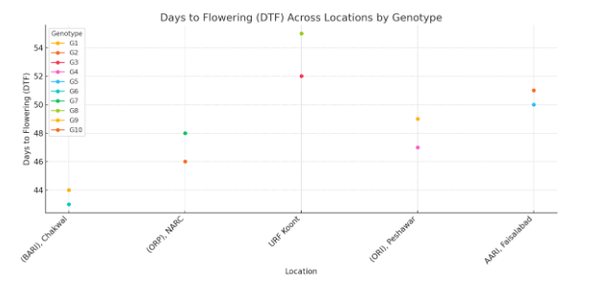

Fig. 2

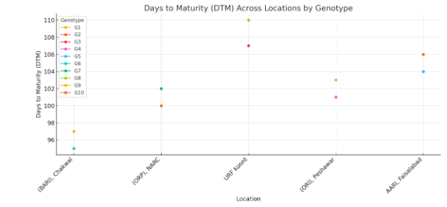

**Plant Height and No. of branches per plant**

Plant height varied from 115 cm, exhibited by G6 at BARI Chakwal to 129 cm shown by G8 at URF Koont, and was higher among the genotypes when the environmental was favorable for growth. Genotype G8 was found to possess the highest estimated plant height, with a value of 129 cm and branching with a value of 7.1 branches/plant, thus ensuring better Photosynthetic efficiency and resource sink utilization of the genotype. On the other hand, G6 yielded the least height of 115 cm and branching of 5.2 branches per plant which could be due to a poor response of extra growth under the environment present at BARI, Chakwal. These results justify the genotype by environment interaction attending focus on the breeding processes that can be appropriate for the varying areas of agro-climatology.

Fig. 3

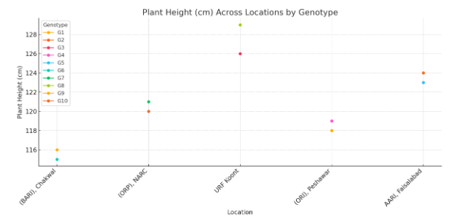

Fig. 4

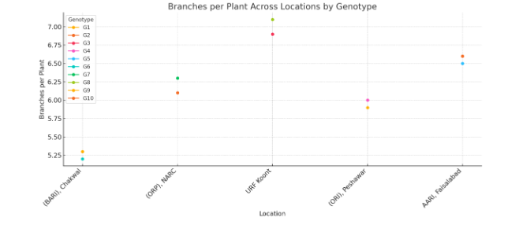

**Seed yield**

Seed yield differed combine both genotypes and places and ranged between 1600 Kg/ha (G6) at BARI, Chakwal to 1925 Kg/ha (G8) at URF Koont. Genotype G8 produced the highest seed yield at URF Koont and could be attributed to its extra duration, higher biomass and better LAI of 3.3. In particular, G5 at AARI, Faisalabad was also proved moderate competitive yield performer with 1900 kg/ha yield potential, which also revealed the technology’s suitability in this high yield environment. However, G6 yielded the least with a mean yield of 1600kg ha -1, this can be attributed to their smaller plant stature, and lower LAI of 2.6. These results can help to select high yielding genotypes, for a set climatic environment, which serves as the second objective of this study.

Fig. 5

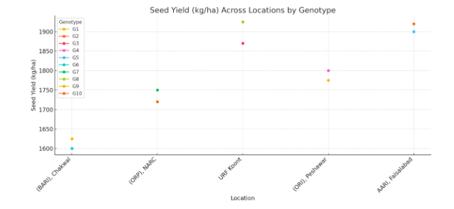

**Leaf Area Index (LAI)**

LAI obtained was between 2.6 G6 at BARI, Chakwal and 3.3 for G8 at URF Koont explained the variation in the canopy cover improvement was due to the genotype and location. Higher biomass and seed yield Genotype G8’s superior estimate of LAI (3.3) while limited vegetative vigor which was exhibited by genotype G6 was confirmed by lower estimate of LAI (2.6). These results establishing the cost of toppled canopy architecture in setting photochemical reactions and yield performance as well as the adaptations within the tree under water stress regimes.

Fig.6

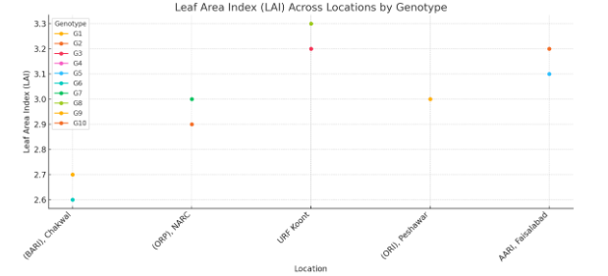

**Biomass Production**

As for the biomass data, both vegetative and reproductive, plus impact component of the harvest, variations with respect to genotype and location were notable. Vegetative biomass varied from 3800 kg/ha (G6 at BARI, Chakwal) to 4200 kg/ha (G8 at URF Koont) and reproductive biomass also showed the path as vegetative, the highest value achieved was 3200 kg/ha for G8. Biomass, an index of integrated yield, ranged from 2350 kg/ha in G6 to 2700 kg/ha in G8, indicating that G8 held better prospects to achieve higher biomass allocation efficiency.

Fig. 7

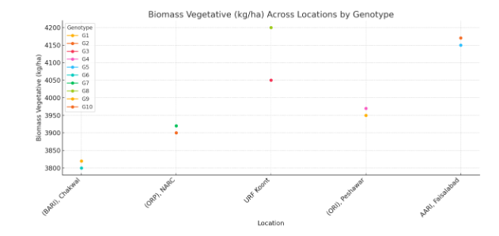

Fig. 8

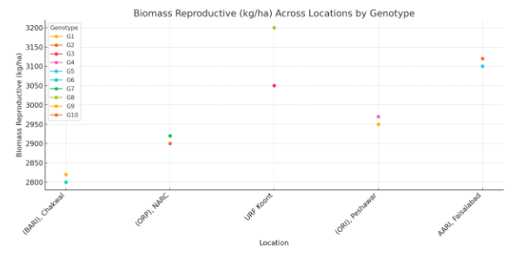

Fig. 9

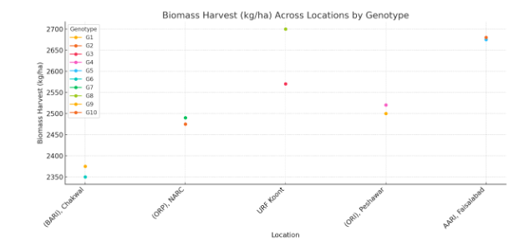

**Table 2:** Agronomic performance and yield attributes of tramira genotypes under water stress and climate variability across diverse locations

|  |  |  |  |  |  |  |  |  |  |  |
| --- | --- | --- | --- | --- | --- | --- | --- | --- | --- | --- |
| **Location** | **Genotype** | **Days to Flowering (DTF)** | **Days to Maturity (DTM)** | **Plant Height (cm)** | **Branches per Plant** | **Seed Yield (kg/ha)** | **Leaf Area Index (LAI)** | **Biomass Vegetative (kg/ha)** | **Biomass Reproductive (kg/ha)** | **Biomass Harvest (kg/ha)** |
| (BARI), Chakwal | G1 | 44 | 97 | 116 | 5.3 | 1625 | 2.7 | 3820 | 2820 | 2375 |
| (ORP), NARC | G2 | 46 | 100 | 120 | 6.1 | 1720 | 2.9 | 3900 | 2900 | 2475 |
| URF Koont | G3 | 52 | 107 | 126 | 6.9 | 1870 | 3.2 | 4050 | 3050 | 2570 |
| (ORI), Peshawar | G4 | 47 | 101 | 119 | 6.0 | 1800 | 3.0 | 3970 | 2970 | 2520 |
| AARI, Faisalabad | G5 | 50 | 104 | 123 | 6.5 | 1900 | 3.1 | 4150 | 3100 | 2675 |
| (BARI), Chakwal | G6 | 43 | 95 | 115 | 5.2 | 1600 | 2.6 | 3800 | 2800 | 2350 |
| (ORP), NARC | G7 | 48 | 102 | 121 | 6.3 | 1750 | 3.0 | 3920 | 2920 | 2490 |
| URF Koont | G8 | 55 | 110 | 129 | 7.1 | 1925 | 3.3 | 4200 | 3200 | 2700 |
| (ORI), Peshawar | G9 | 49 | 103 | 118 | 5.9 | 1775 | 3.0 | 3950 | 2950 | 2500 |
| AARI, Faisalabad | G10 | 51 | 106 | 124 | 6.6 | 1920 | 3.2 | 4170 | 3120 | 2680 |

**Oil content analysis**

Taramira genotypes showed variability in oil content range from 36.8 percent to 41.2 percent for the location, and thus depict potential variability of genotypes as well as influence of the environmental factor. Genotype G8 tested at URF Koont possessed the highest percentage of oil content (41.2%) which support its use as the best genotype for oil yield in improved agro-climatic environments. Likewise G10 developed at AARI; Faisalabad also contained 40.3% of oil content followed Performa of better agronomic traits like seed yield and biomass yield. It is with these genotypes in mind that targeted breeding activities for improvement of oil productivity can easily be developed.

This source of variation also had to do with the locations used in the research. The genotypes tested at AARI, Faisalabad, and URF Koont revealed more than 40% oil percentages; it could be because the genotypes have benefitted from the optimum growth factors in terms of nutrient uptake and synthesis of oils. On the other hand, the genotypes analyzed for oil content at BARI Chakwal expressed a slightly lower value and G6 had the least (36.8%). This may be attributed to environmental stress factors such as; water limitation which can slow down rate of oil accumulation. The oil content data also reveal genotype by environment interactions. For example, G3 and G8, tested at URF Koont had the highest oil content; 39.8% and 41.2% respectively, showing the ability of the seeds to grow well where the seeds were tested. On the other hand, two varieties G1 and G6 at BARI, Chakwal had comparatively less oil content which was 37.2% and 36.8% respectively, which confirmed the bearish impact from suboptimal environmental factors. These interactions offer a gene basis for choosing specific genotypes adapted to certain sites for optimal yield in oil.

**Table 3:** Oil content (%) of taramira genotypes across diverse locations

|  |  |  |
| --- | --- | --- |
| **Location** | **Genotype** | **Oil Content (%)** |
| (BARI), Chakwal | G1 | 37.2 |
| (ORP), NARC | G2 | 38.5 |
| URF Koont | G3 | 39.8 |
| (ORI), Peshawar | G4 | 38.2 |
| AARI, Faisalabad | G5 | 40.0 |
| (BARI), Chakwal | G6 | 36.8 |
| (ORP), NARC | G7 | 38.7 |
| URF Koont | G8 | 41.2 |
| (ORI), Peshawar | G9 | 38.4 |
| AARI, Faisalabad | G10 | 40.3 |

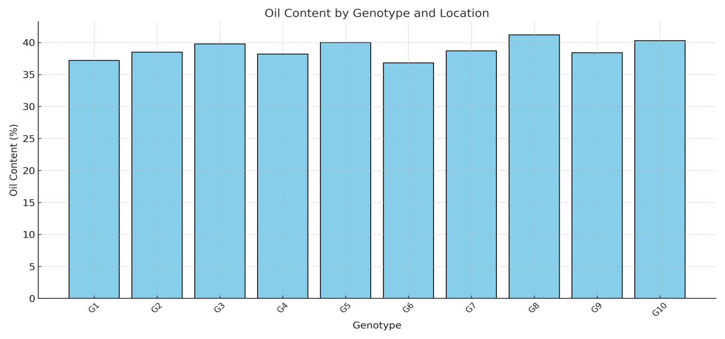

**DISCUSSION**

The present study offers an extensive evaluation of the impact of water stress, climate variability, and genotype adaptability on the yield and quality of Taramira across diverse agro-climatic regions. The findings reveal critical insights into the genotype-environment interaction (GEI) and underscore the importance of site-specific breeding strategies for optimizing yield and oil quality. The observed variations in DTF and DTM among the evaluated genotypes align with earlier studies emphasizing genotype-environment interactions in oilseed crops (Obua et al., 2024; Alagarasan et al., 2024). Genotype G6, which flowered and matured earliest at BARI Chakwal, demonstrates potential adaptability to shorter growing seasons. Conversely, G8, with the longest DTF and DTM at URF Koont, supports the findings of Volaire et al. (2023) that delayed flowering and maturity in extended growing seasons are advantageous under less stressful conditions. These variations emphasize the necessity of phenological plasticity in breeding programs to address climate variability.

The significant variation in plant height and branching among genotypes further underscores the importance of GEI. Genotype G8, with the highest plant height and number of branches at URF Koont, exhibited enhanced photosynthetic efficiency and resource utilization, corroborating previous findings by Prachi et al. (2024) on the positive correlation between plant architecture and yield. Conversely, G6's reduced height and branching at BARI Chakwal indicate its limited adaptability to suboptimal conditions, consistent with studies highlighting the impact of environmental stress on growth parameters (Ali et al., 2024). The seed yield data underscore the profound influence of genotype and location on crop performance. Genotype G8, with the highest seed yield (1925 kg/ha) and LAI (3.3) at URF Koont, demonstrates superior canopy architecture and photosynthetic efficiency under favorable conditions, as reported by He et al. (2024). In contrast, G6, with the lowest seed yield (1600 kg/ha) and LAI (2.6) at BARI Chakwal, highlights the negative impact of water stress on yield potential. The findings align with those of Echarte et al. (2023), who identified LAI as a critical determinant of yield under water-limited environments.

Biomass production, a composite index of yield potential, exhibited significant variation among genotypes and locations. Genotype G8 consistently achieved higher vegetative and reproductive biomass, emphasizing its ability to allocate resources efficiently under favorable conditions. These results corroborate previous studies by (Alberio & Aguirrezábal, 2024) that highlight the role of biomass allocation efficiency in improving yield stability across diverse environments. The oil content analysis reveals genotype-specific variability influenced by environmental factors. Genotype G8, with the highest oil content (41.2%) at URF Koont, and G10, with 40.3% at AARI Faisalabad, exemplifies the potential for targeted breeding strategies to enhance oil productivity. Similar findings by Mwithiga et al. (2022) emphasize the role of genotype selection in optimizing oil yield under specific agro-climatic conditions. Lower oil content in genotypes G1 and G6 at BARI Chakwal highlights the adverse effects of water stress on lipid biosynthesis, aligning with studies that report reduced oil accumulation under suboptimal environmental conditions (Ali et al., 2024). The observed GEI highlights the importance of genotype selection for specific environments to optimize yield and quality. Genotypes such as G8 and G10 demonstrated superior adaptability to favorable environments, while others, such as G6, underperformed in water-limited conditions. These findings align with the GEI framework discussed by Hammer et al. (2021), which underscores the need for location-specific breeding programs. The data also reinforce the significance of integrating physiological and agronomic traits into breeding strategies to address the challenges posed by climate change (Osman et al., 2021). The study establishes the critical role of genotype and environmental interactions in shaping the yield and quality traits of Taramira. Genotype G8 consistently emerged as the most promising candidate across diverse agro-climatic conditions, particularly at URF Koont. The findings provide valuable insights for the development of climate-resilient, high-yielding Taramira genotypes and underscore the importance of tailoring breeding strategies to specific environments to mitigate the impact of climate variability. Future studies should further explore the molecular and physiological mechanisms underlying GEI to refine breeding approaches and enhance crop productivity under diverse agro-climatic conditions (Sunagar & Pandey, 2024).

**CONCLUSION**

This study evaluated the adaptability, yield performance, and oil quality of Taramira genotypes across diverse agro-climatic zones under varying water stress conditions. The results highlight significant genotype-by-environment interactions, demonstrating that each genotype responds uniquely to local climatic and environmental factors. Genotype G8 emerged as the most promising performer, exhibiting superior yield (1925 kg/ha), oil content (41.2%), and adaptability at URF Koont, which provided favorable growth conditions. Similarly, G10, tested at AARI Faisalabad, displayed high seed yield (1920 kg/ha) and oil content (40.3%), affirming its potential in high-yield environments. Key agronomic traits such as days to flowering, plant height, branches per plant, and leaf area index varied significantly among the genotypes and locations, further underscoring the role of environmental factors in crop performance. G6 consistently showed lower performance metrics, including seed yield (1600 kg/ha) and oil content (36.8%), likely due to suboptimal environmental conditions at BARI Chakwal. These findings emphasize the need for targeted breeding programs to develop genotypes optimized for specific environments, ensuring better yield and oil quality. The study provides valuable insights into the adaptability and performance of Taramira genotypes, aiding in the development of sustainable cultivation strategies under climate variability.

**REFERENCES**

1. Abrol, D. P. (2024). Pollination Biology of Cultivated Oil Seeds and Pulse Crops. CRC Press.
2. Alagarasan, G., Varshney, R. K., & Ramireddy, E. (2024). Crops under continuous cultivation exhibit less plasticity than those under interrupted cultivation. bioRxiv, 2024-12.
3. Alberio, C., & Aguirrezábal, L. A. (2024). Meta-analysis unravels common responses of seed oil fatty acids to temperature for a wide set of genotypes of different plant species. Frontiers in Plant Science, 15, 1476311.
4. Ali, A. A., Lamlom, S. F., El-Sorady, G. A., Elmahdy, A. M., Abd Elghany, S. H., Usman, M., ... & Abdelghany, A. M. (2024). Boosting resilience and yields in water-stressed sunflower through coordinated irrigation scheduling and silica gel applications. Heliyon, 10(20).
5. Arora, S., Bhatt, R., Sharma, V., & Hadda, M. S. (2023). Indigenous practices of soil and water conservation for sustainable hill agriculture and improving livelihood security. Environmental Management, 72(2), 321-332.
6. Chand, J., Kumar, P., & Upadhyay, H. (2021). Geographical Distribution of Various Crops like Cereals, Legumes, Oilseed, Vegetables, Fodder and Forages, Commercial Crop, Condiments and Species, Medical and Aromatic Plant: An Overview.
7. Echarte, L., Alfonso, C. S., González, H., Hernández, M. D., Lewczuk, N. A., Nagore, L., & Echarte, M. M. (2023). Influence of management practices on water-related grain yield determinants. Journal of Experimental Botany, 74(16), 4825-4846.
8. Gupta, S., Kumar, A., Janeja, H. S., Prakash, A., & Anand, R. (2024). Genetic Engineering in Indian Mustard (Brassica juncea L.): Current Progress and Future Directions for Enhanced Crop Improvement. Journal of Advances in Biology & Biotechnology, 27(5), 739-751.
9. Hammer, G. L., Cooper, M., & Reynolds, M. P. (2021). Plant production in water-limited environments. Journal of Experimental Botany, 72(14), 5097-5101.
10. He, S., Li, X., Chen, M., Xu, X., Zhang, W., Chi, H., ... & Liu, W. (2024). Excellent Canopy Structure in Soybeans Can Improve Their Photosynthetic Performance and Increase Yield. Agriculture, 14(10), 1783.
11. Jamal, A., Hussain, S., Hussain, S., Matloob, A., Awan, T. H., Irshad, F., ... & WARAICH, E. (2022). Super absorbent polymer application under suboptimal environments: implications and challenges for marginal lands and abiotic stresses. Turkish Journal of Agriculture and Forestry, 46(5), 662-676.
12. Kheiri, M., Kambouzia, J., Rahimi-Moghaddam, S., Moghaddam, S. M., Vasa, L., & Azadi, H. (2024). Effects of agro-climatic indices on wheat yield in arid, semi-arid, and sub-humid regions of Iran. Regional Environmental Change, 24(1), 10.
13. Mba, C., & Ogbonnaya, F. C. (2022). Utilizing plant genetic resources to develop climate resilient crops. In Agricultural biotechnology, biodiversity and bioresources conservation and utilization (pp. 373-404). CRC Press.
14. Mwithiga, G., Maina, S., Muturi, P., & Gitari, J. (2022). Lemongrass (Cymbopogon flexuosus) agronomic traits, oil yield and oil quality under different agro-ecological zones. Journal of Agriculture and Food Research, 10, 100422.
15. Nikzad, S., Mirmohammady Maibody, S. A. M., Ehtemam, M. H., Golkar, P., & Mohammadi, S. A. (2023). Response of seed yield and biochemical traits of Eruca sativa Mill. to drought stress in a collection study. Scientific Reports, 13(1), 11157.
16. Obua, T., Sserumaga, J. P., Tukamuhabwa, P., Namara, M., Awio, B., Mugarra, J., ... & Chigeza, G. (2024). Unravelling yield and yield-related traits in soybean using GGE biplot and path analysis. Agronomy, 14(12), 2826.
17. Osman, R., Tahir, M. N., Ata-Ul-Karim, S. T., Ishaque, W., & Xu, M. (2021). Exploring the impacts of genotype-management-environment interactions on wheat productivity, water use efficiency, and nitrogen use efficiency under rainfed conditions. Plants, 10(11), 2310.
18. Prachi, K., Kanta, C., Chandra, S., & Sharma, I. P. (2024). Plants Functional Traits and Photosynthetic Efficiency for Enhancing Crop Yield. In Plant Functional Traits for Improving Productivity (pp. 119-132). Singapore: Springer Nature Singapore.
19. Praveen, B., & Sharma, P. (2019). A review of literature on climate change and its impacts on agriculture productivity. Journal of Public Affairs, 19(4), e1960.
20. Rao, N. K., Shahid, M., Al Shankiti, A., & Elouafi, I. (2013). Neglected and underutilized species for food and income security in marginal environments. Middle East Horticultural Summit 1051, 91-103.
21. Saeidnia, F., Majidi, M. M., Mirlohi, A., Dehghani, M. R., & Hosseini, B. (2021). Yield stability of contrasting orchardgrass (Dactylis glomerata L.) genotypes over the years and water regimes. Euphytica, 217(7), 136.
22. Sajjad, Zain ul, Faheem Zia, Muhammad Umar Aslam, Maleeha Shafqat, Muhammad Babar Malook, Hassan Rehman Ali, Matloob Ahmad, and Talou E Islam Inqalabi. 2024. “Assessing the Early Establishment and Adaptability of Italian Ryegrass (Lolium Multiflorum) in Irrigated and Rainfed Conditions of Punjab, Pakistan”. Asian Plant Research Journal 12 (5):1-10. <https://doi.org/10.9734/aprj/2024/v12i5266>.
23. Saleem, A., Anwar, S., Nawaz, T., Fahad, S., Saud, S., Ur Rahman, T., ... & Nawaz, T. (2024). Securing a sustainable future: the climate change threat to agriculture, food security, and sustainable development goals. Journal of Umm Al-Qura University for Applied Sciences, 1-17.
24. Siddiqui, M. N., Léon, J., Naz, A. A., & Ballvora, A. (2021). Genetics and genomics of root system variation in adaptation to drought stress in cereal crops. Journal of Experimental Botany, 72(4), 1007-1019.
25. Singh, P. K., & Prakash, S. (2024). Advances in Breeding for Oil Quality Enhancement in Indian Mustard (Brassica spp. L.): Achievements, Challenges, and Research Opportunities. PLANT CELL BIOTECHNOLOGY AND MOLECULAR BIOLOGY, 25(5-6), 52-63.
26. Singh, R. B., Paroda, R. S., & Dadlani, M. (2022). Science, technology and innovation. Indian agriculture towards, 2030(821), 51.
27. Singh, S., Ram, M., Gupta, D., Meena, M. K., Nayak, P. K., Choudhary, K., ... & Chouhan, S. (2024). Assessing genetic variability in taramira (Eruca sativa Mill.) germplasm for enhanced breeding strategies. International Journal of Economic Plants, 11(Feb, 1), 018-025.
28. Sunagar, R., & Pandey, M. K. (2024). Genomic Approaches for Enhancing Yield and Quality Traits in Mustard (Brassica spp.): A Review of Breeding Strategies. Journal of Advances in Biology & Biotechnology, 27(6), 174-185.
29. Sunagar, R., & Pandey, M. K. (2024). Genomic Approaches for Enhancing Yield and Quality Traits in Mustard (Brassica spp.): A Review of Breeding Strategies. Journal of Advances in Biology & Biotechnology, 27(6), 174-185.
30. ul Sajjad, Z., Naseem, M., Iqbal, M., Ghazanfar, A., Hussain, M. Z., Fatima, S., ... & ur Rhman, Z. (2024). CLIMATE CHANGE IMPACTS ON INTERANNUAL (2022 AND 2023) COMPARISON OF WHEAT PRODUCTION UNDER ARID AGROCLIMATIC CONDITION OF PAKISTAN.
31. Volaire, F., Barkaoui, K., Grémillet, D., Charrier, G., Dangles, O., Lamarque, L. J., ... & Chuine, I. (2023). Is a seasonally reduced growth potential a convergent strategy to survive drought and frost in plants?. Annals of Botany, 131(2), 245-254.
32. Wondaferew, D., Mullualem, D., Bitewlgn, W., Kassa, Z., Abebaw, Y., Ali, H., ... & Astatkie, T. (2024). Cultivating sustainable futures: multi-environment evaluation and seed yield stability of faba bean (Vicia faba L.) genotypes by using different stability parameters in Ethiopia. BMC Plant Biology, 24(1), 1-18.