***Original Research Article***

**Estimation of Litterfall Production of Sonneratia alba and Its Contribution to Carbon Accumulation in Mangrove Sediments in Kailolo Village, Maluku, Indonesia**

**ABSTRACT**

Mangrove ecosystems play a crucial role in the global carbon cycle by storing organic carbon in sediments. This study aims to estimate the litterfall production of Sonneratia alba and its contribution to carbon accumulation in mangrove sediments in Kailolo Village, Maluku, Indonesia. The research methods included measuring the Diameter at Breast Height (DBH) and collecting litterfall using litter traps measuring 170 × 100 cm², placed beneath the canopy of trees with varying DBH. The collected litterfall was oven-dried at 150°C for four hours to determine dry weight, followed by biomass production and carbon estimation using the species' carbon fraction (0.471). The results showed that total litterfall production ranged from 2.26 to 18.83 g/m²/day, primarily consisting of leaves, twigs, and fruits. The highest litterfall production was recorded for trees with a DBH of 27.07 cm (18.83 g/m²/day), while the lowest was observed at a DBH of 17.20 cm (2.26 g/m²/day). Carbon accumulation analysis indicated that carbon input into sediments ranged from 1.06 to 8.87 gC/m²/day, with leaves contributing the most. Variations in litterfall production and carbon accumulation were influenced by tree size, reproductive cycles, and environmental factors such as salinity and tidal dynamics. This study confirms that Sonneratia alba plays a significant role in carbon sequestration within mangrove ecosystems due to its high litterfall production. Therefore, the conservation and sustainable management of mangroves, particularly this species, are essential for climate change mitigation and coastal ecosystem sustainability.

**Keywords:** *S*onneratia alba, mangrove litterfall, carbon storage, coastal ecosystems, climate change mitigation

1. **INTRODUCTION**

Mangrove ecosystems are known for their high biodiversity of flora and fauna (Rahman *et al*., 2024a). These ecosystems have recently gained significant attention due to their role in carbon sequestration (Rahman *et al*., 2024b), making them a potential nature-based solution for addressing and mitigating global warming (Huxham *et al*., 2023). Numerous studies indicate that mangrove ecosystems contribute significantly to carbon absorption. Consequently, the assessment of carbon stock potential has become a new paradigm in the sustainable management of mangrove ecosystems (Sidik *et al*., 2023).

Carbon storage in mangrove ecosystems is primarily concentrated in sediment, commonly referred to as soil organic carbon (SOC) (Murdiyarso *et al*., 2015; Rahman *et al*., 2024b). SOC is largely contributed by litterfall, including leaves, fruits, and twigs from mangroves, as well as organic matter from terrestrial sources. The accumulation of SOC in mangrove sediments is influenced by ecosystem types such as bays, open coasts, and estuaries (Kusumaningtyas *et al*., 2019).

One of the key mangrove species contributing to SOC accumulation in sediments is Sonneratia alba (Rahman *et al*., 2020). This species is widely distributed across the Indo-Pacific region, including Indonesia, and is recognized for its high productivity and significant carbon storage potential (Kusmana *et al*., 2018).

Litterfall, composed of leaves, twigs, and reproductive parts, serves as a primary mechanism for mangroves' contribution to the carbon cycle (Rahman *et al*., 2020a). As organic matter decomposes, some carbon is released back into the atmosphere as greenhouse gas emissions, including CO₂ and CH₄ (Kesaulya *et al*., 2023; Rahman *et al*., 2020b; 2025; Tubalawony *et al*., 2024), while the majority is stored in sediments, contributing to long-term carbon sequestration (Alongi, 2014; Murdiyarso *et al*., 2015). Estimating litterfall production, particularly in dominant species like Sonneratia alba, is crucial for understanding carbon dynamics in these ecosystems.

Kailolo Village, located in Central Maluku, Indonesia, has extensive mangrove forests dominated by Sonneratia alba. The mangrove ecosystem in this area plays a vital role in mitigating climate change through carbon storage. However, despite its ecological importance, data on mangrove litterfall production and its contribution to sediment carbon accumulation in this region remain scarce. Therefore, understanding litterfall production rates and their contribution to carbon accumulation in sediments is essential for evaluating the carbon storage capacity of mangrove ecosystems.

This study aims to estimate the litterfall production of Sonneratia alba in the mangrove ecosystem of Kailolo Village and assess its contribution to carbon accumulation in sediments. By measuring litterfall production based on dry weight and carbon fractions, this research seeks to provide insights into the role of Sonneratia alba in carbon sequestration.

1. **METHODOLOGY**
   1. **Study Sites**

This study was conducted in September 2024 in the coastal area of Kailolo Village, Haruku Island District, Central Maluku Regency, Indonesia (Fig. 1). The mangrove ecosystem in Negeri Kailolo, located in Haruku Island District, Central Maluku Regency, plays a crucial ecological and economic role. This area is dominated by Sonneratia alba, a mangrove species known for its high productivity and significant carbon storage capacity.

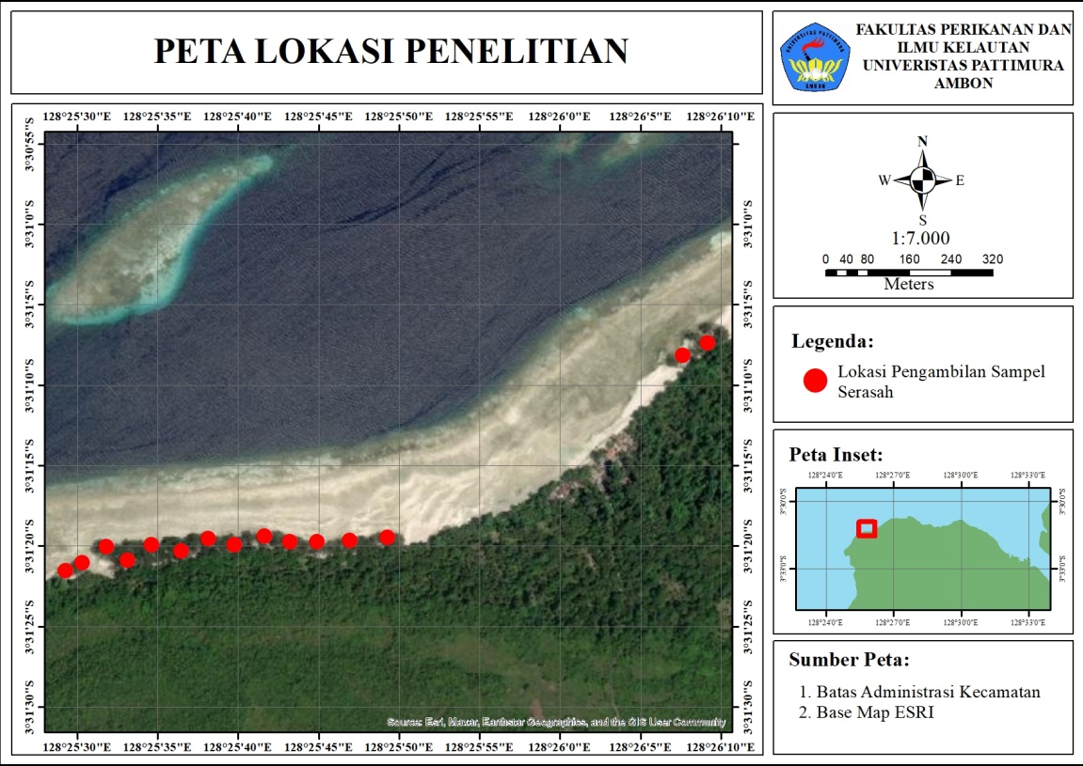

**Fig. 1. Map of Sampling Sites**

* 1. **Data Sampling**

The data collected in this study includes measurement of diameter at breast height (DBH = 130 cm) and mangrove litterfall production across a range of DBH values. DBH was measured at a height of 130 cm above ground, following the method outlined by Bengen *et al*. (2022), as illustrated in Figure 2.

Litterfall sampling was conducted using litter traps made of netting material, measuring 170 × 100 cm². The litter traps were placed beneath the canopy of Sonneratia alba mangrove trees at fifteen stands with varying diameters. The traps were set up during the daytime, and the collected litterfall was retrieved the following day.

The litter collection process lasted for three days. On the first day, seven litter traps were placed. On the second day, litter was collected from the seven traps, and eight new traps were set. On the third day, litter was collected from the eight traps, and the wet weight of each litterfall fraction—including leaves, fruits, and twigs of S. alba—was measured. Wet weight measurements were taken using a digital scale with a precision of 0.001 grams. The placement of litter traps follows the method described by Rahman *et al*. (2020a), as shown in Figure 3.

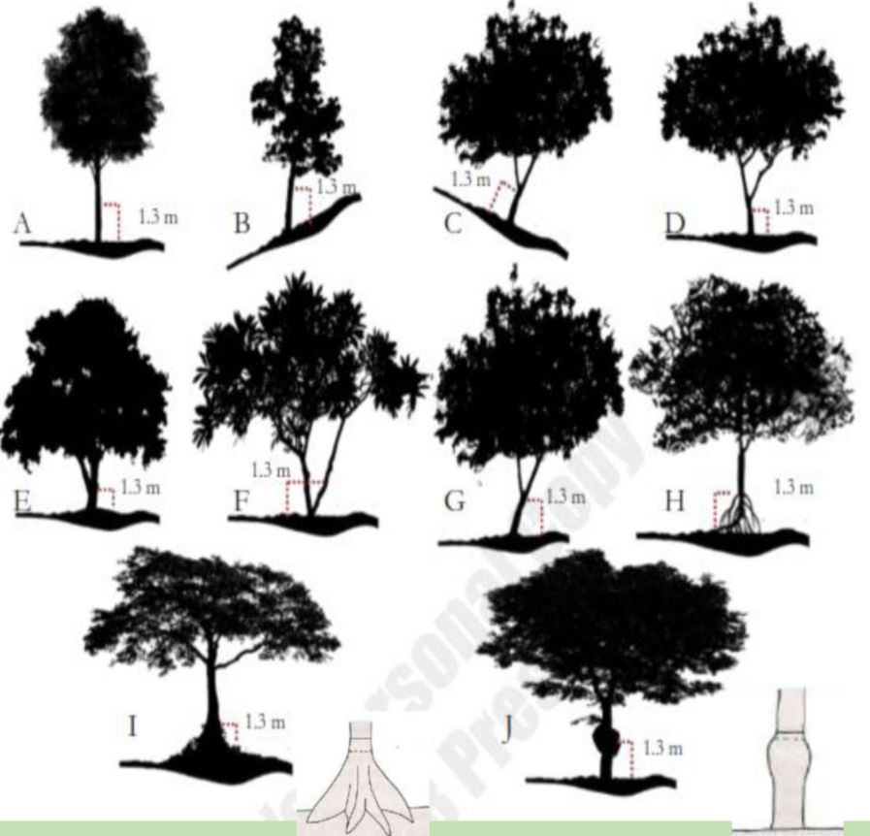

**Fig. 2. Methods to Measurement of Mangrove DBH (Bengen *et al., 2022*).**

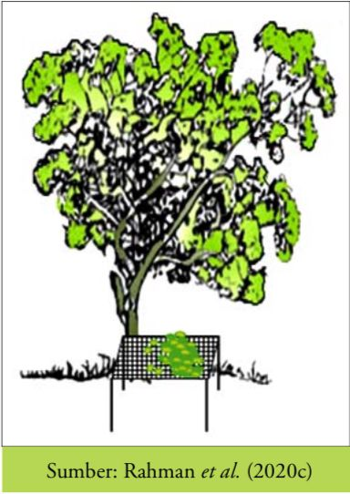

**Fig. 3. Design of Litter Trap (Rahman *et al*., 2020)**

* 1. **Data Analysis**
     1. ***Dry Weight***

After determining the wet weight of each litterfall fraction, the next step was to analyze the dry weight using an oven-drying method. Litterfall subsamples were dried in an oven at 150 °C for 4 hours until a constant weight was achieved. Dry weight measurements were recorded after the drying process to ensure sample stability.

The dry weight of litterfall from undried subsamples was calculated using the following equation:

* + 1. ***Biomass Fraction***

The biomass fraction (%) was determined as the percentage ratio of dry weight to wet weight. The biomass fraction analysis equation follows Rahman *et al.* (2020a) and is expressed as follows:

* + 1. ***Biomass Production***

After determining the biomass fraction, the daily litterfall or biomass production can be formulated as follows:

$$BP (g/m^{2}/hari) = \frac{DoBP x BF}{At}$$

Where:

BP = Biomass Production (g/m2/day)

DoBP = Daily Wet Weight Production of Litterfall (g/day)

BF = Biomass Fraction

At = Litter Trap Area (m2)

* + 1. ***Carbon Production***

The potential for carbon production is determined by multiplying biomass production with the carbon fraction value of Sonneratia alba, which is 0.471 (Kauffman *et al*., 2011; Rahman *et al.,* 2023). Mathematically, this can be expressed as follows:

Carbon Production (gC/m2/day) = Biomass Production (g/m2/day) x 0.471

1. **RESULT AND DISCUSSION**
   1. **Dry Weight**

Table 1 presents the relationship between tree diameter at breast height (DBH) and the dry weight of three litterfall components: leaves, twigs, and fruits. In general, leaf dry weight varies significantly, with the highest value of 9.19 grams recorded at a DBH of 27.07 cm and the lowest value of 1.04 grams at a DBH of 17.20 cm. The absence of a consistent pattern between DBH and leaf dry weight suggests that leaf litter production is not solely dependent on tree size but is also influenced by other factors such as environmental conditions, seasonal variations, and tree growth phases (Lugo & Scatena, 1996).

For the twig component, the dry weight is generally lower than that of leaves, with the highest value of 2.85 grams observed at a DBH of 20.38 cm and the lowest at 0.41 grams for a DBH of 28.66 cm. Some DBH classes exhibit relatively low twig dry weight, such as 12.10 cm (0.69 grams) and 30.25 cm (0.55 grams). This indicates that twig litterfall may not occur uniformly across trees and could be affected by external factors such as wind, rainfall, and tree health (Chave *et al*., 2003). Additionally, for the DBH of 7.96 cm, there is no available data (n.a), which may be due to the absence of twigs in the collected sample.

The fruit litterfall shows a more irregular distribution compared to leaves and twigs. The highest dry weight for fruits is 4.21 grams at a DBH of 44.59 cm, while several DBH classes, including 13.69 cm, 17.20 cm, and 28.34 cm, have values of zero, indicating no fruit litterfall was recorded in these samples. This suggests that fruit production is influenced by tree reproductive cycles, which vary between individuals, and factors such as tree maturity, genetic variation, and environmental conditions (Eisenlohr *et al*., 2013). Unlike leaves and twigs, which are shed regularly, fruit litterfall is often seasonal and depends on specific reproductive phases of the tree species.

Overall, the data in Table 1 indicate no direct correlation between tree diameter and the amount of dry litterfall produced. Litterfall production is likely influenced by a combination of factors such as tree age, environmental conditions, and seasonal patterns. Larger trees do not necessarily produce more litter than smaller ones. Further analysis is needed to better understand the mechanisms driving litter production, including nutrient availability, rainfall patterns, and photosynthetic efficiency, which are known to impact biomass production in forest ecosystems (Vitousek, 1984).

**Table 1. Dry Weight of Mangrove Litter Based on DBH**

|  |  |  |  |
| --- | --- | --- | --- |
| DBH (cm) | Dry Weight (g) | | |
| Leaf | Twig | Fruit |
| 7.96 | 3.99 | n.a | 3.81 |
| 9.55 | 1.78 | 1.86 | 1.32 |
| 11.46 | 6.10 | 1.65 | 1.93 |
| 12.10 | 1.90 | 0.69 | 1.19 |
| 13.69 | 1.64 | 0.77 | 0.00 |
| 17.20 | 1.04 | 0.54 | 0.00 |
| 19.11 | 1.88 | 0.57 | 1.19 |
| 20.38 | 4.08 | 2.85 | 2.76 |
| 22.29 | 2.41 | 1.50 | 0.00 |
| 25.80 | 3.40 | 1.15 | 0.00 |
| 27.07 | 9.19 | 1.78 | 2.21 |
| 28.34 | 2.71 | 1.25 | 0.00 |
| 28.66 | 2.18 | 0.41 | 0.00 |
| 30.25 | 2.72 | 0.55 | 0.00 |
| 44.59 | 2.00 | 0.73 | 4.21 |

* 1. **Biomass Fraction**

The biomass fraction of Sonneratia alba litter represents the ratio between the dry weight and wet weight of each litter component, namely leaves, twigs, and fruits. Based on the figure above, twigs have the highest biomass fraction, around 53.42%, while leaves and fruits have lower values, approximately 27.28% and 26.83%, respectively (Figure 4). This indicates that twigs contain less water than leaves and fruits, possibly due to differences in tissue structure and a higher lignin content (Alongi, 2018).

The high biomass fraction of Sonneratia alba twigs suggests that this component is more resistant to initial decomposition due to its high proportion of rigid materials such as lignin and cellulose. A study by Robertson & Alongi (1992) states that litter rich in lignin tends to decompose more slowly, contributing to carbon accumulation in mangrove ecosystems. Therefore, twigs may play a more significant role in mangrove carbon cycling compared to leaves and fruits, which decompose more quickly.

In contrast, leaves have a lower biomass fraction than twigs, indicating a higher water content. This is consistent with previous studies showing that mangrove leaves generally retain more water than other plant parts, making them more susceptible to microbial and detritivore decomposition (Kristensen *et al*., 2008). The rapid decomposition of Sonneratia alba leaves facilitates nutrient release into the surrounding water, supporting primary productivity in coastal ecosystems.

Similarly, Sonneratia alba fruits have a relatively low biomass fraction, comparable to leaves. This may be related to their high-water content, which significantly affects their wet weight. Mangrove fruits often decompose faster due to their softer structure and rich nutrient content, making them an attractive food source for various litter-decomposing organisms (Twilley *et al*., 1997). Thus, fruits serve as an essential energy source for detritivore communities and play a role in the mangrove ecosystem’s food chain.

Overall, the biomass fraction pattern of Sonneratia alba litter reflects variations in structure and water content among different plant components. These differences influence decomposition rates and the carbon and nutrient cycling processes in mangrove forests. Further research on environmental factors affecting mangrove litter dynamics could aid conservation efforts and the sustainable management of coastal ecosystems (Alongi, 2014).

**Fig. 4. Biomass Fraction of *Sonneratia alba* Litter in Kailolo Villages, Maluku**

* 1. **Litter Production**

In general, total litter production ranges from 2.26 to 18.83 g/m²/day. The highest value was recorded for a tree with a DBH of 27.07 cm (18.83 g/m²/day), while the lowest was observed in a tree with a DBH of 17.20 cm (2.26 g/m²/day) (Figure 5). This variation suggests a potential relationship between tree size and litter production, aligning with previous findings that trees with larger DBH tend to produce more litter due to their greater foliage and branching (Alongi, 2014).

When analyzed based on litter components, leaves constitute the dominant fraction, ranging from 1.49 to 13.13 g/m²/day. The branch and fruit fractions exhibit smaller variations, with some DBH classes not producing any fruit at all. Leaves dominate litter production because they undergo continuous shedding, whereas branches and fruits tend to fall under specific conditions, such as strong winds or fruiting seasons (Twilley *et al*., 1997).

The total litter production of S. alba in this study can be compared to litter production in other mangrove species across Indonesia. For example, a study in Segara Anakan, Cilacap, reported that mangrove litter production ranged from 3.8 to 14.2 g/m²/day, depending on species and environmental conditions (Sukardjo & Yamada, 1992). In the mangrove forests of Karimunjawa, the litter production of Rhizophora mucronata was recorded at 6.2–11.8 g/m²/day, while Avicennia marina ranged from 2.5 to 7.6 g/m²/day (Adame *et al*., 2018). These values indicate that the S. alba litter production observed in this study is comparable to or even higher than that of some other mangrove species.

Environmental factors such as tidal influence, salinity, and soil conditions can significantly affect mangrove litter production. Previous studies have shown that mangrove litterfall is higher in areas with sufficient nutrient supply and stable hydrological conditions (Komiyama *et al*., 2008). This may explain the observed variations in the data, where some large DBH trees do not always have the highest litter production, possibly due to environmental limitations.

In addition to environmental factors, growth cycles and reproductive strategies also contribute to differences in litter production. S. alba is known for its tolerance to intertidal environments with sandy-muddy substrates, meaning that its litter production may fluctuate depending on seasonal conditions and tree maturity (Clough, 1998). Younger trees or those in an active vegetative growth phase may allocate more energy to growth rather than litter production.

Litter production plays a crucial role in mangrove ecosystems as it serves as a primary source of organic matter for sediments and surrounding waters. Fallen leaves undergo decomposition by microorganisms and contribute to carbon and nutrient cycling (Kristensen *et al*., 2008). The higher litter production observed in certain DBH classes suggests that these trees may be key contributors to organic matter supply, thereby supporting the productivity of adjacent coastal ecosystems.

These findings are also relevant for understanding the role of S. alba in climate change mitigation. High litter production contributes to carbon accumulation in mangrove ecosystems through the storage of organic matter in sediments (Alongi, 2020). Therefore, mangroves with high litter production not only support the coastal food web but also play a significant role in long-term carbon sequestration.

Overall, this study highlights that S. alba litter production varies based on DBH, with leaves being the primary contributor. Compared to other mangrove species in Indonesia, S. alba exhibits competitive litter production, making it a vital component of nutrient cycling in coastal ecosystems. Further studies are needed to understand the specific factors controlling litter production over time and their broader implications for mangrove ecosystem functioning.

**Fig. 5. Litter Production of *S. alba* based on DBH in Kailolo Villages, Maluku**

* 1. **The Potential for Carbon Accumulation in Sediment**

The total carbon input ranges from 1.06 to 8.87 gC/m²/day, with the highest value observed for trees with a DBH of 27.07 cm (8.87 gC/m²/day) and the lowest for trees with a DBH of 17.20 cm (1.06 gC/m²/day) (Figure 6). This variation reflects the influence of tree size on organic matter input to sediment, consistent with previous studies indicating that larger trees contribute more organic material to the ecosystem (Kristensen *et al*., 2008).

Leaf litter contributes the most to carbon accumulation, ranging from 0.70 to 6.18 gC/m²/day, followed by branch and fruit components. Some DBH classes exhibit no fruit contribution, suggesting that fruit fall is seasonal and does not consistently contribute to sediment carbon input. Leaves are the primary source of organic carbon because they decompose gradually, enriching sediment with organic material and promoting microbial activity (Bouillon *et al*., 2008).

When compared to previous studies, the carbon input from S. alba litter in this study aligns with findings from other mangrove forests in Indonesia. For instance, a study in the Segara Anakan mangroves, Indonesia, reported carbon inputs from mangrove litterfall ranging from 3.2 to 9.5 gC/m²/day, depending on species and environmental conditions (Alongi *et al*., 2016). Similarly, research in the mangroves of East Kalimantan found carbon accumulation rates between 2.5 and 8.3 gC/m²/day (Sukardjo & Yamada, 1992). These comparisons suggest that S. alba plays a significant role in carbon sequestration, comparable to other dominant mangrove species.

The variation in carbon accumulation potential is influenced by environmental factors such as tidal dynamics, decomposition rates, and sediment characteristics. Tidal inundation affects the retention and burial of organic carbon, with areas experiencing longer submersion times typically showing higher carbon accumulation due to reduced oxidation (Donato *et al*., 2011). Additionally, sediment grain size and organic matter content influence carbon storage efficiency, where fine-grained sediments tend to retain more carbon than sandy substrates (Mcleod *et al*., 2011).

Litter decomposition rates also determine how much carbon is retained in the sediment. Decomposition is driven by microbial activity, which varies with temperature, salinity, and oxygen availability (Kristensen *et al*., 2008). In anaerobic conditions typical of mangrove sediments, organic matter decomposes slowly, leading to long-term carbon storage. This explains why mangroves are considered effective blue carbon ecosystems, capable of sequestering carbon for centuries (Alongi, 2020).

The findings of this study highlight the ecological importance of S. alba in carbon cycling and storage. The species’ high litter production contributes to organic carbon accumulation, supporting sediment stability and nutrient cycling. These processes are essential for maintaining mangrove ecosystem health and resilience against climate change impacts such as sea level rise (Lovelock & Reef, 2020).

From a conservation and management perspective, maintaining S. alba populations is crucial for enhancing carbon sequestration in coastal ecosystems. Deforestation and degradation of mangrove forests could lead to the release of stored carbon back into the atmosphere, contributing to greenhouse gas emissions (Pendleton *et al*., 2012). Therefore, efforts to protect and restore mangroves, particularly species with high litter production like S. alba, are vital for mitigating climate change.

In conclusion, the study demonstrates that S. alba contributes significantly to sediment carbon accumulation, with variations observed across DBH classes. Compared to other mangrove species in Indonesia, its carbon input potential is substantial, reinforcing the species' role in coastal carbon sequestration. Future research should explore long-term carbon burial rates and the influence of external environmental factors on carbon dynamics to strengthen mangrove conservation strategies.

**Fig. 6. The Potential for Carbon Accumulation in Sediment Based on Litter Production of *S. alba* in Kailolo Villages, Maluku**

**CONCLUSION**

This study highlights the significant role of Sonneratia alba in carbon sequestration through its litterfall production in the mangrove ecosystem of Kailolo Village, Maluku. Litterfall production varied across tree sizes, with leaves being the dominant contributor to sediment carbon accumulation. The highest litterfall and carbon input were observed in trees with a DBH of 27.07 cm. Environmental factors, including tidal influence and seasonal variations, affected litterfall dynamics. These findings emphasize the importance of mangrove conservation for climate change mitigation. Sustainable management of S. alba is crucial for maintaining carbon storage capacity and ecosystem resilience in coastal environments.

**DISCLAIMER (ARTIFICIAL INTELLIGENCE)**

Author(s) hereby declare that NO generative AI technologies such as Large Language Models (ChatGPT, COPILOT, etc) and text-to-image generators have been used during writing or editing of this manuscript.

## **AVAILABILITY OF DATA AND MATERIALS**

The datasets generated and analyzed during the current study are available from the corresponding author on reasonable request.

**REFERENCES**

Alongi, D. M. (2014). Carbon cycling and storage in mangrove forests. *Annual Review of Marine Science*, 6, 195-219.

Alongi, D. M. (2018). Blue carbon: Coastal sequestration for climate change mitigation. *Springer*.

Bouillon, S., Borges, A.V., [Castañeda-Moya](https://agupubs.onlinelibrary.wiley.com/authored-by/Casta%C3%B1eda%E2%80%90Moya/Edward), E., et al. (2008). Mangrove production and carbon sinks: A revision of global budget estimates. *Global Biogeochemical Cycles*, 22(2), GB2013.

Chave, J., Andalo, C., Brown, S., Cairns, M. A., Chambers, J. Q., Eamus, D., ... & Yamakura, T. (2005). Tree allometry and improved estimation of carbon stocks and balance in tropical forests. *Oecologia, 145*(1), 87-99.

Clough, B. (1998). Mangrove forest productivity and biomass accumulation in Hinchinbrook Channel, Australia. *Mangroves and Salt Marshes*, 2, 191-198.

Donato, D. C., *et al*. (2011). Mangroves among the most carbon-rich forests in the tropics. *Nature Geoscience*, 4(5), 293-297.

Eisenlohr, P. V., Alves, L. F., Bernacci, L. C., Padgurschi, M. C. G., Torres, R. B., & Martins, F. R. (2013). Forest structure and floristic composition along a successional gradient of lowland Atlantic Forest in southeastern Brazil. *Biota Neotropica, 13*(2), 87-98.

Huxham M, Kairu A, Lang’at JK, Kivugo R, Mwafrica M, Huff A, Shilland R. 2023. Rawls in the mangrove: Perceptions of justice in nature-based solutions projects. People and Nature. 3: 1-15.

Kauffman, J.B., Heider, C., Cole, T., Dwire, K.A., & Donato, D.C. (2011). Ecosystem C pools of Micronesian mangrove forests. Wetlands. 31(2):343–352. doi: 10.1007/s13157-011-0148-9.

Kesaulya I, Rahman, Haumahu S, Krisye. 2023. Global warming potential of carbon dioxide and methane emissions from mangrove sediments in Waiheru Coastal, Ambon Bay. IOP Conference Series: Earth and Enviromental Science. 1207(1), 012030.

Komiyama, A., Ong, J. E., & Poungparn, S. (2008). Allometry, biomass, and productivity of mangrove forests: A review. *Aquatic Botany*, 89(2), 128-137.

Kristensen, E., Bouillon, S., Dittmar, T., & Marchand, C. (2008). Organic carbon dynamics in mangrove ecosystems: A review. *Aquatic Botany*, 89(2), 201-219.

Kusumaningtyas MA, Hutahaean AA, Fischer HW, Perez-Mayo M, Ransby D, Jennerjahn TC. 2019. Variability in the organic carbon stocks, source, and accumulation rates of Indonesian mangrove ecosystems. Estuarine, Coastal, and Shelf Science. 218: 310-323.

Kusmana C, Hidayat T, Tiryana T, Rusdiana O and Istomo. 2018. Allometric models for above – and bellow – ground biomass of *Sonneratia* spp. Global Ecololy and Conservation. 15: 1-13. <https://doi.org/10.1016/j.gecco.2018.e00417>

Lugo, A. E., & Scatena, F. N. (1996). Background and catastrophic tree mortality in tropical moist, wet, and rain forests. *Biotropica, 28*(4), 585-599.

Lovelock, C. E., & Reef, R. (2020). Variable impacts of climate change on mangrove carbon stocks. *New Phytologist*, 225(1), 9-12.

McLeod, E., *et al*. (2011). A blueprint for blue carbon: Toward an improved understanding of the role of vegetated coastal habitats in sequestering CO₂. *Frontiers in Ecology and the Environment*, 9(10), 552-560.

Murdiyarso D, Purbopuspito J and Kauffman J. *et al*. 2015. The potential of Indonesian mangrove forests for global climate change mitigation. Nature Climate Change 5, 1089–1092. <https://doi.org/10.1038/nclimate2734>

Pendleton, L., *et al*. (2012). Estimating global “blue carbon” emissions from conversion and degradation of vegetated coastal ecosystems. *PLoS ONE*, 7(9), e43542.

Rahman, Maryono, Sigiro ON. 2023. What is the true carbon fraction value of mangrove biomass. Malaysian Journal of Science 42:67-72.

Rahman, Wardiano Y, Yulianda F, Rusmana I. (2020a). Seasonal litter production in various mangrove species on the coast of West Muna Regency, Southeast Sulawesi. Indonesian Journal of Agricultural Sciences 25(3): 325-335.

Rahman, Wardiatno Y, Yulianda F, Rusmana I. (2020b). Seasonal fluxes of CO2 , CH4 and N2O greenhouse gases in various mangrove species on the coast of West Muna Regency, Southeast Sulawesi, Indonesia. *Plant Archives*.20(2): 4301 – 4311.

Rahman, Lokollo FF, Manuputty GD, Hukubun RD, Krisye, Wawo M, Wardiatno Y. (2024a). A review on the biodiversity and conservation of mangrove ecosystems in Indonesia. Biodiversity and Conservation 33, 875-903. <https://doi.org/10.1007/s10531-023-02767-9>

Rahman, Ceantury A, Tuahatu JW, Lokollo FF, Supusepa J, Hulopi M, Permatahati YI, Lewerissa A, Wardiatno Y. (2024b). Mangrove ecosystem in Southeast Asiaregion: mangrove extent, blue carbon potential and CO2 emission in 1996-2020. *Science of the Total Environment* 915(3): 1-12. <https://doi.org/10.1016/j.scitotenv.2024.170052>

Rahman, R., Nazar, F., Lokollo, F.F., Supusepa, J., Asni, A., Borut, R.R, Loupatty, S.R., & Maryono (2025). Methane (CH₄) fluxes in mangrove sediments of Negeri Passo, Inner Ambon Bay: implications for climate change. Asian Journal of of Research in Agriculture and Forestry, 11(1), 143 – 152.

Robertson, A. I., & Alongi, D. M. (1992). Tropical mangrove ecosystems. *American Geophysical Union*.

Sidik F, Lawrence A, Wagey T, Zamzani F, Lovelock CE. 2023. Blue carbon: A new paradigm of mangrove conservation and management in Indonesia. *Marine Policy.* 147: 1-9.

Sukardjo, S., & Yamada, I. (1992). Biomass and productivity of a mangrove forest in East Kalimantan, Indonesia. *Tropical Ecology*, 33(1), 1-10.

Tubalawony S, Mailoa MN, Rahman, Pasanea K. 2024. Fluxes of methane gases (CH4) in sediments of mangrove and seagrass ecosystems in Tanjung Tiram, Ambon Bay, Indonesia. Egyptian Journal of Aquatic Biology and Fisheries. 28(4): 951-963.

Twilley, R. R., Chen, R. H., & Hargis, T. (1997). Carbon sinks in mangroves and their implications to carbon budget of tropical coastal ecosystems. *Water, Air, and Soil Pollution*, 99(1-4), 265-288.

Vitousek, P. M. (1984). Litterfall, nutrient cycling, and nutrient limitation in tropical forests. *Ecology, 65*(1), 285-298.