**Case report**

**Rare Case of Littre Hernia Complicated by Perforated Meckel's Diverticulum, A radiological Challenge: a case report and review of the literature.**

**Abstract**

**Background:** Littre's hernia, characterized by the presence of Meckel's diverticulum within the hernial sac, is an uncommon condition. The combination of an incarcerated Littre's hernia and perforation of Meckel's diverticulum is exceptionally rare, adding to the novelty and clinical interest of this case.

**Case Presentation:** We report the case of a 76-year-old female who presented with painful paraumbilical swelling and signs of inflammation. The patient, with a past medical history including diabetes, dyslipidemia, and hypertension, was initially diagnosed with an incarcerated paraumbilical Littre's hernia based on clinical examination and radiological findings. During open hernia repair, the hernial sac was found to contain omentum, ileum, and a perforated Meckel's diverticulum caused by a fish bone. The patient subsequently underwent a segmental bowel resection and primary repair of the hernial defect. She had an uneventful postoperative hospital course and was appropriately discharged.

**Conclusions:** This case highlights a rare and complicated presentation of Littre's hernia with a perforated Meckel's diverticulum. It underscores the importance of clinical vigilance and timely surgical intervention to manage such complex cases effectively. Further documentation and study of similar cases could enhance understanding and inform future treatment strategies.

**Keywords**

Littre's hernia, Meckel's diverticulum, perforation, case report, surgery, abdominal pain

**Introduction**

Meckel's diverticulum (MD) is a common congenital malformation of the gastrointestinal tract, typically found in 2%-4% of the population. It occurs due to the persistence of the vitello-intestinal duct, which connects the yolk sac to the fetal circulation during early embryonic development. Normally, this connection should disappear as the fetal intestine separates from the yolk sac around the 5th-6th weeks of embryonic development. When this connection persists abnormally, it can lead to various vitteline abnormalities, with MD being the most prevalent [1][2].

While MD is the most common gastrointestinal congenital malformation, it is usually asymptomatic in adults. Symptoms may only arise when complications occur, such as intestinal obstruction, gastrointestinal bleeding, inflammation, perforation, or malignant degeneration. One rare complication, occurring in only 1% of cases, is Littre's hernia (LH), which results from a MD protruding through an abdominal opening due to its location on the antimesenteric border of the ileum [3].

Diagnosing symptomatic MD can be challenging, especially in adults. Common symptoms include unexplained abdominal complaints, nausea, vomiting, or intestinal bleeding. Plain radiographs are not sufficient for diagnosis, and arteriography may not always be conclusive due to variations in arterial supply. Technetium-99m pertechnetate scanning is considered the most effective method for detecting MD [4][3].

Treatment for symptomatic MD typically involves surgical resection. However, managing incidentally discovered MD remains a topic of debate in the medical community[1].

This case study present a 76-year-old female patient presenting with a painful swelling in the umbilical region revealed an incarcerated paraumbilical hernia containing a perforated MD. Surgeons successfully performed a segmental resection of the bowel to manage the condition.

**Case presentation**

A 76-year-old middle eastern female presented to the Emergency Department at Adan Hospital with a 24-hour evolution of abdominal pain over a 2 years old protrusion in the umbilical region. The pain had an insidious onset and increasing severity. It was associated with fluctuating fever, nausea, dysuria and decreased oral intake. No defecation disorders or vomiting were mentioned.

Upon further history, the patient underwent right paraumbilical hernia repair in 2021. She developed an abscess at the site of surgery and was treated conservatively, however further details about the operation couldn’t be obtained as the patient was following with a different hospital. According to the family she had had the protrusion since then. In 2019, she underwent surgery for a right femur fracture which led to her being bedridden. Additionally, her past medical history included controlled hypertension, type 2 diabetes, and dyslipidemia.

During physical examination, her abdomen was found to be soft with a paraumbilical irreducible firm swelling, measuring about ~ 4x3 cm. The skin above was warm, red, tender and slightly stretched. An old transverse right paraumbilical incision scar was also noticed. There were no signs of hepatomegaly or ascites. Inguinal and femoral orifices were normal.

She was vitally stable, afebrile, and initial investigations including complete blood count (CBC), liver function test (LFT) and urine routine were all within normal. She only had slightly elevated urea of 15 mmol/L and creatinine of 104 mmol/L. Ultrasonography of the abdomen was performed and showed the presence of umbilical hernia with omental fat and bowel loops content. In addition to a suspected curvilinear echogenic foreign body seen intraluminal in the herniated bowel loop, extending to the extra luminal region and surrounded with subcutaneous extra luminal air locules. CT scan of the abdomen revealed a large para-umbilical hernia containing small bowel and showing subcutaneous mixed fluid/fat strandings measuring 5x3 cm with no signs of bowel obstruction (Figure 1).

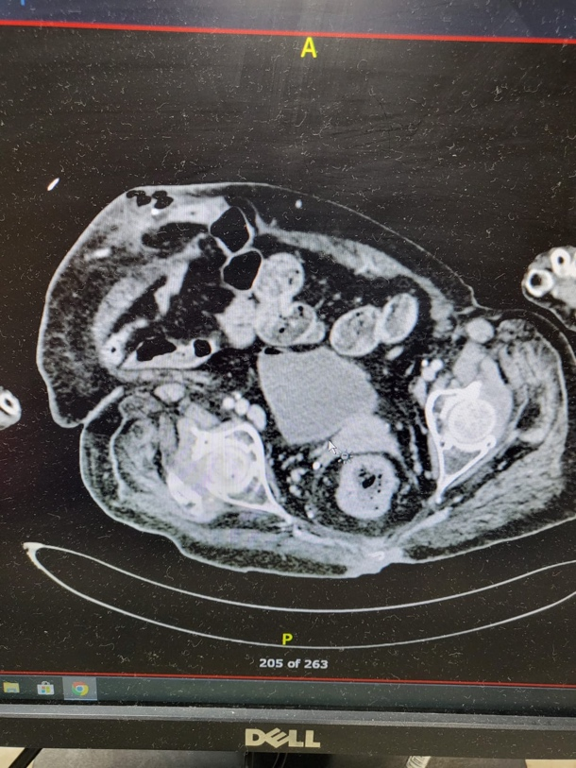

**Figure 1-CT scan of the abdomen showed large para umbilical hernia (arrow)**

A presumed diagnosis of incarcerated paraumbilical hernia with a bowel perforation was then established and she was submitted to open repair. The patient underwent exploration under general anesthesia. She was found to have incarcerated paraumbilical LH containing: omentum, part of the small bowel loop and MD which were both perforated. The foreign body was identified as an intact fish bone (Figure 2).

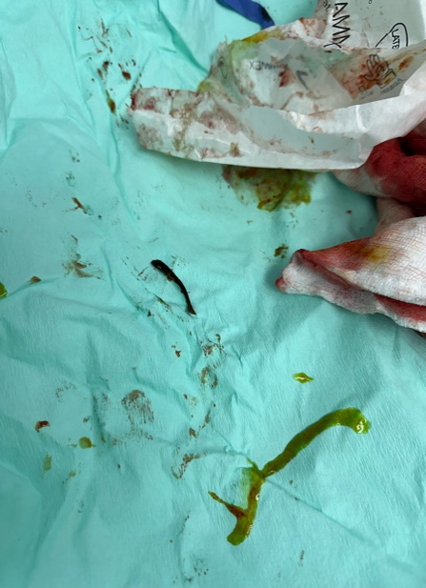

**Figure 2-Foreign body identified as a fish bone (arrow)**

Segmental resection was done to the ileum about 40 cm from the ileocecal valve (Figure 3). After the segmental resection surgeons did end-to-end anastomosis. Then hemostasis was donemeticulously and 2 drains were inserted.

The post-operative course was uneventful, and the patient was discharged on the 10th postoperative day after drains removal. She followed up in the outpatient clinic and there were no symptoms of recurrence of the swelling.

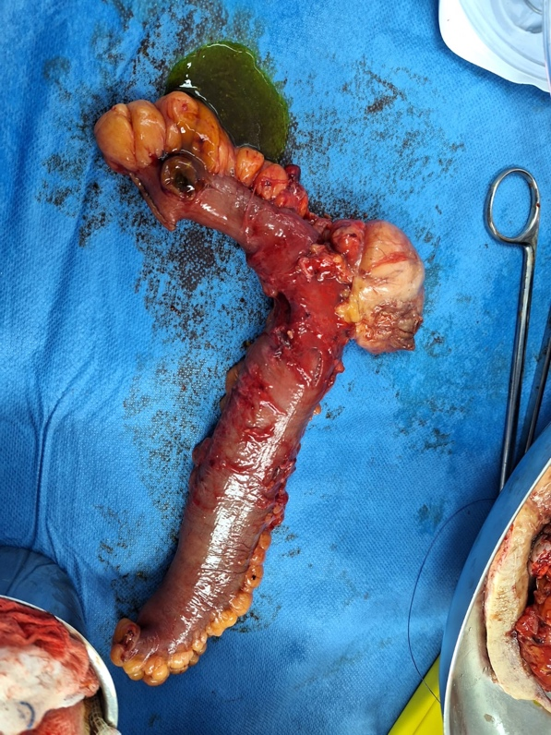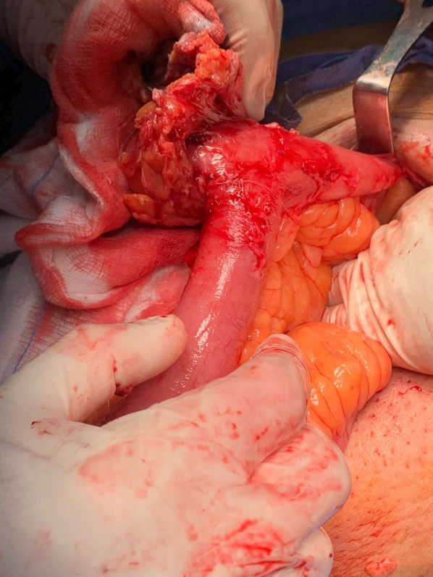

**A B**

Figure 3- (A)**Intraoperative image and (B)** resected **small bowel loop**

Histopathology report released on day 5 post operation with the following impression: PUH shows extensive ischemic necrosis with superadded suppurative inflammation. No evidence of atypia consistent with clinical history of incarceration. Mucosa shows hemorrhage and superficial epithelial necrosis consistent with early ischemic changes. Both resection margins are viable and free of inflammation

**Discussion**

Approximately 50% of the LH cases occur in the inguinal region, with 20% in the femoral region, 20% in the umbilical region, and the remaining 10% in other locations. The incidence of LH presenting in complicated abdominal hernias is reported to be 0.6%. LH can develop through a primary defect in the abdominal wall or as a ventral hernia following previous surgery [3]. Our patient had a para umbilical incarcerated LH.

In the case of LH there are two classes, those containing only a MD are classified as true LH, while the presence of small bowel and other abdominal viscera within the hernia sac defines a mixed LH [5]. In our case report, the patient presented with a mixed LH, intraoperatively revealed the presence of a MD, omentum, and ileal loop.

Meckel's diverticulum (MD) is a common yet intriguing gastrointestinal congenital malformation. Despite its prevalence, this condition remains rare and typically silent in adults. MD often lurks unnoticed, only to be stumbled upon incidentally during surgery or imaging procedures. However, in a small percentage of cases (4 to 7%), the diagnosis of MD is unmasked by troublesome complications [6]. These complications can range from intestinal obstruction to gastrointestinal bleeding, inflammation, perforation, and even malignant transformation. LH, an exceptionally uncommon complication of MD, adds another layer of complexity to this intricate medical tapestry. Due to its unique location stemming from the anti mesenteric border of the ileum, MD has a penchant for protruding through various abdominal openings [3]. The majority of individuals experiencing MD related complications are male. Notably, extensive retrospective analyses involving over 100 patients in each series have shown a male-to-female gender ratio ranging from 1.5:1 to 4:1 [7].

In our remarkable case, a female presented para umbilical LH unveiled a perforated MD caused by an unexpected fish bone encounter. This convergence of events represents a rare fusion of two complications - a LH with a perforated offering a compelling narrative in the realm of medical phenomena.

The enigmatic nature of LH poses a diagnostic challenge, as preoperative identification remains elusive due to their rarity and the lack of distinct radiological and clinical features. Despite the strides in radiological imaging, accurately pinpointing a LH and distinguishing it from other hernias remains an unattainable feat. While various imaging modalities can aid in diagnosing MD, their sensitivity and specificity in detecting this anomaly are notably limited [3].In our patient’s case, two radiological studies were diligently performed, yet both failed to reveal any evidence of MD. Ultimately, the definitive diagnosis was unveiled only through intraoperative exploration, underscoring the intricate diagnostic journey associated with LH and their elusive nature in the field of medical imaging.

When it comes to hernia repair, utilizing a mesh is considered the gold standard for addressing LH in adults. However, in situations where there is ischemia or perforation of the small bowel, the use of mesh should be avoided to mitigate the risk of mesh infection. In cases where the MD shows no edema or inflammation at its base, resection with transverse closure of the ileum is recommended to prevent postoperative ileal stenosis.

If signs of ischemia, inflammation, perforation, or macroscopic ectopic tissue are present at the base of the MD, a segmental resection of the small intestine with anastomosis is warranted [8]. In our patient's case, an emergency open hernia repair was performed, along with segmental enterectomy and primary side-to-side anastomosis. As of the present date, the patient continues to recover without any postoperative complications.

**Conclusion**

In conclusion, LH is a highly uncommon complication of MD. Its preoperative diagnosis poses challenges due to the lack of specific radiological findings and clinical presentation. It is imperative for all surgeons to be vigilant about this type of hernia to prevent potentially fatal complications.

**Declarations**

**Ethical Approval**

This case report was conducted in accordance with the ethical standards of Research Ethical Committee, Ministry Of Health, Kuwait, and the Helsinki Declaration of 1975, as revised in 2008.

**Patient Consent**

Written informed consent was obtained from the patient involved in this case report for the publication of this report and any accompanying images. A copy of the written consent is available for review by the Editor-in-Chief of the Journal of Medical Case Reports.

**Data Availability**

Data sharing is not applicable to this article as no datasets were generated or analyzed during the current study.

**Originality**

This case report has not been published elsewhere and is not under consideration by any other publication.

**References**

1. Fusco, J. C., Achey, M. A., & Upperman, J. S. (2022). Meckel’s diverticulum: Evaluation and management. Seminars in Pediatric Surgery, 31(1), 151142. https://doi.org/10.1016/j.sempedsurg.2022.151142
2. Sagar J, Kumar V, Shah DK. Meckel's diverticulum: a systematic review. J R Soc Med. 2006 Oct;99(10):501-5. doi: 10.1177/014107680609901011. Erratum in: J R Soc Med. 2007 Feb;100(2):69. PMID: 17021300; PMCID: PMC1592061.
3. Evola, G., Piazzese, E., Bonanno, S., Di Stefano, C., Di Fede, G. F., & Piazza, L. (2021). Complicated Littre’s umbilical hernia with normal Meckel’s diverticulum: A case report and review of the literature. International Journal of Surgery Case Reports, 84, 106126. <https://doi.org/10.1016/j.ijscr.2021.106126>
4. Martin, J. P., Connor, P. D., & Charles, K. (2000). Meckel's diverticulum. American family physician, 61(4), 1037–1044.
5. Matias, M. R. A., Kronberga, M., & Aghahoseini, A. (2021). Complicated Littre hernias. International Journal of Abdominal Wall and Hernia Surgery, 4(3), 83. https://doi.org/10.4103/ijawhs.ijawhs_26_21
6. Lequet, J., Menahem, B., Alves, A., Fohlen, A., & Mulliri, A. (2017). Meckel’s diverticulum in the adult. Journal of Visceral Surgery, 154(4), 253–259. https://doi.org/10.1016/j.jviscsurg.2017.06.006
7. Hansen, C., & Søreide, K. (2018). Systematic review of epidemiology, presentation, and management of Meckel’s diverticulum in the 21st century. Medicine, 97(35), e12154. https://doi.org/10.1097/md.0000000000012154
8. Khalifa, M. B., Belaid, A. B., Ghannouchi, M., Nacef, K., Fodha, M., & Boudokhane, M. (2024). Umbilical Littre hernia: A rare case report of an acute abdomen. International Journal of Surgery Case Reports, 114, 109182. <https://doi.org/10.1016/j.ijscr.2023.109182>