**Influence of different type and levels of fertilizer application on biomass and essential oil yield of *Cymbopogon schoenanthus*** ***(lemon grass)* in Togo**

**Abstract:**

Due to its biological properties, *Cymbopogon schoenanthus* (L) Spreng is important in traditional medicine, pharmacology and, more particularly, agronomy as an alternative to synthetic chemical pesticides. Controlling the conditions under which it is grown can increase biomass production, and hence essential oil yields. The aim of the present study was to evaluate the influence of different doses of organic and mineral fertilizer application on biomass and essential oil yields of *C. schoenanthus* (L). The plot was set up in a randomized complete block design with five objects in three replications. Treatments consisted of increasing doses of poultry droppings (5t/ha and 10t/ha), 46% urea (0.05t/ha and 0.1t/ha) and the absolute control. The best yields, in fresh biomass (8.78t/ha), dry biomass (3.21t/ha) and essential oil (69.09l/ha), were obtained with the poultry manure treatment at 10t/ha, then increased at the second and third cuts. Fertilizers did not influence the number of leaves per tillers. On the basis of these results, the use of poultry droppings at a dose of 10t/ha could be recommended in programs to promote *C. schoenanthus* production.



**Key words:** *Cymbopogon schoenanthus*, fertilization, essential oil, biomass yield, southern Togo.

**Introduction**

A predominantly agricultural country, Togo, like other African countries, has for several years opted for crop diversification. Despite this diversification, the agricultural sector is struggling to meet the population's food requirements and to generate the income needed to kick-start the economic and social development of rural populations. This is due to very low yields as a result of various production constraints, including crop attacks by pathogens (bacteria, viruses, fungi) and pests (insect pests) (Déclert, 1990). Synthetic chemical pesticides are widely used by farmers to protect crops against pests. Thus, for decades we have witnessed the massive and uncontrolled use of these products, which in addition to their effectiveness, have generated undesirable consequences such as pest resistance, environmental pollution, various pathologies (cancers, congenital malformations in humans etc.) (Anonymous, 2012). In this situation, various approaches such as biological control, varietal control and the use of plant extracts with insecticidal properties are the subject of numerous studies. Some of these approaches are already used by farmers (use of ash, neem, resistant varieties, etc.). Indeed, in our ecosystem, nature offers us various plants with insecticidal or repellent properties. Extracts from plants such as neem, laurel, eucalyptus, chilli pepper, etc. have been tested in the fight against insect pests of crops or post-harvest products. *Tephrosia* sp species contain several substances recognized as toxic and deterrent to insects (Simmonds *et al.,* 1990). Similarly, *Hyptis suaveolens* (Lamiales: lamiaceae) has been shown to possess insecticidal properties (Perry, 1980; Fatope *et al.,* 1995). Studies have also shown that *Cympobogon. schoenanthus* (L) has numerous properties recognized in traditional medicine (Hammiche et Maiza., 2006; Marwat *et al.,* 2009). In agronomy, work has shown its effectiveness on a wide range of pests such as bacteria and fungi (Koba *et al.,* 2004); termites (Koba *et al.,* 2007); Plutella xyllostella (Laba *et al.,* 2012) and stage II larvae of *Dysdercus voelkeri* (Nadio *et al.,* 2013). Despite its biological properties, *C. schoenanthus* remains undeveloped due to insufficient knowledge on the influence of organic and mineral fertilizer doses on its yields. Thus, the present work aims to evaluate: "the influence of different doses of organic and mineral fertilizers on the biomass and essential oil yield of *C. schoenanthus* at the Lomé agronomic experimentation station (SEAL/UL)".

**1. Materials and methods**

**1.1. Study area**

The trials in this study were carried out at the Station d'Expérimentations Agronomiques de Lomé (SEAL) and the extraction of *C. schoenanthus* essential oil was carried out at the Laboratoire de Recherche sur les Agroressources et la Santé Environnementale (LARASE) of the Ecole Supérieure d'Agronomie de l'Université de Lomé (ESA-UL).

SEAL is located in the south-west between 6°08'11'' north latitude and 1°12'45'' east longitude. It is 100 m northwest of the Ecole Supérieure d'Agronomie de l'Université de Lomé, between 6°22' north latitude and 1°13' east longitude, at an average altitude of 50 m. The soil, a ferralitic type with a pH between 5.2 and 5.8, is obtained over time from continental deposits and is referred to locally as "Terre de Barre" (Detchinli *et al.,* 2017). It is well drained and has a low organic matter content (< 10 g kg-1). The experimental soil has a slope of less than 1% and is located in the Guinean savannah zone under a tropical climate with a bimodal rainfall regime (Detchinli *et al.,* 2017). The Station d'Expérimentations Agronomiques de Lomé enjoys an equatorial Guinean climate. Annual rainfall varies between 800 and 1100 mm.

**1.2. Hardware**

Plant material used is specifically slivers from strains of Indian verbena, *C. schoenanthus*. These were harvested from old experimental plots and transplanted to the new plots set up for the study.

Essential oil extraction equipment, consists of laboratory equipment. Essential oil extraction was carried out using the Clevenger device, whose main components are as follows: Balloon heater 15cm in diameter; Balloon, volume 500ml and thermo-cryostat brand LAUDA ECOSILVER capacity 8 liters extraction system, ball cooler.

**1.3. Methods**

A complete randomized block design with five treatments in three (03) replications was used for the experiment. The trial is made up of 15 experimental units measuring 4 m x 8 m with a 0.8 m x 0.8 m cultivation pattern. Blocks and experimental units are separated by 1m-wide aisles.

**1.3.1. Replanting and maintenance**

Transplanting was carried out on the experimental plot, which had been ploughed flat and levelled after a heavy rain. The cropping pattern adopted was 0.8 x 0.8m, i.e. 15625 plants per hectare. The *C. schoenanthus* clumps were split into small clumps of 14 tillers on average. These splinters were then transplanted into the holes up to 2/3 of their length, after removing the leaves and cutting the roots to obtain splinters about 15cm long. Small hollows were made around each foot of the transplanted plants to facilitate water retention after each watering and conserve moisture under the plants. Water was supplied directly under the plants using a hose with a watering can attached to one end and a tap at the other. Hoeing was carried out every week under the plants to facilitate water infiltration and soil aeration, and speed up plant recovery. Weeding was carried out according to the amount of weed present.

**1.3.2. Manure application**

The fertilizer was applied two weeks after the seedlings had taken root (6 weeks after transplanting). The doses of manure applied per plant were calculated as the ratio between the dose per hectare and the total number of plants per hectare, depending on the cropping pattern adopted. This gave us respective doses of 320 g and 640 g per plant for poultry droppings; 3.2 g and 6.4 g per plant for urea.

**1.3.3. Harvesting and drying**

The experiment involved the first three (3) cuts, which were staggered by two (2) months. The first cut was made five months after transplanting, and the plants were cut 8 or 10 cm above the ground. The fresh biomass obtained was dried in the laboratory in the shade at a temperature of around 28°C for one week.

**1.3.4. Extraction method**

The essential oils were extracted by hydro-distillation. A 50g sample of shade-dried leaves was taken from each treatment. The resulting dry biomass was chopped and placed in a laboratory distiller. The chopped 50g leaves were mixed with 150g of water in the distillation flask and brought to the boil using an electric flask heater. Distillation lasted 1 hour 30 minutes. Extraction was carried out in three replicates for each treatment. Each extract was collected in a glass flask with a pre-determined empty weight. This was used to calculate the average weight of the three replicates of essential oil extracted from each treatment, followed by the volume. The density was then determined using a pycnometer.

The parameters measured included agro-morphological parameters, recovery rate after transplanting and average tillering speed.

**1.4. Parameters assessed**

**1.4.1. Growth parameters**

For agronomic parameters, the height of plants in 5 clumps per plot was measured. On the same plants, the average number of tillers per clump and the average number of leaves per tillers were counted. As for the average number of leaves per tillers, four outer tillers and one inner tillers were considered. From these five tillers, the average number of leaves was counted and the average number of leaves per tillers was also calculated. The yields of essential oil, fresh and dry matter, as well as the weight of essential oil, fresh and dry weight were measured.

Average tillering speed (Vt)

The tillers were counted before fertilization to determine the initial number of tillers. Counting was then carried out at 7-day intervals on 5 plants selected at random from the two central rows of each experimental unit, eliminating the outer clusters. The tillering speed was calculated using the formula:

**Vt =** (𝐓𝐝 − 𝐓𝐢)/𝑱; with Td the number of tillers on the counting date, Ti the number of tillers on the previous counting date and J the number of days between the two counts.

Average number of leaves per tillers

The average number of leaves per tillers was determined by counting the leaves of 5 selected tillers per clump, 4 on the outside and one on the inside.

Average plant height

It was measured six weeks after fertilization on 5 plants chosen at random from the 5 central rows of each experimental unit.

**1.4.2. Evaluation of average yields**

The fresh biomass parameter was assessed on 5 plants from the two central rows of the experimental unit, eliminating 4 outer clumps, corresponding to a useful surface area of 3.84m2. The fresh biomass was weighed (Q1), then the yield was calculated using the formula:

Rdtf (t/ha) = (𝐐𝟏/𝐒) x 10000 ;

With **Q1** the quantity of fresh biomass and **S** the surface area.

The fresh material was dried in the shade and under good natural aeration for 7 to 10 days, then weighed to obtain a quantity of dry biomass **(Q2)**. The dry biomass yield was calculated using the formula:

**Rdts (t/ha) =** (𝐐𝟐/𝐒) **x 10000;** with Q2 the quantity of dry biomass and S the usable surface area. **Average essential oil content (T).**

The extracted essential oil was weighed (Q3) and its content calculated as follows: **T (%)**

**=** (𝐐𝟑/𝐐𝟎) **x 100** with Q0 the quantity in grams of dry biomass used. **Average essential oil yield (RHe)**

It was calculated using the following formula: **(RHe) = T x Rdts**

**2. Statistical data analysis**

The raw data collected were recorded using EXCEL spreadsheets. Growth parameters such as transplant recovery rate, average tillering speed, average number of leaves per tillers, fresh and dry biomass yields, essential oil yields and essential oil content were calculated using EXCEL. GenStat 12th edition software was used for statistical analysis of data related to these growth parameters. Where the analysis revealed significant differences, Duncan's test for separation of means was applied at the 5% threshold.

**3. Results and Discussion**

**3.1. Results**

**3.1.1. Growth parameters**

* **Average tillering speed**

Fertilization had a significant effect on average tillering speed. Fertilized plants (with hen droppings and urea) produced a significantly higher number of tillers than unfertilized plants during all harvest periods (Figure 1). Within each treatment, there was a significant gradual drop in average tillering speed from the first cut. In the unfertilized plots, average tillering speed fell from 1.3 tillers/day at first cut to 0.27 tillers/day at third cut. For the 5t/ha dose of chicken droppings, it went from 2.76 tillers/day at first cut to 0.97 tillers/day at third cut, and for the 10t/ha dose of chicken droppings, it went from 2.87 tillers/day at first cut to 1.33 tillers/day at third cut. From the first to the third cut, the average tillering speed of 0.1t/ha urea fell from 2.63 to 1.07 tillers/day, and for the 0.05t/ha urea dose, it fell from 2.4 to 0.87 tillers/day.

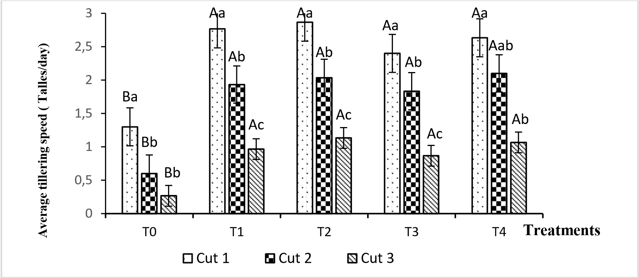

***T0 = Control, T1 =5t/ha manure, T2 =10t/ha manure, T3=0.05t/ha urea (46%) and T4=0.1t/ha urea*** *(46%).*

*-Histograms of the same section marked with the same capital letter are statistically identical at the 5% threshold. Histograms of the same treatment with the same lower-case letter are statistically identical at the 5% threshold.*

**Figure 1:** Effect of fertilization on average tillering speed

* **Average clump height**

Cutting frequency within the same treatment had no significant effect on average clump height. On the other hand, fertilization had a significant effect on clump height compared with the absolute control (T0) (Figure 2). The highest average tuft heights of the different treatments were observed on plots fertilized with 10t/ha of droppings, followed by 0.1t/ha of urea (T4), 0.05t/ha of urea and 5t/ha of hen droppings.

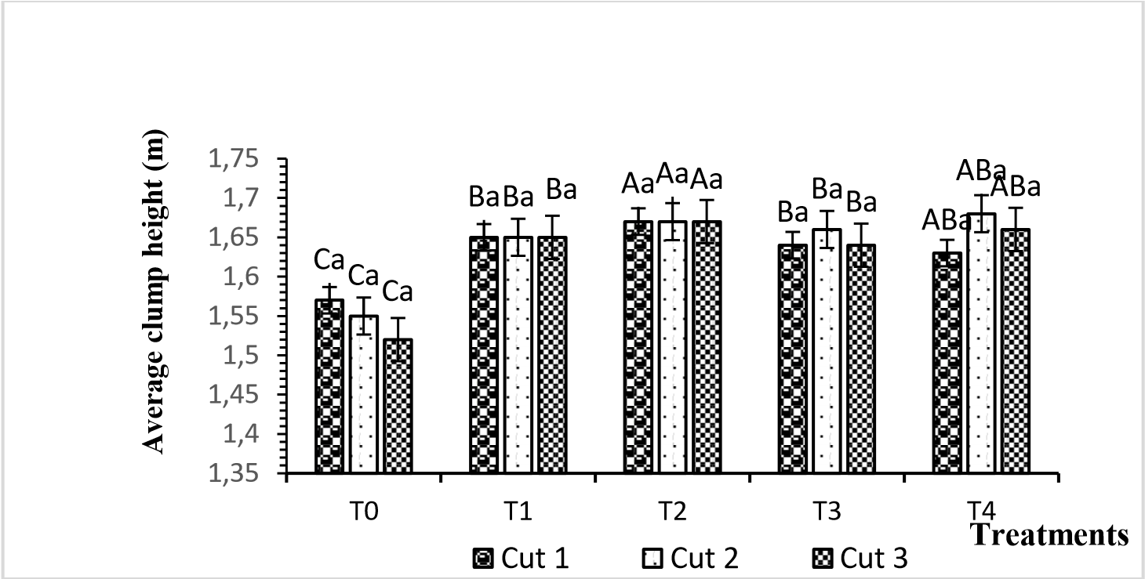

***T0 = Control, T1 =5t/ha manure, T2 =10t/ha manure, T3=0.05t/ha urea (46%) and T4=0.1t/ha urea (46%).***

*-Histograms of the same section marked with the same capital letter are statistically identical at the 5% threshold. Histograms of the same treatment with the same lower-case letter are statistically identical at the 5% threshold.*

**Figure 2:** Effect of fertilization on average clump height

* **Average number of leaves per tillers**

Fertilization and cutting had no significant effect on the average number of leaves per tillers (Figure 3). For all treatments, an identical average number of 7.4 leaves per tillers was recorded for all cutting periods.



0

1

2

3

4

5

6

7

8

T0

T1

T2

T3

T4

**Average number of leaves per**

**plant**

**Treatments**



Shot1



Coup2



Coup3

A

a

A

a

Aa

Aa

Aa

Aa

Aa

a

A

a

A

a

A

Aa

Aa

a

A

a

A

A

a

***T0 = Control, T1 =5t/ha manure, T2 =10t/ha manure, T3=0.05t/ha urea (46%) and T4=0.1t/ha urea (46%).***

*-Histograms of the same section marked with the same capital letter are statistically identical at the 5% threshold. Histograms of the same treatment with the same lower-case letter are statistically identical at the 5% threshold.*

**Figure 3:** Effect of fertilization on the average number of leaves per tillers

* **Average leaf length**

Both fertilization and cutting significantly affected leaf length. The highest average leaf lengths of the different treatments were observed on plots fertilized with 10t/ha of poultry droppings, followed by 0.1t/ha of urea (Figure 4).

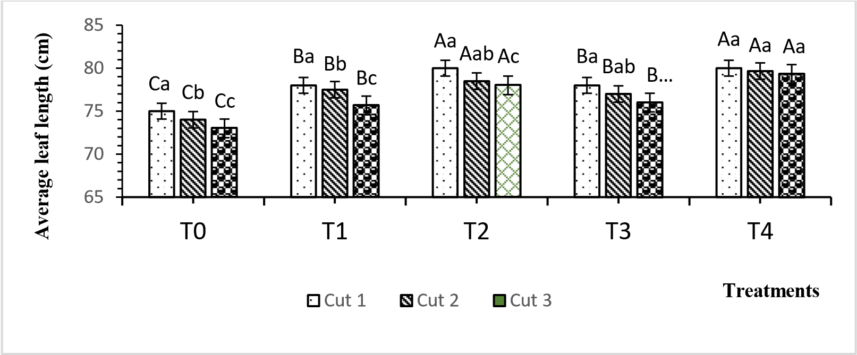

*T0 = Control, T1 =5t/ha manure, T2 =10t/ha manure, T3=0.05t/ha urea (46%) and T4=0.1t/ha urea (46%).*

*-Histograms of the same section marked with the same capital letter are statistically identical at the 5% threshold.*

*Histograms of the same treatment with the same lower-case letter are statistically identical at the 5% threshold.*

**Figure 4:** Effect of fertilization on average leaf length

**3.1.2. Yield evaluation**

* **Average fresh biomass yield (t/ha)**

Both fertilization and cutting significantly affected average fresh biomass yields (Figure 5). The highest average yields were obtained for plants fertilized with 0.1t/ha of urea (8.50 and 8.60 t/ha) and 10 t/ha of poultry droppings (8.1 and 8.6 t/ha), which were comparable during the successive periods of the first and second cuts. In the third cut, however, the 10 t/ha dose of chicken droppings gave the highest average fresh biomass yield (9.63tg/ha), followed by urea 0.1t/ha (8.7kg/ha). Treatments with lower doses (5t/ha of poultry droppings and 0.05t/ha of urea) gave significantly lower average yields. Average fresh biomass yields increased significantly in all three cuts for the 5 t/ha and 10 t/ha poultry manure doses. From the first to the third cut, average yields rose from 7.0 to 8.20 t/ha and from 8.10 to 9.63 t/ha respectively.

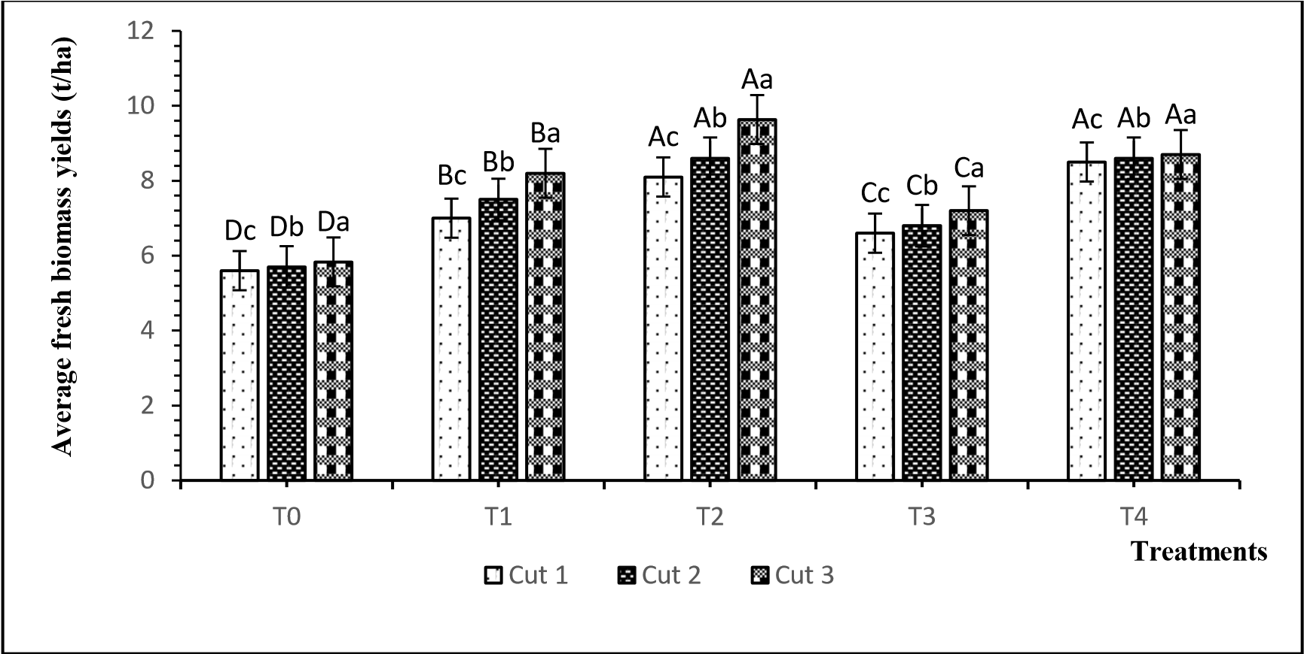

T0 = Control, T1 =5t/ha manure, T2 =10t/ha manure, T3=0.05t/ha urea (46%) and T4=0.1t/ha urea (46%).

*-Histograms of the same section marked with the same capital letter are statistically identical at the 5% threshold. Histograms of the same treatment with the same lower-case letter are statistically identical at the 5% threshold.*

**Figure 5:** Effect of fertilization on average fresh biomass yields

* **Average dry biomass yield**

Fertilization and cutting both significantly improved and affected average dry biomass yields (Figure 6). The highest average yields were obtained from plants fertilized with 0.1t/ha of urea (3.11 and 3.15t/ha) and 10t/ha of poultry droppings (2.96 and 3.15t/ha), which were statistically identical during the successive periods of the first and second cuts. By the third cut, however, the 10t/ha dose of poultry droppings gave a significantly higher average dry biomass yield (3.53 t/ha) than the 0.1t/ha dose of urea (3.18t/ha). The 5t/ha droppings and 0.05t/ha urea treatments gave significantly lower average yields. Average dry biomass yields increased significantly in the last two cuts for the 5 and 10t/ha hen droppings treatments. Average yields rose from 2.6 to 3t/ha and from 2.96 to 3.53t/ha respectively from the first to the third cut.

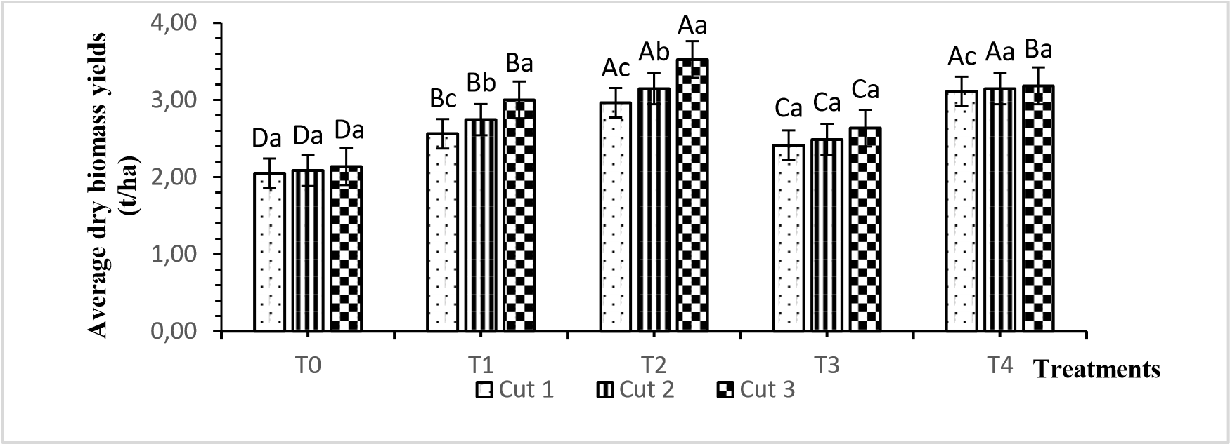

T0 = Control, T1 =5t/ha manure, T2 =10t/ha manure, T3=0.05t/ha urea (46%) and T4=0.1t/ha urea (46%).

*-Histograms of the same section marked with the same capital letter are statistically identical at the 5% threshold. Histograms of the same treatment with the same lower-case letter are statistically identical at the 5% threshold.*

**Figure 6:** Effect of fertilization on average dry biomass yields

* **Average essential oil content**

Neither fertilization nor cutting had any significant effect on average essential oil content. Average contents of 1.89 and 1.90% were obtained at 5 and 10 t/ha chicken droppings respectively. For plots fertilized with urea at doses of 0.05 and 0.1t/ha, these average essential oil contents were evaluated at 1.89 and 1.90% respectively, and at 1.71% for the control (Figure 7).

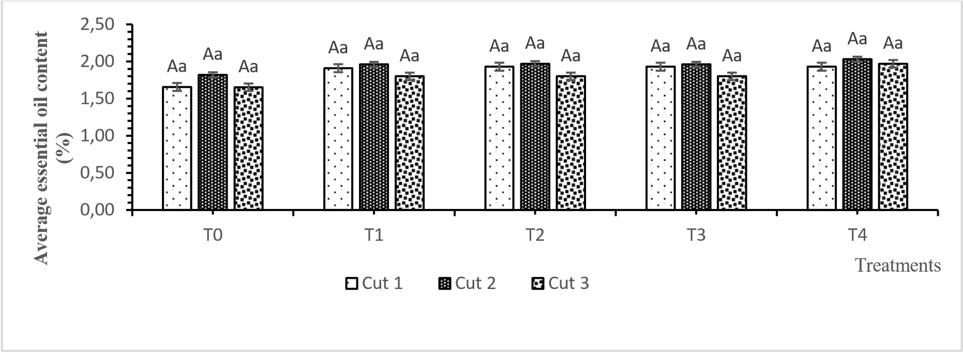

*T0 = Control, T1 =5t/ha manure, T2 =10t/ha manure, T3=0.05t/ha urea (46%) and T4=0.1t/ha urea (46%).*

*-Histograms of the same section marked with the same capital letter are statistically identical at the 5% threshold. Histograms of the same treatment with the same lower-case letter are statistically identical at the 5% threshold.*

**Figure 7:** Effect of fertilization on average essential oil content

* **Average yield of essential oil**

Fertilization and cutting significantly affected average essential oil yields (figure 8). The highest average essential oil yields were obtained from plants fertilized with 0.1t/ha urea (66.89 and 67.70 l/ha) and 10t/ha poultry droppings (63.74 and 67.70 l/ha) during the successive first and second cut periods, and no significant differences were observed. On the third cut, however, the 10t/ha dose of poultry droppings gave the highest average yield of essential oil (75.84 l/ha), followed by the 0.1/ha dose of urea (68.49 l/ha). Treatments with lower doses (5t/ha of poultry droppings and 0.05t/ha of urea) gave significantly lower yields. The average yield of essential oil increased in the last two cuts. This increase was statistically significant for the 5 and 10t/ha doses of poultry droppings. Average yields rose from 55.08 to 64.56l/ha and from 63.74 to 75.84l/ha respectively from the first to the third cut.

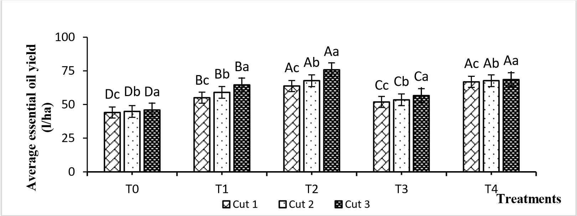

***T0 = Control, T1 =5t/ha manure, T2 =10t/ha manure, T3=0.05t/ha urea (46%) and T4=0.1t/ha urea (46%).***

*-Histograms of the same section marked with the same capital letter are statistically identical at the 5% threshold. Histograms of the same treatment with the same lower-case letter are statistically identical at the 5% threshold.* **Figure 8:** Average essential oil yields

**3.2. Discussion**

Evaluation of the effect of different doses of hen droppings and 46% urea on the agronomic parameters (growth, leaf biomass and essential oil production) of *C. schoenanthus* yielded the results we will now discuss.

**Effect of fertilizers on growth parameters**

Generally speaking, mineral and organic fertilization had a significant influence on most *C. schoenanthus* physiological parameters (mean tillering speed, mean clump height, mean leaf length). The fertilizers provided the plants with essential nutrients for their growth and development. In fact, the mineral elements supplied by the fertilizers are at the origin of the growth and development of the plants, in this case nitrogen, which was the main element supplied. Previous studies have shown that insufficient or absent nitrogen leads to lower yields. Nitrogen is the main stimulant of plant growth (Lompo, 2005), and all forms of life cannot grow and function without the supply of nitrogen in acceptable form (Kaboré, 2004).

**Effect on average tillering speed**

The addition of urea and hen droppings revealed significant effects on average tillering speed over the three cuts (or harvests) compared with the absolute control without fertilizer. However, no difference was observed between the different fertilizer doses. Nevertheless, the 10t/ha manure dose recorded a higher average tillering speed (2.87 tillers/day) than the 0.1t/ha urea dose (2.63 tillers/day), especially in the first cut. This speed decreased over time, from the first cut to the third cut for each treatment. This could be due to the plant variety, or the frequency of cuts, or the age of the plant, or the physical and chemical nature of the soil. As age increases or the soil becomes depleted of nutrients provided by fertilizers, the average tillering speed decreases. Furthermore, this significant drop in average tillering speed over time could be explained by competition between tillers for nutrients, leading to soil impoverishment and the slowing and death of some tillers. These results are in line with those obtained by Mohamed *et al.* (2010), who observed that vegetative growth of *C. flexuosus* increased with increasing doses of nitrogen.

**Effect on average clump height**

The highest clump heights of the different treatments were observed on plots fertilized with 10t/ha of manure and 0.1t/ha of urea. Indeed, it was found that clump sizes remained constant over the three harvest periods for manure, unlike those for urea. This may be linked to the physical and chemical characteristics of the soil (Kouassi *et al.,* 2019). Aradhna and Yashpal (2014) demonstrated in their study that foliar application of Urea at a dose of 2g/plant increases plant height, the number of tillers per clump *of C. citratus.* According to Gajbhiye *et al* (2013) the application of 10t/ha of farmyard manure improves growth parameters (plant height, number of branches and number of leaves per plant).

**Effect on average number of leaves per tillers**

Mineral or organic fertilization did not significantly affect the average number of leaves per tillers*.* This result contradicts that of Tougma *et al.* (2006), who demonstrated in their study that fertilizer treatments had significant effects on the average number of leaves per tillers in *C.*

**Effect on average leaf length**

Fertilization and cutting have significant effects on average leaf length. The longest leaves were observed on plots fertilized with 10t/ha of droppings, followed by 0.1t/ha of urea. Fertilizers would provide important nutrients to the plants, particularly nitrogen. This result corroborates that of Tougma *et al.* (2006), who found that the nutrients N, P and K play important roles in plant development and growth, and stipulate that the insufficiency or absence of these elements causes yield reductions.

**Effect of fertilization on average fresh and dry biomass yields**

The application of organic and mineral fertilizers enabled the fertilized plants to achieve a significant increase in fresh and dry matter yields of Indian verbena compared with the unfertilized plants (absolute control). According to (Lompo 2005), fertilizers play a key role in the synthesis of plant constituents through their action in the elaboration of various enzymes and consequently in the improvement of plant yields, and that organic matter positively affects soil structure and nutrient availability.

**Average fresh biomass yields**

The highest fresh biomass yields were obtained with plants fertilized with 0.1t/ha urea and 10t/ha hen droppings, which were comparable during the successive periods of the first and second cuts. But in the third cut, the 10t/ha dose of hen droppings gave the highest fresh biomass yield (9.63 t/ha), followed by the 0.1t/ha dose of urea (8.70/ha). This can be explained by the fact that urea provides easily-assimilable nitrogen in the short term, while organic fertilizer decomposes over time with a gradual supply of its elements to the plant. Several studies conducted in natural environments and greenhouses have shown that local resources and their composts applied to poor, acidic tropical soils can provide the nutrients required for plant growth and development, thereby increasing crop yields (Kochi *et al*., 2010; Nyembo *et al.,*

**Average dry biomass yields**

The highest dry biomass yields were obtained on plots fertilized with 0.1t/ha urea and 10t/ha chicken droppings during successive cuts 1 and 2. But by the third cut, the 10t/ha dose of droppings gave the highest dry biomass yield (3.53 t/ha), followed by the 0.1t/ha dose of urea (3.27t/ha). These results are strongly linked to the fresh biomass yields obtained. However, the quantities of dry matter obtained were proportional to the quantities of fresh matter harvested. According to Silou *et al* (1999), the application of manure (10 t/ha) and NPK (0.63 t/ha) increased the dry matter content of C. *citratus* leaves one month after transplanting. Dry matter content, which reflects a plant's capacity to mobilize biomass, consolidates over time to a greater extent in unamended soils than in amended soils (Silou *et al.,* 1999).

**Average essential oil content and yields**

The doses of droppings and urea used in this study gave essential oil content and yield, which varied according to the treatments. The differences observed in terms of oil content were not significant, unlike the yields obtained.

**Average essential oil content**

In this study, it was found that the three harvests carried out using different fertilizer doses had no significant effect on essential oil content compared with the control. This could be due to the physical and chemical properties of the soil. Silou *et al* (1999) also obtained the same results, concluding that the effect of chemical and organic fertilizers on the essential oil content of *C. citratus* was not significant. The variation in essential oil content would appear to be related more to the harvesting period than to the different treatments. Beech (1977 and 1990) and Silou et al. (2005) made the same observation on *C. citratus* and *C. f1exuosus,* respectively*.*

**Average essential oil yields**

In contrast to essential oil content, fertilization and cutting significantly affected essential oil yields. The highest essential oil yields were obtained with plants fertilized with 0.1t/ha of urea and 10t/ha of hen droppings, which were statistically identical during the successive periods of the first and second cuts. But by the third cut, the 10t/ha dose of hen droppings gave the highest essential oil yield (75.84l/ha), significantly different from the 0.1t/ha dose of urea (68.49l/ha). Yields increased in the second and third cuts. This increase in essential oil yield from the first to the third cut is explained by the increase in dry biomass yield, which was influenced by fertilization. These results are in line with those obtained by Beech *et al.* (1990) on C. *citratus* and Singh *et al.* (2005) on *C.flexuosus.* This would be due to the positive effect of fertilizer on dry matter. Indeed, essential oil production is obtained by multiplying the dry matter yield by the essential oil content. Fertilizer therefore has an indirect effect on essential oil production by increasing dry matter yields (Silou *et al.,* 1999). In addition, Azizi and Kahrizi (2008) showed that the application of nitrogen-based fertilizers increased the biomass and essential oil yields of *Cuminum cyminum*. Similar results were obtained by Ahmad *et al.* (2011), who showed that the application of poultry droppings as an organic fertilizer gives maximum yield values in fresh and dry matter, and in *Majorana hurtensis* essential oil. In contrast to urea, between the first, second and third cuts, significant increases in biomass and essential oil yields were recorded within each treatment of plants fertilized with chicken droppings. This is explained by the progressive mineralization of hen droppings, which increases yields, while urea is absorbed immediately.

**Conclusion**

The present study assessed the influence of fertilization on biomass and essential oil yield. Poultry droppings and urea (46% N) improved most parameters (average clump height, average tillering speed, average leaf length). Application of the various fertilizers increased fresh and dry matter yields, as well as essential oil yields for *C. schoenanthus*. The dose of 10 t/ha of poultry droppings produced an effect identical to that of 100 kg/ha of urea at the first two cuts. By the third cut, however, the 10 t/ha dose of chicken droppings produced a dry biomass and essential oil yield (3.53 t/ha and 75.84 l/ha) significantly higher at the 5% threshold than that obtained with 0.1 t/ha of urea (3.18 t/ha and 68.49 l/ha). The various treatments had no significant effect on essential oil content. The increase in essential oil production was more closely linked to the increase in biomass production. Further studies would be desirable to assess the influence of the combination of droppings + urea and droppings applied just before transplanting on the growth parameters, biomass and essential oil yields of *C. schoenanthus*.

**References**

Ahmad H., Al-Fraihat, Sati Y.A., Al-dalain, Ziad B., Al-Rawashdeh, Mohammad S., AbuDarwish and Jalal A., Al-Tabbal. (2011). Effect of organic and biofertilizers on growth, herb yield and volatile oil of marjoram plant grown in Ajloun region. J. of Med. Plants Res. 5(13):

2822-2833.

Anonymous b: www. Neem property: azadirachtin A, accessed on 13 /02/2012.

Aradhna S. and Yashpal S. (2014). The effect of foliar applied urea on growth, yield, and oil contents of lemon grass variety-OD-19. J. Med. Plant Sci. 7: 18-25.

Beech D.F. (1977). Growth and oil production of lemongrass (Cymbopogon citratus) in the Ord Irrigation Area, Western Australia. Aus J Exp Agr. 17: 301-307.

Beech D.F. (1990). The effect of carrier and rate of nitrogen application on the growth and oil production of lemongrass (Cymbopogon citratus) in the Ord Irrigation Area, Western Australia. Australian Journal of Experimental Agriculture 30: 243-250.

Bokobana E. M., Koba K., Poutouli W. P., Akantetou P. K., Nadio N. A., Laba B., Tozoou P., Raynaud C. and Sanda K. (2014). Evaluation of the insecticidal and repellent potential of cymbopogon schoenanthus (l.) Spreng. essential oil on aphis gossypii Glover (Homoptera: Aphididae), cotton pest in Togo. Life science, soil and agronomy. FREEZE. CAMES - Vol.02 Issue.02. ISSN 2424-7235: 48-55

Declert C. (1990). Manuel de phytopathologie maraîchère tropicale : cultures de Côte d'Ivoire (le gombo), Edition DIDACTIQUE, p 123.

Detchinli, S. K., Sogbedji, j. M., Atchoglo,R. and Bona K. A. (2017). Modeling optimal economic doses of nitrogen in maize (zea mays L) cultivation On ferralitic soils in Togo. Life, earth and agronomic sciences, 5(1): 52-57.

Gajbhiye B. R., Momin Y. D. and Puri A. N. (2013). Effect of FYM and NPK Fertization on Growth and Quality Parameters of Lemongras (Cymbopogon flexuosus). Agric. Sci. Res.J. 3: 115-120.

Hammiche V. and Maiza K. (2006). Traditional medicine in central sahara: pharmacopoeia of Tassili N'ajjer. J. Ethnopharmacol. 105 : 358-367.

Kaboré B. (2004). Nitrogen contributions of legumes, organomineral amendments in cropping systems: Impact on cereal yields and long-term soil fertility. Rural Development Engineer's thesis/Agronomy Option IDR/UFB. Burkina Faso. 85p.

Koba K., Poutouli P.W., Nenonene Y.A. and Songhai M. S. (2007). Chemical compostion anrd anti-termite activity of three tropical essential oils against termite spcies Trinervitermes geminatus. Sci. Technol. 5: 39-46.

Koba K., Sanda K., Raynaud C., Nenonene Y.A., Millet J. and Chaumont J.P. (2004). Antimicrobial activity of essential oils from three African Cymbopogon sp. against pathogenic germs in pets. Ann. Méd. Vét. 148: 202-206.

Kouassi Y. F., Gbogouri G. A., N'guessan K. A, Bilgo A., Angui K. T. and Ama T. J. (2019). Effects of organic and organomineral fertilizers based on plant and animal waste on the growth and yield of soybean (glycine max (l.) Merrill) in the savannah zone of Ivory Coast. 12p

..

Laba B., Nenonéné A. Y., Adjrah Y., Koba K., Poutouli W. and Sanda K. (2012). Efficacy of Cymbopogon schoenanthus L. Spreng (Poaceae) extracts on diamondback moth damaging Cabbage. J Biofertil Biopestici, 3:3. http://dx.doi.org/10.4172/2155-6202.1000119.

Marwat S. K., Khan M. A., ur-Rehman F., Bhatti I.U. (2009). Aromatic plant species mentioned in the holy Qura'n and Ahadith and their ethnomedicinal iùportance. Pak. J. Nutr. 8 (9): 14721479.

Mohamed E., Elkashif and Amani A. M. O. (2010). Effect of nitrogen and phosphorus rates on growth, yield and oil content of lemongrass (Cymbopogon flexuosus L.). Gezira J. Agric Sci. 10: P.2.

Moris, J. B. (1999). Legume genetic resources with novel ''value added'' industrial and pharmaceutical use, pp 196-210. In: J. Janick (eds.), Perspectives on new crops and new uses. ASHS Press, Alexandra, VA.

Nadio N. A., Koba K., Poutouli W., Akantetou P., Laba B., Bokobana M. E., Raynaud C. and Sanda K. (2013). Insecticidal activities of Cymbopogon schoenanthus (L.) Spreng. essential oil on stage II larvae of Dysdercus voelkeri Schmidt (Heteroptera: Pyrrhocoridae). J. Soc. OuestAfr. Chim. 035. Pp.8 - 14.

Nyembo K. L., Kisimba M. M., Théodore M. M., Jonas J., Kanyenga L.A., Becker N. K., Mpundu M. M. and Baboy L. L. (2014). Effects of increasing doses of hen manure composts on yield of Chinese cabbage (Brassica chinensis L.). Journal of Applied Biosciences, vol 77, pp 6505 - 6522.

Perry, L. M. (1980). Medicinal plants of East and Southeast Asia Massachusetts Institute of Technology, USA.

Silou T.; Bassia A. and Molangui T. (1999). Effect of chemical and organic amendment on the quantitative and qualitative production of Cymbopogon citratus. Recueil de travaux scientifiques. 1 Atelier Régionale sur les huiles essentielles, 19-21 avril 1999, Cotonou Bénin. Pp.110-117

Silou T., Malanda M. and Loubaki L. (2005). Optimization of Cymbopogon citratus essential oil extraction using a full factorial design 23. Journal of Food Engineering. Vol. 65, Issue 2. Pp. 219-223.

Simmonds M. S. J., Blaney W. M., Delle Monache R. and Marini Bettolog. B. (1990). Insect anfeedant activity associated with compounds isolated from species of Lonchocarpus and Teprosia. Journal of Chemical Ecology, 16: 365-380.

Singh M. and Shanna S. (2001). Influence of nitrogen on herbage and oil yield of palmarosa

(Cymbopogon martinii) under semi-arid tropical conditions. European Journal of Agronomy. 14: 157-159.

Tougma W. S. R, Somda I. and Koambire H. (2006). Effect of organic and mineral fertilization on biomass and essential oil production of lemongrass (Cymbopogon citratus, D. C. STAPF) in the Cascades region (Western Burkina-Faso). P45.