Opinion Article

Analysis of Seismic Performance of Hospital Buildings under Multiple Earthquakes

Abstract: Frequent earthquakes indicate that isolated seismic events are rare, with the probability of an independent earthquake typically not exceeding 10%. Earthquakes are not isolated phenomena and may occur in quick succession under certain conditions. If buildings are not reinforced, they may suffer significant damage or even collapse when subjected to subsequent earthquakes. Currently, most international seismic design codes only consider single seismic events, i.e., the effect of the main earthquake. Studying the seismic performance of buildings under multiple earthquakes is of great significance both academically and practically.



Keywords: Multiple earthquakes; RC frame structure; Dampers 0 Introduction

Many studies have shown that earthquakes are not isolated events but consist of foreshocks, main shocks, and aftershocks. In reality, approximately 89% of strong earthquakes are accompanied by strong aftershocks or even stronger subsequent shocks, indicating that earthquakes often occur in a series of strong seismic events. Under the continuous action of strong earthquakes in a short period, structural damage accumulates, significantly affecting the safety of the structure. Therefore, the seismic damage to building structures should not be underestimated. Examples from earthquake disasters in China, such as the 1976 Tangshan

7.8 magnitude earthquake, the 1999 Taiwan Chi-Chi 7.6 magnitude earthquake, the 2008 Wenchuan 8.0 magnitude earthquake, and the 2010 New Zealand earthquake, all demonstrate the severity of structural damage to buildings after earthquakes. After the Tangshan earthquake, researchers predicted that aftershocks would continue for hundreds of years. Following the Wenchuan earthquake, there were 23,935 aftershocks, with the largest being a magnitude of 6.4. Notably, the Luanhe Bridge did not collapse during the Tangshan earthquake but collapsed 15 hours later during a subsequent 7.1 magnitude earthquake. It is important to note that current seismic codes in China and internationally only consider the primary seismic event. There are no specific codes addressing whether the sequence of earthquakes affects building damage. The mechanism of structural damage under multiple earthquakes is still unclear, and incorporating multiple seismic events into structural design and existing codes is an urgent issue[1]. In 2021, Ishida Takanori et al. [2] conducted cyclic loading tests on a ~~non structura~~lnon-structural steel frame (SMRF) to evaluate the seismic performance of steel structure buildings under multiple seismic actions.. In 2021, Xu Chengbiao et al. [3] used a performance-based design method to conduct seismic reinforcement design on a reinforced concrete frame structure based on a practical engineering project. The main research content was to compare and analyze the seismic performance level and collapse resistance of the structure reinforced with buckling restrained

**Comentado** **[A1]:** The abstracto don’t explain the objective of the paper

braces (BRBs) and ordinary steel braces.

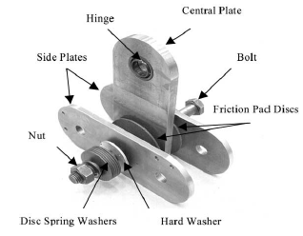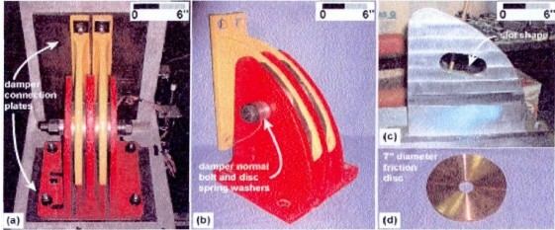

1. Research Status of Friction Dampers in Civil Engineering
   1. Principle of Friction Dampers

Friction dampers are displacement-based vibration reduction structures whose operation consists of adhesion and sliding. Their energy dissipation coefficient depends on material properties and the applied vertical pressure. When the external load is below the maximum static friction coefficient, the device remains in an adhered state. When the external force exceeds this limit, the device slides, generating friction and thereby reducing energy consumption.

Experimental studies on the linear motion of objects within a plane have laid the foundation for conventional sliding models. The earliest explorers of this theory were Davison, Amonton, and Coulomb. Coulomb's friction theory is an important dry friction theory based on the following assumptions:

1. The friction value does not depend on the contact surface.
2. The friction coefficient is proportional to the vertical force applied to the surface.
3. For slow relative sliding, the friction value is independent of the relative sliding velocity. Based on these assumptions, Zhou Yun and Deng Xuesong[4-7] summarized eight key factors influencing the working characteristics of friction dampers during sliding and development: first, the form of the applied load; second, the shape and size of the friction components and grooves; third, the effect of using high-strength anchor rods; fourth, the processing condition of the friction blocks and surfaces; fifth, the duration; sixth, the precision of product processing; seventh, the number of cycles; and eighth, other related factors such

as sliding velocity and temperature.

* 1. Classification of Friction Dampers Based on energy dissipation principles and structural characteristics, friction dampers can

be classified into four main types: 1) friction energy dissipation joints; 2) plate-type friction energy dissipators; 3) cylindrical friction energy dissipators; and 4) composite friction energy dissipators. The following figures illustrate some types of friction dampers.

Figure 1a-Schematic Diagram of Friction Damper Structure Figure 1b- Friction Transmission Energy Dissipation Joint Structure

1. Finite element model establishment
2. Establishment of Finite Element Model

The hospital structure design follows relevant Chinese standards, with the plane and elevation views shown in Figures 2 and 3, respectively. The beam dimensions are 250mm × 500mm, and the column dimensions are 500mm × 500mm, using HRB335 steel and C45

**Comentado** **[A2]:** What is the reference?

concrete. The stirrup spacing is 100mm, with a length of 3300mm, and the structure's natural vibration period is set at 0.40 seconds. The seismic fortification intensity is 7 degrees (0.1g), the earthquake group is the first group, the site category is Class II, and the ground roughness is Class B. Through optimization, the maximum wind pressure on the foundation is determined to be 0.4 kN/m². This project uses the ABAQUS platform developed by China Construction Group for simulation calculations. The nonlinear finite element analysis function of the system is utilized to perform specific calculations on the model's stress and reinforcement, ensuring compliance with current national standards.

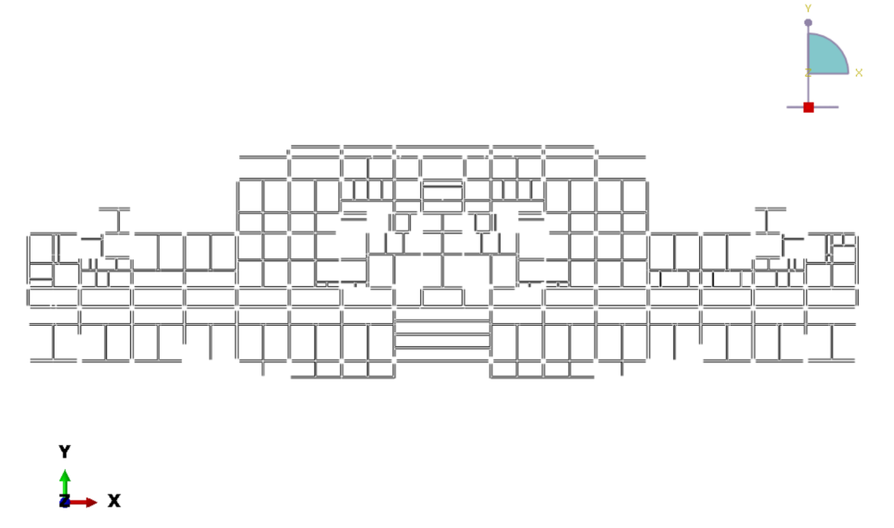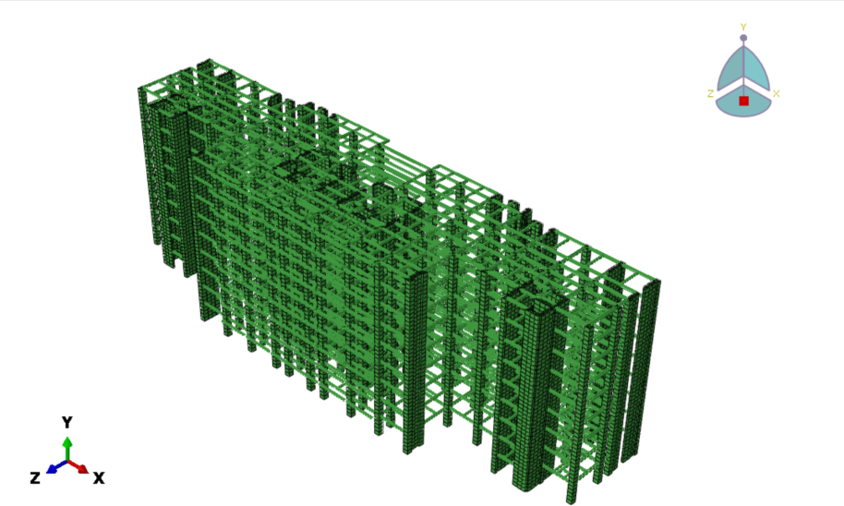

Figure 2 Structural Plane Schematic Diagram

。

Figure 3 Structural Elevation Schematic Diagram

1. Analysis and Calculation
   1. Modal Analysis

This study uses the Lanczos algorithm in ABAQUS software for modal analysis to solve the structural modes. The following formulas introduce the specific calculation formulas for structural damping:

*C*  *M*  *K*

(3.2)

，  2   ,1

1 2

1  2

(3.3)

Where， is the mass damping coefficient；  is the stiffness damping coefficient； *C*

is the damping matrix；*M* is the mass matrix；*K* is the stiffness matrix；1 and 2 represent

the first and second natural frequencies of the structural model, respectively；  is the material damping ratio, with concrete and damping reinforcement taken as 0.03 and 0.02,

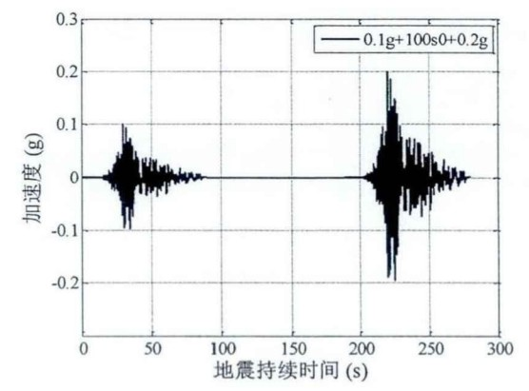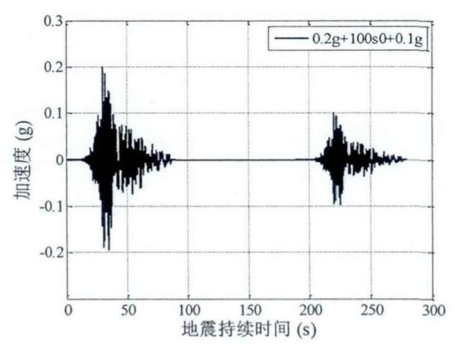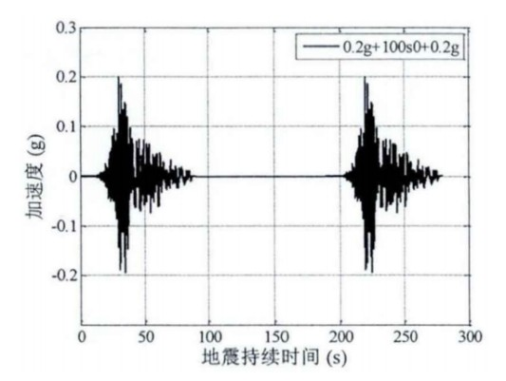

respectively. The first two natural frequencies of the ordinary hospital structure and the

damped hospital structure obtained from modal analysis are: Ordinary structure nodes：

*f*1  0.75986*Hz* 、 *f*2  2.5832*Hz* ； Damped structure nodes

*f*2  2.9678*Hz* 。

* 1. Time History Analysis
     1. Selection and Construction of Seismic Waves

*f*1  0.90853*Hz*

、

According to Chinese standards, two natural waves and one artificial wave are selected,

namely EL-centro wave, CPC wave, and artificial wave. Due to space limitations, only the typical natural wave EL-centro wave suitable for Class II sites is analyzed. We choose the most basic and commonly used construction method, which is to add 100 seconds of zero to the same ground motion data.

(a) Foreshock-Main Shock Type Seismic Motion (b) Main Shock-Aftershock Type Seismic Motion

(c) Double Main Shock Type Seismic Motion

Figure 4 Seismic Wave Selection Method

If the peak value of the selected design seismic acceleration record does not match the peak value corresponding to the seismic fortification intensity of the structure's location, it can be adjusted using proportional scaling. The adjustment formula is as follows:

*a*(*t*)  *A*m ax *a*(*t*)

*A*max

(3.1)

Where，*a*(*t*) 、*a*(*t*)

are the original and adjusted seismic acceleration values at time , respectively.



3.2.2 Seismic Wave Analysis

When performing dynamic time history analysis in ABAQUS software, two key analysis stages are involved. The first stage focuses on applying vertical gravity load to the structure; the second stage introduces seismic waves to conduct loading experiments on the specific hospital building structure. Due to space limitations, this experiment uses the EI-Centro wave to perform elastoplastic dynamic time history analysis on two types of three-dimensional hospital structures with different damping settings: one with conventional damping and one without special damping. The aim is to evaluate their time history responses under magnitude 8 and 9 earthquakes. The specific peak acceleration data are as follows:

1. Under a magnitude 8 earthquake, the recorded peak acceleration is 400 gal;
2. Under a magnitude 9 earthquake, the observed peak acceleration is 620 gal.

In subsequent analysis and discussion, SF represents the elastoplastic time history analysis results of the hospital structure with conventional damping, PF represents the elastoplastic time history analysis results of the hospital structure without special damping, and PFEL represents the elastic time history analysis results of the hospital structure.

Using the EI-Centro seismic wave as boundary input, a three-dimensional fixed-end treatment is applied to the hospital building's base, and elastoplastic dynamic process analysis is performed using the ABAQUS/Explicit module. The specific analysis data are detailed in Tables 2, 3, and Figure 5, which record the maximum inter-story displacement (angle) differences between conventional structures and structures with dampers in the hospital.

Table 1 Maximum Inter-story Displacement (mm) of Hospital Structure

|  |  |  |  |  |  |  |
| --- | --- | --- | --- | --- | --- | --- |
|  |  | 400gal |  |  | 620gal |  |
| SF*1 | PF*1 | PFEL*1 | SF*2 | PF*2 | PFEL*2 |
| F1 | 31.60 | 42.32 | 43.33 | 64.32 | 35.73 | 76.03 |
| F2 | 61.97 | 34.23 | 65.93 | 82.16 | 74.09 | 93.23 |
| F3 | 35.09 | 37.34 | 49.09 | 32.19 | 37.34 | 83.90 |

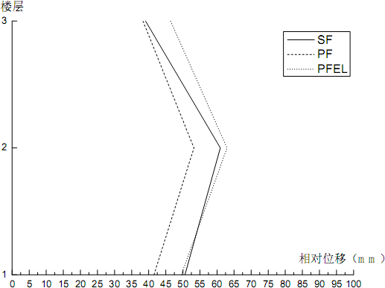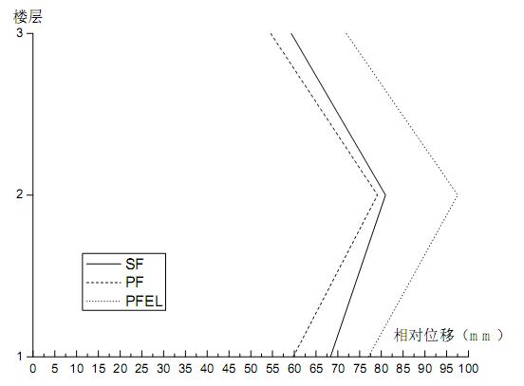

(a) 400gal

(b) 620gal

Figure 5 Inter-story Relative Displacement of Hospital Structure

Table 2 Maximum Inter-story Displacement Angle of Hospital Structure

**Comentado** **[A3]:** Please in English

Figure 5 records the specific values of inter-story displacement angles. Under the influence of a 400 gal seismic peak, the maximum displacement angle of the second floor of the conventional hospital structure is 1/22.67, which is lower than the 1/13.33 of the corresponding floor in the damped hospital structure. Under the impact of a 620 gal seismic peak, the maximum displacement angle of the second floor of the conventional hospital structure increases to 1/16.67, still slightly lower than the 1/14.67 of the damped hospital structure.

As shown in Figure 6, the differences in vertex displacement between conventional buildings and hospital buildings are compared, and the vertex displacement change curves of hospital buildings during elastic and plastic deformation stages are depicted. The figure clearly shows that hospital buildings have significantly increased vertex displacement compared to conventional

buildings, and their natural vibration frequency is higher than that of conventional buildings,

|  |  |  |  |  |  |  |
| --- | --- | --- | --- | --- | --- | --- |
|  |  | 400gal |  |  | 620gal |  |
| SF |  | PF | SF |  | PF |
| 一层 | 3/75 |  | 3/88 | 3/34 |  | 3/65 |
| 二层 | 3/35 |  | 3/65 | 3/46 |  | 3/47 |
| 三层 | 3/91 |  | 3/94 | 3/65 |  | 3/67 |

consistent with the conclusions from the previous modal analysis. Under the influence of the EI- Centro seismic wave with a 400 gal acceleration peak, the structure remains elastic for the first 4 seconds and then gradually transitions to plastic deformation. Under the influence of the EI-Centro seismic wave with a 620 gal acceleration peak, the structure enters plastic deformation earlier, and the difference between elastic and plastic displacement at the vertex significantly increases.

(a) SFand PF(400gal) (b) PF and PFEL(400gal)

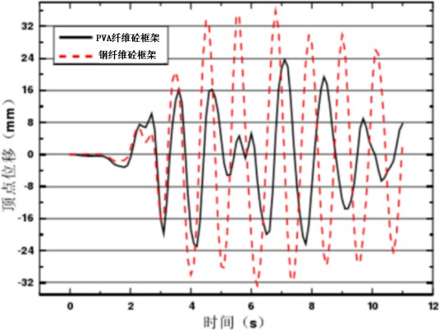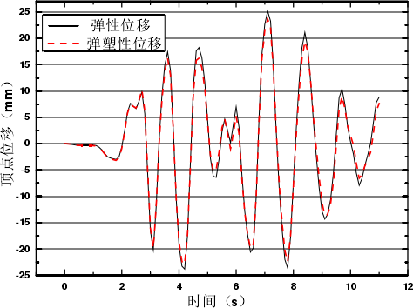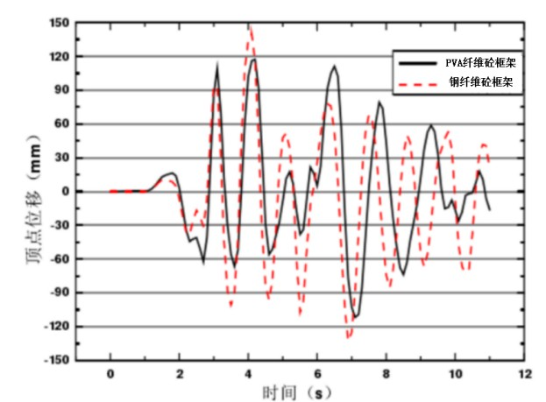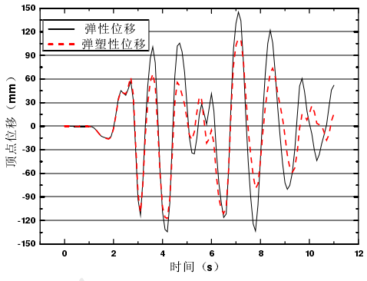

(c) SF and PF(620gal) (d) PFand PFEL(620gal) Figure 6 Vertex Displacement of Hospital Structure (Relative to Ground)

Table .3 Maximum Inter-story Shear Force (kN) of Hospital Structure

|  |  |  |  |  |  |  |
| --- | --- | --- | --- | --- | --- | --- |
|  |  | 400gal |  |  | 620gal |  |
| SF*1 | PF*1 | Difference/% | SF*2 | PF*2 | Difference/% |
| F1 | 371.3 | 392.2 | 33.34 | 240.4 | 247.2 | 2.7 |
| F2 | 323.2 | 346.3 | 37.3 | 368.2 | 369.9 | 3.7 |
| F3 | 89.2 | 304.3 | 36.3 | 349.4 | 333.8 | 3.8 |

Through detailed comparative studies, it is found that under the influence of the EI-Centro seismic wave, the inter-story shear force of conventional hospital buildings is significantly affected by the structure's natural vibration characteristics, especially under larger acceleration peaks. For example, under a 400 gal acceleration peak, the maximum inter-story shear force of conventional hospital buildings is about one-third higher than that of structures with dampers. However, when the acceleration peak increases to 620 gal, the difference in maximum inter-story shear force between the two structures narrows. When considering the inter-story displacement of the two structures, it is noted that the maximum inter-story displacement of conventional hospital buildings is smaller, indicating better lateral displacement stiffness, which is beneficial for enhancing the overall seismic performance of the structure.

1. Summary

In this study, we conducted dynamic time history analysis on conventional hospital buildings and hospital buildings with dampers, comparing their dynamic responses under

seismic influence.

The main conclusions are as follows:

In terms of natural vibration characteristics, conventional hospital buildings and hospital buildings with dampers are synchronized, but it is noteworthy that hospital buildings with dampers have relatively higher natural frequencies.

Under magnitude 8 and 9 earthquakes, the second floor of conventional hospital buildings reaches the peak displacement angle, demonstrating the effectiveness of conventional hospital design in avoiding weak layers at the base. Under the influence of two different seismic waves, by comparing the inter-story displacement of hospital buildings with dampers, the inter-story displacement of conventional hospital buildings, and the maximum inter-story shear force of both types of hospital buildings, it can be seen that hospital buildings with dampers perform better in terms of seismic stiffness, which is beneficial for improving seismic performance.

Under the impact of a magnitude 8 earthquake (with a peak acceleration of 400 gal), the hospital building shows plastic deformation at 4 seconds, with the elastic displacement at the top exceeding the plastic displacement. Under the impact of a magnitude 9 extreme earthquake (with a peak acceleration of 620 gal), the difference between elastic and plastic displacement at the top of the hospital building significantly increases under the influence of both seismic waves. The stiffness reduction due to structural damage causes the peak plastic displacement to lag behind the elastic displacement.

REFERENCES



[1The Ministry of Housing and Urban Rural Development of the People's Republic of China GB50011 — 2010 Code for Seismic Design of Buildings [S] Beijing: China Construction Engineering Corporation Industry Publishing House, 2010]

1. Ishida T, Tenderan R, Kohtaki K, et al. Experimental study on full-scale steel moment- resisting frames with nonstructural walls subjected to multiple earthquakes[J]. Engineering Structures, 2021, 242: 112549.
2. Xu Chengbiao, Peng Youkai, Xu Kai, etc Performance based seismic reinforcement design of RC frame structures [J]. Engineering seismic resistance and reinforcement improvement Zao, 2021, 43 (03): 138-146
3. Chen Haobin, Zhong Genquan, Zhou Yun, etc Experimental study on the performance of end reinforced steel tube dampers [J]. Engineering Seismic and Reinforcement Transformation, 2023, 45 (03): 60-66. DOI: 10.16226/j.issn. 1002-8412.2023.03.008
4. Zhou Yun, Wu Sheng Energy dissipation performance analysis of corrugated steel pipe lead damper [J]. World Earthquake Engineering, 2020,36 (04): 103-111
5. Wu Congxiao, Study on Seismic Performance of Prefabricated Prefabricated Concrete Seismic Reduction Structure System Guangdong Province, School of Civil Engineering,

Guangzhou University, April 18, 2018

1. Deng Xuesong, Li Jiale, Zhou Yun, etc Performance analysis and research of hyperbolic steel tube laminated viscoelastic dampers [J]. Journal of Civil Engineering, 2020,53 (S2): 129-

136. DOI: 10.15951/jtmgcxb. 2020.s2.020

**Con** **formato:** Alemán (Alemania)