NON-NEOPLASTIC **BONEMARROWLESIONS** IN AN ADULT POPULATION IN RIVERS STATE

**ABSTRACT**

**Introduction**: Bone marrow biopsy is used to evaluate patients with both haematological and   
non-haematological pathologies. Non-neoplastic lesions of the marrow could be reactive,  
hypoproliferative or infiltrative.

**Aim:** To establish the role of bone marrow biopsy in the management of haematological and   
non-haematological non-neoplastic disorders in an adult population.

**Materials andMethods**: This is a descriptive cross sectional study, spanning from January 2017  
to November 2023. All consecutive bone marrow biopsy samples of adults 20 years and above   
with non-neoplastic pathologies within the study period were included in this study.

**Results**: During the study period, January 2020 to December 2023, a total of 115 bone marrow   
biopsies were done in adult patients 20 years and above. Chronic anaemia was the most common   
indication. The commonest histological diagnosis was erythroid hyperplasia followed by   
hypoproliferative anaemia. One hundred and two bone marrow biopsies submitted for histology   
out of the 115 samples had pathological diagnoses. This gives a diagnostic utility of 88.7%.  
There was 89.6% concordance between bone mnarrow biopsy and bone marrow aspirate.

**Conclusion:** Bone marrow biopsy is important in the diagnoses of non-neoplastic diseases in   
adults and doctors should be encouraged to employ it in patient management.

**INTRODUCTION**

The bone marrow is the site of mnyeloid, erythroid, megakaryocytic as well as lymphoid cell   
development.1,2,3 In the normal adult, daily marrow production approximates 2.5 billion red cells,  
2.5 billion platelets, and 1.0 billion granulocytes per kilogram body weight. [4] Bone marrow   
examination plays a key role in the evaluation of patients ~~both in~~ with haematological and non-haematological diseases respectively. These disease processes could be neoplastic or non-neoplastic.

The examination of the marrow involves bone marrow aspiration and bone marrow biopsies which   
are usually done at the same instance. They play complimentary roles in the examination of the   
marrow with each offering comparative advantage over the other~~s~~ in certain disease processes. The  
~~bone marrow~~ diseases involving the bone marrow, whether primary or secondary will lead to increase and/or reduction in the different blood cell lineages ~~lines~~ with their attendant clinical manifestations. 5 Non-neoplastic diseases ~~of the~~ involving the bone marrow leads to varying degrees of signs and ~~produce~~ symptoms ~~that range from mild to severe~~. This study aims to evaluate bone marrow disease processes that are not malignant.

**AIM**

To establish the role of bone marrow biopsy in the management of haematological and non-  
haematological non-neoplastic disorders in an adult population.

**OBJECTIVES**

1. To itemize the specific indications for bone marrow biopsies in non-neoplastic diseases infiltrating the bone marrow ~~disease processes~~

2. To describe the range of non-neoplastic diagnoses made fromn bone marrow biopsies and   
bone marrow aspirates and to correlate these diagnoses where both were carried out at the   
same instance in the same patient.

3. To determine the diagnostic utility of the bone marrow biopsy procedure in patient   
management in non-neoplastic diseases

**MATERIALS AND METHODS**

**STUDY DESIGN**

This is a descriptive cross sectional study, spanning through ~~from~~ January 2017 to November 2023 in an adult population 20 years and above. All consecutive bone marrow biopsy samnples submitted to the department of Anatomical Pathology Department University of Port Harcourt Teaching   
Hospital (UPTH) and Rivers State University Teaching Hospital (RSUTH) within the study   
period were included in this study. These bone marrow samples were obtained from patients   
attending the clinics of the Haemotology and Blood Transfusion Department UPTH and

RSUTH. The bone marrow biopsies were indicated as part of investigations requested for patient ~~their~~ management. As a standard institutional requirement, informed consent was obtained by the operating haematologists when the biopsies were taken. Both bone marrow aspiration and biopsies were taken by the haematologist at the same instance, in those cases where BMAs were done in addition to the   
BMB. Ethical clearance was sort and obtained from the ethical clearance committee of the   
teaching hospital. You need to talk about the statistical package used for analysis.

|  |  |  |  |
| --- | --- | --- | --- |
| Count of AGE | Column Labels | |  |
| AGE GRP | F | M | Grand Total |
| 20-29 | 12 | 2 | 14 |
| 30-39 | 6 | 8 | 14 |
| 40-49 | 12 | 15 | 27 |
| 50-59 | 17 | 9 | 26 |
| 60-69 | 6 | 15 | 21 |
| 70-79 | 6 | 6 | 13 |
| 80-89 | 1 | - | 2 |
| Grand Total | 60 | 55 | 115 |

**DATA ANALYSIS: Data software used, result presentation and data comparison tool. Conspicuously missing**

**RESULTS**

During the study period, January 2017 to December 2023, a total of 115 bone marrow biopsies   
were done in patients 20 years and above (Table 1). ~~Of these 115 patients,~~ The subjects include 55 ~~were~~ males and 60 females with a male: female rato of 0.9:1. The age range of ~~with the highest number of biopsied patients in this study is~~ 40-49 years consisting of 12 females and 15 males had the highest frequency (Table 1). The mean age is 49.95 years. The youngest age was 22 years while the oldest patient was 80 years (Table 2). The highest number of patients was biopsied in 2022 while the lowest number was in 2017  
(Figure 1)

Table 1-AGE*SEX Cross tabulation

Table 2-Descriptive statistics

|  |  |
| --- | --- |
|  | VALUES |
| MEAN | 49.9478 |
| MEDIAN | 50 |
| MODE | 64 |
| MAXIMUM AGE | 80 |
| MINIMUM AGE | 22 |

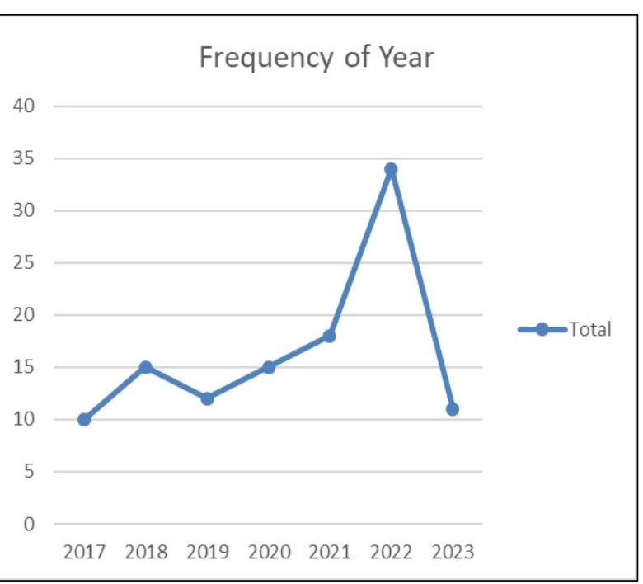

Figure 1-Yearly distribution

Bone marrow aspiration and bone marrow biopsy were performed simultaneously for various   
indications (Figure 2). Chronic unexplained anaemia was the most common indication with 60  
patients (36 females and 24 males) followed by 17 patients that presented with pancytopenia. A  
patient each was biopsied for suspected parasitic infestation, suspected Non-Hodgkin lymphoma

involvement of the bone marrow, fever of unknown origin, suspected Evans syndrome, suspected autoimmune haemolytic anaemia, and bicytopenia

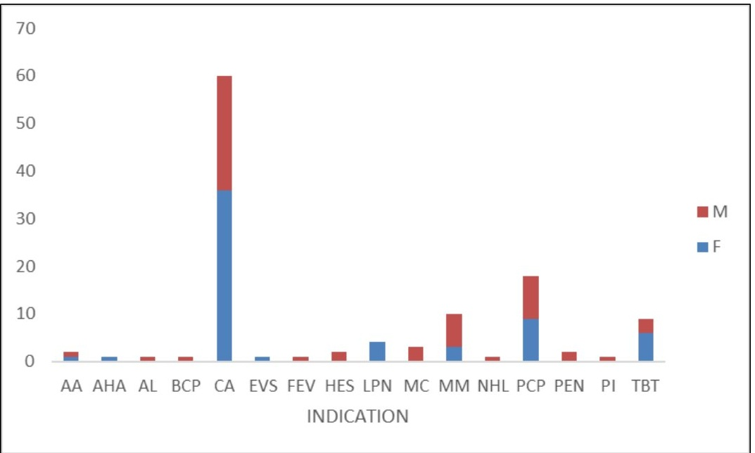

Figure 2: AA: Aplastic Anaemia; AHA: Autoimmune Hemolytic Anaemia; AL: Acute Leukemia;BCP:Bicytopenia; CA: Chronic Anaemia;EVS:EvanSyndrome;FEV:Fever;HES:Hypereosinophilic Syndrome; LPN:Lymphoproliferative Neoplasm; MC: Metastatic Carcinoma; MM: Multiple Myeloma; NHL: Non-Hodgkin lymphoma on Treatment; PCP: Pancytopenia; PEN: Persistent Neutropenia; PI: Parasitic Infestation; TBT:Thrombocytopenia.

The full blood counts of the patients were taken before the BMB. Forty-eight of the 115 patients biopsied had isolated anaemia with the two peak incidences at 40-49 years and 60-69years (Table 3). Ten patients had normal red blood cell count (7 females and 3 males) while 105 (53females and 52 males) patients had reduced haematocrit alone and in combination with other cell line derangements (Tables 3 and 4). Pancytopenia was seen in 25 patients. Eighteen patients had bicytopenia. Five patients had normal full blood count. Thirteen patients had leukocytosis, 35had leucopenia while 67 patients had their white blood cell counts within the normal range.Thirty-seven patients had thrombocytopaenia, six had thrombocytosis while 72 had their within normal expected values.

Table 3 AGE* FBC cross tabulation

|  |  |  |  |  |  |  |  |  |  |
| --- | --- | --- | --- | --- | --- | --- | --- | --- | --- |
| Count of  INFERENCE | FULL BLOOD  COUNT  PARAMERTERS |  |  |  |  |  |  |  |  |
| AGE | ANM | BCT | LCP | LCT | NOR | PCT | TBP | TBT | Grand Total |
| 20-29 | 5 | 4 | 0 | 1 | 1 | 3 | 0 | 0 | 14 |
| 30-39 | 5 | 2 | 0 | 2 | 0 | 4 | 0 | 1 | 14 |
| 40-49 | 10 | 3 | 1 | 5 | 0 | 6 | 0 | 2 | 27 |
| 50-59 | 9 | 3 | 1 | 2 | 3 | 5 | 1 | 2 | 26 |
| 60-69 | 10 | 5 | 0 | 0 | 1 | 5 | 0 | 0 | 21 |
| 70-79 | 9 | 1 | 0 | 0 | 0 | 1 | 0 | 1 | 12 |
| 80-89 | 0 | 0 | 0 | 0 | 0 | 1 | 0 | 0 | 1 |
| Grand Total | 48 | 18 | 2 | 10 | 5 | 25 | 1 | 6 | 115 |

ANM:Anaemia;BCT:Bicytopaenia;LCP:Leucopenia;LCT:Leucocytosis ;NOR:Normal ;PCT:

Pancytopenia;TBP:Thrombocytopenia ; TBT: Thrombocytosis

Table 4:Full blood count by sex

|  |  |  |  |  |
| --- | --- | --- | --- | --- |
|  | | Sex | | Total |
| Female | Male |
| RBC | Normal | 7 | 3 | 10 |
| Reduced | 53 | 52 | 105 |
| Total |  | 61 | 56 | 115 |
| WBC | Increased | 10 | 3 | 13 |
| Normal | 32 | 35 | 67 |
| Reduced | 18 | 17 | 35 |

|  |  |  |  |  |
| --- | --- | --- | --- | --- |
| Total |  | 60 | 55 | 115 |
| PLATELET COUNT  (WBC) | Increased | 2 | 4 | 6 |
| Normal | 37 | 35 | 72 |
| Reduced | 21 | 16 | 37 |
| Total |  | 60 | 55 | 115 |

Various non-neoplastic histological diagnoses were made (Table 5). The commonest was erythroid hyperplasia with 20 females and 17 males. The age group with the highest number of patients with erythroid hyperplasia (figure 3) was 30-39yeares with 9 patients (Table 6).Hypoproliferativeanaemia followed closely with 15 female and 10 male patients with the most patients (nine) seen between 50-59 years. Megaloblastic anaemia (figure 4) was diagnosed in 6females and 5 males with the most patients (four) seen between 40-49 years. Aplastic anaemia was diagnosed in 5 females and 4 males. Idiopathic thrombocytopenic purpura (figure 5) was seen in 5 patients and chronic granulomatous inflammation in 2 patients.ZiehlNeelsen stain for acid fast bacilli was positive for the two cases of chronic granulomatous inflammation (figure 6).Reactive megakaryocytic hyperplasia, benign marrow lymphocytosis and hyper oesinophilic syndrome were each seen in one patient each who happened to be all male patients.

Table 5: Bone marrow biopsy diagnoses

**SEX**

|  |  |  |  |
| --- | --- | --- | --- |
| BMB | F | M | Grand Total |
| AA | 5 | 4 | 9 |
| BME | 1 | 1 | 2 |
| CGI | 2 | 0 | 2 |
| EHP | 20 | 17 | 37 |
| HOA | 15 | 10 | 25 |
| HPS | 0 | 1 | 1 |
| ISD | 2 | 5 | 7 |
| ITP | 4 | 2 | 6 |

|  |  |  |  |
| --- | --- | --- | --- |
| LEI | 0 | 2 | 2 |
| MGA | 6 | 5 | 11 |
| ML | 0 | 1 | 1 |
| NBM | 2 | 4 | 6 |
| NH | 2 | 3 | 5 |
| RMH | 1 | 0 | 1 |
| Grand Total | 60 | 55 | 115 |

AA: Aplastic Anaemia; ALL: Acute Lymphoblastic Leukemia: BME:Bone Marrow Eosnohilia;CGGI: Chronic Granulomatous Inflammation;EHP: Erythriod Hyperplasia; HPS: Hyperesinophilic Syndrome; ISD:Insufficient For Diagnosis;HOA;HypoproliferativeAnaemia;ITP:ImmuneThromboctyopenia; LEI:Leishmaniasis; MGA:MegaloblasticAnaemia; ML: Marrow Lymphocytosis; NBM: Normal Bone Marrow: NH: Neutrophilic Hyperplasia; RMH:Reactive Megakaryocytic Hyperplasia.

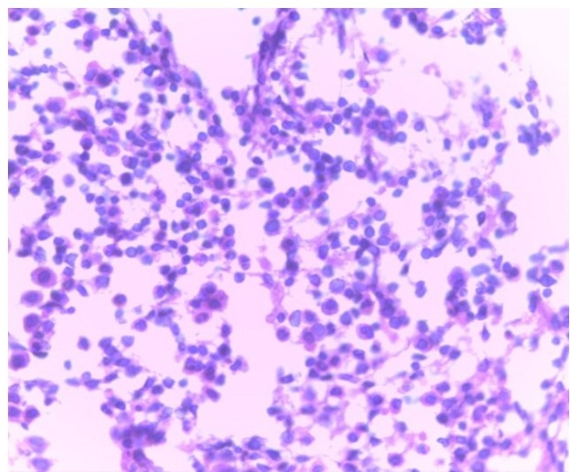

Figure 3: Photomicrograph of haematoxylin and eosin stained section of bone marrow shows increased erythroid islands and hyperplasia of the erythroid precursor in a patient that had recurrent anaemia (X40)

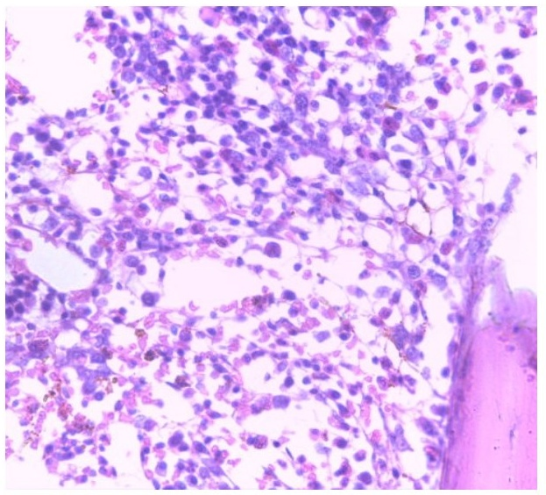

Figure 4: Photomicrograph of haematoxylin and eosin stained section of bone marrow shows hypercellular marrow and erythroid hyperplasia of the precursor cells most of which appear as large blasts with vesicular nuclei and prominent nucleoli in a patient that had pancytopenia (X40)

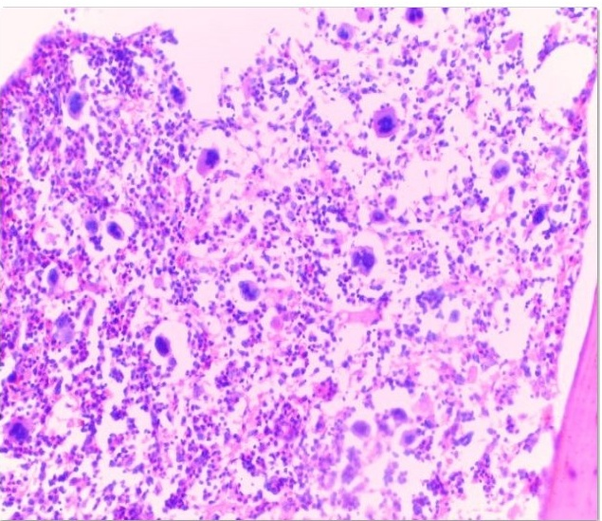

Figure 5: Photomicrograph of haematoxylin and eosin stained section of the bone marrow showing a reactive increase in the production of megakaryocytes. Lymphocytic infiltration of the marrow is noted. (X200). Histological diagnosis is immune thrombocytopenic purpura.

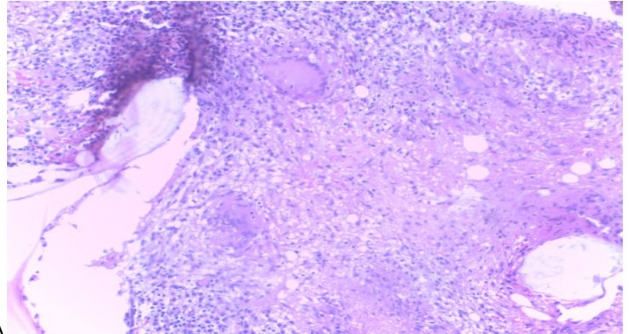

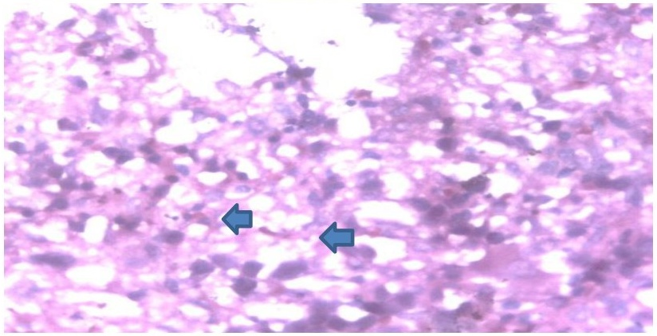

Figure 6: (A). Photomicrograph of haematoxylin and eosin stained section of chronic granulomatous inflammation in the marrow of a retroviral disease patient. A typical Langhans type giant cell is seen at the 12 O'Clockposition. (X20). (B) Ziehl-Neelsen stain of the marrow shows some red coloured acid fast bacilli (arrow).

Table 6: BMB* AGE Cross tabulation

|  |  |  |  |  |  |  |  |  |
| --- | --- | --- | --- | --- | --- | --- | --- | --- |
| Count of AGE | AGE |  |  |  |  |  |  |  |
| BMB | 20-29 | 30-39 | 40-49 | 50-59 | 60-69 | 70-79 | 80-89 | Grand Total |
| AA | 2 | 0 | 3 | 1 | 2 | 0 | 1 | 9 |
| BME | 0 | 0 | 2 | 0 | 0 | 0 | 0 | 2 |
| CGI | 1 | 0 | 1 | 0 | 0 | 0 | 0 | 2 |
| EHP | 4 | 9 | 6 | 6 | 7 | 5 | 0 | 37 |

|  |  |  |  |  |  |  |  |  |
| --- | --- | --- | --- | --- | --- | --- | --- | --- |
| HOA | 3 | 2 | 6 | 9 | 4 | 1 | 0 | 25 |
| HPS | 0 | 1 | 0 | 0 | 0 | 0 | 0 | 1 |
| ISD | 0 | 0 | 1 | 3 | 2 | 1 | 0 | 7 |
| ITP | 3 | 0 | 0 | 1 | 2 | 0 | 0 | 6 |
| LEI | 0 | 0 | 0 | 0 | 1 | 1 | 0 | 2 |
| MGA | 1 | 1 | 4 | 2 | 1 | 2 | 0 | 11 |
| ML | 0 | 0 | 1 | 0 | 0 | 0 | 0 | 1 |
| NBM | 0 | 0 | 1 | 3 | 0 | 2 | 0 | 6 |
| NH | 0 | 1 | 2 | 0 | 2 | 0 | 0 | 5 |
| RMH | 0 | 0 | 0 | 1 | 0 | 0 | 0 | 1 |
| Grand Total | 14 | 14 | 27 | 26 | 21 | 12 | 1 | 115 |

AA: Aplastic Anaemia; ALL: Acute Lymphoblastic Leukemia: BME: Bone Marrow Eosinophilia; CGI:Chronic Granulomatous Inflammation; EHP:ErythriodHyperplasia;HPS:HyperesinophilicSyndrome;ISD: Insufficient For Diagnosis; HOA; HypoproliferativeAnaemia; ITP:ImmuneThromboctyopenia;LEI: Leishmaniasis; MGA: Megaloblastic Anaemia; ML: Marrow Lymphocytosis; NBM: Normal Bone Marrow: NH: Neutrophilic Hyperplasia; RMH: Reactive Megakaryocytic Hyperplasia.

Of the 60 patients that were biopsied for chronic recurrent anaemia, 26 had a bone marrow diagnosis of erythroid hyperplasia, 20 were diagnosed of hypoproliferativeanaemia, 6 of megaloblastic anaemia, 4 had insufficient bone marrow biopsies while a person each was diagnosed of bone marrow eosinophilia, chronic granulomatous inflammation, neutrophilic hyperplasia and normal bone marrow (Table 7). Seventeen patients were biopsied on account of pancytopenia of no explainable cause. Seven of these had a bone marrow biopsy diagnosis of aplastic anaemia, 5 were diagnosed of erythroid hyperplasia, 4 were diagnosed of megaloblastic anaemia and a patient was diagnosed of hypoproliferativeanaemia. Of the 10 patients biopsied on the suspicion of multiple myeloma, 3 patients each had a bone marrow histology diagnosis of erythroid hyperplasia and insufficient bone marrow biopsy while two patients each had a histology diagnosis of hypoproliferativeanaemia and normal bone marrow.

Of the 48 patients with isolated anaemia, 22 were diagnosed of erythroid hyperplasia, 12 were had a bone marrow diagnosis of hypoproliferativeanaemia, 5 of megaloblastic anaemia, 3 had insufficient bone marrow samples for diagnosis, 2 of chronic granulomatous inflammation while a patient each was diagnosed of neutrophilic hyperplasia and leishmaniasis (Table 8). Twenty-five patients had full blood counts that showed pancytopenia. Of these,10 had erythroidhyperplasia, 8 aplastic anaemia, 3 megaloblastic anaemnia, 2 hypoproliferativeanaemia and a patient each had a normal bone marrow and insufficient bone marrow biopsy for diagnosis

Table 7-BMB indications crosstabulation with BMB diagnoses

|  |  |  |  |  |  |  |  |  |  |  |  |  |  |  |  |
| --- | --- | --- | --- | --- | --- | --- | --- | --- | --- | --- | --- | --- | --- | --- | --- |
| BMB | | | | | | | | | | | |  |  |  |  |
| INDICATION | AA | BME | CGI | EHP | HOA | HPS | ISD | ITP | LEI | MGA | ML | NBM | NH | RMH | Grand Total |
| AA | 2 | 0 | 0 | 0 | 0 | 0 | 0 | 0 | 0 | 0 | 0 | 0 | 0 | 0 | 2 |
| AHA | 0 | 0 | 0 | 0 | 0 | 0 | 0 | 0 | 0 | 0 | 0 | 0 | 1 | 0 | 1 |
| BCP | 0 | 0 | 0 | 0 | 0 | 0 | 0 | 0 | 0 | 0 | 0 | 0 | 1 | 0 | 1 |
| CA | 0 | 1 | 1 | 26 | 20 | 0 | 4 | 0 | 0 | 6 | 0 | 1 | 1 | 0 | 60 |
| EVS | 0 | 0 | 0 | 0 | 1 | 0 | 0 | 0 | 0 | 0 | 0 | 0 | 0 | 0 | 1 |
| FEV | 0 | 0 | 0 | 0 | 0 | 0 | 0 | 0 | 0 | 0 | 0 | 0 | 1 | 0 | 1 |
| HES | 0 | 1 | 0 | 0 | 0 | 1 | 0 | 0 | 0 | 0 | 0 | 0 | 0 | 0 | 2 |
| LPN | 0 | 0 | 1 | 2 | 0 | 0 | 0 | 0 | 0 | 0 | 0 | 0 | 1 | 0 | 4 |
| MC | 0 | 0 | 0 | 0 | 1 | 0 | 0 | 。 | 0 | 1 | 0 | 1 | 0 | 0 | 3 |
| MM | 0 | 0 | 0 | 3 | 2 | 0 | 3 | 0 | 0 | 0 | 0 | 2 | 0 | 0 | 10 |
| NHL | 0 | 0 | 0 | 1 | 0 | 0 | 0 | 0 | 0 | 0 | 0 | 0 | 0 | 0 | 1 |
| PCP | 7 | 0 | 0 | 5 | 1 | 0 | 0 | 0 | 0 | 4 | 0 | 0 | 0 | 0 | 17 |
| PEN | 0 | 0 | 0 | 0 | 0 | 0 | 0 | 0 | 1 | 0 | 1 | 0 | 0 | 0 | 2 |
| PI | 0 | 0 | 0 | 0 | 0 | 0 | 0 | 0 | 1 | 0 | 0 | 0 | 0 | 0 | 1 |
| TBT | 0 | 0 | 0 | 0 | 0 | 0 | 0 | 6 | 0 | 0 | 0 | 2 | 0 | 1 | 9 |
| Grand Total | 9 | 2 | 2 | 37 | 25 | 1 | 7 | 6 | 2 | 11 | 1 | 6 | 5 | 1 | 115 |

AA: Aplastic Anaemia;: BME: Bone Marrow Eosinophilia; CGI: Chronic Granulomatous Inflammation;EHP:Erythroid Hyperplasia; HPS: Hypereosinophilic Syndrome; ISD: Insufficient For Diagnosis; HOA;HypoproliferativeAnaemia; ITP: Immune Thrombocytopenia; LEI: Leishmaniasis; MGA: Megaloblastic Anaemia;ML:MarrowLymphocytosis;NBM:Normal Bone Marrow: NH: Neutrophilic Hyperplasia; RMH:Reactive Megakaryocytic Hyperplasia. AHA: Autoimmune Hemolytic Anaemia; AL: Acute Leukemia; BCP:Bicytopenia;CA: Chronic Anaemia; EVS: Evan Syndrome; FEV: Fever; HES: HypereosinophilicSyndrome;LPN:Lymphoproliferative Neoplasm; MC: Metastatic Carcinoma; MM: Multiple Myeloma; NHL: Non-Hodgkin lymphoma on Treatment; PCP: Pancytopenia; PEN: Persistent Neutropenia; PI: Parasitic Infestation;TBT: Thrombocytopenia

Table 8 -BMB*FBC Crosstabulation

|  |  |  |  |  |  |  |  |  |  |
| --- | --- | --- | --- | --- | --- | --- | --- | --- | --- |
| FBC | | | | |  |  |  |  |  |
| BMB | ANM | BCT | LCP | LCT | NOR | PCT | TBP | TBT | Grand Total |
| AA | 0 | 1 | 0 | 0 | 0 | 8 | 0 | 0 | 9 |
| BME | 0 | 0 | 0 | 1 | 0 | 0 | 0 | 1 | 2 |
| CGI | 2 | 0 | 0 | 0 | 0 | 0 | 0 | 0 | 2 |
| EHP | 22 | 4 | 0 | 0 | 0 | 10 | 0 | 1 | 37 |
| HOA | 12 | 4 | 0 | 3 | 2 | 2 | 0 | 2 | 25 |
| HPS | 0 | 0 | 0 | 1 | 0 | 0 | 0 | 0 | 1 |
| ISD | 3 | 0 | 1 | 0 | 1 | 1 | 0 | 1 | 7 |
| ITP | 0 | 6 | 0 | 0 | 0 | 0 | 0 | 0 | 6 |
| LEI | 1 | 1 | 0 | 0 | 0 | 0 | 0 | 0 | 2 |
| MGA | 5 | 1 | 0 | 1 | 0 | 3 | 0 | 1 | 11 |
| ML | 0 | 0 | 1 | 0 | 0 | 0 | 0 | 0 | 1 |
| NBM | 2 | 0 | 0 | 1 | 2 | 1 | 0 | 0 | 6 |
| NH | 1 | 1 | 0 | 3 | 0 | 0 | 0 | 0 | 5 |
| RMH | 0 | 0 | 0 | 0 | 0 | 0 | 1 | 0 | 1 |
| Grand Total | 48 | 18 | 2 | 10 | 5 | 25 | 1 | 6 | 115 |

Out of the 115 patients, 102 show similar diagnoses with the BMB and BMA giving a concordance rate of 89.6%. However, the percentage concordance between bone marrow biopsy and bone marrow aspirate varied between various diagnoses. Bone marrow eosinophilia,erythroid hyperplasia, hyper eosinophilic syndrome, megaloblastic anaemia; marrow lymphocytosis, reactive megakaryocytic hyperplasia and normal bone marrow showed 100%concordance between the aspirate and histology diagnoses (Table 9). Hypoproliferativeanaemia and aplastic anaemia had 96.0% and 88.9% concordance respectively.

For the cases with that showed discordant aspirate and histological diagnoses either of the bone marrow aspirate or bone marrow biopsy diagnosis was used as the gold standard following

ancillary studies. In the case of one BMB diagnosis of aplastic anaemia, the BMA diagnosis was erroneously made as bone marrow eosinophilia. In both cases of the BMB diagnoses of chronic granulomatous inflammation, the BMA reported the diagnoses of hypoproliferativeanaemia in each case (Table 10). There was a case that was wrongly reported as hypoproliferativeanaemia on BMB that was diagnosed as multiple myeloma on BMA. Of the 7 cases that BMB samples were insufficient for diagnosis, 3 were diagnosed as erythroid hyperplasia on BMA, 3 as multiple myeloma and 1 as hypoproliferativeanaemia.

Of the 115 bone marrow biopsies seen, 102 had a pathological diagnosis while 6 showed normal bone marrow biopsies and 7 were insufficient for diagnoses (Table 11). These gave a diagnostic utility of 88.696%.

Table 9 BMB/BMA Cross tabulation

|  |  |  |  |  |  |  |  |  |  |  |  |  |  |  |  |  |
| --- | --- | --- | --- | --- | --- | --- | --- | --- | --- | --- | --- | --- | --- | --- | --- | --- |
| BMA | | | | | | | | | | |  |  |  |  |  |  |
| BMB | AA | RMH | BME | EHP | HOA | HPS | ITP | LEI | MGA | ML | MM | NH | MO | NBM | Grand  Total | Concordance  Rate(%) |
| AA | 8 | 0 | 0 | 0 | 0 | 0 | 0 | 0 | 0 | 0 | 0 | 0 | 1 | 0 | 9 | 88.9 |
| BME | 0 | 0 | 2 | 0 | 0 | 0 | 0 | 0 | 0 | 0 | 0 | 0 | 0 | 0 | 2 | 100 |
| CGI | 0 | 0 | 0 | 0 | 2 | 0 | 0 | 0 | 0 | 0 | 0 | 0 | 0 | 0 | 2 | 0 |
| EHP | 0 | 0 | 0 | 37 | 0 | 0 | 0 | 0 | 0 | 0 | 0 | 0 | 0 | 0 | 37 | 100 |
| HOA | 0 | 0 | 0 | 0 | 24 | 0 | 0 | 0 | 0 | 0 | 1 | 0 | 0 | 0 | 25 | 96 |
| HPS | 0 | 0 | 0 | 0 | 0 | 1 | 0 | 0 | 0 | 0 | 0 | 0 | 0 | 0 | 1 | 100 |
| ISD | 0 | 0 | 0 | 3 | 1 | 0 | 0 | 0 | 0 | 0 | 3 | 0 | 0 | 0 | 7 | 0 |
| ITP | 0 | 0 | 0 | 0 | 0 | 0 | 6 | 0 | 0 | 0 | 0 | 0 | 0 | 0 | 6 | 100 |
| LEI | 0 | 0 | 0 | 0 | 0 | 0 | 0 | 2 | 0 | 0 | 0 | 0 | 0 | 0 | 2 | 100 |
| MGA | 0 | 0 | 0 | 0 | 0 | 0 | 0 | 0 | 11 | 0 | 0 | 0 | 0 | 0 | 11 | 100 |
| ML | 0 | 0 | 0 | 0 | 0 | 0 | 0 | 0 | 0 | 1 | 0 | 0 | 0 | 0 | 1 | 100 |
| NBM | 0 | 0 | 0 | 0 | 0 | 0 | 0 | 0 | 0 | 0 | 0 | 0 | 0 | 6 | 6 | 100 |
| NH | 0 | 0 | 0 | 0 | 0 | 0 | 0 | 0 | 0 | 0 | 0 | 5 | 0 | 0 | 5 | 100 |
| RMH | 0 | 1 | 0 | 0 | 0 | 0 | 0 | 0 | 0 | 0 | 0 | 0 | 0 | 0 | 1 | 100 |



AA: Aplastic Anaemia; BME: Bone Marrow Eosinophilia; CGI: Chronic Granulomatous Inflammation; EHP:Erythriod Hyperplasia; HPS: Hypereosinophilic Syndrome; ISD: Insufficient for Diagnosis; HOA;HypoproliferativeAnaemia;ITP:ImmuneThromboctyopenia; LEI: Leishmaniasis; MGA: Megaloblastic Anaemia;ML: Marrow Lymphocytosis; NBM: Normal Bone Marrow: NH: Neutrophilic Hyperplasia; RMH:Reactive Megakaryocytic Hyperplasia.

Table 10 Diagnostic Discordance Between BMB and BMB (Non-Neoplastic)

|  |  |  |
| --- | --- | --- |
| BMB DIAGNOSIS | BMA DIAGNOSIS | GOLD STANDARD |
| AA | BME | BMB |
| CGI | HOA | BMB |
| CGI | HOA | BMB |
| ISD | HOA | BMA |
| ISD | MM | BMA |
| ISD | MM | BMA |
| ISD | MM | BMA |
| ISD | EH | BMA |
| ISD | HOA | BMA |
| ISD | EH | BMA |
| HOA | MM | BMB |
| ISD | ALL | BMA |

Table 11: THE DIAGNOSTIC UTILITY OF BMB (NON-NEOPLASTIC)

|  |  |  |
| --- | --- | --- |
|  | FREQUENCY | PERCENTAGE (%) |
| Normal Bone Marrow | 6 | 5.217 |

|  |  |  |
| --- | --- | --- |
| Inadequate Bone Marrow Sample | 7 | 6.087 |
| Pathological Diagnoses | 102 | 88.696 |
| TOTAL | 115 | 100.0 |

**DISCUSSION**

The present study was conducted on 115 adult patients suffering from chronic non-neoplastic haematological disorders during the study period of January 2020 to December 2023. The trephine biopsies were done either to diagnose the basic cause of disease or to confirm the diagnosis of peripheral blood smear and aspiration findings or for explaining the prognosis of the disease. This low figure shows that clinicians are yet to maximize the use of bone marrow biopsies as ancillary tool in patient management in our environment. The mean age is 49.95years. The youngest age seen in this study is 22 years and the oldest is 80 years indicating that BMB can be tolerated in the elderly if performed by experienced and qualified doctors as also alluded in other studies that had older patients.67(Warpe et al and Syed) should be in italics

Chronic unexplained anaemia was the most common indication with 60 patients followed by 17patients that presented with pancytopenia. This is consistent with the high rate of anaemia in Nigeria.8,9 The commonest non-neoplastic histological diagnosis in this study was erythroid hyperplasia with 20 females and 17 males. Hypoproliferativeanaemia followed closely with 15female and 10 male patients.Megaloblasticanaemia was diagnosed in 6 females and 5 males.

Erythroid hyperplasia in this study was seen in 20 females and 17 males. Other studies reported that erythroid hyperplasia is a common finding in bone marrow biopsies especially in patients with anaemia.10,11 Erythroid hyperplasia is due to blood loss where the marrow works to compensate for the peripheral anaemia. The high prevalence of iron deficiency anaemia in this environment can also be explained by the high burden of parasitic infestation and the low socioeconomic status leading to inadequate intake of food rich in iron such as meat, eggs and

green vegetables.11,12Similar to this study, Lee et all2 also found that erythroid hyperplasia is commoner in female which can be explained by the regular monthly menstrual flow and dilutional and nutritional anaemia seen in pregnancy.

When the marrow fails to react to the peripheral anaemia in non-neoplastic cases,the patient has a bone marrow diagnosis of hypoproliferative anaemia. Hypoproliferative anaemia is the second most common diagnosis in this study. Some of the patients with this diagnosis had ancillary investigations that showed chronic conditions like renal impairment and autoimmune diseases leading to anaemia of chronic diseases. The the lack of response of the bone marrow to the peripheral anaemia in renal impairment is due to reduction in erythropoietin levels. A previous study by Weiss et al reported that hypoproliferative anaemia can occur in response to chronic disease, inflammation, or other medical conditions.13

Megaloblastic anaemia is due to folate and vitamin B12 deficiency. Megaloblastic anaemia is a form of erythroid hyperplasia where the marrow is hypercellula and there is hyperplasia of the erythroid precursors especially the megaloblasts that could lead to the misdiagnosis of acute myeloblastic anaemia. Folate requirement increases during pregnancy and the diets of many pregnant patients are insufficient to meet the increased need. A previous study by Oh et al .reported that megaloblastic anaemia was found more frequently in females than males, which corresponds with this current finding.14 Chronic haematological diseases like sickle cell and thalassemia also lead to megaloblastic anaemia. However, folate deficiency occurs most often in economically deprived patients.15.16,17

Other diagnoses, such as bone marrow eosinophilia, chronic granulomatous inflammation, and neutrophilic hyperplasia are rare in this study as seen in other studies.10 This study found only 2patients with chronic granulomatous inflammation, which aligns with the findings of Savage et al.18 The Ziehl Neelsen stain of these marrow in the two patients showed acid fast bacilli thus showing the need of special stains in bone marrow biopsies. Three patients had insufficient bone marrow samples for diagnosis. According to Bain et al., insufficient bone marrow samples can often be a challenge in haematological diagnosis, which may necessitate repeat biopsies.10 The

insufficient samples here were seen more in obese uncooperative patients and also due to new operators (new resident doctors) attempting BMB for the first time.

The overall concordance in this study is 89.6%. Chandra et al19 and Metikurke20etal had slightly lower values of 78% and 75.8%. The percentage concordance between bone marrow biopsy and bone marrow aspirate varied between various diagnoses. Bone marrow eosinophilia, erythroid hyperplasia, hyper eosinophilic syndrome, megaloblastic anaemia, marrow lymphocytosis, reactive megakaryocytic hyperplasia, and normal bone marrow showed 100% concordance between the aspirate and histology diagnoses. An earlier study revealed that bone marrow biopsy and bone marrow aspirate diagnoses are generally concordant, especially for diagnoses like erythroid hyperplasia and megaloblastic anaemia.10 However, the histologic diagnoses of chronic granulomatous inflammation showed 100% discordance because the aspirates will not show the histological architecture needed to arrive at such diagnosis. Oh et al. also stated that BMB is essential for diagnosing infiltrative lesions like chronic granulomatous hyperplasia.21

Of the 115 bone marrow biopsies seen, 102 had a pathological diagnosis, while 6 showed normal bone marrow biopsies, and 7 were insufficient for diagnosis. According to Weiss et al.13 BMB is a valuable diagnostic tool with a diagnostic utility of 85%, which aligns with the diagnostic utility of 88.696% found in this study.

**Conclusion**

Erythroid hyperplasia is the commonest bone marrow biopsy diagnosis. Megaloblastic anaemia is more common in women in the reproductive age group. In all the cases of the cases of chronic granulomatous inflammation, bone marrow aspirate was unable to clinch the diagnosis due to the histological architectural requirements to make the diagnosis. The high number of cases of insufficient specimen for BMB can be reduced by more manpower training. More medical practitioners should be encouraged to utilize bone marrow biopsies, when necessary,in evaluating and managing patients.

**Declaration of patient consent**

The authors certify that they have obtained all appropriate patient consent.

**References**

1. Parajuli S, Tuladhar A. Correlation of bone marrow aspiration and biopsy findings in diagnosing haematological disorders-a study of 89 cases. Journal of Pathology of Nepal. 2014;4:534-538.

2. Shirlyn B. Structure and function of haematopoietic system. In: Schlueter editors. Mckenzie clinical laboratory haematology. New Jersey: Pearson Education publishers, 2004;p.43-46.

3. Testa NG, Molineux G. Haemopoeisis: A practical approach. IRL. Press. Oxford university press,New York.1993

4. Birbrair A, Frenette, PS.*Niche heterogeneity inthebonemarrow.* Annals of the New York Academyof Sciences. 2016;1370:82-96.ISSN *1749-6632. PMC 4938003* .PMID *27015419.doi:10.1111/nyas.13016).*

5. Das R,Mandal AP, Ghosh M, Sengupta M. Comparison of bone marrow aspiration and biopsy as diagnostic tool in paediatric age group.JHematol Allied Sci 2023;3:11-7.

6. Warpe S.J, Warpe B. M. Bone Marrow Aspiration and Bone Marrow Biopsy in HaematologicalDisorders.Biomed Pharmacology Journal 2020:13(2).

7. Syed, N., Moiz, B., Adil, S., Khurshid, M. (2007). Diagnostic importance of bone marrow examination in non-hematological disorders. Journal of Pakistan Medical Association, 57(3),123-125.

8. AzingeIE,Ogunyemi A, OgambaCF,Jimoh RO. Prevalence of anemia and associated factors among adults in a select population in Lagos, Southwest Nigeria. J Public Health Afr. 2023 Apr 19;14(4):2224.doi: 10.4081/jphia.2023.2224. PMID:37347070;PMCID: PMC10280247.

9. Azinge IE, Ogunyemi A, Ogamba CF, Jimoh RO. Prevalence of anemia and associated factors among adults in a select population in Lagos, Southwest Nigeria. J Public Health Afr. 2023 Apr 19;14(4):2224.doi: 10.4081/jphia.2023.2224.PMID:37347070;PMCID: PMC10280247.

10. Bain BJ, Clark DM, Wilkins BS. Bone marrow pathology. Wiley-Blackwell; 2010.

11. MainaliN,HomagaiN,Tiwari P.S, Giri A. A Comparative Study of Bone Marrow Aspiration and Bone Marrow Biopsy in Hematological Diseases.Journal of Noble Medical College. 2015;4:12-14

12.Lee SH,LeeJH,KimSK.Erythroid hyperplasia in bone marrow biopsies: a clinicopathological study.Korean J Patho1.2012 Jun;46(3):257-64.

13. Weiss G,Goodnough LT. Anemia of chronic disease. N Engl J Med. 2015;372(11):1064-74.

14. Oh, R. C., & Brown, D.L.(2018). Vitamin B12 deficiency. American Family Physician, 97(10),642-648.

15. Anenga UM, Rimamnunra GN, Eka PO, Agulebe CJ, SwendeTZ,MaanongunMT,AkwarasNA,Ango J J, Izeji R. Prevalence and risk factors for anaemia among pregnant women attending antenatal clinic at Benue State University Teaching Hospital, North-central Nigeria. Afr J Reprod Health.2022 Dec;26(12s):161-168.doi:

16.Foulid WS et al. Vitamin B12 absorption in tobacco amblyopia. British Journal of Ophthalmology.1969;53:393.

17.Goldberg GM, Emanuel B.A study of malignant lymphoma and leukaemia VII cancer.1964;17:277.

18.Savage RA,Hoffman R. Anemia.In:HoffmanR,Benz EJ Jr,Silberstein LE, et al., editors.Hematology:basic principles and practice. 6th ed. Philadelphia,PA: Elsevier; 2013.p.419-33.

19. Chandra S,& Chandra H.Comparisons of bone marrow aspirate cytology, touch imprint cytology and trephine biopsy for bone marrow evaluation. Hematol Rep. 2011;3(3):e22.

20. Metikurke S.HI., Rashmi K, Bhavika R. Correlation of bone marrow aspirate,biopsies and touch imprint findings in pancytopenia. J Hematol. 2013;2 (1):8-13

21. Oh RC, Brown DL. Vitamin B12 deficiency. Am Fam Physician. 2018;97(10):642-8.