**FECAL CARRIAGE OF BETA-LACTAM-RESISTANT *ESCHERICHIA COLI* IN *COLUMBA PALUMBUS* IN LOME**

.

ABSTRACT

|  |
| --- |
| **Aims:** This study aims to investigate the origin of the transfer of beta-lactam-resistant *Escherichia coli* from animals (pigeons) to humans.  **Study design:** This forward-looking study took place from February to July 2024 in Lomé's Golfe district.  **Place and Duration of Study:** Four (04) samples were collected monthly and per site over 6 months from four (04) pigeon houses, namely two residential and two commercial pigeon houses.  **Methodology:** Freshly emitted droppings were collected and inoculated on-site directly into Mac Conkey + CTX (Cefotaxime) and Mac Conkey + ERT (Ertapenem) media, then into salted peptone water. After 24 h incubation at 37°C, the inoculums were reseeded onto Mac Conkey + CTX (Cefotaxime) and Mac Conkey + ERT (Ertapenem) media for a further 24 h incubation at 37°C. All colony types obtained on the seeded media were identified at the end of the different incubations using the API 20E gallery. Extended-spectrum beta-lactamase-producing *Escherichia coli* strains were detected by antibiogram using the Kirby-Bauer method.  **Results:** Of the 96 samples taken, evenly distributed by type of loft, 52 (54.17%) contained ESBL *Escherichia coli* strains. No resistance to carbapenems was observed in any of the *Escherichia coli* strains isolated. Over the study period, from the dry to the rainy season, we observed an increase in the carriage of *Escherichia coli* ESBL in commercial and domestic pigeons, reflecting more frequent dissemination of *Escherichia coli* ESBL strains during the rainy season than during the dry season.  **Conclusion:** pigeons are a reservoir for transferring multi-resistant *Escherichia coli* strains to humans. |

*Keywords: faecal carriage, Escherichia coli*, ESBL, *Columba palumbus*

1. INTRODUCTION

Antibiotic resistance has developed at an alarming rate in recent years, to the point of becoming one of the greatest threats to public health and one of the main challenges for medicine in the 21st century (OECD, 2020). The expansion in pigeon meat production that has occurred in recent years warrants attention to its hygienic status (Jorge C. et al., 2019). *Escherichia coli* is a common bacterium in the intestinal tract of humans and animals. Most strains of these bacteria are not pathogenic and are considered only as indicators of faecal contamination. However, between 10% and 15% of *Escherichia coli* strains are pathogenic and can cause a wide range of food- and water-borne illnesses (Jorge C. et al., 2019). The presence of potentially zoonotic bacteria in migratory and non-migratory wild birds is of public health importance. Various pathogenic bacterial species have been isolated from wild birds. Migratory and non-migratory wild birds can also serve as reservoirs for coliform bacteria, such as *Escherichia coli*, which carry antimicrobial resistance genes. Contact with water and acquisition via food appear to be the main factors in the transmission of resistant bacteria of human or veterinary origin to wild animals (Mohammed Y-S. et al., 2014). Contact with species that transfer multi-resistant bacteria to humans provides a biological mechanism for the increase of antibiotic-resistant genes in human populations, making antibacterial therapy difficult or impossible in humans.

2. material and methods

**2.1 Sampling**

This was a systematic sampling method. A series of four (04) samples was taken monthly over a 6-month period from four (04) pigeon lofts: two residential and two commercials. Samples were taken using sterile swabs from freshly emitted droppings.

**2.2 Microbiological tests**

**2.2.1 Isolation and identification**

Freshly emitted droppings were collected, inoculated on site directly into Mac Conkey + CTX (Cefotaxime) and Mac Conkey + ERT (Ertapenem) media, then inoculated into salted peptone water. After 24 h incubation at 37°C, the inoculums were reseeded on Mac Conkey + CTX (Cefotaxime) and Mac Conkey + ERT (Ertapenem) media for a further 24 h incubation at 37°C. At the end of the different incubations, all colony types obtained on the seeded media were identified using the API 20E gallery. Extended-spectrum beta-lactamase-producing *Escherichia coli* strains were detected by antibiogram using the Kirby-Bauer method.

**2.2.2 Antibiotic susceptibility testing**

Antibiograms were performed according to CASFM -EUCAST (Antibiogram Committee of the French Microbiology Society - European Committee on Antimicrobial Susceptibility Testing) recommendations, October 2022 version, using the Kirby-Bauer method. However, only the following antibiotic discs were tested to confirm the production of extended-spectrum betalactamases by these strains via champagne cork image research according to the recommendations of the EUCAST standard used: amoxicillin-clavulanic acid (AMC; 30µg), ampicillin (AMP; 10µg), ceftazidime (CAZ; 30µg), cefotaxime (CTX; 30µg), cefoxitin (FOX; 30 μg), imipenem (IPM; 10µg), aztreonam (ATM; 30µg), ertapenem (ERT; 05µg).

3. results and discussion

**3.1 Prevalence rate of samples positive for *Escherichia coli* producing broad-spectrum beta-lactamase enzymes**

**96 samples were collected, 48 per type of loft. A total of 54.17% of samples positive for ESBL *Escherichia coli* were obtained. Indeed, commercial pigeon lofts have a slightly higher prevalence rate of samples positive for *Escherichia coli* producing broad-spectrum beta-lactamase enzymes than that of residential lofts, i.e** 29.16% compared to 25.00% **respectively. However, no carbapenem-resistant species** of *Escherichia coli* have been observed. The table 1 below illustrates these results.

**Table 1.** **Positivity rate of beta-lactam-resistant *Escherichia coli* by site**

|  |  |  |
| --- | --- | --- |
|  | **pigeon loft** | |
| **Total number of beta-lactam-resistant E. coli obtained** | 52 | |
| **Total number of samples collected** | 96 | |
| **Beta-lactam-resistant E. coli positivity rate obtained** | 54,17% | |
| **Type of dovecotes** | **Commercial** | **Residential** |
| **Total number of beta-lactam-resistant E. coli obtained per type of site** | 28 | 24 |
| **Beta-lactam-resistant E. coli positivity rate by type of site** | 29.16% | 25.00% |

Compared with international studies, very low rates of ESBL-producing *Escherichia coli* in pigeons have been reported in France (1.4%) (Aires-de-Sousa M., 2020), Brazil (2.8%) (Ngaiganam E-P., 2019), Bangladesh (4.7%) (Cunha M-P-V., 2019) and Algeria (6.5%) (Loucif L., 2022). This variation may reflect differences in dietary habits or immune status (Vogt N-A, Stevens C-P-G., 2020).

Our results are closer to those of Rahman et al. in 2023, who obtained a rate of 22% for ESBL *Escherichia coli* in their study of extended-spectrum beta-lactamase in *Escherichia coli* isolated from animals in Bangladesh (Rahman A., 2023).

**3.2 Antibiotic Susceptibility Testing**

We observe a 100% resistance for the discs of cefotaxime confirming the production of betalactamases by these bacteria studied. However, this rate is 52% for Cefepime, which is a fourth-generation cephalosporin. No resistance is observed for imipenem, however low resistance is observed for ertapenem. We also note a low sensitivity for the disc of amoxicillin + clavulanic acid. The figure 1 illustrates the results of the antibiotic sensitivity test.

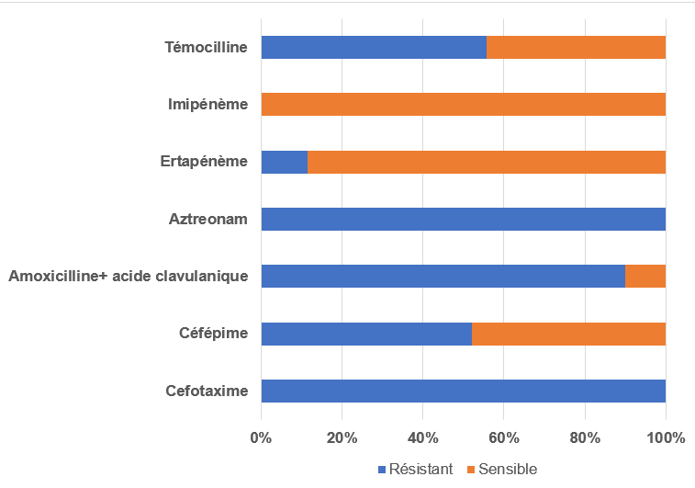

**Fig.1. Result of Antibiotic Susceptibility Testing**

Antibiogram results as shown in the figure above reveals a 100% resistance rate to Cefotaxime, a third-generation cephalosporin, expanded resistance to fourth-generation cephalosporins (Cefepime). this confirms the effective production of the betalactamases enzyme by the *Escherichia coli* strains isolated directly from the above-mentioned selective media and described in the methodology. The absence of resistance to carbapenems observed in the antibiogram confirms the absence of obtaining strains resistant to carbapenems. These results are consistent with those of Rahman *et al*., 2023 (Rahman A., 2023).

**3.3 Monthly distribution of ESBL *Escherichia coli* strains**

In order to have an idea of the evolution of the pigeon carrying rate, we have analysed the ESBL *Escherichia coli* carrying rate by site and by month. The figure below shows these results.

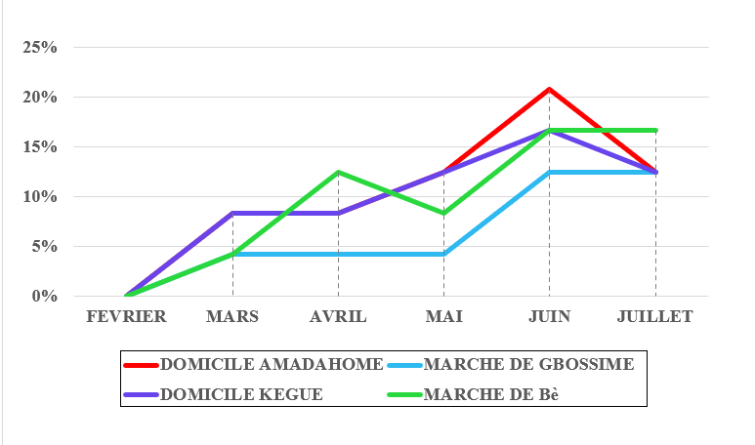

**Fig. 2. Monthly distribution of ESBL *Escherichia coli* strains by site in pigeons**

we observed an increase in the rate of *Escherichia coli* ESBL in pigeon feces, depending on whether the loft was residential or commercial, until June, followed by a slight decrease in July. Given that the first three months of the study period constituted the dry season and the last three months the rainy season, we could say that the fecal carriage rate of ESBL *Escherichia coli* would increase during the rainy season.

4. Conclusion

Resistance in itself becomes a major public health problem in the conditions it is virulent and causes a therapeutic impasse. Further study of the resistance genes will make it possible to determine the resistance supports and deduce their virulence in order to take measures for the benefit of the pigeon breeders and the pigeons themselves.

Consent (where ever applicable)

All authors declare that ‘written informed consent was obtained from the patient (or other approved parties) for publication of this case report and accompanying images. A copy of the written consent is available for review by the Editorial office/Chief Editor/Editorial Board members of this journal."

Ethical approval (where ever applicable)

“All authors hereby declare that "Principles of laboratory animal care" (NIH publication No. 85-23, revised 1985) were followed, as well as specific national laws where applicable. All experiments have been examined and approved by the appropriate ethics committee”

References

1. Aires-de-Sousa M., Fournier C., Lopes E., de Lencastre H., Nordmann P., Poirel L. (2020) High colonization rate and heterogeneity of ESBL and carbapenemase-producing *Enterobacteriaceae* isolated from gull feces in Lisbon, Portugal. *Microorganisms*, *8*, 1487.
2. Antimicrobial Resistance. Tackling the Burden in the European Union Organization for Economic Coordination and Development (OECD). (2020) Generalizability and comparability of prevalence estimates in the wild bird literature: Methodological and epidemiological considerations. *Animal Health Research Reviews*, *21*, 89–95.
3. Cunha M.P.V., Oliveira M.C.V., Oliveira M.G.X., Menão M-C, Knöbl T. (2019) CTX-M-producing *Escherichia coli* isolated from urban pigeons (*Columba livia domestica*) in Brazil. *Journal of Infection in Developing Countries*, *13*, 1052–1056.
4. EFSA; ECDC. The European Union summary report on antimicrobial resistance in zoonotic and indicator bacteria from humans, animals and food in 2017 (2019). *EFSA Journal*, *17*, e05598, 278.
5. Jorge C., Carlos A.C., Camino G.F., Rosa C. (2019) Microbial Load and Antibiotic Resistance Patterns of *Escherichia coli* and *Enterococcus faecalis* Isolates from the Meat of Wild and Domestic Pigeons. *Foods*, *8*(11), 536
6. Mohammed Y.S., Aly E.A. (2014) rôle of wild birds as carriers of multi-drug-resistant *Escherichia coli* and *Escherichia* *vulneris, Environmental Microbiology Brazilian Journal of Microbiology. 45 (4).*
7. Ngaiganam E.P., Pagnier I., Chaalal W., Leangapichart T., Chabou S., Rolain J.M., Diene S.M. (2019) Investigation of urban birds as source of β-lactamase-producing Gram-negative bacteria in Marseille city, France. *Acta Veterinaria Scandinavica*, *61*, 51.
8. Rahman A., Hassan J., Rahman M., & Saiful Islam M. (2023). Extended-spectrum bêta-lactamase in *Escherichia coli* isolated from humans, animals, and environments in Bangladesh: A One Health perspective systematic review and meta-analysis. *UC Davis*.
9. Loucif L., Chelaghma W., Bendjama E., Cherak Z., Khellaf M., Khemri A., Rolain J-M. (2022) Detection of *bla*OXA-48 and *mcr-1* genes in *Escherichia coli* isolates from pigeon (*Columba livia*) in Algeria. *Microorganisms*, *10*, 975.