**Antibacterial activities of *Pleurotus djamor* against selected clinical pathogens**

**ABSTRACT**

**Aims:** This study investigates the cultivation and biological efficacy of Pleurotus djamor var. roseus, commonly known as the pink oyster mushroom, using low-cost techniques and various agro-wastes as substrates. With global mushroom production exceeding two million tons annually, the economic and nutritional importance of mushrooms has been recognized, particularly due to their high protein, fiber content, and antioxidant properties.

**Study design and Methodology :** The research involved the preparation of a suitable substrate, including the sterilization and spawning of paddy straw, followed by monitoring growth parameters such as spawn running, pinhead formation, and fruit body development.

**Place and Duration of Study:** The study was conducted at Department of Microbiology, Kamarajar government arts college, Surandai.

**Results:** The results indicate optimal conditions for mycelial growth and yield, with a biological efficiency of 43% observed in paddy straw substrates. Additionally, the ethanolic extracts of P. djamor were tested for antibacterial activity against both gram-positive and gram-negative pathogens, showing significant inhibitory effects, particularly against Escherichia coli and Pseudomonas aeruginosa.

**Conclusion:** The findings suggest that P. djamor var. roseus is a nutritionally rich mushroom with potential health benefits, supporting its incorporation into dietary practices to combat chronic diseases and aging. This study highlights the advantages of utilizing agro-wastes for sustainable mushroom cultivation while emphasizing the health-promoting attributes of this species.

*Keywords: Pleurotus djamor, Pink oyster mushrooms, growth parameters, Escherichia coli, Pseudomonas*

**1. INTRODUCTION**

*Pleurotus djamor*, commonly known as the pink oyster mushroom, is a species of fungus in the family Pleurotaceae. Mushroom industry is a global and expanding industry, with world production greater than two million tons annually. *Pleurotus djamor* var, *roseus* is an edible mushroom in the order Agaricales. It is also called as roseus mushroom, pink oyster or salman pink oyster because of its pink sporophore, large sized fruit bodies and delicious flavour. It can be grown at 260C and 320C and with relative humidity above 80%. Nowadays increased utilization of mushroom for its nutritive potential and are recognized as an important food items from ancient periods. Mushrooms are macro fungus with distinct fruiting body, can either be hypogenous or epigenous (Amic et al., 2007). Economic importance and nutritional importance of mushroom were increased as edible food this may be due to its high protein and fibres content and rich in antioxidant which play a major role inhuman health protein and nutrient*.* The flavour of the pink oyster mushroom has been described as meaty and fishy. Just like most mushrooms it is quite unami. Its texture is both meaty and chewy. When fried until crispy, it resembles bacon or even ham. However, when it is raw, it has a sour taste. It has a curly cap which is 2-5cm in diameter. The caps are also quite thin. The stem is very short or even non-existent. Pink oyster mushrooms have a strong woody aroma and are tougher in texture than other oyster mushrooms. This mushroom is full of vitamins, minerals and antioxidants within the cell walls of the growing pink hue and top to bottom gills. Pink oyster retain most of the nutrients until the cell walls are broken down with heat. Most cell walls of mushrooms cannot break down our digestive system and heating or looking the mushrooms breaks down the cell wall broken down the cell wall before ingestion. The main aim of the study is to cultivate *P.djamor* var. roseus mushroom on low cost technique and to determine its growth, yield and biological efficacy on different agro wastes (Arbaayah and umi, 2013).

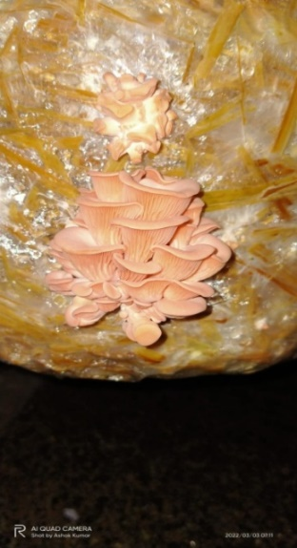 **Fig. 1. Morphology of *Pleurotus djamor***

**2. MATERIALS AND METHODS**

The pink oyster mushroom spawn was collected from Agricultural College and Rresearch Institue, Madurai, 625104. Well dried (free from mould fungi) paddy straw substrate evaluated for the cultivation of *P.djamor var. roseus*. The selected substrate were chopped into 5cm long pieces and transferred to gunny bags. The bags were soaked in clean tap water for 12hours. The excess water was drained out and the pre-soaked substrates were sterilized for 30 minutes at 15 psi pressure. The cultivation of pink oyster mushroom is usually carried out in transparent polythene covers. The size of the cover should be 60 x 30 cm, with a thickness of 80 gauges.

**2.1 PROCEDURE**

Wash hands thoroughly with antiseptic lotion. Take the polythene cover and tie the bottom end with a thread and turn it inwards. Shade dry steam sterilized straw to get a uniform moisture level in all areas. Take out a well-grown bed spawn, squeeze thoroughly and divide into two halves. (Two beds are prepared from the single spawn bag). Fill the straw to a height of 3” in the bottom of polythene bag, take a handful of spawn and sprinkle over the straw layer, concentrating more on the edges. Fill the second layer of the straw to a height of 5” and spawn it as above. Repeat this process to get five straw layers with spawns. Gently press the bed and tie it tightly with a thread. Put 6 ventilation holes randomly for ventilation as well as to remove excess moisture present inside the bed. Arrange the beds inside the thatched shed, (Spawn running room) following Rack system or hanging rope system. Maintain the temperature of 22-25° C and relative humidity of 85-90 % inside the shed. Observe the beds daily for contamination, if any. The contaminated beds should be removed and destroyed. Similarly, observe regularly for the infestation of insect pests *viz.*, flies, beetles, mites etc., If noticed, the pesticide like parathion should be sprayed inside the 1 ml per liter of water. The fully spawn run beds can be shifted to cropping room for initiation of buttons (Bhatia et al., 2013).

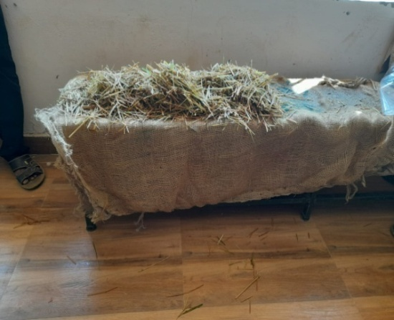 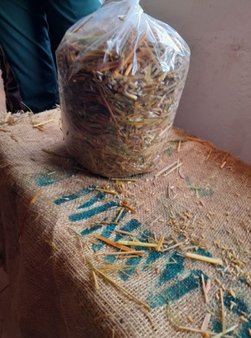

**Fig. 2. Stream sterilized straw Fig. 3. bed preparation**

**2.2 PREPARATION OF ETHANOLIC EXTRACTS**

**A fine-dried mushroom powder sample (10g) was dissolved in 100 ml of ethanol, in a cleaned flat bottom container with occasional shaking and stirring. Mixtures were filtered repeatedly and using cotton cloth and cotton and what man filter paper. The combined Ethanolic extracts were evaporated at 40 degree to dryness. The organic solvent in the extracts was removed by a rotary evaporator, for the entire analysis, compounds of extract were dissolved in Dimethyl sulfoxide (DMSO). Extracts were kept in the dark at 4 degree for not more than 1 week prior to use (**Carlotti et al., 1997**).**

**3. RESULT AND DISCUSSION**

The study revealed the efficiency of the growth parameters and yield of *Pleurotus djamor*. Substrates are one of the most important parameters in mushroom cultivation which depends on the nutritional availability to support the mycelia growth and to develop mushroom fruiting bodies. Also, constructing the substrate in the cunny bags is an important factor for the growth of the mycelia as it should be suitable for the penetration of the mycelium in the basal substrates. Which ultimately influence the fruiting of the spawn running, pinhead formation and fruit body formation are three phases in the cultivation of mushroom**.**

The result indicates that spawn running periods the results were found in accordance with the findings of (Gupta et al., 2013). In the *Pleurotus spp* mycelium growing day was generally observed on 10-15 days. The pinhead formation is the second stage of mycelial growth during cultivation of mushroom. Pinhead formation. The results of this study concur with the finding of (Lavelli et al., 2018) who reported that pinhead formation of P.sajor-cajuwas in 20-25day of incubation. A number of investigators have reported those different timing periods were taken for the fruiting body formation. In our study Fruit body formation and the result was support the finding of (Palacios et al., 2011) obtained a crop from wheat straw + paddy straw 20- 23 days. Khanna and Garcha (1981) found the crop in 104 days on paddy straw and Tan (1981) reported that *P.ostreatus* and other species on cotton waste took 2-3 weeks for fruit body formation after spawn running. The number of primordia and number of effective fruiting bodies initiation had a linear relationship. In this study, the maximum number of Primordia initiation this was more are less similar with the results (Suliburska and Siwulski, 2016) stated a higher number of primordial initiations in *Pleurotus djamor* growing on wheat bran and supplement with sugarcane. Number total primordia per packet were found in Mahogany sawdust reported by Sun et al., (2018). Pileus diameter were recorded as, Pileus thickness were measured as, Stalk length were and the Stalk diameters were recorded in our study.

Gupta et al., (2013) also highest Pileus diameter and thickness in wheat bran and supplement with sugarcane bags. This was more are less similar study. In this present study experiments results indicated that maximum yield was recorded in the paddy straw *Pleurotus djamor* Was reported rice bran supplements the organic nitrogen which helps in the production of high yield. Cereal straw used for cultivation of oyster mushroom is poor source of nitrogen (0.8%) and at the time of fructification when most of the nitrogen is utilized for the mycelial growth, the depleted nitrogen in the substrates became inadequate and limits mushroom yield. In this study paddy straw cultivation biological efficiency 43.00% BE were observed. (Gupta et al., 2013) recorded the highest biological efficiency in paddy straw + wheat straw these result more are less similar to the results.

The Ethanolic extract of *Pleurotus djamor* were examined against both gram positive and gram-negative human pathogens such as *Escherichia coli, Pseudomonas aeroginosa*, bacillus, protease and *Klebsiella pneumonia*. The extract showed maximum inhibition in gram negative organisms such as *Escherichia coli* and *Pseudomonas aerogenosa* whereas *Escherichia coli*. The maximum activity may due to the elution of polar compounds in ethanol extract. The result was supported by Wani et al., 2010 in which methanol extract of *P. djamor* showed maximum activity when compared with hexane extract in *E. coli* and *S.aureus. Klebsiella pneumonia* shows very less activity when compared with others (Table 1 and Figure 4, 5, 6, 7 & 8).

**Table 1: Test organism Vs Concentration of ethanolic extract**

|  |  |  |  |  |  |
| --- | --- | --- | --- | --- | --- |
|  |  | Concentration of ethanolic extract | | | |
| S. No | Test organism | 10µl (mm) | 20µl(mm) | 30µl(mm) | 50µl(mm) |
| 01. | *Escherichia coli* | 6 | 8 | 11 | 12 |
| 02. | *Pseudomonas* | 2 | 4 | 6 | 10 |
| 03. | *Klebsiella* | 1 | 3 | 7 | 9 |
| 04. | *Bacillus* | 10 | 10 | 11 | 12 |
| 05. | *Proteus* | 2 | 4 | 7 | 8 |



**Fig. 4. *Escherichia coli***

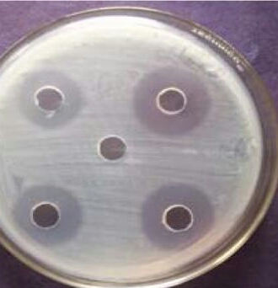

**Fig. 5. *Klebsiella***

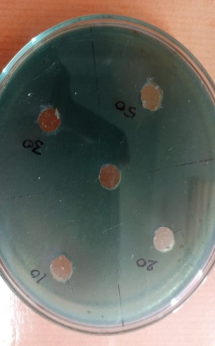

**Fig. 6. *Pseudomonas***

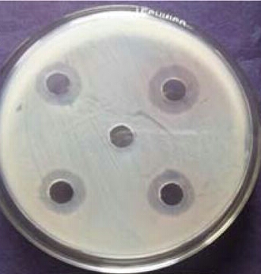

**Fig. 7. *Proteus***

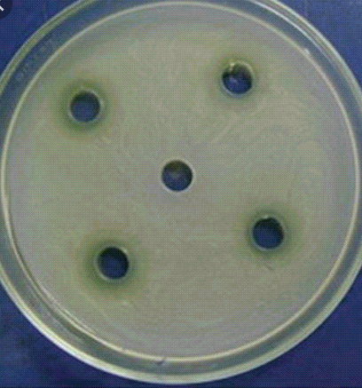

**Fig. 8. *Bacillus***

In the *Pleurotus spp* mycelium growing day was generally observed on 10-15 days (Wani et al., 2010). The pinhead formation is the second stage of mycelial growth during cultivation of mushroom. The Ethanolic extract of Pleurotus djamor were examined against both gram positive and gram-negative human pathogens such as *Escherichia coli, Pseudomonas aeroginosa, Bacillus, Protease* and *Klebsiella pneumonia*. The extract showed maximum inhibition in gram negative organisms such as *Escherichia coli* and *Pseudomonas aerogenosa*.

**4. CONCLUSION**

In conclusion, this study constitute the first report on the chemical composition of *P.djamor* var. *Roseus* showed a high level of carbohydrate, proteins and crude fibers. Besides, they contain all essential b-group vitamins, microelements, amino acids and unsaturated fatty acids. We evaluated in vitro antioxidant activity, and for healthy options, this mushroom contains low lipid and sodium. Nevertheless, the high nutritional quality and antioxidant activity of *P.djamor* var. Roseus will protect against freeradical damage and prevent various chronic diseases and aging. A significant advantage in bioactive compounds extraction from fruiting body, mycelia, or primordia can be manipulated to produce active compounds in a short period of time. The chemical composition and antioxidant results showed that *P.djamor* var roseus as healthy food for daily consumption. However, they considered alternative that should be incorporated into the human diet.

**REFERENCES**

Amic, D., Davidovic-Amic, D., Beslo, D., Rastija, V., Lucic, B., Trinajstic, N. N. (2007). SAR and QSAR of the antioxidant activity Of Flavonids. *Current Medicinal Chemistry*,14: 827-845.

Arbaayah, HH., Umi, KY. (2013). Antioxidant Properties in the Oyster Mushrooms (*Pleurotus spp*.) and Split Gill Mushroom (*Schizophyllan commune*) Ethanolic Extracts. *Mycosphere*, 4: 661-673.

Bhatia, P., Aureli, F D., Amato, M., Prakash, R., Cameotra, SS., Nagaraja, TP., Cubadda, F. (2013). Selenium bioaccessibility and speciation in biofortified Pleurotus mushrooms grown on selenium-rich agricultural residues. *Food Chemistry*, 140: 225-230.

Carlotti, ME., Gallarate, M., Gasco, MR., Morel, S., Serafino, A., Ugazio, E. (1997). Synergistic action of vitamin C and amino acids on vitamin E in inhibition of the lipoperoxidation of linoleic Acid in disperse systems. *International Journal of Pharmaceutics*, 155: 251-261.

Gupta, A., Sharma, S., Saha, S., Walia, S. (2013). Yield and nutritional Content of Pleurotus sajorcaju on wheat straw supplemented with raw and detoxified mahua cake, *Food Chemistry*, 141: 4231-4239.

Lavelli, V., Proserpio, C., Gallotti, F., Laureati, M., Pagliarini, E. (2018). Circular reuse of bio-resources: the role of *Pleurotus spp*. in the Development of functional foods. *Food & Function,* 9: 1353-1372.

Palacios, I., Lozano, M., Moro, C D., Arrigo, M., Rostagno, MA., Martínez, JA., García-Lafuente, A., Guillamón, E., Villares, A. (2011). Antioxidant properties of phenolic compounds occurring in edible Mushrooms. *Food Chemistry*, 128: 674-678.

Suliburska, J., Siwulski, M. (2016). Bioavailability and Digestibility of Nutrients from the Dried Oyster Culinary Medicinal Mushroom, *Pleurotus spp* (Agaricomycetes): In Vivo Experiments. *International Journal of Medicinal Mushrooms*, 18: 681-688.

Sun, L., He, W., Xin, G., Cai, P., Zhang, Y., Zhang, Z., Wei, Y., Sun, B., Wen. X. (2018). Volatile components, total phenolic compounds, and Antioxidant capacities of worm-infected Gomphidiusrutilus. *Food Science and Human Wellness,* 7: 148-155.

Wani, BA., Buddha, RH., Wani, AH. (2010). Nutritional and medicinal Importance of mushrooms. *Journal of Medicinal Plants Research,* 4: 2598-2604.