*Short communication*

Microbial Contaminants on Medical Devices – A Short review

.

ABSTRACT

|  |
| --- |
| Microbial contamination of medical devices is a critical issue in healthcare, as it can lead to serious infections and complications in patients. Contamination can occur due to improper handling, insufficient sterilization, and the presence of biofilms on device surfaces. To mitigate these risks, effective reprocessing/cleaning of medical devices is essential. Adhering to strict reprocessing/cleaning/eradication protocols is crucial to preventing infections and maintaining patient safety. Considering this, the review suggests the many forms of microbial contamination and their connection to medical devices. |

*Keywords: Contamination; Medical Devices; Biofilms; Virus; Fungi; Bacteria*

1. INTRODUCTION

Microbial contamination of medical devices is a significant concern in healthcare, as it poses a direct threat to patient safety. Microbial contamination of medical devices is a critical issue in healthcare that poses substantial risks to patient safety. Medical devices, ranging from simple tools like syringes to complex apparatuses such as ventilators, are integral to modern medical care. However, their potential to harbor and transmit microorganisms can lead to severe infections and complications if not properly managed.

Multidrug-resistant (MDR) microorganisms are a concern to human health in several areas, including medical devices. Microbial adaptation to unfavorable environmental circumstances has rapidly changed since the 1970s, when legal classifications for sterilizing and disinfecting medical devices were developed (Jonathan et al., 2021).

Microbial contamination often results from inadequate cleaning and sterilization processes. Biofilm formation on medical devices further complicates the issue, as biofilms are highly resistant to conventional cleaning methods and can harbor a diverse community of pathogens (Pajkos et al., 2004). The persistence of nosocomial pathogens on inanimate surfaces, including medical devices, underscores the importance of rigorous disinfection protocols to prevent infections (Kramer et al., 2006).

The classification of medical devices based on their risk of infection and the necessary level of disinfection has been extensively discussed in foundational literature (Spaulding, 1968). Furthermore, contemporary reviews emphasize the challenges associated with medical device cleaning and sterilization, offering insights into both existing problems and potential solutions (Furness, 2016). Biofilm-associated infections, which are common in healthcare settings, highlight the need for effective control measures to mitigate the risks posed by microbial contamination (Percival et al., 2015). Ensuring the safety and efficacy of medical devices requires adherence to strict reprocessing protocols and ongoing research to improve infection control practices. Table 1 (Klein., 2015; Pfaller & Diekema., 2010; Hooton & Gupta., 2016; Peleg & Hooper., 2010; Podschun & Ullmann., 1998; Rice., 2008; Glickman & McAdam., 2007; Murray., 1998).

Table 1: Medical devices contaminants

|  |  |  |  |
| --- | --- | --- | --- |
| Bacteria | Viruses | Fungi | Other Pathogens |
| Staphylococcus aureus | Hepatitis B and C viruses | Candida species | Protozoa |
| Escherichia coli | Human Immunodeficiency Virus | Aspergillus species | Helminths |
| Pseudomonas aeruginosa | Influenza virus | Cryptococcus neoformans |  |
| Klebsiella pneumonia | Herpes simplex virus |  |  |
| Enterococcus species | Human Papillomavirus |  |  |
| Acinetobacter baumannii | Norovirus |  |  |
| Clostridioides difficile | Respiratory Syncytial Virus |  |  |

2. Medical devices and their Microbial infections

Device-associated infections (DAIs), or microbial infections connected to medical devices, are a serious problem in hospital environments Figure 1.

**Figure 1: Common Microbial contamination on medical devices**

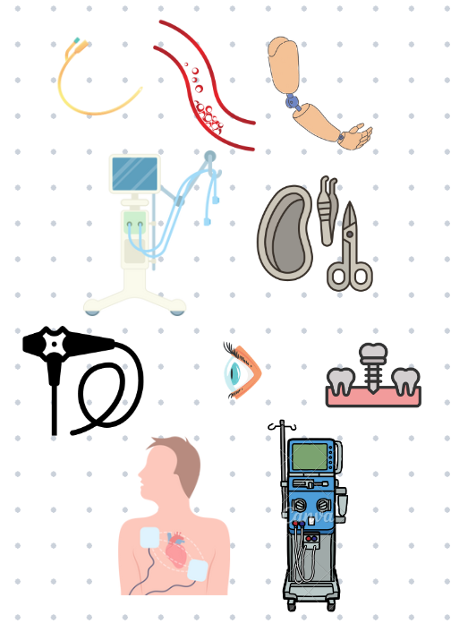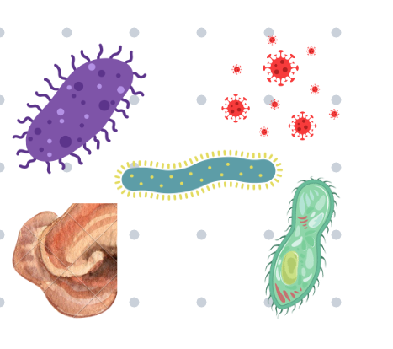

**Microbes**

**Medical Devices**

**Contaminating**

A serious consequence, extended hospital stays, more healthcare expenses, and, in extreme circumstances, death can result from these infections (Figure 2).

**Table 2: Common types of device-associated infections and microbes**

|  |  |  |
| --- | --- | --- |
| **Type of Device** | **Microbes** | **References** |
| Catheter-Associated Urinary Tract Infections (CAUTIs) | Escherichia coli  Klebsiella species  Proteus mirabilis  Pseudomonas aeruginosa  Enterococcus species | Raad et al., (2007) |
| Central Line-Associated Bloodstream Infections (CLABSIs) | Staphylococcus aureus (including MRSA)  Coagulase-negative staphylococci (e.g., Staphylococcus epidermidis)  Enterococcus species  Gram-negative bacteria (e.g., Klebsiella, Pseudomonas aeruginosa)  Candida species |
| Ventilator-Associated Pneumonia (VAP) | Staphylococcus aureus (including MRSA)  Pseudomonas aeruginosa  Klebsiella pneumoniae  Escherichia coli  Acinetobacter species | Chastre, & Fagon,(2002). |
| Surgical Site Infections (SSIs) | Staphylococcus aureus (including MRSA)  Coagulase-negative staphylococci  Enterococcus species  Escherichia coli  Pseudomonas aeruginosa | Mangram et al., 1999 |
| Prosthetic Joint Infections | Staphylococcus aureus (including MRSA)  Coagulase-negative staphylococci  Enterococcus species  Propionibacterium acnes | Tande & Patel, 2014. |
| Cardiac Device-Associated Infections | Staphylococcus aureus (including MRSA)  Coagulase-negative staphylococci  Enterococcus species  Gram-negative bacteria | Sohail et al., 2007 |
| Catheters (Urinary catheters, central venous catheters, peripheral intravenous catheters) | Bacteria: Escherichia coli, Staphylococcus aureus (including MRSA), Pseudomonas aeruginosa, Enterococcus species  Fungi: Candida species | Makki et al., 1981; Grady et al., 2011 |
| Endoscopes (Gastrointestinal endoscopes, bronchoscopes, laparoscopes) | Bacteria: Escherichia coli, Klebsiella pneumoniae, Pseudomonas aeruginosa, Helicobacter pylori  Viruses: Hepatitis B and C viruses  Fungi: Candida species | Rutala et al., 1999 |
| Ventilators and Respiratory Equipment (Mechanical ventilators, nebulizers, CPAP machines) | Bacteria: Pseudomonas aeruginosa, Acinetobacter baumannii, Staphylococcus aureus (including MRSA)  Viruses: Influenza virus, Respiratory Syncytial Virus (RSV)  Fungi: Aspergillus species | McLean et al., 2016; Denning et al., 2006 |
| Surgical Instruments (Scalpels, forceps, scissors, retractors) | Bacteria: Staphylococcus aureus (including MRSA), coagulase-negative staphylococci, Escherichia coli  Viruses: Hepatitis B and C viruses, HIV  Fungi: Candida species | Mangram et al., 1999 |
| Implantable Devices (Pacemakers, prosthetic joints, cardiac stents, artificial valves) | Bacteria: Staphylococcus aureus (including MRSA), coagulase-negative staphylococci, Propionibacterium acnes  Fungi: Candida species | Baddour et al., 2015; Rickard et al., 2018 |
| Dialysis Machines (Hemodialysis machines, peritoneal dialysis equipment) | Bacteria: Pseudomonas aeruginosa, Klebsiella pneumoniae, Escherichia coli  Fungi: Candida species | Kallen et al., 2007; Holmes et al., 2005 |
| Contact Lenses and Ophthalmic Devices (Contact lenses, intraocular lenses, ophthalmic surgical instruments) | Bacteria: Pseudomonas aeruginosa, Staphylococcus aureus, Serratia marcescens  Fungi: Fusarium species  Protozoa: Acanthamoeba species | Dart et al., 2008; Willcox et al., 2007 |

**2.1 Microbial Infections on devices**

1. Biofilms can grow on the surfaces of medical devices by a variety of bacteria and fungi. Comprising intricate groups of bacteria, biofilms are shielded from antibiotics and the host's immune system by an extracellular matrix (Donlan and Rodney., 2001).
2. Microbes can enter the body through devices that are not properly sterilized or by insertion procedures that do not use aseptic methods.
3. The risk of infection increases with the length of time a device is utilized. This is particularly valid for indwelling medical equipment like central lines and catheters.
4. Patients having invasive procedures, those with compromised immune systems, and preexisting medical disorders to be more susceptible to device-associated infections (Hooton et al., 2009).

**2.2 Prevention**

Ensuring proper hand hygiene, sterile procedures, and aseptic techniques during device insertion and maintenance; Regularly checking and maintaining devices to identify early signs of infection; Removing devices as soon as they are no longer needed to reduce the risk of infection; Utilizing devices coated or impregnated with antimicrobial agents to prevent microbial colonization and biofilm formation; Educating patients and healthcare workers about the importance of device care and early signs of infection.

4. Conclusion

Strict quality control procedures, regulatory requirements, and sterilization techniques are necessary to avoid contamination during the production, storage, and use of medical devices. Since it may result in microbial infections, devices fail to function, and adverse health consequences, microbial contamination on medical devices poses a serious risk to patient safety. Advances in materials and sterilizing technology, in conjunction with regular surveillance, considerably mitigate the risk of contamination. To safeguard patient health and lower the risk of healthcare-associated infections (HAIs), medical device manufacturers and healthcare providers need to maintain awareness to make sure that the devices are safe, sterile, and effective.

Consent

Not Applicable

Ethical approval

Not Applicable

**COMPETING INTERESTS DISCLAIMER:**

Authors have declared that they have no known competing financial interests OR non-financial interests OR personal relationships that could have appeared to influence the work reported in this paper.

References

References must be listed at the end of the manuscript and numbered in the order that they Pajkos, A., Vickery, K., & Cossart, Y. (2004). Is biofilm accumulation on endoscope tubing contributing to the failure of cleaning and decontamination? Journal of Hospital Infection, 58(3), 224-229.

Kramer, A., Schwebke, I., & Kampf, G. (2006). How long do nosocomial pathogens persist on inanimate surfaces? A systematic review. BMC Infectious Diseases, 6, 130.

Spaulding, E. H. (1968). Chemical disinfection of medical and surgical materials. In Disinfection, sterilization, and preservation (pp. 517-531).

Furness, A. (2016). Medical device cleaning and sterilization: issues and solutions. In Handbook of hygiene control in the food industry (pp. 635-649). Woodhead Publishing.

Percival, S. L., Suleman, L., Vuotto, C., & Donelli, G. (2015). Healthcare-associated infections, medical devices and biofilms: risk, tolerance and control. Journal of Medical Microbiology, 64(4), 323-334.

Jonathan Joseph Spaulding and Om V. Singh (2021) Medical Device Sterilization and Reprocessing in the Era of Multidrug-Resistant (MDR) Bacteria: Issues and Regulatory Concepts. Frontiers in medical technology. Vol 20. 2:587352

Klein, J. O. (2015). Staphylococcus aureus: Epidemiology and Resistance. In Staphylococcus aureus: A Comprehensive Review (pp. 1-10)

Pfaller, M. A., & Diekema, D. J. (2010). Epidemiology of invasive candidiasis: a persistent public health problem. Clinical Microbiology Reviews, 23(1), 134-159

Hooton, T. M., & Gupta, K. (2016). Escherichia coli Infections. In Principles and Practice of Infectious Diseases (pp. 945-956).

Peleg, A. Y., & Hooper, D. C. (2010). Hospital-acquired infections due to Gram-negative bacteria. New England Journal of Medicine, 362, 1804-1813

Podschun, R., & Ullmann, U. (1998). Klebsiella pneumoniae as a nosocomial pathogen. Clinical Microbiology Reviews, 11(4), 589-603

Rice, L. B. (2008). Acinetobacter baumannii: an emerging multidrug-resistant pathogen. Cleveland Clinic Journal of Medicine, 75(1), 13-19.

Glickman, S. W., & McAdam, A. J. (2007). Mycobacterium tuberculosis: An Overview. In Clinical Microbiology Procedures Handbook (pp. 2-22)

Murray, B. E. (1998). The life and times of the Enterococcus. Clinical Microbiology Reviews, 11(3), 399-407

Raad, I., Hanna, H., Maki, D. (2007). Intravascular catheter-related infections: Advances in diagnosis, prevention, and management. The Lancet Infectious Diseases, 7(10), 645-657. doi:10.1016/S1473-3099(07)70235-9

Chastre, J., Fagon, J. Y. (2002). Ventilator-associated pneumonia American Journal of Respiratory and Critical Care Medicine, 165(7), 867-903. doi:10.1164/ajrccm.165.7.2105078

Mangram, A. J., Horan, T. C., Pearson, M. L., Silver, L. C., Jarvis, W. R. (1999). Guideline for prevention of surgical site infection, 1999. Infection Control & Hospital Epidemiology, 20(4), 247-278. doi:10.1086/501620

Tande, A. J., Patel, R. (2014). Prosthetic joint infection. Clinical Microbiology Reviews, 27(2), 302-345. doi:10.1128/CMR.00111-13

Sohail, M. R., Uslan, D. Z., Khan, A. H., Friedman, P. A., Hayes, D. L., Wilson, W. R., Steckelberg, J. M., Baddour, L. M. (2007). Management and outcome of permanent pacemaker and implantable cardioverter-defibrillator infections. Journal of the American College of Cardiology, 49(18), 1851-1859. doi:10.1016/j.jacc.2007.01.072

Maki, Dennis G., et al. "An epidemiologic study of infections associated with peripheral intravenous catheters." The Journal of Infectious Diseases 144.6 (1981): 583-590.

Grady, Naomi P., et al. "Guidelines for the prevention of intravascular catheter-related infections." Clinical Infectious Diseases 52.9 (2011): e162-e193.

Rutala, William A., and David J. Weber. "Disinfection and sterilization of instruments used in gastrointestinal endoscopy." Gastrointestinal Endoscopy Clinics of North America 9.4 (1999): 511-528.

McLean, Kyla A"Respiratory viral infections in mechanically ventilated patients: Implications for diagnosis and management." American Journal of Respiratory and Critical Care Medicine 194.5 (2016): 583-593

Denning, David W., et al. "The link between fungi and severe asthma: A summary of the evidence." European Respiratory Journal 27.3 (2006): 615-626.

Baddour, Larry M., et al. "Infective endocarditis in adults: diagnosis, antimicrobial therapy, and management of complications: a scientific statement for healthcare professionals from the American Heart Association." Circulation 132.15 (2015): 1435-1486.

Rickard, John, et al. "Cardiovascular implantable electronic device infections: prevention, detection, and management." Journal of the American College of Cardiology 71.15 (2018): 1753-1765.

Kallen, Alexander J., et al. "Preventing infections in patients undergoing hemodialysis." CDC Morbidity and Mortality Weekly Report (MMWR) 56.24 (2007): 574-578.

Holmes, Christoper J., et al. "Peritoneal dialysis-related infections recommendations: 2005 update." Peritoneal Dialysis International 25.2 (2005): 107-131.

Dart, John K.G., et al. "Risk factors for microbial keratitis with contemporary contact lenses: a case-control study." Ophthalmology 115.10 (2008): 1647-1654.

Willcox, Mark DP. "Review of contact lens microbial contamination and infection." Optometry and Vision Science 84.4 (2007): 273-278.

Donlan, Rodney M. "Biofilms and device-associated infections." Emerging Infectious Diseases 7.2 (2001): 277-281.

Hooton, Thomas M.. "Diagnosis, prevention, and treatment of catheter-associated urinary tract infection in adults: 2009 International Clinical Practice Guidelines from the Infectious Diseases Society of America." Clinical Infectious Diseases 50.5 (2010): 625-663.