***Review Article***

**HERBAL SHAMPOO-A REVIEW ARTICLE**

**ABSTRACT**

The main objective of this study is to develop and assess a herbal shampoo, focusing on the safety, effectiveness, and quality of the product. Herbal shampoo is a natural hair care product designed to remove dirt, dandruff, and oil while promoting hair growth, strength, and richness in color. As shampoos are a widely used cosmetic in everyday routines, the shampoo sector has the highest sales volume among all hair care products. At times, consumers have faced adverse effects due to synthetic detergents and preservatives. Integrating natural extracts that perform similarly to their synthetic equivalents is a more radical approach to reducing the reliance on synthetic substances. Shampoo is a vital beauty product as it aids in cleaning the hair. Herbal shampoo is a cosmetic item akin to regular shampoo, utilizing traditional ayurvedic herbs to cleanse the hair and scalp. They are employed to eliminate environmental contaminants, dandruff, oil, and dirt.

**KEYWORDS:**

Herbal shampoo powder, cleanser, hair care, hair detergent.

**DEFINITION**

Shampoo consists of a surfactant (also referred to as a surface-active agent) in a suitable form, like liquid, solid, or powder, which, when applied as instructed, will eliminate surface dirt, impurities, and residue from the hair and scalp without negatively impacting the user. [1]

**INTRODUCTION**

In our everyday routines, shampoos are probably the most commonly used beauty products for cleaning our hair and scalp. A shampoo is fundamentally a detergent solution enhanced with suitable additives for extra benefits like better hair conditioning, lubrication, and treatment.[2]Various types of shampoos exist today, including synthetic, herbal, medicated, and non-medicated options, yet consumers are increasingly drawn to herbal shampoo, believing that these products, being derived from natural sources, are safe and free from side effects. [3] Synthetic surfactants are used in synthetic shampoos primarily for their cleansing and foaming properties, but prolonged use of these surfactants can lead to scalp and eye irritation, as well as hair loss and dryness. We offer natural herbal shampoos as an option to synthetic shampoo. Nonetheless, producing cosmetic items using only natural components is extremely difficult.[4]

Countless medicinal plants believed to be beneficial for hair have been utilized for centuries in shampoo formulations across the globe. These medicinal herbs can be utilized as extracts, powders, raw forms, or derivatives. Developing a shampoo using just a single natural ingredient that is gentler and safer than synthetic alternatives is difficult. It should also feature significant foaming, cleansing properties, and solid content, akin to synthetic shampoo. Consequently, we meticulously considered creating a completely natural cleanser utilizing a proven technique and widely utilized plant ingredients for cleansing hair.[5]

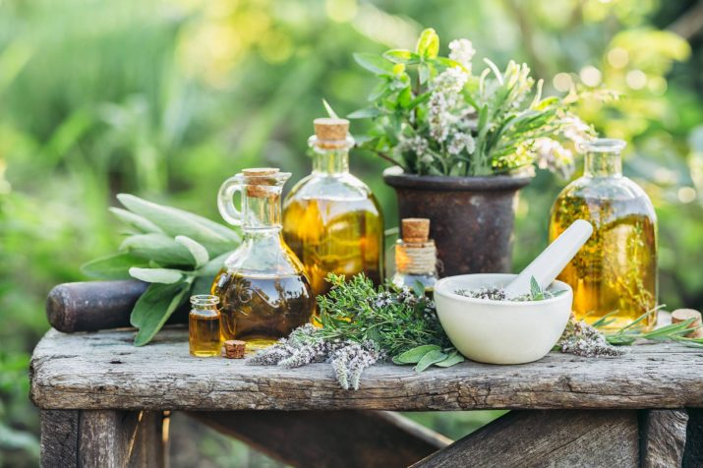

**Fig 1 : Herbal products**

**ANATOMY OF HAIR :**

Grasping the structure of hair is essential for understanding the impacts and advantages of herbal shampoos on hair wellness:

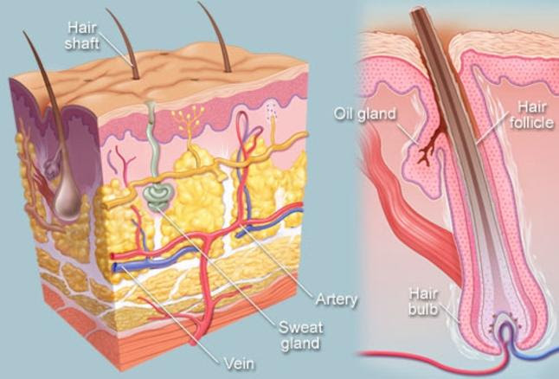**1.Hair Structure:** Hair mainly consists of a protein known as keratin, structured in three layers: the cuticle, cortex, and medulla. The outermost layer, known as the cuticle, is made up of overlapping scales that safeguard the inner layers and influence the hair's strength and luster. Herbal shampoos frequently focus on this layer, seeking to nourish and smooth the cuticle for improved hair texture and look [12,13].

**Fig 2 : Hair Structure**

**2.Scalp:** The scalp serves as the basis for robust hair growth. It comprises hair follicles that facilitate hair growth and sebaceous glands that generate natural oils (sebum) to hydrate and safeguard the hair. Herbal shampoos typically emphasize sustaining a balanced and healthy scalp atmosphere, minimizing excessive oiliness or dryness while encouraging favorable conditions for hair growth.

**3.Hair Growth Cycle:** Hair goes through a growth cycle made up of three stages: anagen (growth), catagen (transition), and telogen (resting). Herbal shampoos might influence this cycle by enriching the scalp, potentially extending the growth phase and decreasing hair loss during the resting stage.

**Anagen (growth phase):**This is the development stage. This stage continues for a number of years.

**Catagen (transitional phase):** In this stage, the hair follicle diminishes, and the rate of hair growth decreases.

**Telogen (resting phase):** It is the dormant stage during which hair growth halts, and new hair starts its growth phase, pushing the old hair out..

**Exogen phase:** Final stage of hair growth cycle in which hair strand fully separates from the scalp and falls out..

**4. Hair Porosity:** Porosity denotes the capacity of hair to take in and hold moisture. Shampoos made with herbal moisturising components can help control hair porosity, stopping unnecessary moisture loss and sustaining hydration levels in the hair. Knowing the details of hair structure allows consumers to choose herbal shampoos designed to target particular elements of hair wellness, enhancing overall nourishment, strength, and vitality.3

**PHYSIOLOGY OF HAIR.**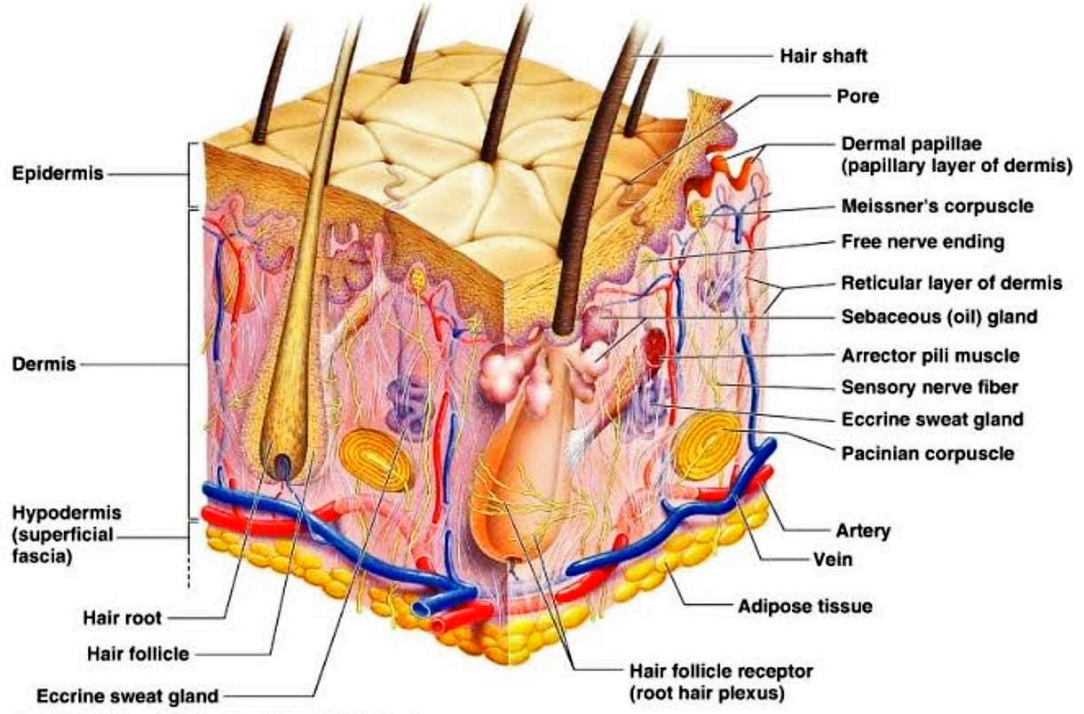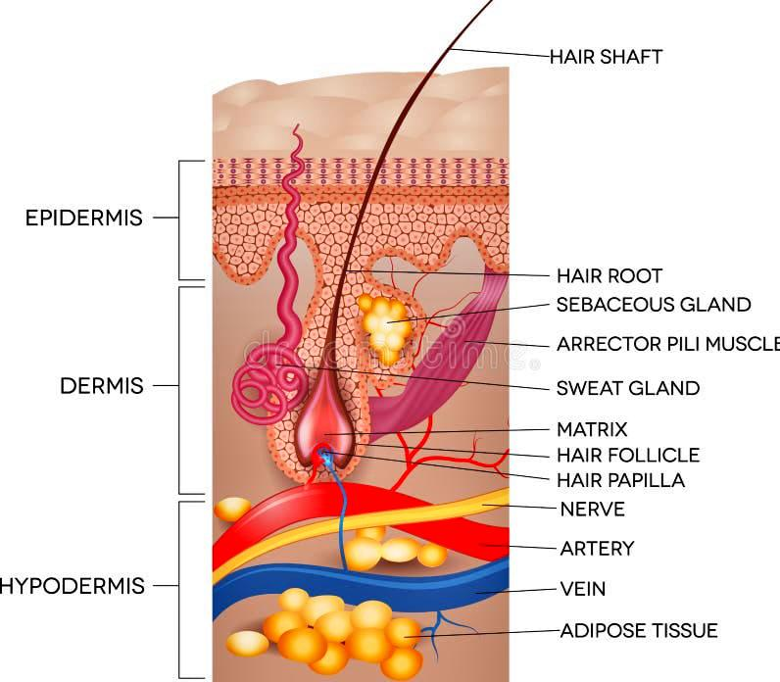

**Fig 3 : PHYSIOLOGY OF HAIR**

**Hair growth cycle**: Hair growth is an ongoing cyclic process, and all mature follicles undergo a growth cycle that includes phases of growth (anagen), regression (catagen), rest (telogen), and shedding (exogen). The length of the phase’s alterations depends on the hair's location and individual nutritional and hormonal conditions.

**1.Anagen:**

The beginning of the anagen phase is marked by the initiation of mitotic activity in the secondary epithelial germ situated between the club hair and dermal papilla in a telogen hair follicle. The anagen is the growth phase where the follicle expands, regains its original shape, and generates the hair fiber. On average, there are nearly hair cm², with a variable range from 175 to 300 hair cm². The speed of hair growth has been noted to differ across locations. The scalp and chin exhibit the fastest growth rate. The speed of scalp hair growth ranges from 0.27 to 0.40 mm daily. The rate of growth for axillary hair is almost identical. The rate at which hair grows on the surface is approximately 0.2 mm each day. Although daily temperature fluctuations do not impact growth rate, the study shows that beard growth is more pronounced in summer compared to winter. Additionally, a research report indicated that women experience faster scalp hair growth than men. The rate of scalp hair growth is higher in young people and adults, decreasing as one ages [14-16].

85-90% of all hair on the scalp is in the anagen phase. Six segments of the anagen phase are shown. During the anagen phases I-V, hair stem cells multiply, encircle the dermal papilla, extend downwards into the skin, and initiate the growth of the hair shaft and inner root sheath (IRS), respectively.

Later, hair matrix melanocytes start to produce pigment, and the shape of the hair shaft begins to emerge: in anagen VI. The hair bulb and surrounding dermal papilla develop, resulting in the emergence of a new hair shaft from the skin. This stage may persist for as long as 6-8 years within hair follicles. Synthesis and pigmentation of the hair shaft occur solely during anagen. The level of axial symmetry in the hair bulb influences the shape of the resulting hair structure. Fiber length frequently relies on the length of the anagen or actively growing stage of the follicle.

Fig 4

The key regulatory proteins during anagen phases include BMP, sonic hedgehog, various WNT proteins and receptors, Insulin-like growth factor-1 (IGF-1), fibroblast growth factor-7, hepatic growth factor (HGF), and vascular endothelial growth factor (VEGF), which are believed to play crucial roles in anagen maintenance.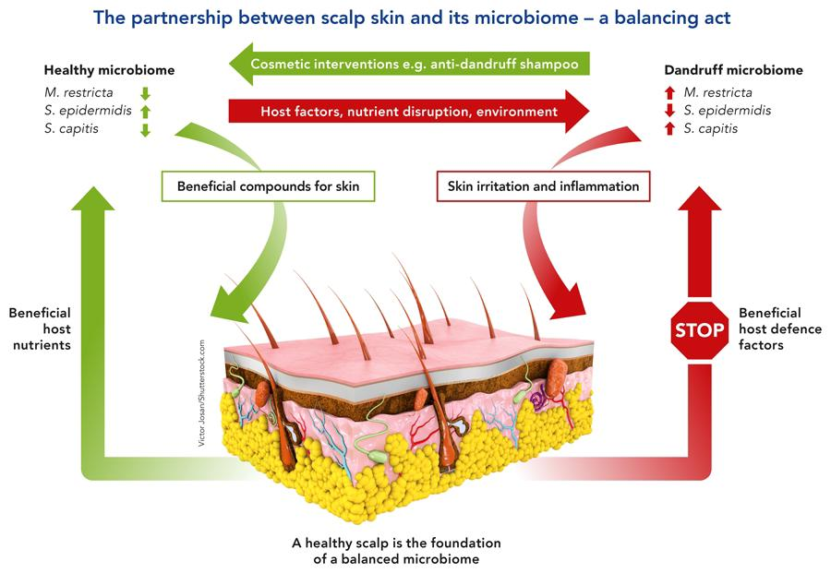

**2.Catagen**:

At the conclusion of anagen, the mitotic activity of the matrix cells decreases, and the follicle transitions into a tightly regulated developmental stage referred to as catagen. Catagen lasts about 2 weeks in humans, irrespective of the location and type of follicle. In catagen, the proximal portion of the hair shaft undergoes keratinization and develops into the club hair, while the distal section of the follicle experiences involution through apoptosis [17,18].

The catagen phase is made up of eight distinct stages. The initial indication of catagen is the cessation of melanogenesis within the hair bulb. Follicular epithelium, mesenchyme, populations of neuroectodermal cells, as well as perifollicular vascular and neural systems exhibit cyclical variations in differentiation and apoptosis. Nevertheless, any apoptosis that takes place in the dermal papilla is a result of the expression of the suppressor bcl-2.

Catagen is a phase of bulb regression. The perifollicular structure constricts and the vitreous membrane becomes denser. Ultimately, the lower hair follicle shrinks to an epithelial strand, drawing the dermal papilla near the bulge. The epithelial strand starts to extend and ultimately arrives just beneath the attachment of the pilar muscle [19,20]. Once the presumptive club hair undergoes keratinization, the epithelial strands start to fold inward and gradually shorten, accompanied by the papilla that condenses, ascends, and settles beneath the bulge. The Column ultimately narrows down to a nipple and generates secondary hair germ beneath the club. The existence of a hairless gene mutation leads to the inability of dermal papilla to migrate toward the bulge region during the catagen phase.

**3.Telogen**:

The telogen phase is characterized by the period between the end of follicular regression and the beginning of the subsequent anagen stage. The telogen phase persists for 2 to 3 months. About 10-15% of all hair is in the telogen phase. In the telogen phase, the hair strand changes into club hair and is ultimately lost. The follicle stays in this phase until the hair germ, which reacts to anagen-starting signals from the dermal papilla, begins to exhibit increased proliferation and transcriptional activity in late telogen, resulting in the onset of anagen. Telogen is a primary phase of the hair cycle that is affected by various modulating factors such as androgens, prolactin, ACTH, retinoids, and thyroid hormones. Telogen follicle germ cells also show expression of bicuculine and FGF-5. The bone morphogenic protein-4 (BMP-4) acts as a growth factor that significantly inhibits follicular growth and differentiation during the telogen phase. The macro-environment around the hair follicle also plays a role in regulating cycle shifts. Telogen with a hair germ that reacts to anagen-initiation signals and can transition into a new anagen phase.

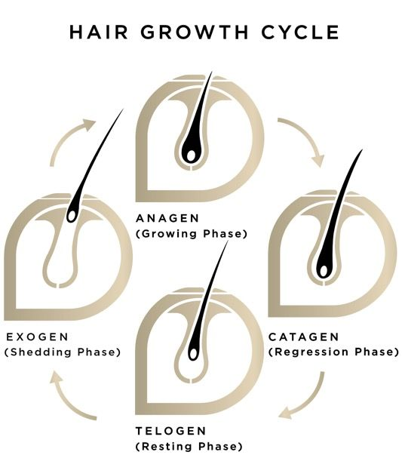fig 5

**4.Exogen**: There is reduced focus on the hair shedding mechanism, but from the patient's viewpoint, it is likely the most crucial aspect of hair growth. It is common for human telogen hairs to be preserved from multiple follicular cycles, indicating that the anagen and exogen phases operate independently. The shedding phase is thought to be an active process that operates independently of telogen and anagen, which is why this specific shedding stage is referred to as exogen. All body hair experiences a comparable life cycle; however, the extent, phase duration, and individual follicle lengths differ across various body regions and individuals, influenced by genetic factors, age, and health conditions

**HAIR PROBLEM** :

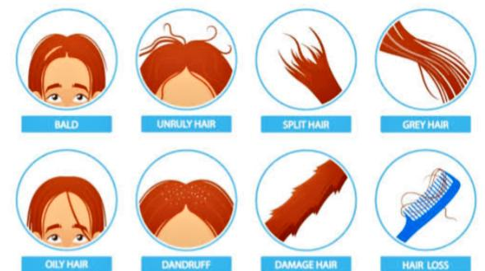Hair problems encompass a wide range of conditions that affect the scalp and hair strands, often necessitating specialised care and treatment:

**Fig 6 :** DifferentHair problems

**1.Dandruff:** A frequent problem marked by scalp peeling, triggered by different elements like dry skin, yeast proliferation, or reactions to hair care items. Shampoos made from herbs that contain antifungal or calming components such as tea tree oil or aloe vera can aid in reducing dandruff.

**2.Hair Loss:** Hair loss, or alopecia, may occur due to genetics, hormonal shifts, stress, or health issues. Shampoos made from herbs that focus on hair loss frequently include components such as saw palmetto or biotin, designed to reinforce hair follicles and reduce shedding.

**3.Dryness and Frizz:** Dry, frizzy hair arises from insufficient moisture and damage to the hair's cuticle. Herbal shampoos containing moisturizing ingredients such as coconut oil or shea butter can replenish hydration and soften the hair shaft.

**4.Oily Scalp:** Excess oil production on the scalp results in oily, lifeless hair. Herbal shampoos designed with clarifying components such as citrus extracts or witch hazel can manage oil production without removing the scalp's natural oils.

**5.Scalp Irritation:** Conditions such as scalp psoriasis, eczema, or reactions to specific components in hair products can lead to itching, redness, or irritation. Herbal shampoos containing soothing, gentle ingredients such as chamomile or calendula are designed to calm and reduce scalp irritation. Selecting the appropriate herbal shampoo designed to target particular hair issues is essential for successfully managing and solving these problems, fostering healthier and more robust hair and scalp conditions.

**HAIR CARE**

Hair texture and luster are typically associated with the properties of the hair surface, whereas the strength of the hair comes from the hair cortex. To achieve this aim, there are hair products designed to enhance the structural integrity of hair fibers and boost tensile strength, as well as those that amplify hair volume, diminish frizz, enhance manageability, and promote new hair growth. Notably, contemporary cosmetic products are created to cleanse hair of debris and restore and enhance hair physiology. For instance, strong conditioning agents can momentarily "substitute" the f-layer, enhancing moisture retention in the cortex and restoring some of the diminished physical attributes of hair. Consequently, the increase in hair luster is a significant advantage of contemporary products.

**HOW SHAMPOO WORKS**: 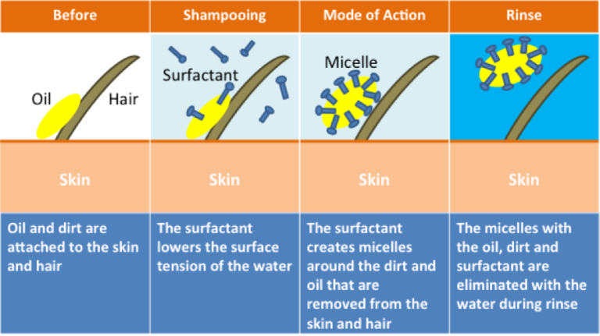

Shampoo works by removing sebum from the hair. Sebum is an oily substance produced by hair follicles that is easily taken up by hair strands, creating a protective barrier. Sebum shields the protein composition of hair from harm, but this safeguard has its drawbacks. It tends to gather dust, hair products, and scalp residue. Surfactants remove sebum from hair shafts, which also eliminates the dirt clinging to them. Although both soaps and shampoos have surfactants, soap attaches to oils so strongly that it strips away too much when applied to hair. Shampoo employs a distinct category of surfactants

Fig 7: Mechanism by which herbal shampoo works through a distinct category of surfactants

adjusted to prevent excessive oil removal from the hair.

The chemical processes involved in hair cleaning are akin to those found in conventional soap. Intact hair possesses a hydrophobic exterior that allows skin lipids like sebum to adhere, although water is initially resisted. The lipid donor washes away effortlessly when the hair is rinsed with plain water. The anionic surfactants significantly lower the interfacial surface tension and facilitate the extraction of sebum from the hair shaft. The non-polar oily substances on the hair shaft are dissolved in the surfactant micelle structures of the shampoo and are washed away during rinsing. There is significant elimination via a surfactant and oil “roll up” off.

**IDEAL PROPERTIES**

* It must thoroughly and effectively cleanse the hair of all dirt or grime, excess sebum or other oily substances, and loose corneal cells.
* It ought to be simple to remove with rinse water.
* It should not lead to any adverse effects such as discomfort in the eyes or skin.
* It should provide a pleasant aroma to the hair.
* To give the hair a lustrous, smooth finish.
* Make a significant volume of foam.
* The hand must not become dry and cracked as a consequence. It should effectively and completely remove dirt. [6,7,8]

**Benefits of herbal shampoo**

***Natural and Gentle***

1. Sulphate-free: Herbal shampoos are free from harsh sulphates, which can strip the hair of its natural oils.

2. Gentle cleansing: Herbal shampoos clean the hair and scalp without stripping them of their natural moisture.

***Promotes Healthy Hair and Scalp***

1. Nourishes the scalp: Herbal shampoos can help to nourish and soothe the scalp, reducing irritation and inflammation.

2. Strengthens hair roots: Herbal shampoos can help to strengthen hair roots, reducing hair fall and promoting healthy hair growth.

3. Improves hair texture: Herbal shampoos can help to improve the texture of the hair, making it soft, smooth, and manageable.

***Environmentally Friendly***

1*.* Biodegradable: Herbal shampoos are biodegradable and free from harsh chemicals that can harm the environment.

2. Cruelty-free: Herbal shampoos are often cruelty-free and vegan-friendly, making them a great choice for those who care about animal welfare.

**Customisable**

1.Tailored to hair type: Herbal shampoos can be tailored to specific hair types, such as dry, oily, or combination hair.

2. Address specific hair concerns: Herbal shampoos can be formulated to address specific hair concerns, such as dandruff, itchiness, or hair loss.

**Cost-Effective**

1. Long-term benefits: Herbal shampoos may be more expensive than conventional shampoos, but they offer long-term benefits for the hair and scalp.

2. Reduced need for styling products: Herbal shampoos can help to improve the health and appearance of the hair, reducing the need for styling products.

**ADVANTAGES**

* Pure and organic ingredients are used.
* These shampoos are free from side effects.
* No synthetic additives such as sodium lauryl sulphate.
* No animal testing.
* Skin friendly.
* These shampoos aid in strengthening the roots, consequently promoting hair growth. Herbal shampoos additionally enhance hair shine, making them advantageous for individuals with dry and lackluster hair.
* It enhances the roots and helps in the formation of new root which are soft then before.
* Herbal shampoos assist in minimizing the production of dandruff on the scalp.
* They could help in decreasing hair loss.

**DISADVANTAGES**

* Certain herbs can irritate the scalp; for instance, menthol.
* Natural products influence the consistency and quality management of products
* Seasonal changes in plant components take place.
* Less stable so, preservative should be added.
* Varying in consistency from batch to batch.
* Dry shampoo doesn’t clean hair.
* Skin allergies may be occurred. [9]

**CLASSIFICATION OF SHAMPOO**

1. Based on appearance.

* Powder shampoo
* Liquid shampoo or lotion shampoo
* Gel shampoo or solid shampoo
* Cream shampoo
* Oil shampoo
* Miscellaneous anti dandruff shampoo or medicated shampoo

2. Based on use or function.

* Conditioning shampoo
* Antidandruff shampoo
* Therapeutic shampoo
* Baby shampoo
* Balancing shampoo
* Clarifying shampoo

3. Based on origin:

* Herbal shampoo
* Egg shampoo

Evaluation of shampoos comprises the quality control tests including visual assessment and physiochemical controls such as ph, density and viscosity.[10]

***Table 1 : Description of Herbal Shampoo ingredients .***

|  |  |  |  |  |  |
| --- | --- | --- | --- | --- | --- |
| Common Name | Botanical name | Parts used | Purpose | Category | Picture |
| Drumstick | Moringa Oliefera | Seed | Anti-dandruff, Anti-microbial | Core ingredient |  |
| Aloevera | Aloe Barbadensis | Pulp | Hair conditioner, control greasy hair | Smoothing agent |  |
| Hibiscus | Rosa Sinesis | Flowers | Improve overall health of hair and scalp | Conditioning agent |  |
| Shikakai | Acacia concinna | Fruits | Scalp health, lousy hair, hair conditioning | Antifungal, Nourish follicles, Curb dandruff |  |
| Ritha | Sapindusmukorossi | Fruits | Reduces frizz and adds shine,soften hairs | soapberry,  soapnut,  washnut,  aritha. |  |
| Sodium Lauryl Sulphate | Sodium dodecylsulfate | Powder | Cleanser, creates lather | Fat  Emulsifier,  Wetting  agent,  Detergent in  Cosmetics. |  |
| Methyl Cellulose | Hypromellose | Powder | Thickener and emulsifier | Thickening Agent, Stabilizing Agent. |  |
| Rose Water | Rosa damascena | Liquid | Hydration, improves low porosity hair | Flavoured water, Perfume agent |  |

***Formulation Of Herbal Shampoo***

|  |  |  |
| --- | --- | --- |
| S.No | Ingredients | Quantity |
| 1. | Drumstick | 10 gm |
| 2. | Alovera | 5 ml |
| 3. | Hibiscus | 4 ml |
| 4. | Shikakai | 8 gm |
| 5. | Ritha | 8 gm |
| 6. | Sodium Lauryl Sulphate | 6 gm |
| 7. | Methyl Cellulose | 1 gm |
| 8. | Rose Water | 10 ml |

***Method Of Preparation :***

1. Measured all the components based on the recipes
2. A decoction was made using Drumstick, Aloe vera, and Hibiscus in one part of water.Strain it through muslin cloth and gather the filtrate.
3. A decoction of shikakai and Ritha was made in a different portion of water.
4. Filter it, by using muslin cloth, collect filtrate.
5. Combined the above filtrate while stirring continuously.
6. Combined the above filtrate while stirring continuously.
7. Combined with methyl cellulose as a thickening agent to maintain the consistency of herbal shampoo in semi-solid mixtures.

8. Preservatives, aromas, and rose water were added last to this perfume.Preservatives arts and & Rose water this perfume was add Lastly.

***Evaluation Of Herbal Shampoo***

**Appearance** :-A shampoo like any other cosmetic preparation should have good.

**Appealing physical appearance**. The shampoos that were formulated and marketed were assessed for their physical properties including colour, scent, and clarity (Table 3). The shampoo we made was clear, light green, and smelled pleasant. No notable difference was detected regarding odour, clarity, and foaming properties between commercial and formulated shampoo, aside from colour..

**Colour**: Black Brown, Dandruff Cleansing Shampoo

**PH**:- The pH of the prepared shampoo was 6, which is within the optimal pH range for shampooing, typically between 4.33 and 4.73. The created shampoo has an acid balance that closely matches the skin's pH. The pH level of shampoo is crucial for enhancing hair qualities, reducing eye irritation, and maintaining the ecological balance of the scalp. Slight acidity inhibits swelling and encourages tightening of the scales, thereby creating shine.

**Viscosity**: The viscosity of shampoo significantly influences its stability over time, the ease of dispensing from the packaging, spreading when applied to hair, and the uniformity of the product in its container. The formulated shampoo exhibited a viscosity of 50 millipoise, which was sufficiently suitable for its intended use.

**Foaming Stabilit**y-The stability of the foam was assessed by shaking a cylinder.

Approach. Approximately 50 ml of a 1% formulated shampoo solution was poured into a 250 ml graduated cylinder and shaken vigorously for 10 times. Foam stability was assessed by measuring the foam volume from the shake test at 1 minute and 4 minutes, respectively. The complete foam volume was assessed following 1 minute of shaking. From the perspective of consumers, the stability of foam is a key requirement for a shampoo. A crucial factor taken into account in the assessment of the shampoo was the evaluation of foam stability. The volume of foam generated by the prepared shampoo exceeds 50 ml. The formulated shampoo produces consistent, small-sized, compact, denser, and stable lather. The foam volume remains consistent over a duration of approximately 5 minutes, indicating that the foam produced by the shampoo is quite stable.

**Surface Tension** :-Measurements were conducted using a 10% shampoo solution in distilled water at ambient temperature. Completely cleanse the stalagmometer with hydrochloric acid and purified water. Surface tension is significantly influenced by grease or other types of lubricants.

**Wetting time:-** The wetting time was determined by recording the duration it took for the canvas paper to fully submerge. A canvas paper with a weight of 0.44 g was sliced into a disc that measures 1 inch in diameter. A canvas paper disc was placed over the shampoo (1% v/v) surface, and the time it took for the disc to sink was recorded with a stopwatch.

**Cleaning action**: Approximately 1 g of grease is applied to non-adsorbent cotton and stored in a conical flask filled with a 1% shampoo solution. The conical flask is agitated for 1 hour in a mechanical shaker. Cotton is gathered, dried, and measured.

**Dirt dispersion:** Shampoo that leads to ink concentrating in the foam is regarded as low quality; the dirt ought to remain in the water. Soil trapped in the foam will be hard to wash out. It will restore on the hair. The anticipated quantity of ink in the foam was minimal, suggesting that the developed formulation is acceptable.

**Solid contents (%)**:A clean, dry china plate was weighed, and 4 grams of shampoo was added to it. The weight of the plate and shampoo was recorded. The precise weight of the shampoo was determined. Position the china dish containing herbal shampoo on the hot plate until the liquid part has evaporated. The weight of the shampoo (solids) post-drying was determined.

**POWDER SHAMPOO**

**Table 2 : Description of powder shampoo ingredients.**

|  |  |  |  |  |  |
| --- | --- | --- | --- | --- | --- |
| COMMON NAME | BOTANICAL NAME | PARTS USED | CATEGORY | PURPOSE | PICTURE |
| Shikakai | Acacia Concinna | Fruit pods,leaves | Natural foaming agent | Foam base and Anti-dandruff |  |
| Reetha | Sapindus Mukorossi | Dessicated fruit | Natural surfactant and cleanser | Hair nourishing and cleansing |  |
| Tulasi | Ocimum tenuiflorum | Dried leaves | Anti fading | Antibacterial |  |
| Amla | Phyllanthus emblica | Dried ripe fruits | Hair growth promoter | Hair health, scalp health |  |
| Neem | Azadirachta  indica | Neem leaves and extracts | Anti-dandruff | Improve greying of hair |  |
| Henna | Lawsonia  inermis | Dried leaves | Hair colourant | Conditioner |  |
| Harda | Terminalia  chebula | Dried ripe fruits | Anti-inflammatory, Anti-bacterial | Hair growth promoter |  |
| Bhringraj | Eclipta  prostrata | Entire herb | Hair growth promoter | Promote the hair health |  |

**Table 3 : FORMULA OF HERBAL DRY SHAMPOO POWDER**

|  |  |
| --- | --- |
| **Ingredients** | **Quantity 100gm** |
| Shikakai | 15 gm |
| Reetha | 10 gm |
| Tulasi | 10 gm |
| Amla | 15 gm |
| Neem | 5 gm |
| Harda | 10 gm |
| Henna | 15 gm |
| Bhringraj | 5 gm |
| Black tea | 5 gm |
| Hibiscus flower | 10 gm |

**PREPARATION OF DRY SHAMPOO POWDER**

1. All the powder is in a dry state and ground.
2. The crude ingredients were gathered, and each was size-reduced individually using a driven mixer.
3. Sieving then this fine powder was passed through sieve no.:80 , to get the sufficient quantity of fine powder.
4. Weighed each necessary herbal powder individually for shampoo preparation
5. All these fine ingredients were thoroughly blended by the mixer to create a uniform fine powder.
6. Packing and labeling, it was then appropriately packed and labeled.

**EVALUATION OF HERBAL SHAMPOO**

**Organoleptic evaluation :**

An organoleptic assessment on factors such as color, smell, flavor, and texture was conducted. Color and texture were assessed through sight and tactile sensation, respectively. To evaluate taste and odour, a group of five individuals with heightened sensitivity to these elements was assembled, and random sampling was conducted.

**General powder characteristics:**

General powder characteristics encompass the assessment of parameters that will influence the external properties (such as flow characteristics, appearance, packaging requirements, etc.) of the formulation. Evaluated attributes in this section include powder form, particle size, angle of repose, and bulk density. Samples for all these evaluations were collected at three distinct levels, namely top, middle, and lower levels. Grain dimensions.

Particle size is a parameter that influences different characteristics such as spreadability, grittiness, etc. The particle size was assessed using the sieving method with I.P. Standard sieves through mechanical shaking for 10 minutes.

**Angle of repose**

It is defined as the maximum angle possible in between the surface of pile of powder to the horizontal flow.

Funnel method

The necessary quality of the dried powder is collected in a funnel positioned 6 cm above a horizontal surface. The powder was permitted to spread and create a pile on the paper on the flat surface. The height and radius of the powder were measured, and the angle of repose (θ) can be calculated by using the formula.

Open - ended cylinder method

The necessary quantity of dried powder is put into a cylindrical tube that is open at both ends and positioned on a flat surface.

Next, the funnel should be elevated to create a mound. The heap's height and radius are measured and documented. For the two methods mentioned above, the angle of repose (θ) can be determined using the formula.

θ = tan -1(h / r) Where,

θ – Angle of repose, h – Height of the heap, r – Radius of the base

**Bulk density**

Bulk Density is the relationship between the specified mass of a powder and its total volume. The necessary quantity of powder is dried and placed in a 50 ml measuring cylinder until it reaches the 50 ml line. The cylinder is then released onto a hardwood surface from a height of 1 inch every 2 seconds. The amount of the powder is assessed. Next, the powder is measured by weight

This is repeated to get average values. The Bulk Density is calculated by using the below given formula.

Mass of the herbal powder shampoo

Bulk Density= Mass of the herbal powder shampoo

Volume of the herbal powder shampoo

**Tapped density**

The tapped density refers to a higher bulk density achieved by mechanically tapping a container holding the powder sample. Following the measurement of the initial powder volume or mass, the measuring cylinder or container is mechanically tapped for 1 minute, and volume or mass readings are recorded until minimal additional changes in volume or mass are noted. It was stated in grams for each cubic centimeter (g/cm3).

**Table 4 : POLY HERBAL ANTI DANDRUFF SHAMPOO.**

Description of Poly herbal anti dandruff shampoo ingredients

|  |  |  |  |  |  |
| --- | --- | --- | --- | --- | --- |
| Common name | Botanical name | Part used | Category | Purpose | Picture |
| Neem | Azadirachta indica A. Juss | Fresh Leaves | Antifungal/ Antibacterial | Improve greying of hair |  |
| Bhringraj | Eclipta alba (L.) Hassk | Powder of Leaves | Antifungal/ Antibacterial agent | Promote the hair health |  |
| Shikakai | Acacia concinna Linn | Leaves | Natural foaming agent | Scalp health, lousy hair, hair conditioning |  |
| Fenugreek | Trigonella foenum-graecum L. | Seeds | Anti dandruff | Reduce the premature greying of hair |  |
| Reetha | Sapindus trifoliatus linn | Seeds | Natural surfactant and cleanser | Hair nourishing and cleansing |  |
| Aloe Vera | Aloe barbadensis miller | Latex of Leaves | Smoothing agent | Hair conditioner, control greasy hair |  |
| Lemon Juice | Citrus limon (L.) Burm | Fresh Ripe Fruit Juice | Anti dandruff | Enhance hair shine, remove excess oil |  |
| Tulsi | Ocimum sanctum L | Fresh Leaves | Anti fading,  anti  scalp inflammation | Antibacterial |  |
| Orange | Citrus Linn. | Pericarp | Antibacterial | Reduce lousy hairs |  |
| Ginger | Zingiber officinale Roscoe | Rhizome | Hair promoter | Improve blood circulation |  |
| Curry Leaves | Murraya koenigii Linn. | Fresh Leaves | Hair strengthen | Shine & strong the hairs |  |
| Hibiscus | Hibiscus-sinensis L | Fresh Leaves. | Conditioning agent | Improve overall health of hair and scalp |  |

**Table 5 : FORMULATION Of POLY HERBAL ANTI DANDRUFF SHAMPOO**

|  |  |
| --- | --- |
| **Ingredients** | Quantity(100ml) |
| Herbal extract | 24ml |
| Sodium Lauryl Sulphate | 6gm |
| Guar gum | 1gm |
| NaCl (0.1M) | Q.s |
| Glycerin | 2ml |
| Vitamin E | 800mg |
| Lavender oil | 2 drops |
| Water | Q.s100ml |

**PREPARATION OF POLY HERBAL ANTI DANDRUFF SHAMPOO**

* The mixture was prepared using a straightforward decoction method.
* All the herbs were precisely measured with a digital balance, and the amounts utilized are provided in Table 1.
* The raw herbs were gathered, and these components were size reduced using a manual mixer, individually ground into powder. The fine powder was sifted through a sieve no. 120 and mixed separately with 100ml of distilled water, then boiled until the water volume was reduced to one quarter.
* Following boiling, the extract was allowed to cool to room temperature before being filtered through muslin cloth to obtain the final filtrate.

**EVALUATION PARAMETERS FOR ANTI DANDRUFF SHAMPOO**

**1.PH**

A 10% v/v shampoo solution is made in distilled water, and the pH of this solution was determined using a digital pH meter at room temperature of 30-2°C.

**2.Determination of percentage solids content**

A dry, clean dish was weighed and mixed with 4 grams of shampoo. The shampoo was placed on the scale. The precise weight of the shampoo was determined. The container with shampoo was set on the hot plate until the liquid part had evaporated. The weight post-drying was determined.(10)

**3.Wetting time (sec)**

A cotton ball with a weight of approximately 0.44gm was placed into a container filled with shampoo. The duration required for the cotton to settle at the base of the formulation was recorded as the wetting time.

**4.Viscosity**

The flow resistance index was measured using a Brookfield viscometer DV-II Pro at ambient temperature Lc. 30+2°C with different rpm and torque levels.

**5.Surface tension measurement**

Mix the shampoo with distilled water to achieve a 10% concentration. Measurements were conducted using a stalagnometer.

**6.Foam formation/Foam stability**

Cylinder shake technique applied. A graduated cylinder is filled with 50ml of a 1% shampoo solution (1ml in 100ml of water), which is shaken for ten minutes, and the foam generated after one minute is measured. Document the foam stability after 4-5 minutes±2 for 48 hands assessed for the presence of inhibition zones surrounding the wells. The diameters of the inhibition zones were determined from the images with a digital antibiotic zone reader.

**7.Stability studies**

Stability studies were conducted following KH guidelines for accelerated testing with necessary adjustments. The formulation sample was collected and stored at room temperature (30 ± 2°C) and in a refrigerator (4 ± 2°C) for a period of one month. The samples were evaluated for their physical appearance, pH, viscosity, cleaning effectiveness, and foam stability.

**8.In-vitro anti-dandruff activity**

The method utilized was the well diffusion assay. The antimicrobial effectiveness of a polyherbal anti-dandruff shampoo was assessed against Malassezia furfur through an agar well diffusion assay method. A 500µl suspension of fungal cells was distributed across the Sabouraud Dextrose Agar (SDA) plates, and wells (measuring mm in diameter) were created on the agar plates with a sterilized stainless steel cork borer. The wells received 20µl of the corresponding shampoo. The plates were held at 35 °C.

2. Target particular hair issues: Herbal shampoos can be designed to tackle specific hair problems, including dandruff, itchiness, or hair loss.

**REFERENCES**

1.Mayank Signgh, piyush Yadav Memish kumar Maurya jaiswal, Nitin Yadav (2021), "A review on Cosmetic Product shampoo”, ijort vol. 9, (1) 2320- 2882

2.Nagajyothi N, Dhanalakshmi M, Thenmozhi S, Natarajan R, Rajendran NN. Formulation and evaluation of pitavastatin nanosuspension. Int J Pharm Life Sci 2014;5:3318-24.

3. Pal RS, Saraswat N, Wal P, WalA, Pal Y. Preparation and assessment of poly-herbal anti-dandruff formulation. Open Dermatol J 2020;14:22-7.

4. Al Badi K, Khan SA. Formulation, evaluation and comparison of the herbal shampoo with the commercial shampoos. Beni-Suef Univ J Basic Appl Sci 2014;3:301-5.

5.Mayank Signgh, piyush Yadav Memish kumar Maurya jaiswal, Nitin Yadav (2021), "A review on Cosmetic Product shampoo”, ijort vol. 9, (1) 2320- 2882

6.Jammao kaveri, Gaikwad vishal Shivaji. “A review on Herbal Shampoo”; ijcrt, vol-10, 23202882.

7.Mrs. K. Sravanthi, N. Kavitha, K. Sowmya, S. Nazneen, U. vaishnavi, CH, Anil (2021), “A review on formulation & evaluation of onvidandruff Shampoo”, ijpra vol.6 ,(3)2249-778

8.Balsam, S.M., Gershon S.D., Rieger, M. M. Sagarin, E & strianse, S. J, “Cosmetic science & Technology”. 2nd edition, Vol. 2, John Wiley India, New Delhi, 2008

9. Priya d, gaikwad, kamani v mulay, madhavee d borade. formulation and evaluation of herbal shampoo. ijsr.2018;9(3):29-31.

10.ashwini sukhdev pundkar* and sujata p. ingale ,world journal of pharmaceutical research, volume 9, issue 5, 901-911.

11.Aniket Pawar, Rakesh Pomnar, Mahesh Sawant Rohit Asher Komal suryawanshi,The formulation and evaluation of herbal shampoo 2022 IJCRT,Vol-10, Issue 7 July 2022

12. Gubitosa J, Rizzi V, Fini P, Cosma P. Hair care cosmetics: From traditional shampoo to solid clay and herbal shampoo, a review. Cosmetics. 2019 Feb 19;6(1):13.

13. Al Badi K, Khan SA. Formulation, evaluation and comparison of the herbal shampoo with the commercial shampoos. Beni-Suef University Journal of Basic and Applied Sciences. 2014 Dec 1;3(4):301-5.

14. Mainkar, Jolly. Evaluation of commercial herbal shampoos. International journal of cosmetic science. 2000 Oct;22(5):385-91.

15. Dubey S, Nema N, Nayak S. Preparation and evaluation of herbal shampoo powder. Ancient science of life. 2004 Jul 1;24(1):38-44.

16. Sastrawidana DK, Pradnyana GA, Madiarsa M. Preparation and characterization of herbal shampoo from goat milk and natural extract. InJournal of Physics: Conference Series 2019 Oct 1 (Vol. 1317, No. 1, p. 012033). IOP Publishing.

17. Malpani T, Jeithliya M, Pal N, Puri P. Formulation and evaluation of Pomegranate based herbal shampoo. Journal of Pharmacognosy and Phytochemistry. 2020;9(4):1439-44.

18. Godeto YG, Bachheti RK, Bachheti A, Saini S, Wabaidur SM, Mohammed AA, Širić I, Kumar P, Abou Fayssal S, Rai N. Sustainable use of extracts of some plants growing in ethiopia for the formulation of herbal shampoo and its antimicrobial evaluation. Sustainability. 2023 Feb 9;15(4):3189.

19. Arora R, Singh RK, Meenakshi B. Formulation and evaluation of herbal shampoo by extract of some plants. The Pharmaceutical and Chemical Journal. 2019;6(4):74-80.

20. Saripalla DD, Khokhani ND, Kamath A, Rai RP, Nayak S. Organoleptic and physicochemical properties of natural‐based herbal shampoo formulations with Cyclea peltata as a key ingredient. Journal of cosmetic dermatology. 2022 Apr;21(4):1666-74.