**Original Research Article**

**Anatomy and Facies Analysis of Fluvial Body, Western Flank of Anambra Basin, Southern Nigeria: An Outcrop Study**

ABSTRACT

|  |
| --- |
| Fluvial sediments have complex body geometry. This paper describes sediment facies and architectural elements of a mud-prone fluvial body and showcases a conceptualized stratigraphic framework that reflects sandstone geometry and dimensions, drawing valuable lessons for evaluating reservoir potential in subsurface analogues.  Geological attributes collected for this purpose are lithology, sandstone-mudstone ratio, internal geometry and dimensions, grain size and sorting, small-scale sedimentary structures, and bed thickness.  Four channel surfaces of different magnitudes are recognised. Channel complex comprises multilaterally stacked conglomerate-sandstone units encased in floodplain mud. Single-storey channel consists of vertically stacked lenticular granular-to-pebbly sandstone associated with wavy, non-parallel coarse-to-very-coarse sandstone. Channel-fills are composed of cross-bedded hemispheric-shaped medium-to-coarse sandstone, whereas lens consists of planar cross-bedded tabular medium sandstone. Three groups of architectural elements recognised are: channel, overbank, and floodplain elements.  The geometry reflects a complex labyrinth of interconnected sandstone bodies typical of meandering river systems. In the Lower Zone, complex ribbon of vertically-stacked coarser facies progressively thin from centre to margin and terminate into floodplain mud, creating a huge risk for horizontal sweep. The Middle Zone comprises sheet sandstone bodies with moderate-to-high lateral continuity and potential for better horizontal sweep. Sandstone-mudstone ratio and visual porosity in the Upper Zone are <25% and <10%, respectively indicating poor reservoir potential. Upward-decreasing permeability trends established for this geometry may cause injected water to flood high-permeability basal part while bypassing upper mud-prone interval. Understanding the style of deposition is, therefore, critical to predicting internal barriers for successful management of reservoirs with similar architecture. |

*Keywords: Analogues, facies, architecture, geometry, stacking, meandering, fluvial.*

1. INTRODUCTION
   1. **Background**

Fluvial reservoirs, like other reservoirs, are generally heterogeneous from the scale of pore structure to larger scales of depositional settings. At pore scale, diagenetic controls dominantly influence these heterogeneities, whereas sedimentary architecture dominates at basin scale, varying as a function of tectonic setting [1, 2, 3, 4, 5]. Many of these heterogeneities are sub-seismic and may significantly affect hydrocarbon recovery by attenuating flow communication across pay intervals within stacked channel sandstone [6]. Outcrop studies provide valuable information that can be used to determine mesoscopic scale variations in sedimentary heterogeneities in analogous subsurface reservoirs [7, 8, 9, 10, 11, 12, 13, 14, 15] enabling better understanding of sedimentary architecture and its impact on flow performance. These heterogeneities, however, vary from one fluvial system to another depending on dominant depositional processes, channel morphology, pattern of river flow within a channel (braiding, meandering, and anastomosing), flow regime, and more, culminating in a complex fluvial body geometry and dimensions.

This paper describes sediment facies and architectural elements of a mud-prone fluvial body, and showcases a conceptualized stratigraphic framework that reflects sandstone geometry and dimensions to draw valuable lessons for evaluating reservoir potential in subsurface analogues that have similar architecture.

**1.2** **Geological Setting**

The Anambra Basin constitutes an extension of the Lower Benue Trough (Figure 1). The Benue Trough is a rift structure that originated about the same time during the opening of the South Atlantic Ocean when the Gondwana Supercontinent broke in late Jurassic times. In early Cretaceous, the intracratonic rift basin failed to develop into an ocean basin after the separation of African and South American plates [18, 19], developed in the early Cretaceous. It extends from confluence of the Niger River in the southwest to the Benue River in the northeast. The Cretaceous sediments in the trough are affected by a compressional phase during the Santonian that created a folding pattern with variable intensity trending basin-wide from Northeast to Southwest and locally from the axis towards the edges of the basin, usually in East to West direction [21]. The basin borders northern Nigerian Massif in the north and the Tertiary Niger Delta Basin in the south. The southern Benue Trough was subjected over time to irregular subsidence of the eastern half causing profound magmatism, folding and uplift that resulted in flexural inversion of the Abakaliki and Anambra areas, and subsequently developed into major structural units, notably Abakaliki Anticlinorium and Anambra Syncline [22, 23, 24]. Although sedimentation in the Anambra basin began during the Albian when marine transgression caused marine waters to invade the basin and the rest of Lower Benue Trough, the depressions became depocentres for sediment accumulation during Campanian to Paleocene [25, 26, 27] during which sediments were sourced primarily from the Abakaliki Anticlinorium, Oban Massif and Cameroon Basement to the right, and southwestern Nigeria Craton to the left [28, 29, 30].

The Cretaceous sediments in the Anambra basin have huge economic potential including metalliferous minerals (iron ore, base metals – copper, lead and zinc, other minerals – cadmium, silver and gold), energy sources (fossil fuels – coal, lignite, oil and natural gas, radioactive minerals, geothermal energy, and hydropower), industrial minerals (stone aggregates, gravel, sand, clay, barytes, glass sands, laterite, limestone) and chemical minerals (rock salt, sulphur) and mineral water of juvenile origin and groundwater of meteoric origin and surface water [31].

Following careful synthesis of literature [18, 19, 21, 22], we present a succinct stratigraphy of the Anambra basin (Figure 2) chronologically as follows:

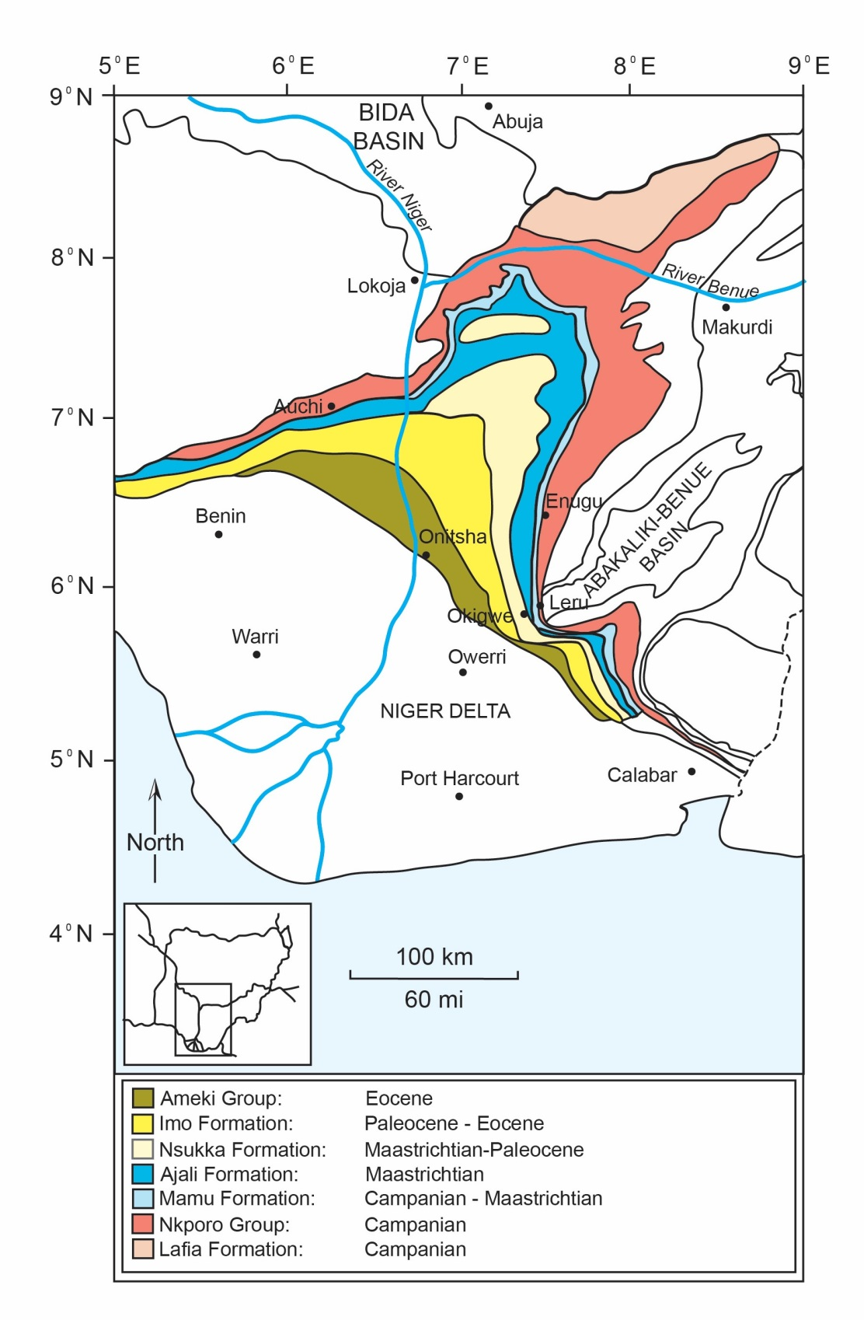

Figure 1. Geological map and stratigraphy of Anambra Basin [16] reproducedfrom [17].

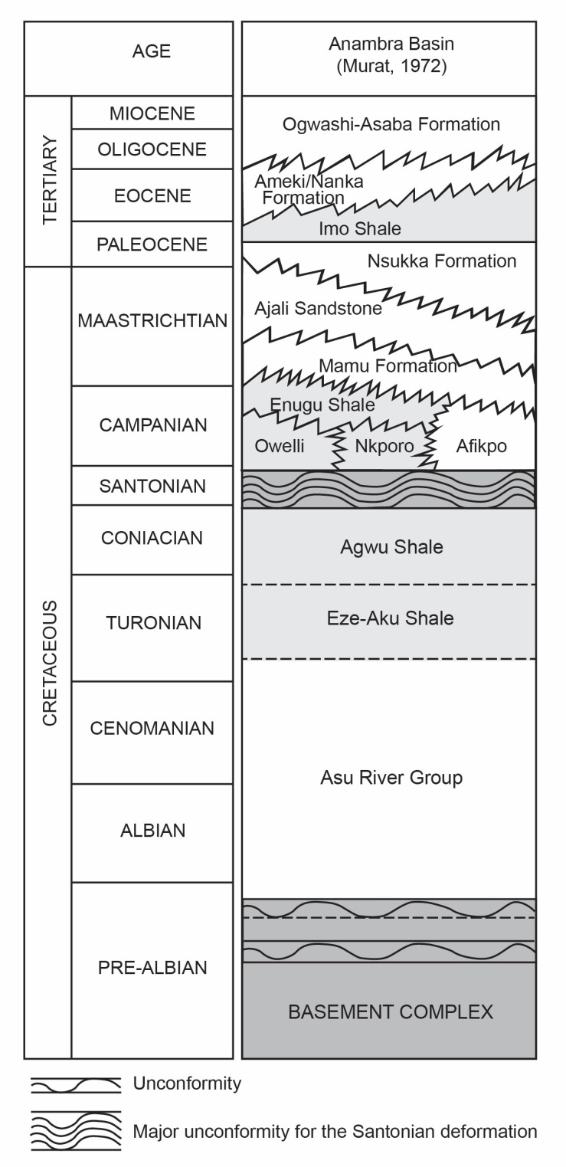

Figure 2. Schematic stratigraphic succession in the southern Benue Trough [25] reproduced from [17].

*Albian*

Albian sediments are the oldest sediments in the Anambra basin. They are classified as Abakaliki Shales and “Unnamed Formation” with the former overlying unconformably pre-Albian Basement Complex rocks. The two formations constitute the Asu River Group. At the type locality, along the Asu River, sedimentary succession in this group consists of poorly bedded sandy shales with sandstone and sandy limestone lenses that reflect characteristics typical of shallow marine deposits. Volcanic activity in this group is thought to be contemporaneous with the deposition of Albian sediments and its occurrences include intrusive bodies, dykes, lava flows intermingled with breccias and tuffs as found in the Albian sediments around Workum Hills in the Lower Benue Trough. Limestone is not uncommon, and may be up to 30 m thick in places. Shale beds are usually composed of *Mortoniceras* and *Elobiceras*, and are folded south of Abakaliki where they are associated with Lead-Zinc mineralisation.

*Cenomanian*

The Cenomanian sediments are attributed to shallow marine origin. They are restricted to Calabar flank where they range in age from Cenomanian–lower Turonian. At the type locality in Odukpani village near Calabar, the deposits are about 600 m thick, and consist of arkose, sandstone, limestone and alternating limestones and shales. Towards the upper parts, the sediments become predominantly shaly.

*Turonian*

Alternating transgression and regressions that occurred during Turonian to early Santonian times deposited shallow-marine carbonates, shales and deltaic sequences. A typical formation that contains Turonian sediments in the Anambra Basin is Eze-Aku Formation. At its type locality, along Eze-Aku River in southeastern Nigeria, the 1000 m-thick formation comprises hard grey to black shales and siltstones with frequent facies changes to sandstones or sandy shale. Notable fossil finds in the formation are *vascoceratids* pelecypods, gastropods, echinoids, and fish teeth, which indicate a basal Turonian age for the formation within its 1000 m-thick intervals.

*Coniacian*

Coniacian deposits make Awgu Formation. These deposits are bluish grey planar bedded shales with rare intercalations of fine-grained sandstone and thin shelly limestones. They are up to 800 m thick, and are rich in ammonites and other molluscs.

*Santonian*

The Santonian substage is widely regarded as a regressive substage in Nigeria that is regarded as a period of non-deposition. A different perspective to account for lack of sediments of this age is the possibility of a regional event that caused the sediments to be eroded, reworked and deposited elsewhere. Due to the Santonian depositional break, Albian-to-Coniacian sediments have estimated thickness of over 3,000 m.

*Campanian*

The Campanian began with a short event of marine transgression that was followed by a period of regression. Campanian sediments overlie the Santonian unconformity, and they exemplify Owelli Sandstone and its age equivalents, Nkporo Formation, and Afikpo Formation. The sediments may reach an estimated thickness of 1000 m in southeastern Nigeria. Based on examination of cores that were recovered from wells in this area, the largely non-fossiliferous Nkporo Formation generally consists of dark shales and mudstone with sandy shale and sandstone irregularly sandwiched between the intervals. The Enugu Shale represents Campano-Maastrichtian sediments overlying Owelli and Nkporo Formations and laterally terminates into the Afikpo Formation.

*Maastrichtian*

The Maastrichtian sequence is typified by Mamu Formation. The formation consists of intercalations of marine sediments, and primarily fresh water and low-salinity sandstones, shales, mudstone and sandy shales replacing the marine sediments in coal-bearing intervals. It is well exposed at Miliken Hill along Old Enugu-Onitsha Express, and passes upward into a sequence of Ajali Formation. The formation is composed of friable, poorly sorted sandstones with reddish iron-derived stains. A distinct band marks internal grading from coarse to fine grains. Sand grains are often subangular and are bound by white sometimes silty clay. Large-scale crossbedding is common in Ajali Sandstone. Aside from the type locality, along the Ajali River, it is also exposed along Auchi-Agenebode road after Fugar town, among other areas of exposure. Outcrops of Ajali Formation are commonly overlain by reddish sands of variable thicknesses, which probably resulted from weathering and/or ferruginisation of fine-grained sandstone.

The Ajali Sandstone is overlain conformably by Maastrichtian-Paleocene Nsukka Formation. This formation is similar in respect of lithology to Mamu Formation, consisting of alternation of sandstone, shale, and sandy shale. At its exposure along Enugu-Onitsha road, the formation comprises thin coal seams at various intervening spaces.

*Paleocene-Miocene*

Paleocene sediments are exemplified by Imo Shale, which conformably succeeds Nsukka Formation. The formation passes upward into Eocene Ameki Formation. The formation consists of a series of fossiliferous greyish-green sandy-clay with calcareous concretions and white clayey sandstones, and may be up to 1,400 m in thickness. Based on observation at its type locality near the old Ameki train station, the formation is characterized by rapid lateral facies change into shaly units or intervals of alternating claystone and sandstone.

The formation is unconformably overlain by the Oligocene-Miocene Ogwashi-Asaba Formation and its lateral equivalent, Nanka Formation. Nanka Formation consists of fine to coarse sandstones with lower shaly limestone, and cross-bedded white or yellow sandstone interlaminated with fine-grained sandstone and sandy clay in the upper parts of the sequence.

2. material and methods

**2.1 Outcrop Description**

The fluvial body studied is located between Latitudes N 07011'03.1'' and N 07011'06.7'', and Longitudes E 006028'02.7'' and E 006028'04.1''. The siliciclastic body is accessible via a road network, beautifully exposed along Okpekpe-Igodo township road in Edo North, southern Nigeria. The succession forms an age-equivalent to the Owelli Sandstone Formation, and represents one of the sandstone successions in a largely mudstone-prone floodplain (Figure 3). A set of basic geological fieldwork equipment including geological hammer for sampling rock samples, measuring tape for measuring dimensions, hand-held grain-size comparator for examining modal grain size and degree of sorting, and GPS device were used for gathering outcrop data and examining rock samples.

Geological attributes collected from the outcrop are lithology, sandstone-mudstone ratio, sandstone and mudstone geometry and dimensions, grain size and sorting, small-scale sedimentary structures, and small-scale vertical sequences of bed thickness. Sediment units that appear to have deposited under constant conditions [32] were measured to obtain bed thickness data, which form the basis for generating graphic logs. The geological attributes together with their vertical relationships enable classification of sediment facies and facies association, whereas internal geometry of sediment body allows definition of architectural elements. Intervals of sediment facies recognised based on lithology, grain size, nature of bed contacts, and small-scale sedimentary structures were traced laterally and vertically to assess irregularity of bed thickness, and geometry and dimensions of first-order units in the fluvial body.

3. results and discussion

**3.1 Morphology, Geometry, Dimensions and Stacking**

In the fluvial body, channel surfaces of different magnitudes are observed (Figure 4). Based on decreasing magnitudes, four kinds of channel morphology are recognised (Table 1).

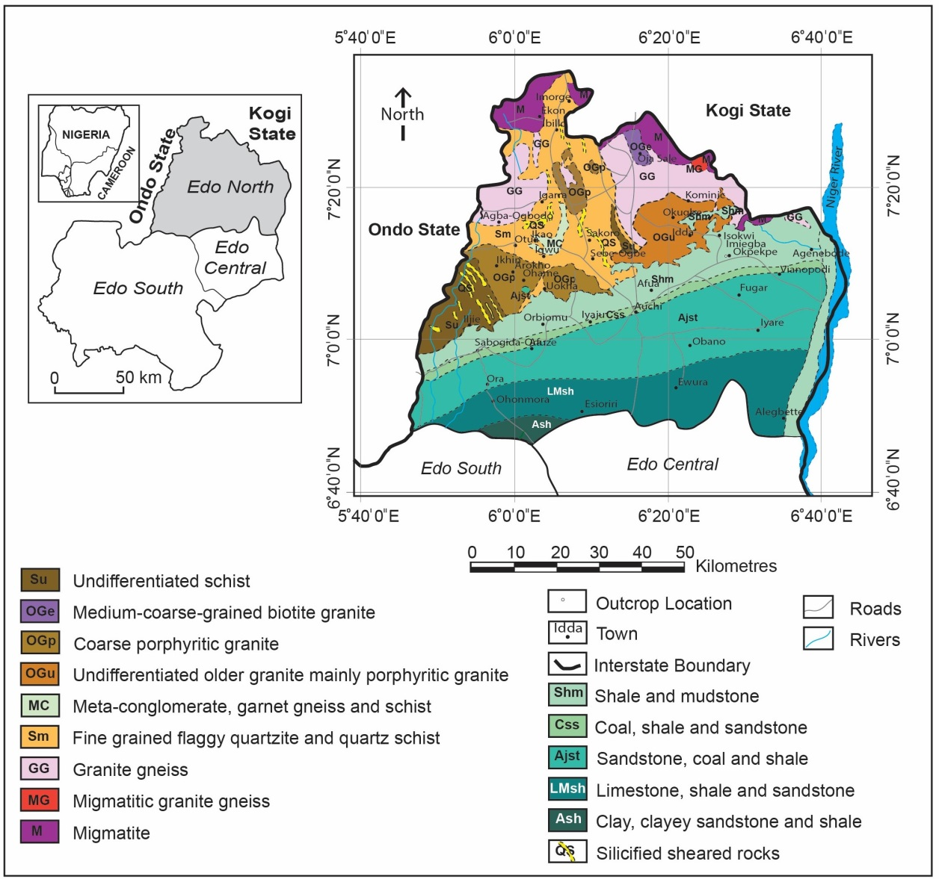

Figure 3. Geological map of Edo North where the fluvial body investigated is located. Inset: Maps of Edo State and Nigeria. Geological map is reproduced from [20]. Map lines delineate areas that relate to the study area and do not necessarily depict accepted national boundaries.

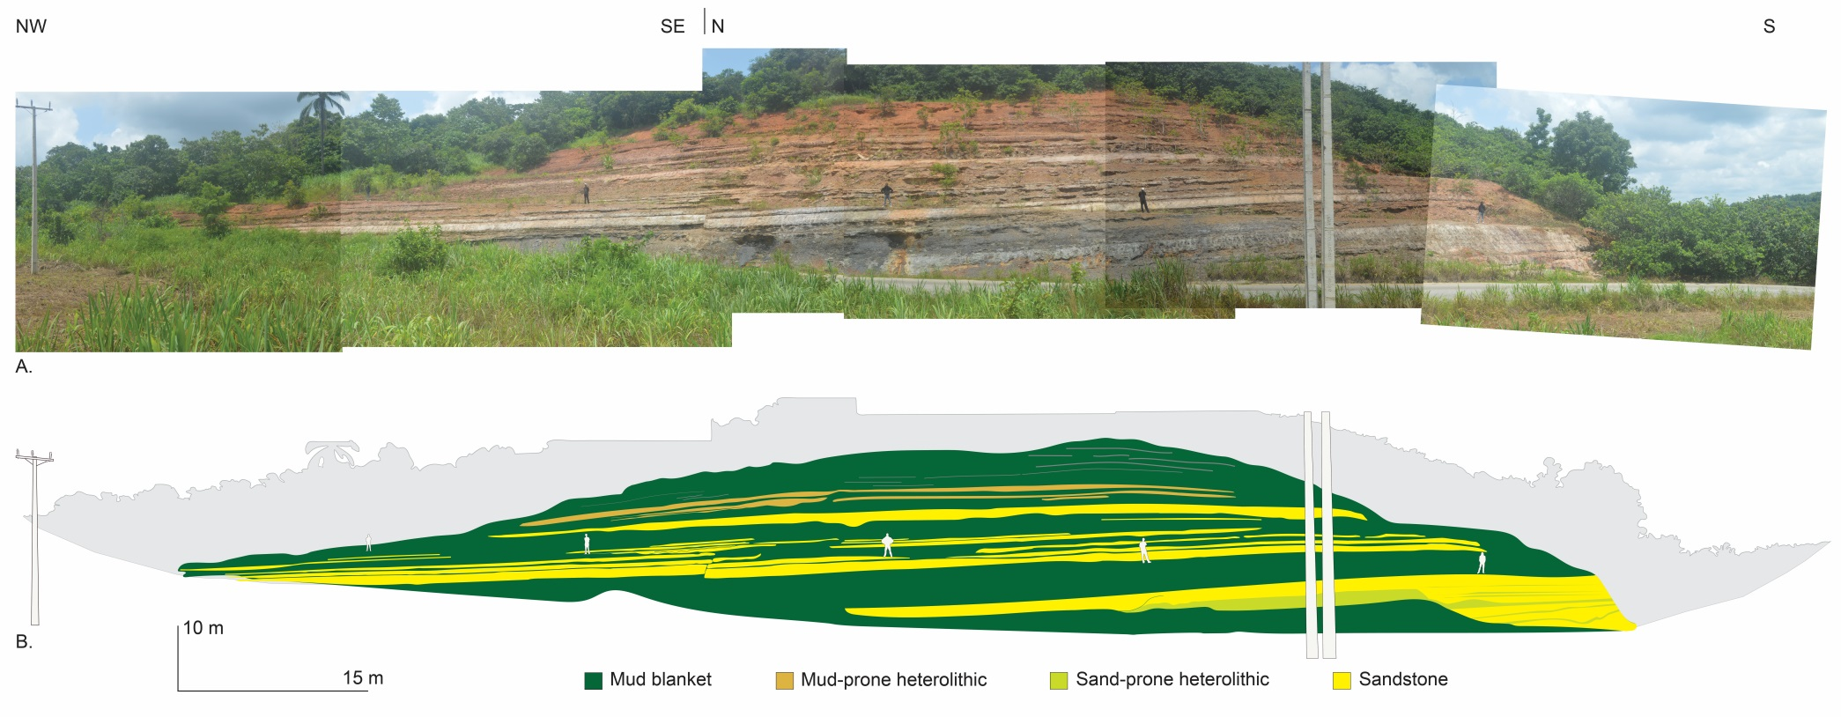

Figure 4. (A) Exposure of fluvial complex along Okpekpe-Igodo township road in Edo North, southern Nigeria. (B) Vertical section covering exposure of the fluvial complex showing lateral extent of sandstone bodies in the mud-prone complex. The complex has minimum dimensions of 30 m high, 145 m wide and ~ 1.1 km long.

Table 1. Characteristics of sandstone units recognised in the Campanian fluvial outcrop near Okpekpe.

|  |  |  |  |  |  |
| --- | --- | --- | --- | --- | --- |
| Channel geometry | Description | Thickness (m) | Width (m) | Length (km) | Stacking pattern |
| Channel complex | Amalgamated channels that form a complex of multistorey channels.  Complex ribbon morphology.  Width/Height = 4.0. | 30.0-35.0 | 145.0 | 1.1-1.5 | Multilateral stacking |
| Single-storey channel | Lenticular granular-pebbly sandstone associated with wavy, non-parallel coarse-to-very-coarse grained sandstone beds.  Complex ribbon morphology.  Width/Height = 3.8. | 9.4 | 36.0 | 0.5-0.7 | Vertical stacking |
| Channel-fill | Cross-bedded hemispheric-shaped medium-to-coarse grained sandstone commonly associated with basal erosional surface.  Single ribbon morphology.  Width/Height = 3.0. | 1.8-5.0 | 21.0 | <0.5 | Vertical stacking |
| Lens | Planar cross-bedded tabular sandstone with sheet geometry, commonly characterized by irregular bed thickness across lateral extent. | 0.3-3.0 | 7.0-12.0 | <0.1 | Isolated stacking |

Type 1: Channel Complex

This type comprises amalgamated channels with characteristic multilateral stacking of conglomerate-sandstone units encased in floodplain mud blanket to form a 145.0 m-wide, 30.0-35.0 m-thick, and 1.1-1.5 km-long siliciclastic body. It is characterized by a complex ribbon structure with width-to-thickness ratio of 4.

Type 2: Single-storey Channel

Type 2 consists of vertically stacked lenticular granular-to-pebbly sandstone occurring in association with wavy, non-parallel coarse-to-very-coarse grained sandstone. It forms a 36.0 m-wide, 9.4 m-thick and 0.5-0.7 km-long single-storey channel structure with compound ribbon morphology and a width-to-height ratio of 3.8. It is characterized by upward thinning beds. The central body of the channel is composed of sediments that were deposited by in-channel flow, whereas the wing comprises finer-grained sediments that are indicative of spilling of in-channel flow into channel margin. The concordant margin of the structure thins out into a succession of shale and mudstone.

Type 3: Channel-fill

This morphology consists of cross-bedded hemispheric-shaped medium-to-coarse grained sandstone unit that forms typically a channel-fill sequence. The sequence is characterized by simple ribbon morphology with vertically stacked upward-fining succession that grades from pebbly sandstone at the base to fine sandstone at the upper parts. Moreover, this morphology can be traced laterally along its width up to 21.0 m and may reach a thickness of 5.0 m.

Type 4: Lens

This morphology has the smallest dimensions among the types observed. It comprises lens-shaped planar cross-bedded tabular sandstone, commonly characterized by irregular bed thickness (0.3-3.0 m thick and 7.0-12.0 m wide). The sandstone units rarely exceed 100.0 m long, and are typically isolated laterally and vertically.

**3.2 Sediment Facies Analysis**

In the siliciclastic body, three lithology associations (hereafter referred to as Facies Associations) are recognised based on dominant lithology: conglomerate, sandstone, and mudrock [33]. Based on grain size, sedimentary structures, and nature of bedding, fifteen distinct sediment types (preferably termed facies) are defined across the three facies associations (Figure 5). The facies proportion in the outcrop is presented in Figure 6 and Table 2, and their characteristics are described in the following section.

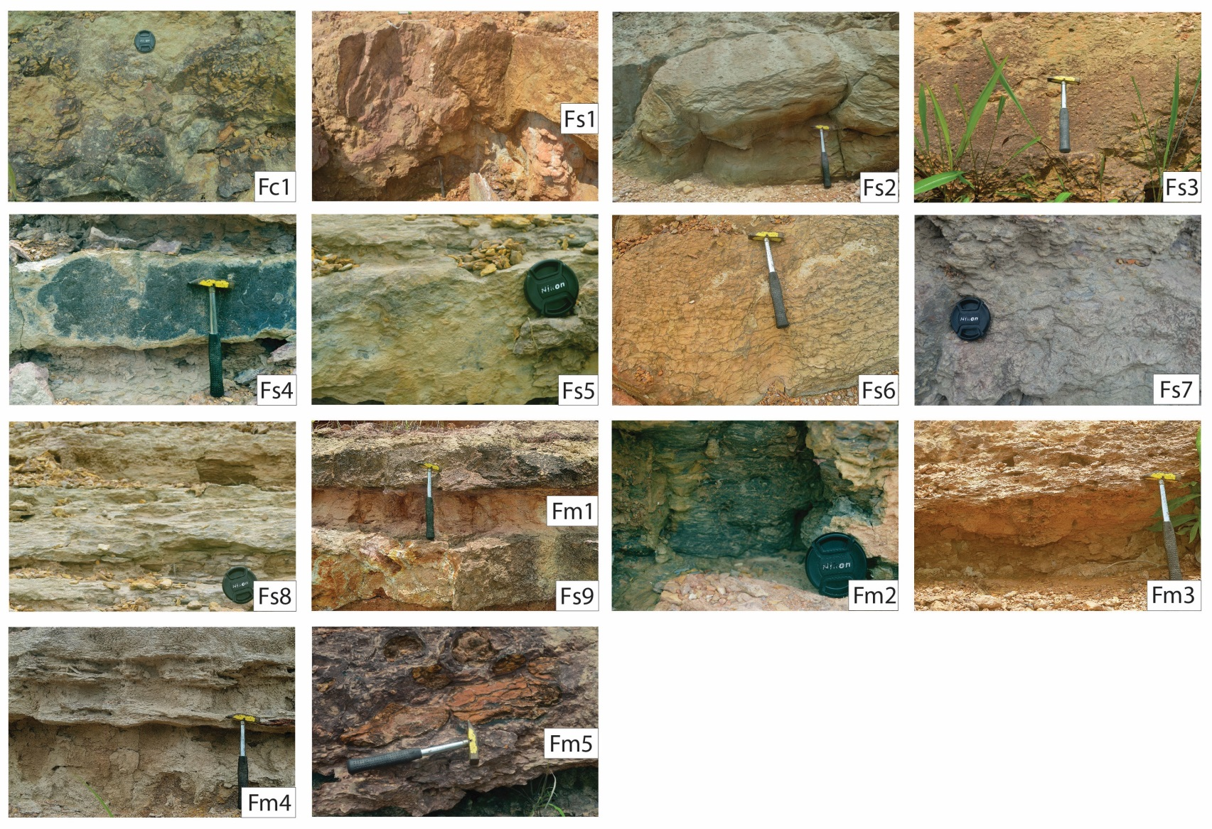

Figure 5. Representative photographs of sediment facies recognised in the fluvial complex. Based on dominant lithology, the fifteen facies can be grouped into three: conglomerate, sandstone, and mudrock.

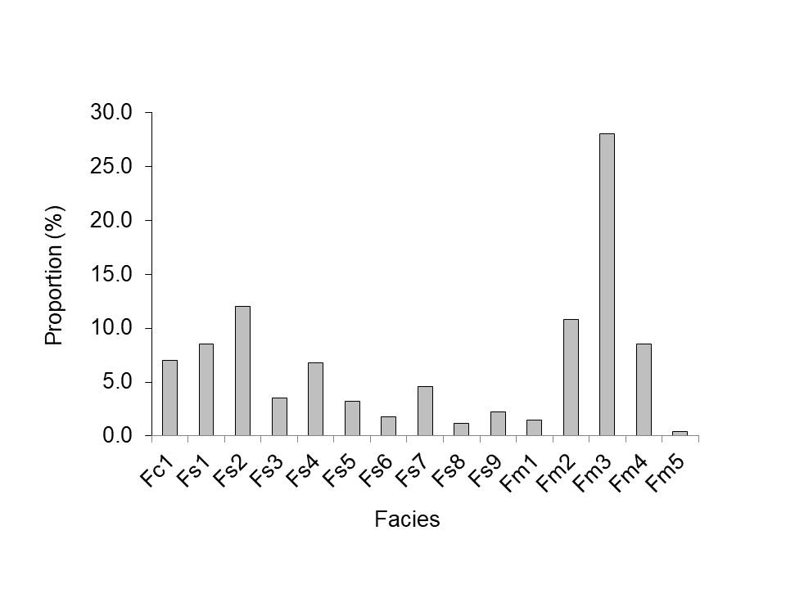

Figure 6. Facies distribution chart showing variable proportion in the fluvial complex. In the complex, Fm3 is the most abundant facies (28%), and Fm5 the least (<1%).

Table 2. Classification of facies identified from fluvial outcrop in Okpekpe area.

|  |  |  |
| --- | --- | --- |
| Facies Association | Lithofacies Code and Description | Percentage  proportion |
| Conglomerate | Fc1: Massive conglomerate | 7.0 |
| Sandstone | Fs1: Massive lenticular-bedded very coarse-grained sandstone | 8.5 |
| Fs2: Massive wavy-bedded coarse-grained ripple cross-laminated sandstone | 12.0 |
| Fs3: Graded pebbly scour-fill sandstone | 3.5 |
| Fs4: Planar parallel-bedded rippled coarse-grained sandstone | 6.8 |
| Fs5: Planar parallel-bedded ripple-laminated medium-to-coarse-grained sandstone | 3.2 |
| Fs6: Discontinuous wavy, non-parallel fine-to-medium-grained sandstone | 1.8 |
| Fs7: Flaser-bedded coarse-grained sandstone | 4.6 |
| Fs8: Wavy subparallel-bedded ripple cross-laminated coarse-grained sandstone | 1.2 |
| Fs9: Planar subparallel-bedded clayey sandstone (commonly interbedded with “reddish” claystone). | 2.2 |
| Mudrock | Fm1: Structureless claystone (interbedded) | 1.5 |
| Fm2: lenticular laminated shale (continuous-discontinuous, no internal structures, rare micro-cross lamination) | 10.8 |
| Fm3: Wispy laminated claystone (appear to have discontinuous, planar, parallel bedding) | 28.0 |
| Fm4: Wavy laminated mudstone | 8.5 |
| Fm5: Mudrock clasts | 0.4 |

Facies Association 1: Conglomerate

*Fc1: Massive conglomerate*

Massive conglomerate (Fc1) makes up the entire conglomerate facies association and constitutes 7% of the fluvial body. The facies consists of clasts of variable dimensions ranging from 4.5 cm to 15.2 cm long and 0.5 cm to 7.5 cm wide. The clasts are without preferred orientation and are arranged in a disorganised manner within a matrix of fine-to-coarse grained sandstone. They have variable composition with sandstone and claystone most common. Associated with the facies are mud-prone load balls (Fm5) that are randomly distributed over a basal erosional surface within a matrix of fine sandstone. Such load clasts are up to 0.4 m long and 0.1 m wide. The facies is characterized by low sandstone-mudstone ratio (55%), very poor sorting and a disorganised internal structure. Crude cross bedding occurs in places, and largest clasts occur at the base to imprint a normal grading trend. Individual beds bound with wispy laminated claystone (Fm3).

Facies Association 2: Sandstone

Facies association 2 comprises sandstone and accounts for 39% of the entire fluvial body. It is made up of eight constituent facies that have different grain size range, grain sorting, sandstone-mudstone ratio, bed thickness and lateral extent, bedding style, and internal architecture. The facies are described as follows:

*Fs1: Massive lenticular-bedded very coarse-grained sandstone*

This facies makes up about 9% of the constituent facies recognised in the fluvial body. It is composed of massive sandstone, about 1.5 m thick, that scoured into greyish pink structureless claystone (Fm1). The facies is very coarse-grained and poorly-to-moderately sorted although sorting gets better towards the top. Dispersed shards of claystone are commonplace forming basal lags in the ungraded sandstone and reducing sandstone-mudstone ratio to about 70%. Internal structure consists of current ripples with sharp lee sides, and trough cross lamination that occur at the upper finer-grained parts.

*Fs2: Massive wavy-bedded coarse-grained ripple cross-laminated sandstone*

This facies is characterized by wavy subparallel bedding, and consists of coarse grained moderately-sorted sandstone. Individual beds are up to 1.0 m thick, but a high tendency for amalgamation makes vertical succession of bed thickness to exceed 3.0 m. The facies has a sandstone-mudstone ratio of 90-95% with good visible porosity. Internal grading is observed from coarse-grained ripple-laminated lower part to fine-to-medium-grained ripple cross-laminated upper section. The facies extends laterally up to 35.0 m across the outcrop width, and constitutes 12% of the constituent facies. It passes abruptly upward into interval of wispy laminated claystone (Fm3).

*Fs3: Graded pebbly scour-fill sandstone*

This facies makes up around 4% of the constituent facies in the fluvial outcrop. It consists of pebbly sandstone that grades upward into intervals of fine-to-medium-grained ripple-laminated sandstone. In Fs3 sequences, grain sorting is better towards the upper part with corresponding better visible porosity. Generally, bed thickness in these sequences varies between 1.2 m and 2.5 m with a lateral extent of 22.0 m. Internal structure is composed of normal grading, scour fill, current ripples, and ripple cross lamination. The facies is characterized by erosional base and abrupt transition into wavy laminated mudstone (Fm4).

*Fs4: Planar parallel-bedded rippled coarse-grained sandstone*

Planar parallel-bedded rippled coarse-grained sandstone has a proportion of about 7% in the siliciclastic body. The facies is characterized by variable bed thickness, ranging from 0.2 m to about 1.5 m with lateral extent of 15.0 m-22.0 m before thinning out into a succession of lenticular shale (Fm2). The facies is entirely sand, and is moderately-to-well sorted. In Fs4 intervals, internal architecture comprises isolated current ripples, but no internal grading is observed. Bedding is planar and non-erosional. Fs4 sequences commonly alternate with Fm2. The facies is bounded by sharp basal contact with a thick succession of wavy laminated mudstone (Fm4), and passes upward into intervals of planar parallel-bedded ripple-laminated medium-to-coarse-grained sandstone (Fs5).

*Fs5: Planar parallel-bedded ripple-laminated medium-to-coarse-grained sandstone*

Fs5 shares similar bed characteristics with Fs4. It comprises medium-to-coarse-grained poor-to-moderately sorted sandstone. It is characterized by a much lower sandstone-mudstone ratio (65%), and lower visible porosity than Fs4 (<20%). The facies succession is underlain by lenticular laminated shale (Fm2) and passes upward into intervals of wavy subparallel-bedded ripple cross-laminated coarse-grained sandstone (Fs8). Internal architecture is dominated by ripple lamination, but no evidence of internal grading is observed. The facies constitutes less than 4% of the fluvial outcrop.

*Fs6: Discontinuous wavy, non-parallel medium-grained sandstone*

This facies comprises medium-grained sandstone and displays discontinuous wavy, non-parallel lamination. It makes up less than 2% of the outcrop, and it is typically poorly-to-moderately sorted. It has sandstone-mudstone ratio of 55%. In Fs6 intervals, bed boundaries are indistinct making it difficult to measure bed thickness. The facies rarely exceeds 1.5 m in lateral extent, and lacks organised internal structure.

*Fs7: Flaser-bedded coarse-grained sandstone*

This facies comprises poorly sorted coarse-grained sandstone that shares a sharp contact with underlying planar parallel-bedded rippled coarse-grained sandstone (Fs4). The facies, which has a relative abundance of 5% in the siliciclastic body, passes gradually upward into a succession of wavy subparallel-bedded ripple cross-laminated coarse-grained sandstone (Fs8). Successive Fs7 beds have no distinct boundaries and are commonly less than 1.0 m in thickness. These beds extend 25.0 m in width and have disrupted lamination that emanated from excess sand deposition with minor mud. Internal architecture is composed of flaser lamination and climbing ripples. No internal grading is observed in Fs7 intervals.

*Fs8: Wavy subparallel-bedded ripple cross-laminated coarse-grained sandstone*

This facies is the least abundant (< 2%) among the sand-prone facies recognised in the fluvial outcrop. It consists of coarse-grained sandstone that is poorly-to-moderately sorted. Individual beds are separated by wavy subparallel bedding, which imposes a lateral thinning trend of beds. These beds are 0.3 m thick or more, although less thickness is observed for some beds over lateral extent where beds are thicker. The facies has a sandstone-mudstone ratio of 90-95% but is plagued by poor-to-moderately sorting that tends to reduce its visible porosity. Although there is no perceptible internal grading, ripple cross lamination and wavy lamination dominate its internal architecture. The facies is bounded below by a gradational contact with planar parallel-bedded ripple-laminated medium-to-coarse-grained sandstone (Fs5) while it passes upward into wavy laminated mudstone (Fm4).

*Fs9: Planar subparallel-bedded clayey fine-to-coarse sandstone*

Planar subparallel-bedded clayey sandstone constitutes less than 3% in the exposed fluvial body. The facies is composed of a mixture of fine-to-coarse-grained sandstone and claystone that impose a disorganised internal structure. Apart from a sandstone-mudstone ratio of 55% or less, the facies is characteristically very poorly sorted. Fs9 sequences are planar and subparallel, exhibiting lateral thinning of bed thickness. The facies is typically interbedded with structureless claystone (Fm1) and eventually passes upward into a succession of wispy laminated claystone (Fm3). Successive beds are up to 1.0 m thick, although a range of bed thickness between 0.3 m and 0.7 m is common. The beds can be traced over lateral distance of 45.0 m.

Facies Association 3: Mudrock

This facies association is mudrock in its entirety, and consists of claystone, shale, and mudstone. The facies has a relative abundance of 59% in the fluvial body. Its constituent facies are described as follows:

*Fm1: Structureless claystone*

Structureless claystone occurs as background facies into which massive lenticular-bedded very coarse-grained sandstone (Fs1) is incised. Although the facies makes up less than 2% of the fluvial outcrop, it forms laterally extensive mudrock unit that is commonly interbedded with planar subparallel-bedded clayey sandstone (Fs9). It displays white-to-yellow grey that turns reddish-to-light brown upon exposure to weathering. It has no internal structure, and varies in thickness from <0.3 m to 1.2 m.

*Fm2: lenticular laminated shale*

This mudrock facies consists of 98% shale and <5% silt. The silt forms lenticular continuous-to-discontinuous lamination but lacks internal structures except sporadic micro-cross lamination. The shale is greyish blue-to-pale blue, and contains sporadic carbonaceous material. It occurs in association with planar parallel-bedded rippled coarse-grained sandstone (Fs4) and planar parallel-bedded ripple-laminated medium-to-coarse-grained sandstone (Fs5). The facies constitutes about 11% of the outcrop section where it reaches a maximum thickness of 1.3 m and exceeds 100 m in lateral extent.

*Fm3: Wispy laminated claystone*

Wispy laminated claystone (Fm3) is the only mudrock facies that is ferruginised, displaying a reddish orange colour. It is the most abundant mudrock facies and the facies with highest proportion in the entire outcrop (28%). In places, internal architecture displays wispy lamination formed by *discontinuous silt streaks and lenses.* The facies extends laterally over entire width of the outcrop, and occurs in association with Fc1, Fs2, Fs6, and Fs8.

*Fm4: Wavy laminated mudstone*

Wavy laminated mudstone (Fm4) occurs as brownish grey mudrock facies that is composed of continuous silt laminae with no distinct internal structure. These silt-rich laminae are usually less than 0.1 m thick. Fm4 intervals can be traced up to 45.0 m, but rarely exceed 0.4 m in thickness. Internal architecture displays subtle internal grading from silt to mud. The facies is closely associated with Fs3, Fs4, and Fs8.

*Fm5: Mudrock clasts*

Mudrock clasts of variable colours and sizes make up less than 1% of the fluvial outcrop. In the outcrop, mudrock clasts with moderate reddish brown and dimensions 4.5 - 15.2 cm long and 0.5 - 7.5 cm wide are most common. Rarely, they comprise disrupted silt lamination that leads to disorganised internal architecture such as in Fc1. Elsewhere, the facies occurs as intermittent shards of mudrock clasts, and rip-up clasts at the lower sections of scour-fill sandstone (Fs1 and Fs3).

**4. Result and Discussion**

**4.1 Architectural Elements, Dimensions, and Depositional Environment**

Based on morphology, geometry, and dimensions of sandstone units, seven architectural elements are recognised in the fluvial body. These architectural elements are: (I) Major Channel (II) Lateral-Accretion Deposit (III) Downstream-Accretion Deposit (IV) Levee (V) Crevasse Splay (VI) Floodplain Fines (VII) Floodplain Mud (Figure 7). For descriptive convenience, we grouped these elements into three, namely: (1) Channel Elements (2) Overbank Elements (3) Floodplain Elements.

1. *Channel Elements*

This category comprises major channel and within-channel elements such as lateral-accretion and downstream-accretion elements. In the fluvial body, channel element (about 2.5 m thick) scoured into underlying floodplain mud and forms upward thinning and upward fining succession from trough cross-bedded granules-to-conglomeratic sandstone to planar, occasionally ripple-laminated medium sandstone. Channel elements form a ribbon-like structure and are separated by silty mudrock (Figure 8). These channel elements together with floodplain fines sandwiched between them form approximately 10 m-thick major channel (Lower Zone; Figure 9) that is capped by floodplain mud blanket – marking end of channel activity prior to unconfined flow in subsequent depositional episodes. Above erosive scours, pebbles and rip-up clay clasts are observed. Sandstone beds are continuous from channel-axis to channel margin and tend to amalgamate in the upper parts of the channel succession. Towards channel margin, these beds thin laterally and are eventually tapered off due to reducing amount of sediment as the river flowed towards the margin. In the axis, channel-fill sediments comprise tabular cross-bedding that range in length from 5-8 m. Lenticular-shaped scours observed in the succession have lengths ranging from 0.5 m to 6.0 m with height varying from 0.3 m to 3.0 m. These scours are composed of trough cross-bedded medium-to-coarse-grained sandstone, although tabular cross bedding associated with pebbly sandstone occurs in places.

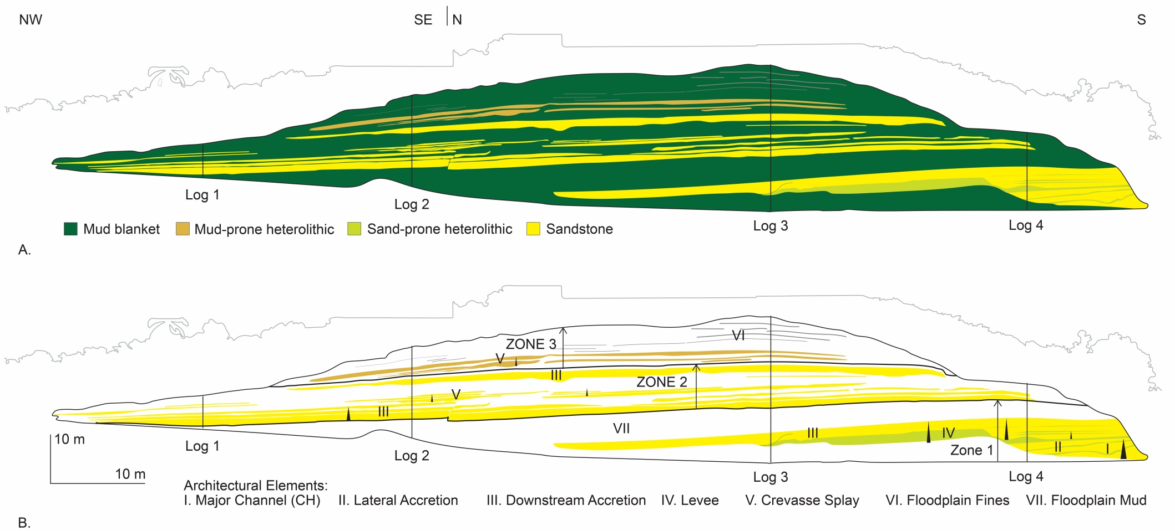

Figure 7. (A) Vertical section covering exposure of the fluvial complex. (B) Definition of architectural elements in the section. Three zones delineated have variable internal geometry and dimensions. Description of architectural elements is presented in the text.

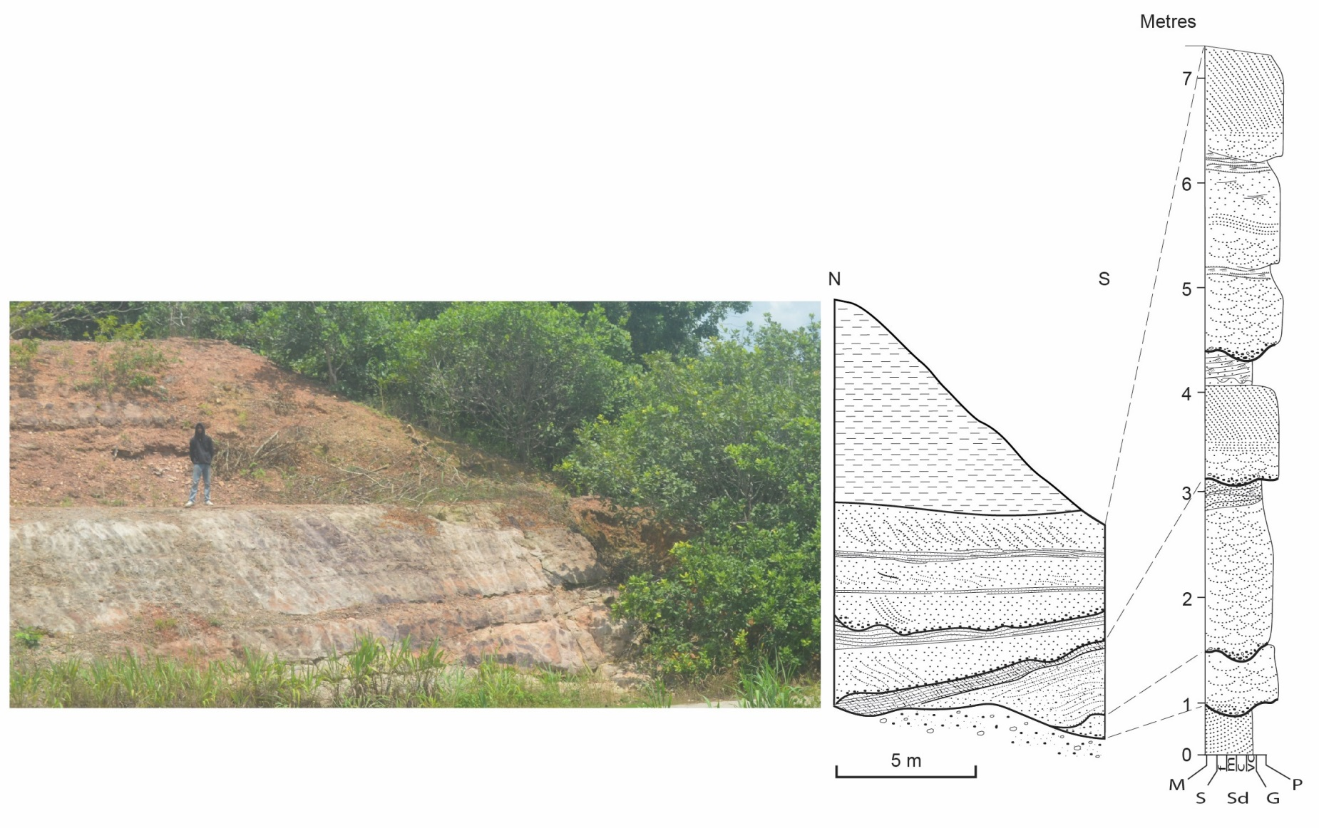

Figure 8. (A) Schematic logs through the fluvial complex. Location of logs is shown in Figure 7. (B) Photograph of major channel. (C) Vertical sketch through the cliff face of major channel.

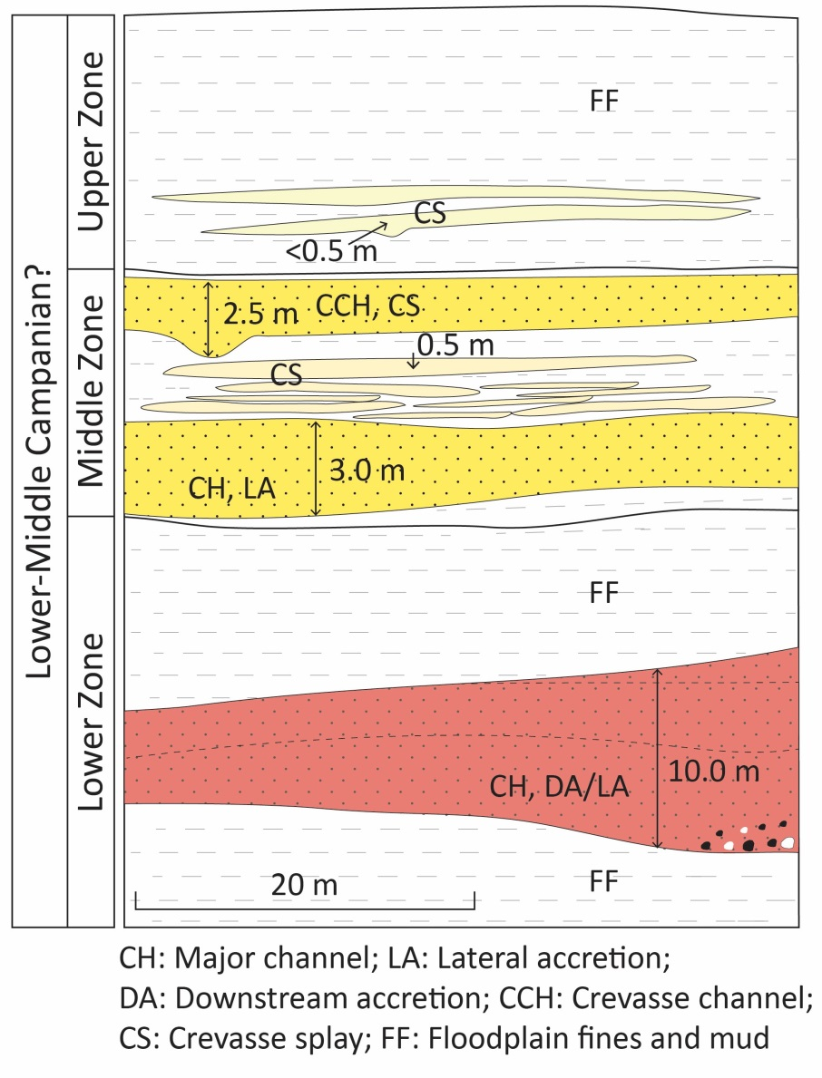

Figure 9. A model to conceptualize internal geometry and dimensions of architectural elements in the fluvial complex. Lower Zone comprises a major channel typified by a complex ribbon. Middle Zone consists of sheets bodies attributed to poorly channelized flows with minor scour and fills (crevasse channels). Upper Zone is mud-prone comprising crevasse splays (<0.5 m thick) that developed from overbank deposition in the floodplain by flash floods.

Apart from varying in width and thickness, major channel element is characterized by broad and flat erosive bases that are overlain by mud-prone load casts. The channels have steep margins that thin towards the axis. In some places within the fluvial body, channels with a gentle relief (<1.0 m) are identified, and are composed of coarse-grained sandstone and granules with varying amount of silty sandstone before passing into floodplain fines. Field observation also revealed sediment infilling in the stepped channel margins consists of fine-grained sandstone to lenticular-bedded granular-to-pebbly sandstone, implying deposition during falling stages of meandering river flow [34, 35, 36, 37].

In the fluvial body, channel sandstone accumulated by both vertical and lateral accretion [38], although the latter is dominant manifesting as sheet sandstone bodies that are delineated in the Middle Zone. These sheet sandstones have flat bounding surfaces without any evidence of erosion, suggesting that they are formed by sheet floods that extended into the floodplain. The element is thought to be associated with poorly channelized or unstable channelized flow. In these sheet sandstone bodies, average width-to-height ratio is 15, unlike in downstream-accretion where average width-to-height ratio is 3.0. The orientation of the accretion surface and that of the cross-bedding within the downstream-accretion element is between 45o and 50o of each other, suggesting that sheet sandstone accumulated by accretion in a direction that was parallel to local flow. Downstream-accretion element, on the other hand, is characterized by lens-shaped sandstone that lies horizontally on erosional base. In this element, very coarse-to-pebbly sandstone is found to fill broad and shallow scours. Away from channel margin, there is a gradation of downstream-accretion element to lateral-accretion element, an observation found to be consistent with previous works [35, 39, 40, 41, 42]. Between surfaces of downstream-accretion element, fine to very coarse occasionally pebbly sandstone that is planar cross-bedded or trough cross-bedded, with horizontally lamination, and ripple cross-lamination dominate the internal architecture in the downstream accretion element.

1. *Overbank Elements*

The development of overbank elements in the fluvial complex is attributed to abundance of suspended load that resulted in significant deposition of floodplain mud, and the noticeable isolation of channel fills from one another [43, 44]. These elements are levee and crevasse splay. They are formed when flow spilled from channel carrying relatively coarse deposits and depositing them as bed load in overbank areas. Although levee element is less common in the complex, it is composed of sand, silt, and mud. Its internal structures are horizontal lamination and small current ripples. The element has wedge geometry and constitutes the wing of the Lower Zone, extending from channel body through channel margin. It is 5.0 m in thickness and 25.0 m in width. Apart from the Lower Zone, overbank elements are found in the Middle and Upper Zones. In these zones, they occur as crevasse channels (2.5 m thick) and crevasse splays (<0.5 m thick).

By contrast, crevasse splay forms proximal sand sheet that commonly extends from marginal overbank into distal overbank area where it forms distal overbank sheet. Crevasse splay element in the fluvial succession comprises fine-to-coarse sandstone that becomes pebbles in places. The splay is characterized by lens geometry reaching a maximum of 2.0-6.0 m in thickness. Internal structures are trough cross-bedding, ripple cross-lamination, and low-angle cross bedding. Associated channel (i.e. crevasse channel) consists of coarse-to-very coarse often pebbly sandstone that grades upward into trough cross-bedded coarse sandstone before passing into ripple cross-laminated fine-to-coarse sandstone, which caps the sequence. Unlike splay component, crevasse channel has a simple ribbon geometry that is generally 2.5 m deep and 7.5 m wide. Crevasse splays are results of deposition attributed to fingers-like progradation of deposits from crevasse channel into floodplain (Figure 10).

1. *Floodplain Elements*

Floodplain elements consist of floodplain fines and mud. Floodplain fines are usually deposited from sheet flow in overbank areas. In the fluvial body, they occur as silt and muddy silt, although very fine sand with characteristic fine lamination and very small ripples are also observed. This suspended load marks a waning flood regime [41]. Where floodplain fines are thin, they form drape deposits on ripple-laminated sandstone. By contrast, floodplain mud element is entirely mud, and represents background facies before channel activity began. Together the elements form sheets of suspended load that extend in length over several kilometres and are 10s of m thick [45].

**4.2 Reservoir Potential**

The continental sediments that are collected and transported by fluvial systems are deposited under various depositional processes, and their properties are influenced by channel morphology, pattern of river flow within a channel (braiding, meandering, and anastomosing), flow regime, and more, resulting in a complex fluvial body geometry and dimensions [46, 47]. Apart from their complex geometries, which vary stratigraphically due to allogenic influences on fluvial style or autogenic migration of the fluvial system [48], fluvial reservoirs are difficult to understand, characterize, and model [49]. Although meandering rivers do not create thick sedimentary packages [50], sand and mud that are deposited within well-defined meander belts form macroforms including point bars, crevasse splay, and mud-rich channel plugs within a background of floodplain fines. In these belts, there is a complex arrangement of sand pods, lenses, and channels forming a complex labyrinth of interconnected sand bodies that may extend over several hundreds of metres enclosed within floodplain mud [51]. In stratigraphic record, point bars are the main sand-prone macroforms found in meandering river sediments, whereas levees, if present, may be less preserved [50]. Point bars form by lateral accretion of sediment on the inside of meander bends, and they occur in plan section as discrete sand bodies with a lenticular or half-moon shape [49]. The larger the river system, the bigger the dimensions of resultant point bar sand bodies that will develop in its meander belt. Individual point bars in the 35-1 amalgamated fluvial sandstone bodies in the giant Widuri oil field in the Asri Basin, west Java Sea have sandstone bodies that are up to 18 m in thickness, varying in width from 1200 m to 1500 m [52]. There is a transition from wide composite sandstone bodies at the base to narrow solitary sandstone bodies at the top of the reservoir interval with cumulative oil production of 3.2 MMbbls of oil from one well that is located in one of the point bars [53].

The labyrinth reservoir geometry type, typical of meandering river systems [51], characterizes sandstone bodies in the fluvial complex. In the Lower Zone, sandstone bodies form complex ribbon that consists of vertically stacked channel-fill sequence. Away from the central part of the complex, sandstone progressively thins towards the margin, and eventually terminates into floodplain mud (Figure 11). This zone consists of a basal erosional surface that is overlain by channel lags with intraformational mudrock rip-up clasts. Overlying this layer are large-scale cross-bedded sandstones that pass upward to horizontal and ripple cross-laminated intervals, before being capped by mudrock, which reflects poor continuity of

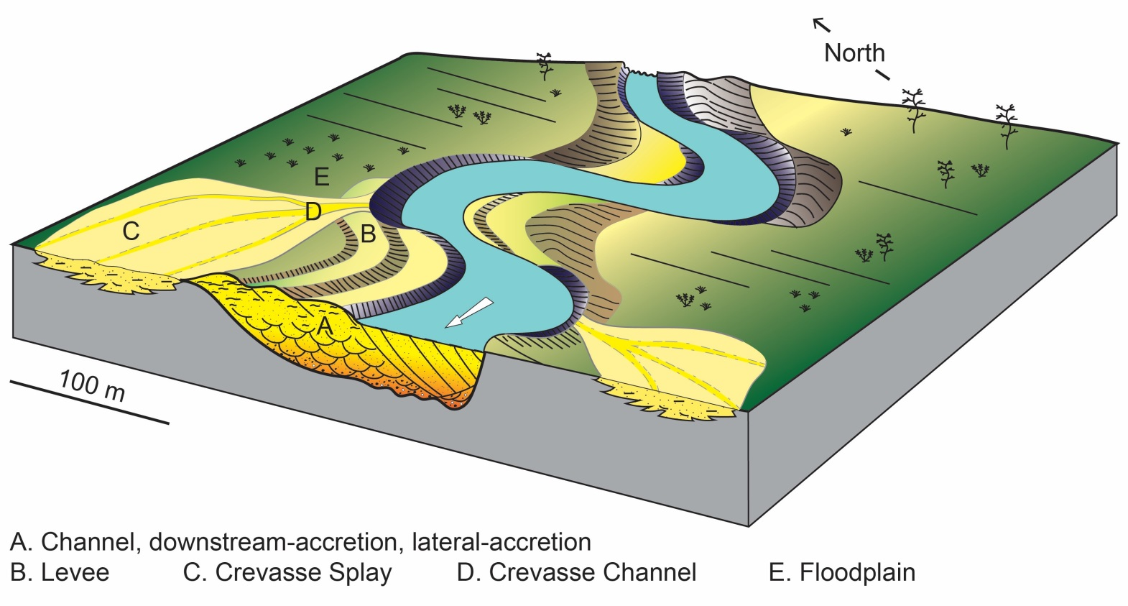

Figure 10. A block model showing distribution of architectural elements that are associated with a meandering river system.

sandbodies away from central channel body. Towards the top, local mud-prone balls are observed, and in places, clay drapes separate intervals of ripple cross laminae.

In the Middle Zone, sheet sandstone bodies attributed to poorly channelized flow have marked moderate-to-high lateral continuity. The presence of sand-rich crevasse splays in this zone may improve vertical connectivity where they are sandwiched between two sheet sandstone bodies. Although the Upper Zone consists of crevasse splays, it is considered poor in terms of reservoir potential because of very low sandstone-mudstone ratio (<25%) and very low visual porosity (<10%) of the crevasse splays.

The fining-upward trend that characterizes vertical profile of the siliciclastic body is associated with upward-decreasing permeability profiles from cross-bedded sandstones at the base of point-bar sequences to ripple-cross laminae that dominate top of the sequences [54]. The upward-decreasing permeability profiles are unfavourable to efficient sweep, causing injected water to flood high-permeability basal part of point bar while leaving the uppermost section unswept [6, 49, 55]. A major risk to oil recovery in this reservoir type is posed by floodplain mud that constitutes mud plugs and reduces flow communication between injection well and production well [51]. In the Widuri oil field, these mud plugs are 50-150 m wide and are up to 5 m thick [52]. Well planning in this reservoir type is problematic because of poorly understood connectivity between the sandstone bodies [12], which commonly results in poor communication between injection and production wells [7, 57]. However, where mud plug does not totally separate two point bars areally and/or the presence of sand-prone crevasse splays may improve connectivity between one point bar and another [10, 58]. Furthermore, abundant mud chips that occur along the base of point bars have potential to reduce vertical communication [59]. The reservoir in Peoria field, Colorado is a classic example where vertical connectivity between stacked point bars was severely hampered by mud-rich lags at the base of individual point bars [60]. Where these lags are randomly distributed, they are likely to form flow baffles rather than continuous flow barriers.

5. ConclusionS

The siliciclastic body described in this study is interpreted as a mud-prone fluvial complex whose deposition is attributed to a meandering river system. This system consists of laterally migrating channel that forms narrow sheets to very broad sheets in cross section. These sheet bodies are associated with mobile-channel belt comprising laterally-accretion deposits (point bars) and a significant amount of well-preserved suspended load. The depositional model for the outcrop reveals external siliciclastic-body geometry, and internal architecture, which is a function of dimensions and orientation of architectural elements, and their vertical and lateral relations. The architectural style in this low net-to-gross (51%) system is influenced by the style of deposition and defines potential flow units in the system. Geometry of the fluvial body reflects a complex labyrinth of interconnecting sand bodies. Among the three zones delineated in the complex, only the Upper Zone is considered non-reservoir due to very low sandstone-mudstone ratio (<25%) and very low visual porosity (<10%) of crevasse splays. In the Lower Zone, poor lateral continuity of channel sandstone reduces its reservoir potential although vertical stacking in the central complex results in good vertical connectivity of channel facies that will enable vertical sweep during hydrocarbon production

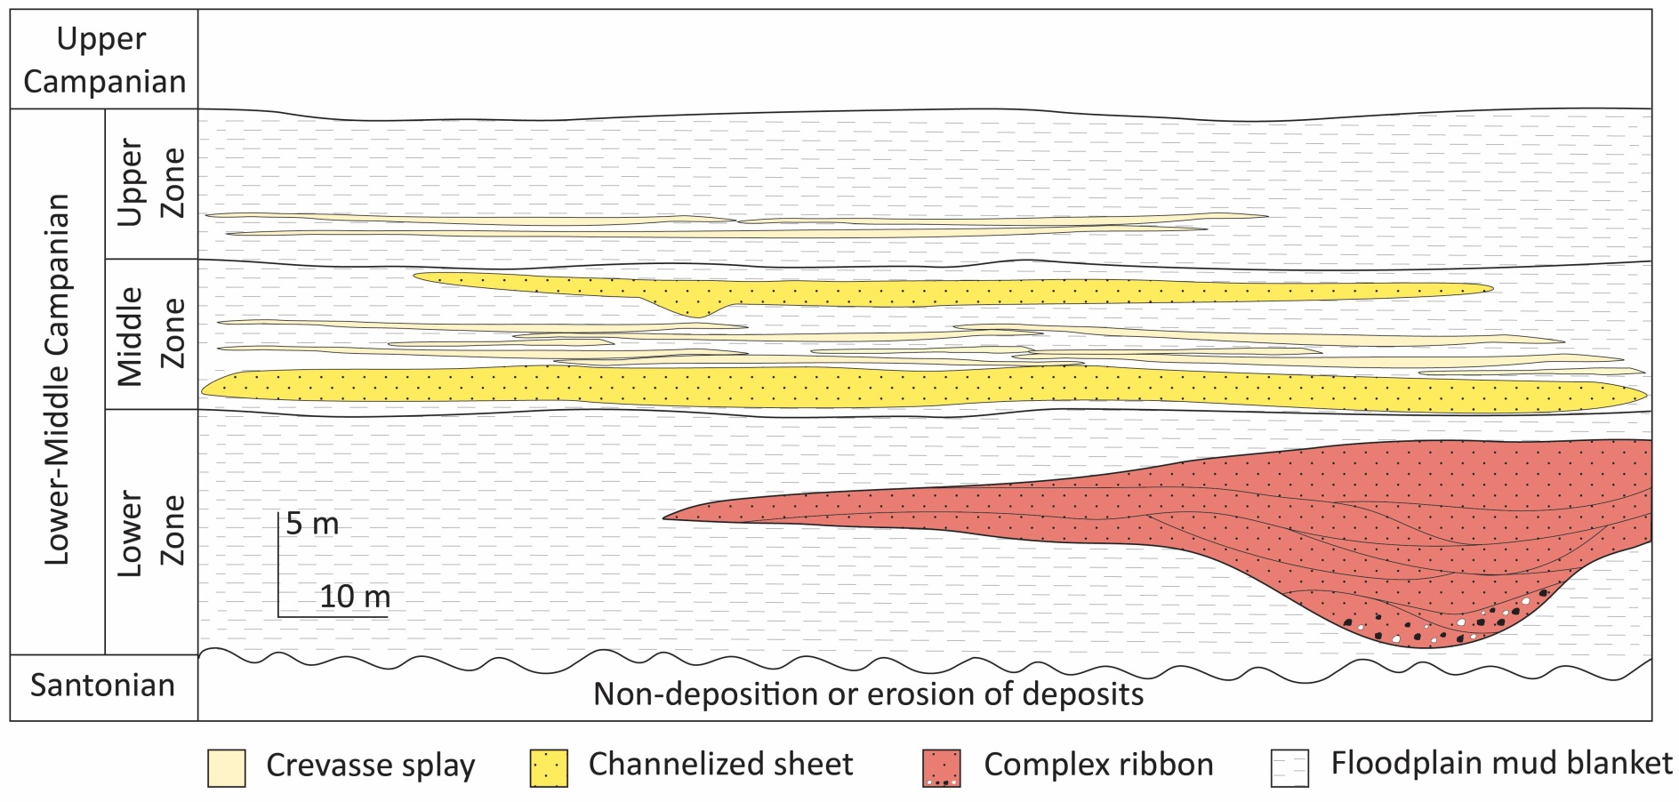

Figure 11. A conceptualized 2-D model illustrating stratigraphic relationship of the architectural elements in the fluvial complex.

in analogous reservoirs. In the Middle Zone, the risk of poor vertical connectivity is reduced by the presence of crevasse splays sandwiched between sheet sandstone bodies. These laterally extensive sandstone bodies will improve horizontal sweep in subsurface analogues. However, the contribution of crevasse splays between these sandstone bodies to production remains a huge uncertainty leading to the risk of vertical flow and/or flow segregation.

Understanding the style of deposition will improve prediction of internal barriers and heterogeneity in fluvial complex, and thus reduce difficulty that is associated with managing a labyrinth reservoir. In this instance, infill drilling, selective recompletion, horizontal drilling, and strategic cross-reservoir flooding are potential recovery mechanisms that will suit oil recovery in subsurface analogues. Because of the excellent exposure, the fluvial body studied is a good analogue for subsurface facies analysis in fluvial systems that have similar internal architecture.

REFERENCES

1. Miall AD. Architectural-element analysis: a new method of facies analysis applied to fluvial deposits. Earth Science Reviews. 1985;22:261-308.
2. Bridge JS. Rivers and floodplains: forms, processes, and sedimentary record. Oxford: Blackwell Science Ltd.; 2003.
3. Weissman GS, Hartley AJ, Nichols GJ, Scuderi LA, Olson ME, Buehler HA, Banteah R. Fluvial form in modern continental sedimentary basins: distributive fluvial systems (DFS). Geology. 2010;38:39-42.
4. Colombera L, Mountney NP, Howell JA, Rittersbacher A, Felletti F, McCaffrey WD. A test of analog-based tools for quantitative prediction of largescale fluvial architecture. Bulletin 100. Association of American Petroleum Geologists. 2016a;237-267.

DOI: 10.1306/11181514227

1. Stow D, Nicholson U, Kearsey S, Tatum D, Gardiner A, Ghabra A, Jaweesh M. The Pliocene-Recent Euphrates river system: sediment facies and architecture as an analogue for subsurface reservoirs. Energy Geoscience. 2020;1:174-193.
2. Jones A, Doyle J, Jacobsen T, Kjønsvik D. Which sub-seismic heterogeneities influence waterflood performance? a case study of a low net-to-gross fluvial reservoir. In: deHaan HJ, editor. New Developments in Improved Oil Recovery. Special Publication 84. London: Geological Society. 1995;5-18.
3. Tyler N, Finley RJ. Architectural controls on the recovery of hydrocarbons from sandstone reservoirs. In: Miall AD, Tyler N, editors. The Three-Dimensional Facies Architecture of Terrigenous Clastic Sediments and its Implications for Hydrocarbon Discovery and Recovery. Oklahoma: Society for Sedimentary Geology. 1991;1-5.
4. Cronin BT, Hurst A, Celik H, Türkmen I. Superb exposure of a channel, levee and overbank complex in an ancient deep-water slope environment. Sedimentary Geology. 2000;132:205-216.
5. Larue DK. Outcrop and waterflood simulation modeling of the 100-foot channel complex, Texas, and the Ainsa II channel complex, Spain: analogs to multistory and multilateral channelized slope reservoirs. In: Grammer GM, Harris PM, Eberli GP, editors. Integration of Outcrop and Modern Analogs in Reservoir Modeling. Memoir 80. Tulsa: Association of American Petroleum Geologists. 2004;337–364.
6. Donselaar ME, Overeem I. Connectivity of fluvial point bar deposits: an example from the Miocene Huesca fluvial fan, Ebro basin, Spain. Association of American Petroleum Geologists Bulletin. 2008;92(9):1109-1129.
7. Koehrer B, Aigner T, Pӧppelreiter M. Field-scale geometries of Upper Khuff reservoir geobodies in an outcrop analogue (Oman Mountains, Sultanate of Oman). Petroleum Geoscience. 2011;17:3-16. DOI: 10.1144/1354-079310-009
8. Pranter MJ, Hewlett AC, Cole RD, Wang H, Gilman J. Fluvial architecture and connectivity of the Williams Fork Formation: use of outcrop analogues for stratigraphic characterization and reservoir modeling. In: Martinius AW, Howell JA, Good TR, editors. Sediment-Body Geometry and Heterogeneity: Analogue Studies for Modeling the Subsurface. Special Publication 387. London: Geological Society. 2014;57-83.

DOI: 10.1144/SP387.1

1. Bowman MBJ, Smyth HR. Reducing uncertainty and risk through field-based studies. In: Bowman M, Smyth HR, Good TR, Passey SR, Hirst JPP, Jordan CJ, editors. The Value of Outcrop Studies in Reducing Subsurface Uncertainty and Risk in Hydrocarbon Exploration and Production. Special Publication 436. London: Geological Society. 2016;1-8. DOI: 10.1144/SP436.13
2. Newell AJ, Shariatipour SM. Linking outcrop analogue with flow simulation to reduce uncertainty in sub-surface carbon capture and storage: an example from the Sherwood Sandstone Group of the Wessex Basin, UK. In: Bowman M, Smyth HR, Good TR, Passey SR, Hirst JPP, Jordan CJ, editors. The Value of Outcrop Studies in Reducing Subsurface Uncertainty and Risk in Hydrocarbon Exploration and Production. Special Publications 436. London: Geological Society. 2016;231-246. DOI: 10.1144/SP436.2
3. Aghaei H, Colombera L, Yan N, Mountney NP, Bernagozzi G, Di Giulio A. Impact of fluvial meander-belt sedimentary heterogeneity on the efficiency of low-enthalpy geothermal doublets: heat-transport simulation of forward stratigraphic models. Geoenergy. 2024;2:16 p. DOI: 10.1144/geoenergy2024-024
4. Nwajide CS, Reijers TJA. Sequence architecture in outcrops: examples from the Anambra Basin, Nigeria. Nigerian Association of Petroleum Explorationists Bulletin. 1996;11:23-33.
5. Omoniyi BA. Lithofacies analysis of multistorey braidplain sandstone, Lokoja-Bassange Formation, Benin flank of Anambra Basin, Nigeria. Geography, Environment and Earth Science International. 2003; 27(4):1-20. DOI: 10.9734/JGEESI/2023/v27i4676
6. Wright JB. Review of the origin and evolution of the Benue Trough in Nigeria. Earth Evolution Sciences. 1981;1(2):98-103.
7. Offodile ME. A review of the geology of the Cretaceous of the Benue Valley. In: Kogbe CA, editor. Geology of Nigeria, Second Ed. Rock View (Nigeria) Ltd. 1989:365-376.
8. Nigerian Geological Survey Agency. Geological and mineral resources map of Edo State, Nigeria. 2022.
9. Kogbe CA. The Cretaceous and Paleogene sediments of southern Nigeria. In: Kogbe CA, editor. Geology of Nigeria, Second Ed. Rock View (Nigeria) Ltd. 1989:325-334.
10. Benkhelil J. The origin and evolution of the Cretaceous Benue Trough (Nigeria). African Earth Sciences. 1989;8:251-282.
11. Obi GC, Okogbue CO. Sedimentary response to tectonism in the Campanian-Maastrichtian succession, Anambra Basin, Southeastern Nigeria. Africa Earth Sciences. 2004;38:99-108.
12. Abdullahi M, Kumar R. Basement and structure near the southwestern margin of the Lower Benue Trough between and including, the Anambra Basin and Afikpo Syncline, as derived from aeromagnetic and gravity data. Pure and Applied Geophysics. 2021:18 p. DOI: 10.1007/s00024-021-02801-3
13. Burke KC, Dessauvagie TFJ, Whiteman AJ. Geological history of the Benue valley and adjacent areas. In: Dessauvagie TFJ, Whiteman AJ, editors. African Geology. University of Ibadan Press, Ibadan. 1972;187-218.
14. Murat RC. Stratigraphy and paleogeography of the Cretaceous and Lower Tertiary in southern Nigeria. In: Dessauvagie TFJ, Whiteman AJ, editors. African Geology. University of Ibadan Press, Ibadan. 1972;251-266.
15. Oboh-Ikuenobe FE, Obi CG, Jaramillo CA. Lithofacies, palynofacies, and sequence stratigraphy of Palaeogene strata in Southeastern Nigeria. Africa Earth Sciences. 2005;41:79-101.
16. Agagu OK, Adighije CI. Tectonic and sedimentation framework of the Lower Benue Trough, southeastern Nigeria. African Earth Sciences. 1983;1(3/4):267-274.
17. Ojoh KA. The southern part of the Benue Trough (Nigeria) Cretaceous stratigraphy, basin analysis, paleo-oceanography and geodynamic evolution in the equatorial domain of the South Atlantic. Nigerian Association of Petroleum Explorationists Bulletin, 1992;7:131-152.
18. Obaje NG. Geology and mineral resources of Nigeria. New York: Springer; 2009. DOI: 10.1007/978-3-540-92685-6
19. Ford SO. The economic minerals resources of the Benue Trough. Earth Evolution Sciences. 1981;1(2):154-163.
20. Selley RC. Applied Sedimentology. Second edition. Orlando: Academic Press; 2000.
21. Omoniyi BA. Outcrop-based modeling of fluvial channel and crevasse splay deposits: implications for hydrocarbon recovery. 5th Faculty of Science International Conference, Akungba-Akoko, Nigeria. 2024[abstract];47,CE013.
22. Harms JC, Mackenzie DB, McCubbin DG. Stratification in modern sands of the Red River, Louisiana. Geology. 1963;71:566-580.

## Allen PA, Matter A. Oligocene meandering stream sedimentation in the eastern Ebro basin, Spain. [Eclogae geologicae Helvetiae](https://www.bing.com/ck/a?!&&p=6adff22a096bd052af18c9a04d616eb3fbf4720916a1ab5c6f2748968d2df2c9JmltdHM9MTczNjM4MDgwMA&ptn=3&ver=2&hsh=4&fclid=3b0f13cd-d5ae-6729-135b-06e3d47166f4&psq=Eclog+Geol+Helv&u=a1aHR0cHM6Ly9hcmNoaXZlLm9yZy9kZXRhaWxzL2VjbG9nYWVnZW9sb2dpYzAwdW5rbmdvb2c&ntb=1). 1982;75:33-50.

1. Friend PF, Sinha R. Braiding and meandering parameters. In: Best JL, Bristow CS, editors. Braided Rivers. Geological Society, London, Special Publication. 1993;75:105-111.
2. Collinson JD, Mountney NP. Sedimentary structures. Fourth ed. Edinburgh: Dunedin Academic Press Ltd.; 2019.
3. Hudson PF. Fluvial depositional processes and landforms. In: Richardson D, Castree N, Goodchild MF, Kobayashi A, Liu W, Marston RA, editors. The International Encyclopedia of Geography. John Wiley & Sons, Ltd., 2017;1-9.

DOI: 10.1002/9781118786352.wbieg0872

1. Allen JRL. Studies in fluviatile sedimentation: bars, bar complexes and sandstone sheets (low-sinuosity braided streams in the Brownstones (Lower Devonian), Welsh Borders. Sedimentary Geology. 1983a;33:237-293.
2. Miall AD. Reconstructing fluvial macroform architecture from two-dimensional outcrops: examples from the Castlegate Sandstone, Book Cliffs, Utah. Sedimentary Research, 1994;64:146-158.
3. Galloway WE, Hobday DK. Terrigenous Clastic Depositional Systems: Applications to Fossil Fuel and Groundwater Resources. Second edition. Berlin: Springer-Verlag; 1996. DOI: 10.1007/978-3-642-61018-9
4. Miall AD. Fluvial depositional systems. Switzerland: Springer; 2014.
5. Friend PF. Towards the field classification of alluvial architecture or sequence. In: Collinson JD, Lewin J, editors. Modern and Ancient Fluvial Systems. Special Publication 6. International Association of Sedimentologists. 1983;345–354.
6. Lang SC, Fielding CR. Facies architecture of a Devonian, soft-sediment-deformed alluvial sequence, Broken River Province, northeastern Australia. In: Miall AD, Tyler N, editors. The Three-Dimensional Facies Architecture of Terrigenous Clastic Sediments and its Implications for Hydrocarbon Discovery and Recovery. Oklahoma: Society for Sedimentary Geology. 1991;122-132.
7. Miall AD. The geology of fluvial deposits: sedimentary facies, basin analysis, and petroleum geology. Berlin: Springer; 2006.
8. Bridge JS, Mackey SD. A theoretical study of fluvial sandstone body dimensions. In: Flint SS, Bryant ID, editors. Geological Modeling of Hydrocarbon Reservoirs. Special Publication 15. International Association of Sedimentologists. 1993c;213–236.
9. Omoniyi BA. Fluvial Facies and their Reservoir Potential: A Concise Review. Science Research and Engineering Development. 2021;4(4):1255-1266.
10. Miall AD. Alluvial deposits. In: Walker RG, James NP, editors. Facies Models: Response to Sea Level Change. Newfoundland: Geological Association of Canada. 1992a;119-142.
11. Shepherd M. Oil Field Production Geology. Tulsa: American Association of Petroleum Geologists; 2009.
12. Gibling MR. Width and thickness of fluvial channel bodies and valley fills in the geological record: a literature compilation and classification. Sedimentary Research. 2006;76:731-770.
13. Webber KJ, van Geuns LC. Framework for constructing clastic reservoir simulation models: Petroleum Technology. 1990;42(10):1248-1297.
14. Carter DC. 3-D seismic geomorphology: insights into fluvial reservoir deposition and performance, Widuri field, Java Sea. Association of American Petroleum Geologists Bulletin. 2003; 87(6):909-934.
15. Shanley KW. Fluvial reservoir description for a giant, low-permeability gas field: Jonah field, Green River Basin, Wyoming, U.S.A. In: Robinson JW, Shanley KW, editors. Jonah Field: Case Study of a Giant Tight-gas Fluvial Reservoir. Studies in Geology 52. Tulsa: Association of American Petroleum Geologists. 2004;159–182.
16. Davies DK, Williams BPJ, Vessell RK. Dimensions and quality of reservoirs originating in low and high sinuosity channel systems, Lower Cretaceous Travis Peak Formation, East Texas, USA. In: North CP, Prosser DJ, editors. Characterization of Fluvial and Aeolian Reservoirs. Special Publication 73. London: Geological Society. 2004;95-121.
17. Pranter MJ, Ellison AI, Cole RD, Patterson PE. Analysis and modeling of intermediate-scale reservoir heterogeneity based on a fluvial point-bar outcrop analog, Williams Fork Formation, Piceance Basin, Colorado. Association of American Petroleum Geologists Bulletin. 2007;91:1025-1051.
18. Weber KJ. How heterogeneity affects oil recovery. In: Lake LW, Carroll Jr., editors. Reservoir characterisation. Florida: Academia Press. 1986;487–554.
19. Dromgoole P, Speers R. Geoscore: A method for quantifying uncertainty in field reserve estimates. Petroleum Geoscience. 1997;3:1–12.
20. van Toorenenburg KA, Donselaar ME, Noordijk NA, Weltje GJ. On the origin of crevasse-splay amalgamation in the Huesca fluvial fan (Ebro Basin, Spain): implication for connectivity in low net-to-gross fluvial deposits. Sedimentary Geology. 2016;343:156-164.
21. Young R, Harmony WE, Budiyento T. The evolution of Oligo-Miocene fluvial sand-body geometries and the effect on hydrocarbon trapping, Widuri field, west Java Sea. International Association of Sedimentologists, Special Publication. 1995;22:355-380.
22. Chapin MA, Mayer DF. Constructing a three-dimensional rock property model of fluvial sandstones in the Peoria field, Colorado. In: Miall AD, Tyler N, editors. The Three Dimensional Facies Architecture of Terrigenous Clastic Sediments and its Implication for Hydrocarbon Discovery and Recovery. Concepts in Sedimentology and Paleontology 3. Oklahoma: Society for Sedimentary Geology. 1991;160–171.