**Original Research Article**

**Morphometric characterization of Sudda vagu basin in a hard‑rock aquifer system using geospatial and geostatistical tools in part of Nirmal District, Telangana State, India**

**ABSTRACT**

Using LISS-IV satellite data and geographic information systems (GIS), an attempt has been made to understand the morphometric characteristics of the Sudda Vagu basin in the northwest corner of Telangana state, with the objective of computing the detailed morphometric parameters and their bearing on the hydrogeological condition of the region. The basin's drainage area spans 323.8 square kilometres and is distinguished by a drainage pattern that is dendritic to sub-dendritic, signifying homogenous lithology and a mild slope devoid of structural control. Rainfall mostly determines how stream segments grow in the basin region. In first order streams, both the total number and total length of stream segments are at their maximum and diminish with increasing stream order. Almost consistent bifurcation ratio (Rb) between several succeeding orders indicates a partial structural control. There is a positive correlation between the drainage density value of 1.108 and the stream frequency (Fs) value of 1.504. It is evident from the drainage density (Dd) that the area has relatively thick plant cover and porous subsurface soil. The drainage basin has a generally permeable subsurface condition, modest discharge of runoff, and an elongated form, as shown by the calculated Circularity Ratio (Rc) value of 0.403 and Elongation Ratio (Re) value of 0.35. A flatter peak of flow over a longer duration is represented by the Form Factor (Ff) value of 0.097. Compared to circular basins, flood flows in such elongated basins are simpler to control. Therefore, it is evident from the study that morphometric analysis based on GIS technique is very helpful for planning and managing watersheds as well as for understanding the dominant geo-hydrological characteristics.

**Keyword:** Morphometric parameters, Drainage density, Stream order, Geographical information system (GIS), and Remote sensing (RS)

**INTRODUCTION**

Morphometric features of a river basin reproduce its hydrological behaviour and are useful in estimating the hydrologic response of the basin. Quantitative Morphometric analysis helps understanding of the drainage development, surface run-off generation, infiltration capacity of the ground and groundwater potential. Morph metric assessment of a river basin provides a quantitative analysis of the drainage system, which is an essential aspect of the characterization of basins (Strahler,1964). This is most essential in any hydrological investigation like evaluation of groundwater potential, groundwater management, basin management and environmental assessment. Various hydrological phenomena can be correlated with the physiographic characteristics of a drainage basin such as size, shape, slope of the drainage area, drainage density, size and length of the contributories, etc. (Rastogi and Sharma, 1976). The morphometric evaluation can be performed through measurement of linear, aerial, relief, gradient of channel network and contributing ground slope of the basin (Nautiyal, 1994; Nag and Chakraborty, 2003). Morphometric studies of various drainage basins have been carried out by using GIS and remote sensing technique for the estimation of morphometric parameters because the results obtained were reliable and accurate (Sarala, 2013). Various Morphometric parameters such as drainage pattern, stream order, bifurcation ratio, drainage density and other linear aspects are studied using remote sensing technique and topographical map (Mesa, 2006).

Basin area (A), Basin perimeter (P), Maximum basin length (Lb), Stream order (SU), Stream length (Lu), Bifurcation ratio (Rb), Mean bifurcation ratio (Rbm), Length of overland flow (Lo), Drainage density (Dd), Stream frequency (FS), Drainage texture (Dt), Form factor ratio (Ff), Elongation ratio (Re), Circularity ratio (Rc), Basin relief (H), and Relief ratio (Rh) can all be used to determine the morphometric analysis of drainage networks. Morphometry characterizes the design of the earth’s surface, shape, and aspect of its landforms (Horton, 1945; Schumm, 1956; Chorley, 1957; Miller 1957; Melton, 1957 1965; Strahler, 1964; Campbell et al., 1982; Nooka et al., 2005; Shailaja et al., 2017; Sumesh and Vijayan, 2017; Umrikar, 2017; Sukristiyanti et al., 2018; Usharani et al., 2021; Nagaraju and Prabhakar, 2022). Geographic information systems (GIS) and remote sensing (RS) are useful instruments for morphometric research. A satellite image is very useful for updating the drainage networks and provides a quick overview of a large area. Different morphometric parameters, for example, drainage pattern, stream order, bifurcation ratio, drainage density, and other linear aspects have been concentrated on utilizing remote sensing techniques and topographical maps (Sharma et al., 2021; Usharani et al., 2021). A few analysts have focused on an area's land and water resources by combining morphometric analysis with RS and GIS. The Telangana district of Nirmal has weak groundwater recharge potential zones along the portion that extends to the western side of the district. The majority of people in the area use the groundwater that has been so extracted for agricultural and drinking purposes. However, because groundwater resources have been mismanaged, maintaining the recharge zone and groundwater quality in the study region requires a proper groundwater aquifer potential zone and management plan. Therefore, it is crucial to define the current state of groundwater in the western portions of the Nirmal district by groundwater research. Thus, an effort was made to ascertain the morphometric criteria for describing the Nirmal Sudda vagu basin.

**STUDY AREA**

The present study area Sudda vagu basin around Bhainsa region lie between 77° 47' 00" to 78° 02' 00" E longitude and 18° 59' 00" to 19° 17' 00" N latitude of Nirmal district Telangana state covers to area of 323.8 sq.km (Figure 1). Deccan traps basalt in the Sudda vagu basin, which is situated on granitic terrain. Adilabad to the north, Komaram Bheem to the northeast, Mancherial to the east, Jagityal and Nizamabad (together with the Godavari) to the south, and Nanded District of Maharashtra to the west define the boundaries of the Nirmal district. Geographically, the district is in a semi-arid region with a mostly hot and dry environment, but also experiences a tropical climate. Tanur Mandal receives 976 mm of rain annually, while Pembi Mandal receives 1129 mm, with a district average of 1051 mm. An average year has about sixty-three days of rain. The Godavari River flows in a W-E direction along the district's southern border. The primary landforms, comprising 52% of the area, are pediplains. Pediments make up 22% of the area, dissected plateaus 12%, and denudational hills 8%. Dendritic to sub-dendritic drainage predominates. The district is located in the southern portion of Nirmal district, in the Godavari basin. Two significant irrigation projects—Kadam on the River Kadem and Sriram Sagar across the Godavari at Pochampad (Nizamabd district)—benefit the region. The Godavari River's tributaries Swarna and Sudda pass through the Nirmal district. The district's predominant soil type is red loamy soil, which is formed of local rocks. The remaining soils are black cotton soils that are primarily made of basalt rock. The district experiences year-round heat and dryness, with the exception of the south-west monsoon season.

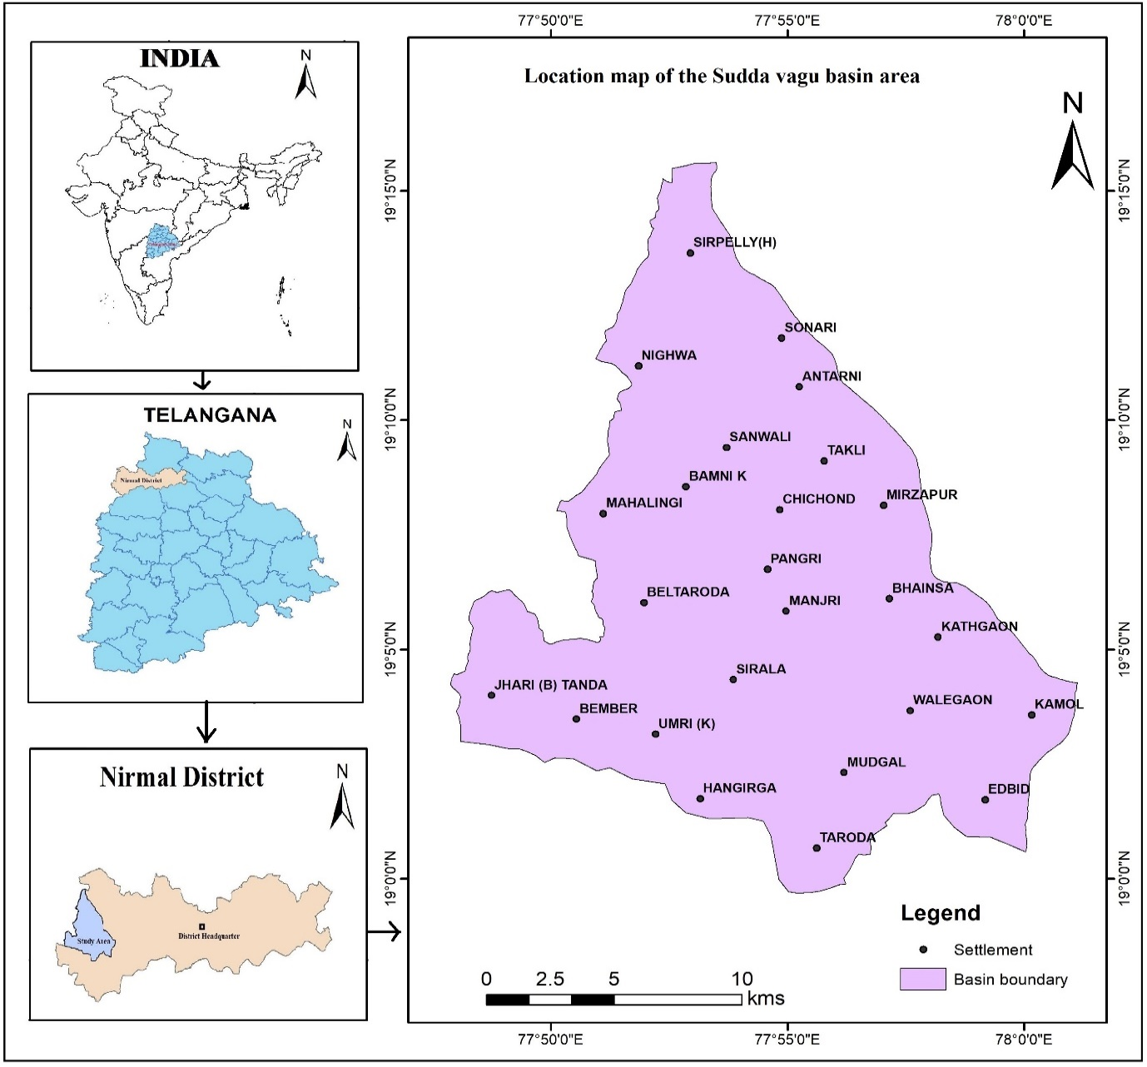

Figure 1. Location map of the Sudda vagu basin area

**MATERIALS AND METHODOLOGY**

**DATA SOURCES AND ANALYSIS**

The satellite data has been collected from NRSC, Hyderabad. The remote sensing multispectral satellite imagery of the IRS P6-LISS IV (Figure 2.4) resolution is 5.8 m, images were geo-referenced Survey of India (toposheet No’s 56 E/15, 56 E/16, 56 F/13 and 56 I/04) topographic at scale of 1:50,000 map utilized for ground reference. Remote sensing (RS) and GIS-based morphometric investigation gives higher precision. In the present study several digital image processing techniques were employed to enhance the ability to examine the regional/ geological and geomorphological features to understand the groundwater potentiality in the region study area. The accuracy of digital elevation map is usually represented by spatial resolution and height. Shuttle Radar Topographic Mission (SRTM) was a mission to generate the topographic data (website: http://srtm.csi.cgiar.org/). The topography of the study area is undulating with a gentle slope towards southeast. The highest elevation is 471 m and the lowest elevation is 340 m above mean sea level (Figure 2). The drainage pattern in Sudda vagu basin is dendritic to sub-dendritic (Figure 3).

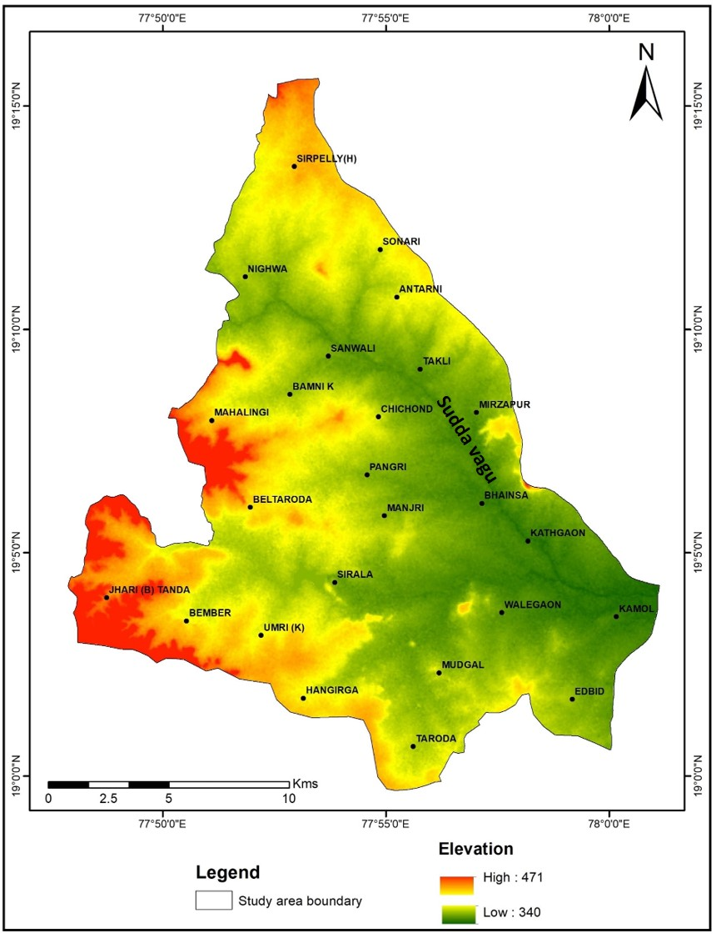

Figure 2. Digital elevation map of the Sudda vagu basin

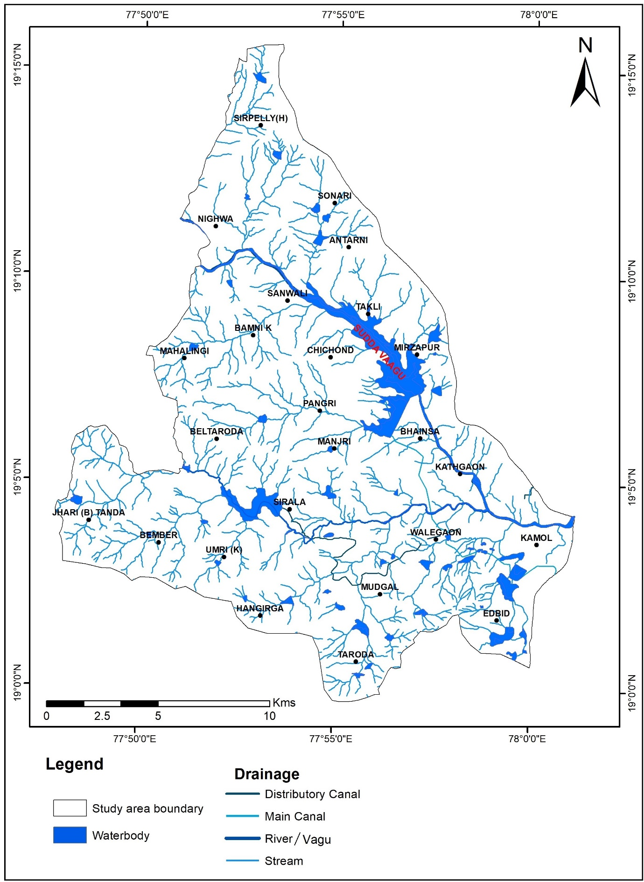

Figure 3. Drainage map of the Sudda vagu basin

**MORPHOMETRIC ANALYSIS**

The geomorphological investigation is the precise determination of basin geometry, stream channel network, linear parameters like Basin area (A), Basin perimeter (P), Maximum basin length (Lb), Stream order (U), Stream length (Lu), Bifurcation ratio(Rb), Mean bifurcation ratio (Rbm), Length of overland flow (Lo), Drainage density (Dd), Stream frequency (FS), Drainage texture (Dt), Form factor ratio (Ff), Elongation ratio (Re), Circularity ratio (Rc), Basin relief (H), and Relief ratio (Rh) were derived (Horton, 1945; Schumm, 1956; Chorley, 1957; Miller, 1957; Melton, 1957 1965; Strahler, 1964; Campbell et al., 1982; Nooka et al., 2005; Mahadevaswamy et al., 2012; Shailaja et al., 2017; Umrikar, 2017; Kuntamalla et al., 2018a, b; Sukristiyanti et al., 2018; Usharani et al., 2021; Nagaraju and Prabhakar, 2022). The basic parameters of the Sudda vagu basin (Table 1) and the geomorphological boundaries were assessed using formulas depicted in Table 2.

**Table 1. Basic parameters of the Sudda vagu basin**

|  |  |  |
| --- | --- | --- |
| S. No | Sudda Vagu Basin in Nirmal District | |
| 1 | Basin Area (Km2) | 323.8 |
| 2 | Basin perimeter (km) | 100.4 |
| 3 | Basin length (km) | 57.73 |
| 4 | Elevation in Minimum (m) | 340 |
| 5 | Elevation in Maximum (m) | 471 |
| 6 | Maximum basin length ( Lb ) (km) | 57.73 |

**Table 2. Formulas used for evaluation of morphological parameters**

|  |  |  |  |  |
| --- | --- | --- | --- | --- |
| **S. No.** | **Morphometric**  **parameter** | **Formula** | **References** | **Description** |
| 1 | Basin Area (A) | Area from which water drains to a common stream and boundary determined by opposite ridges | ------- | Computation of this parameter helps in categorizing the watershed size |
| 2 | Basin Perimeter (P) | P=Outer boundary of drainage basin  measured in kilometer | --------- | The entity is further required to compute some morphometric  parameters |
| 3 | Maximum basin length  (Lb) | Maximum basin length (kilometer) | Nooka Ratnam  et al. (2005) | It helps in understanding the circularity of drainage basin |
| 4 | Stream Order (U) | Hierarchical Rank | Strahler (1964) | The low order streams are indicative of unfavorable conditions for groundwater recharge and vice versa |
| 5 | Stream Length (Lu) | Length of the streams (kilometers) | Horton (1945) | The hierarchy in hard rock basaltic terrain is generally low order stream lengths are greater than the successive stream orders |
| 6 | Bifurcation Ratio (Rb) | Rb=Nu/Nu+1  Where, Rb=Bifurcation Ratio  Nu=No. of Stream Segments of given order Nu+1=No. of stream segments of next higher order | Schumm (1956) | This empirical formula helps in understanding the impact of tectonics and lithology on drainage network |
| 7 | Mean Bifurcation Ratio (Rbm) | Rbm= Average of bifurcation ratios of all order | --------- | The average value depicts stage of basin development |
| 8 | Length of overland flow  (Lo) | Lg=1/Dd*2  Where, Lo=length of overland flow Dd=Drainage density | Horton (1945) | It is necessary to understand the  overland flow for watershed  development hence this empirical  formula favorably showcase the  groundwater potential |
| 9 | Drainage Density (Dd) | Dd=L/A  Where, Dd=Drainage density (km/km2) L=Total stream length of all orders and A=Area of the basin (km2) | Horton (1932) | The high values of drainage density unfavored the groundwater recharge |
| 10 | Stream Frequency (FS) | FS=N/A  Where, Fs= Drainage Frequency N=Total no. of streams of all orders and A=Area of the basin (km2) | Horton (1932) | This parameter is inversely proportional to groundwater potential of the region. |
| 11 | Drainage Texture (Dt) | Dt=N/P  Where, N=No. of streams in a given order  and  P=Perimeter (km) | Horton (1945) | The formula proposed by Horton is popularly used as influential parameter for understanding the groundwater recharge |
| 12 | Form Factor Ratio (Ff) | Rf =A/ Lb 2  Whrere, A=Area of the basin (km2) and  Lb =Maximum basin length | Horton (1932) | The shape parameters popularly used for understanding the shape of the basin and soil erosion studies |
| 13 | Elongation Ratio (Re) | Re= (2/ Lb )*(A/π**)1/2**  Where, Area of the basin (km2) and  Lb =Maximum basin length (km) | Schumm (1956) | The shape parameters popularly used for understanding the shape of the basin and soil erosion studies |
| 14 | Circularity Ratio (Rc) | 4* π*A/P2  Where, Rc= Circularity Ratio, π= 3.14, A= Area of the basin (km2) P2=Square of the perimeter (km) | Miller (1953) | The shape parameters popularly used for understanding the shape of the basin and soil erosion studies |
| 15 | Basin Relief (H) | H=Z-z  Where, Z=Maximum elevation of the basin  (m) and z=Minimum elevation of the basin (m) | Hadley and  Schumm (1961) |  |
| 16 | Relief Ratio (Rh) | Rh=H/ Lb  Where, H=Basin Relief (m) and Lb =Basin Length (m) | Schumm (1956) |  |

**RESULTS AND DISCUSSION**

Several morphometric parameters that are directly or inversely related to the groundwater recharge such as stream order, stream length, bifurcation ratio (Rb), length of overland flow (Lo), etc. are discussed below:

**LINEAR PARAMETERS**

**Stream order (U):** The stream ordering of Sudda vagu basin has been done based on Strahler's stream ordering scheme (Strahler, 1964). As per this concept, Sudda vagu basin is of fifth order (Figure 4). The basin occupies an area of 323.8 km2 (Table 3).

**Stream Number (Nu):** The number of stream segments in a given order is known as stream number and it is inversely related to the stream order (U). It is noticed that the absolute number of streams diminishes with an increment in stream order and consequently shows consistence with Horton’s law of stream order. This result shows that the catchment has no structural control or regional upliftment. In Sudda vagu basin, the maximum number of streams was the first order streams 251, second order streams 109, third order streams 86, fourth order streams 33 and fifth order streams 8 are noticed in the basin (Table 3).

**Stream Length (Lu):** The stream length (Lu) of each order segment is determined by Horton’s law for the watershed. Lu addresses the development stage of drainage segments and reciprocates to the surface runoff of the catchment. In the study region, the 1st order Lu is 194.32 km, the 2nd order is 87.17 km, the 3rd order is 58.25 km, the 4th order is 20.76 km and the 5th order is 4.17 km. The Horton’s law (1945) that as the stream order increases, the length of the stream diminishes (Table 3), addressing the control over morphological and geographical parameters of the catchment and lithological inconsistency.

**Table 3. Stream orders and stream lengths of Sudda vagu basin**

|  |  |  |
| --- | --- | --- |
| Stream Numbers in different orders | Count of Stream Orders | Total Stream length (km) |
| 1 | 251 | 194.32 |
| 2 | 109 | 81.172 |
| 3 | 86 | 58.257 |
| 4 | 33 | 20.762 |
| 5 | 8 | 4.177 |
| Grand total | 487 | 358.688 |

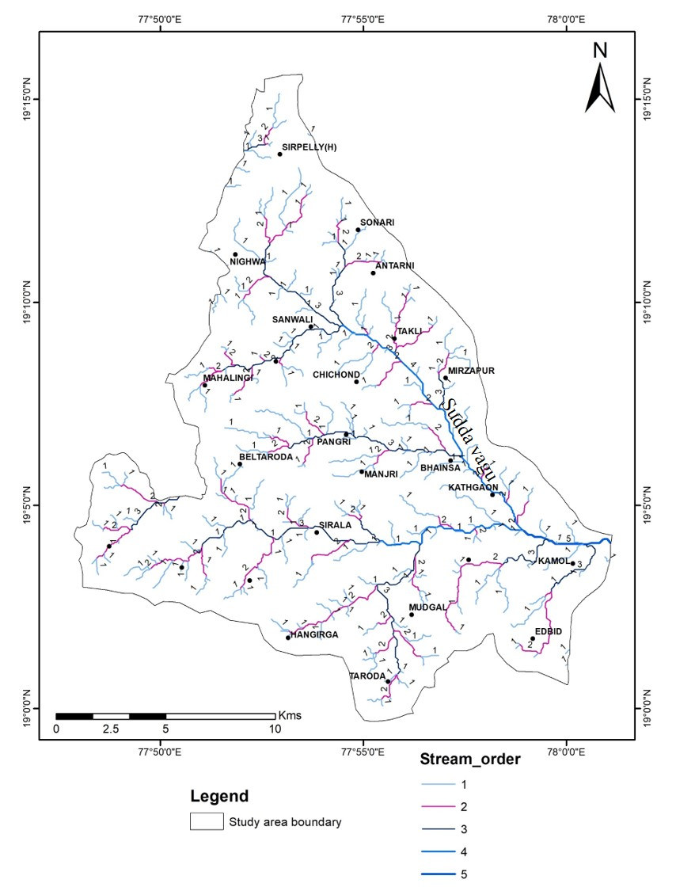

Figure 4. Drainage stream order map of the Sudda vagu basin

**Bifurcation Ratio (Rb):** Bifurcation Ratio (Rb) is an important linear parameter in morphometry, demonstrating the carrying capacity of water and the capability of the event of a flood in the catchment. Sriyana (2011) states that the bifurcation ratio (a) Br <3: River channels that have a fast ascent in rising floodwater level, while the decline is slow (b) Br 3-5: River channels have an increment and abatement in rising floodwater level, neither too quick nor too slow (c) Br >3: River divert has fast ascent in rising water level, in like manner it declines. In view of results (Table 4), the study region has mean Rb <3, which shows the watershed has river channels that have a quick ascent in rising floodwater level, while the decline is slow.

**Table 4. Bifurcation values of the Sudda vagu-basin**

|  |  |  |
| --- | --- | --- |
| Bifurcation ratios | | |
| Stream orders Numbers | Count of Stream Orders values | Mean Rb |
| 1/2 | 2.30 | 2.577 |
| 2/3 | 1.27 |
| 3/4 | 2.61 |
| 4/5 | 4.13 |

**RELIEF PARAMETERS**

**Basin Relief (Bh):** Basin relief (Bh) is connected with geomorphic processes and characteristics of the landform of the basin. The absolute and relative relief is derived from the greatest difference in elevation. Basin relief is predominantly affected by geomorphology, drainage characteristics and basic topography of the area. The elevation values range from 471 m to 340 m. The basin relief is obtained as 131m, which shows low to medium erosional and denudational rates in the basin (Table 5). High basin relief indicates steeper slope and less favorable for groundwater recharge, whereas low basin relief has gentle slopes thus support groundwater recharge. (Strahler, 1958).

**Relief Ratio (Rh):** This means that Rr is the ratio of total relief of the basin to the longest dimension of the basin parallel to the principal drainage line (Schumn, 1956). The high relief ratio (Rh) values represent steep slope with high elevation and thus do not support any kind of groundwater occurrence. It has been observed that basin 0.002 value show low relief ratio values accounting for less runoff and greater recharge (Table 5). It is obvious that the less resistant rocks of the area in the basin (Sreedevi et al., 2005).

**Table 5. Relief parameters of Sudda vagu basin.**

|  |  |  |
| --- | --- | --- |
| S.No | Relief parameters | Value |
| 1 | Basin relief (Bh) (in metres) | 131 |
| 2 | Relief ratio (Rh) | 0.002 |

**AREAL/SHAPE PARAMETERS**

**Drainage Density (Dd):** The drainage density (Dd) is the ratio of the total length of streams in a given basin to the total area of the basin (Strahler, 1964). The drainage density affects surface runoff pattern; i.e., a region with high precipitation results in more surface runoff, while decreasing the lag-time and increasing the peak of hydrograph (Kale and Gupta, 2001). It is reported by Jadhav and Babar (2013) that low drainage density generally occurs in regions of highly permeable sub-surface materials, thick vegetation, and low relief, while high drainage density divulges in impermeable subsurface materials, poor vegetation cover with high relief. According to Vittala et al., 2004 and Chandrashekar et al., 2015 states that the drainage density can be arranged into five classes of drainage density with the following value ranges (km/km2), i.e., very coarse (<2), coarse (2-4), moderate (4-6), fine (6-8), and very fine (> 8). Similarly, the present study drainage density values also. i.e., very coarse (<1.6), coarse (1.6-3.3), moderate (3.3-4.9), fine (4.9-6.6), and very fine (> 8) shows in Figure 5. The Dd value (1.108 km/km2) (Table 6) of the basin very coarse <2 value (Vittala et al., 2004 and Chandrashekar et al., 2015), the area having below 5 value shows good potential for determination of recharge structure the stream frequency is also main important parameter and the basin are passing through an early mature stage of the fluvial geomorphic cycle.

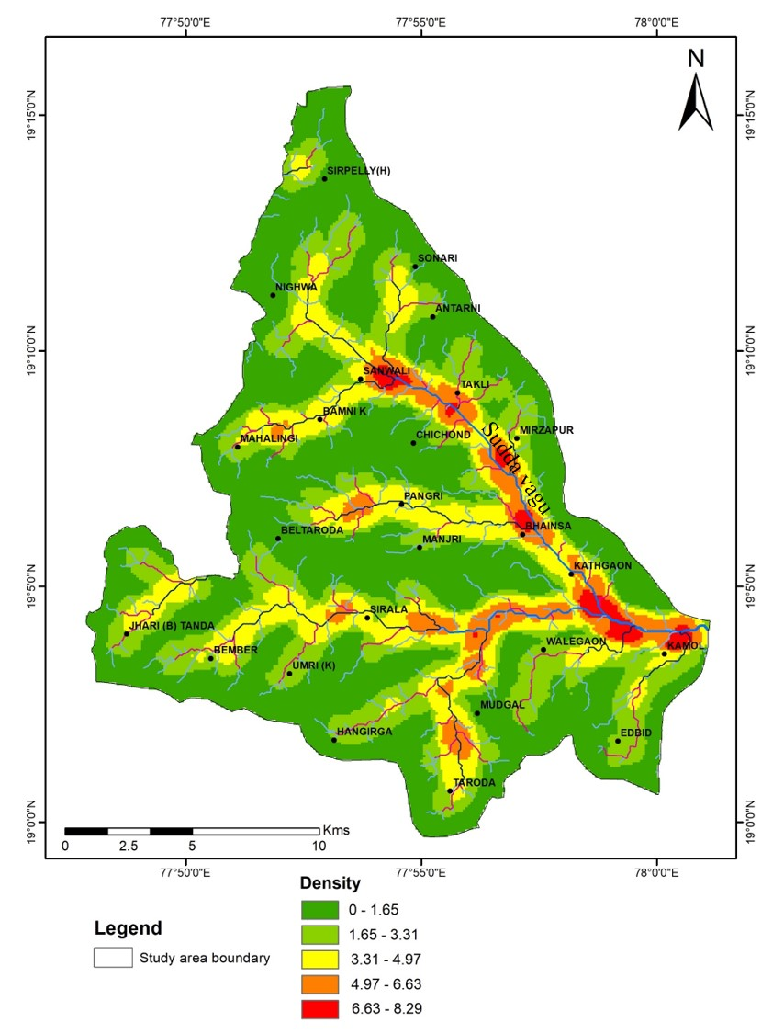

Figure 5. Drainage density map of the Sudda vagu basin.

**Stream Frequency (Fs):** Stream frequency (Fs) is ratio of total number of stream segments of all orders to the total area of the basin and has a direct correlation with drainage density (Horton,1945). The stream frequency value of basin is 1.504 km2 (Table 6). The low Fs value reveals that this basin is covered with good amount of vegetation and has high infiltration capacity, and low runoff rates due to lesser number of streams.

**Drainage Texture (Dt):** The Texture ratio plays a very important role in the geomorphic setup of the basin which means the relative spacing of the drainage channels. It depends upon a number of natural factors such as climate, rainfall, vegetation, lithology, slope, capacity of infiltration, and stage of development (Smith, 1950). Smith (1950) has classified drainage texture into different textures such as coarse (<4), intermediate (4 to 10), fine (>10) and ultra-fine (>15). The drainage texture value of the basin is 4.851 km-1 (Table 6), and are classified as coarse to intermediate drainage texture of basin nature. This suggests that region has scanty vegetation with relief and moderately steeper slopes (Sukristiyanti et al., 2018).

**Form factor (Ff):** The ratio of the basin area (A) to the square of the basin length (Lb) defines the form factor (Ff). Form factors are generally <0.785 for a completely circular basin (Bhagwat et al., 2011). Fewer form factors address elongated basins, though basins with high form factors address high peak flow of short duration. The elongated basin with low form factors has a low peak of long duration. In the study region, the basin has a low Ff value of 0.097 (Table 6) which demonstrates its elongated shape, very low relief and gentle slopes of flood streams for a long duration. Thus, flood streams of elongated basins are not difficult to manage as circular basins.

**Circularity Ratio (Rc):** Circulatory Ratio (Rc) is a significant indicator and relies upon the geographical structure, environment, relief, drainage density, stream frequency and slope of the watersheds. Its value varies between 0 to 1, which characterizes the minimum to maximum circulatory ratio (Javed et al., 2009). The value of the circulatory ratio is calculated as 0.403 for watershed which characterizes the elongated shape and less peak flow on account of geomorphological change (Table 6).

**Elongation Ratio (Re):** Elongation ratio (Re) is an important parameter and is expressed as the ratio of diameter of a circle of the same area as the basin to the maximum basin length (Schumm, 1956). The elongation ratio (Re) generally ranges between 0 and 1. Higher elongation ratio value is indicative of circular shape of the basin, while a lower Re value signifies an elongated shape of the basin. Values close to 1.0 are typical of regions of very low relief and gentle slope whereas that of 0.6 to 0.8 are associated with high relief and steep ground slope. The present basin has Re value of 0.352, which is more elongated shape (Table 6).

**Length of overland flow (Lo):** This factor relates inversely to the average slope of the river channel and is quite identical with the length of sheet flow. According to Horton (1945), Length of overland flow (Lo) is a vital independent parameter to express the length of flow of water over the ground surface before it drains to certain stream channels. This factor, defined as half of the reciprocal of drainage density, affects the advancement levels of both hydrological and physiographical features in the drainage basins. In the present case, the high length of overland flow in basin is 1.806 km2/km (Table 6). This reveals that the rate of long flow path and gentle ground slopes, which reflects areas of less runoff and more infiltration. The low value of Lo indicates the rainwater will enter the stream quickly (Magesh et al., 2012).

Table 6. Areal / shape parameters of Sudda vagu basin.

|  |  |  |
| --- | --- | --- |
| S.No. | Areal / shape parameters | Value |
| 1 | Drainage Density (Dd) km/km2 | 1.108 |
| 2 | Stream Frequency (Fs) km-2 | 1.504 |
| 3 | Drainage Texture (Dt) km-1 | 4.851 |
| 4 | Form factor (Ff) | 0.097 |
| 5 | Circulatory ratio (Rc) | 0.403 |
| 6 | Elongation ratio (Re) | 0.352 |
| 7 | Length of the overland flow (Lo) km2/km | 1.806 |

**Conclusions**

The present study shows the utility of remote sensing and geographic information system (GIS) for the morphometric analysis of basins. The morphometric properties of different basins exhibit their respective effect on the hydrologic characteristics of the basin. Execution of morphometric examination in a study region might give supportive knowledge to any hydrological examination like a prioritisation of basin, assessment of groundwater potential, basin management and environmental assessment. The study area stream order varying from 1 to 5th orders. It is mainly covered by 1st order streams. The first order streams lengths are maximum in study area. Drainage density (Dd) and stream frequency (Fs) are the most useful criterion for the morphometric classification of drainage basins which certainly control the runoff pattern, and other hydrological parameters of the drainage basin. The drainage density value of Sudda vagu basin is 1.108 this value shows the good potential area. The especially NNW-SSE trend of study area having low-lying area and contour elevations of the basin varies from 471m to 340m slope direction is towards southeast side of the basin. Drainage density is the most reliable character for morphometric analysis of basin. The Dd value (1.108 km/km2) of the basin very coarse <2 value, the area having below 5 value shows good potential for determination of recharge structure the stream frequency is also main important parameter and the basin are passing through an early mature stage of the fluvial geomorphic cycle. Lower order streams mostly dominate the basin. Rc, Rf and Re show the elongated shape of the basin have low discharge of runoff and medium relief of the terrain. It is noticed that stream segments up to 3rd order traverse parts of the high altitudinal zones, which are characterized by steep slopes, while the 4th and 5th order stream segments occur in comparatively flat lands wherein maximum infiltration of runoff occurs; these are important locations for constructing check dams. Hence from the study it is clear that morphometric analysis is a competent tool for geo-hydrological studies. These studies are very useful for planning and drainage basin management.

**Acknowledgments**

The authors are very much thankful to the Head, Department of Geophysics, Osmania University, Hyderabad for providing necessary facilities to carry out the work.

**Disclaimer (Artificial Intelligence)**

Author(s) hereby declare that NO generative AI technologies such as Large Language Models (ChatGPT, COPILOT, etc.) and text-to-image generators have been used during the writing or editing of this manuscript.

**Competing interests**

Authors have declared that no competing interests exist.

**References**

Bhagwat TN, Shetty A and Hegde VS. 2011. Spatial variation in drainage characteristics and geomorphic instantaneous unit hydrograph (GIUH); implications for watershed management- a case study of the Varada River basin, Northern Karnataka. Catena, 87(1): 52-59.

Campbell AJ, Sidle RC and Froehlich HA. 1982. Prediction of peak flows for culvert design on small watersheds in Oregon. Completion Report for Project A-053-ORE, Office of Water Research and Technology, United States Department of the Interior. Oregon State University.

Chandrashekar H, Lokesh K V, Sameena M, Roopa J and Ranganna G 2015 Proc. Int. Conf. on Water Resources, Coastal and Ocean Engineering (Mangalore) vol 4 ed G S Dwarakish (Elsevier Procedia) 1345 – 1353 [3]

Chorley RJ. 1957. Illustrating the laws of morphometry. Geological Magazine, 94(2): 140-150.

Geol 50(8):1235–1242.

Hadley, R. and Schumm, S., 1961. Sediment sources and drainage basin characteristics in upper cheyenne river basin. USGS, Water-Supply Paper no. 1531-B: 198pp

Horton RE. 1932. Drainage-basin characteristics. Transactions of American Geophysical Union, 13(1): 350-361.

Horton RE. 1945. Erosional development of streams and their drainage basins; hydro physical approach to quantitative morphology. Geological Society of America Bulletin, 56(3): 275- 370.

Jadhav, S.I., and Babar M., (2013). Morphometric Analysis with Reference to Hydrogeological Repercussion on Domri River Sub-basin of Sindphana River Basin, Maharashtra, India. Jour. Geosciences Geomatics, 1(1), 29-35.

Javed A, Khanday MY and Ahmed R. 2009. Prioritization of subwatersheds based on morphometric and land use analysis using remote sensing and GIS techniques. Journal of the Indian Society of Remote Sensing, 37(2): 261-274.

Kale, V.S. and Gupta, A. (2001). Introduction to Geomorphology. Sangam Books Ltd, India, 285p

Kuntamalla, S., Gugulothu, S., Nalla, M. and Raj Saxena, P., 2018b. Drainage Basin Analysis through GIS: A Case study of Lakhnapur Reservoir Watershed in Rangareddy District, Telangana State, India. International Journal of Engineering, Science and Mathematics, 7(3), pp.9-17.

Kuntamalla, S., Nalla, M. and Saxena, P.R., 2018a. Morphometric Analysis of Drainage Basin through GIS: A Case Study from South Western part of Rangareddy District, Telangana State, India. In 11th International Conference on Researches in Science, Technology and Managment (p. 11).

Magesh NS, Chandrasekar N and Soundranayagam JP, (2012) Delineation of groundwater potential zones in Theni district, Tamil Nadu, using remote sensing, GIS and MIF techniques, Geoscience Frontiers 3(2): 189-196.

Mahadevaswamy, G., Nagaraju, D., Papanna, C., Nagesh, P.C. and Rao, K., 2012. Morphometric analysis of nanjangud taluk, Mysore District, Karnataka, India using GIS techniques. Nature, Environment and Pollution Technology, 11(1), pp.129-134.

Melton MA. 1957. An analysis of the relations among elements of climate, surface properties, and geomorphology. Columbia Univ. New York. Technical Report No. 11, Project NR 389-042 Office of Naval Research.

Melton MA. 1965. The geomorphic and paleoclimatic significance of alluvial deposits in southern Arizona. The Journal of Geology, 73(1): 1-38.

Mesa LM (2006) Morphometric analysis of a subtropical Andean basin (Tucuman, Argentina). J Environ

Miller VC. 1957. A quantitative geomorphic study of drainage basin characteristics in the clinch mountain area Virginia and Tennessee. Journal of Geology, 65(1):112-113.

Nag SK, Chakraborty S. (2003). Influence of rock types and structures in the development of drainage network in hard rock area, Jou of Indian Soc. of Remote Sensing, 31(1), 25–35.

Nagaraju, C. and Prabhakar, G., 2022. Morphometric analysis of peddavagu sub-watershed of Krishna River, Maddur Mandal, Mahabubnagar district, Telangana state. Bulletin of Pure & Applied Sciences-Geology, 41(1), pp.1-11.

Nautiyal MD. (1994). Morphometric analysis of a drainage basin, district Dehradun, Uttar Pradesh, Journal of Indian Soc of Remote Sensing, 22(4), 251–261.

Nooka Ratnam K, Srivastava YK. Venkateswara Rao V. Amminedu E and Murthy KSR. 2005. Check dam positioning by prioritization of micro-watersheds using SYI model and morphometric analysisremote sensing and GIS perspective. Journal of the Indian Society of Remote Sensing, 33(1): 25-38.

Rastogi RA and Sharma TC 1976, “Quantitative analysis of drainage basin characteristics”, Journal of Soil Water Conservation India, 26(1–4): 18–25.

Sarala C. (2013). Geographical Information System Based Morphometric Analysis of Halia Drainage Area, Nalgonda District, Andhra Pradesh, India. IJIRSET. 2(11).

Schumm SA. 1956. Evolution of drainage systems and slopes in badlands at Perth Amboy, New Jersey. Geological Society of America Bulletin, 67(5): 597-646.

Sharma P, Singh MM, Chaurasia RS and Sabir M. 2021. Remote Sensing and GIS based approach in morphometric analysis of Birma River basin (Central India). Sustainability, Agri, Food and Environmental Research, 11(1).

Smith, K.G. (1950). Standards for grading texture of erosional topography. American Jour. Science, 248, 655-668.

Sreedevi PD, Subrahmanyam K and Ahmed S. 2005. The significance of morphometric analysis for obtaining groundwater potential zones in a structurally controlled terrain. Environmental Geology, 47(3): 412-420.

Sriyana S. 2011. Kajian Karakteristik DAS Tuntang dan Model Pengelolaan DAS Terpadu. Teknik, 32(3): 180-186.

Strahler AN. 1964. Part II. Quantitative geomorphology of drainage basins and channel networks. Handbook of Applied Hydrology: McGraw-Hill, New York, pp.4-39.

Strahler, A.N. (1958). Dimensional analysis applied to fluvially eroded landforms. Bull. Geol. Soc. America, 69, 279-300.

Sukristiyanti S, Maria R and Lestiana H. 2018. Watershed-based morphometric analysis: a review. In IOP conference series: Earth and Environmental Science, 118 (1), p. 012028.

Sukristiyanti, S., Maria, R. and Lestiana, H., 2018, February. Watershed-based morphometric analysis: a review. In IOP conference series: earth and environmental science (Vol. 118, No. 1, p. 012028). IOP Publishing.

Sumesh, K. and Vijayan, P.K., 2017. Sub-watershed prioritization based on potential zones of Kuttiadi river basin, A Geo-Morphometric approach using GIS. International Journal of Geomatics and Geosciences, 8(1), pp.1-12.

Umrikar BN. 2017. Morphometric analysis of Andhale watershed, Taluka Mulshi, District Pune, India. Applied Water Science, 7 (5): 2231-2243.

Usharani, B., Rejani, R., Kumar, K.S. and Sivalakshmi, Y., 2021. Morphometric investigation in a semi-arid watershed of Suryapet in Telangana. Indian Journal of Dryland Agricultural Research and Development, 36(2), pp.18-26.

Vittala S S, Govindaiah S and Gowda H H 2004 J Indian Soc Remote 32 351-362.