-

**Original Research Article**

**Developing a Comprehensive Forest Database for Planning and Carbon Stock Estimation Using GIS: A Case Study from Rajgarh Forest Division, Sirmaur District, Himachal Pradesh**

.

ABSTRACT

The present investigation was carried in Sirmaur district of Himachal Pradesh, located between 30° 38’40” to 31° 01’14” N latitude and 77° 01’ 5” to 77° 26’ 13”E longitude, at an elevation ranging from 500 m to 3500 m a.s.l. to develop comprehensive forest resource database and spatial analysis of growing stock for Rajgarh forest division. The paper maps, toposheets acquired from the office of Rajgarh Forest Division were scanned and then imported to Arc Map (Data builder) for digitization. Georeferencing was done by linking points on the maps with those same locations in the geographically referenced data using polynomial transformation that converted the location of the entire image to the correct geographic location. The widely used datum is WGS (World Geodetic System) 1984 To create various data layers, on screen digitization for each feature type on the maps of Rajgarh Forest Division was performed in Arc Map. The various features like divisional forest boundary, roads, rivers and streams, territorial units (forest compartments), administrative units (forest ranges, blocks and beats), vegetation and land uses were digitized to create comprehensive database and necessary thematic maps were prepared viz., administrative map, silvicultural map amd vegrtation map. There are six working circles, four ranges, 879 compartments and 41 beats. Small to very small variation in area of different management units, forest vegetation and land uses were observed as compared to area reported in Working Plan. For estimation of volume and carbon inventory data was analysed in geographical information system (Arc.GIS).Out of total growing stock and carbon stock of 7.05×106 m3 and 3.29×106 t, respectively, in the Division the Habban, Rajgarh, Narag and Sarahan range accounted 71.98 % and 67.85 %, 19.72 % and 22.59 %, 4.03 % and 5.06 %, & 4.27 % and 4.50 %, respectively for the total growing stock and carbon stock, respectively. Among different working circle, Chil Shelterwood, Deodar-Kail, Rehabilitation, Plantation, Protection and Selection accounted 8.98 % and 9.15 %, 31.37 % and 28.44 %, 6.45 % and 7.73 %, 2.47 % and 2.57 %, 15.13 % and 21.66 %, 35.59 % and 30.45 % for total growing stock and carbon stock, respectively. Geographic information system is used for developing database store forest inventory data and used in forest management planning.

*Keywords: Spatial analysis; Georeferencing; Thematic maps; Carbon inventory; Growing stock*

1. INTRODUCTION

Forest ecosystems are one of the most valuable renewable natural resources, because of its economic, environmental, aesthetic and recreational values. In order to meet the ever increasing fundamental needs of timber, fuel wood and non timber forest products, the forest ecosystem are overexploited and damaged, by the people for their own benefits (Vitousek *et al.,* 1997). As a result of these factors, consequences like excessive soil erosion, frequent landslide, flood, drought, change in habitat composition, land cover, regional and global climate, as well as species extinction and invasion are being faced by mankind (Lubchenco, 1998; Canadell *et al.,* 2007). Most of the countries including India, do realize the importance of forests and to check the further deterioration of these forests, improving their conditions and planned utilization of available resources is quite essential. Scientific management of forest ecosystems has its roots in the 19thcentury when exploitive harvesting was replaced by a management approach that aimed at maintaining a constant flow of harvestable products and which foresters called the sustained yield approach. Along with the concept of sustainable development that was widely accepted after the Rio summit in 1992 the sustained yield approach has been widely replaced by concern over sustainability of the entire ecological system, consisting of ecosystem structures, functions, goods and services (Kimmins *et al.,* 2007). To keep the balance between the exploitation and regeneration processes, a scientific approach for sustainable management of forests is essential. Timely and accurate field surveys are thus the prerequisite. Forests and wood products can effectively reduce the process of climate change in several ways.

Studies on the spatial distribution of biomass and forest carbon stock are important to combat the pressing problem of climate change. Accurate estimation of forest biomass is required for greenhouse gas inventories and terrestrial carbon accounting. Forest inventory-based approaches to estimate carbon stocks and flows use the NFI (National Forest Inventory) approach or other sampling networks that cover a wide range of conditions across a country or region (Kurz and Apps, 1999; Liski *et al*.,2002). In India, forest departments in the respective states conduct continuous forest inventories of various forest types for preparation of forest working plans. These inventories are aimed at estimation of growing stocks in the existing forests and projecting these stocks for the coming years. On a national scale, changes in the biomass and carbon stocks of trees can be estimated based on National Forest Inventory data. For both developed and developing countries, there is a strong need to know what happens in relation to carbon dynamics within their territories in order to implement conservation policies, as well as forest management and conservation strategies for these environments. Therefore, studies that quantify carbon stocks are important for forests.

Working Plan has been the main instrument of forest planning (more exactly forest working) for scientific management of forests. It is a very useful document for evaluating the status of forests and biodiversity resources of a forest division, assessing the impact of past management practices and deciding about suitable management interventions for future. Periodical updating and revision of working plan is essential to keep pace with the trends emerging out of forest people interface and to address national and international obligations. The conventional method of enumeration of the forest inventory by a handful of Working Plan staff is very uncertain, highly time consuming and somewhat unrealistic. By the time enumeration of the forest stock of one division is completed and the Working Plan is prepared for the next 10 years or so, there may be a sea-change of reality on the ground and the forest Working Plan may have become non-implementable.

Geographic Information System (GIS) provides an opportunity to overcome these problems as it has potential to store, retrieve and analyze this voluminous spatial and non-spatial data (Burrough and McDonnel, 1995). GIS is becoming an increasing very effective tool for working plan preparation, which involves analysis of several spatial layers and parameters in relation to forests for prescribing management practices. Forest stock maps constitute the basis of Working Plan for the territorial forest divisions. They contain detailed spatial information on extent of recorded forest land including the administrative jurisdiction at various levels, infrastructure, communication facilities, water resources and the status of forest vegetation. The last component include categorization of forest into density classes, species distribution, assessment of growing stock, regeneration status, growth data for various species, age/size distribution and normality of forest. All these information are extremely vital in presenting the management options like afforestation of blank areas, reforestation of degraded forests, harvesting of mature crop (plantation) followed by regeneration, restoration of biodiversity in monoculture areas, and management of protected areas for biodiversity conservation. Therefore the present study entitled “Developing a Comprehensive Forest Database for Planning and Carbon Stock Estimation Using GIS: A Case Study from Rajgarh Forest Division, Sirmaur District, Himachal Pradesh” with objectives to develop comprehensive database for Rajgarh Forest Division.

2. material and methods

The data used in this study included inventory report, management map and toposheets delineated with compartments and species, which were acquired from the office of the Rajgarh Forest Division (Table 1). The study area falls under twelve toposheets (1:15,000) of Survey of India.

**Table 1. Spatial and aspatial data acquired from Rajgarh Forest Division**

|  |  |  |  |
| --- | --- | --- | --- |
| **Sr. No** | **Data Element** | **Source** | **Scale** |
| 1 | Management map of Rajgarh Forest Division | Forest Department | 1:20000 |
| 2 | Toposheets (delineate with compartments and species) | Forest Department | 1:15000 Scales by survey sheets 53F/1/NE, 53F/1/SE, 53F/1/SW,53F/2/NE & 2SE, 53F/2/NW, 53F/5/NE, 53F/5/NW, 53F/5/SE, 53F/5/SW, 53F/6/NW, 53E/8/SW & SE |
| 3 | Inventory Data | Forest Department  (Working Plan) |  |

#### 2.1 Computer Hardware and Software

Most of the processing was done using the package ArcGIS 9.3, ESRI’s premier GIS software developed by ESRI, USA in 2008. ArcGIS has a capability to provide comprehensive mapping and analysis tools, along with simple editing and geoprocessing tools. It is a comprehensive set of tools for geoprocessing, data conversion, map sheet management, overlay analysis, map projection and much more. The maps acquired from the office of Rajgarh Forest Division were scanned and then imported to Arc Map (Data builder) for digitization. Georeferencing was done by linking points on the maps with those same locations in the geographically referenced data using polynomial transformation that converted the location of the entire image to the correct geographic location. The widely used datum is WGS (World Geodetic System) 1984 and the maps were geometrically registered to WGS 1984 UTM (Universal Transverse Mercator) 43N coordinate system. To create various data layers, on screen digitization for each feature type on the maps of Rajgarh Forest Division was performed in Arc Map. The various features like divisional forest boundary, roads, rivers and streams, territorial units (forest compartments), administrative units (forest ranges, blocks and beats), vegetation and land uses were digitized. A topological report was vertex, reshape polygon and cut polygon features *etc*. Finally intersection report was generated and vertexes which were not intersected were edited to produce polygons. Roads and rivers data layers were also checked for intersection and edited accordingly. The various steps followed for creation of comprehensive data base are presented in Figure 1.

**2.1.1 Generation of Thematic maps**

Based on data entered in database management system, various thematic maps were generated viz., a) Administrative Map, b) Silvicultural maps, c) Land use map and d) Vegetation map.

**2.1.2 Creation of GIS database**

In Rajgarh forest division, out of 879 compartments, forest department has enumerated 219 compartments. Database was created in GIS which included area of forests, name of forest classes, working circles, compartments, ranges, forest vegetation and land uses, ocular density, site quality, stems distribution in compartments, volume distribution (Growing stock) in compartments *etc*. as given in the inventory report were entered into corresponding compartments in database sheet under Database Management System. The area based on various administrative (Forest range), territorial (Compartment), and silvicultural (Working Circle) units, vegetation and land uses were calculated in GIS and compared with recorded area as given in the enumeration records of the Rajgarh Forest Division. Biomass was estimated by multiplying stem volume with specific wood density of particular species and biomass expansion factor (IPCC, 2006) and same was transformed into carbon stock figures by multiplying it with a factor of 0.50 (IPCC, 2006). Thereafter data pertaining to biomass and carbon entered into corresponding compartments in database sheet under database management system. The distribution of growing stock and carbon stock in different forest ranges, forest classes, working circles, periodic blocks, and forest vegetation has been analyzed through the extrapolation of enumerated sampling data of forest department (attribute data) in GIS environment as volume (growing stock) and carbon stock values transformed into per hectare basis and then multiplied with area under each units of classification (administrative, silvicultural, forest classes and forest vegetation) to know complete status of Rajgarh Forest Division.

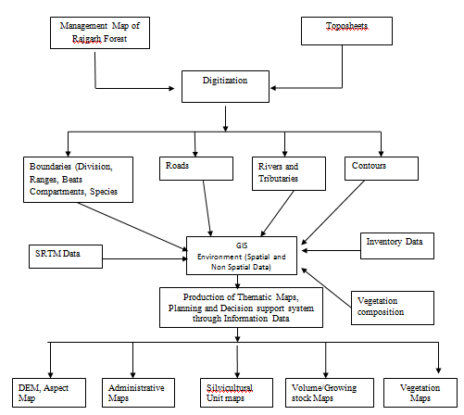

**Fig. 1. Flow chart for creation of database for the Rajgarh forest division**

3. results and discussion

The GIS database was comprised of various attributes *i.e.* area of forests, ocular density, site quality, stems and volume distribution (Growing stock) in compartments directly taken from inventory report, 2012-2027 of Rajgarh Forest Division. After transformation of volume figure to biomass, biomass carbon and carbon mitigated, the resulted values were entered against each compartment of corresponding forest ranges and working circles that became the part of database in addition to basic attributes. Based on database various thematic maps were created.

**3.1 Generation of Thematic Maps**

Based on the database management system, various thematic maps were developed, including a) Administrative Map, b) Silvicultural maps, c) Vegetation map.

* + 1. **Administrative / Territorial unit**

Forest range is very important unit in the management and administration. There are four Forest Ranges in the Rajgarh Forest Division *i.e.* Habban, Rajgarh, Narag and Sarahan. Block is the main territorial unit of the forest, generally demarcated by natural features (Fig. 2). There are twelve Forest Block in the Rajgarh Forest Division (Fig. 3). Beat is the smallest functional territorial unit and is the foundation of Indian forest administration. There are 41 beats in the Rajgarh Forest Division (Fig. 4).Compartments/Sub Compartments are a basic territorial and permanent working plan unit of forest management for execution of work and records. Vector data layer comprising of 879 compartments in the Rajgarh Forest Division is (Fig. 5). There are 291 compartments in Habban Range, followed by 180, 179, and 229 in Rajgarh, Narag, and Sarahan, respectively.

* + 1. **Silvicultural Unit**

Data layers comprising of six working circles distributed in forest ranges of Rajgarh Forest Division (Fig. 6). Ocular density ranges between 0.1 to 0.8 (Fig.7). Three type of site quality viz., II, III, II/III (Fig.8)

* + 1. **Vegetation**

Vegetation includes: Chir pine (Chil), Deodar, Oaks, Kail, Fir, Spruce, Eucalyptus/ Miscellaneous Broad Leaved, and Bamboo which can be seen distributed in various forest ranges of the Rajgarh Forest Division (Fig. 9).

Similar comprehensive database has also been developed in various parts of the country such as Forest Divisions of Chhattisgarh (Bebarta, 2008), West Bengal (Raha, 2000) Maharashtra (Grewal, 2001 and Rao 2005 and 2006), Andhra Pradesh (Sharma and Murthy, 2014) and Andaman and Nicobar Islands (Kumar *et al*., 2014). Similarly, forest resource databases were also prepared for protection forest in Taipei city (Chen *et al*., 2000), forest resource database on current forest scenario in Peninsular Malaysia (Hamzad, 2001), forest resource and environment information database for Jiangxi Province, China (XueLin *et al*., 2005).

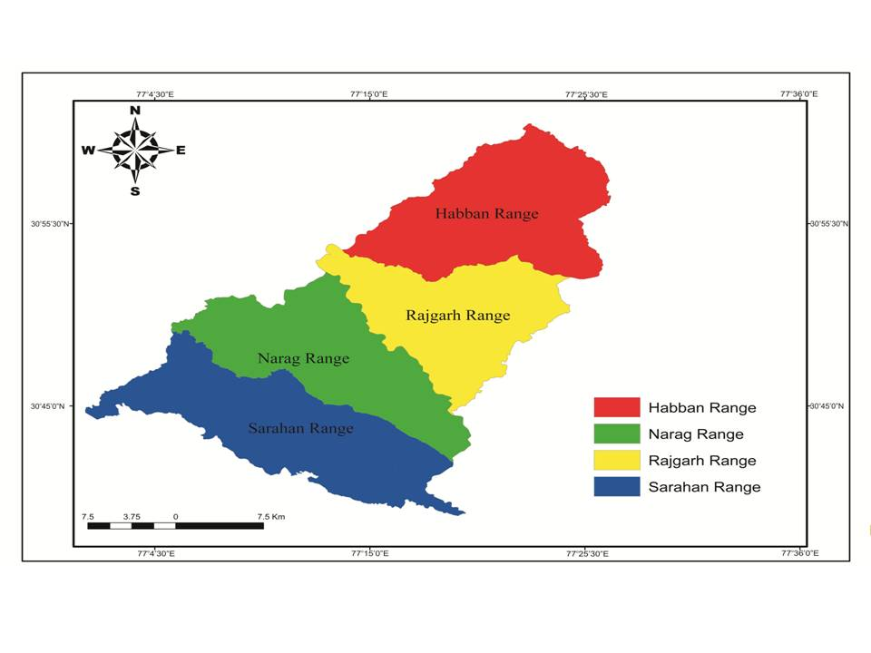

**Fig. 2. Forest Range map the Rajgarh forest division**

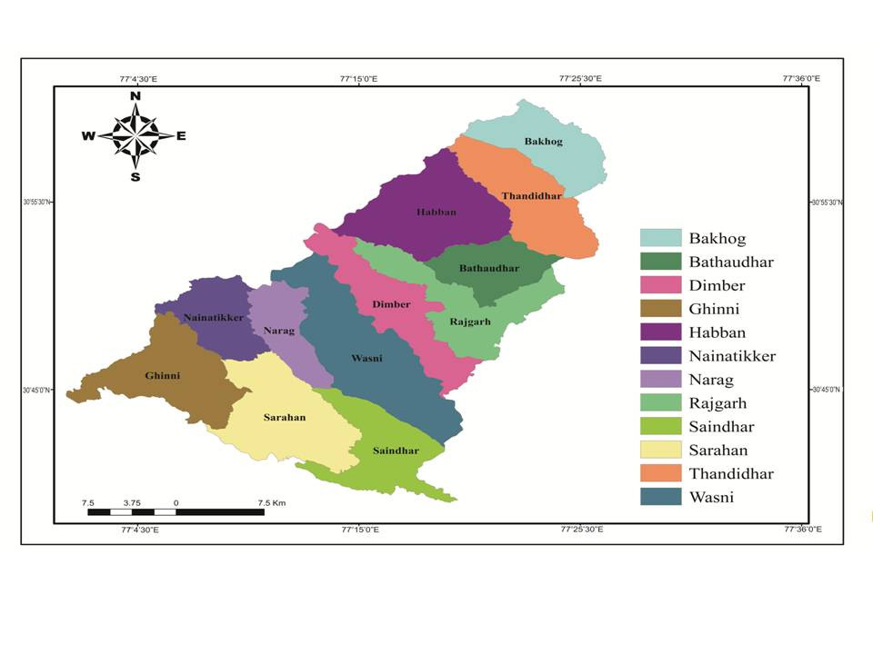

**Fig. 3. Forest Block Map of Rajgarh forest division**

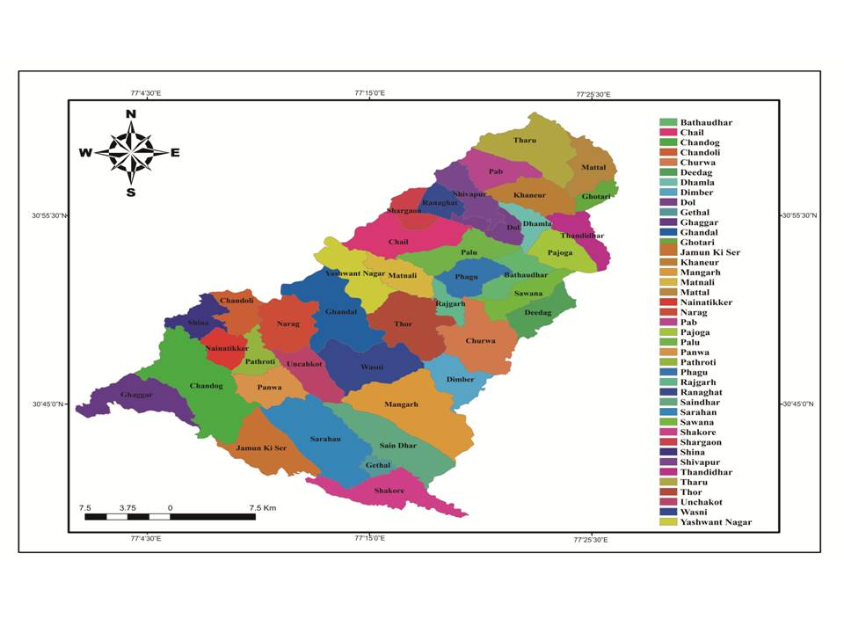

**Fig. 4. Forest beat map of Rajgarh forest division**

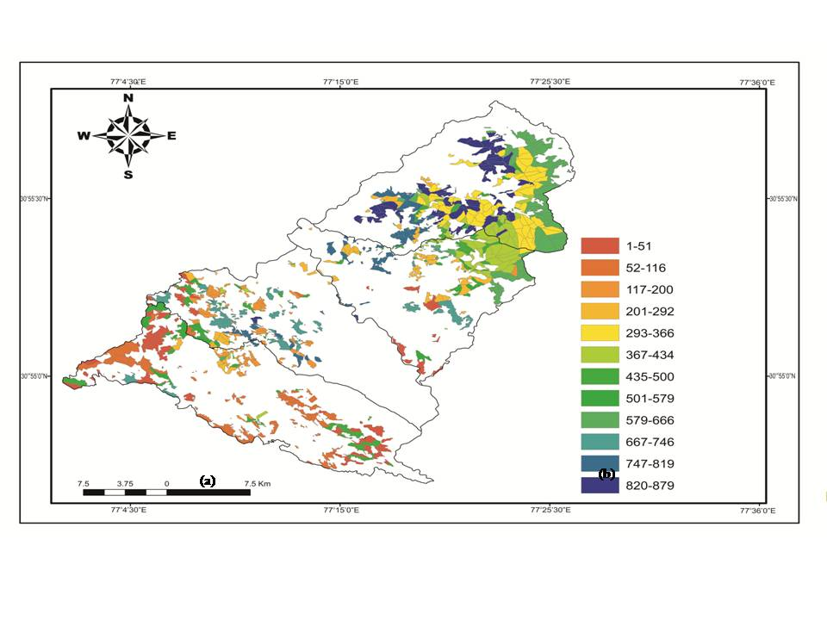

**Fig. 5. Forest compartment map of Rajgarh forest division**

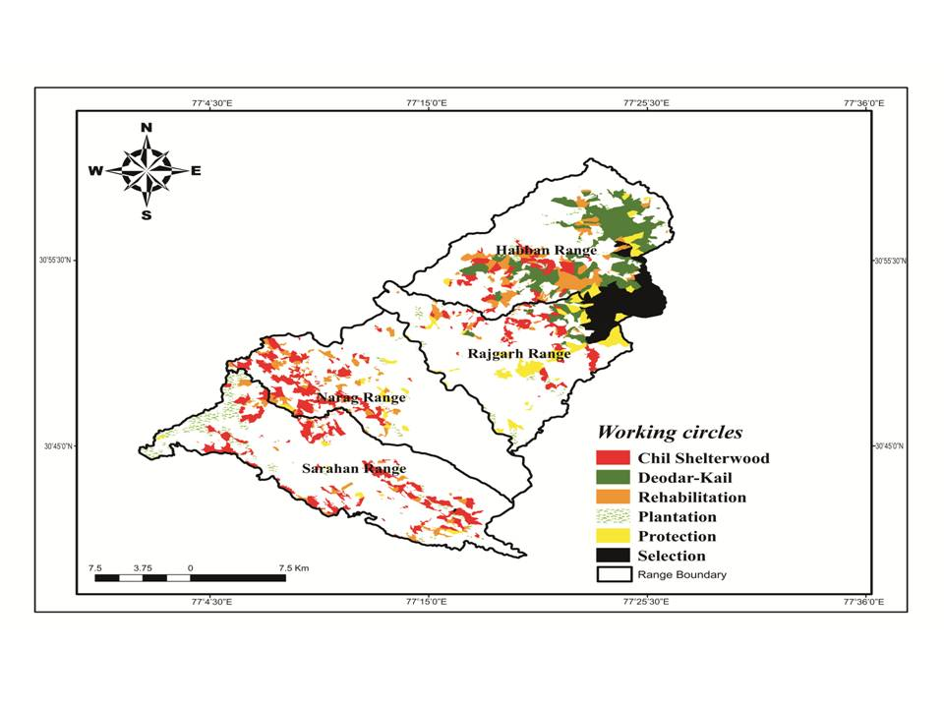

**Fig. 6. Forest working circle map of Rajgarh forest division**

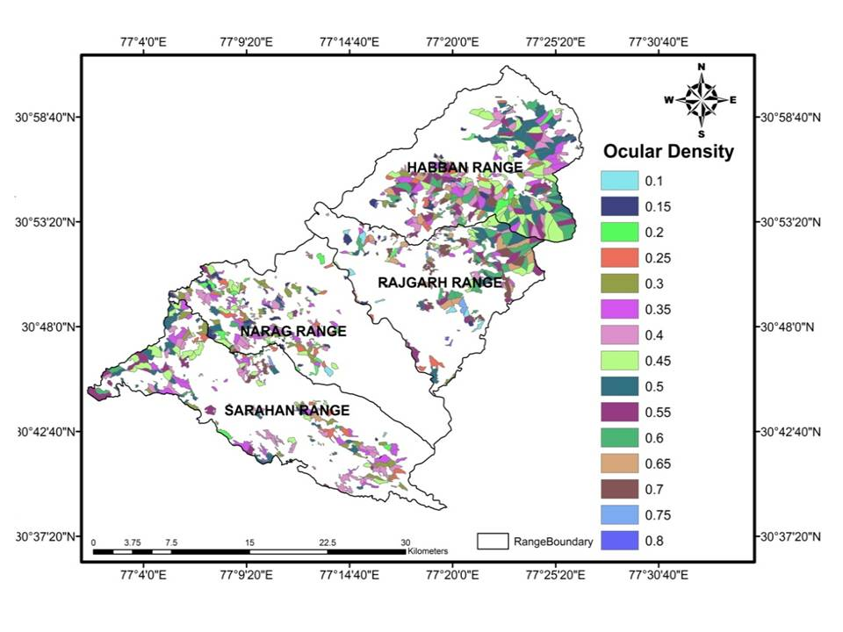

**Fig. 7. Ocular Density map of Rajgarh forest division**

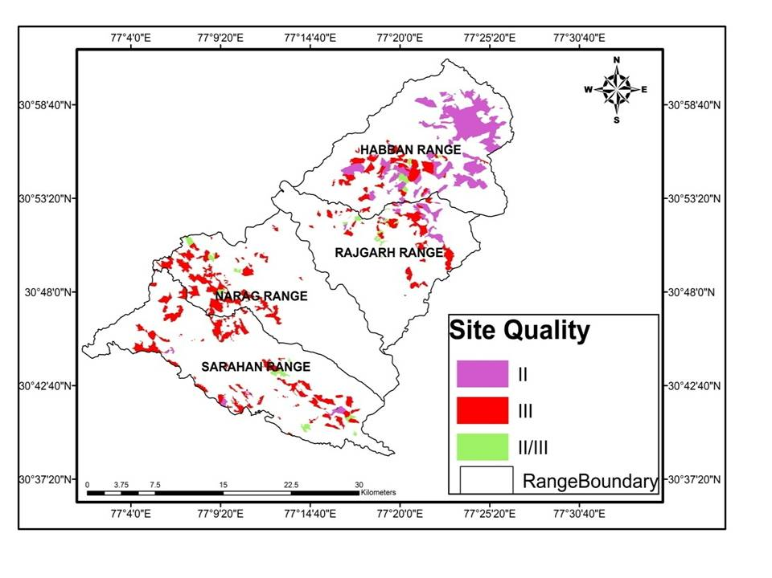

**Fig. 8. Site quality map of Rajgarh forest division**

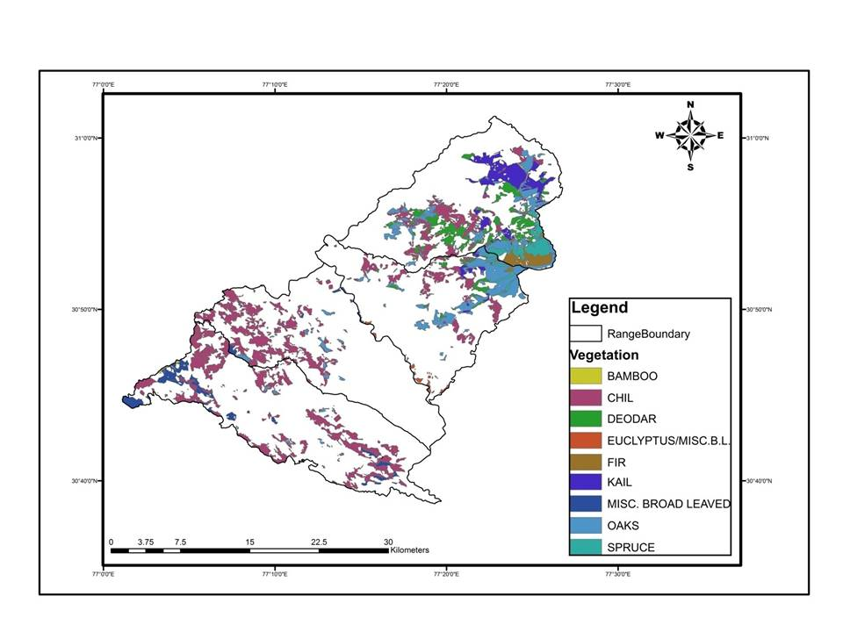

**Fig. 9. Vegetation Map of Rajgarh forest division**

**3.2 Area Estimation**

**3.2.1 Working Circles and ranges**

A small variation was observed between the GIS-calculated areas and the recorded areas of working circles and ranges in the Rajgarh Forest Division (Table 2). The differences were minimal overall, with a total recorded area of 21,413.34 ha and a calculated area of 21,353.10 ha, resulting in a division-wide difference of -60.24 ha. In the Chil Shelterwood Working Circle, the total recorded area is 6017.50 ha, while the calculated area is slightly lower at 5947.91 ha, leading to a negative difference of -69.59 ha. The Deodar-Kail Working Circle shows a positive total difference of 111.18 ha, as the calculated area (4252.53 ha) exceeds the recorded area (4141.35 ha). The Rehabilitation Working Circle has a total negative difference of -40.68 ha, with Sarahan and Narag ranges contributing significantly to the variation. The Plantation Working Circle records the largest discrepancy, with a total negative difference of -76.51 ha, primarily due to Sarahan Range (-66.67 ha). The Protection Working Circle exhibits minimal variation, with a total negative difference of -11.41 ha. The Selection Working Circle shows a small positive difference of 26.77 ha across all ranges. These variations highlight minor discrepancies in recorded versus GIS-calculated areas, which may be attributed to boundary delineation or computational adjustments.

**3.2.2 Forest Vegetation**

The recorded areas for forest vegetation types in the Rajgarh Forest Division, as per the Working Plan, are as follows: Chir pine (8235.53 ha), Oaks (3157.70 ha), Miscellaneous Broad-Leaved (1984.75 ha), Deodar (1979.76 ha), Kail (1968.79 ha), Spruce (927.45 ha), Fir (644.68 ha), Bamboo (45.00 ha), and Eucalyptus/Broad-Leaved (142.85 ha). Variations due to GIS processing are detailed in Table 3. Chir pine shows the largest negative difference (-236.05 ha), followed by Miscellaneous Broad-Leaved (-56.30 ha). Positive differences are observed for Oaks (42.90 ha), Deodar (154.69 ha), and Kail (19.86 ha). Minor negative differences are noted for Spruce (-0.53 ha), Fir (-1.93 ha), Bamboo (-1.40 ha), and Eucalyptus/Broad-Leaved (-11.00 ha). Overall, the total recorded area (19,086.51 ha) slightly exceeds the GIS-calculated area (18,996.75 ha) by -89.76 ha,(Table 3) reflecting minor discrepancies likely due to boundary adjustments or computational variations. Similarly variation between recorded and calculated area of administrative (forest ranges), territorial and silvicultural units has been reported by Sarkar (2011), while working on creation of database for Solan Forest Division.

**Table 2. Recorded and calculated area of different working circles of Rajgarh Forest Division**

|  |  |  |  |  |  |  |  |  |
| --- | --- | --- | --- | --- | --- | --- | --- | --- |
| **Working Circle** | | **Range** | **Recorded Area (ha)** | **Calculated Area**  **(ha)** | **Differences (ha)** | **Total recorded area**  **(ha)** | **Total calculated area**  **(ha)** | **Differences (ha)** |
| **Chil Shelterwood Working Circle** | | Habban | 917.15 | 934.51 | 17.36 | 6017.50 | 5947.91 | -69.59 |
| Rajgarh | 974.71 | 970.97 | -3.74 |
| Narag | 1700.95 | 1658.71 | -42.24 |
| Sarahan | 2424.69 | 2383.72 | -40.97 |
| **Deodar-Kail Working Circle** | | Habban | 3684.61 | 3775.82 | 91.21 | 4141.35 | 4252.53 | 111.18 |
| Rajgarh | 456.74 | 476.72 | 19.98 |
| Narag | - | - | - |
| Sarahan | - | - |  |
| **Rehabilitation Working Circle** | | Habban | 1697.53 | 1716.17 | 18.64 | 3479.43 | 3438.75 | -40.68 |
| Rajgarh | 227.89 | 233.02 | 5.13 |
| Narag | 931.30 | 888.70 | -42.60 |
| Sarahan | 622.71 | 600.85 | -21.86 |
| **Plantation Working Circle** | | Habban | 389.36 | 391.39 | 2.03 | 2912.40 | 2835.89 | -76.51 |
| Rajgarh | 439.20 | 434.24 | -4.96 |
| Narag | 194.52 | 187.61 | -6.91 |
| Sarahan | 1889.32 | 1822.65 | -66.67 |
| **Protection Working Circle** | | Habban | 451.01 | 445.70 | -5.31 | 2311.16 | 2299.75 | -11.41 |
| Rajgarh | 1458.61 | 1458.52 | -0.09 |
| Narag | 278.60 | 269.80 | -8.80 |
| Sarahan | 122.94 | 125.73 | 2.79 |
| **Selection Working Circle** | | Habban | 1823.40 | 1842.07 | 18.67 | 2551.50 | 2578.27 | 26.77 |
| Rajgarh | 728.10 | 736.20 | 8.10 |
| Narag | - | - | - |
| Sarahan | - | - | - |
| **Total** | | | | | | **21413.34** | **21353.10** | **-60.24** |
|  | | | | | | | |

**Table 3. Recorded and calculated area of forest vegetation in Rajgarh Forest Division**

|  |  |  |  |
| --- | --- | --- | --- |
| **Forest Vegetation** | **Recorded Area**  **(ha)** | **Calculated**  **Area (ha)** | **Difference**  **(ha)** |
| **Chir pine (Chil)** | 8235.53 | 7999.48 | -236.05 |
| **Miscellaneous**  **Broad Leaved** | 1984.75 | 1928.45 | -56.30 |
| **Oaks** | 3157.70 | 3200.60 | 42.90 |
| **Deodar** | 1979.76 | 2134.45 | 154.69 |
| **Kail** | 1968.79 | 1988.65 | 19.86 |
| **Spruce** | 927.45 | 926.92 | -0.53 |
| **Fir** | 644.68 | 642.75 | -1.93 |
| **Bamboo** | 45.00 | 43.60 | -1.40 |
| **Eucalyptus/**  **Broad Leaved** | 142.85 | 131.85 | -11.00 |
| **Total** | **19086.51** | **18996.75** | **-89.76** |

* 1. **Distribution status of biomass and carbon stock**

**3.2.1 Working circles**

Among different working circles of Rajgarh Forest Division, the maximum volume and carbon stock existed in Selection working Circle (2.51×106 m3 & 1.00 ×106 t) followed by Deodar-Kail working Circle (2.21×106 m3 & 9.34×105 t), Protection working circle (1.07×106 m3 & 7.12×105  t), Chil Shelterwood working circle (6.33×105 m3 & 3.01×105 t), Rehabilitation working circle (4.55 ×105 m3 & 2.54 ×105 t) and minimum in Plantation working circle (1.74×105 m3 & 8.44 ×104 t), respectively. (Table 4). However on per hectare basis, the distribution volume and carbon stock in different working circles were as: Selection working circle (983.40 m3 ha-1 & 392.01 t ha-), Deodar-Kail working circle (534.12 m3 ha-1 & 225.59 t ha-1), Protection working circle (461.60 m3 ha-1 & 307.92 t ha-1), Chil Shelterwood working circle (105.25 m3 ha-1 & 49.98 t ha-1), Rehabilitation working circle (92.14 m3 ha-1 & 45.52 t ha-1) and Plantation working circle (59.91 m3 ha-1 & 28.97 t ha-1), respectively (Table 4). This may be due to variation in site, crop density, crop composition and extent of area under different working circles.

*3.2.1.1 Chil Shelterwood Working Circle*

The distribution of volume and carbon stock in various ranges that fall under Chil Shelterwood working circle of Rajgarh Forest Division was found to be maximum in Sarahan (1.91×105 m3 & 8.93×104 t) followed by Habban (1.84×105 m3& 8.85×104 t), Rajgarh (1.36×105 m3 & 6.47×104 t) and Narag (1.22×105 m3 & 5.83×104 t), respectively. On per hectare basis, the maximum volume and carbon stock was recorded in Habban (170.85 m3 ha-1 & 81.80 t ha-1) followed by Rajgarh (139.82 m3 ha-1 & 66.44 t ha-1), Sarahan (82.07 m3 ha-1 & 38.34 t ha-1) and minimum in Narag (70.59 m3 ha-1 & 33.60 t ha-1), respectively (Table 4).

*3.2.1.2Deodar-Kail Working Circle*

The data in relation to distribution of volume and carbon stock in various ranges that fall under Deodar-Kail working circle of the Rajgarh Forest Division is given in table 4. The results revealed that volume and carbon stock was found to be maximum in Habban (2.01×106 m3 & 8.49×105 t) followed by Rajgarh (2.03×105 m3 & 8.49×104 t), respectively. On per hectare basis, the maximum volume and carbon stock existed in Habban (582.60 m3 ha-1 & 241.27 t ha-1) followed by Rajgarh (323.67 m3 ha-1 & 139.37 t ha-1) (Table 4).

**Table 4. Volume and carbon stock in different working circles of Rajgarh Forest Division**

|  |  |  |  |  |  |
| --- | --- | --- | --- | --- | --- |
| **Working Circles** | **Forest Range** | **Volume**  **(**m3**)** | **Carbon Stock (t)** | **Total Volume**  **(**m3**)** | **Total**  **Carbon Stock (t)** |
| Chil Shelterwood WC | Habban | 170.85 | 81.80 | 6.33×105  (105.25)* | 3.01×105  (49.98)* |
| Rajgarh | 1.36×105  (139.82) | 6.47×104  (66.44) |
| Narag | 1.22×105  (70.59) | 5.83×104  (33.60) |
| Sarahan | 1.91×105  (82.07) | 8.93×104  (38.34) |
| Deodar-Kail WC | Habban | 2.01×106  (582.60) | 8.49×105  (241.27) | 2.21×106  (534.12) | 9.34×105  (225.59) |
| Rajgarh | 2.03×105  (323.67) | 8.49×104  (139.37) |
| Narag | - | - |
| Sarahan | - | - |
| Rehabilitation W C | Habban | 3.62×105  (213.21) | 2.04×105  (120.23) | 4.55×105  (92.14) | 2.54×105  (45.52) |
| Rajgarh | 1.44×104  (62.99) | 7.46×103  (32.75) |
| Narag | 6.42×104  (68.88) | 3.60×104  (38.62) |
| Sarahan | 1.46×104  (23.47) | 6.52×103  (10.46) |
| Plantation W C | Habban | 1.20×104  (30.75) | 4.64×103  (11.91) | 1.74×105  (59.91) | 8.44×104  (28.97) |
| Rajgarh | 9.74×104  (221.67) | 5.34×104  (121.50) |
| Narag | 6.48×103  (33.32) | 3.16×103  (16.27) |
| Sarahan | 5.87×104  (31.06) | 2.32×104  (12.28) |
| Protection W C | Habban | 3.82×105  (846.65) | 2.12×105  (470.74) | 1.07×106  (461.60) | 7.12×105  (307.92) |
| Rajgarh | 5.57×105  (381.93) | 4.02×105  (272.37) |
| Narag | 9.11×104  (327.11) | 6.86×104  (246.34) |
| Sarahan | 3.68×104  (299.01) | 2.89×104  (235.24) |
| Selection W C | Habban | 2.13×106  (1160.66) | 8.70×105  (474.86) | 2.51×106  (983.40) | 1.00×106  (392.01) |
| Rajgarh | 3.82×105  (525.12) | 1.30×105  (178.67) |
| Narag | - | - |
| Sarahan | - | - |
| Total | | | | 7.05×106  (329.27) | 3.29×106  (153.42) |
|  | | | |  |  |
|  |  |

*Values in parenthesis on per hectare basis

*3.2.1.3 Rehabilitation Working Circle*

The distribution of volume and carbon stock in different ranges that fall under Rehabilitation working circle of the Rajgarh Forest Division was found to be maximum in Habban (3.62×105 m3 & 2.04×105 t) followed by Narag (6.42×104 m3 & 3.60×104 t), Sarahan (1.46×104 m3 & 6.52×103 t) and Rajgarh (1.44×104 m3 & 7.46×103 t), respectively (Table 4). On per hectare basis, the maximum volume and carbon stock existed in Habban (213.21 m3 ha-1 & 120.23 t ha-1) followed by Narag (68.88 m3 ha-1 & 38.62 t ha-1), Rajgarh (62.99 m3 ha-1 & 32.75 t ha-1) and minimum in Sarahan (23.47 m3 ha-1 & 10.46 t ha-1), respectively (Table 4).

* + - 1. *Plantation Working Circle*

The distribution of volume and carbon stock in various ranges that fall under Plantation working circle of the Rajgarh Forest Division was found to be maximum in Rajgarh (9.74×104 m3 & 5.34×104 t) followed by Sarahan (5.87×104 m3 & 2.32×104 t), Habban (1.20×104 m3 & 4.62×103 t), and minimum in Narag (6.48×103 m3 and 3.16×103 t), respectively (Table 4). However on per hectare basis, the maximum volume and carbon stock observed in Rajgarh (221.67 m3 ha-1 & 121.50 t ha-1) followed by Narag (33.32 m3 ha-1 & 16.27 t ha-1), Sarahan (31.06 m3 ha-1 & 12.28 t ha-1) and minimum in Habban (30.75 m3 ha-1 & 11.91 t ha-1), respectively (Table 4).

* + - 1. *Protection Working Circle*

The data in relation to distribution of volume and carbon stock in different ranges that fall under Protection working circle of the Rajgarh Forest Division was found to be maximum in Rajgarh range (5.57×105 m3 and 4.02×105 t) followed by Habban (3.82×105 m3 and 2.12×105 t), Narag (9.11×104 m3 and 6.86×104 t) and minimum in Sarahan (3.68×104 m3 and 2.89×104 t), respectively (Table 4). On per hectare basis, the maximum volume and carbon stock existed in Habban (846.65 m3 ha-1 and 470.74 t ha-1) followed by Rajgarh (381.93 m3 ha-1 and 272.37 t), Narag (327.11 m3 ha-1 and 246.34 t ha-1) and minimum in Sarahan (299.01 m3 ha-1 & 235.24 t ha-1), respectively (Table 4).

* + - 1. *Selection Working Circle*

Selection working circle was distributed in two ranges only *i.e.* Habban and Rajgarh ranges. The estimated volume and carbon stock was maximum in Habban (2.13×106 m3 and 8.70×105 t) followed by Rajgarh (3.82×105 m3 and 1.30×105 t), respectively. However on per hectare basis, the maximum volume and carbon stock existed in Habban (1160.66 m3 ha-1 & 474.86 t ha-1) and minimum in Rajgarh (525.12 m3 ha-1 & 178.67 t ha-1), respectively (Table 4).

This distribution pattern of volume and carbon stock may be attributed to crop composition, crop density, management practices and extent of area under different working circle.

* + 1. **Periodic Blocks**

*3.2.2.1 Chil Shelterwood Working Circle*

A maximum volume and carbon stock existed in PB I (2.80×105 m3 and 1.32 ×105 t), followed by PB II (1.27×105 m3 and 6.07×104 t) and PB IV (1.16×105 m3 and 5.48 ×104 t) while minimum (1.11×105 m3 and 5.29×104 t) volume and carbon stock found in PB III. On per hectare basis, the maximum volume and carbon stock existed in PB I (125.29 m3 ha-1 & 59.36 t ha-1) followed by PB IV (119.10 m3 ha-1 & 56.23 t ha-1), PB II (97.10 m3 ha-1 & 46.29 t ha-1) and minimum in PB III (73.60 m3 ha-1 & 35.20 t ha-1), respectively (Table 5).

The distribution of volume and carbon stock in various ranges of Rajgarh Forest Division those fall under PB I was as: maximum volume (1.22×105 m3) and carbon stock (5.85×104 t) existed in Habban followed by Sarahan (7.39×104 m3 and 3.44×104 t) and Rajgarh (4.23×104 m3 and 1.99×104 t), while minimum volume and carbon stock of 4.18×104 m3 and 1.96×104 t, respectively in Narag. On per hectare basis, the maximum volume and carbon stock existed in Habban (291.49 m3 ha-1 & 140.39 t ha-1) followed by Rajgarh (152.71 m3 ha-1 & 71.82 t ha-1), Sarahan (78.08 m3 ha-1 & 36.37 t ha-1) and minimum in Narag (70.81 m3 ha-1 & 33.18 t ha-1), respectively (Table 5).

In Periodic Block II, maximum volume (4.85×104 m3) and carbon stock (2.30×104 t) was found in Sarahan followed by Rajgarh (4.03×104 m3 and 1.94×104 t), Narag (2.41×104 m3 and 1.15×104 t), while minimum volume and carbon stock of 1.43×104 m3 and 6.68×103 t, respectively in Habban. On per hectare basis, the maximum volume and carbon stock existed in Rajgarh (223.92 m3 ha-1 & 107.79 t ha-1) followed by Habban (98.18 m3 ha-1 & 45.86 t ha-1), Sarahan (76.09 m3 ha-1 & 36.12 t ha-1) and minimum in Narag (69.47 m3 ha-1 & 33.27 t ha-1), respectively (Table 5).The distribution of volume and carbon stock in various ranges of Rajgarh Forest Division those fall under PB III was as: maximum volume and carbon stock of 4.75×104 m3 and 2.32×104 t, respectively in Narag followed by Sarahan (4.02×104 m3 and 1.85×104 t) and Habban (1.57×104 m3 and 7.91×103 t) while minimum volume and carbon stock of 7.18×103 m3 and 3.33×103 t, respectively in Rajgarh. On per hectare basis, the maximum volume and carbon stock existed in Habban (76.75 m3 ha-1 & 38.72 t ha-1) followed by Narag (74.75 m3 ha-1 & 36.44 t ha-1), Rajgarh (72.06 m3 ha-1 & 33.48 t ha-1) and minimum in Sarahan (71.42 m3 ha-1 & 32.83 t ha-1), respectively (Table 5). In Periodic Block IV, maximum volume and carbon stock (4.62×104 m3 & 2.20×104 t) existed in Rajgarh followed by Habban (3.26×104 m3 & 1.54×104 t), Sarahan (2.86×104 m3 & 1.34 ×104 t) and Narag (8.58×103 m3 & 4.01×103 t), respectively. On per hectare basis, the maximum volume and carbon stock existed in Habban (219.98 m3 ha-1 & 102.22 t ha-1) followed by Rajgarh (110.60 m3 ha-1 & 52.67 t ha-1), Sarahan (102.68 m3 ha-1 & 48.05 t ha-1) and minimum in Narag (67.35 m3 ha-1 & 31.52 t ha-1), respectively (Table 5).

This distribution pattern of volume and carbon stock may be attributed to crop composition, crop density, management practices and extent of area under different periodic blocks. However on the basis of productivity, the variation in growing stock and carbon stock may be attributed to crop age, crop density and composition under respective PBs rather than an outcome of scheduled management practice. Though there is mention of Periodic block areas allotted in the working plan yet they are not being treated as PBs because of ban on green felling in the state.

The higher value of growing stock and carbon in PB I was due to the presence of trees of higher diameter classes which otherwise were required to be removed for better growth of stock. Among species, Pinus roxburghii having maximum value of growing stock and carbon stock in all PBs may be due to its dominant presence and lessr for associated species were due to low density of sizable trees, perhaps its harvesting for fuel wood. The present growing stock of forest is comparable to the estimated growing stock by Sharma and Baduni (2000) who reported that growing stock value (440 m3 ha-1 on the NE aspect) was observed in the high Himalayan chir pine forest, whereas the minimum value (67.76 m3 ha-1 on SW aspect) was observed in the Siwalik chir pine forest. The present volume found to be at higher side in comparison study to Haripriya (2000) in Indian forest.

The carbon stock recorded in the present study is in conformity with the results of Jina et al. (2008) who found a that carbon stock varied from 41.31-115.40 t ha-1 of in non degraded chir pine forests of Kumaon Himalaya. The present values are more or less similar to the values reported by Sharma et al. (2010c); Sheikh et al. (2009) for Siwalik Pinus roxburghii forest Garhwal Himalaya and Nizami et al. (2009) for subtropical pine forests of Pakistan. However the present value found to be at higher side in comparison to the study of Haripriya (2000) who reported carbon stock of 34 t ha-1in Indian forests. Similarly, Sharma (2009), in chir pine forests of Solan Forest Division recorded a carbon density of 44.71 t ha-1. The results are also in at higher ends with the results of Manhas et al. (2006) who recorded a carbon density of 47.42 t ha-1 in temperate Indian forests.

**Table 5. Volume and carbon stock in different Periodic Blocks of Chil Shelterwood working circle of Rajgarh Forest Division**

|  |  |  |  |  |  |
| --- | --- | --- | --- | --- | --- |
| **Periodic Blocks** | **Forest Range** | **Volume (m3)** | **Carbon Stock (t)** | **Total Volume (m3)** | **Total Carbon Stock (t)** |
| PB I | Habban | 1.22×105  (291.49)* | 5.85×104  (140.39)* | 2.80×105  (125.29)* | 1.32×105  (59.36)* |
| Rajgarh | 4.23×104  (152.71) | 1.99×104  (71.82) |
| Narag | 4.18×104  (70.81) | 1.96×104  (33.18) |
| Sarahan | 7.39×104  (78.08) | 3.44×104  (36.37) |
| PB II | Habban | 1.43×104  (98.18) | 6.68×103  (45.86) | 1.27 ×105  (97.10) | 6.07 ×104  (46.29) |
| Rajgarh | 4.03×104  (223.92) | 1.94×104  (107.79) |
| Narag | 2.41×104  (69.47) | 1.15×104  (33.27) |
| Sarahan | 4.85×104  (76.09) | 2.30×104  (36.12) |
|  |  |  |  |  |  |
| PB III | Habban | 1.57×104  (76.75) | 7.91×103  (38.72) | 1.11 ×105  (73.60) | 5.29 ×104  (35.20) |
| Rajgarh | 7.18×103  (72.06) | 3.33×103  (33.48) |
| Narag | 4.75×104  (74.75) | 2.32×104  (36.44) |
| Sarahan | 4.02×104  (71.42) | 1.85×104  (32.83) |
| PB IV | Habban | 3.26×104  (216.98) | 1.54×104  (102.22) | 1.16 ×105  (119.10) | 5.48 ×104  (56.23) |
|  |  |  |
| Rajgarh | 4.62×104  (110.60) | 2.20×104  (52.67) |
|  |  |  |
| Narag | 8.58×103  (67.35) | 4.01×103  (31.52) |
| Sarahan | 2.86×104  (102.68) | 1.34×104  (48.05) |
| Total | | | | 6.33×105  (105.25) | 3.01×105  (49.98) |

*Values in parenthesis on per hectare basis

*3.2.2.2 Deodar-Kail Working Circle*

The estimated volume and carbon stock in different Periodic Blocks of Deodar-Kail working circle of Rajgarh Forest Division are presented in Table 6. The maximum growing stock and carbon stock (1.31×106 m3 and 5.79×105 t) existed in PB Un-allotted, while minimum growing stock and carbon stock (9.04×105 m3 and 3.55×105 t) was found in PB I. On per hectare basis, the maximum volume and carbon stock existed in PB I (687.69 m3 ha-1 & 270.20 t ha-1) followed by PB Un-allotted (462.66 m3 ha-1 & 204.83 t ha-1) (Table 6).

**Table 6. Volume and carbon stock in different Periodic Blocks of Deodar-Kail working circle of Rajgarh Forest Division**

|  |  |  |  |  |  |
| --- | --- | --- | --- | --- | --- |
| **Periodic Blocks** | **Forest Range** | **Volume**  **(**m3**)** | **Carbon Stock (t)** | **Total Volume**  **(**m3**)** | **Total Carbon Stock (t)** |
|  |  |  |  |  |  |
| PB I | Habban | 8.97×105  (703.95) | 3.52×105  (276.16) | 9.04×105  (687.69) | 3.55×105  (270.20) |
| Rajgarh | 7.16×103  (176.48) | 3.36×103  (82.89) |
| PB Un-allotted | Habban | 1.11×106  (461.24) | 4.97×105  (206.38) | 1.31×106  (462.66) | 5.79×105  (204.83) |
| Rajgarh | 1.96×105  (470.86) | 8.15×104  (195.86) |
|  |  |  |  |  |  |
| Total | | | | 2.21×106  (534.12) | 9.34×105  (225.59) |

*Values in parenthesis on per hectare basis

The distribution of volume and carbon stock in various ranges of Rajgarh Forest Division those fall under Deodar-kail PB I was as: maximum volume (8.97×105 m3) and carbon stock (3.52×105 t) existed in Habban followed by Rajgarh (7.16×103 m3 & 3.36×103 t), respectively. On per hectare basis, the maximum volume and carbon stock existed in Habban (703.95 m3 ha-1 & 276.16 t ha-1) and minimum in Rajgarh (176.48 m3 ha-1 & 82.89 t ha-1), respectively (Table 6).

In Periodic Block Un-allotted, maximum volume (1.11×106 m3) and carbon stock (4.97×105 t) existed in Habban followed by (1.96×105 m3 & 8.15×104 t) by Rajgarh, respectively. On per hectare basis, the maximum volume and carbon stock existed in Rajgarh (470.86 m3 ha-1 & 195.86 t ha-1) and minimum (461.24 m3 ha-1 & 206.38 t ha-1) in Habban, respectively (Table 6).

This distribution pattern of volume and carbon stock may be attributed to crop composition, crop density, management practices and extent of area under different periodic blocks. However on the basis of productivity, the variation in growing stock and carbon stock may be attributed to crop age, crop density and composition under respective PBs rather than an outcome of scheduled management practice. Though there is mention of Periodic block areas allotted in the working plan yet they are not being treated as PBs because of ban on green felling in the state.

The higher value of growing stock, biomass and carbon stock in PB I was due to the presence of trees of higher diameter classes which otherwise were required to be removed for better growth of stock. The present growing stock in deodar-kail forest is comparable to the estimated growing stock (383.10-440.71 m3 ha-1) by Haripriya (2000) in case of deodar forest. The biomass of deodar-kail forest with in the range of 121.33-247.21 t ha-1 is reported by Tiwari *et al*. (2005). The present values of carbon stocks of the region are comparable with the studies of Ahmad *et al*. (2014a) they reported total carbon ranged between 134.60 (mixed deodar-kail forest) t ha-1 to 140.37 (pure deodar forest)

*3.2.2.3 Forest Vegetation*

Among the different forest vegetation types of Rajgarh Forest Division, the maximum growing stock existed in Oaks (1.79×106 m3), followed by Deodar (1.79×106 m3), Spruce (1.43×106 m3), Chil (8.53×105 m3), Kail (6.56×105 m3), Fir (3.32 ×105 m3), Miscellaneous Broad Leaved (2.05×105 m3), Eucalyptus/Broad Leaved (1.26×103 m3) and minimum growing stock in Bamboo (9.26 ×102 m3) forest vegetation (Table 7).

While carbon stock distribution in different forest vegetation types of Rajgarh Forest Division are presented in Table 7. The maximum carbon stock existed in Oaks (1.41×106  t), followed by Deodar (6.32 ×105 t), Spruce (4.08×105 t), Chil (4.00×105  t), Kail (2.68×105 t) Fir (8.52×104 t), Miscellaneous Broad Leaved (8.10×104 t), Eucalyptus/Broad Leaved (4.99 ×102 t) and minimum in Bamboo (4.14×102 t) forest vegetation. (Table 7).

**Table 7. Volume and carbon stock in different forest vegetation of Rajgarh Forest Division**

|  |  |  |  |
| --- | --- | --- | --- |
|  | | | |
| **Forest Vegetation** | **Volume ( m3)** | **Carbon Stock (t)** |
| Chir pine (Chil) | 8.53×105 | 4.00×105 |
| Miscellaneous Broad Leaved | 2.05×105 | 8.10×104 |
| Oaks | 1.79×106 | 1.41×106 |
| Deodar | 1.79×106 | 6.32×105 |
| Kail | 6.56×105 | 2.68×105 |
| Spruce | 1.43×106 | 4.08×105 |
| Fir | 3.32×105 | 8.52×104 |
| Bamboo | 9.26×102 | 4.14×102 |
| Eucalyptus/ Broad Leaved | 1.26×103 | 4.99×102 |
| Total | 7.05×106 | 3.29×106 |

This is merely a reflection of type of vegetation combination and crop composition followed by extent of area under respective forest vegetation.

The Maps showing distribution of growing stock and carbon stock from the inventory reports of the division has been prepared for working circles (Fig 10-11)and forest vegetation (Fig. 12-13).

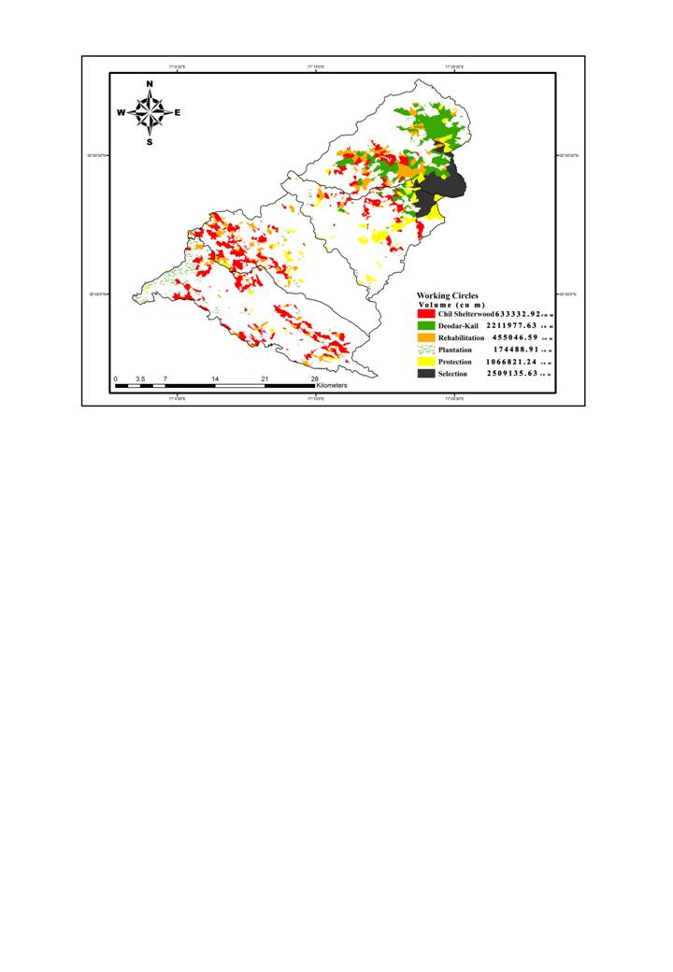

**Fig.10 Volume distribution in different working circle forest division**

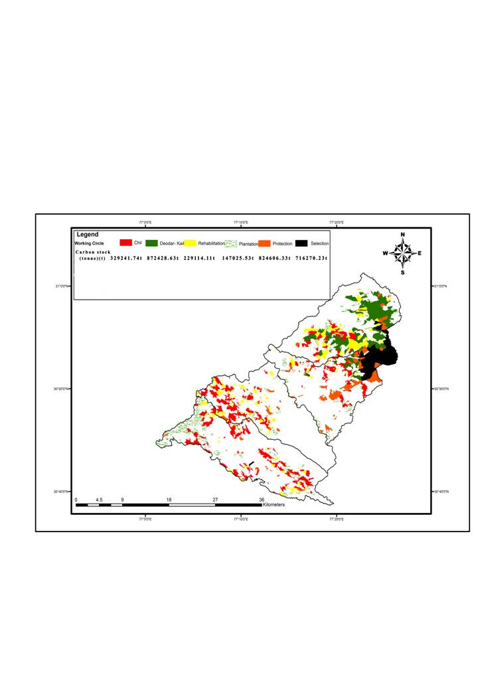

**Fig. 11. Carbon distribution in different working circle forest division**

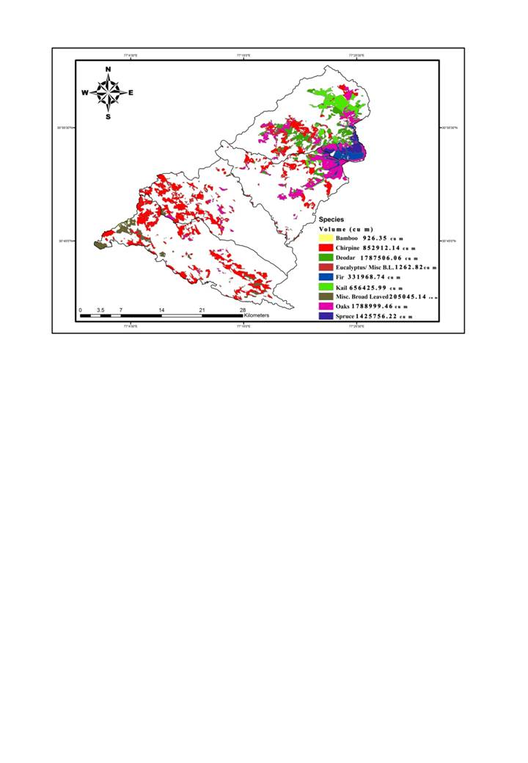

**Fig. 12. Volume distribution in Vegetation of Rajgarh forest division**

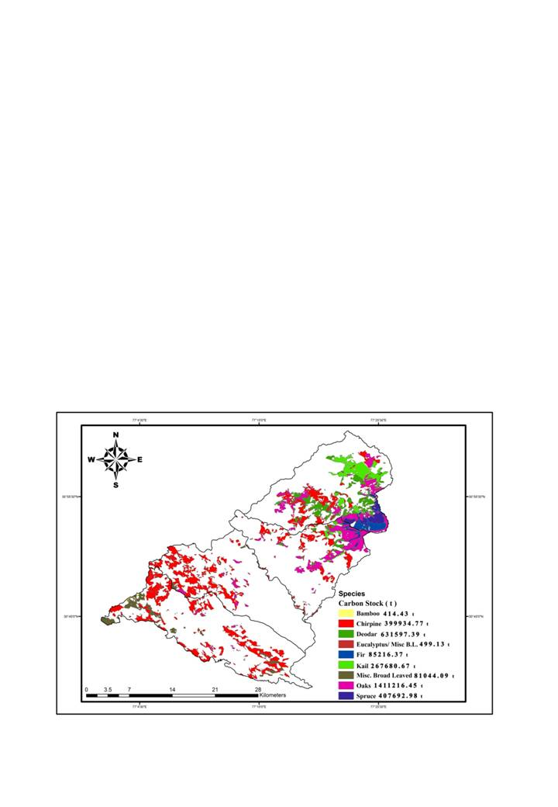

**Fig.13 Carbon stock in different Vegetation Rajgarh forest division**

On similar lines, maps of biomass density and pools of all forest of the eastern USA using GIS were prepared by Brown *et al*. (1997); Cairns *et al*. (1997); Schroeder *et al*. (1997) and for carbon sink and stock of forest ecosystem of Tiantai County in Zhejiang Province of southeast China by Hsieh *et al*. (2011). Leighty *et al*. (2006) combined the spatial and forest inventory data to estimate and produce thematic map of total carbon stock in the Tongass forest. Similarly by using GIS technology, carbon biomass map of western black sea region (Msr *et al*., 2012) and forest distribution map of the forests of the US (Powell *et al*., 1993) were prepared.

On similar ground, various attempts to digitize working plan and digital stock maps are already in progress in several states of the country such as West Bengal (Raha, 2000) and Maharashtra (Grewal, 2001 and Rao, 2006). Chhattisgarh Forest Department has already build up the infrastructure to develop Forest Information System/Decision Support Systems for working plans, production, personnel management, plantation, office management, micro planning and joint forest management with an interface with GIS. Stock map and management map of East Raipur and Udanti Division of Chhattisgarh has been prepared and such maps for other divisions of the state are in progress (Bebarta, 2008).

4. Conclusion

The present study utilized gis and spatial analysis to map, analyze, and evaluate forest resources in the rajgarh forest division. The integration of administrative, territorial, and silvicultural data with vegetation and land-use attributes provided a detailed understanding of forest area distribution, growing stock, biomass, and carbon stock. The results revealed variations between calculated and recorded areas across administrative units, silvicultural divisions, and vegetation types, underscoring the importance of spatial validation. Among forest ranges, habban was identified as the largest contributor to total area, volume, and carbon stock, while reserved forests dominated in terms of forest classes. Discrepancies observed in calculated versus recorded data were minor, indicating overall consistency with enumeration records. The analysis of working circles highlighted the significant contribution of the selection working circle to total volume and carbon stock, with marked differences in productivity across periodic blocks. Among vegetation types, oaks and deodar were identified as the most substantial contributors to volume and carbon stock, reinforcing their ecological and economic value. This research demonstrates the utility of gis for effective forest resource assessment and planning. The derived thematic maps and digital stock data provide a robust framework for forest management, enabling informed decision-making for conservation, sustainable utilization, and carbon mitigation strategies. Future studies can build on this methodology by incorporating temporal data to monitor changes and evaluate the long-term impact of management interventions.

Consent

Informed consent was obtained from all participants involved in the surveys and observations. Confidentiality of the collected data was maintained to protect the privacy of the respondents. The research adhered to ethical guidelines to ensure the well-being and rights of the participants were respected at all times.

**REFERENCES**

Ahmad, A., Mirza, S.N. & Nizami, S.M. (2014). Assessment of biomass and carbon stocks in coniferous forest of Dir Kohistan, KPK. Pakistan Journal of Agricultural Sciences, 51(2), 335-340.

Bebarta, K.C. (2008). Application of GIS, GPS and remote sensing technologies in forest management: a case study of Chhattisgarh. Indian Forester, 134(1), 36-41.

Brown, S., Schroeder, P. & Birdsey, R. (1997). Aboveground biomass distribution of US eastern hardwood forests and the use of large trees as an indicator of forest development. Forest Ecology and Management, 96, 37-47.

Burrough, P.A. & MacDonnel, R.A. (1995). Principles of geographical systems. Oxford University Press, Oxford, UK, 333p.

Cairns, M.A., Brown, S., Helmer, E.H. & Baumgardner, G.A. (1997) Root biomass allocation in the world's upland forests. Oecologia, 111, 1-11.

Canadell, J.G., Pataki, D.E. & Pitelka, L.F. (2007). Terrestrial ecosystems in a changing world. In: Global Change-The IGBP Series, Springer, Berlin.

Chen, Y.K., Jan, J.F., Teng, S.P. & Yeh, K.S. (2000). Study on data conversion for digital mapping. Journal of the Experimental Forest of National Taiwan University, 14(1), 21-28.

Grewal, J.S. (2001). Maharashtra working plan incorporates GIS, GIS development.net. Available from: http://www.gisdevelopment.net/application/environment/conservation. [Accessed 26 November 2011].

Hamzad, K.A. (2001). Remote sensing, GIS and GPS as a tool to support precision forestry practices in Malaysia. Second Asian Conference on Remote Sensing, Singapore.

Haripriya, G.S. (2000). Estimates of biomass in Indian forests. Biomass and Bioenergy, 19, 245-258.

Hsieh, D.S., Shi, Y.Q., Jin, Y., Wang, L.H. (2011). GIS-based approach for quantifying and mapping carbon sink and stock values of forest ecosystem: a case study. Energy Procedia, 5, 1535–1545.

International Panel on Climate Change (2006). Guidelines for National Greenhouse Gas Inventories. In: Eggelston, L., Buendia, L., Miwa, K., Ngara, T. & Tanabe, K. (eds.). Institute for Global Environmental Strategies (IGES).

Jina, B.S., Sah, P., Bhat, M.D. & Rawat, Y.S. (2008). Estimating carbon sequestration rates and total carbon stockpile in degraded and non-degraded sites of oak and pine forest of Kumaun central Himalayas. Ecoprint, 15, 75-81.

Kimmins, J.P., Rempel, R.S., Welham, C.V.J., Seely, B. & Van Rees, K.C.J. (2007). Biophysical sustainability, process-based monitoring and forest ecosystem management decision support systems. Forestry Chronicle, 83, 502–514.

Kumar, S., Murti, S.H.K. & George, R. (2014). Application of remote sensing, GIS, and GPS for forest management in Andaman and Nicobar Islands, India. Indian Forester, 140(2), 107-112.

Kurz, W.A. & Apps, M.J. (1999). Developing Canada's National forest carbon monitoring: accounting and reporting system to meet the reporting requirements of the Kyoto Protocol. Mitigation and Adaptation Strategies for Global Change, 11, 33-43.

Leighty, W.W., Hamburg, S.P. & Caouette, J. (2006). Effects of management on carbon sequestration in forest biomass in Southeast Alaska. Ecosystems, 9(7), 1051-165.

Liski, J., Perruchod, D. & Karjalainen, T. (2002). Increasing carbon stocks in the forest soils of western Europe. Forest Ecology and Management, 169, 159-175.

Lubchenco, J. (1998). Entering the century of the environment: a new social contract for science. Science, 279, 491-497.

Manhas, R.K., Negi, J.D.S., Kumar, R. & Chauhan, P.S. (2006). Temporal assessment of growing stock, biomass and carbon stock of Indian forests. Climate Change, 74, 191.

Msr, M., Msr, N. & Erkut, S. (2012). Estimations of total ecosystem biomass and carbon storage for fir (Abies nordmanniana S. subsp. bornmulleriana (Mattf.)) forests (Western Black Sea region). Kastamonu Universitesi Orman Fakultesi Dergisi, 12(3), 60-64.

Powell, D.S., Faulkner, J.L., Darr, D.R., Zhu, Z. & MacCleery, D.W. (1993). Forest resources of the United States, 1992. USDA Forest Service GTR RM-234, Rocky Mountain Forest and Range Experiment Station, Fort Collins, CO.

Raha, A.K. (2000). Forest working plan in new millennium. Geospatial World. Available from: http://www.geospatialworld.net/index. [Accessed 26 November 2011].

Rao, Y.L.P. (2005). Application of GIS in formulating a forest working plan: a case study of Roha forest sub-division, Raigad district. Map India, pp. 1-9.

Rao, Y.L.P. (2006). GIS in forest management: preparing a forest working plan in India. GIM International, 20(8), 41-43.

Sarkar, P. (2011). Forest stock mapping of Solan Forest Division using remote sensing and geographical information system. MSc Thesis, Dr. Y.S. Parmar UHF, Solan (H.P.), India, 58p.

Schroeder, P., Brown, S., Mo, J., Birdsey, R. & Cieszewski, C. (1997). Biomass estimation for temperate broadleaf forests of the US using forest inventory data. Forest Science, 43, 424-434.

Sharma, C.M. & Baduni, N.P. (2000). Structural attributes and growing stock variations on different aspects of high Himalayan and Shiwalik chir pine forests. Journal of Tropical Forest Science, 12(3), 482-492.

Sharma, C.M., Baduni, N.P., Gairola, S., Ghildiyal, S.K. & Suyal, S. (2010). Tree diversity and carbon stocks of some major forest types of Garhwal Himalaya, India. Forest Ecology and Management, 260, 2170–2179.

Sharma, P.K. & Murthy, R.A. (2014). Andhra Pradesh forest inventory: assessment of growing stock, stem density, bamboo resource and health of forests and status of its soil. Indian Forester, 140(2), 643-653.

Sheikh, M.A., Kumar, M. & Bhat, J.A. (2011) Wood specific gravity of some tree species in the Garhwal Himalayas, India. Forestry Studies in China, 13(3), 225-230.

Tiwari, A.K., Agarwal, A., Sunil, K. & Tiwari, S.C. (2005). Analysis of land use and biomass in Khanda watershed, Garhwal Himalaya, using satellite remote sensing data. Tropical Ecology, 46(2), 253-263.

Vitousek, P.M., Mooney, H.A., Lubchenco, J. & Melillo, J.M. (1997). Human domination of Earth’s ecosystems. Science, 277, 494–499.

Working Plan (2012). Working plan for the forest of Rajgarh Forest Division. Department of Forest, Himachal Pradesh.

XueLin, C., ZhiYun, Z., WeiMing, L., XinGen, X., KeHui, S. & Hong, Z. (2005). Establishment of GIS information database for forest resources in Tonggu County and its application in forest resources management. Acta Agriculturae Universitatis Jiangxiensis, 27(2), 313-316.