**As-built Metrology of Curve Parameters within Selected Road Network of Rivers State University Main Campus, Port Harcourt, Nigeria**

**Abstract**

The insertion of curves in road designs is of utmost important for the safety of the driver and commuters. It provides a smooth transition when the roadway changes direction and also ensures that proper and safe sight distances are maintained for the speed which the road will accommodate. These changes of direction can occur in both the horizontal and vertical direction. The study seeks to investigate the curve parameters of selected road network within the main campus of Rivers State University, Nkpolu Oroworukwo, Port Harcourt, Rivers State. The study utilizes the quantitative data collection approach which depends strictly on ground survey data acquisition. Field data were acquired with the use of the Total Station (Kolida KTS 440L) instrument. The Field data were reduced to obtain horizontal and vertical angles and further processing and map production were carried out using Auto-CAD 2007 and Auto-CAD 3D Software. An accuracy of approximately 1:16,000 and 0.008 were achieved for traversing and levelling operations respectively, which was within the allowable degree of accuracy. The findings revealed that the sections of the road network under study covers a total length and width of approximately 2.93km and 7.00m respectively. The parameters for 5 horizontal curves and 6 vertical curves were determined and will be useful to the University Estate and Works Department in ascertaining if the curves parameters noted were in line with the design prior to construction works.

1. **Background to the study**

Surveying is a measurement science and involves the determination of the measurement data, the reduction and interpretation of the data to usable form, and, conversely, the establishment of relative position and size according to given measurement requirements (Eze, Lawson and Pepple, 2024). The determination of the relative horizontal and vertical position of points on the earth surface is imperative, as these points serves as control and bench marks during construction activities and land boundaries definition (Eze, Hart and Eke, 2022)).

Curve are the transitions which are provided at the intersection of two straight lines. Where the fieldwork is composed of straight lines, setting out is comparatively straight forward. With roads, railways and pipelines, two straights will normally be connected by a curve where there is a change of direction. The purpose of these curves is to deflect a vehicle travelling along of the straights safely and comfortably through a deflection angle to enable it to continue its journey along the other straight. The two types of horizontal curves are vertical curves (Ghilani and Wolf, 2008).

The introduction of horizontal and vertical curves into road design is critical in ensuring the safety of vehicle, drivers and commuters. It is an overall design control for horizontal alignments in roadway design that may equal or exceed the legal statutory speed limit. The level of service is directly related to the speed of operation. It should meet driver expectations and be consistent with the facility’s functional classification and location (Uren and Price, 2010).

Design speed selection is a critical decision that should be done at the beginning of the planning and design process. This speed should balance safety, mobility, and efficiency with potential environmental quality, economics, aesthetics, as well as social and political impacts. Roadway design features (curve radii, super elevation, sight distance, etc.) are impacted by the design speed, as well as other characteristics not directly related to speed. Therefore, any changes to design speed may affect many roadway design elements (Gregory, 2015).

Design speeds for rural roads should be as high as practicable to supply an optimal degree of safety and operational efficiency. Data has shown that drivers operate quite comfortably at speeds that are higher than typical design speeds. Lower design speeds may be appropriate for certain urban roadways (residential streets, school zones, etc.). Traffic calming techniques have proven to be a viable option for residential traffic operations. Designers should evaluate high speed compatibility with safety (pedestrians, driveways, parking, etc.) for urban arterials (Qianqian, 2014; Ghilani and Wolf, 2008).

It is very necessary that appropriate safety measures be adopted in the introduction of horizontal and vertical curves to make the infrastructure road user friendly and decrease the risks of hazardous circumstances.

**Notations of a Typical Circular Curve**

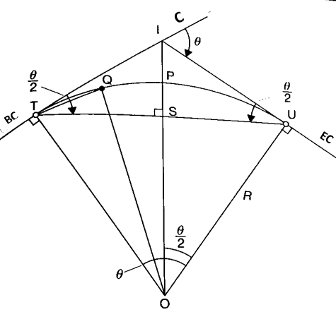

**Figure 1: A typical Circular curve (Uren and Price, 2010).**

As showed in figure 1, the analysis of the curve parameters the typical curve relationships/equations shall be used

1. Tangent lengths IT and IU: in triangle IUO

R tan($\frac{θ}{2}$) = $\frac{IU}{IO}$ = $\frac{IU}{R}$

Hence IU = IT = R tan $(\frac{θ}{2})$ (1.1)

1. External distance, PI: in triangle IUO

cos $(\frac{θ}{2})$ = $\frac{R}{IO}$

or IO = $\frac{R}{cos⁡(θ/2)}$ =R sec $(\frac{θ}{2}$)

But PI = OI – OP = OI – R

Hence PI = R sec $(\frac{θ}{2})$- R = R[sec $\left(\frac{θ}{2}\right)-1$] (1.2)

1. Mid-ordinate, PS: in triangle TSO

cos $(\frac{θ}{2})$ = $\frac{OS}{OT}$

or OS = OT cos $(\frac{θ}{2}$) =R cos $(\frac{θ}{2}$)

But PS = OP – OS = R – R cos($\frac{θ}{2}$) = R[1 – cos $(\frac{θ}{2})$] (1.3)

1. Long chord, TU: in triangle USO

sin $(\frac{θ}{2})$ = $\frac{US}{UO}$ = $\frac{US}{R}$

or US = R sin($\frac{θ}{2}$)

But TU = US + TS and US = TS

Hence TU = 2R sin($\frac{θ}{2}$) (1.4)

The length of the circular curve, Lc, can be obtained from one of the two formulae depending on whether the curve is a radius curve or a degree curve:

For a curve of radius R:

Lc = *Rθ* metres (1.5)

Where R is in metres and *θ* is in radians.

For a *D*̊ degree curve:

Lc = 100($\frac{θ}{D}$) metres (1.6)

Where *θ* and *D* are in the same units, either degrees or radians.

Q = is any point on the circular curve

S = is the mid point of the long cord

P = is the mid point of the circular curve

θ = deflection angle = external angle at I

R = radius of curvature

O = Centre of Curvature

I = Intersection point

T&U = Tangent point

Intersection angle = (180-θ) = internal angle at I

Long cord TU = It is straight line joining TU

Tangent length = IT&IU (IT = IU)

Tangential angle, ITQ = angle from the tangent at T (or U) to any point on the curve.

Mid-ordinate = PS: It is the greatest offset from the long chord to the curve.

Radius angle = angle TOU = deflection angle

External distance = PI: Is the shortest distance from the intersection point to the curve.

The study investigate the parameters of the existing curves and to what extent. The as-built metrology of the curves in Rivers State University will provide the adequate safety measures that can be adopted for smooth transition when the road changes direction.

The significance of this study is such that provide information about the status and parameters of the curves under study, enhance safe transportation and efficient traffic control of vehicle moving along the study area. The findings of this study will also be useful to the university Estate and Works Department, as well as the Physical Planning Department, especially in future planning, construction and management of engineering projects in the Campus.

**Study Area Description**

The study area is situated within Rivers State University Main Campus, Nkpolu-Oroworukwu, Port Harcourt, in Port Harcourt City Local Government Area. It is geographically located is between latitude 04̊ 47’ 30’’ to latitude 04˚ 48’ 20’’ and longitude 06˚ 58' 35” to longitude 06˚ 59’ 05”. It is bounded at the west by Mgbouosimini community, at the south by Eagle Island, at the east by mile 3 diobu community and at the North by Nkpolu-Oroworukwu community (Pepple, Eze and Zagha, 2024).

As showed in figure 2, the study area covers approximately 2.88km and stretches from the main gate and passes through parts of the University circular road and connects to Road A, B, and G extensions respectively.

**Figure 2: Map of Rivers State University Main Campus and Environs. (Othophoto Map of Rivers State 2021.**

1. **Materials and Methods**

**Table 1: Equipment and Hardware Selection**

|  |  |  |  |
| --- | --- | --- | --- |
| **S/N** | **Description of Items** | **Instrument Type** | **No. of Item** |
| 1 | Total station) and its accessories | (Kolida KTS 440L) | 1 |
| 2 | Tripod stand | Leica TRI100 | 1 |
| 3 | Prisms and tracking rod | GDST OEM 6771112 | 2, 2 |
| 4 | 100m Measuring Tape | PANYI Steel Tape PJ9 | 1 |
| 5 | Nails and Harmer |  |  |
| 6 | Automatic Level | Leica (NA24) | 1 |
| 7 | Field Book and stationaries |  |  |
| 8 | Laptop Computer | Dell Latitude E6540 | 1 |

**Table 2: Software Selections**

|  |  |  |
| --- | --- | --- |
| **S/N** | **Description of Items** | **Version** |
| 1 | AutoCAD | 2007 |
| 2 | Kolida data downloading Software | 2022 |
| 3 | AutoCAD 3D | 2019 |
| 4 | Microsoft office | 2007 |

**Secondary Data Sources**

Secondary data used for field data acquisition consists Northings and Easting coordinates of identified control points in the study area. As contained in table 3, the coordinates were projected in Universal Transverse Mercator (UTM, Zone 32N). The secondary data was collected from the Department of Surveying and Geomatics, Rivers state university, River state.

**Table 3: Spatial Data of Control Points**

|  |  |  |  |
| --- | --- | --- | --- |
| Station ID | Northings (m) | Easting (m) | Reduced level (m) |
| SVG GPS 002 | 530903.200 | 275962.761 | 11.986 |
| SVG WGPS 003 | 530933.315 | 275992.841 | 8.876 |
| SVG WGPS 004 | 530938.002 | 275855.250 |  |
| SVG 005/2018/01 | 5309428.721 | 276428.721 | 11.986 |
| SVG 005/2018/04 | 530099.624 | 275958.695 |  |
| SVG 005/2018/05 | 530103.649 | 275648.306 |  |

**Primary Data Acquisition**

This constitute the methods adopted for field data acquisition, the stepwise approach of the research methods are as follows:

**Test of Instrument**

The reliability of the Kolida KTS440L total station instrument was tested to see if the instrument was in good working condition and also if it could give the required accuracy. The result of the instrument test is shown in table 4:

**Table 4: Collimation Test**

|  |  |  |
| --- | --- | --- |
| **Instrument Face** | **Horizontal Circle**  **Reading** | **Vertical Circle**  **Reading** |
| Face left | 332 ̊ 17’ 54’’ | 88 ̊ 14’ 30.3’’ |
| Face right | 172 ̊ 17’ 57’’ | 271 ̊ 44’ 57’’ |
|  | Difference = 00 ̊ 00’ 03’’ | 00 ̊ 00’ 30’’ |

The results in table 4 indicate that the instrument was in good condition and could be used to obtain the required primary data for the study.

**Control (In-situ) Check**

The control used as a referenced points for primary data acquisition were checked to ascertain if they in-situ and its reliability to reference field observations. The total station was set on SVG 002 with all necessary temporary adjustments appropriately carried out. As showed in figure 3, a back sight was taken by observing the reflector vertically placed on the back control station SVG WGPS 004 with the horizontal circle readings properly read and recorded. Thereafter, the total station was turned toward observing reflector vertically placed on the fore control station SVG WGPS 003 with the vertical circle reading properly read and recorded respectively.

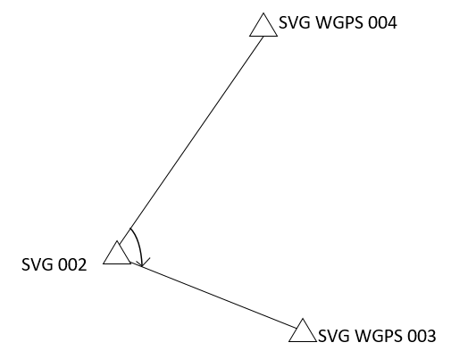

**Figure 3: Sketch layout of the control used**

**Table 5: Angular method for Control Check.**

|  |  |  |  |  |  |  |
| --- | --- | --- | --- | --- | --- | --- |
| Station | Sight | Face | HCR | Horizontal angle | Mean | Vertical angle readings |
| SVG 002 | SVG WGPS 004 | FL1 | 00 **̊** 00’00’’ |  |  | 89 ̊ 53’ 58’’ |
|  | SVG WGPS 003 | FL2 | 117 ̊ 02’ 00’’ | 117 ̊ 02’ 00’’ |  |  |
|  | SVG WGPS 003 | FR2 | 297 ̊ 02’ 02’’ |  | 117 ̊ 01’ 59.5’’ |  |
|  | SVG WGPS 004 | FR1 | 180 ̊ 00’ 03’’ | 117 ̊ 01’ 59’’ |  | 270 ̊ 05’ 54’’ |

Horizontal angle (Ha) of FL = FL2 - FL1 (3.1)

Horizontal angle (Ha) of FR = FR2 - FR1 (3.2)

Mean angle (Ma) = FL2 - FLI + FR2 - FR1 / 2 (3.3)

Where; HCR = Horizontal Circle Readings,

FL = Face Left and FR = Face Right

**Reconnaissance Survey**

A holistic view of the road network with curves under study was done. Instrument Stations Station Selected where based on inter-visibility and free from obstacle and likely obstruction from human and vehicular movements. A recce diagram shows all details of features in the study area was produced and assisted greatly in primary data acquisition.

**Primary sources**

**Traversing**

The traverse was done in three loops, this includes Loop 1, Loop 2 and Loop 3 respectively. Traversing was carried out based on the basic principles working from whole to part Loop 1 started at SVG 002, 003, 004 near the faculty of environmental sciences open field which run through to main gate and back to faculty of environmental sciences SVG002. The result of loop 1 is shown in table 6.

**Leveling**

Profile levelling was adopted with interval of at twenty-five meters (25m) using a Leica Automatic Level (NA24) model.

The height of collimation method of levelling data reduction was used for reduction of points observed in the field. Consider the model;

HI = RL of BM + BS of BM (3.4)

RL of observed Points = HI – IS or HI – FS (3.5)

Whereas;

HI = Height of Collimation, RL = Reduced Level, BS = Back Sight reading, IS = Intermediate Sight readings and FS = Fore Sight reading

1. **Results**

The results of the study are presented in tables and map and are contained in tables 6 and 7, and figure 4 and 5.

|  |  |  |  |  |  |  |  |
| --- | --- | --- | --- | --- | --- | --- | --- |
| Station From | Bearings | Distances  (m) | ΔN (m) | ΔE (m) | Northings(m) | Eastings(m) | Station To |
|  |  |  |  |  | 530903.200 | 275962.761 | WGPS002 |
|  | 44˚ 58’ 0’’ | 42.564 | 30.115 | 30.08 | 530933.315 | 275992.841 | WGPS003 |
| GPS 003 | 67˚ 20’ 12’’ | 42.276 | 16.289 | 39.011 | 530949.637 | 276031.841 | Peg 1 |
| Peg 1 | 89˚ 59’ 26’’ | 130.508 | 0.021 | 130.507 | 530949.658 | 276162.358 | Peg 2 |
| Peg 2 | 89˚ 47’ 21’’ | 193.003 | 0.710 | 193.001 | 530950.368 | 276355.357 | Peg 3 |
| Peg 3 | 96˚ 56’ 30’’ | 73.857 | -8.926 | 73.315 | 530941.459 | 276428.672 | SVG 005 |
| SVG 005 | 274˚ 50’ 5’’ | 41.581 | 3.504 | -41.433 | 530944.969 | 276387.238 | Peg 4 |
| Peg 4 | 268˚ 57’19’’ | 134.699 | -2.455 | -134.67 | 530942.518 | 276252.561 | Peg 5 |
| Peg 5 | 269˚ 33’16’’ | 158.172 | -1.229 | -158.16 | 530941.221 | 276094.393 | Peg 6 |
| Peg 6 | 250˚ 15’33’’ | 94.777 | -32.01 | -89.206 | 530909.278 | 276005.186 | Peg 7 |
| Peg 7 | 261˚ 44’42’’ | 42.878 | -6.156 | -42.433 | 530903.135 | 275962.269 | SVG 002 |
| SVG 002 | 44˚ 58’ 00’’ | 42.568 | 30.117 | 30.089 | 530933.315 | 275992.841 | WGPS 003 |

**Table 6: Specimen of Traverse Computation**

**Table 7: Coordinates and reduced level of some Points for Loop 1**

|  |  |  |  |
| --- | --- | --- | --- |
| **Station ID** | **Northings(m)** | **Eastings(m)** | **Reduced levels(m)** |
| SVG002 | 530903.200 | 275962.761 | 11.986 |
| WGPS003 | 530933.315 | 275992.841 | 8.876 |
| PEG1 | 530940.404 | 276024.482 | 9.502 |
| PEG2 | 530955.036 | 276253.162 | 10.497 |
| Station ID | Northings(m) | Eastings(m) | Reduced levels(m) |
| SVG005/001 | 531094.098 | 276428.721 | 11.986 |
| PEG3 | 5301008.437 | 276484.455 | 11.624 |
| PEG4 | 531213.551 | 276640.299 | 11.599 |
| PEG5 | 531146.682 | 276559.450 | 11.610 |
| PEG6 | 530988.125 | 276442.656 | 11.625 |
| PEG7 | 530955.015 | 276417.448 | 11.902 |
| PEG8 | 530949.205 | 276282.391 | 10.925 |
| PEG9 | 530949.637 | 276031.851 | 11.982 |
| PEG10 | 530947.925 | 275839.998 | 11.626 |

**Table 8: Coordinates and reduced level of some Points for Loop 2**

|  |  |  |  |
| --- | --- | --- | --- |
| Station ID | Northings(m) | Eastings(m) | Reduced levels(m) |
| SVG002 | 530903.200 | 275962.761 | 11.986 |
| WGPS003 | 530933.315 | 275992.841 | 8.876 |
| PEG1 | 530947.925 | 275839.998 | 11.629 |
| PEG2 | 530940.520 | 27644.032 | 9.143 |
| PEG3 | 530742.921 | 275646.502 | 7.645 |
| PEG4 | 530543.043 | 275649.074 | 6.910 |
| PEG5 | 530543.043 | 275651.624 | 8.064 |
| PEG6 | 530343.136 | 2756653.995 | 10.133 |
| SVG005/05 | 530103.649 | 275648.306 | 10.123 |

**Table 9: Coordinates and reduced level of some Points for Loop 3**

|  |  |  |  |
| --- | --- | --- | --- |
| Station ID | Northings(m) | Eastings(m) | Reduced levels(m) |
| SVG005/05 | 530103.649 | 275648.306 | 10.123 |
| PEG1 | 530018.121 | 275690.996 | 8.633 |
| PEG2 | 529877.612 | 275833.089 | 8.174 |
| PEG3 | 529762.836 | 275947.054 | 6.146 |
| PEG4 | 529685.669 | 275846.001 | 6.148 |
| PEG5 | 529834.776 | 275907.421 | 6.724 |
| PEG6 | 529834.216 | 276032.009 | 4.580 |
| PEG7 | 529958.490 | 276072.037 | 5.077 |
| PEG8 | 530065.908 | 275970.748 | 6.565 |
| SVG05/04 | 530099.621 | 275958.691 | 7.191 |

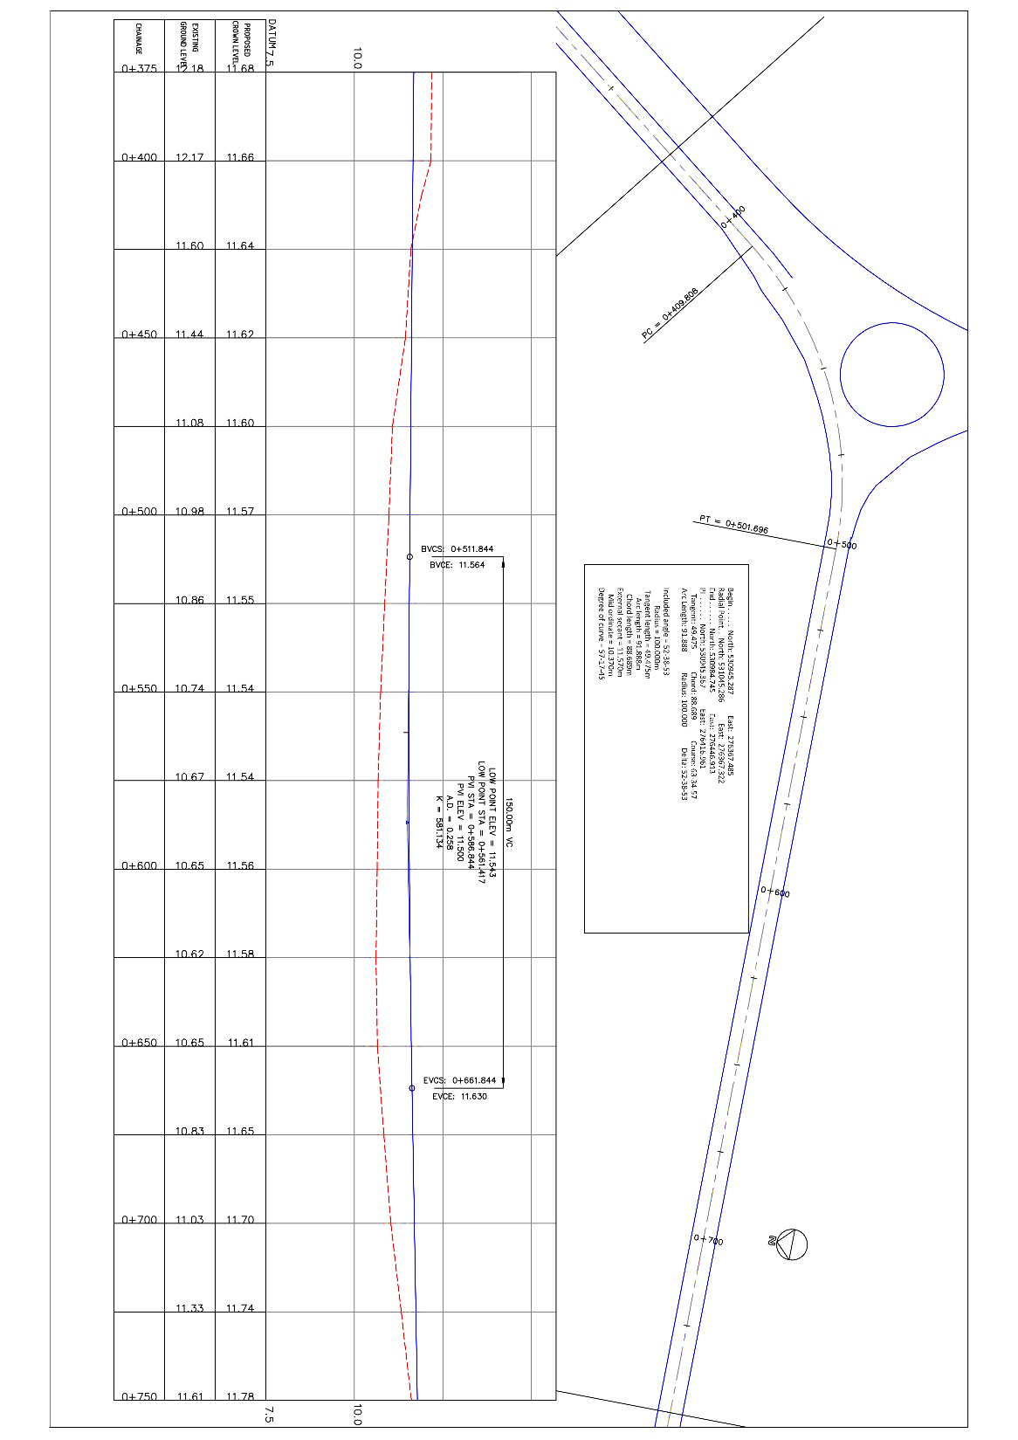

**Figure 4: Specimen of Horizontal Curve A Identified in the Study Area**

**Curve (A) Parameters**

The parameters of curve A is shown below

Chainage distance 0+375-0+750

Begin: 530945.287mN 276367.485mE

Radial Point: 531045.286mN 276367.322mE

End: 530984.745mN 276446.913mE

PI: 530945.367mN 276416.961mE

Included angle = 52-38-53, Radius = 100.000m

Tangent length = 49.475m, Arc length = 91.888m

Chord length = 88.689m, External secant = 11.570m

Mid ordinate = 10.370m, Degree of curve = 57-17-45

**Curve B Parameters**

This curve is located within road B and basketball court.

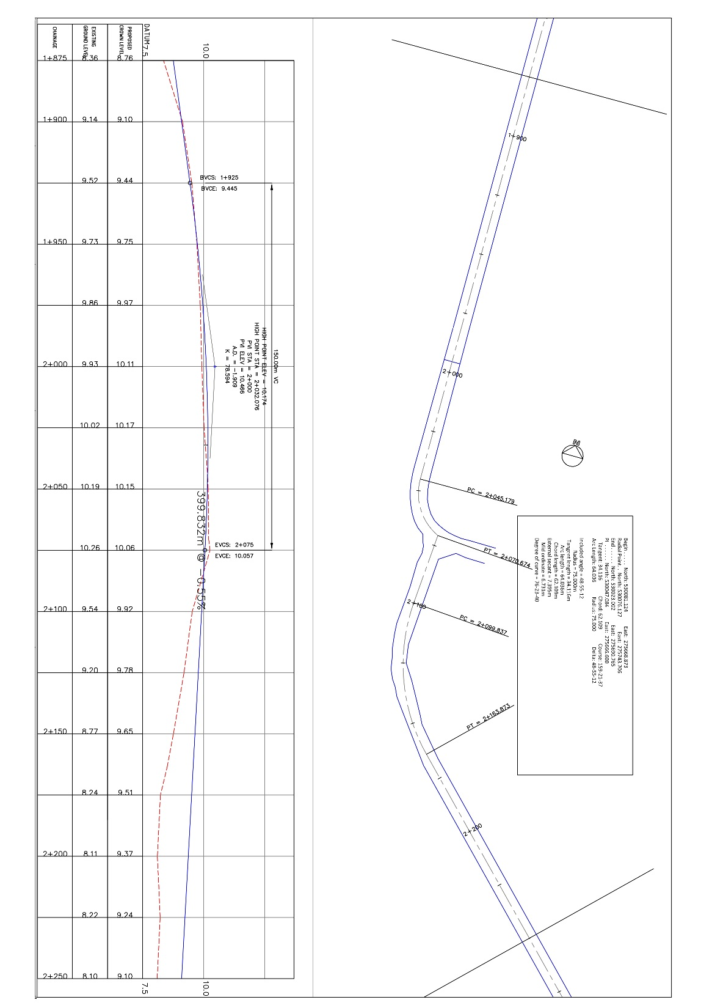

**Figure 5: Specimen of Horizontal and Vertical Curve B determined in the Study Area**

**Curve (B) Parameters**

The parameters of curve B is shown below

Chainage distance 1+1875-2+250

Begin: 530081.124mN 275668.873mE

Radial Point: 530076.127mN 275743.706mE

End: 530023.002mN 275690.765mE

PI: 530047.084mN 275666.600mE

Included angle = 48-55-12, Radius = 75.000m

Tangent length = 34.116m, Arc length = 64.036m

Chord length = 62.109m, External secant = 7.395m

Mid ordinate = 6.731m, Degree of curve = 76-23-40

**Discussion of Findings**

The Field data were reduced to obtain horizontal and vertical angles and further processing and map production were carried out using Auto-CAD 2007 and Auto-CAD 3D Software. An accuracy of approximately 1:16,000 and 0.008 were achieved for traversing and levelling operations respectively, which was within the allowable degree of accuracy. The findings revealed that the sections of the road network under study covers a total length and width of approximately 2.93km and 7.00m respectively. The parameters for 5 horizontal curves and 6 vertical curves were determined and will be useful to the University Estate and Works Department in ascertaining if the curves parameters noted were in line with the design prior to construction works.

Table 6 is a specimen of traverse information computed using the first principle of field data manipulation. The table consists of final corrected coordinates of some points traversed, traverse point identities, distances and directions. Tables 7, 8, and 9 contains summary of information about traverse loop 1, 2 and 3 respectively. The information revealed that the highest elevation was11.986m and the lowest elevation was 4.580m. Figures 4 and 5 is are specimens of some horizontal and vertical curves identified with parameters determined.

1. **Conclusion**

The traversing and levelling techniques used yielded the required results that addresses the aim and objectives of the study. The expected degree of accuracy for every stage of the project work was achieved. The desire to define the alignment of the road, determination of existing curves and its parameters of selected road network within-the main campus of Rivers State University was achieved.

1. **Recommendation**

The following recommendations are highlighted;

1. The curve parameters determined in this study should be used to validate the curve as-designed prior to road construction and check for possible variation.
2. Sections of the road network with lowest elevation should be monitored for flood, especially when it rains heavily.

**REFRERENCES**

1. Eze, P. I., Lawson, N. and Pepple G. T. (2024). Investigation of Drainage Inverts levels for optimal Functionality in a Section of Onne Multipurpose Terminal: Rivers State, Nigeria. IRE 1705508 Iconic Research and Engineering Journals. IRE Journals, 7(8):219-225. ISSN: 2456-8880 online
2. Eze P. I; Hart, L, and Eke, S. N. (2022). Assessment of Relative Accuracy of Selected Total Station Instrument for a Closed Traverse Survey. Journal of Communications Technology and Electronics, 8(5), 72-78.
3. Ghilani, C. D. and Wolf, P. R. (2008). Elementary Surveying and Introduction, An Introduction to Geomatics (13th Ed.), New York; Pearson Publisher, 2012. Pp 468-469, 470-471, 504-505.
4. Gregory J. T. (2015). Roadway Horizontal Alignment. Continuing Education and Development, Inc. 22 stonewall court, woodcliff lake, NJ07677.
5. Pepple G. T., Eze, P. I. and Zagha B. F. (2024). Facility Mapping of Street Lighting in Rivers State University Main Campus, Port Harcourt: Nigeria. International Journal of Scientific Research and Engineering Development, 7(1):496-50.
6. Musa, J.I., Otachi, M. Y., Saliu, I. I., Muhammed, I. M., Kuti, I. A., Ezekiel, L. P. and Joseph, M. S. (2019). Assessment of Urban Drainage Systems in Nigeria: A Review. Department of Agricutural and Bioresources Engineering, Federal University of Technology, Minna, Niger State.
7. Qianqian, Z. (2014). AReview of Sustainable Urban Drainage Systems Consedering the Climate Change and Urbanization Impacts. Water, 2014: (6):976-992.
8. Parkinson, J., Tayler, K. and Mark, O. (2007). Planning and Designof Urban Drainage Systems in Formal Settlement in Developing Countries. Urban Water Journal, 4(4):137-149
9. Schofield, W. (2001). Engineering Surveying. Butterworth-Heinemann. ISBN 978-0- 7506- 4987-2.
10. Wakjira, T. D. (2018). A Review of Sustainability of Urban Drainage Traits and Consequences. Journal of Sedimentary Environment 3(3):131-137. Doi: 10:12957/jse.2018.3782
11. Uren, J. and Price, W. F. (2010), “Surveying for Engineers” Fifth Edition Published by Palgrave Macmillan.