***Original Research Article***

**FINITE ELEMENT MODELLING OF TRANSIENT SEEPAGE AND SEDIMENT TRANSPORT SOLUTIONS IN DIAPHRAGM WALLS FOR COASTAL PROTECTION WORKS IN THE NIGER DELTA.**

**ABSTRACT**

In this study, a 2D transient seepage and sediment transport analyses in diaphragm walls for coastal protection works were investigated using the finite element method. Transient seepage and sediment transport (flow boundary conditions) are one of the major controlling factors in the stability analysis of diaphragm walls for coastal protection works. Seepage and sediments transport reduce the passive resistance of the soil through piping and scours effect leading to stability problems. Representative soil stratigraphy from the Niger Delta region subjected to transient seepage (long term steady state seepage with a slow drawdown over a period of 24hrs) conditions modelled using a finite element method-based product Geostudio 2018R2V9.1(SEEP/W). Sediments (soil particles) movement by advective process (water only) simulated and tracked using the seepage flow velocities. Sediments transport velocities and total travelled distances due to seepage forces for each case study computed. The finite element solutions are based on the Galerkin’s weighted residual method and the use of Lagrange isoparametric triangular or quadrilateral elements. The seepage and sediment transport analyses results obtained showed higher values of water rates and particle transport for diaphragm wall embedded in sand layer than clay or sand with clay intercalations. Therefore, it is recommended that seepage and sediment transports must be considered in the analysis and design of diaphragm walls for coastal protection works in the Niger Delta region.

**Keywords:** Finite Element, Modelling, Transient Seepage, Sediment Transport, Geostudio, Diaphragm Walls, Coastal Protection, Niger Delta

**1. INTRODUCTION**

The construction of coastal structures along the shoreline of the Niger Delta region have been on increase due to the high offshore demands from the activities of the oil/gas industries and cargo transportation through waterways. Most coastal structures are founded on deep foundations with diaphragm walls for shoreline (coastal) protections or as quay walls. Diaphragm walls are flexible/embedded retaining walls that depend to a significant extent or even wholly on the earth passive thrusts below excavation level and resistance forces provided by the support systems [1]. The difficult/adverse coastal environmental conditions including turbulent tidal waves (repeated variation in water levels, currents, and wave impacts) results in saturated or unsaturated soil conditions with time-dependent flow and pore-water pressure fluctuations along shorelines. Geotechnical engineering problems are mainly arisen due to presence of ground water movement or seepage in earth structures/soil [2]. The flow of water within a particulate medium occurs due to an energy imbalance, in which case, water flows from the high-level energy towards the low-level energy [3]. One of the major problems that cause failure of coastal structures is seepage through and/or under, which occurs due to the difference in water level between the upstream and downstream [4]. Seepage is the flow of water under gravitational forces in a permeable medium. The flow rate through the soil is affected by the density/viscosity of the liquid (water), degree of saturation, void ratio, porosity and the gradation or particle size distribution [5]. Seepage results in sediment transport through surface erosion/scour which reduces the depth of penetration (embedment) of the wall leading to decrease in the passive resistance force and increase in the active forces acting on the wall. Simulation of seepage and sediments transport through soils (both saturated and unsaturated conditions) results in the computation of fluxes, pore-water pressures distributions and water velocity/pathway (migration of sediments) needed for detailed engineering analysis/design of diaphragm walls along the shorelines. The alarming rates of failure of coastal structures due to seepage and sediment transport problems of diaphragm walls have been a major problem in the Niger Delta region affecting adjoining quay apron stacking areas and disruption of offshore productions/cargo transportation. For these reasons, transient seepage and sediments transport in diaphragm walls for coastal protection works and also dam body continue to be major geotechnical problems and are being investigated by many researchers.

[6] used the finite element method to investigate steady state seepage in the dam body and foundation having isotropic and anisotropic materials based on the Galerkin’s approach and the effects of horizontal drainage length and cut off wall also determined.[7] evaluated the effect of steady state seepage flow on the stability of vertical sheet pile walls in a cohesionless soil in terms of the rotation about the anchor attachment.[8] modelled the stability of sheet pile walls subjected to seepage flow by slip lines (method of stress characteristics) and finite elements method. [9] developed a finite element transient seepage model for saturated-unsaturated soil systems called TRASEE and used it to solve example problems in dam body and compared values found with the results by other methods. [4] investigated the seepage through and underneath the hydraulic structures with the finite volume methods (FVM). [10] aimed to determine the total seepage discharge and velocities through homogenous earth dams provided with a vertical sheet pile and formed on impervious foundation. [11] calculated the seepage under embankment dams, earth systems and environment using the finite element-based SEEP/W software and compared the accuracy of the results with physical modelling results. [12] conducted series of tests for seepage flow through homogenous and anisotropic soils and compared results with finite element method. [13] computed seepage and pore pressure behaviour using soil water characteristic curve (SWCC) and permeability functions obtained from laboratory tests on undisturbed samples in 1-D finite element analysis (SEEP/W).

Detailed engineering evaluations must be carried out to determine the amount of seepage and sediments transport during the analysis/design phase before the construction of diaphragm wall for coastal protection works. The principal quantity (dependent variable) solved for in a finite element solution of a seepage problem is the pressure head at each nodal point in the finite element mesh [14]. For such complex stratigraphy (multi-layer saturated/unsaturated soils) with transient flow and varying boundary conditions, analytical solutions such as the graphical use of flow nets are not possible rather high-power numerical methods provide the needed solutions. Due to repeated fluctuations of water level along the shoreline, volumetric water content and hydraulic conductivity functions for transient flow conditions provide the realistic pore-water pressure distributions needed for analysis and design of diaphragm wall for coastal protection works. Determination of realistic pore-water pressures distribution (unsteady state condition) using effective stress analysis and particle tracking (transport of sediments by advection process) resulting from water level fluctuations can be best handled using finite element method [15]. Finite element method is very useful in finding solutions to differential equations that have no close form or analytical solutions [16].

In this paper, saturated-unsaturated soil conditions were considered and finite element method was used to compute transient seepage and sediments transport through the soils.

**2.** **METHODOLOGY**

**2.1 Study Area**

The area of the research is the Niger Delta region in the southern part of Nigeria bordering with the Atlantic Ocean, Figure 1. In Niger Delta, diaphragm walls are used for shoreline protections such as in Nigerian Ports Authority berths (4, 5, 6, 9,10,11 and 12), West African Container Terminal berths (7 and 8) in Federal lighter Terminal and Federal Ocean Terminal Onne Rivers State and Nigerian Port Authority Warri in Delta State. The sites as shown in the goggle map are located in Onne in Eleme local government area of Rivers state Nigeria. They are accessible through the Federal Ocean Terminal junction and also through Ogu creek and Bonny River at the back side. Total area of the site in the Federal Lighter Terminal (FLT) is 26,250sqm comprising of berth 1-3 and 131,250sqm comprising of berth 1-15 in the Federal Ocean Terminal (FOT) of the Nigerian Ports Authority (NPA) Onne. Berths 1-3 in FLT and Berths 1- 11 in the FOT lie along the Ogu creek side while Berth 12-15 in FOT lie along the Bonny River side. The sites are approximately 10km from the Atlantic coast with the Federal Ocean Terminal actually located in an inlet, where tidal currents play a major role in water flow. The areas investigated falls within the tertiary Niger Delta which occurs at the south-central sedimentary basin of Nigeria bordering the Atlantic Ocean and extends from about 3º-9ºE and latitude 4º30’ - 5º20’N (from Berth 9-11).

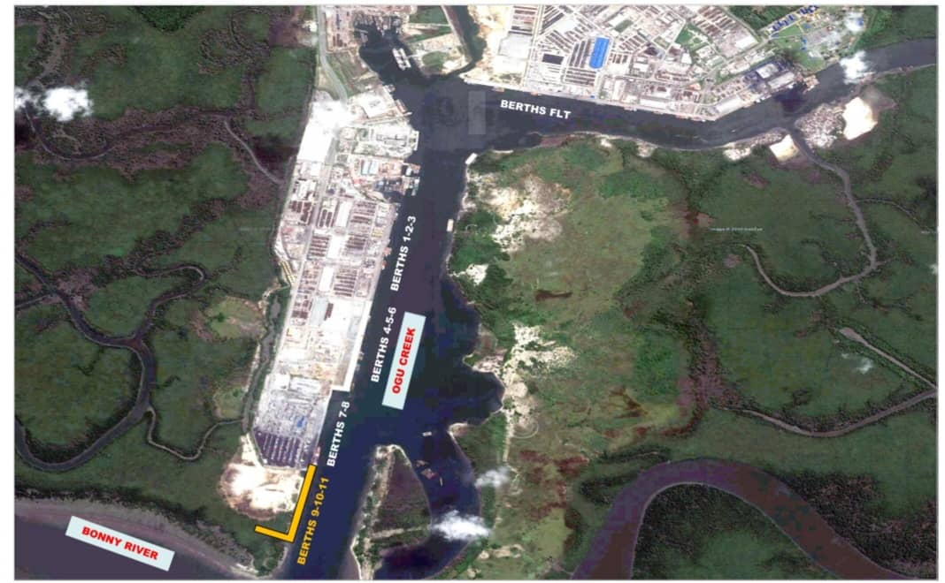

**Figure 1. Goggle maps of Onne study area**

**2.2 Sources of Data**

Seepage and sediment transport analyses using finite element methods require acquisition of relevant data/information such as levels, geotechnical subsoil conditions and meteomarine data which serve as input data. Relevant data used were obtained from standard codes of practice, authorities and reputable sources. Laboratory tests results on representative samples taken from these areas from Dutch Cone penetrometer tests (CPT) to refusal depths and various geotechnical boreholes to depth of 40 metres below existing ground level (Standard Penetration Tests) showed similar lithology (subsoil and groundwater conditions) which have been classified into 3 categories. All the tests were executed in accordance and compliance with the specifications contained in [17].

**2.2.1 Geotechnical Soil Stratigraphy, Properties and Boundary Conditions Data for SEEP/W Modelling.**

Table 1 shows the soil stratigraphy for the 3-Case study with a probe depth of 40m, as used for SEEP/W Modelling.

**Table 1. Soil Stratigraphy for SEEP/W Modelling**

|  |  |  |  |  |  |  |  |  |  |
| --- | --- | --- | --- | --- | --- | --- | --- | --- | --- |
| **Strata Unit** | **Case Study 1** | | | **Case Study 2** | | | **Case Study 3** | | |
|  | Description | Top level  (m) | Bottom level  (m) | Description | Top level  (m) | Bottom level  (m) | Description | Top level  (m) | Bottom level  (m) |
| Unit 1 | Hydraulic fill | +0.00 | -3.00 | Hydraulic fill | +0.00 | -1.50 | Hydraulic fill | +0.00 | -1.50 |
| Unit 2 | Hydraulic fill | -3.00 | -15.00 | Hydraulic fill | -1.50 | -10.00 | Hydraulic fill | -1.50 | -10.00 |
| Unit 3 | LSS to MDS | -15.00 | -19.00 | LSS to LS | -10.00 | -24.00 | LSS to LS | -10.00 | -24.00 |
| Unit 4 | Soft to Firm Clay | -19.00 | -24.00 | Firm to Stiff Clay | -24.00 | -40.00 | MDS to DS | -24.00 | -40.00 |
| Unit 5 | MDS to DS | -24.00 | -40.00 |  |  |  |  |  |  |

*Hydraulic fill: Loose Silty Sand to Loose Sand, LSS: Loose Silty Sand, MDS: Medium Dense Sand, DS: Dense Sand

Preliminary dredging level of existing unit 1 and 2 (very soft to dark grey organic peaty Clay) to depth of -15m for case study 1, unit 1 and 2 to a depth of 10m for both case study 2 and 3 were assumed completed. Sandfill taken from riverbed with no selection likely in very loose state once discharged has been placed to +0.00m. The fill materials are granular (non-cohesive) soil materials with the same property as the loose silty sand and are allowed for compaction with the fill compaction requirements. This material is described as hydraulic fill. Table 2 shows the geotechnical properties of the soil as used in the SEEP/W modelling.

**Table 2. Geotechnical Properties of Soil for SEEP/W Modelling**

|  |  |  |  |  |  |  |  |
| --- | --- | --- | --- | --- | --- | --- | --- |
| **Parameter** | **Name/**  **Symbol** | **Unit** | **Hydraulic fill** | **LSS to MDS** | **Soft to Firm Clay** | **MDS to DS** | **Firm to Stiff Clay** |
| Hydraulic | Model | - | Saturated/  Unsaturated | Saturated/  Unsaturated | Saturated/  Saturated | Saturated/  unsaturated | Saturated/  unsaturated |
| Horizontal Conductivity | Kx | m/day | 0.60 | 0.60 | 8.64E-02 | 0.60 | 0.15 |
| Vertical Conductivity | Ky | m/day | 0.60 | 0.60 | 1.7E-05 | 0.60 | 0.15 |
| Saturated Water Content | ϴs | - | 0.41 | 0.41 | 0.65 | 0.41 | 0.55 |
| Compressibility | av | /KPa | 1.0E-6 | 1.0E-6 | 4.24E-4 | 1.0E-6 | 4.24E-4 |
| Residual Water Content | ϴr | - | 5.0E-5 | 5.0E-5 | 6.0E-6 | 1.0E-6 | 1.042E-5 |

The boundary conditions used for SEEP/W modelling and analysis, are as reported in Table 3.

**Table 3. Boundary Conditions (BC) for SEEP/W modelling.**

|  |  |  |  |
| --- | --- | --- | --- |
| **Boundary Condition** | **Long Term Steady State** | | **Transient** |
| Name | Upstream | Downstream | Slow drawdown |
| Type | Hydraulic | Hydraulic | Hydraulic |
| Kind | Water total head | Water total head | Water total head |
| Constant | 38.5m | 38m | Not applicable |
| Function | Not applicable | Not applicable | (0hr,38m) and 24hrs,35.4m) |

**2.2.2 Waves, Current, Seismic Input, Levels, Ground Water Conditions**

The site is about 10km from the Atlantic Coast and for this reason no natural waves and the only water level oscillation is due to movement of vessels (ships). The wave height is considered to be 500mm. The Federal Ocean Terminal is located in an inlet hence tidal currents play major roles in water flow. Ebb current velocity can be considered equal to 1.5 knots (0.75m/sec). Information on Tide levels at Onne Port are similar to Bonny town and are stated in Table 4 as obtained from Tidal predictions for Nigerian ports and River Channels [18].

**Table 4. Tidal Level for SEEP/W modelling.**

|  |  |  |  |
| --- | --- | --- | --- |
| Description* | Tide Level (m) | Description* | Tide Level(m) |
| HAT | +2.70 | MSL | +1.50 |
| MHWS | +2.30 | LAT | +0.10 |
| MHWN | +1.90 |  |  |

*HAT: Highest Astronomical Tide, MHWS Mean High Water Springs, MHWN: Mean High Water Neaps, MSL: Mean Sea Level, LAT: Lowest Astronomical Tide

No seismic design is applicable to diaphragm walls design in the Niger Delta region hence, pseudo-static ground movement not considered in the analysis. Finally, the existing ground water level at the site from geotechnical reports is 1.5m below existing ground level. Properties of the diaphragm wall as used in the analysis are:

Top level = + 0.00m Elastic Modulus, E = 20E6kpa

Toe level = - 30.00m Unit bulk weight, γ = 25kN/m3

Length, L = 30m Area, A = 2.2m2/m

Thickness of wall =1100mm Net width of wall = 2000mm

Moment of Inertia, I = 3.24m4/m

**2.3 Transient State Seepage**

A flow is transient because of change in boundary conditions with time and ability of the soil to release (pumpage) or store water (recharge) or change in volumetric water content. In a transient (unsteady) state flow condition, the following requirements apply:

1. soil deformation occurs (associated with volume change)
2. the pore water pressure changes with time and the rate of flow also changes (varying pressure head and varying flux rate with time)
3. saturated-unsaturated soil conditions applied
4. flow is assumed to be turbulent (not uniform over the entire area perpendicular to the flow).
5. under seepage (confined flow) and seepage through (unconfined flow) are fully handled
6. time steps are required
7. need to start from known initial condition.

In transient flow, water is either stored in or discharged from the medium and hence,

Flow that exits (extraction – case of water drawdown) = flow that enters – flow discharged during a time interval

Flow that exits (injection – case of water filling) = flow that enters + flow stored during a time interval [9].

**2.3.1 2-D Transient State Seepage Formulations**

The general mass balance equation for transient flow in unsaturated soil according to Richards states that the sum of the rates of change of flow in x, y, and z directions plus the external applied flux is equal to the rate of change of the volumetric water content with respect to time [13].

Mathematically expressed as:

$\frac{d}{dx}(Kx\frac{dh}{dx}$) + $\frac{d}{dy}(Ky\frac{dh}{dy} )+\frac{d}{dz}(Kz\frac{dh}{dz}$) + Q = $\frac{dθ}{dt}$ (1)

In terms of Specific yield, Equation 1 is rewritten as:

$\frac{d}{dx}(Kx\frac{dh}{dx}$) + $\frac{d}{dy}(Ky\frac{dh}{dy} )+\frac{d}{dz}(Kz\frac{dh}{dz}$) + Q = S $\frac{dh}{dt}$ (2)

Where:

h = total head, Kx, Ky and Kz = the hydraulic conductivities in x, y and z directions

Q = the applied boundary flux or source term (injection or extraction), t = time

ϴ = the volumetric water content and S = Specific yield.

By Galerkin’s Weighted Residual Method (GWRM), the errors or residual/difference between the approximate solution and the true solution is orthogonal to the functions used in the approximation i.e., equal to zero as assumed by [19]. Applying GWRM and integration by parts (Green’s theorem), the following transformation results:

$ʃʃ_{R}\sum_{i=1}^{n}{\left[Kxxb\frac{{dN}_{i}^{T}}{∂X}\frac{∂Nj}{∂x}+Kyyb \frac{{dN}_{i}^{T}}{∂y}\frac{∂Nj}{∂y}\right]}h_{j}∂x∂y-ʃʃ_{R}SN_{i}^{T}N_{j}∂x∂y\frac{∂h}{∂t}+ʃʃ_{R}QN_{i}^{T}∂x∂y - ʃ_{L}N_{i}^{T}\left(Kxxb\frac{∂h}{∂x}L_{x}+Kyyb\frac{∂h}{∂y}L_{y}\right)∂L=0$ (3)

The above equation is expressed in matrix form as:

[A] [h] + [M $]\left[\frac{dh}{dt}\right]-$ [p] = 0

This can be rewritten in simplified form as:

∆t [A] [h] + [M]{h1} = ∆t [P] + [M]{h0}

The Transient Finite element 2-D equation for Seep/W is written as [20]:

∆t [K] + [M]{H1} = ∆t [Q1] + [M]{H0} (4)

H1 = new unknown or head at each time step

H0 = initial condition at the start of the time step

Q1 = boundary condition at the end of the time step

[M] = mass matrix (it has volume or area and slope. Mw)

In Seep/w, only groundwater flow due to pressure and gravity-driven gradients is considered as default physical processes [20].

**2.4 Method of Data Analysis**

This is done using the finite element software Geostudio 2018R2V9.1(SEEP/W). The point coordinates for the general geometry are (-30,0), (35,0), (-0.55,10), (0.55,10), (-30,16), (-0.55,16), (0.55,16), (36,16), (-30,24), (-0.55,21), (0.55,21), (35,21), (-30,24), (-0.55,33), (-30,37), (-0.55,37), (0.55,37), (35,37), (-30,40), (-0.55,40),(-0.55,40), (0.55,40), (35,40), (-30,28), (-0.55,28), (-30,26), (-0.55,26) and (35,40).

**2.4.1 Seepage Analysis (SEEP/W).**

**2.4.1.1 Long -Term Steady State Seepage Analysis (Initial Seepage condition).**

The following were the key components for finite element long-term seepage analysis solutions:

1. Input data as given in Tables 1 and 2 used and the entire domain discretized into 493 elements having an approximate global element size of 2.4m. The dredging depth at the seaside is -10m.
2. Boundary conditions as in Table 3 was implemented and the solution obtained.

**2.4.1.2 Transient State Seepage Analysis (Slow drawdown Seepage condition).**

The following were the key components for finite element transient seepage analysis solutions:

1. The model for the long-term steady state cloned, initial pore water pressure was obtained from it and duration of a day, 15-time steps with an exponential initial increment size of 0.05 days was used. Input data as in long-term condition was also used.
2. Boundary conditions as in Table 3 used in adopting the spline data point function and the solution was obtained.
   * 1. **Sediment Transport Analysis**

i. The same model for transient state seepage analysis with slow drawdown was used.

ii Solute particles were introduced closer to the under tip of the diaphragm wall and downstream boundary to determine the solute particles velocity and total travelled distance due to seepage forces. A number of particles can be introduced arbitrarily to the flow system at any given position either by expressing its x & y coordinates or assigning directly. Particles are assumed to move in the direction of the water flow with the same speed as the water flows. The new positions of the particles are computed according to the average linear/ actual velocity of the groundwater. The SEEP/W transient seepage models for case study 1 at 0hr and 24hrs are as shown in Figures 2 and 3.

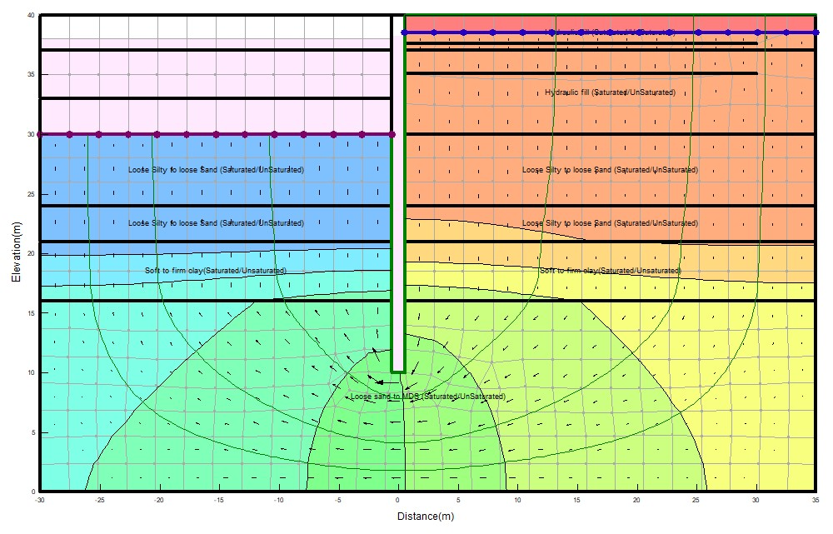

**Figure 2. Case study 1 Seep/w Transient model @ dredge depth of -10m and 0hr**

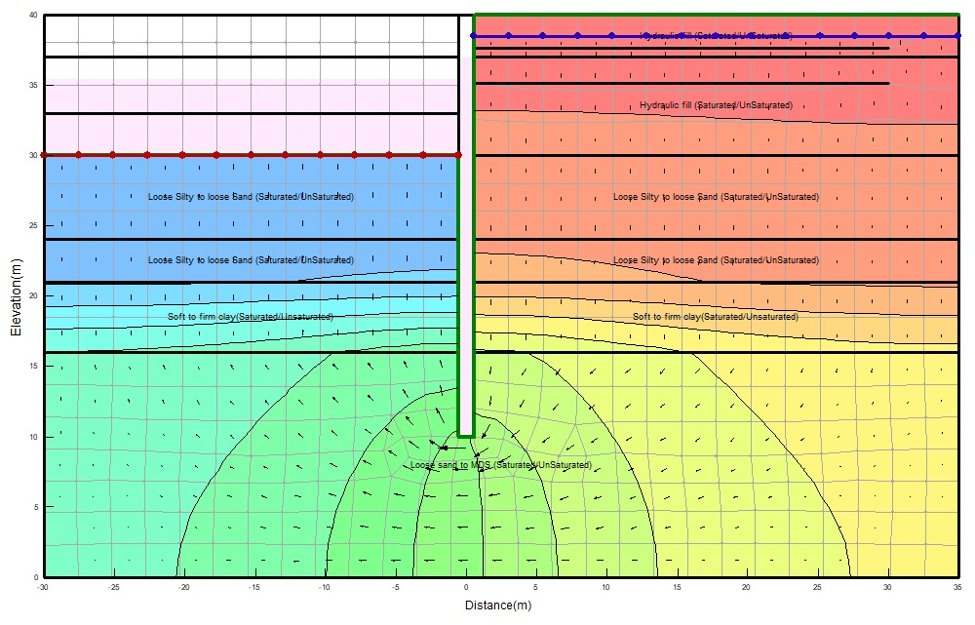 **Figure 3. Case study 1 Seep/w Transient model @ dredge depth of -10m and 24hr****s**

**3. RESULTS AND DISCUSSION**

**3.1 Results**

**3.1.1 Seepage Analysis Results**

From the transient seepage analysis with 15-time step for 24hrs, the following results as presented in Table 5 were recorded per metre length. Considering the time of zero hour and 24hrs, Case 1 has (0hr, 4.042E-5m3/s) and (24hrs, 2.49E-4 m3/s), Case 2 has (0hr, 2.39E-5 m3/s) and (24hrs, 1.43E-4 m3/s), Case 3 has (0hr, 6.63E-5 m3/s) and (24hr, 4.11 E-04m3/s).

Graphical display of the variations in water fluxes with time under the diaphragm wall for the 3-case study are represented graphically in Figure 4**.** Gradients are computed at Gauss integration points and averaged to the nodes for contouring. It is a function of element size and geometry. The resultant gradient of ix and iy gives the XY- gradient; if it approaches zero, then the effective stress is zero. Hence, it must be less than 1 as developed by Casagrande for flow nets having upward flow. The element with the highest exit gradient is important because it shows the area or element with the lowest factor of safety.

**Table 5. Transient water rates (Seepage) under diaphragm wall for the different Case study.**

|  |  |  |  |
| --- | --- | --- | --- |
| **Time**  **(hr)** | **Case Study 1**  **(Water rate m3/s)** | **Case study 2**  **(Water rate m3/s)** | **Case study 3**  **(Water rate m3/s)** |
| 0 | 4.04E-05 | 2.39E-05 | 6.63E-05 |
| 1.20 | 4.94E-05 | 2.73E-05 | 8.35E-05 |
| 2.45 | 6.03E-05 | 3.24E-05 | 0.000101497 |
| 3.75 | 7.16E-05 | 3.84E-05 | 0.000120176 |
| 5.10 | 8.35E-05 | 4.51E-05 | 0.000139574 |
| 6.50 | 9.57E-05 | 5.22E-05 | 0.000159689 |
| 7.95 | 0.000108431 | 5.97E-05 | 0.000180523 |
| 9.47 | 0.000121714 | 6.75E-05 | 0.000202315 |
| 11.05 | 0.000135581 | 7.57E-05 | 0.000225065 |
| 12.68 | 0.000149885 | 8.42E-05 | 0.000248533 |
| 14.40 | 0.00016492 | 9.31E-05 | 0.000273199 |
| 16.17 | 0.000180392 | 0.000102237 | 0.000298583 |
| 18.02 | 0.000196594 | 0.000111826 | 0.000325165 |
| 19.93 | 0.00021338 | 0.00012176 | 0.000352704 |
| 21.93 | 0.000230896 | 0.000132125 | 0.000381441 |
| 24.00 | 0.000248996 | 0.000142837 | 0.000411135 |

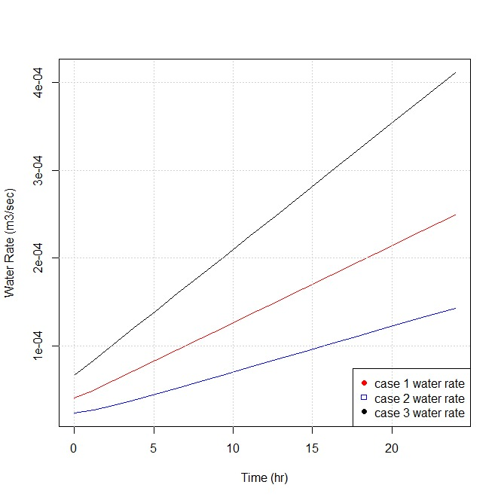

**Figure 4. Variations in water fluxes with time under the diaphragm wall for the different Case study.**

Water XY-gradients versus time at the downstream cross section for 3-case study presented in Table 6. Also, graphical display of the variations in XY-gradients with time at the downstream level for the 3-case study are shown in Figure 5**.**

The distribution of pore water pressure (Kpa) along the entire length of the diaphragm wall for the transient seepage analysis considering zero hour and 24hr given in Table 7 for the three-case studies.

**Table 6. Transient water XY- gradient on the downstream level for the different Case study.**

|  |  |  |  |
| --- | --- | --- | --- |
| **Time**  **(hr)** | **Case study 1**  **(Water XY gradient)** | **Case study 2**  **(Water XY gradient)** | **Case study 3**  **(Water XY gradient)** |
| 0 | 0.043382177 | 0.025708974 | 0.071220605 |
| 1.20 | 0.067203646 | 0.056308565 | 0.089995839 |
| 2.45 | 0.080996444 | 0.074755587 | 0.10928527 |
| 3.75 | 0.093622484 | 0.088351424 | 0.12934574 |
| 5.10 | 0.10639661 | 0.099455479 | 0.15017777 |
| 6.50 | 0.1195738 | 0.10926903 | 0.17178135 |
| 7.95 | 0.13320681 | 0.11847025 | 0.19415649 |
| 9.47 | 0.14746346 | 0.12754421 | 0.21756037 |
| 11.05 | 0.16234612 | 0.13670713 | 0.241993 |
| 12.68 | 0.17769862 | 0.14599006 | 0.26719718 |
| 14.40 | 0.19383439 | 0.15565203 | 0.29368729 |
| 16.17 | 0.21044012 | 0.1655451 | 0.32094895 |
| 18.02 | 0.22782914 | 0.17587752 | 0.34949654 |
| 19.93 | 0.2458448 | 0.18656793 | 0.37907288 |
| 21.93 | 0.26464374 | 0.19771562 | 0.40993514 |
| 24.00 | 0.28406932 | 0.20923107 | 0.44182614 |

.

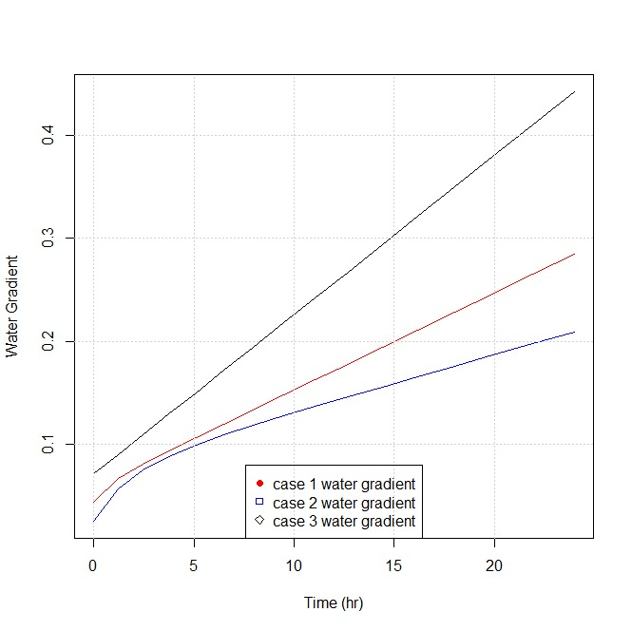

**Figure 5. Variations in water horizontal and vertical XY-gradients with time at downstream level for different Case study.**

**Table 7. Distribution of pore water pressure with depth at 0hr and 24hr for the different Case study.**

|  |  |  |  |  |  |  |
| --- | --- | --- | --- | --- | --- | --- |
| **Depth (m)** | **Case Study 1** | | **Case Study 2** | | **Case Study 3** | |
|  | Pore- water pressure at 0sec  (KPa) | Pore-water pressure at 1day  (Kpa) | Pore-water at 0sec  (KPa) | Pore-water at 1day  (KPa) | Pore-water at 0sec  (KPa) | Pore-water at 1day  (KPa) |
| 10 | 282.632 | 270.536 | 282.874 | 272.709 | 282.624 | 270.271 |
| 12 | 262.913 | 252.273 | 263.63471 | 257.201 | 263.120 | 253.348 |
| 14 | 243.050 | 233.112 | 244.05833 | 239.659 | 243.380 | 234.959 |
| 16 | 223.144 | 213.693 | 224.41648 | 221.717 | 223.584 | 216.223 |
| 18.5 | 198.800 | 192.715 | 199.51222 | 197.264 | 198.796 | 192.536 |
| 21 | 174.432 | 171.562 | 174.59213 | 172.717 | 173.980 | 168.677 |
| 24 | 144.538 | 142.199 | 144.67545 | 143.187 | 144.179 | 139.908 |
| 26 | 124.605 | 122.6058 | 124.7259 | 123.470 | 124.302 | 120.673 |
| 28 | 104.670 | 103.003 | 104.77352 | 103.737 | 104.420 | 101.407 |
| 30 | 84.734 | 83.392 | 84.819028 | 83.991 | 84.535 | 82.118 |
| 32.565 | 59.166 | 58.233 | 59.225166 | 58.655 | 59.028 | 57.354 |
| 35.13 | 33.600 | 33.067 | 33.629631 | 33.308 | 33.518 | 32.572 |
| 37 | 14.953 | 14.719 | 14.968762 | 14.826 | 14.919 | 14.499 |
| 37.63 | 8.673 | 8.537 | 8.6818905 | 8.599 | 8.653 | 8.410 |
| 38.5 | 0 | 0 | 0 | 0 | 0 | 0 |
| 40 | -15 | -15 | -15 | -15 | -15 | -15 |

**3.1.2 Sediment Transport Results**

A particle’s velocity is determined given the computed water flux and the saturated volumetric water content of the soil. Particle tracking or sediment transport under the diaphragm wall and exit from downstream involving the total distance travelled and average speed for the different case study at dredge depth of 10m presented in Table 8.

**Table 8. Particle tracking records under the diaphragm wall and at downstream exit for the different Case study.**

|  |  |  |  |  |  |  |
| --- | --- | --- | --- | --- | --- | --- |
| **Description** | **Case Study 1** | | **Case Study 2** | | **Case Study 3** | |
|  | Under the wall | Exit from down-stream | Under the wall | Exit from down-stream | Under the wall | Exit from down-stream |
| Total distance travelled (m) | 4.46 | 1.31 | 2.39 | 1.16 | 6.25 | 2.22 |
| Average speed (m/s) | 5.16E-5 | 1.52E-5 | 2.76E-5 | 1.35E-5 | 7.23E-5 | 2.56E-5 |

**3.2 Discussion**

**3.2.1 Seepage Analysis**

i). From the transient water rates (Seepage) under the diaphragm wall as presented in Table 6, Case study 1 (diaphragm wall in sand-clay-sand) showed water rate at 0hr of 4.04E-05 m3/s/m and 2.49E-04 m3/s/m at 24hr. From 0hr to 24hr, the flow rate under the diaphragm wall in this stratigraphy increased by 2.08E-04 m3/s/m due to the slow drawdown of the water level. Also, Case study 2 (diaphragm wall in sand – firm clay) showed water rate at 0hr of 2.39E-05 m3/s/m and 1.428E-04 m3/s/m at 24hr. From 0hr to 24hr, the flow rate under the diaphragm wall in this stratigraphy increased by 1.189E-04 m3/s/m due to the slow drawdown of the water level. For Case study 3, (diaphragm wall in sand – sand) showed water rate at 0hr of 6.63E-05 m3/s/m and 4.111E-04 m3/s/m at 24hr. From 0hr to 24hr, the flow rate under the diaphragm wall in this stratigraphy increased by 3.45E-04 m3/s/m due to the slow drawdown of the water level. Therefore, transient water flow rate for a 3-case study increases as the water drawdown to the lowest depth of slow drawdown of 35.4m with higher rates at the starting point 0hr to 6.5hr and gradually decreases to 24hr. The maximum transient seepage rate occurred for the 3-case study at the end of 24hrs with case study 3 (diaphragm wall fully embedded in different sand layers) having the greatest transient seepage rate as 4.111E-04 m3/s/m. The lowest transient water flow rate for the 3-case study is for case 2 (diaphragm wall embedded through sand to firm clay stratum) with a value of 1.43E-04 m3/s. These results are in agreement with literature as groundwater flowrate is very high in sand layers than in clay layers [3,5].

ii) Transient x-y gradient on the downstream level for the 3-case study increases as the water drawdown to the lowest depth of slow drawdown of 35.4m (at 24hr). The maximum transient x-y gradient occurred for the 3-case study at the end of 24hrs with case study 3 (diaphragm wall fully embedded in different sand layers) having the greatest transient x-y gradient as 0.442. The lowest transient x-y gradient for the 3-case study is for case 2 (diaphragm wall embedded through sand to firm clay stratum with a value of 0. 209.These results are in agreement with literature as groundwater flowrate increases, the rate of sediment transport on the downstream faces increases and this is more pronounced in contractive soils (sand layers) as the hydraulic exit gradient is greater than the critical hydraulic gradient [15].

**3.2.2 Sediment Transport Analysis Results**

i). From the particle tracking records under the diaphragm wall as presented in Table 8, Case study 1 (diaphragm wall in sand-clay-sand) showed an average speed of 5.16E-5 m/s with a total travelled distance of 4.46m from the initial assigned point. Also, Case study 2 showed an average speed of 2.76E-5 m/s with a total travelled distance of 2.39m from the initial assigned point and Case study 3 showed an average speed of 7.23E-5 m/s with a total travelled distance of 6.25m from the initial assigned point. The greatest average particle speed (7.23E-05m/s) was encountered for case study 3 at the end of 24hrs under the diaphragm wall. This conformed with the greatest value of seepage rate also obtained for case study 3. Hence, Seepage rate or flow rate enhances sediment transportation.

ii). From the particle tracking records exit from downstream, Case study 1 (diaphragm wall in sand-clay-sand) showed an average speed of 1.526E-5 m/s with a total travelled distance of 1.31m from the initial assigned point. Also, Case study 2 showed an average speed of 1.35E-5 m/s with a total travelled distance of 1.16m from the initial assigned point and Case study 3 showed an average speed of 2.56E-5 m/s with a total travelled distance of 2.22m from the initial assigned point. The greatest average particle speed (2.56E-05m/s) was encountered for case study 3 at the end of 24hrs at exit from downstream. Therefore, particle/sediment movement or transportation in a flexible retaining wall is more pronounced at the tip (under) the diaphragm wall as shown in the results of the 3-case study and the greatest values obtained for diaphragm walls embedded in sand layer.

**4. CONCLUSION AND RECOMMENDATION**

**4.1 Conclusion**

The following concluding remarks are made based on the results obtained:

1. Transient state seepage analysis has shown the realistic distributions of pore water pressures and fluxes due to changes in volumetric water content and hydraulic conductivity functions. Hence, transient state seepage, not steady state should be adopted in the analysis/design of diaphragm walls for coastal protection works.
2. Due to high seepage and sediment transportation rates in sand layer, the depth of embedment of diaphragm walls for coastal protection works in sand layer must be increased to accommodate sediment transport resulting from scour actions leading to reduction in passive resistance in sand.
3. For diaphragm wall embedded in sand, surface pavement of the backfill or drains introduction on the wall with filters reduces seepage/sediment transport problems affecting wall stability.

**4.2 Recommendation**

Seepage and sediment transport must be considered in the analysis/design of diaphragm wall for coastal protection works in the Niger Delta and obtained flow conditions/pore-water pressures distributions used for further stability analysis (uncoupled or coupled analysis).

**REFERENCES**

[1] Brian, S., & Williams, P. (2001). Embedded Retaining Walls: Theory, Practice and Understanding. Perspective lecture of the 15th International Conference on Soil Mechanics and Geotechnical Engineering.

[2] Marandi, S.M., Firoozjani, Y.R., & Safapour.P. Solving Seepage Problems in Soils using Free Galerkin’s Methods. Advanced Materials Research, Vols 472-475, Pp 1717-1728.

[3] Fethi, A. (2000). Applied Analyses in geotechnics, 1st Edition, T.J international Ltd publishers, Padstow Cornwall.

[4] El-Jumaily, K.K., & Al-Bakry, J.M.H. (2013). Seepage Analysis Through and Under Hydraulic Structures Applying Finite Volume Method *Engineering and Technology Journal, Vol. 31 Part(A), No 9, 1719-1731.*

[5] Harr, M.E. (1990). Groundwater and Seepage. Dover Publications, Inc; Mineola, New York.

[6] Temel, B., & Timucin, A.A. Finite Element Analysis of the Seepage Problem in the Dam Body and Foundation Based on the Galerkin’s Approach. Article in European Mechanical Science, 2022.

[7] Richart, F.E., & Schmertmann, J.H. (2011) The Effects of Seepage on the Stability of Sea Wall. Department of Civil Engineering, University of Florida.

[8] Veiskarami, M., & Zanj, A. (2014). Stability of sheet pile walls subjected to seepage flow by slips line and finite element. Geotechnique, 64. No 10, 759-755.

[9] Fredlund, D.G., Lam, L., & Barbour, S.L. (1987). Transient seepage model for saturated-unsaturated soil systems- a geotechnical engineering approach. *Canadian Geotechnical Journal*, Vol 24, Pp 565-580.

[10] Doaa, A. & El Molla, T. (2019). Seepage through homogeneous earth dams provided with a vertical sheet pile and formed on impervious foundation. *Ain Shams Engineering journal.* Pp 529-539.

[11] Kheiri, G., Javdanian, H. & Shams, G. (2020). A numerical modelling study on the seepage under embankment dams. *Modelling Earth Systems and Environment journal*, Vol 6, Pp 1075-1087.

[12] Tanaka, T., Hayashi, K., & Verruijt, A. (2000). International Symposium on Geotechnical Aspects of Underground Construction in Soft Ground.

[13] Jotisankasa, A. & Tepparnich, J. (2015). Seepage and Pore Water Pressure Behavior. Proc. International Conference on Geotechnical Engineering.

[14] Department of the Army. Geotechnical Analysis by the Finite Element Method, Engineering Technical Letter (ETL), U.S Army Corps of Engineer, Washington, July 1995.

[15] Woessner, W.W., Hunt, R.J., & Anderson, M.P. (2015). Applied Groundwater Modelling – Simulation of flow and Advective Transport. 2nd Edition, Academic Press, Inc, San Diego, California.

[16] Zienkiewicz, O.C., & Taylor, R.L. (2000). The Finite Element Methods. 5th Edition, Butterworth – Heinemann Pulisher UK.

[17] British Standards Institutions: BS 1377-2 (2022), Methods of Test for Soils for Civil Engineering Purposes, Part 2: Classification Tests and Determination of Geotechnical Properties.

[18] Nigerian Navy, (2016). Tidal Predictions for Nigerian Ports and River Channels.

[19] Nwaogazie, I.L. (2019). Finite Element Modelling of Engineering Systems, 2nd Edition University of Port Harcourt Press Plc, Port Harcourt.

[20] Geo-Slope International (2017). Seepage Modelling with SEEP/W – An Engineering Methodology. Calgary, Alberta Canada.