Response of Groundnut (Arachis hypogaea L.) to Foliar Application of Nitrogen through Nano Urea and Urea Phosphate

ABSTRACT
A field experiment was conducted during kharif season of 2023 and 2024 under Mahatma Phule Krishi Vidyapeeth, Rahuri (M.S.) at research farm of Oilseeds Research Station, Jalgaon (Maharashtra), India to study the “Response of Groundnut (Arachis hypogaea L.) to foliar application of Nitrogen through Nano Urea and Urea Phosphate”. The experiment was laid out under Randomized Block Design with three replications with ten treatments. The three treatment consisting of 100, 75, 50 % RDF, three treatments consisting of 100, 75 and 50 % RDF with combination of 0.2 and 1 % nano urea and urea phosphate spray at flowering stage, three treatments consisting of 100, 75 and 50 % RDF with combination of 0.2 and 1% spray of nano urea and urea phosphate at flowering and peg formation stage, respectively and one treatment consisting of 100 % RDF + 2% urea spray at 30 and 60 DAS, respectively were applied to the groundnut var. JL-776 (Phule Bharati) with uniform application of 5 ton of FYM to all the treatments as per recommendation.
The results showed that, application of 100 % RDF + foliar spray of 0.2% nano urea + 1 % urea phosphate at flowering & peg formation stage (T₇) significantly increased kernel yield, pod yield, haulm yield, biological yield, protein and oil per cent in seed as well as nutrients content and uptake of nitrogen, phosphorus, potassium, zinc, iron, copper and manganese in seed and haulm as compared to 100% RDF + foliar spray of urea @ 2% at 30 & 60 DAS and other conventional fertilizer treatments.
Keywords: Nano fertilizer, Groundnut, Foliar, Inceptisols.
---------------------------------------------------------------------------------------------------------------------

- INTRODUCTION

Groundnut is an important oilseed and supplementary food crop of the world. It is fourth most important source of edible oil and third most important source of vegetable protein. It is premier oilseed crop of India popularly known as peanut, earthnut, monkey nut, manila nut, pinda, goober and kingpin of oilseeds, unpredictable legume and energy capsule.
In India, groundnut is grown on 4.71 million hectares area with production of 10.18 million tonnes and productivity of 2163 kg ha⁻¹. In Maharashtra, it is grown on 0.21 million hectares area with production of 0.27 million tonnes and 1278 kg ha⁻¹ productivity (Agricultural Statistics At a glance-2023, GOI, Directorate of Economics and Statistics). Being an important oilseed crop, it contributes about 35% of the area and 40% of the production of the oilseed crops grown in the country.
Groundnut has a distinct position among the oilseeds as it can be consumed and utilized in diverse ways. It is rich source of edible oil (44-55%), high quality protein (22-36%) and carbohydrates (6-24%) and hence, it is valued both for edible oil and confectionary purposes. Groundnut kernel are consumed as raw, boiled, roasted or fried products also used in a variety of culinary preparations like peanut candies, butter, peanut milk and chocolates (Desai et al., 1999). Cake left after extraction of the oil is an excellent feed for livestock. Vegetative parts of groundnut like leaf and stem are good source of nutritionally high quality fodder for farm animals.
Despite having high yield potential especially oil quantity and quality are the most important parameters of Groundnut, being largely controlled by mineral fertilization of the plants and it is considered as one of the most productive inputs in agriculture. The green revolution promoted the excessive use of fertilizers and pesticides to meet the food demand of increasing population but this has led to environmental pollution as well as health issues. A large portion of inorganic fertilizers added to the soil are lost and become unavailable to plants. For example, 40-70%, 80-90%, and 50-90% of nitrogen (N), phosphorus (P), and potassium (K) fertilizers are lost and/or fixed in soils, resulting in economic losses (Ombodi and Saigusa, 2000). Therefore, more fertilizers will add to soils to compensate for lost fertilizers, negatively affecting soil nutrient balance (Baruah and Datta, 2009), uncontrolled release of nutrients into surface and ground water results in adverse effects such as eutrophication in water bodies, and irreparable damage to the soil structure and soil microbial flora thus reduces soil fertility and soil health. Therefore, it is a challenge to minimize the negative environmental effects at the same time ensuring food demand and quality. So, the sustainable agriculture is an urgent issue and hence the suitable agro technological interventions are essential like nanotechnology and biotechnology for ensuring the safety and sustainability of relevant production system (Shukla et al., 2017).
Nano fertilizers play significant role in the crop production up to 35 to 40% of the productivity. Below 50 nm size, the laws of classical physics give way to quantum effects, provoking different optical, electrical and magnetic behaviors. Nano sized active ingredients in fertilizer help to improve nutrient use efficiency and this could be due to their high specific surface area, which facilitates good absorption of the nutrients. The distribution of nano NPK element was found to be uniform and their use efficiency was 97.43 %, 98.11% and 97.03 %, respectively (Chouriya et al., 2020).
Green revolution had led to the increased consumption of chemical fertilizers which resulted in the higher productivity on one hand, whereas on the other hand it also caused environmental hazards. Nutrients use efficiency of conventional fertilizers is very low. To overcome all the drawbacks in a betterway, nanotechnology can be ray of hope. Nano fertilizers is an important tool in agriculture to improve crop growth, yield and quality parameters with increased nutrient use efficiency, reduction in wastage of fertilizers and cost of cultivation. Nanofertilizers are applied either to soil and or leaves. Foliar application can be during unfavourable soil and weather conditions. In addition to this, it promotes the direct entry of nutrients into the plants system, thus reduce the wastage of fertilizer. Hence foliar application of nanofertilizers leads to higher nutrient use efficiency (NUE) and has given a rapid response to the growth of crops. Nano fertilizers are more reactive and can penetrate through cuticle, ensuring controlled release and targeted delivery (E. Iyarin Thanka Mahil et al., 2019).
The application of nano-fertilizers (NFs) is an emerging research field in agriculture. These are materials in the size range of 1–100 nm that support the nutrition of the plants. It is a novel way to optimize the nutrient supply, either alone or in combination. NFs are an economical alternative to ordinary chemical fertilizers that can increase global food production in a sustainable way. NFs are made up of nutrients and micronutrients and may act as carriers for nutrients. The nanocarriers deliver the nutrients to the right place, reducing the additional amount of active chemicals deposited in the plant, besides a slow release. Although nano-coated materials manage to penetrate through the stomata with a size exclusion limit greater than 10 nm, the nanoparticles appear to be able to make holes and enter the vascular system. This review addresses the potential benefits of NFs to agriculture, synthesis, mode of entry, mechanisms of action, and the fate of nanomaterials in soil. Finally, policy makers will have the bases to regulate the dose, frequency, and time period of NF applications for food production. We suggest formulating the integrated risk management frameworks for the possible applications of NFs in agriculture (Graciela Dolores Avila-Quezada et al., 2022)
The objective of this literature was to know the importance of effects of foliar nano-fertilization on different crops compared to conventional nutrient sources and methods of application. Nano science and nanotechnology research in agriculture and horticulture are still at an elementary stage but developing rapidly. Conventional bulk fertilizer or traditional fertilizers are not only expensive for the producer, but may be harmful to humans and the environment. This has led to the search for environmentally friendly fertilizers or smart fertilizer, mainly those with high nutrient-use efficiency, and nanotechnology is rising as a promising alternative. More recently, foliar feeding has been widely used and accepted as an essential part of crop production, especially on horticultural crops. Although not as widespread on agronomic crops, the benefits of foliar feeding have been well documented and increasing efforts have been made to achieve consistent responses (Pratima Ningaraddi Morab et al., 2020).
Nano fertilizers are more useful than conventional fertilizers. They have the ability three times as effective for nutrients to reduce chemical fertilizer requirements and make crops resistant to drought and disease and less dangerous to the environment. They easily absorbed by plants because of their high surface area to volume ratio (Al-juthery, et al., 2018).
Foliar Nutrition means the application of the nutrients needed by the plant by spraying their solutions on the vegetative mass within certain concentrations and at the right time. Therefore, the plants can absorb it through the stomata of the leaf or through the cell walls and membranes to participate in the vital plant processes. This increase the vegetative mass and qualitative qualities are suitable to avoid conditions that reduce the availability of plant nutrients in the soil, (Jamal et al., 2007).

Phosphorus is also another important mineral nutrient that has different roles in plant functional metabolism (Pourranjbari Saghaiesh et al., 2019), including energy transferring of legume crops during BNF (Hussain, 2017). Hence, P can promote legume crops to produce their own N sources, but at the time of P deficiency, rates of BNF can be negatively affected due to reduced number of effective root nodules (Malhotra et al., 2018). Phosphorus nutrition is also important for groundnut crop since it improves nodulation, significantly contributes for healthy and efficient root growth (Mitran et al., 2018).

- MATERIALS AND METHODS
A field experiment was carried out during Kharif season, 2023 and 2024 at Oilseeds Research Station, farm, Jalgaon (Maharashtra) India at an altitude of 227.00 m above sea level, at 21⁰00’ N latitude and 75⁰56’ E longitude. The region falls under agro-climatic zone VII a tropical and subtropical plain of Maharashtra. Jalgaon faces extreme of both high and low temperature. During summer maximum temperature goes up to 46⁰C and in winter minimum temperature reaches near 6⁰C. Receives monsoon rainfall with an average 650 mm annually. The mean annual rainfall is about 650 mm of which major portion (600 mm) is received during the monsoon season (June to September) and some times during October. The continuous rainfall was received from 26 to 39th in 2023 and 23 to 42nd standard meteorological week in 2024 during the crop growth period. At the start of the experiment soil samples were collected at 0-20 cm depth before preparing the field for sowing using an auger. The composite soil samples were prepared by mixing air dried and crushed to pass through a 2 mm sieve and stored in sealed plastic jars before analysis. Soil bulk and particle density, pH, EC, OC, WHC, N, P, K, Zn, Fe, Cu, Mn and microbial count (Bacteria, Fungi and Actinomycetes) and enzymes (Alkaline and acid phosphatase activity and dehydrogenase activity) were determined for sowing of groundnut crop var. JL-776. The soil was silt-clayey (7.99 % sand, 42.96 % silt and 49.05 % clay) in texture having pH 8.0, electrical conductivity 0.19 dS/m, 5.10 g organic carbon/kg soil, 165.58 kg KMnO₄ oxidizable N/ha soil, 13.80 kg 0.5 NaHCO₃ extractable P/ha soil and 609 kg 1.0 N NH₄OAc exchangeable K/ha soil in top 20 cm soil, respectively.

Experimental design and treatments:
The experiment was laid out in a Randomized Block design with 10 treatments with three replications. In this experiment, conventional fertilizers doses were applied through urea and single super phosphate (RDF 25:50:00 kg/ha NPK) and 5 t FYM to all plots as common dose. The conventional fertilizers dose i.e. 100, 75, 50 % RDF was applied to three treatments each, Three treatments each consisting of conventional dose 100, 75, 50 % RDF in combination with foliar application of 0.2% nano urea and 1% urea phosphate at flowering stage and three treatments each consisting of conventional fertilizers dose 100,75, 50 % RDF in combination with 0.2% nano urea and 1 % urea phosphate at flowering and peg formation stage, respectively and one treatment consist of 100 % RDF in combination with 2 % urea at 30 and 60 DAS.
Pod and haulm and kernel yield:
The crop was harvested at maturity 120 DAS in both the season i.e. kharif 2023 and 2024. Fresh haulm and pod samples were collected from plot, haulm samples were oven dry and powdered and analyzed nutrients content and uptake. Kernel samples also analyzed for content and uptake of nutrients. The dried haulm samples were ground separately (wiley mill) to pass through a 1 mm sieves and used for different chemical analyses.
Soil samples and analysis:
Soil samples were collected from both season of each plot and at a depth 0-15 cm. Soil samples from the were passed through a 2mm sieve and stored at four ⁰C for estimation of soil microbial population, alkaline and acids phosphatase and dehydrogenase activity (DHA). The lator soil samples were air dried, ground and sieved on a 2 mm msh for chemical analysis (SOC and available N,P,K, Zn, Fe, Cu and Mn). The microbial population was determined by seral dilution method. Numbers of colony forming cells of bacteria, fungi, Actinomycetes were determined by serial dilution pour plate method (Vance et al., 1987) and expressed in colony forming units (CFU) g⁻¹ dry soil. The population of different microorganisms viz., bacterial (x10⁷ CFU g⁻¹ soil), fungi (x10⁴ CFU g⁻¹ soil), and acinomycetes (x10⁶ CFU g⁻¹ soil) in the field soil were determined by using standard serial dilution plating techniques (Vance et al., 1987). The organic carbon was determined by rapid titration (Walkley and Black, 1934) and available soil N by Alkaline Permagnate Method (Subbiah and Asija, 1956), available phosphorus (Olsen’ 1954), available Potassium (Flame photometer Method (Merwin and Peech, 1951) and available micronutrients by DTPA extract method (Lindasy and Norvell, 1978).

Statistical analysis:
Statistical analysis was done using standard procedure of analysis of variance. Statistical analysis was carried out based on mean values obtained. Data were analysed using analysis of variance (ANOVA). Analysis of variance of the experimental data was carried out as per Randomized Block Design. The ‘F’ test tested the significance of the difference. In case of significant F test ANOVA with 5 % significance level (P<0.05), the means were compared using the least significant different (LSD) test at a α=0.05. MS EXCEL was used to analyze the experimental data for its test of significance. A five per cent level of significance was used to test the significance results. The critical difference were calculated when the differences among treatments were significant were in the ‘F’ test. In the remaining cases, only standard error of means was worked out in OPSTAT-CCSHAU, Hisar version.

- RESULTS AND DISCUSSION

The pods and haulm yield (kgha⁻¹), produced at harvest is considered the economic yield of groundnut crop, which produces a cumulative effect of all factors contributing to better growth and thereby resulted in higher yield of groundnut per plant. It is one of the essential characters which shows the production potential of groundnut crop presented in (Table -1 and figures 1, 2 and 3). Data pertaining to the effect of conventional of fertilizers (RDF) in combination with application of foliar spray of nano urea and urea phosphate management on the yield potential of groundnut presented in Table-1). Result exhibited that the pod (3369 kg ha⁻¹), haulm (5163 kgha⁻¹) and kernel yield (2337 kgha⁻¹) pooled mean basis of groundnut crop was significantly influenced by the application of conventional fertilizers 100 % RDF in combination with foliar spraying of 0.2 % nano urea + 1 % urea phosphate at flowering and pegging stage (T₇) which was at par with treatment T₈ (75 % RDF + foliar spraying of 0.2 % nano urea + 1 % urea phosphate at flowering and pegging stage).
Almost similar results were obtained by Saitheja et al., (2022), Karanja, (2020) indicated that both adoption of varied dose of basal nitrogen and diverse concentration of nano urea and normal urea foliar spray significantly influenced the yield attributes. Abdel-Aziz et al., (2018), Davarpanah et al., (2017), indicated that both nitrogen sources significantly improved the fodder of oats over control. Midde et al., (2022) reported that nano fertilizers increased the productivity of rice crop, it could be due to the fact that nano encapsulated nitrogen effectively releases nutrients, regulating plant development and enhancing target activity. The nano fertilizer is a colloidal farming fertilization additive that aids in nutrients uptake, transportation and absorption. Panda et al., (2020) reported that the highest fruit yield and growth parameters fruit per plant, fruit length and fruit girth increased due to application of foliar spray of nano fertilizers with recommended dose of fertilizer. Pandav et al., (2022) supported and mentioned that the significantly higher seed and straw yield of mustard crop were observed with application of RDN and two spray of nano urea @ 40 ppm. (Sathyan et al., 2022) reported that a significant impact on the growth, yield and economics of field pea due to application of 0.1 % nano zinc and 0.2 % nano urea. Tekulu et al., (2020) observed that the combined application of nitrogen and phosphorus was recommended for increasing grain yield of groundnut in semiarid north Ethiopia. Al-juthery et al., (2020) studied the traits of nano-tricombination potato crop and showed that significant increase potato and biological yield and other characters. Similar findings also reported by Chouriya et al., (2020) that the nano sized active ingredient in fertilizer help to improve nutrients use efficiency and this could be due to their high specific area, which facilitates good absorption of the nutrients. The present investigation is in line of with those of Patel et al., (2022) and Kumar et al., (2016) showed the application of RDF and foliar application of urea in combination with micronutrient increased the pod and haulm and kernel yield of groundnut.
pH, EC (dSm⁻¹) and organic carbon:
A perusal of data containing pH, EC and organic carbon (OC %) in the soil before sowing and after harvest is presented in Table-2. Data pertaining to soil pH as influenced by conventional fertilizers 100 % RDF in combination with 0.2% nano urea + 1 % urea phosphate at flowering and pegging formation stage are furnished in Table-2. Results revealed that 100 % RDF + foliar spray of nano urea and urea phosphate at flowering and peg formation stage minutely decrease the pH(7.95) and EC (0.13) against initial values. Cultivation of groundnut reduced the soil pH and EC due to addition of high biomass and root nodules of the groundnut crop. Application of nano urea and urea phosphate along with recommended dose of fertilizer to soil had beneficial effect on the nutrient availability this results in conformity with obtained by Maniknandan et al, (2016). After harvest of groundnut crop, a slightly lower value of pH and EC was observed under 100% RDF + foliar spray of nano urea and urea phosphate. Similar results obtained by Panda et al., (2020), Rani et al., (2019). The data pertaining to the organic carbon (OC) analyzed before sowing and after harvest of groundnut are presented in Table 2. Among different ratio of conventional fertilizer i.e. 100 % RDF+ foliar spray of 0.2 % nano urea and 1 % urea phosphate at flowering and peg formation stage (T₇) showed higher OC (6.22 g kg⁻¹) as compared to rest of the treatments and it was at par with 75 % RDF + foliar spray of 0.2% nano urea + 1 % urea phosphate at flowerings & peg formation stage (T₈). Similar results were obtained by Maniknandan et al., (2016) and Panda et al., (2020).
Available N, available P and available K (kg ha⁻¹):
Data related to available N, available P, available K, DTPA- extractable Zn, Fe, Cu and Mn as influenced by conventional fertilizer i.e. RDF in combination with foliar spray of nano urea and urea phosphate are presented in Table 3.
The data presented in Table 3 revealed that the application of nano urea and urea phosphate with recommended dose of fertilizers increased the available nutrients of N, P, K, Zn, Fe, Cu and Mn in soil after harvest of the groundnut crop in pooled basis. The maximum value of available nitrogen content (159.61, 9.88 and 555.50 kg ha⁻¹) in soil was found by the application of 100 % RDF + foliar spray of 0.2% nano urea + 1 % urea phosphate at flowerings & peg formation stage (T₇) which was higher over all the treatments of conventional fertilizersT₁ (100% RDF), T₂ (75 % RDF) and T₃ (50 % RDF) and foliar application treatments along with recommended dose fertilizers (T₄, T₅, T₆, T₈, T₉ and T₁₀) respectively in both the years of pooled analysis. The per cent increment in available nitrogen, phosphorus and potassium in soil after harvest of crop were in order of 2.82, 3.84 and 4.93 due to application of 100 % RDF + foliar spray of 0.2% nano urea + 1 % urea phosphate at flowerings & peg formation stage (T₇) as compared to 100% RDF + foliar spray of urea @ 2% at 30 & 60 DAS (T₁₀).in both years of pooled analysis.
Data pertaining soil available micronutrients given in Table 4 revealed that, DTPA-extractable Zn, Fe, Cu and Mn higher values were observed by the application of 100 % RDF + foliar spray of 0.2% nano urea + 1 % urea phosphate at flowerings & peg formation stage (T₇) which was higher over all the treatments of conventional fertilizersT₁ (100% RDF), T₂ (75 % RDF) and T₃ (50 % RDF) and foliar application treatments along with recommended dose fertilizers (T₄, T₅, T₆, T₈, T₉ and T₁₀) respectively in both the years of pooled analysis. Similar results were quoted by Maniknandan et al, 2016, Mahanta et al, 2019, Neogi et al., 20, Kumar et al, 2021 and Al-juthery et al, 2019 that the application of nano urea and urea phosphate along with recommended dose of fertilizer to soil had beneficial effect on the nutrient availability.
Economics:
Data related to economics was presented in Table 5 revealed that the application of 100 % RDF + foliar spray of 0.2% nano urea + 1 % urea phosphate at flowerings & peg formation stage (T₇) was observed higher gross, net monetary return and benefit cost values i.e. 234228, 159242 Rs. ha⁻¹ and 3.12 B:C ratio in both years of pooled analysis, respectively, similar results supported by Saitheja et al., 2022, Panda et al., 2020, Sathyan et al., 2022, Raj et al., 2024 and Kannoj et al., 2022.
- CONCLUSION
By the application of 100 % RDF + foliar spray of 0.2% nano urea + 1 % urea phosphate at flowerings & peg formation stage (T₇) increases kernel, pod, biological, soil available nutrients (kg ha⁻¹) and gross and net monetary return (Rs ha⁻¹) and benefit cost ratio and same treatment at par with by the application of 75 % RDF + foliar spray of 0.2% nano urea + 1 % urea phosphate at flowering& peg formation stage (T₈)

REFERENCES
Abdel-Aziz, H. M. M., Hassaneen, M. N. A. and Omer, A. M. (2016). Nano chitosan NPK fertilizer enhances the growth and productivity of wheat plants grown in sandy soil. Spanish Journal of Agricultural Research, 14: 1-9.
Agricultural Statistics At a glance (2023), GOI, Directorate of Economics and Statistics.
Al-juthery, H. W. A., Habeeb, K. H., Kadhimaltaee, F. J., AL-Taey, Duraid, K. A. and Al-Tawaha, A. R. M. (2018). Effect of foliar application of different sources of nano-fertilizers on growth and yield of wheat. Journal of Innovative Scientific Information and Services Network, 15(4): 3988-3997.
Al-juthery, Hayyawi W. A., Estabraq and Hilal Obaid Al-Maamouri (2019). Urea and nano nitrogen fertigation and foliar application of nano-boron and nano-molybdenum on water use efficiency and elements use efficiency by potato plants (Solanum tuberosum L.). International Journal of Botany Studies, 4(6):62-69.
Al-juthery, Hayyawi W. A., Estabraq and Hilal Obaid Al-Maamouri (2020). Effect of urea and nano-nitrogen fertigation and foliar application of nano boron and molybdenum on some growth and yield parameters of potato. QJAS Al-Qadisiyah Journal for Agriculture Sciences. 10(1):253-263.
Chouriya Akhlesh, Arti Choure and Sarita Singh (2020). Nano Fertilizers Used for Field Crop in Chhindwara District of Madhya Prades. Indian Journal Pure Applied Bioscience 8(5), 462-465.
Bakry B.A., S.S. El-Nwehy, R.R. Afify, O.M. Ibrahim and M.E. Abd El-Az (2022). Preparation, Characterization and Evaluation of Nano Phosphorus Foliar Application on Peanut ProductDOI: 10.3923/ajps.2022.423.431on under Sandy Soil.Asian Journal of Plant Sciences.: 10.3923:423.431.
Baruah, S. and Dutta, J. (2009). Nanotechnology applications in pollution sensing and degradation in agriculture: a review. Environmental Chemistry Letters, 7(3): 191-204.
Davarpanah Sohrab, Ali Tehranifar, Gholamhossein Davarynejad, Mehdi AranJavier Abadía and Reza Khorassaniand (2017). Effects of Foliar Nano-nitrogen and Urea Fertilizers on the Physical and Chemical Properties of Pomegranate (Punica granatum cv. Ardestani) Fruits: Hortscience:52(2):288–294.
Desai, B.B., Kotecha, P.M., and Salunke, D.K (1999). Science and Technology of groundnut: Biology, Production, Processing and Utilization, Naya Prakash, Calcutta.
E. Iyarin Thanka Mahil and Kumar Arvinda B. N. (2019). Foliar application of nanofertlizers in agricultural crops-A review. Journal of Farm Science, 32 (3):239-249.
Graciela Dolores Avila-Quezada, Ingle Avinash P., Patrycja Golinska and Rai Mahendra. (2022). Strategic agriculture: Benefits and bottlenecks: Nanotechnology Reviews:11(1):2123-2140.
Hussain, R.M. (2017). The effect of phosphorus in nitrogen fixation in legumes.Agriculture. Research Technology. Open Access Journal:5(1) 12-14.
Jackson, M.L. (1973). Soil Chemical Analysis.Prentice Hall of India Pvt. Ltd., New Delhi, pp. 263-393.
Jamal Arshad., Yong-Soon Moon and Malik Zainul Abdin (2010). Sulphur a general overview and interaction with nitrogen. Australian Journal of Crop Science. 4(7):523-529.
Johnson, C. M. and Ulrich, A. (1959). Analytical methods for use in plant analysis. California Agricultural Statistical Bulletin, 766.
Kanjana, D. (2020). Evaluation of Foliar Application of Different Types of Nanofertilizers on Growth, Yield and Quality Parameters and Nutrient Concentration of Cotton under Irrigated Condition. International Journal of Current Microbiology and Applied Sciences: 9(7): 429-441.
Kannoj, J. Choudhary, Devendra Jain, Manish Tomar, Ritesh Patidar and Ruchika Choudhary (2022). Effect of nano urea vs conventional ureaon the nutrient content, uptake and economics of black wheat (Triticum aestivum L.) along with biofertilizers. Biological Forum–An International Journal. 14(2a):499-504.
Kumar, H. M. Vinod, S. R. Salakinkop and S. S. Angadi (2016). Enhancing groundnut (Arachis hypogaea L.) productivity through foliar nutrition. Journal Farm Science, 29(2): 190-193.
Kumar Rakesh , Manoj Kumar, Ravi Kumar Meena, Kuldeep Singh,Vijendra Kumar and Dinesh Kumar (2021). Soil Microbial and Enzymatic Responses as Influenced by Various Sources through nano nitrogen in Fodder Oats, Frontiers in Crop Improvement. 9(11): 3668-3672.
Lindsay, W.L. and Norvell, W.A. (1978). Development of DTPA soil test for zinc, iron, manganese and copper. Soil Science Society of America Journal, 42: 421-442.
Mahanta Nitumoni, Ashok Dambale and Montrishna Rajkhowa (2019). Nutrient use efficiency through nano fertilizers. International Journal of Chemical Studies. 7(3):2839-2842.
Malhotra, H., Sharma, V.S. and Pandey, R. (2018). Phosphorus nutrition: plant growth in response to deficiency excess: Inn. Hasanuzzaman S., et.al. (Eds.), Higher Education in the Era of the fourth Industrial Revoluation. Springer Nature Singapore Pte. Ltd, pp. 171-190.
Manikandan, A. and Subramanian, K. S. (2016). Evaluation of zeolite-based nitrogen nanofertilizers on maize growth, yield and quality on inceptisols and alfisols. International Journal of Plant and Soil Science, 9(4): 1-9.
Merwin, H.D. and Peech, M. (1951). Exchangeability of soil potassium in the sand, silt and clay fractions, as influenced by the nature of complimentary exchangeable cations. Soil Science Society of America Proceedings, 15: 125-128.
Midde Sai Kumar, M. Saravana Perumal, G. Murugan, R. Sudhagar, Vilram Sai Metapally and Maheswara Reddy Bada. Evaluation of nano urea on growth and yield attributes of rice (Oriza sativa L.) (2022). Chemical Science Review Letter. 11(42):211-214.
Mitran. T., Meena, R.S., Lal, R., Layak, J., Kumar, S. and Datta, R. (2018). Role soil phosphorus on soil on legume production. Inn: Meena R.S., et. al. (Eds.), Legume for Soil Health and Sustainable Management, Springer Nature, Al. Singapore, pp. 487-510.
Neogi,S. and S. K. Das (2022). Effect of nitrogen and zinc in nano forms on growth and productivity of potato (Solanum tuberosum L.) in inceptisols. Journal of Crop and Weed. 18(1): 32-38.
Olsen, S.R., Cole, C.V., Frank, S.W. and Dean, L.A. (1954). Estimation of available phosphorus by extraction with sodium bicarbonate, United States Development of Agriculture Circular number, 939.
Ombodi, A. and Saigusa, M. (2000). Improvement of nitrogen use efficiency of tendergreen mustard grown in the field during rainy seasons by using polyolefin-coated urea. Tohoku Journal of Agricultural Research, 51: 1-2.
Pandav, D. M., M.S. Talathi, P.S. Bodake, V.G. Chavan, S.S.More, U.B. Pethe, V.A. Rajemahadik, S.S. Ghodake and G.K. Mote (2022). Response of nitrogen level and nano urea on mustard (Brassica juncea L.) under Konkan condition. The Pharma Innovation Journal: 11(12): 2055-206.
Panda, Janmjaya., Alok Nandi, Siba Prasad Mishra, Asit Kumar Pal, Ajoy Kumar Pattnaik and Nitish Kumar Jena (2020). Effects of fertilizer on yield , yield attributes and economics in Tomato (Solanum lycopersicum L.). International journal of Current microbiology and Applied Sciences:9(5):2583-2591.
Patel, D. K., Malav, J. K., Chaudhari, G. I. and Patel, D. M. (2022). Foliar application of urea and micronutrients on growth, yield and soil chemical properties after harvest of groundnut in loamy sand. The pharma Innovation Journal, 11(3): 1166-1169.
Pourranjabari Saghaiesh, S. Souri and M.K., Moghaddam, M. (2019). Characterization of nutrient uptake and enzyme activity in Khatouni melon (Cucumis melon var. Inodorus) seedling under different concentration of nitrogen, potassium and phosphorus of nutrient solution. Journal of Plant nutrition. 1-8.
Morab, Pratima Ningaraddi., Sumanth Kumar G.V., Katara Akshay Rameshbhai and Uma V. (2021). Foliar nutrition of nano fertilizers:A smart way to increasethe growth and productivity of crops. Journal of Pharmacognosy and Phytochemistry. 10(1):1325-1330.
Raj Rahul, Umesha C., and Pranav Kumar (2024). Effect of phosphorus and nano urea on growth and yield attributes of maize (Zea mays (L.). International Journal of Advanced Biochemistry Research: 8(7):665-669.
Rani, B., Zalawadia, N. M., Buha, D. and Rushang, K. (2019). Effect of different levels of chemical and nano nitrogenous fertilizers on content and uptake of N, P, K by sorghum crop cv. Gundari. Journal of Pharmacognosy and Phytochemistry, 8(5): 454-458.
Sathyan, D. (2022). Effect of nano nutrients on pea growth and yield (Pisum sativum L.). The Pharma Innovation Journal : 11(9): 1895-1898.
Saitheja, Vaaddi., M. Senthivelu, G. Prabukumar and V. Babu Rajendra Prasad. (2022). Maximizing the productivity and profitability of summer irrigayed greengram (Vigna radiata L.) by combining basal nitrogen dose and foliar nutrition of nano nd normal urea. International Journal of Plant and Soil Sciences.34(22):109-116.
Shukla, A., Dasgupta, N., Ranjan, S., Singh, S. and Chidambram, R. (2017). Nanotechnology towards prevention of anaemia and osteoporosis: from concept to market. Biotechnology &Biotechnological Equipment, 31(5): 863- 879.
Subbiah, B. V. and Asija, G.L. (1956). A rapid procedure for determination of available nitrogen in soil.Current Science, 25: 259-260.
Tekulu Knife, Gebeyehu Taye and Dereje Assefa. (2020). Effect of starter nitrogen and phosphorus rates on yield and yield components grain protein content of groundnut (Arachis hypogeae L.). Heliyon. 6, e05101.
Vance, E.D., Brookers, P.C. and Jackson, D.S. (1987). An extraction methods for measuring soil microbial biomass carbon. Soil Biology and Biochemistry, 19:703-707.
Walkley, A.J., and black, I.A. (1934). Estimation of soil organic carbon by chromic acid titration method. Soil Science, 37: 20-38.

Table 1: Effect of nano urea and urea phosphate on kernels, pods, haulm and biological yield of groundnut (kg ha⁻¹)
Treatments | Kernels yield (kg ha⁻¹) | Dry pod yield  (kg ha⁻¹) | Haulm yield  (kg ha⁻¹) | Biological yield (kg ha⁻¹)
 | Pooled mean | Pooled mean | Pooled mean | Pooled mean
T₁ - 100% RDF (25:50 N:P₂O₅ kg ha⁻¹) | 1887 | 2882 | 4309 | 7191
T₂ - 75 % RDF(18.75:37.50 N:P₂O₅ kg ha⁻¹) | 1688 | 2617 | 3917 | 6534
T₃ - 50% RDF (12.50:25 N:P₂O₅ kg ha⁻¹) | 1572 | 2465 | 3693 | 6158
T₄ - 100% RDF + Foliar spray of 0.2% Nano urea + 1 % Urea phosphate at flowering stag | 2202 | 3311 | 4873 | 8184
T₅ -75 % RDF + Foliar spray of 0.2% Nano urea + 1 % Urea phosphate at flowering stage | 2126 | 3194 | 4569 | 7764
T₆ -50% RDF + Foliar spray of 0.2% Nano urea + 1 % Urea phosphate at flowering stage | 1680 | 2625 | 3906 | 6531
T₇ -100 % RDF + Foliar spray of 0.2% Nano urea + 1 % Urea phosphate at flowering & peg formation stage | 2337 | 3469 | 5163 | 8632
T₈ -75 % RDF + Foliar spray of 0.2% Nano urea + 1 % Urea phosphate at flowering s & peg formation stage | 2223 | 3347 | 4932 | 8279
T₉ -50% RDF + Foliar spray of 0.2% Nano urea + 1 % Urea phosphate at flowering & peg formation stage | 1996 | 3024 | 4372 | 7396
T₁₀ -100% RDF + Foliar spray of urea @ 2% at 30 & 60 DAS | 2006 | 3074 | 4648 | 7722
SE+ | 32.99 | 148.38 | 245.92 | 370.46
CD (P-0.05) | 98.03 | 440.87 | 730.66 | 1100.69
CV (5 %) | 2.90 | 8.60 | 9.60 | 8.63

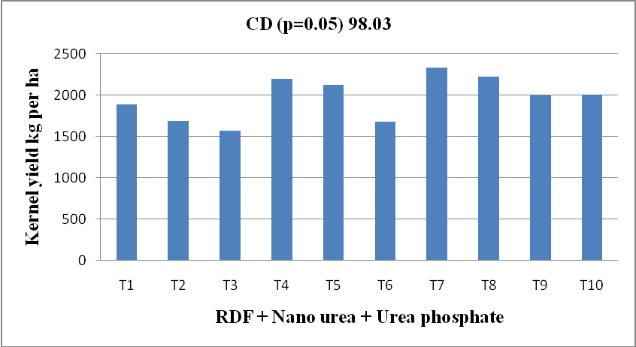

Figure 1: Effect of nano urea and urea phosphate with RDF on kernel yield of groundnut crop (Pooled basis)

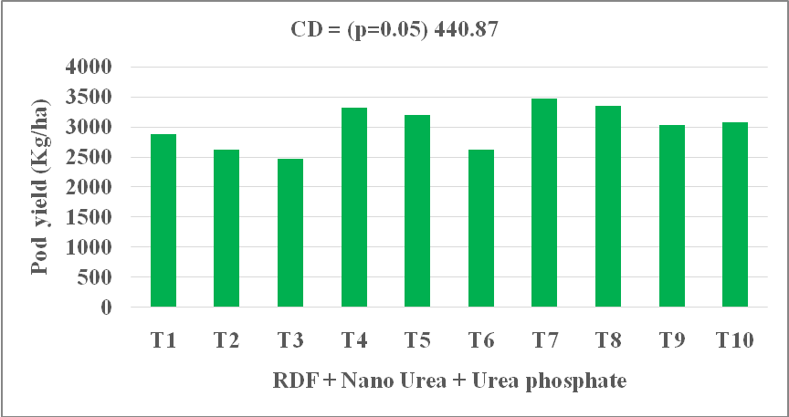
.Figure 2: Effect of nano urea and urea phosphate with RDF on pod yield of groundnut crop (Pooled basis)

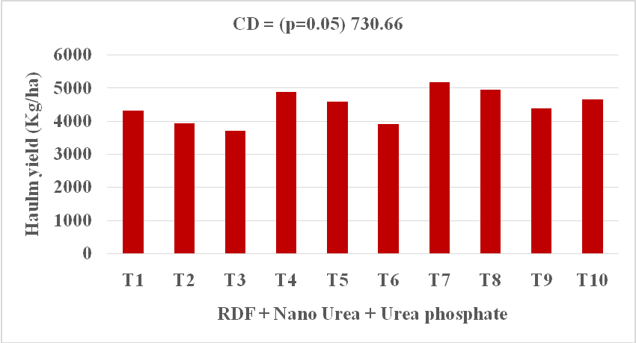
Figure 3: Effect of nano urea and urea phosphate with RDF on haulm yield of groundnut crop (Pooled basis)

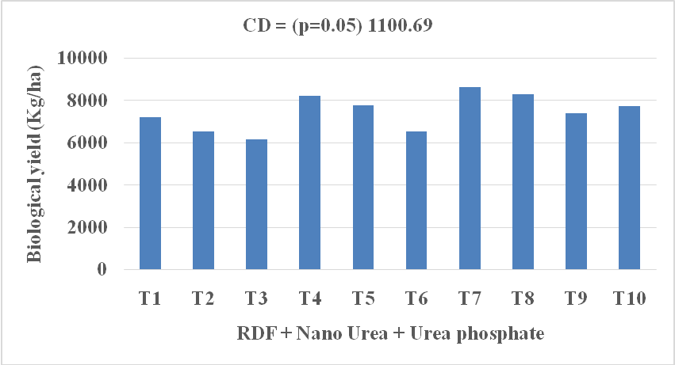
Figure 4: Effect of nano urea and urea phosphate with RDF on biological yield of groundnut crop (Pooled basis)

Table 2: Effect of nano urea and urea phosphate on pH, electrical conductivity and organic carbon on soil after harvest of groundnut
Treatments | pH | EC (dSm⁻¹) | Organic carbon (g kg⁻¹)
 | Pooled mean | Pooled mean | Pooled mean
Initial | 8.05 | 0.18 | 5.0
T₁ - 100% RDF (25:50 N:P₂O₅ kg ha⁻¹) | 8.08 | 0.13 | 4.80
T₂ - 75 % RDF(18.75:37.50 N:P₂O₅ kg ha⁻¹) | 8.05 | 0.12 | 4.50
T₃ - 50% RDF (12.50:25 N:P₂O₅ kg ha⁻¹) | 8.10 | 0.13 | 3.58
T₄ - 100% RDF + Foliar spray of 0.2% Nano urea + 1 % Urea phosphate at flowering stag | 8.07 | 0.12 | 5.55
T₅ -75 % RDF + Foliar spray of 0.2% Nano urea + 1 % Urea phosphate at flowering stage | 8.02 | 0.11 | 4.93
T₆ -50% RDF + Foliar spray of 0.2% Nano urea + 1 % Urea phosphate at flowering stage | 8.02 | 0.13 | 4.53
T₇ -100 % RDF + Foliar spray of 0.2% Nano urea + 1 % Urea phosphate at flowering & peg formation stage | 7.95 | 0.13 | 6.22
T₈ -75 % RDF + Foliar spray of 0.2% Nano urea + 1 % Urea phosphate at flowering s & peg formation stage | 7.97 | 0.13 | 5.78
T₉ -50% RDF + Foliar spray of 0.2% Nano urea + 1 % Urea phosphate at flowering & peg formation stage | 7.97 | 0.13 | 5.32
T₁₀ -100% RDF + Foliar spray of urea @ 2% at 30 & 60 DAS | 8.03 | 0.13 | 5.48
SE+ | 0.04 | 0.01 | 0.32
CD (P-0.05) | 0.10 | 0.02 | 0.95
CV (5 %) | 0.76 | 8.24 | 10.88

Table 3: Effect of nano urea and urea phosphate on available N, P and K on soil after harvest of groundnut

Treatments | Available N  (kg ha⁻¹) | Available P  (kg ha⁻¹) | Available K  (kg ha⁻¹)
Treatments | Pooled mean | Pooled mean | Pooled mean
Initial | 164.53 | 14.00 | 607.00
T₁ - 100% RDF (25:50 N:P₂O₅ kg ha⁻¹) | 146.84 | 7.87 | 506.50
T₂ - 75 % RDF(18.75:37.50 N:P₂O₅ kg ha⁻¹) | 144.41 | 6.77 | 462.87
T₃ - 50% RDF (12.50:25 N:P₂O₅ kg ha⁻¹) | 137.32 | 5.08 | 452.57
T₄ - 100% RDF + Foliar spray of 0.2% Nano urea + 1 % Urea phosphate at flowering stag | 156.94 | 9.08 | 541.43
T₅ -75 % RDF + Foliar spray of 0.2% Nano urea + 1 % Urea phosphate at flowering stage | 147.41 | 8.13 | 525.53
T₆ -50% RDF + Foliar spray of 0.2% Nano urea + 1 % Urea phosphate at flowering stage | 140.08 | 7.90 | 523.63
T₇ -100 % RDF + Foliar spray of 0.2% Nano urea + 1 % Urea phosphate at flowering & peg formation stage | 159.61 | 9.88 | 555.50
T₈ -75 % RDF + Foliar spray of 0.2% Nano urea + 1 % Urea phosphate at flowering s & peg formation stage | 153.76 | 9.16 | 534.00
T₉ -50% RDF + Foliar spray of 0.2% Nano urea + 1 % Urea phosphate at flowering & peg formation stage | 144.66 | 7.95 | 516.37
T₁₀ -100% RDF + Foliar spray of urea @ 2% at 30 & 60 DAS | 155.10 | 9.54 | 528.10
SE+ | 6.74 | 0.32 | 14.10
CD (P-0.05) | 20.04 | 0.96 | 41.89
CV (5 %) | 7.86 | 6.91 | 4.75

Table 4: Effect of nano urea and urea phosphate on available Zn, Fe, Cu and Mn on soil after harvest of groundnut

Treatments | mg kg⁻¹
Treatments | DTPA-extractable  Zn | DTPA-extractable Fe | DTPA-extractable  Cu | DTPA-extractable  Mn
Treatments | Pooled mean | Pooled mean | Pooled mean | Pooled mean
Initial | 1.12 | 2.9 | 6.62 | 4.54
T₁ - 100% RDF (25:50 N:P₂O₅ kg ha⁻¹) | 1.06 | 2.18 | 4.09 | 4.42
T₂ - 75 % RDF(18.75:37.50 N:P₂O₅ kg ha⁻¹) | 0.99 | 1.93 | 3.97 | 4.24
T₃ - 50% RDF (12.50:25 N:P₂O₅ kg ha⁻¹) | 0.90 | 1.85 | 3.95 | 4.21
T₄ - 100% RDF + Foliar spray of 0.2% Nano urea + 1 % Urea phosphate at flowering stag | 1.30 | 2.47 | 4.19 | 5.49
T₅ -75 % RDF + Foliar spray of 0.2% Nano urea + 1 % Urea phosphate at flowering stage | 1.12 | 2.41 | 4.15 | 5.19
T₆ -50% RDF + Foliar spray of 0.2% Nano urea + 1 % Urea phosphate at flowering stage | 1.02 | 2.17 | 4.10 | 4.77
T₇ -100 % RDF + Foliar spray of 0.2% Nano urea + 1 % Urea phosphate at flowering & peg formation stage | 1.54 | 2.79 | 4.55 | 5.67
T₈ -75 % RDF + Foliar spray of 0.2% Nano urea + 1 % Urea phosphate at flowering s & peg formation stage | 1.35 | 2.27 | 4.36 | 5.45
T₉ -50% RDF + Foliar spray of 0.2% Nano urea + 1 % Urea phosphate at flowering & peg formation stage | 1.12 | 2.24 | 4.24 | 5.25
T₁₀ -100% RDF + Foliar spray of urea @ 2% at 30 & 60 DAS | 1.29 | 2.48 | 4.10 | 4.87
SE+ | 0.06 | 0.14 | 0.09 | 0.18
CD (P-0.05) | 0.18 | 0.42 | 0.25 | 0.52
CV (5 %) | 8.98 | 10.72 | 3.55 | 6.16

Table 5: Effect of nano urea and urea phosphate on gross and net monetary return and B:C ratio of groundnut

Treatments | GMR (Rs ha⁻¹) | GMR (Rs ha⁻¹) | B:C Ratio
Treatments | Pooled mean | Pooled mean | Pooled mean
T₁ - 100% RDF (25:50 N:P₂O₅ kg ha⁻¹) | 194591 | 122106 | 2.68
T₂ - 75 % RDF(18.75:37.50 N:P₂O₅ kg ha⁻¹) | 176711 | 104932 | 2.46
T₃ - 50% RDF (12.50:25 N:P₂O₅ kg ha⁻¹) | 166435 | 95362 | 2.34
T₄ - 100% RDF + Foliar spray of 0.2% Nano urea + 1 % Urea phosphate at flowering stag | 223531 | 149795 | 3.03
T₅ -75 % RDF + Foliar spray of 0.2% Nano urea + 1 % Urea phosphate at flowering stage | 215466 | 142437 | 2.95
T₆ -50% RDF + Foliar spray of 0.2% Nano urea + 1 % Urea phosphate at flowering stage | 177201 | 103878 | 2.42
T₇ -100 % RDF + Foliar spray of 0.2% Nano urea + 1 % Urea phosphate at flowering & peg formation stage | 234228 | 159242 | 3.12
T₈ -75 % RDF + Foliar spray of 0.2% Nano urea + 1 % Urea phosphate at flowering s & peg formation stage | 225942 | 151662 | 3.04
T₉ -50% RDF + Foliar spray of 0.2% Nano urea + 1 % Urea phosphate at flowering & peg formation stage | 204034 | 130461 | 2.77
T₁₀ -100% RDF + Foliar spray of urea @ 2% at 30 & 60 DAS | 207630 | 135084 | 2.86
SE+ | 9994 | 9994 | -
CD (P-0.05) | 29695 | 29695 | -
CV (5 %) | 8.55 | 13.37 | -

