**Review Article**

**Natural Farming: A sustainable way towards doubling farmers’ income**

**ABSTRACT**

The intensive use of inorganic fertilizers and pesticides helped meet the food requirements of ever-growing population, their indiscriminate use has posed serious risks on soil and human health. However, there is an urgent need of sustainable farming systems or chemical-free farming methods, such as natural and organic farming that aim to revitalize environment and meet the food demand. Alternative practices like conservation agriculture, carbon-positive farming, and regenerative agriculture are emerging as solutions to conventional farming's negative environmental impact. Among these, natural farming has gained quite a momentum in nullifying the expenditure incurred as the production cost along with reducing external inputs and emphasizing native resources, agro-ecological principles and community participation. Over the last decade, efforts have been made in India to promote science-based natural farming practices, a transition of 2% cultivated land annually from conventional to natural farming without affecting food security and expect to replace 20% by 2030 in India. Hence, the future thrusts of natural farming may not lie in boosting crop yield rather it may boost farmers' income through nullifying the production cost (zero budget farming) and long-term sustainability replenishing soil health and ultimately human and animal health.

**Keywords:** Natural farming, Soil health, Sustainable agriculture, DFI, chemical free

1. **INTRODUCTION**

India’s ever increasing human population sources more than 50% of their livelihood from agriculture till date. Agricultural food supplies derived from 2.4% global geographical area for over 1.4 billion human population often suffices the present need of hunger, export and trade. Soon by 2050, the demand of food supply may probably spike to over 350 million tonnes for a population near to 2 billion (Kumar and Sharma, 2020). Green revolution transformed agricultural production from hunger to self-sufficiency. Parallelly, injudicious exploitation of agrochemicals specially fertilizers (28.97 million tonnes, 2019-20) (Anon., 2022 Agricultural Statistics at a Glance, 2022) lead to massive deterioration of soil; air; water; flora and fauna biodiversity (Evenson and Gollin, 2003; Canfield et al., 2010; Smith et al., 2013; Balkrishna et al., 2022). Diminishing agricultural land day upon day coupled with soil health declining, agricultural system needs core strengthening to feed and secure nutrition for ever-increasing human population. Henceforth, sustainability plays a vital role in keeping the equilibrium to food security and sustainable environment i.e., soil health and human health. Therefore, several agricultural practices like organic farming, biodynamic farming or natural farming (NF) came as a powerful opportunity to revive potentiality of agriculture in India (table 1). Natural farming focuses on minimizing or eliminating external inputs, relying on native resources and agro-ecological principles for sustainability, while organic farming emphasizes avoiding synthetic chemicals and fertilizers but allows external organic inputs. Natural farming is more locally focused, whereas organic farming may involve larger-scale certification and standardized practices. Fig. 1 represents the basic comparison of natural farming, organic farming and conventional farming. Although, such approaches offer sceptical practical applications to a larger community of farmers, considerations on soil health, area suitability, demand, soil-microbial health, crop suitability and standardized operating principles must be studied prior to mass adoption for a better approach. Considering the need of the hour, the authors came to provide a review on sustainable approaches under natural farming for a better and sustainable future.

Table 1:Different chemical free-farming methods in India

|  |  |  |  |
| --- | --- | --- | --- |
| **Method** | **Constituents** | **Scope/ future** | **Pioneer workers** |
| Agnihotra/ Homa farming | Ghee, grains, milk, piece of dried cow dung burnt in copper pyramid. Smoke purifies the air around. | Can be practiced by individual orchardists or a village group | Potdar Inspired and Paranjpe by “Sadguru”. 1970 to 2000 |
| Biodynamic | Cow horn manure and cow horn quartz (silica) | Limited use | Steiner, 1924. |
| Compost tea and Bokashi tea | Liquid extraction of nutrients and microbes from finished compost, molasses added. | Anaerobically composted animal and plant wastes, bran, inoculated with “effective microbes” | Elaine Ingham, 1990s |
| Krishi-suktis and Vrikshayurveda | Sound practices for raising of crops. Animal dung manure to field crops and Kunapajala (KJ). KJ mainly for perennial crops. KJ is fermented liquid manure prepared from flesh, animal and plant wastes, and cow products. | Kunapajala has gained limited popularity is readily acceptable. | Parashara (c.400 BCE), Kashyapa (c. 800 CE), Surapala (c. 1000 CE) |
| Natuecoculture | Mulching–no ploughing; Amrit Mitti–a name given by Late OP Rupela; compost strips made for raising crops; Amrut Jal- fermented cow dung and urine with jaggary. Applied as nutrient liquid. | Has the potential for gardeners and orchardists. Not suitable for large scale farms. | Dabholkar, 1967 |
| Panchagavya | Mixing 5 products of cow, coconut water and cane jaggery. Fermented for 30 days. Seed dip, soil drench and foliar paste. | Panchagavya has gained popularity with farmers in several states of India. | K Natarajan, 2003 |
| Rishi–Krishi | Four steps: Angara–soil from Banyan tree trunk; Amrit–Pani (ghee, honey, cow dung in water); Beej Sanskar([seed dressing with paste of Angara and Amrit–Pani), and Achhadana (mulch). | Have similarities to methods of Dabholkar and Palekar. Suitable for small farmers. | Deshpande, 1970. |
| Zero budget natural farming | Four key elements: Beejamrita–seed treatment, Jevamrita fermented microbial culture, Achhadana mulching, and Waaphasa; no irrigations. | For small scale operations | Palekar, 2005–06 |

Source: Nene (2017)

1. **CONCEPTS OF NATURAL FARMING**

Natural farming as a concept given by a Japanese Philosopher cum farmer ‘Masanobu Fukoka’ in his famous writings named “One-straw Revolution” (1935) explained as a natural process of farming with exclusion of agrochemicals or cost involving external inputs within the ecology established. However, in India the concept reshaped as ZERO BUDGET NATURAL FARMING (ZBNF) by Shri. Subhash Palekar and a varied replicas of such models are continually reproduced in India currently to suit specific farming systems. Natural Farming is a holistic agricultural approach that blends traditional farming practices with modern ecological principles, encouraging sustainability and self-sufficiency. It emphasizes the integration of crops, trees, and livestock thereby creating a diversified farming system that mimics natural ecosystems. By focusing on on-farm resource recycling, it reduces the dependency on external inputs, such as synthetic fertilizers, pesticides, and herbicides. The system utilizes local organic materials, like cow dung and urine, for soil fertility and pest management, which not only nourish the soil but also promote soil microbial health. Biomass recycling through practices like mulching and using crop residues helps maintain soil moisture, prevents erosion, and supports soil aeration. Natural Farming also encourages minimal tillage to preserve soil structure and reduce soil erosion. The exclusion of synthetic chemicals leads to a cleaner environment, healthier crops, and reduces pollution. Furthermore, it promotes cost-effectiveness by reducing the need for purchased inputs, offering a sustainable economic model for farmers. This practice also generates local employment opportunities, contributing to rural development. Ultimately, Natural Farming supports a resilient agricultural system, ensuring long-term environmental health, economic viability, and the well-being of farming communities.

1. **THE IDEOLOGY OR PRINCIPLES OF NATURAL FARMING**

**Japanese Version:** The principle, technology and style of farming in Japanese version of Natural farming originated dates back to 1940’s, which were simplified as principles as follows: (Anonymous, 1993; INFRC, 1988; Matsumoto, 1993).

1) The practices must ensure superiority in food quality to boost human health.

2) The process must be simplified ensuring sustainability.

3) It should be economically viable and must possess supportive belief to farmers and consumer as well.

4) The practice must replicate natural environment for ecological protection.

5) It should suffice the demand of food without causing any possible threat to the environment.

**Indian Version:** Following are the holistic principles corresponding to regenerative farming practices which suggests its alignment to restore ecosystems, enrich biodiversity and improve soil health in long term basis (Fig. 2).

* **Polycropping with Tree Integration:** Considering perennial trees mimics natural ecosystems, enhancing biodiversity, reducing pests, and improving resilience to climate change. Trees can provide shade, organic matter, and habitat for beneficial insects and animals, while crops grow in the diverse environment, promoting nutrient cycling.
* **Avoidance of Synthetic Agro-inputs:** Avoiding synthetic fertilizers, pesticides, and herbicides reduces pollution, conserves biodiversity, and promotes healthier soils. This approach focuses on building soil health and pest resistance naturally rather than relying on external chemical inputs.
* **Soil cover:** Cover crops and mulch help maintain moisture, prevent erosion, improve soil structure, and support microbial life. This practice ensures the soil remains rich in organic matter and reduces the need for external inputs.
* **Use of Local Seeds:** Local, indigenous seeds are adapted to the region’s climate, pests, and diseases. They are typically more resilient and better suited for low-input farming systems, reducing reliance on expensive hybrid seeds.
* **Bio-stimulants and Botanical Extracts:** Using bio-stimulants to enhance soil microbial activity promotes nutrient availability and soil health. Botanical extracts for pest management, like neemastra/agniastra/bhramastra etc, provide natural alternatives to chemical pesticides while maintaining the ecological balance.
* **Minimal Tillage:** Reducing tillage helps protect soil structure, prevent erosion, and preserve soil organisms like earthworms. It also allows for the soil to maintain a healthy microbial ecosystem and improves water-holding capacity.
* **Integration of Livestock:** Livestock can play an important role by providing manure for fertilization, helping with pest control, and even grazing on cover crops to maintain biodiversity. The synergy between crops and animals can lead to better nutrient cycling, reduce waste, and enhance the overall productivity of the farm.

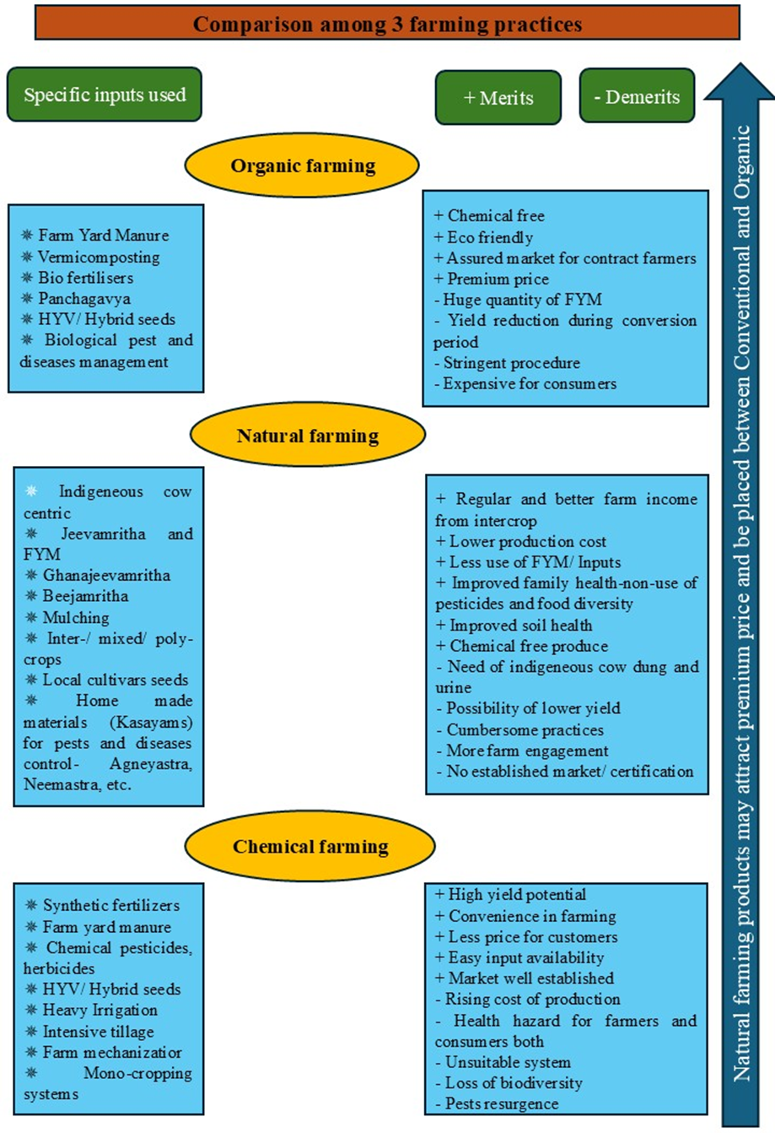

**Fig. 1.** Basic comparison of three farming systems.

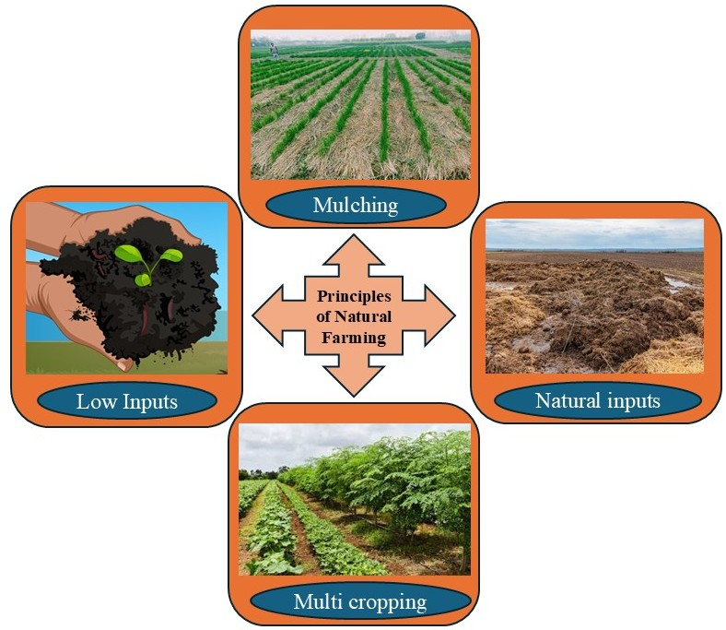

**Fig. 2.** Principles of Natural Farming (Source: Principles of Natural Farming, Palekar, 2014)

1. **COMPONENTS UNDER NATURAL FARMING (**Ranjit et al., 2020**)** (Fig. 3):

**Jeevamrutha:** A nutrient rich organic bio-stimulant prepared by fermenting cow dung, cow urine, jaggery, and water for 48 hours. It enhances soil fertility and microbial activity in soil. Promotes plant nutrient absorption. Stimulates soil microflora and microfauna that aids in the mineralization of complex organic matter allowing ample nutrient availability to crops.

**Beejamrutha:** It is anatural seed treatment solution prepared by soaking seeds in a mixture of cow dung, water, lime, and cow urine. Seeds/Seedlings are soaked in this mixture before being sowing or transplanting. It improves seed germination, protects seeds from diseases and pests, promotes vigorous growth.

**Acchadana (Mulching):**

Straw Mulch: Dried crop residues and plant material acts as a protective cover for the soil, improving soil moisture as well as soil fertility upon decomposition of the substrate mulch. It prevents weed growth upto some extend. Live Mulch: Leguminous crops as cover crops or smoother crops or intercrops provide nutrients to the soil, reduce pest issues, and improve overall soil microbiome.

**Whapasa:** It refers to the balance of water vapour in air and in the soil. It reduces dependency on regular irrigation, which is quite evident in conventional farming. It allows irrigation at specific intervals promoting resource use optimization.

**Bio-pesticides and Natural Pest Management:**

**Neemastra:** It is a neem-based formulations to treat and prevent insect attacks, particularly on foliage and sap-sucking pests.

**Agniastra:** Prepared from neem leaf pulp, tobacco powder, green chilli powder, garlic paste, and turmeric powder. Effective against sucking pests (e.g., aphids, whiteflies) and caterpillars (e.g., leaf roller, stem borer, fruit borer).

**Brahmastra:** Comprises of neem, karanj, custard apple, and daphnia leaves. Alkaloids in this concoction effectively kills hidden caterpillars in fruit pods, grains, leaf sheath etc.

**Dashaparni Ark:** A mixture of tobacco powder, ginger paste, turmeric, garlic, and the leaves of ten different plants (e.g., neem, hibiscus, guava). It can act as an alternative to Agniastra, Brahmastra, and Neemastra.

**Fungicide:** Fermented curd water or rice water acts effective against fungal infections in plants, providing a natural solution for fungal management.

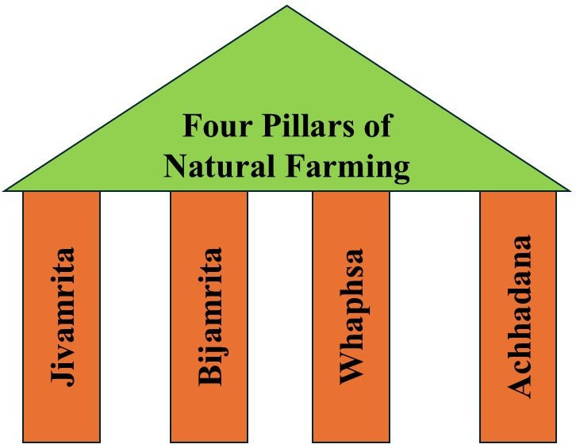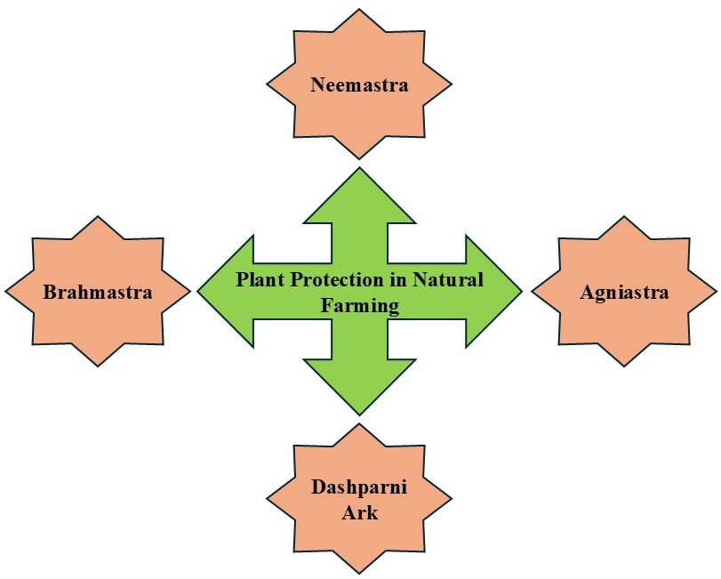

**Fig. 3.** Components of natural farming (Source: Principles of Natural Farming (Palekar, 2014)

1. **PRESENT SCENARIO OF NATURAL FARMING IN INDIA**

India’s diverse agro-climatic conditions pay a significant opportunity for extension of natural farming across the nation. Each region has unique farming challenges and resources owing to wider adaptability of natural farming practices. Additionally, farmers’ traditional knowledge, passed down through generations, plays a key role in adapting natural farming techniques specific to the location known. This knowledge, coupled with modern ecological principles, can significantly enhance agricultural productivity in a sustainable manner (Kumar et al., 2019). Natural farming is gaining significant advances across India, the states leading in adopting natural farming includes Andhra Pradesh, Himachal Pradesh, and Gujarat. In additionally states like Uttar Pradesh, Madhya Pradesh, Odisha, Chhattisgarh, Jharkhand, and Tamil Nadu (Fig. 4) have gain good momentum in adopting natural farming practices, contributing to the widespread acceptance and adoption of these techniques. In response to the growing need for sustainable farming practices, the Central Government launched the Bharatiya Prakritik Krishi Paddhati (BPKP) in the 2020-21 financial year. This scheme is a sub-scheme under the Pradhan Mantri Krishi Vikas Yojana (PKVY) and is designed to promote chemical-free farming across India. The initiative aims to reduce the use of synthetic chemicals and fertilizers, instead focusing on organic farming methods that rely on local resources like cow dung, cow urine, and other traditional inputs to enhance soil health and promote biodiversity. Under the BPKP scheme, nearly 6.1 lakh hectares of agricultural land across the mentioned states have been covered, with a total fund allocation of ₹49.8 crore to support the transition to natural farming. This investment highlights the government’s commitment to transforming India’s agriculture by supporting the adoption of chemical-free, sustainable practices that ensure long-term soil health and improve the resilience of farming systems.

According to Kalarani et al., 2023 an estimate approximately of 4.09 lakh hectares of land were reported to be under natural farming across India in 2023, this demonstrates a positive shift towards sustainable agricultural practice. A total fund of ₹4587.17 lakh has been allocated and released across eight states to promote these practices (Andhra Pradesh, Madhya Pradesh, Chhattisgarh, Kerala, and Odisha). The main models of Natural Farming widely adopted in the country are: Zero-Budget Natural Farming (ZBNF), it focuses on reducing dependency on externally purchased inputs by utilizing locally available organic resources like cow dung, cow urine and other naturally derived inputs. Andhra Pradesh Community-based Natural Farming (APCNF): This model emphasizes mainly on community involvement, where farmers adopt natural farming collectively, creating shared knowledge networks and enhancing sustainability at the local level.

According to a report from NITI Aayog, India has the potential to significantly expand chemical-free farming in the coming years. The report suggests that India could double the acreage of natural farming to 15% immediately and potentially grow it to 30% by 2030. This growth is not expected to threaten national food security, as the reduction in chemical inputs and fertilizer subsidies will help balance the potential losses in output. This transition towards sustainable agriculture is seen as a vital step towards reducing India's dependency on chemical fertilizers and pesticides, while improving the health of the soil and environment. The National Institute of Agricultural Extension Management (MANAGE), Hyderabad, is the nodal agency responsible for the promotion of natural farming in India. The institute plays a crucial role in capacity building, organizing training programs for officials from agriculture departments at the central and state levels, agricultural universities (SAUs), private organizations, and farmers. These training programs helps in disseminating knowledge about natural farming techniques and building expertise among stakeholders. In addition to the BPKP scheme, the Government of India launched the National Mission on Natural Farming (NMNF) in 2023. The goal of the NMNF is to motivate farmers to adopt chemical-free farming practices and increase the coverage of natural farming across the country. By 2025, the mission aims to bring 10 million hectares of land under natural farming, which will significantly boost the national efforts to transition towards more sustainable and eco-friendly agricultural practices.

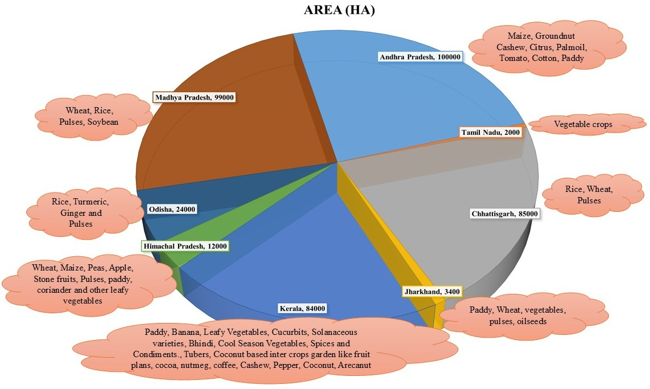

Source: Source: https://pib.gov.in/PressReleasePage.aspx?PRID=1813682, Annual Report 2022-23)

**Fig. 4.** State wise area and distribution of crops under natural farming in India

1. **IMPORTANCE AND UNEXPLORED POSSIBILITIES**

Various studies highlighted the promising productivity and sustainability of natural farming benefiting both ecology and soil health. Through prioritization of biodiversity and ecological balance, it enhances long-term farm productivity without depleting available natural resources. Additionally, natural farming reduces dependence on external chemical inputs, improving cost-effectiveness in farming. This approach is also considered economically viable due to lower production costs and higher-quality yields. Furthermore, it holds significant potential to boost rural development and create employment opportunities by fostering community-based initiatives and promoting the growth of organic markets (Devarinti, 2016; Tiwari & Raj, 2020). Natural farming focuses on ecological balance, minimizing synthetic inputs, and using native resources, promoting sustainability. In contrast, conventional farming relies heavily on chemical fertilizers, pesticides, and monocropping to maximize yields, often leading to environmental degradation and reduced long-term soil health (Fig. 5).

**Sustainability:** It offers regenerative practices through soil fertility restoration, biodiversity enrichment, resources conservation, null chemical dependency, climate resilience, socio-economic benefits without compromising the future resources.

**Soil health improvement:** This form of farming believes cultivating crops in harmony with nature, avoiding chemical inputs to conserve biodiversity and promote a healthy soil ecosystem. This approach significantly improves soil health by preventing erosion, restoring soil moisture, enriching microbial population and ultimately nutrient availability in soil and in plants. It nurtures soil aeration and water retention by forming both micro and macro pores, allowing better movement of air and water in soil. This holistic approach enhances soil structure, promotes ecological balance, and ensures long-term agricultural sustainability.

**Production gain:** Studies show the positive impact of natural farming (NF) practices, particularly in improving crop yield and soil health. In elephant foot yam, bijamrita corm treatment and jivamrita soil application boosted growth and yield (Biswas et al., 2023). In Himachal Pradesh, the combination of ghanjivamrit, jivamrit, and mulching significantly increased wheat yield (1767.3 kg/ha) and gram yield (734.1 kg/ha), with enhanced nitrogen availability (275 kg/ha), NPK uptake, microbial activity, and dehydrogenase activity (Choudhary et al., 2022). These studies highlight the effectiveness of natural farming practices in addressing nutrient deficiencies and enhancing agricultural productivity.

**Climate resilience:** It is achieved through practices that enhance soil health, biodiversity, and water efficiency. Organic matter and microbial activity in NF improve soil structure, boosting water retention and reducing erosion, thus helping crops withstand droughts and floods. Biodiversity in NF systems, through crop diversification and agroforestry, strengthens ecosystem functions, enhancing pest control and pollination, and increasing resilience to extreme weather events. Techniques like mulching, minimal tillage, and efficient irrigation reduce water use and improve moisture retention. Additionally, NF promotes carbon sequestration in soils, mitigating climate change by storing atmospheric CO2, and helps maintain microclimates that buffer crops from temperature fluctuations and unpredictable weather, contributing to overall climate adaptability.

**Socio-Economic upliftment of farmers:** This form of farming practices offers low input cost and produces chemical free food inclining consumers to pay premium price for the produces, hence bridging the gap to low productivity of crops in comparison to chemical farming. It offers profitable returns to farmers. studies revealed treating elephant foot yam with bijamrita and jivamrita achieved a net return of INR 1,69,189/ha and resulted with a BCR of 2.82 (Biswas et al., 2023). Further, in another study, combining vermicompost and jivamrita resulted in a net return of INR 1,47,530/ha and a BCR of 2.56 (Sharma and Tahkur, 2022). These studies demonstrate how natural farming practices, with their minimal input costs and reliance on organic methods, lead to increased profits by reducing dependency on expensive synthetic inputs, NF helps farmers boost their income, alleviate financial strain, and support long-term agricultural sustainability. This combination of economic viability and environmental health positions natural farming as a promising solution for enhancing farm profitability.

**Chemical free food and Human Health:** It offers remarkable benefits by availing chemical free foods unlike conventional farming which are linked to several life-threatening diseases like cancer and diabetes. Crops grown using NF practices are free from these harmful chemicals, offering nutritional superiority, social acceptability, and better economic value (Tripathi et al., 2018).

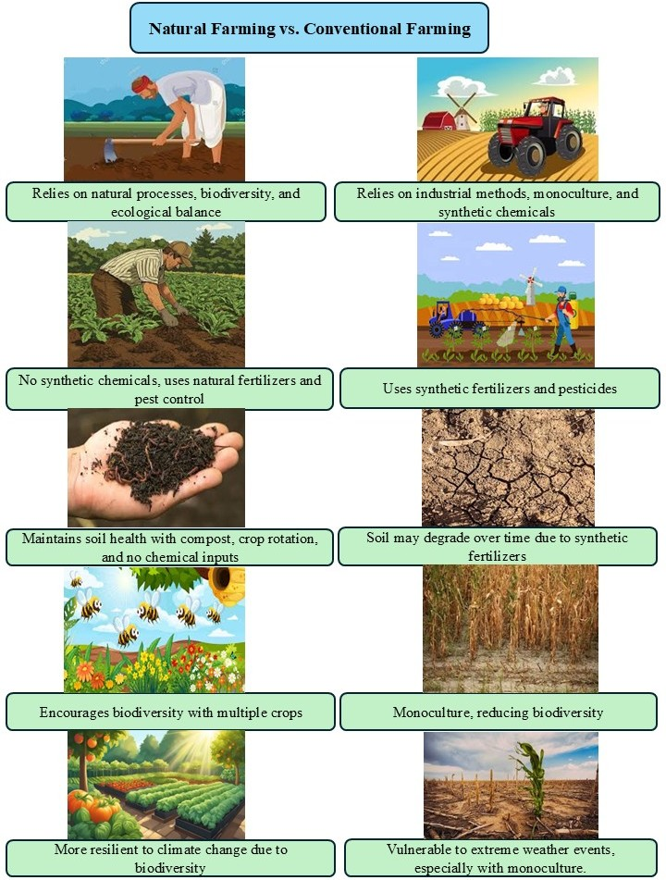

**Fig. 5.** Natural farming Vs Conventional farming

1. **CHALLENGES AND FUTURE THRUST AREAS**

Though natural farming holds great potential to sustain agricultural system, there are some underlying challenges that needs a thorough study and strategic planning to turn limitations to opportunity in near future. Some of the major challenges limiting large scale natural farming adoption are as follows:

**Yield reduction:**  This type of farming demands a good soil health to result comparative yield as that of conventional farming. However, the for-soil systems require a conversion period leading to lower crop yields initially due to the soil's prior reliance on chemical inputs. Some studies, such as Korat and Mathukia (2022), suggest that NF may not always outperform organic farming in terms of yield. Therefore, to validate the long-term benefits of NF, large-scale, long-term trials across India are needed rather than just relying on the experiences of enthusiastic farmers. Natural farming is a new management practices and initially the soil systems

**Absence of effective weed management strategies:** The absence of effective weed management strategies poses a significant challenge. Without chemical herbicides, farmers rely on manual methods like mulching, or crop rotation, which are labour-intensive and may not always be efficient in controlling persistent weeds. As weeds compete with crops for nutrients, water, and sunlight, this lack of effective control can lead to reduced crop yields.

**Inefficiency in disease and pest management:** Disease and pest management in natural farming is often executed as pre-incidence protection of crops with regular use of plant derived pesticides. However, upon failure to prevent disease/pest incidence, there seems to have rapid spread leading to crop loss. The limitations on usage of chemicals raises concerns about the effectiveness of natural insecticides in controlling pests, potentially leading to crop losses over time. While some studies suggest the potential of natural products for pest and disease management, further field trials are essential to validate their practical effectiveness in field.

**Lack of standardized protocol for inputs preparation:** Lack of a standardized protocol for preparing inputs, such as natural fertilizers and pesticides, creates inconsistency in their effectiveness. Since it relies on locally available, natural substances, the methods of preparation can vary widely depending on regional practices, materials, and expertise. This variability can lead to suboptimal results and difficulty in scaling NF practices. Establishing standardized guidelines for the preparation and application of inputs would help ensure better outcomes, improve the reliability of NF, and make it more accessible to a wider range of farmers.

**Market access for premium price:** Since, most of the study so far encounters crop yield reduction under NF system, there is need to formulate regulations through Government and related bodies for premium product price that compensates the loss in yield and provide chemical free food to the world. As presently there are no regulations made, farmers often hesitate in adopting such farming in commercial scale. The lack of established supply chains and certification systems can hinder farmers from benefiting from their chemical free produce.

Future thrusts in natural farming must orient towards several key areas to enhance its effectiveness and scalability. Research and innovation are crucial factor to develop improved natural inputs, pest management strategies and soil health practices which can optimize yields while maintaining sustainability. Farmer awareness and training programs need to be expanded to get thorough understanding of the practices for adopting, further ensuring they are participation confidently in transitioning from conventional farming systems. For a larger picture, policy support and incentives are primarily essential. Policies should also focus on strengthening certification systems for organic produce to ensure fair pricing and market access. Additionally, integrating technology for better monitoring of soil conditions, pests, and crop growth can enhance the efficiency of NF practices. Finally, expanding market networks will help farmers access higher-value markets and improve the financial viability of NF in the long term.

1. **CONCLUSION**

Natural farming offers a promising path toward sustainable agriculture and the goal of doubling farmers' incomes in India. By eliminating the reliance on chemical inputs, NF not only improves soil health but also enhances biodiversity, leading to long-term productivity. The focus on chemical free practices reduces the cost of expensive fertilizers and pesticides, which can significantly lower production costs for farmers, thereby increasing economic returns. In the long run, it supports the resilience of farming systems, making them more adaptable to climate change and environmental challenges. Additionally, it can open doors to premium markets for NF produce, where farmers can secure higher prices for their farm produce. This added value, combined with reduced input costs, directly contributes to improving farmers' economic well-being. As farmers transition to NF, they also benefit from better soil health and water retention, improving yields over time, despite initial yield dips during the transition phase. However, achieving widespread adoption requires significant support, including farmer training, government incentives and access to markets. Long-term investments in research, better technology, and infrastructure will further enable to thrive, creating a more sustainable, profitable, and resilient agricultural system. In conclusion, with the right support, natural farming has the potential to significantly contribute to the dual goals of sustainability and increasing farmers' incomes.

**DISCLAIMER (ARTIFICIAL INTELLIGENCE)**

Author(s) hereby declare that NO generative AI technologies such as Large Language Models (ChatGPT, COPILOT, etc) and text-to-image generators have been used during writing or editing of this manuscript.

**COMPETING INTERESTS**

Authors have declared that no competing interests exist.

**REFERENCES**

1. Agricultural statistics at a glance (2022). Directorate of Economics and Statistics, Department of Agriculture, Cooperation and Farmers’ Welfare, Ministry of Agriculture and Farmers’Welfare.
2. Anonymous. 1993. About the name of Kyusei Nature Farming. In: The Basis of Paradise, The Editorial Board of Kyusei Dogma. Kyusei Publisher, Tokyo, Atami.
3. Biswas S, Das R and Thakur R. (2023). Effect of corm and soil treatments with organic liquid formulations on performance of elephant foot yam in Jharkhand, India. *Int. J. Plant Sci*, *35*, 116-124.
4. Canfield D E, Glazer A N and Falkowski P G. (2010). The evolution and future of Earth’s nitrogen cycle. *science*, *330*(6001), 192-196.
5. Choudhary R, Sharma R P, Rana N, Dev P, Sharma G D and Kumar R. (2022). Effect of natural farming on yield performances, soil health and nutrient uptake in wheat+ gram inter cropping system in sub-temperate regions of Himachal Pradesh.
6. Devarinti S R. (2016). Natural farming: eco-friendly and sustainable. *Agrotechnology*, *5*(2), 1000147.
7. Evenson R E and Gollin D. (2003). Assessing the impact of the Green Revolution, 1960 to 2000. *science*, *300*(5620), 758-762.
8. INFRC. 1988. Guidelines for Nature Farming Techniques. Atami, Japan. 38 pp.
9. Kalarani M K, Karthikeyan R, Sivakumar R and Umapathi M. (2023). Natural farming: Scope and Importance. *Natural Farming For Sustainable Agriculture*, 1.
10. Korat H V, Mathukia R K and Faldu M R. (2022). Influence of low cost natural farming, organic farming and conventional farming on performance of wheat and chickpea. *Guj. J. Ext. Edu. Special Issue*, 33-37.
11. Kumar P and Sharma P K. (2020). Soil salinity and food security in India. Frontiers in Sustainable Food Systems. 4, 533781.
12. Kumar R, Kumar S, Yashavanth B S and Meena P C. (2019). Natural Farming practices in India: Its adoption and impact on crop yield and farmers’ income. *Indian Journal of Agricultural Economics*, *74*(3), 420-432.
13. Matsumoto, Y. (1993). Kyusei nature farming: A sustainable farming method for the 21st century. In *Third Kyusei Nature Farming: Third International Conference. USDA, Washington DC*.
14. Nene Y L. (2017). A critical discussion on the methods currently recommended to support organic crop farming in India. *Asian Agri-History*, *21*(3), 267-285.
15. Palekar, S. Zero Budget Natural Farming. (2014). Available: http://palekarzerobudgetspiritual farming.org.
16. Kumar R, Kumar S, Yashavanth B S, Meena P C, Indoria A K, Kundu S. and Manjunath M. (2020). Adoption of natural farming and its effect on crop yield and farmers’ livelihood in India. *ICAR-National Academy of Agricultural Research Management, Hyderabad, India*, *130*.
17. Sharma R and Thakur I. (2022). Impact of bioorganic nutrients and chemical fertilizers on sustainable production of French bean and soil health. *Journal of Environmental Biology*, *43*(3), 430-439.
18. Smith P, Haberl H, Popp A, Erb K H, Lauk C, Harper R, Tubiello F N, de Siqueira Pinto A, Jafari M, Sohi S and Masera O .(2013). How much land‐based greenhouse gas mitigation can be achieved without compromising food security and environmental goals?. *Global change biology*, *19*(8), 2285-2302.
19. Tripathi S, Shahidi T, Nagbhushan S, Gupta N. (2018). Zero budget natural farming for the sustainable development goals. *Council on Energy, Environment and Water, New Delhi, India*.
20. Balkrishna A, Arya V, Joshi R, Kumar A, Sharma G, Dhyani A. Doubling Farmers' Income in India: Progress, Gaps and Futuristic Approaches. Indian Journal of Ecology. 2022 Jun;49(3):1044-50.