Comparative analysis of Indigenous tree seed germination for a revamping biodiverse reforestation

.

ABSTRACT

|  |
| --- |
| **Aims:** This paper is to carry out a comparative analysis on seed germination of four indigenous tree varieties so that they may be used for reforestation and enhancing biodiversity in their ecosystems.  **Study design:** An experimental research was on four indigenous tree varieties were chosen based on their socio-economic and biodiversity importance: *Maesopsis eminii* (Umuhumure) ; *Albizia gummifera* (umusebeyi), *Entandrophragma excelsum* (Umuyove)  and *Prunus africana* (Umuremera). Three substracts were separately prepared in which 100 seeds of each varieties were planted and their growth were monitored daily in were controlled nursery.  **Place and Duration of Study:** From October to December 2023, data were collected after 5 days on the following indicators, growth, cinetic and duration of germination. Analytical tools such as anova and regression were applied.  **Methodology:** Three substracts were separately prepared in which 100 seeds of each varieties were planted and their growth were monitored daily in were controlled nursery.  **Results:** The number of grain germinated increased as the time goes by but it is the variety *Umuhumure* which marked with a higher and steady growth than other variety and *Umusebeyi*, 80 out of 100, tops in the number of grain germinated after three months. The study shows that rates of growth were 74, 37, 29 and 14 out of 100 for *Umusebeyi, Umuremera, Umuyove and Umuhumure* respectively. On overall, with one-way ANOVA, means of grains germinated of the three indigenous trees are significantly different (<0.01) when grain variety factor is considered but when the interaction between variety and replication are also considered (two-way ANOVA), the two have a significant effect on the number of grains germinated (<0.01). Other findings are the effect of the germinated grains depends on the number of replication and period of grains growth (in terms of days). 6% and 48% variations explain the interaction between replication and type of variety on one hand and the number of variety growth on the other hand.  **Conclusion:** the *Albizia gummifera* (*Umusebeyi*) to be considered when the reforestation of indigenous tree is undertaken. However, other varieties may be used if the right substracts and growth conditions are found. |

*Keywords: indigenous trees, replication, ANOVA, biodiversity*

1. INTRODUCTION

After The Burundian natural environment is decreasing mainly due to the expansion of human activities (Nkengurutse *et al.* 2019). However, this environment contains indigenous species which have functions or are beneficial to mankind and the biosphere in general but they are threatened by deforestation. Doggart et al. (2020) and Kissinger et al. (2012) have pointed out the diverse factors leading to deforestation, some may be proximate (agriculture expansion, urban growth, infrastructure development and mining) while others are or underlying such as those that relate to macro-level interactions of demographic, economic, technological, social, cultural and political factors (Bukuru *et al.* 2022). In fact, during 1990, Burundi marked a high international record of deforestation rate, reaching 9% (Athman et al. 2006). The estimations of deforestation varied from 8000 to 32000 ha due to civil war (Banderembako, 2006). In Burundi, human activities such as agriculture is ranking the first factor that affects the forest canopy and hence the biodiversity reduction.

Environmental restoration and biodiversity programs are hampered by the low variety of species with multiple functions, which limits the choices and possibilities and leads to the homogeneity of spaces. However, the government of Burundi has put in place a national strategy and action plan on Biodiversity (2013-2020) which had dismal effects on the environment restoration and protection (INECN, 2016). Now the attention is directed on the alien or indigenous trees. These ones are species that have developed and adapted to a specific environment over time. They play a crucial role in local ecosystem and contribute to biodiversity, climate regulation and soil protection.

However, exotic species such as *Eucalyptus* sp., *Pinus* sp., *Callitris* sp. et *Grevillea* robusta, have harmful effects which were not suspected when they were introduced (Guedes *et al.* 2018). The indigenous species seems to be scarce in Burundian silvicultural and agroforestry programs. It is urgent that tests on the performance of native species be carried out to solve this problem and counter the problem of landscape degradation. The indigenous trees may serve as tool for afforestation, reforestation and restoration of ecosystem, hence improve the biodiversity of tree species. In addition, as a means of promoting the benefits of trees as habitat and food for other biodiversity, it is often stated that indigenous (native) trees should be encouraged above alien (exotic/non-native) species, because the services that they provide are already part of the local ecology, and other native species will have co-adapted with them (Chalker-Scott, 2015; Johnson *et al.,* 2012; Smith *et al.*, 2006, and Kandle *et al.,* 2000).

Accordingly, many institutions including public-government (local, national), private sector, and civil society have undertaken policy options and programmes aimed at reversing deforestation in the country whilst meeting the demand for requisite forest products. The government of Burundi has introduced the National strategy and Action Plan in order to revamp the biologic diversity in 2020. This was in line with the International Convention of Biologic Diversity ratified on 15 August 1997. The aim was to implement among others the pledge of reducing the gas emissions by 3% (unconditionally) and 20% (conditionally) by 2030 (CIFOR, 2022 and INECN, 2013).

This study aims at contributing to the conservation and dissemination the indigenous trees of economic use. Specifically, this paper seeks to examine the most performing woody indigenous trees through (1) indigenous tree seed germination performance and (2) the growth type through some specific parameters such as height of seedlings, diameter of stem and the number of leaves. The results of this study can contribute to better understanding the aspect of role of indigenous trees in vegetative biodiversity and conservation of plant species. Understanding seed germination is essential for restoring ecosystems and preserving endangered species.

2. experimental details

This study follows an experiment design which starting by selecting four types seeds of indigenous trees. The species were chosen on the basis of the existing literature concerning their socio-economic importance of each species and taking into account the availability of their seeds, four tree species were selected namely: (1) Maesopsis *eminii* (Umuhumure), (2) Entandrophragma *excelsum* (*Umuyove*), (3) Albizia *gummifera* (*umusebeyi*) and (4) Prunus *africana* (*Umuremera*).

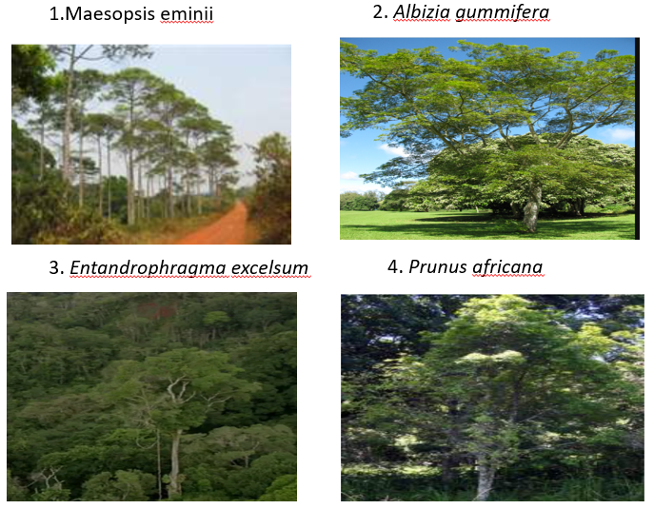

Plate 1 : The selected four species

According to Bionet (2022),Maesopsis *eminii* is invasive in parts of Tanzania (Haysom and Murphy 2003). The species is indigenous to Uganda where it grows in moist evergreen forests and moist semi-deciduous forests as well as in grasslands and seasonal wetlands at altitudes of 700 to 1500m. Albizia *gummifera* is a deciduous tree with a flattened, open crown, growing up to 30 metres tall. The straight, cylindrical bole can be up to 100cm in diameter; it is usually without buttresses or with small, thick buttresses. The tree is harvested from the wild for local use as a food, medicine and source of wood. Entandrophragma *excelsum*, is Africa's tallest indigenous tree native to tropical East Africa and occurs in eastern D.R.C of the Congo, Rwanda, Burundi, Uganda, Tanzania, Malawi and Zambia. This species is scattered in areas of upland semi-deciduous forest, in mid-elevation and montane rainforest, at 1280 – 2150 metres elevation. It is locally also found in riverine forest. Finally, used intensively for traditional medicine, Prununs *africana* is a medium to large, handsome evergreen tree with a spreading crown of 10 to 20 m when mature. become quite huge under frost-free conditions, but is usually medium-sized in gardens. Its leaves, barks and roots are harvested for medicinal uses.

**2.1 Sources and treatment of tree seeds**

Maesopsis eminii seeds/seeds were collected in Kirundo province. Some fruits were collected after they had fallen while others were picked from the trees. The latter were placed in conservation awaiting physiological maturity (i.e. when the flesh becomes tender), After three (3) days, we crumbled the fruits in a bucket filled with water to remove their flesh and sticky fibers. The seeds obtained were dried in the sun for one day.

The seeds/seeds of the other three tree species (Albizia gummifera, Entandrophragma excelsum, Prunus africana) came from the Kibira National Park. They were purchased from an experienced nurseryman (a retired officer of the Burundian Office for the Protection of 'Environment).

**2.2 Preparation of Substrate**

Three types of substrates were used for sowing the seeds:

**Type 1:** substrate made from a mixture of 4 wheelbarrows of manure, 2 wheelbarrows of black soil (humified soil) and 1 wheelbarrow of sand (4-2-1);

**Type 2:** substrate made from a mixture of 2 wheelbarrows of manure, 2 wheelbarrows of soil (humified soil) and 0 wheelbarrows of sand (2-2-0);

**Type 3:** substrate made from a mixture of a wheelbarrow of manure, a wheelbarrow of black soil (humified soil) and a wheelbarrow of sand (1-1-1).

For each type, the components were spread on tent and mixed up using a shovel until a homogeneous mixture was obtained. Seed experiment treatment were three time replicate in order to observe the differences in seed germination parameters

**2.3 Seed Sowing and Monitoring**

The experiment took place in a nursery installed within the perimeter of the Faculty of Agronomy and Bio-Engineering (FABI) educational farm of University of Burundi in Gitega. The seeds were sown in polyethylene bags containing the soil for each type of substrate. After filling the bags, the seeds were sown vertically with a depth of two (2) times the size of the seed. The bags were arranged in completely randomized blocks. The seeds do not all germinate at the same time. Therefore, we regularly observed the seedlings throughout the experiment between 9 a.m. and 10 a.m. Germination monitoring consisted of noting the germination dates as well as the number of germinated seeds.

**2.4 Seed parameters collection during seed germination**

The parameters used to evaluate the behavior of the seeds during germination were assessed through the following variables:

1. Seed germination rate (TG)= Number of seeds germinated (n) * 100/ Total number of seeds sown (N)
2. Germination= The germination kinetics (CG), providing information on the evolution of the
3. Cumulative germination rates (TCg)= Number of newly germinated seeds (ni) * 100/ Total number of seeds sown (N)

Germination time or latency time: time it takes a seed to germinate after it has broken free form its dormant seed. The measured seedlings were first chosen from the rows also chosen among others. These seedlings constituted the samples which were concerned by the measurement whenever necessary. The sample plants were marked by inserting a strand of colored toothpick into the bag. Height of seedlings, stem diameter and number of leaves,

**2.5 Data Analysis**

Quantitative estimation was used, basically parametric and non-parametric estimations were done such descriptive statistics and ANOVA. Analytical tools used were SPSS for data analysis and R for graphic visualization

3. results and discussion

**3.1 Descriptive Statistics**

The analysis compares different varieties of native trees in terms of germination rates. This helps select the varieties most suited to local conditions and reforestation or conservation objectives. It assesses seed viability by measuring the percentage of germinated seeds compared to the total number of seeds sown. This gives information on the quality of the seeds used.

**Table 1: Mean of germinated seeds per variety and replicate trials**

|  |  |  |  |  |
| --- | --- | --- | --- | --- |
| **Variety** | **Replicate** | **Mean** | **SD** | **N** |
| **Umuhumur e (**Maesopsis eminii) | R1 | **17.60** | 9.08 | 48 |
| R2 | **12.54** | 11.02 | 48 |
| R3 | **10.81** | 11.06 | 48 |
| **Total** | **13.65** | 10.75 | 144 |
| **Umuremera (**Prunus africana) | R1 | **43.29** | 14.95 | 21 |
| R2 | **36.00** | 11.03 | 21 |
| R3 | **31.76** | 9.98 | 21 |
| **Total** | **37.02** | 12.91 | 63 |
| **Umusebeyi (**Albizia gummifera) | R1 | **86.27** | 9.31 | 30 |
| R2 | **71.03** | 8.20 | 30 |
| R3 | **66.40** | 5.88 | 30 |
| **Total** | **74.57** | 11.59 | 90 |
| **Umuyove (**Entandrophragma excelsum) | R1 | **30.67** | 12.08 | 24 |
| R2 | **29.38** | 9.69 | 24 |
| R3 | **25.83** | 7.51 | 24 |
| **Total** | **28.63** | 10.01 | 72 |

The *Umusebeyi* variety has the highest average germination rate, with 74.57 seeds germinated on average for all repetitions combined. *Umuremera* has an average germination rate of 37.02 germinated seeds. *Umuyove* has a rate of 28.63 seeds germinated on average. *Umuhumure* has the lowest average germination rate, with only 13.65 seeds germinated on average.

The number of observations varies depending on the variety, with 144 seeds for *Umuhumure*, 90 for *Umusebeyi*, 72 for *Umuyove* and 63 for *Umuremera*. This difference in sample size can influence the precision of the estimates, particularly for varieties with fewer observations. Roughly speaking, these descriptive results highlight significant differences in average germination rates between varieties, with *Umusebeyi* performing the best and *Umuhumure* the worst. Intra-varietal variability is also notable, as shown by the high standard deviations. This information is useful for identifying the most promising varieties and adapting nursery practices accordingly.

Three features present the difference in indigenous seed germination. High germination is obserbed in the *Umusebeyi* which stands out with the highest average of germinated seeds, indicating that it could be the most productive variety in terms of germination. In terms of stability, *Umuhumure* and *Umuyove* show more stable germination between repetitions, which can be an indicator of consistency. Finally, Variations between replicates in *Umusebeyi* may indicate sensitivity to environmental conditions or variations in sowing techniques.

The Figure 1 shows the averages of germinated seeds for each repetition (R1, R2, R3) according to the four tree varieties: *Umuhumure, Umuremera, Umusebeyi* and *Umuyove.*

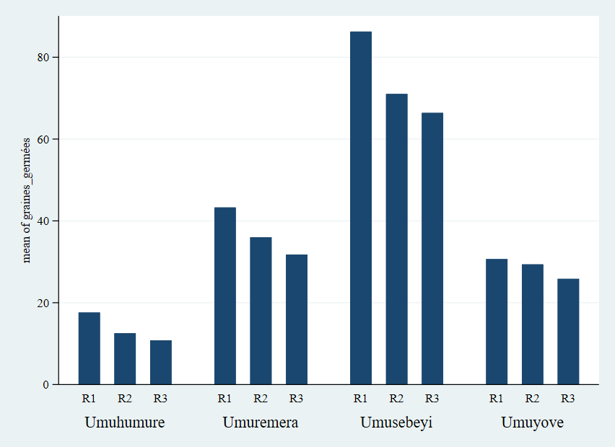

**Figure 1: Average germinated Seeds by Replicate and Variety**

*Umusebeyi* shows an exceptionally high germination in R1, while *Umuhumure* and *Umuyove* have the lowest. However, the general trend shows a decrease compared to R1 for all varieties, with *Umusebeyi* always in the lead. In R3, a continuous reduction in germination for all varieties, but *Umusebeyi* remains the most prolific variety.

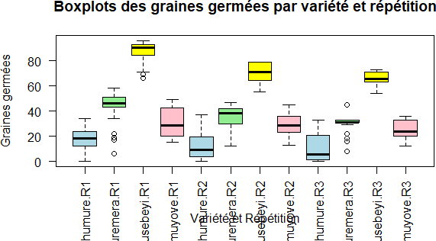

**Figure 2: Box and whisker plot of germinating data,**

***3*.3 Analysis of Variance (ANOVA)**

Before running a parametric anova, we checked if the data with homogeneous variance were normally distributed. Shapiro-Wilk and homogeneity variance tests were done.

The study was carried out to find out which indigenous tree seed germinates well in the environmental conditions provided. The aim was to find out the right indigenous tree seed that will boost the forest biodiversity given that some of the indigenous trees are at risk of extinction (Boton, 2020 and Shackleton, 2016). The seedling growth rate of plantation is the only means for selection for the appropriate species for forest survivorship and height growth (Martinez-Bravo *et al*. 2022). The experiment done shows that out of the indigenous tree varieties, Albizia *gummifera* (*Umusebeyi*) presented features such as high germination and variability, that prove to be the right choice for the farmers. The *Umusebeyi* is widely used as traditional medecine. Its bark is infused and then used to treat malaria while the pounded bark is also used to treat headache in Burundi. Another potential indiginous tree tested was the prunus *africana (umuremera)*. As it has been revealed by Jaouadi *et al.* (2010), the latter shows a moderate rate of germination. Most used as traditional medicine and poison for arrow, this variety is found in the protected areas such as national park of Kibira and Ruvubu. A well-funded study was carried out in 2019 in order to make a preliminary inventory standing stock and also to assess the level of sustainable exploitation of tree cut quota. The Prunus *africana* is accounted by CITES among the indigenous tree to be protected given its importance in enriching the forest biodiversity and also human uses in many economic activities.

4. Conclusion

The study aims at contributing to the conservation and dissemination the indigenous trees of economic use. Specifically, this paper seeks to examine the most performing woody indigenous trees through (1) indigenous tree seed germination performance and (2) the growth type through some specific parameters such as height of seedlings, diameter of stem and the number of leaves.

The methodology follows an experiment design on the four types of indigenous seed tree sawed in the nursery of the institution station. After germination, measures on key indicators were taken. Descriptive and inferential statistical analyses such as ANOVA were done. The two-way ANOVA results show that varieties, replicates and their interaction have significant effects on the number of germinated seeds and the effect of the number of days after sowing. Partial effect sizes indicate that varieties explained most of the variance, followed by days, replicates, and finally the interaction between varieties and replicates.

These results highlight the importance of considering both varieties and replicates when analyzing native tree seed germination in nurseries. The significant interaction suggests that the effect of varieties on germination depends on the context of the repetition and vice versa.

References

Hilly, M., Adams, M. L., & Nelson, S. C. (2002). A study of digit fusion in the mouse embryo. Clinical and Experimental Allergy, 32(4), 489-498.

Athman, C., Evenden, J. & Chaveas. M. (2006).Technical Assistance to the US Government Mission in Burundi on Natural Resource Management and Land Use Policy. United States Forest Service (USFS) International Programs, Department of Agriculture. Washington DC: USFS.

Banderembako, D. (2006). The Link between Land, Environment, Employment, and Conflict in Burundi. Washington DC: USAID.

Bionet 2022. East African Indigenous Trees. BioNET-INTERNATIONAL Secretariat - UK.

Boton, M.D. (2020). *Potential of Native Trees Species Regeneration and Establishment in Exotic Tree Plantations: The Case of Bellefoungou Forest Reserve in Northern Benin*. Master Thesis, Makerere University, Uganda.

Bukuru, A.; Ndayiziye, G.; Mbarushimana, D.; Masharabu, T.; Ahishakiye, R.; Vyizigiro, T.; Nahimana, G. & Nkengurutse, J. (2022). Indiginous versus Exotic Tree Species used in Silviculture and Agroforestry: An overview from Burundi Seed Data Centre. *East African Journal of Science, Technology and Innovation,* Vol 3 (Special Issue), February 2022.

Chalker-Scott, L. Nonnative, noninvasive woody species can enhance landscape biodiversity. Arboric. Urban For. 2015, 41, 173–186.

CIFOR (2022). Les Forêts du Basin du Congo: Etat des Forêts 2021. CIFOR, BN 978-602-xxx-xxx-xDOI: 10.17528/cifor/008565 deforestation-report.pdf (Accessed September 25, 2017).

Doggart, N.; Morgan-Brown, T.; Lyimo, E.; Mbilinyi, B.; Meshack, C.K.; Sallu, S.M. & Spracklen, D.V. (2020). Agriculture is the main Driver of Deforestation in Tanzania.

Guedes, B.S.; Olsson, B.A.; Egnell, G.; Sitoe, A.A et Karltun, E. (2018). Plantations of Pinus and Eucalyptus Replacing Degraded Mountain Miombo Woodlands in Mozambique Significantly Increase Carbon Sequestration. *Global Ecology and Conservation*, Vol 14, April 2018, e00401.

Haysom, K.A. & Murphy, S.T. (2003). The status of invasiveness of forest tree species outside their naturalhabitat: a global review and discussion paper. Forest Health and Biosecurity Working Paper FBS/3E. ForestryDepartment. FAO, Rome (unpublished). www.fao.org/docrep/006/j1583e/j1583e00.htm.

http://www.univ-chlef.dz/revuenatec

INECN (2013). *Stratégie Nationale et Plan d’Action sur la Biodiversité 2013-2020*. République du Burundi.

INECN 2016

Jaouadi W., L. Hamrouni, Souayeh N. & Khouja M.L. Étude de la germination des graines d’Acacia *tortilis* sous différentes contraintes abiotiques, Biotechnol. Agron. Soc. Environ., 14 (2010): 643-652.

Johnston, M.; Nail, S. &James, S. ‘Natives versus aliens’: The relevance of the debate to urban forest management in Britain. In Trees, People and the Built Environment, Proceedings of the Urban Trees Research Conference, Birmingham, UK, 13–14 April 2012; Johnston, M., Percival, G., Eds.; pp. 181–191.

Kendle, A.D. &Rose, J.E. The aliens have landed! What are the justifications for ‘native only’ policies in landscape plantings? Landsc. Urban Plan. 2000, 47, 19–31.

Kissinger, G., Herold, M., & De Sy, V. (2012). Drivers of deforestation and forest degradation: A synthesis report for REDD+ policymakers. Vancouver Canada. Available at: http://www.forestbonds.net/sites/default/files/userfiles/1file/6316-drivers-

Martinez-Bravo, R.D.; Ricker, M.; Nava-Cruz, Y. & Siebe, C (2022). Mineral Fertilisation in Tropical Reforestation: Seedling Growth and Survival of Ten Native Tree Species in Tabasco, Mexico. *Madera y Bosques*, 2022, № 1, p. e2812269

Nkengurutse, J.; Mzabri, I.; Masharabu, T.; Ndihokubwayo, N. Havyarimana, F. & Khalib, A. (2019). Contribution to the Domestication of Indigenous Fabaceae Species of Burundi: Entada abyssinica Seeding Production. *Nature and Technology*,

Shackleton, C. (2016). Do Indigenous Street Trees Promote more Biodiversity than Alien Ones? Evidence using Mistletoes and Birds in South Africa. *Forests* Vol 7 (7): 134,  [**https://doi.org/10.3390/f7070134**](https://doi.org/10.3390/f7070134)

Smith, R.M.; Thompson, K.; Hodgson, J.G.; Warren, P.H. & Gaston, K.J. Urban domestic gardens (IX): Composition and richness of the vascular plant flora, and implications for native biodiversity. Biol. Conserv. 2006, 129, 312–322.