Aromatherapy in the management of pediatric dental patients: A narrative review

.

ABSTRACT

|  |
| --- |
| **Aims:** The objective of the present study is to carry out, through a narrative review, the use of aromatherapy in the management of pediatric dentistry patients, analyzing its advantages, benefits and applicability in relation to dental anxiety.  **Study design:** The study consists of a narrative review through an electronic search for articles involving the use of aromatherapy in the clinical practice of pediatric dentistry in the SciELO, PubMed and Virtual Health Library (VHL) databases, using the descriptors: Aromatherapy AND Pediatric Dentistry.  **Results:** From the electronic search, 15 studies available in the literature were found. After reading the titles and abstracts, 6 studies were excluded that did not meet the pre-established inclusion criteria or that did not meet the objective of the present review. Therefore, 09 studies were read in full and added to the literary base that formed the basis of this study.  **Conclusion:** Aromatherapy is an important alternative in managing anxiety in pediatric dentistry patients, being safe, of good applicability and low cost. It is suggested that new robust studies be developed that further emphasize the technique, aiming at the benefits of the practice. |

*Keywords:* *(Aromatherapy,* *Anxiety, Pediatric Dentistry,* *Child)*

1. INTRODUCTION

Dental anxiety is described as a mental disorder, characterized by fear and apprehension regarding dental treatment, and is considered one of the greatest challenges in care, especially pediatric dentistry.1,2 Studies show that the prevalence of anxiety in child patients can reach around 24%, and may be related to individual, family and environmental factors.2,3

In relation to the dental environment, several components are, in most cases, responsible for fear, as fear is a response to the new and/or unknown4. Furthermore, the exposure of materials, lack of familiarity with the environment, instruments, odors and sounds, especially in pediatric dentistry, are great allies in increasing and/or inducing dental anxiety in these patients, directly influencing their behavior and increased sensitivity to pain, highlighting the need for individualized approaches on the part of professionals.3,4,5

Although there are pharmacological and behavioral resources for managing anxiety, they have limitations, high costs and can have adverse effects.6 Thus, the use of herbal medicines, such as aromatherapy, appears as an alternative in the management of anxious pediatric dentistry patients, as it has low cost, accessibility and minimal adverse effects.3,7,8

Therefore, the objective of the present study is to carry out, through a narrative review, the use of aromatherapy in the management of pediatric dentistry patients, analyzing its advantages, benefits and applicability in relation to dental anxiety.

2. material and methods

An electronic search was carried out in the year 2025, in the SciELO, PubMed and Virtual Health Library (VHL) databases, using the descriptors: Aromatherapy AND Pediatric dentistry, regarding studies that involved the use of aromatherapy in the clinical practice of pediatric dentistry.

Studies published in the years 2018 to 2025 were included to compose this review, available in full text format, without specifying the language of publication, without country restrictions and that were within the researched theme, which involves the use of aromatherapy as an anxiety-reducing mechanism during pediatric dental care. Studies that did not meet the inclusion criteria were excluded.

3. results

From the electronic search, 15 studies available in the literature were found. After reading the titles and abstracts, 6 studies were excluded that did not meet the pre-established inclusion criteria or that did not meet the objective of the present review. Therefore, 09 studies were read in full and added to the literary base that formed the basis of this study.

**Figure 01**. Flowchart illustrating the methodological design for the construction of this literature review.

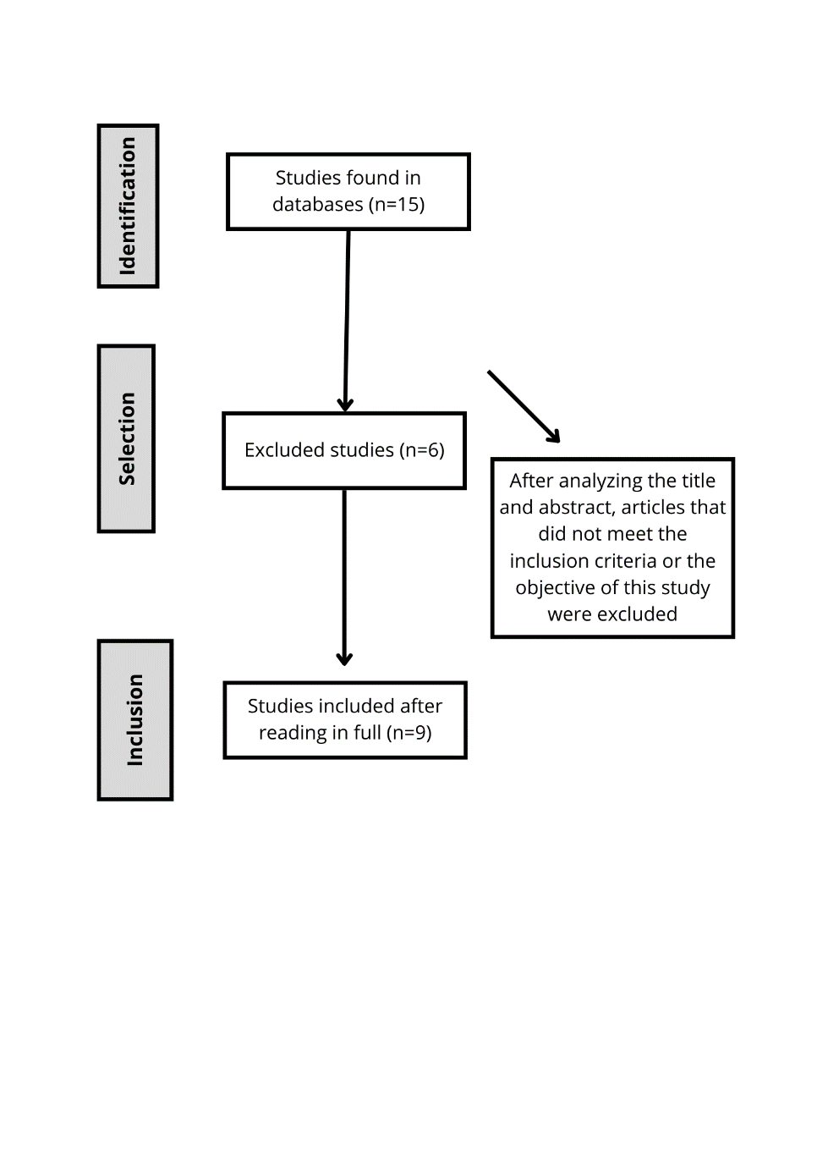

**Table 01.** Electronic search studies compiled after applying the inclusion and exclusion criteria.

|  |  |  |
| --- | --- | --- |
| **Authors/Year** | **Type of Study** | **Purpose of the study** |
| Arslan, Aydinoglu, Karan., 2020 | Randomized clinical trial | To evaluate the correlations between psychological and physiological findings following lavender oil inhalation among children assigned to tooth extraction. |
| Tripathy et al., 2023 | Randomized clinical trial | Compare the effectiveness of lavender and patchouli essential oils in aromatherapy and their effect on dental anxiety in children. |
| Cai et al., 2021 | Systematic review | To evaluate the effectiveness of aromatherapy in dental anxiety. |
| Kong, Song, Chen, Li., 2024 | Systematic review and meta-analysis | To evaluate the effectiveness of various non-pharmacological interventions in reducing dental anxiety as well as increasing heart rate during pediatric dental treatments. |
| Samani et al., 2024 | Randomized clinical trial | To evaluate the possible anxiolytic effect of jasmine aromatherapy in pediatric dental procedures. |
| Ghaderi F, Solhjou N. 2020 | Randomized clinical trial | Determine the effect of lavender aromatherapy on anxiety level during dental treatment and pain perception during dental injection in children. |
| Arslan I, Aydinoglu S, Karan NB., 2020 | Randomized clinical trial | To evaluate the correlations between psychological and physiological findings after inhalation of lavender oil in children undergoing tooth extraction. |
| Nirmala K, Kamatham R., 2021 | Randomized clinical trial | To evaluate the effectiveness of aromatherapy in reducing anxiety and dental pain during local anesthesia procedures. |
| Bartolome et al. 2021 | Observational study | Identify which alternative techniques are used in the dental clinic by professionals to manage the behavior of child patients. |

**4. LITERATURE REVIEW**

**4.1 DENTAL ANXIETY**

According to Nirmala et al., 2021, anxiety during dental treatment is prevalent in around 5% to 20% of children, which is relevant data since the presence of this disorder can increase the patient's perception of pain, making the moment unpleasant and consequently destabilizing their emotions.7

Studies show that anxious dental patients tend to avoid necessary treatments, which negatively affects their oral health and quality of life. Furthermore, anxiety can make care difficult, leading to negative behaviors and creating an often traumatic moment for the pediatric dentist patient.3,10,11

In the dental environment there are several sensory stimuli and situations that can be a great potential for fear and/or anxiety in patients, especially in pediatric dentistry patients, since they are a public with a higher level of sensitivity and less knowledge, thus, anxiety in these cases can be more intense.3,4,12

This anxiety, which most often develops in childhood when left untreated, continues with the patient into adulthood, generating a series of negative impacts on their oral health.4 Therefore, controlling this disorder in the face of dental treatment through techniques that help minimize sensory triggers in the dental clinic are extremely useful in patient management, providing less traumatic dental visits.13

4.2 AROMATHERAPY

Although there are several methods already consolidated to control the patient's anxiety and behavior, such as the use of pharmacological drugs, these have limitations, high costs, can have adverse effects, in addition to non-acceptance by family members.6

From this, the use of complementary alternative medicines emerges as an alternative in the management of anxious pediatric dentistry patients. Studies show that aromatherapy has benefits such as low cost, minimal side effects, low cost and easy applicability.3,7,8,9,12

Bartolome et al. 2021 says in his study, that aromatherapy consists of the use of certain aromatics, which can produce positive effects both physically and emotionally, through the release of neurotransmitters that induce relaxation, in many individuals changes in the level of anxiety, heart rate and breathing can be observed.19

Lavender essential oil is one of the most used in aromatherapy. This is extracted by hydrodistillation of Lavandula angustifolia flowers, and has a sedative, anxiolytic and analgesic effect.20

Currently, aromatherapy is recognized worldwide and the application of essential oils is guaranteed to be safe. They can be applied in different ways, including application to the skin, baths, massage and inhalation.7

According to Nirmala K, Kamatham R. 2021, inhalation is, among these forms, the most basic of use. The oils can be inhaled through a humidifier or with moistened gauze/cotton. The relatively low cost and minimal side effects are the factors that indicate this practice by health professionals as an excellent therapeutic intervention in patient management.7

**4.3 AROMATHERAPY IN PEDIATRIC DENTISTRY**

In the pediatric dentistry scenario, the use of aromatics appears as an important alternative in behavioral management and anxiety control, offering greater comfort and safety to children and their families.21

The findings of the study by Arslan et al. (2020), led the authors to suggest that lavender oil could be used to treat anxiety in pediatric dentistry patients, since in their study, children who inhaled the aromatic oil had lower anxiety, pain, blood pressure and heart rate scores after tooth extraction.22

A recent randomized clinical trial that aimed to evaluate the correlations between psychological and physiological findings after inhaling lavender oil among children assigned to tooth extraction, concluded that children who used aromatherapy had significantly lower anxiety and pain scores after tooth extraction.23

Ghaderi and Solhjou (2020), evaluating the effect of aromatherapy, with indicators of childhood anxiety in salivary cortisol and pulse rate during treatments that could potentially cause stress, observed that aromatherapy with lavender essential oil can generate a significant reduction in physiological parameters in children during dental care, in addition to reducing the perception of pain during the anesthesia procedure.4

Aromatherapy emerges as a complementary alternative therapeutic approach that uses essential oils as its main product, which induce satisfactory pharmacological and physiological effects in users.3,11 Thus, this treatment method has strong potential in terms of the ability to reduce anxiety during dental treatment, in order to provide comfortable care for patients, professionals and families.11,23

5. Conclusion

Given the findings, it is concluded that aromatherapy is an important alternative in managing anxiety in pediatric dentistry patients, being safe, of good applicability and low cost. It is suggested that new robust studies be developed that further emphasize the technique, aiming at the benefits of the practice.

References

1. Alshuaibi AF, Aldarwish M, Almulhim AN, Lele GS, Sanikommu S, Raghunath RG. Prevalence of dental fear and anxiety and its triggering factors in the dental office among school-going children in Al Ahsa. Int J Clin Pediatr Dent. 2021;14:286–92.

2. Yon MJY, Chen KJ, Gao SS, Duangthip D, Lo ECM, Chu CH. An introduction to assessing dental fear and anxiety in children. Healthcare. 2020;8:86.

3. Grisolia BM, dos Santos APP, Dhyppolito IM, Buchanan H, Hill K, Oliveira BH. Prevalence of dental anxiety in children and adolescents globally: a systematic review with meta-analyses. Int J Paediatr Dent. 2021;31:168–83.

4. Ghaderi F, Solhjou N. The effects of lavender aromatherapy on stress and pain perception in children during dental treatment: A randomized clinical trial. Complement Ther Clin Pract. 2020.

5. BARRETO, KA.; LIMA DSM.; SOARES FC.; COLARES V.. Ansiedade relacionada ao tratamento odontológico em pacientes infantis: uma revisão da literatura. Odontol. Clín.-Cient. 2016.

6. James J, Retnakumari N, Vadakkepurayil K, Thekkeveetil AK, Tom A. Effectiveness of Aromatherapy and Music Distraction in Managing Pediatric Dental Anxiety: A Comparative Study. Int J Clin Pediatr Dent. 2021.

7. Nirmala, Kamalapuram, Kamatham, Rekhalakshmi Effect of Aromatherapy on Dental Anxiety and Pain in Children Undergoing Local Anesthetic Administrations: A Randomized Clinical Trial Journal Article 2021, J Caring Sci.

8. Reyes MCGM, Reyes MCGM, Ribay KGL, Paragas ED. Effects of sweet orange aromatherapy on pain and anxiety during needle insertion among patients undergoing hemodialysis: a quasi-experimental study. Nurs Forum [Internet]. 2020;55:425–32. https://doi.org/10.1111/nuf.12447.

9. Arslan I, Aydinoglu S, Karan NB. Can lavender oil inhalation help to overcome dental anxiety and pain in children? A randomized clinical trial. Eur J Pediatr. 2020 Jun;179(6):985-992. doi: 10.1007/s00431-020-03595-7. Epub 2020 Feb 6. PMID: 32030454.

10. Tripathy S, Kohli A, Sharma K, Katyayan R, Bhatnagar P, Sahar N. Comparative Evaluation between Lavender Essential Oil and Patchouli Essential Oil in Aromatherapy and Its Effect on Dental Anxiety in Children. Int J Clin Pediatr Dent. 2023 Sep-Oct;16(5):681-685. doi: 10.5005/jp-journals-10005-2674. PMID: 38162239; PMCID: PMC10753106.

11. Cai H, Xi P, Zhong L, Chen J, Liang X. Efficacy of aromatherapy on dental anxiety: A systematic review of randomised and quasi-randomised controlled trials. Oral Dis. 2021 May;27(4):829-847. doi: 10.1111/odi.13346. Epub 2020 May 26. PMID: 32267044

12. Zerman N, Zotti F, Chirumbolo S, Zangani A, Mauro G, Zoccante L. Insights on dental care management and prevention in children with autism spectrum disorder (ASD). What is new? Front Oral Health. 2022 Sep 27;3:998831. doi: 10.3389/froh.2022.998831. PMID: 36238091; PMCID: PMC9551997.

13. 1Kong X, Song N, Chen L, Li Y. Non-pharmacological interventions for reducing dental anxiety in pediatric dentistry: a network meta-analysis. BMC Oral Health. 2024 Sep 28;24(1):1151. doi: 10.1186/s12903-024-04919-x. PMID: 39342194; PMCID: PMC11439256.

14. Nirmala K, Kamatham R. Effect of Aromatherapy on Dental Anxiety and Pain in Children Undergoing Local Anesthetic Administrations: A Randomized Clinical Trial. J Caring Sci. 2021 Aug 23;10(3):111-120. doi: 10.34172/jcs.2021.026. PMID: 34849354; PMCID: PMC8609116.

15. Avramova N. Dental fear, anxiety, and phobia; causes, diagnostic criteria and the medical and social impact. J Mind Med Sci. 2022;9:202–8.

16. Carrillo-Díaz M, Migueláñez-Medrán BC, Nieto-Moraleda C, Romero-Maroto M, González-Olmo MJ. How can we reduce dental fear in children? The importance of the first dental visit. Children 2021;8:1167.

17. Appukuttan DP. Strategies to manage patients with dental anxiety and dental phobia: literature review. Clin Cosmet Investig Dent [Internet]. 2016;8:35–50. https://doi.org/10.2147/CCIDE.S63626.

18. Janthasila N, Keeratisiroj O. Music therapy and aromatherapy on dental anxiety and fear: a randomized controlled trial. J Dent Sci. 2023;18:203–10.

19. BARTOLOMÉ VB.; MÉNDEZ ZM.; VILAR RC.; ARRIETA BJJ. Técnicas alternativas del manejo de la conducta en odontopediatría. Revista De Odontopediatría Latinoamericana. 2021

20. Naufal AH, Virgirinia RP, Fatchiyah F. Molecular interaction of lavender [Lavandula angustifolia Mill] essential oil compounds as potential anxiolytic against α2δ subunit voltage gated calcium channel. Berk Penelit Hayati. 2023;29:1–11.

21. DE SOUZA, MGP.; FONSECA, SCM.; DE DEUS, AVH.; BARROS, JRC. ANSIEDADE INFANTIL: relação com a estrutura familiar e suas consequências. Brazilian Journal of Implantology and Health Sciences. 2024.

22. Arslan I, Aydinoglu S, Karan NB. Can lavender oil inhalation help to overcome dental anxiety and pain in children? A randomized clinical trial. Eur J Pediatr. 2020 Jun. doi: 10.1007/s00431-020-03595-7.

23. Abdalhai, R., Kouchaji, C. & Alkhatib, R. The effect of aromatherapy with Lavender-Neroli oil and music in management of pediatric dental anxiety: a randomized control trial. BDJ Open 10, 5 (2024). https://doi.org/10.1038/s41405-024-00186-8