The Normocaloric Diet Reduces Daytime Food Intake in Obese Mice due a High-Fat Diet and Normalizes Fat Accumulation and Metabolic Parameters

.
ABSTRACT

Introduction: The consumption of ultra-processed foods, rich in fat, has contributed to the global increase in obesity and other metabolic disorders resulting from excess adipose tissue and Non-Alcoholic Fatty Liver Disease (NAFLD). Physical exercise and dietary reeducation constitute the first-line treatment for weight loss; however, to accelerate weight loss, the use of restrictive diets is common but are unsustainable in the long term and result in weight regain.
Aims: Evaluate the effects of replacing a high-fat diet to a normocaloric diet (ad libitum) on food intake, fat accumulation, glycemic homeostasis, and non-alcoholic fatty liver disease.
Methodology: Animals were divided into two groups one feed with high-fat diet and the other with standard diet for 8 weeks. Then, half of the animals on the high-fat diet had their food replaced for a standard diet. Body weight was measured weekly. After an additional 7 weeks, we assessed food intake and tested glucose and insulin tolerance. The animals were euthanized 8 weeks after the dietary intervention, and liver tissue was collected for histological analysis.
Results: The high-fat diet induced obesity and metabolic changes such as hyperglycemia, insulin resistance, dyslipidemia, and hepatic steatosis. The replacement for a standard diet, even without influencing total caloric intake, reduced food intake during the day and was able to restore body weight, normalize blood glucose and lipid profile, beyond improve the hepatic steatosis.
Conclusion: Less restrictive dietary interventions, based on macronutrient balanced diets, are effective in the treatment of obesity and Non-Alcoholic Fatty Liver Disease.

Keywords: obesity; high-fat diet; diet therapy; NAFLD; weight loss; food intake; glycemic homeostasis.

1. INTRODUCTION

The consumption of ultra-processed foods, rich in sugars and fats, has been contributing to the increase in obesity worldwide ^{(1,2,3,4)}. At this rate, it is estimated that by 2035, more than 50% of the global population will be obese ⁽⁵⁾, representing a significant public health problem because the excess adipose tissue is associated with the development of various Non-Communicable Chronic Diseases (NCDs), such as hypertension, Type 2 Diabetes Mellitus (DM2), and Non-Alcoholic Fatty Liver Disease (NAFLD), the leading cause of chronic liver disease globally ^{(1,4,6)}.
The liver is an organ that operates in a highly coordinated and dynamic manner to regulate the metabolism of macronutrients according to hormonal, neural, and dietary stimuli ⁽⁷⁾. However, in obesity, an inflammatory state occurs, leading to metabolic changes that contribute to NAFLD, such as stimulation of de novo lipogenesis due to hyperinsulinemia, increased uptake of free fatty acids from adipose tissue lipolysis due to insulin resistance, along with mitochondrial dysfunction and increased oxidative stress ^{(6,8)}.
Various strategies are being employed to combat obesity and comorbidities such as NAFLD. These include adopting healthier lifestyle habits, engaging in physical exercise, dietary reeducation, and more drastic measures like pharmacological treatment and bariatric surgeries ^{(9,10)}. However, it is common for highly restrictive diets to be used to achieve a quick solution to obesity, which are generally unsustainable in the long term and often followed by weight regain ⁽¹¹⁾.
Some diets, such as the hypocaloric Mediterranean diet, are well-accepted in the treatment of NAFLD, as are certain foods like coffee and the modulation of the microbiota ⁽¹²⁾. In this context, diets of high quality could reduce NAFLD cases. Therefore, there is a question about the improvement in the nutritional composition of diets, moving from a high-fat diet to a normocaloric and balanced diet in macronutrients for the treatment of obesity and its comorbidities like NAFLD. In this sense, we aimed to evaluate the effects of replacing a high-fat diet (HFD) to a normocaloric diet (CD) (ad libitum) on food intake, fat accumulation, glycemic homeostasis, and Non-Alcoholic Fatty Liver Disease (NAFLD).

2. material and methods

2.1 Animals

All experiments were approved by the university’s ethics committee on animal use (ceua – state university of western paraná - unioeste protocol no. 22-20). Male c57bl/6 mice at 6 weeks of age (average weight of 20g) were housed in polypropylene boxes (30x20x13cm, 2-3 animals/box) under controlled temperature (23± 2ºc) and lighting conditions (12 hours light/dark). All animals underwent an acclimatization period (2 weeks) during which they received a standard rodent diet and water ad libitum.

2.2 Obesity Induction and Diet Composition

After the acclimatization period, the animals were randomly divided into two groups: the control group (CTL, n=9) received a standard rodent diet (Supralab, Brazil; 70% carbohydrates, 20% proteins, 10% lipids; 3.8 kcal/g) throughout the experiment; and a high-fat diet group (HFD, n=26) received a high-fat diet for 8 weeks to induce obesity. The high-fat diet was prepared at the Laboratory of Endocrine Physiology and Metabolism (LAFEM – UNIOESTE) and consisted of 50% ground standard diet, 14.8% casein, 4% soybean oil, and 31.2% lard (36.7% carbohydrates, 25.4% proteins, 37.9% lipids; 6.23 kcal/g).

2.3 Dietary Intervention

After inducing obesity in the HFD group, a dietary intervention was conducted with half of the HFD group animals, where the high-fat diet was replaced with a standard diet, resulting in the high-fat diet-standard diet group (HFD-CD, n = 13), which continued on this diet for an additional 8 weeks.

2.4 Food Intake Assessment

In the 7th week after the dietary intervention, the animals were individually housed, and food intake was recorded by subtracting the amount of offered feed from its residue every 12 hours for three days. The presented results were obtained by averaging the consumption, expressed in kcal.

2.5 Intraperitoneal Glucose Tolerance Test (ipGTT)

The intraperitoneal glucose tolerance test (ipGTT) was conducted 7 weeks after the dietary intervention. The animals underwent an 8-hour fast, and blood was collected from a tail snip for fasting glycemia measurement (time 0) using a glucose meter and test strips (Accu-Chek® Active, Roche, Brazil). Subsequently, the animals received an intraperitoneal injection of glucose at a concentration of 2g/kg body weight, and glycemia was measured at 15, 30, 60, 90, and 120 minutes after administration.

2.6 Insulin Tolerance Test (ITT)

After a 2-hour fast, blood was collected from the tail for fasting glycemia measurement (time 0) using a glucose meter and test strips (Accu-Chek® Active, Roche, Brazil). Regular insulin (0.75 IU/kg) was administered intraperitoneally, and glycemia was measured again at 3, 6, 9, 12, 15, 18, and 21 minutes after injection. At the end of the test, the animals received 100 μl of 50% glucose to prevent hypoglycemia and were observed for one hour.

2.7 Euthanasia

After 8 weeks of dietary intervention, the mice were weighed, anesthetized with xylazine (9 mg/kg) (Anasedan®, Vetbrands, Brazil), and ketamine (90 mg/kg) (Dopalen®, Vetbrands, Brazil). Once absent cutaneous reflex, naso-anal length was measured, and decapitation was performed. Blood was collected and transferred to Eppendorf tubes, centrifuged (12,600 g, 10 minutes, 4 °C), and plasma stored at -80 °C for triglyceride (TG) and cholesterol (COL) measurement using commercial colorimetric kits (Bioclin, Quibasa, Brazil). Subsequently, laparotomy was performed for extraction and weighing of retroperitoneal and perigonadal white adipose tissue and the liver.

2.8 Insulin Resistance

Insulin resistance was calculated using the TyG index, associated with fasting glucose and TG, both in fasting conditions. Calculated by: Ln(fasting TG [mg/dL] x fasting plasma glucose [mg/dL])/2 (ref) ⁽¹³⁾.

2.9 Liver Histology

A fragment of the left hepatic lobe was collected from each animal, in a cross-section from the center towards the organ's margin. Samples were fixed in Carson's formalin solution (37% formaldehyde by weight (10%), methanol (1.5%), and PBS, pH 7.4 (88.5%)) for 24 hours and then washed in running water before being dehydrated in increasing concentrations of alcohol. Samples were then clarified in xylene, embedded, and included in Paraplast® (Sigma Co, St Louis, MO). 7μm thick slices were cut using a manual rotary microtome (Olympus 4060), equipped with a steel knife. Sections were stained with hematoxylin and eosin (HE) for hepatic steatosis analysis ⁽¹⁴⁾. Images were analyzed under an optical microscope (Olympus BX61) equipped with a digital camera (Olympus DP71) and DP Controller 3.2.1.276 software.

2.10 Data Analysis and Statistics

Data are presented as means ± standard errors of the mean. The Shapiro-Wilk test was used for normality analysis. Parametric data were analyzed using unpaired Student's t-test or one-way ANOVA. Non-parametric data were analyzed using the Mann-Whitney test or Kruskal-Wallis test. The significance level was set at p < 0.05, and analyses were performed using GraphPad Prism version 8.0 (GraphPad Software ©).

3. results

3.1 Dietary Intervention for Eight Weeks Reduces the Body Weight of Obese Mice on a High-Fat Diet

After eight weeks of a high-fat diet, the body weight gain in the HFD group was approximately 2.5 times higher compared to the CTL group (Fig. 1A), confirming obesity. In the tenth week (Fig. 1B), the animals in the HFD group were divided into two groups: HFD, which continued with the high-fat diet, and HFD-CD, which switched to a standard rodent diet for another eight weeks. Figure 1B represents the weight progression of obese animals on a high-fat or standard diet. It is observed that just two weeks after returning to the standard diet, the animals in the HFD-CD group already showed body weight statistically similar to the CTL group (Fig. 1B). The CTL group maintained relatively constant body weight over the eight weeks, while the HFD group continued to gain weight throughout the experiment. However, the HFD-CD group exhibited a significant reduction in body weight after the dietary intervention (Fig. 1C).
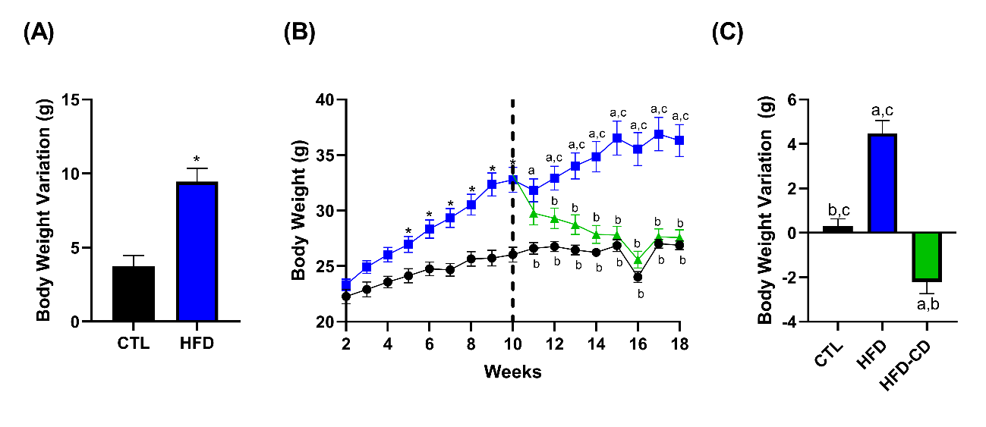

Fig. 1. Effects of standard and high-fat diet on the body weight of mice. Variation in body weight during the induction of obesity (A). Evolution of body weight in mice fed a standard or high-fat diet (B). Variation in body weight after dietary intervention (C). Data presented as mean ± SEM. Different letters represent statistical differences between groups: a (CTL, n=9), b (HFD, n=13), and c (HFD-CD, n=13). p <0.05 was adopted as the significance criterion.

3.2 Dietary Intervention for Eight Weeks Modestly Improves Glucose Tolerance in Obese Mice on a High-Fat Diet

Following glucose administration during the ipGTT, all three groups exhibited similar glycemic peaks, and after 30 minutes, plasma glucose concentration began to decline. However, at 60, 90, and 120 minutes, the blood glucose levels of the HFD-CD group and the CTL group were similar, while the HFD group remained higher (Fig. 2A). Analyzing the area under the glycemic curve during the ipGTT, it is observed that the HFD-CD group showed a slight improvement in glucose tolerance, statistically similar to the CTL group (Fig. 2B).
During the ipITT, the area under the glycemic curve was similar between the groups (Fig. 2D). However, in the representative curve of the test (Fig. 2C), it is noted that the blood glucose of the HFD group remained higher than the CTL group until 12 minutes, and that of the HFD-CD group remained intermediate between the CTL and HFD groups. Fifteen minutes after insulin application, the plasma glucose of the three groups was similar until the end of the test (Fig. 2C).

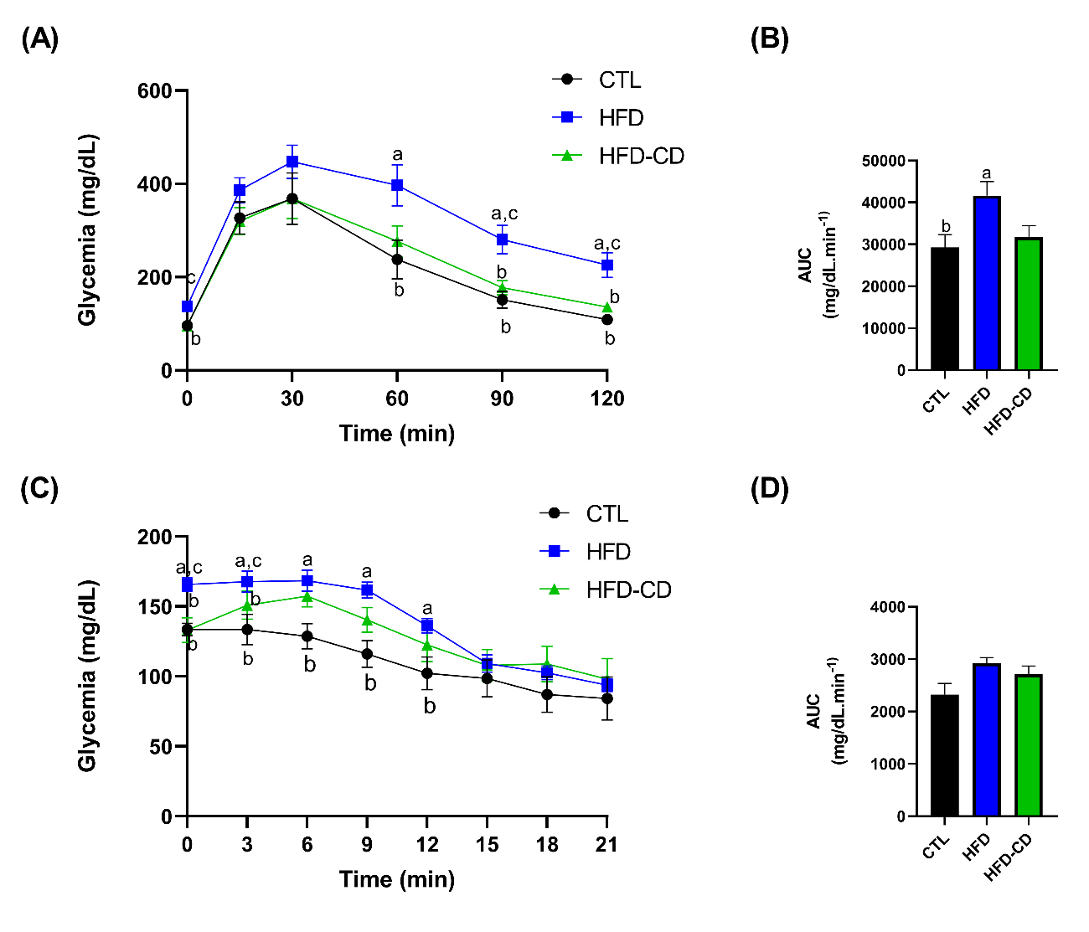
Fig. 2. Effect of dietary intervention on blood glucose during the glucose and insulin tolerance test in obese mice. Blood glucose curve during intraperitoneal glucose administration (A) and insulin (C), and area under the curve of blood glucose during ipGTT (B) and ipITT (D). Data presented as mean ± SEM. Different letters represent statistical differences between groups: a (CTL, n=9), b (HFD, n=13), and c (HFD-CD, n=13). p <0.05 was adopted as the significance criterion.

3.3 The Food Intake of Obese Mice on a High-Fat Diet is Similar to That of Lean Mice During the Nighttime and Higher During the Daytime

Nighttime food intake (19:00 to 07:00h) (Fig. 3A) and over a 24-hour period (Fig. 3B) was similar among the three groups of studied animals. However, interestingly, the daytime food intake of the HFD group (from 7:00 to 19:00h) was significantly higher when compared to the CTL and HFD-CD groups (Fig. 3C).
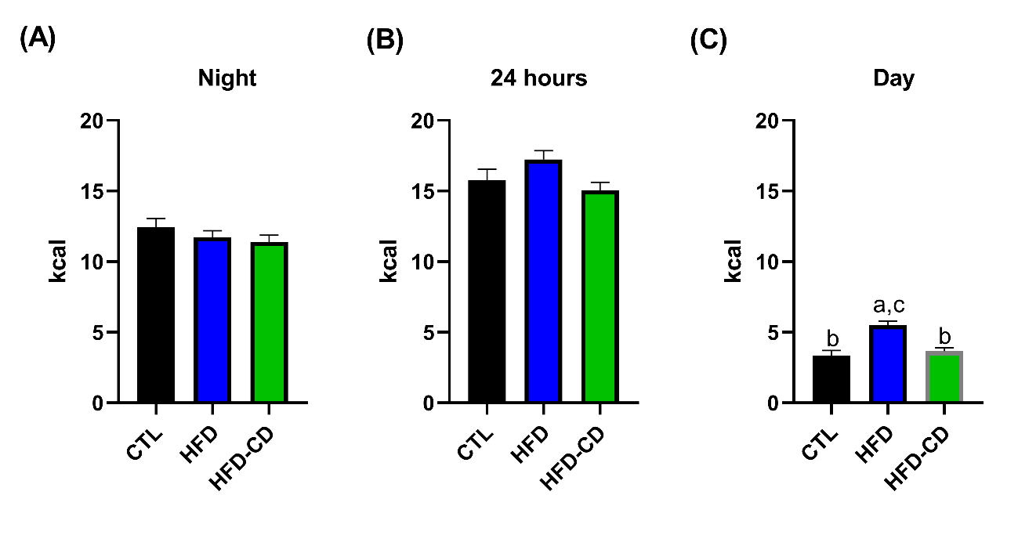
Fig. 3. Comparison of food intake in animals with a high-fat or standard diet in three distinct periods. Nighttime calorie consumption, from 7:00 PM to 07:00 AM (A). Caloric intake over a 24-hour period (B). Daytime calorie consumption, from 07:00 AM to 7:00 PM (C). Data presented in kcal as the mean ± SEM of food intake over a period of 3 complete days. Different letters represent statistical differences between groups: a (CTL, n=9), b (HFD, n=13), and c (HFD-CD, n=13). p <0.05 was adopted as the significance criterion.

3.4 Dietary Intervention for Eight Weeks Normalizes Fat Stores and Biochemical Parameters in Obese Mice on a High-Fat Diet

Table 1 shows that body weight, perigonadal and retroperitoneal fat weight, fasting blood glucose, plasma triglycerides, cholesterol, and TyG index were significantly higher in the HFD group compared to the CTL group. Interestingly, after eight weeks of dietary intervention, all analyzed parameters in the HFD-CD group were statistically lower than the HFD group and similar to the CTL group (Table 1).

Table 1. Biometric and Plasma Parameters analyzed eight weeks after dietary intervention
 | CTL | HFD | HFD-CD
Body Weight (g) | 26,89 ± 0,39 ^{b} | 36,3 ± 1,43 ^{a,c} | 27,57 ± 0,7 ^{b}
Perigonadal Fat  (mg/g de PC) | 10,49 ± 0,63 ^{b} | 49,33 ± 3,20 ^{a,c} | 14,06 ± 1,71 ^{b}
Retroperitoneal Fat (mg/g de PC) | 1,24 ± 0,30 ^{b} | 11,68 ± 1,97 ^{a,c} | 2,43 ± 0,59 ^{b}
Fasted Glycemia (mg/dL) | 95,67 ± 5,90 ^{b} | 137,2 ± 9,37 ^{a,c} | 95,05 ± 3,14 ^{b}
Fed Glycemia (mg/dL) | 123,4 ± 1,67 | 135,2 ± 4,78 ^{c} | 118,6 ± 3,78 ^{b}
Plasma COL (mg/dL) | 75,4 ± 4,46 ^{b} | 127,8 ± 13,03 ^{a,c} | 70,85 ± 7,56 ^{b}
Plasma TG (mg/dL) | 53,34 ± 5,44 ^{b} | 85,17 ± 7,50 ^{a,c} | 57,38 ± 4,72 ^{b}
TyG Index | 4,22 ± 0,10 ^{b} | 4,72 ± 0,06 ^{a,c} | 4,28 ± 0,04 ^{b}
Data presented as mean ± SEM. Different letters represent statistical differences between groups: a (CTL), b (HFD), and c (HFD-CD). Body weight, perigonadal fat, retroperitoneal fat, fed blood glucose: One-way ANOVA (CTL n=9; HFD n=13; HFD-CD n=13). Fasting blood glucose: Kruskall-Wallis (CTL n=9; HFD n=13; HFD-CD n=13). Plasma cholesterol (Plasma COL): One-way ANOVA (CTL n=5; HFD n=7; HFD-CD n=6). Plasma triglyceride (Plasma TG) and TyG index: Kruskall-Wallis (CTL n=5; HFD n=7; HFD-CD n=6). p <0.05 was adopted as the significance criterion.

3.5 Hepatic Histology Shows Improvement in Hepatic Steatosis After Eight Weeks of Dietary Intervention in Obese Mice on a High-Fat Diet

Photomicrographs of the liver (Fig. 4E), stained with H&E, were used to quantify the presence of macrovesicular and microvesicular steatosis based on the percentage of the total affected area (Fig. 4A and B).
Regarding macrovesicular steatosis, all assessed areas in HFD animals were classified as Score 2, while dietary intervention in the HFD-CD group resulted in slight improvement, reducing to Score 1 in 20% of the areas. CTL animals also presented macrovesicular steatosis Score 1 in 75% of the assessed areas (Fig. 4A).
Concerning microvesicular steatosis, 20% of the assessed areas in HFD animals had Score 2, and 80% had Score 1. Dietary intervention resulted in 80% of the assessed areas classified as Score 1 and 20% as Score 0, very similar to the CTL group, which had 75% in Score 1 and 25% in Score 0 (Fig. 4B).
Therefore, all three evaluated groups showed signs of NAFLD; however, the HFD group had the highest score on a scale of 0 to 9, with an average of 4.6. Dietary intervention was able to reverse the progression of the disease, and thus, the CTL and HFD-CD groups presented similar values (Fig. 4C). The most advanced stage of the disease in the HFD group was characterized by the presence of more inflammatory foci per field (Fig. 4D).

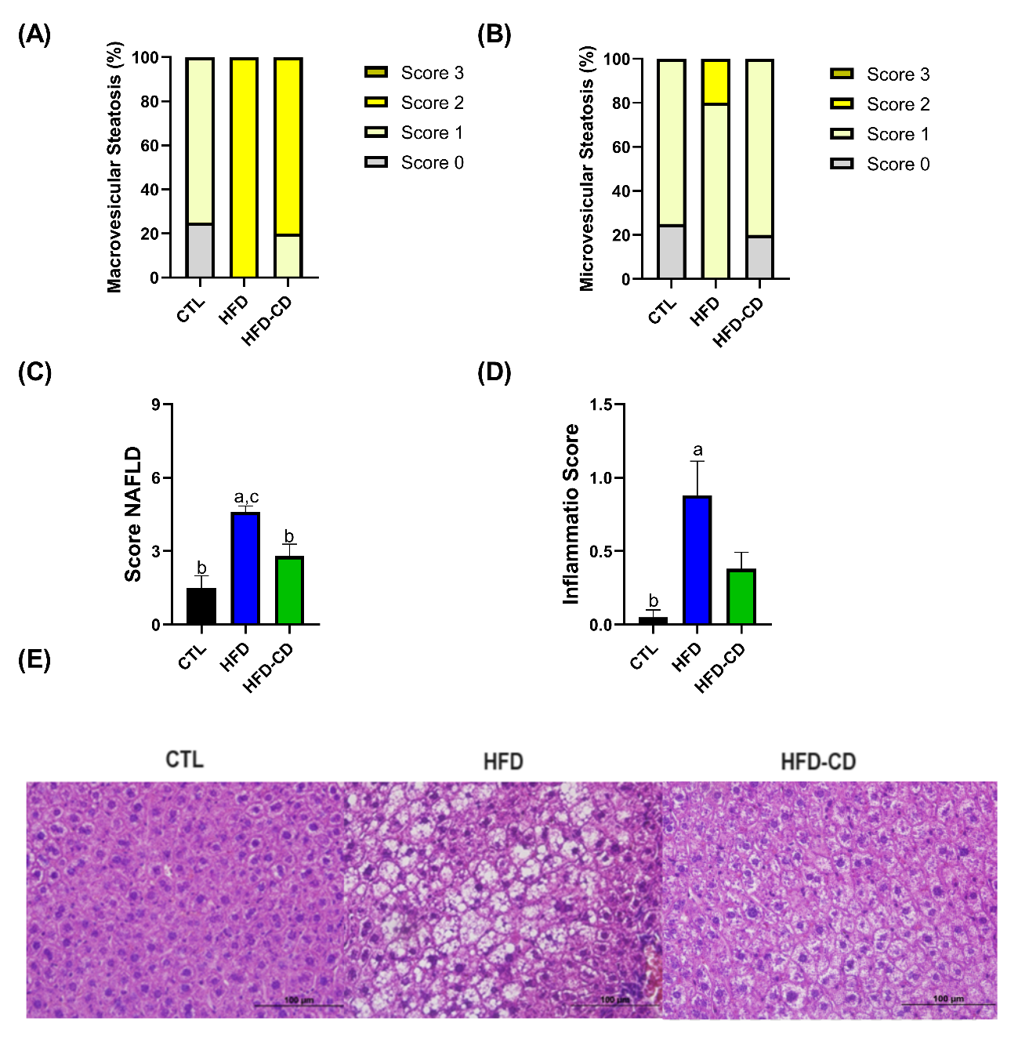
Fig. 4. Effects of dietary intervention on hepatic steatosis in obese mice fed a high-fat diet. Percentage of liver areas with macrovesicular (A) and microvesicular (B) steatosis. Scoring scale for NAFLD (C). Inflammatory foci per field (D). Photomicrograph of the liver stained with Hematoxylin and Eosin, magnification of 400x. Different letters represent statistical differences between groups: a (CTL n=4), b (HFD n=5), and c (HFD-CD n=5). p <0.05 was adopted as the significance criterion.

4. DISCUSSION

Obesity has become a pandemic, and a diet high in fat, combined with a sedentary lifestyle, seems to be a crucial factor in explaining this population-wide weight gain. Contemporary diets are highly palatable, rich in fats and simple carbohydrates. These diets cause hypothalamic injuries that result in an imbalance between caloric intake and energy expenditure. How much longer a subject consumes this type of food, greater will be the imbalance and increased food intake, leading to a vicious circle that induces excessive weight gain, accompanied by various comorbidities¹⁵. A high-fat diet contributes to hypothalamic inflammation even before body weight gain ¹⁶, and the reversal of obesity through caloric restriction leaves the NPY/AgRP axis more activated without promoting changes in POMC/CART, which may explain the difficulty in maintaining long-term weight loss ^{(17,18)}.
In our study, we observed that administering a high-fat diet for 8 weeks was effective in inducing obesity and associated metabolic changes, such as hyperglycemia, glucose intolerance, dyslipidemia, and hepatic steatosis. The administration of a high-fat diet is a well-established obesity induction model in the literature ^{(6,19)}, but there is a significant variation in the lipid percentage of these diets. Many studies use high-fat diets composed of 60% fat, which is not representative of the typical western human diet with around 35% fat ⁽²⁰⁾. In this work, we chose to use a diet with 37.9% lipids, very similar to the composition of the human diet.
In addition to the nutritional composition of diets, the chemical composition also influences metabolic responses. The literature shows that a high-fat diet with the addition of palm oil does not induce liver insulin resistance ⁽²¹⁾, whereas the addition of corn oil, lard, and coconut oil impairs hepatic metabolism ⁽¹⁹⁾. Treating animals with a 37.9% fat diet with the addition of lard and soybean oil resulted in hepatic changes with increased areas of steatosis and inflammation (Fig. 4).
After 8 weeks of a high-fat diet, fifty percent of the animals switched to a standard diet, and after 8 weeks of diet replacement, body weight, fat stores, blood glucose, and plasma TG and cholesterol levels were similar to control animals, while glycemic homeostasis and hepatic steatosis were partially normalized in the HFD-CD group compared to the HFD group. It is important to note that despite the dietary intervention with the diet switch, the animals were not subjected to caloric restriction, as the feed was offered ad libitum, and surprisingly, we observed that all three groups had the same total caloric intake, although the HFD-CD group lost weight, and the HFD group continued to gain weight until euthanasia. A similar observation was made in the study by Hatzidis et al. ⁽²²⁾, where they induced obesity with a high-fat diet for 9 weeks and subjected one group of animals to dietary intervention by switching from a high-fat diet to a standard diet for 4 weeks. It was observed that both the animals consuming a high-fat diet and those fed a standard diet had the same caloric intake, despite the weight loss in the dietary intervention group and the maintenance of obesity in the animals fed a high-fat diet.
In our study, we observed that although the total food intake was the same, the HFD-CD and CTL animals consumed approximately 15 kcal/day, while the HFD animals consumed around 17 kcal/day. According to Guo et al. ⁽⁸⁾, significant differences in body weight can be maintained with very small differences in food intake, requiring less than 1 kcal/day more to maintain a higher weight. Moreover, animals subjected to a high-fat diet show lower total energy expenditure due to a decrease in voluntary physical activity ^{(8, 22)} and hypothalamic inflammation that impairs thermogenesis ⁽²³⁾ and may stimulate hedonic eating behavior. Interestingly, in the present study, despite similar food intake during the night and over 24 hours (Fig 3A and B) among the three groups studied, during the daytime, HFD-CD and CTL animals ate less compared to HFD animals (Fig 3C), which could justify the reduction in body weight and fat accumulation, and consequently, improvements in other evaluated parameters. Similar results were observed in HFD mice undergoing vertical gastrectomy (article submitted for publication).
Several studies suggest that the consumption of high-fat diets at certain times of the day can accentuate body weight gain. The timing of food intake is related to the synchronization of various organs involved in the digestion and absorption of nutrients and metabolism, such as the stomach, intestine, and pancreas ⁽²⁴⁾. Animal studies indicate that the timing of food intake influences the synchronization of circadian rhythm genes, and this timing is crucial for weight gain, as well as fat mobilization and body weight reduction ⁽²⁴⁾.
Evidence obtained from animal experimentation shows that eating at the wrong time is closely related to the development of obesity ⁽²⁵⁾. Mice subjected to a high-fat diet during the day, in their resting period, showed greater weight gain despite having a similar total food intake to the control group ^{(25, 26)}. In this sense, interventions that affect food intake at different times of the day can prevent the development of obesity and its comorbidities.
Moreover, it is known that a high-fat diet could alter eating behavior through changes in the expression of genes that regulate circadian rhythm in the hypothalamus, liver, and adipose tissue. This effect has been associated with changes in insulin, leptin, glucose, and free fatty acid levels ⁽²⁷⁾. These data suggest that a high-fat diet could alter the food consumption of animals during the light/dark cycle through changes in genes that regulate circadian rhythm. In our study, dietary intervention in the HFD-CD group seems to regulate food consumption during the day, reducing these values and contributing to the observed reduction in body weight.
The body weight loss in the HFD-CD group was accompanied by a significant reduction in both perigonadal and retroperitoneal fat stores, consistent with various experiments involving dietary changes after a period of high-fat diet-induced obesity ^{(22, 28, 29)}.
Interestingly, despite traditional therapy for obesity recommending caloric restriction and physical exercise, Hatzidis et al. ⁽²²⁾ observed that mice that switched from a high-fat diet to a standard diet became as lean as control animals, even without exercising, and voluntary running on wheels did not result in additional weight loss, reinforcing the idea that maintaining food intake according to circadian rhythm is crucial in weight gain.
Prolonged consumption of a high-fat diet leads to hyperglycemia and insulin resistance ⁽³⁰⁾. In our study, animals in the HFD-CD group showed a reduction in blood glucose only at some points in the glucose curve (Fig. 2A), with no significant differences in ipITT (Fig. 2D). However, insulin sensitivity inferred through the TyG Index showed that dietary intervention improved insulin sensitivity in HFD-CD animals, partly due to weight loss, considering that in the obese state, macrophages infiltrate target organs and produce inflammatory cytokines that negatively affect insulin signaling and increase chronic inflammation ⁽⁶⁾.
Our data also showed that after 8 weeks of a high-fat diet, mice had an increase in hepatic area with steatosis and inflammatory foci, an effect that was mitigated after 8 weeks of returning to a standard diet. This effect was similar to that found by Baiges-Gaya et al. ⁽²⁹⁾, who observed that switching from a high-fat and carbohydrate-rich diet to a standard diet was effective in reducing lobular inflammation and ballooning of hepatic cells, typical changes in NAFLD. Siersbæk et al. ⁽⁷⁾ also showed that this reversal occurs at both macroscopic and genomic levels. It has also been demonstrated that variations in the expression of circadian rhythm genes are directly related to the development of hepatic steatosis and the development of NAFLD ⁽³¹⁾. These data suggest that dietary intervention with a standard diet may modulate the expression of genes that regulate circadian rhythm, leading to normalization of food consumption during the daytime and acting, at least in part, to reduce hepatic steatosis levels.

4. Conclusion

In conclusion, replacing a high-fat diet with a normocaloric and balanced diet significantly reduces food intake in animals during the daytime, resulting in the normalization of body weight, fat stores, and plasma lipid profile. It also improves glycemic homeostasis and attenuates hepatic steatosis in mice obese due to a high-fat diet.
Ethical approval

All authors hereby declare that "Principles of laboratory animal care" (NIH publication No. 85-23, revised 1985) were followed, as well as specific national laws where applicable. All experiments have been examined and approved by the appropriate ethics committee.

References

1. Brasil. Ministério Da Saúde. Guia alimentar para a população brasileira. 2nd ed. Brasília, Df: Ministério Da Saúde; 2014.
2. Fisberg M, Maximino P, Kain J, Kovalskys I. Obesogenic environment – intervention opportunities. Jornal de Pediatria. 2016 May;92(3):S30–9.
3. Maija Kallioinen, Sabrina Ionata Granheim, World Health Organization. Regional Office For The Western Pacific. Overweight and obesity in the Western Pacific Region : an equity perspective. Manila, Philippines: World Health Organization, Western Pacific Region; 2017.
4. Nilson EAF, Andrade R da CS, Brito DA de, Michele Lessa de O. Custos Atribuíveis a obesidade, Hipertensão E Diabetes No Sistema Único De Saúde, Brasil, 2018. Revista Panamericana De Salud Pública [Internet]. 2020 Apr 10;44(32):1
5 World Obesity Federation. World obesity atlas 2023 [Internet]. 2023.
6 Li H, Meng Y, He S, Tan X, Zhang Y, Zhang X, et al. Macrophages, Chronic Inflammation, and Insulin Resistance. Cells. 2022 Sep 26;11(19):3001.
7. Siersbæk M, Varticovski L, Yang S, Baek S, Nielsen R, Mandrup S, et al. High fat diet-induced changes of mouse hepatic transcription and enhancer activity can be reversed by subsequent weight loss. Scientific Reports [Internet]. 2017 Jan 10 [cited 2021 May 28];7.
8. Guo X, Yin X, Liu Z, Wang J. Non-Alcoholic Fatty Liver Disease (NAFLD) Pathogenesis and Natural Products for Prevention and Treatment. International Journal of Molecular Sciences [Internet]. 2022 Jan 1 [cited 2023 May 6];23(24):15489.
9. Melby C, Paris H, Foright R, Peth J. Attenuating the Biologic Drive for Weight Regain Following Weight Loss: Must What Goes Down Always Go Back Up? Nutrients. 2017 May 6;9(5):468.
10. Cohen R, Pechy F, Petry T, Correa JL, Caravatto PP, Tzanno-Martins C. Bariatric and metabolic surgery and microvascular complications of type 2diabetes mellitus. Jornal Brasileiro de Nefrologia. 2015;37(3).
11. Tahreem A, Rakha A, Rabail R, Nazir A, Socol CT, Maerescu CM, et al. Fad Diets: Facts and Fiction. Frontiers in Nutrition [Internet]. 2022 Jul 5;9(9).
12. Montemayor S, García S, Margalida Monserrat-Mesquida, Tur JA, Bouzas C. Dietary Patterns, Foods, and Nutrients to Ameliorate Non-Alcoholic Fatty Liver Disease: A Scoping Review. Nutrients. 2023 Sep 14;15(18):3987–7.
13. Guerrero-Romero F, Villalobos-Molina R, Jiménez-Flores JR, Simental-Mendia LE, Méndez-Cruz R, Murguía-Romero M, et al. Fasting Triglycerides and Glucose Index as a Diagnostic Test for Insulin Resistance in Young Adults. Archives of Medical Research. 2016 Jul;47(5):382–7.
14. Liang W, Menke AL, Driessen A, Koek GH, Lindeman JH, Stoop R, et al. Establishment of a General NAFLD Scoring System for Rodent Models and Comparison to Human Liver Pathology. Sookoian SC, editor. PLoS ONE. 2014 Dec 23;9(12):e115922.
15. Mendes NF, Velloso LA. Perivascular macrophages in high-fat diet-induced hypothalamic inflammation. Journal of Neuroinflammation. 2022 Jun 9;19(1).
16. Jais A, Brüning JC. Hypothalamic inflammation in obesity and metabolic disease. Journal of Clinical Investigation. 2017 Jan 3;127(1):24–32.
17. Liu X, Jin Z, Summers S, Derous D, Li M, Li B, et al. Calorie restriction and calorie dilution have different impacts on body fat, metabolism, behavior, and hypothalamic gene expression. Cell Reports [Internet]. 2022 May 17 [cited 2022 Dec 9];39(7):110835.
18. De Souza CT, Araujo EP, Bordin S, Ashimine R, Zollner RL, Boschero AC, et al. Consumption of a Fat-Rich Diet Activates a Proinflammatory Response and Induces Insulin Resistance in the Hypothalamus. Endocrinology. 2005 Oct;146(10):4192–9.
19.Kleinert M, Clemmensen C, Hofmann SM, Moore MC, Renner S, Woods SC, et al. Animal models of obesity and diabetes mellitus. Nature Reviews Endocrinology [Internet]. 2018 Mar 1;14(3):140–62.
20. Stott NL, Marino JS. High Fat Rodent Models of Type 2 Diabetes: From Rodent to Human. Nutrients. 2020 Nov 27;12(12):3650.
21. Janneke de Wilde, Smit EF, Mohren R, Boekschoten MV, Philip de Groot, van, et al. An 8-Week High-Fat Diet Induces Obesity and Insulin Resistance with Small Changes in the Muscle Transcriptome of C57BL/6J Mice. Lifestyle genomics. 2009 Jan 1;2(6):280–91.
22. Hatzidis A, Hicks JA, Gelineau RR, Arruda N l, De Pina IM, O’Connell KE, et al. Removal of a high-fat diet, but not voluntary exercise, reverses obesity and diabetic-like symptoms in male C57BL/6J mice. HORMONES. 2017 May 12;16(1).
23. Arruda AP, Milanski M, Coope A, Torsoni AS, Ropelle E, Carvalho DP, et al. Low-Grade Hypothalamic Inflammation Leads to Defective Thermogenesis, Insulin Resistance, and Impaired Insulin Secretion. Endocrinology. 2011 Jan 25;152(4):1314–26.
24. Lopez-Minguez J, Gómez-Abellán P, Garaulet M. Timing of Breakfast, Lunch, and Dinner. Effects on Obesity and Metabolic Risk. Nutrients [Internet]. 2019 Nov 1;11(11):2624.
25. Arble DM, Bass J, Laposky AD, Vitaterna MH, Turek FW. Circadian Timing of Food Intake Contributes to Weight Gain. Obesity. 2009 Sep 3;17(11):2100–2.
26. Sherman H, Genzer Y, Cohen R, Chapnik N, Madar Z, Froy O. Timed high‐fat diet resets circadian metabolism and prevents obesity. The FASEB Journal. 2012 May 16;26(8):3493–502.
27. Kohsaka A, Laposky AD, Ramsey KM, Estrada C, Joshu C, Kobayashi Y, et al. High-Fat Diet Disrupts Behavioral and Molecular Circadian Rhythms in Mice. Cell Metabolism. 2007 Nov;6(5):414–21.
28. Parekh PI, Petro AE, Tiller JM, Feinglos MN, Surwit RS. Reversal of diet-induced obesity and diabetes in C57BL/6J mice. Metabolism. 1998 Sep;47(9):1089–96.
29. Baiges-Gayà G, Elisabet Rodríguez-Tomàs, Castañé H, Jiménez-Franco A, Núria Amigó, Camps J, et al. Combining Dietary Intervention with Metformin Treatment Enhances Non-Alcoholic Steatohepatitis Remission in Mice Fed a High-Fat High-Sucrose Diet. Biomolecules. 2022 Nov 30;12(12):1787–7.
30. Velázquez KT, Enos RT, Bader JE, Sougiannis AT, Carson MS, Chatzistamou I, et al. Prolonged high-fat-diet feeding promotes non-alcoholic fatty liver disease and alters gut microbiota in mice. World Journal of Hepatology [Internet]. 2019 Aug 27;11(8):619–37.
31. Shi D, Chen J, Wang J, Yao J, Huang Y, Zhang G, et al. Circadian Clock Genes in the Metabolism of Non-alcoholic Fatty Liver Disease. Frontiers in Physiology. 2019 May 8;10.

