**Profile of tuberculosis deaths by mesoregion in the state of Pará from 2012 to 2022: an ecological study**

**ABSTRACT**

**INTRODUCTION**

Tuberculosis (TB) is an infection caused by bacteria of the *Mycobacterium tuberculosis* complex, transmitted by air, from a person with pulmonary or laryngeal TB, bacillary, to another person, by exhalation of aerosols from coughing, talking or sneezing. Despite progress in TB control and the existence of reference treatments established more than 40 years ago, there are still ten million new cases per year worldwide and 1.5 million deaths

**METHODS**

A descriptive and ecological study was carried out with all cases that died between the years 2010 and 2022, notified in the notifiable diseases information system of Pará, describing the clinical, epidemiological and sociodemographic characteristics and performing geographic and statistical analysis of deaths, through binary logistic regression.

**RESULTS**

1,253 deaths were reported in the State of Pará. It has a greater tendency in the growth of the mortality rate, being the metropolitan mesoregion with the highest value, the mean age was 52.1 years, male, brown, without elementary education and in the urban area. New cases were the most frequently recorded, as well as the pulmonary clinical form (84%) and alcoholism (15.5%). The most common diagnosis was sputum smear microscopy, however, follow-up sputum smear microscopies were reduced and directly observable treatment was rarely performed (19.2%). Regarding the multivariate analysis of deaths by mesoregion, it showed differences between them, where each of them presented a significant variable divergent from the other.

**CONCLUSIONS**

According to the results found in our study, it shows that epidemiological surveillance professionals need to adopt different surveillance measures and strategies for each mesoregion. For such a situation, it is extremely necessary to strengthen municipal health so that early diagnosis and appropriate treatment for each clinical case occur, in addition to public policies that improve socio-environmental and economic conditions, adapting to regional differences of the entire state population.

**Keywords:** tuberculosis, epidemiological surveillance, mortality, Amazon.

**INTRODUCTION**

Tuberculosis (TB) is an infection caused by bacteria of the *Mycobacterium tuberculosis complex*, transmitted by air, from a person with pulmonary or laryngeal TB, bacillary, to another person, by exhalation of aerosols from coughing, speaking, or sneezing (MS, 2019).

A total of 1.6 million people died from TB in 2021 (including 187,000 people with HIV). Worldwide, tuberculosis is the 13th leading cause of death and the second leading cause of infectious death after COVID-19 (above HIV and AIDS). In 2021, an estimated 10.6 million people fell ill with TB worldwide. Six million men, 3.4 million women and 1.2 million children. Tuberculosis is present in all countries and age groups. But tuberculosis is curable and preventable (WHO, 2023).

Despite progress in TB control and the existence of reference treatments established more than 40 years ago, there are still ten million new cases per year worldwide and 1.5 million deaths (WHO, 2022). This is partly related to the complexity of TB treatment and its duration (four antituberculous drugs for a minimum of six months: isoniazid and rifampicin for six months, supplemented with ethambutol and pyrazinamide for the first two months), the ability of the bacillus to survive within macrophages with reduced metabolism, and the emerging resistance to antituberculosis drugs (Aubry & Veziris, 2023).

The present study aims to describe the clinical, epidemiological and demographic characteristics of TB cases that died between 2010 and 2022 by mesoregion, notified in the notifiable diseases information system (SINAN).

**MATERIALS AND METHODS**

**Study Types**

A descriptive and ecological study was carried out with all notified cases of TB and whose death information was filled out in the notification and follow-up form of SINAN/PA, residents of the State of Pará between 2010 and 2022. The population databases for calculating mortality rates were taken from the TABNET/DATASUS database.

**Selection of Participants**

Considering the criteria for defining TB cases, according to the Ministry of Health (MS), divided into **laboratory criteria** and **Clinical-Epidemiological**, we have: (i) **laboratory criteria,** any case that, regardless of the clinical form, presents at least one positive sputum smear microscopy, culture, or rapid molecular test specimen for TB (ii) **Clinical-epidemiological criteria**, It is any case that does not meet the laboratory confirmation criterion described above, but that has received the diagnosis of TB Active. This definition takes into account clinical-epidemiological data associated with the evaluation of other complementary tests (such as imaging, histological, among others).

Using the Microsoft Excel 2016 software, TB cases were filtered between 2010 and 2022. The total number of cases reported in the periods was 62,901 cases, but only 1,253 cases had field 62 of the TB follow-up form (Death from TB) filled out, and these 1253 cases were used for the analysis of this study.

**Place of Study**

The state of Pará is officially formed by the union of 144 municipalities, distributed in six mesoregions, with great social, geographical, economic, cultural and environmental differences:

1. Metropolitan Mesoregion of Belém: it is the most developed region of the state, concentrating most of the population and economic activities. The municipality of Belém is the main urban center, with a more advanced infrastructure and better public services;
2. Marajó Mesoregion: located on the island of Marajó, this region has unique characteristics. It is marked by the presence of riverside and quilombola communities, with an economy based on artisanal fishing and agriculture. It has a low human development index (HDI) compared to other regions of the state;
3. Northeast Pará Mesoregion: covers municipalities such as Castanhal, Capanema and Bragança. It is a region that has a strong influence of family farming, with emphasis on the production of cassava, corn and tropical fruits. It is also known for rural tourism;
4. Southwest Pará Mesoregion: encompasses municipalities such as Santarém and Itaituba. It has a great environmental diversity, being marked by the presence of the Amazon Rainforest and the Tapajós and Xingu rivers. The economy is based mainly on mineral exploration (gold) and agribusiness (soybeans);
5. Southeast Pará Mesoregions/Lower Amazonas/Tocantins Mesoregions: these are areas that concentrate a large part of the indigenous population of Pará, in addition to traditional quilombola communities. The economy is linked to mineral exploration (bauxite), extensive cattle ranching/family farming (Pará, 2024).

**Data Analysis**

The data were organized and tabulated using the Office Excel 2019 program, and were later statistically analyzed using the IBM SPSS Statistics 20 software. The variables studied were: race, sex, education, area of residence, type of entry, type of special populations, clinical form, comorbidity, sputum smear microscopy, sputum culture, histopathological, chest X-ray, HIV test, control sputum smear microscopy, and supervised treatment.

The choropleth maps were created using the QGIS 3.34.5 software and to perform the categorization into five classes, the average of the overall mortality rate for the entire study period (2010-2022) was used, ranging from Very Low, Low, Medium, High and Very High. First, the total amplitude (AA) of the samples was calculated, that is, the difference between the maximum value and the minimum value, five classes (k) were listed, and then the total amplitude was divided by the number of classes chosen (AA/k), resulting in the value of the amplitude of the classes. This result was added to the lower limit value to then create the threshold values for each category mentioned above.

The epidemiological profile was analyzed by absolute and relative frequencies and presented in tables. A binary logistic regression was performed with the dependent variable the mesoregion of residence, with a model for each mesoregion, to investigate the odds ratio of the independent variables by mesoregion. The Statistical Package for the Social Sciences (SPSS) 26.0

**Ethical Aspects**

The present study used secondary data from the SINAN/PA database, the authorization of the use of the data is referenced by the consolidated opinion of the Ethics and Research Committee of the Evandro Chagas Institute, number 3,950,565, issued on April 2, 2020.

**RESULTS**

The situation of TB in Brazil, according to the 2023 epidemiological bulletin of the Ministry of Health, in which the incidence coefficient is remaining stable between 2010 and 2022, totaling values between 35.9~36.3/100 thousand inhabitants, and the mortality coefficient also showed temporal stability, staying above 2/100 thousand inhabitants. (BRAZIL, 2023). When compared to the state of Pará, the results showed a certain difference between the general trend in the historical series, with Brazil having some annual fluctuations, with a downward trend in the period, but with an upward perspective in the long term, and Pará, even with fewer annual fluctuations, has a trend of more accentuated growth in the mortality rate over the years (figure 1).

**Figure 1 – TB Mortality Rate in Pará and Brazil. 2010-2023.**

Fonte: DATASUS.

A total of 1,253 deaths were reported in the state of Pará during the entire study period (2010-2022), considering all notifications that had marked "death from TB" in field 62 (Closure Status) in the SINAN follow-up form and the results of all descriptive data, using absolute and relative values (Table 1).

The results of the analysis of the age group crossed with sex show that most of the cases (65.9%) were included in the age groups of 31 – 70 years, with a mean age of 52.1 years, demonstrating how much the Economically Active Population (EAP) was affected, and the male gender was predominant in the notifications (Figure 2), as well as the brown race, reported in 75.8% (950/1253) of the death notifications in the state of Pará during the study period.

**Figure 2 – Age group x Sex of TB deaths , Pará. 2010-2022**.

Font: SINAN/SESP.

**Table 1 – Epidemiological variables of patients who died from TB, Pará. 2010-2022.**

|  |  |  |
| --- | --- | --- |
| EPIDEMIOLOGICAL VARIABLES | N (1253) | % |
| Race |  |  |
| Yellow | 8 | 0,6 |
| White | 131 | 10,5 |
| Ignored | 45 | 3,6 |
| Indigenous | 16 | 1,3 |
| Brown | 950 | 75,8 |
| Black | 99 | 7,9 |
| No information | 4 | 0,3 |
| Zone |  |  |
| Peri | 4 | 0,3 |
| Rural | 202 | 16,1 |
| Urban | 1037 | 82,8 |
| Schooling |  |  |
| Illiterate | 135 | 10,8 |
| 1st to 4th grade incomplete | 245 | 19,6 |
| EPIDEMIOLOGICAL VARIABLES | **N (1253)** | **%** |
| 4th grade | 86 | 6,9 |
| Incomplete 5th to 8th grade | 150 | 12 |
| Complete Fundamental | 73 | 5,8 |
| Incomplete high school | 45 | 3,6 |
| High School | 94 | 7,5 |
| Incomplete Superior | 7 | 0,6 |
| Complete Superior | 12 | 1 |
| Ignored | 322 | 25,7 |
| Not applicable | 19 | 1,5 |

|  |  |  |
| --- | --- | --- |
| Ticket Type |  |  |
| New case | 1037 | 82,8 |
| Don't know | 6 | 0,5 |
| Postmortem | 26 | 2,1 |
| Recidivism | 70 | 5,6 |
| Re-entry after abandonment | 63 | 5 |
| Transfer | 51 | 4,1 |
| Special populations* |  |  |
| Population Deprived of Liberty | 21 | 1,7 |
| Homeless Population | 19 | 1,5 |
| Health Professional | 6 | 0,5 |
| Immigrant | 2 | 0,2 |
| Clinical form |  |  |
| Pulmonary | 1057 | 84,4 |
| Extrapulmonary | 121 | 8,7 |
| Pulmonary + extrapulmonary | 75 | 6 |
| Associated diseases and conditions* |  |  |
| AIDS | 141 | 11,3 |
| Alcoholism | 197 | 15,7 |
| Diabetes | 169 | 13,5 |
| Mental illness | 35 | 2,8 |
| Illicit Drug Use | 68 | 5,4 |
| Smoking | 158 | 12,6 |
| HIV |  |  |
| Positive | 152 | 12,1 |
| Negative | 553 | 44,1 |
| In progress | 51 | 4,1 |
| Not realized | 497 | 39,7 |
| Laboratory and imaging tests** |  |  |
| Sputum Smear Smear Smear | 596 | 47,6 |
| Escarro Culture | 62 | 4,9 |
| EPIDEMIOLOGICAL VARIABLES | **N (1253)** | **%** |
| Histopathological | 119 | 9,3 |
| Chest X-ray | 947 | 75,6 |
| Rapid Molecular Test - TB | 33 | 2,6 |
| Supervised treatment |  |  |
| Yes | 236 | 18,8 |
| No | 194 | 15,5 |
| Ignored | 30 | 2,4 |
| No information | 793 | 63,3 |
|  |  |  |

Source: SINAN/SESPA. * In the variables SPECIAL POPULATIONS AND ASSOCIATED DISEASES AND INJURIES, only the cases that were marked as "Yes" on the Notification form were added to the table. ** In the item LABORATORY AND IMAGING TESTS, the variable HISTOPATHOLOGICAL were considered only with a POSITIVE AFB result, in the variable TMR-TB the results of SENSITIVE TO RIFAMPICIN were referenced, and in the CHEST X-RAY, only the cases were referenced as CONSTIPATION.

Regarding the area of occurrence, it was reported that 82.9% (1021/1232) of the cases occurred in the urban area, while only 16% (197/1232) occurred in the rural area, in the descriptive analysis of schooling 54.6% cumulatively of the cases did not complete elementary school, of which 10.8% were illiterate.

Regarding the type of admission and/or treatment, i.e., how the patient was introduced into the notification system, 83.1% (1024/1232) were reported as new cases, confirming a high incidence rate of TB in Pará

With regard to special populations, the TB notification form is divided into four groups: Population deprived of liberty, Homeless population, health professional, and Immigrant. According to these groups, 4517 cases and 21 deaths of the population deprived of liberty, 596 cases and 19 deaths of the homeless population, 568 cases and 6 deaths of health professionals and 130 cases and only 2 deaths of immigrants were notified, considering the notified cases that were not included in the aforementioned groups, there were 57,215 cases and 1207 deaths, demonstrating that this population had more deaths than special populations.

The pulmonary clinical form was the most reported among deaths (84% - 1035/1232) in Pará, and among the diseases and conditions notified, alcoholism was the most reported (193/1232 - 15.7%), emphasizing that this information was higher than HIV/TB comorbidity, which is so relevant to the clinical evolution of the patient and demands a lot of attention, being reported positive in 151 cases (12.3%). Many of these factors and individual behaviors make it difficult for patients to heal, as they need to adjust habits and leave addictions to access treatment and this generates personal conflicts.

Regarding the TB diagnostic techniques performed in the reported deaths, 47.4% (583/1232) had positive sputum smear microscopy, 5.1% (63/1232) had positive sputum culture, 9.3% (115/1232) had positive Acid-Resistant Bacillus (AFB0 in the histopathological test. Regarding chest X-rays, 75.6% (931/1232) had a suspicious result for TB, and only 3% (37/1232) had a normal chest X-ray.

Regarding TB follow-up sputum smear microscopy, which is performed monthly to analyze the patient's improvement or cure, there was a precipitous drop in the tests performed from the 1st month onwards in deaths reported during the study period. Failure to perform follow-up sputum smear microscopy affects the team's analysis of identifying drug-resistant patients or whether they are undergoing treatment (Figure 3).

**Figure 3 - Follow-up sputum smear microscopy of cases that progressed to death, Pará. 2010 to 2022.**

Font: SINAN/SESPA

Of the cases studied, only 236 (19.2%) were informed that there was Directly Observable Treatment (DOT), while the number of patients who did not undergo DOT was 3.2x higher (772). Regarding the analysis of the mortality rate in Pará in the deaths studied by mesoregion, a variety of values were evidenced, but with an expected result to have the highest mortality rate in the Metropolitan mesoregion, and it can be inferred that it is the place with the largest agglomeration of people in the state, as well as the largest number of health units with the greatest potential to diagnose TB (Figure 4).

**Figure 4 – Overall TB Mortality Rate by Mesoregion. Pará, 2010-2022.**

Source: SINAN/SESPA

Based on the mean overall TB mortality rate, categories were created that served as the basis for analysis of the annual temporal variation of the mortality rate by mesoregion, which showed great variation during the time series, with the year 2022 having the worst mortality rates globally, where 4 (66.6%) mesoregions were classified in the very high category (figure 5).

Regarding the multivariate analysis of deaths according to each health mesoregion of Pará, it showed differences between them, where each of them presented a significant variable divergent from the other, with the Metropolitan of Belém emphasizing that deaths in this region were less associated with men (p-0.031 OR 0.763 95%CI 0.597-0.976), smokers (p-<0.001 OR 0.484 95%CI 0.340-0.690) and deaths with the pulmonary clinical form (p-<0.001 OR 0.424 95%CI 0.305-0.588).

**Figure 5 - Annual maps of TB Mortality Rate by Mesoregion. Pará, 2010 – 2022.**

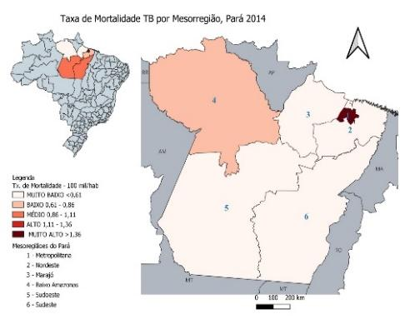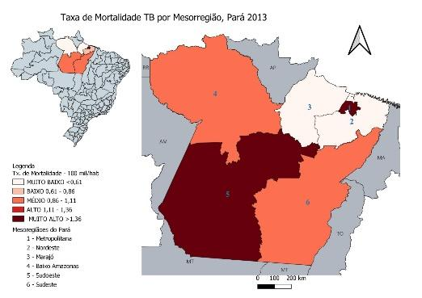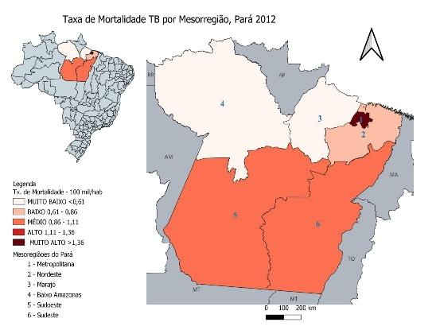

2013

2010

2014

2012

2011

2013

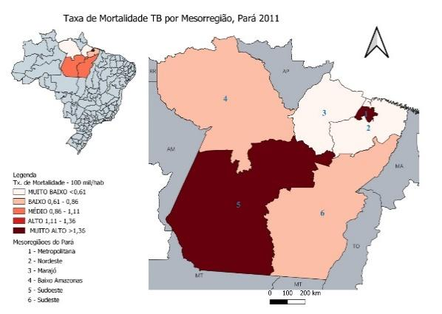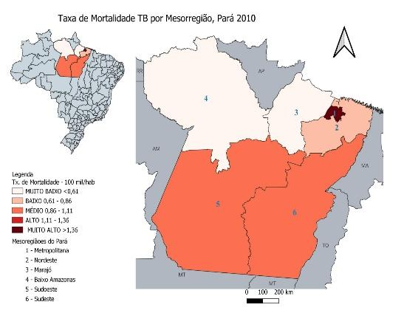

2019

2018

2017

2016

2015

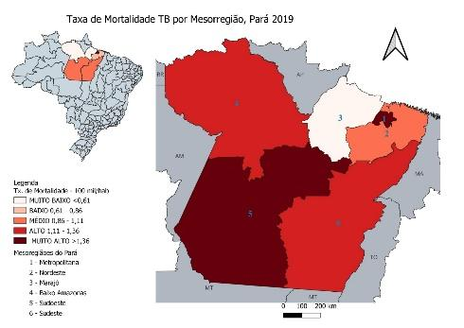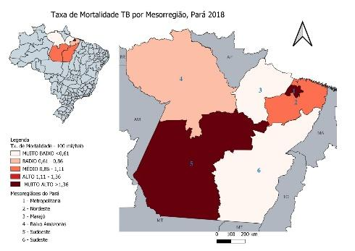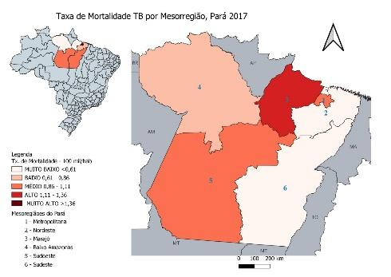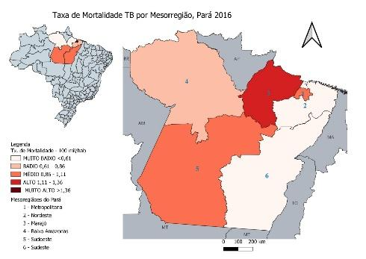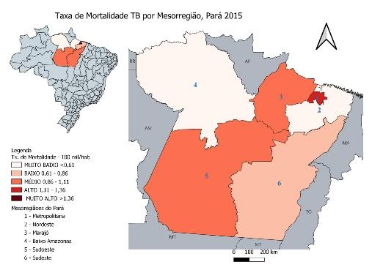

2022

2021

2020

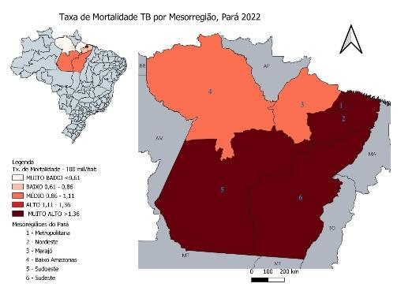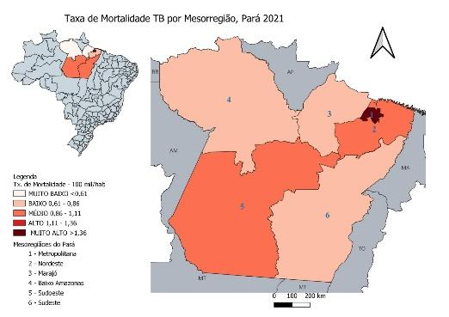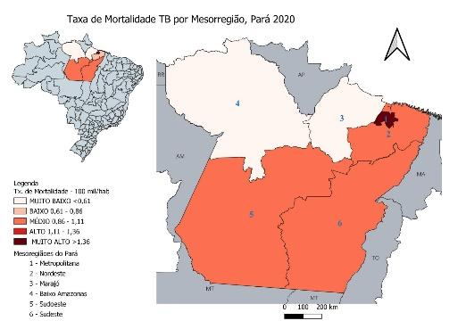

Font: SINAN/SESPA

In the Lower Amazonas, age was a factor associated with death (p-0.042 OR 1.013 95%CI 1.000-1.027). In the Southwest of Pará, it was already alcoholism (p-0.014 OR 2.005 95%CI 1.153-3.488). The population deprived of liberty (p-0.036 OR 2,694 95%CI 1,067-6,803) and the pulmonary clinical form (p-0.003 OR 2,205 95%CI 1,307-3,720) in the Northeast of Pará had a greater statistical association with death, and in the Southeast of Pará, smoking (p-<0.001 OR 0.429 95%CI 0.293-0.627) and pleural clinical form (p-0.028 OR 0.202 95%CI 0.048-0.844) had less association with deaths. The Marajó mesoregion did not have any statistically significant dependent variables, as shown in Table 2.

**Table 2 – Final multivariate model for the variables associated with the health mesoregions of Pará.**

|  |  |  |  |  |
| --- | --- | --- | --- | --- |
| Metropolitan of Belém | | | | |
| Variables | p-value | OR | IC95% | |
|  |  |  | Minimal | Maximum |
| Male | 0,031 | 0.763 | 0.597 | 0.976 |
| Smoking | <0,001 | 0.484 | 0.340 | 0.690 |
| Lung Form | <0,001 | 0.424 | 0.305 | 0.588 |
| Constant | <0,001 | 2.858 |  |  |
| Baixo Amazonas | | | | |
| Age | 0.042 | 1.013 | 1.000 | 1.027 |
| Diabetes Mellitus | 0.043 | 0.345 | 0.123 | 0.966 |
| Constant | <0,001 | 0.031 |  |  |
| Southwest Pará | | | | |
| Styling | 0.014 | 2.005 | 1.153 | 3.488 |
| Drug use | 0.055 | 0.238 | 0.055 | 1.031 |
| Constant | <0,001 | 0.068 |  |  |
| Northeast Paraense | | | | |
| Deprived of Liberty | 0.036 | 2.694 | 1.067 | 6.803 |
| Lung Form | 0.003 | 2.205 | 1.307 | 3.720 |
| Constant | <0,001 | 0.093 |  |  |
| Marajó (none of the variables was significant) | | | | |
| Southeast Pará | | | | |
| Smoking | <0,001 | 0.429 | 0.293 | 0.627 |
| Forma Pleural | 0.028 | 0.202 | 0.048 | 0.844 |
| Constant | <0.001 | 0.441 |  |  |

Font: SINAN/SESPA.

**DISCUSSION**

The study showed us divergent results compared to the national level in terms of the mortality rate during the study period, and can attribute the greater trend of increase in the mortality rate in Pará to socioeconomic factors, since the state has higher indicators for the risk factors of poverty, malnutrition and housing conditions, as well as the factor of differences in the sensitivity capacity of the Pará health system compared to the national level, as it influences the diagnosis and treatment of TB affecting mortality rates.

Regarding the age group found in the study, the profile of those affected is the same result presented by Dong et al (2022), because in their study the most affected age groups were between 20 and 74 years old, in another study by Eddabra & Neffa (2020), they found an age group with different variation, ranging from 15 to 59 years old, however, it remains within the PEA and Dhali et al (2021) demonstrated in their survey the mean age of 45 years in their reported cases, while Oliveira et al, 2019 the mean age of patients who died from TB was 54.0 ± 16.3. This situation of TB affecting and consequently evolving to death plus ASD is reinforced by many studies that report that it affects the most productive adults and generating personal financial losses and their families (Snow et al. 2018, Eddabra & Neffa, 2020).

Regarding the comparison of the proportion between males and females, the results found are consolidated by other studies that also had proportions of 1.45 and 1.50 between male/female, which report that the hypothesis for this occurrence refers to the male sex, which still has the greatest tendency to have occupational relations outside the home environment, they start to have more contact with third parties, who are infected, in addition to the resistance factor to seek medical care, thus generating a higher incidence of TB in men. However, mycobacterial infections are expected to worsen in postmenopausal women. It is possible that hormonal changes resulting from this period contribute to a worse immune response to infections by intracellular microorganisms (Medeiros et al, 2007, Eddabra & Neffa, 2020; Brito et al, 2020; Chahboune et al, 2022).

Chahboune et al (2022) found in their research that a little more than two-thirds of the patients (68.66%) lived in urban areas, which is expected, because in urban areas there is greater agglomeration, contributing to TB transmission. Another factor that affects the incidence in urban areas is the greater availability of health services and professionals, increasing the chance of making the diagnosis.

With regard to the theme of education, the finding is directly related to the profile already found in other studies and in what is mentioned in the literature, which reports on the population, that the lower the level of education, the more susceptible to having more diseases, thus being more affected by TB, because the lower the education, the worse the living conditions in all aspects, because it leads proportionally to lower family income, also contributing to treatment abandonment due to not understanding the severity of the disease and understanding the treatment and its consequences, increasing the probability of mycobacterial resistance to drugs and death (Santos-Junior et al. 2016; Araújo et al. 2017; Oliveira et al. 2017; Wanzeller & Mello, 2018).

In the study by Oliveira et al (2019), a result equivalent to the results found in Pará (83%) was found, that is, a prevalence of 88% in notifications of new cases in relation to all other "types of entry" in the notification form. The result found in the study is different from what is referred to in the process of contamination of special populations, which is usually more contaminated, since there are already reports of recognition that incarcerated populations are at high risk of exposure and development of tuberculosis, but receive less attention in the main policies to combat TB, as well as more association with early death (Oliveira et al, 2019; Cords et al, 2021; Who, 2023).

The predominant clinical pulmonary form in the study in Pará is the same as the survey of the study by Eddabra & Neffa (2020), which was present in 63.5% of the cases, as well as Brito et al (2020), which also had a high predominance (86.37%) of pulmonary presentation and 54.78% of bacillary cases, emphasizing that the bacillary cases may be even larger, as 23.60% of their cases did not undergo tests. Pulmonary tuberculosis, a transmissible form of the disease, was responsible for almost 80% (755/944) of deaths (Oliveira et al, 2019).

Regarding associated diseases and conditions, the study showed that Alcoholism (15.7%) was the most common problem among deaths, results that were followed by the study by Oliveira et al (2019), which also surveyed deaths in southeastern Brazil, showing that 50% had some habits that impair treatment adherence, 30.4% used alcohol, 13.3% tobacco and 5.6% other psychoactive substances, other information intensifies that such habits may be risk factors for tuberculosis infection and tuberculosis lung disease (Bates et al 2007; Feng et al, 2014; Oliveira et al, 2019; Eddabra & Neffa, 2020).

Sputum smear microscopy, among the available tests, even because the logistics and performance process is less costly, it still continues to be the most performed in the State of Pará, such a result was highlighted by the study by Brito et al (2020) which had 54.78% of the positive cases in the 1st sputum smear microscopy sample and 5.92% in the culture and in the study by Chahboune et al (2022) that the diagnosis of TB was bacteriologically confirmed by 84.09% of the Patients. In southern Brazil, a study showed results equivalent to those found in deaths in Pará, where 86.9% had chest X-rays suspected of TB (Oliveira et al, 2019).

Periodic follow-ups with sputum smear microscopy are an essential component in follow-up, and negative sputum smear microscopy at the second month of treatment is an important result of its evolution, and a guide for decisions about drug therapy (Stoffel et al, 2014). Failure to perform control sputum smear microscopies can have consequences such as delaying the identification of patients who do not adhere to treatment, or do not respond to drug therapy, and can hinder the early detection of bacterial multidrug resistance (Satyanarayana et al, 2011; Wanzeller & Mello, 2018), at this point, the study showed a negative evolution in the continuous performance of sputum smear microscopy over the months of follow-up, generating a problem for the surveillance of the disease to analyze the aforementioned indicators, and through the analysis of the follow-ups of the cases by the date of closure, we realized that more than 50% (745-1253) died within 30 days after the date of notification, contributing to the drastic decrease in the Follow-up sputum smear microscopy.

The study by Satyanarayana et al (2011) showed results that corroborate our findings on the time reduction in the performance of control sputum smear microscopies, pointing out as possible reasons for not performing follow-up sputum smear microscopies, the lack of cough or expectoration by patients, incomplete or inadequate information provided by the health team regarding the need to perform sputum tests. Stoffel et al (2014) added another casuistry reporting the centralization of the test in a reference laboratory far from the home, and Wanzeller & Mello (2018) ratifies the relevance of the responsibility of the service that accompanies the TB patient for the collection and delivery of the sample to the laboratory, which reduces travel costs for the patient and ensures the agility of the result.

According to the Ministry of Health, directly supervised treatment is defined as the direct observation of the taking of tuberculosis medication, ideally, on all working days of the week, or exceptionally, three times a week during the first month of treatment, combined with political will, regular acquisition and distribution of medications, and a regular information system.

DOT is an important tool for controlling the disease, but it is necessary to reinforce that it goes beyond supervising the taking of the drug to increase the effectiveness of the treatment (Lâvor et al, 2015). It is the municipal responsibility to operationalize DOT and monitor prevention measures, however, due to the occurrence of the decentralization of DOT to units other than the one where the patient was notified, it generates inconvenience and increases the possibility of treatment abandonment, as reported by Souza et al (2017) that this strategy alters the daily routine and generates embarrassment in the patient when performed in the health unit, one of the factors associated with difficulty in adhering to treatment (Santos et al, 2021).

In the maps by mesoregions of Pará where the general mortality rate was used for preparation in the choropleth method, it shows us that within the state there is a great difference between the mesoregions, in terms of the mortality rate, but it presents an expected result that is related to the higher rate being in the metropolitan mesoregion, where the highest population concentration and coverage of health care is found in relation to the other mesoregions.

Comparing with studies at the national level, some results show that the low development status of the North and Northeast regions has a direct impact on the provision of actions and services for prevention, health promotion, surveillance, and health care for people with tuberculosis. These regions have fewer health care resources, with a lower density of health professionals and number of doctors, which can influence tuberculosis mortality rates (Cortez et al, 2021; Queiroz et al, 2023), that is, within their particularities, studies show that regions with higher population density tend to have improved health conditions, increasing the quality of health care in the place.

**CONCLUSIONS**

According to the results found in our study, it shows that epidemiological surveillance professionals need to adopt different surveillance measures and strategies for each mesoregion.

The study shows that TB is a stable public health problem in the state of Pará, but with high incidence and mortality rates, showing that it is a significant point of attention for health management

Regarding social, demographic, and clinical outcomes, Pará maintains a pattern similar to other places with high mortality, with the pulmonary clinical form, the age group of the economically active population, which leads to financial impacts on the families involved, increasing the social problem involving TB and association with risk factors such as alcoholism and smoking and morbidities such as HIV and diabetes.

However, a strategy that presents a global need for the State is to improve the quality of diagnosis and follow-up of patients, because without incomplete information or data, health professionals will not have adequate support to know how the level of TB control is and about anti-TB drug resistance.

The demonstration in the variation of the mortality rate of each mesoregion indicates great disparities from one region to another, as well as considering the discrepancy between deaths from urban to rural areas, highlighting the need to discover the profile of specific risk factors occurring in each state region so that intervention strategies can be designed appropriate to their particularities.

In summary, even though Pará managed to maintain the epidemiological levels of incidence and mortality in the period studied, the struggle to achieve the global goals established in the eradication of TB still persists. For such a situation, it is extremely necessary to strengthen municipal health so that early diagnosis and appropriate treatment for each clinical case occur, in addition to public policies that improve socio-environmental and economic conditions, adapting to regional differences of the entire state population. Because without a comprehensive approach to all the problems identified in the relationship of the impact of TB, it will not be possible to improve the health of the people of Pará.

**LIST OF ABBREVIATIONS**

TB – Tuberculose

SINAN – Notifiable Diseases Information System

PA- Pará

MS – Ministry of Health

PEA – Economically Active Population

DOT – Directly Observable Treatment

**REFERENCES**

AL MAYAHI, Z.K., ALAUFI, I., AL GHUFAILI, B. et al (2020). Epidemiological profile and surveillance activity of tuberculosis in South Batinah, Oman, 2017 and 2018. International journal of mycobacteriology, 9(1), 39–47. [https://doi.org/ 10.4103/ijmy.ijmy_188_19](https://doi.org/%2010.4103/ijmy.ijmy_188_19)

ARAÚJO, A.S., VIEIRA, S.S., LUCENA, J.B. (2017). Conditioning factors for abandonment of tuberculosis treatment related to the user and the health team. São Paulo: Editora Gente.

AUBRY A, VEZIRIS N. Tuberculosis, one of the oldest infectious diseases: what major recent advances? [Tuberculosis: New findings on an old infectious disease]. Med Sci (Paris). 2023 Mar; 39(3):203-204. French. DOI: 10.1051/medsci/2023054. Epub 2023 Mar 21. PMID: 36943114.

BATES M.N, KHALAKDINA A, PAI M, CHANG L., LESSA F., SMITH K.R. Risk of tuberculosis from exposure to tobacco smoke: a systematic review and meta-analysis. Arch Intern Med. 2007; 167 (4):335–342.

BRAZIL. Ministry of Health. Tuberculosis: Boletim Epidemiológico, mar. 2023.

BRITO, A.B., MAGALHÃES, W.B., PAIVA, J.P.S., et al. Tuberculosis in Northeastern Brasil (2001-2016): trend, clinical profile, and prevalence of risk factors and associated comorbidities. Revista da Associacao Medica Brasileira (1992), 66(9), 1196–1202. <https://doi.org/10.1590/1806-9282.66.9.1196>

CHAHBOUNE, M., BARKAOUI, M., IDERDAR, Y., et al. Profil épidémiologique, aspects diagnostiques et évolutifs des patients tuberculeux au centre de diagnostic de la tuberculose et des maladies respiratoires de Settat, Maroc [Epidemiological profile and diagnostic and evolutionary features of TB patients at the Diagnostic Centre for Tuberculosis and Respiratory Diseases in Settat, Morocco]. The Pan African medical journal, 42, 185. <https://doi.org/10.11604/pamj.2022.42.185.35250>

CORDS O., MARTINEZ L., WARREN J.L, et al. Incidence and prevalence of tuberculosis in incarcerated populations: a systematic review and meta-analysis. Lancet Public Health. 2021 May; 6(5):e300-e308. doi: 10.1016/S2468-2667(21)00025-6. Epub 2021 Mar 22. PMID: 33765455; PMCID: PMC8168455.

CORTEZ AO, DE MELO AC, NEVES L de O, RESENDE KA, CAMARGOS P. Tuberculosis in Brazil: One country, multiple realities. J Bras Pneumol. 2021; 47(2):1–11

DHALI, A., DAS, K., DHALI, G.K., et al. Abdominal tuberculosis: Clinical profile and outcome. International journal of mycobacteriology, 10(4), 414–420. <https://doi.org/10.4103/ijmy.ijmy_195_21>

DONG, Z., WANG, Q.Q, YU, S.C., et al . Age-period-cohort analysis of pulmonary tuberculosis reported incidence, China, 2006-2020. Infect Dis Poverty. 2022 Jul 28; 11(1):85. doi: 10.1186/s40249-022-01009-4. PMID: 35902982; PMCID: PMC9331155.

EDDABRA, R., NEFFA, M. Epidemiological profile among pulmonary and extrapulmonary tuberculosis patients in Laayoune, Morocco. Pan Afr Med J. 2020 Sep 15;37:56. doi: 10.11604/pamj.2020.37.56.21111. PMID: 33209183; PMCID: PMC7648485.

FENG, J.Y., HUANG, S., TING, W.Y., et al. Impact of smoking on latent tuberculosis infection: age matters. Eur Respir J. 2014; 43 (2):630–632.

FERREIRA, K.R., ORLANDI, G.M., SILVA, T.C. da. Representations on adherence to the treatment of Multidrug-Resistant Tuberculosis Rev. Esc. Enferm. USP. [Internet]. 2018 [acesso em 30 out 2019]; 52. Disponível em: <http://dx.doi.org/10.1590/S1980-220X2018010303412>

GLOBAL TUBERCULOSIS REPORT 2022. World Health Organization. [https://www.who.int/teams/global-tuberculosis-programme/tb-reports/global-tuberculos is- report-2022](https://www.who.int/teams/global-tuberculosis-programme/tb-reports/global-tuberculos%20is-%20report-2022)

JUNGES, J.R., BURILLE, A., TEDESCO, J. Directly Observed Treatment of Tuberculosis: Critical Analysis of Decentralization. Interface (Botucatu) [Internet]. 2020; 24:e190160. Available from: <https://doi.org/10.1590/Interface.190160>

KARUMBI, J., GARNER, P. Directly observed therapy for treating tuberculosis. Cochrane database syst rev. [Internet]. 2015 [acesso em 30 out 2019]; 29(5). Disponível em: <http://doi.org/10.1002/14651858.CD003343.pub4>.

LAVÔR, D.C.B. da S, PINHEIRO, J. dos S, GONÇALVES, M.J.F. Evaluation of the implementation of the directly observed treatment strategy for tuberculosis in a large city. Rev. Esc. Enferm. USP. [Internet]. 2016 [acesso em 30 out 2023]; 50(2). Disponível em: <http://dx.doi.org/10.1590/S0080-623420160000200010>.

LIMA-COSTA, M.F.; BARRETO, S.M. Types of epidemiological studies: basic concepts and applications in the area of aging. Epidemiol. Serv. Saúde, Brasília, v. 12, n. 4, p. 189-201, dez.  2003. Available at <http://scielo.iec.gov.br/scielo.php?script=sci_arttext&pid=S1679-49742003000400003 &lng=en&nrm=iso>. Accessed on 20 Apr.  2024. http://dx.doi.org/10.5123/S1679-49742003000400003.

LÓPEZ, M.P., ULLOA, A.P., ESCOBAR, F.A. Tuberculosis and prison overcrowding from the perspective of social inequities in health in Colombia, 2018. Biomedical. 2022;42:159-69. <https://doi.org/10.7705/biomedica.5894>

MEDEIROS, S.F. de, MAITELLI, A., NINCE, A.P.B. Effects of hormone therapy in menopause on the immune system. Rev Bras Ginecol Obstet [Internet]. 2007Nov; 29(11):593–601. Available from: https://doi.org/10.1590/S0100-72032007001100008

MEDRONHO, R.A et. al. Epidemiology. 2nd ed. SÃO PAULO: Atheneu, 2009, 683.

OLIVEIRA, A., FONZAR, U.J.V., SANTIL, F.L.P. (2017). Spatial analysis of tuberculosis in the years 2010 to 2015. Maringá/PR: Journal of the Graduate Program in Geography, v.9, n.2, p.52-70.

OLIVEIRA, S.P., SILVEIRA, J.T.P.D., BERALDI-MAGALHÃES, F., (2019). Early death by tuberculosis as the underlying cause in a state of Southern Brazil: Profile, comorbidities and associated vulnerabilities. International journal of infectious diseases : IJID : official publication of the International Society for Infectious Diseases, 80S, S50–S57. <https://doi.org/10.1016/j.ijid.2019.02.043>.

STOP. Subdivisions of the State of Pará. 2024 [accessed on 20 Apr. 2024]. Available at: https://www.pa.gov.br/pagina/54/subdivisoes.

QGIS Development Team, 2024. QGIS Geographic Information System. Open Source Geospatial Foundation Project. Disponível em: [http://qgis.osgeo.org](http://qgis.osgeo.org/)

QUEIROZ, J.R, VIEIRA, N.F, OLIVEIRA, M.D.S, MAIA, L.G.M, FIGUEIREDO, R.C., GONZALEZ, R.I.C, GUIMARÃES, R. A. Tuberculosis mortality trends and relationship with development status in Brazil between 2005?2019. Cien Saude Colet [internet journal] (2023/Jul).

QUEIROZ, M.A.F., LIMA, S.S., AMORAS, E.D.S.G., (2022). Epidemiological and Cytokine Profile of Patients with Pulmonary and Extrapulmonary Tuberculosis in a Population of the Brazilian Amazon. Microorganisms, 10(10), 2075. <https://doi.org/10.3390/microorganisms10102075>

SATYANARAYANA, S., NAGARAJA, S.B., KELAMANE, S., et al. Did successfully treated pulmonary tuberculosis patients undergo all follow-up sputum smear examinations? Public Health Action. 2011; 1(2):27-9.

SANTOS, D.A. DA S., MARQUES, A.L.A., GOULART, L.S., et al (2021). FACTORS ASSOCIATED WITH TREATMENT ABANDONMENT OF PULMONARY TUBERCULOSIS. Cogitare Enfermagem, 26, e72794. <https://doi.org/10.5380/> CE.V26I0.72794

SANTOS, J.G.M., GIBAUT, M.A.M., BISPO, T.C.F. (2016). Tuberculosis: Adherence to treatment and the factors that trigger noncompliance. São Paulo: Revista Enfermagem Contemporânea. v.5, n.2, p.284-292.

SILVA, T.O., VIANNA, P.J.S., ALMEIDA, M.V.G., et al. Street people in Brazil: a descriptive study of their sociodemographic profile and tuberculosis morbidity, 2014-2019. Epidemiol Serv Saude. 2021; 30(1):e2020566. English, Portuguese. doi: 10.1590/S1679-49742021000100029. PMID: 33787809.

SOUZA, A.C.S. de, SILVA, M.L.S.J. da, MIRANDA, L.N. Difficulties in adherence to the treatment plan by patients with tuberculosis. Cad. Grad. Ciênc. Bio. Sau. Unit. [Internet]. 2017 [accessed on 13 Dec 2023]; 4(2). Available at: https:// periodicos.set.edu.br/index.php/fitsbiosaude/article/view/4560/2623

SNOW, K.J., SISMANIDIS, C., DENHOLM, J.. The incidence of tuberculosis among adolescents and young adults: a global estimate. Eur Respir J. 2018; 51 (2):1702352

SNOW, K.J., CRUZ, A.T., SEDDON, J.A., et al. Adolescent tuberculosis. Lancet Child Adolesc Health. 2020 Jan; 4(1):68-79. doi: 10.1016/S2352-4642(19)30337-2. Epub 2019 Nov 18. Erratum in: Lancet Child Adolesc Health. 2019 Nov 27;: PMID: 31753806; PMCID: PMC7291359.

SOTO CABEZAS, M.G., MUNAYCO ESCATE, C.V., ESCALANTE MALDONADO, O et al. Epidemiological profile of extensively drug-resistant tuberculosis in Peru, 2013-2015. Rev Panam Salud Publica. 2020 Sep 23; 44:E29. Spanish. doi: 10.26633/RPSP.2020.29. PMID: 32973891; PMCID: PMC7498293.

SOUZA, N.P.; SILVA, E.M.G.C.; TEIXEIRA, M.D. et al. Application of the kernel density estimator in conservation units in the São Francisco River basin for analysis of deforestation hotspots and hot spots. In: Brazilian Symposium on Remote Sensing, 16. (SBSR), 2013, Foz do Iguaçu. Annals... São José dos Campos: INPE, 2013. p. 4958-4965. DVD, Internet. ISBN 978-85-17-00066-9 (Internet), 978-85-17-00065-2 (DVD). Available at: <http://urlib.net/3ERPFQRTRW34M/3EGMJ5>.

STOFFEL, C., LORENZ, R., ARCE, M. Treatment of pulmonary tuberculosis in a low-prevalence urban area: compliance and bacteriological negativization. Medicine (Buenos Aires). 2014;74:9-18.

TOUSO, M.M., POPOLIN, M.P., CRISPIM, J. de A., et al (2014). Social stigma and the families of patients with tuberculosis: a study based on cluster and multiple correspondence analysis. Ciência & saúde coletiva, 19(11), 4577–4586. <https://doi.org/10.1590/1413-812320141911.46062013>

TUBERCULOSIS. World Health Organization. Who. Disponível em: <https://www.who.int/news-room/fact-sheets/detail/tuberculosis>. Acessado em:15/01/2024.

WANZELLER R.M.; MELLO, A.G. Tuberculosis and schooling: A literature review. Revista Internacional de apoyo a la inclusión, logopedia, sociedad y multiculturalidad, [S. l.], v. 4, n. 2, 2018. doi: 10.17561/riai.v4.n2.1. Available at: https://revistaselectronicas.ujaen.es/index.php/riai/article/view/4314. Accessed on: 6 jul. 2023.