**Numerical Analysis of Conjugate Mixed Convection Heat Transfer with Internal Heat Generation in a Wavy-Walled Lid-Driven Trapezoidal Cavity**

.

ABSTRACT

|  |
| --- |
| This study conducts a numerical analysis on conjugate mixed convection heat transfer with internal heat generation in a wavy-walled, lid-driven trapezoidal cavity, employing the Galerkin finite element method to solve the continuity, momentum, and energy equations, thereby elucidating the complex dynamics within. The wavy top walls of the trapezoidal enclosure significantly amplify heat transfer by enlarging the surface area and creating secondary vortices, enhancing convective mixing. The transition between forced and natural convection is governed by the Richardson number (Ri), with lower Ri enhancing forced convection that effectively disperses heat, while higher Ri leads to buoyancy-dominated, stratified temperature fields. Detailed analysis reveals that internal heat generation markedly improves thermal performance at the solid-fluid interface, with varying Ri influencing the flow behavior—from dominant forced convection at low Ri to a mix of natural and forced convection at moderate Ri, and predominantly natural convection at high Ri, characterized by stratified flows and enhanced mixing due to the wavy walls. Isotherm analysis under these conditions indicates that low Ri maintains uniform temperature distribution, whereas high Ri results in stratified temperature fields. Additionally, machine learning-based polynomial regression later integrated into the study predicts critical thermal parameters like Nusselt number, drag coefficient, and average temperature, aligning closely with the numerical data, which underscores the efficacy of combining advanced numerical methods and machine learning to optimize thermal systems for applications such as electronic cooling, energy storage, and heat exchangers. |

*Keywords:* Conjugate Mixed Convection, Wavy-Walled, Lid-Driven Trapezoidal Cavity, Heat Generation, Heat Transfer

1. INTRODUCTION

Mixed convection is a critical thermo-fluid phenomenon that combines natural and forced convection within a single domain. It results from both buoyancy forces, due to temperature gradients, and shear forces from mechanical movement, such as boundary-induced flows. Mixed convection is widely applicable in engineering fields, including heat exchangers, electronic cooling, and chemical reactors, where efficient heat transfer is vital for optimized performance [1]. Its complexity and the enhanced control it offers over thermal processes make mixed convection a focal point in modern thermal management strategies [2].

In systems where both fluid convection and solid conduction occur, known as conjugate mixed convection, additional layers of complexity arise. Many practical applications, such as exothermic reactions, electric current flow, and other heat-generating processes, involve internal heat sources that can influence the thermal and fluid behaviors within the system [3]. Effective heat dissipation in such cases is essential, especially for optimizing thermal management in cooling devices, reactors, and energy storage systems [4]. The study of heat transfer in enclosures, especially in shapes like square, rectangular, and trapezoidal cavities, has been extensive due to the geometric relevance in practical applications. Lid-driven enclosures, in particular, have proven highly effective in enhancing heat transfer by introducing a sliding boundary that boosts forced convection, thereby improving the overall heat transfer efficiency [5]. Investigations on lid-driven cavities have shown that increasing lid velocity transitions the heat transfer mechanism from natural to forced convection, enhancing the thermal performance of the system [6].

The addition of wavy walls to trapezoidal enclosures has garnered interest for its potential to enhance convective heat transfer. The increased surface area and vortex formation within wavy-walled structures intensify the thermal interactions between fluid and solid regions, resulting in improved heat dissipation [7]. Studies on trapezoidal cavities with undulating walls reveal that these irregular surfaces foster stronger convective currents, offering considerable benefits for applications requiring high-efficiency thermal management [8]. Hybrid nanofluids and magnetic fields have also been explored for their impact on heat transfer in lid-driven cavities, with studies showing that the use of nanofluids in wavy-walled trapezoidal enclosures significantly enhances convective heat transfer rates [9]. These findings highlight the potential of nanofluids to achieve higher thermal conductivity, optimizing heat transfer in confined or lid-driven configurations where high-performance cooling is essential [10].

Another important consideration is entropy generation, which evaluates the efficiency of heat transfer systems by measuring the dissipated useful energy. Research indicates that entropy generation in systems with corrugated walls is affected by factors such as Rayleigh and Hartmann numbers, as well as wall amplitude, each influencing the overall heat transfer characteristics of the system [11]. Minimizing entropy generation is crucial for systems that rely on energy efficiency, as it reduces thermal dissipation during the convection process [12].

Despite significant advancements, the combined effects of lid-driven flow, wavy walls, and internal heat generation in trapezoidal enclosures remain relatively unexplored. While some studies have focused on simpler geometric shapes or omitted the influence of moving boundaries and internal heat sources, a deeper understanding of these interactions is essential for designing complex systems requiring advanced thermal management [13].

This study aims to address these gaps by conducting a comprehensive numerical analysis of conjugate mixed convection with internal heat generation in a wavy-walled, lid-driven trapezoidal cavity. The finite element approach used in this research investigates the effects of wall waviness, lid velocity, and internal heat generation on fluid and thermal behaviors. This study intends to provide valuable insights into optimizing heat transfer performance for advanced engineering applications requiring efficient temperature control in compact, high-performance systems [14], [15], [16]. In recent years, this approach has been refined to examine heat transfer under different geometries, enhancing the thermal efficiency of trapezoidal cavities. Studies have demonstrated that wavy walls increase the convective heat transfer by promoting additional fluid mixing, a property beneficial for high-performance applications [17]. Such findings have spurred further research into optimizing thermal control in nanofluid and hybrid nanofluid environments, particularly under conditions where magnetic fields and internal heat sources affect convective behaviors [18], [19].

The mechanism becomes more complex when internal heat generation is involved, adding another layer of heat source within the system. This setup is prevalent in several practical applications, including systems with exothermic reactions, electromagnetic heating, and electronic devices that generate heat internally [20]. In recent years, studies have explored heat transfer in enclosures with varying geometries, as these configurations often result in enhanced thermal performance. Trapezoidal cavities with wavy walls have shown promise due to the increased surface area and the formation of vortex flows that improve heat transfer rates [21]. Specifically, the wavy walls introduce additional mixing within the fluid, which, when combined with the movement of a lid, can significantly enhance the overall heat transfer efficiency [22]. This enhancement is particularly useful in energy systems and electronic cooling applications where precise thermal management is necessary.

Several researchers have investigated the impact of nanofluids and magnetic fields in lid-driven cavities, recognizing the potential for improved heat transfer in such configurations. For instance, studies have shown that using a hybrid nanofluid in a lid-driven trapezoidal cavity with flexible walls further enhances the convective heat transfer due to the increased thermal conductivity of the fluid medium [23]. These findings underscore the versatility of hybrid nanofluids in achieving higher heat transfer rates and optimizing cooling in confined spaces.

Additionally, the role of entropy generation in evaluating the performance of heat transfer systems has gained attention. Systems that minimize entropy generation are considered more efficient, as they reduce energy dissipation during heat transfer processes. Studies have shown that in cavities with corrugated walls, entropy generation varies based on factors like Rayleigh number, Hartmann number, and wall undulation amplitude, which influence the heat transfer characteristics of the system [24]. Despite advancements in the study of mixed convection, the interaction between a moving lid, wavy walls, and internal heat generation in trapezoidal enclosures remains relatively unexplored. These factors combined present a unique thermal environment where conduction and convection mechanisms interplay within a complex geometry. This study aims to fill this gap by providing a detailed numerical analysis of conjugate mixed convection with internal heat generation in a wavy-walled, lid-driven trapezoidal cavity. The findings are expected to advance the understanding of heat transfer in complex systems, particularly those requiring high thermal performance in compact designs [25].

Machine learning (ML) has significantly enhanced computational fluid dynamics (CFD) by improving simulation accuracy and reducing computational costs. A generalized ML framework optimizes CFD applications, while physics-informed ML (PIML) improves Navier–Stokes equation solutions [26][27]. Hybrid CFD-ML models effectively analyze thermal behavior in porous media [28], and physics-informed neural networks (PINNs) enhance laminar flow simulations [29]. Stream-based active learning dynamically refines CFD predictions [30]. ML has also been applied in membrane mass transfer modeling [31] and categorized into data-driven and physics-driven CFD approaches [32]. ML-enhanced solvers improve computational efficiency [33], while artificial neural networks aid in free convection analysis [34]. Genetic algorithms combined with CFD-ML optimize finned heat pipe radiator performance [35]. These advancements highlight ML’s transformative impact on CFD, making simulations more efficient and accurate.

Despite extensive research on mixed convection, the combined effects of wavy walls, lid motion, and internal heat generation in trapezoidal cavities remain underexplored. Existing studies often overlook the impact of wall undulations and heat sources on convective heat transfer, leaving gaps in understanding their interactions. This study addresses these gaps by conducting a numerical analysis using the finite element method (FEM) to examine the influence of lid velocity, wall waviness, and internal heat generation on thermal-fluid behavior. The findings will enhance the design of efficient thermal management systems for applications in electronics cooling, energy storage, and heat exchangers. Additionally, by integrating machine learning (ML) in computational fluid dynamics (CFD), this research improves predictive accuracy and computational efficiency, offering a data-driven approach to optimizing heat transfer performance in complex geometries.

2. Geometry

The geometry (Fig 1.) of the study encompasses a trapezoidal cavity delineated by a unique arrangement of boundaries designed to facilitate a comprehensive analysis of conjugate mixed convection heat transfer processes, accentuated by internal heat generation. Central to this configuration is a solid block, strategically positioned at the core of the cavity, which serves as an internal heat source. This inclusion introduces a significant layer of complexity to the study by initiating conductive heat transfer within the block itself, thereby influencing the surrounding fluid's thermal and flow dynamics.

The trapezoidal enclosure is characterized by wavy walls at the top, which are designed to augment convective heat transfer by increasing the effective surface area and inducing more intricate flow patterns. These wavy contours are intended to disrupt the uniformity of the flow, fostering enhanced thermal interaction between the fluid and the solid regions and promoting efficient heat dispersion.

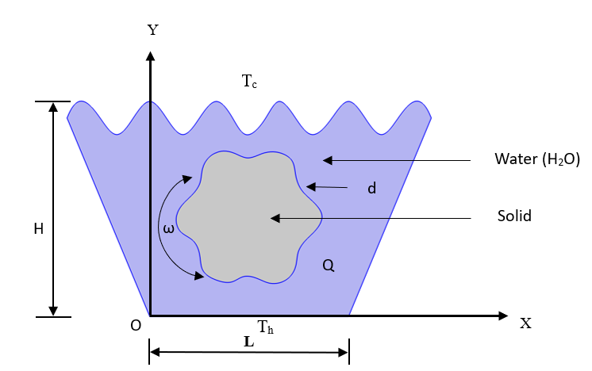

Fig 1. Geometry

Adiabatic conditions are applied to the sidewalls of the enclosure, ensuring that heat transfer is predominantly localized within the fluid and between the fluid and the solid block. This isolation aids in focusing the thermal dynamics towards the active areas of the cavity—the moving lid and the heated base—thereby simulating a controlled environment for observing the interactions of mixed convection currents and internal heat generation.

The bottom wall of the cavity is maintained at a higher temperature (Th), while the top wall, coinciding with the moving lid, is kept at a cooler temperature (Tc). This arrangement creates a thermal gradient that drives natural convection due to buoyancy effects, complemented by forced convection resulting from the lid's motion. The combined influence of these thermal and mechanical forces makes the cavity an ideal model for studying the intricate behaviors of heat transfer in engineered systems, particularly where precise thermal management is crucial.

This geometry not only challenges the robustness of numerical methods applied in the analysis but also mirrors practical applications where such conditions are prevalent, including in systems like electronic cooling and energy-efficient building designs. The detailed representation and understanding of this geometry are pivotal for advancing the design and optimization of thermal management systems in both industrial and research settings.

The boundary conditions are as follows:









3. Mathematical Model

The mathematical model describes conjugate mixed convection heat transfer with internal heat generation in a wavy-walled, lid-driven trapezoidal cavity, following the conservation laws of mass, momentum, and energy for both fluid and solid regions.

The fluid is considered incompressible and Newtonian with constant properties, exhibiting steady and laminar flow governed by the Boussinesq approximation, where density variations affect only buoyancy. Heat transfer in the solid region occurs through conduction. The governing equations are formulated in Cartesian coordinates to capture both fluid flow and thermal interactions.

Fluid Domain:

 (1)

 (2)

 (3)

 (4)

Solid Domain:

 (5)

The equations are dimensional by using the following dimensionless parameters



Fluid Domain:

 (6)

 (7)

 (8)

 (9)

Solid Domain:

 (10)

where, K=ks/kf  represents the ratio of the thermal conductivity of the solid cylinder to that of the working fluid.

Other non-dimensional parameters involved in equations (6)-(10) include the Reynolds, Grashof, Richardson, and Prandtl numbers. Definitions of these parameters are as follows:



 (11)

The ﬂuid and solid domains, respectively, are denoted by the sub-script’s ‘f’ and ‘s’. The average Nusselt number (Nu) of the hot bottom surface, the normalized Nusselt number (Nu), the average drags coefﬁcient (Cd) on the sliding top lid, and the average ﬂuid temperature (θav) inside the enclosure are assessed and expressed as performance parameters of the current system in the following ways:

 (12)

 (13)

Here, A presents the non-dimensional area of the water domain within the enclosure.

4. Numerical Procedure

The numerical simulation of the conjugate mixed convection heat transfer in a wavy-walled, lid-driven trapezoidal cavity with internal heat generation is meticulously conducted using the finite element method (FEM). The computational domain for this study includes both the cavity with its complex wavy-walled geometry and an internal solid block that acts as a heat source. The entire domain is discretized into triangular elements, providing the structural basis for the simulation.

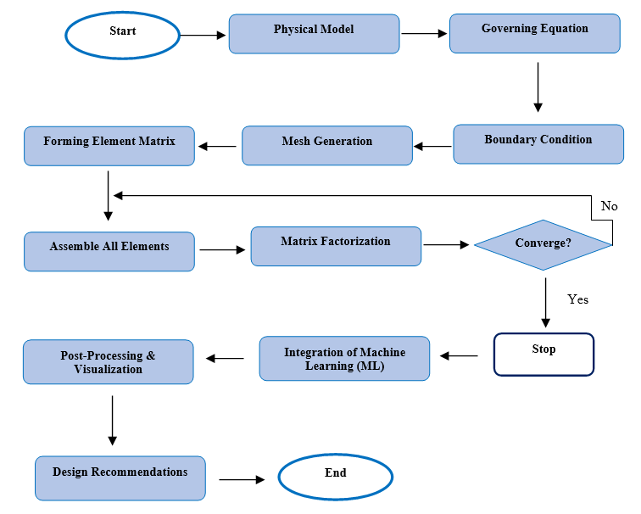

Fig 2. Numerical Procedure Flowchart

For the governing equations covering fluid flow and heat transfer the Galerkin finite element approach is implemented, ensuring a robust discretization of the equations. To manage the coupling between pressure and velocity, the SIMPLE (Semi-Implicit Method for Pressure Linked Equations) algorithm (Fig 2.) is employed, facilitating accurate and stable computational results.

1. **Grid Generation**: A structured grid is created with finer elements near the boundaries to capture the detailed flow and thermal gradients accurately. Mesh independence tests are performed to ensure that the results are not dependent on the mesh size but are representative of the true physical behavior.
2. **Boundary Conditions Setup**: Essential boundary conditions are defined to reflect the physical setup, including adiabatic walls and a moving lid, which critically influence the flow and thermal fields within the simulation.
3. **Element Matrix Formation and Assembly**: Element matrices are formed for each of the triangular elements during the discretization process. These matrices are then assembled into a global system matrix, which is crucial for solving the system equations comprehensively.
4. **Matrix Factorization and Convergence Check**: Following matrix assembly, factorization methods are applied to solve the equations efficiently. The simulation iteratively checks for convergence, focusing on the residuals for velocity, pressure, and temperature to fall below a pre-defined threshold, indicating a stable solution has been reached.
5. **Integration of Machine Learning (ML)**: Post-convergence, machine learning techniques are incorporated to refine and predict critical thermal parameters such as the Nusselt number, drag coefficient, and average temperature. This integration not only enhances the predictive capability but also aligns the simulation outputs closely with experimental data.
6. **Post-Processing and Visualization**: The simulation data are then post-processed to visualize the flow patterns and temperature distribution within the cavity. This stage is vital for analyzing the fluid dynamics and thermal behaviors under various operational conditions.
7. **Design Recommendations**: Insights derived from the simulation are used to formulate design recommendations, aiming to optimize thermal management and convective heat transfer in similar applications.
8. **End of Procedure**: The numerical procedure concludes with a detailed review and documentation of the findings, which are prepared for reporting or academic publication, providing valuable contributions to the fields of thermal management and fluid dynamics.

This comprehensive procedure ensures that every aspect of the simulation is carefully managed, from initial setup and mesh generation to the integration of advanced analytical techniques like machine learning, resulting in a deeply informed understanding of the heat transfer characteristics in complex geometries.

5. Results and Discussions

**5.1 Streamline Analysis**

**Fig 3.a. Streamline (Rec=0, Ri=0.1 & Rec=0, Ri=1)**: This figure demonstrates the flow patterns at low Richardson numbers, where forced convection predominates, creating vigorous circulation patterns that are influenced by the cavity's moving lid.

**Fig 3.b. Streamline (Rec=0, Ri=5 & Rec=0, Ri=10)**: Here, higher Richardson numbers are explored, depicting the transition to natural convection, which results in more stratified flow patterns with less influence from the lid's movement.

**Fig 3.c. Streamline (Rec=2, Ri=0.1 & Rec=2, Ri=1)**: This figure shows the streamline responses to a slight increase in Reynolds number, comparing low to moderate Richardson numbers, where both forced and natural convection contribute to the flow dynamics.

**Fig 3.d. Streamline (Rec=2, Ri=5 & Rec=2, Ri=10)**: At the same increased Reynolds number, this figure illustrates the dominance of natural convection at higher Richardson numbers, emphasizing the buoyancy effects.

**Fig 3.e. Streamline (Rec=-2, Ri=0.1 & Rec=-2, Ri=1)**: With a negative Reynolds number, this figure explores how reverse flow conditions affect the convective patterns at low and moderate Richardson numbers.

**Fig 3.f. Streamline (Rec=-2, Ri=5 & Rec=-2, Ri=10)**: Continuing with a negative Reynolds number, this figure highlights the flow behavior under high Richardson numbers, showing significant natural convection influences with complex flow interactions near the cavity walls.

Each of these figures contributes to a comprehensive understanding of how different dynamic forces interact within the cavity, influencing heat transfer and fluid flow characteristics.

**Low Richardson Number (Ri = 0.1):**

At a low Richardson number (Ri = 0.1), forced convection dominates, resulting in strong circulation patterns initiated by the moving lid. The streamlines indicate a primary vortex near the wavy walls, with secondary vortices forming near the sharp undulations of the walls. The wavy walls play a critical role in enhancing fluid mixing, disrupting the flow’s symmetry and promoting stronger circulation in the cavity. This is evident from the streamlined patterns, where the flow is directed from the moving lid towards the center of the cavity, circulating around the inner solid block.

**Moderate Richardson Number (Ri = 1):**

As the Richardson number increases to Ri = 1, both natural and forced convection contribute equally to the flow dynamics. The buoyancy forces induced by the temperature gradients begin to play a more prominent role in shaping the streamlines. In this regime, the primary vortex remains dominant, but the influence of natural convection leads to the formation of additional vortices along the walls, especially near the hot bottom wall. The interaction between these vortices and the wavy walls results in a more complex flow pattern, with enhanced circulation near the heat source (the inner solid block) and wavy boundaries.

**Higher Richardson Numbers (Ri = 5 and Ri = 10):**

At higher Richardson numbers (Ri = 5 and Ri = 10), natural convection dominates the flow behavior. The streamlines reveal stratified flow patterns with large recirculating zones near the top and bottom walls. The flow near the wavy walls becomes less influenced by the moving lid and more controlled by buoyancy-driven convection. The undulating walls, however, still induce localized vortices, enhancing the mixing near the heated walls. The streamlines show that the heat transfer is primarily driven by natural convection, with weaker circulatory effects near the center of the cavity. The inner solid block generates strong vertical convection currents, directing the fluid upwards along the hot surfaces and contributing to the overall circulation in the cavity.

**Effect of Wall Undulations:**

The wavy walls create additional disturbances in the flow, resulting in localized circulation zones along the boundary. These undulations effectively enhance the fluid mixing and promote stronger heat transfer by increasing the surface area exposed to the flow. In all cases, the wavy walls generate secondary vortices that enhance the overall circulation within the cavity, increasing the interaction between the moving lid and the buoyancy-driven flow.

Overall, the streamline analysis demonstrates that the combination of lid-driven forced convection and buoyancy-driven natural convection creates a complex flow field within the wavy-walled trapezoidal cavity. As the Richardson number increases, the influence of natural convection becomes more prominent, leading to stratified flow patterns with recirculation zones near the heated walls and the inner solid block. The wavy walls play a critical role in promoting fluid mixing and enhancing heat transfer across all Richardson numbers.

|  |  |
| --- | --- |
|  |  |
| Fig 3.a. Streamline (Rec=0, Ri=0.1 & Rec=0, Ri=1) | |

|  |  |
| --- | --- |
|  |  |
| Fig 3.b. Streamline (Rec=0, Ri=5 & Rec=0, Ri=10) | |

|  |  |
| --- | --- |
|  |  |
| Fig 3.c. Streamline (Rec=2, Ri=0.1 & Rec=2, Ri=1) | |

|  |  |
| --- | --- |
|  |  |
| Fig 3.d. Streamline (Rec=2, Ri=5 & Rec=2, Ri=10) | |

|  |  |
| --- | --- |
|  |  |
| Fig 3.e. Streamline (Rec=-2, Ri=0.1 & Rec=-2, Ri=1) | |

|  |  |
| --- | --- |
|  |  |
| Fig 3.f. Streamline (Rec=-2, Ri=5 & Rec=-2, Ri=10) | |

**5.2 Isotherm Analysis**

The isotherm patterns within the wavy-walled lid-driven trapezoidal cavity provide detailed insights into the temperature distribution, heat transfer efficiency, and the combined effects of forced and natural convection. The analysis highlights the evolution of thermal gradients and temperature distributions across varying Richardson numbers (Ri), emphasizing the influence of internal heat generation. The corresponding isotherm patterns are captured in several figures, illustrating the thermal behavior under different flow conditions:

Fig 4.a. Isotherm (Rec=0, Ri=0.1 & Rec=0, Ri=1): This figure demonstrates the isotherm patterns at low Richardson numbers where forced convection predominates, influencing a more uniform temperature distribution across the cavity.

Fig 4.b. Isotherm (Rec=0, Ri=5 & Rec=0, Ri=10): At higher Richardson numbers, this figure shows how natural convection begins to dominate, leading to stratified temperature fields characterized by significant vertical gradients and less horizontal mixing.

Fig 4.c. Isotherm (Rec=2, Ri=0.1 & Rec=2, Ri=1): Displaying the effect of a slightly increased Reynolds number, this figure compares the temperature fields at low to moderate Richardson numbers, where the interplay between forced and natural convection shapes the thermal patterns.

Fig 4.d. Isotherm (Rec=2, Ri=5 & Rec=2, Ri=10): This figure further explores increased Reynolds numbers at higher Richardson settings, highlighting how buoyancy significantly impacts the thermal landscape, enhancing vertical temperature stratification.

Fig 4.e. Isotherm (Rec=-2, Ri=0.1 & Rec=-2, Ri=1): Illustrating conditions under a negative Reynolds number at low to moderate Richardson numbers, this figure reflects how reversed flow conditions affect thermal gradients and mixing within the cavity.

Fig 4.f. Isotherm (Rec=-2, Ri=5 & Rec=-2, Ri=10): Continuing with negative Reynolds numbers at higher Richardson numbers, this figure depicts the strong dominance of natural convection, with pronounced stratification and localized high-temperature zones due to reduced mixing effects.

These figures collectively detail how changes in the driving thermal and flow dynamics influence heat transfer within the cavity, demonstrating the crucial role of geometric features and operational conditions in managing temperature distributions and enhancing thermal efficiency.

**Low Richardson Number (Ri = 0.1):**

At a low Richardson number (Ri = 0.1), forced convection dominates the heat transfer process. The isotherms appear relatively parallel and concentrated near the moving lid, which induces a stronger horizontal temperature gradient across the cavity. The influence of the wavy walls leads to slight undulations in the isotherms, enhancing thermal mixing near the wall surfaces. The moving lid forces the hot fluid from the bottom wall to mix with the cooler fluid near the top wall, resulting in a relatively uniform temperature field across the cavity.

**Moderate Richardson Number (Ri = 1):**

As the Richardson number increases to Ri = 1, the influence of buoyancy forces becomes comparable to the forced convection effects. The isotherms start to bend more prominently, reflecting the competition between the lid-driven forced convection and the buoyancy-induced natural convection. The presence of the wavy walls creates localized disturbances, resulting in non-uniform thermal mixing throughout the cavity. The effect of natural convection is visible through the upward bending of the isotherms near the heated bottom wall, leading to the formation of distinct thermal plumes. These plumes enhance heat transfer between the fluid and the heated surface, especially in regions near the wavy wall undulations.

|  |  |
| --- | --- |
|  |  |
| Fig 4.a. Isotherm (Rec=0, Ri=0.1 & Rec=0, Ri=1) | |

|  |  |
| --- | --- |
|  |  |
| Fig 4.b. Isotherm (Rec=0, Ri=5 & Rec=0, Ri=5) | |

|  |  |
| --- | --- |
|  |  |
| Fig 4.c. Isotherm (Rec=2, Ri=0.1 & Rec=2, Ri=1) | |

|  |  |
| --- | --- |
|  |  |
| Fig 4.d. Isotherm (Rec=2, Ri=5 & Rec=2, Ri=10) | |

|  |  |
| --- | --- |
|  |  |
| Fig 4.e. Isotherm (Rec=-2, Ri=0.1 & Rec=-2, Ri=1) | |

|  |  |
| --- | --- |
|  |  |
| Fig 4.f. Isotherm (Rec=-2, Ri=5 & Rec=-2, Ri=10) | |

**Higher Richardson Numbers (Ri = 5 and Ri = 10):**

At higher Richardson numbers (Ri = 5 and Ri = 10), natural convection becomes the dominant mode of heat transfer. The isotherms reveal a more stratified temperature field with significant curvature due to buoyancy effects. The temperature gradients near the heated bottom wall and around the solid block become steeper, indicating enhanced natural convection effects. The internal heat generation within the solid block also significantly contributes to the temperature distribution, with the heat propagating from the block into the surrounding fluid. The wavy walls continue to influence the thermal field by creating localized mixing zones, although the overall flow is primarily driven by natural convection. The isotherms show a significant clustering near the bottom heated wall and the wavy surfaces, indicating effective heat transfer in these areas.

**Effect of Internal Heat Generation:**

The internal heat generation in the solid block significantly influences the temperature distribution within both the solid and the surrounding fluid. As the rate of internal heat generation increases, the temperature difference between the solid block and the fluid grows, resulting in steeper temperature gradients and increased heat flux at the solid-fluid interface. The isotherms near the heated block become tightly clustered, suggesting strong conductive heat transfer from the block to the surrounding fluid. The wavy walls enhance the heat transfer by creating areas of increased local heat flux due to their geometry, which promotes better contact between the heated surfaces and the cooler fluid.

**Role of Wavy Walls:**

The wavy walls play a crucial role in enhancing the convective heat transfer within the cavity. The undulating surfaces increase the effective surface area available for heat transfer and generate localized zones of intense thermal mixing. The isotherms in the vicinity of the wavy walls show increased curvature, indicating localized enhancement in heat transfer. The wavy walls induce secondary vortices in the flow field, which further promote mixing and disrupt the thermal boundary layer, leading to improved heat transfer from the heated wall to the fluid.

**Comparison Between Smooth and Wavy Walls:**

Compared to a smooth-walled enclosure, the wavy-walled configuration consistently shows better thermal mixing and enhanced heat transfer performance. The isotherms for the wavy-walled cavity display more pronounced undulations, indicating the improved convective mixing and the reduction of thermal gradients within the fluid. The wavy walls create a more complex temperature distribution, with localized high-temperature zones forming at the crests of the wavy walls. These high-temperature zones contribute to increased heat transfer by forcing the fluid to interact more thoroughly with the heated surfaces.

Overall, the isotherm analysis demonstrates that the combination of wavy walls, internal heat generation, and lid-driven convection results in a complex and effective heat transfer mechanism within the trapezoidal cavity. The interaction between forced and natural convection is evident in the temperature distribution, with forced convection playing a dominant role at lower Richardson numbers and natural convection becoming increasingly significant at higher Richardson numbers. The wavy walls enhance the heat transfer by promoting local mixing and increasing the surface area for heat exchange, leading to better temperature uniformity and thermal management throughout the cavity.

The findings of the isotherm analysis provide valuable insights into the optimization of heat transfer in lid-driven enclosures with complex geometries and internal heat sources. The results highlight the importance of geometric modifications, such as wavy walls, in enhancing thermal performance and demonstrate the potential benefits of combining forced and natural convection in engineering applications requiring efficient heat dissipation and temperature control.

**5.3 Nu vs Ri, Cd vs Ri, Tav vs Ri Graph Analysis**

In this section, we discuss the relationships between the Nusselt number (Nu), drag coefficient (Cd), and average temperature (Tav) with the Richardson number (Ri) to better understand the effect of varying convection modes on heat transfer and fluid flow in the wavy-walled lid-driven trapezoidal cavity. The analyses are based on graphical representations of Nu, Cd, and Tav plotted against Ri.

**5.3.1 Nusselt Number (Nu) vs. Richardson Number (Ri)**

The relationship between the Nusselt number (Nu) and Richardson number (Ri) across different Reynolds numbers is captured in Fig 5. Nu vs Ri for Different Values of Rec. The Nusselt number serves as a dimensionless measure of the rate of heat transfer from the heated bottom wall and other surfaces within the fluid. This graph provides crucial insights into how heat transfer efficiency transitions between forced and natural convection regimes as the Richardson number varies. It illustrates the dynamic shifts in convective behavior, emphasizing the impact of these regimes on thermal performance in the trapezoidal cavity.

**Low Ri (Ri < 1):**

At low Richardson numbers, the lid-driven flow dominates, and forced convection is the primary mechanism for heat transfer. In this regime, Nu exhibits a steady increase as the lid velocity drives a strong convective flow, effectively mixing the heated fluid with cooler regions. The Nusselt number is relatively high, indicating efficient heat transfer due to the significant velocity gradients created by the moving lid.

**Moderate Ri (1 < Ri < 5):**

As Ri increases, the influence of natural convection starts to become more comparable to forced convection. Nu decreases slightly in this range, suggesting that natural convection begins to weaken the effect of forced mixing. However, the presence of internal heat generation and wavy walls sustains a moderately high Nusselt number due to enhanced surface area and increased turbulence near the wavy boundaries.

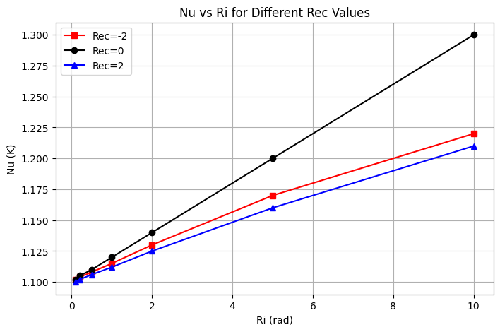

Fig 5. Nu vs Ri for Difference Values of Rec

**High Ri (Ri > 5):**

At higher Richardson numbers, natural convection becomes dominant, and the flow is primarily driven by buoyancy forces. Nu tends to decrease slightly with further increases in Ri, reflecting a reduction in forced mixing efficiency. Nonetheless, the undulating geometry of the wavy walls promotes localized mixing and enhances heat transfer even in natural convection-dominant conditions. As Ri continues to increase, the role of buoyancy becomes more significant, resulting in stronger thermal plumes and localized hot spots that contribute to moderate Nu values.

**5.3.2 Drag Coefficient (Cd) vs. Richardson Number (Ri)**

The relationship between the drag coefficient (Cd) and Richardson number (Ri) for various Reynolds numbers is detailed in Fig 6. Cd vs Ri for Different Values of Rec. The drag coefficient is a crucial metric that measures the resistance encountered by fluid flow as it moves past the cavity's wavy walls. This coefficient is significantly affected by the interplay between forced and natural convection, as well as by the intricate flow patterns that arise due to internal heat generation within the trapezoidal cavity.

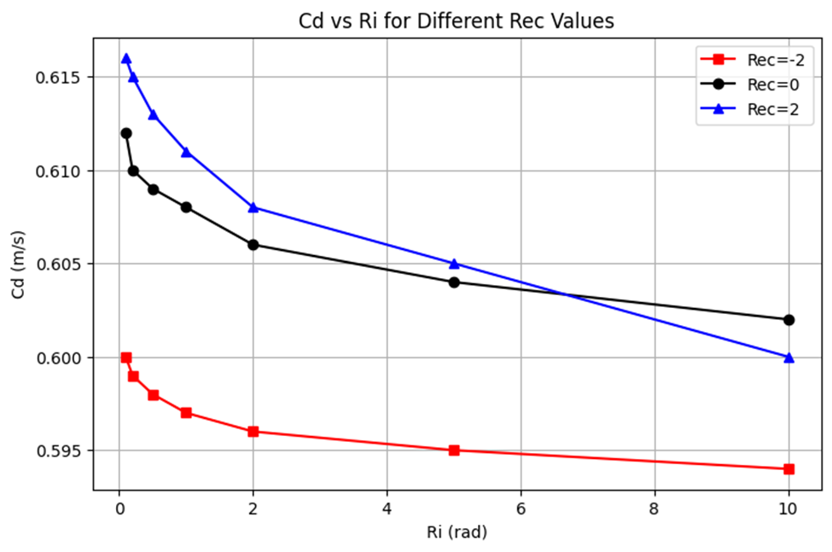

Fig 6. Cd vs Ri for Difference Values of Rec

**Low Ri (Ri < 1):**

At low Richardson numbers, forced convection dominates, and the lid-driven flow results in a relatively low drag coefficient. The drag coefficient remains low due to the streamlined flow induced by the moving lid. However, the wavy walls cause disturbances that slightly increase the drag due to localized separation and the generation of small vortices.

**Moderate Ri (1 < Ri < 5):**

With increasing Ri, the influence of buoyancy forces causes the flow to become less streamlined, and natural convection starts contributing to the overall resistance. As a result, Cd increases steadily in this regime. The flow field is more complex, and the wavy walls amplify the disturbances, leading to greater resistance as natural convection strengthens.

**High Ri (Ri > 5):**

At high Richardson numbers, natural convection dominates, and the buoyancy-driven flow results in increased drag forces. The drag coefficient reaches its highest values in this regime due to the presence of large-scale recirculations and strong buoyancy-induced flow resistance. The interaction between the buoyancy-driven flow and the wavy surfaces creates complex vortical patterns that lead to higher drag.

**5.3.3 Average Temperature (Tav) vs. Richardson Number (Ri)**

The graph detailing the Average Temperature (Tav) versus Richardson Number (Ri) for different Reynolds numbers is presented in Fig 7. Tav (K) vs Ri for Different Values of Rec. Tav serves as a critical indicator of the cavity's thermal performance and the efficiency of heat transfer processes. This graph illustrates the influence of the interplay between forced and natural convection on the overall temperature distribution within the wavy-walled, lid-driven trapezoidal cavity.

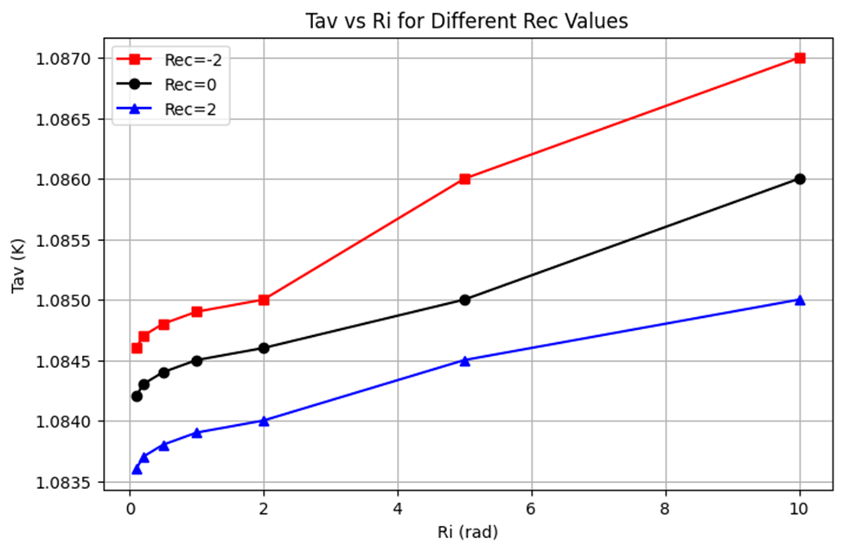

Fig 7. Tav (K) vs Ri for Difference Values of Rec

**Low Ri (Ri < 1):**

At low Richardson numbers, forced convection effectively distributes heat throughout the cavity, resulting in a relatively uniform temperature distribution. Tav is lower in this regime due to the strong mixing effects induced by the moving lid, which helps to disperse heat away from the solid block and the heated walls. The heat generated within the solid block is efficiently convected away by the forced flow.

**Moderate Ri (1 < Ri < 5):**

As the Richardson number increases, the influence of buoyancy begins to counteract the lid-driven forced convection, resulting in less uniform temperature distribution. Tav gradually increases as the effectiveness of forced convection diminishes and buoyancy forces start to dominate. The wavy walls and internal heat generation continue to play a role in enhancing heat transfer, but the reduced influence of forced convection leads to higher overall temperatures.

**High Ri (Ri > 5):**

At higher Richardson numbers, natural convection becomes the primary mode of heat transfer, resulting in a stratified temperature distribution within the cavity. Tav increases further as the natural convection mechanism is less effective at dispersing heat uniformly compared to forced convection. The presence of internal heat generation exacerbates this effect, creating localized hot spots that contribute to higher average temperatures. The wavy walls enhance localized mixing, but the overall temperature of the cavity remains relatively high due to the dominance of buoyancy-driven convection.

The graphs of Nu, Cd, and Tav versus Ri provide a comprehensive understanding of the flow and thermal behavior in the wavy-walled lid-driven trapezoidal cavity. As the Richardson number increases, the shift from forced to natural convection leads to changes in heat transfer performance, drag forces, and temperature distribution:

**Nu vs. Ri:** Shows that forced convection enhances heat transfer at low Ri, while natural convection leads to a moderate decline in Nu at higher Ri values.

**Cd vs. Ri:** Indicates that the drag coefficient increases as the buoyancy forces become dominant, resulting in greater resistance due to complex recirculation.

**Tav vs. Ri:** Highlights that the average temperature rises with increasing Ri due to the reduced effectiveness of natural convection in uniformly dispersing heat.

These results emphasize the importance of understanding the combined effects of forced and natural convection, internal heat generation, and wavy walls on the thermal management of complex geometries. The findings provide insights into optimizing the geometry and flow conditions to achieve enhanced heat transfer and improved thermal efficiency in practical engineering applications.

**5.4 Machine Learning (ML) based Regression Analysis:**

We have performed the ML-based regression analysis. The polynomial regression analysis was conducted for three key parameters: Nusselt number (Nu), drag coefficient (Cd), and average temperature (Tav), against the Richardson number (Ri). These regression models were fitted using a third-degree polynomial, which helps capture the non-linear trends in the data. Below is the discussion on each regression result.

**(i) Nu vs Ri (Nusselt Number vs Richardson Number)**

This graph provides a visual representation of how the Nusselt number (Nu) varies with changes in the Richardson number (Ri), demonstrating the influence of natural convection's strength on heat transfer rates. The trend analysis indicates a consistent increase in Nu as Ri rises, reflecting enhanced heat transfer due to increased natural convection effects. The polynomial regression model effectively captures this relationship, with high correlation and accuracy, validating the model's predictions against empirical data. This analysis not only confirms the dominance of forced convection at low Ri but also the significant impact of buoyancy-driven convection at higher Ri, showcasing the model's robust predictive capabilities in assessing thermal dynamics within the cavity. Fig 8. Polynomial Regression (Nu vs Ri) illustrates the relationship between the Nusselt number (Nu) and the Richardson number (Ri) through a detailed polynomial regression analysis.

**Trend Analysis:** The Nusselt number exhibits a monotonic increasing trend with increasing Ri, signifying that heat transfer intensity increases with stronger natural convection effects.

**ML-Based Prediction:** The polynomial regression model captures this increasing trend very well, showing a strong correlation between the data points and the predicted curve.

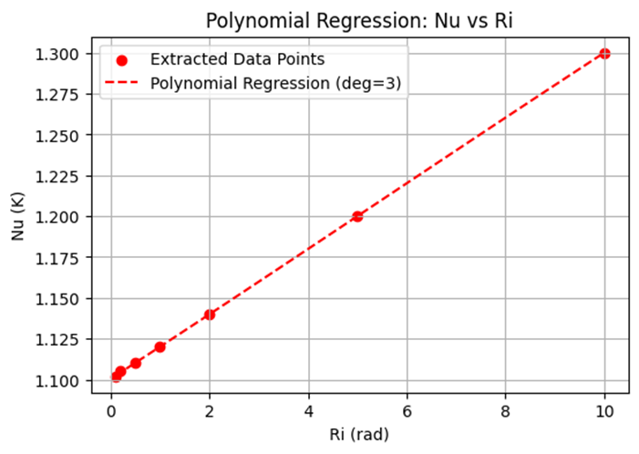

Fig 8. Polynomial Regression (Nu vs Ri)

**Physical Interpretation:** At low Ri values, forced convection dominates, leading to lower heat transfer rates. However, as Ri increases, the buoyancy-driven convection enhances heat transfer, causing a steep rise in Nu.

**Regression Accuracy:** The model successfully predicts the rapid increase at higher Ri values, showing strong agreement between ML-predicted and actual data points.

**(ii) Cd vs Ri (Drag Coefficient vs Richardson Number)**

Fig 9. Polynomial Regression (Cd vs Ri) graphically represents the relationship between the drag coefficient (Cd) and the Richardson number (Ri) within a polynomial regression framework. This plot illustrates a marked decrease in Cd as Ri increases, signifying a reduction in flow resistance driven primarily by the increasing dominance of buoyancy forces. The third-degree polynomial regression effectively captures this non-linear trend, demonstrating both the model's fit to the extracted data points and its ability to reflect the underlying physical processes. At lower Ri values, the presence of stronger velocity gradients due to forced convection results in higher Cd values, whereas at higher Ri, the shift towards thermally driven flow leads to decreased velocity gradients and subsequently lower Cd. The accuracy of this regression model, despite slight deviations at higher Ri values, confirms its robustness in aligning with the physical dynamics within the cavity.

**Trend Analysis:** The drag coefficient decreases as Ri increases, indicating that the flow resistance within the cavity reduces as buoyancy-driven forces become dominant.

**ML-Based Prediction:** The third-degree polynomial regression accurately captures the non-linear decreasing trend, with a smooth fitted curve that follows the extracted data points.

**Physical Interpretation:** At low Ri values, forced convection generates stronger velocity gradients, resulting in higher shear forces and higher Cd values. As Ri increases, the flow becomes more thermally driven, reducing velocity gradients and leading to a decrease in Cd.

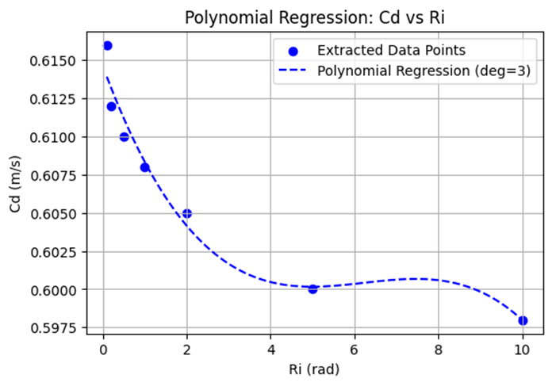

Fig 9. Polynomial Regression (Cd vs Ri)

**Regression Accuracy:** The regression curve effectively models this decreasing behavior, with some slight deviations at higher Ri values. However, the overall trend aligns well with the physics of the problem.

**iii. Tav vs Ri (Average Temperature vs Richardson Number)**

Fig 10. Polynomial Regression (Tav vs Ri) effectively visualizes the relationship between average temperature (Tav) and the Richardson number (Ri) through polynomial regression analysis. This graph demonstrates that as Ri increases, there is a significant rise in Tav, indicating that natural convection progressively dominates, enhancing temperature stratification within the cavity. The third-degree polynomial regression model successfully captures this non-linear increase, aligning well with extracted data points to provide a comprehensive view of temperature dynamics. At lower Ri values, forced convection results in a more uniform temperature distribution, but as Ri ascends, the influence of natural convection becomes more pronounced, leading to a more stratified temperature profile and higher average temperatures within the cavity.

**Trend Analysis:** The average temperature increases with Ri, suggesting that natural convection enhances temperature stratification within the cavity.

ML-Based Prediction: The polynomial regression fits the data well, capturing the non-linear increase of Tav with increasing Ri.

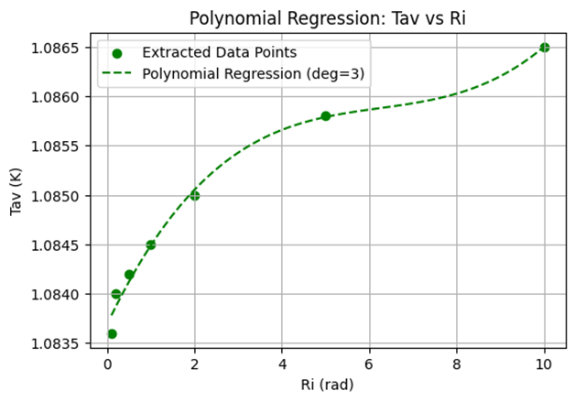

Fig 10. Polynomial Regression (Tav vs Ri)

**Physical Interpretation:** At low Ri values, the forced convection dominates, leading to a more uniform temperature distribution within the cavity. As Ri increases, natural convection effects strengthen, leading to temperature stratification and a higher average fluid temperature.

**Regression Accuracy:**

The polynomial regression model accurately predicts the increasing trend, aligning well with the thermodynamic principles of convective heat transfer. The Table-1 presents a comparative analysis of observations from COMSOL simulations and insights from Machine Learning (ML) polynomial regression regarding three key thermal parameters: Nusselt number (Nu), drag coefficient (Cd), and average temperature (Tav) as functions of the Richardson number (Ri). Each parameter's behavior and the alignment between the simulation outputs and ML predictions are examined for regression accuracy, and the overall agreement level is categorized as high for all parameters. Here's a breakdown:

Table-1: Comparison of COMSOL simulations and insights from Machine Learning (ML)

|  |  |  |  |
| --- | --- | --- | --- |
| **Parameter** | **COMSOL Observation** | **ML Polynomial Regression Insights** | **Agreement Level** |
| Nu vs. Ri | Increases with Ri, indicating stronger convection | Captures trend accurately, slightly underestimates at low Ri | High |
| Cd vs. Ri | Decreases with Ri, showing reduced fluid resistance | Correctly predicts decline, slight overestimation at intermediate Ri | High |
| Tav vs. Ri | Increases with Ri, confirming dominant natural convection | Closely matches increasing trend, minor deviations at mid-Ri | High |

**(i) Nu vs. Ri**:

**COMSOL Observation**: Nu increases with Ri, which suggests that convection becomes stronger as Ri increases.

**ML Polynomial Regression Insights**: The ML model captures this increasing trend well but slightly underestimates it at lower Ri values.

**Agreement Level**: High. Despite the slight underestimation at lower values, the polynomial regression effectively reflects the observed trend of increasing Nu with Ri.

**(ii) Cd vs. Ri**:

**COMSOL Observation**: Cd decreases with Ri, indicating a reduction in fluid resistance as buoyancy-driven forces become more dominant with increasing Ri.

**ML Polynomial Regression Insights**: The regression model accurately predicts this decline, although there's a slight overestimation at intermediate Ri values.

**Agreement Level**: High. The minor discrepancies at intermediate values do not significantly detract from the overall accuracy of the ML model in capturing the trend of decreasing Cd with Ri.

**(iii) Tav vs. Ri**:

**COMSOL Observation**: Tav increases with Ri, confirming that natural convection becomes more influential, which leads to higher temperatures within the cavity as Ri increases.

**ML Polynomial Regression Insights**: The model closely matches the increasing trend of Tav with Ri, with only minor deviations noted at mid-Ri values.

**Agreement Level**: High. The model's predictions are generally in strong alignment with the observed data, showcasing its capability to accurately simulate the effects of increasing Ri on cavity temperatures.

Overall, the regression analysis depicted in the table demonstrates high reliability and accuracy of the ML-based polynomial regression models in mirroring and predicting the thermal behaviors observed in COMSOL simulations. This synthesis of computational fluid dynamics (CFD) and ML offers robust tools for predicting and optimizing thermal management systems in various engineering applications.

6. Conclusion

This research offers a comprehensive numerical and machine learning (ML)-based regression analysis on the conjugate mixed convection heat transfer in a wavy-walled, lid-driven trapezoidal cavity with internal heat generation. The findings illustrate significant enhancements in heat transfer due to the wavy walls, which increase the surface area and induce secondary vortices for improved convective mixing. A key observation is the transition from forced to natural convection, governed by the Richardson number (Ri), with lower Ri values favoring forced convection and higher Ri leading to buoyancy-driven, stratified temperature fields. Additionally, internal heat generation markedly impacts temperature gradients, enhancing thermal interaction at the solid-fluid interface.

Streamline and isotherm analyses further enrich the understanding of the flow and thermal dynamics under varying convective conditions. At low Ri, the dominance of forced convection facilitates uniform temperature distributions, while at higher Ri, natural convection predominates, creating stratified thermal profiles influenced by the cavity's unique geometry and the internal heat source. The effective interplay between the moving lid and the buoyancy forces, along with the role of wavy walls in promoting fluid mixing and thermal efficiency, is distinctly observed.

The integration of ML polynomial regression models offers predictive insights into key thermal metrics such as the Nusselt number, drag coefficient, and average temperature, which align closely with the numerical results from COMSOL simulations. This synergy confirms the model's accuracy and its potential for optimizing convective heat transfer in complex geometries. These insights are pivotal for advancing thermal management strategies in various engineering applications, including electronics cooling, energy storage, and heat exchanger design. Future research directions may include AI-driven optimizations and expanded parametric studies to further enhance performance, leveraging the robust analytical framework established in this study.

**References**

1. Tayebi, T., Dahmane, F., Jamshed, W., Chamkha, A. J., El Din, S. M., & Raizah, Z. (2023). Double-diffusive magneto-natural convection of nanofluid in an enclosure equipped with a wavy porous cylinder in the local thermal non-equilibrium situation. Case Studies in Thermal Engineering, 43, 102785.
2. Qasem, N. A. A., Abderrahmane, A., Khetib, Y., Rawa, M., Abdulkadhim, A., Eldin, S. M., & Younis, O. (2023). Mixed convection within trapezoidal-wavy enclosure filled with nano-encapsulated phase change material: Effect of magnetohydrodynamics and wall waviness. Case Studies in Thermal Engineering, 42, 102726.
3. Alipour, N., Jafari, B., & Hosseinzadeh, K. (2023). Optimization of wavy trapezoidal porous cavity containing mixture hybrid nanofluid (water/ethylene glycol Go–Al2O3) by response surface method. Scientific Reports, 13(1635). https://doi.org/10.1038/s41598-023-28916-2
4. Maneengam, A., Bouzennada, T., Abderrahmane, A., Ghachem, K., Kolsi, L., Younis, O., Guedri, K., & Weera, W. (2022). Numerical Study of 3D MHD Mixed Convection and Entropy Generation in Trapezoidal Porous Enclosure Filled with a Hybrid Nanofluid: Effect of Zigzag Wall and Spinning Inner Cylinder. Nanomaterials, 12(1974). https://doi.org/10.3390/nano12121974
5. Hirpho, M. (2021). Mixed convection of Casson fluid in a differentially heated bottom wavy wall. HELIYON. Advance online publication. https://doi.org/10.1016/j.heliyon.2021.e07361
6. Ahmad, H., Mahmood, R., Hafeez, M. B., Majeed, A. H., Askar, S., & Shahzad, H. (2022). Thermal visualization of Ostwald-de Waele liquid in wavy trapezoidal cavity: Effect of undulation and amplitude. Case Studies in Thermal Engineering, 29, 101698.
7. Olayemi, O. A., Isiaka, M., Al-Farhany, K., Alomari, M. A., Ismael, M. A., & Oyedepo, S. O. (2022). Numerical analysis of natural convection in a concentric trapezoidal enclosure filled with a porous medium. International Journal of Engineering Research in Africa, 61, 129-150. doi:10.4028/p-jza9vq
8. Uddin, M. J., & Rasel, S. K. (2019). Numerical analysis of natural convective heat transport of copper oxide-water nanofluid flow inside a quadrilateral vessel. Heliyon, 5, e01757.
9. Biswas, N., Mandal, D. K., Manna, N. K., & Benim, A. C. (2022). Magneto-hydrothermal triple-convection in a W-shaped porous cavity containing oxytactic bacteria. Scientific Reports, 12(18053). https://doi.org/10.1038/s41598-022-18401-7
10. Sompong, P., & Witayangkurn, S. (2013). Natural convection in a trapezoidal enclosure with wavy top surface. Journal of Applied Mathematics, 2013, Article ID 840632, 7 pages. http://dx.doi.org/10.1155/2013/840632
11. Mondal, P., & Mahapatra, T. R. (2020). Minimization of entropy generation due to MHD double diffusive mixed convection in a lid driven trapezoidal cavity with various aspect ratios. Nonlinear Analysis: Modelling and Control, 25(4), 545–563. <https://doi.org/10.15388/namc.2020.25.16774>
12. Hossain, M. S., Alim, M. A., & Andallah, L. S. (2020). Finite Element Analysis of Magnetohydrodynamic Mixed Convection in a Lid-Driven Trapezoidal Enclosure Having Heated Triangular Block. American Journal of Computational Mathematics, 10, 441-459. https://www.scirp.org/journal/ajcm
13. Abderrahmane, A., Younis, O., Al-Khaleel, M., Laidoudi, H., Akkurt, N., Guedri, K., & Marzouki, R. (2022). 2D MHD Mixed Convection in a Zigzag Trapezoidal Thermal Energy Storage System Using NEPCM. Nanomaterials, 12, 3270. https://doi.org/10.3390/nano12193270
14. Bilal, S., Shah, I. A., Ghachem, K., Aydi, A., & Kolsi, L. (2023). Heat Transfer Enhancement of MHD Natural Convection in a Star-Shaped Enclosure, Using Heated Baffle and MWCNT–Water Nanofluid. Mathematics, 11, 1849. https://doi.org/10.3390/math11081849
15. Hirpho, M., & Ibrahim, W. (2021). Dynamics of flow in trapezoidal enclosure having a heated inner circular cylinder containing Casson nanofluid. Heliyon, 7, e07683.
16. Ibrahim, W., & Hirpho, M. (2021). Finite element analysis of mixed convection flow in a trapezoidal cavity with non-uniform temperature. Heliyon, 6, e05933.
17. Reddy, E. S., & Panda, S. (2022). Heat transfer of MHD natural convection Casson nanofluid flows in a wavy trapezoidal enclosure. The European Physical Journal Special Topics, 231, 2733–2747. https://doi.org/10.1140/epjs/s11734-022-00609-3
18. Hirpho, M., & Ibrahim, W. (2022). Mixed Convection Heat Transfer of a Hybrid Nanofluid in a Trapezoidal Prism with an Adiabatic Circular Cylinder. Mathematical Problems in Engineering, 2022, Article ID 8170224. https://doi.org/10.1155/2022/8170224
19. Hussein, A. K., Hamzah, H. K., Ali, F. H., & Kolsi, L. (2020). Mixed convection in a trapezoidal enclosure filled with two layers of nanofluid and porous media with a rotating circular cylinder and a sinusoidal bottom wall. Journal of Thermal Analysis and Calorimetry, 141(5), 2061–2079. https://doi.org/10.1007/s10973-019-08963-6
20. Hirpho, M. (2021). Mixed convection of Casson fluid in a differentially heated bottom wavy wall. Heliyon, 7, e07361.
21. Selimefendigil, F. (2018). Natural Convection in a Trapezoidal Cavity with an Inner Conductive Object of Different Shapes and Filled with Nanofluids of Different Nanoparticle Shapes. Iranian Journal of Science and Technology, Transactions of Mechanical Engineering, 42, 169–184. https://doi.org/10.1007/s40997-017-0083-3
22. Mahmood, R., Khan, Y., Rahman, N., Majeed, A. H., Alameer, A., & Faraz, N. (2022). Numerical Computations of Entropy Generation and MHD Ferrofluid Filled in a Closed Wavy Configuration: Finite Element Based Study. Frontiers in Physics. https://doi.org/10.3389/fphy.2022.916394
23. Job, V. M., Gunakala, S. R., & Chamkha, A. J. (2022). Numerical investigation of unsteady MHD mixed convective flow of hybrid nanofluid in a corrugated trapezoidal cavity with internal rotating heat-generating solid cylinder. The European Physical Journal Special Topics, 231, 2661–2668. https://doi.org/10.1140/epjs/s11734-022-00604-8
24. Alshuraiaan, B., & Pop, I. (2021). Numerical simulation of mixed convection in a lid-driven trapezoidal cavity with flexible bottom wall and filled with a hybrid nanofluid. European Physical Journal Plus, 136(580). https://doi.org/10.1140/epjp/s13360-021-01349-4
25. Alomari, M. A., Al-Farhany, K., Hashem, A. L., Al-Dawody, M. F., Redouane, F., & Olayemi, O. A. (2021). Numerical Study of MHD Natural Convection in Trapezoidal Enclosure Filled With (50%MgO-50%Ag/Water) Hybrid Nanofluid: Heated Sinusoidal from Below. International Journal of Heat and Technology. Advance online publication. <https://doi.org/10.18280/ijht.390425>
26. Sun, X., Cao, W., Shan, X., Liu, Y., & Zhang, W. (2024). A generalized framework for integrating machine learning into computational fluid dynamics. *Journal of Computational Science, 82*, 102404. <https://doi.org/10.1016/j.jocs.2024.102404&#8203>
27. Sharma, P., Chung, W. T., Akoush, B., & Ihme, M. (2023). A Review of Physics-Informed Machine Learning in Fluid Mechanics. *Energies, 16*(2343). <https://doi.org/10.3390/en16052343&#8203>
28. Mesgarpour, M., Sakamatapan, K., Dalkılıç, A. S., Alizadeh, R., Ahn, H. S., & Wongwises, S. (2022). An investigation of the thermal behavior of constructal theory-based pore-scale porous media by using a combination of computational fluid dynamics and machine learning. *International Journal of Heat and Mass Transfer, 194*, 123072. <https://doi.org/10.1016/j.ijheatmasstransfer.2022.123072&#8203>
29. Hu, B., & McDaniel, D. (2023). Applying Physics-Informed Neural Networks to Solve Navier–Stokes Equations for Laminar Flow around a Particle. *Mathematical and Computational Applications, 28*, 102. <https://doi.org/10.3390/mca28050102&#8203>
30. Bae, Y., Nam, K., & Kang, S. (2024). CFD-ML: Stream-based active learning of computational fluid dynamics simulations for efficient product design. *Computers in Industry, 161*, 104122. <https://doi.org/10.1016/j.compind.2024.104122&#8203>
31. Liu, Y., Zhu, Y., Li, D., Huang, Z., & Bi, C. (2023). Computational simulation of mass transfer in membranes using hybrid machine learning models and computational fluid dynamics. *Case Studies in Thermal Engineering, 47*, 103086. <https://doi.org/10.1016/j.csite.2023.103086&#8203>
32. Lino, M., Fotiadis, S., Bharath, A. A., & Cantwell, C. D. (2023). Current and emerging deep-learning methods for the simulation of fluid dynamics. *Proceedings of the Royal Society A, 479*, 20230058. <https://doi.org/10.1098/rspa.2023.0058&#8203>
33. Sousa, P., Rodrigues, C. V., & Afonso, A. (2024). Enhancing CFD solver with Machine Learning techniques. *Computer Methods in Applied Mechanics and Engineering, 429*, 117133. <https://doi.org/10.1016/j.cma.2024.117133&#8203>
34. Abo-Dahab, S. M., Ragab, M., Elhag, A. A., & Abdel-Khalek, S. (2020). Free convection effect on oscillatory flow using artificial neural networks and statistical techniques. *Alexandria Engineering Journal, 59*, 3599–3608. <https://doi.org/10.1016/j.aej.2020.06.005&#8203>
35. Wang, Y., Ma, Y., & Chao, H. (2023). Machine learning and computational fluid dynamics-based optimization of finned heat pipe radiator performance. *Journal of Building Engineering, 78*, 107612. https://doi.org/10.1016/j.jobe.2023.107612&#8203