### Practice of transhumance and its effect on pastoral resources in the Korola watershed in the Sudanian zone of Mali

**ABSTRACT**

Faced with strong agricultural pressure and severe environmental constraints, some livestock farmers are turning to agro-pastoralism, or sedentary or semi-transhumant livestock farming. Because of climatic hazards, the sub-humid zone has seen a rush of livestock, and agriculture has developed considerably, with mobility still the most appropriate system for feeding herds. In recent decades, pastoralists and their herds from the northern regions to the Sudanian zone. The study describes farming practices in the Korola sub-watershed in the Sudanian zone of Mali. Surveys and censuses of indigenous and transhuman herds were conducted in the Korola sub-watershed. The study reveals that the high number of cattle is due to their contribution to the socio-economic development of agro-pastoralists through the integration of agriculture and livestock (animal traction, production of organic manure) and hoarding to secure people's incomes. The number of transhumant groups identified was highest in Dembela (196), followed by Blendio (166) and Nièna (37) with an average of 133. The herd's concentration is higher in the Dembela area (115696) than in the other municipalities, at 94136 in Blendio and 16173 in Nièna. The estimated numbers were highest in July (132298 cattle), followed by August and March with 29177 and 25690 head, respectively. The main area of origin was the RCI, with 188 groups, followed by Ségou (43), Kignan (22), and Beleko (17). The Republic of Ivory Coast (108), Ségou (72), Beleko (44), and Konina with 28 groups.

**Keywords:** transhumance, pastoral resources, forage constraints, Korola, Mali

**INTRODUCTION**

In the Sudanian zone of Mali, like the other bioclimatic zones of the country, pastoral livestock farming is based on the exploitation of natural pastures (Ba et al., 2022; Konaré, 2022). Over the last three decades, land use in pastoral and agro-pastoral zones has greatly intensified thanks to population growth (Soumaré and Traoré, 2019). The increase in livestock numbers over recent decades (Ba, 2011), led the rainy season to the concentration of increasingly high numbers of animals in increasingly reduced pastoral areas (Konaré, 2022). Added to this is the advance of the agricultural front encroaching on rangeland, thus limiting livestock access to pastoral resources (Coulibaly, 2017).

These phenomena coupled with civil insecurity have led many pastors to change their mobility habits (Coulibaly, 2017). Since the outbreak of the security crisis in Mali in 2012, there has been a migration of pastoralists and their herds from the northern and central regions of the country known for the availability and quality of their pastures (Konaré, 2022). These constraints can both affect the productivity of pastoral herds and lead to the degradation of the vegetation of rangelands in host areas.

Thus, natural grazing areas and schedules of access to crop residues during the seasons of the year are defined by agricultural occupation. Food then became the main constraint to cattle breeding in the Mali South zone, constituting a transit point and/or a final destination for many transhumant breeders. Transhumance thus took shape in the management of farmers' sedentary herds with interaction on agriculture-livestock integration (Coulibaly et al., 2009). Some transhumants arrive from October to May but others circulate in the area further south throughout the rainy season and stay there after the harvest until the following winter (Umutoni et al., 2016; Koné et al., 2017).

Watersheds have been the subject of numerous studies in Mali (Pépin and Guiguen, 1989; Ferry et al., 2011). The main ones focused on the interior Niger Delta (Touré, 1992; Mariko et al., 2003; Mahé, 2021; Hiernaux et al., 2021). However, little work has concerned the pastoral resources of the Bagoé watershed in the Sudanian zone of Mali.

The Korola sub-watershed has an agro-sylvo-pastoral vocation having benefited from several livestock infrastructures (transhumance track, water points, etc.). In recent years, an intensification of livestock activities and an increase in the frequency of transhumant livestock has been noted in the area. It is in this context that this study was initiated to document transhumance and its effects in the Korola sub-watershed located in the Sudanian zone of Mali.

**MATERIALS AND METHODS**

**Study area**

The Korola sub-watershed covers an area of ​​1245.3 km2 whose outlet coordinates are 6°39’W and 11°71’N (Figure 1).

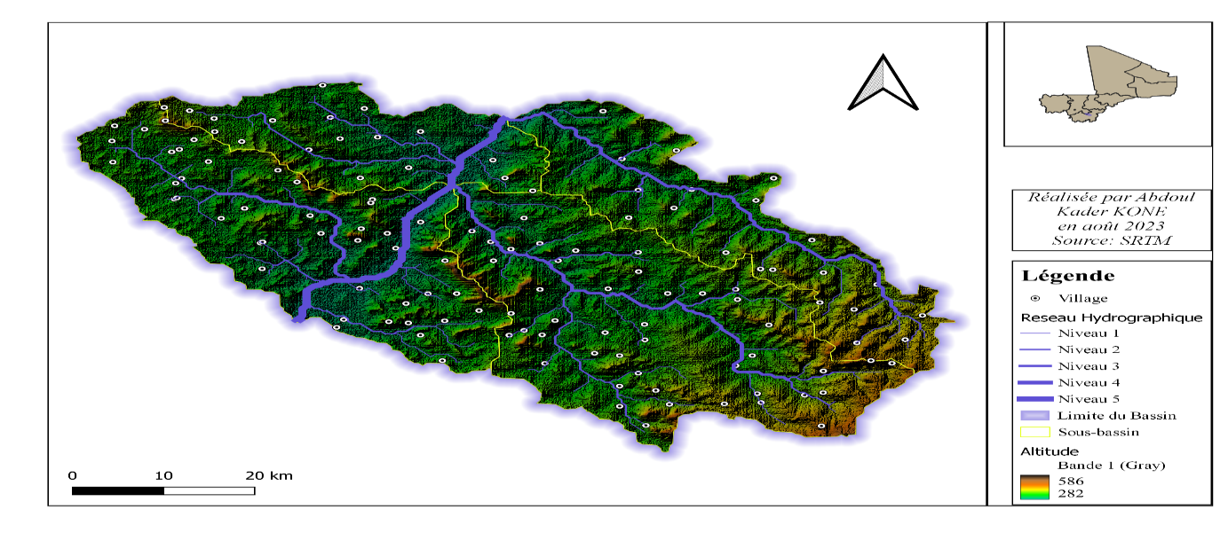

**Figure1:** Korola watershed and drainage channels

The Korola sub-basin straddles three rural communes (Dembela, Nièna and Blendio). It is a highly anthropized area which has 43 villages with an estimated population of 43,000 inhabitants. The population is mainly composed of Senufos, Gana, Samogos and Bambaras. The landscape is made up of a succession of agricultural spaces and non-agricultural spaces. The shrub savannah dominates the non-agricultural space with a low representation of galleries in the terroirs.

The average annual rainfall of the watershed is 960 mm. Agricultural practices have been greatly influenced by the supervision of the CMDT. The cultivated areas are mainly occupied by cotton and the 3 major cereals (corn, sorghum, and millet). Several other crops (rice, fonio, peanuts, etc.), as well as horticultural crops, are well represented in the agricultural landscape (Sangaré, 2020).

The Korola sub-watershed, like most of the Bagoé basin, is subject to a Sudanian climate characterized by a rainy season from May to October and a dry season from November to April. The highest monthly average temperature is recorded during the period March - April (37.5°C) and the lowest in August (29.9°C). Three (03) soil-vegetation units (TC5, PL9, PL11) were determined in the watershed by PIRT (1983).

**Data acquisition**

Data were collected through surveys of sedentary agro-pastoralists and transhumants. We used probability sampling (Ivan, 2010) for the selection of agro-pastoralists according to the following criteria:

- Age (at least 40 years old);

- Activity carried out (agriculture and/or livestock);

- Be from the locality or be a resident over 30 years old;

- Know the natural formations of the locality.

This is how a pastoral survey was carried out among 74 agro-breeders spread across the three communes of the study area.

It aims to collect information relating to the structure of the cattle herd, breeding practices including herd mobility and to characterize the pastoral resources of the study area. The collection of information on the situation of pastures (period of use, passage of transhumants, evolution of the diversity of woody and herbaceous species) was also conducted by said stakeholders.

Monitoring of transhumants was carried out for two (02) years. These surveys consisted of identifying water points and transhumant routes in consultation with the various stakeholders in the sub-basin municipalities. Thus 15 villages spread across the three communes were chosen according to the degree of concentration of livestock and the frequency of transhumants. The data collected covered:

• Movement period (back and forth) of transhumant herds;

• Estimation of livestock by counting with transhumants after awareness raising;

• The composition of the transhumant herd.

Information was collected from shepherds, breeders, and hunters depending on the study sites. Eight focus group sessions were organized to collect information on the impact of livestock farming practices on pastoral resources in the sub-basin. These are agro-breeders with knowledge of the evolution of land use and the exploitation of natural resources.

**Data analysis**

The information collected in the field was entered into databases using Excel. The data obtained were used for statistical analysis using the software (R version 4.4.2, <http://www.r-project.org>) and the ggplot2 Package. These data allowed us to estimate the number and structure of the transhumant herd, and the movement of transhumant groups.

**RESULTS**

**Practice of transhumance in the sub-basin**

In the study area, transhumant herds are mainly composed of cattle. Table 1 presents the numbers of transhumant herds.

**Table1:** Average size of transhumant herds in the sub-watershed

|  |  |  |  |  |  |  |
| --- | --- | --- | --- | --- | --- | --- |
| Municipalities | Transhumant group | Number of transhumant herds | | | | |
| **Total** | **Average** | **Minimum** | **Maximum** | **Standard deviation** |
| Blendio | 166 | 94136 | 567 | 53 | 2110 | 392 |
| Dembela | 196 | 115696 | 590 | 45 | 3852 | 523 |
| Nièna | 37 | 16173 | 437 | 68 | 2100 | 396 |
| *Average* | 133 | 75335 | 531 | 55 | 2687 | **463** |

196 transhumant herds were recorded in Dembela compared to 166 in Blendio. Only 37 transhumant herds were recorded in Nièna.

In relation to the numbers, the concentration is higher in the Dembela area (115,696 heads) than in the other municipalities of the order of 94,136 in Blendio and 16,173 in Nièna. This high concentration of herds in this commune is explained by the fact that for a decade Dembela has become a meeting area par excellence due to its geographical position and the availability of pastoral resources.

**Dynamics of the numbers of transhumant herds in the sub-watershed**

The numbers of transhumant herds vary greatly depending on the seasons (Figure 2).

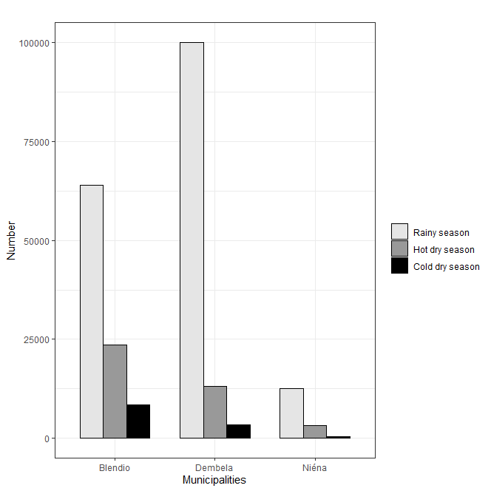

**Figure2:** Variation by season in the numbers of transhumant herds in the sub-watershed

Transhumance was only practiced in the Sudanian zone during the dry season, currently, it is practiced throughout the year in the study area.

It is done according to the north-south gradient. The staircase system is developed, that is to say, the herds from the northern part migrate towards the south and those from the southern zone migrate further south towards the border of Ivory Coast. The return flow is more accentuated in July-August. As numbers increase, some transhumants become more sedentary. The majority of transhumant herds in the area come mainly from the regions of Ségou, Dioïla, San, and Koutiala.

Figure 2 illustrates the monthly evolution of the numbers of transhumant herds in the study area in 2021.

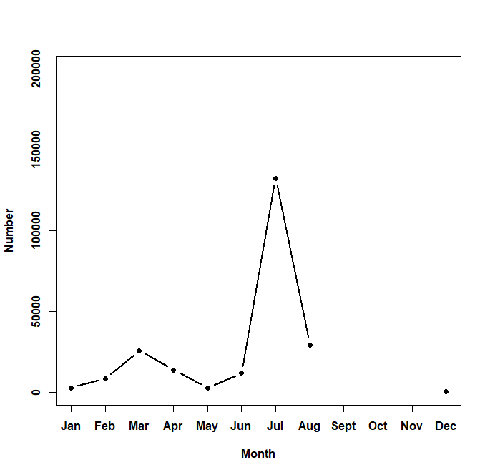

**Figure3:** Dynamics of the numbers of transhumant herds in the sub-watershed

The estimated number is highest in July (132,298 cattle), followed by the months of August and March with 29,177 and 25,690 head respectively (figure 3). This permanent presence of transhumants in the sub-basin can be explained by the climatic situation of the municipalities favoring the access of herds to resources (pasture and water) where forage and water stress were not increased. Over the past thirty years, these movements have led to changes in the relationships between pastoralists and farmers in host or transit communities.

**Origin and destination of transhumant herds in the Korola sub-watershed**

Information was collected from transhumant shepherds on their origins and departures (figure 4).

The main areas of origin were the RCI with 188 groups, followed by Ségou (43), Kignan (22), and Beleko (17). These transhumants have large numbers with large amplitude movements of livestock (north-south on the outward journey and south-north on the return) during all seasons. The distances traveled are several hundred kilometers and frequently exceed the borders of the country of origin.

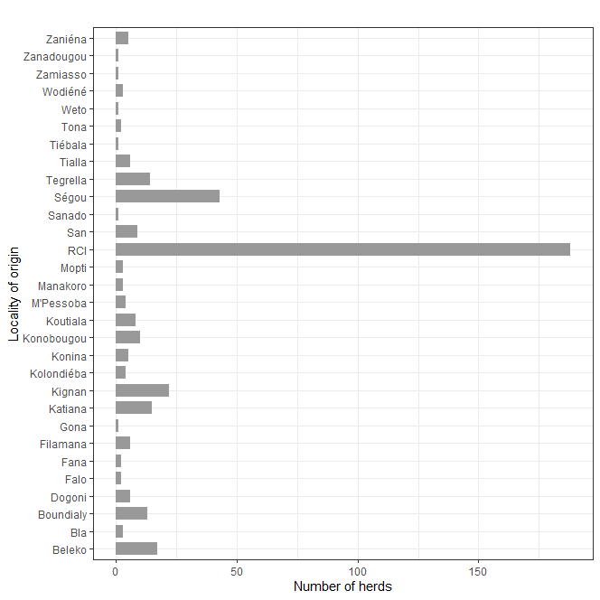

**Figure4:** Locality of origin of groups of transhumants staying in the sub-watershed

Regarding the departure of transhumant groups, the majority of transhumants had as their destination the Republic of Ivory Coast (108), Ségou (72), Beleko (44), and Konina with 28 groups (Figure 5). Very often, movements take place within and on the periphery of the sub-watershed or national but they can be cross-border.

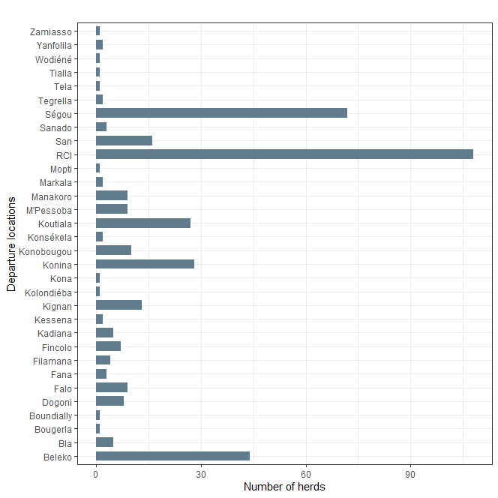

**Figure5:** Departure locations for transhumant groups staying in the sub-watershed

**Impact of the practice of transhumance on pastoral resources**

The information collected through focus groups conducted in the communes of Nièna, Dembela, and Blendio showed that livestock farming practices in the Korola sub-watershed have changed significantly over the last thirty years.

Firstly, the frequency of the practice of transhumance has increased. 70% of respondents in the focus groups perceived this increase as the result of the reduction in grazing areas in many areas. In recent years, a type of circulating transhumance has been observed in the Dembela and Blendio areas during crop periods. According to farmers, certain groups of breeders who have been on transhumance for several years have no longer returned home. They are present throughout the year and move from one area to another depending on the periods (crop period, harvest, and post-harvest) but also depending on the availability of pastoral resources. It also emerged in many discussions that due to pressure on plant resources in general and fodder resources in particular, certain species have disappeared.

Other findings were reported on the early drying up of certain ponds and rivers. The main extinct herbaceous species are *Cymbopogon giganteus* and *Lippia chevevalieri*. As for the woody species, they are *Gymnosporia africana*, *Oxynantera taabyssinica*, and *Erythrophleum suaveolens*. Species palatable to livestock are disappearing in favor of non-palatable species such as *Hiptis suaveolens* and *Cassia tora*. This situation was an element that contributed to the reduction of access to pasture and water for transhumant herds. "Since we have a lot of animals, we prioritize our animals first. In addition, few transhumant herders now have access to crop residues because we collect most of these residues to distribute them to our animals," reported the agro-herders during the group discussions.

The last thirty years have been characterized by changes in the relationships between pastoralists and agro-pastoralists in host or transit communities. Farmers perceived this change in relations between transhumant herders and host communities in terms of a reduction in exchanges and contacts, and an increase in conflicts.

In individual surveys, the average duration of presence of transhumant shepherds in Nièna was 15 to 30 days. “The availability of pastures has become a problem, most of the areas which in the past were dedicated to pastoral activities have been transformed into cultivation areas,” explained the farmers, which reduced the stay time of transhumants in Nièna.

Unlike Blendio and Dembela, the length of stay of transhumants in the areas has increased significantly with an average of 60 days. The availability of pastoral resources in this area constitutes a favorable factor. In addition, these areas are frequented by transhumants from the northern and central regions of Mali; who in the past crossed them to go to Ivory Coast. Now some are staying because of insecurity at the Ivorian border. Those who continue to the Ivory Coast or the border, upon return, are forced to stop there due to insecurity problems in central and northern Mali.

**DISCUSSION**

Agro-pastoralists in the study area reported a substantial increase in livestock numbers observed in recent years. The concentration is higher in the Dembela area than in the other municipalities. This situation has led to significant problems in the management of pastoral areas in the area. These results are in agreement with those of Ba (2011) who estimated that in areas like Sikasso where the pressure on the soil becomes increasingly strong, where fallow is shortened or simply disappears, and where arable land is rare, cattle numbers are stagnating and increasing competition between agriculture and livestock.

Concerning the length of stay of transhumants, the average of their presence in Nièna was 15 to 30 days. Our values ​​are comparable to those of Umutomi et al. (2016) which are 6 to 60 days in the Bougouni area despite a sharp increase in transhumants. In the study area, livestock concentrations are higher in July, followed by August and March, contrary to the results of Konaré (2022) which showed the numbers of transhumants were higher between February and May in the Kéniéba area.

Faced with a fodder and water deficit, breeders are often forced to practice transhumance in different seasons to alleviate the animal food crisis. This study showed that pastoral mobility occur in the sub-watershed throughout the year. In the study area, the number of transhumant herds is highest in July (132,298 heads), followed by August and March with 29,177 and 25,690 heads respectively. The work of the study by Konaré and Coulibaly (2019) leads to different results on the period of concentration of transhumant herds in the Kéniéba area where numbers are very large in December and January. Our results are lower than those obtained by Yvon et al. (2008), who found numbers of 200,000 heads and 17,000 heads in the area.

The intensification of the practice of transhumance was reported by the majority of respondents as being the factor that has contributed to environmental changes in recent years (Diallo et al., 2022). In Kéniéba with the same type of bioclimate, Konaré and Coulibaly (2019) reported that transhumants are responsible for the rape of women, damage to crops, and cutting down of sacred trees. According to the same authors, transhumance has also favored the appearance of species such as *Hiptus suaveolens*, *Acacia ataxacantha*, *Ipomea sp*. Leclerc and Sy (2011) observed in the peanut basin in Senegal, the degradation of pastoral resources follows pressure from transhumants coming from Mali and Mauritania. Yvon et al. (2008) showed in their work that the concentration of transhumants results from the contraction of traditional pastoral areas and reforestation.

It has been reported by several people that certain forage species are endangered such as *Cymbopogon giganteus*, *Pterocarpus erinaceus*, *Pterocarpus lucens*, and *Lippia chevevalieri* following the pruning actions of shepherds.

This same observation was made by Cissé et al. (2024) in particular *Khaya senegalensis* and *Pterocarpus erinaceus* according to transhumant and agro-breeders in the Kangaba zone.

**CONCLUSION**

In the sub-watershed, the practice of transhumance has undergone significant changes in recent years with an increase in animal movements. Through this study, we described the current breeding practices in the Korola sub-watershed in the Sudanian zone of Mali.

This study made it possible to highlight an intensification of transhumance in the study area leading, in certain village areas, to a sedentarization of groups of breeders. According to agro-breeders, this situation has had negative impacts on pastoral resources, notably the reduction of pastoral space, the disappearance of certain forage species (woody and herbaceous), the early drying up of certain bodies of water, the degradation of plant cover thus exacerbating conflicts between indigenous and non-indigenous people. Several ethnic groups practice transhumance, unlike in the past when it was a specialty of the Fulani.

**DISCLAIMER (ARTIFICIAL INTELLIGENCE)**

Author(s) hereby declare that NO generative AI technologies such as Large Language Models (ChatGPT, COPILOT, etc.) and text-to-image generators were used during the writing or editing of this manuscript.

## CONSENT AND ETHICAL APPROVAL

The study protocol was approved by the institutional ethics committee of the Faculty of Science and Technology (FST). Informed, voluntary consent was obtained from all owners. All measures were taken to minimize the risks associated with participation in the study.

**REFERENCES**

Ba, A., Koné, A.K., Diawara, M.O., Diarra, H.D & Traoré, S.O. (2022). FodderPotential Evaluation of Agro-Pastoral Sites Using Spatial ImageryTechnology in the Cotton Production Zone of Mali, West Africa. *East African Journal of Agriculture and Biotechnology*, 5(1), 150-161.

Ba, A. (2011). Cattle farming in the cotton-growing area of ​​southern Mali. PhD thesis, Montpellier SupAgro. 170p.

Blanchard, M. (2010). Soil fertility management and the role of the herd in cotton-cereal-livestock systems in southern Mali: local technical knowledge and practices for integrating agriculture and livestock. PhD thesis, Université Paris-Est, Créteil. 300p.

Cissé, S.N., Coulibaly, N., Drame, O., Koné, A.K., Ba, A., Karembé, M., Timbely, D. (2024). Impacts of the local convention on the use of woody fodder in the Kangaba circle in Mali. International Journal of Latest Research in Humanities and Social Science (IJLRHSS), Volume 07 - Issue 08, 2024, www.ijlrhss.com || PP. 109-115

Coulibaly, D., Poccard-Chappuis, R & Ba, A. (2009). Territorial dynamics and changes in pastoral resource management methods in Southern Mali (Mali). Renc. Rech. Ruminants, 16. pp357–360.

Coulibaly, N. (2017). Evaluation of the potential for herbaceous and woody resources at the Koutiana site in the Niono Ranch (Ségou region/Mali). Master's thesis, Higher Institute of Training and Applied Research (ISFRA), 70p.

Ferry, L., Muther, N., Martin, D & Mietton, M. (2011). The main watersheds of the Niger in Mali. In: Upper Niger: some research results on water resources and uses. Paris (FRA); Marseille: UNESCO; IRD, 2 p.

Hiernaux, P., Turner, M., Eggen, M., Marie, J., Haywood, M. (2021). Resilience of wetland vegetation to recurrent drought in the Inland Niger Delta of Mali from 1982 to 2014. Wetlands Ecol Manage (29), 945-967, https://doi.org/10.1007/s11273-021-09822-8.

Hountondj, Y-CH. (2008). Environmental dynamics in the Sahelian and Sudanian zones of West Africa: Analysis of changes and assessment of degradation of vegetation cover. Doctoral thesis, University of Liège, 153 p.

Ivan, F. (2010). Survey Methods and Practices. Ottawa: Statistics Canada, 434p.

Konaré, D & Coulibaly, M. (2019). Assessment of the Impacts of Transhumance on Pastoral Resources in Southern Mali in the Rural Commune of Dabia (Cercle of Kéniéba). European Scientific Journal, (15), 202- 227.

Konaré, D. (2022). Effects of Transhumance on Pastoral Resources in the Circle of Keniéba in Mali. Doctoral Thesis, Institute of University Pedagogy, Mali, 250p.

Kone, A.K. (2017). Assessment of Pastoral Potential in the Cotton-Growing Zone of Mali: The Case of the Village Lands of Benguéné, Ziguéna and Nafégué. Master's Thesis, Higher Institute of Training and Applied Research (ISFRA), Bamako, Mali. 105p.

Leclerc, G and Sy, O. (2011). Spatial indicators of pastoral transhumance in Ferlo, Cybergeo: European Journal of Geography 1-23, http://cybergeo.revues.org/23661

Mahé, G. (2021). The Inner Niger Delta, an exceptional natural environment. Initiatives for the Future of Great Rivers. URL https://www.initiativesfleuves.org/actualites/gil-mahe-ird-delta-interieur-niger-milieu-naturel-exceptionnel/.

Mariko, A., Mahe, G., Servat, E. (2003). Flooded areas in the Inner Niger Delta in Mali by NOAA/AVHRR. SFPT Bulletin No. 172 (2003-4), 8 p.

Pépin, Y., Guiguen, N. (1989). Kambo Watershed Kadiolo Region in Mali. Summary report, summary of observations 1988-1989-1990. Bamako: ORSTOM, 114 p. multigr. https://agritrop.cirad.fr/340942/.

PIRT. (1983). Land resources in Mali. N. Y. Gov. Mali, USAIDTAMS.

Sangaré, H., Daou, I., Keïta, I. (2020). Evolution of land use in the Korola watershed (Sikasso region, Mali) from Landsat satellite images. Rev Ivoir Sci Technol, 36, 193–207. http://www.revist.ci

Sanogo, O.M. (2011). Improving the productivity of mixed crop-livestock farms through better management and feeding of dairy cows in the Koutiala area, Mali. PhD thesis, Wagening University. 153p.

Soumaré, M and Traoré, S. (2019). Plate 1. Agricultural zone of cotton-growing areas, Soumaré M. (ed), Atlas of cotton-growing areas of Mali, second edition, IER-CIRAD, pp 15-18.

Umutoni, C., Avoirunde, A.A., Sawadogo, G.J. (2016). Local knowledge of transhumance practices in the Sudano-Sahelian zone of Mali. Rev. Livestock Medicine Vet. Countries Trop. 69, 53–61. https://doi.org/10.19182/remvt.31180