***Original Research Article***

**Genetic Diversity Assessment of Winged Bean [*Psophocarpus tetragonolobus* (L.) DC.] Genotypes**

**Abstract**

An underappreciated legume with significant nutritional and agricultural potential, especially in tropical areas, is the winged bean (Psophocarpus tetragonolobus (L.) DC.). The presence of anti-nutritional chemicals, extended maturation times, and unpredictable growth habits prevent its widespread cultivation despite its high protein content, nitrogen-fixing capacity, and adaptability to a variety of agro-ecological situations. Using Mahalanobis D2 analysis, this study attempts to evaluate the genetic divergence and grouping patterns across forty genotypes of winged beans. Over the course of two consecutive Kharif seasons (2022–2024), the experiment was carried out at the Department of Genetics and Plant Breeding's Experimental Farm, SASRD, Medziphema, Nagaland. Sixteen agronomic characteristics were assessed using a randomised block design with three replications. Tocher's approach was used to divide the genotypes into five clusters. Cluster I had the most genotypes (33), while Cluster IV and V had just one and two genotypes, respectively. With inter-cluster distances ranging from 10.8 to 42.24, significant genetic diversity was evident. The characteristics that contributed most to genetic divergence were tuber weight, tuber diameter, and days to first flowering. The findings demonstrate how hybridisation between distinct parental genotypes from various clusters may lead to genetic improvement. Breeding efforts may be improved and the use of winged bean germplasm as a sustainable food source can be encouraged by increasing studies on its genetic diversity. With the goal of raising production potential and improving the economic viability of this nutrient-dense legume, this study offers insightful information for future crop modification techniques.

**Keywords: Orphan legume, D2, Tocher, Diversity**

**Introduction**

The winged bean (*Psophocarpus tetragonolobus* (L.) DC.) is classified as an underutilized or orphan legume commonly found in tropical regions. This plant exhibits a strong twining growth habit, nitrogen-fixing ability, and a tuberous root system (Eagleton, 2020; Vatanparast et al., 2016). It thrives in diverse agro-ecological zones, particularly in hot and humid equatorial climates, making it a promising crop for agricultural development (Afridatul et al., 2021; Lepcha et al., 2017). Belonging to the Fabaceae family, the winged bean has a chromosome number of 2n = 2x = 18 or 2n = 22.

The winged bean is also known by various names, including four-angled bean, princess pea, asparagus pea, dambala, Manila bean, kok-tau, and Goa bean. Despite its high nutritional value, it remains relatively underutilized. The seeds contain essential amino acids and fatty acids in significant quantities (NAS, 1981; Kulthe et al., 2013). Nearly all parts of the plant—including tender leaves, flowers, green pods, dried seeds, and tuberous roots—are edible and have commercial value (Sriwichai et al., 2021; Singh et al., 2013). It can be cultivated as a cover crop, green vegetable, grain legume, forage, or tuber crop (Sriwichai et al., 2021). Notably, its tubers have an exceptionally high protein content, ranging from 8% to 20% (dry weight), surpassing that of other tuberous crops such as *Ipomoea batatas* (2%), *Dioscorea* spp. (2%), and *Manihot esculenta* (1%). In addition to its protein-rich composition (29.8–37.5%), winged bean seeds are also a good source of carbohydrates (4.3 g per 100 g), edible oil (15–20%), and vitamin A (300–900 IU) (Singh et al., 2013; Koshy et al., 2013). However, despite these nutritional benefits, the presence of anti-nutritional compounds—such as chymotrypsin inhibitors, hemagglutinins, trypsin inhibitors, and amylase inhibitors—can hinder digestion and reduce the crop's acceptability among farmers and consumers (Kortt, 1980; Mohanty et al., 2013). These factors negatively impact its widespread adoption (Kulthe et al., 2013).

Despite its nutritional and agricultural potential, research on the winged bean has been limited. It has received little attention and funding for yield improvement, despite being a highly nutritious crop. Genetic diversity is a key factor in crop improvement, enabling plant breeders to select genetically diverse parents for targeted hybridization programs. Several challenges hinder its wider adoption, including its long maturation period, indeterminate growth habit, low seed yield, and the necessity for staking. Additionally, the presence of anti-nutritional factors, such as chymotrypsin inhibitors, hemagglutinins, and trypsin inhibitors, further limits its appeal (Lepcha et al., 2017). Limited information on the genetic diversity of winged bean germplasm (Laosatit et al., 2022) makes conservation efforts and breeding programs even more critical (Sriwichai et al., 2021). Understanding its genetic diversity is essential for developing efficient breeding strategies and identifying heterotic combinations for crop improvement (Laido et al., 2013). Expanding research on the winged bean could enhance its agricultural viability and promote its adoption as a sustainable and highly nutritious food source. Recognizing the importance of this underutilized legume, the present study aims to assess the genetic divergence (D² analysis) and clustering patterns among fourty winged bean genotypes, which could provide valuable insights for future breeding programs.

**Materials and Methods**

The experiment was conducted at Experimental farm of Department of Genetics and plant breeding, SASRD, Medziphema, Nagaland. It is situated at 29045’43” N latitudes and 93053’04” E longitudes at an elevation of 304.80 m above mean sea level (MSL). The site of the experimental area falls under sub-tropical climate with high humidity, moderate temperature (Maximum 38º C during summer to minimum 6º C during winter) with medium to high rainfall (2000 to 2500 mm). The soil is acidic in nature with pH varying from 4.5 - 6.2 and the organic matter content of soil is low which varied from 1.2 - 2.9%. The topography is fairly uniform and plot is well drained with assured irrigation facility to raise the healthy crop. The present investigation was conducted two consecutive *Kharif season*, 2022-2023 as well as 2023-24. The experiment was laid in Randomized Block Design with 3 replications under both divergence and stability study. The experimental material consisted of fourty genotypes of *Psophocarpus tetragonolobus* (L.) DC (Table 1). The spacing between row to row was 120 cm and plant to plant distance of 100 cm maintained by thinning after 15 days of sowing and the recommended fertilizer dose was applied once, as basal dose *i.e*. N: P2O5: K2O: 30:30:20 Kg/ha one day before the date of sowing for the entire crop life. Growth parameters like Plant height (m), Days to first flowering, Days to 50% flowering, Days to pod initiation, days to maturity, Pod length (cm), pod width (cm), dry pod weight (g), tuber length (cm), tuber weight (g), tuber width (cm), pod yield per plant, number of pods per plants, number of seeds per pod, 100 seed weight (g) and seed yield per plant (g).

**RESULTS AND DISCUSSION**

All sixteen variables under study showed a very significant variation in mean square owing to genotypes at the P<0.01 level, suggesting that the genotypes of the forty-winged beans are genetically distinct from one another. Winged bean genotypes showed nearly identical type results seen by Mahto and Dua (2009), Kushwaha et al. (2013), Sriwichai et al. (2021), and Kant et al. (2022).

**Assessment of genetic diversity:** The study of genetic divergence was conducted using Mahalanobis D2 statistics. Data were submitted to D2 analysis in order to examine genetic divergence in forty genotypes of winged beans. To arrange the genotypes into distinct clusters, the Tocher technique was used in the analysis.

**Group constellations:** The accessions were grouped into five clusters. Among five clusters, cluster-I was the largest one with 33 genotypes namely, Local wokha-2, Local Suchonoma, NUWB-4, Local peren, Local Medziphema, VRWB-23, VRWB-24, NUWB-3, VRWB-26, VRWB-68, VRWB-35, VRWB-36, LOCAL PANGTI-1, Local dimapur-1, VRWB-45, Local dimapur-2, Local akuk, VRWB-50, VRWB-54, Local wokha-1, VRWB-75, VRWB-77, VRBW-85, VRWB-88, Local bagthy, VRWB-93, VRWB-100, VRWB-104, Local Mongsenyimti, VRWB-112, VRWB-115, VRWB-116 and NUWB-2. Whereas, cluster-V includes 2 genotypes namely VRWB-59, VRWB-32. followed by cluster II with 3 genotypes namely VRWB-17, Local Peren, VRWB-20 and VRWB-27. Followed by cluster III and Cluster IV exhibits solo clusters or monogenic clusters with local attributes *i.e.,* genotypes namely Local Dimapur-3 and Local Pangti-2 (Table 2 and Fig. 1).

Since genotypes from the same cluster would be less diverse, it would be ineffective to select for them in order to further improve the crop. Therefore, there would be a chance to combine gene constellations of various origins through hybridisation involving genetically varied parents from various remote clusters. Using Metroglyph analysis, Singh et al. (2002) discovered that 18 pure line genotypes from native and foreign mixed populations differed in 10 features in winged bean strains that were reported. These strains were then categorised into eight groups. Nine clusters of 30 native and alien winged bean specimens showed genetic divergence, according to Mahto and Dua (2009). Using Mahalanobis D2 statistics, Kushwaha et al. (2013) also documented genetic diversity among 26 winged bean germplasm lines arranged into six groups.

**Inter and intra cluster distances among clusters:** D2 values of intra and inter-cluster distance are given in Table 4. and in Fig 2. The average D2 values of intra and inter-clusters are given in Table 4. The results showed that cluster V had maximum intra cluster D2 value (9.89) which comprises two genotypes showed the highest genetic diversity among the genotypes within cluster with D2value 9.89 followed by cluster I with thirty-three genotypes with D2 value 7.03 and Cluster II with three genotypes with D2 value 3.5. The mono-genotypic clusters were represented by one genotype so the intra-cluster distance was found to be zero. Between clusters, inter-cluster distances varied from 42.24 to 10.8. Maximum inter-cluster distance (42.24) was observed between cluster-II and V followed by between cluster-III and V (42.09), cluster-II and IV (30.36), cluster-V and I (27.08), cluster-V and IV (22.89) cluster-III and IV (17.93), cluster-II and III (16.95), cluster-II and I (13.96) cluster-I and IV (12.88) and the least cluster distance between cluster-I and III (10.8).

Through the use of Metroglyph analysis, Singh et al. (2002) revealed intra-cluster distances ranging from 0.00 to 55.1, whereas cluster IV and VIII had the largest inter-cluster distance (259.31). Winged bean genotypes were found to have intra-cluster distances ranging from 70.24 to 213.25 and inter-cluster distances ranging from 234.78 to 1283.39 (Kushwaha et al., 2013).

**Cluster mean Performance for different characters:** A comparison of the cluster means values for sixteen traits in five different clusters reflected considerable differences present in them (Table 3). The cluster mean values showed a wide range of variations for all the characters undertaken in this study. Cluster-II accommodated 3 genotypes, which had maximum number of traits with lowest cluster mean value for days to first flowering (60.56), Day to 50% flowering (87.86), Day to pod initiation (64.04), days to pod initiation (125.64), days to maturity (`144.85) which is a desirable character according to it earliness and also recorded least cluster mean was of dry pod weight (4.82) and tuber length (17.22), highest cluster mean value for number of seed per pod (41,28), Pod yield per plant (239.15) and seed yield per plant (134.83) followed by Cluster-III which comprises of one genotype shows highest cluster mean for Plant height (7.34), dry pod weight (7.57), number of seed per pod (12.77) and pod length (22.12), this also contributes highest cluster mean for days to first flowering (124.62), Day to 50% flowering (150.33), Day to pod initiation (128.34), this cluster also reflected lowest cluster mean value for tuber weight (25.24) and tuber width (1.96). Cluster-I which accommodated thirty-three genotypes which had no highest cluster mean value but shows lower for number of seed per pod (11.46) and pod. Cluster-V which accommodated two genotypes had maximum cluster mean value for pod width (2.89), tuber length (26.82) and tuber weight (103.03). This cluster also reflected lowest cluster mean value for plant height (4.60), 100 seed weight (30.47), pod yield per plant (123.06) and pod length (14.69), day to pod initiation (69.90) and days to maturity (147.38) in the genotype. Cluster IV accommodated single genotypes which exhibits highest mean for days to maturity (199.89), tuber width (4.15) and 100 seed weight (32.08) and showed lowest accommodation for seed yield per plant (73.96) and number of pods per plant (21.12).

The efficiency of the Ward's clustering approach was primarily demonstrated by the grouping patterns that were identified based on the genetic correlations among the assessed attributes. Similar morphological, chronological, and physiological characteristics measured in this study have been used by other researchers to characterise the phenotype of other leguminous crops, including Arachis pintoi (Carvalho and Quesenberry, 2009), Phaseolus lunatus (Asante et al., 2008), and a number of wild Archis accessions (Asante et al., 2008; Upadhyaya et al., 2011). These researchers ascribed the relationships among the quantitative characters to pleiotropy or genetic linkage.

**Contribution of different characters towards divergence:** The contribution percentage of sixteen traits towards genetic divergence is presented in Table 4.The highest contribution in the manifestation of genetic divergence was exhibited by tuber weight (37.05%), followed by tuber diameter (13.85%), Days to first flowering (11.03%), tuber length (13.72%), dry pod weight (5.26%), plant height (4.36%), pod yield per plant (4.23%), seed yield per plant (4.10%), days to maturity (2.31%), number of pod per plant (1.67%), pod length (0.51%), 100 Seed Weight (0.90%), days to 50% flowering (0.90%) and the least contribution was shown by the pod width (0.13%) The extent of diversity in the present materials is tuber weight, tuber diameter, days to first flowering, dry pod weight, tuber length and plant height. All these characters offer a good scope for improvement in the plant yield through rational selection of parental genotypes.

Out of 780 combinations, protein content ranked 1st maximum times (289 times) found in tuber weight followed by tuber width (108), tuber length (107), days to first flowering (86), plant height (34), seed yield per plant (32), dry pod weight (41), pod yield per plant (33), Days to maturity (18), number of pod per plant (13), 100 seed weight (7), Days to 50% flowering (7), Pod length (4) and least by pod width (1) (only one time).

The selection of parents from genetically heterogeneous clusters should thus take into account reasonably easily inherited characteristics such as total sugar content, tuber width, tuber crude protein, and tuber dry matter. Protein and sugars were shown to have the greatest contributions to the divergence among winged bean varieties by Kushwaha et al. (2013).

**Conclusion**

This study emphasises the potential for crop enhancement through selective breeding by highlighting the substantial genetic variation across forty winged bean genotypes. With characteristics like tuber weight, tuber width, and days to first flowering accounting for the majority of the divergence, the clustering analysis identified discrete genetic groups. The large distances between clusters point to the possibility of hybridisation to improve desired characteristics, such as nutritional value and production potential. More research and breeding efforts are necessary to encourage the winged bean's adoption as a sustainable and high-protein food source, which will eventually improve food security and agricultural sustainability, given its underutilised status.

**Table 1: Winged bean genotypes used in this study.**

|  |  |  |  |  |  |  |  |
| --- | --- | --- | --- | --- | --- | --- | --- |
| **S. No.** | **Genotypes** | **S. No.** | **Genotypes** | **S. No.** | **Genotypes** | **S. No.** | **Genotypes** |
| 1 | VRWB-50 | 11 | VRWB-26 | 21 | VRWB-104 | 31 | Local Wokha -1 |
| 2 | VRWB-54 | 12 | VRWB-27 | 22 | VRWB-112 | 32 | Local Akuk |
| 3 | VRWB-116 | 13 | NUWB-1 | 23 | VRWB-115 | 33 | Local Dimapur-2 |
| 4 | VRWB-59 | 14 | VRWB-32 | 24 | VRWB-88 | 34 | Local Pangti-2 |
| 5 | VRWB-77 | 15 | VRWB-35 | 25 | NUWB-3 | 35 | Local Dimpur-1 |
| 6 | VRWB-17 | 16 | VRWB-36 | 26 | NUWB-2 | 36 | Local Pangti – 1 |
| 7 | VRWB-20 | 17 | VRWB-85 | 27 | NUWB-4 | 37 | Local Medziphema |
| 8 | VRWB-23 | 18 | VRWB-93 | 28 | Local Mongsenyimti | 38 | Local Peren |
| 9 | VRWB-24 | 19 | VRWB-45 | 29 | Local Bagty | 39 | Local Suchonoma |
| 10 | VRWB-75 | 20 | VRWB-100 | 30 | Local Dimapur-4 | 40 | Local Wokha-2 |

**Table 2: Clustering of forty winged bean genotypes by Tocher method.**

|  |  |  |
| --- | --- | --- |
| **Clusters** | **No. of Genotypes** | **Name of Genotypes** |
| **Cluster-1** | 33 | Local wokha-2, Local Suchonoma, NUWB-4, Local peren, Local Medziphema, VRWB-23, VRWB-24, NUWB-3, VRWB-26, VRWB-68, VRWB-35, VRWB-36, LOCAL PANGTI-1, Local dimapur-1, VRWB-45, Local dimapur-2, Local akuk, VRWB-50, VRWB-54, Local wokha-1, VRWB-75, VRWB-77, VRBW-85, VRWB-88, Local baghty, VRWB-93, VRWB-100, VRWB-104, Local Mongsenyimti, VRWB-112, VRWB-115, VRWB-116, NUWB-2 |
| **Cluster -2** | 3 | VRWB-17, VRWB-20, VRWB-27 |
| **Cluster -3** | 1 | Local dimapur-3 |
| **Cluster -4** | 1 | Local pangti-2 |
| **Cluster -5** | 2 | VRWB-32, VRWB-59 |

**Table 3: Inter and intra Cluster distance (D2 values) among forty genotypes of winged bean**

|  |  |  |  |  |  |
| --- | --- | --- | --- | --- | --- |
| **Clusters** | **Cluster 1** | **Cluster 2** | **Cluster 3** | **Cluster 4** | **Cluster 5** |
| **Cluster 1** | **7.03** | 13.96 | 10.8 | 12.88 | 27.08 |
| **Cluster 2** |  | **3.5** | 16.95 | 30.36 | 42.24 |
| **Cluster 3** |  |  | 0 | 17.93 | 42.09 |
| **Cluster 4** |  |  |  | 0 | 22.89 |
| **Cluster 5** |  |  |  |  | **9.89** |

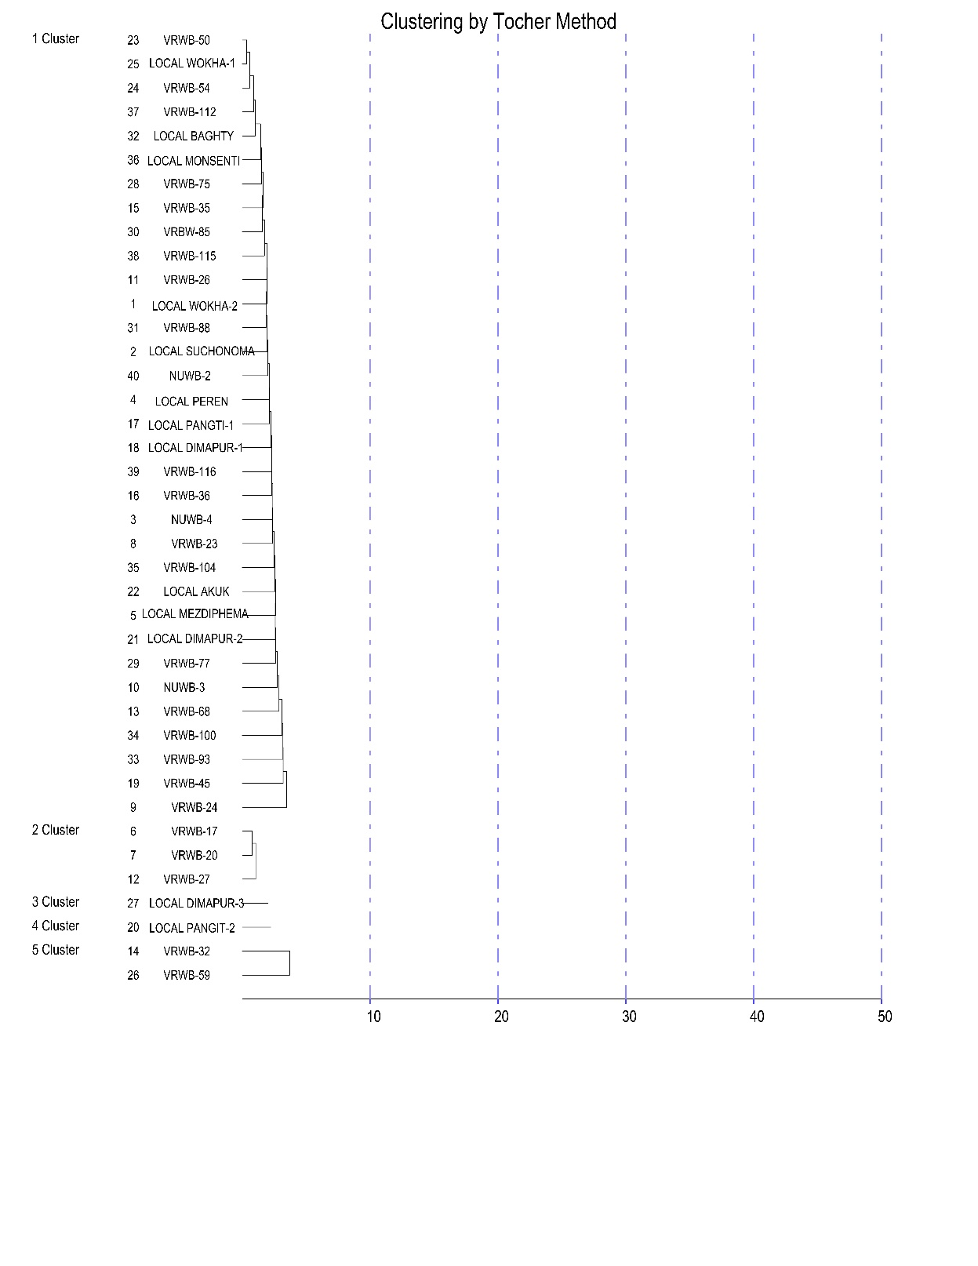

**Fig. 1. The dendrogram clustering of forty genotypes into five clusters of Winged bean**

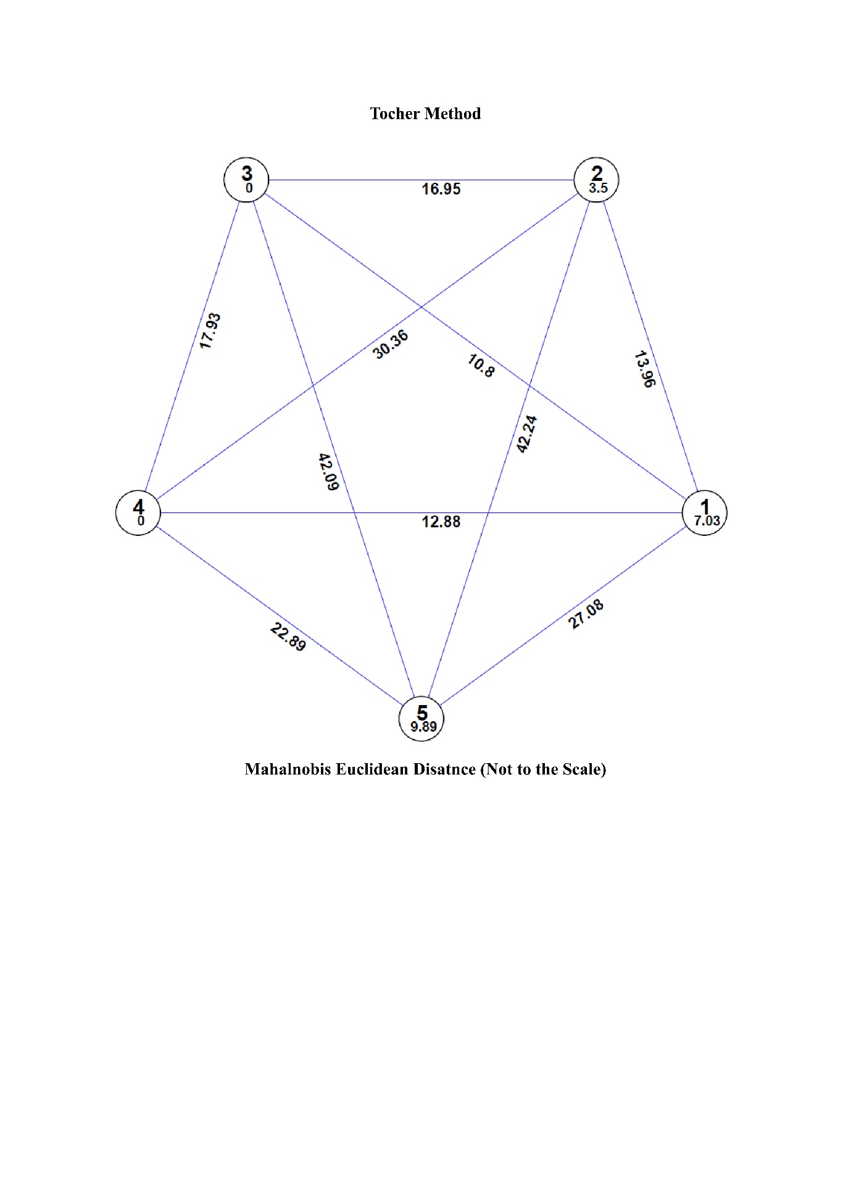

**Fig. 2. Mahalanobis Euclidian distance of clusters showing average genetic distance (D2) between and within using Tochers’ method**

**Table 4: Intra cluster means (Tocher method) for sixteen different traits in winged bean.**

|  |  |  |  |  |  |
| --- | --- | --- | --- | --- | --- |
| **Characters** | **Cluster 1** | **Cluster 2** | **Cluster 3** | **Cluster 4** | **Cluster 5** |
| Plant height(m) | 5.78 | 6.79 | 7.34 | 4.74 | 4.60 |
| Days to first flowering | 95.65 | 60.56 | 124.69 | 122.18 | 102.55 |
| Days to 50% flowering | 126.95 | 87.86 | 150.33 | 146.02 | 133.78 |
| Days to pod initiation | 100.45 | 64.04 | 128.34 | 124.96 | 107.42 |
| Days to maturity | 183.38 | 144.85 | 194.78 | 199.89 | 184.59 |
| Pod length (cm) | 16.30 | 16.28 | 22.12 | 19.39 | 14.69 |
| Pod width (cm) | 2.63 | 2.64 | 2.70 | 2.63 | 2.89 |
| Dry pod weight (g) | 4.82 | 6.00 | 7.57 | 5.35 | 5.25 |
| Tuber length (cm) | 25.24 | 17.22 | 24.92 | 22.48 | 26.82 |
| Tuber weight (g) | 39.21 | 33.58 | 25.84 | 50.11 | 103.03 |
| Tuber width (cm) | 2.44 | 2.34 | 1.96 | 4.15 | 2.20 |
| Pod yield per plant | 161.95 | 239.15 | 219.17 | 123.06 | 162.26 |
| Number of pods per plant | 32.13 | 41.28 | 28.07 | 21.12 | 31.21 |
| Number of seeds per pod | 11.46 | 12.71 | 12.77 | 12.62 | 12.60 |
| 100 Seed Weight (g) | 30.81 | 32.83 | 30.97 | 32.68 | 30.47 |
| Seed yield per plant (g) | 100.98 | 134.83 | 87.63 | 73.96 | 93.74 |

**Table 5: Percent contribution of the individual traits towards total divergence in forty winged bean genotypes**

|  |  |  |
| --- | --- | --- |
| **Source** | **Times ranked 1st** | **Contribution %** |
| Plant height (m) | 34 | 4.36% |
| Days to first flowering | 86 | 11.03% |
| Days to 50% flowering | 7 | 0.90% |
| Days to pod initiation | 0 | 0 % |
| Days to maturity | 18 | 2.31% |
| Pod length (cm) | 4 | 0.51% |
| Pod width (cm) | 1 | 0.13% |
| Dry pod weight (g) | 41 | 5.26% |
| Tuber length (cm) | 107 | 13.72% |
| Tuber weight (g) | 289 | 37.05% |
| Tuber width (cm) | 108 | 13.85% |
| Pod yield per plant | 33 | 4.23% |
| Number of pods per plants | 13 | 1.67% |
| Number of seeds per pod | 0 | 0 % |
| 100 Seed weight (g) | 7 | 0.90% |
| Seed yield per plant (g) | 32 | 4.10% |

**References**

Afridatul, S., Syukur M., Trikoesoemaningtyas, T., and Maharijaya, A. 2021. Agro-morphological traits and harvest period assessment of winged bean (Psophocarpus tetragonolobus) *genotypes of Biological Diversity*,22(2).

Asante, I.K., Offei, S.K., Addy, R., and Carson, AG. 2008). Phenotypic and Seed Protein Analysis in 31 Lima Bean (Phaseolus lunatus) Accessions in Ghana. *West Afr J Appl Ecol*, 12.

Carvalho, MA., and Quesenberry, K.H. 2009. Morphological characterization of the USA Arachis pintoi Krap. And Greg. *Collection. Plant Syst Evol*, 277(1):11

Eagleton, G. 2020. Winged bean (Psophocarpus tetragonolobus) cropping systems. *Biodiversitas Journal of Biological Diversity,* 21(12): 5927-5946.

Kortt, A.A. (1980). Isolation and properties of a chymotrypsin inhibitor from winged bean seed (Psophocarpus tetragonolobus (L) DC.). *Biochim Biophys Acta Protein Struct,* 624:237–248.

Koshy, E.P., Alex, B.K., and John, P. 2013. Clonal fidelity studies on regenerants of Psophocarpus tetragonolobus (L.) DC. Using RAPD markers. *The Bioscan*, 8(3):763–766.

Kulthe, M., Mogle, U.P., and Kashid N.G. 2013. Study of mutagenic efficiency of NMU in winged bean (Psophocarpus tetragonolobus (L) DC.). *Biosci Disc*, 4(1):121-123.

Laido, G., Mangini, G., Taranto, F., Gadaleta, A., Blanco, A., Cattivelli, L., Marone, D., Mastrangelo, A.M., Papa, R., and De Vita, P. 2013.Genetic Diversity and Population Structure of Tetraploid Wheats (Triticum turgidum L.) estimated by SSR, *DArT and pedigree Data. PLoS ONE*, 8:e67280.

Laosatit, K., Amkul, K., Chankaew, S., and Somta, P. 2022. Molecular Genetic Diversity of Winged Bean Gene Pool in Thailand Assessed by SSR Markers. *Hortic. Plant J*, 10:9–10.

Lepcha, P., Egan, A.N., Doyle, J.J., and Sathyanarayana, N. A. 2017. Review on current status and future prospects of winged bean (Psophocarpus tetragonolobus) in tropical agriculture. *Plant Foods for human nutrition*, 72:225-235.

Mohanty, C.S., Verma, S., Singh, V., Khan, S., Gaur, P., and Gupta, P., Nizar M.A., Dikshit N., Pattanayak R., Shukla A., Niranjan A., Sahu N., Behera S.K., Rana T.S. 2013. Characterization of winged bean (Psophocarpus tetragonolobus (L.) DC.) based on molecular, chemical and physiological parameters*. Am J Mol Biol*, 3:187-197.

NAS, 1981.The winged bean: a high-protein crop for the humid tropics, 2nd edn. National Academy of

Sciences, Washington, D.C.

Singh, S.K., Singh, S.J., Reemi, and Devi, N. 2013. The Winged Bean: A Vegetable Crop of Amazing Potential. *Annals of Hort,* 6(1):159-160.

Sriwichai, S., Monkham, T., Sanitchon, J., Jogloy, S., and Chankaew, S. 2021. Dual-Purpose of the Winged Bean (Psophocarpus tetragonolobus (L.) DC.), the Neglected Tropical Legume, Based on Pod and Tuber Yields. *Plants*, 10:1746.

Upadhyaya, H.D., Sharma, S., Singh, S., and Singh, M. 2011. Inheritance of drought resistance related traits in two crosses of groundnut (Arachis hypogaea L.). *Euphytica*, 177:55– 66.

Vatanparast, M., Shetty, P., Chopra, R., Doyle, J.J., Sathyanarayana, N., and Egan, A.N. 2016. Transcriptome sequencing and marker development in winged bean (Psophocarpus tetragonolobus; Leguminosae). *Scientific reports*, 6(1):29070.