**Comparative Therapeutic Efficacy of Tacrolimus and Cyclosporine in Canine Keratoconjunctivitis Sicca**

**ABSTRACT**

Cyclosporine and tacrolimus are key immunosuppressive treatments in Canine Keratoconjunctivitis Sicca (KCS). While cyclosporine is widely used, tacrolimus may be more effective in refractory cases. Comparing their therapeutic efficacy is crucial for optimizing treatment and improving canine eye health. The present study was carried out in the Department of Veterinary Medicine, College of Veterinary Science and Animal Husbandry, Nanaji Deshmukh Veterinary Science University (N.D.V.S.U.), Jabalpur, Madhya Pradesh (M.P.). for a period of 6 months. The study aimed to compare the therapeutic efficacy of topical tacrolimus (0.03%) and cyclosporine (0.2%) ointments in the management of canine keratoconjunctivitis sicca. A total of 8 dogs diagnosed with idiopathic keratoconjunctivitis sicca were randomly divided into two treatment groups of 4 dogs each and Group G3 served as the apparently healthy control. Dogs in Group G1 were treated with cyclosporine (0.2%) ointment three times daily for 30 days, while those in Group G2 received tacrolimus (0.03%) ointment twice daily for the same duration. The therapeutic response of each treatment group was evaluated on days 15 and day 30 post-treatment using the Schirmer tear test (STT-I), tear film breakup time (TFBUT) and clinical ophthalmic grading score. The clinical ophthalmic grading score was determined by assessing conjunctivitis, ocular discharge, eye irritation, corneal opacity and pigmentation. G2 group showed a significant reduction in clinical signs except corneal opacity and pigmentation while G1 group showed non-significant reduction in clinical signs on day 30 (post treatment). There was no significant difference between both groups in efficacy. However, Group G2 demonstrated a more effective increase in tear production and better control of clinical signs by day 30 as compared to Group G1.

***Keywords:*** *Tacrolimus, cyclosporine, Canine keratoconjunctivitis sicca, dogs*

1. **INTRODUCTION**

Keratoconjunctivitis sicca (KCS), or dry eye, is a long-term inflammatory eye condition in dogs, primarily caused by an autoimmune attack on the lacrimal glands, though factors like medications, congenital issues, infections and systemic diseases can also contribute. It leads to insufficient tear production, causing eye irritation, thick discharge, redness and corneal damage such as scarring, pigmentation and ulcers. Over time, compensatory changes like conjunctival thickening and epithelial damage can worsen vision impairment. Ageing, certain breeds and hormonal imbalances increase the risk. Diagnosis is based on clinical signs and tear production tests like the Schirmer tear test (John *et al*., 2018). The primary therapeutic approach for managing KCS involves promoting tear production. This is typically achieved through a combination of aqueous tear stimulants, anti-inflammatory agents, artificial tears and antibiotics. Lacrimogenic agents, particularly topical calcineurin inhibitors such as Cyclosporine and Tacrolimus, have demonstrated significant efficacy in stimulating aqueous tear production and reducing inflammation (Gilger *et al.*, 2012).

Cyclosporine A is the most commonly used lacrimostimulant in KCS. It is a neutral, hydrophobic, cyclic undecapeptide produced by the fungi *Tolypocladium inflatum* and *Beauveria nevus* (Boboridis and Konstas, 2018). Cyclosporin A restores the production of mucin in the conjunctival goblet cells, which in turn increases tear production by blocking the growth of T-helper lymphocytes and the infiltration of lacrimal gland acini (Hendrix *et al.*, 2011). Tacrolimus is a macrolide produced by *Streptomyces tsukubaensis* that is similar to Cyclosporine A. Tacrolimus has been observed to reduce the immune system response by blocking the production of inflammatory cytokines and histamine from mast cells (Mahmoudi *et al*., 2020). While cyclosporine has been the traditional first-line therapy, tacrolimus has gained attention for its potential to be more effective in refractory cases. The present study was conducted to compare the therapeutic efficacy of Tacrolimus and Cyclosporine in canine Keratoconjunctivitis sicca.

**2. MATERIALS AND METHODS**

**2.1 Location and place of work**

The proposed study was carried out for six months i.e., from August, 2023 to January, 2024 at Department of Veterinary Medicine, College of Veterinary Science and Animal Husbandry, Nanaji Deshmukh Veterinary Science University (N.D.V.S.U), Jabalpur, Madhya Pradesh (M.P.).

**2.2 Ophthalmic examinations**

In this study, eight dogs diagnosed with idiopathic KCS and presented to the Veterinary Clinical Complex underwent a comprehensive ophthalmic evaluation. The assessment included the Schirmer tear test (STT-I) using standardized strips (Visioaid, Sava Vet, Gujarat, India), with an inclusion criterion of STT-I values below 10 mm/min (Figure 1 (a)) (Maggs *et al*., 2018). Tear film breakup time (TBUT) was also measured using FLUO strips (Care Group, Gujarat, India) (Figure 1 (b)) (Maggs *et al*., 2018). The affected dogs were randomly assigned to two treatment groups (G1 and G2), each consisting of four dogs, while an additional four clinically healthy dogs served as apparently healthy control group (G3). Dogs in G1 were treated with 0.2% cyclosporine ointment three times daily for 30 days, whereas those in G2 received 0.03% tacrolimus ointment twice daily for the same period.

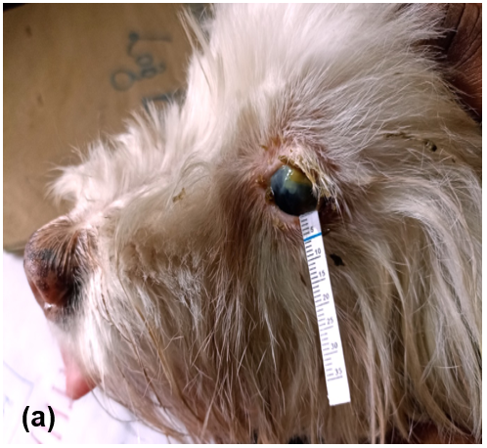 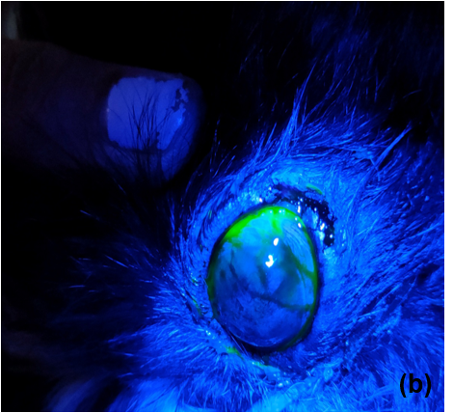

Fig. 1: (a) Schirmer tear test (STT-I) (b) Tear film breakup time (TFBUT)

**2.3 Clinical Evaluation**

Clinical evaluation was based on Schirmer tear test (STT-I), tear film breakup time (TFBUT) and clinical ophthalmic grading score on day 0 (Pre-treatment), day 15 and day 30 (post-treatment). The clinical-ophthalmic signs grading score was assigned to all dogs in the treatment group by subsequent follow-up examinations. Assessment of conjunctivitis, ocular discharge, eye irritation, corneal opacity and pigmentation was assigned a score of 0 to 3 (Silva *et al*., 2018) (Table 1).

**Table 1: Clinical- ophthalmic signs grading score**

|  |  |  |  |  |
| --- | --- | --- | --- | --- |
| **Clinical score** | **Conjunctivitis** | **Ocular discharge** | **Eye irritation** | **Corneal opacity and pigmentation** |
| 0 | None | None | None | None |
| 1 | Mild hyperaemia | Mild ocular discharge | Some eye blinking | < 25% of the surface |
| 2 | Moderate to severe | Moderate mucoid ocular discharge cornea | Frequent eye blinking and narrow palpebral opening | 25% to 50% of the surface |
| 3 | Moderate to severe hyperaemia with chemosis | Severe mucoid ocular discharge | Eye is mainly closed | > 50% of the surface |

**2.4 Statistical analysis**

The recorded data was analyzed by applying one-way ANOVA and mean comparisons within group were made by Duncan's multiple range test and between group by unpaired t-test and clinical score were assessed using Kruskal–Wallis H test, based on the least significant difference at 5 % level of significance, as per the standard procedure described bySnedecor and Cochran (1994).

**3. RESULTS AND DISCUSSION**

**Schirmer tear test:** STT-I (mm/min) was measured in all 8 dogs under therapeutic trial on day 0 (pre treatment), day 15 and day 30 (post treatment) and compared with dogs of healthy control group. The initial (STT-I) values (mm/min) measured on day 0 before treatment were 4.29 ± 1.20 in group G1 and 4.00 ± 0.56 in group G2. Statistical analysis indicated a significant reduction in STT-I values in both treatment groups compared to the healthy control group (G3), which had a mean STT-I of 17.38 ± 0.59 mm/min. Following treatment, an increase in STT-I values was observed in both G1 and G2, reaching 7.00 ± 1.34 mm/min and 7.88 ± 0.54 mm/min, respectively on day 15. By day 30, further improvement was noted, with STT-I values increased to 9.00 ± 1.70 mm/min in G1 and 10.25 ± 0.84 mm/min in G2. The results are summarised in Table 2.

The decline in STT-I (mm/min) in the study suggestive of KCS in infected dogs, this might be due chronic desiccation and inflammation leads to swelling of excretory ductules of lacrimal gland or immune mediated destruction of lacrimal gland resulting in significant drops in tear production. These findings are in agreement with Berdoulay *et al*. (2005), Best *et al*. (2014), Radziejewski and Balicki (2016), John *et al*. (2018), Voitena *et al*. (2018), Oliveira *et al*. (2019) and Silva *et al*. (2018) who reported lower STT-I (mm/min) in dogs affected with KCS and also found significant increase in mean STT-I value after treatment.

**Table 2: Mean Schirmer tear test (mm/min) in dogs of different treatment groups at different time intervals**

|  |  |  |  |
| --- | --- | --- | --- |
| **Schirmer tear test (mm/min) (Mean ± SE)** | | | |
| **Group** | **Day 0** | **Day 15** | **Day 30** |
| **G1** | 04.29Bb ± 1.20 | 07.00Abb ± 1.34 | 9.00Ab ± 1.70 |
| **G2** | 04.00Cb ± 0.56 | 07.88Bb ± 0.54 | 10.25Ab ± 0.84 |
| **G3** | 17.38Aa ± 0.59 | 17.25Aa ± 0.25 | 17.88Aa ± 0.54 |

*Means with different superscripts between groups (lowercase) and between days (uppercase) differ significantly (P ≤ 0.05)*

**Tear film breakup time (TFBUT):** TFBUT was assessed in eight dogs undergoing treatment on days 0, 15 and 30 and compared with the healthy control group. Pre-treatment mean TFBUT values (sec) in groups G1 and G2 were 8.29 ± 0.83 and 7.63 ± 1.16, respectively, which were significantly lower than the control group (G3) at 20.13 ± 0.95 sec. Following treatment, TFBUT increased to 10.14 ± 0.91 sec in G1 and 10.25 ± 1.09 sec in G2 by day 15. By day 30, further improvement was observed, with values reaching 14.14 ± 1.24 sec in G1 and 14.63 ± 0.84 sec in G2. The results are summarised in Table 3.

The decrease in TFBUT is primarily due to decreased goblet cell density caused by chronic conjunctival inflammation results in qualitative abnormalities in the tear film, such as reduced lipid or mucin components. These deficiencies lead to increased evaporation and instability of the tear film when accompanied by clinical signs. These findings match with Madruga *et al*. (2018), Ribeiro *et al*. (2008) and Nascimento *et al*. (2023) who reported decreased TFBUT in KCS affected dogs.

**Table 3: Mean Tear film breakup time (sec) in dogs of different treatment groups at different time intervals**

|  |  |  |  |
| --- | --- | --- | --- |
| **Tear film breakup time (sec) (Mean ± SE)** | | | |
| **Group** | **Day 0** | **Day 15** | **Day 30** |
| **G1** | 08.29Bb ± 0.83 | 10.14Bb ± 0.91 | 14.14Ab ± 1.24 |
| **G2** | 07.63Bb ± 1.16 | 10.25Bb ± 1.09 | 14.63Ab ± 0.84 |
| **G3** | 20.13Aa ± 0.95 | 20.00Aa ± 1.06 | 20.63Aa ± 1.26 |

*Means with different superscripts between groups (lowercase) and between days (uppercase) differ significantly (P ≤ 0.05)*

**Clinical ophthalmic signs grading score**

The therapeutic response evaluation of different treatment regimen was studied on day 15 and 30 (post treatment) on the basis of clinical-ophthalmic signs grading score conjunctivitis, ocular discharge, eye irritation, corneal opacity and pigmentation, an overall response to treatment was assessed.

In the clinical signs evaluated, G1 group showed non significant (P > 0.05) improvement in all individual clinical signs while G2 group showed significant improvement (p<0.05) in clinical signs except corneal opacity and pigmentation. The overall clinical ophthalmic score showed significant improvement in clinical signs in both treatment groups with no significant difference between them Table 4, 5 ,6 and 7.

In view of the above study, it is concluded that Cyclosporine is an immune-modulating medication that interferes with the activation of certain T cells. It binds with cyclophilin to form a complex that inhibits calcineurin, a phosphatase essential for activating the NF-AT (Nuclear Factor of Activated T-cells) transcription factor. This blockage prevents the transcription of interleukin-2 (IL-2) and other cytokines, reducing inflammation and boosting tear production. The present study was similar to the findings of Morgan and Abrams (1991), Olivero *et al*. (1991), Hendrix *et al*. (2011), John *et al*. (2018), Voitena *et al*. (2018) and Radziejewski and Balicki (2016), who reported non significant clinical improvement with Cyclosporine within one month of treatment. In contrast, Ofri *et al*. (2009) observed significant results after two weeks of treatment with 0.2% Cyclosporine when administered three times a day.

Tacrolimus is a macrolide antibiotic and topical calcineurin inhibitor that suppresses the transcription of pro-inflammatory cytokine genes by targeting the T-cell activation process. It has a pharmacological profile similar to Cyclosporine but is considered more potent, achieving comparable or superior results at lower concentrations. The present study was similar to the findings of Berdoulay *et al*. (2005), Radziejewski and Balicki (2016), John *et al*. (2018), Silva *et al*. (2018), Voitena *et al*. (2018), Oliveira *et al*. (2019) and Estanho *et al*. (2023) who reported significant clinical improvement with Tacrolimus by the end of one month of treatment. However, in contrast, Hendrix *et al*. (2011) reported non-significant clinical improvement after 12 weeks of treatments with 0.03% Tacrolimus. A significant clinical improvement in corneal pigmentation was not observed, even treated with Tacrolimus, in which amelioration of conjunctivitis, ocular discharge and eye irritation was seen. This may be explained by the short duration of the treatment (only 30 days).

Within each group, the decrease in overall clinical ophthalmic grading scores over time was statistically significant indicating substantial improvement in ophthalmic parameters. Both treatments i.e., Cyclosporine and Tacrolimus were effective, but notably a more pronounced therapeutic response was observed in G2 (Tacrolimus) by the end of study.

The results of this small, short term study support that tacrolimus and cyclosporine are potentially successful in increasing tear production and improvement in clinical signs, but notably a more pronounced therapeutic response was observed in G2 (Tacrolimus) by the end of study.

**Table 4: Mean conjunctivitis score in dogs of different treatment groups at different time intervals**

|  |  |  |  |  |  |
| --- | --- | --- | --- | --- | --- |
| **Conjunctivitis score (Mean ± SE)** | | | | | |
| **Group** | **Day 0** | **Day 15** | **Day 30** | **K value** | ***P* value** |
| G1 | 1.75 ± 0.25 | 1.50 ± 0.50 | 0.75 ± 0.25 | 4.263 | 1.119NS |
| G2 | 2.00 ± 0.40 | 1.50 ± 0.50 | 0.50 ± 0.28 | 4.988 | 0.050* |
| **K value** | 0.250 | 0.000 | 0.467 |  | |
| ***P* value** | 0.617NS | 1.000NS | 0.490NS |

*\*Significant (P ≤ 0.05), NS- Non significant*

**Table 5: Mean discharge score in dogs of different treatment groups at different time intervals**

|  |  |  |  |  |  |
| --- | --- | --- | --- | --- | --- |
| **Ocular discharge score (Mean±SE)** | | | | | |
| **Group** | **Day 0** | **Day 15** | **Day 30** | **K value** | ***P* value** |
| G1 | 2.00 ± 0.40 | 1.75 ± 0.62 | 1.00 ± 0.40 | 2.359 | 0.320NS |
| G2 | 2.00 ± 0.00 | 1.50 ± 0.28 | 0.50 ± 0.28 | 7.883 | 0.019* |
| **K value** | 0.000 | 0.384 | 0.900 |  | |
| ***P* value** | 1.000NS | 0.500NS | 0.300NS |

\**Significant (P ≤ 0.05), NS- Non significant*

**Table 6: Mean eye irritation score in dogs of different treatment groups at different time intervals**

|  |  |  |  |  |  |
| --- | --- | --- | --- | --- | --- |
| **Eye irritation score (Mean±SE)** | | | | | |
| **Group** | **Day 0** | **Day 15** | **Day 30** | **K value** | ***P* value** |
| G1 | 1.50 ± 0.28 | 1.00 ± 0.57 | 0.50 ± 0.28 | 2.750 | 0.253NS |
| G2 | 1.75 ± 0.25 | 1.25 ± 0.25 | 0.50 ± 0.28 | 6.096 | 0.047* |
| **K value** | 0.467 | 0.093 | 0.000 |  | |
| ***P* value** | 0495NS | 0.760NS | 1.000NS |

*\*Significant (P ≤ 0.05), NS- Non significant*

**Table 7: Mean corneal opacity and pigmentation score in dogs of different treatment groups at different time intervals**

|  |  |  |  |  |  |
| --- | --- | --- | --- | --- | --- |
| **Corneal opacity and pigmentation score (Mean±SE)** | | | | | |
| **Group** | **Day 0** | **Day 15** | **Day 30** | **K value** | ***P* value** |
| G1 | 2.00 ± 0.00 | 1.75 ± 0.25 | 1.50± 0.28 | 1.130 | 0.560NS |
| G2 | 2.25 ± 0.50 | 1.75± 0.25 | 1.25 ± 0.47 | 3.544 | 0.170NS |
| **K value** | 0.250 | 0.000 | 1.000 |  | |
| ***P* value** | 0.610NS | 1.000NS | 0.750NS |

\**Significant (P ≤ 0.05), NS- Non significant*

**Table 8: Mean combined clinical-ophthalmic score in the dogs of different treatment groups at different time intervals**

|  |  |  |  |  |  |
| --- | --- | --- | --- | --- | --- |
| **Overall clinical ophthalmic grading score (Mean ± SE)** | | | | | |
| **Groups** | **Pre treatment** | **Post treatment** | | **K value** | ***P* value** |
| **Day 0** | **Day 15** | **Day 30** |
| G1 | 7.25 ± 0.62 | 6.00 ± 0.40 | 3.75 ± 0.47 | 8.280 | 0.016* |
| G2 | 8.00 ± 0.40 | 6.00 ± 0.70 | 2.75 ± 1.50 | 8.935 | 0.010* |
| **K value** | 1.099 | 0.092 | 0.797 |  | |
| ***P* value** | 0.290NS | 0.760NS | 0.372NS |

\**Significant (P ≤ 0.05), NS- Non significant*

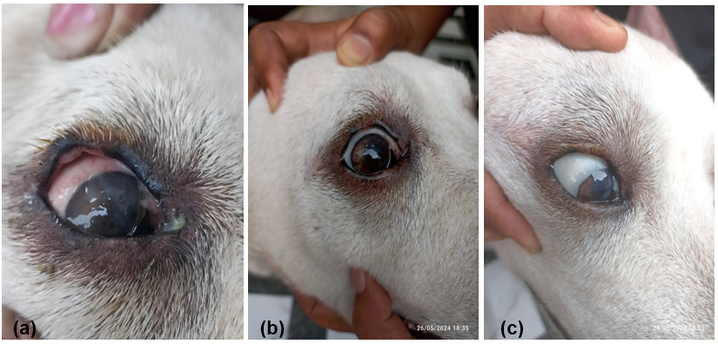

**Fig 2: KCS in Labrador Retriever dog treated with Cyclosporine**

**(a) Day 0 pre treatment (b) Day 15 post treatment (c) Day 30 post treatment**

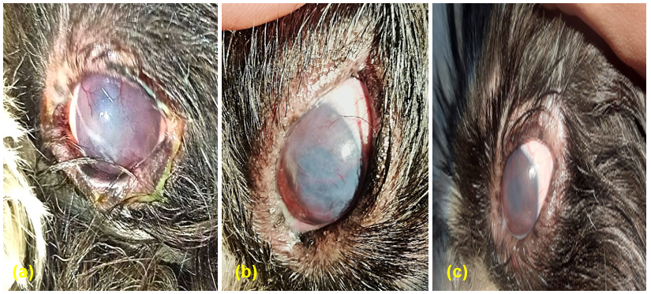

**Fig 3: KCS in Lhasa Apso dog treated with Tacrolimus**

**(a) Day 0 pre treatmen (b) Day 15 post treatment (c) Day 30 post treatment**

**4. CONCLUSION**

Mean Schirmer tear test (STT-I) and mean tear film breakup time (TFBUT) findings revealed a significantly lower mean value on day 0 (pre-treatment). However, the mean value increased significantly in both groups on day 30 (post-treatment). The therapeutic response evaluation on the basis of overall clinical ophthalmic signs grading score revealed that treatment with Tacrolimus (0.03%) showed better results in comparison to Cyclosporine (0.2%) on day 30 in Keratoconjunctivitis sicca in dogs. Future research can focus on optimizing dosing strategies, combination therapies and long-term efficacy of tacrolimus and cyclosporine in canine KCS.

**7. REFERENCES**

Berdoulay, A., English, R.V. and Nadelstein, B. (2005). Effect of topical 0.02% tacrolimus aqueous suspension on tear production in dogs with keratoconjunctivitis sicca. *Veterinary Ophthalmology*, **8**(4): 225-232.

Best, L.J., Hendrix, D.V. and Ward, D.A. (2014). Diagnosis and treatment of keratoconjunctivitis sicca in dogs. *Today’s Veterinary Practice*, **4** (4): 16-22.

Boboridis, K.G. and Konstas, A.G. (2018). Evaluating the novel application of cyclosporine 0.1% in ocular surface disease. *Expert Opinion on Pharmacotherapy*, **19**(9): 1027-1039.

Estanho, G.J.G., Passareli, J.V.G.C., da Silva Pando, L., Vieira, D.E., Nai, G.A., Santarem, C. L. and Andrade, S.F. (2023). Comparison of topical 0.03% tacrolimus and homologous injectable platelet-rich plasma in the treatment of keratoconjunctivitis sicca in dogs. *Veterinary World*, **16**(1): 134-143.

Gilger, B.C., Wilkie, D.A., Salmon, J.H. and Peel, M.R. (2012). A topical aqueous calcineurin inhibitor for the treatment of naturally occurring keratoconjunctivitis sicca in dogs. *Veterinary Ophthalmology*, **16**(3): 192-197.

Hendrix, D.V., Adkins, E.A., Ward, D.A., Stuffle, J. and Skorobohach, B. (2011). An investigation comparing the efficacy of topical ocular application of tacrolimus and cyclosporine in dogs. *Veterinary Medicine International*, **2011**(1): 1-5.

John, C., Gopinathan, A., Singh, K., Sharma, P., Sowbharenya, C. and Sarangom, S.B. (2018). Clinical evaluation of topical tacrolimus ointment usage in different stages of keratoconjunctivitis sicca in dogs. *Turkish Journal of Veterinary and Animal Sciences*, **42**(4): 259-268.

Madruga, G.M., Ribeiro, A.P., Magalhaes, T.B.S., Rondelli, L.A.S. and Furlan, F.H. (2018). Effect of 0.15% sodium hyaluronate and 0.5% carboxymethylcellulose on tear film breakup time in healthy dogs and in dogs with keratoconjunctivitis sicca. *Brazilian Archive of Veterinary Medicine and Zootechnics*, **70**(5): 1388-1396.

Maggs, D.J., Miller, P.E. and Orfi, R. (2018). Slatter's Fundamental of Veterinary Ophthalmology, 6th Edn., Elsevier Health Science, St. Louis, Missouri, pp 18-47.

Mahmoudi, A., Malaekeh-Nikouei, B., Hanafi-Bojd, M.Y., Toloei, M., Hosseini, M. and Nikandish, M. (2020). Preliminary in vivo safety evaluation of a tacrolimus eye drop formulation using hydroxypropyl beta cyclodextrin after ocular administration in NZW rabbits. *Clinical Ophthalmology*, **14**: 947-953.

Morgan, R.V. and Abrams, K.L. (1991). Topical administration of cyclosporine for treatment of keratoconjunctivitis sicca in dogs. *Journal of the American Veterinary Medical Association*, **199**(8): 1043-1046.

Nascimento, F.F., Passareli, J.V.G.C., Zulim, L.F.D.C., Silva, D.A., Giuffrida, R., Estanho, G. J.G. Villa M.C. and Andrade, S.F. (2023). Comparison between the strip meniscometry test, the schirmer tear test and tear film breakup time in normal dogs and dogs with dry eye. *Brazilian Ophthalmology Archives*,**86**(4): 314-321.

Ofri, R., Lambrou, G.N., Allgoewer, I., Graenitz, U., Pena, T.M., Spiess, B.M. and Latour, E. (2009). Clinical evaluation of pimecrolimus eye drops for treatment of canine keratoconjunctivitis sicca: a comparison with cyclosporine A. *The Veterinary Journal*, **179**(1): 70-77.

Oliveira, J.K., Williams, D.L., Bollmann, C., Seabra, N.M., Bortolini, M. and Montiani‐Ferreira, F. (2019). Comparative efficacy of topical oclacitinib 0.1% and tacrolimus 0.01% in canine keratoconjunctivitis sicca. *Veterinary Ophthalmology*, **22**(5): 633-643.

Olivero, D.K., Davidson, M.G., English, R.V., Nasisse, M.P., Jamieson, V.E. and Gerig, T.M. (1991). Clinical evaluation of 1% cyclosporine for topical treatment of keratoconjunctivitis sicca in dogs. *Journal of the American Veterinary Medical Association*, **199**(8): 1039-1042.

Radziejewski, K. and Balicki, I. (2016). Comparative clinical evaluation of tacrolimus and cyclosporine eye drops for the treatment of canine keratoconjunctivitis sicca. *Acta Veterinaria Hungarica*, **64**(3): 313-329.

Ribeiro, A.P., Brito, F.L.D.C., Martins, B.D.C., Mamede, F. and Laus, J.L. (2008). Qualitative and quantitative tear film abnormalities in dogs. *Ciencia Rural*, **38**(2), 568-575.

Silva, D.A., Nai, G.A., Giuffrida, R., Sgrignoli, M.R., Santos, D.R.D., Donadao, I.V. and Andrade, S.F. (2018). Oral omega 3 in different proportions of EPA, DHA, and antioxidants as adjuvant in treatment of keratoconjunctivitis sicca in dogs*. Brazilian Archives of Ophthalmology*, **81**(5): 421-428.

Snedecor GW, Cochran WG. Statistical Methods. 8th Edn IOWA State University Press. Ames, Iowa, USA. 1994.

Voitena, J.N., Cunha, O., Fukushima, F.B., Carvalho, G.F., Ramos, L.C.S., Henriques, V.C. and Costa, D.M.B. (2018). Efficacy of cyclosporine and tacrolimus drops in the treatment of keratoconjunctivitis sicca in dogs. *Brazilian Archive of Veterinary Medicine and Zootechnics*, **70**(3): 699-703.