**Survey for the Prevalence of Fusarium Wilt of Chickpea in Prakasam District of Andhra Pradesh, India**

**ABSTRACT:** A roving survey was conducted during *rabi* 2018-19 in six predominantly chickpea growing mandals of Prakasam district, A.P with an aim to observe the incidence of *Fusarium oxysporum* f.sp. *ciceri* (*Foc*)and to forecast/ forewarm the farmers regarding measures to be taken to offset its damage. When the data was collected from 24 fields running across 12 villages in six mandals of Prakasam district, average wilt incidence was found to be 94.25 per cent. Among the villages, villages from Ponnaluru, Komarolu and Cumbum had maximum 100 per cent disease incidence. Least incidence of 74.5 per cent was observed in Ongole mandal. In Ongole mandal, Throvagunta village had 89.14 per cent while Yarajarla village had 59.88 per cent wilt incidence.

**Key Words:** Chickpea, *Foc*, survey, wilt incidence, Andhra Pradesh

**INTRODUCTION:**

Chickpea (*Cicer arietinum* L.) is the oldest and third most important premier *Rabi* season pulse crop in the world after dry beans and peas. It is especially grown in dry areas in the Indian subcontinent (Saxena, 1990) which accounts for 90% of the total world chickpea production (Juan *et al*., 2000). The main producers of chickpea were India, Australia and Pakistan which account for about 67.32 %, 6.19 % and 5.72 % respectively, to global production (Jendoubi *et al.*, 2017). Both biotic and abiotic constraints lead to the reduction of yields in chickpea.

The crop is infected by 172 pathogens (67 fungi, 3 bacterial, 22 viruses and mycoplasma and 80 nematodes) reported from 55 countries. Major fungal diseases throughout the world include Fusarium wilt (*Fusarium oxyporum* f. sp. *ciceri*), collar rot (*Sclerotium* *rolfsii*), dry root rot (*Rhizoctonia bataticola*), Ascochyta blight (*Ascochyta rabei*) and Botrytis gray mold (*Botrytis cineria*) (Nene and Sheila, 1999). Chickpea wilt caused by soil borne *Fusarium oxysporum* f. sp. *ciceri* [(Padwick) Snyd and Hans.] (*Foc*) is most prevalent in India (McKerral, 1923) and is also important throughout the world (Woltz and Jones, 1981; Gupta *et al.,* 1997). Fusarium wilt incidence varied from 14 to 32 % in different states of India as reported by Dubey *et  al.* (2010). Depending on agro climatic conditions and varietal susceptibility yield losses were reported ranging from 10% to 100% (Warda *et al*., 2017). As it is a facultative saprophyte, it can be either soil or seed borne and it can survive in the seed and dead plant material in the form of chlamydospores (Singh, 2003). Considering the nature of damage and losses caused by wilt disease of chickpea, the present study was undertaken to study the status of chickpea wilt in Prakasam district of Andhra Pradesh.

**MATERIALS AND METHODS :**

A roving survey was conducted during *rabi* 2018-19 to assess the disease incidence of Fusarium wilt in six predominantly chickpea growing mandals of Prakasam district of Andhra Pradesh *viz.,* Ongole, Maddipadu, Ponnaluru, Komarolu, Cumbum and Parchuru (Fig. 1). In every mandal, two villages and in each village, two fields were surveyed at random. One isolate of *Foc* was obtained from the diseased samples of College Farm, Agricultural College, Bapatla. In each field, disease incidence was recorded in five square meters, one each from four corners (excluding the border rows) and one from the centre.

Based on the number of healthy and wilted plants per square meter, disease incidence was calculated from the following formula (Mayee and Datar 1986).

Number of wilted plants

Wilt incidence (%) = ----------------------------- x 100

Total number of plants

The wilt affected plants collected during the survey were brought to the laboratory in brown paper cover and were used for pathogen isolation.

**RESULTS AND DISCUSSION:**

When the data was collected from 24 fields running across 12 villages in six mandals of Prakasam district, average wilt incidence was found to be 94.25 per cent. Maximum incidence (in terms of symptoms, whether completely wilted or not), 100 per cent wilt incidence was recorded in three of the six surveyed mandals. Among the villages, villages from Ponnaluru, Komarolu and Cumbum had 100 per cent disease incidence. In Parchur mandal, Adusumilli village had 97.37 per cent disease incidence while Parchur village had 92.38 per cent. Maddipadu mandal had an average wilt incidence of 96.10 per cent with village means of 96.08 per cent in Gundlapalli village and 96.14 per cent in Vellampalli village (Table 1 and Fig. 2). It is interesting to note that though *Foc* symptoms are seen at several of the surveyed villages, 100% mortality was not seen prior to maturity of the crop resulting in harvesting comfortable yields as on date.

Least incidence of 74.5 per cent was observed in Ongole mandal. In Ongole mandal, Throvagunta village had 89.14 per cent while Yarajarla village had 59.88 per cent wilt incidence. Though comparatively low in average PDI, it is also considered serious as except in the village Yarajarla 1 (32.22%), in all other villages of the Ongole mandal, the incidence was more than 85.00 per cent (Table 1 and Fig. 2). In the College Farm, the incidence was 38.9 per cent indicating that the incidence was low probably due to low inoculum potential associated with regular crop rotation. The above data indicated that inoculum potential in the surveyed mandals of Prakasam district was very high, though during the year of survey complete wilting was not observed.

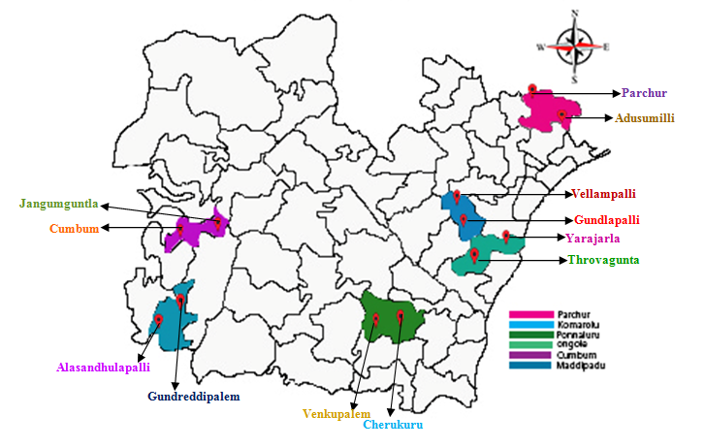

**Fig. 1: Geographical distribution of surveyed villages in Prakasam district of A.P.**

**Table 1: Prevalence of chickpea Fusarium wilt in Prakasam district of Andhra Pradesh**

**during *rabi* 2018-19**

| **District** | **Mandal** | **Village** | ***Fusarium* Isolates designation** | **Disease incidence (%)** | **Village mean (%)** | **Mandal mean (%)** | **District mean (%)** |
| --- | --- | --- | --- | --- | --- | --- | --- |
| Prakasam | Ongole | Throvagunta 1 | F 19002 | 88.00 | 89.14 | 74.50 | 94.25 |
| Throvagunta 2 | F 19003 | 90.28 |
| Yarajarla 1 | F 19004 | 32.22 | 59.88 |
| Yarajarla 2 | F 19005 | 87.53 |
| Maddipadu | Gundlapalli 1 | F 19006 | 93.36 | 96.08 | 96.10 |
| Gundlapalli 2 | F 19007 | 98.79 |
| Vellampalli 1 | F 19008 | 92.27 | 96.14 |
| Vellampalli 2 | F 19009 | 100 |
| Ponnaluru | Cherukuru 1 | F 19010 | 100 | 100 | 100 |
| Cherukuru 2 | F 19011 | 100 |
| Venkupalem 1 | F 19012 | 100 | 100 |
| Venkupalem 2 | F 19013 | 100 |
| Komarolu | Gundreddipalem 1 | F 19014 | 100 | 100 | 100 |
| Gundreddipalem 2 | F 19015 | 100 |
| Alasandhulapalli 1 | F 19016 | 100 | 100 |
| Alasandhulapalli 2 | F 19017 | 100 |
| Cumbum | Cumbum 1 | F 19018 | 100 | 100 | 100 |
| Cumbum 2 | F 19019 | 100 |
| Jangumguntla 1 | F 19020 | 100 | 100 |
| Jangumguntla 2 | F 19021 | 100 |
| Parchur | Parchur 1 | F 19022 | 84.75 | 92.38 | 94.87 |
| Parchur 2 | F 19023 | 100 |
| Adusumilli 1 | F 19024 | 94.73 | 97.37 |
| Adusumilli 2 | F 19025 | 100 |
| Guntur | Bapatla | Bapatla | F 19001 | 38.9 | 38.9 | 38.9 | 38.9 |

* Observations at 40-50 DAS

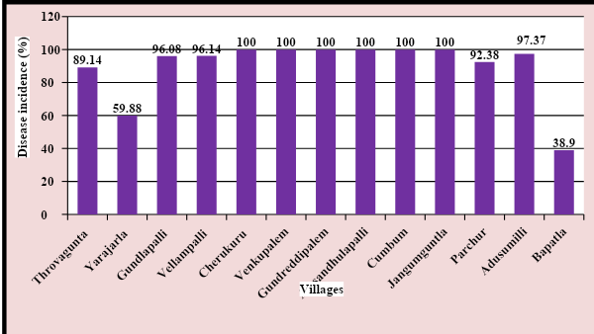

**Fig. 2: Prevalence of Chickpea Fusarium wilt in Prakasam district of Andhra Pradesh during *rabi* 2018-19.**

These results obtained in the present study on survey of chickpea wilt caused by *Fusarium oxysporum* f. sp. *ciceri* are similar to those reported earlier by several workers on chickpea. Survey conducted during *Rabi* 2011-12 in Kurnool, Kadapa and Ananthapur districts of A.P revealed that the chickpea wilt incidence ranged from 10 to 15 per cent (Annual Project report, RARS, Nandyal). Thaware *et al.* (2015) surveyed chickpea Fusarium wilt disease in Marathwada region of Maharashtra state during *Rabi* 2013-14 and 2014-15 and found that the incidence was high in *Rabi* 2013-14 compared to 2014-15. In all the eight districts surveyed, the disease was found to be widely distributed and regular occurrence with moderate to severe incidence and its average incidence was maximum in the district of Parbhani (15.73%) followed by Nanded (15.63%) and Hingoli (14.93%) districts. Patra *et al.* (2017) noticed prevalence of Fusarium wilt of chickpea in the agro-ecological conditions of undulating red and lateritic zone of West Bengal during 2014-15 and 2015-16 with a mean disease incidence ranging from 13.90 to 27.76 per cent. Murali *et al.* (2018) studied prevalence of chickpea wilt in Tamil Nadu and found that the incidence varied from 34.00 to 57.33 per cent. Venkata Ramanamma *et al.* (2020) conducted a survey in 30 mandals of A.P during *Rabi* 2014-15 found that lower mean wilt incidence of 2.0% in Kondapuram, Nellore district and Ongole, Prakasam district and higher mean wilt incidence of 9.7% in Atmakur (Kurnool dist.) and Vajrakarur (Anantapuramu dist.). Shrivastava and Mahajan, 2021 conducted a survey among 180 chickpea fields from 60 locations in 10 tehsils under Vidisha district, M.P during *Rabi* 2018-19 and 2019-20. The mean disease incidence was maximum in Gyaraspur tehsil (17.87%), followed by Tyonda (17.20 %) and variety wise more wilt incidence was on local cultivar (21.30 %) followed by JG 315 (16.35 %) and JG 74 (15.40 %), minimum wilt incidence on JG 12 (15.05%), JG 130 (12.22%) and JG 63 (10.12%).

**CONCLUSION:**

The study revealed a maximum incidence (in terms of symptoms, whether completely wilted or not), 100 per cent wilt incidence was recorded in three (Ponnaluru, Komarolu and Cumbum) of the six surveyed mandals. Least incidence of 74.5% was observed in Ongole mandal, though comparatively low, but is also considered serious as except in the village Yarajarla 1 (32.22%), in all other villages of the same mandal the incidence was more than 85.00%. Thus, the present study indicated a precarious situation of Prakasam district where in if appropriate measures such as growing resistant varieties, and other management practices such as biocontrol agents, biorationals *etc.* are not taken up, in the years to come losses will increase drastically.

**FUTURE SCOPE:**

A similar study can be undertaken to assess the prevalence of chickpea wilt in various districts of Andhra Pradesh, aiming to identify the incidence of the disease. Such research would aid in minimizing agricultural losses and boosting productivity, thereby contributing to sustainable farming practices in the region.

**REFERENCES:**

Annual Project report. (2012). Regional Agricultural Research Station, Nandyal.

Dubey, S.C., Singh, S.R & Singh, B. (2010). Morphological and pathogenic variability of Indian isolates of *Fusarium oxysporum* f. sp. *ciceris* causing chickpea wilt. *Archives of Phytopathology and Plant Protection,* 43:174–190.

Gupta, S.K., Upadhyay, J.P & Ojha, K.H. (1997). Effect of fungicidal seed treatment on the incidence of chickpea wilt complex. *Annals of Plant Protection Sciences*. 5: 184-187.

Jendoubi, W., Bouhadida, M., Amal, B & Mohamed, M.B.K. (2017). Fusarium wilt affecting chickpea crop. *Agriculture.* 7 (23): 1-16.

Juan, A., Cortes, N.J.A., Bernard, H & Diaz, J.M. (2000).Yield loss in chickpeas in relation to development of Fusarium wilt epidemics. *Phytopathology.* 90: 1269–1278.

Mayee, C. D., & Datar, V. V. (1986). *Phytopathometry*. Marathwada Agricultural University, Parbhani. 146pp.

Mckerral, A. (1923). A note on Fusarium wilt of gram in Burma and measures taken to combat it. *Agricultural Journal of India*. 28: 608-613.

Murali, P.S.S., Vanitha1, A., Kamalakannan1, P., Raju A & Jeyakumar, P. (2018). Prevalence of *Fusarium oxysporum* f. sp. *ciceris* Causing Wilt in Chickpea and Its Pathogenic, Cultural and Morphological Characterization. *International Journal of Current Microbiology and Applied Sciences.* 7 (2): 1301-1313.

Nene, Y.L & Sheila, V.K. (1999). ICRISAT Newsletter. In proceedings *on International workshop on chickpea improvement.* Feb-March. 172-180.

Patra, S., Biswas, M.K & Mahato, A. (2017). Prevalence of Fusarium Wilt of Chickpea in the Agro-ecological condition of Undulating Red and Lateritic zone of West Bengal, India. *International Journal of Current Microbiology and Applied Sciences*. 6 (11): 2456-2462.

Saxena, M.C. (1990). Problems and potential of chickpea production in nineties. In *Proceedings of the second international workshop on chickpea improvement*, 4–8 December 1989, ICRISAT Center, Patancheru, India, 125-132pp.

Shrivastava, A. & Mahajan, K.C. (2021). Survey of Chickpea Wilt caused by *Fusarium* *oxysporum* f. sp. *ciceri* in Vidisha District of Madhya Pradesh. *Biological Forum – An International Journal.* 13 (3a): 84-88.

Singh, S.D. (2003). *Soil borne diseases of chickpea*. ICRISAT, Patancheru.

Thaware, D.S., Kohire, O.D & Gholve, V.M. (2015). Survey of chickpea wilt (*Fusarium oxysporum* f.sp. *ciceri)* disease in Marathwada region of Maharashtra state. *Advance Research Journal of Crop Improvement*. 6 (2): 134-138.

Venkata Ramanamma, K, Bhaskara Reddy, B.V., Sarada Jayalakshmi R. & Jayalakshmi, V. (2020). Survey for chickpea Fusarium wilt in Andhra Pradesh. *Journal of Research ANGRAU.*48 (2):1-6.

Warda, J., Mariem, B., Amal, B., Mohamed, B & Mohamed, K. (2017). A review on Fusarium wilt affecting chickpea crop. *Agriculture*. 7 (23): 1-16.

Woltz, S.S & Jones, J.P. (1981). Requirements of *Fusarium oxysporum*: basis for a disease control system*.* P.E. Nelson, T.A. Toussoun and Cook, R.J. (eds.). *Fusarium Disease, Biology and Taxonomy.* Pennsylvania State University Press, USA. 340–349.