QUALITY ASSESSMENT AND EVALUATION IN TRADITIONAL
LANDRACES OF RICE (Oryza sativa)

ABSTRACT
Rice (Oryza sativa L.) is a staple food crop, particularly in India, where consumer preferences for cooking quality traits have been central and are gaining further importance due to changing lifestyles and market demands. The demand for high-quality rice is growing, driven by consumer preferences for specific cooking attributes such as texture, grain elongation, and tenderness. However, there is limited research on the cooking qualities of traditional rice landraces, which are known for their genetic diversity and adaptability. This study aimed to evaluate 13 traditional rice landraces viz., Anaikomban, Bhavani, Karuthakkar, Bommi, Kaivara samba, Vadan samba, Kudavazhai samba, Sembalai, Valaguru, Kuzhiadichan, Kallundai, Sigappu Anai komban and Vaalan, assessing the variability for grain physiological and cooking quality characters. Variability studies were carried out to study the extent of variability for different physiological and cooking quality characters viz., grain length, grain breadth, grain L/B ratio, grain length before cooking, grain length after cooking, grain breadth before cooking, grain breadth after cooking, grain L/B ratio before and after cooking, linear elongation ratio, cooking time, alkali spreading value, water uptake and water absorption by weight. The analysis of variance revealed significant differences among the landraces for all the characters studied except alkali spreading value, water absorption by weight and water uptake. High GCV and PCV were recorded for traits like 100 grain weight, L/B ratio before cooking, L/B ratio after cooking and alkali spreading value. Moderate GCV and PCV recorded for traits viz., cooking time, grain elongation ratio, length before cooking, length after cooking, grain breadth before cooking and grain breadth after cooking. It indicates the availability of abundant variability present in rice landraces. Low GCV and PCV were recorded for traits like hulling percentage, water uptake. High heritability and high genetic advance as percent of mean were observed for the characters viz., Alkali spreading value, water absorption by weight, L/B ratio before cooking, L/B ratio after cooking, breadth after cooking and length after cooking, length before cooking, breadth before cooking, water uptake. Moderate heritability and moderate genetic advance as per cent of mean were observed for the characters viz., hulling percentage and 100 grain weight. Hence selection of these characters useful for quality improvement.
Key words: Quality, Landraces, Variability, heritability and genetic advance
Introduction
Rice (Oryza sativa) is a key staple food crop that provides food for around 60% of the World’s population as it is produced seasonally and consumed annually. Rice cultivation in India Extends from 8º to 35º N latitude and from sea level to as high as 3000 meters mean sea level. Rice crop need a hot and humid climate. It is best suited to regions which have high humidity, prolonged sunshine and an assured supply of water. In India, Rice covers an area of about 46.5 million hectares with production 135.5 to 138 million metric tons and productivity of 2.85 tonnes/ha. In Tamilnadu, Area under rice cultivation is about 22.05 lakh hectare with production of 7.85 million metric tonnes and productivity of 2.74 t/ha. In Tamilnadu, the grain type preferred by the consumers is Medium slender.
Grain production development has been the primary goal of plant breeders for several decades, but demand for high-quality rice has increased in recent years as people’s living standards have gradually improved (Rathi et al., 2010). As a result, improving rice grain quality attributes has become a major issue in rice breeding programs in order to suit consumer preferences and market demand. Both domestic and international markets depend greatly on rice quality (Unnevehr et al., 1992). Rice variations with good milling parameters, good appearance quality, good cooking and eating parameters can be termed as better grain quality rice varieties, increasing rice’s entire economic worth.
Quality is defined as the product’s acceptability or compatibility for a particular end use. The physical, physiological and biochemical aspects of grains make up their grain quality attributes (Sattari et al., 2015). The physical and material characteristics of a rice grain can be described by its quality, which may be inherited or acquired. Size, shape, uniformity and general appearance are examples of physical quality characteristics (Cruz and Khush, 2006; Sellappan et al., 2009); kernel shape and L/B ratio are significant characteristics when evaluating grain quality (Rita and Sarawgi, 2008). Another group of characteristics that are directly related to cooking and eating quality are the amylose content (Ward et al., 2006), gelatinization temperature (gel consistency and cooked rice texture (Meullenet et al.,2000).
Materials and Methods:
The present investigation was carried out in the Department of Plant Breeding and Genetics, Adhiparasakthi Agricultural College, Kalavai during June to September 2024. The seed materials of Rice landraces used in the present study were collected from farmer’s field during RAWE programme (table 1). The experimental material comprised of thirteen land races . The details of the Landraces are furnished in Table 1 and fig 1. The experimental material consisted of 13 indigenous landraces of rice (Oryza sativa L.) carried out during Kharif, 2024 in a Completely Randomized Block Design with two replications for physiological and cooking quality traits.
Observations on grain characteristics viz., kernel length, kernel breadth, kernel L/B ratio were recorded from 10 randomly selected kernels. Required quantities (100 g) of harvested seeds were used to record the hulling percentage, which were properly cleaned before starting the experiment. Hulling percentage was computed as below.
Weight of rough rice
Hulling percentage = ------------------------------------ x 100
Weight of brown rice
The brown rice obtained after dehulling was passed through Satake Grain Testing Mill (Type – TM 05) for 45 seconds to obtain uniformly 7-8 per cent polish. The weight of polished rice was recorded. Milling percentage was calculated as below
Weight of rough rice
Milling percentage = ----------------------------- x 100
Weight of milled rice

The milled samples were sieved to separate whole kernels from the broken ones. Full rice and three-fourth kernels were taken as whole milled rice for computation. Head rice recovery (HRR) was calculated in percentage as below.
Weight of rough rice
Head rice recovery = -------------------------- x100
Weight of whole milled rice

The polished rice samples were analysed after three months of ageing for the six quality traits viz., kernel length after cooking, kernel breadth after cooking, linear elongation ratio, breadth wise expansion ratio, water uptake and volume expansion ratio by recording observations from 10 randomly selected kernels in the laborator (Murthy and Govindaswamy, 1967). Alkali spreading value was calculated following the method suggested by Little et al. (1958). Analysis of variance was carried out as suggested by Panse and Sukhatme (1967), GCV and PCV were carried out as per the methods suggested by Burton (1952). Heritability (BS) and Genetic Advance were estimated by using the formula suggested by Allard (1960) and Johnson et al. (1955) respectively.
Fig 1. Collection of 13 landraces used in this study
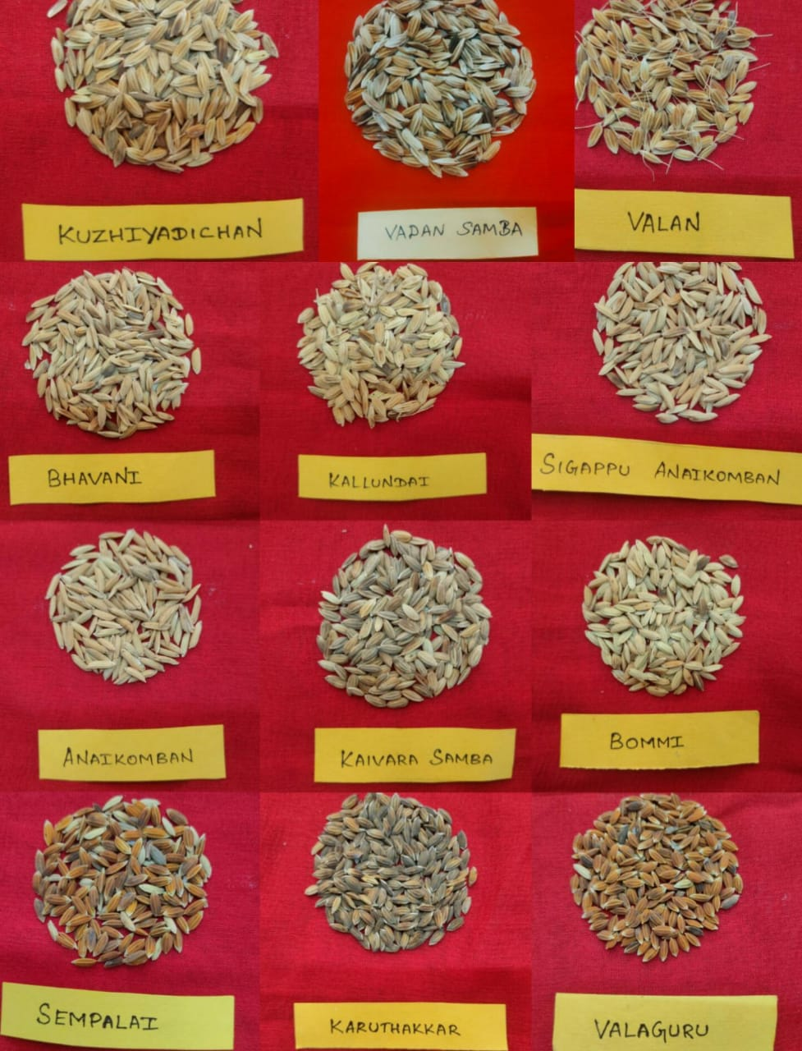
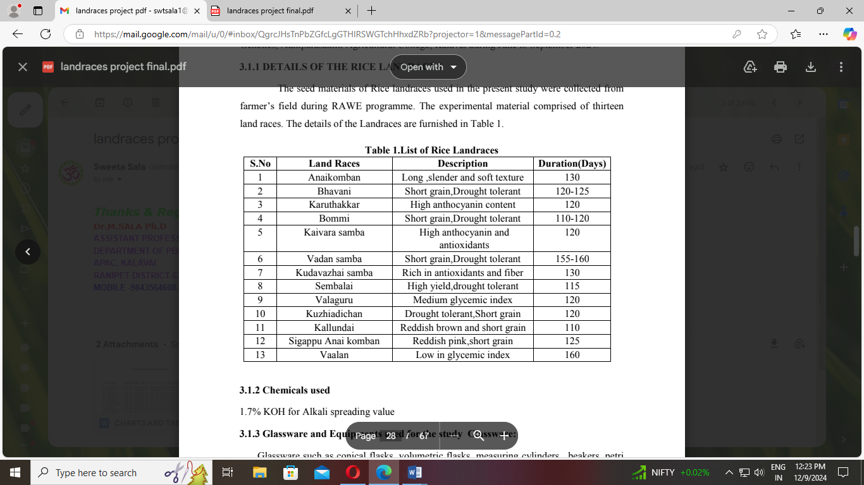

RESULTS AND DISCUSSION
The analysis of variance revealed significant differences among the medicinal landraces and cultivated varieties for all the characters studied except alkali spreading value, water absorption by weight, water uptake suggesting that significant genetic variation present in the material. The results were presented in table 2.
Table 2. Analysis of Variance
Source of variation | df | Grain before cooking |  |  | Grain after cooking |  |  | HP | WAW | ASV | CT | GER
Source of variation | df | GL(mm) | GB  (mm) | L/B  ratio | GL  (mm) | GB  (mm) | L/B  ratio
Treatment | 12 | 0.015* | 0.001* | 0.399* | 0.024* | 0.005* | 0.139* | 41.20* | 0.007 | 1.654 | 3.172* | 0.028*
Error | 13 | 0.001 | 0.001 | 0.019 | 0.004 | 0.003 | 0.011 | 0.475 | 0.004 | 0.500 | 6.654 | 0.001
Total | 25
Significant @5% level
Based on mean performance the Rice landraces namely, Anaikomban, Sigappuanaikomban, Karuthakar, Kalundai were observed best for most of the characters hundred grain weight, grain length after cooking, grain length before cooking, grain breadth before and after cooking, L/B ratio before and after cooking, cooking time. The landraces valaguru has least performance for the characters namely, hulling percentage, hundred grain weight, grain length before and after cooking, L/B ratio before cooking, cooking time and alkali spreading value (table 3 and fig 2).

Table 3. Best and Least Performing Landraces for different quality traits
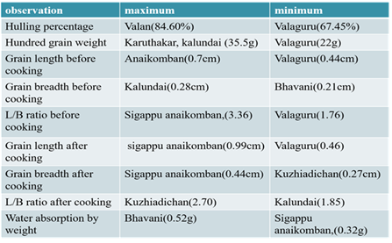

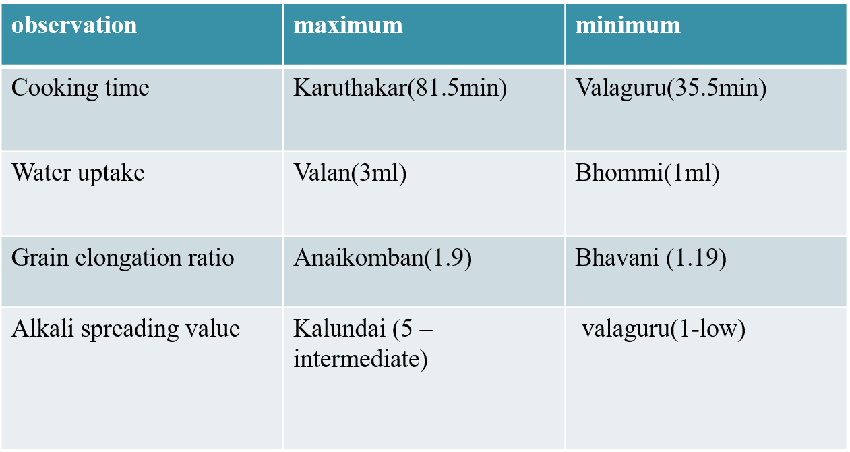

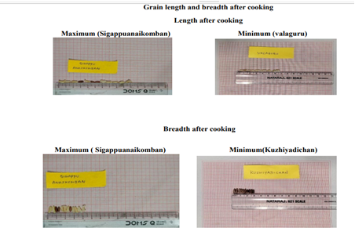
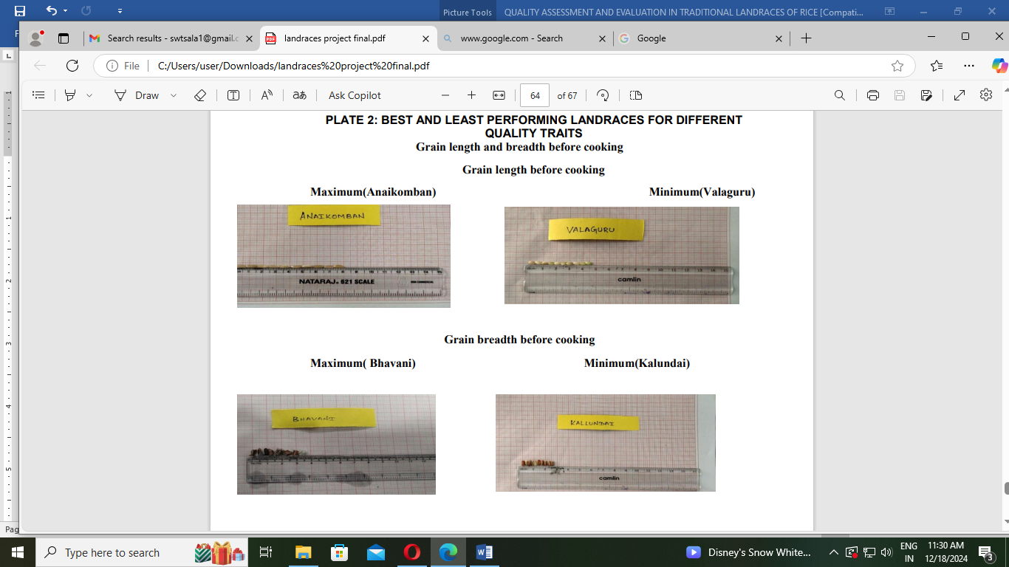
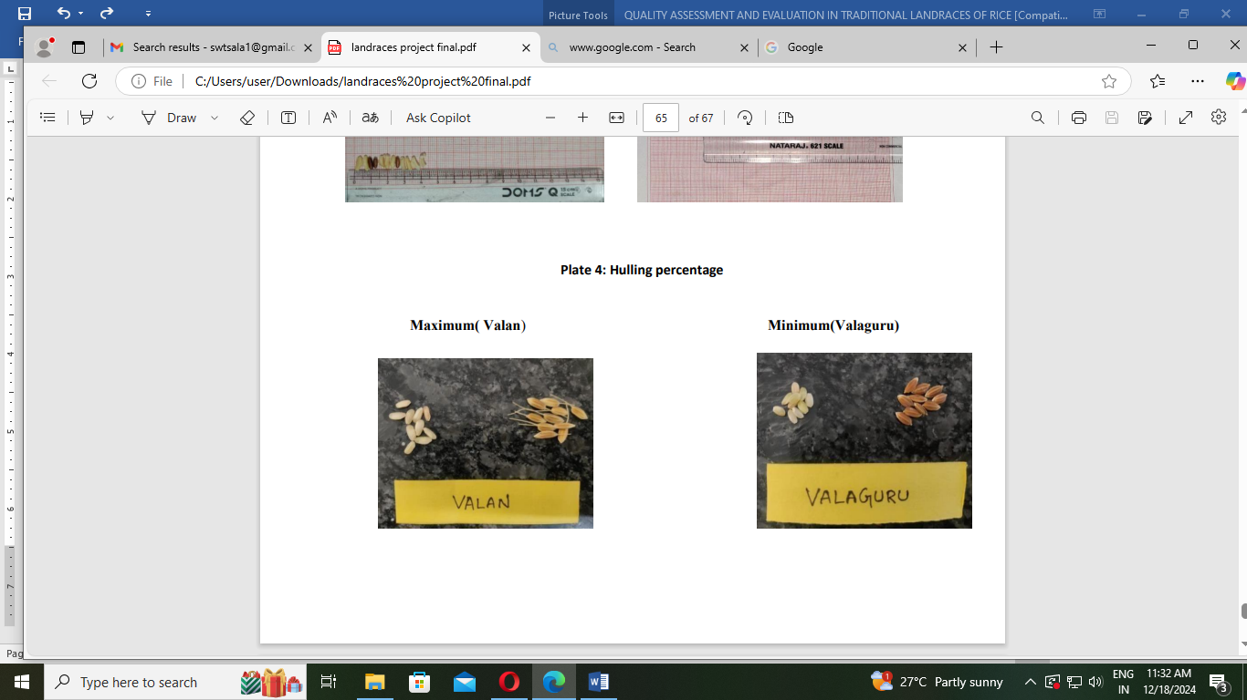
Fig 2. Best and Least Performing Landraces for different quality traits

Genotypic and Phenotypic Coefficient of Variance
The degree of genetic variability in landraces can be determined using genetic indices like PCV and GCV. In the experimental material, there was significant phenotypic and genotypic variation for every trait under consideration. The phenotypic coefficient of variation (PCV) values were only a little larger than the genotypic coefficient of variation (GCV), indicating a minimal influence of the environment on the expression of character. High GCV and PCV were recorded for traits like hundred grain weight, L/B ratio before cooking, L/B ratio after cooking and alkali spreading value. Similar results were reported by Allam et al. (2015), Rathi et al. (2019), Longjam and Singh (2019), Chakrabarty et al. (2021) Singh et al. (2020), Vanaja et al. (2006), Sahu et al. (2018). This indicating the existence of significant genetic variation and little environmental effect and hence this scope for selection of these traits would be effective. The characters under studied would have far more potential for genetic improvement through direct selection of these traits for future breeding programme. Therefore, on the basis of phenotype selection can be effective for the improvement of these characters.
Moderate GCV and PCV for traits like cooking time, grain elongation ratio, length before cooking, length after cooking, grain breadth before cooking and grain breadth after cooking. It indicates the availability of abundant variability present in rice landraces. Low GCV and PCV were recorded for traits like hulling percentage, water uptake. This indicating the presence of low variability for these traits in the present experimental material and therefore little scope for improvement of these traits.
Table. 4. Variability parameters for grain quality traits in Rice
Name of the trait | Mean | PCV (%) | GCV (%) | Heritability  (h2) | Genetic advance as % of mean
Hundred grain weight | 29.06 | 11.18 | 7.91 | 50.05 | 11.53
Hulling Percentage | 77.88 | 9.28 | 7.03 | 57.38 | 10.97
Grain length before cooking (mm) | 0.61 | 14.42 | 14.08 | 95.24 | 28.30
Grain breadth before cooking (mm) | 0.24 | 20.88 | 19.46 | 86.82 | 37.35
L/B ratio before cooking | 2.45 | 25.62 | 24.60 | 92.19 | 48.66
Grain length after cooking (mm) | 0.78 | 14.80 | 14.61 | 97.44 | 29.71
Grain breadth after cooking (mm) | 0.34 | 22.04 | 18.55 | 70.79 | 32.15
L/B ratio after cooking | 2.27 | 24.53 | 21.33 | 75.61 | 38.20
Water absorption by weight (g) | 0.41 | 21.63 | 17.32 | 64.10 | 28.56
Alkali spreading value | 3.57 | 74.81 | 64.81 | 86.63 | 54.12
Cooking time | 60.88 | 7.34 | 6.22 | 71.73 | 10.85
Water uptake | 1.57 | 14.22 | 13.63 | 91.74 | 26.88
Grain elongation ratio | 1.33 | 12.69 | 11.07 | 76.17 | 19.91

Heritability and genetic advance
High heritability and high genetic advance as per cent of mean were observed for all the characters under studied. The characters viz., alkali spreading value, water absorption by weight, L/B ratio after cooking, breadth after cooking and length after cooking, length before cooking, breadth before cooking, water uptake. This was in accordance with the findings of Sanghamitra et al (2018), Dhanwani et al. (2013), Sahu et al. (2017), Adhikari et al. (2018), Naik et al. (2022), Kumar et al. (2020) and Singh et al. (2020). This indicating the predominance of additive gene action on the trait and as such that trait is likely to respond effectively to phenotypic selection. Moderate heritability and moderate genetic advance as per cent of mean were observed for all the characters under studied. The characters viz., hulling percentage and 100 grain weight.
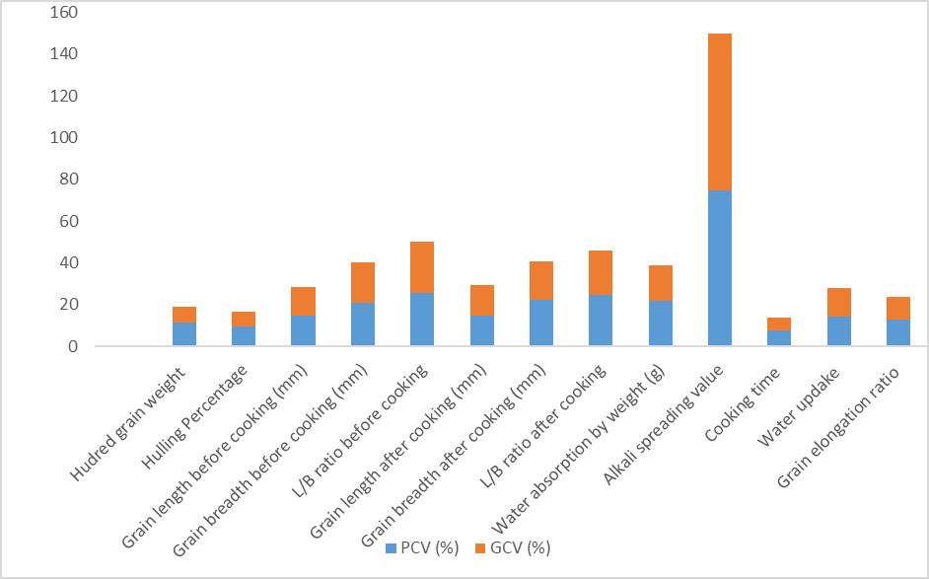
Fig. 3. Phenotypic coefficient of variation (PCV) and Genotypic coefficient of variation (GCV) for grain quality traits in Rice
Conclusion : From the present study, it can be concluded that the Rice landraces namely viz., Anaikomban, Sigappuanaikomban, Karuthakar, Kallundai were observed best for most of the characters hundred grain weight, grain length after cooking , grain length before cooking, grain breadth before and after cooking, L/Bratio before and after cooking, cooking time. Hence selection of these landraces useful for quality improvement. The landraces valaguru has the least performance for the characters namely, Hulling percentage, Hundred grain weight , Grain length before and after cooking , L/Bratio before cooking and Alkali spreading value. High GCV and PCV were recorded for traits like hundred grain weight, L/B ratio before cooking, L/B ratio after cooking and alkali spreading value. This indicating the existence of significant genetic variation and little environmental effect and hence this scope for selection of these traits would be effective. High heritability and high genetic advance as per cent of mean were observed for all the characters under studied. The characters viz., alkali spreading value, water absorption by weight, L/B ratio after cooking, breadth after cooking and length after cooking, length before cooking, breadth before cooking, water uptake. This indicating the predominance of additive gene action on the trait and as such that trait is likely to respond effectively to phenotypic selection.

References
- Adhikari, B. N., Joshi, B. P., Shrestha, J., & Bhatta, N. R. (2018). Genetic variability, heritability, genetic advance and correlation among yield and yield components of rice (Oryza sativa L.) . Journal of Agriculture and Natural Resources, 1(1),149-160.
- Allard, R.W. (1960). Principles of plant breeding. John Wiley and Sons. Inc., U.S.A. pp. 485.
- Allam, C.R., Jaiswal, H.K., Qamar, A., Challa Venkateshwarlu and Reddy, Y.S. 2015. Variability, heritability and genetic advance studies in some indegenous genotypes of basmati rice (Oryza sativa L.). Electronic Journal of Plant Breeding. 6(2): 506-511
- Burton and Devane 1953. Quantitative inheritance in grasses. In: Proc. 6th Inter Grassland Congr., 1: 277-283.
- Chakraborti, Anilkumar C, Ram Lakhan Verma , Abdul Fiyaz R , Reshmi Raj KR , BC Patra1 , Divya Balakrishnan , Sutapa Sarkar , Nimai P Mondal , Meera K KarL , Jitendriya Meher , RM Sundaram and LV Subba Rao.2021. Rice breeding in India: eight decades of journey towards enhancing the genetic gain for yield, nutritional quality, and commodity value. Oryza Vol. 58 (69-88).
- Cruz, N. D. "Rice grain quality evaluation procedures. In" Aromatic Rice (2000):"Melting the secrets of gelatinization temperature in rice." Functional Plant Biology 37, no. 5 (2010): 439-447.
- Dhanwani RK, Sarawgi AK, Solanki A, Tiwari JK. Genetic variability analysis for various yield attributing and quality traits in rice (Oryza sativaL.)The Bioscan. 2013; 8(4):1403-1407.
- Elsy, C.R., Roasamma, C.A., and Potty, N.N. 1992. Njavara – a rice variety with special characters. 29: 55-56.
- Falconer and Mackey 1996. Introduction to quantitative genetics. Oliver and Boyd Ltd., London W.I. pp. 365-369.
- Ghosh, A. K., Nanda, B. B., Swami, S. G and Nayak, B. B. 1971. Influence of nitrogen on the physico-chemical characteristics of rice grain. Oryza. 891: 87-97.
- Johnson H W, Robinson H F and Comstock R E 1955. Estimates of genetic and environmental variability in soybean. Agron J 47(7) : 314-18.
- Juliano, B. O., and Bechtel. B. 1985. The rice grain and its gross composition. In: Rice Chemistry and Technology (Juliano B O, ed), 2nd edn. American Association of Cereal Chemistry. 17–57.
- Juliano, B.O. (1971). A simplified assay for milled rice amylose. Cereal Sci., 16: 334-338
- Kumar C P S, Naik M, Joshi J L and Rajan R E B 2020. Variability studies among rice genotypes (Oryza sativa L.) under coastal saline condition. Plant Archives. 20(1): 738- 740.
- Little, R. R. Hilder, G.B., and Dawson, E.H. 1958.Differential effect of dilute alkali on 25 varieties of mildwhite rice. Cereal Chem., 35: 111–126.
- Longjam, S., & Singh, N. B. (2019). Assessment of heritability and genetic advance for yield contributing characters in hill rice (Oryza sativa L.) genotypes of Manipur. The Pharma Innovation Journal, 8(4), 07-11.
- Meullenet, Jean‐Francois, Bradley P. Marks, Jean‐Ann Hankins, Virginia K. Griffin, and Melissa J. Daniels. "Sensory quality of cooked long‐grain rice as affected by rough rice moisture content, storage temperature, and storage duration." Cereal chemistry 77, no. 2 (2000): 259-263.
- Murthy, P.S.N. and Govindaswamy, (1967). Inheritance of grain size and its correlation with the hulling and cooking qualities. Oryza, 4: 12-21.
- Naik, M.R., Chetariya, C.P. and Akkenapally, J.S. 2022. Characterization of the Genetic Variability in Rice (Oryza sativa L.) and its Assessment Using Principal Component Analysis (PCA). International Journal of Environment and Climate Change, 12(10): 1257-1269.
- Panse VG, Sukhatme PV. Statistical Methods for Agricultural Workers. Indian Council of Agricultural Research Publication 1985, 87-89
- Rathi, S., R.N.S. Yadav and R.N. Sarma. 2010. Variability in grain quality characters of upland rice of Assam, India. Rice Sci., 17(4): 330-333.
- Rita B and Sarawgi.,AK.(2008). Agro-morphological and quality characterization of Badshah bhog group from aromatic Rice germplasm of Chhattisgarh. Bangladesh Journal of Agriculture Research.; 33:479-492.
- Sahu , Deepak Sharma*, Suvendu Mondal , Vikash Kumar , Satyapal Singh , Samarth Baghel , Ashish Tiwari , Gautam Vishwakarma , B.K. Das. 2017.Genetic Variability for Grain Quality traits in indigenous rice landraces of Chhattisgarh, India. Journal of Experimental Biology and Agricultural Sciences. ISSN No. 2320 – 8694.
- Sahu S, Rastogi NK, Chandrakar PK, Gauraha D. 2018. Genetic variability of quality, yield and yield related traits in germplasm of rice (Oryza sativa L.). IJCS.;6(2):2393-2400.
- Sanghamitra, P., Prasad Sah, R., Bagchi, T.B., Sharma, S.G., Kumar, A., Munda, S. and Sahu, R.K.2018. Evaluation of variability and environmental stability of grain quality and agronomic parameters of pigmented rice (O. sativa L.). Journal of Food Science and Technology, 55(3): 879-890.
- Sattari, Ali, Nafiseh Mahdinezhad, Baratali Fakheri, M. Noroozi, and Haj Beheshtizadeh. "Improvement of the eating and cooking qualities of rice: a review." International Journal of Farming and Allied Sciences 4, no. 2 (2015): 153-160.
- Sellappan, Krishnan, Karabi Datta, Vilas Parkhi, and Swapan K. Datta. "Rice caryopsis structure in relation to distribution of micronutrients (iron, zinc, βcarotene) of rice cultivars including transgenic indica rice." Plant science 177, no. 6 (2009): 557-562.
- Singh, S.K., Suneetha,Y., Vijay, G. K., Srinivasa Rao, V., Sandeep Raja, D. and Srinivas, T.2020. Variability, correlation and path studies in coloured rice. International Journal of Chemical Studies, 8 (4): 2138-2144.
- Sivasubramanian S. and Madhava Menon P. 1973. Genotypic and phenotypic variability in rice. Madras agric. J., 60.
- Unnevehr, Laurian, Bart Duff, and Bienvenido, O. Juliano, eds. Consumer. demand for rice grain quality: Terminal report of IDRC projects, National grain quality (Asia), and International grain quality economics (Asia). Int. Rice Res. Inst., 1992.
- Vanaja, T. and L.C. Babu. 2006. Variability in grain quality attributes of high yielding rice varieties (Oryza sativa L.) of diverse origin. J. Top. Agric., 44(1-2): 61-63.
- Ward, Rachelle M., Qunyu Gao, Hank de Bruyn, Robert G. Gilbert, and Melissa A. Fitzgerald. (2006)."Improved methods for the structural analysis of the amylose-rich fraction from rice flour." Biomacromolecules 7 (3): 866-876.
- Zhou Guodong, Min Zhang, DonghongJi, and Qiaoming Zhu. 2007. Tree kernel-based relation extraction with context-sensitive structured parse tree information.

