EFFECT OF DIFFERENT SALINITY LEVELS ON ROOT AND SHOOT ATTRIBUTES OF BRINJAL VARIETIES GRAFTED ON SOLANUM TORVUM

ABSTRACT
A study was conducted to know the effect of different salinity levels on root and shoot attributes of brinjal varieties grafted on Solanum torvum under pot experiment and laid out in Factorial Randomized Block Design (FRBD) at College of Agriculture, Department of Horticulture, Vasantrao Naik Marathwada Krishi Vidyapeeth, Parbhani (Maharashtra) during the year 2020 and 2021. Experiment replicated twice with two factors, i.e., brinjal grafts at four levels (Phule Arjun, Phule Harit, Krishna and Manjari Gota grafted on Solanum torvum by cleft grafting method) and salinity levels at five levels (0/control, 2, 3, 4 and 5 dS m⁻¹ were imposed with sodium chloride). Among the different varieties grafted on Solanum torvum Phule Harit showed significantly superior performance for shoot dry weight, primary roots, root fresh and dry weight, root to shoot ratio. However, shoot fresh weight, secondary roots and root length were recorded in Phule Arjun. Among the different salinity levels, majority of the characters were noted to be significantly maximum in control. All together Phule Arjun and Phule Harit grafted on Solanum torvum was found significantly maximum values for majority parameters at heigher salinity levels (3.00 and 5.00 dS m⁻¹).
Keywords: Brinjal, Solanum torvum, Grafting and Salinity levels, Root and shoot attributes

INTRODUCTION
Brinjal (Solanum melongena L.) is a member of solanaceae family and a native of India (De Candolle, 1984), it is known as poor man’s vegetable, Aubergine and Eggplant throughout the world. Brinjal is moderately sensitive to salinity. India is emerged to be the world’s second largest producer of vegetable crops after China. In India, brinjal occupies an area of 0.73 million hectares with production of 12.98 million metric tons and productivity of 19.10 tons per hectare (Anon, 2022). Eggplant is a rich source of nutrients containing carbohydrates (6.4 %), protein (1.3 %), fat (0.3 %), calcium (0.02 %), phosphorus (0.02 %), iron (0.0013 %), 34 mg β-carotene, 0.05 mg riboflavin, 0.05 mg thiamine, 0.5 mg niacin and 0.9 mg ascorbic acid per 100 grams of fruit. Brinjal is having medicinal properties like beneficial for diabetic patients, liver complaints (Shukla and Naik, 1993).
Drought and salinity are the major environmental factors which reduces crop productivity of which salinity is detrimental in limiting plant growth and crop productivity (Schwarz et al., 2010). Therefore, it is imperative to have more knowledge on salt stress to develop new technologies for water and soil management and salt tolerant cultivars to grow under saline conditions. Grafting offers an alternative to breeding and biotechnological approaches to rapidly enhance salt tolerance in vegetable crops (Keatinge et al., 2014 and Abbas et al., 2023). Grafting is an integrative reciprocal process involves union of two parts (a rootstock and scion) together from two different plant parts to form a single, living plant (Kumar, 2011 and Kumar et al., 2017). Rootstock provides good physical anchorage against wind, is significantly affected by soil characteristics, plant health characters like pests and disease effects, as well as the irrigation and fertilization patterns. Salinity suppresses the root growth in most of the cultivated nongrafted egg plants, however, in grafted plants, with the help of selective rootstock promote the root development by moderately restricting entry of salts into roots and this enhance the water and nutrient uptake and increase phytohormones activity, and support vegetative growth and dry matter accumulation in scion and additionally it improves graft union compatibility, ultimately resulting in good quality yield (Aydin, 2024).
MATERIALS AND METHODS
This experimental study was performed at College of Agriculture, Department of Horticulture, Vasantrao Naik Marathwada Krishi Vidyapeeth, Parbhani during the year 2020 and 2021. The experiment was laid out in Factorial Randomized Block Design (FRBD) with two replications and it consisted of two factors, i.e., Grafts and Salinity levels. There were four varieties of brinjal viz., Phule Arjun (F₁), Phule Harit, Krishna (F₁) and Manjari Gota grafted on Solanum torvum is the first factor and five levels of salinity imposed by using artificial salt solution was prepared by mixing NaCl with fresh water, applied in four different Electrical conductive (EC) values of 2, 3, 4 and 5 dS m⁻¹ including control (0 dS m⁻¹) is the second factor. The seeds of Solanum torvum (Turkey Berry) used as rootstock and varieties/hybrids adopted and released for Maharashtra region has been selected as scions were obtained from Senior Vegetable Breeder, All India Co-ordinated Research Project (AICRP) on Vegetable Crops, Mahatma Phule Krishi Vidyapeeth (MPKV), Rahuri, Maharashtra. Four cultivated varieties of brinjal were grafted onto Solanum torvum rootstock by adopting cleft grafting method. The age of rootstock was 60 to 65 days (three to four true leaves) and scion age was 30 to 35 days (three to four true leaves). Grafting was carried out in the morning and evening hours in mist chambers made up with transparent polythene of hundred microns thickness. Salinity stress has been induced by applying respective salt solution of two liter per plant in weekly interval starting from 20 days after transplanting and non salt treated plants were kept as control. The control plants were irrigated with distilled water without any added salt (NaCl). The data obtained during experiment were analyzed as per the standard statistical methods prescribed by Panse and Sukhatme (1985).
RESULTS AND DISCUSSION
The data in respect of shoot parameters viz., shoot fresh weight and shoot dry weight of brinjal and root parameters viz., number of primary roots per plant, number of secondary roots per plant, root length, root fresh weight, root dry weight and root to shoot ratio under the influence of different grafts and salinity levels are furnished in Table 1&2 and Figure 1.
Among the grafts (Table 1), significantly the maximum shoot fresh weight was noticed in Phule Arjun grafted on Solanum torvum (463.45 g) and the minimum was observed in Manjari Gota grafted on Solanum torvum (392.66 g). Among different levels of salt concentrations, the highest shoot fresh weight was found in control (664.59 g) and the lowest was observed in 5 dS m⁻¹ (216.79 g). Among the treatment combinations, Phule Arjun grafted on S. torvum with control was noticed significantly the highest shoot fresh weight (773.26 g) and the lowest was recorded in Krishna grafted on Solanum torvum with 5 dS m⁻¹ (149.88 g). Phule Arjun grafted on Solanum torvum was proved to be maximum for shoot fresh weight at 4.00 and 5.00 dS m⁻¹ (382.88 g and 262.63 g, respectively), but at 3.00 dS m⁻¹ it was found in Krishna grafted on Solanum torvum (426.69 g).
Among grafts, significantly the highest shoot dry weight was observed in Phule Harit grafted on Solanum torvum (129.83 g) and the lowest shoot dry weight was observed in Krishna grafted on Solanum torvum (108.63 g). Grafting improved the shoot dry weight in eggplant. The findings are in accordance with those obtained by Yetisir and Sari (2003); Khah et al. (2006); Curuk et al. (2009); Bekhradi et al. (2011); Mohamed et al. (2012); Shahbaz et al. (2013); Semiz and Suarez (2019); Aslam et al. (2020) and Ulas et al. (2021). Among the different levels of salt concentrations, the highest shoot dry weight was found in the control (174.23 g) and the lowest shoot dry weight was observed in 5 dS m⁻¹ (73.94 g). Saline conditions at the root zone of the brinjal grafts resulted in reduced shoot dry weight. These findings were also reported in earlier studies by Akinci et al. (2004); Colla et al. (2006); Unlukara et al. (2008) and Ahire and Nikam (2011). Among the treatment combinations, Manjari Gota grafted on S. torvum with control was noticed significantly the highest shoot dry weight (197.33 g). Phule Harit grafted on Solanum torvum was proved to be maximum for shoot dry weight at 3.00 and 5.00 dS m⁻¹ (126.44 g and 99.24 g, respectively), but at 4.00 dS m⁻¹ it was Manjari Gota grafted on Solanum torvum (107.22 g). Whereas, significantly the lowest shoot dry weight was recorded in Krishna grafted on Solanum torvum with 5 dS m⁻¹ (49.05 g).
Among the different grafts (Table 2), significantly the highest number of primary roots per plant was recorded in Phule Harit grafted on Solanum torvum (54.05) and the lowest was observed in Krishna grafted on Solanum torvum (36.05). Grafting increased the effective root area for sufficient nutrient and water absorption, especially the primary roots. Among the different levels of salt concentrations (Abbas et al., 2023), the highest number of primary roots per plant was noticed in the control (52.45) and the lowest were observed in 5 dS m⁻¹ (33.53). Salinity levels acted against the number of primary roots, but it was
Table 1: Effect of different salinity levels on shoot parameters of brinjal varieties grafted on Solanum torvum (Pooled mean of 2020 and 2021 data)
Factors | Treatment Details | Shoot fresh weight (g) | Shoot dry weight (g)
A₁ | Phule Arjun grafted on Solanum torvum | 463.45 | 122.36
A₂ | Phule Harit grafted on Solanum torvum | 411.71 | 129.83
A₃ | Krishna grafted on Solanum torvum | 398.66 | 108.63
A₄ | Manjari Gota grafted on Solanum torvum | 392.66 | 124.92
SE (m) ± |  | 1.854 | 0.574
C.D at 5 % |  | 5.528 | 1.712
B₁ | 0 dS m⁻¹ | 664.59 | 174.23
B₂ | 2.00 dS m⁻¹ | 488.97 | 138.58
B₃ | 3.00 dS m⁻¹ | 387.60 | 117.16
B₄ | 4.00 dS m⁻¹ | 325.14 | 103.26
B₅ | 5.00 dS m⁻¹ | 216.79 | 73.94
SE (m) ± |  | 2.073 | 0.642
C.D at 5 % |  | 6.180 | 1.915
T₁ | A₁B₁ | 773.26 | 178.55
T₂ | A₁B₂ | 480.57 | 158.90
T₃ | A₁B₃ | 417.94 | 109.81
T₄ | A₁B₄ | 382.88 | 94.24
T₅ | A₁B₅ | 262.63 | 70.31
T₆ | A₂B₁ | 681.19 | 171.97
T₇ | A₂B₂ | 571.81 | 145.84
T₈ | A₂B₃ | 341.19 | 126.44
T₉ | A₂B₄ | 272.25 | 105.66
T₁₀ | A₂B₅ | 192.11 | 99.24
T₁₁ | A₃B₁ | 581.99 | 149.10
T₁₂ | A₃B₂ | 468.24 | 121.78
T₁₃ | A₃B₃ | 426.69 | 117.32
T₁₄ | A₃B₄ | 366.50 | 105.92
T₁₅ | A₃B₅ | 149.88 | 49.05
T₁₆ | A₄B₁ | 621.94 | 197.33
T₁₇ | A₄B₂ | 435.26 | 127.80
T₁₈ | A₄B₃ | 364.59 | 115.08
T₁₉ | A₄B₄ | 278.94 | 107.22
T₂₀ | A₄B₅ | 262.57 | 77.17
SE (m) ± |  | 4.145 | 1.284
C.D at 5 % |  | 12.360 | 3.829

not that extent in grafted eggplant as it was the wild species. Among the treatment combinations, Phule Harit grafted on S. torvum with control was recorded significantly the maximum number of primary roots per plant (63.37) and the minimum were recorded in Manjari Gota at 2.00 dS m⁻¹ (25.13). Phule Harit grafted on Solanum torvum was proved to be maximum for number of primary roots per plant at 3.00 dS m⁻¹ (58.51), but at 4.00 dS m⁻¹ it was Manjari Gota grafted on Solanum torvum (40.69).
Among the grafts, significantly the highest number of secondary roots per plant were observed in Phule Arjun grafted on Solanum torvum (2699.85) and the lowest were observed in Manjari Gota grafted on Solanum torvum (1530.27). It is fact that grafting on wild species is always advantages with respect to increasing root number. The most obvious salt limitation is root growth and roots are more sensitive to stress than other plant parts, with the only effect of treatment being increased root dry weight in crops irrigated with 3.0 and 5.0 dS m⁻¹. Most importantly, our findings indicated that high salinity levels may alter the partitioning pattern of dry preferring investment in root systems (Chartzoulakis et al., 1995). Among the different levels of salt concentrations, the highest number of secondary roots per plant were found in the control (2674.86) and the lowest was noticed in 5 dS m⁻¹ (1327.82). Similar trend was recorded as like primary roots under salinity levels regarding secondary roots also. Among the treatment combinations, Phule Arjun grafted on S. torvum with control noted significantly the highest number of secondary roots per plant (3486.88) and the lowest were recorded in the Manjari Gota grafted on Solanum torvum with 5 dS m⁻¹ (894.13). Phule Arjun grafted on Solanum torvum was proved to be maximum for number of secondary roots per plant at 4.00 and 5.00 dS m⁻¹ (2158.32 and 1910.44, respectively), but at 3.00 dS m⁻¹, it was Krishna grafted on Solanum torvum (2495.26).
Root length among the grafts was shown significant difference. Among the grafts (Table 2 and Figure 1), significantly the maximum root length was observed in Phule Arjun grafted on Solanum torvum (50.45 cm) and the minimum was observed Phule Harit grafted on Solanum torvum (37.81 cm). It may be due to the differences in source and sink relationship as well as compatibility differences. Under salt concentrations, the maximum root length was observed in control (58.08 cm) and minimum was recorded in 5 dS m⁻¹ (33.01 cm). Enhanced salt tolerance of grafted vegetables has often been associated with root system. The high salt exposure suppressed lateral root initiation and organogenesis, resulting in the abortion of lateral root development. In the present study, the root length in both grafted and non-grafted plants exhibited decreasing trend with increasing level of salt concentrations and the maximum reduction in root growth was observed in higher salt concentrations. Among the treatment combinations, Phule Arjun grafted on S. torvum with control was recorded significantly the maximum root length (69.75 cm). Whereas, significantly the lowest root length was recorded in Krishna grafted on Solanum torvum with 5 dS m⁻¹ (31.94 cm).
Among the grafts, significantly the maximum root fresh weight was recorded in Phule Harit grafted on Solanum torvum (139.67 g) and the minimum root fresh weight was observed in Krishna grafted on Solanum torvum (53.54 g). Under salt concentrations, the maximum root fresh weight was observed in control (128.40 g) and the minimum root fresh weight was recorded in 5 dS m⁻¹ (51.01 g). Salt stress affects plant growth through a variety of physiological and biochemical mechanisms, including osmotic stress, ion toxicity, and nutritional imbalance (Kao et al., 2003). Because rootstocks are stronger and have a more extensive root system than scions, they allow for greater water and nutrient uptake as well as increased internal plant hormones and photosynthesis rates, promoting plant growth and development and increasing the plan resistance to stress conditions (Ahn et al., 1999; Cohen et al., 2002, Yang et al., 2022). This trait was responded negatively with increase in salt concentration at rhizospere. Among the treatment combinations, Phule Harit grafted on S. torvum with control was recorded significantly the maximum root fresh weight (264.53 g). Phule Harit grafted on Solanum torvum was proved to be maximum for root fresh weight at 3.00, 4.00 and 5.00 dS m⁻¹ (97.83 g, 78.86 g and 77.16 g, respectively). Whereas, significantly the lowest root fresh weight was recorded in Krishna grafted on Solanum torvum with 5 dS m⁻¹ (34.92 g).
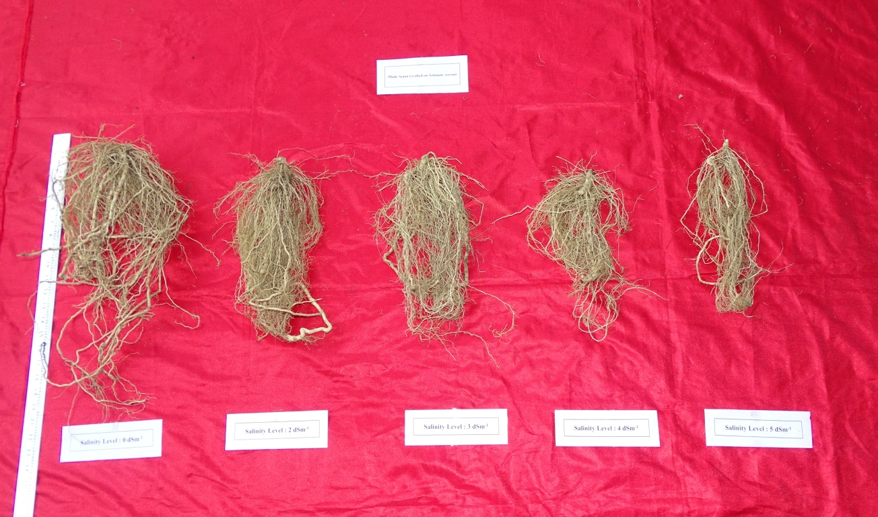 | 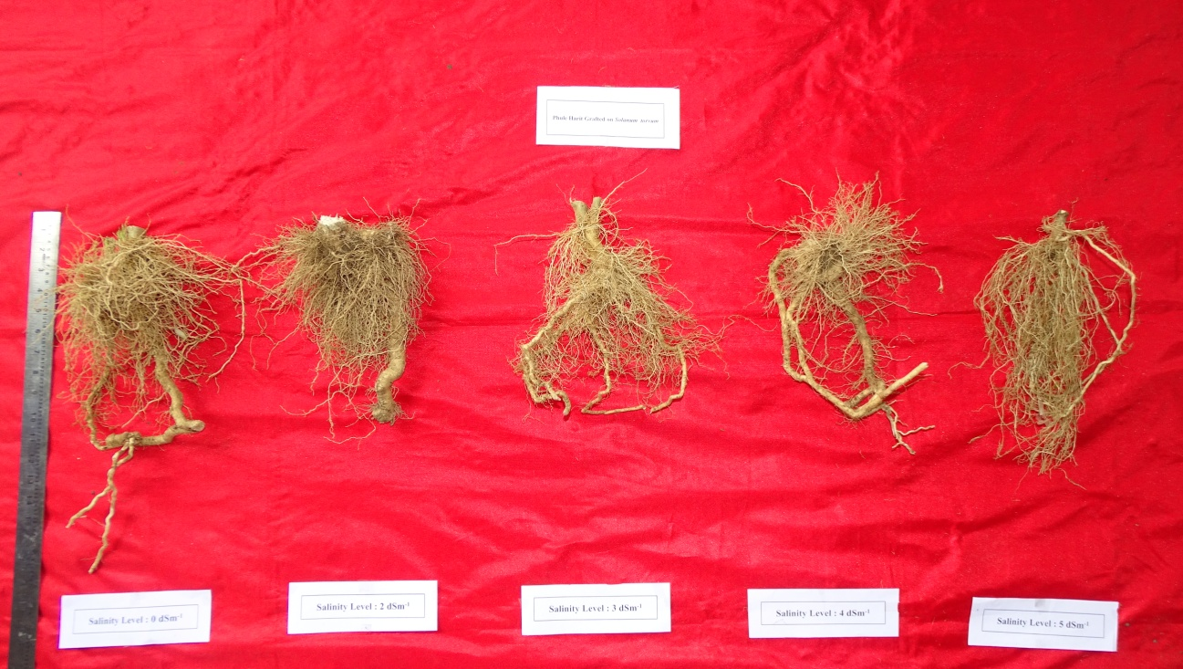
a. Phule Arjun | b. Phule Harit
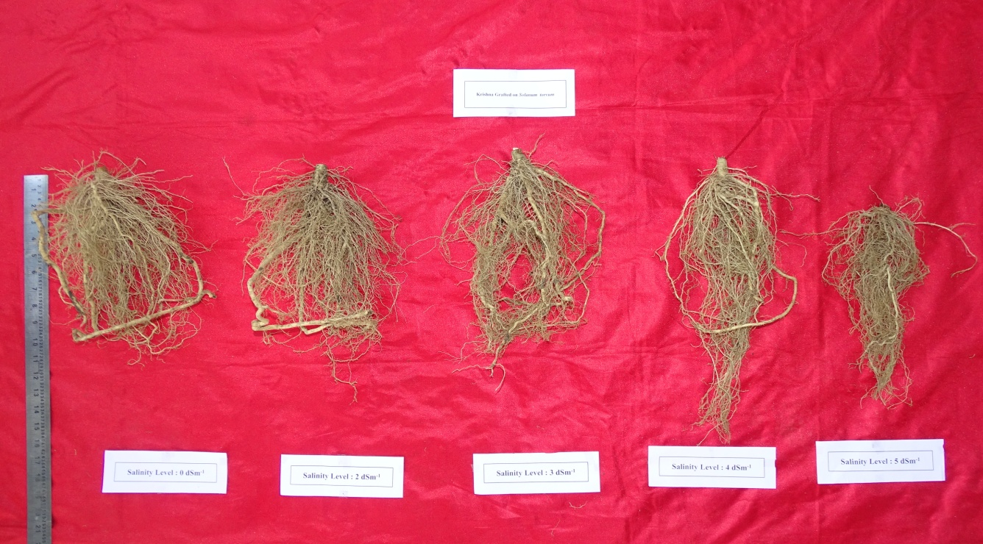 | 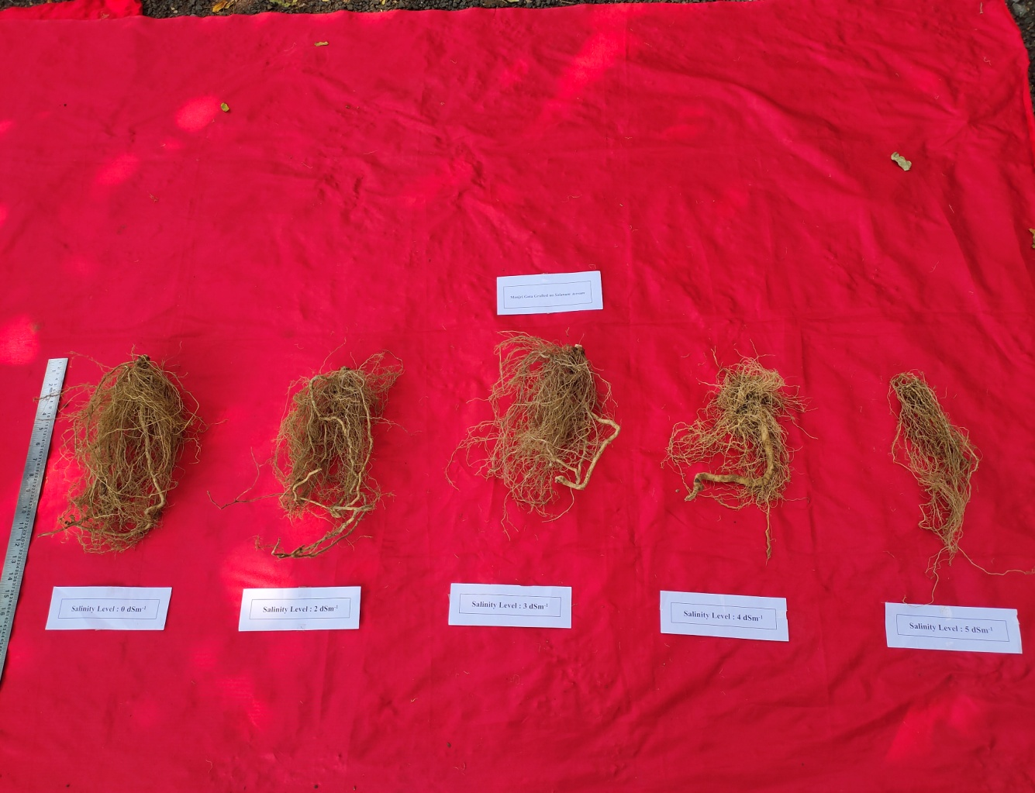
c. Krishna | d. Manjari Gota
Figure 1: Effect of different salinity levels on root growth of brinjal varieties (a. Phule Arjun; b. Phule Harit; c. Krishna and d. Manjari Gota) grafted on Solanum torvum
Among grafts, significantly the maximum root dry weight was observed in Phule Harit grafted on Solanum torvum (67.33 g) and the minimum root dry weight was recorded in Krishna grafted on Solanum
Table 2: Effect of different salinity levels on root parameters of brinjal varieties grafted on Solanum torvum (Pooled mean of 2020 and 2021 data)
Factors | Treatment Details | Number of primary roots per plant | Number of secondary roots per plant | Root length (cm) | Root fresh weight (g) | Root dry weight (g) | Root to shoot ratio
A₁ | Phule Arjun grafted on Solanum torvum | 47.68 | 2699.85 | 50.45 | 63.95 | 33.09 | 0.280
A₂ | Phule Harit grafted on Solanum torvum | 54.05 | 1563.85 | 37.81 | 139.67 | 67.33 | 0.497
A₃ | Krishna grafted on Solanum torvum | 36.05 | 2163.83 | 43.60 | 53.54 | 27.69 | 0.272
A₄ | Manjari Gota grafted on Solanum torvum | 40.33 | 1530.27 | 41.32 | 69.63 | 31.80 | 0.268
SE (m) ± |  | 0.186 | 7.847 | 0.377 | 0.500 | 0.295 | 0.003
C.D at 5 % |  | 0.556 | 23.397 | 1.123 | 1.490 | 0.878 | 0.010
B₁ | 0 dS m⁻¹ | 52.45 | 2674.86 | 58.08 | 128.40 | 59.48 | 0.342
B₂ | 2.00 dS m⁻¹ | 49.50 | 2382.63 | 46.95 | 99.45 | 47.24 | 0.340
B₃ | 3.00 dS m⁻¹ | 46.18 | 2013.14 | 41.50 | 69.62 | 34.38 | 0.292
B₄ | 4.00 dS m⁻¹ | 40.97 | 1548.80 | 36.87 | 59.99 | 30.65 | 0.297
B₅ | 5.00 dS m⁻¹ | 33.53 | 1327.82 | 33.01 | 51.01 | 28.14 | 0.375
SE (m) ± |  | 0.208 | 8.773 | 0.421 | 0.559 | 0.329 | 0.004
C.D at 5 % |  | 0.622 | 26.159 | 1.255 | 1.666 | 0.982 | 0.011
T₁ | A₁B₁ | 58.13 | 3846.88 | 69.75 | 80.90 | 46.63 | 0.215
T₂ | A₁B₂ | 51.75 | 3266.75 | 56.75 | 69.85 | 40.77 | 0.210
T₃ | A₁B₃ | 49.00 | 2316.88 | 47.51 | 65.46 | 29.28 | 0.294
T₄ | A₁B₄ | 40.63 | 2158.32 | 43.44 | 52.57 | 28.03 | 0.295
T₅ | A₁B₅ | 38.88 | 1910.44 | 34.78 | 51.00 | 20.77 | 0.387
T₆ | A₂B₁ | 63.37 | 2003.26 | 49.51 | 264.53 | 120.33 | 0.700
T₇ | A₂B₂ | 61.32 | 1790.01 | 38.22 | 180.07 | 83.63 | 0.574
T₈ | A₂B₃ | 58.51 | 1606.32 | 36.32 | 97.83 | 46.90 | 0.371
T₉ | A₂B₄ | 47.63 | 1257.13 | 33.03 | 78.76 | 39.96 | 0.378
T₁₀ | A₂B₅ | 39.44 | 1162.57 | 32.00 | 77.16 | 45.84 | 0.462
T₁₁ | A₃B₁ | 39.94 | 2796.38 | 59.26 | 63.92 | 32.66 | 0.219
T₁₂ | A₃B₂ | 38.63 | 2600.13 | 47.82 | 61.39 | 31.17 | 0.256
T₁₃ | A₃B₃ | 36.07 | 2495.26 | 44.07 | 55.91 | 29.06 | 0.248
T₁₄ | A₃B₄ | 34.94 | 1583.25 | 34.94 | 51.55 | 26.81 | 0.253
T₁₅ | A₃B₅ | 30.69 | 1344.13 | 31.94 | 34.92 | 18.77 | 0.383
T₁₆ | A₄B₁ | 48.38 | 2052.94 | 53.82 | 104.27 | 38.31 | 0.236
T₁₇ | A₄B₂ | 46.32 | 1873.63 | 45.03 | 86.50 | 33.38 | 0.319
T₁₈ | A₄B₃ | 41.13 | 1634.13 | 38.38 | 59.31 | 32.29 | 0.254
T₁₉ | A₄B₄ | 40.69 | 1196.51 | 36.07 | 57.10 | 27.80 | 0.261
T₂₀ | A₄B₅ | 25.13 | 894.13 | 33.32 | 40.97 | 27.20 | 0.269
SE (m) ± |  | 0.417 | 17.604 | 0.842 | 1.118 | 0.659 | 0.008
C.D at 5 % |  | 1.243 | 52.491 | 2.511 | 3.333 | 1.964 | 0.023
torvum (27.69 g). Grafted plants exhibited the best root dry weight as the rootstock was a wild species. The difference among the grafts might be physiological and anatomical differences among the scions. Under salt concentrations, the maximum root dry weight was observed in the control (59.48 g). The minimum root dry weight noted in 5 dS m⁻¹ (28.14 g). Under salinity stress conditions, all grafted genotypes had lower root fresh and dry weights than non-grafted plants (Kiran et al., 2018, Sanchez-Rodrguez et al., 2014). Because of ion toxicity, high foliar Na⁺ concentrations can reduce CO₂ assimilation (Liu et al. 2012 and Huang et al. 2011). Salinity has been linked to a variety of injuries, including growth inhibition and metabolic disturbances (Carvajal et al., 1998; Del Amor et al., 2000, Munns and Tester, 2008 and Shams & Khadivi, 2023). Root dry weight can increase due to increased water and nutrient uptake from the rootstocks strong root system and decreased sodium adsorption from the roots. As a result, salinity tolerant rootstocks may aid in reducing plant losses (Nomura et al., 1998; Yao et al., 2003; Oztekin, 2009). The maximum root dry weight was recorded in the treatment combination Phule Harit grafted on S. torvum with control (120.33 g). Phule Harit grafted on Solanum torvum was proved to be maximum for root dry weight at 3.00, 4.00 and 5.00 dS m⁻¹ (46.90 g, 39.96 g and 45.84 g, respectively).
Among the grafts, maximum root to shoot ratio was observed in Phule Harit grafted on Solanum torvum (0.497) and the minimum root to shoot ratio was recorded in Manjari Gota grafted on Solanum torvum (0.268). In different salt concentrations, the maximum root to shoot ratio was observed at higher concentration 5 dS m⁻¹ (0.375) and the minimum root to shoot ratio was observed in the treatment 3 dS m⁻¹ was 0.292. Significantly, the maximum root to shoot ratio was observed in Phule Harit grafted on S. torvum with control (0.700). Whereas, the minimum root to shoot ratio was observed in Phule Arjun grafted on S. torvum with control (0.210).
CONCLUSION
A positive effect of grafting was observed when Solanum torvum Sw. was used as rootstock under salt stress conditions. Among the graft combinations, the results indicated that Phule Arjun and Phule Harit grafted onto Solanum torvum was found significantly maximum values for different shoot and root parameters. Salinity levels also had a significant impact on the different parameters. Phule Arjun and Phule Harit grafted onto Solanum torvum at salinity levels of 3.00, 4.00 and 5.00 dS m⁻¹ constantly showed a significant impact on the both root and shoot parameters.
COMPLIANCE WITH ETHICAL STANDARDS
ETHICAL ISSUES: None
REFERENCES
Abbas, F., Faried, H. N., Akhtar, G., Ullah, S., Javed, T., Shehzad, M. A., ... & Abeed, A. H. (2023). Cucumber grafting on indigenous cucurbit landraces confers salt tolerance and improves fruit yield by enhancing morpho-physio-biochemical and ionic attributes. Scientific Reports, 13(1), 21697.
Ahire, M. L. & Nikam, T. D. (2011). Differential response of brinjal (Solanum melongena Linn.) varieties to salinity stress in relation to seed germination and osmolytes accumulation. Seed Sci. & Biotech. 5 (1), 29 - 35.
Akinci, IE., Akinci, S., Yılmaz, K., Dikici, H. (2004). Response of eggplant varieties (Solanum melongena) to salinity in germination and seedling stages. New Zealand J. Crop and Horti. Sci. 32, 193 - 200.
Anonymous, (2022). Indian Horticulture Database. National Horticulture Board, Gurgaon, Haryana, India.
Aslam, W., Noor, R. S., Hussain, F., Ameen, M., Ullah, S. & Chen, H. (2020). Evaluating morphological growth, yield, and postharvest fruit quality of cucumber (Cucumis sativus L.) grafted on Cucurbitaceous rootstocks. Agriculture. 10 (4), 101.
Aydin, A. (2024). Effects of grafting with wild tomato (Solanum pimpinellifolium and Solanum habrochaites) rootstocks on growth and leaf mineral accumulation in salt stress. Horticulture, Environment, and Biotechnology, 1-17.
Bekhradi, F., Kashi, A. & Delshad, M. (2011). Effect of three cucurbits rootstocks on vegetative and yield of ‘Charleston Gray’ watermelon. International Journal of Plant Production, 5 (2), 105-109.
Carvajal, M., Del Amor, F., Fernandez, G., Martinez, V. & Cerda, A. (1998). Time course of solute accumulation and water relations in muskmelon plants exposed to salt during different growth. Plant Sci. 138, 103 - 112.
Chartzoulakis, K., Therios, I., Misopolinos, N. & Noitsakis, B., (1995). Growth, ion content and photosynthetic performance of salt stressed kiwifruit plants. Irrig. Sci. 16, 23 - 28.
Cohen, R., Horev, C., Burger, Y., Shriber, S., Hershenhorn, J., Katan J. & Edelstein, M. (2002). Horticultural and pathological aspects of Fusarium wilt management using grafted melons. Hort. Sci. 37 (7), 1069 - 1073.
Colla, G., Roupahel, Y., Cardarelli, M. & Rea, E. (2006). Effect of salinity on yield, fruit quality, leaf gas exchange, and mineral composition of grafted watermelon plants. Hort. Sci. 41 (3), 622 - 627.
Curuk, S., Dasgan, H. Y., Mansuroglu, S., Kurt, S., Mazmanoglu, M., Antaklı, O. & Tarla, G. (2009). Grafted eggplant yield, quality and growth in infested soil with Verticillium dahliae and Meloidogyne incognita. Pesquisa Agropecuaria Brasileira. 44, 1673 - 1681.
De Candolle, A. (1984). Origin of cultivated plants. Pp 287-88. Kegan Paul, Trench and Co. London.
Del Amor, F. M., Ruiz-Sanchez, M. C., Martinez, V. & Cerda, A. (2000). Gas exchange, water relations and ion concentration of salt stressed tomato and melon plants. J. Plant Nutri. 23, 1315 - 1325.
Huang, Y., Bie, Z.L., Liu, Z.X., Zhen, A. & Jiao, X.R. (2011). Improving cucumber photosynthetic capacity under NaCl stress by grafting onto two salt tolerant pumpkin rootstocks. Biol. Plant. 55 (2), 285 - 290.
Kao, W. Y., Tsai, T. T. & Shih, C. N. (2003). Photosynthetic gas exchange and chlorophyll a fluorescence of three wild soybean species in response to NaCl treatments. Photosynt. 41, 415 - 419.
Keatinge, J. D. H., Lin, L. J., Ebert, A. W., Chen, W. Y., Hughes, J. A., Luther, G. C. & Ravishankar, M. (2014). Overcoming biotic and abiotic stresses in the Solanaceae through grafting: Current status and future perspectives. Bio. Agri. & Horti. 30 (4), 272 - 287.
Khah, E. M., Kakava, E., Mavromatis, A., Chachalis, D. & Goulas, C. (2006). Effect of grafting on growth and yield of tomato (Lycopersicon esculentum Mill.) in greenhouse and open field. J. Appl. Horti. 8 (1), 3 - 7.
Kıran, S., Kuşvuran, S., Ateş, C., Sonmez, K. & Ellialtioglu, S. S. (2018). Morphological characteristics and ion concentrations of grafted and non-grafted eggplant seedlings under drought and salt stress. J. Ani. & Pl. Sci. 28 (6), 1755 - 1765.
Kumar, A. S., Raja, P., Pandey, A. K. & Rabindro, P. (2017). Evaluation of Wilt resistance of wild Solanum Species through grafting in brinjal. Int. J. Curr. Microbiol. App. Sci. 6 (9), 3464 - 3469.
Kumar, G. N. M. (2011). Propagation of plants by grafting and budding. Washington State University. A Pacific Northwest Extension Publication. 19.
Liu, Z. X., Bie, Z. L., Huang, Y., Zhen, A., Lei, B. & Zhang, H. Y. (2012). Grafting onto Cucurbita moschata rootstock alleviates salt stress in cucumber plants by delaying photoinhibition. Photosyn. 50 (1), 152 - 160.
Mohamed, F., El - Hamed, K., Elwan, M. & Hussien, M. A. (2012). Impact of grafting on watermelon growth, fruit yield and quality. Vegetable Crops Res. Bulletin. 76, 99.
Munns, R. & Tester, M. (2008). Mechanisms of salinity tolerance. Annu. Rev. Plant Bio. 59, 651 - 681.
Nomura, M., Hibino, T., Takabe, T., Sugyama, T., Yokota, A., Miyake, H. & Takabe, T. (1998). Transgenically produced glycine betaine protects ribulose 1, 5-bisphosphate carboxylase/oxygenase from inactivation in Synechococcus sp. PCC7942 under salt stress. Plant Cell Physiol. 39, 425 - 432.
Oztekin, G. B. (2009). Response of tomato rootstocks to salinity stress. Ph. D. Thesis. Department of Horticulture Institute of Natural and Applied Sciences University of Ege. Izmir, Turkey.
Panse, V. G. & Sukhatme, P. V. (1985). Statistical methods for Agriculture workers. ICAR, New Delhi.
Schwarz, D., Rouphael, Y., Colla, G. & Venema, J. H. (2010). Grafting as a tool to improve tolerance of vegetables to abiotic stress: Thermal stress, water stress and organic pollutants. Sci. Hort. 127, 162 - 171.
Semiz, G. D. & Suarez, D. L. (2019). Impact of grafting, salinity and irrigation water composition on eggplant fruit yield and ion relations. Scientific Reports, 9 (1), 1 - 9.
Shahbaz, M., Mushtaq, Z., Andaz, F. & Masood, A. (2013). Does proline application ameliorate adverse effects of salt stress on growth, ions and photosynthetic ability of eggplant (Solanum melongena L.). Scientia Hort. 164, 507 - 511.
Shams, M., & Khadivi, A. (2023). Mechanisms of salinity tolerance and their possible application in the breeding of vegetables. BMC Plant Biology, 23(1), 139.
Shukla, V. & Naik, L. B. (1993). Agro techniques of Solanaceous vegetables, in ‘Advances in Horticulture’, Vol. 5, Vegetable Crops, Part 1 (KL Chadha & G. Kalloo, eds.), Malhotra Pub. House, New Delhi, 365.
Ulas, F., Aydın, A., Ulas, A., & Yetisir, H. (2021). The efficacy of grafting on alkali stressed watermelon cultivars under hydroponic conditions. Gesunde Pflanzen, 73 (3), 345 - 357.
Unlukara, A., Kurunç, A., Kesmez, G. D. & Yurtseven, E. (2008). Growth and evapotranspiration of okra (Abelmoschus esculentus L.) as influenced by salinity of irrigation water. J. Irrig. & Drain. Engin. 134 (2), 160 - 166.
Yang, L., Xia, L., Zeng, Y., Han, Q., & Zhang, S. (2022). Grafting enhances plants drought resistance: Current understanding, mechanisms, and future perspectives. Frontiers in Plant Science, 13, 1015317.
Yao, F. J., Huang, D. F., Zhang, H. M. & Liu, Y. Q. (2003). Effects of rootstocks on growth and fruit quality of grafted watermelon. J. Shanghai Jiaotong University - Agric Sci. 21 (4), 289 – 294.
Yetisir, H. & Sari, N. (2003). Effect of different rootstock on plant growth, yield and quality of watermelon. Australian J. Experimental Agri. 43 (10), 1269 - 1274.

